1. Header ma koi be page per jata to Wo Link per selected show ni hota Selected home he show hota ha
2. 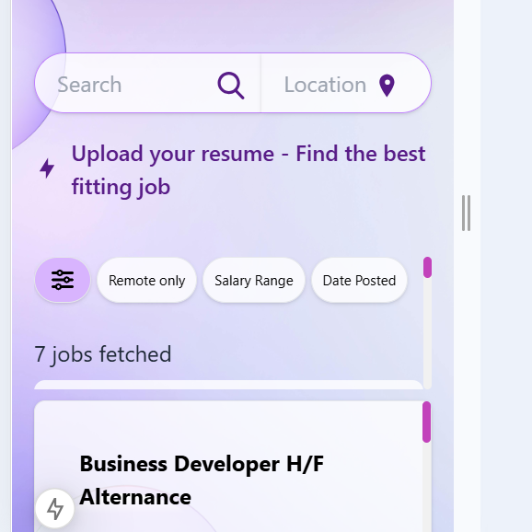

Ye jobs to peechey chali gai hyn sari wo to dikh he ni rahi. Jobs dekhien sari jis per click karien wo aeisey dikh jaye open ho kaya jeisey eb behtar way ho. Beshak khali jobs dekha dien details ni dekhayien start. Jab kisi job per click ho then detail show ho koi neechey ya jis tarhan behtar lagey.

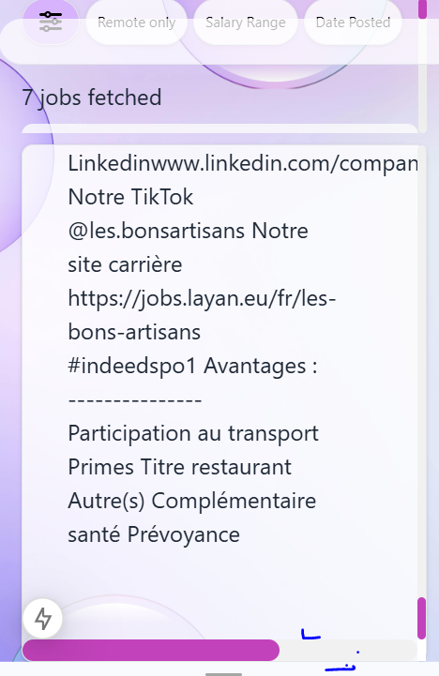

Ye scroll kiyo show ho raha left to right per. Ye na show ho mobile responsive show hon details.

**Important Note:** Aeisey karien Indeed, Glassdoor per dekhien keisey jobs ki detail show hoti ha.

4 ) Jobs page ma neechey footer kahan gaya. Mobile per to ni show ho raha. Laptop mobile dono per he footer to ho is per be

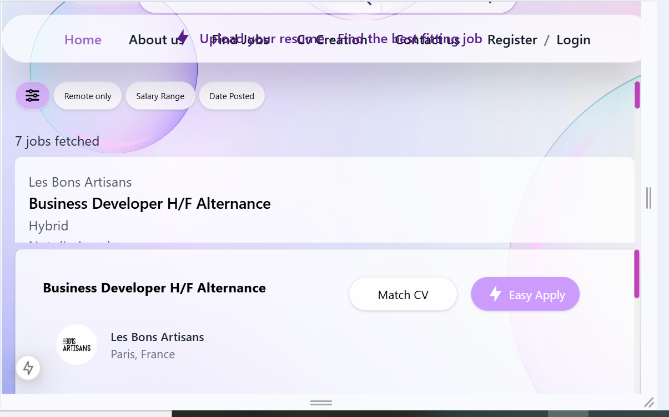

5) Tabs per be thek ni a raha jobs sari chup gai hyn

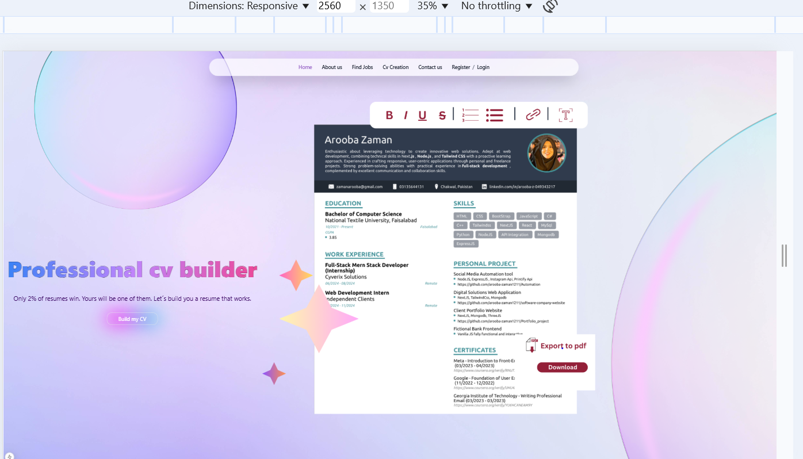

6) Bari screen per ye thek ni a raha section baki sections thekk hyn. Ye middle ma show ho properly jeisey laptop screen per ha

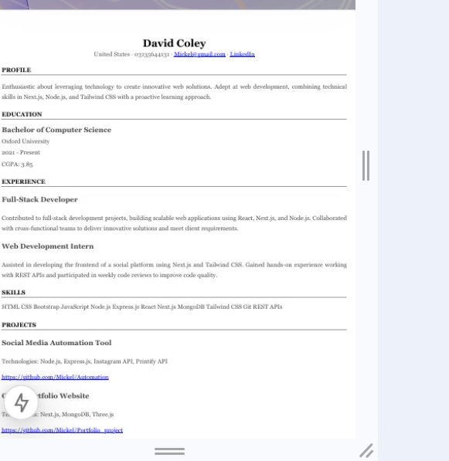

7) Mobile view ma ye itna zayaad attach hogaye hyn templates

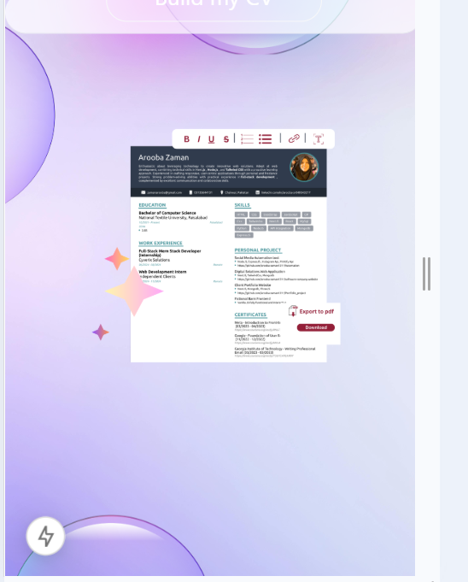

8) Mobile view ma ye buhat he chota hogaya ha speaces aus ki wajah sey zayaad lag rahi is ko bara karien mobile view per

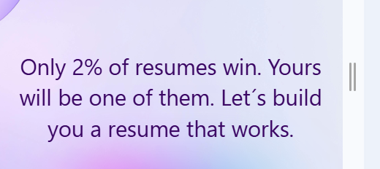

9) Jo font style means roman ya jo be yahan use hoa hoa ha ye wala he puri app ma use karien. Footer ma be yahi font style ho aus ma different ha. Consistency rakhien.

10) register and login page dono ko responsive for all devices kerna ha

11) login per pic buhat gandi lagi ha aur sign up ki ha wo axhi piyari aur loogin ki lagani ha

12) check kerna ha update profile per user ma please wait loader show ho raha ha y ani.

13) arrow password-update user ma weisa he kerna ha jeis profile-update ma ha.

14) forget pass per be loading laga dien

15) forget pass ma please wait ky agy loader ni aya

16) jab secs khatam ho jaty otp am to verify otp wala button diable ho jata ha aus ka color aus tarhan ka ker dena tab ky pata lagey disable hogaya ha

17) update password after forget ky jo ata aus ma pic ni axhi wo axhi lagani ha piyari

18) update password after forget ma jab please wait ata ha to wo butto ka size change ho raha is ma wo na ho.

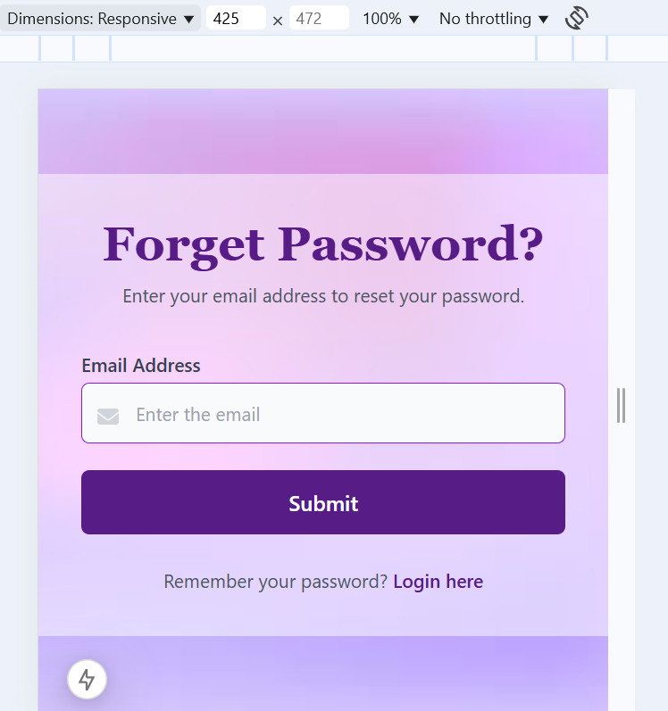

19) Mobile per thek ni ye.

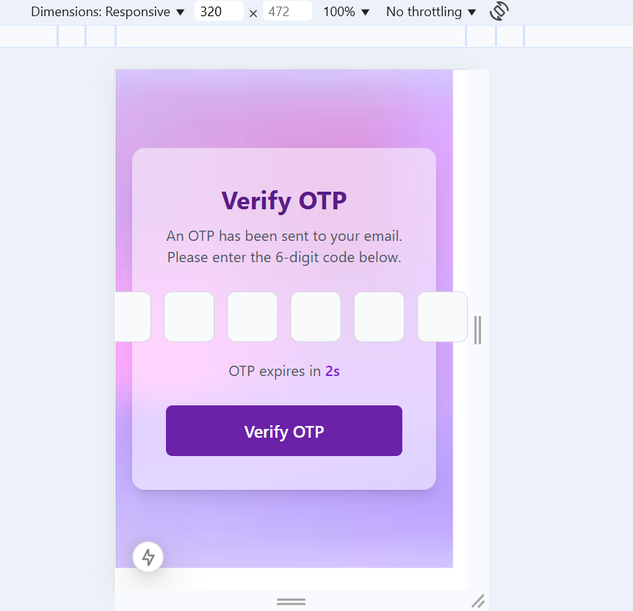

20) ye be mobile per thek ni

21) contact us per loadind dubara laga deni ha

22) login per ye validations lagani hyn aur neechey red ma dekhani hyn

import Joi from "joi";

const userLoginFieldsValidation = Joi.object({

  email: Joi.string()

    .email({ tlds: { allow: false } })

    .required()

    .messages({

      "string.empty": `Please provide the email. The email cannot be empty`,

      "string.email": `Please provide an email that must be in a valid format`,

      "string.base": `Email must be in a string format`,

    }),

  password: Joi.string()

    .min(8)

    .required()

    .messages({

      "string.empty": `Password must not be empty`,

      "string.base": `Password must be in the form of a string`,

      "string.min": `Password must have at least 8 characters`,

    }),

});

export default userLoginFieldsValidation;

23) register form per be validations lagani red ma he show hon

import Joi from "joi";

const userRegisterFieldsValidation = Joi.object({

  name: Joi.string().min(2).max(35).required().messages({

    "string.empty": `Please provide the name. The name cannot be empty`,

    "string.base": `Name only contains characters `,

    "string.min": `Name must be Correct`,

  }),

  email: Joi.string()

    .email({ tlds: { allow: false } })

    .required()

    .messages({

      "string.empty": `Please provide the email. The email cannot be empty`,

      "string.email": `Please provide email that must be in a valid Format`,

      "string.base": `Email must be in a String Format`,

    }),

  password: Joi.string()

    .min(8)

    .pattern(new RegExp("^(?=.*[a-z])(?=.*[A-Z])(?=.*[0-9])(?=.*[!@#$%^&*])"))

    .required()

    .messages({

      "string.base": `Password must be in the form of a string`,

      "string.empty": `Please provide the password. The password cannot be empty`,

      "string.min": `Password must have at least 8 characters`,

      "string.pattern.base": `Password must include at least one uppercase letter, one lowercase letter, one number, and one special character`,

    }),

});

export default userRegisterFieldsValidation;