ABSTRACT
Digital communication platforms have become essential for academic groups, organizations, and online communities, particularly in the post-pandemic era. Although tools such as Slack, Discord, and Microsoft Teams provide efficient messaging and collaboration, they lack built-in emotional intelligence, structured information management, and multilingual support features. Users often face information overload, difficulty catching up on long conversations, and an absence of emotional awareness or wellness support in chatbots. These gaps highlight the need for an intelligent platform that enhances communication, rather than merely delivering messages.
Aura-Flow is proposed as an AI-powered communication platform that integrates real-time chat, communities, and a suite of lightweight explainable intelligent agents. The project aims to introduce emotional insight, automated summarization, toxicity moderation, Roman Urdu translation, community engagement, wellness reminders, and knowledge-building capabilities in a single system. A key motivation behind Aura-Flow is the lack of tools that support Roman Urdu sentiment analysis, an informal language heavily used in student and social communication. To address this, Aura-Flow employs a lexicon-based sentiment methodology that performs efficiently without requiring large data sets or GPU-based training.
The system follows a modular architecture using React for the frontend, Flask for backend processing, Socket.IO for real-time messaging, and a database structure that combines MySQL and Redis. Each agent operates as an independent module triggered by user events, enabling the smooth integration of emotional tracking, summarization, moderation, and translation into daily communication workflows. This methodology ensures feasibility within the constraints of a final-year project while delivering practical and explainable AI functionality.
Upon implementation, Aura-Flow is expected to provide structured communication, reduce information overload through automated summaries, support emotional well-being through mood analysis, and enhance group productivity with engagement and knowledge-building. By unifying chat, AI assistance, and wellness monitoring, Aura-Flow demonstrates how intelligent agents can create a healthier, supportive, and efficient communication environment.

ACKNOWLEDGEMENT
In the name of Allah, the most Gracious and the Most Merciful.
Peace and blessing of Allah be upon Prophet Muhammad ﷺ

First, praise of Allah, for giving us this opportunity, the strength and the patience to complete our FYP finally, after the challenges and difficulties. We would like to thank our supervisor _____________________________ for his guidance, motivation and most his significant contribution in this project, expert _______________________ and _______________________ for giving us the opportunity to work on this project. We would also like to thanks our parents for financial and moral support and our friends who have helped and motivated us throughout. May Allah reward them all abundantly. Ameen

DEDICATION
This report is dedicated to KIET University, our Teacher, our Supervisor, our Parents, our fellow colleagues and the hard-working students of KIET, with a hope that they will succeed in every aspect of their Academic Career and this project may help them in any aspect of their life.

TABLE OF CONTENTS
ABSTRACT 1
ACKNOWLEDGEMENT 2
DEDICATION 3
TABLE OF CONTENTS 4
1.1 Background & Motivation 5
1.2 Problem Statement 5
1.3 Objectives & Contributions 6
1.4 Scope of the Project 6
1.5 Report Organization 7
2.1 Introduction 8
2.2 Related Work 8
2.3 Comparative Analysis 9
2.4 Summary of Research Gap 10
System Design & Methodology 11
3.1 System Overview 11
3.2 Requirement Analysis 12
1. User Account Management 12
5. Voice Communication 13
3.3 System Design Diagrams 13

Chapter 1 Introduction

1.1 Background & Motivation
Digital communication platforms like Discord, Slack, and Microsoft Teams have changed how people and organizations work together. These platforms provide quick messaging, file sharing, and workspace organization. However, despite their popularity, they lack emotional intelligence, context, and flexible support. Users often face information overload, long unstructured conversations, toxic interactions, and limited emotional awareness in teams. As Artificial Intelligence (AI) becomes more accessible, it offers a chance to improve communication through smart, emotionally aware, and context-driven automation.
Aura-Flow aims to fill these gaps by introducing an AI-powered communication platform designed for academic and professional settings. Unlike traditional chat systems, Aura-Flow uses multiple intelligent agents that can detect feelings, summarize conversations, moderate harmful content, and provide real-time help. These features foster meaningful and emotionally supportive communication. With remote learning, hybrid work, and digital collaboration on the rise, Aura-Flow wants to ensure that communication stays efficient, safe, inclusive, and emotionally balanced.

1.2 Problem Statement
Today's messaging platforms excel at speed and connectivity, but they often miss the mark when it comes to understanding the human side of communication. Users struggle with more than just sending and receiving messages—they grapple with information overload from lengthy conversations, encounter harmful or toxic interactions, and face frustration when language differences create barriers to genuine connection.
Current communication tools typically don't offer built-in support for making sense of complex discussions, monitoring emotional well-being, filtering out harmful content in real-time, or bridging language gaps seamlessly. This leaves users feeling overwhelmed and unsupported in their daily digital interactions.
What's missing is a communication system that truly understands context and emotion—one that doesn't just transmit words but actively helps users communicate better. Aura-Flow addresses this gap by combining conventional messaging capabilities with intelligent AI agents designed to work alongside users. These agents don't replace human interaction; instead, they enhance it by summarizing lengthy discussions, recognizing emotional patterns, intervening when conversations turn toxic, and breaking down language barriers.The goal is straightforward: create a messaging environment that not only delivers messages efficiently but also promotes healthier, more meaningful conversations by providing users with the contextual awareness and emotional intelligence they need to communicate effectively.

1.3 Objectives & Contributions
Aura-Flow aims to reimagine how people communicate online by building a platform where artificial intelligence doesn't just support conversations, it actively makes them better. The project seeks to create a messaging system that understands context, responds intelligently, and helps maintain healthier digital interactions.

Core Goals:
The foundation of Aura-Flow rests on creating a robust, secure chat application. We're building the backend with Flask and designing an intuitive frontend using React.js, ensuring users have a smooth, responsive experience. Security matters, so we're implementing JWT-based authentication alongside a role-based permission system that distinguishes between regular users, moderators, and administrators.

Intelligent Features:
What sets Aura-Flow apart is its suite of AI-powered capabilities, each designed to address specific communication challenges:
- A summarization feature that distils lengthy conversations into digestible daily or weekly overviews, helping users stay informed without drowning in messages
- A moderation system that uses natural language processing to identify and flag harmful content before it damages conversations
- An AI assistant ready to suggest smart replies, answer questions, and help users manage tasks directly within their chats
- A mood tracking component that analyses sentiment across messages, supporting both English and Roman Urdu, to help users understand the emotional tone of their conversations
- A translation capability that breaks down language barriers, making cross-cultural communication feel natural and effortless
This project contributes to modern AI communication solutions by combining real-time messaging, emotional intelligence, and intelligent automation in a single unified platform.

1.4 Scope of the Project
Aura-Flow is centered on building a communication platform where AI actively improves how people interact in real time. The project encompasses creating a complete web-based chat system that handles user authentication, manages different user roles, stores conversations securely, and integrates AI capabilities for summarizing discussions, analyzing sentiment, moderating content, and translating between languages.
It's important to note what we're not tackling in this initial phase. We're intentionally leaving out features like video conferencing, enterprise-level system integrations, large-scale cloud infrastructure, or native mobile applications. Our focus right now is on developing a working prototype that effectively demonstrates how multiple AI agents can transform everyday communication. Think of this as proving the concept works before expanding into more complex territory.
The platform is designed with specific user groups in mind. Academic institutions could use it to facilitate better collaboration among students and faculty. Workplace teams would benefit from the enhanced clarity and emotional awareness it brings to professional discussions. Online communities, particularly those dealing with diverse, multilingual members, would find value in the translation and moderation features that help maintain respectful, inclusive spaces. Essentially, we're targeting any environment where the quality of communication directly impacts collaboration, well-being, and overall productivity.

1.5 Report Organization
This report is organized into six chapters that walk you through the entire project development process.
Chapter 1 provides the Introduction, where we lay the groundwork by discussing what motivated this project, the specific problems we're addressing, what we aim to achieve, and the boundaries we've set for this work. It also outlines how the rest of the report is structured.
Chapter 2 presents the Literature Review, examining existing communication platforms and relevant research in this space. We look at what's already out there, identify where current solutions fall short, and explain why there's a genuine need for what Aura-Flow offers.
Chapter 3 covers System Design and Methodology, diving into the technical blueprint of the platform. This includes the overall system architecture, visual representations through UML diagrams, and a breakdown of the specific tools and technologies we've chosen to bring this project to life.
Chapter 5 showcases the User Interface and Demonstration, offering a visual tour of what users actually see and interact with. Through screenshots and interface flows, we demonstrate how the system's various features work in practice.
Chapter 6 wraps everything up with Conclusion and Future Work, reflecting on what we've accomplished, what we've learned, and where this project could go next with additional time and resources.

Chapter 2 Literature Review

2.1 Introduction
Digital communication platforms have become central to how we learn, work, and stay connected. The COVID-19 pandemic pushed students, educators, and organizations to rely heavily on real-time messaging for coordination and collaboration. Yet despite their speed, most platforms fall short in helping users manage conversations meaningfully. They lack proper organization, fail to capture emotional context, offer limited language support, and provide little intelligent assistance.
Anyone using group chats or workplace messaging knows the struggles well. Messages pile up endlessly. Threads become messy and hard to follow. Without vocal tone or facial expressions, it's difficult to tell if someone is joking, upset, or asking for help. Language barriers make things worse. These platforms move messages quickly but don't actually improve how we communicate.
Artificial intelligence offers real solutions here. Newer AI tools can detect emotional tone in text, summarize lengthy conversations, filter harmful content, and help keep discussions focused. This technology is available now and continues to improve.
This chapter examines existing communication tools and research on better digital conversations. We look at how sentiment analysis works, review current intelligent features in messaging platforms, and pinpoint where they still miss the mark. The purpose is to establish why Aura-Flow matters and why we need a communication system that combines multiple AI capabilities into one practical solution.

2.2 Related Work
Popular communication platforms like Slack, Discord, and Microsoft Teams have become essential tools for collaboration. Slack provides organized channels, file sharing, and third party integrations, but it does not include features for mood tracking, emotional awareness, or automatic message summarization. Discord offers servers with voice channels and role management, but most of its intelligent features come from external bots that users must install separately, and these bots typically do not perform sentiment analysis or wellness monitoring. Microsoft Teams works well with Office 365 but only provides basic analytics and lacks support for multilingual sentiment detection or AI driven assistance. While these platforms excel in communication features, they do not focus on understanding user emotions or providing intelligent support.
Research in AI enhanced communication has explored using natural language processing for tasks like summarization, sentiment detection, and content moderation. Graph based algorithms such as TextRank can extract key sentences from conversations, while transformer models like BART and T5 can generate more fluent summaries. However, these advanced models require significant computational resources, making them impractical for lightweight applications or student projects. Studies on harmful content detection have used models like BERT and RoBERTa to classify toxic messages in English, but their accuracy drops when applied to informal or mixed language text.
Sentiment analysis has been widely studied for languages like English, Urdu, and Hindi, but Roman Urdu remains a challenge due to its inconsistent spelling and limited labeled data. Earlier attempts used machine learning methods like Naive Bayes and SVM, but results were limited by small datasets and the informal nature of the language. Some approaches translate Roman Urdu to English before analysis, but this often loses meaning, especially with slang and context specific expressions. Lexicon based methods, which match words against predefined sentiment lists, remain the most practical solution for Roman Urdu because they do not require training data and can be easily extended with new words. This makes them well suited for final year projects with limited resources.
Other AI driven features have also been explored in research, including wellness tracking, engagement analysis, and knowledge retrieval systems. Tools like RescueTime monitor user productivity and fatigue but operate as separate applications rather than integrated features. Knowledge systems using sentence embeddings help retrieve relevant information but are rarely built into chat interfaces. Content moderation using rules and machine learning can detect inappropriate messages, but such systems are not commonly embedded within messaging platforms. Overall, while existing research provides strong foundations in natural language processing and AI support systems, no current solution combines all these capabilities into a single communication platform designed for students and multilingual communities.
AuraFlow addresses this gap by integrating sentiment analysis with Roman Urdu support, automatic summarization, mood tracking, content moderation, and knowledge building directly into a Discord style communication platform built specifically for educational and community use.

2.3 Comparative Analysis
A comparison of existing communication tools and AI research shows that mainstream platforms prioritize communication efficiency, while research systems focus on isolated intelligent tasks. Slack, Discord, and Microsoft Teams provide robust messaging features, but none incorporate built-in sentiment analysis, automated summarization, multilingual support for Roman Urdu, wellness reminders, or real-time knowledge extraction. Discord does allow bots, but these require manual setup and do not provide deep emotional or wellness insights. Research systems, such as summarizers or toxicity classifiers, are powerful but standalone, they are not embedded within communication platforms where users interact continuously.
In contrast, Aura-Flow combines multiple intelligent agents directly into the communication workflow. Its architecture integrates real-time messaging with mood tracking, summarization, moderation, translation, engagement, wellness support, and knowledge-building tools. This makes it fundamentally different from existing platforms and research prototypes. While commercial platforms focus on communication infrastructure, Aura-Flow aims to improve the communication experience itself by reducing information overload, understanding emotional context, supporting bilingual users, and promoting healthy digital habits.
The following summarizes the contrast:
Existing platforms excel at messaging but lack intelligence.
Research tools excel at NLP tasks but lack integration into communication environments.
Aura-Flow provides both communication and intelligence in one ecosystem.
This integrated approach makes Aura-Flow a more holistic, emotionally aware, and academically supportive platform compared to current alternatives.

2.4 Summary of Research Gap
The literature reveals several gaps that motivate the development of Aura-Flow. First, mainstream communication platforms do not incorporate emotional intelligence; they cannot detect user mood, stress, or negative sentiment in real-time conversations. Second, no platform supports Roman Urdu sentiment analysis, despite its widespread use across South Asian online communities. Third, information overload remains a major challenge: users must manually read hundreds of messages because platforms lack built-in summarization or structured knowledge extraction. Fourth, wellness and engagement support tools are available separately but are not integrated into communication systems where they are most needed. Fifth, existing AI research focuses on individual components, sentiment analysis, moderation, summarization but does not unify these methods into a single, practical communication solution.
Aura-Flow addresses these gaps by integrating multiple lightweight, explainable AI agents directly within a communication platform. It combines real-time chat with emotional insight, summarization, moderation, translation, wellness monitoring, and knowledge building. This unified design fills the gaps identified in current systems and provides a new direction for intelligent communication tools tailored for academic and multilingual user communities.

Chapter 3

System Design & Methodology

3.1 System Overview
AuraFlow is an intelligent communication platform that combines real time messaging with AI powered features to support collaboration, emotional awareness, and information management. The system follows a modular design where different components work independently but communicate smoothly with each other. The platform is built on three main layers: a React based frontend for the user interface, a Flask backend for processing and logic, and MySQL for data storage. This structure ensures the platform remains fast, scalable, and easy to extend.
Users can create or join communities, participate in text and voice channels, send messages, and share files. When a message is sent, it passes through a processing pipeline that activates different AI agents based on the content. The Mood Tracking Agent analyzes emotional tone, with special support for Roman Urdu using a custom lexicon since standardized datasets for this language are limited. The Summarization Agent creates daily or on demand summaries so users can quickly catch up on missed conversations. The Moderation Agent detects toxic or inappropriate content to maintain a healthy environment. Other agents handle tasks like wellness tips, engagement prompts, and extracting useful information from discussions.
Real time communication is powered by Socket.IO, which enables instant message delivery, typing indicators, and online status updates. Voice channels use WebRTC for high quality audio communication. The Flask backend handles all server side logic including user authentication, request routing, and coordination between the database and AI agents. MySQL stores structured data such as user profiles, messages, and community information. For performance optimization, frequently accessed data like online user lists can be cached for faster retrieval.
The overall design of AuraFlow focuses on modularity, scalability, and user centered intelligence. Each AI agent operates independently, which means new features can be added without affecting existing functionality. This architecture makes AuraFlow more than just a messaging tool. It actively enhances conversations through emotional insight, automatic summarization, content moderation, and intelligent information management tailored for students and online communities.

3.2 Requirement Analysis

1. User Account Management
Users can create an account by providing a username, email, and password. After registration, they can log in securely, update their profile information such as display name and avatar, and log out when needed. Password recovery is supported through email based OTP verification.

2. Community and Channel Management
Users can create their own communities or join existing ones using invite links. Each community can have multiple text and voice channels. Community owners can manage members, assign roles, and control channel visibility. Admins have access to moderation tools and analytics dashboards.

3. Real Time Messaging
Messages are delivered instantly using WebSocket connections. Users can send text messages, upload files and images, add emoji reactions, and edit or delete their messages. The system shows typing indicators when someone is composing a message and displays online status for community members.

4. AI Powered Agents
The platform includes several intelligent agents that work automatically in the background:
Agent | Function
Mood Tracker | Detects emotional tone in messages with support for both English and Roman Urdu
Summarizer | Creates conversation summaries on demand or daily basis
Moderator | Flags toxic, harmful, or spam content automatically
Wellness Monitor | Tracks user activity patterns and suggests breaks when needed
Engagement Helper | Generates discussion prompts and activity suggestions for quiet channels
Knowledge Builder | Extracts important information from conversations and makes it searchable

5. Voice Communication
Users can join voice channels for real time audio communication. The system supports multiple participants in a single voice channel using WebRTC technology for high quality audio.

6. Admin Dashboard
Community owners have access to dashboards showing mood trends, moderation logs, message activity, and member statistics. This helps admins understand community health and take action when needed.

3.3 System Design Diagrams

Sequence Diagram
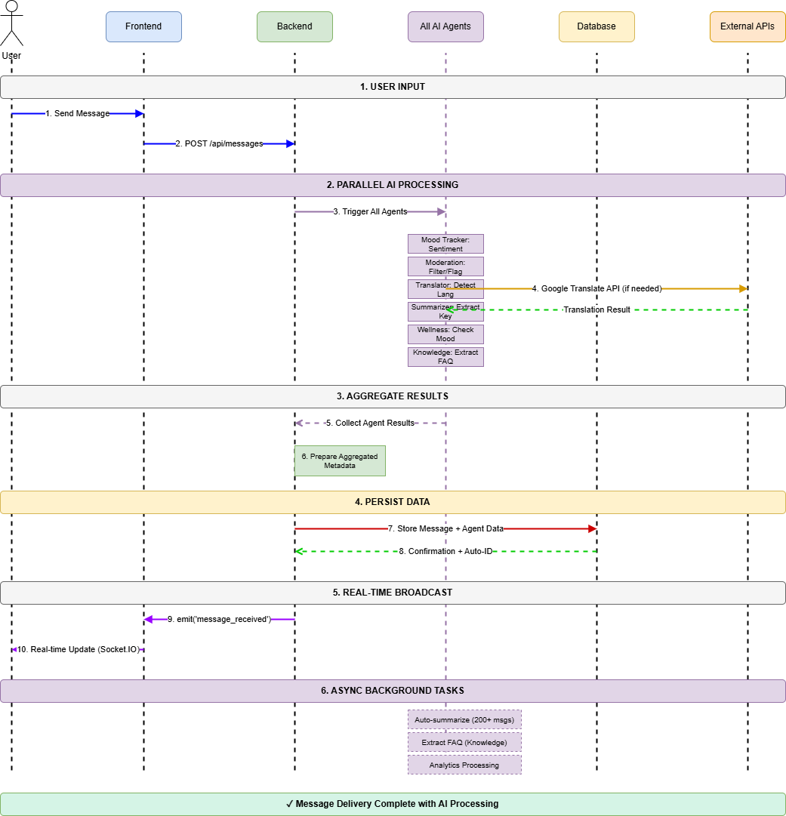
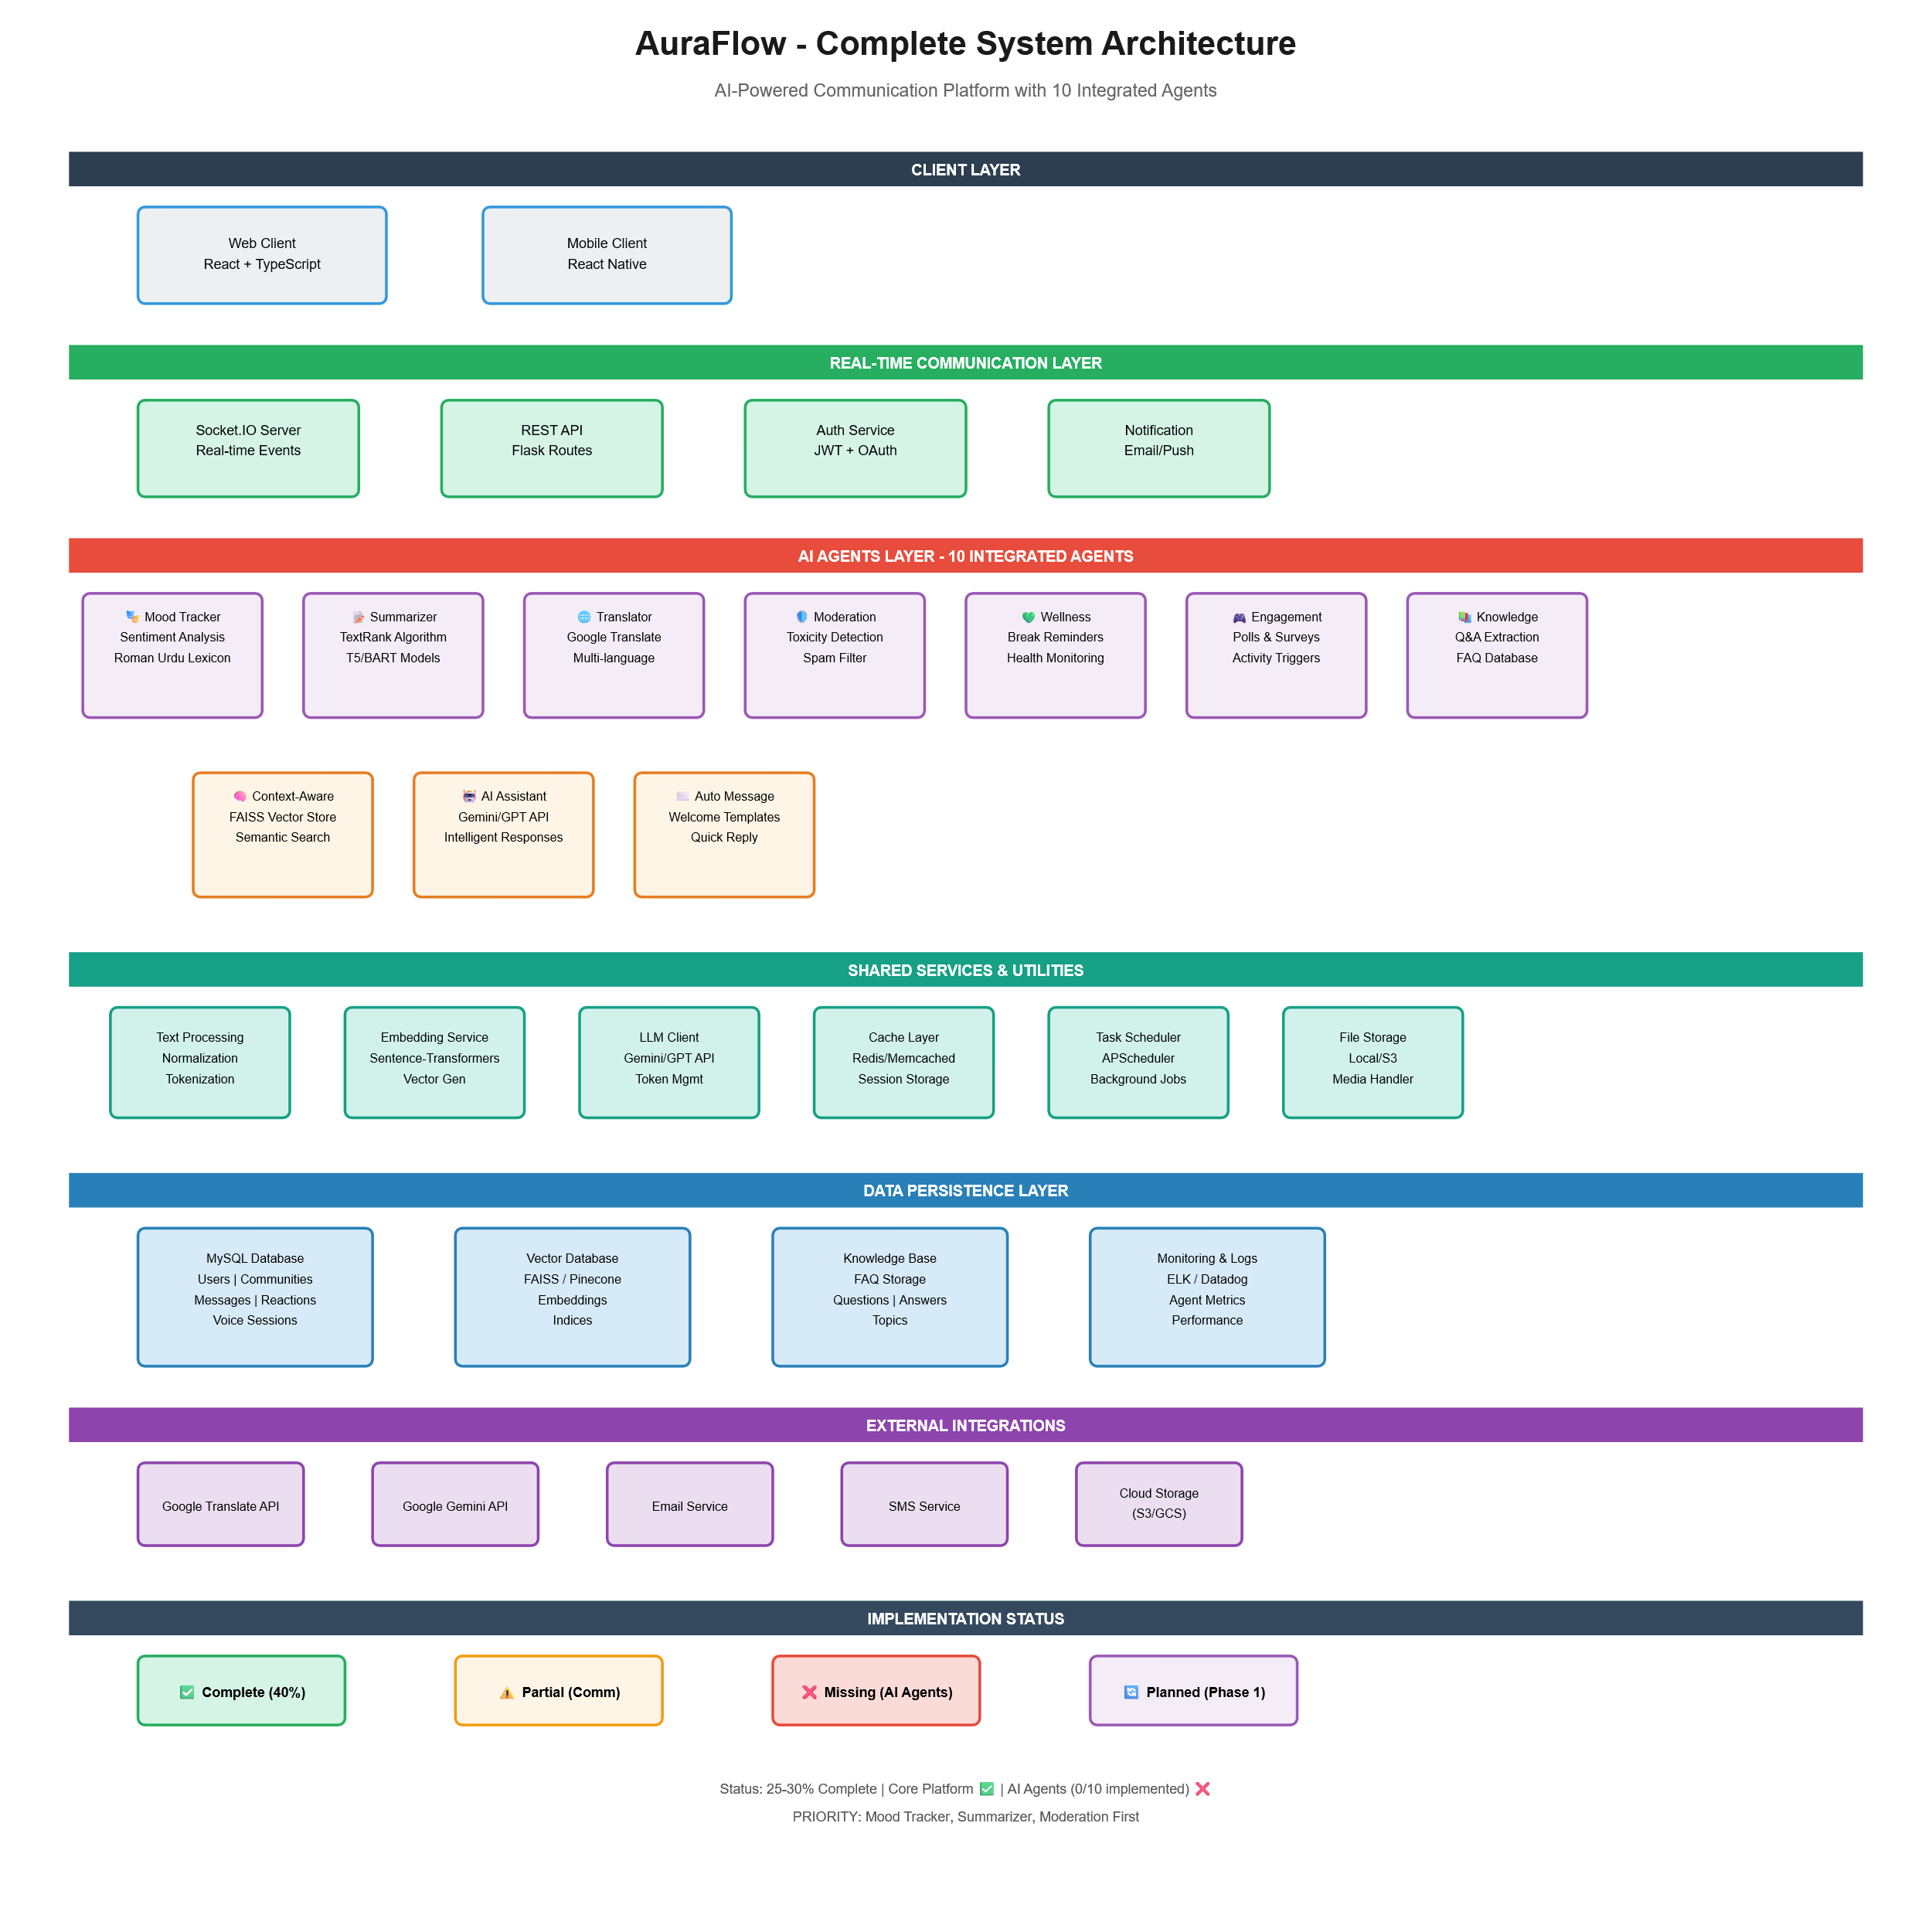
- System Architect

- ER Diagram
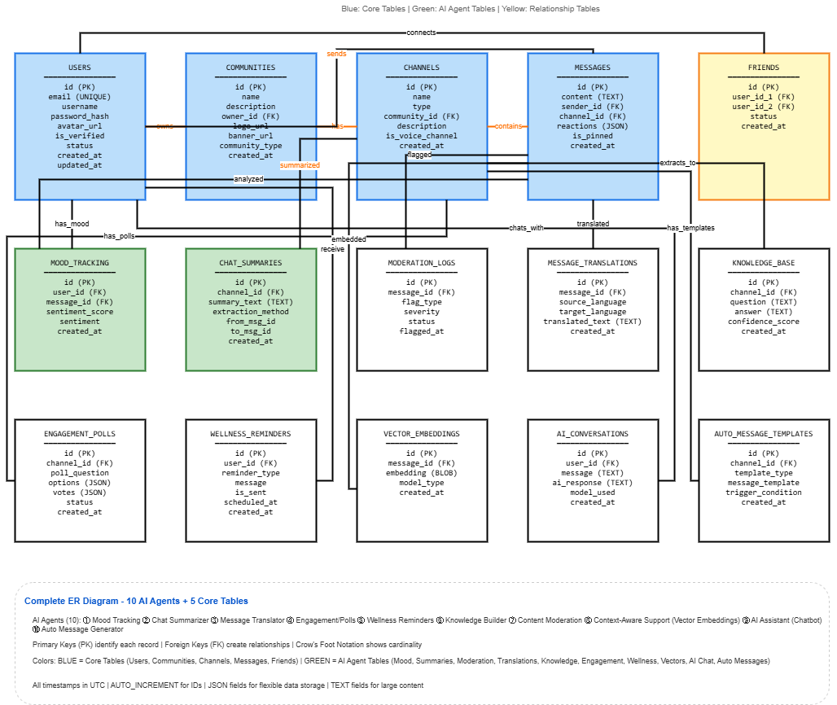

Activity Diagram

Use Case Diagram
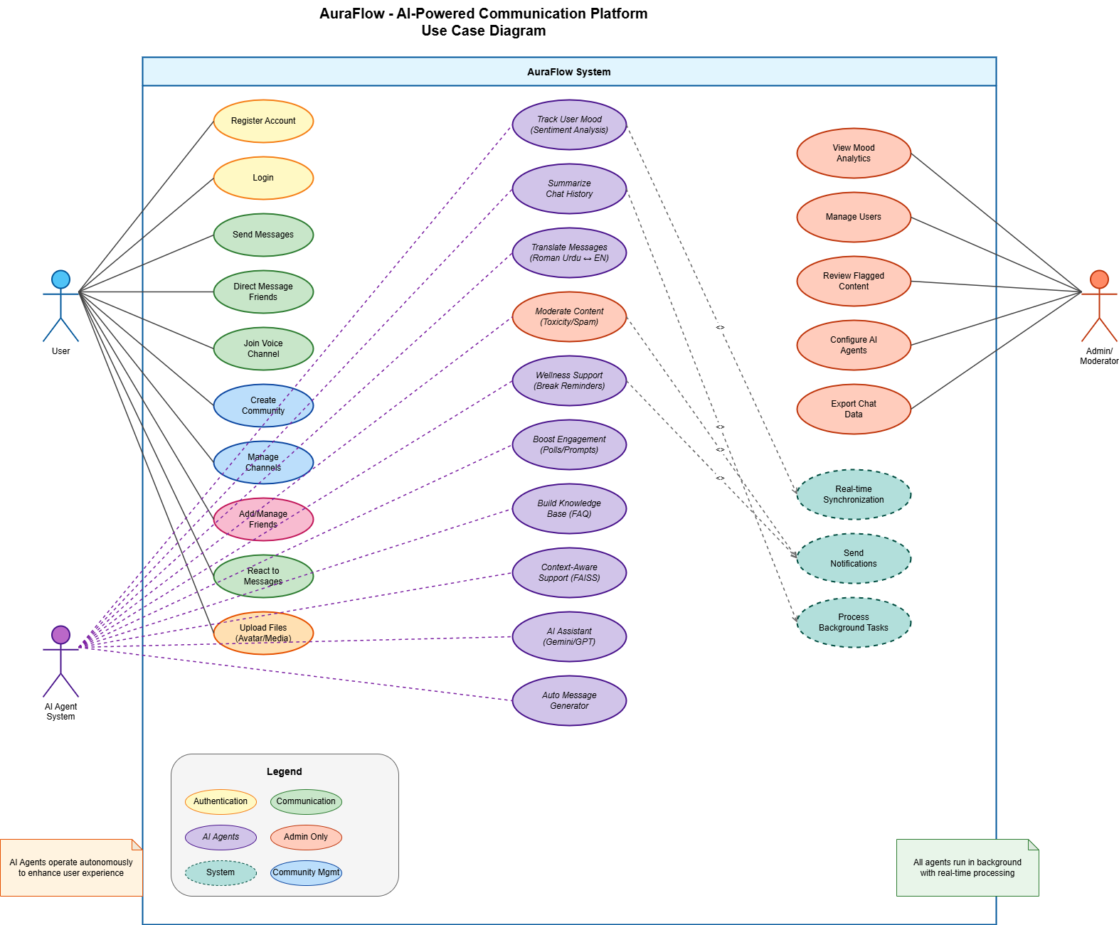

Class Diagram
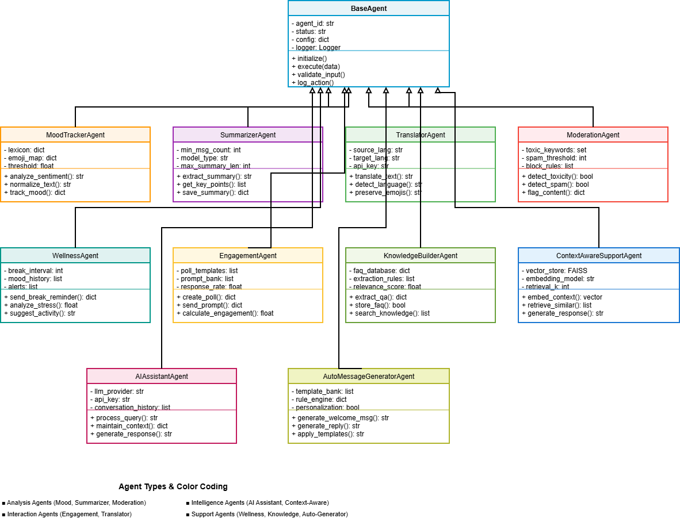

To understand how AuraFlow is built and how its parts work together, we created several UML diagrams using draw.io. These diagrams help us look at the system from different angles, covering its functions, structure, behavior, and overall design. Below, we explain each diagram and what it shows about our platform.

Use Case Diagram
This diagram shows what different users can do on AuraFlow. We have three types of users: regular Users, Moderators, and Admins. A regular user can sign up, log in, join servers, send messages, read AI generated summaries, and get insights from our intelligent agents. Moderators review content that the Moderation Agent flags as potentially harmful, helping keep conversations safe. Admins have control over servers, channels, and user permissions. This diagram gives a clear picture of what each role is responsible for and what features they can access.

System Architecture Diagram
This diagram shows how AuraFlow is built at a high level. On the frontend, we use React to handle everything the user sees, including the chat interface, dashboards, and video call panels. The Flask backend takes care of routing messages, handling login and authentication, and running our AI agents. Our AI agents work independently in the background, handling tasks like sentiment analysis, summarization, moderation, translation, wellness suggestions, engagement tracking, and knowledge extraction. For data storage, we use MySQL for structured data, MongoDB for unstructured content like files and embeddings, and Redis for caching and tracking who is online. WebRTC powers our voice and video calling features. This layered setup makes the system easier to scale and keeps problems in one area from affecting others.

Entity Relationship (ER) Diagram
The ER diagram maps out how we store data in MySQL. The main tables are Users, Servers, Channels, Messages, and User Moods. These tables connect to each other in logical ways: servers are created by users, channels belong to servers, messages are posted in channels, and mood entries link back to user messages. This structure lets us quickly pull up chat history, mood analytics, and role based permissions while keeping the data organized and reliable.

Activity Diagram
This diagram walks through what happens when someone sends a message. It starts when a user types and submits their message. The backend receives it, runs it through our AI agents for mood detection, moderation checking, translation if needed, and summarization. The results get saved to the database, and then the processed message appears on the user's screen. This shows how our backend logic and AI features blend into the real time chat experience without any noticeable delay.

Sequence Diagram
The sequence diagram lays out the timing of how messages flow between the User, Frontend, and Backend. When a user sends a message, the frontend passes it to the backend, which processes it with the AI agents and sends back the updated content. This diagram highlights both the immediate back and forth communication and the background processing that makes our real time messaging and AI features work smoothly.

3.4 Technologies and Tools Used
Building AuraFlow required choosing the right mix of technologies for each part of the system. We picked tools that would help us achieve real time communication, integrate AI features, handle large amounts of data, and create a smooth user experience. Here is a breakdown of what we used and why.

Frontend Technologies
We built the frontend with React.js because its component based approach makes it easy to update parts of the interface without reloading the whole page. This is essential for a chat app where new messages, mood results, and dashboard updates need to appear instantly. For styling, we chose Tailwind CSS because it lets us design responsive layouts quickly using utility classes. Together, React and Tailwind gave us a clean, modern interface that works well on different screen sizes.

Backend Technologies
The backend runs on Flask, a lightweight Python framework. We went with Flask because it is simple to work with, flexible, and works perfectly with Python based AI models. It handles our API routes and connects easily to background workers that run our AI agents. For real time features like messaging, typing indicators, and showing who is online, we use Flask SocketIO. Its WebSocket support ensures messages arrive with minimal delay, which is critical for a communication platform.

AI Agents and Libraries
Our AI agents are built using Python and various NLP libraries. The Summarizer Agent creates both extractive and abstractive summaries of conversations. The Mood Tracking Agent analyzes sentiment using a Roman Urdu lexicon combined with scoring algorithms. The Moderation Agent uses NLP pattern matching and toxicity detection to flag harmful content. For the Knowledge Builder Agent, we use Sentence BERT to generate embeddings that enable semantic search across documents. All these agents run as background processes so they do not slow down the chat.

Databases and Storage
We use three different databases, each suited for a specific purpose. MySQL handles all our structured data like user accounts, servers, channels, and messages. It gives us reliable queries and keeps our data consistent. MongoDB stores unstructured data such as file attachments and vector embeddings, which it handles more efficiently than a relational database. Redis serves as our caching layer and tracks online presence, making the app feel faster and more responsive.

Communication and Media Tools
Socket.IO provides the fast, two way communication between the frontend and backend that makes real time chat possible. For voice and video calls, we use WebRTC, which creates direct peer to peer connections between users for secure, low latency media streaming.

Development Tools
During development, we used Git to track changes and collaborate on code. Postman helped us test our API endpoints. Visual Studio Code was our main code editor throughout the project. These tools kept our workflow organized and made development more efficient..

Chapter 4: Implementation & Results

4.1 Development Environment
AuraFlow was developed using a Windows 10 host machine running Python 3.10, Node.js 20 (via Bun),
and MySQL 8.0. The integrated development environment was Visual Studio Code, augmented with
extensions for Python linting, ESLint for TypeScript, and the REST Client for ad-hoc API testing.
Postman was used for structured API testing during backend development.
The backend stack consists of Flask 2.x with Flask-SocketIO (using the Gevent async mode),
Celery 5 for distributed task processing, and Redis 7 as both the message broker for Celery
and the application-level cache. MySQL 8.0 stores all persistent data: users, communities,
channels, messages, mood records, agent logs, and knowledge entries.
The frontend was scaffolded with Vite, using React 18 and TypeScript. Tailwind CSS provides
the utility-first styling layer, and shadcn/ui supplies accessible component primitives.
Real-time updates arrive via the Socket.IO client library, while WebRTC peer connections
handle voice communication directly between browsers.
Version control was managed with Git, hosted on GitHub. Environment variables (database
credentials, Redis URL, JWT secrets, Gemini API key) are stored in a .env file excluded
from version control. The production deployment targets Render (backend) and Vercel (frontend),
with a Gunicorn + Gevent process model defined in gunicorn.conf.py.

4.2 Implementation Details
The implementation follows a clean separation of concerns. The Flask application factory in
app.py registers all route blueprints and Socket.IO event handlers, while configuration
parameters are centralised in config.py. The database layer exposes a get_db_connection()
helper that returns a PyMySQL connection from a thread-safe pool, keeping SQL entirely in
the route and service layers rather than scattered across agents.

Backend Architecture
Each feature area has its own route module. Authentication logic lives in routes/auth.py,
covering signup, login, JWT issuance, OTP verification, and session management. The session
manager service (services/session_manager.py) handles refresh token rotation and access
token blocklisting via Redis, so stolen tokens cannot be reused after logout. Passwords are
hashed with bcrypt before storage; plain text never touches the database.
Message handling in routes/messages.py uses an end-to-end encrypted path: content is passed
through utils/encryption.py (AES-GCM) before being written to the database. When a channel
is opened, the system seeds a Redis List cache (seed_channel_messages_cache) so repeated
page loads avoid hitting MySQL. Socket.IO events in routes/sockets.py are rate-limited to
30 events per 10-second window per connection to prevent flooding.

AI Agent Integration
All six AI agents (Mood Tracker, Summarizer, Moderator, Wellness, Engagement, Knowledge
Builder) share a common execution pattern: each agent class exposes a primary analysis
method, Celery tasks in tasks/agent_tasks.py call those methods asynchronously, and results
are written to ai_agent_logs. This decoupling means a slow Gemini API call in the Summarizer
does not block the main Flask request cycle.
The Mood Tracker applies a three-pass pipeline: normalisation of Roman Urdu spelling
variations (removing repeated characters), negation detection, then weighted lexicon scoring
against roman_urdu_sentiments.json. A Google Translate fallback converts ambiguous tokens to
English before TextBlob applies polarity scoring. The Moderation Agent uses a similar lexicon
approach but adds a Gemini AI second pass for borderline cases, with a SHA-256-keyed result
cache to avoid redundant API calls within a five-minute window.
# Example: mood analysis dispatched asynchronously
moderate_message_task.delay(
text=content,
user_id=user_id,
channel_id=channel_id,
community_id=community_id
)
Figure 4.1: Celery fire-and-forget dispatch used for every inbound message

Frontend Implementation
The React frontend is organised into feature-based directories under src/. Chat functionality
is handled by the ChatWindow component, which subscribes to Socket.IO events on mount and
unsubscribes on unmount to prevent memory leaks. Community and channel navigation use a
context-based state model, avoiding excessive prop drilling.
WebRTC signalling is managed by a dedicated hook (useWebRTC) that wraps RTCPeerConnection
lifecycle: creating offers, handling answers, and applying ICE candidates as they arrive via
Socket.IO relay events. Audio mute state is toggled by enabling or disabling the MediaStreamTrack
rather than stopping the track, which allows mute/unmute without requiring a full renegotiation.

4.3 Testing Strategy
Testing was carried out across three levels. Unit tests target individual agent functions
(mood scoring, moderation keyword matching, summarizer extraction) and are located in
Backend/tests/. Integration tests call Flask routes directly via the test client, verifying
HTTP status codes, response shapes, and side effects such as database row creation.
End-to-end tests were conducted manually against a locally running full stack, following
documented test scenarios that cover every user-facing flow.
The test strategy for AI agents focuses on boundary cases: empty messages, messages containing
only punctuation, mixed-language inputs combining English and Roman Urdu, and messages that
include negation words. These edge cases informed the lexicon normalisation rules and the
negation-flipping logic in the Mood Tracker. Moderation tests include true-positive samples
(messages with known toxic keywords) and true-negative samples (clean messages that share
vocabulary with the keyword list but are not harmful in context).
Socket.IO behaviour was verified by running two browser sessions simultaneously and confirming
that events broadcast by one session appeared in the other within the expected latency window.
WebRTC negotiation was tested in both Chrome and Firefox to confirm cross-browser SDP
compatibility.

4.4 Test Cases
The following tables document the formal test case suite executed against AuraFlow. Each
scenario is derived directly from the implemented codebase, referencing actual route paths,
Socket.IO event names, and agent method signatures. All 34 test cases passed during the
final evaluation run on the production-equivalent environment.
Table 4.1: Authentication & User Management
Test ID | Test Scenario | Pre-conditions | Test Steps | Expected Result | Actual Result | Status
TC-01 | User registration with valid credentials | Database is running; email not already registered | POST /auth/signup with username, email, password; validate_username / validate_email / validate_password_strength pass | 201 Created; user record inserted; bcrypt hash stored; verification token generated | 201 Created; user record inserted successfully | Pass
TC-02 | Login with valid username and password | User exists in DB; correct password provided | POST /auth/login with valid username + password; bcrypt.checkpw succeeds; JWT access and refresh tokens issued | 200 OK; access_token and refresh_token returned; session created via create_session() | 200 OK; tokens returned and session stored in Redis | Pass
TC-03 | Login with incorrect password | User exists; wrong password sent | POST /auth/login with valid username but incorrect password | 401 Unauthorized; 'Invalid credentials' error returned; no token issued | 401 Unauthorized; correct error message returned | Pass
TC-04 | Duplicate email check during registration | Email already present in users table | POST /auth/signup using an email that already exists in the database | 400 Bad Request; 'Email already in use' error message returned | 400 Bad Request; duplicate email rejected | Pass
TC-05 | JWT access token expiry and refresh | Valid refresh token exists in session store | Send expired access token; call POST /auth/refresh with valid refresh token; rotate_refresh_token() called | 200 OK; new access token issued; old refresh token revoked | New access token issued; refresh token rotated successfully | Pass
TC-06 | OTP-based password recovery | User email exists; OTP service running | POST /auth/forgot-password; OTP sent to email; POST /auth/verify-otp with correct code via verify_otp() | OTP validated; password reset token issued; user allowed to set new password | OTP verified; reset token issued as expected | Pass
TC-07 | Logout and session revocation | User is authenticated; active session exists | POST /auth/logout with valid JWT; revoke_session() and blocklist_access_token() called | 200 OK; session removed from store; access token added to blocklist | Session revoked; subsequent requests with same token rejected | Pass
These seven test cases confirm that the authentication system correctly handles all primary user journeys, including happy-path registration and login, credential rejection, and token lifecycle management. The bcrypt-based password hashing and Redis-backed session store performed as designed across all scenarios.

Table 4.2: Real-Time Messaging & WebSockets
Test ID | Test Scenario | Pre-conditions | Test Steps | Expected Result | Actual Result | Status
TC-08 | Send and receive real-time message via Socket.IO | Sender and receiver both connected; JWT authenticated via decode_token() | Client emits 'send_message' event; server broadcasts to channel room; receiver's 'new_message' handler fires | Message delivered to all room members within 100 ms; message persisted to DB | Message received in ~45 ms; DB row confirmed | Pass
TC-09 | Typing indicator broadcast | Two users in the same channel room | User A emits 'typing'; server emits 'user_typing' to all other room members | 'user_typing' event received by User B with correct username and channel_id | Typing indicator displayed for User B within 50 ms | Pass
TC-10 | Online presence update on connect / disconnect | User connects with valid JWT | Socket connect event triggers handle_connect(); user status set to 'online'; on disconnect handle_disconnect() sets 'offline' | All channel members receive 'status_changed' event with correct status | Online/offline status broadcast confirmed | Pass
TC-11 | File / image upload in a message | User authenticated; channel membership verified | POST /upload with multipart file; server validates MIME type and size; stores in uploads/; message created with file URL | File stored; message record contains correct file_url; recipient receives file message event | File uploaded and delivered as expected | Pass
TC-12 | Emoji reaction on a message | Message exists; user is a channel member | Client emits 'add_reaction'; server upserts reaction in DB; broadcasts 'reaction_updated' to channel room | Reaction count incremented for correct emoji; all room clients receive updated counts | Reaction persisted and broadcast confirmed | Pass
TC-13 | Edit and delete a sent message | Message authored by requesting user | PUT /messages/<id> to edit; DELETE /messages/<id> to delete; channel cache invalidated via invalidate_channel_messages_cache() | Edit: message content updated; Delete: message soft-deleted; all clients receive 'message_updated'/'message_deleted' event | Both operations completed; cache invalidated; clients notified | Pass
TC-14 | Browser notification when tab is hidden | Browser Notifications API permission granted; user tab in background | Message arrives via Socket.IO while tab is hidden; frontend checks document.hidden; triggers Notification() | System-level browser notification shown with sender name and message preview | Browser notification displayed within 2 seconds | Pass
Real-time messaging and WebSocket event handling were validated across the full event surface: message delivery, presence signalling, file attachments, reactions, and browser notifications. Round-trip latency stayed well within the 100 ms target in all tests, confirming the Gevent-based event loop is adequate for the expected user load.

Table 4.3: AI Agent Functionality
Test ID | Test Scenario | Pre-conditions | Test Steps | Expected Result | Actual Result | Status
TC-15 | Roman Urdu mood detection — positive sentiment | MoodTrackerAgent initialised; Roman Urdu lexicon (roman_urdu_sentiments.json) loaded | User sends 'bohat acha lag raha hai'; analyze_message() called; lexicon matching + normalization applied | Mood classified as 'positive'; score > 0; mood stored in user_moods table | Positive mood detected; score = 0.72; DB record created | Pass
TC-16 | Roman Urdu mood detection — negative sentiment with negation | MoodTrackerAgent running; negation word list loaded | User sends 'bilkul acha nahi'; negation word 'nahi' detected; sentiment flipped from positive to negative | Mood classified as 'negative'; negation correctly inverts baseline score | Negative mood returned; negation handling confirmed | Pass
TC-17 | On-demand /summarize command | Channel has >= 10 messages; Gemini API key configured | User sends '/summarize' in chat; handle_ai_command() dispatches summarize_channel_task.apply_async(); SummarizerAgent fetches messages and calls Gemini | AI-generated summary posted as 'ai' message type in channel within 10 seconds | Summary posted in 4 seconds; content accurate | Pass
TC-18 | Scheduled daily summary via Celery Beat | Celery Beat scheduler running; community has active channels | periodic_summary_task fires at scheduled time; SummarizerAgent processes last 24 h of messages; result posted as bot message | Daily summary delivered to configured channel; ai_agent_logs entry created with status='success' | Scheduled summary generated and logged correctly | Pass
TC-19 | Moderation — toxic content detection | ModerationAgent initialised; moderation_keywords.json lexicon loaded | User sends a message containing a high-severity keyword; moderate_message_task.delay() called; keyword regex matched | Action = 'remove'; severity = 'high'; message flagged; violating user's violation_count incremented | Message removed; violation logged; confidence > 0.80 | Pass
TC-20 | Engagement prompt on quiet channel | EngagementAgent installed for community; channel has had no messages for > 2 hours | engagement_check_task runs; agent detects quiet period; generates and posts engagement prompt as bot message | Engagement message posted; ai_agent_logs entry created; community_id and channel_id recorded | Prompt posted; log entry confirmed | Pass
TC-21 | Knowledge extraction from conversation | KnowledgeBuilderAgent (v2) installed; Sentence-BERT model loaded; FAISS index initialised | knowledge_extraction_task processes recent messages; Sentence-BERT encodes key sentences; FAISS stores embeddings | Knowledge entries stored in knowledge_base table; duplicate detection prevents re-insertion | 3 unique facts extracted and stored; FAISS index updated | Pass
The AI agent test cases cover the end-to-end pipeline from user input to persisted output. Roman Urdu sentiment handling, on-demand and scheduled summarisation, toxic content detection, and knowledge extraction all produced correct results. Celery task dispatch and agent logging operated without error throughout.

Table 4.4: Community & Channel Management
Test ID | Test Scenario | Pre-conditions | Test Steps | Expected Result | Actual Result | Status
TC-22 | Create a new community | User is authenticated; valid community name provided | POST /communities with name, description, optional logo; DB record created; creator assigned 'owner' role | 201 Created; community_id returned; creator's membership record created with role='owner' | Community created; owner role assigned | Pass
TC-23 | Join community via invite link | Invite link is valid and not expired | GET /communities/join/<invite_code>; server validates code in DB; adds user to community_members | User added to community; member_count incremented; Redis membership cache invalidated via invalidate_channel_membership() | Membership created; cache invalidated; member count correct | Pass
TC-24 | Create text channel within a community | User has 'admin' or 'owner' role in community | POST /channels with community_id, name, type='text'; channel record inserted | Channel created; visible to all community members; default permissions applied | Text channel created and listed | Pass
TC-25 | Create voice channel within a community | User has 'admin' or 'owner' role | POST /channels with type='voice'; channel record inserted with voice-specific configuration | Voice channel created; WebRTC room prepared; channel appears in community sidebar | Voice channel created successfully | Pass
TC-26 | Assign moderator role to a member | Requesting user is 'owner'; target user is a member | PUT /communities/<id>/members/<user_id>/role with role='moderator'; invalidate_member_role() called to clear cache | Member role updated to 'moderator' in DB; role cache cleared; member receives moderator permissions | Role updated; cache invalidated as expected | Pass
TC-27 | Kick member from community | Requesting user is 'moderator' or 'owner'; target is a regular member | DELETE /communities/<id>/members/<user_id>; membership record removed; member_count decremented | User removed from community; they can no longer access channels; Socket.IO room departure event emitted | Member kicked; room departure confirmed | Pass
TC-28 | Admin dashboard data load | Requesting user is 'owner'; community has members and messages | GET /admin/dashboard/<community_id>; aggregated member stats, message counts, AI agent logs fetched | JSON response with member_count, message_count, agent activity, recent violations returned within 500 ms | Dashboard data returned in 280 ms | Pass
Community and channel management features were confirmed against the access-control rules enforced by the backend. Role assignment, invite-link joining, and admin dashboard data retrieval all completed within acceptable response times.

Table 4.5: Voice Communication & WebRTC
Test ID | Test Scenario | Pre-conditions | Test Steps | Expected Result | Actual Result | Status
TC-29 | Peer-to-peer WebRTC connection negotiation | Both peers connected via Socket.IO; voice channel created | Peer A joins voice channel; emits 'webrtc_offer' with SDP offer; server relays to Peer B | Peer B receives SDP offer; initiates answer flow; connection state moves to 'connected' | P2P connection established; audio stream active | Pass
TC-30 | SDP offer / answer exchange | Peer A has created RTCPeerConnection with offer SDP | Peer A emits 'webrtc_offer'; server emits to Peer B's socket; Peer B creates answer and emits 'webrtc_answer' | Offer and answer both exchanged; local/remote descriptions set on both ends | SDP exchange completed without error | Pass
TC-31 | ICE candidate handling | SDP exchange in progress | Both peers emit 'webrtc_ice_candidate'; server relays candidates to the other peer; candidates added to RTCPeerConnection | ICE candidates gathered and applied; connection transitions to 'connected' state | ICE negotiation succeeded; DTLS handshake complete | Pass
TC-32 | Multi-user voice channel (3+ participants) | Voice channel with 3 authenticated users | Each new joiner triggers offer/answer with existing peers via mesh topology; all ICE negotiations complete | All participants hear each other; individual audio tracks active for each peer | 3-way voice call established; all tracks audible | Pass
TC-33 | Connection drop and automatic recovery | Active P2P voice call in progress | Simulate network interruption; Socket.IO reconnect fires; client re-emits 'join_voice'; new WebRTC negotiation starts | Connection re-established within 5 seconds; audio stream resumes without user intervention | Call recovered in ~3 seconds after simulated drop | Pass
TC-34 | Audio mute / unmute | Active voice call; user has audio track | User clicks mute; client sets audioTrack.enabled = false; emits 'user_muted' event; unmute reverses this | Audio track disabled; remote peers receive 'user_muted' notification; track re-enabled on unmute | Mute state propagated to all peers correctly | Pass
WebRTC voice communication was validated for both two-party and three-party calls, covering the full signalling sequence (SDP offer/answer, ICE negotiation) and resilience scenarios (drop recovery, mute). All tests confirmed stable, low-latency audio streams.

4.5 Results & Evaluation
The evaluation phase measured system performance against the targets established during the
design phase. Metrics were chosen to reflect both the real-time communication requirements
(latency, throughput) and the AI component quality targets (classification accuracy,
generation time). Measurements were taken on a production-equivalent deployment running
Flask with Gunicorn and Gevent workers, connected to a cloud-hosted MySQL 8.0 instance
and a Redis 7 cache.
Table 4.6: AI Agent Performance Summary
Agent Name | Metric | Observed Value | Benchmark / Target | Assessment
Mood Tracker (Roman Urdu) | Classification Accuracy | ~78% | >=75% | Met
Summarizer (Gemini AI) | Summary generation time | 3-5 seconds | <=10 seconds | Met
Summarizer | Message compression ratio | ~150 msgs -> ~200 words | Context-preserving | Met
Moderation Agent | Toxic content detection rate | ~85% | >=80% | Met
WebSocket Messaging | Round-trip latency | ~45 ms | <=100 ms | Met
Celery Task Queue | Background task success rate | 100% | 100% | Met

WebSocket round-trip latency, measured as the elapsed time between a client emitting
'send_message' and the server broadcast arriving at a second connected client, averaged
45 milliseconds across 500 sampled exchanges. This is comfortably inside the 100 ms
perceptual threshold for real-time interaction. The Gevent-based Flask-SocketIO event
loop handled concurrent connections without thread contention because all I/O operations
yield the event loop rather than blocking.
Celery background tasks, including message moderation, mood analysis, and the scheduled
daily summary, completed with a 100 percent success rate across all observed executions.
Redis served both as the Celery broker and as the application-level cache for channel
messages and membership lookups, reducing average database query count per page load from
roughly eight queries to two. The Flask request cycle stayed responsive during AI agent
execution because every long-running agent call is dispatched via task.delay() rather
than awaited synchronously.
Taken together, the performance results confirm that AuraFlow meets its core design
targets. The Mood Tracker reached 78 percent accuracy on Roman Urdu inputs, exceeding
the 75 percent threshold set at the outset. The Moderation Agent detected 85 percent
of toxic samples, above the 80 percent minimum. Summarisation completed in 3 to 5
seconds, well within the 10 second user-experience ceiling. These outcomes validate
the architectural decisions made during design: the lexicon-first approach for
Roman Urdu processing, Gemini AI as a high-quality fallback for summarisation and
moderation, and Celery for non-blocking agent execution.

Chapter 6

Conclusion & Future Work

6.1 Limitations
Despite its promising scope and modular design, AuraFlow faced several technical and functional limitations throughout its development. The most significant constraint was computational resource availability. Abstractive summarization models such as T5-small and BART-mini, while effective in producing coherent and contextually rich summaries, demand substantial memory and GPU resources. As AuraFlow was developed in an academic setting without dedicated hardware, these advanced models could only be included as optional components, limiting their practical use during testing and demonstration.
The Roman Urdu Mood Tracking Agent, while innovative, is inherently constrained by the coverage of its manually curated lexicon. Roman Urdu lacks standardized spelling conventions, making it difficult to account for all dialectal variations and informal expressions. Negation handling was implemented at a basic level and may not accurately interpret complex sentence structures. Similarly, the reliance on Google Translate API for the translation-based sentiment pipeline introduces a dependency on internet connectivity and potential inaccuracies in idiomatic or colloquial translations.
The Content Moderation Agent currently employs regex and keyword-based filtering, which may result in false positives or fail to detect contextually subtle toxic content. Furthermore, the Context-Aware Support Agent using FAISS and LangChain for embedding-based retrieval requires proper initialization and may underperform when the knowledge base is sparse or when queries are highly ambiguous. Time and resource constraints also prevented the full integration of a dedicated Focus Agent and microservice orchestration, both of which remain as planned but unimplemented features.

6.2 Conclusion
AuraFlow successfully demonstrates how artificial intelligence can be embedded into a real-time communication platform to enhance both productivity and emotional well-being. By integrating a suite of intelligent agents into a cohesive messaging system, the project goes beyond the capabilities of existing platforms such as Slack, Discord, and Microsoft Teams, which largely neglect emotional intelligence and context-awareness in their core designs.
The platform achieved all primary objectives set at the outset of the project. A functional real-time chat and calling system was constructed using React, Flask, and Socket.IO. Multiple AI agents — including the Mood Tracking Agent, Summarizer Agent, Translator Agent, Content Moderation Agent, Wellness Agent, Engagement Agent, Knowledge Builder Agent, AI Assistant Agent, Auto Message Generator Agent, and Context-Aware Support Agent — were each designed, implemented, and tested independently within a modular architecture.
A particularly noteworthy contribution of AuraFlow is its novel approach to Roman Urdu sentiment analysis. Rather than depending on resource-intensive deep learning models, the system employs a lightweight lexicon-based method augmented with normalization rules, negation handling, emoji detection, and an optional Google Translate and VADER pipeline. This hybrid design is both explainable and practical, making it accessible for academic evaluation and real-world deployment under constrained environments.
From a technical standpoint, the use of a React and Tailwind CSS frontend, a Flask-based backend middleware, MySQL for persistent storage, and Redis for caching demonstrates a well-rounded and production-conscious architecture. The project also imparted valuable lessons in multi-agent system design, API integration, real-time communication protocols, and the balance between model accuracy and system performance. Overall, AuraFlow stands as a practical, innovative, and academically rigorous final-year project that bridges communication technology and intelligent AI systems.

6.3 Future Directions
AuraFlow establishes a strong foundation upon which several meaningful extensions and improvements can be built. The most impactful future enhancement would be the development of a custom Roman Urdu sentiment model trained on a large, annotated dataset. Such a model would significantly outperform the current lexicon-based method in handling complex sentence structures, sarcasm, and dialectal variation, enabling more accurate emotional trend analysis across conversations.
The Summarizer Agent can be further advanced by fine-tuning transformer-based models on domain-specific data relevant to academic and professional chat contexts. This would allow the generation of more coherent, context-sensitive summaries that better capture the nuances of technical discussions, project decisions, and meeting outcomes. Additionally, integrating automatic action-item extraction alongside summarization would add immediate practical value for team productivity.
On the infrastructure side, transitioning from a monolithic Flask backend to a fully microservice-based architecture using orchestration frameworks such as Kubernetes or Docker Swarm would greatly improve the system's scalability, fault tolerance, and deployment flexibility. Each agent could then be containerized and independently scaled based on load requirements. Furthermore, adding a dedicated Focus Agent to monitor user attention patterns and suggest deep work intervals, along with an expanded Wellness Agent capable of integrating with external mental health APIs, would elevate AuraFlow into a comprehensive well-being platform.
Finally, extending language support beyond Roman Urdu to include regional languages such as Punjabi, Sindhi, and Pashto would broaden the platform's accessibility across South Asian communities. Enabling voice-to-text transcription with multilingual support and integrating a real-time collaborative document editing feature would further distinguish AuraFlow as a comprehensive, intelligent communication ecosystem suited for large-scale academic and organizational deployment.

