Working Mechanism of Server.py Backend:
Main features Implemented:
- Multi-threading for handling many clients
- Separate authentication server on port 6001
- Group chat server on port 5000
- TCP + IPv4 communication
- Client-server model (centralized message flow)
- User signup, login, logout
- Online user tracking with database
- SQLite database for storing users and status
- Auto-create admin account on first run
- Message broadcasting to all connected clients
- Safe removal of disconnected clients
- Thread-safe DB access with lock
- Thread-safe client list access with lock

start_auth_server ()
This function basically start a small authentication server that follow the simple client-server model. It use IPv4 sockets and TCP protocol so the data come in correct order and don’t get lost in the middle. The server listen on port 6001 and just keep waiting for clients to show up. When a new auth client connect, the server accept it and create a new thread so the main loop don’t freeze. This way many clients can try to authenticate at same time without making the server choke. It keep running forever until admin stop it by hand.
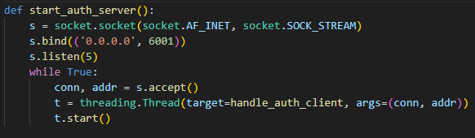
The auth_server creates a handle_auth_client thread that handle each connected client separately.
handle_auth_client()
This function work as the core authentication handler for the whole system. It run in the client-server model where this server act as the authority and every client must talk with it first before allowed to join anything else. Communication use IPv4 with TCP sockets so the data always come stable, not mixed, not out of order. The function read one full message from client, split it with ‘|’, and decide which operation to perform.
Commands that clients use to interact with server:
We introduced some commands so that the whole chat system can talk in one simple language between client and server. These commands are just small text words like SIGNUP, LOGIN, LOGOUT and GET_ONLINE, or a combination of these with ‘|’ sign, and they control the full logic of authentication. All commands travel through TCP over IPv4, so each message reach the server in correct order without mixing.
SIGNUP is used when a new user want to make account in the system. Client send username and password with this command, and server try to store them in the users database. If username already exist, signup break and server send back “0”. If everything is ok, server send “1” and also make entry in online status table.
LOGIN is used when already registered user want to enter the system. Client send username and password, server check inside database if password match exactly. If match is good, server mark that user online and send “1”. If something wrong, server just send “0”. This command also help server track user status so group chat know who is present.
LOGOUT is used when user is leaving the system. Client send username and server update that user as offline inside the online_status table. Time of logout is also saved so admin can see last active moment. Server reply “1” to confirm it receive the request.
GET_ONLINE is used when client want to know which users are currently online. Server search online_status table for all usernames where is_online = 1 and send them back in small text list. This make the chat feel like real system where you can see who is active.
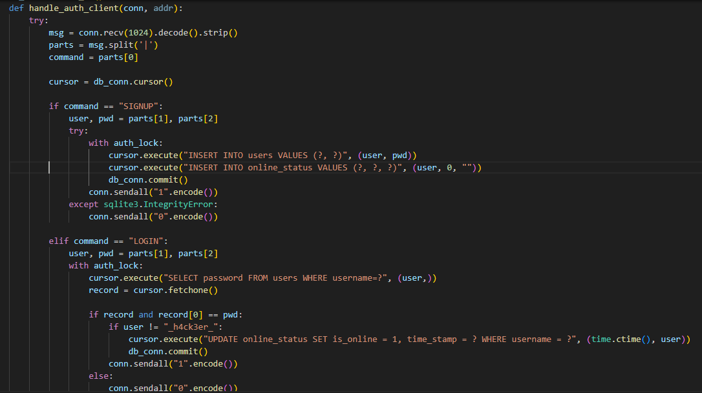

client_soc(client, i, m, stop_event)
This function handle one client inside the group chat. It receive the messages from that client through TCP, which make the whole communication more reliable and less messy. When the server get a message, it print it first and then send the same message to all the other connected sockets. This is like a small broadcast system where server act like a middle-man and share the message to everybody else. If the client send nothing, or send ';', or some error happen, the function just stop, remove that client from the list, and close the connection. This keep the chat from breaking even when someone leave suddenly or behave weird.
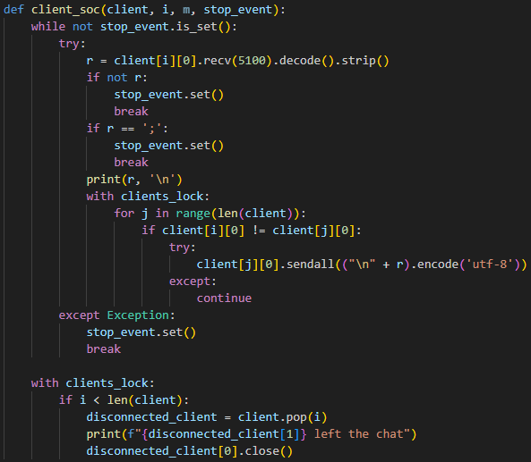

GroupChat()
This function is the main place where the full chat system start working. It launch the authentication server in background and then open the main chat server on port 5000 using IPv4 and TCP again. The whole design is plain client-server model: clients connect to the server, and the server pass messages around. The admin type their name and also decide how many clients can join. When a client arrive, the server accept the socket, read the client’s name and then send back the admin name. After all allowed clients join, the server create one thread per client so messages can move at same time without waiting. The group chat work by a simple cycle:
- client send text → server receive → server forward to other clients.
Everything go through the server like a central hub. This function make the chatting actually happen.

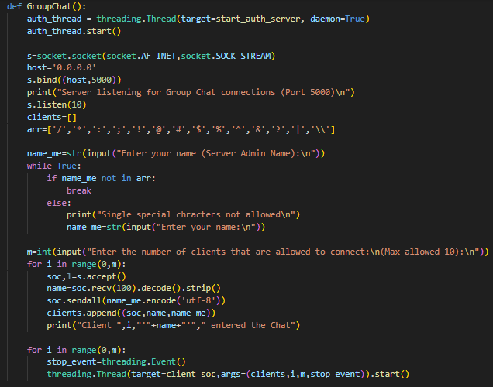

Working Mechanism of Client.py Backend:

We designed the client file to let users connect with server and other peers for chat. It work with TCP/IP (IPv4) and uses threading to let send and receive messages at same time. Client must connect server first for group chat, else it will not work.
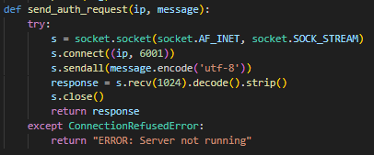
- This function send command message (like SIGNUP, LOGIN, LOGOUT, GET_ONLINE) to authentication server at port 6001.
- It connects to server using TCP socket.
- Sends the message and waits for response.
- Returns server response to caller.
- If server not running, returns error.

- The below function handles login and signup for client.

- Shows menu: Login, Signup, or Back to main menu.
- Login: asks username and password, send `LOGIN|username|password` to server. Server reply "1" if success, "0" if fail.
- Signup: asks new username and password, send `SIGNUP|username|password`. Server reply "1" if success, "0" if already exists.
Back: return None to go main menu.
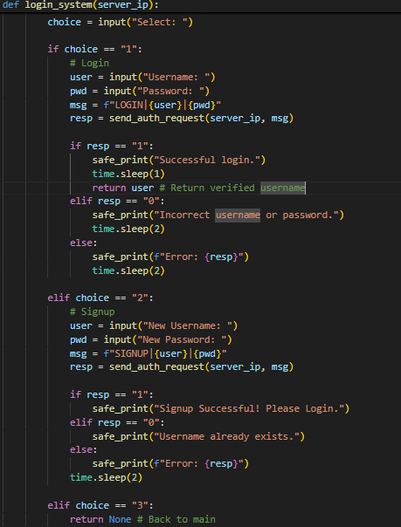

- The below function handles peer-to-peer direct chat.

- Client can choose to host chat or connect to peer.
- Hosting: bind to port 6000, wait for peer to connect.
- Connecting: ask peer IP, connect to port 6000.
- Send and receive messages simultaneously in loop using blocking recv/send.
- Chat ends when either send `;`.

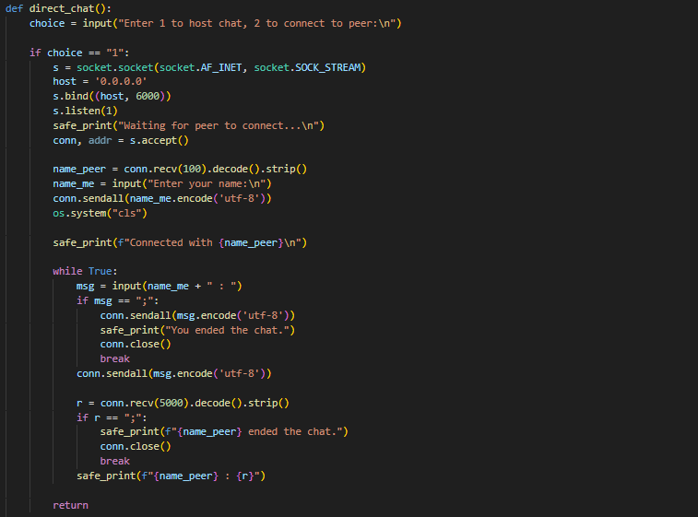
- This function handles group chat via server.

- Connects server at port 5000.
- Sends logged-in username to server.
- Receives admin name from server.
- Starts two threads: one for sending messages, one for receiving messages.
- Messages sent with format `username:message`.
- Chat ends when user sends `;` or server closes connection.

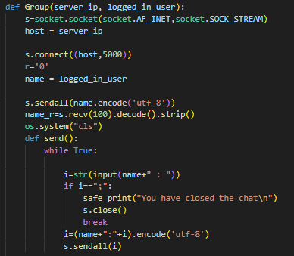

- The below function is the main controller for group chat mode.

- Ask server IP.
- First, calls `login_system()` to login or signup.
- After login, shows dashboard: Join Group Chat, Check Online Users, Logout.
- Join: call `Group()` to start group chat.
- Check Online: sends `GET_ONLINE` to server and prints online users.
- Logout: sends `LOGOUT|username` command to server.
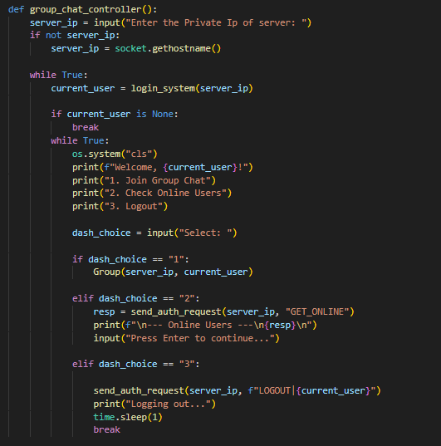

Main menu loop:

- Client can select mode: Direct Chat (peer-to-peer), Group Chat (server), or Exit.
- Direct chat calls `direct_chat()`.
- Group chat calls `group_chat_controller()`.

Features implemented in Client File

- Multi-threading for simultaneous send/receive
- TCP sockets using IPv4
- Peer-to-Peer Networking Model
- Group chat via server
- Signup, login, logout authentication
- Safe printing of messages in multithreaded environment
- Command-based protocol for server interaction (SIGNUP, LOGIN, LOGOUT, GET_ONLINE)
- Graceful chat termination (`;` to end chat)
- Online user checking
- Error handling if server not running

