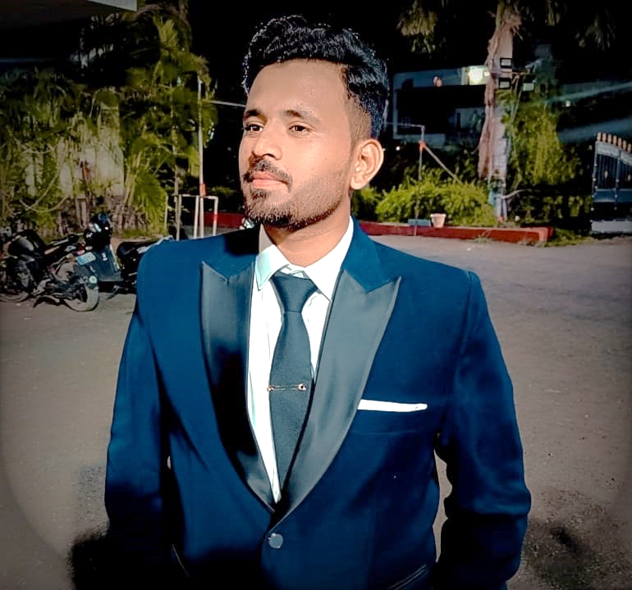

ABDUL RAHEMAN

FRONT END DEVELOPER (REACT JS)

# contact



Degloore Naka, Nanded, Maharashtra.



+919022932268

Abdulraheman71110

@gmail.com



# skills

* WEB TECHNOLOGIES: HTML, CSS, BOOTSTRAP, JAVASCRIPT.
* IDE: visual studio code, REACT JS.

➢ Operating Systems: -

* Windows server 2000,2003,2008.
* Windows, Vista, Win7&Win 8,8.1

# Languages

* ENGLISH
* URDU
* HINDI

# INTERNSHIP

## INTERN

TEKISKY PVT LTD.– Nanded 01/2024 –06/ 2024

* I have done my 3 months course with TEKISKY PVT LTD. & have work on HTML, CSS, JAVASCRIPT, BOOTSTRAP, REACT JS.

## PROJECT

#### TITLE: Global Tours.

##### Language: HTML, CSS & BOOTSTRAP

The main object of this project is to develop a framework using HTML, CSS& BOOTSTRAP. It is website of Tours&Travels Exploring around the world. Project was assigned by TEKISKY PVT LTD. It is complete web template. Website is completed on every possible aspect.

# Profile

Working experience on Visual studio code, HTML, CSS, JAVASCRIPT & REACT JS. Ability to complete work on time & in Challenging environment. I would like to be a part of an organization where I could use and enhance my knowledge and talent for the development of both the organization and myself.

# Education

### B. TECH IN COMPUTER SCIENCE ENGG

MATOSHRI PRATISHTHAN GROUP OF INSTITUTIONS – NANDED **4TH YEAR**

### DIPLOMA IN MECHANICAL ENGG

MATOSHRI PRATISHTHAN GROUP OF INSTITUTIONS – Nanded  **Passed**

### SSC

AL ALIA INTERNATONAL INDIAN SCHOOL

– RIYADH (KSA) **Passed**