403 Work Station

ML Classification

By Abdul Rahman

# Introduction

In this lab your aim is to create a classification convolutional neural network to count the number of workpieces at the sorting station. You are given a dataset that contain pictures of the sorting station with different combinations of work pieces ranging from 0 to 6.

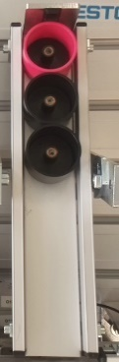

The above is a sample image taken from the dataset that has 3 workpieces in it.

## What’s a neural network?

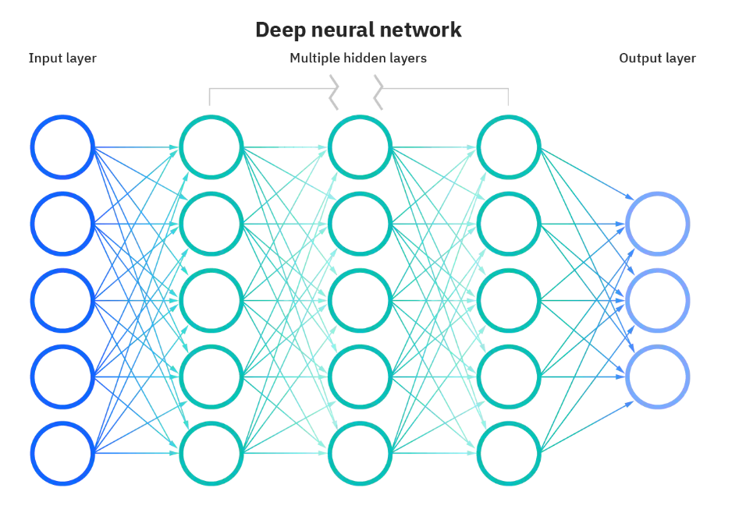

A simple neural network can be graphically explained with the image above. It contains nodes denoted by the circles in the image, layers denoted as vertical groupings of nodes and finally connections between nodes denoted by the arrows. Here the output layer has three nodes. This implies that this network is capable of distinguishing between 3 different output classes.

It does so by taking 5 input values implied by the 5 nodes at the input layer. The values at the input layer get transferred from layer to layer. As it transfers from layer-to-layer, values at the nodes get altered in relation to the numbers contained within the arrows connecting nodes. These numbers are known as weights. When these values reach the output layer, the node with the highest value determines the class (output type) present in the image. If the color image is 100*33 in size this mean we will have 990 nodes at the input layer (990 = 3colorpixels*100*33). Also, because we will be dealing with workpieces ranging in number from 0 to 6 it is required to have 7 nodes at the output layer to represent the 7 possible classes.

When we train a neural network, the main task involved includes the altering of the weights (number contained within arrows) such that output of the network becomes more accurate. Because the weights are initially randomized the output of a neural network tends to be poor at first. However, in training through a step called back propagation the weights get altered incrementally to obtain better results that improve with each step.

Keep in mind that this explanation is extremely simplified and skips over several concepts such as activation functions, gradient descent. However, for the purposes of the lab this explanation provides sufficient intuition about neural networks.

## Why use a convolutional neural network?

A simple explanation alludes to the way humans classify images. When determining the number of workpieces in the image provided above do you think about all the pixel values? Instead, our brain has been adapted at looking for patterns and creating layers of increasing abstraction that when pieced together help us do the task of classification with ease.

Convolutional neural network aims to mimic the process described above by abstracting features (patterns) from the image through the application of filters. Initially this is done at random by using a variety of different filters. However, with training the network learns which filters produce the best features to get output results that tend to be more accurate. You can watch the link below to learn more about neural networks.

<https://www.youtube.com/watch?v=x_VrgWTKkiM>

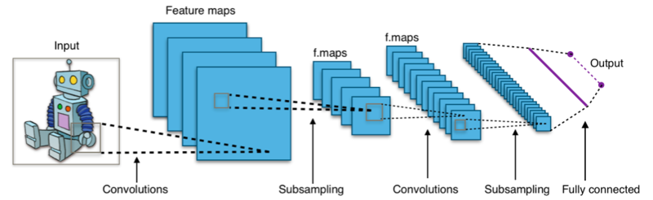

# Step 1: Sorting the data into subfolder

The dataset has 436 different images combined together. So, your first task would be sorting the images into subfolders with each folder denoting the type of images present within. For example, sub-folder “4” should contain only images that have 4 workpieces contained in them. Doing it manually would not be fun.

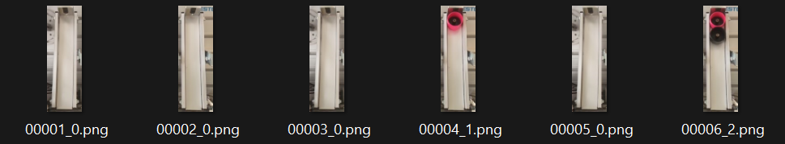

Fortunately for us the filename of the image contains the number of workpieces present within. Examine the last number just before the file extension “.png”. This implies we can leverage a python script to automate this process.

The basic steps involve:

* Creation of subfolders based on classes present.
* Creating list of filenames from the source folder.
* Using if statements to determine the class present in a filename
* Copying the identified file from source to its corresponding subfolder

A python module called “datafolder.py” contains a module detailed out with comments and docstrings that has carried out the steps mentioned above.

If you plan on using this module, use the code below:

import datafolder as df

mkfldr=df.datafolder('rawdata',['0','1','2','3','4','5','6'])

mkfldr.generate()

After creating the folder with all images contained within its corresponding folder make sure to compress it.

# Step 2: Training a convolutional neural network

For training we will use google colab. The motivation for using google colab is the availability of google’s cloud gpu to significantly speed up training time. In addition, google colab has all the packages we will be using preinstalled, only requiring us to import the packages needed.

Upload the “baseline_model.ipynb” into google colab.

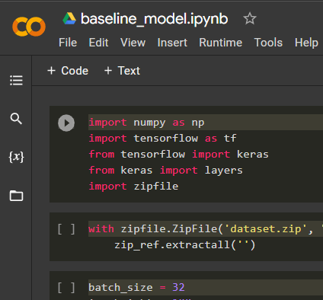 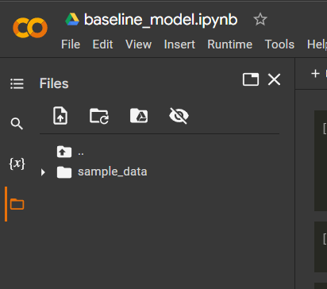

Click on the file icon shown on the left image above, the files tab should open. Then drag the compressed dataset folder made eaelier into the space shown in the image on the right.

Proceed to run the rest of the code till the end. You can read the text and comments to gain an understanding of what the code does. Finally, make sure to download the “model.tflite” found in the files tab onto your computer. This file contains the trained model that we will be using with the raspberry pi.

# Step 3: Implementation with Raspberry Pi

Here we utilize open cv which is a library aimed at real-time computer vision. The implementation stage can be broadly grouped into the following stages:

* Extracting images from the Raspberry Pi’s camera.
* Feeding the image to the model.
* Utilizing the output of the model to display the class present.

Find the “camera.py” python script that explains these stages in greater detail.

**Special Note:**

This part of the lab is not finished. Find ‘trail.py’, this python script shows that the ‘model.tflite’ made in step two works when we feed it a static image from dataset. So run this script first to ensure the model/neural network is able to run on the pi.

The ‘camera.py’ python script is an incomplete code that utilizes open cv to extract images of the raspberry pi’s camera. Because we have two sorting stations the code aims at extracting two images that then feeds the image to the model. I have run a version of this script without the model and know the images are extracted properly. However, I did not get the chance to pass the live image to the model. This latter point is that task that it left to do.

Common errors that may occur are:

* File paths present in code may not reflect the file paths on your computer.
* Certain libraries utilized in the code may not be installed or maybe out of date in your computer. A quick google search will let you know not to install the libraries with the “pip” command.