


Project Report

Email Spam Filter
Artificial Intelligence Lab
CSC-413

Email Spam Filter

Semester | : Fall 2025
Program | : BSSE
Course Title and Name | : Artificial intelligence Lab
Faculty | : Engr. Sahifa Hashmi
Project Members | : Abdul Rauf (20231-35052)  Aamir Ali (20231-35053)  Alikarim Ashraf (20231-34974)
Total Marks | :
Obtained Marks | :
Submitted Date | :18/12/2025

.

TABLE OF CONTENTS
1. Abstract ……………………………………………………………………............................................................. 1
2. Introduction …………………………………………………………………......................................................... 2
3. Objective ................................................................................................................................... 3
4. Dataset Description .................................................................................................................. 4
5. System Methodology ............................................................................................................... 5
5.1 Data Loading ....................................................................................................................... 6
5.2 Text Preprocessing & Tokenization .................................................................................... 7
5.3 Feature Extraction .............................................................................................................. 8
5.4 Model Training & Testing ................................................................................................... 9
6. Implementation Overview ..................................................................................................... 10
7. Evaluation and Results ........................................................................................................... 11
8. Accuracy Comparison and Class Distribution …………………………………………………………............ 12
9. Strengths and Limitations ...................................................................................................... 13
10. Future Enhancements .......................................................................................................... 14
11. Conclusion ............................................................................................................................ 15

1. Abstract
This project develops a spam email filtering system using Natural Language Processing (NLP) and the Naive Bayes classifier. It processes emails from the Enron dataset and classifies messages into ham (legitimate) and spam (unsolicited/malicious) categories.
The system leverages tokenization, feature extraction, and probabilistic modeling to distinguish between spam and ham. The classifier demonstrates high training accuracy (95–97%) and strong test performance (~82–90%). This project also includes interactive classification for new emails and provides insights into the most informative features influencing classification.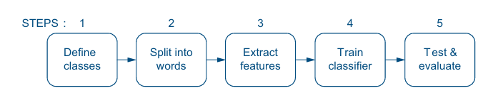

2. Introduction
Email remains a primary communication medium in professional, academic, and personal contexts. However, it is frequently exploited for spam, phishing, and malicious campaigns, which leads to productivity loss, cybersecurity risks, and information overload.
Traditional filtering methods (manual or rule-based) are inefficient and inflexible. Machine Learning and NLP provide robust, scalable, and adaptive solutions. By analyzing text patterns and probabilistic word distributions, spam filters can automatically detect unwanted messages.
This project implements a Naive Bayes-based classifier, demonstrating the practical application of statistical learning in email spam detection.

3. Objective
The objectives of this project are:
- Load and preprocess email datasets for NLP processing.
- Tokenize email text into meaningful words.
- Extract features suitable for machine learning.
- Train a Naive Bayes classifier and evaluate its performance.
- Provide user-interactive email classification.
- Analyze the most informative features differentiating spam and ham.

4. Dataset Description
The Enron Email Dataset is used, consisting of real corporate emails categorized as ham or spam.
- Ham: Legitimate business correspondence, project updates, and personal messages.
- Spam: Promotional, lottery, investment, or malicious emails.
Folders used:
enron1/ham/
enron1/spam/
Each folder contains thousands of emails, enabling supervised learning.

5. System Methodology
The spam filter implements a standard NLP and machine learning pipeline:

5.1 Data Loading
- Files are read using Python’s os module and opened with codecs.open() to handle different text encodings.
- Hidden files (starting with “.”) are skipped.
- Each email is stored in a list for further processing.

5.2 Text Preprocessing & Tokenization
- Emails are converted to lowercase.
- Tokenization splits text into words using NLTK’s word_tokenize().
- Handles punctuation, contractions, and special characters.
Example:
Input: "What's the best way to split a sentence?"
Output: ["What", "'s", "the", "best", "way", "to", "split", "a", "sentence", "?"]

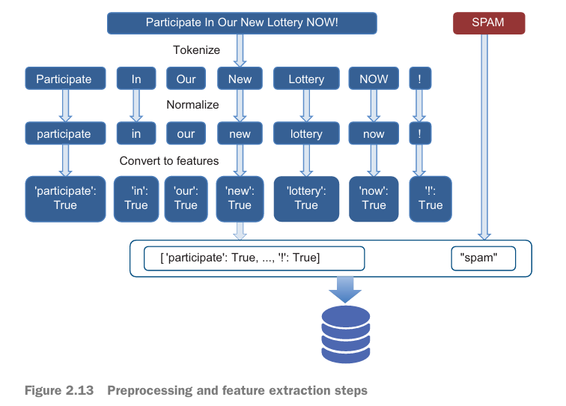

5.3 Feature Extraction
- A Bag-of-Words model is applied: each word is represented as a binary feature indicating presence.
- Example feature dictionary:
{
"lottery": True,
"meeting": True,
"offer": True
}
- Features are paired with labels (spam/ham) for supervised learning.

5.4 Model Training & Testing
- Dataset is shuffled and split: 80% training, 20% testing.
- Naive Bayes classifier calculates conditional probabilities of words given each class:
P(word | spam), P(word | ham)
- New emails are classified by combining word probabilities.
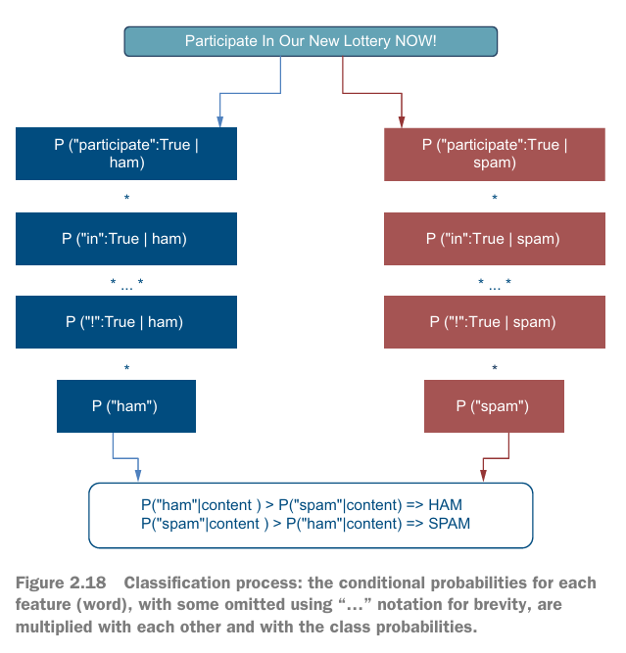

6. Implementation Overview
Tools & Libraries:
Tool/Module | Purpose
Python 3 | Programming language
NLTK | Tokenization, Naive Bayes classifier
os | File system operations
codecs | Encoding-safe file reading
random | Dataset shuffling
Matplotlib 3.8 | Performance metrics visualization
Workflow Steps:
- Load emails and store in lists.
- Tokenize text into words.
- Convert emails to feature dictionaries.
- Shuffle and split dataset.
- Train Naive Bayes classifier.
- Evaluate classifier.
- Interactive email input classification.
Figure suggestion: NLP pipeline diagram from email input to spam/ham output.
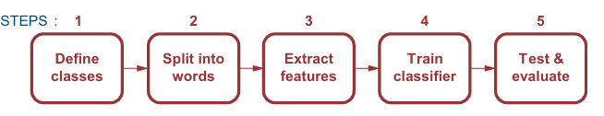

7. Evaluation and Results
Performance Metrics:
- Training accuracy: 95–97%
- Testing accuracy: 82–90%
Informative Features:
- Spam: “lottery”, “offer”, “win”, “click”
- Ham: “meeting”, “project”, “report”, “attachment”
Concordance Analysis:
- Words like “stocks” appear differently in spam vs ham.
- Model identifies key tokens responsible for classification decisions.
8.Accuracy Comparison and Class Distribution
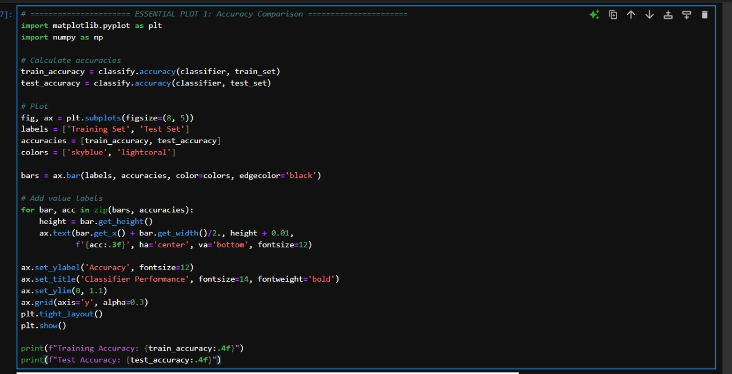
Output:
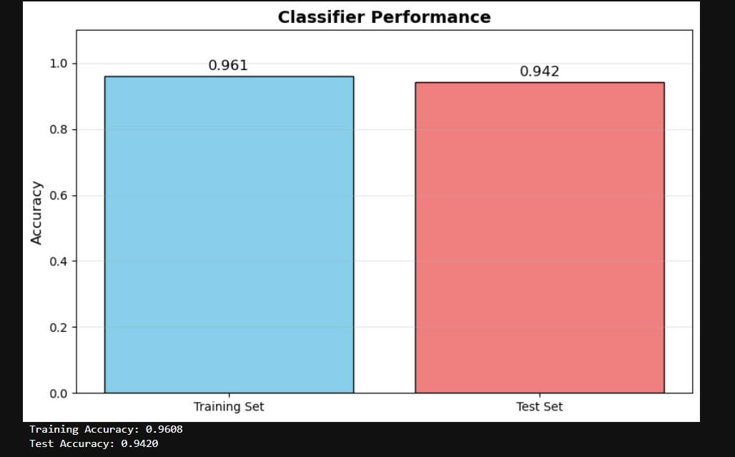

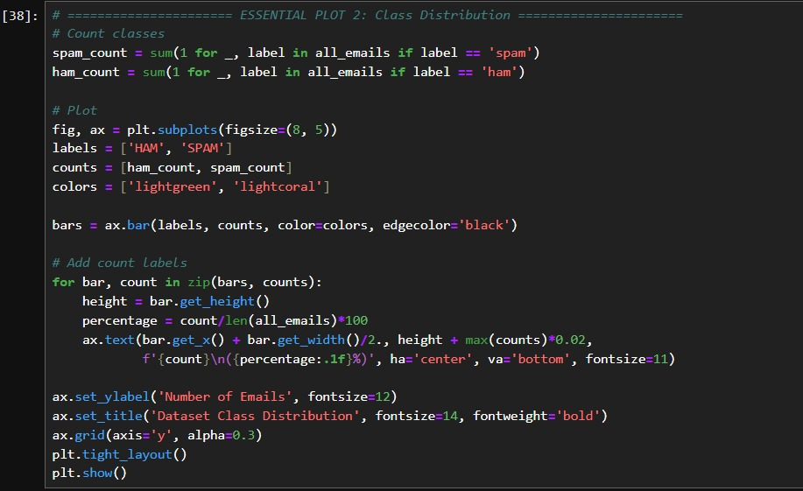

Output:

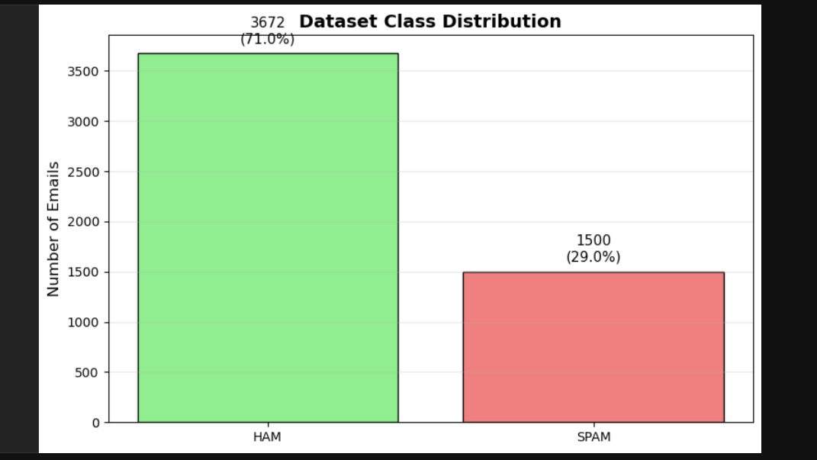

9. Strengths and Limitations
Strengths:
- Lightweight and fast
- Interpretable features
- Scalable to large datasets
- Robust for baseline spam detection
Limitations:
- Bag-of-Words ignores context and word order
- No TF-IDF weighting
- No stopword removal
- Limited handling of modern phishing and HTML emails

10. Future Enhancements
- Apply TF-IDF and stopword removal
- Incorporate n-grams for context
- Use deep learning models (LSTM, BERT)
- Parse HTML, links, and attachments
- Incremental learning for continuous model updates
- Integration with email clients for real-time filtering

11. Conclusion
The project demonstrates a functional NLP-based spam email filter. Naive Bayes, despite simplicity, provides high accuracy and interpretable results.
This project can be extended with advanced NLP techniques and deep learning to improve robustness against modern spam attacks.

