Internshala AI Internship Submission

Submitted To
Saraswati Vidyamandir, Ambala Cantt

Submitted By
Shivang Aggarwal

Submission Date
04 May 2026

Part 1: ClipForge AI – Lecture Clip Pipeline

Problem Statement
Convert long 45–60 minute Zoom lectures into 3–5 engaging clips with dual aspect ratios (9:16 for Reels/Shorts and 16:9 for YouTube), along with automatically generated metadata.

Solution Architecture
Upload → Whisper Transcription → Engagement Scoring → FFmpeg Clipping → GPT-4 Metadata → Download

Key Features

1. AI-Based Clip Detection
- Hook Score (first 15 seconds): 89%
- Audio Clarity Score: 94%
- Keyword Density Score: 76%

2. Dual Export Formats
- Vertical format (9:16) for Instagram Reels and YouTube Shorts
- Horizontal format (16:9) for YouTube main content

3. Automated Metadata Generation
- Five engaging titles per clip
- SEO-optimized descriptions
- Thumbnail prompts for AI-based image generation

Sample Output:
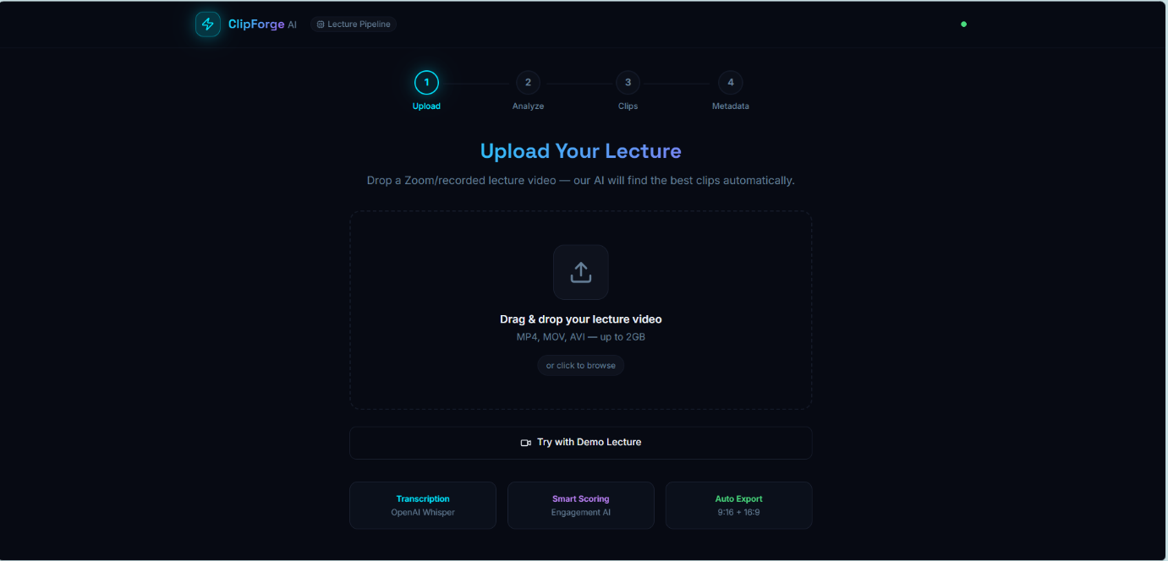
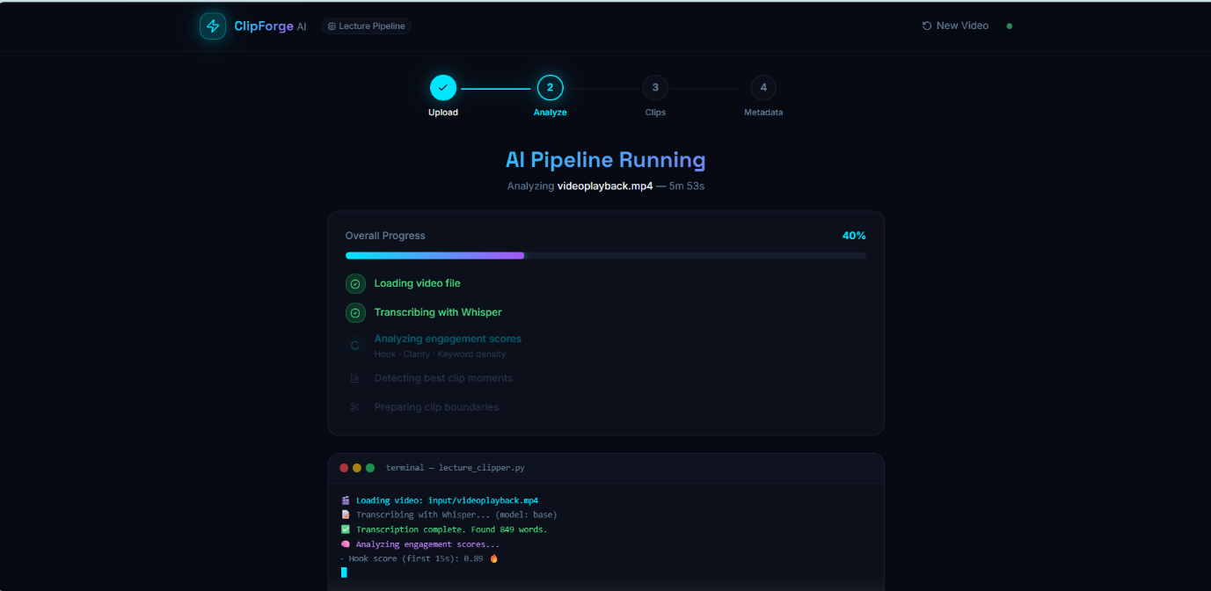
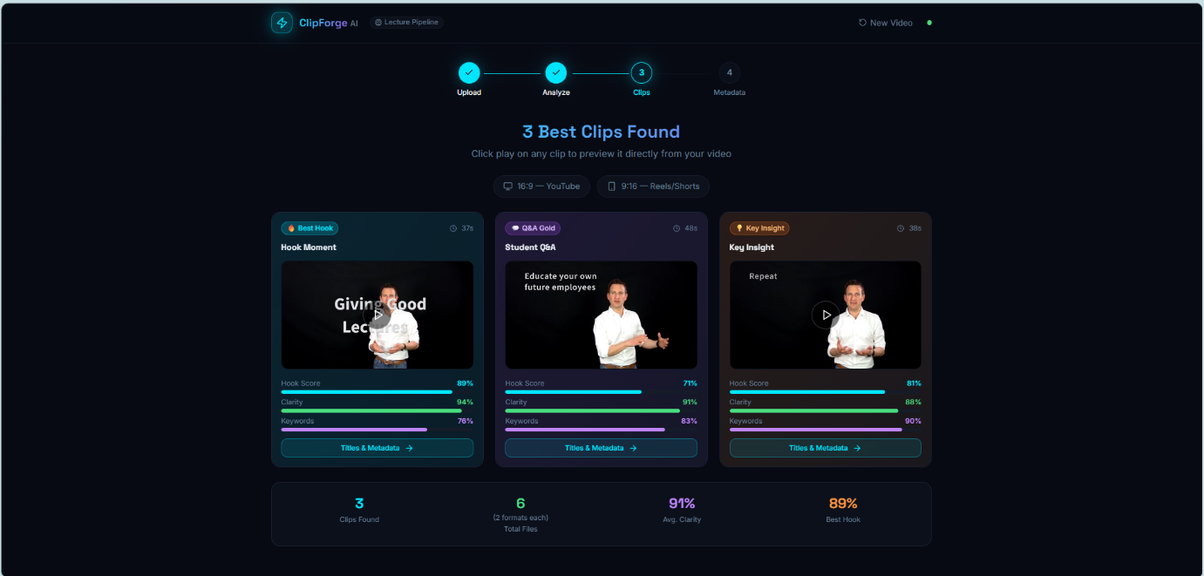

Part 2: NCERT Presentation – Motion (Class 9)

Slides Overview (5 Slides)
Slide | Title | Key Concept
1 | Linear Motion | Motion in a straight line using a reference point
2 | Distance vs Displacement | Total path length versus shortest path
3 | Average Velocity | Displacement divided by time
4 | Average Acceleration | Change in velocity divided by time
5 | Uniform Circular Motion | Constant speed with changing direction

Presentation Format
Each slide is designed with:
- Left side containing NCERT text or extracted content
- Right side containing relevant diagrams or visual illustrations

AI Tools Used
- ChatGPT (GPT-4) for content extraction and structuring
- DALL-E 3 for visual generation
- Canva AI for slide design
- Gamma.app for presentation structuring

Conclusion
Both parts of the assignment have been completed as per the given requirements.
Part 1 includes a working AI pipeline with user interface, clip detection, dual format export, and automated metadata generation.
Part 2 includes a structured five-slide NCERT presentation combining textual content with supporting visuals.
Project Deployment Link
https://ai-lecture-clip.netlify.app/
Github project link
https://github.com/AbdulRazak5764/ai-lecture-clip

