ONLINE EXAM CHEATING RISK PREDICTOR

A Cognitive–Behavioral Probability-Based Proctoring Framework

1. ABSTRACT
Online examinations have become an essential component of modern education systems, enabling remote learning and large-scale assessments. However, ensuring fairness and preventing cheating in such environments remains a major challenge due to the absence of physical invigilation.
Existing proctoring systems rely on webcam monitoring and rule-based detection, which are often intrusive, privacy-invasive, and incapable of detecting intelligent cheating behaviors.
This project proposes an AI-based Cheating Risk Predictor that evaluates student behavior and outputs a continuous cheating risk probability (0–100%) instead of binary decisions.
The system integrates computer vision, behavioral biometrics, and interaction analysis to identify anomalies. The solution emphasizes ethical AI, privacy preservation, and human-in-the-loop decision-making.

2. INTRODUCTION
The rapid growth of online education platforms has transformed traditional examination systems into digital formats. While this provides flexibility and accessibility, it also introduces challenges in maintaining academic integrity.
Students may use unfair means such as:
- Using external devices
- Getting external help
- Switching screens
- Impersonation
Traditional proctoring systems fail to detect subtle behavioral cheating patterns. Therefore, there is a need for an intelligent system that understands behavior instead of relying on rigid rules.

3. PROBLEM STATEMENT

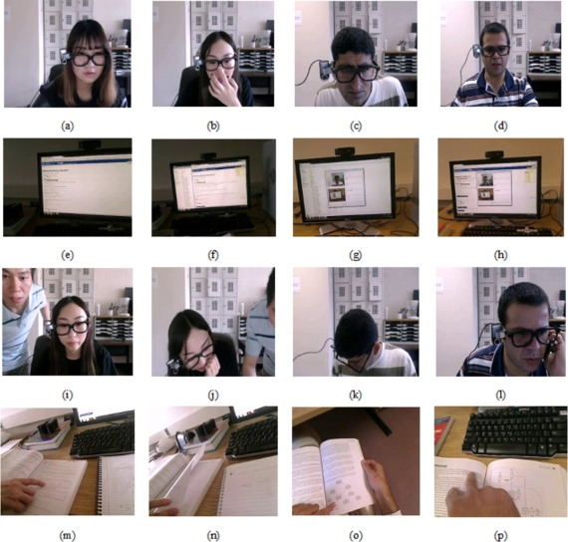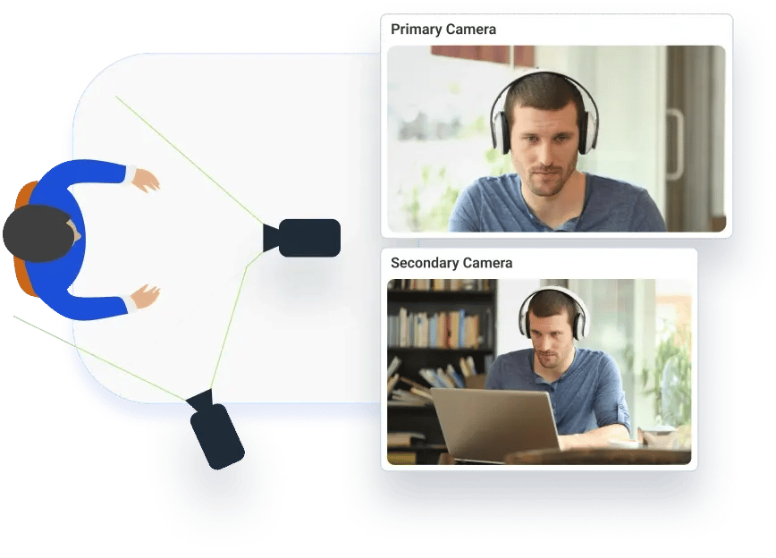

Existing systems suffer from:
- Binary decision-making (Cheating / Not Cheating)
- High false positive rates
- Lack of behavioral intelligence
- Privacy concerns due to continuous surveillance

Core Problem
Design a system that predicts cheating probability using behavioral patterns.

4. OBJECTIVES
- Extract behavioral data from webcam and user interaction
- Detect anomalies in gaze, posture, and typing
- Estimate cognitive behavior patterns
- Generate cheating risk score (0–100%)
- Reduce false accusations
- Ensure ethical and privacy-aware monitoring

5. LITERATURE REVIEW
Research shows that:
- Rule-based systems are limited
- Computer vision detects only physical cheating
- ML models lack explainability
- No system predicts cheating probability
👉 Research Gap:
No intelligent system combines behavioral analysis + probability scoring

6. PROPOSED SYSTEM

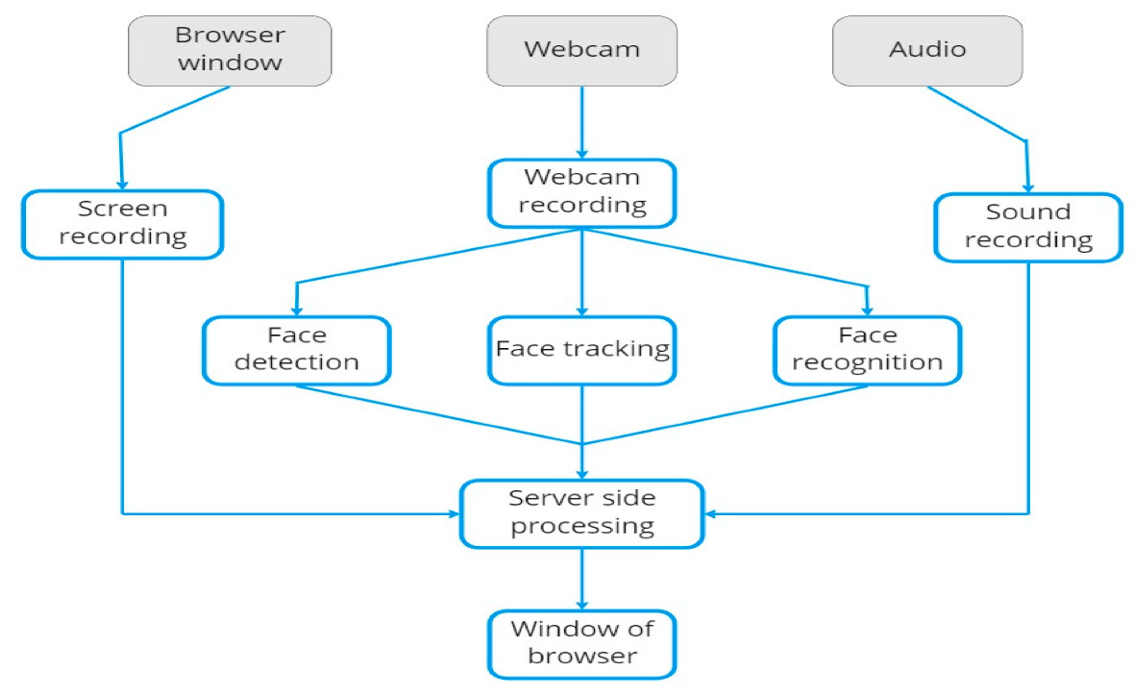

We propose a system that:
- Tracks real-time behavior
- Extracts features
- Analyzes patterns
- Outputs cheating risk score
👉 Example Output:
Risk = 72% (Moderate Risk)

7. SYSTEM ARCHITECTURE
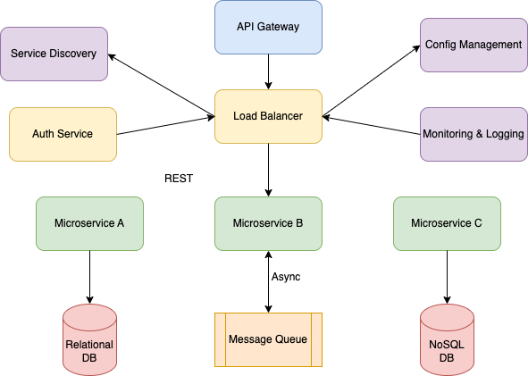

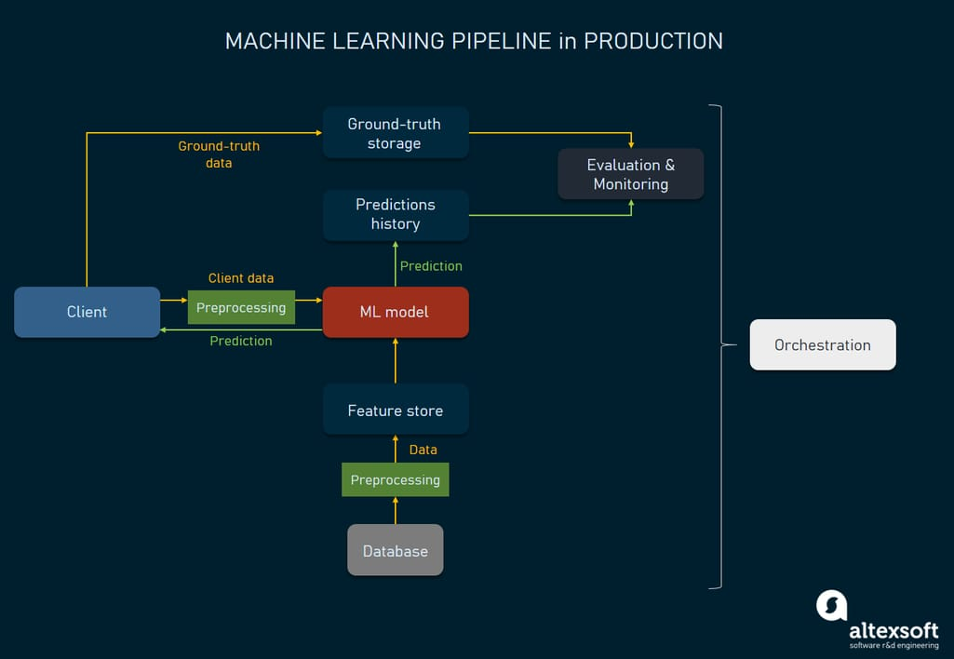

Flow:
Webcam + Keyboard + Mouse
↓
Feature Extraction
↓
Behavior Analysis
↓
Risk Prediction
↓
Dashboard

8. MODULES DESCRIPTION

8.1 Data Acquisition
- Webcam video capture
- Keyboard logging
- Mouse tracking



8.2 Feature Extraction
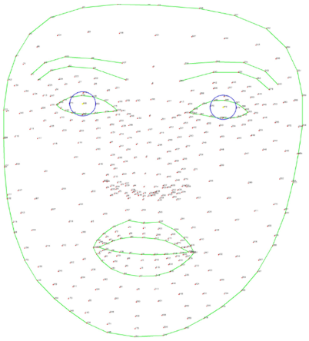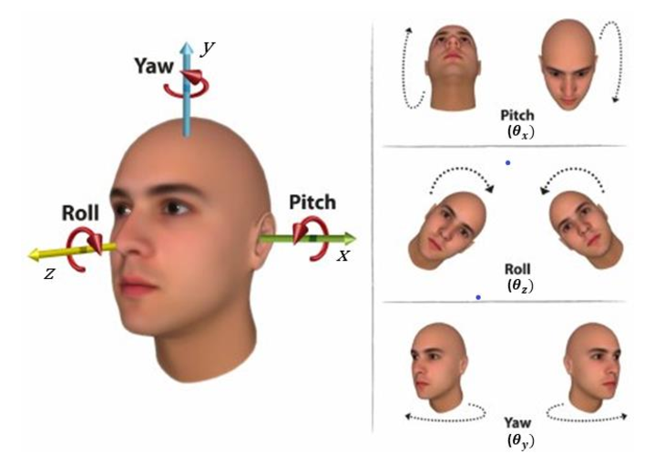

- Face detection
- Head pose estimation
- Eye gaze tracking
- Typing speed
- Mouse idle time

8.3 Behavioral Analysis
- Detect anomalies
- Identify unusual patterns

8.4 Risk Prediction
- Weighted scoring model
- Output: 0–100%

8.5 Dashboard
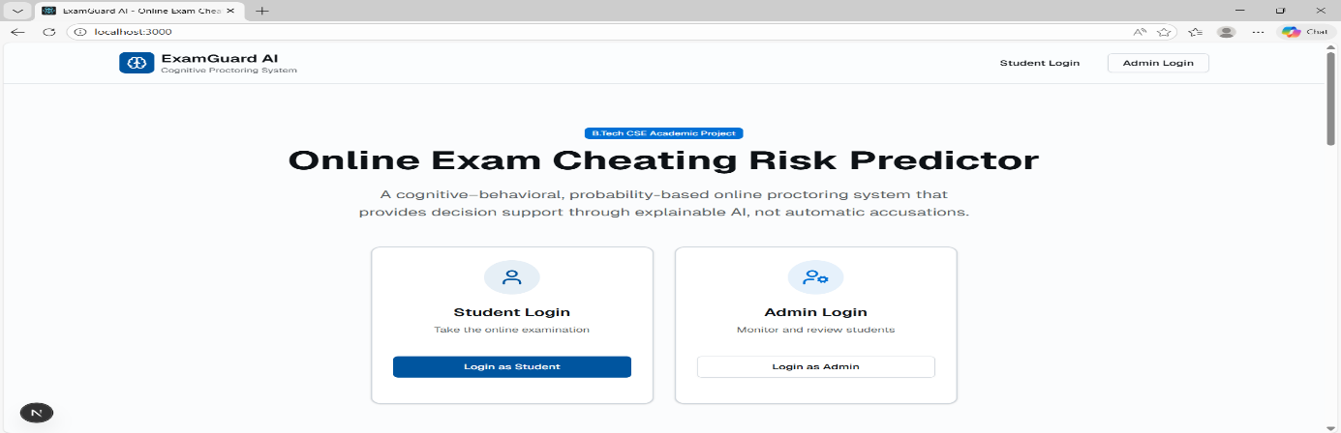

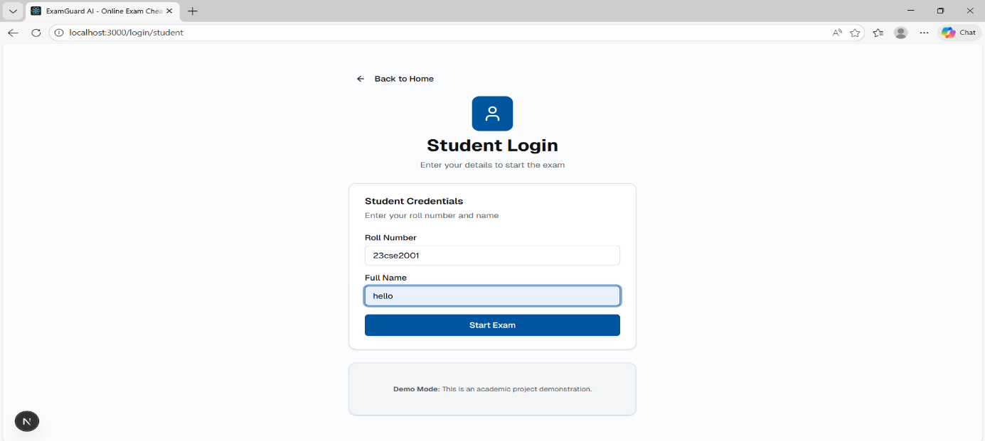
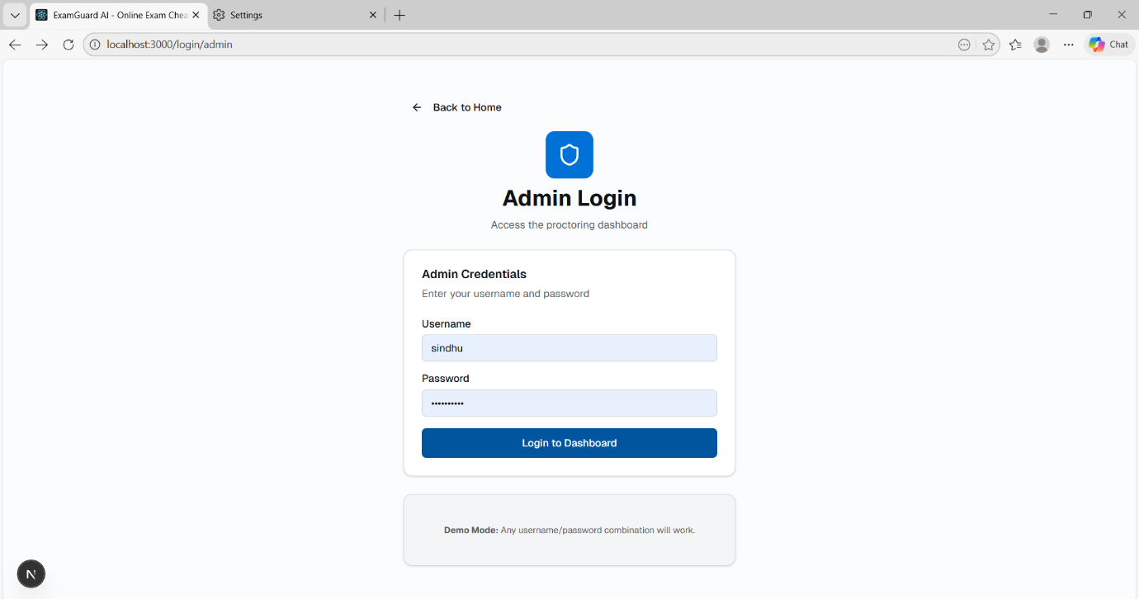
Displays:
- Risk score
- Alerts
- Logs

9. TECHNOLOGIES USED

Category | Tools
Programming | Python
Computer Vision | OpenCV, MediaPipe
ML | TensorFlow / PyTorch
Backend | Flask
Frontend | HTML/CSS
Database | MongoDB

10. IMPLEMENTATION

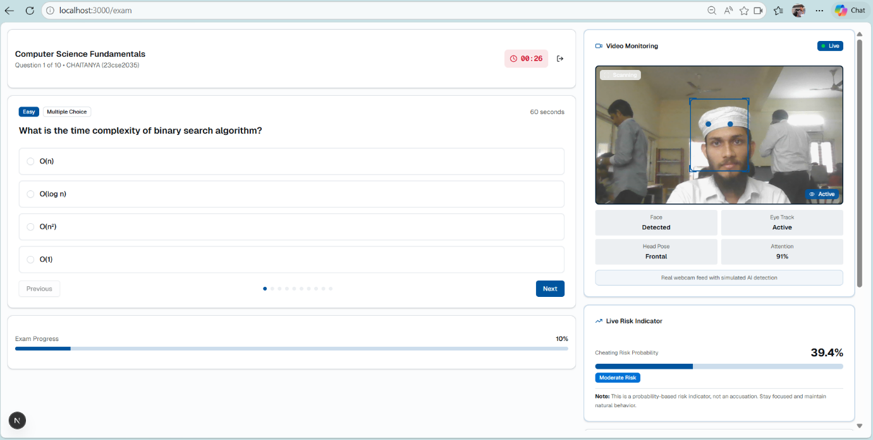

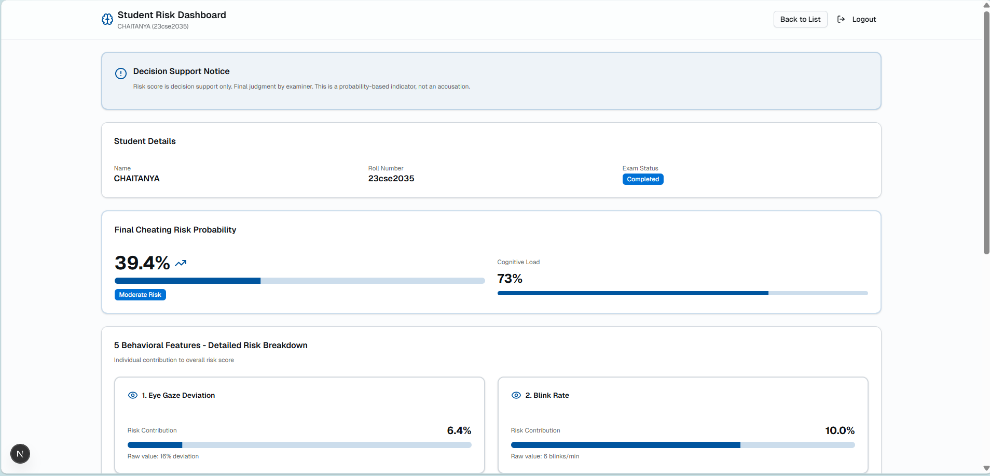

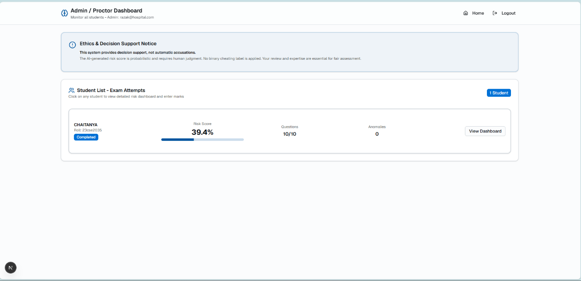
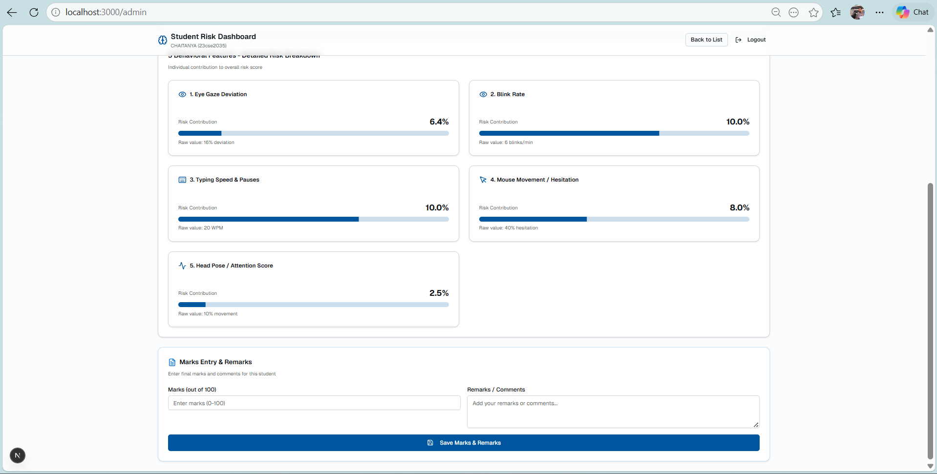

11. RISK SCORING MODEL
Risk Score =
(Behavior × 40%)
+ (Performance × 25%)
+ (Environment × 20%)
+ (Interaction × 15%)

12. RESULTS
- Real-time behavior tracking achieved
- Risk score successfully generated
- System detects abnormal patterns
- Low latency (~1–2 sec)

13. ADVANTAGES
- Real-time monitoring
- Accurate prediction
- Low false positives
- Ethical design
- Scalable

14. LIMITATIONS
- Requires webcam
- Sensitive to lighting
- Limited dataset

15. FUTURE SCOPE
- Advanced ML models (LSTM)
- Cloud deployment
- Higher accuracy
- Integration with LMS

16. CONCLUSION
This project presents a next-generation AI-based proctoring system that predicts cheating risk using behavioral intelligence.
It improves fairness, reduces false accusations, and provides an ethical alternative to traditional surveillance systems.

