SLIDE-7

1.ARCHITECTURE DIAGRAM

Architecture Concept
Vehicle Sensors / Telematics
↓
Data Ingestion Layer
↓
AI / ML Models
(Failure Prediction,
Service Forecasting)
↓
Master Agent
(Orchestration + UEBA)
↓
┌────────┬─────────┬──────────┐
│ Data │ Voice │ Scheduling│
│ Agent │ Agent │ Agent │
└────────┴─────────┴──────────┘
↓
Customer Interface
(Voice Bot + Web Dashboard)
↓
Service Center System
↓
Manufacturing Feedback
(RCA / CAPA Insights)
UEBA Security Layer → wraps Master + Worker Agents

ARCHITECTURE DIAGRAM IMAGE
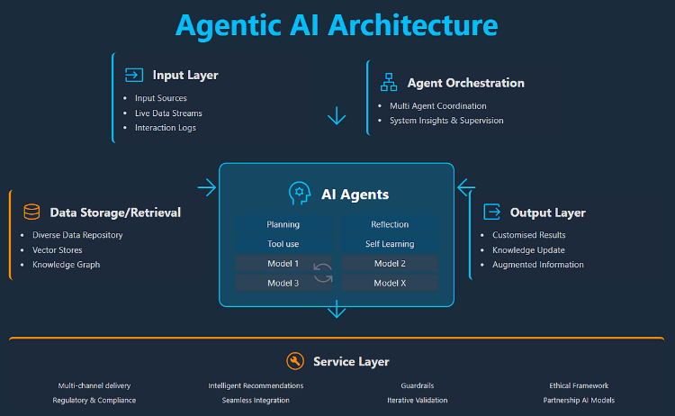
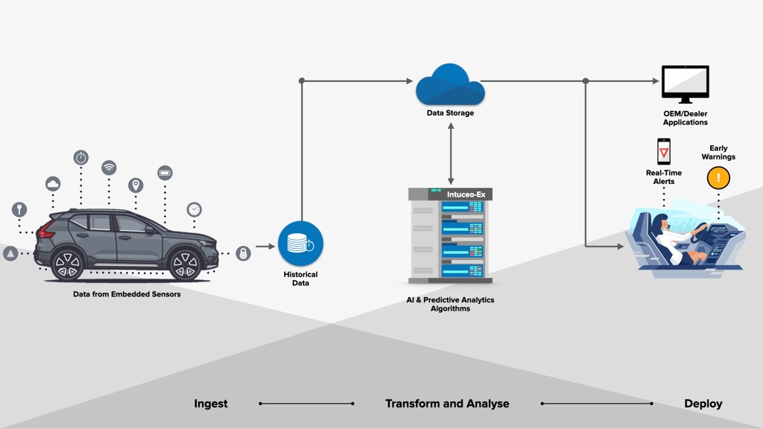
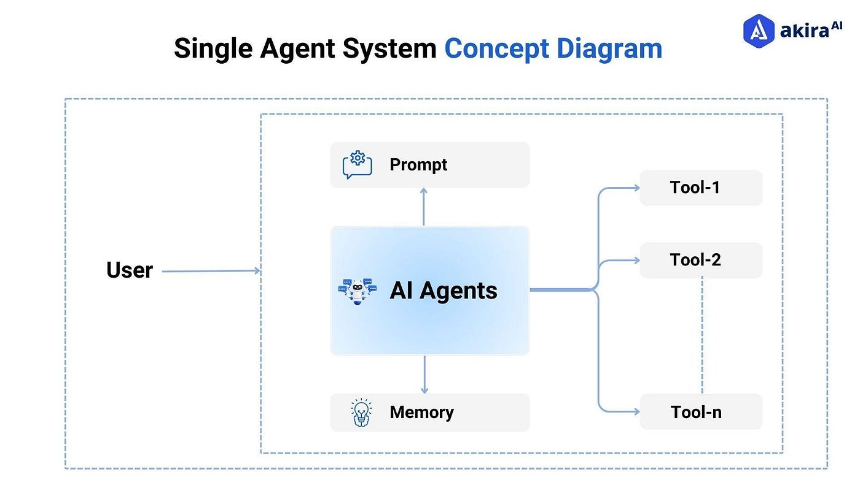
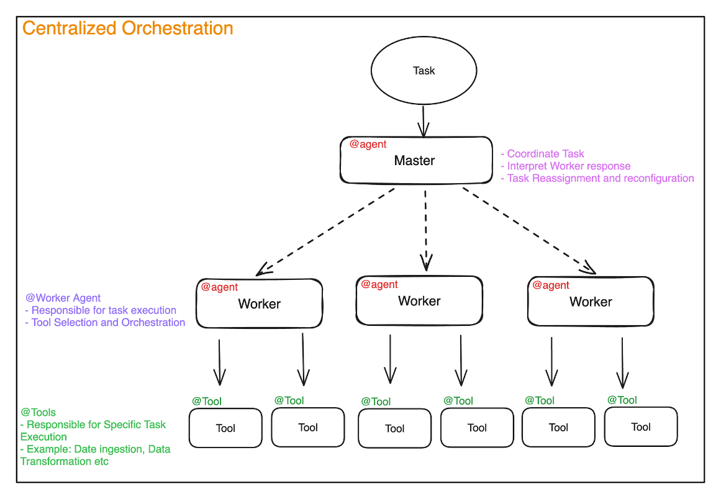
The architecture shows an Agentic AI system where a Master Agent orchestrates multiple Worker Agents for predictive maintenance, customer engagement, service scheduling, and manufacturing feedback, secured by UEBA.

