2.Flow Chart Logic
Vehicle Sensors / Telematics Data
↓
Real-time Data Collection
↓
AI Failure Prediction Model
↓
Master Agent Decision Engine
↓
Is Failure Likely?
↓ Yes ↓ No
Diagnosis & Priority Continue Monitoring
↓
Voice-based AI Agent
(Customer Notification)
↓
Customer Confirms Service?
↓ Yes ↓ No
Auto Service Scheduling Reminder / Re-alert
↓
Service Center Execution
↓
Post-Service Feedback
↓
RCA / CAPA Analysis
↓
Manufacturing Quality Improvement

FLOW CHART IMAGE
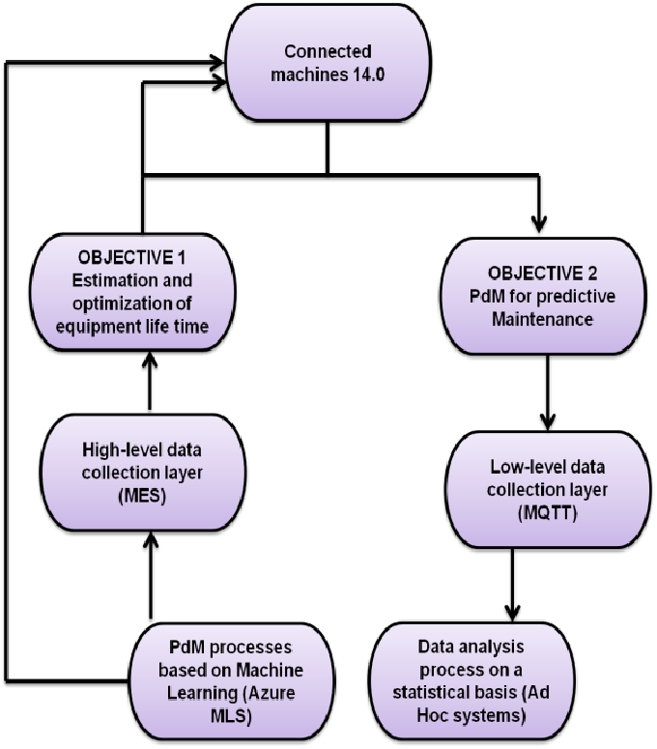
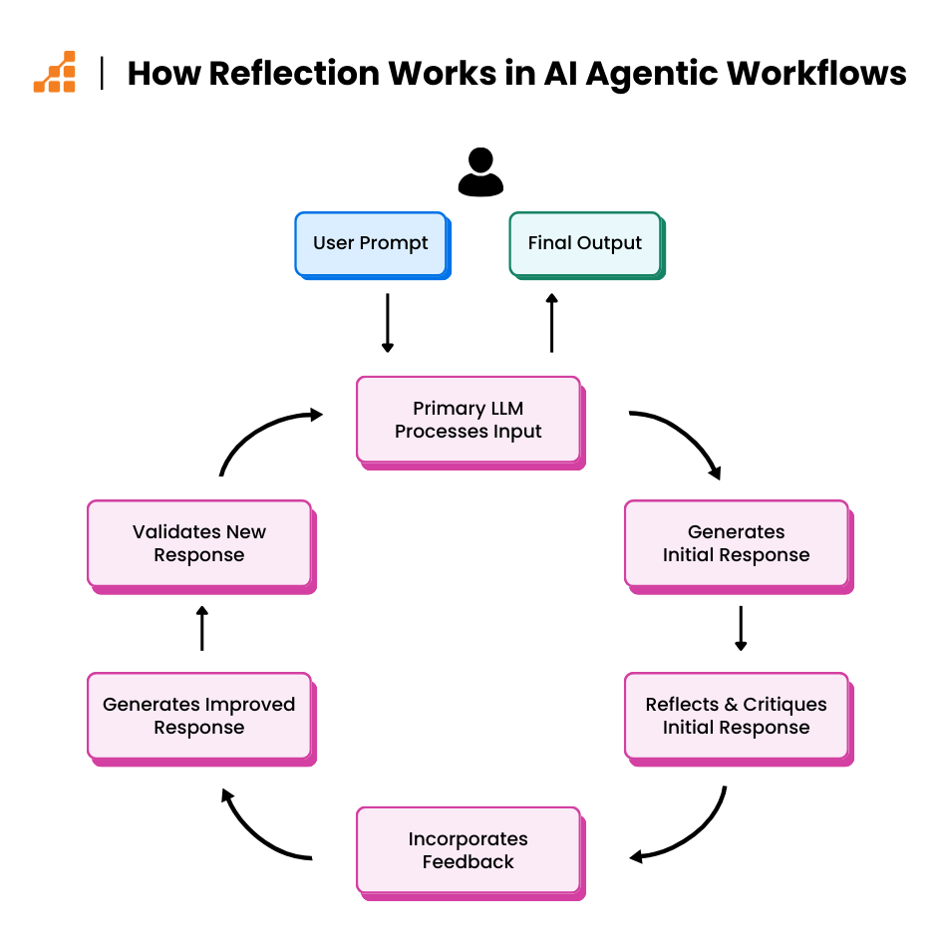
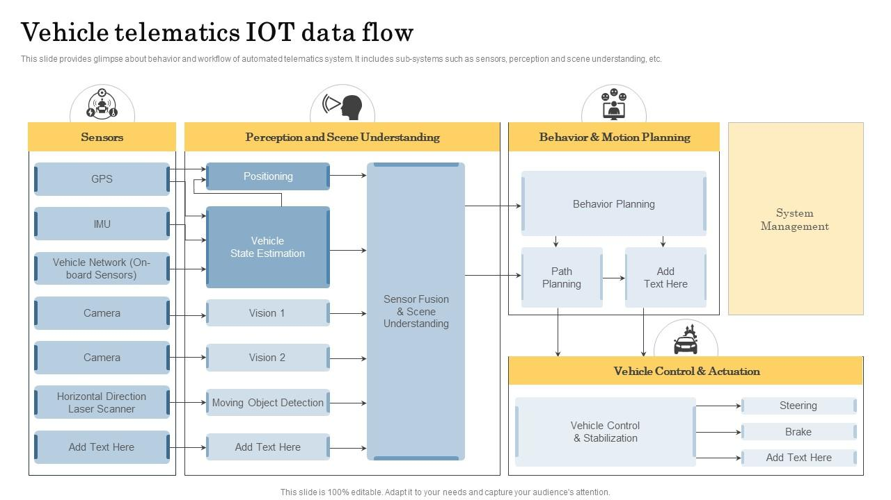
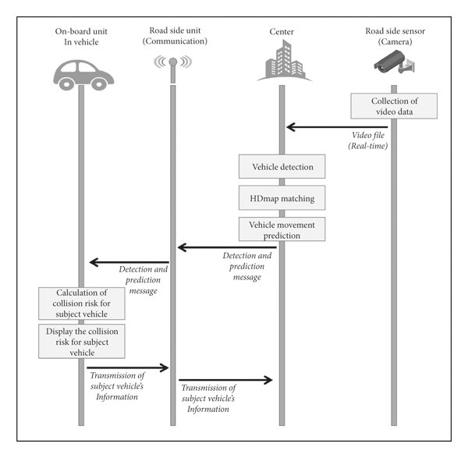

Short Slide Description
This flow illustrates how vehicle data is analyzed by Agentic AI to predict failures, engage customers, schedule service, and feed insights back to manufacturing.

