Graphical Representation
Charts to Include :

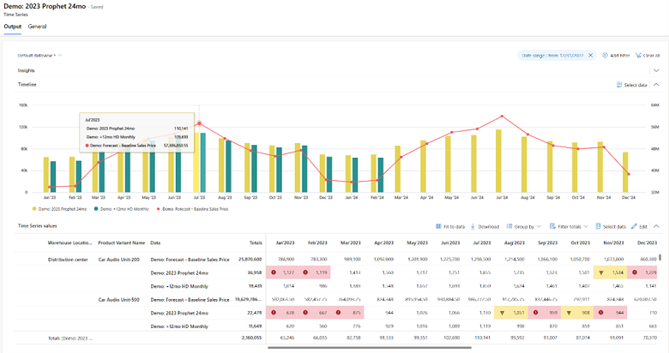

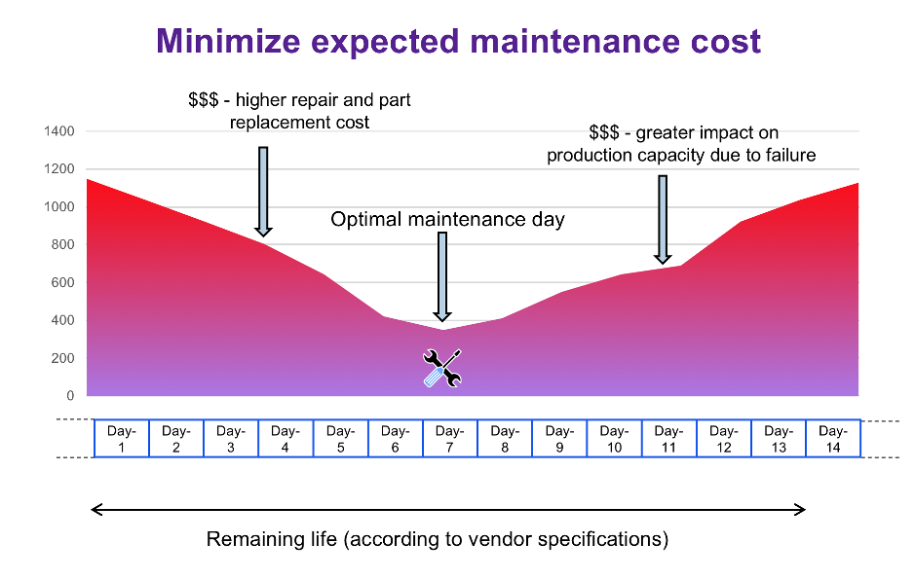

Chart 1: Breakdown Reduction (Bar Chart)
X-axis: Before AI | After AI
Y-axis: Number of breakdowns
Shows:
- Predictive maintenance reduces unexpected failures
Chart 2: Service Demand Forecast (Line Chart)
X-axis: Time (Weeks / Months)
Y-axis: Number of service requests
Shows:
- AI helps forecast service load
- Better service center planning

Chart 3 (Optional): Customer Satisfaction
Before vs After AI (Bar / Pie chart)
Shows:
- Improved customer experience due to proactive service
These charts highlight reduced breakdowns, optimized service demand, and improved customer satisfaction enabled by Agentic AI.

