### **✅ Jenkins Job Explanation: Assignment02**

You've successfully configured and run a Jenkins job named **Assignment02** to automate building a Maven-based Java project from your GitHub repository. Here's a breakdown of each step based on the screenshots:

### **🔁 STEP 1: Create a New Job in Jenkins**

1. Navigate to Jenkins dashboard.
2. Click on **“New Item”**.
3. Enter the name: Assignment02.
4. Select **“Freestyle project”** and click **OK**.

### **🔧 STEP 2: Configure GitHub Repository (Source Code Management)**

Location: Configure > Source Code Management

1. Select Git.
2. In Repository URL, enter: <https://github.com/AbdulRehaman082493/mahalogin.git>
3. 3.Leave Credentials as - none - (because it’s a public repo).
4. In Branches to build, enter:

*/master

This means Jenkins will track the master branch.

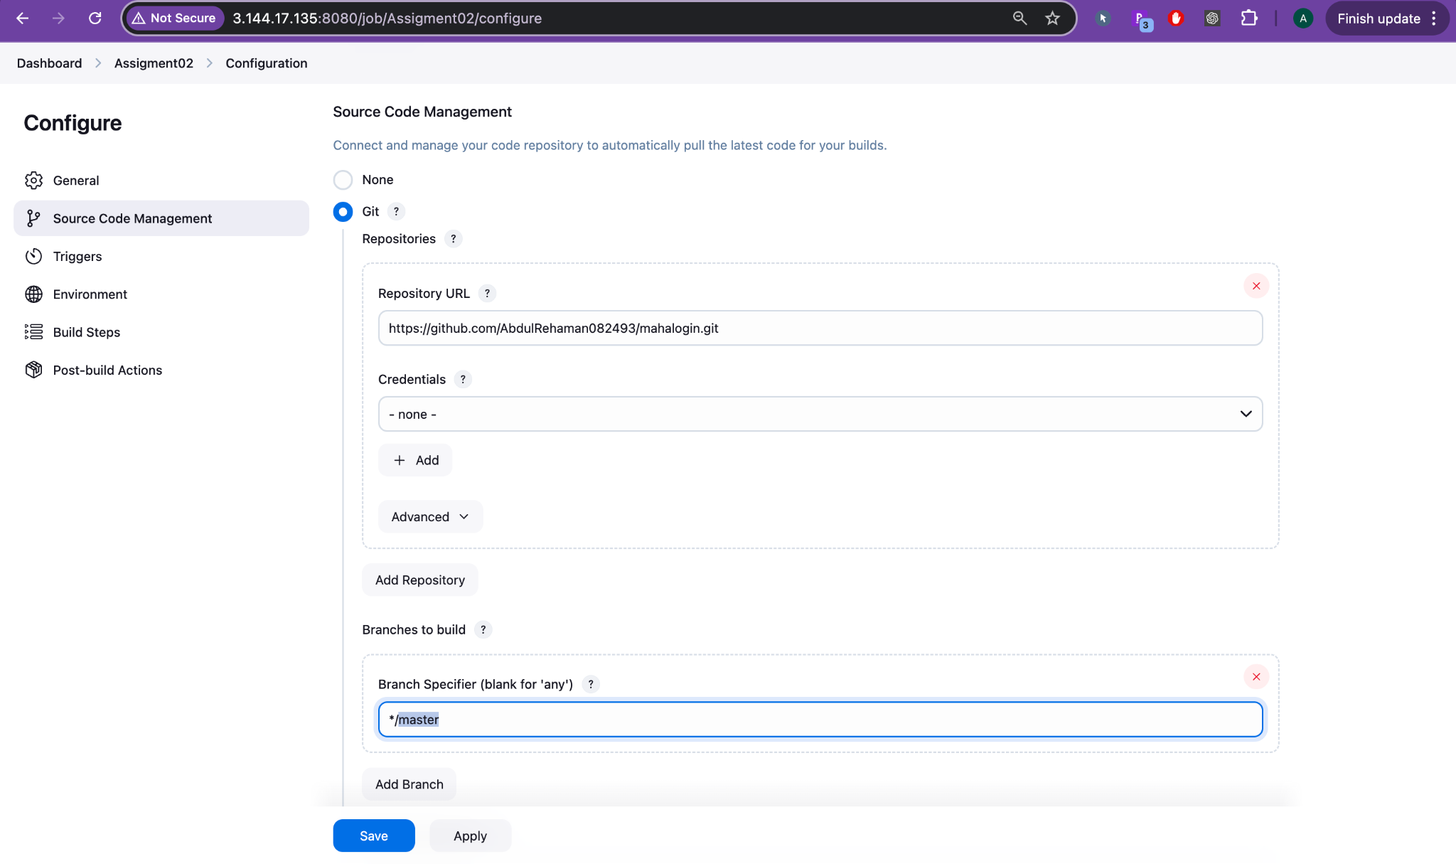

### **⚙️ STEP 3: Add Build Step Using Maven**

Location: Configure > Build Steps

1. Click Add build step → Invoke top-level Maven targets.
2. In Goals, type:

clean install

This command:

* Deletes the target/ folder.
* Compiles the project.
* Runs tests.
* Packages and installs the .war file locally.

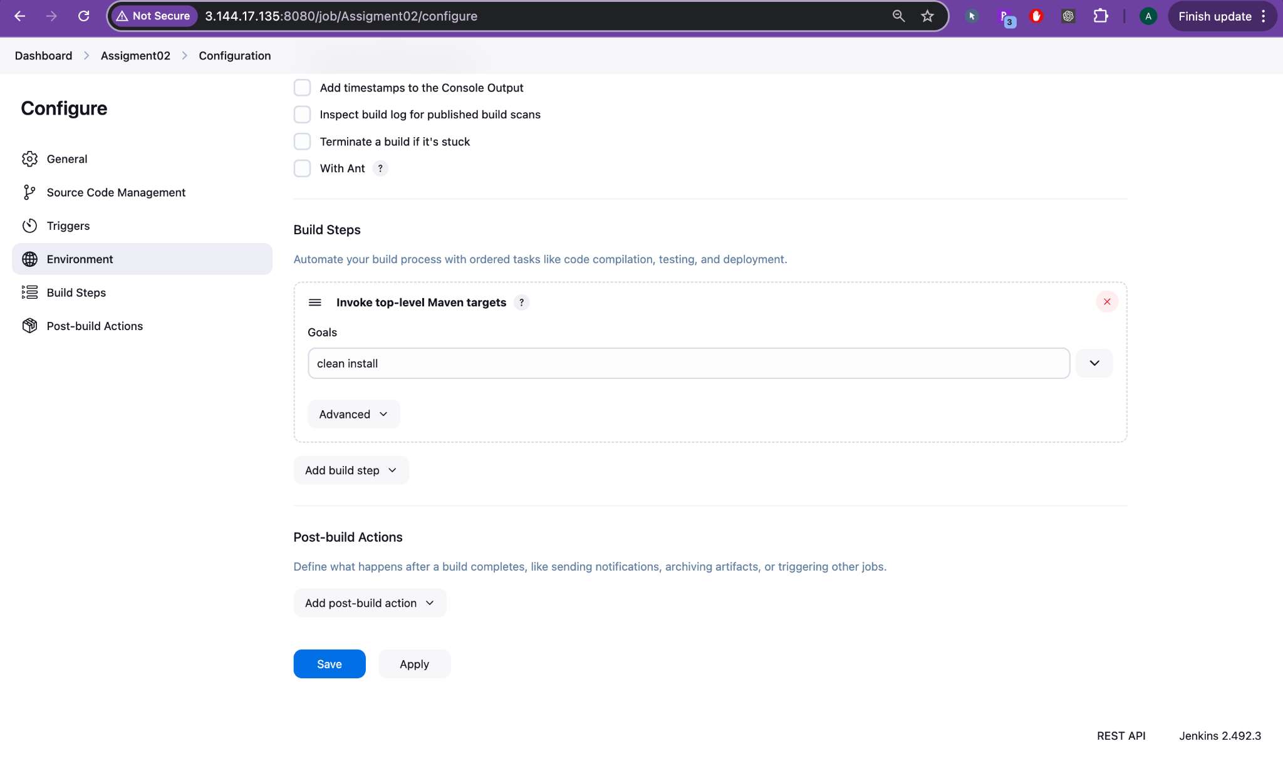

### **🧪 STEP 4: (Optional) Add Post-Build Actions**

You can add email notifications, artifact archiving, deployment steps, etc.

1. Click **Add post-build action**.
2. Choose what fits your pipeline (not configured in your current setup).

### 

### **💾 STEP 5: Save and Run the Job**

1. Click **Save**.
2. On the job page, click **Build Now**.

### 

### **📋 STEP 6: Review the Console Output**

**Location:** Assignment02 > #1 > Console Output

* This shows Maven downloading dependencies, compiling code, and creating the .war file:

Installing /var/lib/jenkins/workspace/Assignment02/target/mahaLogin-2.0.war

BUILD SUCCESS

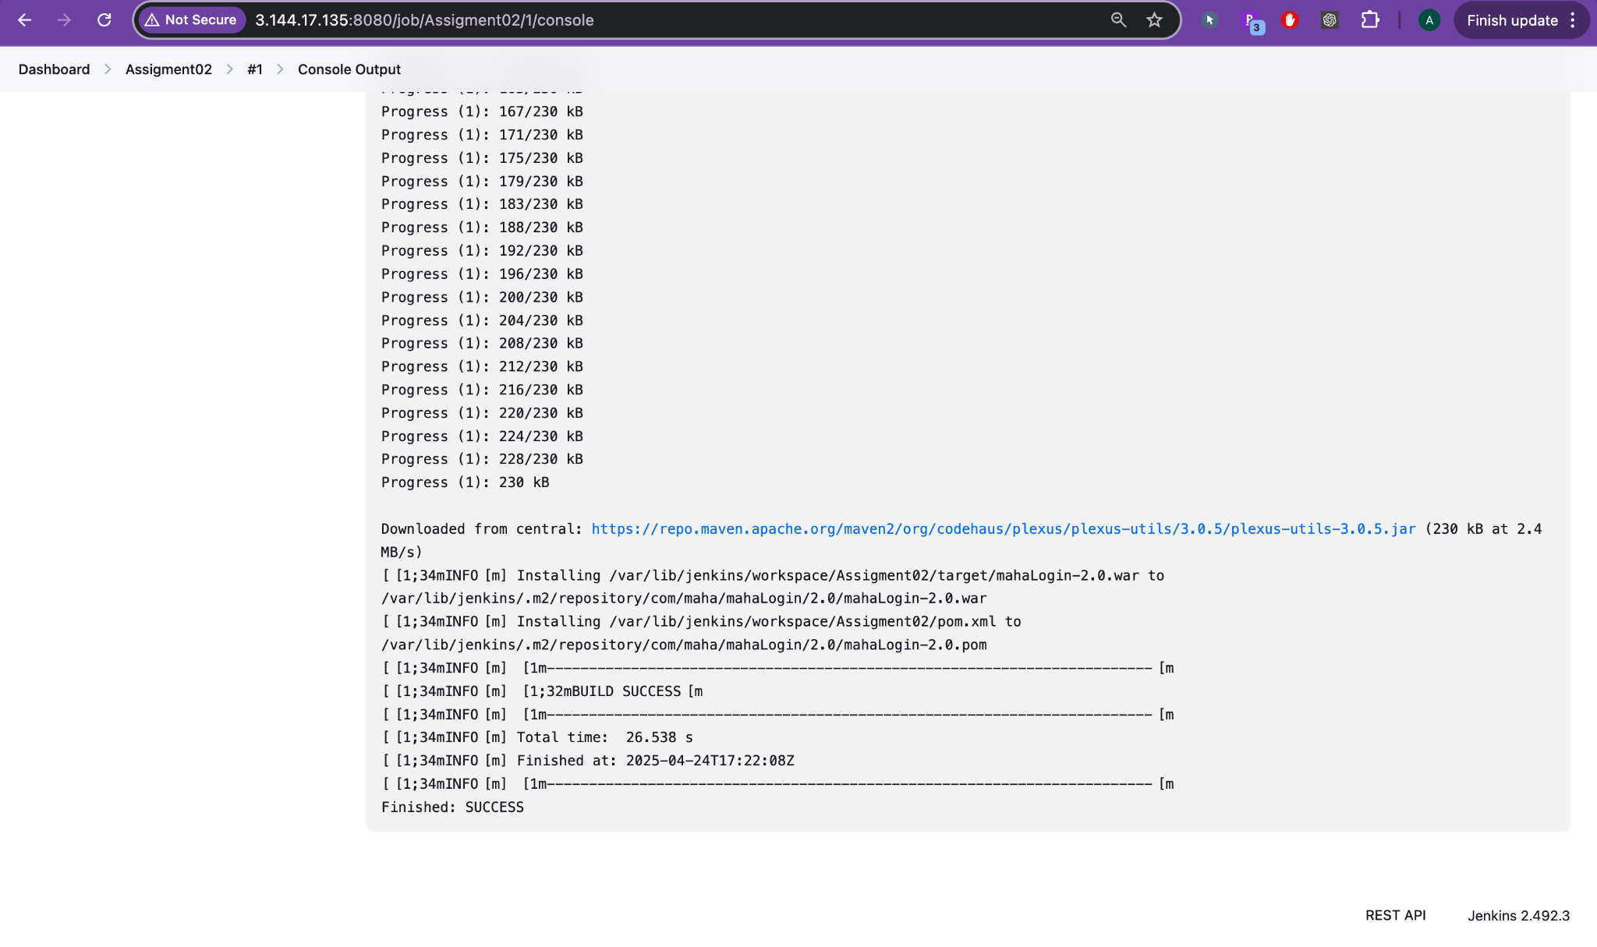

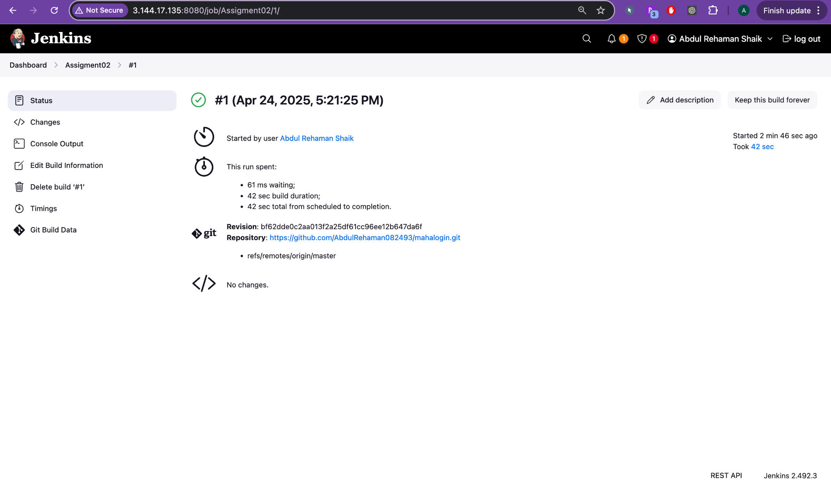

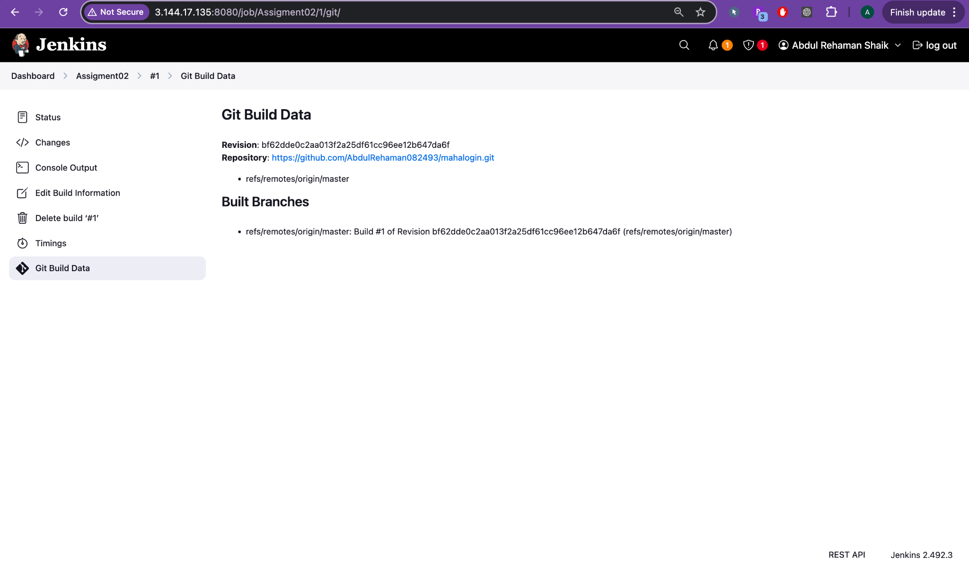

### **🧾 STEP 7: Verify Build Summary**

**Location:** Assignment02 > #1

* Shows:  
  + Who triggered the build (You)
  + Build time and duration
  + Git branch: refs/remotes/origin/master
  + Commit ID used for the build

### 

### 

### 

### **🧠 Summary**

| **Section** | **Details** |
| --- | --- |
| **Source** | GitHub - master branch |
| **Build Tool** | Maven (clean install) |
| **Output** | .war file in Jenkins workspace target directory |
| **Status** | ✅ SUCCESS |