Documentation

### **Step 1: Launch EC2 Instance**

1. Go to the [EC2 Dashboard](https://console.aws.amazon.com/ec2).
2. Click **"Launch Instance"**.
3. Set instance details:  
   * **Name**: e.g., Jenkins-Ubuntu
   * **AMI**: Ubuntu 24.04 (as shown in your screenshot)
   * **Instance Type**: t2.micro (free tier)
4. Under **Key Pair**:  
   * Select an existing key pair or create a new one.
5. Under **Network settings** → Click **Edit**:  
   * **Allow SSH (port 22)** from your IP
   * **Add Custom Rule**:  
     + Type: Custom TCP
     + Port Range: 8080
     + Source: Anywhere (or custom IP)
6. **Storage**: Leave as default (8 GiB)
7. Click **"Launch Instance"**

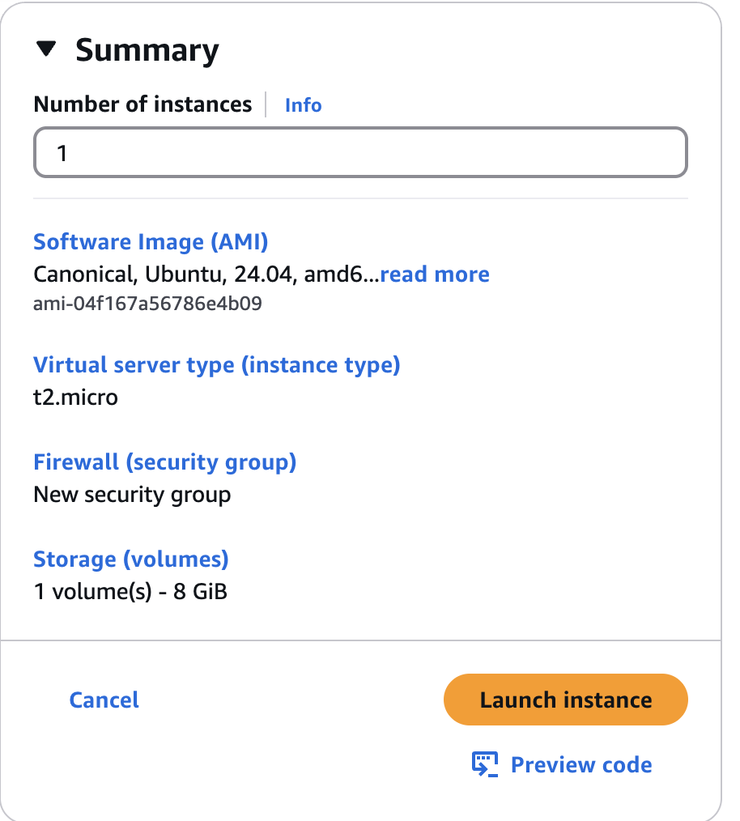

### 

### **Step 2: Connect to EC2 via SSH**

chmod 400 your-key.pem # Give secure permissions

ssh -i your-key.pem ubuntu@<EC2_Public_IP>

Replace your-key.pem with your key file and <EC2_Public_IP> with your instance’s public IP from AWS.

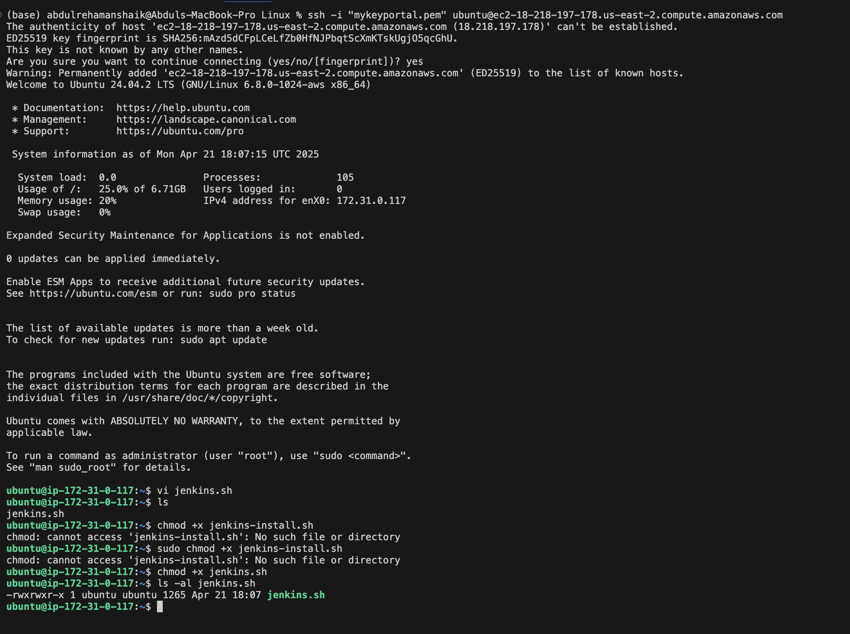

### **Step 3: Create Jenkins Install Script**

1.Create a new script file:  
  
 vi jenkins-install.sh

2. Press i to enter **insert mode**, paste the full script you provided.

3.Save and exit:  
  
 Press Esc

Type :wq and press Enter

### **Step 4: Make the Script Executable**

chmod +x jenkins-install.sh

### **Step 5: Run the Script**

./jenkins-install.sh

This script will:

* Install OpenJDK 17
* Install Maven and tree (optional)
* Add Jenkins GPG key and repository
* Install Jenkins
* Configure UFW firewall to allow ports 22 and 8080
* Enable and start Jenkins service

#!/bin/bash

echo "🔄 Updating package list..."

sudo apt update -y

echo "📦 Installing OpenJDK 17..."

sudo apt install openjdk-17-jdk -y

echo "📦 Installing Maven (optional)..."

sudo apt install maven -y

echo "📦 Installing 'tree' utility (optional)..."

sudo apt install tree -y

echo "🔑 Adding Jenkins repository key..."

sudo mkdir -p /usr/share/keyrings

curl -fsSL https://pkg.jenkins.io/debian-stable/jenkins.io-2023.key | sudo tee /usr/share/keyrings/jenkins-keyring.asc > /dev/null

echo "📦 Adding Jenkins source list..."

echo "deb [signed-by=/usr/share/keyrings/jenkins-keyring.asc] https://pkg.jenkins.io/debian-stable binary/" | sudo tee /etc/apt/sources.list.d/jenkins.list > /dev/null

echo "🔄 Updating package list again..."

sudo apt update -y

echo "📦 Installing Jenkins..."

sudo apt install jenkins -y

echo "🚀 Starting and enabling Jenkins service..."

sudo systemctl start jenkins

sudo systemctl enable jenkins

echo "🛡️ Configuring UFW firewall rules..."

sudo ufw allow 8080

sudo ufw allow OpenSSH

sudo ufw --force enable

echo "✅ Jenkins installation complete!"

echo "🌐 Access Jenkins at: http://<your-server-ip>:8080"

echo "🔐 Initial Admin Password:"

sudo cat /var/lib/jenkins/secrets/initialAdminPassword

### **Step 6: Get Jenkins Initial Admin Password**

sudo cat /var/lib/jenkins/secrets/initialAdminPassword

Copy this password.

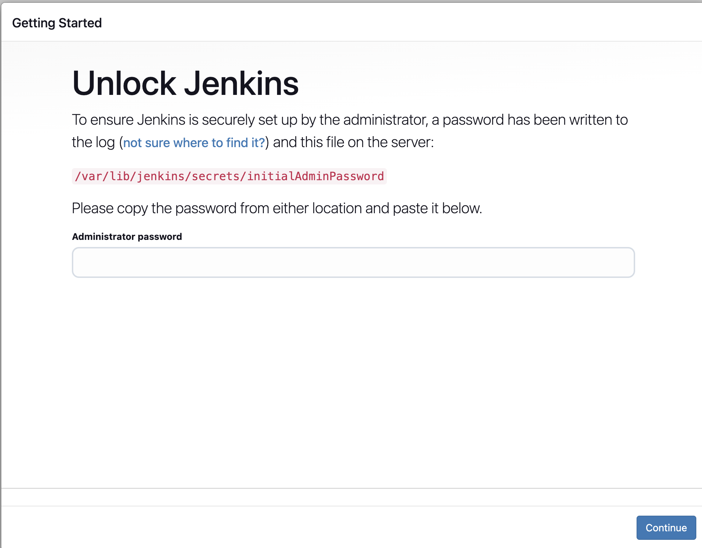

### **Step 7: Access Jenkins Web Interface**

Open your browser and go to:

http://<EC2_Public_IP>:8080

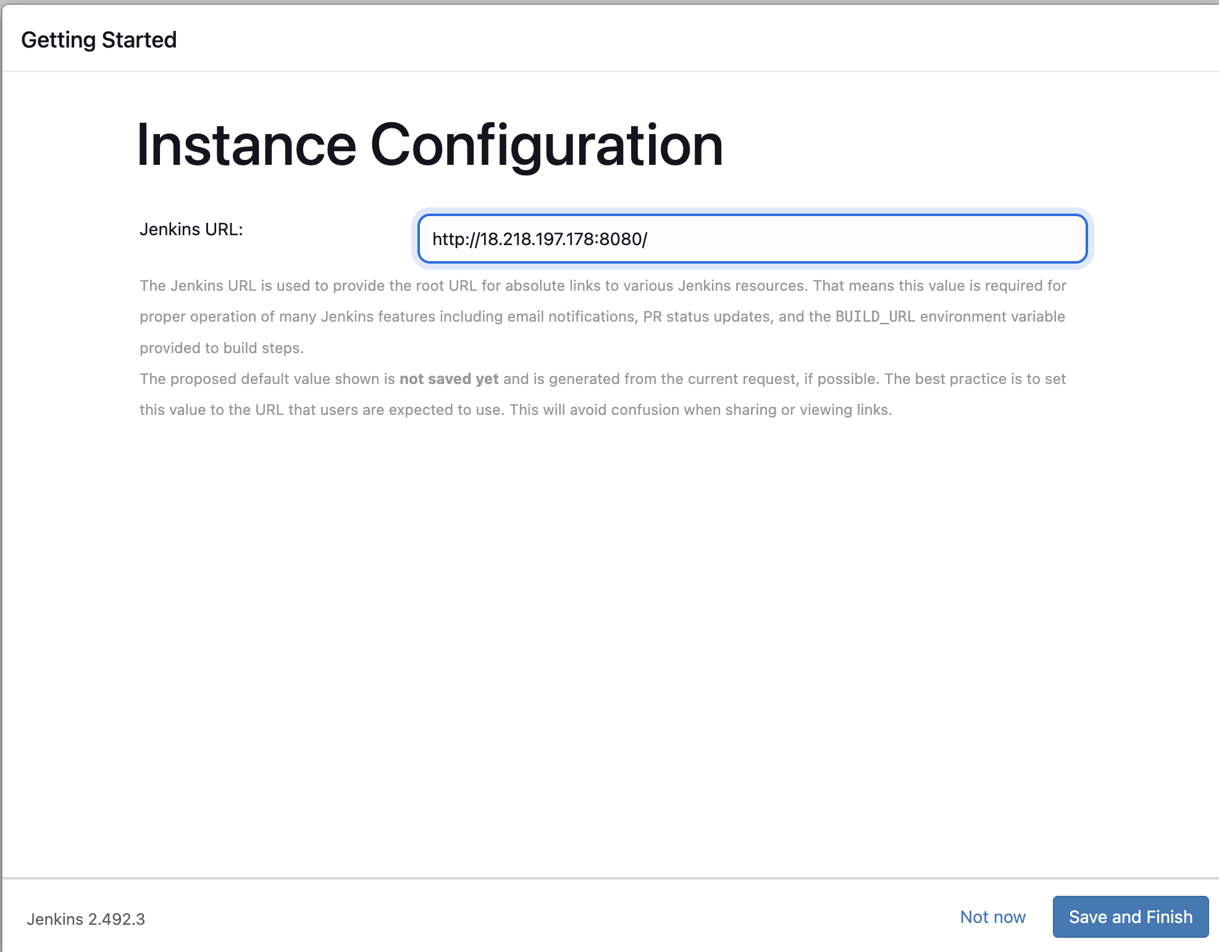

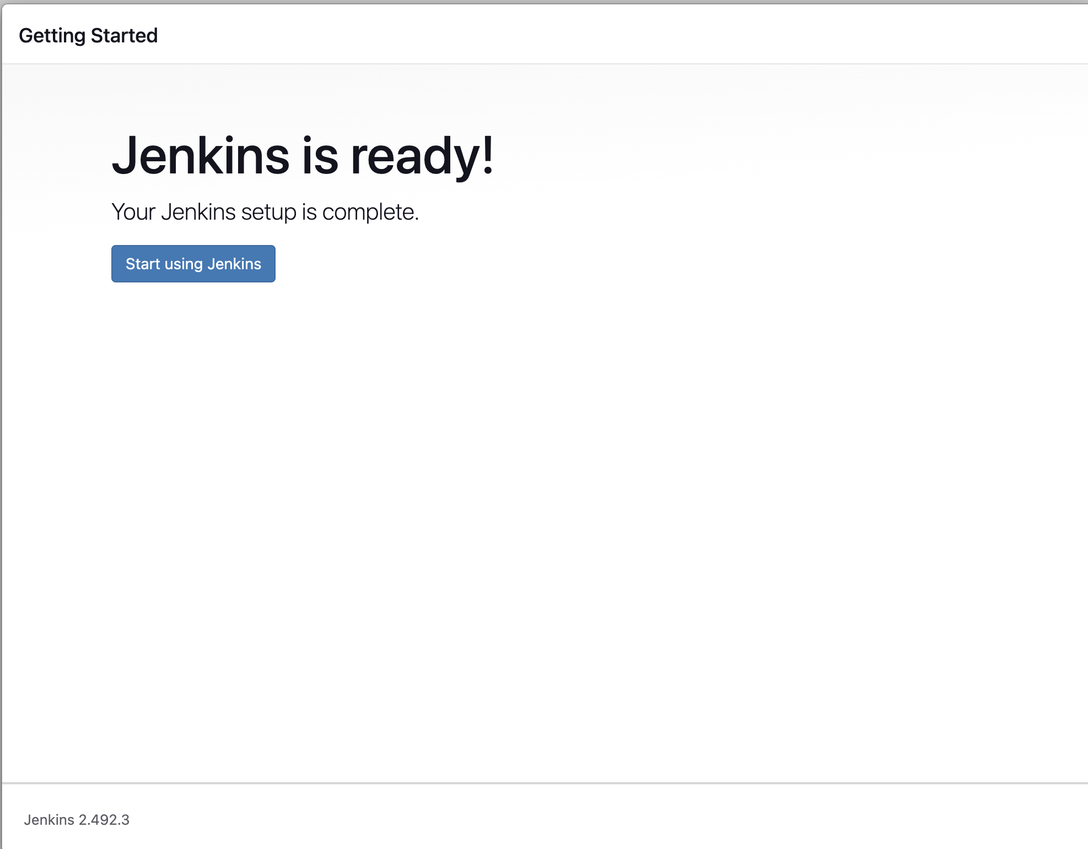

* Paste the password
* Install suggested plugins
* Create the first admin user
* Start using Jenkins!

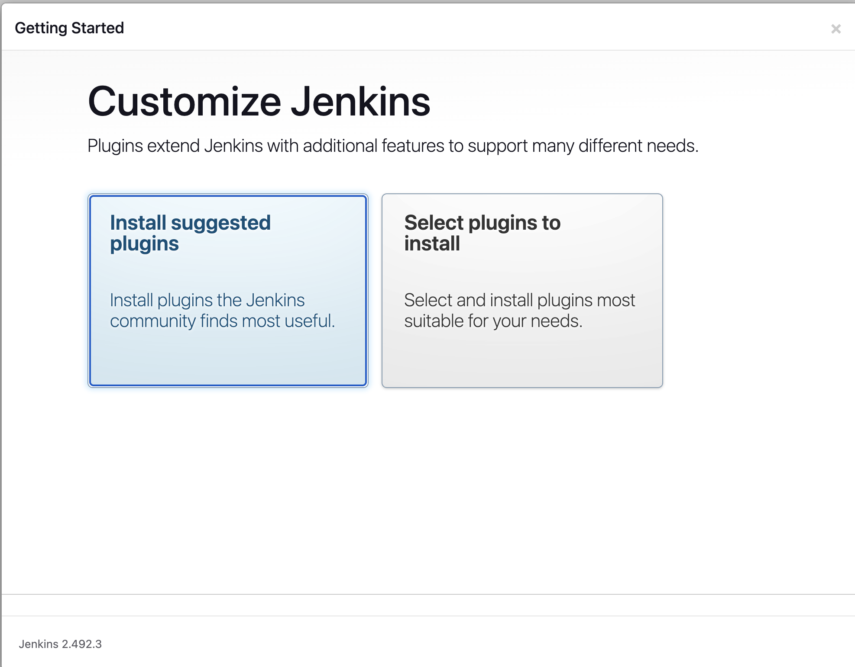

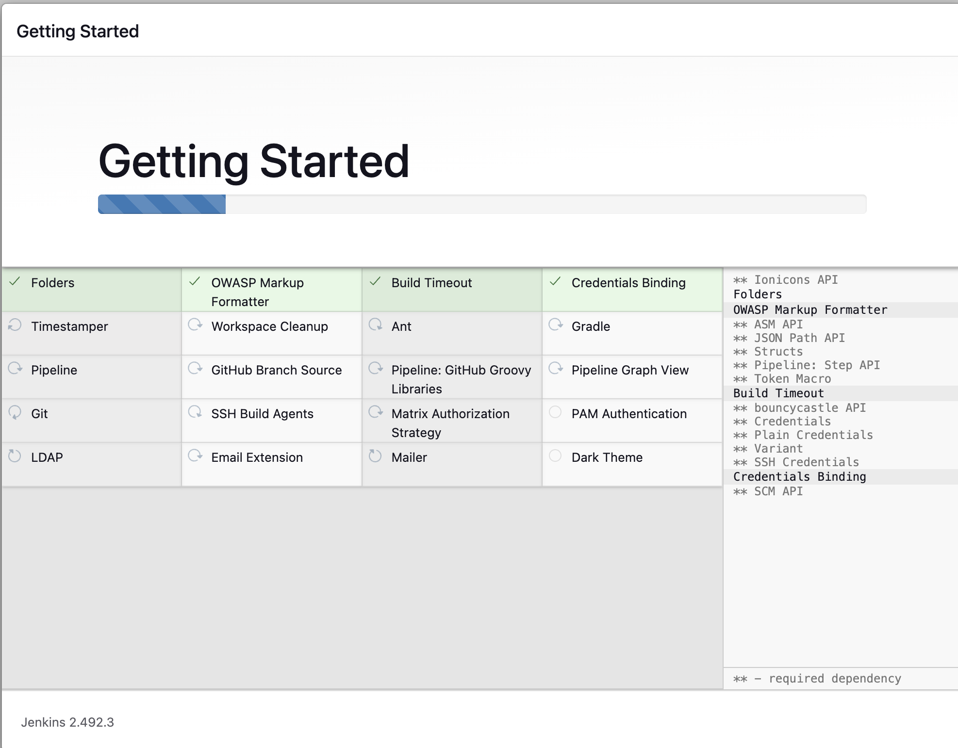

### **What to Watch For**

* If you see any **errors** during package installs, share a screenshot or paste it here.

Once it completes, you’ll see:  
  
✅ Jenkins installation complete!

🌐 Access Jenkins at: http://<your-server-ip>:8080

🔐 Initial Admin Password:

* <some-random-password

### **🔐 Unlock Jenkins UI**

After the script is fully done:

sudo cat /var/lib/jenkins/secrets/initialAdminPassword

### **✅ Step 7: Unlock & Setup Jenkins**

1. **Paste initial password**
2. Click **“Install Suggested Plugins”**
3. Create:  
   * Admin Username
   * Password
   * Email
4. Finish and log in to Jenkins!

