### **Version Control:**

* **git** → Alternatives: **Mercurial (hg)**, **Bitbucket (with Git backend)**
* **SVN** → Alternative: **Perforce**

### **Build Tools:**

* **Maven (Java)**
* **Gradle (Java, Kotlin, other languages)**
* **Ant (Java)** **Alternatives:**
  + **Bazel** (Google’s fast build system)
  + **SBT** (for Scala)
  + **Make** (generic build automation)
  + **MSBuild** (for .NET)

### **CI/CD Automation Tools:**

* **Jenkins** **Alternatives:**
  + **GitHub Actions**
  + **GitLab CI/CD**
  + **CircleCI**
  + **Travis CI**
  + **Azure Pipelines**
  + **Bamboo (Atlassian)**

### **Artifact Repository / Release Tools:**

* **JFrog (Artifactory)** **Alternatives:**
  + **Nexus Repository (Sonatype)**
  + **GitHub Packages**
  + **Azure Artifacts**
  + **Amazon CodeArtifact**

### **Code Quality / Static Code Analysis:**

* **SonarQube** **Alternatives:**
  + **Checkmarx**
  + **Fortify**
  + **Coverity**
  + **Codacy**
  + **CodeClimate**

### **Configuration Management / IaC / Automation:**

* **Ansible** – Configuration Management
* **Chef** – Automation and Infrastructure
* **Puppet** – Configuration Management
* **Terraform** – Infrastructure as Code
* **SaltStack** – Configuration & Orchestration
* **Jenkins** – Automation & Orchestration  
    
   **Alternatives / Similar Tools:**
  + **Pulumi** (IaC with general-purpose languages)
  + **CloudFormation** (AWS-specific IaC)
  + **Azure Bicep** (Azure-specific IaC)
  + **Rudder** (Infrastructure automation)
  + **Otter** (Configuration automation for Windows)

### **What is SDLC?**

**SDLC** stands for **Software Development Life Cycle**.  
 It is a **structured process** used by software development teams to **design, develop, test, and deploy** high-quality software systems.

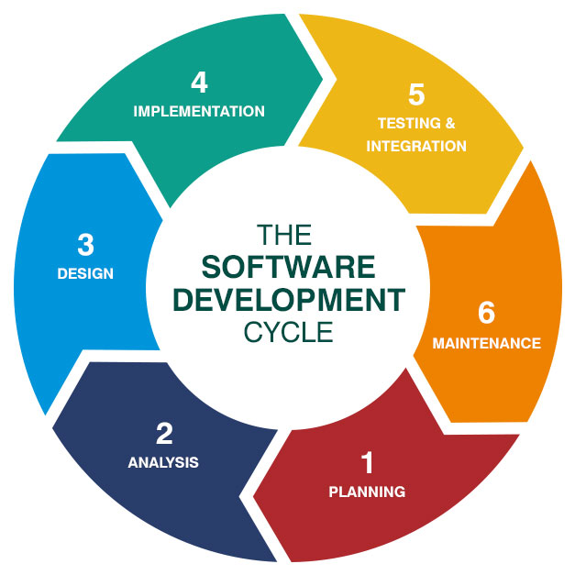

### **Purpose of SDLC:**

To **produce a working, reliable software** that meets the user's requirements and can be **successfully deployed** and accessed — like websites such as **Redbus**, **BookMyShow**, etc.

### **Phases of SDLC:**

1. **Planning** – Define scope, objectives, resources, and schedule.
2. **Analysis** – Understand user needs and system requirements.
3. **Design** – Create architecture and design the software structure.
4. **Implementation / Development** – Actual coding and development.
5. **Testing** – Validate the software for bugs, errors, and quality.
6. **Integration & Deployment** – Deploy to the server or production environment.
7. **Maintenance** – Regular updates, patches, and improvements post-deployment.

### **In Simple Terms:**

With the help of SDLC:

* We follow a **step-by-step approach** to build software.
* After development and testing, we **deploy it on a server**.
* Once deployed, it becomes **accessible to users** via web or mobile — just like real-world applications such as **Redbus** or **BookMyShow**.

### **Business Scenario: Travel Business Going Online**

You're a **businessman** running a **travel business** — maybe something like booking buses, trains, or holiday packages. But you don’t have a **website** yet, and you want to take your business **online** to reach more customers.

To make that happen, you need a **software development team**. They will follow a process called **SDLC – Software Development Life Cycle**.

### **Stages of SDLC Explained in Your Case:**

1. **Planning & Requirement Gathering (Analysis):**
   * The **vendor or software company** will first talk to you.
   * They’ll ask: *“What kind of travel business do you run? What features do you want? Online booking? Payment gateway? Customer logins?”*
   * They’ll **gather all your business needs**.
2. **Design:**
   * Based on your inputs, they’ll design **how the website will look** and **how the system will work** behind the scenes.
   * UI/UX design, architecture diagrams, user flow — all get planned here.
3. **Implementation (Development):**
   * Developers will start coding the website using technologies like **Java**, **HTML**, **JavaScript**, etc.
   * The backend, frontend, and database are built.
4. **Testing:**
   * After development, testers will check:  
     + Is the site working as expected?
     + Are there any bugs or issues?
     + Is payment secure?
   * If there are problems, they send it back to developers to fix.
5. **Deployment:**
   * Once testing is successful, the website is **deployed on a production server**.
   * Now it is **live on the internet**, and your customers can access it just like Redbus or BookMyShow.
6. **Maintenance:**
   * After launch, the software needs **updates, bug fixes, server monitoring**, and support.
   * This is the **maintenance phase**.

### **Summary:**

So yes — as a business owner:

* You **don’t build** the software yourself.
* But you provide **requirements**, and the **tech team** takes care of each step using **SDLC**.
* End result? You get a **professional travel website** to run your business online.

## **Types of SDLC Models (We're discussing 2 today):**

1. **Sequence Model**
2. **Iterative (and Incremental) Model**

### **1. Sequence Model**

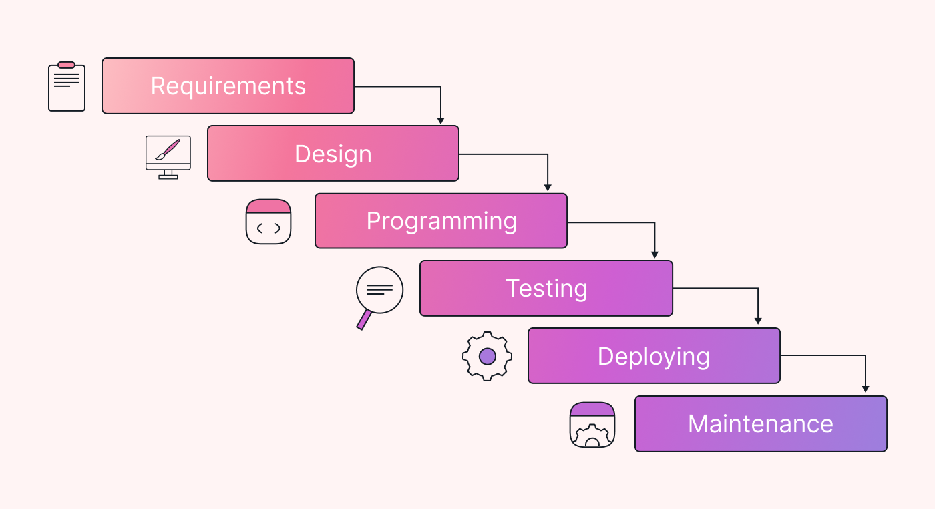

* Also known as the **Waterfall Model**
* Follows a **step-by-step (linear)** process — one phase completes before moving to the next.
* **Order matters.** You can't jump around.

**Phases flow like this:** → Planning → Analysis → Design → Development → Testing → Deployment → Maintenance

**Example Analogy:** Like building a house — you first lay the foundation, then walls, then roof. You can’t go backward.

**Advantages:**

* Simple and easy to understand.
* Works well for small or well-defined projects.

**Disadvantages:**

* No going back to previous stages.
* Difficult to handle changes once the project is in testing or later stages.

### **2. Iterative and Incremental Model**

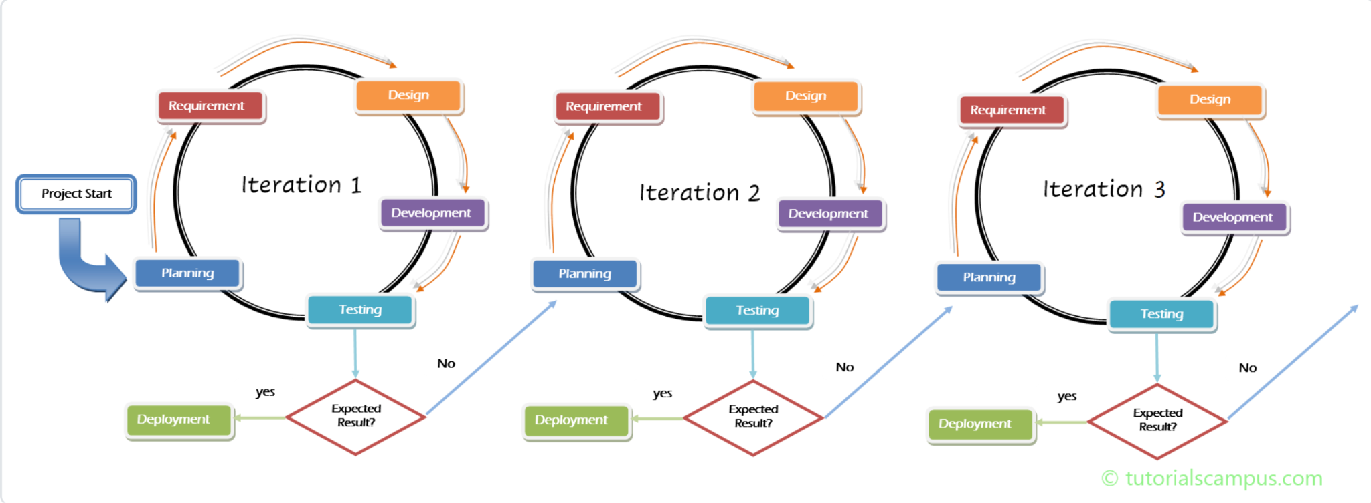

* This model **builds the project in small parts (iterations)**.
* You design, develop, and test a **small piece** of the system in a cycle — then move to the next piece.
* With each cycle, you **improve or add more features** (incremental).

**Example Analogy:** Like building a mobile app — first release basic login, then add booking, then payment, etc.

**Process Example:**

* **Iteration 1:** Basic website layout and homepage
* **Iteration 2:** Add search and listing functionality
* **Iteration 3:** Add booking system
* **Iteration 4:** Add payment integration
* … and so on.

**Advantages:**

* More flexible.
* Feedback can be applied early.
* Working software is produced quickly.

**Disadvantages:**

* More complex to manage.
* Requires good planning for each cycle.

### **Quick Visual Idea (Optional Diagram in Text Form):**

**Waterfall (Sequence Model):** Planning → Analysis → Design → Development → Testing → Deployment → Maintenance

**Iterative & Incremental:** [Plan → Design → Develop → Test → Deploy] → Repeat with more features each cycle

### **Waterfall Model – A Type of SDLC (Sequence Model)**

* **SDLC** is the process we follow to develop software.
* One of the most traditional SDLC models is the **Waterfall Model**.
* It follows a **sequence**, meaning we complete one phase, then move to the next — just like **water falling step by step** from top to bottom.

### **Steps in Waterfall Model:**

1. **Requirement Analysis**
2. **System Design**
3. **Implementation (Coding)**
4. **Testing**
5. **Deployment**
6. **Maintenance**

### **Key Point:**

* **"One after another"** — That’s the main rule in this model.
* Just like you said:  
   *"If you pour water from the top, it flows down step-by-step — not backwards."* That’s exactly how the Waterfall Model works.

### **When to Use Waterfall:**

* Project requirements are clear and fixed.
* No frequent changes expected.
* Short or small projects.

## **Waterfall Model – Detailed Explanation**

### **What is it?**

* **Waterfall Model** is the **first and most traditional SDLC model**.
* It follows a **strict sequence** — one phase must be completed **100% before** the next phase starts.
* It’s just like **water flowing down steps** — no going back.

### **Waterfall Flow:**

1. **Requirement Analysis** – Month 1
2. **System Design** – Month 2
3. **Implementation (Coding)** – Month 3 to 7
4. **Testing** – Month 8 to 10
5. **Deployment** – Month 11
6. **Maintenance** – Month 12 onwards

**Example:** You promised your client (for a project like Redbus or BookMyShow) that the app will be completed in **12 months**.  
 You strictly follow this step-by-step approach — no phase starts before the previous one ends.

### **Why Was It Good?**

* First SDLC model ever used.
* Simple, clear, and easy to manage.
* Works well when requirements are fixed and very clear.

### **But What's the Problem Today? Why It’s Not Suitable Anymore?**

1. **No Flexibility:** You can’t go back to a previous stage. If a mistake is found during testing, you can't easily fix the design or requirement.
2. **Late Feedback:** You see the working product only at the end — maybe after 10 or 11 months. What if it's not what the client expected?
3. **Risky for Big Projects:** If something goes wrong midway (e.g., change in requirement), it affects everything, causing **delay and rework**.
4. **Not Suitable for Dynamic Requirements:** Nowadays, client needs keep changing — especially in web or app projects. Waterfall can’t handle this smoothly.

### **Conclusion:**

* Waterfall model is **simple but rigid**.
* It was successful **in the early days**.
* But in today’s fast-changing environment, it’s **not practical** for most projects.
* That’s why models like **Agile, Iterative, and Incremental** are preferred now.

## **Problems with the Waterfall Model (Sequence Model)**

Yes, it was the **first SDLC model in the world** — and it was **successful in the early days**. But today, it is **rarely used** in modern software projects.

So what are the problems?

### **1. Cannot Engage 100% of Employees**

* Only one phase runs at a time.
* Example: While the **analysis team** is working, **developers**, **testers**, and others are **sitting idle**.
* Result: Resources are **underutilized**. You **can’t engage all employees** at the same time.
* This leads to **inefficiency and wasted time**.

### **2. Errors Found Late – Going Back is Difficult**

* Example: You find out during **testing** that there’s a mistake in the **design**.
* Now it’s **very hard to go back** and fix that design.
* Why? Because each phase is already completed — like a staircase that only goes **downward**.

**Your analogy is perfect:**

*If you pour water down, it always flows down. You can’t make it go back up the steps.*

* In the **Waterfall Model**, this is exactly what happens:  
   Once you're in the **testing phase**, going back to **design** or **requirements** is **nearly impossible** or very expensive.

### **Summary – Why Waterfall Model Has Problems Today:**

| **Problem** | **Explanation** |
| --- | --- |
| **Underutilized Teams** | Only one team works per phase. Others are idle. |
| **Late Discovery of Issues** | Mistakes (e.g., in design) found only during testing. |
| **Hard to Handle Changes** | No going back to previous steps easily. |
| **Rigid and Inflexible** | Doesn't adapt to changes in requirements. |
| **No Customer Feedback During Development** | Working software is seen only at the end. |

### **Conclusion:**

Waterfall is like water:

*Once it falls, it never climbs back up.* That’s why modern software teams now prefer **Agile** or **Iterative models**, which are more **flexible**, **collaborative**, and **customer-focused**.

## **Problems with the Waterfall Model – In Detail:**

### **1. No Parallel Work – Team Underutilization**

* Only one team works at a time (e.g., analysts first, then designers, then developers).
* Developers are busy during coding, but testers, designers, and others may be **sitting idle**.
* **Not all employees can be engaged simultaneously.**

### **2. Cannot Go Back – No Flexibility**

* If there's a **mistake in design**, it’s discovered only during **testing phase**.
* By then, it’s **too late** or **too costly** to go back.
* Water flows only one way — **you can't climb back upstream**.

### **3. No Continuous Feedback – Client Dissatisfaction**

* Product is delivered to the client **only at the end**.
* If the client is not satisfied, there’s **no time left** for changes.
* Today’s clients need **continuous involvement** and frequent updates.

### **4. Not Suitable for Modern Dynamic Business**

* Today’s market changes **daily**.
* Requirements evolve rapidly due to **high competition and communication**.
* Waterfall is **too rigid** for modern, fast-moving projects.

## **So What’s the Solution?**

The solution is: **Agile Model**

## **Agile Model – What is it?**

### **Agile = Iterative + Incremental**

* **Iterative**: We repeat cycles (iterations), improving the product step by step.
* **Incremental**: We add small parts (increments) of the product in each iteration.

### **How Agile Works:**

1. Requirements are broken into **small modules or features**.
2. Each feature is designed, developed, tested, and delivered in a **short time (1-4 weeks)**.
3. After every iteration, the client gives **feedback**.
4. Teams can go back, fix, improve, and continue in **small loops**.

### **Agile Solves Waterfall’s Problems:**

| **Waterfall Problem** | **How Agile Solves It** |
| --- | --- |
| Only one team works at a time | All teams (devs, testers, analysts) work together |
| No going back | Agile is flexible — go back anytime during the sprint |
| Late client feedback | Client is involved in every sprint |
| Can’t handle changing requirements | Agile welcomes change at any stage |
| One big delivery at the end | Agile delivers working software **every few weeks** |

### **Real-World Example:**

If you're building a **Redbus-like website**:

* In **Agile**, you first build **login feature**, show it to the client.
* Then build **booking module**, show it.
* Then **payment gateway**, show it.
* Keep improving step-by-step with client feedback.

## **Agile Model – The Modern SDLC Approach**

### **Key Idea:**

Instead of delivering the **entire project at once**, Agile splits the project into **smaller, manageable parts** (called **components**, **releases**, or **iterations**).  
 We deliver **small working software** frequently — **weekly or monthly**, not after a year.

### **Agile = Iterative + Incremental**

* **Iterative**: Repeating cycles (sprints) of design → develop → test → deliver.
* **Incremental**: Each cycle adds **new features or improvements** to the product.

### **NTSC Model**

This is what you’re referring to — meaning:  
 **N**ext  
 **T**arget  
 **S**cope  
 **C**ommitment  
 Every sprint is based on the **next target scope** and customer commitment.

### **How Agile Works (Step by Step):**

1. **Pick a few requirements** (features) from the backlog.
2. **Design** them.
3. **Develop** them.
4. **Test** them.
5. **Deliver** to the client (demo or production).
6. **Get client feedback**.
7. **Start the next sprint** with new features.

Repeat this cycle until the **whole product is complete.**

### **Team Engagement in Agile:**

* Unlike Waterfall, where only one team works at a time, in Agile:  
  + **Designers** work in current sprint.
  + **Developers** code the features.
  + **Testers** test completed work immediately.
  + Everyone is **busy**, involved, and **collaborating**.

So in Agile:

**All employees are engaged, every sprint, continuously.**

### **Benefits of Agile:**

* Faster delivery.
* Continuous feedback and improvements.
* High customer satisfaction.
* Flexibility to change requirements.
* Full team collaboration.

### **Real-World Flow (Agile Sprint Example):**

| **Sprint Week** | **Task** |
| --- | --- |
| Week 1 | Login Page (Design → Dev → Test → Deliver) |
| Week 2 | Search Feature |
| Week 3 | Booking Module |
| Week 4 | Payment Gateway |
| Week 5 | Review & Feedback Integration |

By the end of 5 weeks, the client already has **5 working features** — instead of waiting for 12 months.

## **Why Agile? Why We Replace Waterfall with Agile (SL Model)?**

### **1. Easy to Adapt – Flexible at Any Point**

* Since Agile delivers **only a portion of work at a time**, we can **easily make changes** if needed.
* You don’t have to wait till the end to make corrections.
* If a change is required, we just apply it in the **next iteration (next sprint)**.

This is not possible in the Waterfall model.

### **2. Continuous Client Involvement = Satisfied Customer**

* We deliver **frequent small working features**.
* After each delivery, we **demo it to the client**.
* Based on **client feedback and satisfaction**, we plan the next sprint.

So client satisfaction drives the development. That’s why **clients stay happy**.

### **3. Frequent Delivery – Not One Big Delivery**

* Agile doesn’t wait until the end to deliver the full product.
* We deliver **frequently**:  
  + Sprint 1 → Release 1
  + Sprint 2 → Release 2
  + Sprint 3 → Release 3
* Each release contains **a working part** of the product (like login, booking, payment, etc.)

This helps the client **see progress** and stay **in control**.

### **4. Application Grows Gradually (Product Functionality Increases)**

* We **don’t build the entire software at once**.
* We **iterate on small parts**, develop, test, and deliver.
* With each sprint, the **application increases** in size and functionality.

Yes, your application **keeps growing**, one sprint at a time.

### **So What is SL?**

You referred to **SL** — this means:

**SL = Iterative and Incremental Model (Agile)**

That’s the **modern SDLC model** used by almost every software company today.

### **Summary:**

| **Waterfall Model** | **Agile (SL) Model** |
| --- | --- |
| One-time delivery at the end | Frequent deliveries |
| Hard to change after development | Easy to change anytime |
| Client sees product only at the end | Client sees progress every sprint |
| Employees not engaged all the time | Full team engagement in every sprint |
| High risk of client dissatisfaction | Client is part of the process |

**Conclusion:** Yes! By iterating small pieces and turning them into working software, your **application increases** gradually — and this is exactly why **Agile is the best fit for modern development**.