Report 1

Title: Implement Security Group Test Use cases on a fresh EC2 Instance

# **[1] All Outbound Traffic allowed (Default)**

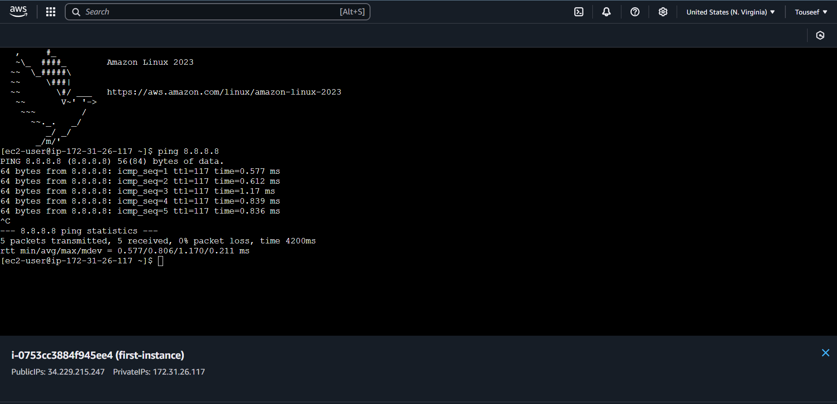

Executed ping command for 8.8.8.8 and we can see that it was successful. We are getting response from the server.

# **[2] All Inbound Traffic not allowed (Default)**

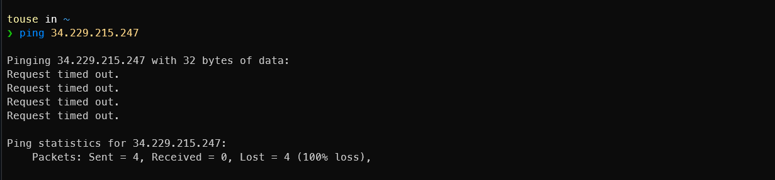

Executed ping command for out instance pubic IPv4 34.229.215.247 but got no response

# **[3] All Inbound Traffic allowed (Custom Rule)**

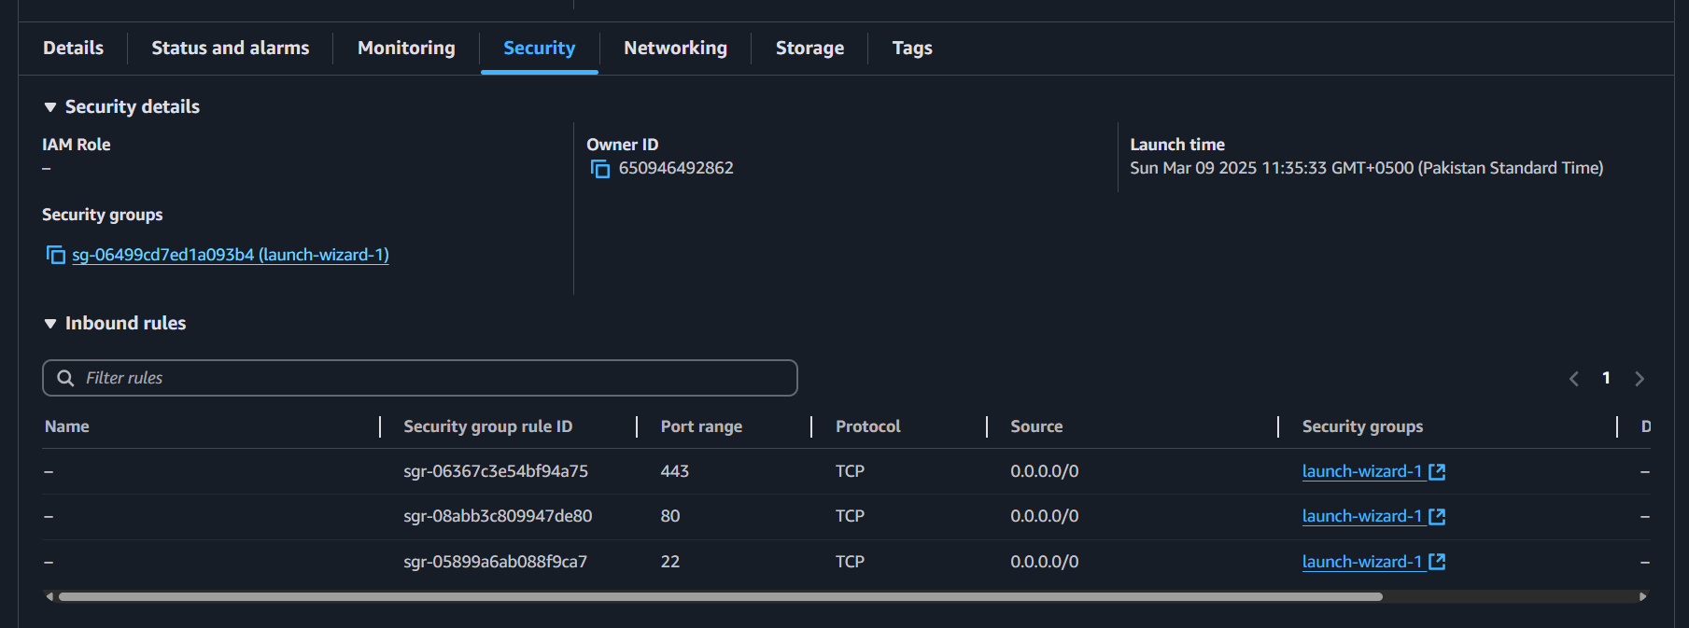

Opening current set security group of our instance

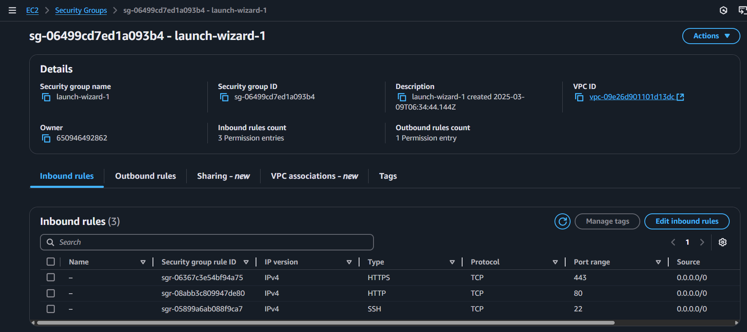

Going to `Edit Inbound Rules`

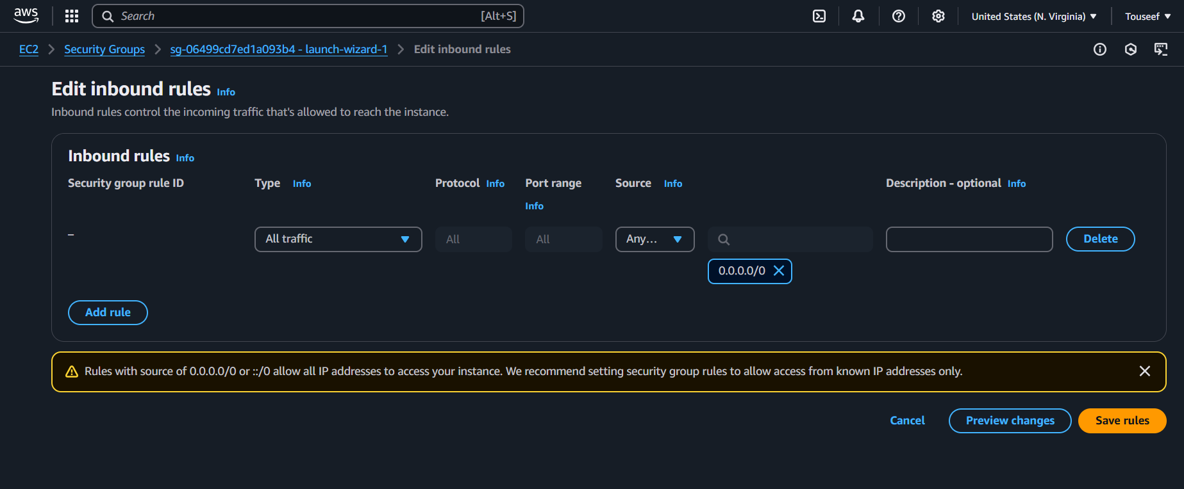

Delete all existing Inbound rules and add an Inbound rule that Allows all traffic from IPv4.

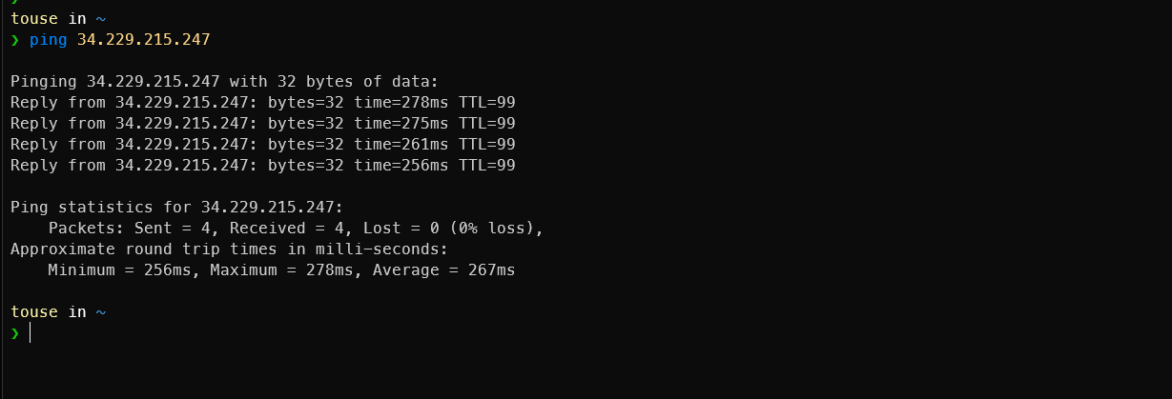

Now the ping is working form our local machine.

# **[4] Restrict All Outbound Traffic (Custom Rule)**

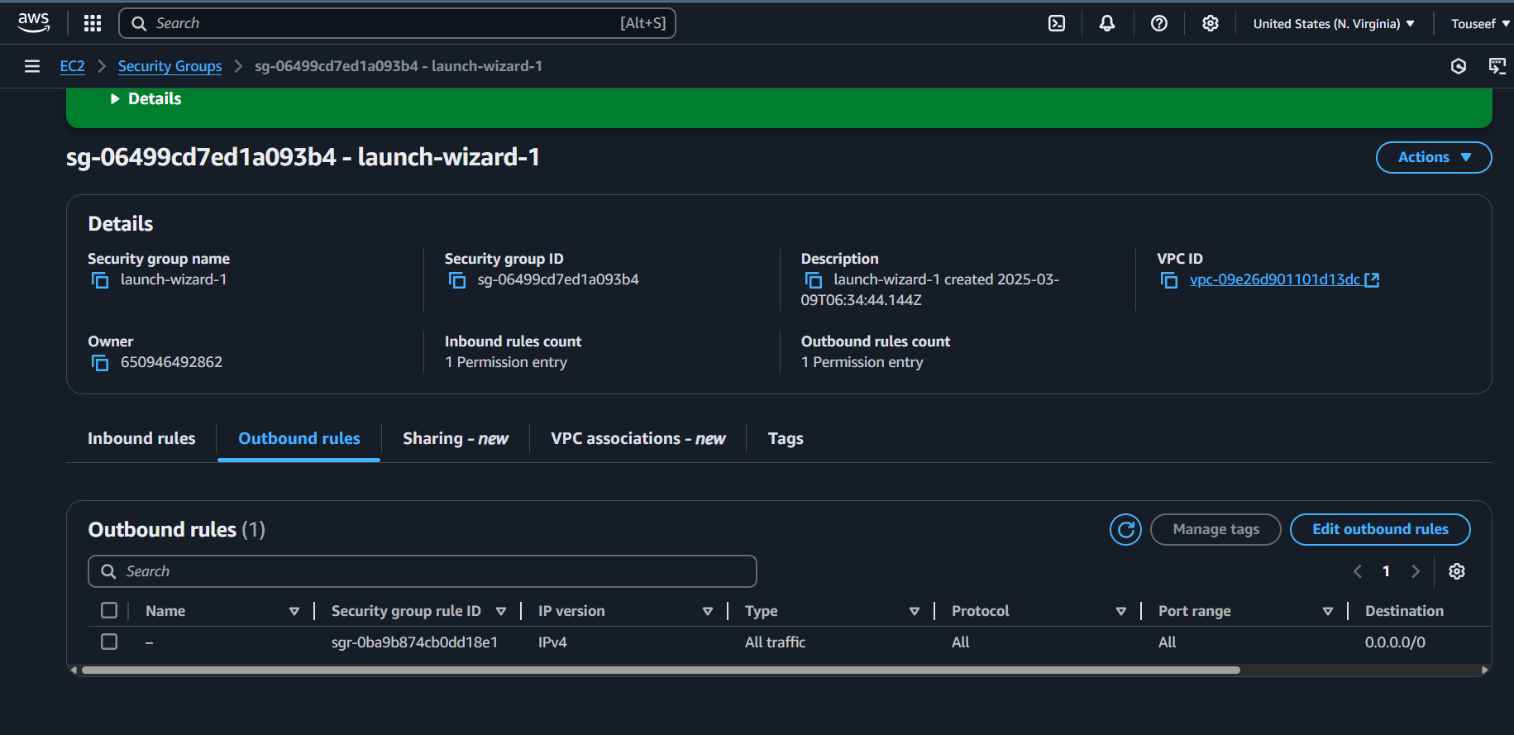

Inside the Security Group, going to `Edit Outbound Rules`

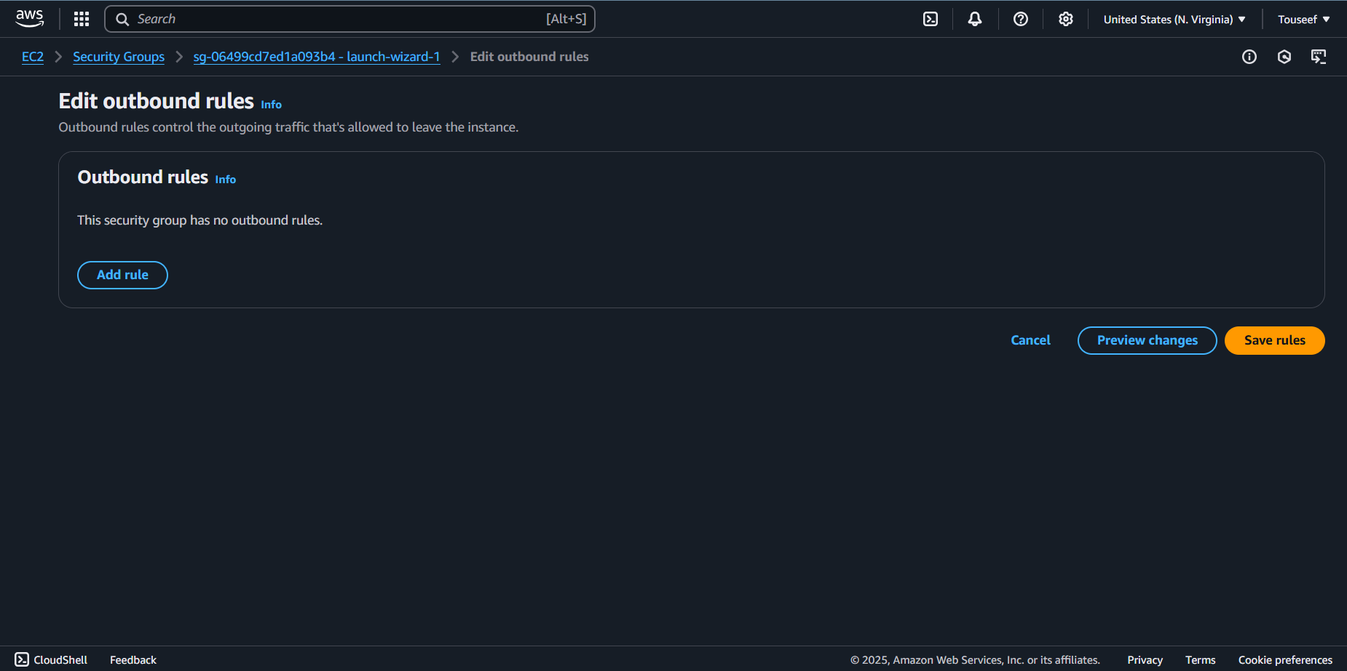

Deleted all existing Outbound rules and saved

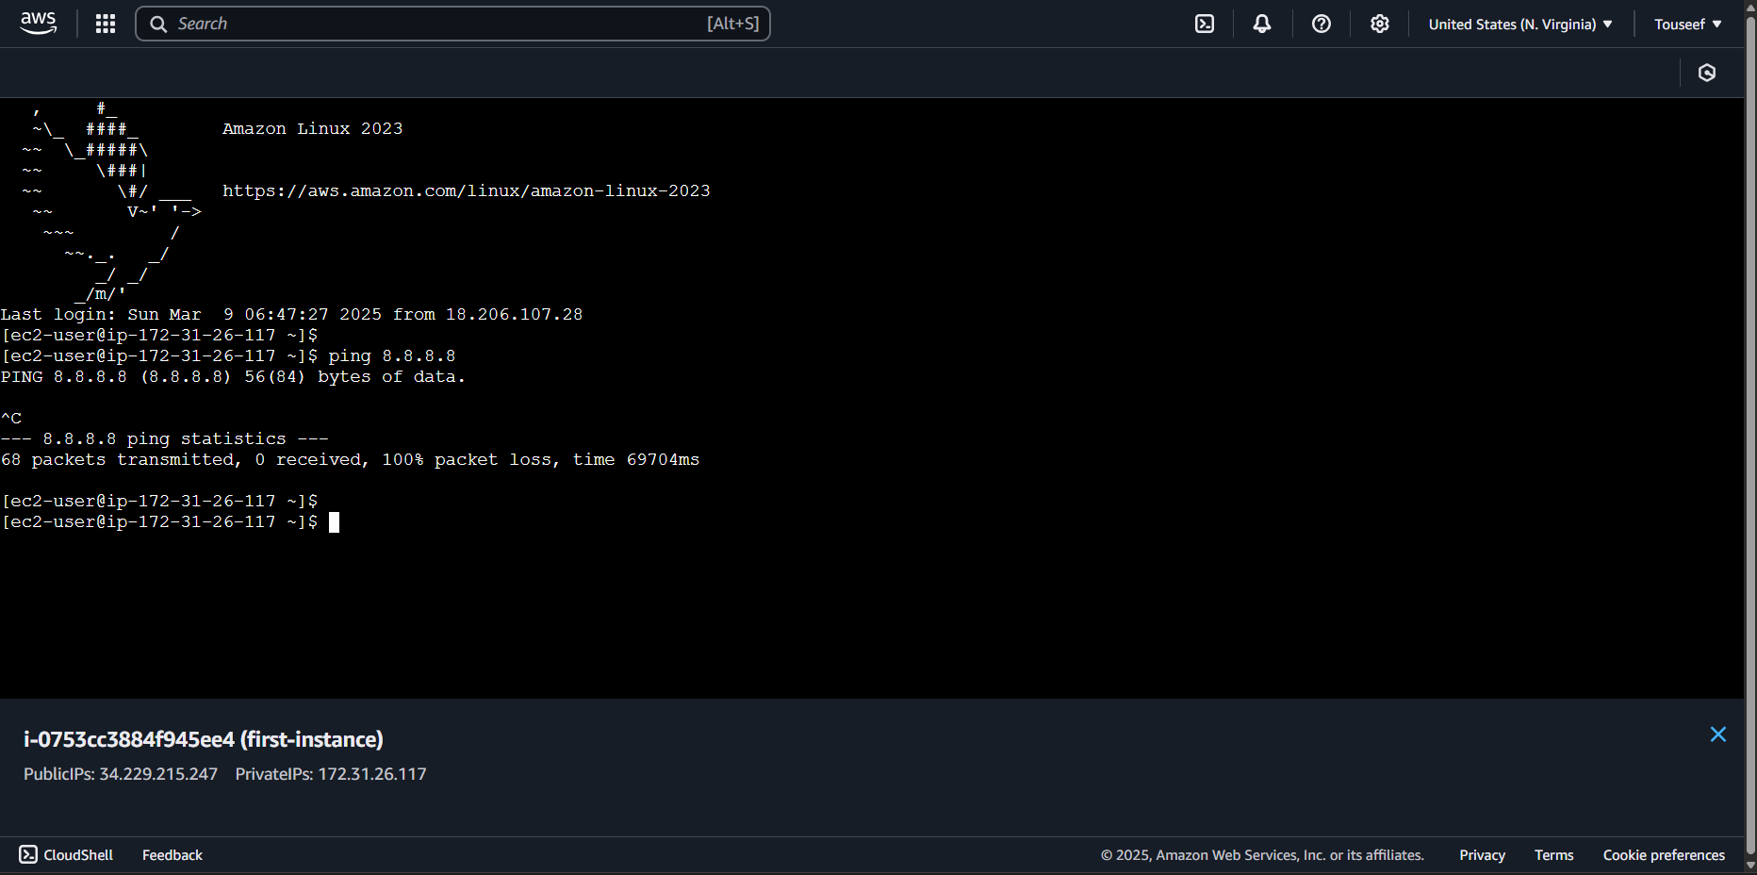

Now we are unable to ping the public IP 8.8.8.8