Report

Title: Automating Configuring the Apache Server using User Data Script on EC2 Instance

# Setup

Create a fresh EC2 instance with following configs;

* No Key Value Pair Encryption
* Allow http/https Traffic
* Add your User Data Script to Advanced Details Section  
  

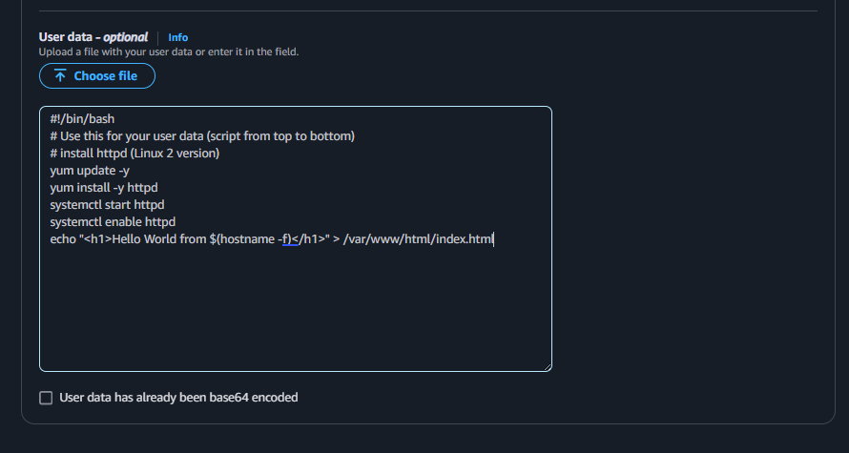

* Everything else to default values

# Procedure

1. Copy the instance pubic ip and run in the browser;
2. Now copy the public IP of your EC2 machine and send the http request from your browser. You should be able to see content of your index.html file in the browser body. 



