Report

Title: Create Windows VM on AWS and Configure IIS

# Setup

Create a fresh EC2 instance with following configs;

* AIM => Windows OS
* Instance Type => T3.micro
* Create New Key Value Pair Encryption (it will download the .pem file on your machine)
* Allow RDP traffic
* Allow http/https Traffic

# Procedure

Go to Connect section of your instance.

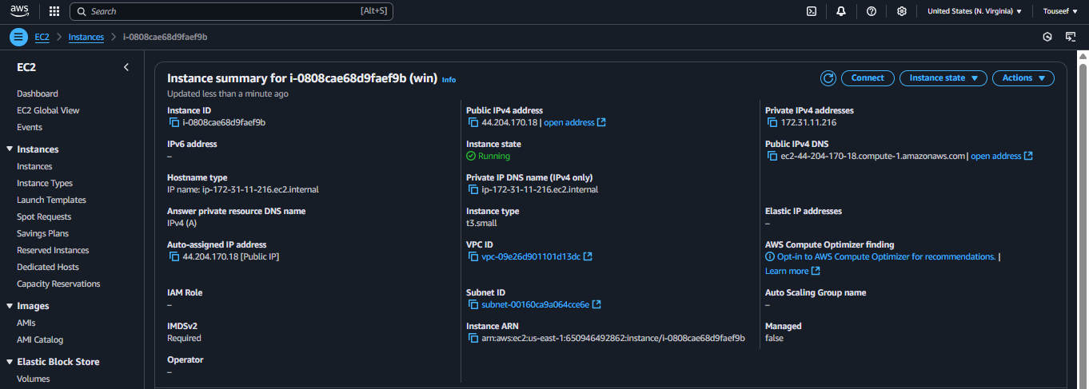

Go to RDP tab, click on get password link, upload your .pem file (which was downloaded when create key pairs) to decrypt the password.

Note down the username and password to connect to your windows instance in future.

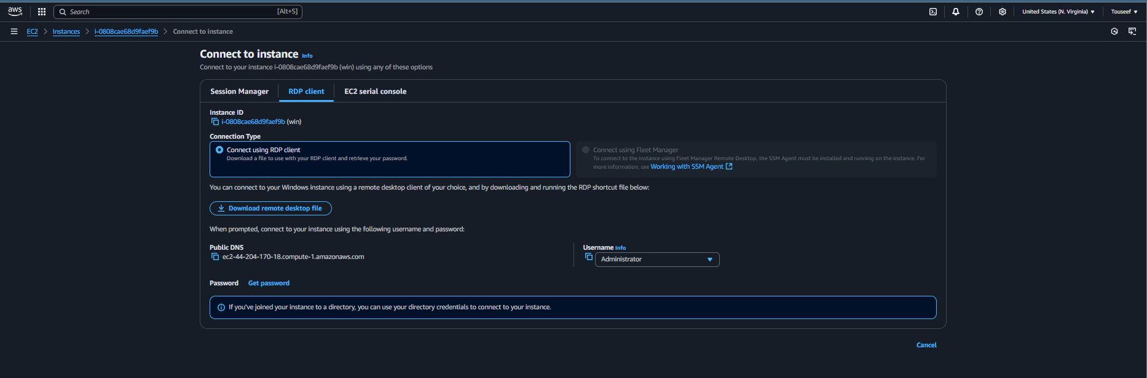

Copy public IPv4 DNS address of your instance as follows;

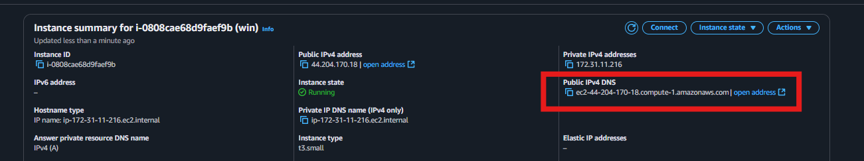

Inside MobaXterm, select Session from the toolbar. Select RDP from the top session types.

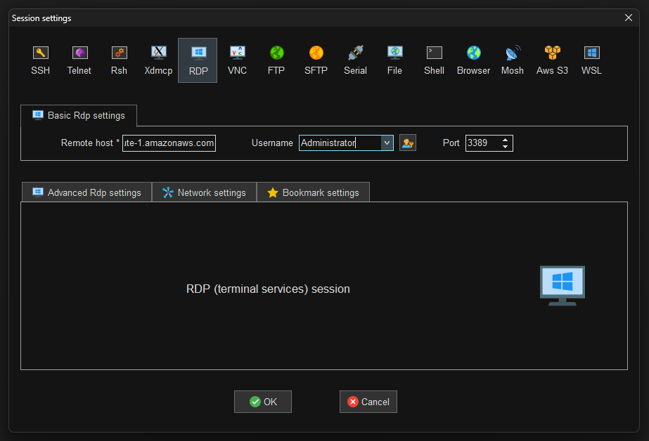

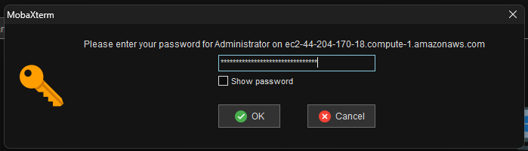

Now you will be connected to the instance as follows;

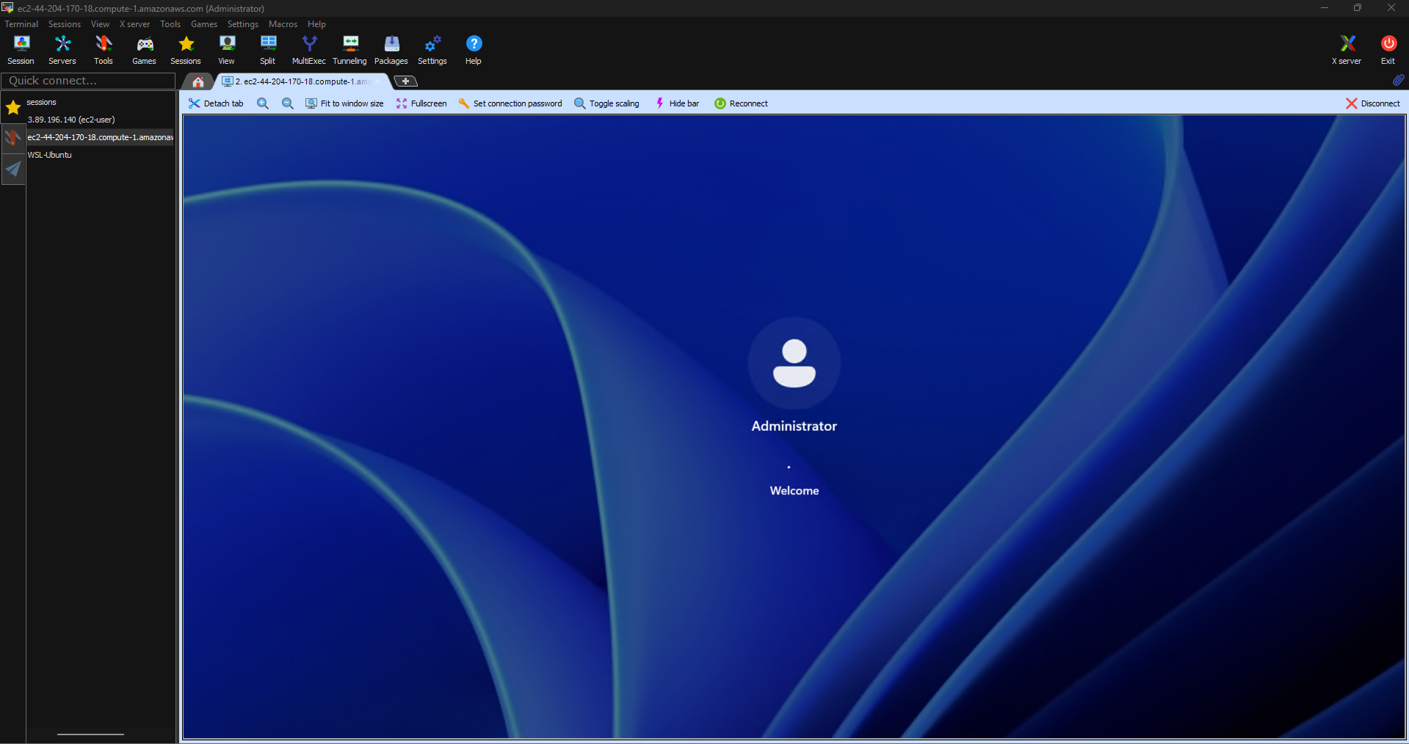

Go to Start menu of windows. Open Server Manager.

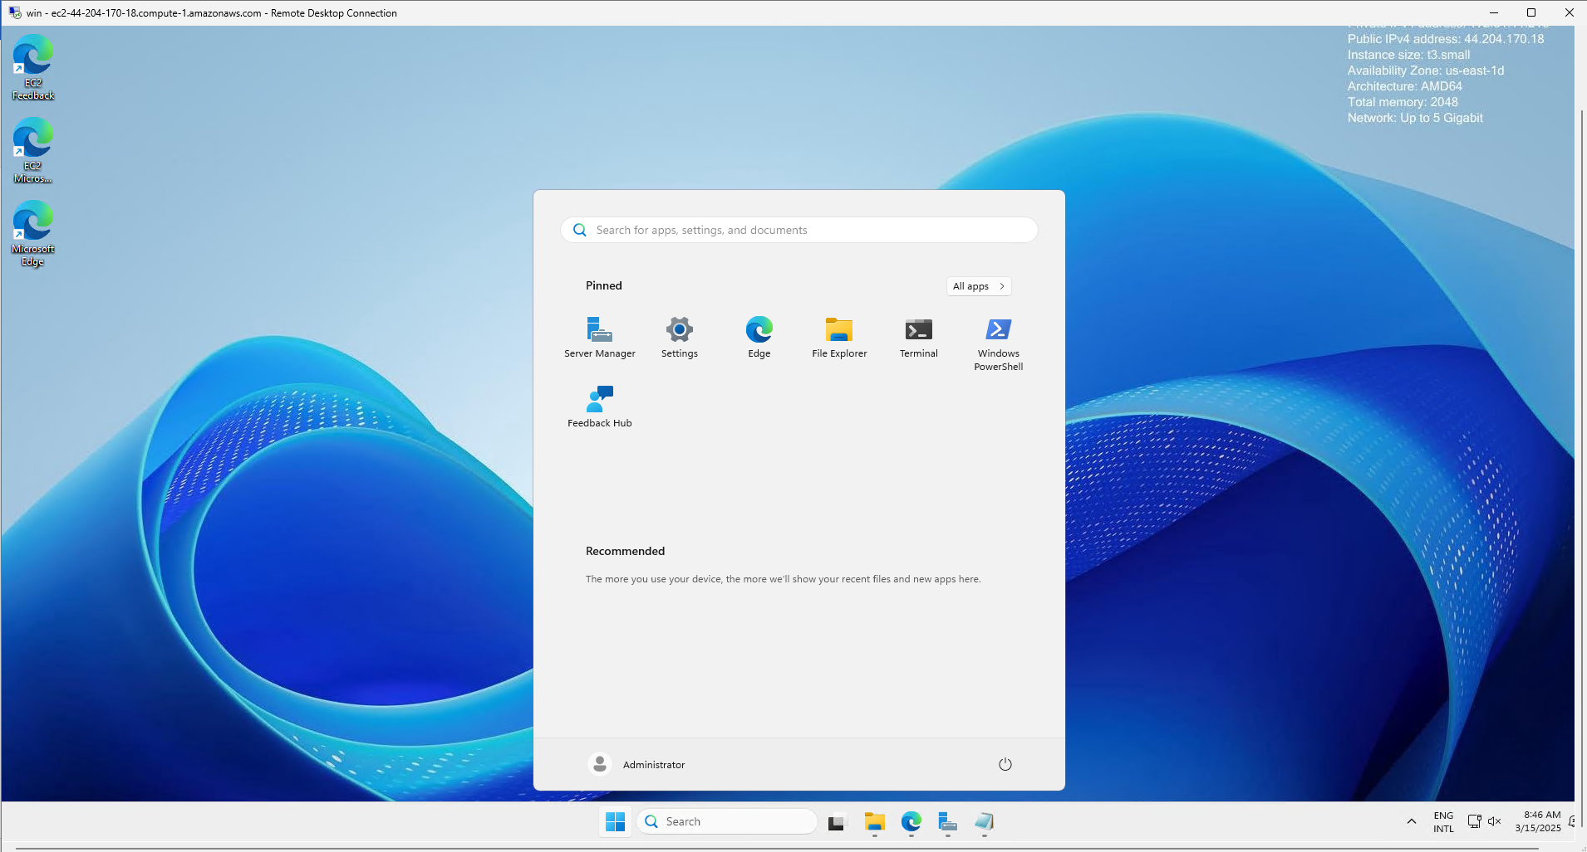

Go to Manage in the top right and select Add Roles and Features. Keep pressing Next until Server Roles section. Select IIS from the list and proceed with the installation.

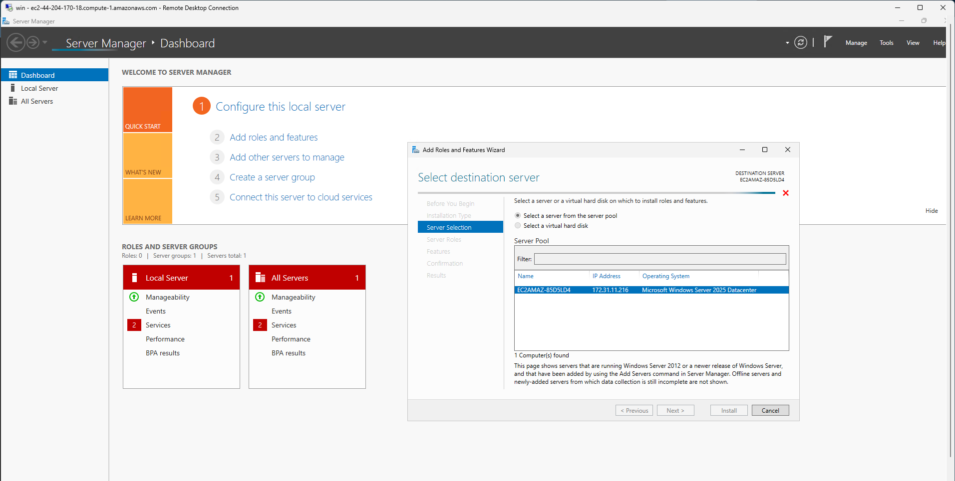

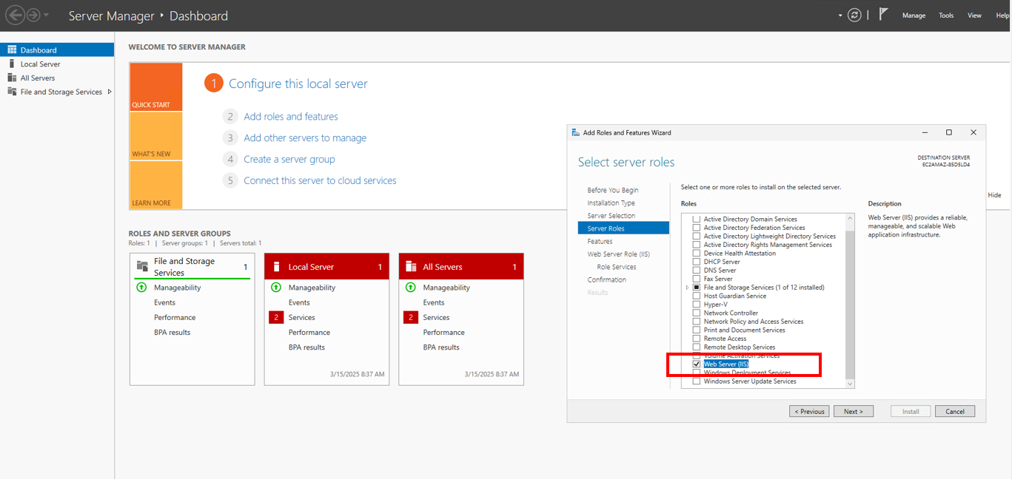

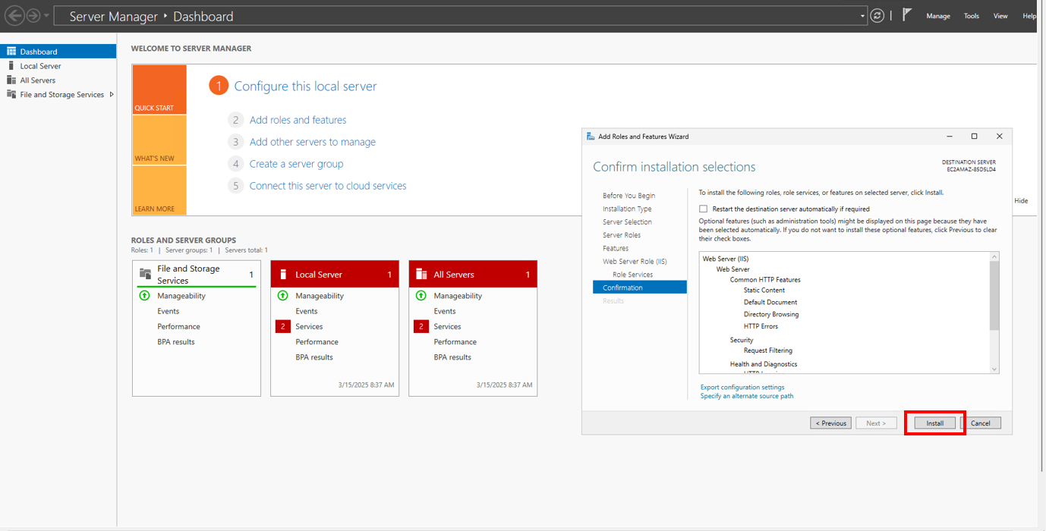

Now go to C:\inetpub\wwwroot and open the issstart file in the notepad and add your custom text and then you can show any text what ever you want on your IIS Web server.

Now copy and paste the public IP of the instance in the browser and see the custom text.