­­­

Report

Title: Provisioning Elastic IP and managing association with an EC2 Instance

# Theory

## Elastic IP

* Static Public IP
* Reassign able
* High availability (minimum downtown)
* AWS charges for unused IP but if you assigned it to a machine, it is free of cost

# Setup

Create a fresh EC2 instance with following configs;

* AMI => Amazon Linux
* Instance Type => T2.micro
* No Key Pair needed
* Proceed with all Defaults

# Procedure

After creating an EC2 instance, note down the public IP;

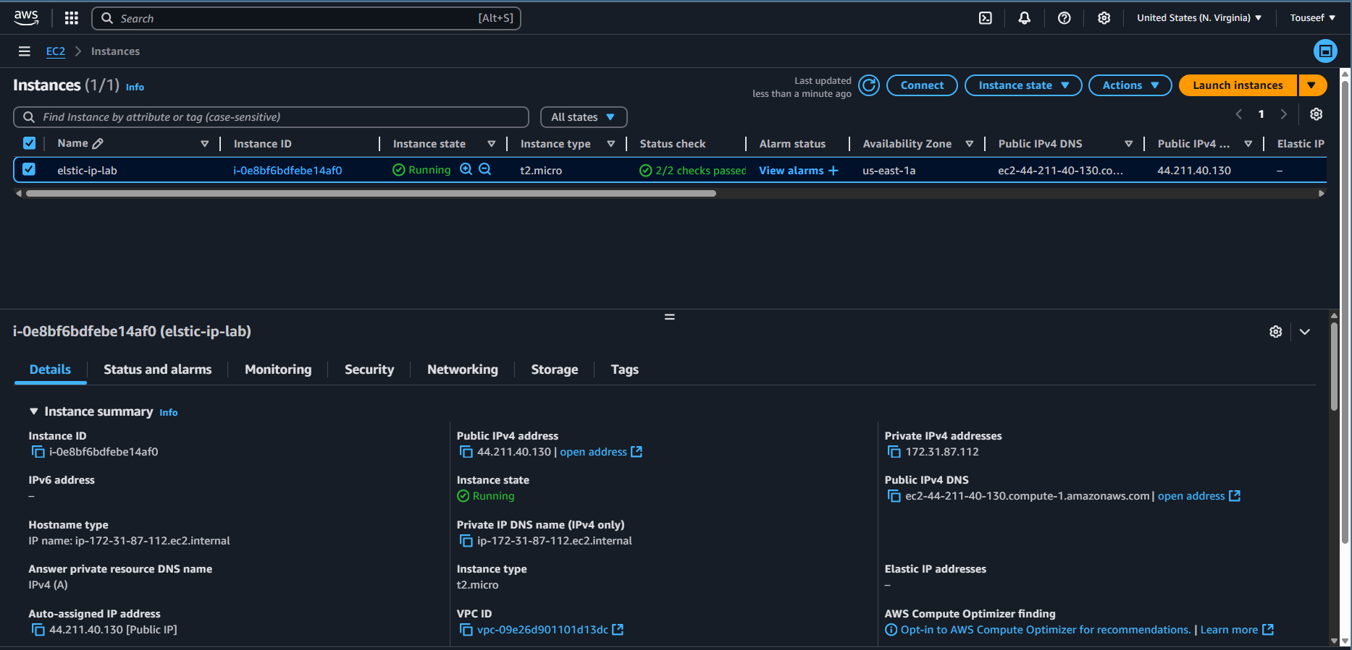

Now go to the Elastic Ips option in the sidebar menu. Here press the Allocate Elastic IP address button.

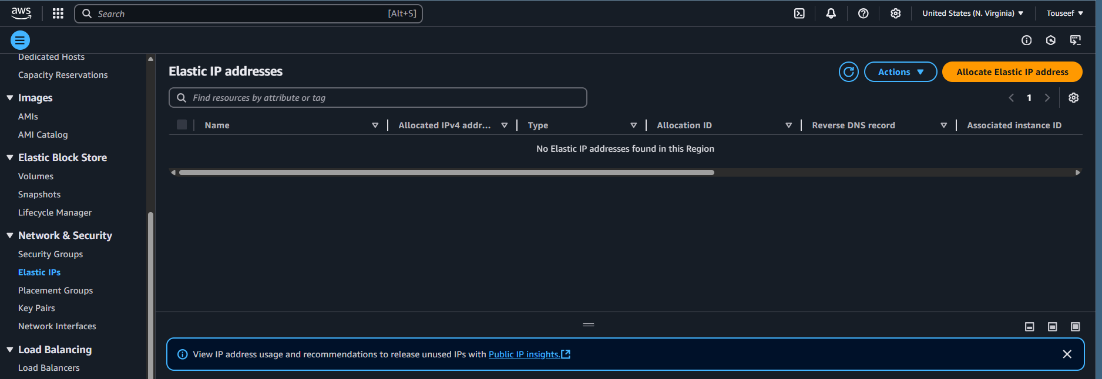

Proceed with default values and press Allocate.

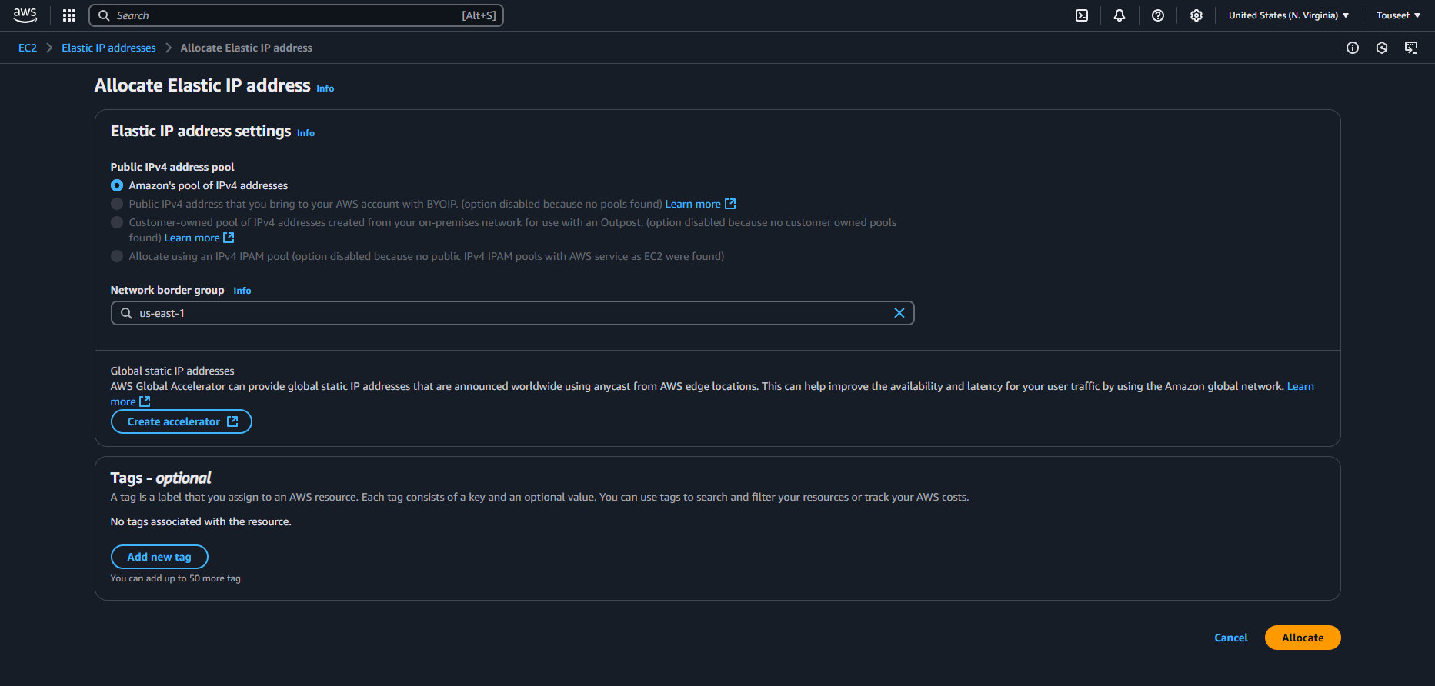

A random IPv4 public IP will be reserved in your AWS account as shown below. Now we need to assign it to our EC2 isntance.

Select the Elastic IP that you want to associate, go to Actions, select Associate Elastic IP address option.

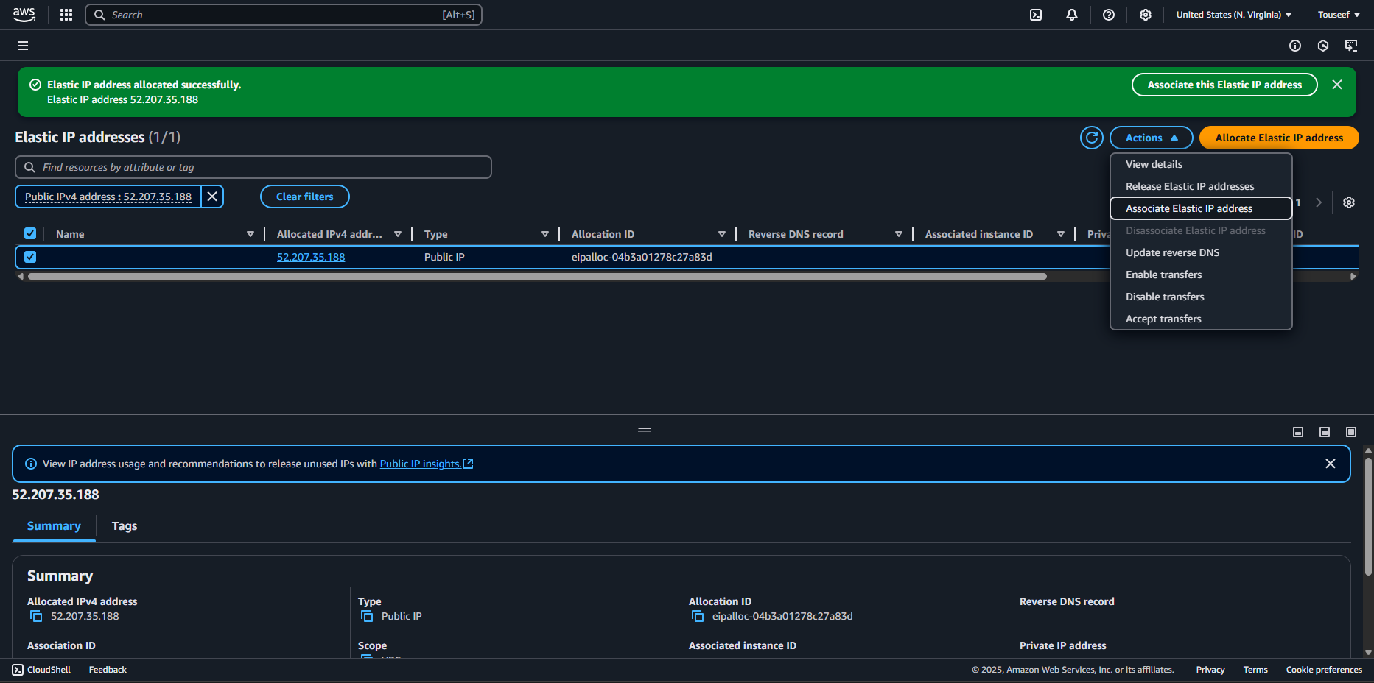

Here select your EC2 instance and press Associate.

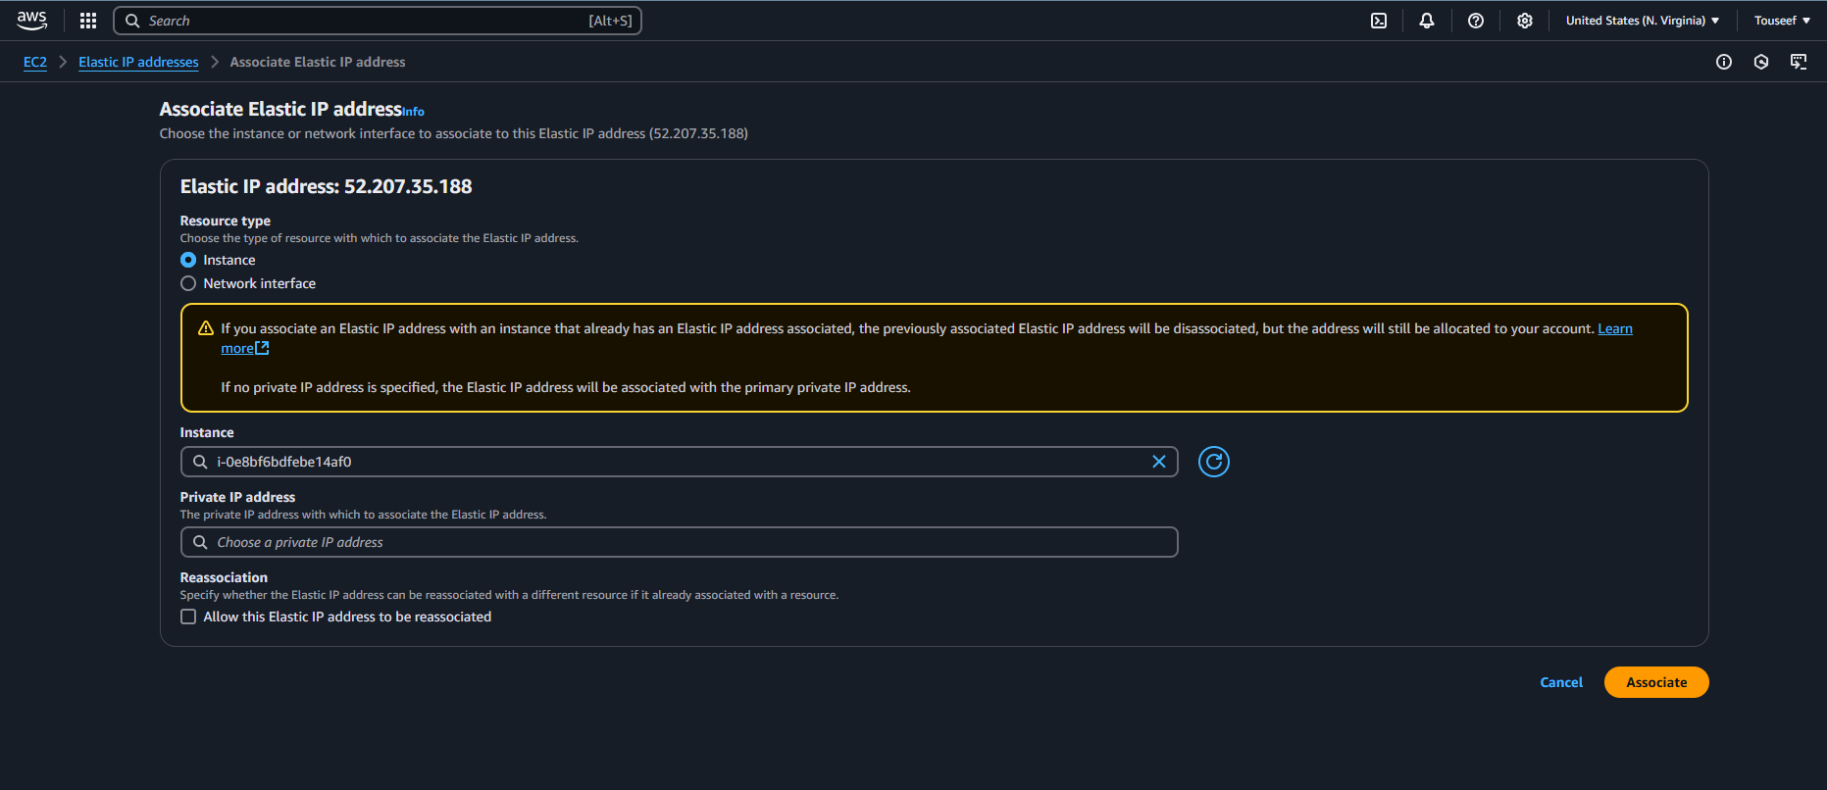

Now go back to your EC2 instance details. Here you would see that the Public IP of the instance has been replaced with the Elastic IP.

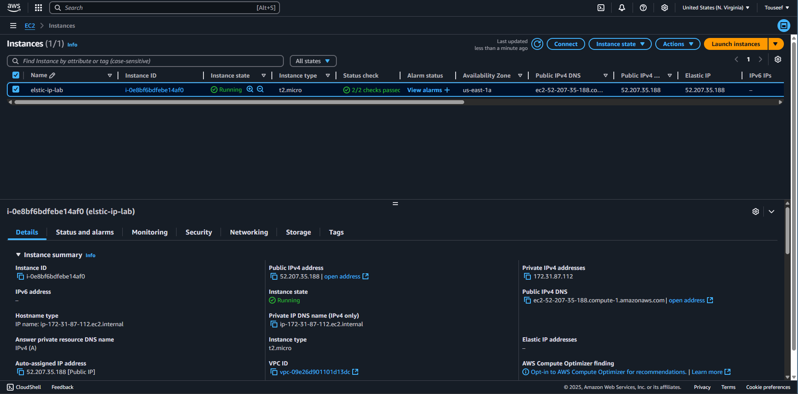

Now stop the instance. You would notice that the Elastic IP is still assigned to the instance.

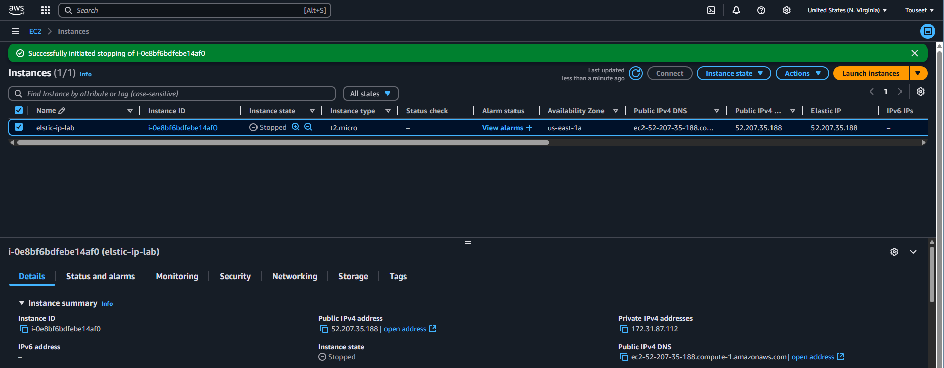

Now terminate the instance. You would notice that that Elastic IP get auto disassociated from the instance.

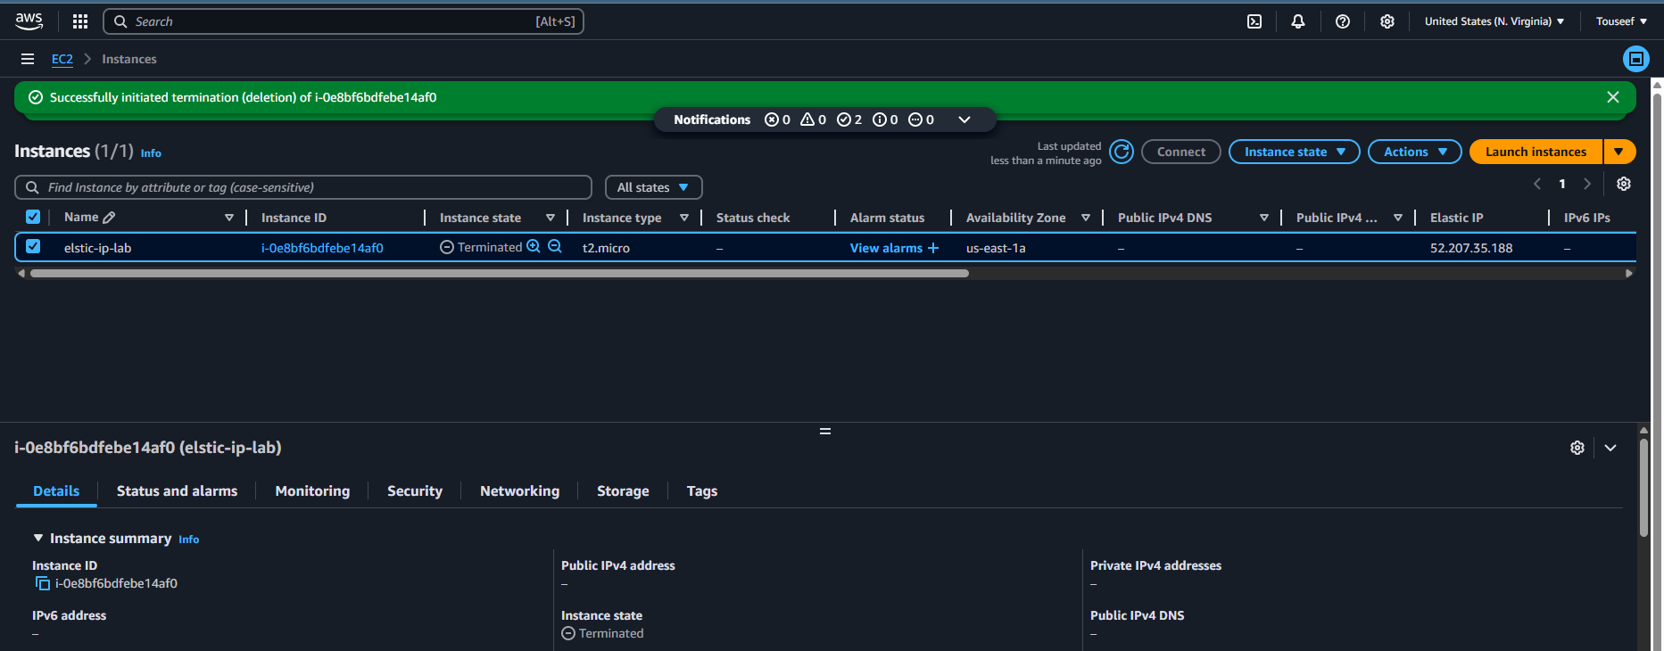

Now go back to the Elastic IP addresses page and you will see it is not associated with any instance.

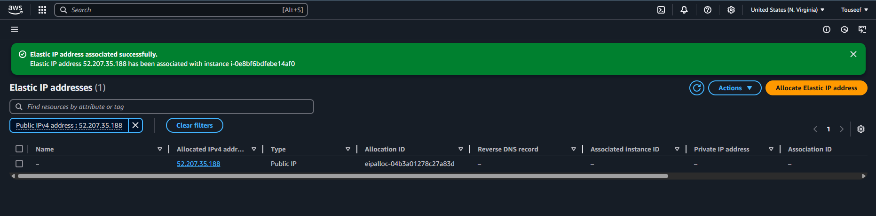

Now release the Elastic IP by selecting the IP and going to actions > Release Elastic IP addreses

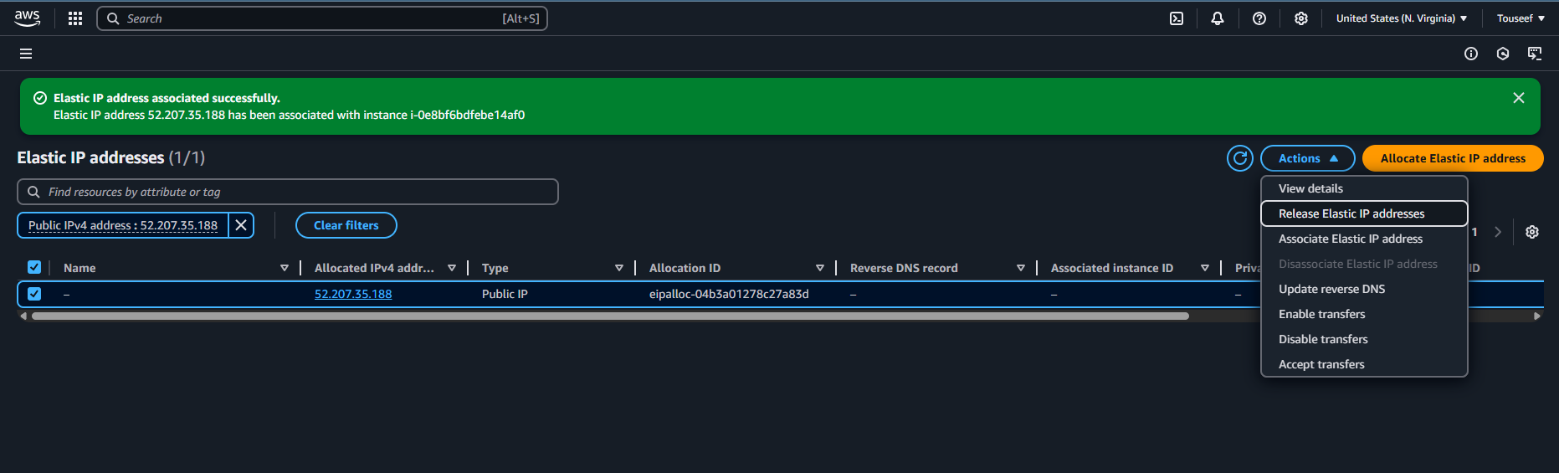

And confirm that you do want to release the IP address.

