­­­

Report

Title: Recovering Access to an EC2 Instance with a Lost Key Pair

# Setup

An EC2 instance who is no longer accessible due to lost key pair

Creating a fresh temporary EC2 instance with following configs;

* AMI => Amazon Linux OS
* Instance Type => T3.micro
* Create New Key Value Pair for SSH access (it will download the .pem file on your machine)
* Keep other at Default

# Procedure

This is the EC2 instance who is no longer accessible.

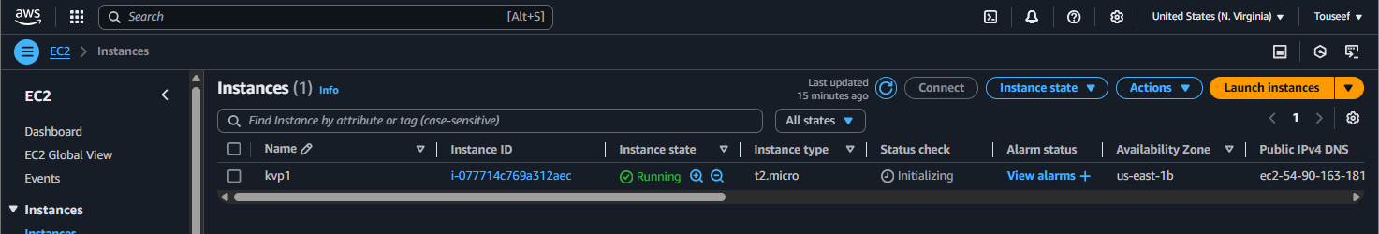

First step is to stop this instance, create a snapshot of the EBS volume (for backup, in case something goes wrong) and detach its default EBS volume as show below;

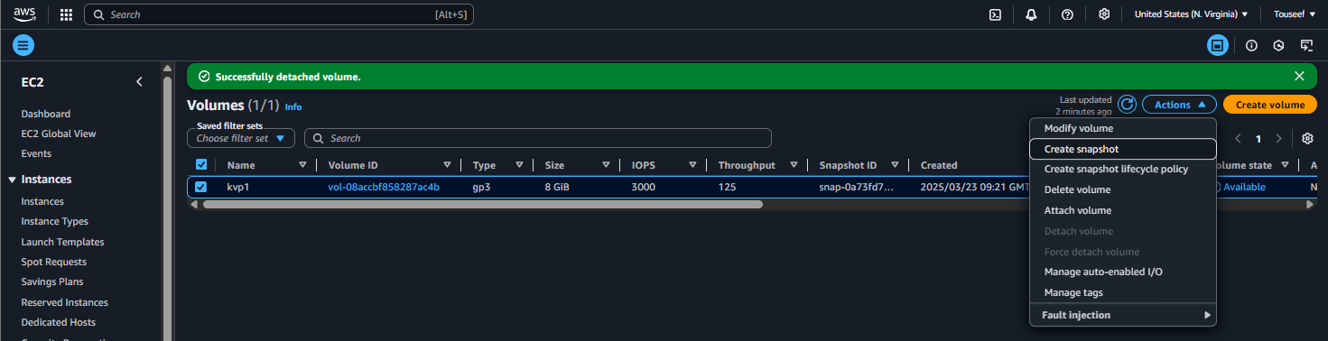

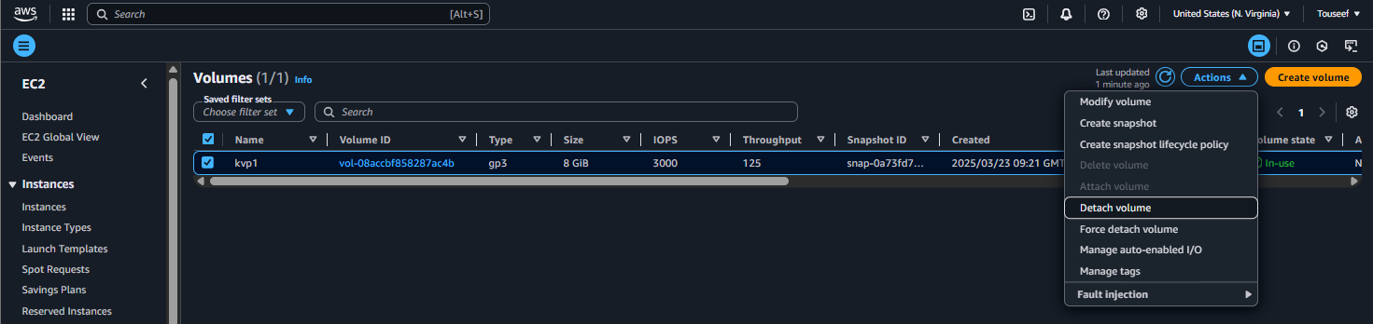

Launch a temporary fresh EC2 instance to help restore access to inaccessible EC2 instance. Attach the previous EC2 instance’s EBS volume to this new temporary instance as follow;

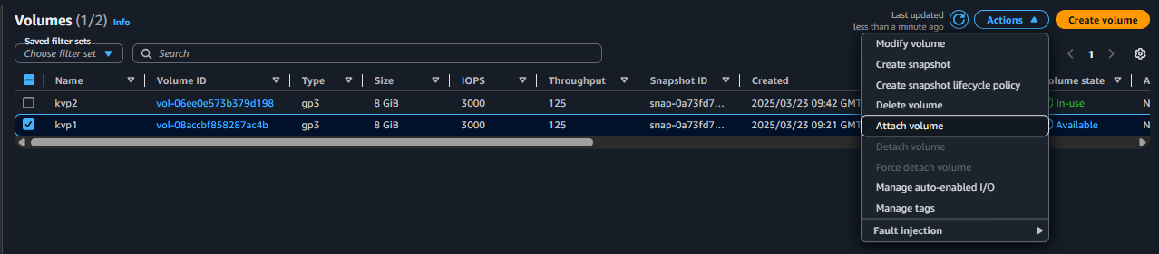

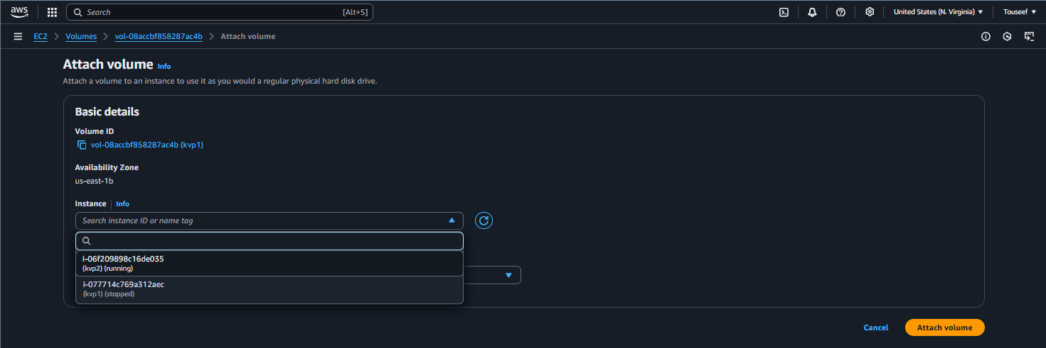

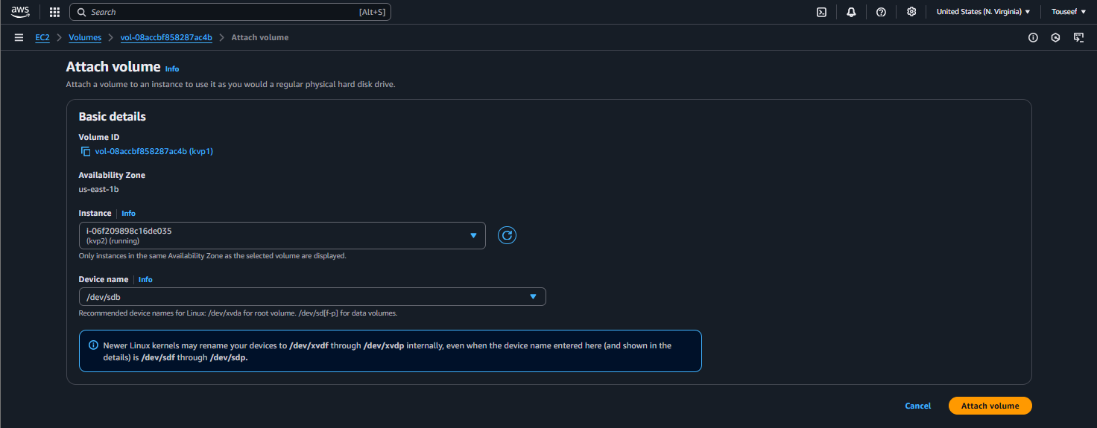

Now SSH to new temporary EC2 instance and mount the newly attached volume as follows;

List block devices, and find the newly attached volume. In my case it is xvdb;

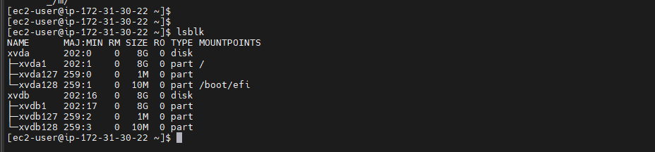

Switch to root user, and create a new mount location. Also find out the filesystem type of the new volume. The expected file system should be “/dev/xvdb1: Linux rev 1.0 ext4 filesystem data ...” but in our case, the file system is XFS file system. So mention the filesystem in mount command below.  
Note:   
/dev/xvdb = the whole disk  
/dev/xvdb1 = first partition (the actual filesystem is here)

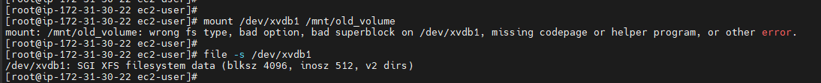

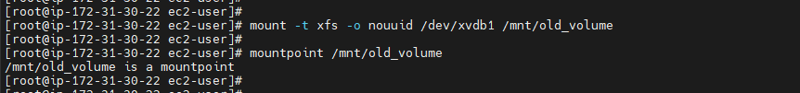

Note: Using -o nouuid in the mount command due to potential conflict of current EBS meta data with newly attached EBS metadata.

Now navigate to .ssh directory of the newly attached volume.

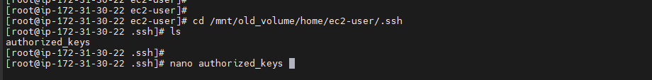

Generate a new key value pair as follows. It will generate two files <new-key> and <new-key.pub>

Save the <new-key> contents as a .pem file on your local machine as it is the private key you would use to ssh.

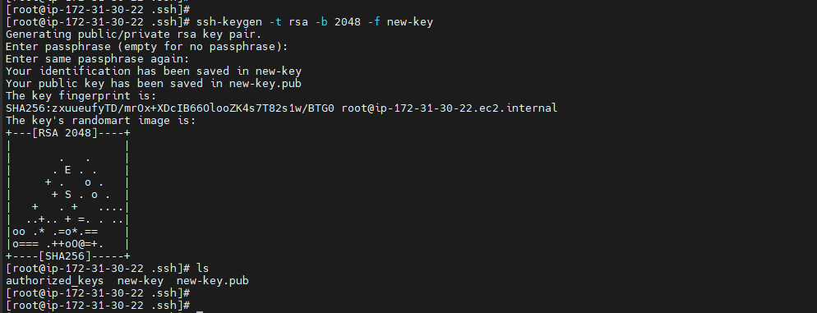

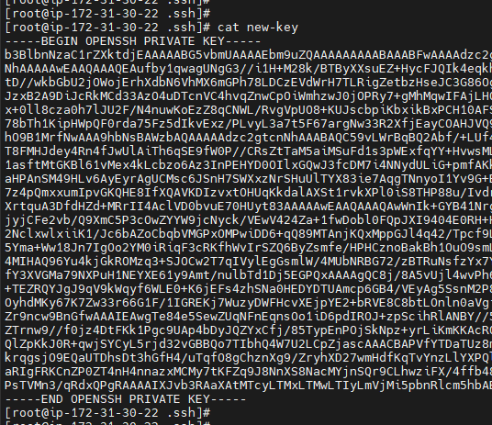

Replace the contents of the authorized_keys file with the contents of the <new-key.pub> file using the nano command.

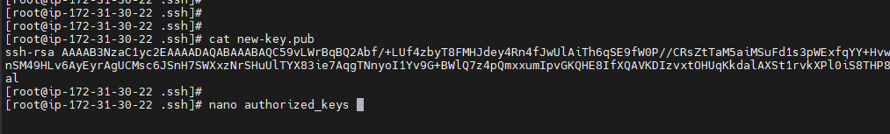

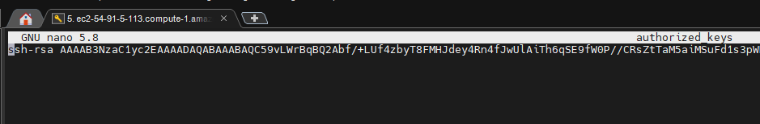

Remove the extra files.

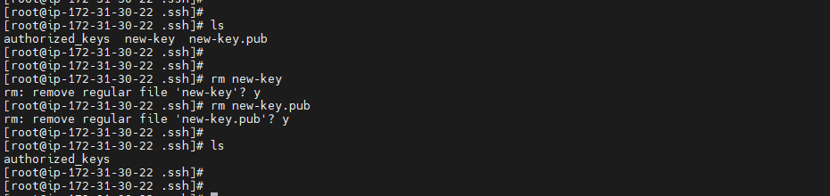

Now detach the new volume and attach back to previous instance at the root dir.

Start the instance, and try connecting using ssh with new .pem file.

Boom! You are in!