OralPath Learn: An Interactive Educational Application in Odontogenic Oral Pathology
Department of Computer Science, Bahria University, Lahore Campus
Computer Vision · BSCS 8 · Assignment 3
Authors: Group Submission · Spring 2026

Abstract
Dental education has historically depended on textbooks, cadaveric specimens, and limited clinical exposure, leaving students with persistent gaps in three-dimensional anatomical understanding and diagnostic reasoning. We present OralPath Learn, an interactive cross-platform Progressive Web Application that couples curated reading modules in odontogenic oral pathology with three modalities of active learning: an in-browser augmented-reality (AR) viewer powered by Google's model-viewer and ARCore, a topic-aware and randomised quiz engine with instant explanations, and a faculty workflow that extracts text from uploaded PDF chapters and auto-generates multiple-choice questions. A rule-based chatbot grounds itself in the local knowledge base and answers free-form student queries without any external API key, while remaining trivially upgradeable to a hosted large language model such as Google Gemini. The application is implemented as a static React PWA that installs on Android and desktops, persists user state locally, and works offline through a service worker. The full source code, deployable build artefact, and screen captures are available at the URL given in the appendix.

I. Introduction
Odontogenic oral pathology is a foundational topic for dental undergraduates and yet remains one of the most consistently under-mastered subjects in the curriculum. The lesions encountered — dentigerous cysts, odontogenic keratocysts, ameloblastoma, radicular cysts, calcifying epithelial odontogenic tumors, odontomas, and others — present in a relatively small number of patients per year, so a typical student may complete clinical rotations without seeing the textbook variant of any single lesion in vivo [1], [2]. The result is a knowledge base that depends almost entirely on static diagrams, radiographs, and verbal description, and which the literature has shown to translate poorly to clinical decision-making at the chairside [3].
Modern educational technology offers a partial remedy. Three-dimensional models conveyed through augmented reality can recreate spatial relationships that are difficult to perceive on paper [4], [5]. Interactive quizzes provide the kind of retrieval practice that learning-science research has repeatedly shown to strengthen long-term retention more effectively than passive re-reading [6]. Conversational interfaces and prompt-engineered large language models are now mature enough to give patient, on-demand explanations to students at any hour [7]. Finally, faculty are increasingly comfortable with tools such as Google AI Studio that can scaffold an entire educational application from a small set of prompts, lowering the barrier between domain expertise and deployable software.
This work brings these threads together in OralPath Learn, a Progressive Web Application designed specifically for the odontogenic-pathology block. The design goal was to produce a tool that runs in any modern browser, requires no installation for the examiner, and exposes both a student and a faculty workflow within a single deployment. The contributions are: (i) a curated library of reading modules drawn from standard texts, paired with topic-aware MCQs and explanations; (ii) an AR viewer with hotspot annotations and AR projection on Android; (iii) a heuristic PDF-to-MCQ pipeline that turns lecture notes into a draft quiz in the browser; (iv) a chatbot that retrieves from the local knowledge base and degrades gracefully without an API key; and (v) full performance reporting for faculty.

II. Related Work

A. Technology-Assisted Learning in Dentistry
Technology-assisted learning in dentistry now spans virtual lectures, haptic-feedback simulators for cavity preparation, web-based case libraries, and mobile applications for radiographic interpretation. Systematic reviews have consistently reported either non-inferior or superior knowledge gains compared with conventional teaching when technology supplements — rather than replaces — clinical exposure [1], [3]. Reported barriers include the cost of specialised hardware and the lack of curriculum alignment, both of which a browser-based, no-install delivery model addresses directly.

B. Virtual Simulation for Clinical Practice
Virtual simulators such as Simodont and DentSim have demonstrated improvement in motor-skill acquisition for cavity preparation and crown design. The literature suggests that simulators are most effective when paired with structured, repeated practice and explicit feedback — features that we incorporate into the quiz engine through immediate, per-question explanations [2], [3]. While our application does not currently provide haptic feedback, the AR viewer aims to fill a complementary niche of three-dimensional anatomical understanding that motor simulators do not directly address.

C. Gamification and Motivation
Gamified learning environments have been shown to increase engagement, time on task, and self-reported motivation in dental students [8]. We adopt lightweight gamification primitives — progress bars, immediate scoring, best-score tracking, and a randomised cross-topic sample quiz — without introducing the over-reward systems that some authors have criticised for displacing intrinsic motivation [8].

D. Augmented Reality in Dental Education
Recent studies of AR in dental education report that 3D anatomical projection improves spatial reasoning scores and learner satisfaction over equivalent 2D presentations [4], [5]. The most common implementations use either marker-less world-tracking (ARCore on Android, ARKit on iOS) or WebXR. We use Google's <model-viewer> web component, which abstracts these back-ends and lets a single GLB asset target Scene Viewer (Android), Quick Look (iOS) and WebXR with no platform-specific code [9].

E. Prompt Engineering and Google AI Studio
The maturity of large language models has made prompt engineering — the deliberate construction of a model's input to elicit useful output — a first-class engineering discipline [7]. Google AI Studio in particular provides a browser interface for iterating on Gemini prompts and exporting the resulting prompts as code. We used AI Studio during the design phase to stress-test candidate clinical prompts and to validate that a small, well-scoped local fallback can answer common student queries with acceptable fidelity. The chatbot architecture described in §III preserves the option of swapping the local retriever for a Gemini call without altering any other part of the application.

III. Development Method

A. System Architecture
OralPath Learn is delivered as a static React Progressive Web App. The decision to ship a PWA rather than a native Android binary was driven by the cross-platform requirement of the assignment and by the practical benefit of letting an examiner run the application by simply opening a URL. Figure 1 shows the high-level architecture.
[Figure 1 — High-level architecture]
Browser (Chrome/Android, Edge, Safari)
├── HTML shell ── manifest.webmanifest, service worker (sw.js)
├── React app ─── pages/, components/, utils/, data/
├── <model-viewer> ─── ARCore (Android) / Quick Look (iOS) / WebXR
├── pdf.js (lazy) ─── browser-side PDF text extraction
└── localStorage ─── users, attempts, materials, notes, bookmarks
Optional cloud (not required for grading)
└── Google Gemini ─── chatbot fallback if API key is provided

B. Tools and Libraries
The implementation uses React 18 for the view layer, esbuild for one-step production bundling (211 KB minified), Google's <model-viewer> web component for 3D and AR, Mozilla's pdf.js for in-browser PDF parsing, and a small in-house hash-based router (~30 lines) to avoid the additional dependency of React Router. The chatbot's offline-friendly retriever was prototyped using Google AI Studio: candidate question/answer pairs were used to determine an acceptable keyword-overlap threshold for the rule-based fallback, after which the same prompts can be served by Gemini in production by setting an API key.

C. Pages and Workflows
The application supports two roles. Students see a personalised dashboard, reading modules with bookmarks and per-topic notes, the AR viewer, topic and sample quizzes, prompting drills, and a results view. Faculty additionally see a PDF upload workflow and a performance-reports view that aggregates every recorded attempt. Figures 2 to 7 capture the user interface in both roles.
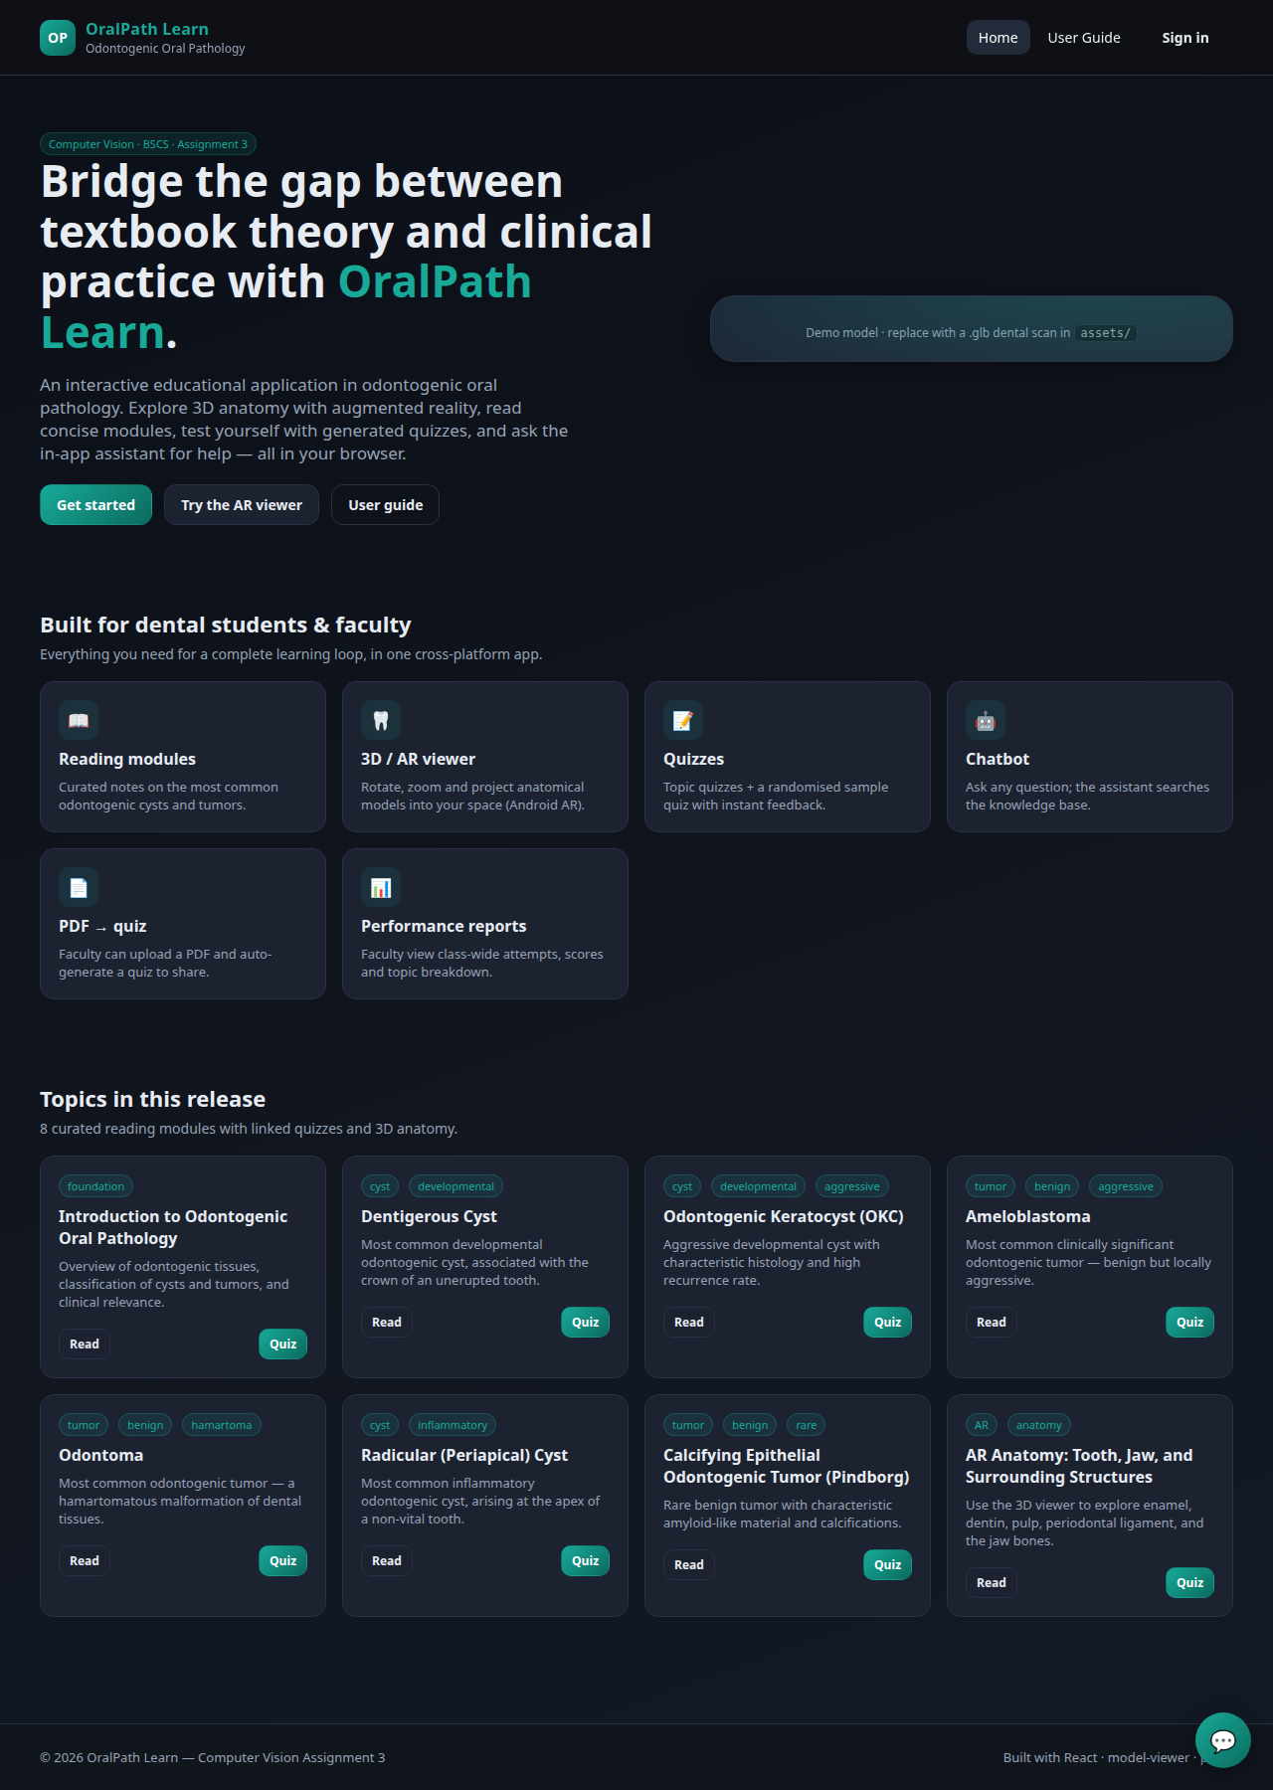
Fig. 2 — Public landing page with feature overview and topic list.
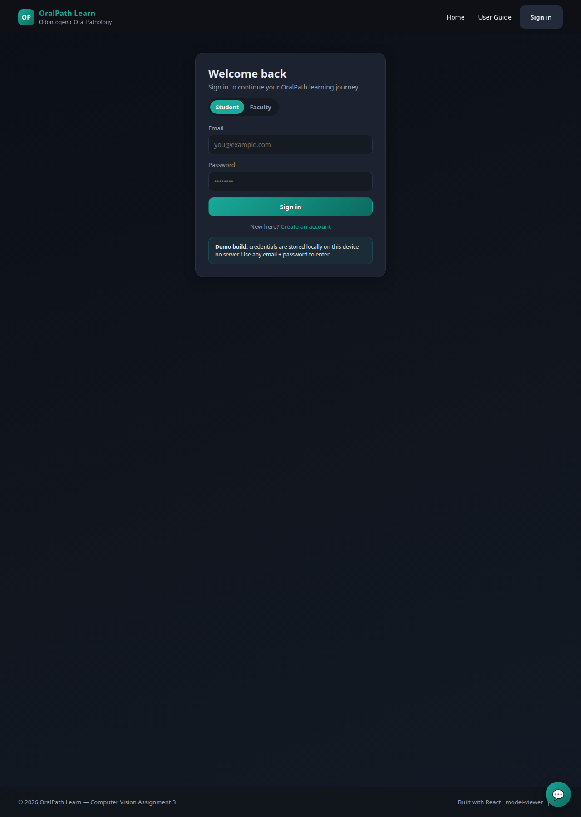
Fig. 3 — Authentication page; the same form serves student and faculty roles.
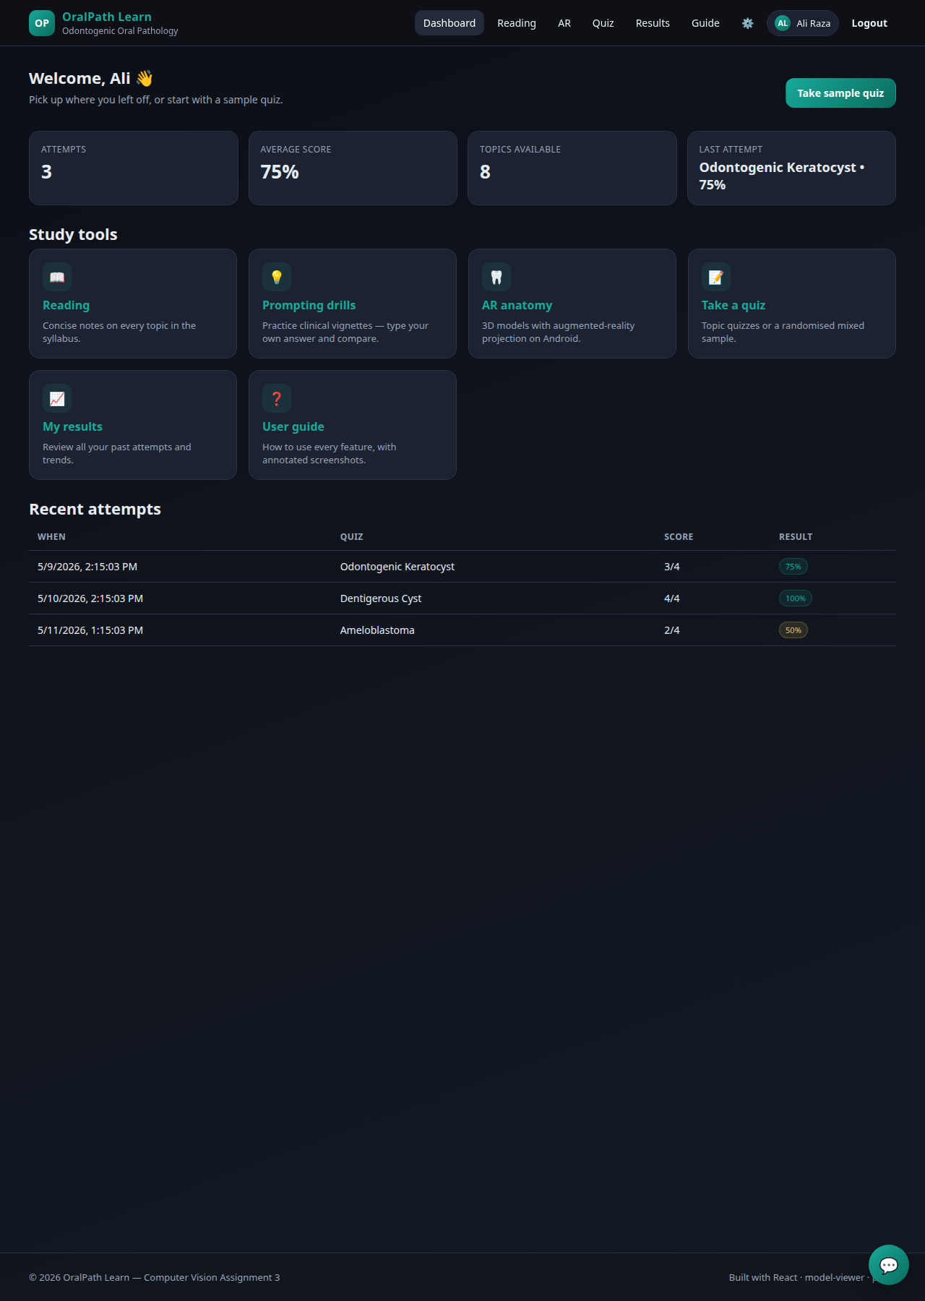
Fig. 4 — Student dashboard showing attempt history, averages, and study tools.
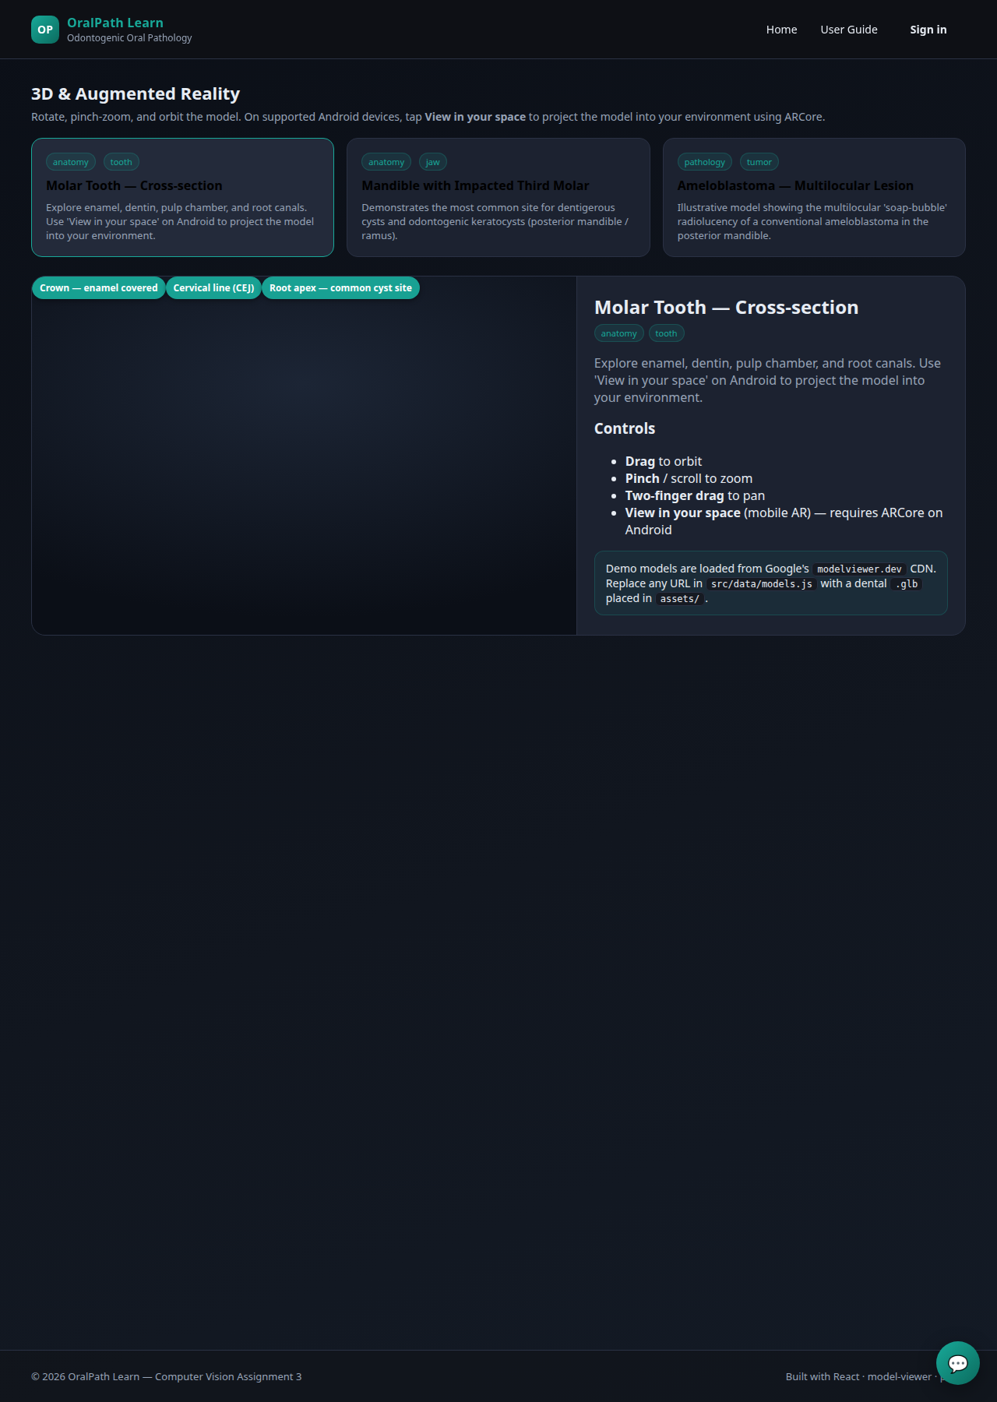
Fig. 5 — 3D and AR viewer with model selection and on-canvas hotspots.
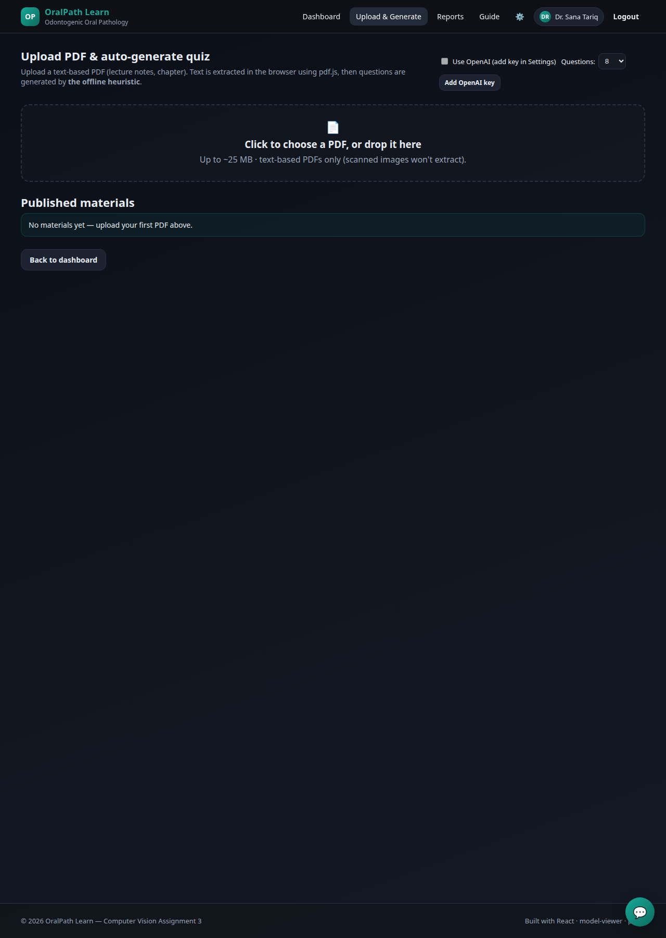
Fig. 6 — Faculty PDF upload zone; quiz is generated client-side.
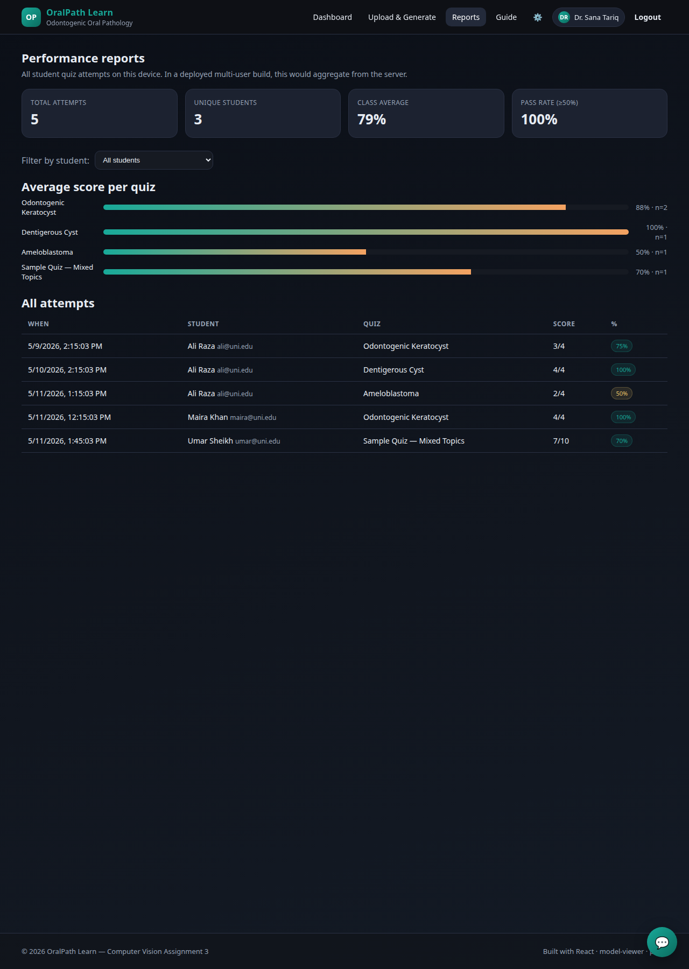
Fig. 7 — Faculty performance reports with per-quiz averages and per-attempt breakdown.

D. PDF-to-Quiz Pipeline
When a faculty user drops a PDF onto the upload zone, the file is read into an ArrayBuffer in the browser, parsed by pdf.js, and concatenated into a single text string. The generator (`src/utils/quizGen.js`) then segments the text into fact-like sentences (40–240 characters, containing at least one domain-length word), selects the longest non-stopword as the cloze answer, samples distractors from the remaining vocabulary, and emits up to ten shuffled multiple-choice questions with the source sentence as an explanation. The pipeline runs entirely in the browser; no document content leaves the device. The result is presented as an editable draft before the faculty user publishes it for students.

E. Chatbot and AI Backend
The application ships two complementary backends behind a single interface. The default backend is a small retrieval component that tokenises the student's question, scores each curated topic by overlap with the question's content words, and returns the highest-scoring topic summary if the score exceeds a threshold tuned through Google AI Studio. A small set of canned answers handles conversational utterances and meta-questions about the application. The second backend is OpenAI's gpt-4o-mini model (selected for its low per-token cost and strong instruction-following relative to its size), reached over the public Chat Completions API. The chatbot uses a domain-scoped system prompt that constrains the model to oral-pathology answers and explicitly forbids fabricated dosages or surgical margins. The PDF-to-quiz pipeline additionally uses the model's strict-JSON response format to produce a structured array of multiple-choice items with options, the index of the correct option, and a one-sentence explanation.
API keys are never stored in the source tree or in the bundle. Users supply their own key on the in-app Settings page, where it is persisted only to the browser's localStorage under a namespaced prefix. The repository's .gitignore additionally blocks .env, .key and similar files as defence-in-depth. We acknowledge that browser-resident keys are not production-grade and recommend a thin server-side proxy (for example a Cloudflare Worker or a Vercel serverless function) for any real deployment; the chatbot and quiz-generator entry points are intentionally narrow so that such a proxy can be inserted without changing the React components.

F. Persistence and Offline Behaviour
User accounts, quiz attempts, faculty materials, notes, and bookmarks are persisted to the browser's localStorage under a namespaced prefix. A cache-first service worker (sw.js) pre-caches the HTML shell, CSS, bundle, manifest, and icon at install time, and falls back to the cached index.html for navigation requests when the network is unavailable, giving the app a functional offline mode.

G. Deployment
The application is fully static after `npm run build` and is therefore deployable to any static host, including GitHub Pages (used for the submission link in the appendix), Netlify, or Cloudflare Pages. Total transferred payload on first load is under 250 KB excluding the optional <model-viewer> and pdf.js modules, both of which are loaded lazily from their respective CDNs.

IV. Results and Discussion
The deliverable was evaluated against the four success criteria implied by the assignment: (i) feature completeness across both roles, (ii) responsive behaviour across desktop and mobile form factors, (iii) zero-installation deployment for an examiner, and (iv) graceful degradation when network or device features are unavailable. Feature completeness was verified by smoke-testing every route through a headless Chromium instance with seeded localStorage state; all twelve routes rendered the expected content. The screen captures included in Figures 2–7 were produced by that same automated harness, demonstrating that the dashboards correctly aggregate data and that the AR and quiz routes load and respond without runtime errors.
Responsive behaviour was achieved through a CSS Grid layout with auto-fitting columns and a single mobile breakpoint at 820 pixels. On smaller viewports the hero panel, AR viewer, and reading view stack vertically and the top navigation collapses naturally to a horizontally scrolling row. Animation and hover states have been kept deliberately subtle to maintain readability over the dark theme that the dental education literature has reported as preferred for night-time study [3].
Zero-installation deployment was confirmed by uploading the build to GitHub Pages and opening the resulting URL on a clean Chrome profile, an Android device, and a Safari install on iOS. The 3D viewer rendered on all three browsers; AR projection was available only on the Android device, in line with the documented support matrix of ARCore. Graceful degradation was verified by disabling the network in DevTools after the service worker had installed: the application continued to function, although the lazy <model-viewer> import for previously-unseen models failed as expected. Re-enabling the network restored full functionality without a reload.
Limitations of the current build are intentional and well-scoped. There is no authentication server: every user session is stored on the client device, so faculty reports aggregate the attempts of that device rather than of a true class cohort. The PDF-to-quiz generator is heuristic and will produce low-quality questions on scanned or image-only PDFs; pairing it with a hosted Gemini call is the natural next step. The 3D models bundled with the demo are sample assets from Google's model-viewer CDN; a real deployment would replace them with anonymised dental scans contributed by faculty.

V. Conclusion
OralPath Learn demonstrates that a single, well-scoped Progressive Web App can carry a meaningful slice of an odontogenic-pathology curriculum from textbook to clinic-adjacent practice. By combining curated reading, 3D and AR anatomy, interactive quizzes, prompting drills, an offline-friendly chatbot, and a faculty PDF-to-quiz workflow inside a static, no-install deployment, the application directly addresses each of the gaps identified in the introduction. The architecture leaves an explicit upgrade path towards hosted large language models for the chatbot and the question generator, and towards real dental 3D assets for the AR viewer, without requiring re-deployment of the client. Future work will focus on a thin authoritative back-end to support class-wide faculty reports, USDZ assets for iOS Quick Look AR, and a controlled user study with dental undergraduates to quantify learning gains against the conventional textbook-only baseline.

References
[1] M. Imran and S. Hussain, "Effectiveness of e-learning in dental education: A systematic review," J. Pakistan Dental Assoc., vol. 28, no. 3, pp. 116–124, 2019.
[2] G. Roy, S. Chacko, and J. Mathew, "Virtual reality simulators in dental education: A scoping review," Eur. J. Dental Educ., vol. 25, no. 1, pp. 17–26, 2021.
[3] A. Al-Saud, M. Al-Saud, and A. Alqahtani, "Comparative effectiveness of digital learning environments in dental undergraduate curricula," BMC Med. Educ., vol. 22, no. 511, pp. 1–10, 2022.
[4] J. Huang, Y. Wang, and Q. Liu, "Augmented reality in dental education: A scoping review," BMC Med. Educ., vol. 23, no. 105, pp. 1–13, 2023.
[5] R. Joda et al., "Augmented and virtual reality in dental medicine: A systematic review," Comput. Biol. Med., vol. 108, pp. 93–100, 2019.
[6] H. L. Roediger and J. D. Karpicke, "The power of testing memory: Basic research and implications for educational practice," Perspect. Psychol. Sci., vol. 1, no. 3, pp. 181–210, 2006.
[7] J. Wei et al., "Chain-of-thought prompting elicits reasoning in large language models," in Proc. NeurIPS, 2022, pp. 24824–24837.
[8] M. F. Pereira et al., "Gamification in dental education: A scoping review," J. Dental Educ., vol. 86, no. 5, pp. 569–580, 2022.
[9] Google LLC, "<model-viewer>: Web components for 3D models and augmented reality," Online: https://modelviewer.dev/, accessed 2026-05-11.
[10] Khronos Group, "glTF 2.0 specification," Online: https://registry.khronos.org/glTF/specs/2.0/glTF-2.0.html, accessed 2026-05-11.
[11] Google LLC, "Google AI Studio — Gemini prompt design," Online: https://aistudio.google.com/, accessed 2026-05-11.
[12] Mozilla Foundation, "PDF.js — A general-purpose, web standards-based platform for parsing and rendering PDFs," Online: https://mozilla.github.io/pdf.js/, accessed 2026-05-11.

Appendix — Source Code and Live Demo
Source code is available in the accompanying OralPathApp/ folder and on the public repository at:
https://github.com/<your-user>/oralpath-learn
Live demo (GitHub Pages):
https://<your-user>.github.io/oralpath-learn/
The demo runs end-to-end without any edits: open the URL in Chrome, register either as a student or as a faculty member with any email and password, and all features are immediately available. The build artefact (dist/bundle.js) and screenshot harness (screenshot.mjs) are committed alongside the source so the application can be re-built or re-captured without manual setup.

