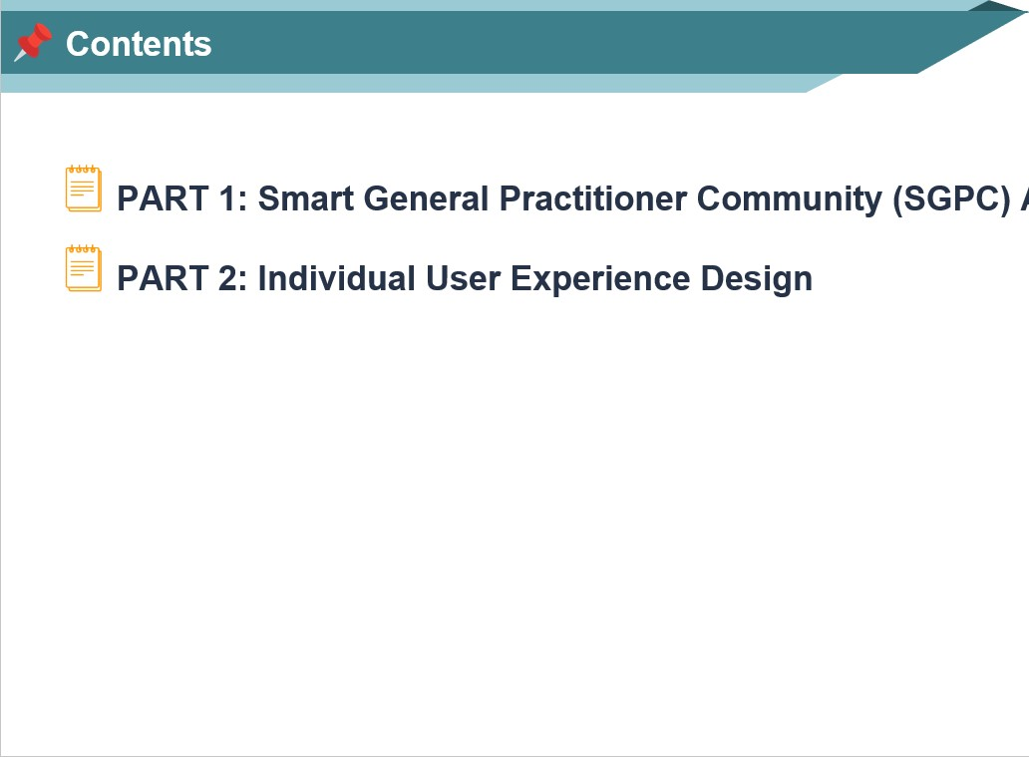
App

Assessment ( 100 % )

ASSESSM
HECK
and to EVAL
Source: eLearning Industry
must be a be
The purpose of this assignment is to assess students' understanding of user experience and user interface, apply their understanding to real application development based on user experience (UX) design.
The assignment consists of two parts, and each part performed according to the requirements. You must submit report which meets the specified criteria. The report should no longer than 2500 words ± 10%.
In particular, the Part 1 requires you to develop a mobile application based on your user experience design outcome even though the development mainly focuses on the application's user interface. The Part 2 does not require development but only user experience design.
any


Smart General Practitioner Community — Background
providing
GPs
treatment Source: Which.co.uk diagnose
and and
In the UK, general practitioners (GPs) act as family doctors, comprehensive and ongoing healthcare to patients of all ages. are often the first point of contact for individuals seeking and play an important role in the healthcare system. They and treat a wide range of health conditions, manage chronic diseases, and provide preventive care such as immunisations health screenings. Your GP will also provide health education lifestyle advice to support your overall wellbeing and prevent illness.
GPs often work in community settings, such as group clinics health centres, coordinating care with other health professionals including specialists, nurses and allied health workers. They maintain detailed patient records to ensure of care and make referrals to specialists when necessary. GPs also provide mental health support, manage long-term conditions and have home visits for patients who are unable attend surgery.
or
continuity can
to
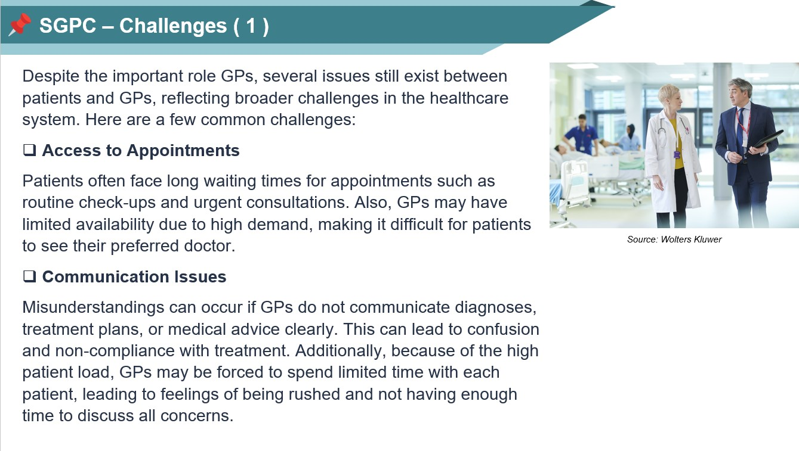

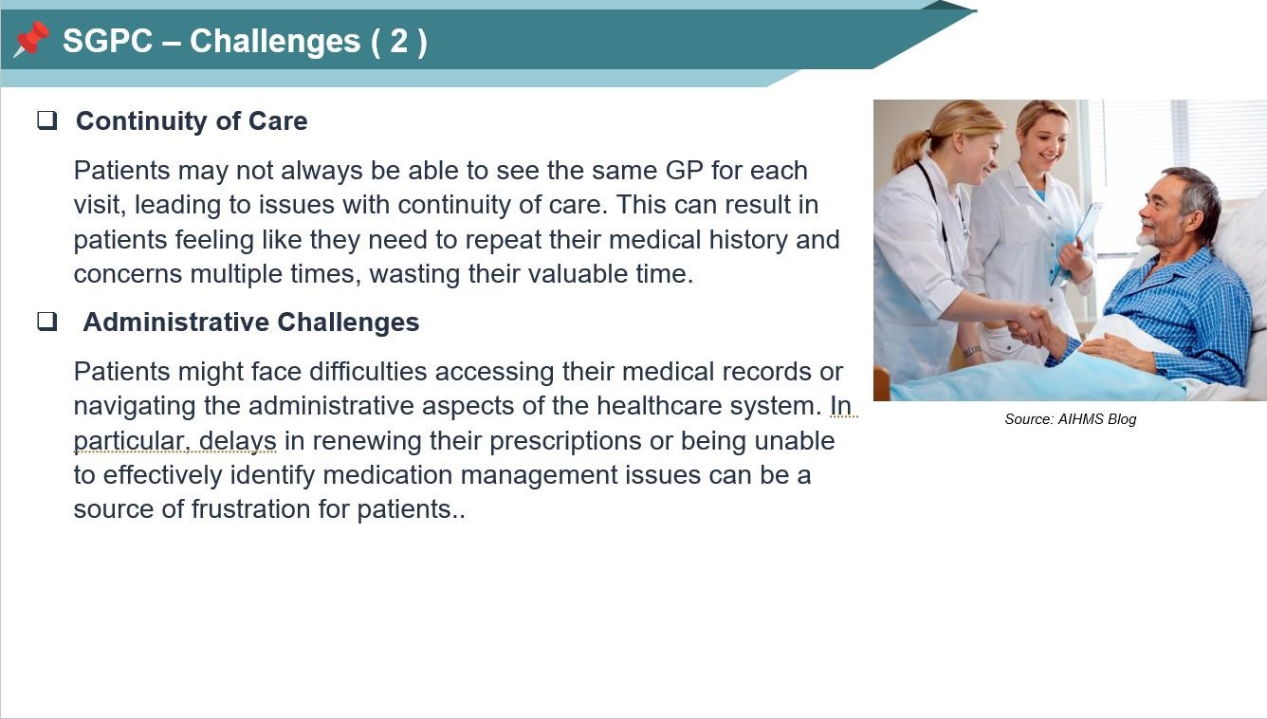

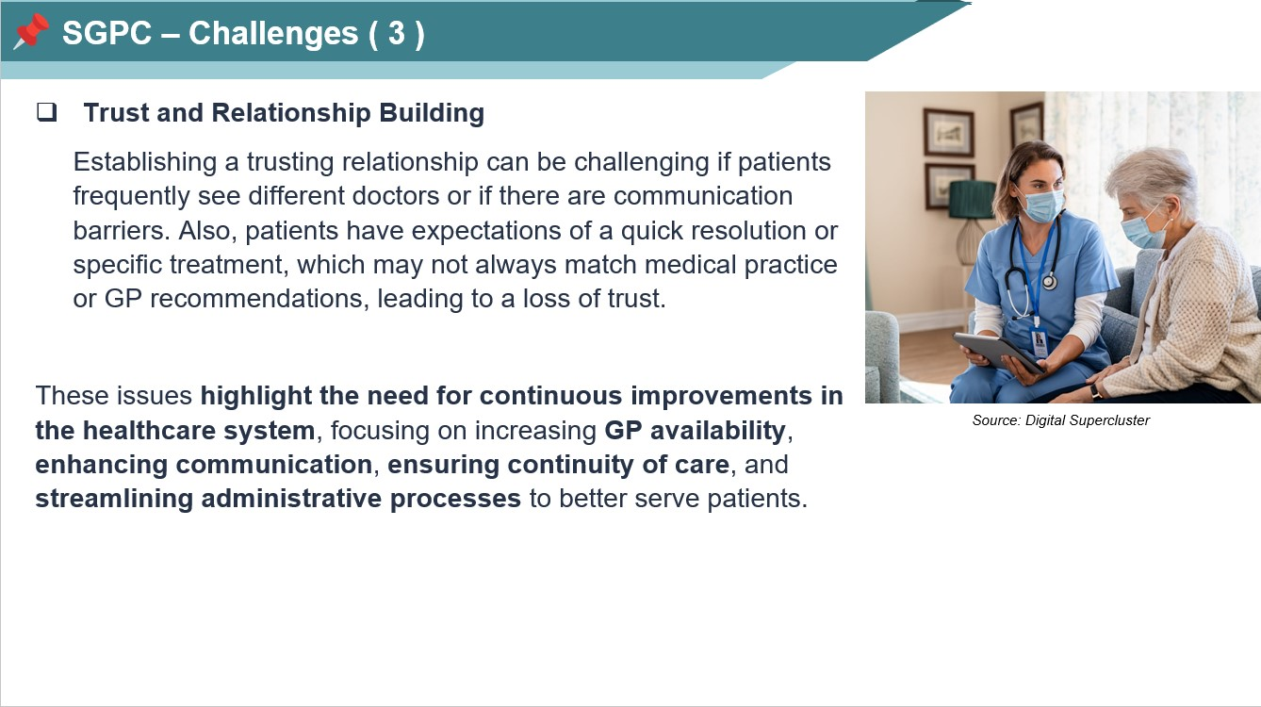
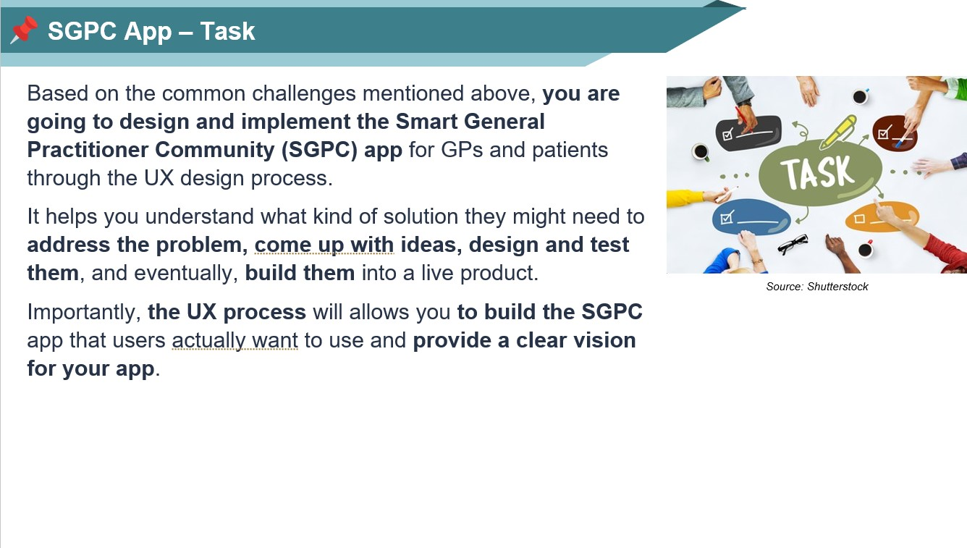

You can consider various actions for the SGPC UX design and implementation. These actions can be explored through the UX design process, resulting in various deliverables. While you cannot include all the UX deliverables in your report, at least the following deliverables must be included, but one from Option A and one from Option B:
Interview or Survey: You must conduct interviews or surveys. There is no limit on the number of people due to time constraint, but it is recommended to have at least 2 people for interviews or surveys. The data from the interviews or surveys should be used in your UX design methods.


UX Research Methods
Source: Octet Design Studio
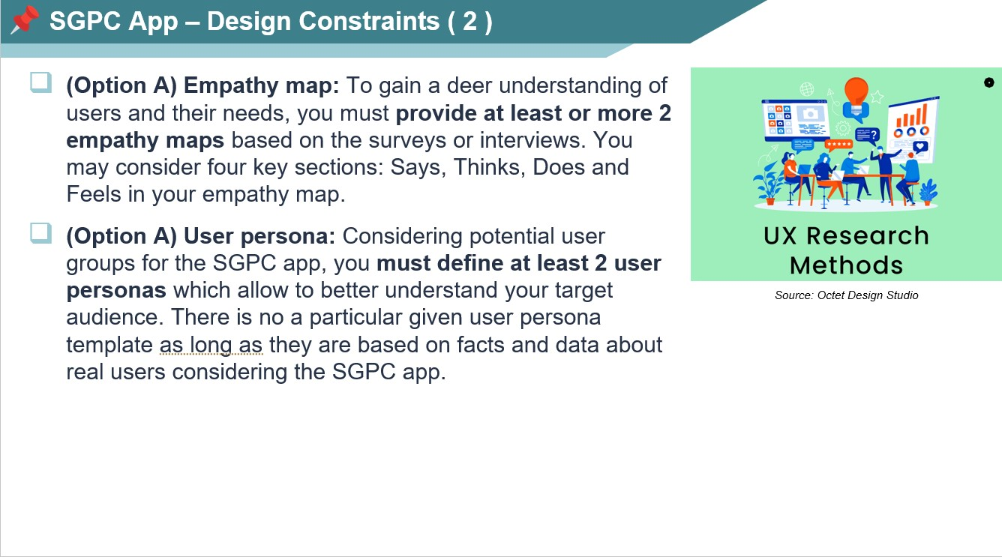

Competitive analysis: To understand market, service, product, and goals better, you must conduct competitive analysis. You should select at least 2 competitors and include your findings in the report.
UX Research Methods
Source: Octet Design Studio
(Option B) Journey map: To understand the overall user experience and set of actions of the SGPC app, you must provide a journey map which depicts visually the processes that a user goes through in order to accomplish a goal.
(Option B) User flow: To give stakeholders a better understanding of specific tasks in the SGPC app, you must provide a path that a user goes through when using the app from the start point to the final interaction using user flow. You must include at least 2 user flows in the report but more user flows if necessary.

Source: Octet Design Studio
than
UX Research Methods
report.
Low-fidelity wireframe: You must design a low-fidelity wireframe for the SGPC app. The low-fidelity wireframe must be drawn on paper using a pen or pencil rather digital. Then, the wireframe should include at least 5 screens for the SGPC app with description in your
High-fidelity prototype: Based on the low-fidelity wireframe, you must create high-fidelity prototype Figma. You can add interactions into the prototype for usability testing. Then, you should include the captured images with description in your report.
Usability testing: You should conduct the usability testing using interactive high-fidelity prototype in to identify any usability issues, obstacles or areas for improvement in the design.
using
Source: Octet Design Studio
order

Implementation Constraints ( 1 )
must
Kotlin.
design to
Based on the deliverables from UX design process, you implement the SGPC app using Android studio with
Due to time constraints, your main focus will be on the of the SGPC app implementation. However, it is beneficial implement some of the functionalities of the SGPC app.
It is also recommended to develop the SGPC app to be similar as possible to the high-fidelity prototype. Detailed instructions for the implementation are given in the next

as
Source: slide.
You must provide a zip file containing all source code but should not include dependencies. The Android studio provides an option to export a project to a zip file.
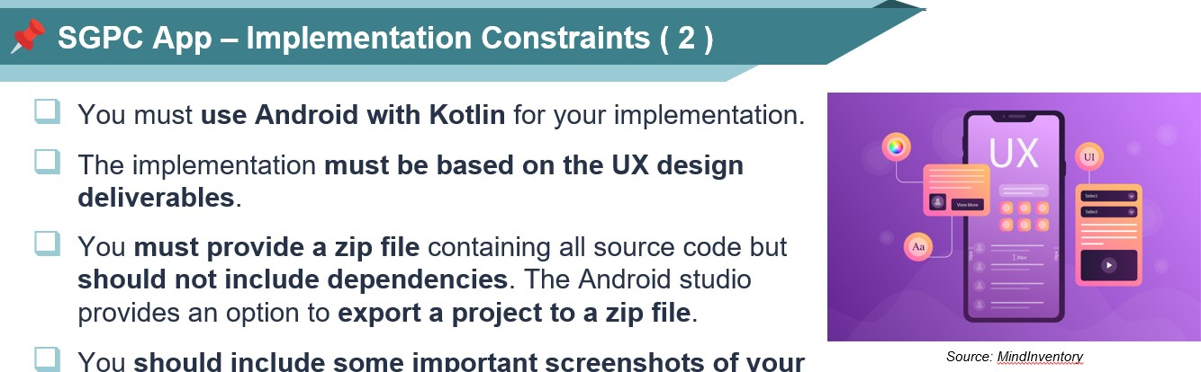
You should include some important screenshots of your app in your report to confirm the implementation of the SGPC app, alongside with some code if necessary.
You must provide a video which shows your SGPC app running. The video must be less than 2 minutes.
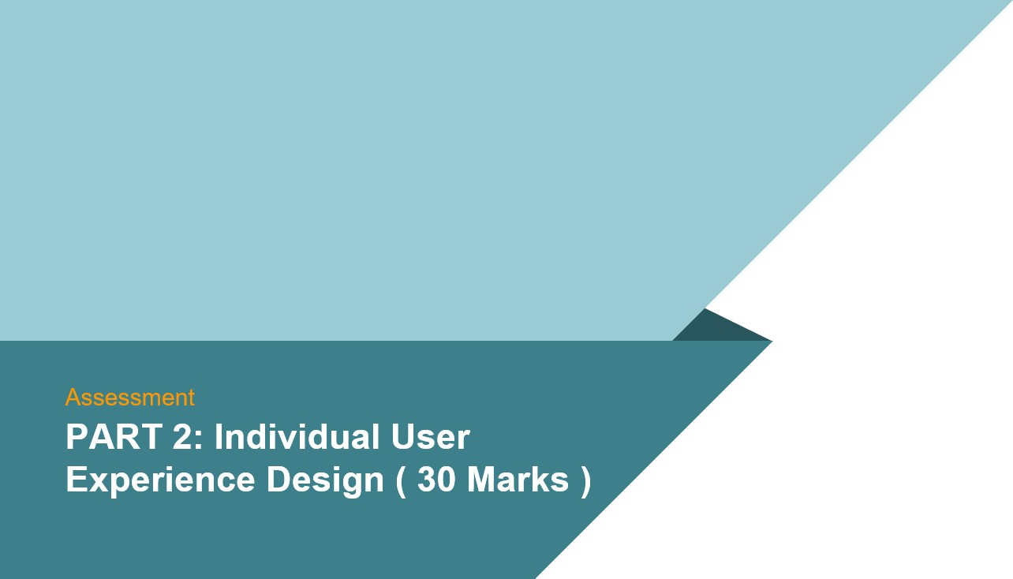

It is time to conduct an individual user experience design based on any idea that pops into your head or has already been in your mind.
In order to successfully develop your idea into an app, the UX design process is essential because it takes a user-centric approach by understanding the needs and preferences of the target users.
Source: Shutterstock
So, you can create your app interfaces and features that align with user expectations, resulting in more intuitive and enjoyable user experience.
Due to the time constraints, you fucus on conducting user experience research and designing wireframes.
Intended

Learning 100% 58% 55% 48% 45% 38%
Outcome or Comments Exceptional 1st High upper Lower Low High Mid Low High Mid Low High Mid Low 3rd Low Fail
Evaluative 1st Mid 1st Mid 1st 1st 21 3rd 3rd
Criteria
Exceptional work of the Very high-quality work High quality work Competent work, Work of limited quality, Work does not meet Poor quality work Work of no LOI: This is Partl of the highest quality, demonstrating excellent demonstrating good demonstrating reasonable demonstrating some standards required for well below the merit OR Describe what is assignment to demonstrating knowledge andexcellent analysis, knowledge organisation,and understand ng: knowledge understanding, andanalysis: knowledge understanding, andsome relevant understandingknowledge and the Honours Level degree6 of an standardsrequired for the Absent,work not meant by design and understanding, analysis: accuracy, relevance, organisation, accuracy: analysis, organisation, Level 6 of an submitted, accessibility and implement a mobile organisation, accuracy: presentation, and appropriate relevance, presentation, accuracy, relevance, There is evidence of Honours degree penalty in usability in user- app through UX relevance, presentation, skills and appropriate skills. presentation, and study and some basic some experience design design process, and appropriate skills. appropriate skills understanding of misconduct process. based on the given relevant concepts and cases scenario. techniques, but subject
L02: (70%) All the deliverables for the All the deliverables for the Part All the deliverables for All the deliverables for the Some of the deliverables to significant omissions
Describe how Part 1 are excellent work 1 are complete with enough the Part 1 are complete Part 1 are complete but for the Pan 1 are not and errors (38) for the given scenario and information for the given and the content is Just are no sufficient provided or there are user experience it also includes extra scenario. enough for the given The mobile some major errors In Work is significantly design fits within deliverables The mobile implementation scenario. implementation based on mobile implementation, below the standard a company's The mobile based on the UX design is The mobile the UX design is provided providing different or required for Level 6 of business implementation based on complete and sufficient to implementation based but includes minor errors wrong results. an Honours operations. the UX design is excellent demonstrate on the UX design is The report is complete, The report is not complete Some evidence of study
The report is complete with provided without minor but some content is not and have missing parts. and some knowledge
L03: The report is complete enough information. errors and the sufficient and evidence of under-
Undertake with excellent informatiom implementation is just standing but subject to enough very senous omissions
analysis and
The report is complete. and errors (32)
design a usable, useful and Exceptional work of the Very high-quality work High quality work Competent work, Work of limited quality, Work does not meet Poor quality work Work of no This is Part 2 of the highest quality, demonstrating excellent demonstrating good demonstrating reasonable demonstrating some standards required for well below the merit OR desirable assignment to demonstrating excellent knowledge and understand ng: knowledge and knowledge and under- relevant knowledge and the Level 6 of an standards Absent, interface knowledge and analysis, organisation, understanding, analysis: standing, some analysis: understanding Honours degree required for the work not considering showcase yourthe UX understanding, analysis: accuracy, relevance, organisation, accuracy: organisation, accuracy: Level 6 of an submitted,
project using
customer organisation, accuracy: presentation, and appropriate relevance, presentation, relevance, presentation, There is evidence of Honours degree penalty in requirements design based on relevance, presentation, skills and appropriate skills. and appropriate skills. study and some basic some own scenario. and appropriate skills. understanding of misconduct (30%) relevant concepts and cases
Develop a techniques, but subject
The deliverables for Part 2 The deliverables for Part 2 are The deliverables for Part The deliverables for Part The deliverables Part 2 to significant omissions prototype based are exceptional and the provided with enough 2 are prov ded and the 2 are provided, but not are very lacking and errors (38) on the UXO content is excellent information and the content is content is just good sufficient The report is not complete incorporating user enough to showcase your very enough to showcase your enough to showcase The report is complete, and have missing parts. Work is significantly preferences. portfolio based on the UX portfolio based on the UX your portfolio based on but some content is not below the standard design. design. the UX design. sufficient required for Level 6 of
L05: The report is complete The report is complete with The report is complete. an Honours
Interpret, with excellent informatiom enough informatiom

Some evidence of study implement, and and some knowledge and evidence of undertest the design standing but subject to
and prototype for very senous omissions usability and and errors (32)

accessibility.

