Accident Hotspot Identification and Visualization

1. Overview
This project aims to identify accident hotspots across the United States by analyzing traffic accident data, categorizing geographic regions into smaller blocks, and visualizing accident-prone areas based on user inputs such as location, time, and day of the week.

2. Data Sources
A. National Highway Traffic Safety Administration (NHTSA)
• Fatality Analysis Reporting System (FARS) dataset (2019–2023) retrieved via:
https://crashviewer.nhtsa.dot.gov/CrashAPI/FARSData/GetFARSData?dataset=Accident&FromYear=2019&ToYear=2023&State=*&format=csv
B. San Francisco Government Open Data
• Traffic_Crashes_Resulting_in_Injury_20250319.csv
• Source: https://data.sfgov.org
C. California Open Data Portal
• File Names:
– hq1d-p-app52dopendataexport2022crashes.csv
– hq1d-p-app52dopendataexport2023crashes.csv
– hq1d-p-app52dopendataexport2024crashes.csv
– hq1d-p-app52dopendataexport2025crashes.csv
• Source: https://data.ca.gov
D. Additional Combined Dataset
• Approximately 1 million entries generated from merging all above sources.

3. Data Preparation
- Loaded data into a Pandas DataFrame.
- Cleaned data by removing records with missing latitude or longitude information.
- Renamed columns for consistency (HOUR to hour, DAY to day).
- Ensured the data types for latitude and longitude columns were floats for accurate geographic calculations.

4. Methodology
The project identifies hotspots using a geographic grid. The U.S. geographic area is divided into blocks of size 0.005 degrees (~0.5 km). Each accident is assigned to a block based on its latitude and longitude.

5. Hotspot Calculation
- Each accident’s grid cell is determined by latitude/longitude.
- Accident frequencies within each grid cell are computed.
- Cells with counts ≥ the 90% are classified as hotspots.

6. Time and Day Filtering
Data is filtered based on user input for hour (0–23) and day of the week (1=Monday, ..., 7=Sunday). Weekdays (1–5) or weekends (6–7) and interval of 3 hours are supported.

7. Visualization
- Folium library for geographic mapping.
- Heatmaps show overall accident densities.
- Polygon overlays highlight hotspot blocks.
- User location is marked distinctly.

8. Technical Implementation
Implemented with FastAPI for robust, scalable backend API deployment. Maps are generated dynamically and served as HTML, enabling quick visualization within any modern web interface.

9. API Integration
Endpoints:
• POST /analyze-accidents/ : Accepts JSON data (latitude, longitude, hour, day_of_week)
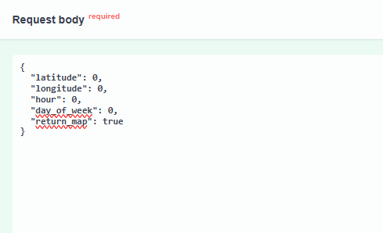
• Returns JSON with:
map_id, map_url, hotspot_nearby (bool), user_location
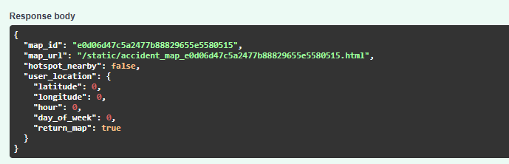
• GET /view-map/{map_id} : Returns the generated Folium map HTML.

How to Run This Project
1. Install Dependencies:
pip install fastapi uvicorn folium numpy pandas
2. Project Structure (example):
├── main.py
├── data
│ └──df_combined.csv
└── static
3. Run the Application:
uvicorn main:app --host 0.0.0.0 --port 8020
4. Access Endpoints:
• http://localhost:8020/docs for interactive API docs
• /analyze-accidents/ endpoint for sending user inputs and viewing generated maps.

