global cargo service
Group Member’s
1-Abdul Samad
2-Muhammad Danish
3-Imtiaz Hussain
April, 2020
Benazir Bhutto Shaheed University Lyari
Chakiwara Campus.

WORKING DISCRIPTION

ABOUT WEBSITE WORKING

ALL LINKS WORKING
WEBSITE DESIGN BEAUTIFUL COLOR
TESTING OK

ABOUT GROUP MEMBER WORKING

WEB TESTING: Muhammad Danish & Abdul Samad &
Imtiaz Hussain

WEB DEVELOPING: Muhammad Danish & Abdul Samad &
Imtiaz Hussain

WEB DESIGNING: Muhammad Danish & Abdul Samad &
Imtiaz Hussain

WEB DOCUMENTATION: Muhammad Danish & Abdul Samad
& Imtiaz Hussain

DATA COLLECTION: Muhammad Danish & Abdul Samad &
Imtiaz Hussain

Table of Content

- Introduction
- Problem Statement
- Hardware/ Software Requirements

Introduction

The thirst for learning, upgrading technical skills and applying the concepts in real life environment at a fast pace is what the industry demands from IT professionals today. However busy work schedules, far-flung locations, unavailability of convenient time-slots pose as major barriers when it comes to applying the concepts into realism. And hence the need to look out for alternative means of implementation in the form of laddered approach.

The above truly pose as constraints especially for our students too! With their busy schedules, it is indeed difficult for our students to keep up with the genuine and constant need for integrated application which can be seen live especially so in the field of IT education where technology can change on the spur of a moment. Well, technology does come to our rescue at such times!!

Keeping the above in mind and in tune with our constant endeavour to use Technology in our training model, we at BENAZIR BHUTTO SHAHEED UNIVERSITY LYARI have thought of revolutionizing the way our students learn and implement the concepts using tools themselves by providing a live and synchronous Project learning environment!

Problem Statement
Global Cargo Service is here to give you the best cargo service in Paistan and also in entire world. The company advertises by social media, advertising on television and so on. Due to rapid development in internet field, the company decides to launch a website where people will get all the information about the various type of cargo services like shipping, sea, road and also a warehouse service in 120+ countries in a world.

Requirement Specification:
The Web site is to be created based on the following requirements.

- The Home Page should be created making use of Frames with a suitable logo and for Cargo service.
- Home Page should contain a knowledge about freight like (sea, air) and also a fast and land transit.
- The next phase contain services about a detail of what we offers and also give a details about all freight.
- Then we show you about us that what is our team how much it qualified and also show you a price details with the qualities of basic premium.
- When a user want to contact with us through website we will give an option about get a quote where user fell free to contact with us about their querry and there message shows us through dashboard that can access by Admin.
- If any one want to contact us just a message we will provide an anoter bar that use only for a message .
- The user should also be able to feel free contact with us through entire world and ask any question about Global Cargo Service.
- There should be a “Contact Us” page which will have the Address of the Company which is as follows and the mail address which when clicked will invoke the local mail client from where they can send an email.

Hardware/ Software Requirements

Hardware
- A minimum computer system that will help you access all the tools in the courses is a Pentium 166 or better
- 64 Megabytes of RAM or better

Software
- Notepad/HTML editor
- Dreamweaver
- IE 5.0/ Netscape 6.0

Deployment
How to run or deploy in your pc first go to localhost and import global.sql file in your database and then go to any browser or incognito and run this project and
check your requirements.

Technologies
Technologies which are used to development of this software
1)Html 5
2)Css3
3)Javascript
4)Jquery
5)Bootstrap
6)Php
7)Ajax
8)React.js
9)Mysql database

Home Page


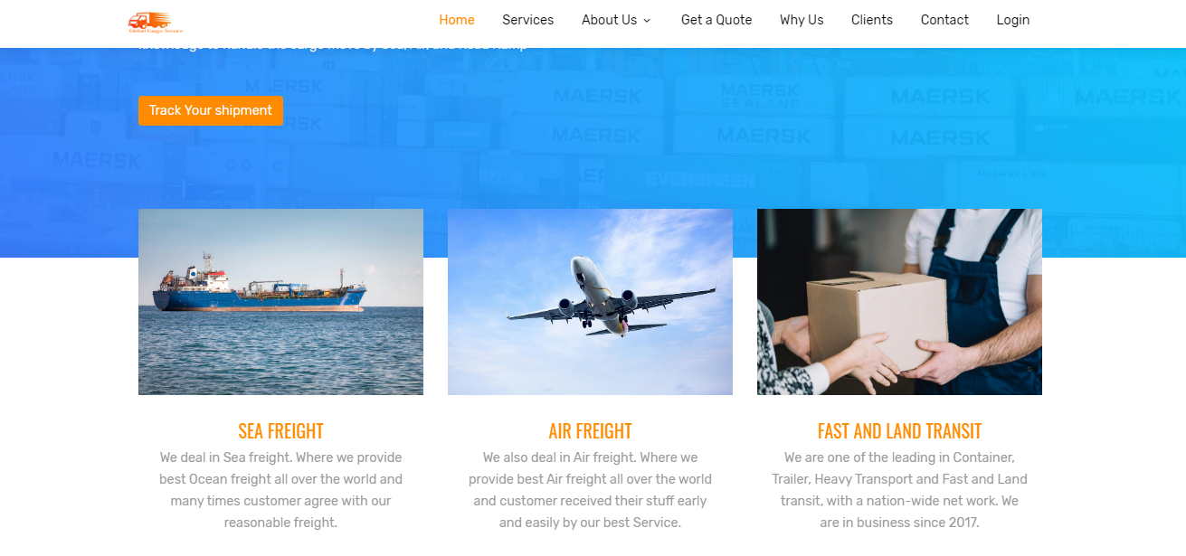

Services
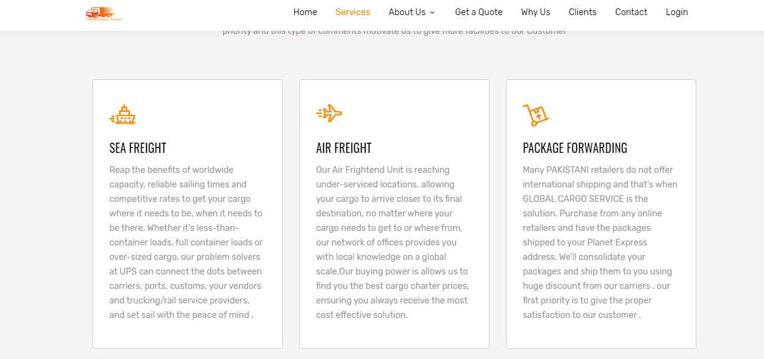
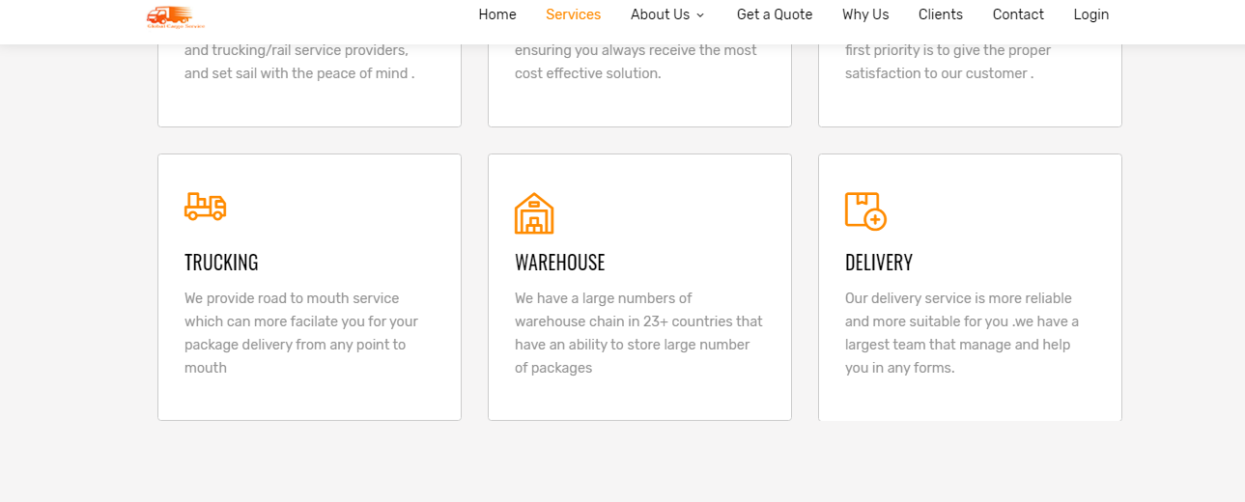

ABOUTUS

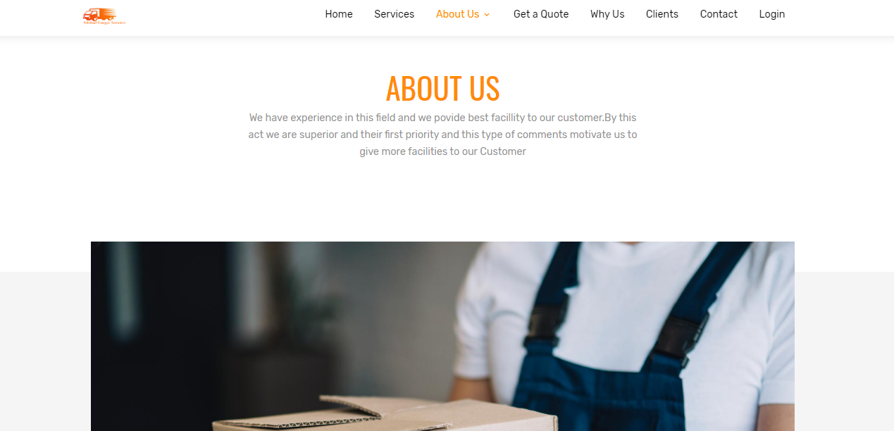

OUR STAFF

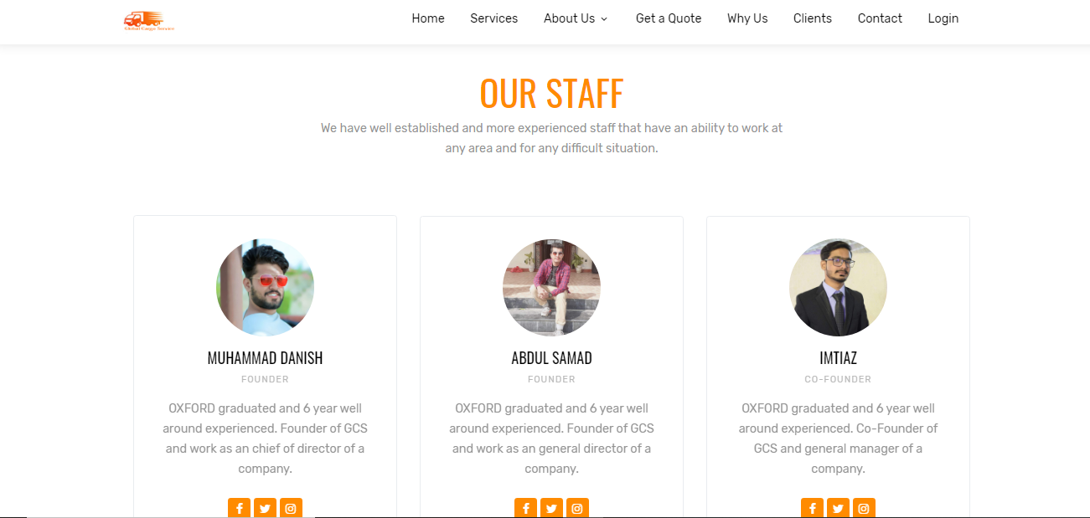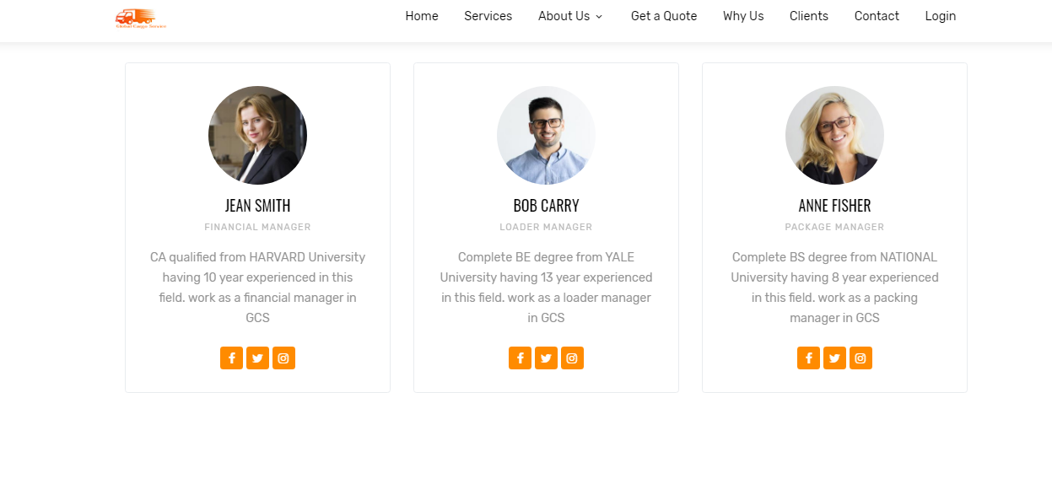

PRICING

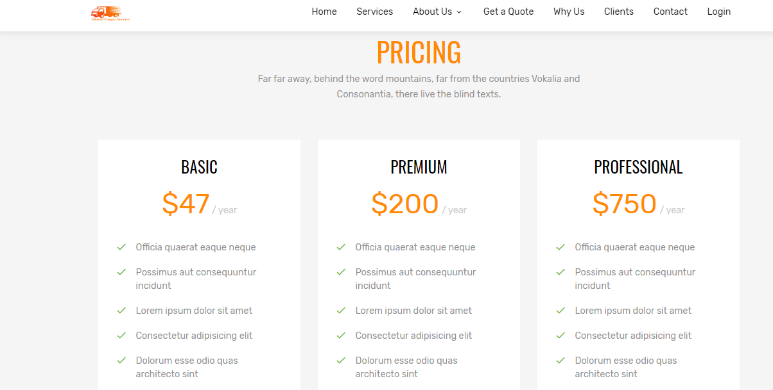

GET A QUOTE

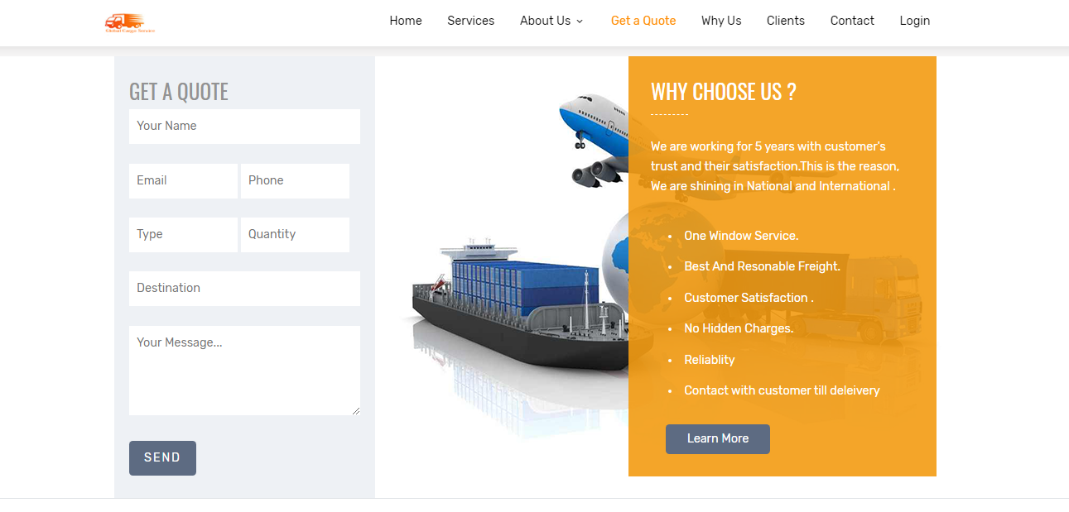

CONTACT

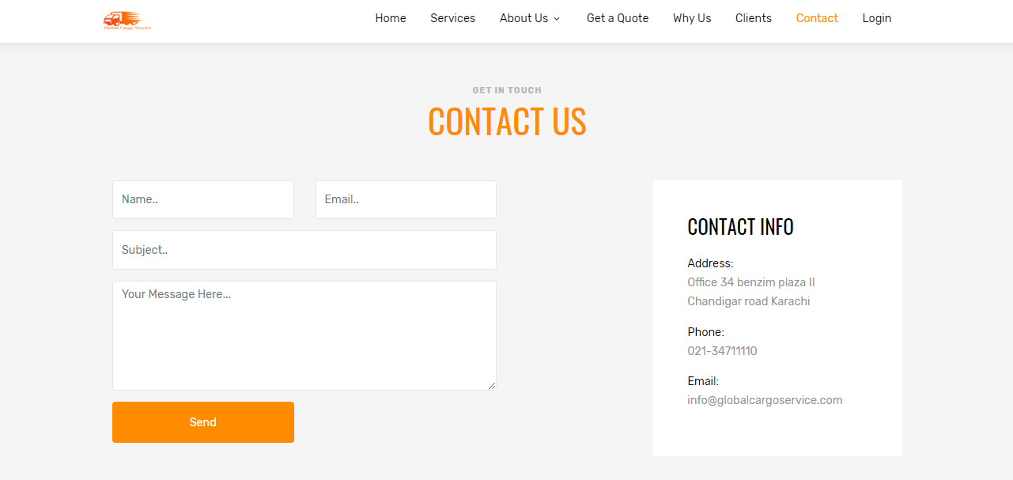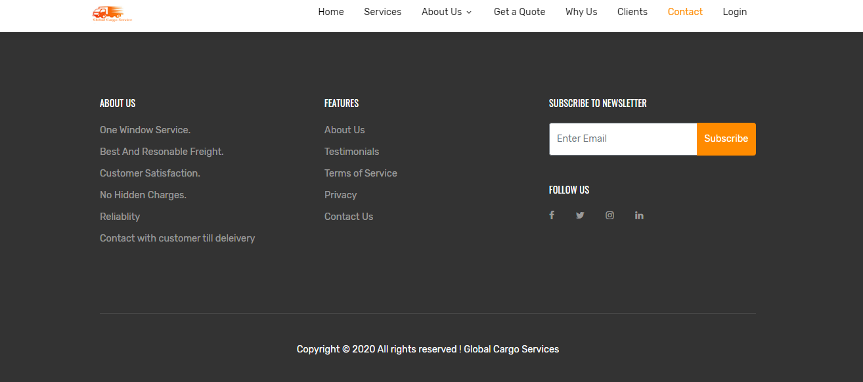

ADMIN PENAL

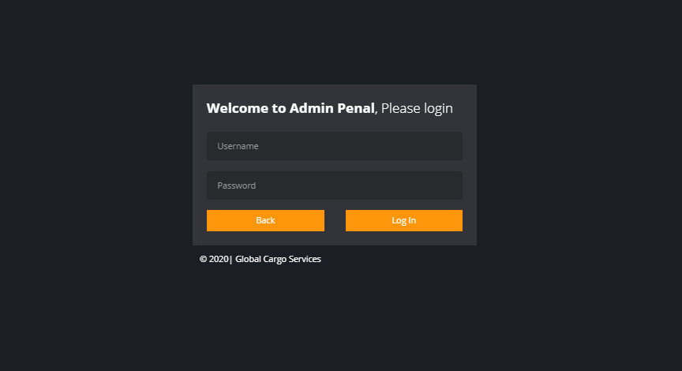

TRACKING SYSTEM

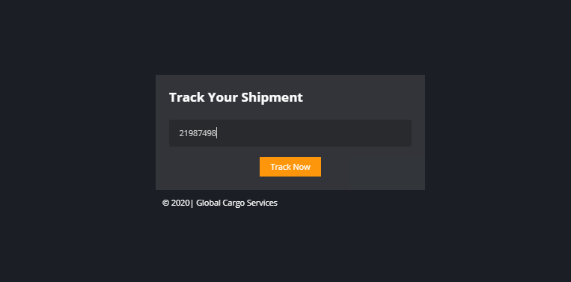
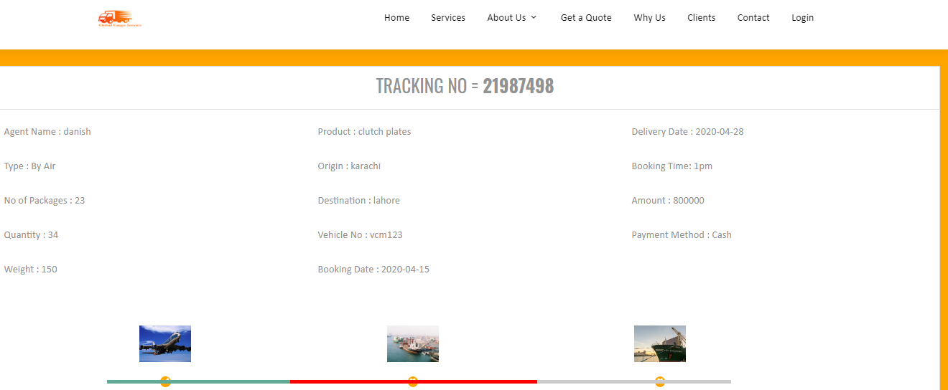

DASHBOARD

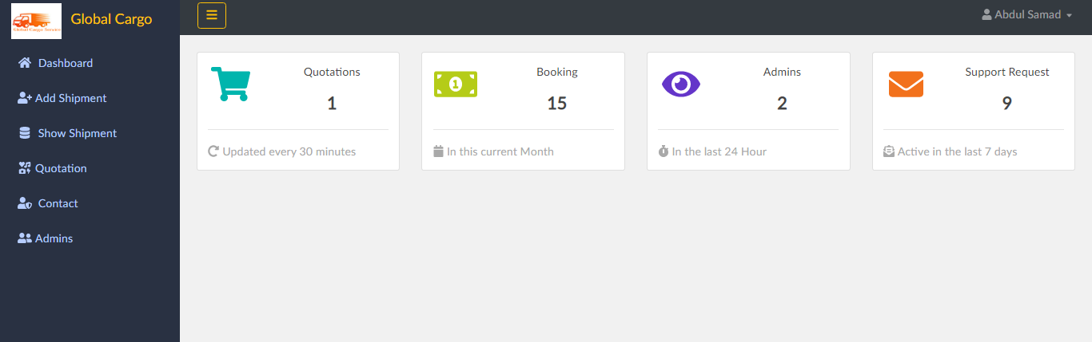

ADD DETAILS
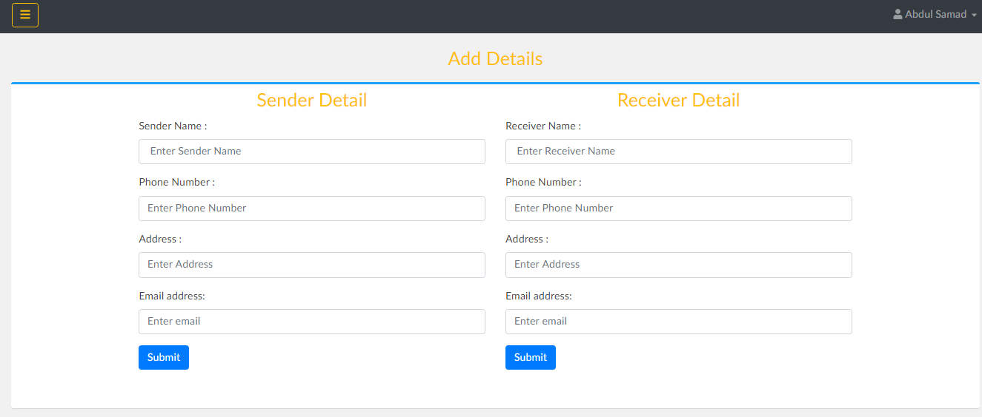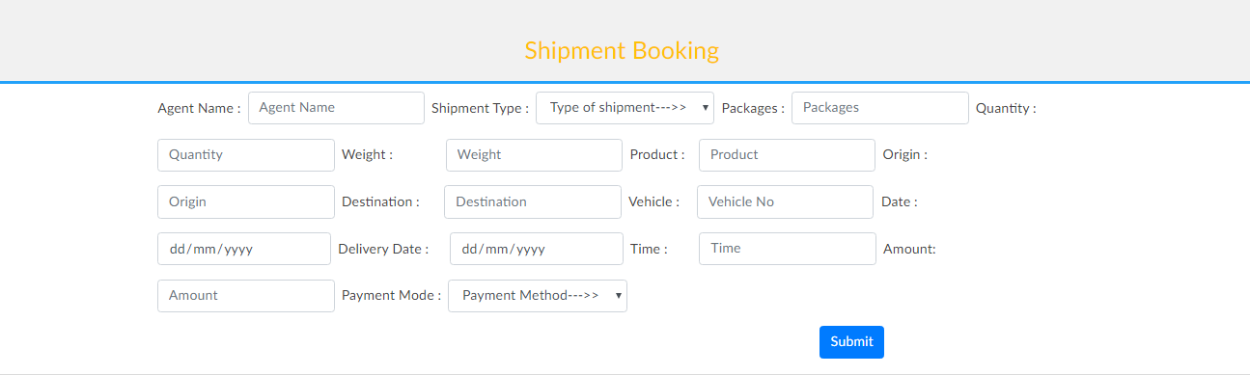

RECEIVE DETAILS

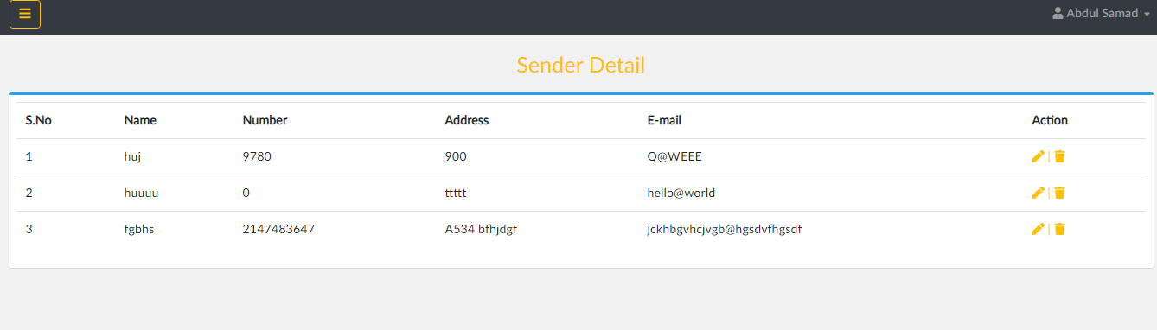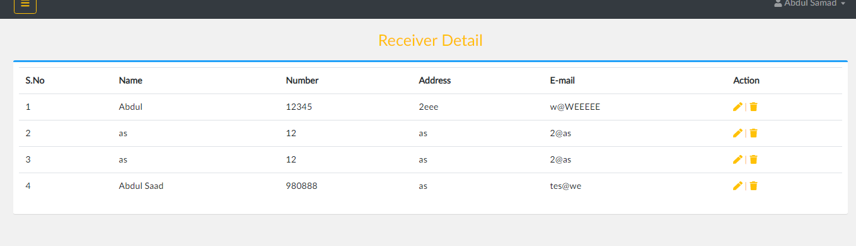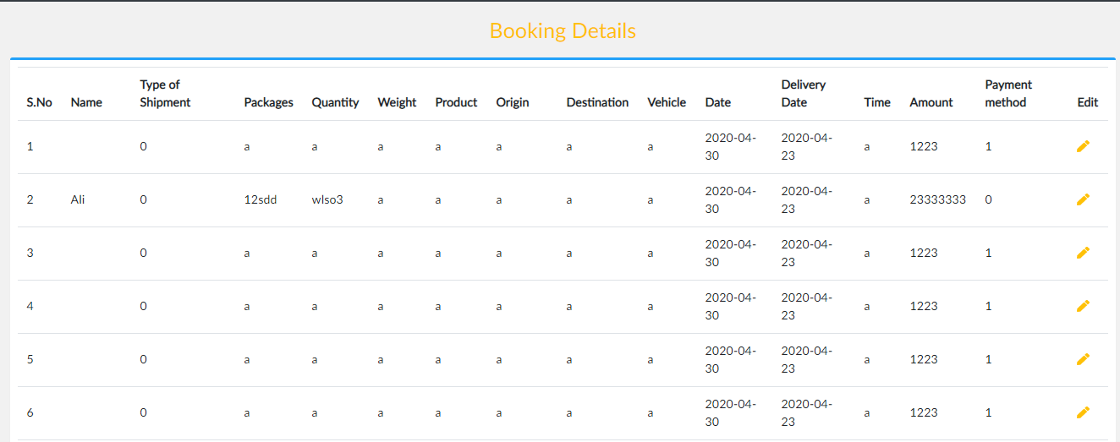

RECEIVE QUOTATION & MESSAGES

