|  |  |
| --- | --- |
|  | **Emojify: Emoji Recommendation System** |
|  |  |
|  | Abdul Samie (19I-0663), Fatima Noor (19I-1967)  NLP  5/1/23 |

Contents

EmojifyAI: Emoji Recommendation System 2

Introduction 2

Methodology 2

Results 2

Conclusion 3

# EmojifyAI: Emoji Recommendation System

## Introduction

EmojifyAI is a Python package designed to recommend relevant emojis for a given input sentence using state-of-the-art natural language processing techniques. The system is built on top of the BERT model, a popular transformer-based model for natural language understanding tasks. By leveraging BERT's contextual embeddings, EmojifyAI can provide meaningful and contextually relevant emoji suggestions for a variety of input sentences.

## Methodology

The EmojifyAI package employs the following steps to suggest emojis for an input sentence:

1. **Data Preparation:** The package uses a raw emoji data file containing emoji descriptions. The data is pre-processed and saved as a CSV file for efficient processing.
2. Model Loading: EmojifyAI loads a pretrained BERT model and tokenizer using the transformers library.
3. Mean Token Calculation: The package processes the emoji descriptions and the input sentence by tokenizing them and calculating the mean tokens using the BERT model. This process generates dense vector representations for both the emojis and the input sentence.
4. Cosine Similarity: The cosine similarity between the mean tokens of the input sentence and the emojis is computed. This similarity metric is used to rank the emojis based on their relevance to the input sentence.
5. Emoji Recommendation: Finally, the top-N (e.g., top-5) most relevant emojis are suggested based on their cosine similarity scores.

## Results

EmojifyAI was able to recommend contextually relevant emojis for various input sentences. The following examples demonstrate the system's performance:

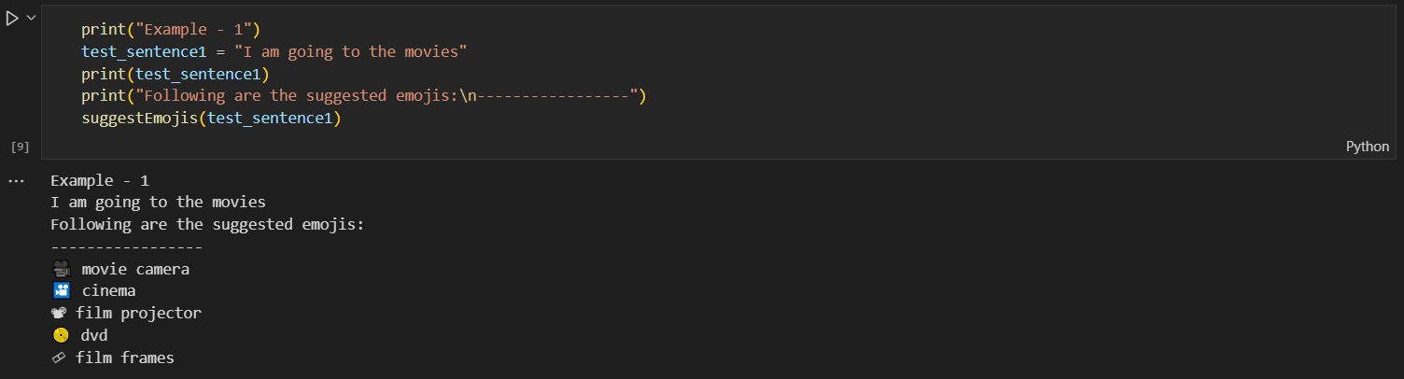

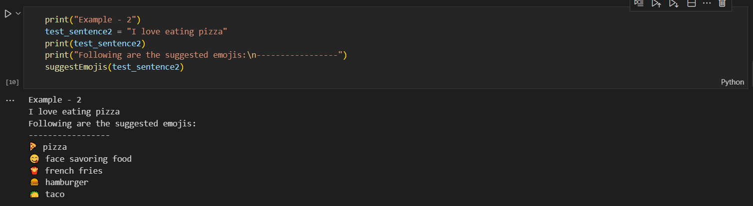

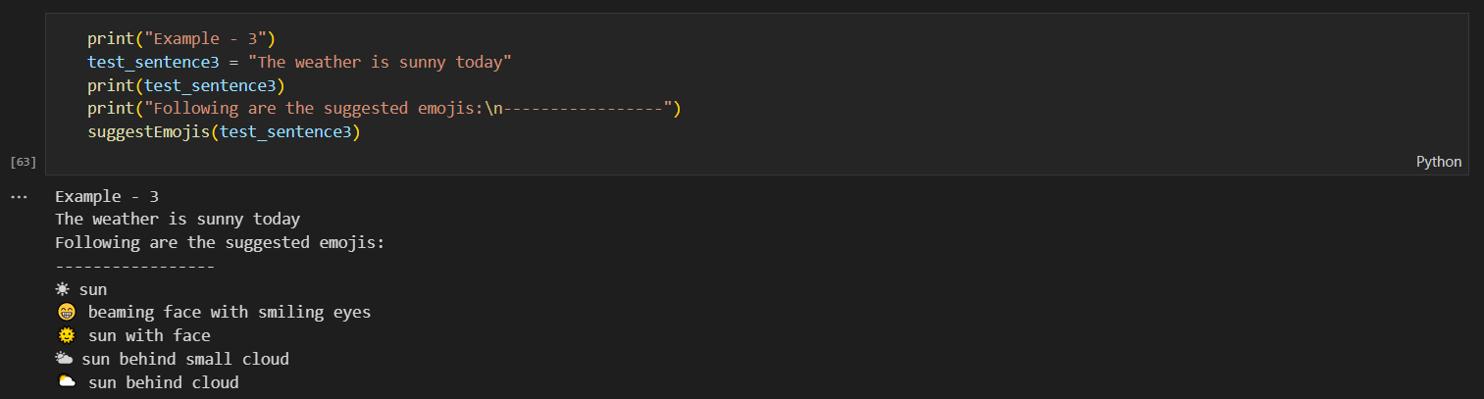

These examples show that the EmojifyAI package can effectively suggest emojis that are contextually appropriate for the input sentences.

## Conclusion

EmojifyAI is a powerful and easy-to-use Python package for recommending relevant emojis based on an input sentence. By utilizing BERT's contextual embeddings and cosine similarity, the system can generate meaningful emoji suggestions that enhance text communication.

Future improvements to EmojifyAI could include incorporating additional sources of emoji data, refining the pre-processing techniques, or experimenting with other natural language understanding models to improve the quality of the recommendations. Additionally, incorporating user feedback could help to refine and personalize the emoji suggestions for individual users.