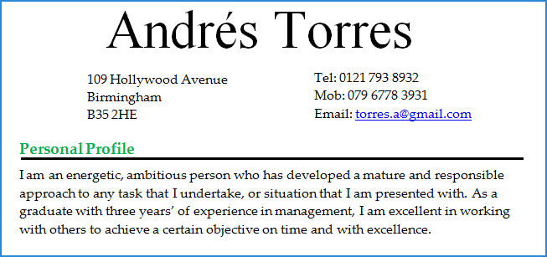

**What information to include on a personal profile**

The purpose of your personal profile is to concisely present your skills, qualities, work experience, and your career goals and ambitions. Consequently, you can mention anything from the following categories when constructing your personal profile:

**Personal Qualities**

* Self-motivated
* Creative
* Adaptable
* Having an eye for detail

**Skills**

* Management skills
* Communication skills
* Problem-solving skills
* Design skills

**Experience**

* 5 years experience in …
* Excellent track record of …
* Extensive background in …
* Previous work experience in …

## Business management CV profile

I have a clear, logical mind with a practical approach to problem-solving and a drive to see things through to completion. I have more than 2 years of experience in managing and leading teams across multiple sectors. I am eager to learn, I enjoy overcoming challenges, and I have a genuine interest in Business Management and making organisations successful

## IT CV profile

I am a highly competent IT professional with a proven track record in designing websites, networking and managing databases. I have strong technical skills as well as excellent interpersonal skills, enabling me to interact with a wide range of clients. I am eager to be challenged in order to grow and further improve my IT skills. My greatest passion is in life is using my technical know-how to benefit other people and organisations.