**Inversion of Control (IoC):** is a container which contain Bean classes. Dependency Injection(DI) is known as IOC. IoC is also known as dependency injection (DI).

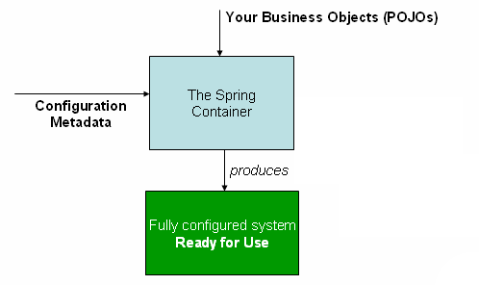

Figure 1. The Spring IoC container

DI

Bean

Bean Life Cycle

Autowived

Qualify

AOP

Spring Bean Scope

SpringBoot help configure easily then Spring.

**Create A new project by Intellij IDEA**

* Group name is Domain name
* Artifact is a name and its start with small letter.
* Type is like Maven POM
* Packaging is always must be Jar, Jar is smart then War.
* Name is same as Artifact

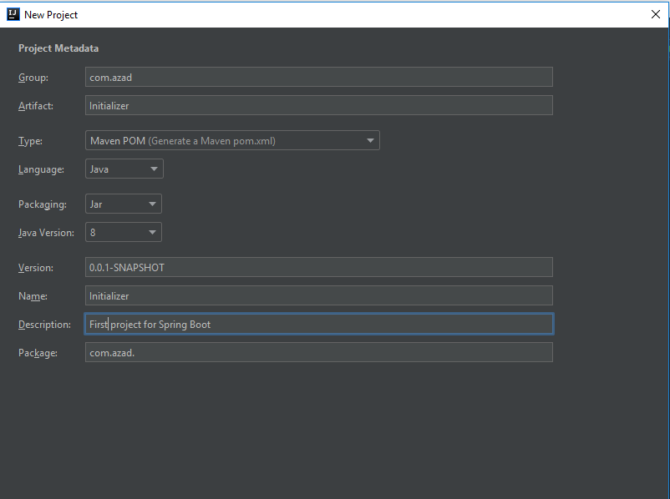

Maven is project build tool and help to create package easily.