AI Based Customer Feedback Analyzer
Project Documentation
n8n Automation Workflow
Author: Abdul Wahab Shakeel
Last Updated: August 2026

1. Project Overview
The AI Based Customer Feedback Analyzer is an n8n automation workflow that collects customer feedback from two sources — a public web form and Google Maps reviews — automatically analyzes the sentiment of each piece of feedback using Google's Gemini API, logs the results into Google Sheets, sends email alerts for negative feedback, and generates a weekly summary report. The workflow also includes dedicated error handling so that any failure in the pipeline is logged rather than silently dropped.

2. Objective
To automate the end-to-end process of collecting, understanding, and responding to customer feedback — removing the need for manual review, reducing response time to negative feedback, and providing management with an ongoing, structured record of customer sentiment.

3. Features
- Collects feedback from two sources: a public web form and scheduled Google Maps review pulls (via SerpApi)
- Validates and normalizes incoming data into a consistent schema
- Performs AI-based sentiment analysis (positive / neutral / negative, numeric score, summary) using Google Gemini
- Logs every entry into a Google Sheet, matched on a unique Review ID to prevent duplicate rows on repeated runs
- Sends an automatic email alert whenever negative feedback is detected
- Generates a weekly feedback summary report on a separate schedule
- Logs errors from any critical node into a dedicated Error Log tab, so failures are never silent

4. Workflow Architecture
The workflow is built around two entry points — form submissions and a scheduled Google Maps review fetch — which converge into a shared normalization, sentiment-analysis, and logging pipeline. A separate weekly-schedule branch reads the Sheet and emails a summary. Every node with a realistic chance of failure has its error output routed to a shared Log Error node.
Form Submission → Normalize Input
Schedule Trigger → HTTP Request (SerpApi) → Split Out → Normalize Google Review
↓ (both paths merge)
Valid Feedback? → Gemini: Analyze Sentiment → Parse Gemini Response
↓
Append/Update Row in Sheet → If (negative?) → Send Email Alert

Weekly Schedule Trigger → Get Row(s) in Sheet → Calculate Weekly Stats → Send Weekly Report

Every risky node's Error output → Log Error → Error Log sheet tab

Key Nodes
Node | Purpose
HTTP Request | Calls SerpApi's Google Maps Reviews engine for a specific place_id
Normalize Google Review | Maps raw SerpApi fields into a consistent schema
On form submission / Normalize Input | Same normalization for direct form submissions
Valid Feedback? | Filters out empty or invalid entries
Gemini - Analyze Sentiment | Sends feedback text to Gemini API for sentiment, score, and summary
Parse Gemini Response | Parses the Gemini output into clean fields
Append or update row in sheet | Writes to Google Sheets, matched on Review ID (prevents duplicates)
If | Branches to send an alert email when sentiment is negative
Log Error | Catches error output from any critical node, appends to Error Log
Get row(s) in sheet / Calculate Weekly Stats | Weekly summary report, triggered on its own schedule

5. Tools & Technologies Used
- n8n — workflow automation platform
- Google Gemini API — AI sentiment analysis
- SerpApi — Google Maps review data source
- Google Sheets — data storage (Feedback Log, Error Log, Form Responses tabs)
- Gmail — email alerts and weekly report delivery

6. Google Sheet Structure

Tab: Feedback Log
Column | Description
Timestamp | When the feedback was created
Name | Reviewer / customer name
Email | Customer email (N/A for Google Maps reviews)
Feedback | Full feedback text
Source | google_maps or form
Sentiment | positive / neutral / negative
Score | Numeric sentiment score
Summary | AI-generated one-line summary
Rating | Star rating (if available)
Review ID | Unique ID used for de-duplication

Tab: Error Log
Column | Description
Timestamp | When the error occurred
Workflow | Workflow name
Node | Node that failed
Error | Error message

7. Error Handling
Every critical node (HTTP Request, Gemini - Analyze Sentiment, Append or update row in sheet, Get row(s) in sheet, and both Send a message nodes) has its Error output wired to a shared Log Error node. This node appends Timestamp, Workflow, Node, and Error details to the Error Log sheet tab. This ensures that if any part of the pipeline fails — for example an API outage or a malformed request — the failure is captured and visible instead of causing a silent, unnoticed break in the automation.

8. Challenges Faced
- Duplicate rows on repeated runs — solved by switching to "Append or update row in sheet" with Review ID as the matching column.
- Google Maps reviews do not include a customer email address (a Google privacy restriction) — handled by explicitly labeling the field "N/A - Not provided by Google Maps" rather than leaving it blank.
- Ensuring failures don't break the workflow silently — solved by enabling "Continue (using error output)" on every risky node and routing all error outputs into one shared logging branch.

9. Testing Checklist
- Execute workflow — all nodes show a green checkmark
- Feedback Log tab updates with no duplicate rows on repeated runs
- Error Log tab has no new entries after a clean run
- Negative feedback triggers an email alert
- Weekly stats trigger runs and sends a summary

10. Screenshots

10.1 Feedback Form
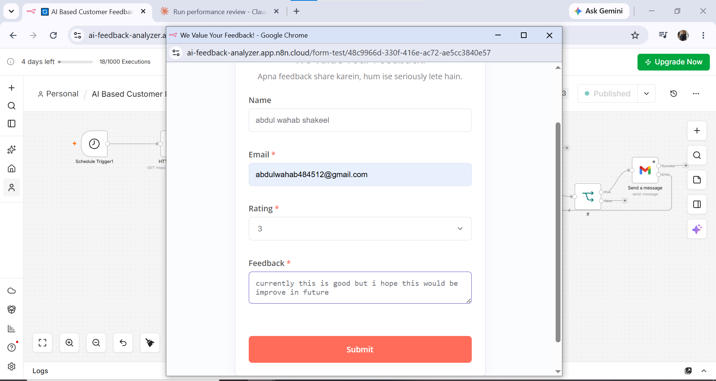
Figure 1: Customer filling out the public feedback form
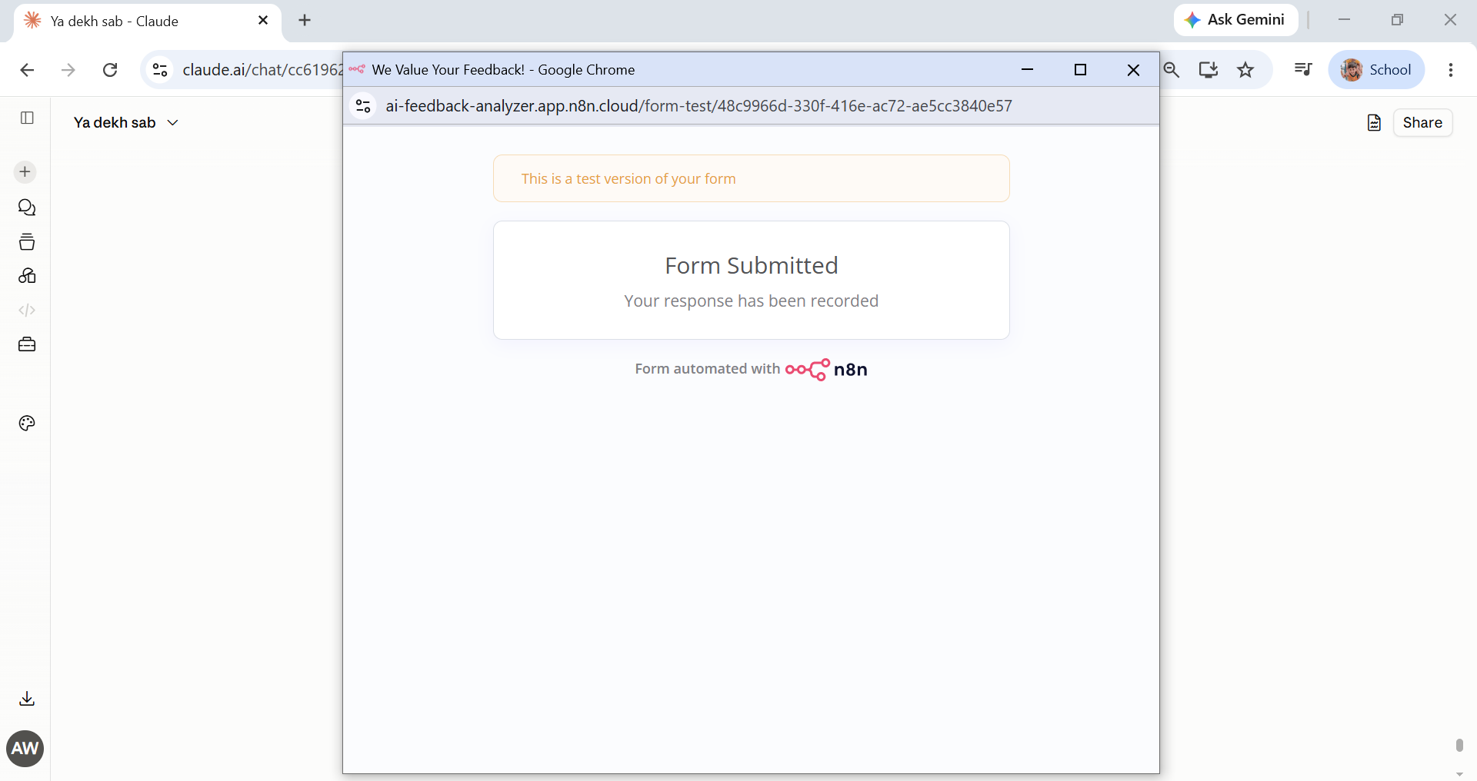
Figure 2: Form submission confirmation

10.2 Google Sheet — Feedback Log
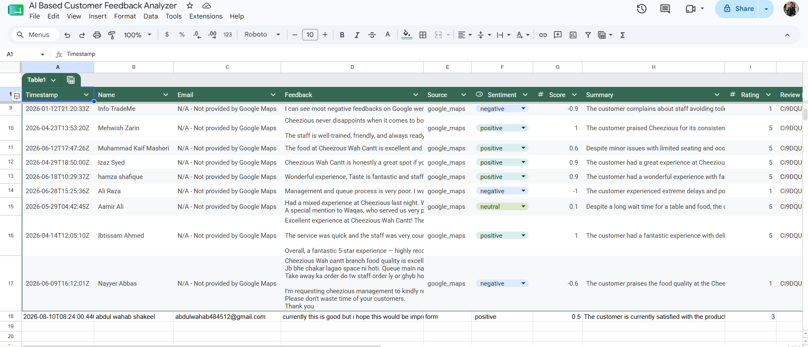
Figure 3: Feedback Log tab showing normalized, analyzed feedback entries

10.3 Google Sheet — Error Log
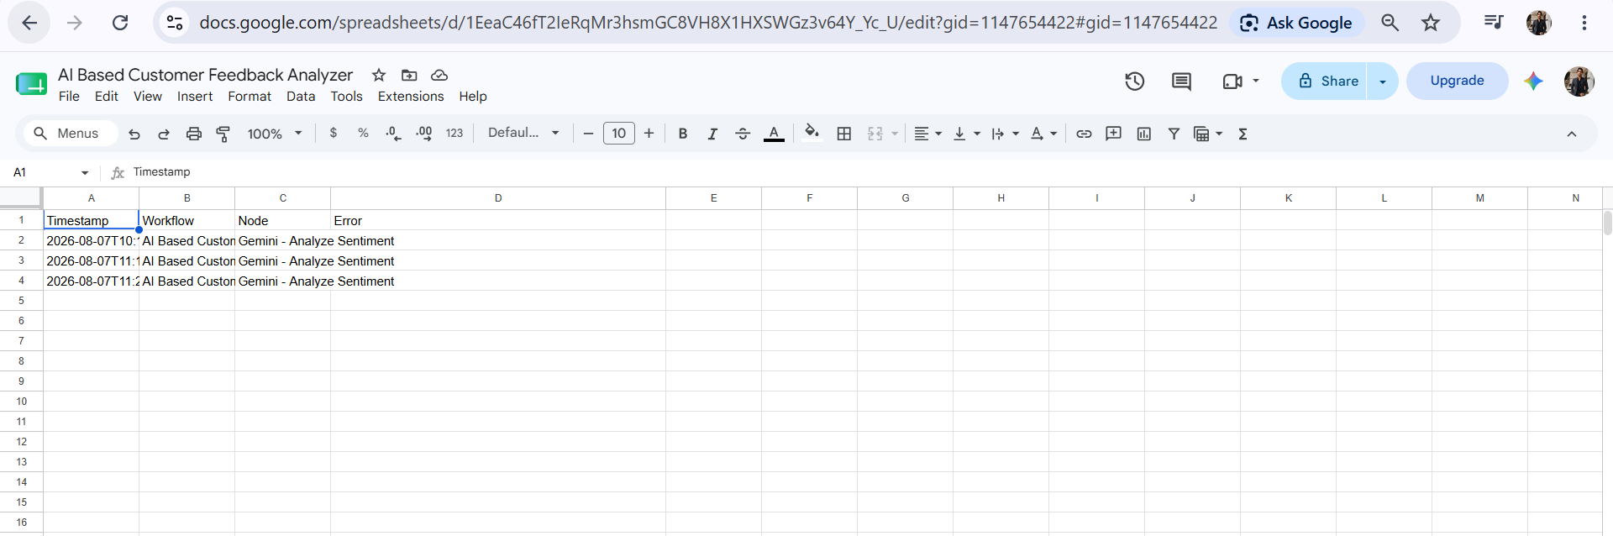
Figure 4: Error Log tab capturing node failures with timestamp and error message

10.4 Weekly Report Email
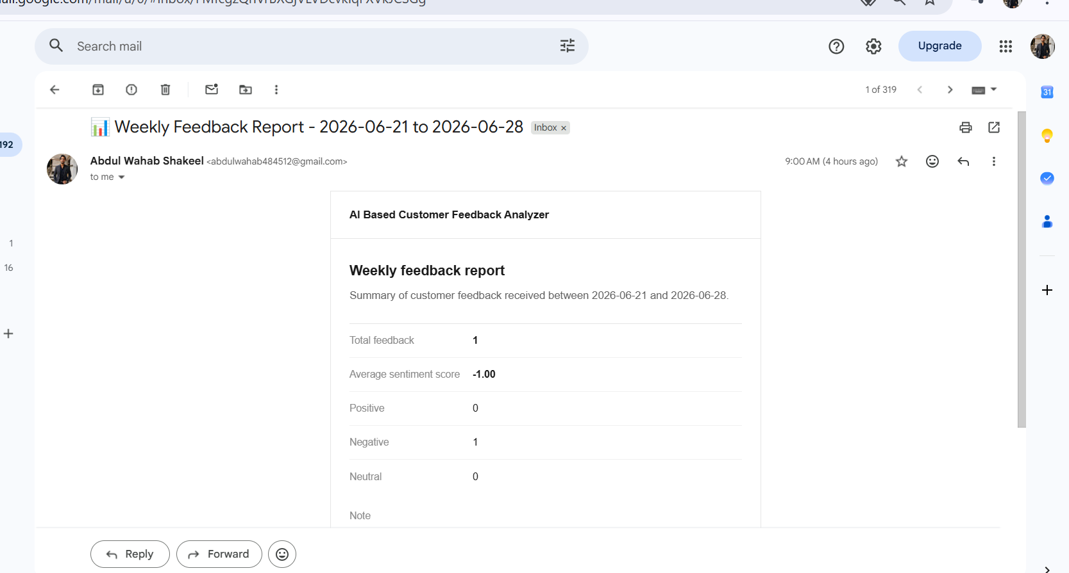
Figure 5: Automated weekly feedback summary email

10.5 Negative Feedback Alert
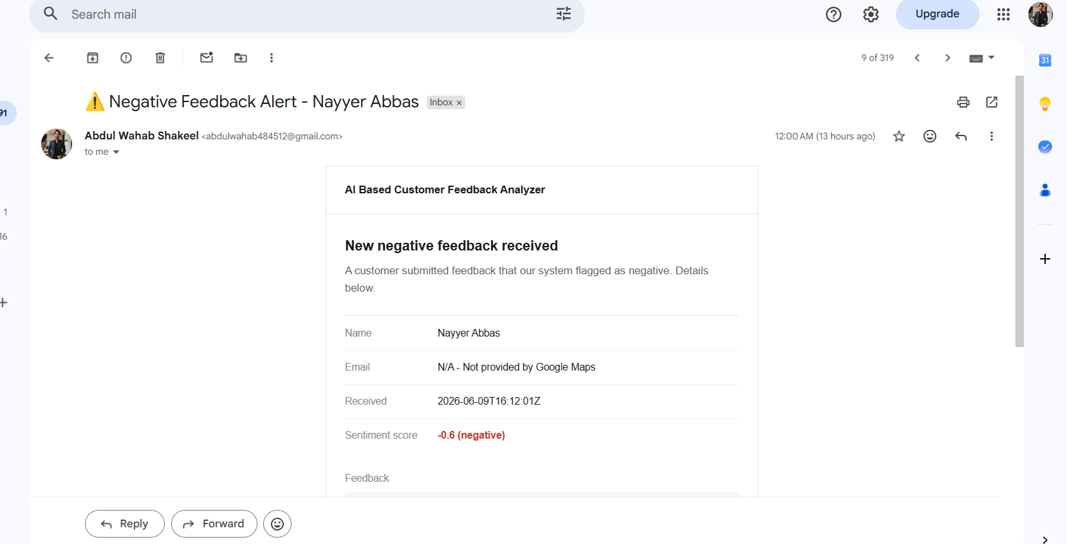
Figure 6: Real-time email alert triggered by negative sentiment

10.6 Workflow Canvas
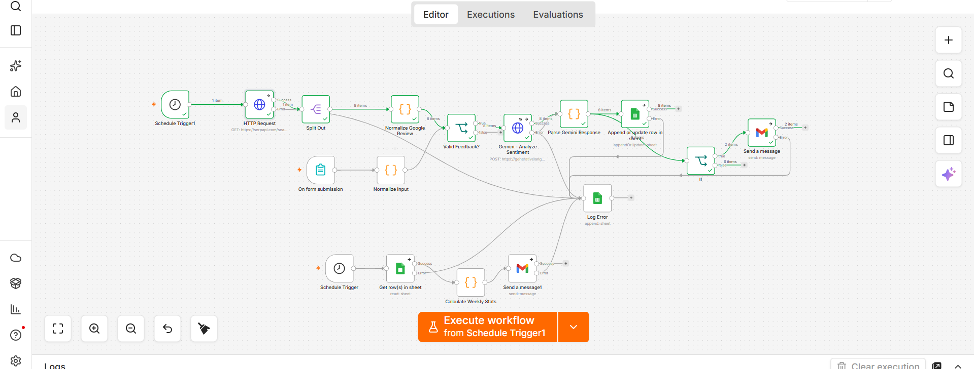
Figure 7: Full n8n workflow — successful end-to-end execution

11. Status
- Form submission pipeline — working
- Google Maps reviews pipeline — working
- Sentiment analysis (Gemini) — working
- De-duplication via Review ID — working
- Error logging — working
- Weekly stats report — working

