

**PUNJAB UNIVERSITY COLLEGE OF**

**INFORMATION TECHNOLOGY (PUCIT)**

**Database Systems Lab 02**

**BS-CS Afternoon Fall-19 (New Campus)**

**Date: 12-3-2021**

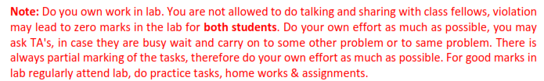

**Q1:**

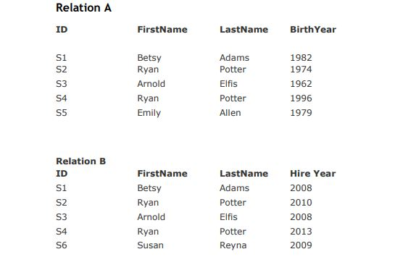



1. Find A Times B
2. Find (A TIMES B) where IDA > IDB
3. Find (A TIMES B) where IDA = IDB
4. Find (A TIMES B) where IDA < IDB
5. Find A-B
6. Find B-A

**Q2:**

Consider some relations A and B such that

Cardinality of A=12

Cardinality of B=10

Cardinality of A UNIONB=20

What would be the value of following?

– Cardinality A INTERSECT B

– Cardinality A TIMES B

– Degree of A UNION B

– Cardinality of A MINUS B Cardinality of B MINUS A

**Q3:**

Relation A:

|  |  |  |  |
| --- | --- | --- | --- |
| Id | First_name | Last_name | address |
| 11 | John | Steve | New York |
| 22 | Michael | Clarke | California |
| 33 | George | Smith | Melbourne |

Relation B:

|  |  |  |  |
| --- | --- | --- | --- |
| Id | First_name | Last_name | address |
| 44 | Roze | Merrie | Norway |
| 22 | Michael | Clarke | California |
| 55 | Amelia | John | Germany |

Find the following:

1. A Union B
2. A Intersection B

**Q4:**

Relation C:

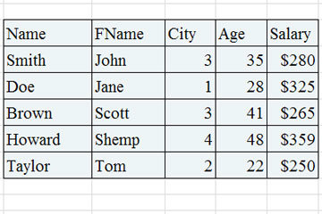

Find the following for above relation:

1. σ Salary > 250 (C)
2. σ Name = “Brown” (C)

**Q5:**

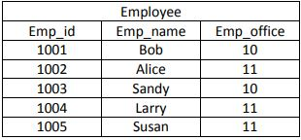

Find the following for above relation:

1. Π Emp_id, Emp_name (Employee)
2. Π Emp_id (σ Emp_office=11 (Employee))

**Q6: Given are Two Relations of Employee Table and Department Table such that**

**Employee**

|  |  |  |  |  |  |
| --- | --- | --- | --- | --- | --- |
| **Empno** | **Empname** | **job** | **Mgr.** | **DeptNo** | **Sal** |
| 1234 | King | clerk | 7838 | 10 | 2500 |
| 1235 | Miller | salesman | 7839 | 20 | 4000 |
| 1236 | shone | Manager | 7837 | 30 | 2000 |
| 1237 | jones | Manager | 7839 | 20 | 3400 |
| 1238 | martin | president | 7830 | 10 | 1200 |

**Department**

|  |  |  |
| --- | --- | --- |
| **Deptno** | **Deptname** | **Loc** |
| 10 | Accounts | CA |
| 20 | Research | DS |
| 30 | Sales | NY |

**Find following:**

1. JOIN Employee AND Department over DeptNo.
2. Find resultant statement for all those tuples whose Job is Clerk and also tell Department. Deptname and Department.Loc for these tuples.
3. Resultant statement which contains Employee.EmpNo, Department.Loc where Employee.Sal >2000.

**Best of Luck**