Psychological schools of thought are major theories or frameworks that offer different perspectives on understanding the human mind and behavior. These schools emerged from research and analysis, providing specific methodologies and tools to study psychological processes.
The main schools of psychology are structuralism, functionalism, Gestalt, behaviorism, psychoanalysis, humanism, and cognitive psychology. These schools represent different approaches to understanding the human mind and behavior, focusing on aspects like mental structure, function, observable actions, unconscious drives, personal growth, and mental processes like thought and memory.
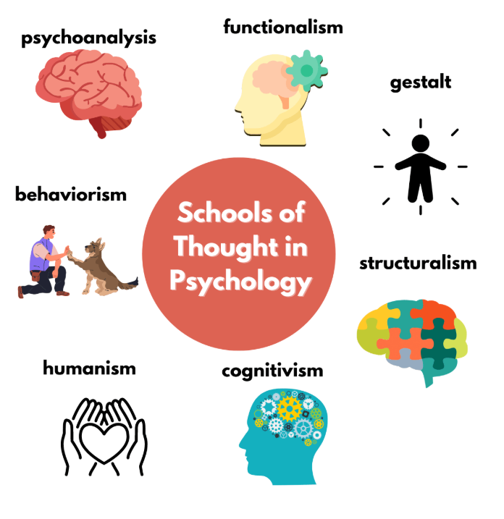
- Structuralism: The first major school, which sought to understand the basic elements of consciousness through introspection.
Introspection in psychology is the conscious, inward examination of one's own mental states, including thoughts, emotions, and sensations. Historically, it was used as a formalized research method by Wilhelm Wundt to study conscious experience. It aids in self-awareness
- Functionalism: Focused on the purpose and function of the mind and behavior in adapting to the environment.
- Behaviorism: Studied observable behavior, arguing it is learned through a person's interactions with their environment, including reinforcement and punishment.
- Psychoanalysis: Emphasized the influence of the unconscious mind and early childhood experiences on behavior and personality.
- Humanism: Stresses an individual's potential for growth, self-actualization, and free will.
- Cognitivism: Focuses on mental processes such as memory, perception, and problem-solving.
- Gestalt psychology: Argues that the mind perceives wholes rather than just the sum of individual parts.
- Biopsychology: Examines how biological structures and processes, like genetics and the brain, affect behavior.

Key schools of psychology
Structuralism:
The first school of thought, which focused on breaking down mental processes into their most basic components.

Structuralism was the first school of thought in psychology, founded by Wilhelm Wundt and developed by his student Edward Titchener. It sought to understand the structure of consciousness by breaking down mental processes into their most basic components using a method called introspection. The goal was to analyze how these basic elements fit together to form complex experiences.
- Core principle: The mind can be analyzed by breaking it down into its fundamental parts, similar to how a chemist analyzes a compound.
- Key method: Introspection, or the careful observation of one's own conscious experience and internal states.
- Goal: To identify the basic "elements" of the mind (like sensations, feelings, and images) and understand how they combine to form the complex structures of conscious thought.
- Founders: Wilhelm Wundt is credited with establishing the first psychology laboratory, and Edward Titchener, his student, further developed and promoted structuralism.
- Legacy: While structuralism is no longer a dominant school of thought, it was a foundational step in establishing psychology as a distinct scientific discipline.

Functionalism:
Emphasized the purpose or function of behaviors and mental processes rather than their structure.
Functionalism is a school of thought in psychology that emphasizes the purpose or function of the mind and behavior, viewing mental processes as tools for adaptation to one's environment. It focuses on the "why" of mental processes, such as how they help an organism function and survive, rather than on analyzing them into their basic components like structuralism did. Key proponents include William James, who was influenced by Charles Darwin's theory of evolution.
- Focus on function: Instead of breaking down the mind into elements, functionalism examines how mental activities help an organism adapt to its environment.
- Adaptation: A central tenet is that the mind's primary role is to help humans adapt and function effectively in their surroundings.
- Influence of Darwin: The approach was heavily influenced by Charles Darwin's theory of evolution, looking at how mental traits helped an organism survive.
- Contrast with structuralism: Functionalism was a direct response to structuralism, which focused on breaking down the mind's structure through introspection. Functionalists shifted the focus from the mind's structure to its utility and purpose.
- Key figures: William James is considered the founder, but other notable functionalists include John Dewey, George Herbert Mead, and James Rowland Angell.
Gestalt psychology:
- Argued that the whole of an experience is more than the sum of its parts, viewing experiences as unified wholes.
Gestalt psychology is a school of thought that emphasizes that the human mind perceives things as a whole rather than as separate parts, often summarized by the phrase "the whole is something else than the sum of its parts". It proposes that we have an innate ability to organize sensory information into meaningful patterns, guided by principles such as proximity, similarity, continuity, closure, and connectedness. This perspective is used today in fields like user experience design and therapy to help understand perception and solve problems.
Core principles
- The whole is greater than the sum of its parts: The mind perceives a complete, integrated whole that has qualities of its own, which cannot be understood by simply analyzing its individual components. For example, a melody is more than just a collection of individual notes.
- Innate pattern-seeking: Humans have an innate tendency to seek patterns and order in the stimuli they encounter.
- Perceptual organization: The mind organizes information using several principles to create meaningful wholes. Some of the key principles include:
  - Proximity: Elements that are close to each other are perceived as a group.
In the world of design and psychology, the Law of Proximity is one of the most powerful Gestalt principles. It suggests that our brains naturally group elements together based on how close they are to one another, even if the shapes or colors are completely different.
Here are some real-world and design examples of Proximity in action:

1. Typography and Text
This is the most common application. We use space to tell the reader which pieces of information belong together.
- Paragraphs: We group related sentences together with a line break. Without that extra space (proximity), a page looks like an intimidating wall of text.
- Headings: A well-designed layout places a heading closer to the body text it describes than to the section above it. This signals that the heading "belongs" to the text below.
- Captions: When a photo has a small line of text directly underneath it, you immediately know that text describes that specific image.
2. User Interface (UI) Design
Digital interfaces rely heavily on proximity to create "clutter-free" experiences.
- Navigation Menus: Links like Home, About, and Contact are placed close together in a row. This tells the user they are part of the same navigation system.
- Form Fields: In a checkout form, the "First Name" label is placed directly above its input box. If the labels were spaced equally between all boxes, you wouldn't know which box to type in.
- Social Media Feeds: On apps like Instagram or X (Twitter), the "Like," "Comment," and "Share" buttons are clustered right under a post. This proximity links the actions to that specific piece of content.
3. Everyday Life
Our brains use proximity to navigate the physical world without us even realizing it.
- Waitlines: If you see a cluster of people standing close together outside a building, you assume they are "in line" for something.
- Grocery Stores: Items are grouped by proximity (e.g., crackers are near the cheese). If you see a bottle of wine sitting next to a display of glasses, you perceive them as a "party suggestion" group.
- People in a Room: At a party, if four people are standing in a tight circle and two others are standing ten feet away, you immediately perceive them as two distinct groups/conversations.

Comparison: Proximity vs. Isolation
Feature | Proximity (Grouped) | Isolation (Independent)
Visual Effect | Elements seen as a single unit or "chunk." | Elements seen as distinct or unique.
User Focus | Encourages scanning and categorization. | Draws attention to a specific "Call to Action."
Example | A cluster of icons in a dock/taskbar. | A "Delete" button placed far away from "Save."

Pro Tip: If you want to make a design feel more organized, don't just add borders or lines. Try adjusting the white space first. Often, simply moving related items closer together is enough to create order.

  - Similarity: Elements that share similar characteristics (like color or shape) are perceived as a group.
  - Continuity: The mind tends to see a continuous, smooth, and flowing pattern rather than a disjointed one.
  - Closure: The mind will complete incomplete figures by "filling in the gaps" to perceive a whole object.
  - Connectedness: Elements that are visually connected are perceived as a single unit.
Applications
- User experience (UX) design: Gestalt principles are used to create intuitive and effective user interfaces by arranging elements in a way that aligns with how users naturally perceive them.
- Therapy: Modern-day Gestalt therapy uses the core ideas to help clients identify and solve their challenges by looking at their problems as a whole experience, not just isolated issues.
- Perception studies: The theory has been influential in the study of perception, highlighting the importance of top-down processing—where the brain uses existing knowledge to interpret sensory input—in organizing information.

- Behaviorism:
Focused on studying only observable behavior and how it is learned through conditioning.
https://www.verywellmind.com/psychology-schools-of-thought-2795247
https://www.verywellmind.com/psychology-schools-of-thought-2795247
https://www.verywellmind.com/what-is-resilience-2795059


