**Build-A-Website**

**Links Needed for the Exercise ( Do this First )**

_____________________________________________________________

Required Downloads

*Download visual studio code or atom :*

* <https://atom.io/> (Recommended)
* <https://code.visualstudio.com/download> (Larger File)

*Download Git (for hosting)*

Windows

* Download git - <https://git-scm.com/download/win>
* Find your git bash by finding it in your explorer

Mac

* Open your terminal
* Type in ‘git --version’
* It should prompt you to download git if you do not have it. Please follow the instructions

__________________________________________________________________________

Exercise

. A. Download and extract the exercise file - [**https://tinyurl.com/y5dop7zp**](https://tinyurl.com/y5dop7zp)

* Steps (if you get lost): <https://imgur.com/a/PxGdAfs>

______________________________________________________________________

Website

1. Download and extract the starting kit - [**https://bootstrapmade.com/devfolio-bootstrap-portfolio-html-template/?download_theme=devfolio.zip**](https://bootstrapmade.com/devfolio-bootstrap-portfolio-html-template/?download_theme=devfolio.zip)

2. Steps (Use if you get lost) - [**https://imgur.com/a/dW5HIu7**](https://imgur.com/a/dW5HIu7)

__________________________________________________________________________

Hosting

1. Create a github account if you do not have one - <https://github.com/>
2. General for Git

* Open up your git bash or terminal
* Do `git config --global user.name “yourUserNameFromGitHub”
* Do git config --global user.email “your github email”

**Feedback**

Help us improve our events by giving us your feedback:

<https://www.surveymonkey.com/r/9ZDFWFK>

**3RD PARTY HOSTING**

[**https://www.youtube.com/watch?v=g8kfAZOjgR0**](https://www.youtube.com/watch?v=g8kfAZOjgR0)

**Get Inspired by what others have done**

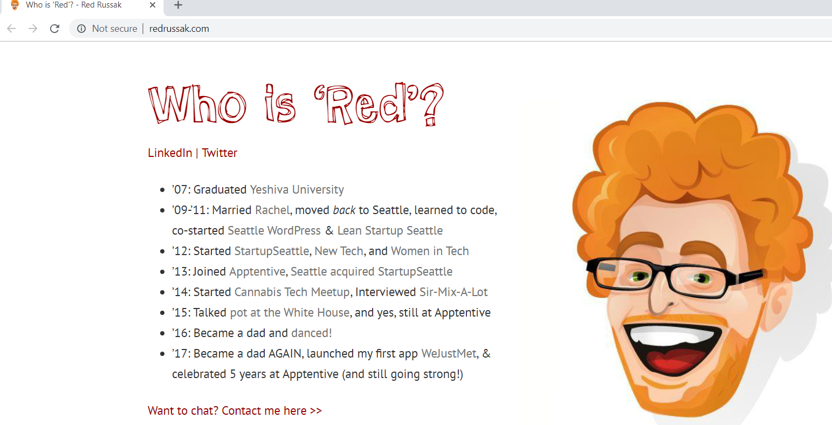

[**http://redrussak.com/**](http://redrussak.com/)

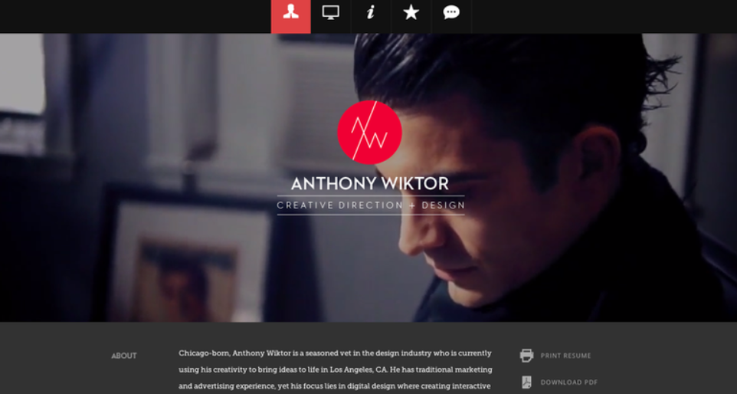

[**http://www.anthonydesigner.com/**](http://www.anthonydesigner.com/)