LAB REDI SPRING 2026
3.4 Green transition Dashboard

LAB University of Applied Sciences
Bachelor of Engineering, Industrial Information Technology
2026
Unubold Luvsandagva
 |  | Abstract
Author(s)  Unubold Luvsandagva | Publication type  Internship Report | Completion year  2026
Author(s)  Unubold Luvsandagva | Number of pages  14
Title of the thesis
LAD REDI SPRING 2026
3.4 Green transition Dashboard
Degree
Bachelor of Industrial Information Technology
Name, title and organisation of the client
LAB University of Applied Science
Abstract
This report covers the work progress of design and frontend development of the Green Transition Dashboard UI/UX project within LAB REDI 2026 for the Electric Mobility Digital Twin (EMDT) platform. The EMDT platform collects real-time data from electric vehicle fleets to calculate CO₂ savings, energy footprint and regenerative braking potential based on road topography, and the project goal was to design a clear, usable dashboard interface through which operators could monitor these key performance indicators and explore topography-based route optimisation. The process followed a UX design pipeline: literature review and benchmarking, persona and use-case definition, low-fidelity wireframing, a high-fidelity Figma prototype, and an interactive dashboard built in React according to the prototype.
Keywords
EV, Electric vehicle, digital twin, dashboard, UI/UX, real-time telemetry, React

Contents
1 Introduction 1
1.1 Scope and delimitations 1
2 UX Research and Design foundation 3
2.1 Benchmarking Existing EV and Sustainability Dashboards 3
2.1.1 Dashboard UI Design Patterns and Heuristics 3
2.1.2 User Personas and Key Use Cases 3
2.2 Design and Prototyping Tools and Methods 4
3 UI/UX Design and Frontend Development Process 5
3.1 Defining the Dashboard Content: Prioritising What to Show 5
3.1.1 Identifying Key Information for Operators 5
3.2 Start of the Wireframe 6
3.2.1 Low-Fidelity Wireframe 6
3.2.2 High-Fidelity Figma Prototype 6
3.2.3 Building the Dashboard in React 7
3.2.4 Usability Testing and the Final Build 8
3.3 Interaction Design and Visual Feedback 9
3.4 Map and Route Visualisation 11
4 Summary 12
References 13
Appendix 1. Prototype and build access: 14

- Introduction
The Electric Mobility Digital Twin (EMDT) platform collects real-time data from electric vehicle (EV) fleets and uses it to calculate CO₂ savings, energy footprint and regenerative braking potential based on road topography. The 3.4 Green Transition Dashboard UI/UX (GTD-UX) project, carried out within LAB REDI 2026, was set up to design a well-designed user interface through which EMDT operators can monitor these key performance indicators (KPIs) and explore optimised routes.
The main objective of the project was to design a usable, clear dashboard UI/UX prototype for the EMDT Green Transition Dashboard, enabling users to monitor CO₂ savings and energy footprint KPIs and to explore topography-based EV route optimisation visually. This was broken down into the following sub-objectives:
- Literature review and benchmarking of sustainability and EV dashboards
- Defining user personas and key use cases
- Producing low-fidelity wireframes for all core components in Figma
- Developing a high-fidelity interactive prototype in Figma
- Building an interactive dashboard according to the prototype in React
- Carrying out usability testing (peer testing and heuristic UI/UX evaluation methods)
- Improving the design according to the usability-testing results
- Delivering a design system and a final project report
  - Scope and delimitations
In scope
- UX research
- Wireframes
- High-fidelity Figma prototype
- Map view UI
- Usability testing
- Design system
- Final report
Out of scope:
- Backend/API development
- Live data integration
Because backend and API development and live data integration were explicitly out of scope, this report focuses solely on the UI/UX design process and the resulting frontend: how the dashboard’s content was decided, how it was wireframed and prototyped, and how it was built and refined as an interface.
- UX Research and Design foundation
This chapter presents the research and design foundations that shaped the GTD-UX dashboard: how comparable EV and sustainability dashboards were benchmarked, the UI design patterns that benchmarking pointed to, the personas and use cases defined for the EMDT platform’s operators, and the tools and methods used to move from research to a working prototype.
  - Benchmarking Existing EV and Sustainability Dashboards
Rather than starting from a blank page, the project began with a literature review and benchmarking exercise, looking at existing electric-vehicle and sustainability dashboards and at general dashboard UI/UX design guidance.
    - Dashboard UI Design Patterns and Heuristics
This benchmarking pointed to a small number of patterns that reoccur across well-regarded EV and sustainability dashboards, and that were carried forward into the GTD-UX design:
- Grouping related metrics into clearly bounded panels, instead of scattering them across the screen.
- Using colour to encode state - for example green, amber and red zones for charge level, speed or steering angle - rather than relying on numbers alone.
- Keeping the most time-critical information - speed, battery level and current power flow - in a fixed, always-visible position rather than behind navigation or tabs.
- Giving the platform’s headline sustainability numbers, such as CO₂ saved, a persistent and glanceable place in the layout, since these are the EMDT platform’s core value proposition rather than a secondary metric.
These patterns were considered alongside general usability heuristics, such as always keeping the system’s status visible to the user, and they directly shaped the three-column dashboard layout.
    - User Personas and Key Use Cases
Alongside the dashboard benchmarking, personas and key use cases were defined for the EMDT platform’s operators, to keep the design grounded in who would use it and why:
- Fleet operator - monitors several EVs at once and is primarily interested in aggregate CO₂ savings and identifying any vehicle under-performing on energy efficiency.
- Route planner - checks the elevation profile of the route Google Maps returns for a given origin and destination, and is primarily interested in how that elevation affects estimated energy use and range, rather than comparing between alternative routes.
From these personas, five key use cases were defined:
- Monitor live KPIs at a glance without needing to interpret raw numbers.
- Plan or compare a route by elevation and estimated energy cost before a trip.
- Check vehicle and battery status before dispatching a vehicle.
- Review a completed trip’s energy use and regenerative-braking performance afterwards.
- Monitor current state of pedals and angle of steering wheel to give idea to user to know how his inputs affecting the vehicle
These personas and use cases were used throughout the project to decide what information belonged on the dashboard and how prominently it should be displayed.
  - Design and Prototyping Tools and Methods
The project moved between three main tools across its lifecycle: Figma for both the low-fidelity wireframes and the high-fidelity interactive prototype, Google Maps’ JavaScript API for the live map view used inside the prototype and the final build, and React for building the interactive dashboard itself.
The first one to two weeks of the project schedule were deliberately set aside for tool exploration before wireframing began. A JavaScript mapping library was also considered at the planning stage; Google Maps’ JavaScript API was used in the final implementation instead, for its built-in Directions and Elevation services.

- UI/UX Design and Frontend Development Process
This chapter reports on how the GTD-UX dashboard was designed and built: how its content was decided, how that content moved from a wireframe through a high-fidelity prototype into a working React dashboard, and the visual design, interaction design and map/route visualisation choices made along the way. It corresponds to the project plan’s “Wireframing (Low-fi)”, “High-Fidelity UI Design (Figma)”, “Build the Dashboard according to prototype”, “Usability Testing & Iteration” and “Improvement according to usability testing” work packages.
  - Defining the Dashboard Content: Prioritising What to Show
Before any layout or visual design work began, the first design decision was simply: what does an operator need to see on this dashboard? Based on the EMDT platform’s core KPIs and the personas and use cases from Chapter 2, a list of the information the dashboard needed to surface was drawn up before any wireframing started.
    - Identifying Key Information for Operators
The resulting content list was, in priority order:
- Battery state of charge and estimated range - answers the immediate “can this vehicle complete its trip” question.
- Trip energy used, distance driven and average energy consumption - the core sustainability KPI the whole platform is built around.
- Route map with origin/destination search and an elevation profile - supports topography-based route optimisation.
- Regenerative braking level(drive mode) and live power flow (battery → motor → wheel) - shows recovery potential in the moment.
- Current speed, gear and drive mode - baseline vehicle status.
- Vehicle system status (motor, controller, CAN bus, ABS, ESC) - reassurance and fault-awareness at a glance.
- Steering and pedal input - a directly interactive view of how the driver is affecting the numbers above.
This list, rather than any existing dashboard’s layout, was the starting point for every later design decision: each item needed a clearly bounded place in the interface before wireframing began, and the order above reflects how directly each item relates to the platform’s core sustainability KPIs.
  - Start of the Wireframe
With the content list and layout grouping in place, the interface moved through four stages: a low-fidelity wireframe, a high-fidelity interactive Figma prototype, an initial build of the dashboard in React according to that prototype, and a final build refined through usability testing. Each stage produced a distinct artefact, reproduced below.
    - Low-Fidelity Wireframe
The wireframe translated the three-column grouping directly into boxes: trip info, car info and gear indicator on the left; the map, steering wheel and pedals in the centre; and battery, further battery information and the speedometer on the right. Labelling each box, rather than drawing any visual style, was the point of this stage: it confirmed that every item on the content list had a place before any visual design decisions were made.
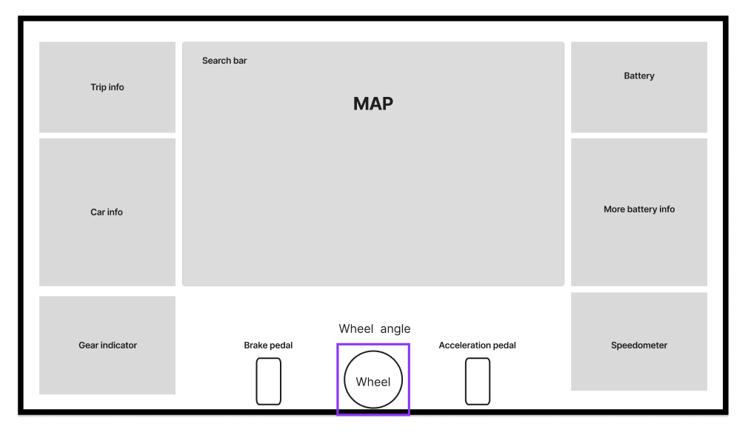Figure 1. Low-fidelity wireframe translating the prioritised content list into a three-column layout skeleton.
    - High-Fidelity Figma Prototype
The high-fidelity Figma prototype kept the wireframe’s grouping unchanged and added the dark, HUD-inspired visual language that the rest of the project builds on: a slate colour palette, an elevation-coloured route line on the map, a battery-to-motor-to-wheel energy flow diagram, and a fully designed steering wheel with a gear/regen selector beneath it.
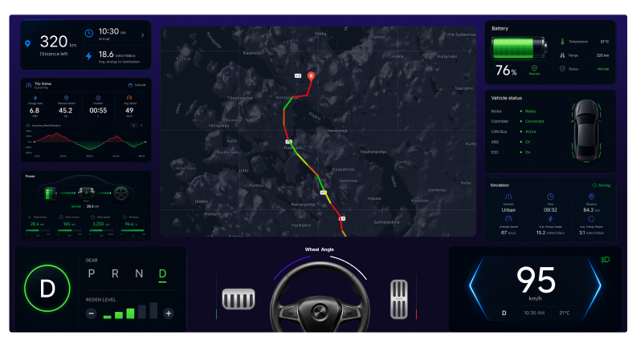
Figure 2. High-fidelity Figma prototype applying the dark HUD visual language to the wireframe skeleton.
    - Building the Dashboard in React
The initial React build carried the Figma prototype’s visual design into a working interface, including a live Google Map, an elevation-profile chart with red/green gain-loss colouring matching the prototype, and a functioning power-flow visualisation. At this stage several values were still hardcoded or only partially wired up.
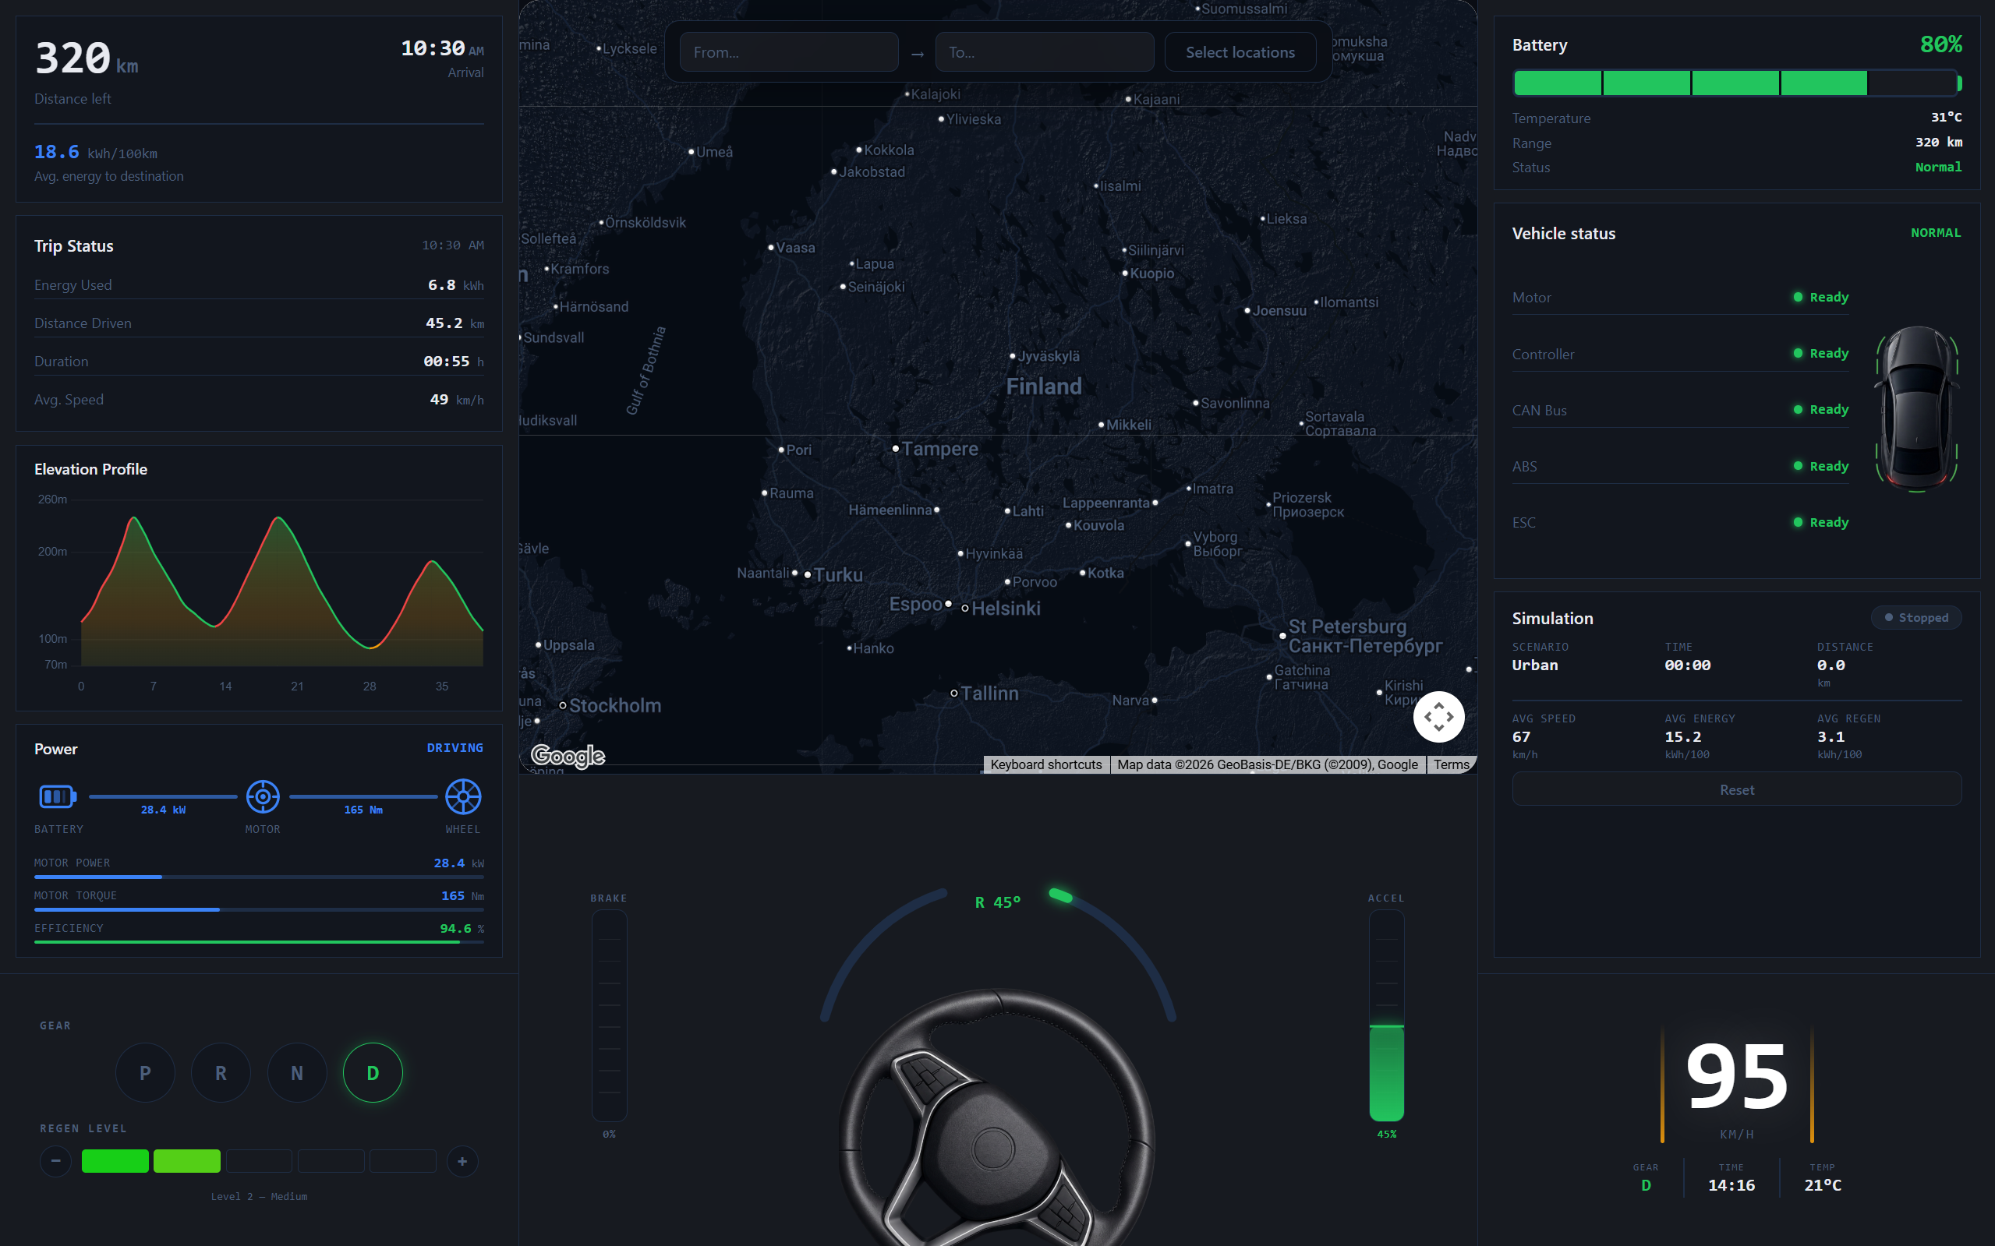
Figure 3. Initial build of the dashboard according to the prototype. Core layout and panels are in place, but several values are still placeholder/hardcoded.
    - Usability Testing and the Final Build
As no real EMDT operators were available, the initial build was tested with several friends of mine instead, who were shown the dashboard and asked for their reactions and suggestions. A few issues came up repeatedly: some panels felt cramped and the spacing between elements was off in places, and more than one person said the dark theme was too dark and asked for a brighter option. Based on this feedback, a final round of changes was made.
The final build addressed both findings. Every hardcoded value was replaced with live application state, with an explicit dash placeholder ("—") shown when no drive is active rather than a fake number, and the elevation profile is generated per selected route instead of being a fixed demo chart. A full light theme was added alongside the dark theme, built as a parallel set of colour tokens rather than a simple inversion, so every panel, chart and control looks equally finished in either mode.
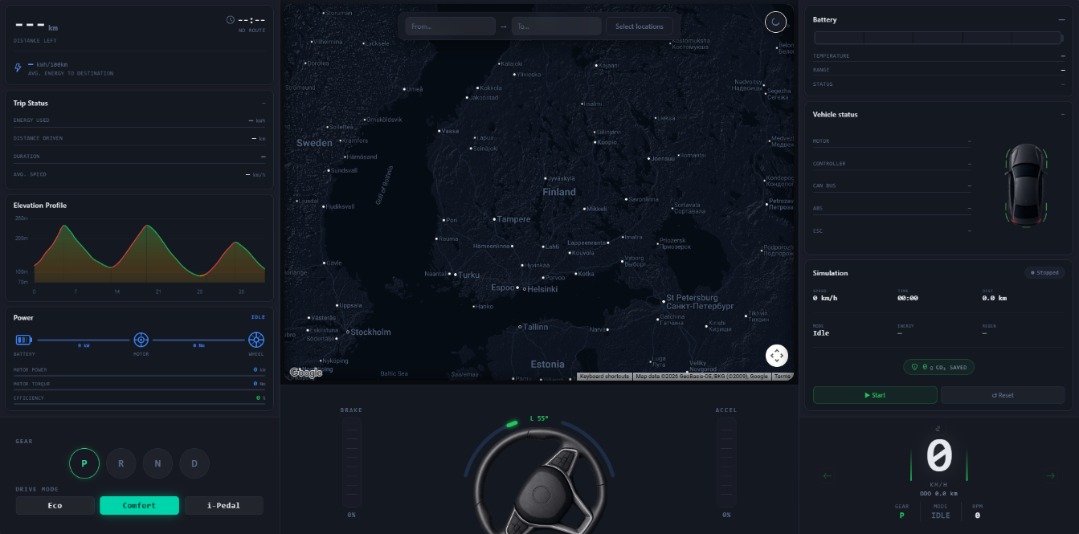
Figure 4a. Final build, dark theme.
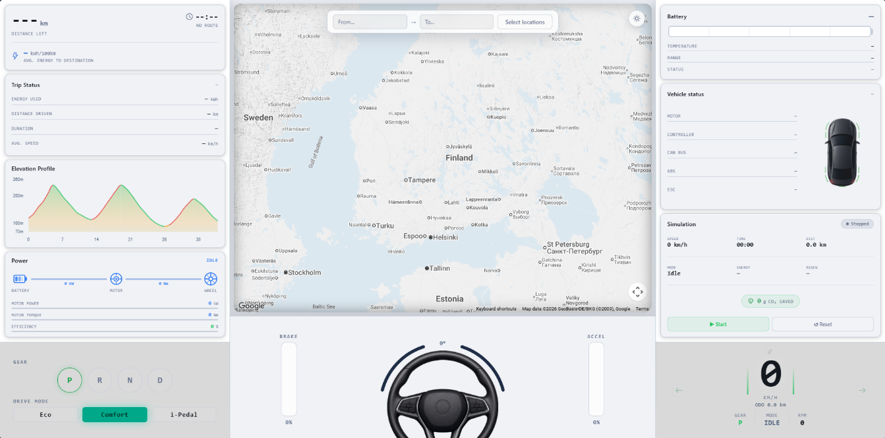
Figure 4b. Final build, light theme, added directly in response to usability-testing feedback.
The light theme added after usability testing shares the same accent colours for brand consistency, with inverted background and surface tones for daytime readability. Numerical data throughout the interface is set in a monospace typeface for alignment and readability, labels use uppercase with letterspacing for a HUD-like feel, and map overlay elements use a glass-morphism treatment - a semi-transparent, blurred surface with a subtle border - so the map stays legible underneath them.
The final build is available at https://github.com/Uunii/Dashboard; see Appendix 1 for setup instructions.
  - Interaction Design and Visual Feedback
The driving controls are operated from the keyboard, giving the dashboard a directly interactive feel rather than only a passive display:
Key | Action
↑ | Accelerate
↓ | Brake
← | Steer left
→ | Steer right
Table 1. Driving control
Pedal presses ramp up over roughly 0.8 seconds rather than jumping instantly, so pressing and releasing the accelerator or brake feels more like operating a real pedal than toggling a switch. The steering wheel rotates up to ±540° across three colour zones - green below 180°, yellow below 360°, and red at or above 360° - so the driver has an immediate visual read on how much lock is applied without reading a number.
Instead of a bare regen slider, the vehicle is controlled through three drive modes, each mapped to its own regen and throttle profile:
Mode | Power | Regen | Behaviour
Eco | Reduced | Strong | Max range, softer throttle, heavier recovery
Comfort | Standard | Medium | Balanced everyday driving (default)
i-Pedal | Standard | Max | One-pedal driving — the car brakes to a full stop on release
Table 2. Drive modes
The modes are selected from prominent dashboard buttons, and switching between them visibly changes how the accelerator behaves and how strongly the car decelerates when the pedal is released.
The battery-to-motor-to-wheel energy flow diagram switches between four visual states:
Mode | Visual | Values shown
Idle | Dim blue, no values | -
Driving | Blue flow | Positive power and torque
Regen | Green flow | Negative power (energy recovery)
Braking | Red flow | Negative power (friction loss)
Table 3. Visual colours
For demonstration the dashboard also provides a set of demo states that illustrate different vehicle conditions at the press of a key, along with independent control of turn signals:
Key | Action
1 | Normal state — healthy car, green indicator
2 | Warning state — amber indicators, low-tire-pressure light
3 | Error state — red indicators, fault lighting
4 | Charging state — battery blue, time-to-full shown
7 | Left turn signal on/off (blinks)
9 | Right turn signal on/off (blinks)
0 / Esc | Clear demo state
Table 4. Demo controls
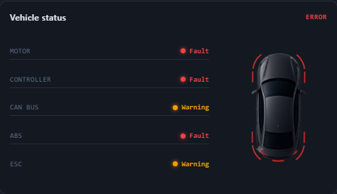
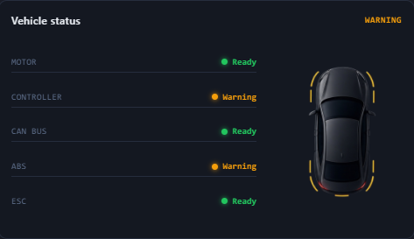
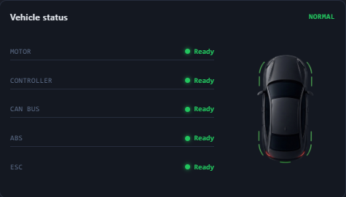

Figure 5. Demo state examples
These states re-skin the car image, battery, status indicators and cockpit telltales (turn signals, headlight, ODO on the speedometer) so the interface can demonstrate warning and failure conditions live, in addition to normal driving.
  - Map and Route Visualisation
The map view directly supports the route-planner persona’s use case from Chapter 2. A user enters an origin and destination through a search bar with autocomplete suggestions; once a route is chosen, the map draws the route line coloured to reflect climb and descent along the way, and an elevation-profile chart beneath the map mirrors the same colouring so the map and chart read as one connected picture rather than two separate widgets.
This colour-coding was a deliberate UX choice: it lets an operator judge how demanding a route looks at a glance, before reading any of the specific trip numbers in the left-hand column, directly supporting the topography-based route optimisation use case identified during the persona work.
- Summary
The project set out to design a usable, clear dashboard UI/UX prototype for the EMDT Green Transition Dashboard, and to answer the research question of how real-time dashboard UI/UX can effectively communicate CO₂ savings and energy footprint KPIs and support users' decision-making. The completed GTD-UX prototype presents the prioritised content list from Chapter 3 inside a three-column layout, with the colour-coded, always-visible critical information from Chapter 2 carried through to the final build.
Prioritising content before wireframing, then moving through prototyping, building and testing, gave each stage a clear basis to work from. As no real EMDT operators were available, the initial build was tested with several friends instead, who pointed out cramped spacing in places and asked for a brighter alternative to the dark theme. The final build addressed both, alongside removing every remaining hardcoded value from the interface. As anticipated in the project plan's risk analysis, working solo across UX research, design and development was managed through structured weekly scheduling, and translating complex EV data into intuitive visuals without oversimplifying it remained an ongoing balancing act throughout.
Because backend/API development, live data integration and a mobile application were out of scope, the prototype remains frontend-only, built on simulated data. Further UI/UX work identified for future iterations includes testing with real EMDT operators, accessibility improvements, additional KPI views, and a mobile companion view. Overall, the project delivered a dashboard design that meets its objectives within the defined scope, grounded in a clear, prioritised understanding of what the interface needed to show and why.

References
Allclonescript. 2025. 20 Best Dashboard UI/UX Design Principles You Need in 2025. Retrieved on 02 June 2026. Available at https://medium.com/@allclonescript/20-best-dashboard-ui-ux-design-principles-you-need-in-2025-30b661f2f795
DesignRush. 2024. 9 Dashboard Design Principles for 2026. Retrieved on 02 June 2026. Available at https://www.designrush.com/agency/ui-ux-design/dashboard/trends/dashboard-design-principles
Nielsen Norman Group. 1994. 10 Usability Heuristics for User Interface Design. Retrieved on 04 June 2026. Available at https://www.nngroup.com/articles/ten-usability-heuristics/
Nielsen Norman Group. 2024. How to Conduct a Heuristic Evaluation. Retrieved on 04 June 2026. Available at https://www.nngroup.com/articles/how-to-conduct-a-heuristic-evaluation/
Figma. 2026. What is Wireframing? The Complete Guide. Retrieved on 08 June 2026. Available at https://www.figma.com/resource-library/what-is-wireframing/
Figma. 2026. Create a Basic Wireframe and Prototype. Retrieved on 08 June 2026. Available at https://help.figma.com/hc/en-us/articles/13666942319127-Create-a-basic-wireframe-and-prototype
Figma. 2024. Free Figma Wireframe Kit. Retrieved on 08 June 2026. Available at https://www.figma.com/community/file/967057499645382730/impakt-wireframe-kit-nov-2024-update
Figma. 2024. Tesla Dashboard UI Component Library. Retrieved on 08 June 2026. Available at https://www.figma.com/community/file/1382192547846546595/tesla-dashboard-ui-component-library
Geotab. 2026. EV Fleet Management. Retrieved on 18 August 2026. Available at https://www.geotab.com/fleet-management-solutions/electric-vehicles/
Nielsen Norman Group. 2024. Tesla’s Touchscreen UI: A Case Study of Car-Dashboard User Interface. Retrieved on 09 June 2026. Available at https://www.nngroup.com/articles/tesla-big-touchscreen/
Collabora. 2022. Carlafox, an Open-Source Web-Based CARLA Visualizer. Retrieved on 09 June 2026. Available at https://www.collabora.com/news-and-blog/blog/2022/10/11/carlafox-open-source-web-based-carla-visualizer/

Appendix 1. Prototype and build access:
Repository: https://github.com/Uunii/Dashboard
git clone https://github.com/Uunii/Dashboard.git
cd Dashboard
npm install
npm run dev
The dashboard uses the Google Maps JavaScript API for the map view, route search and elevation profile, so a Google Maps API key is required to run it. Create one via the Google Cloud Console (enabling the Maps JavaScript API, Directions API and Elevation API), then add it to the project's environment variables before running npm run dev.
More info about setting up is in github repository.

