

Team Urban13

Yassine Hamcha Lorenzo van der Woude

Abdul Zor Stefan Meijer

Peter Malmgrem

Table of Contents

1. Introduction 2

1.1. Purpose and scope 2

2. Login page 3

3. Home page 3

4. Statistics page 4

5. Admins page 5

6. About us page 6

7. Other functions 7

7.1. Log out function 7

7.2. Notification function 7

# Introduction

Welcome to the user manual of the admin website for the University of Amsterdam (UvA) which manages all the information and results connected to the bicycle storage of the UvA. This manual contains a description of the functions of the website and step-by-step procedures for website access and use.

# Purpose and scope

This user manual is designed to provide user assistance for the admins that have access to the admin page of the UvA bicycle storage which contains results and restricted information associated to the bicycle storage.

# Login page

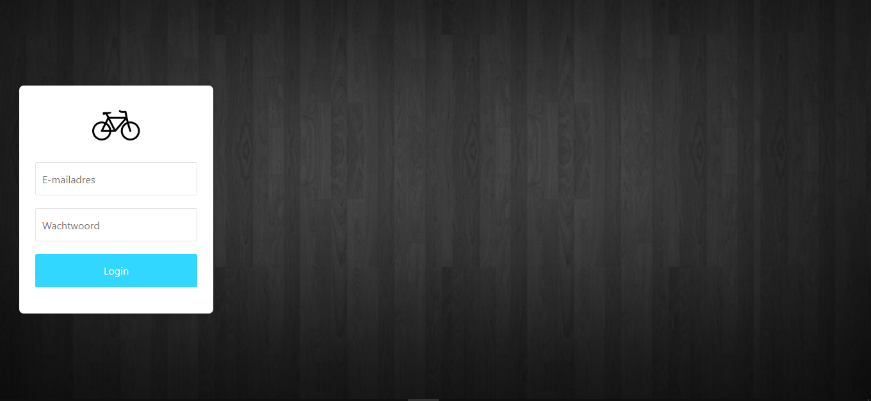

This is the login page. This is the first page you will see when typing the website URL. You WILL need an email and password ,provided by the UvA, to be able to access the website. Whenever you have typed in the needed username and password, you can CLICK the login button to log in and have access to the website. However, if you fill in a wrong username/password you will not gain access and will receive an error message.

# Home page

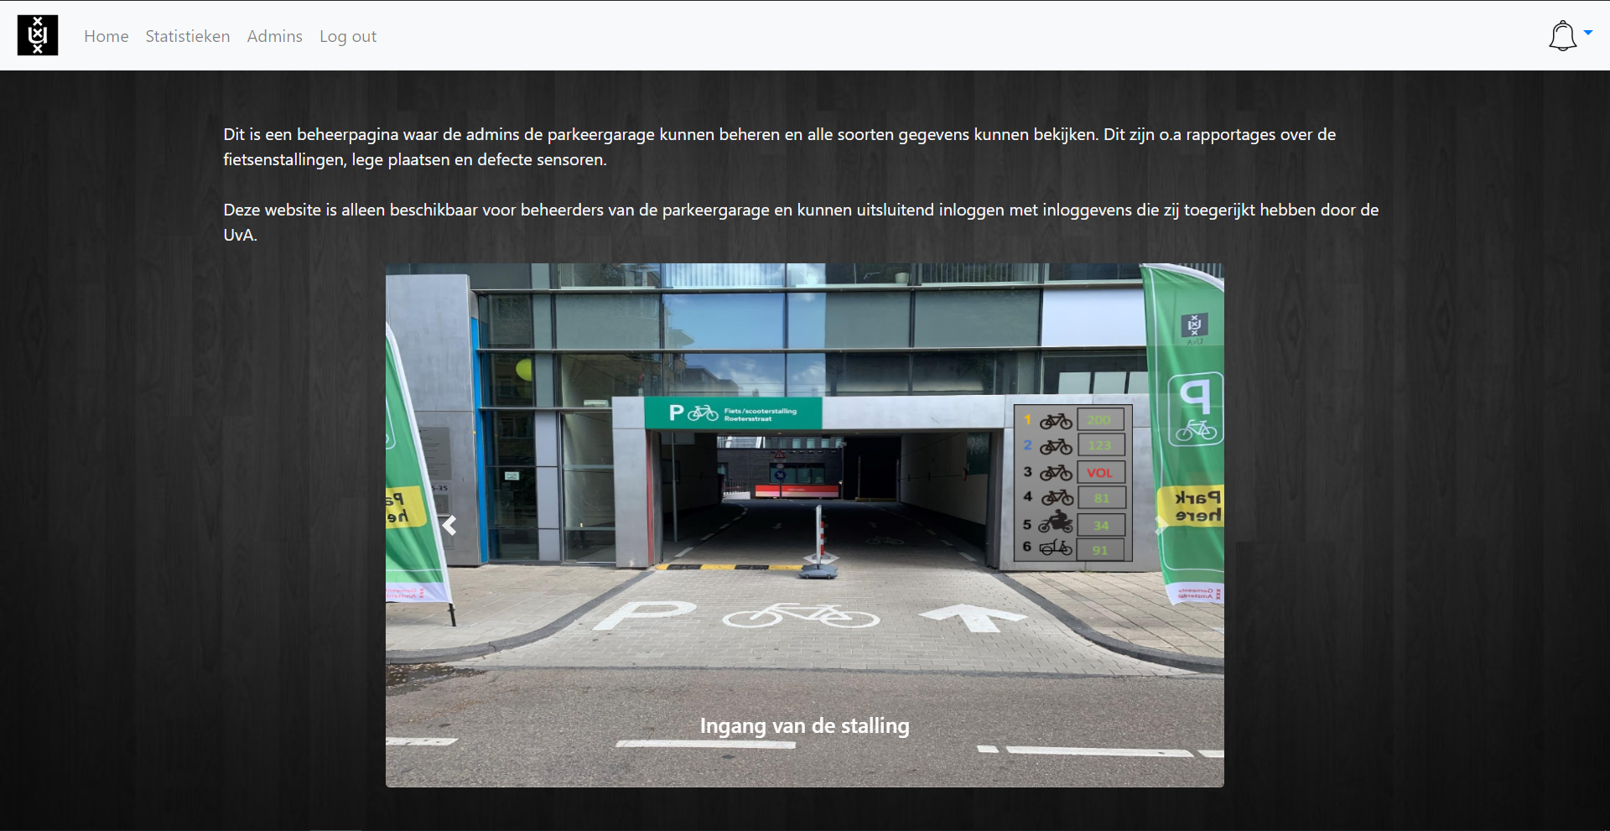

The home page is the first thing you will see after you login. You can see a description of the website, alongside a slideshow of photos about the entrance, inside and floor plan of the bicycle storage.

# Statistics page

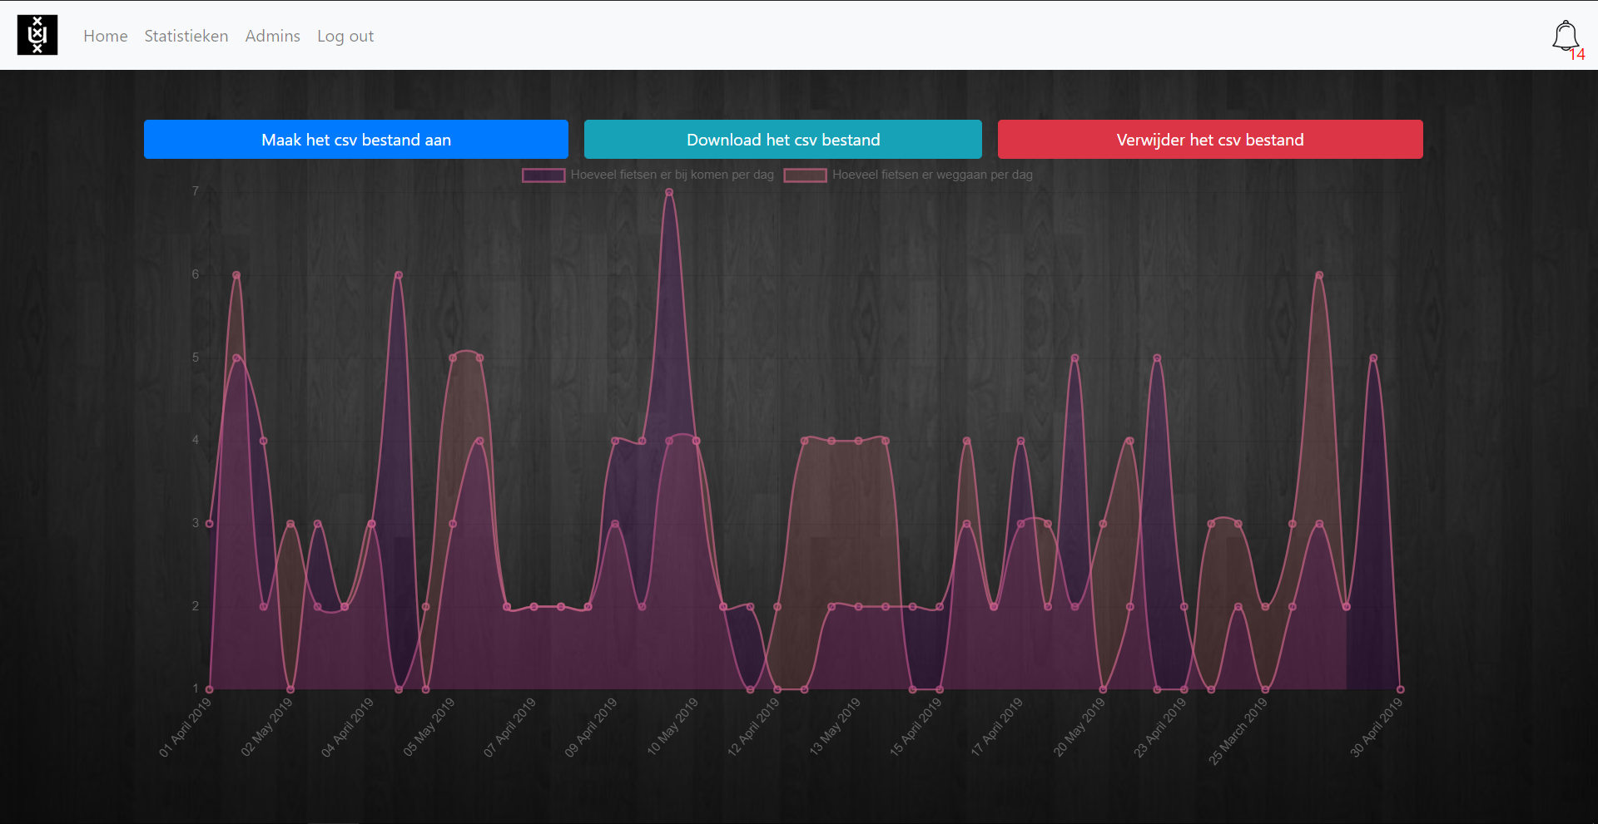

This is the statistics page. There is a chart available where the amount of bicycles that enter and leave are being presented.

You can CLICK on the tags i.e. “hoeveel fietsen er bij komen per dag” to SPECIFY what you want to view. There are 3 options on the top of the page which are “Maak het csv bestand aan”, “Download het csv bestand” and “Verwijder het csv bestand”. To CREATE a csv file, PRESS the “maak het csv bestand aan” button. If you want to DOWNLOAD an EXISTING csv file, PRESS the “download het csv bestand” button. PRESS the “verwijder het csv bestand” to DELETE the csv file that has been previously created. The csv file can be shown in Excel for further data collections as shown below:

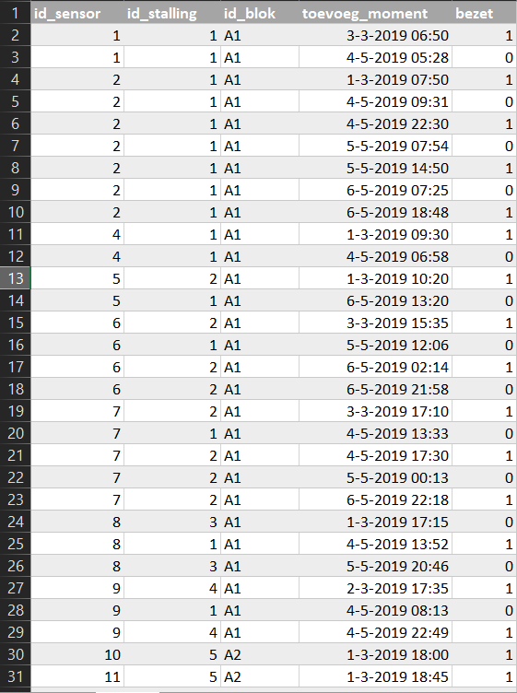

# Admins page

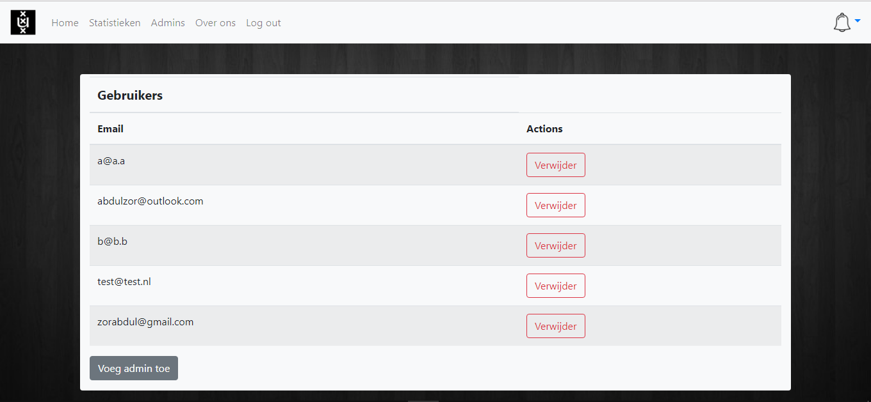

This is the admins page. Here you are able to MANAGE the available admin accounts that are saved. You can DELETE an account by PRESSING on the “Verwijder” button. Upon PRESSING the “Verwijder” button, you will SEE a window pop up that asks you to VERIFY your decision as seen below:

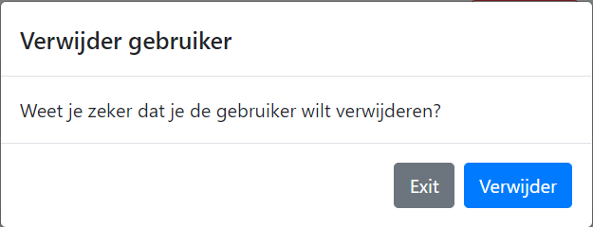

If you do not want to DELETE the account, PRESS the “Exit” button. If you want to PERMANENTLY DELETE the selected account, PRESS the “Verwijder” button.

Back to the admin page, you can PRESS the “Voeg admin toe” button to ADD another admin account that can be managed. After PRESSING the “Voeg admin toe” button, a window will pop up as seen below:

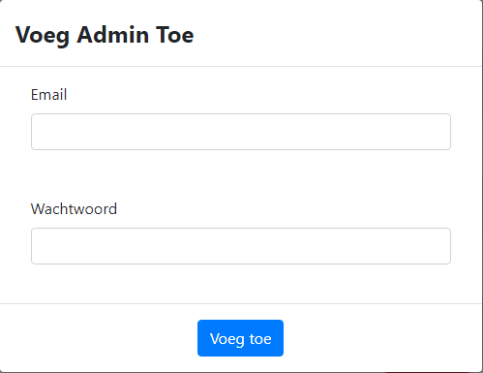

Here you can ADD the account by inserting the right email and password in the EMPTY spaces. When you are finished TYPING the email and password, PRESS the “Voeg toe” button to ADD the account.

# About us page

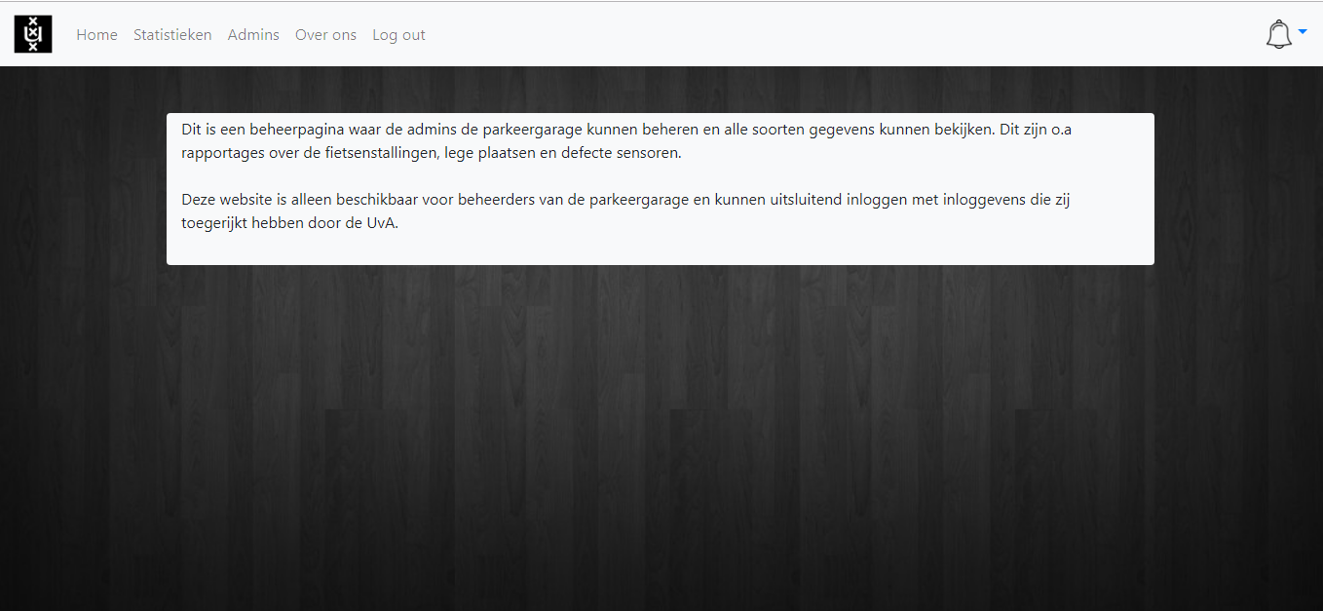

This is the about us page, where a description is given of the purpose of the website. Because this user manual is in English, here is a translation of what it says:

“This is a management page where the admins can manage the parking garage and view all types of data. These are, among other things, reports about the bicycle sheds, empty places and defective sensors.

This website is only available to managers of the parking garage and can only log in with logins provided by the UvA.”

# Other functions

# Log out function

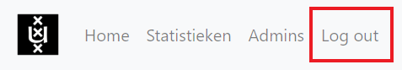

This is the Log out function. This function is self-explanatory. If you CLICK this button, you will LOG OUT and get redirected to the login page as seen below:



# Notification function

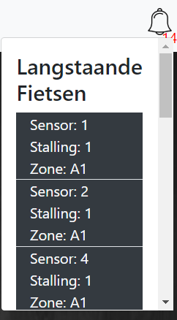

This is the notification function. CLICK on the notification bell to SEE if there are any long-standing bicycles in any of the bicycle sheds. You can also SEE if there are any defective sensors that have to monitored.