WEEK 3

VACS AI Patient & Grading Issue Report
Final Clinical and Operational Audit
Sarah Thompson • Robert “Bob” Jenkins • Maria Thompson
Nine visits • 77 grouped findings • Consolidated October 23, 2026
Purpose: Bring the nine Week 3 encounter audits into one complete report. Patient sections appear in Sarah, Robert and Maria order, with Tuesday, Wednesday and Thursday under each patient. The original findings, issue identifiers, priorities, status qualifications, tables, focused evidence and capture instructions remain with their encounter. Open investigations remain identified as unverified; this compilation is not a post-fix retest.

Quick Guide for Non-Clinical Readers
Term | Plain-language meaning
VACS / EMR | The virtual training system / the electronic chart shown to the student.
AI patient / grader / rubric | The simulated patient / scoring system / reference requirements.
SOAP | Subjective, Objective, Assessment and Plan sections of the clinical note.
Grouped finding | One underlying issue; several deductions may relate to it.
High / Medium / Low | Original audit priority; priority alone does not prove a defect is confirmed.
Open / unable to verify | Still unresolved / evidence is insufficient to confirm the cause.
Focused evidence | Relevant original screenshot excerpts placed beneath each issue.
Initial audit / retest | First review of an encounter / later verification of reported fixes.
Issue identifiers | Original patient-day codes retained for traceability, including numbering gaps.
Visit-specific clinical glossaries are retained at the start of each encounter section. Each section preserves the original review date and grading result; the consolidated date does not replace those records.

Final Review Summary
This final audit compiles 77 grouped findings across nine visits: 23 High, 49 Medium and 5 Low priority. These totals include open source conflicts, missing-data investigations and unable-to-verify items, as labeled in the individual reports. They are not a count of 77 independently confirmed software defects. No corrected grade is calculated.
The recurring concern is disagreement among the chart, simulated patient, reference and grader about the same visit. Common areas include treatment stage, medications, allergies, measured results, symptom history and what evidence was actually available. The individual reports distinguish those conflicts from routine SOAP-writing suggestions.
Encounter | Grade | Findings | H / M / L | Page
Sarah Thompson  Tuesday initial visit | 81.6% | 9 | 2 / 5 / 2 | 3
Sarah Thompson  Wednesday 3-month follow-up | 81.4% | 9 | 2 / 6 / 1 | 16
Sarah Thompson  Thursday 6-month follow-up | 80.4% | 9 | 2 / 6 / 1 | 29
Robert “Bob” Jenkins  Tuesday initial visit | 74% | 9 | 2 / 7 / 0 | 43
Robert “Bob” Jenkins  Wednesday 3-month follow-up | 74.1% | 10 | 1 / 8 / 1 | 56
Robert “Bob” Jenkins  Thursday 6-month follow-up | 88.6% | 7 | 4 / 3 / 0 | 70
Maria Thompson  Tuesday initial visit | 87.2% | 8 | 3 / 5 / 0 | 80
Maria Thompson  Wednesday 3-month follow-up | 71% | 9 | 2 / 7 / 0 | 91
Maria Thompson  Thursday 3-month follow-up | 64.6% | 7 | 5 / 2 / 0 | 106
Evidence and status
Original issue identifiers, source review dates, scores and evidence limits remain intact. A deduction establishes the grader’s response, not independent proof of the live chart. Read the stated status and targeted Capture instructions before treating a finding as confirmed. Repeated issues remain under each affected visit. No sample patient findings or scores are incorporated.

Sarah Thompson Tuesday Initial Visit
Initial audit • Grading result 81.6% • Review date October 23, 2026
Purpose: Record unresolved differences between Sarah’s current asthma chart, actual AI-patient answers, reference checklist and grading feedback. Several deductions require history that conflicts with direct answers. The controller prescription history and pulmonary measurements also need reconciliation. This is the first audit of Sarah’s Tuesday initial encounter.

Quick Guide for Non-Clinical Readers
Term | Plain-language meaning
VACS / EMR | Virtual Ambulatory Care Simulation / electronic medical record.
AI patient / grader | The simulated patient / the system scoring the clinical note.
SOAP | Subjective, Objective, Assessment and Plan sections of a clinical note.
Asthma / exacerbation | An inflammatory airway condition / a breathing flare-up.
SABA / albuterol | Short-acting airway-opening reliever medicine / the product used here.
ICS / INCS | Inhaled corticosteroid for the lungs / intranasal corticosteroid for the nose. Nasal fluticasone does not replace an asthma controller.
MART / SMART | One ICS-formoterol inhaler used for both scheduled maintenance and symptom relief.
OCS / prednisone | Oral corticosteroid / the short-course steroid used during Sarah’s recent flare.
ACT | Asthma Control Test, a questionnaire used to assess symptom control.
FEV1 / FVC | Air breathed out in one second / total air breathed out during a forced breath.
GINA | Global Initiative for Asthma, the guideline organization.
Post-bronchodilator | A breathing test measured after an airway-opening medicine.

Final Review Summary
The grader returned 81.6% (“Solid”) and praised the MART/SMART recommendation, safety counseling, action plan and recognition of the spirometry discrepancy. Nine grouped findings remain open: two High, five Medium and two Low priority. The Low-priority entries are investigations, not confirmed defects. Repeated deductions are grouped under their underlying conflict; no corrected score is calculated.
Issue and priority | Unresolved finding
ST-Tue-01 • High | Chart denies prior controller prescription, but patient reports intermittent budesonide.
ST-Tue-02 • Medium | Reference contains conflicting symptom-frequency targets.
ST-Tue-03 • High | Grader requires denial of recent oral steroids despite a documented prednisone-treated flare.
ST-Tue-04 • Medium | Grader requires steroid-safety concern despite an explicit non-confirming answer.
ST-Tue-05 • Medium | Grader requires uncertain diagnosis age despite a specific patient answer.
ST-Tue-06 • Medium | Expected heart rate and temperature differ from the current chart.
ST-Tue-07 • Medium | Reported pulmonary ratio does not reproduce from the displayed FEV1 and FVC.
ST-Tue-08 • Low | Additional positive symptoms are required but not established by the reviewed answers.
ST-Tue-09 • Low | Possible missed assessment numbering requires exact submitted-note verification.
Evidence reviewed: Pasted Tuesday EMR; seven original interview images 003847, 003927, 004001, 004036, 004106, 004131 and 004201; reference Pasted text(20261024-004829).txt; SOAP draft in this conversation; four feedback images 005612, 005638, 005705 and 005744. All image timestamps are source filenames, not encounter dates.
Evidence limits: No targeted live EMR captures or export of the exact submitted SOAP were supplied. The feedback images preserve score, narrative and listed deductions through 5A.3; the last ends at the Gold Standard Comparison heading. Content below that heading is not available. Joined crops preserve a question and its answer across adjacent originals and are identified in captions.
Excluded: Routine omissions of explicit guideline wording, risk-reduction percentages, numeric BMI ranges, counseling-goal phrasing, occupation grade level and referral-pathway wording are not automatically software defects. Unknown symptoms are not treated as denials. Tdap overdue and room-air saturation are supplied in this chart, so prior patients’ missing-context findings do not apply. Static dates and age/DOB differences are excluded.

Issue ST-Tue-01. Controller history conflicts across chart patient and grading targets
Priority: High
Status: Open; direct patient evidence available, live prescription history pending
What the student saw or heard: The HPI explicitly states no prior ICS controller was prescribed, and the active list contains only albuterol, cetirizine and nasal fluticasone. Asked about daily asthma controllers, Sarah says she uses budesonide only when a cold is starting and relies primarily on albuterol. Its formulation, dose and prescription status are unconfirmed.
What the reference or grader expects: The reference requires that she has never received a controller or guideline-directed anti-inflammatory treatment. Deductions 1E.18 and 3B.3–4 penalize reporting the intermittent budesonide history or leaving it unconfirmed. The structured Plan also refers to daily ICS adherence and switching budesonide, reinforcing the inconsistent treatment-stage assumptions.
Why this matters: The learner cannot safely choose between failure to prescribe and inconsistent use without reconciliation. Inserting an absolute “never prescribed” statement would contradict the patient’s current report. Reporting unverified use does not establish that the medicine was actually prescribed.
Suggested fix: Align the intended medication history across chart, patient response bank, Plan and rubric. If budesonide is real, expose its prescription and actual use. If not, correct the patient answer. Accept a reconciliation plan until the product and history are established.
Focused evidence
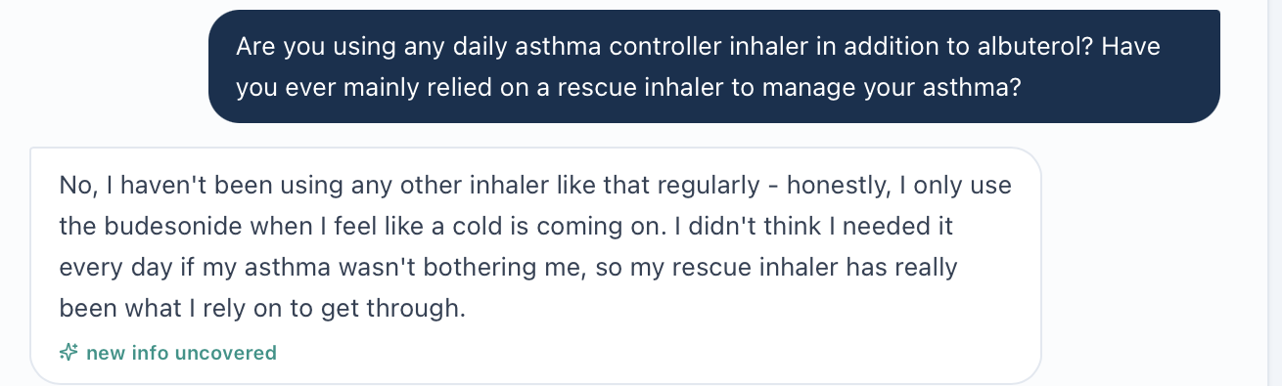
Original controller question and answer from image(20261024-004036).png.
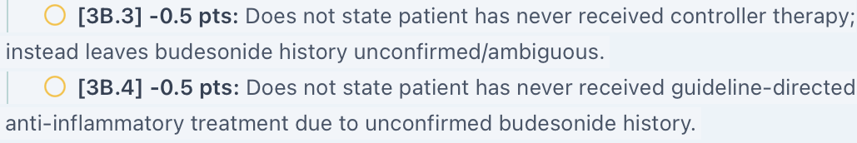
Original grader crop ST_Tue_AI_Feedback_controller.png. Long source lines continue in reading order without rewriting.
Evidence limit or targeted capture: Capture ST_Tue_EMR_Medication_History_01.png, including current, prior and discontinued inhalers, and ST_Tue_EMR_HPI_and_Plan_01.png. If records cannot resolve it, ask neutrally for the budesonide product, strength, directions and source; preserve the entire short continuation once.

Issue ST-Tue-02. Reference frequency targets conflict with direct answers and its own assessment section
Priority: Medium
Status: Open; original interview and grader evidence available
What the student saw or heard: Sarah reports albuterol 1–2 times daily on 5–6 days weekly and nighttime awakening 2–3 nights weekly. The SOAP preserves these frequencies. The patient also mentions an approximate weekly count; the note retains her clearer daily-use and days-per-week descriptions.
What the reference or grader expects: The Subjective reference expects albuterol 4–5 times weekly and awakening about once weekly. Deductions 1B.6 and 1B.8 enforce those lower frequencies. The same reference’s Assessment section instead requires 1–2 times daily and 2–3 awakenings weekly, matching the interview.
Why this matters: The grader penalizes a frequency that another part of the same reference requires. This can change the perceived symptom burden and treatment discussion.
Suggested fix: Use one consistent frequency dataset across patient, reference sections and scoring. Accept the actual answer with its units and time window; do not replace it with a hidden lower frequency.
Focused evidence
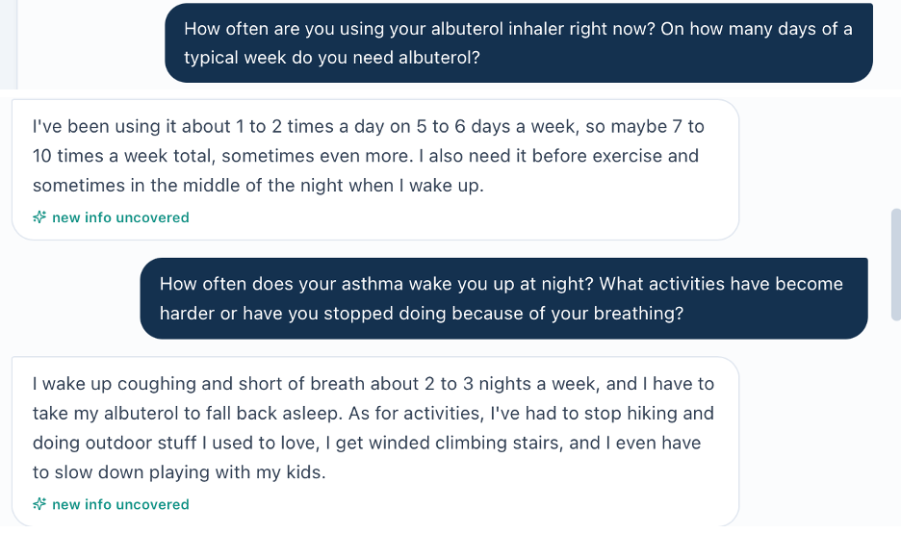
Albuterol question from image(20261024-003847).png joined to frequency and nighttime answers in image(20261024-003927).png.
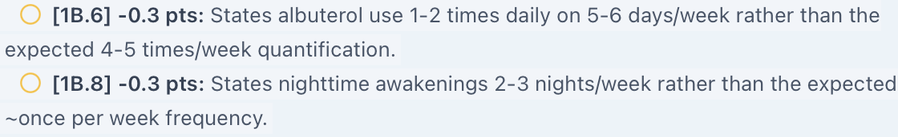
Original grader crop ST_Tue_AI_Feedback_frequency.png. Long source lines continue in reading order without rewriting.

Issue ST-Tue-03. Grader requires denial of recent oral steroids despite the prednisone treated flare
Priority: High
Status: Open; current chart and direct interview agree
What the student saw or heard: The chart documents a viral-triggered exacerbation six weeks ago requiring urgent care and five days of prednisone. Sarah confirms the urgent-care visit and five-day steroid course, then confirms prednisone in the following screenshot. She denies emergency department visits and hospitalization, not oral steroid treatment.
What the reference or grader expects: The reference repeatedly requires denial of recent OCS. Deductions 1B.13 and 1F.3 penalize documenting the course six weeks earlier. No reference time-window definition is supplied that would justify changing the stated history to a denial.
Why this matters: This removes an important recent exacerbation risk factor from the expected record. Accurate documentation of the recent steroid-treated flare is treated as an error.
Suggested fix: Update the reference and grader to accept the five-day prednisone course six weeks ago. Keep emergency department, hospitalization, urgent-care and steroid-use histories distinct and apply explicit time windows.
Focused evidence
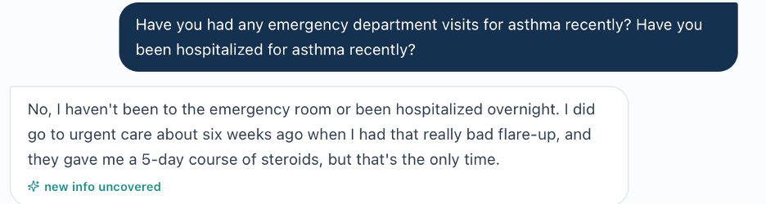
Original urgent-care and steroid history from image(20261024-003927).png; explicit prednisone confirmation follows in image(20261024-004001).png.
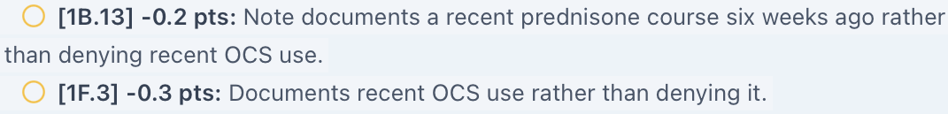
Original grader crop ST_Tue_AI_Feedback_prednisone.png. Long source lines continue in reading order without rewriting.

Issue ST-Tue-04. Steroid safety fear is required despite a direct nonconfirming answer
Priority: Medium
Status: Open; original question answer and grader evidence available
What the student saw or heard: Asked about concerns or questions regarding ICS or steroid inhalers, Sarah says she does not have specific concerns. She explains that she did not realize daily preventive treatment was needed and believed steroids were only for emergencies.
What the reference or grader expects: The reference requires an ICS-safety concern and a fear-based acceptance barrier. Deductions 1C.10, 1G.1 and 3D.3 enforce that expectation. Narrative feedback also advises clarifying that she denies specific concerns rather than implying fear, creating tension with the deductions.
Why this matters: A knowledge gap about purpose is established; a safety fear is not. Labeling fear despite the answer would misstate the interview. General ICS safety counseling remains appropriate regardless of whether fear is present.
Suggested fix: Accept the documented distinction between misunderstanding treatment purpose and fearing treatment harm. Align the response bank and scoring if a specific safety concern is intended.
Focused evidence
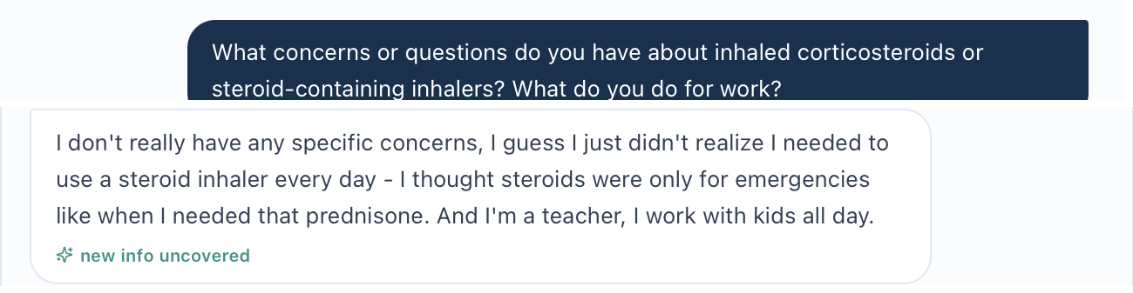
ICS-concern question from image(20261024-004106).png joined to its answer in image(20261024-004131).png.
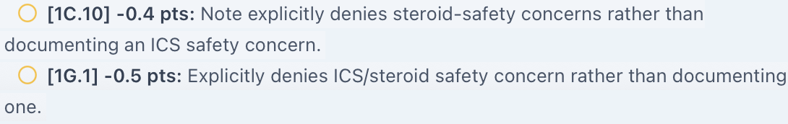
Original grader crop ST_Tue_AI_Feedback_fear.png. Long source lines continue in reading order without rewriting.

Issue ST-Tue-05. Reference requires uncertain diagnosis age despite a specific answer
Priority: Medium
Status: Open; direct patient and grader images available
What the student saw or heard: Asked how old she was at asthma diagnosis, Sarah explicitly says eight years old. The SOAP records childhood onset at age eight.
What the reference or grader expects: The reference expects uncertainty about exact age or a lifelong history. Deduction 1C.2 penalizes the specific age instead of accepting the current answer.
Why this matters: The student is penalized for preserving an explicit patient-reported fact. A general childhood or longstanding history can coexist with a recalled age, but required uncertainty cannot.
Suggested fix: Align the intended diagnosis history and patient answers. Accept “diagnosed at age eight, patient reported” for this encounter unless a verified record corrects it.
Focused evidence
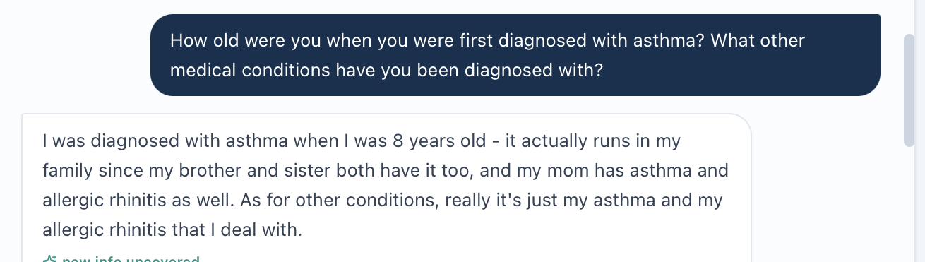
Original diagnosis-age question and answer from image(20261024-004036).png.
Original grader crop ST_Tue_AI_Feedback_age.png. Long source lines continue in reading order without rewriting.

Issue ST-Tue-06. Grading targets for heart rate and temperature differ from the supplied chart
Priority: Medium
Status: Open factual conflict; live Vitals capture needed
What the student saw or heard: The chart summary, Objective and detailed Vitals give heart rate 82 beats/min and temperature 98.2°F. These are the SOAP values.
What the reference or grader expects: The reference expects heart rate 88 and temperature 98.6°F. Deductions 2A.2 and 2A.4 call the chart-matched values transcription errors.
Why this matters: The current chart dataset and expected measurements disagree. The feedback proves its scoring targets but does not independently establish the live measurements.
Suggested fix: Use the current Tuesday Vitals as the scoring source after verification. Align the reference and grader and regrade faithful transcription.
Focused evidence
Original grader crop ST_Tue_AI_Feedback_vitals.png. Long source lines continue in reading order without rewriting.
Evidence limit or targeted capture: Capture ST_Tue_EMR_Vitals_01.png with HR, temperature, units and patient/visit context. No reconstructed Vitals image is used as proof.

Issue ST-Tue-07. Displayed pulmonary ratio does not reproduce from the visible volumes
Priority: Medium
Status: Open chart investigation; test-condition verification pending
What the student saw or heard: The pulmonary panel lists FEV1 2.5 L, FVC 3.3 L and FEV1/FVC 0.69. Dividing the displayed volumes gives 0.758, approximately 0.76, not 0.69. A +14%/+280 mL response is also reported, without a fully paired set of pre- and post-bronchodilator volumes.
What the reference or grader expects: Values from one test condition should reproduce the ratio within reasonable rounding. If the volumes and ratio belong to different pre/post conditions, those conditions must be explicit. The grader praises flagging this discrepancy; no deduction solely for identifying it is alleged.
Why this matters: The learner cannot safely interpret the listed volumes and ratio as one coherent measurement set. The difference is too large to be explained by the displayed rounding alone.
Suggested fix: Expose the paired pre- and post-bronchodilator FEV1, FVC and ratios or correct the numbers. Verify the absolute and percentage response from the actual baseline. Preserve uncertainty until the test conditions are reconciled.
Focused evidence
No original live EMR screenshot supplied. Evidence is the pasted chart and reproducible arithmetic described above.
Evidence limit or targeted capture: Capture ST_Tue_EMR_Pulmonary_01.png with the full report, units and pre/post labels. The observation relies on pasted EMR text and reproducible arithmetic, not a live source screenshot.

Issue ST-Tue-08. Additional positive symptom targets are not established by the reviewed interview
Priority: Low
Status: Unable to verify; targeted neutral clarification needed
What the student saw or heard: An open symptom-and-trigger question elicits cough, breathlessness and chest tightness, with colds and exercise as triggers. The nasal-history question elicits congestion and sneezing. Sarah does not explicitly report wheezing, seasonal asthma worsening or postnasal drip in these answers.
What the reference or grader expects: The reference requires intermittent wheeze, seasonal worsening and postnasal drip. Deductions 1B.2/5/14 and 3C.5/10 penalize their absence.
Why this matters: These facts are not established, but the patient was not directly asked each specific symptom. Non-volunteering alone is not proof of a patient-response defect. Adding the reference symptoms without confirmation would be unsupported.
Suggested fix: Ask neutral follow-ups about wheezing, seasonal variation and drainage into the throat. If the intended positives remain unavailable or are denied, align the response bank and grader. If confirmed, update the note; then this is a documentation gap rather than a confirmed software issue.
Focused evidence
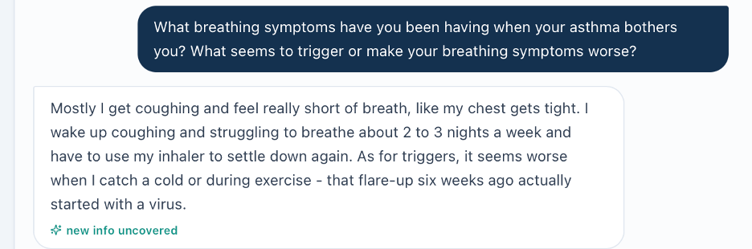
Original symptom/trigger question and answer from image(20261024-003847).png.
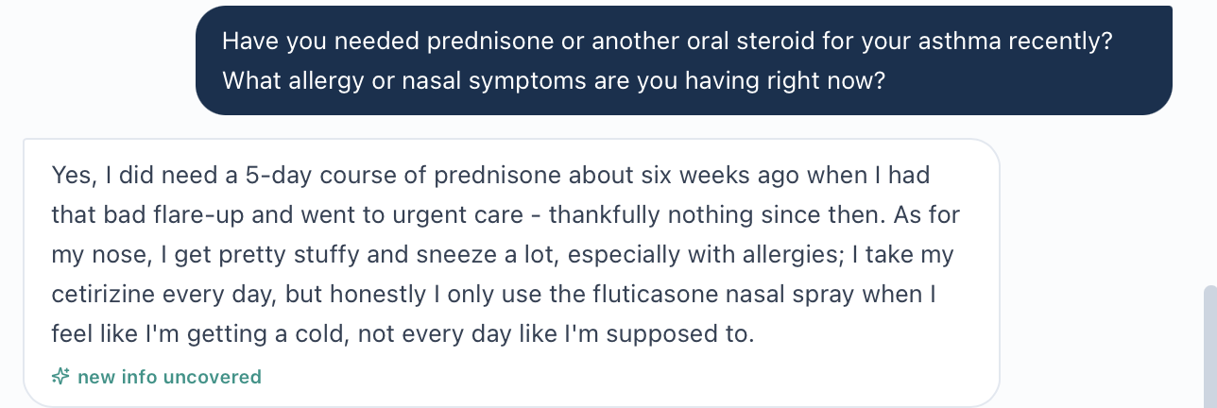
Original nasal-history question and answer from image(20261024-004001).png.

Issue ST-Tue-08 continued
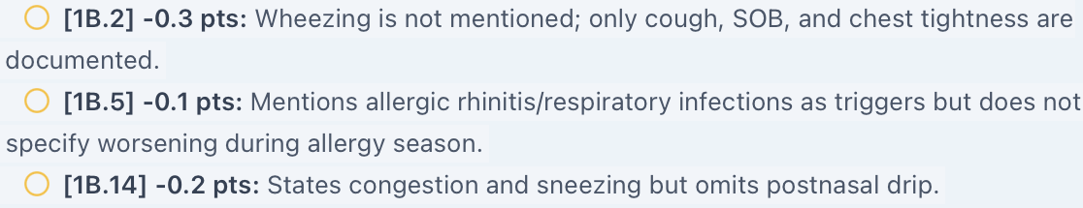
Original grader crop ST_Tue_AI_Feedback_symptoms.png. Long source lines continue in reading order without rewriting.
Evidence limit or targeted capture: Preserve the entire short clarification interview once. Do not request separate screenshots for individual answers. This entry is not counted as a confirmed defect.

Issue ST-Tue-09. Possible missed assessment numbering needs exact submitted note verification
Priority: Low
Status: Unable to verify; saved submission required
What the student saw or heard: The SOAP draft in this conversation presents four explicitly numbered assessment problems: uncontrolled asthma, allergic rhinitis, asthma medication knowledge deficit and preventive care gaps.
What the reference or grader expects: Deduction 5A.3 says the assessment problems are not numbered and only implicitly prioritized by order. The feedback elsewhere praises the note’s organization.
Why this matters: If the numbering was preserved in the saved note, this deduction conflicts with the submitted structure. If paste or formatting removed it, this is a submission/formatting problem rather than a confirmed grading defect. The exact saved note has not been supplied.
Suggested fix: Compare the saved Assessment field or submitted payload with the draft. If numbering is present, investigate parsing and regrade. If it was lost, restore explicit numbering and verify the saved text.
Focused evidence
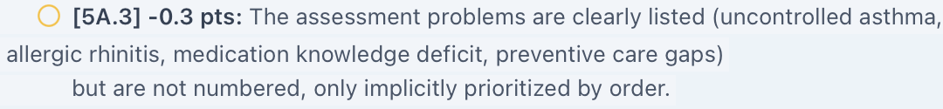
Original grader crop ST_Tue_AI_Feedback_numbering.png. Long source lines continue in reading order without rewriting.
Evidence limit or targeted capture: Capture ST_Tue_EMR_Submitted_Assessment_01.png with all assessment entries and their numbers. The chat draft is not substituted for actual submission evidence.

Additional Evidence Needed
Capture only the targeted live fields below with Sarah’s identity and Tuesday initial-visit context visible. Reuse the saved interview and feedback. Do not repeat individual grader rows or individual interview answers.
ST_Tue_EMR_Medication_History_01.png: Capture: current, prior and discontinued asthma prescriptions, including any budesonide product and directions.
ST_Tue_EMR_HPI_and_Plan_01.png: Capture: the “no prior ICS” history and current daily-ICS/budesonide Plan options; use sequential continuation if needed.
ST_Tue_EMR_Vitals_01.png: Capture: HR 82 and temperature 98.2°F with units and encounter context.
ST_Tue_EMR_Pulmonary_01.png: Capture: FEV1, FVC, ratio, percentage/absolute response and all pre/post-bronchodilator labels.
ST_Tue_EMR_Submitted_Assessment_01.png: Capture: the actual saved Assessment with complete problem entries and numbering.
Minimum Neutral Clarifications
If the medication record does not resolve budesonide, ask which product and strength she uses, who prescribed it, and the label directions. For ST-Tue-08 ask whether she experiences wheezing, whether symptoms vary by season, and whether she has drainage into her throat. Preserve the entire short continuation once; do not overwrite the original interview or treat new answers as proof of what was available earlier.
Acceptance Checks After Correction
Pass means consistent controller history, one coherent set of symptom frequencies, acceptance of the documented prednisone course, diagnosis age and lack of specific ICS fear, aligned Vitals, and reproducible or clearly labeled spirometry. Verify the exact saved Assessment before confirming a numbering defect. Regrade after source alignment; a higher score alone does not prove the conflicts are resolved.

Sarah Thompson Wednesday 3 Month Follow Up
Initial audit • Grading result 81.4% • Review date October 23, 2026
Purpose: Review unresolved differences between Wednesday’s current SMART regimen, clinical improvement, interview answers, reference checklist and grader. The main concern is that the workflow and scoring mix continuing effective SMART therapy with starting it as a new step-up. This is the first audit of Wednesday, not a post-fix retest.

Quick Guide for Non-Clinical Readers
Term | Plain-language meaning
VACS / EMR | Virtual Ambulatory Care Simulation / electronic patient chart.
AI patient / grader | The simulated patient / the system scoring the note.
SOAP | Subjective, Objective, Assessment and Plan sections.
ICS / LABA / SABA | Anti-inflammatory inhaled steroid / long-acting airway opener / short-acting reliever.
SMART / MART | One ICS-formoterol inhaler used for scheduled maintenance and as-needed relief.
Symbicort | Budesonide/formoterol combination inhaler used here for SMART.
ACT | Asthma Control Test; 21 is within its well-controlled range.
FEV1 / FVC | Air breathed out in one second / total air breathed out during a forced breath.
Bronchodilator response | Change in lung function after an airway-opening medicine.
GINA | Global Initiative for Asthma, the guideline organization.
BMI / SpO₂ | Body mass index / blood oxygen saturation.
Reported / observed | A patient’s description / a clinician directly watching the action.

Final Review Summary
The grader returned 81.4% (“Solid”). It praised continuation without escalation, technique correction and critical review of conflicting data, yet several deductions enforce a different regimen or history. Nine grouped findings remain open: two High, six Medium and one Low priority. ST-Wed-07 is a reference-data conflict without a visible related numeric deduction; ST-Wed-09 is an unverified submission investigation. No corrected score is calculated.
Issue and priority | Unresolved finding
ST-Wed-01 • High | Current SMART therapy conflicts with reference medicines and escalation requirements.
ST-Wed-02 • High | Main chart, supplemental spirometry and reference contain different results.
ST-Wed-03 • Medium | Problem list says partly controlled while ACT/advisory indicate well-controlled range.
ST-Wed-04 • Medium | Specific functional gains required despite nonconfirming patient answers.
ST-Wed-05 • Medium | Nighttime symptoms required despite no recalled awakenings.
ST-Wed-06 • Medium | Grader requires understanding despite explicit uncertainty about SMART mechanism.
ST-Wed-07 • Medium | Reference heart rate, weight and BMI targets conflict internally and with the chart.
ST-Wed-08 • Medium | Patient-reported technique errors required to be documented as directly observed.
ST-Wed-09 • Low | Possible missed assessment numbering needs exact saved-note verification.
Evidence reviewed: Pasted Wednesday EMR; eight original interview images 013609, 013648, 013708, 013745, 013823, 013852, 013923 and 014040; reference Pasted text(20261024-015446).txt; SOAP draft in this conversation; four grader images 020517, 020548, 020612 and 020631. Source image filenames use October 24 UTC; the review date above uses the user’s local date.
Evidence limits: No targeted live EMR screenshots or exact submitted-note export were supplied. Grader images cover score, narrative and deductions through 5A.3; the last ends at the Gold Standard Comparison heading. No content below that heading is assumed. Focused crops preserve source text, with joined question/answer images identified in captions.
Excluded from defect count: Routine omissions of explicit guideline year, optional vaccine rationale, exact grade level, and future treatment alternatives are not automatically software defects. Exact as-needed Symbicort frequency was not quantified, so requesting clarification is reasonable; it is not treated as a proven mismatch. OTC loratadine and multivitamin are patient-reported and should be reconciled rather than removed to satisfy a fixed medication count. No Tdap missing-data issue applies: Wednesday explicitly documents it as overdue.

Issue ST-Wed-01. Treatment stage and escalation requirements conflict with current SMART therapy
Priority: High
Status: Open workflow/reference conflict; interview evidence available, live chart captures pending
What the student saw or heard: The active list and patient both identify Symbicort 160/4.5 mcg, one inhalation twice daily plus one as needed. The advisory says ACT 21 and to assess technique before further escalation. The assessment asks for a step-up; Plan options and counseling instead suggest switching to ICS/LABA or SMART and adding a long-acting medicine.
What the reference or grader expects: The reference lists current budesonide HFA 180 mcg twice daily and albuterol, but also says no escalation is warranted and later requires starting SMART and stating that escalation is indicated. Deductions 1A.7–8 and 1E.1–2/4–5 require the earlier regimen, while 4A.1/4–5 penalize continuation/no escalation. Grader strengths explicitly praise avoiding unnecessary escalation.
Why this matters: A coherent note cannot both continue existing effective SMART and initiate it as a new escalation from ICS alone. Following the reference’s current-medication targets would misstate the active list and direct answer.
Suggested fix: Choose the intended Wednesday treatment stage and synchronize the medication list, questions, options, counseling, reference and grader. For the supplied case, accept continuation of SMART with technique correction unless verified clinical findings justify a change. Do not require albuterol as current rescue when the active SMART plan uses Symbicort.
Focused evidence
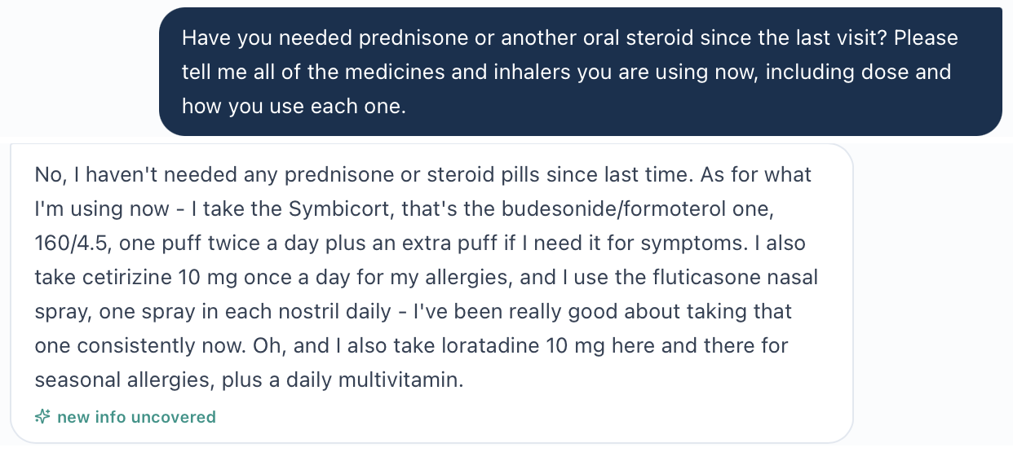
Original current-medication question and answer from image(20261024-013708).png; separate source regions are joined in reading order.

Issue ST-Wed-01 continued
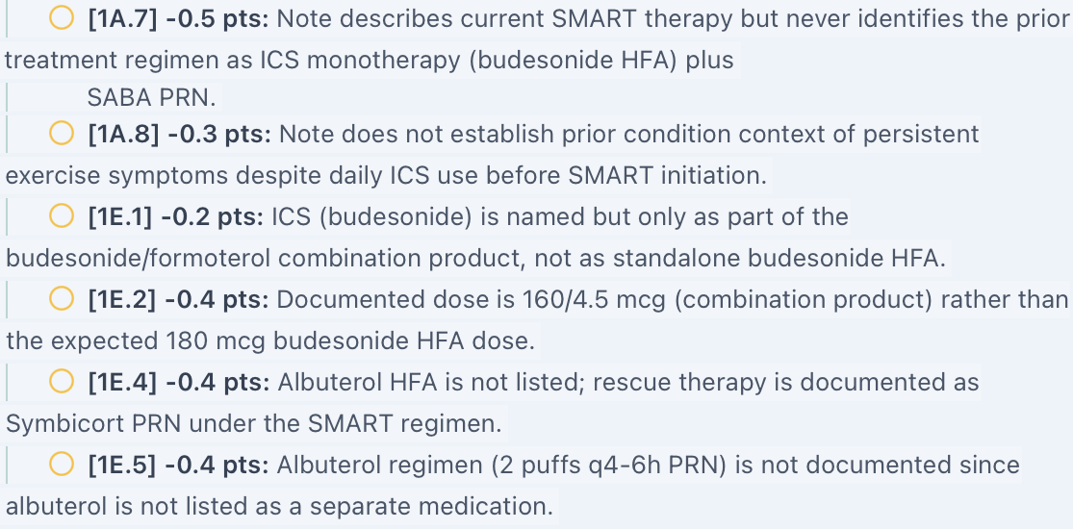
Original grader crop ST_Wed_AI_Feedback_meds.png. Source lines continue in reading order without rewriting.
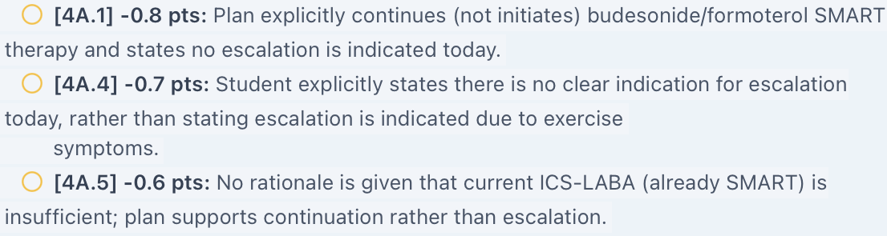
Original grader crop ST_Wed_AI_Feedback_step.png. Source lines continue in reading order without rewriting.
Evidence limit or targeted capture: Capture ST_Wed_EMR_Medications_01.png and ST_Wed_EMR_Assessment_Plan_Counseling_01.png with sequential continuation if needed. Reference and deduction conflicts are established; live workflow images remain outstanding.

Issue ST-Wed-02. Pulmonary measurements differ across main supplemental and grading records
Priority: High
Status: Open chart and grading-data conflict; live source confirmation pending
What the student saw or heard: The main panel gives FEV1 2.5 L (78% predicted), FVC 3.3 L, ratio 0.69 and response +14%/+280 mL. Supplemental data give ratio 0.76 and response +9%/+180 mL. The displayed volumes yield approximately 0.76. It is unclear whether these represent different test conditions or an intended longitudinal comparison.
What the reference or grader expects: The reference requires a third set: pre-bronchodilator ratio 0.75 and response +15%/+375 mL, while elsewhere requiring interpretation of +9%/+180 mL as below threshold. Deductions 2B.1/3/4 penalize recording the supplied values. Feedback also praises preserving the discrepancy rather than guessing.
Why this matters: The learner cannot identify a reliable current test or satisfy opposing reversibility targets. Averaging or silently choosing a hidden result would not resolve the source problem.
Suggested fix: Provide one clearly labeled current set and any distinct historical set, including paired pre/post volumes and ratios. Align reference and grader to the actual record, and accept explicit uncertainty until corrected.
Focused evidence
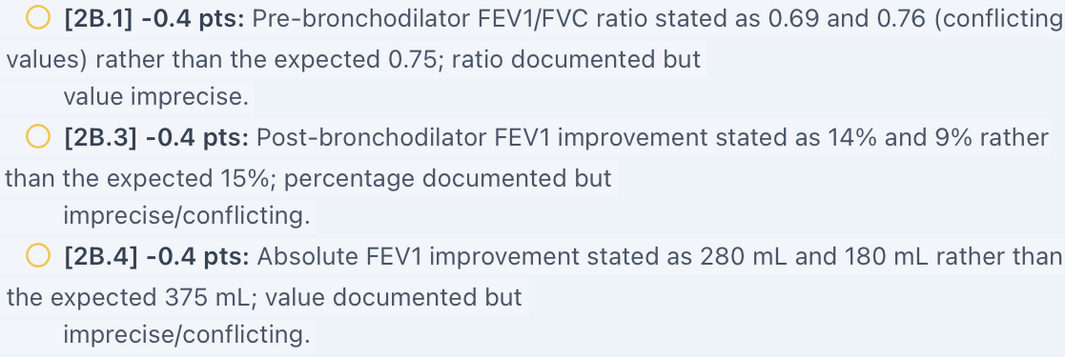
Original grader crop ST_Wed_AI_Feedback_pft.png. Source lines continue in reading order without rewriting.
Evidence limit or targeted capture: Capture ST_Wed_EMR_Pulmonary_01.png and ST_Wed_EMR_Supplemental_Data_01.png, including all test conditions and expanded report details. Grader images establish scoring targets but are not live measurement proof.

Issue ST-Wed-03. Control label conflicts with ACT interpretation and the current advisory
Priority: Medium
Status: Open internal label/workflow investigation; live capture pending
What the student saw or heard: The problem list says asthma is “Partly controlled.” The advisory and supplemental ACT section say 21 is in the well-controlled range, improved from baseline 16. The interview reports symptoms 1–2 days weekly, no recalled nighttime waking and no interval flare-ups. The SOAP flags the disagreement instead of treating a score alone as a complete control assessment.
What the reference or grader expects: Control labels and workflow prompts should reflect the same current clinical assessment. The guiding questions ask why escalation is inappropriate, while the assessment/Plan and counseling assume escalation. The broader treatment-stage conflict is counted under ST-Wed-01; this entry addresses the inconsistent control label itself.
Why this matters: The contradictory status can steer the learner toward escalation despite improvement. ACT is one input, so reconciliation should include the full symptom and risk history rather than automatic relabeling from a score alone.
Suggested fix: Update or explain the problem-list status using the current symptom assessment, risk history and ACT. Keep the advisory and control label synchronized and make any residual uncertainty explicit.
Focused evidence
No original live EMR image supplied. Evidence is the pasted Wednesday chart and supplied reference described above.
Evidence limit or targeted capture: Capture ST_Wed_EMR_Control_Status_01.png showing the advisory, ACT interpretation and problem-list label. No standalone deduction solely for identifying the label conflict is alleged.

Issue ST-Wed-04. Reference requires specific functional gains that the patient does not confirm
Priority: Medium
Status: Open; neutral question answer and grader evidence available
What the student saw or heard: Asked directly about returning to hiking and keeping up with her children, Sarah says she does not recall mentioning hiking, has not thought about improvement in terms of her children, but feels less limited generally. The SOAP documents improved exercise tolerance without claiming those specific gains.
What the reference or grader expects: The reference requires resumed outdoor activities and better ability to keep up with children. Deductions 1B.5–6, 1D.8, 1G.3 and 3D.12 penalize their nonconfirmation.
Why this matters: The question directly seeks the intended outcomes, but the answer supplies only general improvement. Recording reference-specific activities as confirmed would overstate the history.
Suggested fix: Align the response bank and functional targets. Accept general improved tolerance with the specific activities unconfirmed, or make intended gains available through a consistent neutral answer.
Focused evidence
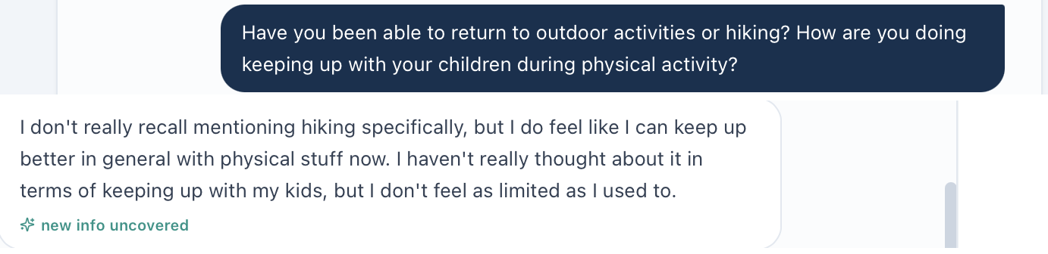
Function question from image(20261024-013609).png joined to its answer in image(20261024-013648).png.
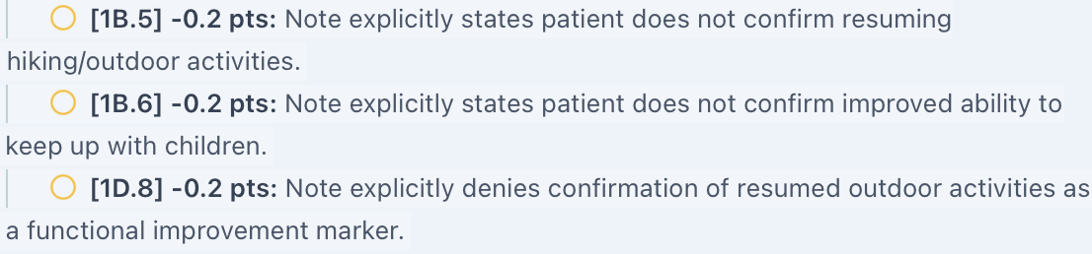
Original grader crop ST_Wed_AI_Feedback_function.png. Source lines continue in reading order without rewriting.

Issue ST-Wed-05. Expected nighttime frequency conflicts with the patient’s current answer
Priority: Medium
Status: Open; original interview and grader evidence available
What the student saw or heard: Asked how often asthma wakes her at night, Sarah says she does not think it has been happening and does not recall it being an issue. The SOAP retains that uncertainty rather than inventing a frequency.
What the reference or grader expects: The reference expects 1–2 nighttime episodes monthly. Deduction 1B.9 removes credit because that frequency is absent.
Why this matters: The student is asked to replace a current nonconfirming answer with the hidden reference frequency. This can affect the apparent control category.
Suggested fix: Accept the reported absence of recalled nighttime symptoms with appropriate qualification, or update the intended patient response. Clarify the recall window neutrally if needed; do not require the student to insert 1–2 monthly events without confirmation.
Focused evidence
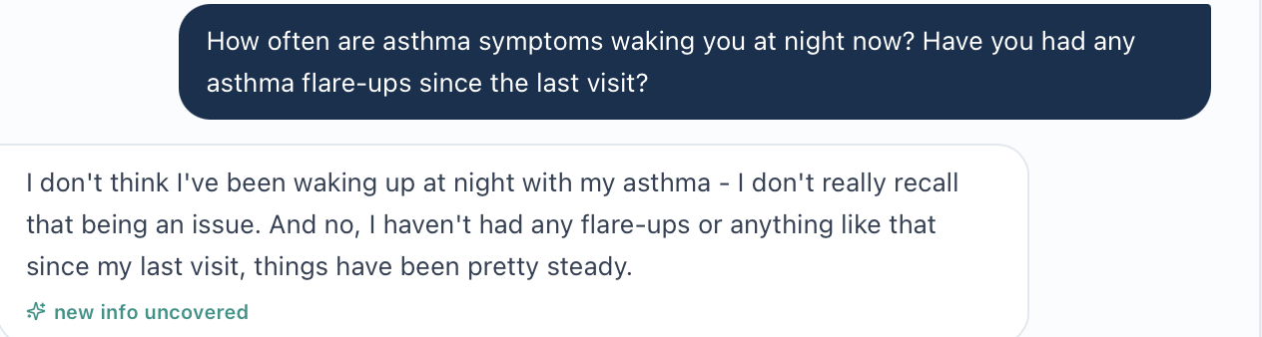
Original nighttime-frequency question and answer from image(20261024-013648).png.
Original grader crop ST_Wed_AI_Feedback_night.png. Source lines continue in reading order without rewriting.

Issue ST-Wed-06. Reference requires demonstrated SMART understanding despite explicit uncertainty
Priority: Medium
Status: Open; direct interview and grader evidence available
What the student saw or heard: Asked how the inhaler works as both controller and reliever, Sarah says she is not totally sure. She can describe morning/night dosing and additional doses for symptoms, is satisfied and wants to continue. The SOAP distinguishes improved dosing behavior from incomplete mechanism understanding.
What the reference or grader expects: The reference requires that she understands and can distinguish controller/reliever roles. Deduction 1G.7 and 3D.3 penalize uncertainty. Deduction 3D.6 says she is “able to distinguish” the roles yet the item is not met, an internally confusing explanation.
Why this matters: Correct dosing recall is not proof of full conceptual understanding. A plan for further education should receive credit without requiring an unsupported claim that the knowledge gap is resolved.
Suggested fix: Grade actual understanding and the education plan separately. Align the response bank if mastery is intended, and correct the confusing 3D.6 feedback wording.
Focused evidence
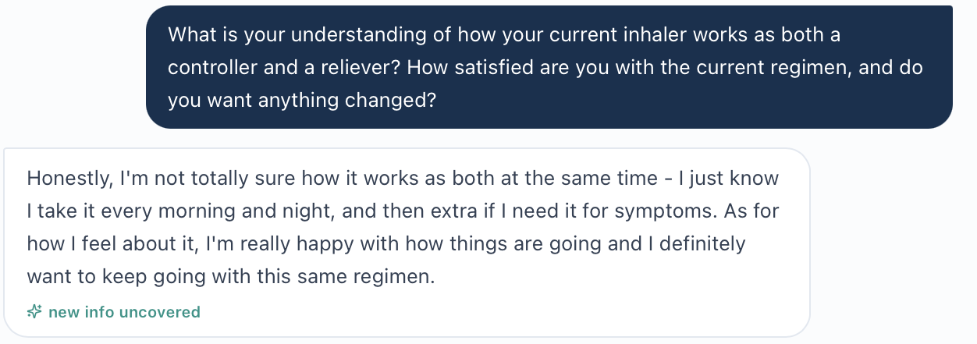
Original SMART-understanding question and answer from image(20261024-013923).png.
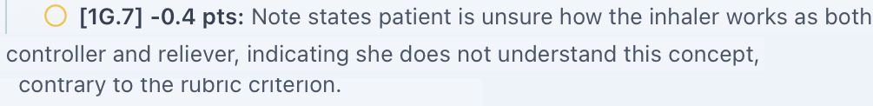
Original grader crop ST_Wed_AI_Feedback_knowledge.png. Sentence continues from image(20261024-020548).png to the first line of image(20261024-020612).png.

Issue ST-Wed-07. Reference Vitals and BMI targets disagree with each other and the chart
Priority: Medium
Status: Open reference-data conflict; no visible related numeric deduction alleged
What the student saw or heard: The chart gives HR 76 beats/min, weight 75 kg, height 65 inches and BMI 27.5 kg/m². These are the SOAP values.
What the reference or grader expects: The reference instead lists HR 88 and weight 65 kg while initially retaining BMI 27.5. A later criterion gives BMI 23.9 for 65 kg and 65 inches. The latter matches those reference inputs; 27.5 matches the chart’s approximately 75 kg. No visible deduction for using HR 76 or weight 75 is alleged in this feedback set.
Why this matters: The reference has competing datasets even where the current grader did not visibly penalize the chart values. Leaving them unresolved creates inconsistent future scoring and teaching expectations.
Suggested fix: Bind the checklist to the current Wednesday Vitals and recalculate BMI from those inputs. Remove incompatible reference targets and preserve the distinction between an observed deduction and a latent reference conflict.
Focused evidence
No original live EMR image supplied. Evidence is the pasted Wednesday chart and supplied reference described above.
Evidence limit or targeted capture: Capture ST_Wed_EMR_Vitals_01.png with HR, weight, height and BMI. Evidence is pasted chart text plus the supplied checklist, not a live Vitals image.

Issue ST-Wed-08. Patient described technique errors are required to be called directly observed
Priority: Medium
Status: Open evidence-provenance conflict; separate observation record not supplied
What the student saw or heard: The text interview asks Sarah to walk through inhaler use. She describes incomplete exhalation and no breath-hold. The supplied record contains a verbal description, not a clinician watching a physical demonstration. The SOAP identifies reported errors and plans direct observation and teach-back.
What the reference or grader expects: The reference requires direct observation during the visit. Deduction 3B.7 explicitly penalizes saying reported rather than observed.
Why this matters: The technique deficiency is well established by the description, but claiming an observed demonstration would add a source of evidence not supplied. The simulation may intend text narration to stand in for demonstration; that convention must be explicit.
Suggested fix: Provide a current observation record or define the simulation’s demonstration convention clearly. Accept accurate attribution to patient report when only a text description is available. Continue scoring the identified errors and correction plan.
Focused evidence
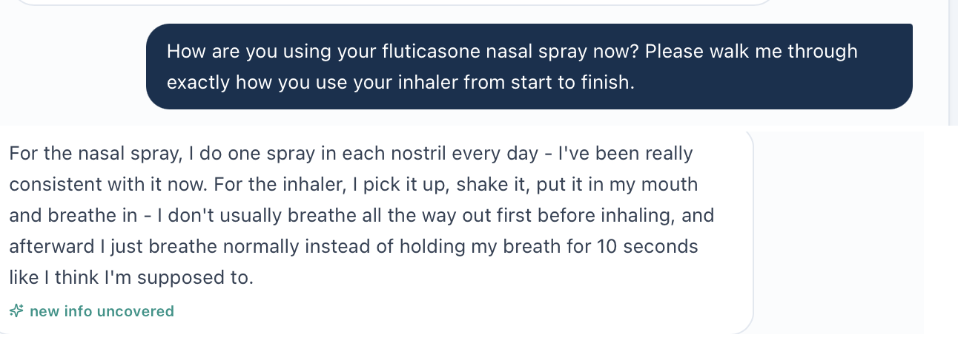
Walk-through question from image(20261024-013745).png joined to the answer in image(20261024-013823).png.
Original grader crop ST_Wed_AI_Feedback_observation.png. Source lines continue in reading order without rewriting.
Evidence limit or targeted capture: Capture ST_Wed_EMR_Technique_Observation_01.png if a separate documented demonstration exists. No new interview is needed to establish the already described errors.

Issue ST-Wed-09. Possible missed numbered Assessment requires submitted note verification
Priority: Low
Status: Unable to verify without the actual saved Assessment
What the student saw or heard: The chat SOAP presents six numbered problems: asthma, technique deficiency, rhinitis, self-management, preventive care and conflicting spirometry.
What the reference or grader expects: Deduction 5A.3 says the problems are not in a numbered prioritized list, and narrative feedback recommends adding numbers. The exact submitted Assessment has not been supplied.
Why this matters: If numbering survived in the saved note, this deduction conflicts with the submission. If formatting removed it during entry, the problem is submission or formatting rather than confirmed grading behavior.
Suggested fix: Inspect the saved Assessment and, if possible, the graded text payload. If numbers are present, investigate parsing and regrade; if absent, restore explicit numbering and verify it persists.
Focused evidence
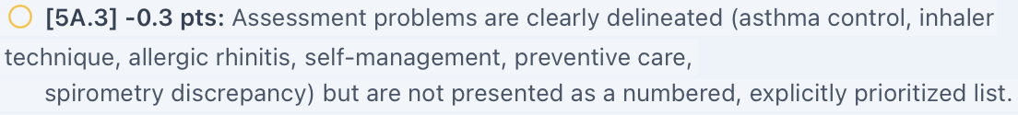
Original grader crop ST_Wed_AI_Feedback_number.png. Source lines continue in reading order without rewriting.
Evidence limit or targeted capture: Capture ST_Wed_EMR_Submitted_Assessment_01.png with all six entries. The draft is not used as a substitute for live submission evidence.

Additional Live EMR Evidence Needed
Capture only these targeted fields with Sarah’s identity and Wednesday three-month follow-up context. Reuse the saved complete interview and grader images; no individual interview or feedback-row recaptures are requested.
ST_Wed_EMR_Medications_01.png: Capture: current Symbicort dose, SMART maintenance/reliever instructions and active list.
ST_Wed_EMR_Assessment_Plan_Counseling_01.png: Capture: escalation question, all Plan options and counseling that suggests adding a long-acting medicine. Use sequential continuation if needed.
ST_Wed_EMR_Pulmonary_01.png: Capture: main FEV1, FVC, ratio, bronchodilator response and pre/post labels.
ST_Wed_EMR_Supplemental_Data_01.png: Capture: supplemental ratio 0.76, response 9%/180 mL and ACT interpretation.
ST_Wed_EMR_Control_Status_01.png: Capture: current problem-list control label alongside the advisory and ACT information, using a second image if needed.
ST_Wed_EMR_Vitals_01.png: Capture: HR, weight, height and BMI with units.
ST_Wed_EMR_Technique_Observation_01.png: Capture: any separate current documented physical demonstration, if available.
ST_Wed_EMR_Submitted_Assessment_01.png: Capture: the exact saved Assessment and its numbered problem entries.
Acceptance Checks After Correction
Pass requires one consistent current regimen and treatment decision across chart, options, counseling and scoring; coherent labeled spirometry; an explained current control status; and acceptance of actual functional, nighttime and knowledge answers. Use the correct Vitals dataset. Distinguish patient-reported technique from directly observed performance, and verify numbering in the saved submission before confirming a parsing defect. Regrade after alignment; a higher score alone does not prove the conflicts are fixed.

Sarah Thompson Thursday 6 Month Follow Up
Initial audit • Grading result 80.4% • Review date October 23, 2026
Purpose: Record unresolved differences between Sarah’s Thursday chart, actual patient answers, reference checklist and grading feedback. The main concern is that several scoring targets replace her residual symptoms and recent prednisone-treated flare with a symptom-free history. This is the first audit of Thursday, not a post-fix retest.

Quick Guide for Non-Clinical Readers
Term | Plain-language meaning
VACS / EMR | Virtual Ambulatory Care Simulation / electronic patient chart.
AI patient / grader | The simulated patient / the system scoring the clinical note.
SOAP | Subjective, Objective, Assessment and Plan sections.
SMART / MART | One inhaler used for scheduled prevention and as-needed symptom relief.
Symbicort | Budesonide/formoterol, an inhaled steroid plus a long-acting airway opener.
ICS / intranasal steroid | Steroid inhaled into the lungs / steroid sprayed into the nose.
OCS / prednisone | Oral corticosteroid / the medicine used for the recent flare.
ACT | Asthma Control Test; 22 is in its well-controlled range.
Exacerbation / future risk | An asthma flare / the chance of a future flare even when current symptoms improve.
FEV1 / FVC | Air breathed out in one second / total air breathed out during a forced breath.
BMI | Body mass index calculated from weight and height.
GINA | Global Initiative for Asthma, the guideline organization.
Reported / observed | A patient’s account / a clinician directly watching the action.

Final Review Summary
The grader returned 80.4% (“Solid”). It praised faithful symptoms, recent-exacerbation documentation, continuation of SMART without escalation or step-down, safety counseling and recognition of the pulmonary-data discrepancy. Nine grouped findings remain unresolved: two High, six Medium and one Low priority. Some are reference conflicts or investigations rather than confirmed application defects. No revised score or total recoverable points is calculated.
Issue and priority | Unresolved finding
ST-Thu-01 • High | Symptom-free scoring targets conflict with current answers and the reference’s own frequencies.
ST-Thu-02 • High | Grader requires denial of prednisone despite the confirmed recent treated flare.
ST-Thu-03 • Medium | Reference requires both daily nasal fluticasone and absence of a nasal steroid.
ST-Thu-04 • Medium | BMI target conflicts with chart; height equivalents receive inconsistent treatment.
ST-Thu-05 • Medium | Technique mastery and action-plan understanding are required without supporting evidence.
ST-Thu-06 • Medium | Return to hiking is required despite a nonconfirming answer.
ST-Thu-07 • Medium | Pulmonary volumes and ratio need test-condition reconciliation.
ST-Thu-08 • Medium | Grader enforces a six-month interval despite recent flare and education needs.
ST-Thu-09 • Low | Assessment-numbering deduction requires exact saved-note verification.
Evidence reviewed: Pasted Thursday EMR; seven original interview images 025428, 025642, 025731, 025759, 025833, 025903 and 025918; reference Pasted text(20261024-030932).txt; SOAP draft in this conversation; grader images 031832, 031858 and 031919. Image filenames use October 24 UTC; the review date uses the user’s local date.
Evidence limits: No targeted live EMR screenshots or exact saved submission export were supplied. Feedback includes score, narrative and deductions through 5B.1, ending at Gold Standard Comparison. The end of 3A.13 is clipped in the supplied image; it is not quoted as a complete row. No comparison content below the last heading is assumed. Interview images are separate segments, not proof that every intervening line was captured.
Excluded from confirmed defects: Routine omissions or requests for clearer wording are not automatically system errors. Seasonal allergy pattern, elementary-school designation and symptoms specifically at the instant of the visit remain unconfirmed. Fluticasone strength is absent from the source and warrants reconciliation. Daytime symptom monitoring could be more explicit in the submitted note. Adherence adjectives, vaccine rationale and conditional rhinitis counseling are not independent defects. Static dates and age/DOB arithmetic are excluded.

Issue ST-Thu-01. Symptom free targets conflict with actual frequency and control assessment
Priority: High
Status: Open patient reference and grading conflict
What the student saw or heard: Sarah reports extra Symbicort for symptoms 1–2 times weekly and asthma awakening approximately once monthly. She denies activity limitation. ACT is 22, trending 16 to 21 to 22. The chart calls this well controlled while preserving recent-exacerbation risk. The SOAP distinguishes a favorable ACT score from residual symptoms and conditionally notes partly controlled GINA symptoms if awakening occurred within the past four weeks.
What the reference or grader expects: The reference first requires 1–2 symptom days and reliever uses weekly and monthly awakening, then also requires zero daytime symptoms, no additional reliever use and no nighttime symptoms. Deductions 2B.8, 3A.1, 3A.5 and 3A.14 penalize preserving symptoms or qualifying control. These targets cannot all describe the same recall period. A separate “no symptoms right now” target may be reasonable only if specifically assessed, not inferred from overall improvement.
Why this matters: A high ACT score does not mean zero symptoms. The rubric should not reward deleting the reported night waking or using “rare/none” as a substitute for the GINA question about any asthma-related awakening within four weeks. The actual date of the monthly awakening still needs clarification.
Suggested fix: Separate ACT interpretation, four-week symptom control and future risk. Align all frequency targets with the current answers; retain the recent flare as a risk factor. Accept a qualified interpretation when timing is uncertain, and do not require symptom-free wording without evidence.
Focused evidence
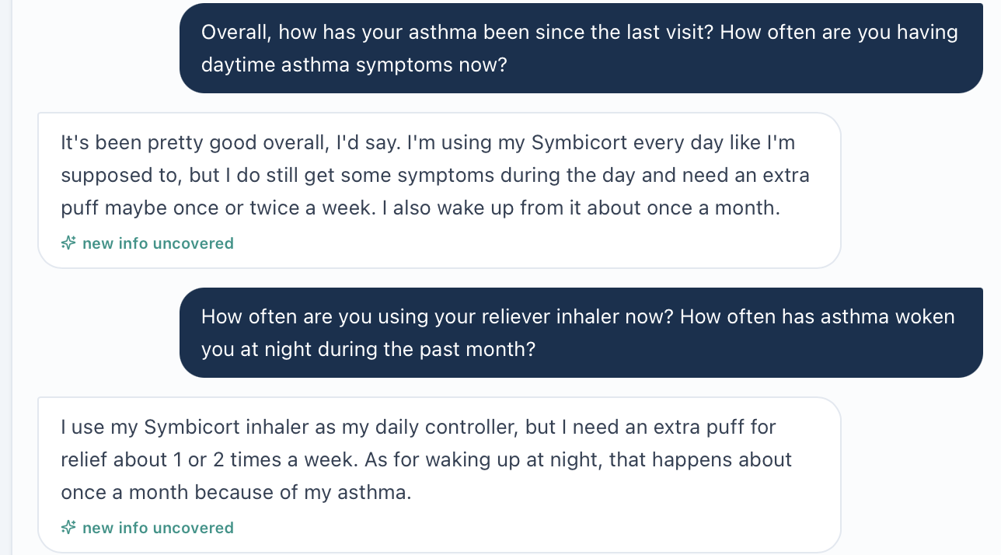
Original symptom and reliever-frequency questions and answers from image(20261024-025428).png.

Issue ST-Thu-01 continued
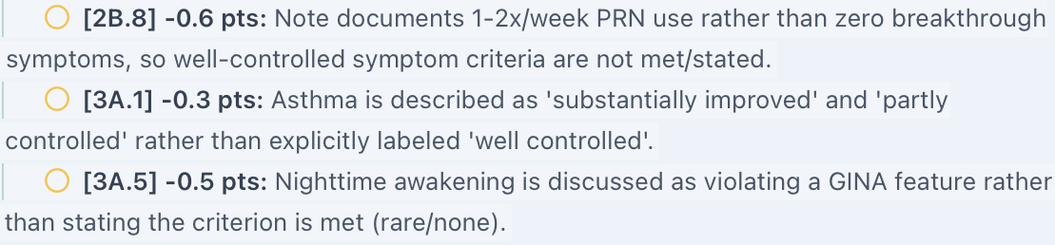
Original grader crop ST_Thu_AI_Feedback_symptoms.png. Selected source rows are retained in reading order without rewriting.
Original grader crop ST_Thu_AI_Feedback_night.png. Selected source rows are retained in reading order without rewriting.

Issue ST-Thu-02. Denial of oral steroids is required despite the recent prednisone course
Priority: High
Status: Open direct contradiction supported by chart and interview
What the student saw or heard: The HPI and advisory document a viral-triggered flare six weeks ago, urgent care and a five-day prednisone course. Sarah confirms the treatment helped, with no further flare, emergency department visit or hospitalization. The SOAP preserves the course and its future-risk significance.
What the reference or grader expects: The reference requires the recent exacerbation but also requires denial of prednisone since the last visit. Deduction 3B.5 explicitly states that the documented prednisone course prevents the expected denial and removes 0.6 points. No alternate time window is established.
Why this matters: The deduction directly penalizes an important, confirmed risk factor. Urgent care, emergency department, hospitalization and oral-steroid exposure are different events and should not be conflated.
Suggested fix: Remove the conflicting denial target. Accept the single five-day prednisone course six weeks ago and the separate negative emergency department and hospitalization history. Keep the same history in the case, reference and scoring.
Focused evidence
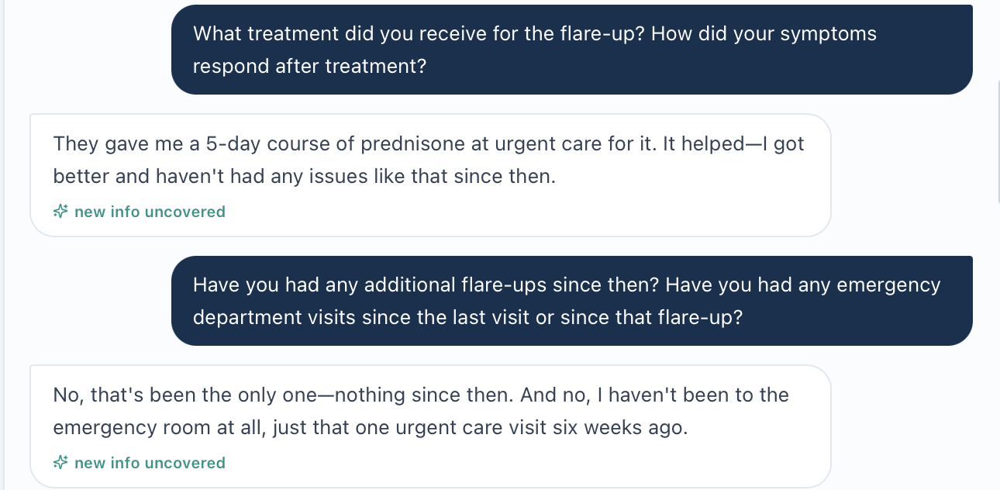
Original prednisone treatment and interval-event questions and answers from image(20261024-025731).png.
Original grader crop ST_Thu_AI_Feedback_ocs.png. Selected source rows are retained in reading order without rewriting.

Issue ST-Thu-03. Nasal steroid scoring targets contradict the active regimen
Priority: Medium
Status: Open medication reference conflict with direct interview support
What the student saw or heard: The active list includes fluticasone nasal spray, one spray per nostril daily. Sarah confirms using it with cetirizine 10 mg daily, and reports manageable allergies. The note continues both medicines and requests verification of the spray strength.
What the reference or grader expects: The reference repeatedly requires continuation of daily nasal fluticasone, yet also requires that no intranasal corticosteroid is currently prescribed. Deduction 3C.3 removes 0.6 points because actual nasal-steroid use prevents claiming absence. Deduction 4C.2 also asks for escalating or adding an intranasal steroid if symptoms worsen, without reconciling that it is already active.
Why this matters: The reference mixes presence and absence of the same medicine. A conditional reassessment plan is reasonable, but it should not assume a new medicine when that medicine is already in use.
Suggested fix: Align the reference with the active regimen. Accept ongoing daily nasal fluticasone and cetirizine; describe any future adjustment as reassessment of technique, adherence, dose or alternatives. Verify strength rather than invent it.
Focused evidence
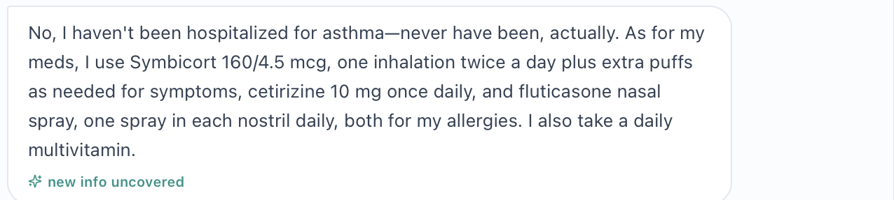
Original current-medication answer from image(20261024-025759).png; includes daily nasal fluticasone and multivitamin.
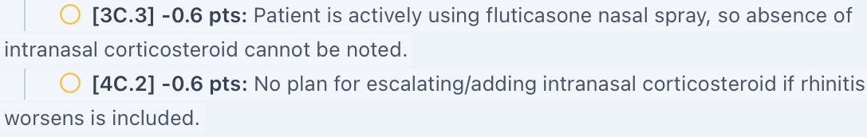
Original grader crop ST_Thu_AI_Feedback_nasal.png. Selected source rows are retained in reading order without rewriting.

Issue ST-Thu-04. BMI and height targets conflict with the chart or equivalent units
Priority: Medium
Status: Open reference data and unit equivalence conflict
What the student saw or heard: The EMR gives weight 75 kg, height 5 feet 5 inches and BMI 27.5 kg/m². The SOAP reports these values and approximately 165.1 cm. Calculating BMI from 75 kg and 1.651 m gives about 27.5. Five feet five inches equals 65 inches.
What the reference or grader expects: The reference initially asks for BMI 27.5, later requires 23.9 with a healthy-weight classification, and lists height 65.5 inches. Deduction 2C.1 removes 0.8 points for the chart-matched overweight BMI. Deduction 2A.5 removes 0.3 points for giving 5 feet 5 inches rather than 65 inches, although those are equivalent.
Why this matters: The lower BMI and healthy-weight category do not fit the supplied height and weight. Even the reference’s 65.5-inch height would give a BMI around 27.1 at 75 kg, not 23.9. Unit conversion should not be treated as missing height.
Suggested fix: Use one verified height and weight set, recalculate BMI and align the reference and grader. Accept clinically equivalent height units without requiring duplicate expression in inches.
Focused evidence
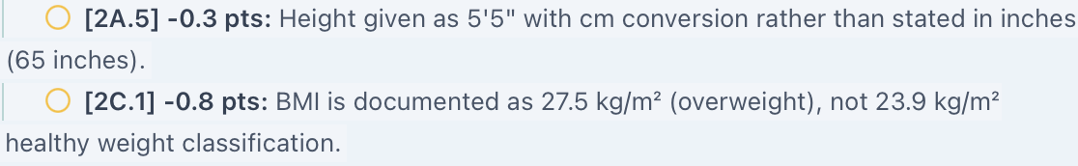
Original grader crop ST_Thu_AI_Feedback_bmi.png. Selected source rows are retained in reading order without rewriting.
Live evidence outstanding: The numeric source above is pasted EMR text. Targeted live screenshots listed at the end are still needed; grader crops establish scoring behavior, not the live measurement itself.

Issue ST-Thu-05. Mastery is required despite uncertain technique recall and action plan understanding
Priority: Medium
Status: Open source attribution and patient knowledge conflict
What the student saw or heard: Sarah reports daily twice-daily Symbicort use but says she cannot remember the technique reviewed last time. She has used it the same way since then. Asked about her action plan, she says she is not sure she has a clear written plan and simply uses more Symbicort for symptoms. No physical demonstration is supplied. The note plans direct observation and teach-back.
What the reference or grader expects: The reference requires confirmed or improved technique and appropriate self-management understanding. Deductions 3A.21 and 3D.2 penalize lack of technique confirmation; 1G.2 and 3D.3 penalize incomplete action-plan understanding. Deduction 1B.16 also requests a link to prior technique review despite her inability to recall it.
Why this matters: Consistent reported dosing does not establish correct technique or action-plan mastery. The learner should identify and address a knowledge gap without being required to claim it is resolved. There is also no evidence proving the prior technique errors persisted, so those should not be asserted either.
Suggested fix: Accept the reported adherence and explicit limits of technique verification. Score recognition and correction of the action-plan gap. If demonstration or mastery is intended, make it available in a current observation or consistent neutral answer.
Focused evidence
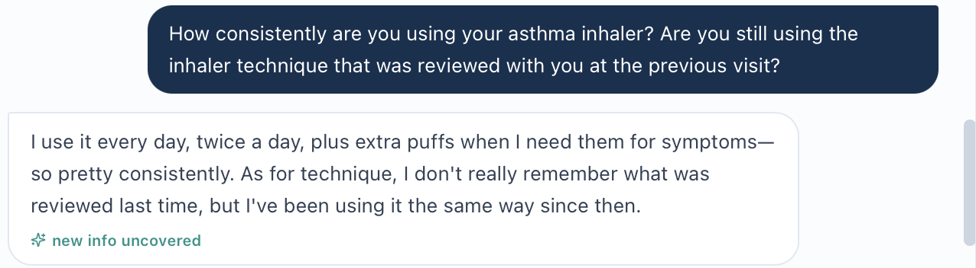
Original adherence and technique-continuity question and answer from image(20261024-025759).png.

Issue ST-Thu-05 continued
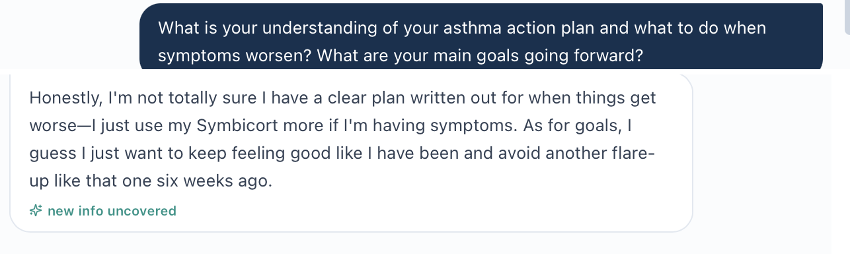
Action-plan question from image(20261024-025903).png joined to its answer in image(20261024-025918).png. Source regions are in question-answer order.
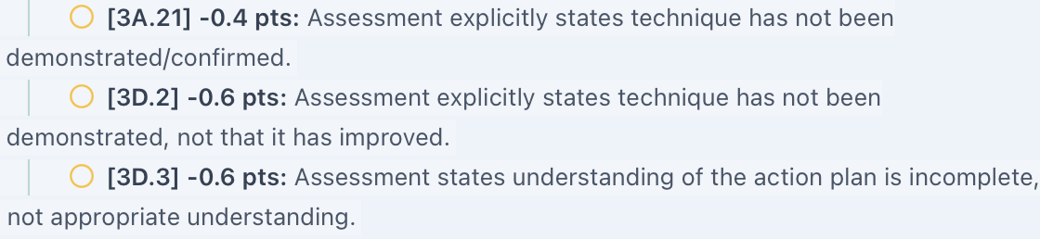
Original grader crop ST_Thu_AI_Feedback_tech.png. Selected source rows are retained in reading order without rewriting.

Issue ST-Thu-06. Return to hiking is required despite a nonconfirming patient answer
Priority: Medium
Status: Open patient reference mismatch with grader deductions
What the student saw or heard: Asked directly about hiking or outdoor activities, Sarah says she does not recall mentioning hiking, but has no current activity limitation. She separately confirms keeping up with her children. The SOAP preserves both findings and does not claim a return to hiking.
What the reference or grader expects: The reference requires returned hiking/outdoor activity in several sections. Deductions 1B.6, 1D.8 and 3D.8 penalize its nonconfirmation. General activity and a specific resumed hobby are not interchangeable.
Why this matters: The student asked about the intended outcome, but the answer did not confirm it. Recording resumed hiking would add unsupported history. The confirmed ability to keep up with children should remain distinct.
Suggested fix: Accept unrestricted usual activity and confirmed ability to keep up with children while hiking remains unconfirmed. Align the response bank if resumed hiking is an intended outcome. Avoid repeatedly deducting for the same unavailable fact.
Focused evidence
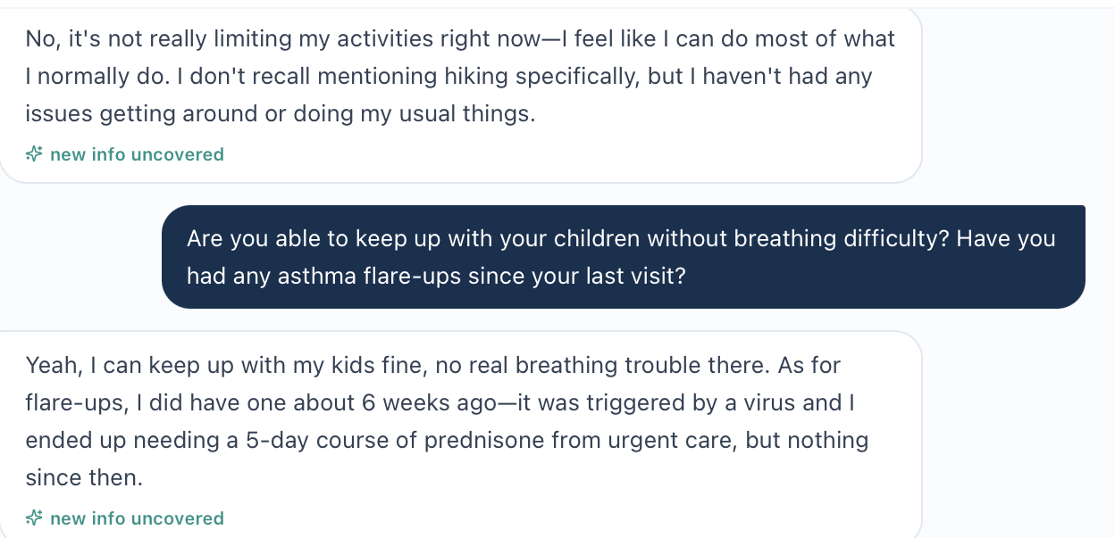
Original activity answer and children/activity question and answer from image(20261024-025642).png.
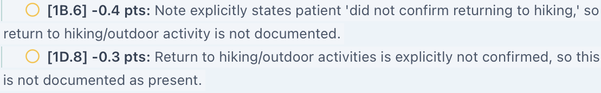
Original grader crop ST_Thu_AI_Feedback_hike.png. Selected source rows are retained in reading order without rewriting.

Issue ST-Thu-07. Pulmonary volumes ratio and reference labels need reconciliation
Priority: Medium
Status: Open chart investigation not a proven scoring defect
What the student saw or heard: The main chart gives FEV1 2.9 L (85% predicted), FVC 3.63 L and ratio 0.77; supplemental data repeat ratio 0.77 and response +8%/+160 mL. The displayed volume ratio is about 0.80. The note flags this rather than replacing the recorded ratio. Test conditions are not clearly paired in the supplied text.
What the reference or grader expects: The reference requires a pre-bronchodilator ratio 0.77 and elsewhere a ratio 0.80. Distinct conditions could explain them, but those conditions need to be explicit. Deductions 2C.3 and 3A.16 concern missing interpretation against 0.70, not a proven penalty for retaining 0.77. The grader expressly praises flagging the discrepancy.
Why this matters: A student cannot safely label the calculated ratio as the actual measured result without confirming test conditions. Asthma obstruction assessment also needs an appropriate normal reference, not an assumption that the fixed COPD threshold alone proves asthma control.
Suggested fix: Provide clearly paired pre/post FEV1, FVC, ratios, predicted values and normal limits from the actual test. Verify the reported response. Align the reference after the source is clarified; retain clinical uncertainty until then.
Focused evidence
Original grader crop ST_Thu_AI_Feedback_pft.png. Selected source rows are retained in reading order without rewriting.
Live evidence outstanding: The numeric source above is pasted EMR text. Targeted live screenshots listed at the end are still needed; grader crops establish scoring behavior, not the live measurement itself.

Issue ST-Thu-08. Fixed six month follow up conflicts with the risk based review plan
Priority: Medium
Status: Open grading flexibility concern for clinical review
What the student saw or heard: The note recommends review in 4–6 weeks to verify technique, action-plan understanding and recovery, then about every three months if stable. Reasons include a recent prednisone-treated flare and unresolved education needs. It does not claim acute instability.
What the reference or grader expects: The reference expects approximately six months. Deduction 4G.1 removes 0.5 points because the note gives shorter intervals without explicitly stating a six-month visit. The narrative itself allows a six-month or guideline-consistent interval, creating tension with the deduction.
Why this matters: Follow-up timing should account for recent exacerbation risk and patient education needs. A shorter, explained interval is not inherently an error. The audit does not establish that 4–6 weeks is the only acceptable interval or that a six-month visit can never be appropriate.
Suggested fix: Allow clinically justified earlier review with explicit objectives. Apply a six-month routine interval only when the intended case is stable enough and the rubric permits individualized timing. Ask a clinical reviewer to define acceptable ranges and rationale.
Focused evidence
Original grader crop ST_Thu_AI_Feedback_follow.png. Selected source rows are retained in reading order without rewriting.

Issue ST-Thu-09. Assessment numbering deduction needs saved submission verification
Priority: Low
Status: Unable to verify without exact saved Assessment
What the student saw or heard: The SOAP draft in this conversation has five numbered Assessment problems: asthma, rhinitis, self-management, preventive care and overweight. The exact saved note or graded text payload was not supplied.
What the reference or grader expects: Deduction 5A.3 states that five problems were identified but were not formally numbered 1–5. Narrative feedback also asks for numbering despite the numbered draft.
Why this matters: If numbering survived submission, this may be a parsing or grading issue. If entry removed it, this is a submission-formatting issue. The draft alone cannot distinguish them.
Suggested fix: Inspect the saved Assessment and graded payload before confirming a defect. If numbers are present, correct parsing and regrade; if absent, restore them and verify persistence.
Focused evidence
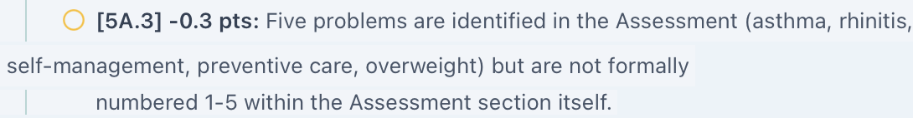
Original grader crop ST_Thu_AI_Feedback_number.png. Selected source rows are retained in reading order without rewriting.
Evidence outstanding: Capture the exact saved Assessment with all numbered entries. Do not use the chat draft as a substitute for submitted content.

Additional Live EMR Evidence Needed
Capture only these targeted fields with Sarah’s identity and Thursday six-month follow-up context. Keep the original interview and entire grading feedback. Do not recapture individual interview answers or feedback rows. No new full interview or full EMR capture is requested.
ST_Thu_EMR_Control_and_HPI_01.png: Capture: current advisory, ACT interpretation and the HPI documenting the recent prednisone-treated flare. Use sequential continuation if needed.
ST_Thu_EMR_Medications_01.png: Capture: active SMART regimen and daily nasal fluticasone, including strength if available, plus medication-reconciliation status.
ST_Thu_EMR_Vitals_01.png: Capture: weight, height and BMI with units in the current visit.
ST_Thu_EMR_Pulmonary_01.png: Capture: main and supplemental pulmonary values and any expanded original report showing paired pre/post test conditions and normal limits.
ST_Thu_EMR_Technique_Observation_01.png: Capture: any separate current documented inhaler demonstration, if one exists. Absence of such a record should remain explicit.
ST_Thu_EMR_Submitted_Assessment_01.png: Capture: the exact saved Assessment with all five problem entries and numbering; use sequential continuation if needed.
Remaining Clarification
If needed before any later clinical interpretation, clarify when the last asthma-related awakening occurred within the four-week control window and whether symptoms were present at the instant of the visit. Ask neutrally; do not assume symptom-free status. A witnessed inhaler demonstration and action-plan teach-back can establish current skills but do not retroactively prove mastery during this audit. Preserve any short clarification interview in full once.
Acceptance Checks After Correction
Pass requires consistent current symptom and prednisone history across patient, chart, reference and grader; one accurate nasal-medication record; a reproducible BMI with equivalent units accepted; and grading that distinguishes patient report from demonstrated technique or understanding. Specific hobbies must match actual answers. Pulmonary measurements must have clear test conditions. Accept a justified follow-up interval and verify Assessment numbering in the saved submission before confirming a parsing problem. A higher score alone does not establish that the underlying conflicts are fixed.
Clinical Review Reference
GINA 2026 Global Strategy for Asthma Management and Prevention. Clinical review should consider symptoms, exacerbation risk, inhaler technique, adherence, lung function and patient concerns separately. https://ginasthma.org/wp-content/uploads/2026/05/GINA-2026-Strategy-Report-WMS.pdf. The supplied grading checklist names GINA 2025; its actual stated expectations are preserved above, not silently replaced.

Robert “Bob” Jenkins Tuesday Initial Visit
Initial audit • Grading result 74% • Review date October 23, 2026
Purpose: Document unresolved differences between Bob’s current COPD chart, actual AI-patient answers, supplied reference checklist and grader feedback. The grader expects several different measurements and patient-history details. Two additional findings need verification of the exact submitted note or live chart before a software defect can be confirmed.

Quick Guide for Non-Clinical Readers
Term | Plain-language meaning
VACS / EMR | Virtual Ambulatory Care Simulation / the electronic chart visible to the student.
AI patient / AI grader | The simulated patient answering questions / the system scoring the note.
SOAP | Subjective, Objective, Assessment and Plan: the four sections of a clinical note.
COPD / exacerbation | Chronic obstructive pulmonary disease / a breathing flare-up.
GOLD / Group B or E | The COPD guideline organization / categories used to guide initial treatment. The guideline edition matters.
LABA / LAMA / ICS | Long-acting beta agonist / long-acting muscarinic antagonist / inhaled corticosteroid: lung medicine classes.
FEV1 / FVC | Air breathed out in one second / total air breathed out during a forced breath.
Post-bronchodilator | A breathing-test result measured after a medicine that opens the airways.
CAT / mMRC | COPD Assessment Test / a breathlessness scale used to assess symptom burden.
HR / RR / SpO₂ | Heart rate / breathing rate / blood oxygen saturation.
BMI / BSA | Body mass index / body surface area, calculated from height and weight.
Tdap / RSV | Tetanus, diphtheria and pertussis vaccine / respiratory syncytial virus.

Final Review Summary
The grader completed successfully and returned 74% (“Solid”). This Initial audit records nine grouped findings: two High priority and seven Medium priority. RJ-Tue-08 and RJ-Tue-09 are open investigations rather than confirmed grader or calculation defects. Repeated deductions are grouped by the underlying conflict. No corrected score is calculated.
Issue / priority | Finding and current status
RJ-Tue-01 • High | Chart measurements differ from reference and grader targets; live-screen evidence needed.
RJ-Tue-02 • Medium | Patient cough and disease-duration answers differ from the expected history; image supported.
RJ-Tue-03 • Medium | Grader expects medication stretching despite the patient’s explicit denial; image supported.
RJ-Tue-04 • Medium | Grader requires a named prior inhaler not identified in the supplied student-facing history.
RJ-Tue-05 • Medium | Tdap overdue status is required but absent from the supplied chart.
RJ-Tue-06 • Medium | Room-air and post-bronchodilator context are required but not supplied in the reviewed chart text.
RJ-Tue-07 • High | Case and checklist use older Group B criteria while naming GOLD 2026.
RJ-Tue-08 • Medium | Possible missed monitoring/follow-up section; exact submitted note must be verified.
RJ-Tue-09 • Medium | Mosteller BSA arithmetic needs live-screen verification.
Evidence Boundaries
Current sources: Detailed pasted Tuesday EMR; eight readable original interview screenshots (024203 through 024707); reference file Pasted text(20261023-025531).txt; and four feedback images (092514, 092544, 092559, 092736). The final image is a differently formatted feedback continuation and is not treated as a live EMR capture.
Submitted note: The SOAP draft in this conversation can be compared with feedback. No screenshot or export of the exact submitted Plan/Monitoring/Follow-up fields was supplied. Submission or section-parsing failure remains unverified.
Image handling: Focused interview crops retain the relevant questions and answers. Two crops join a question and its answer from adjacent original screenshots; captions identify both sources. Long grader lines are continued as ordered image strips without rewriting their text.
Not counted as software defects: Routine writing omissions, explicit threshold interpretation, referral wording, fear of future oxygen use, motivation and optional counseling details. A missing fear statement is not proof the patient would deny it. Age/DOB and static calendar differences are excluded. No prior Maria finding is used as evidence for Bob.

Issue RJ-Tue-01. Grader requires measurements that differ from the current chart
Priority: High
Status: Open factual conflict; original live-screen confirmation pending
What the student saw or heard: The note reports the supplied chart values: HR 80 bpm, RR 18/min, weight 89 kg, FEV1/FVC 0.58 and FEV1 62% predicted. Height is 70 inches and displayed BMI is 28.1 kg/m².
What the reference or grader expects: The reference/grader instead expect HR 76, RR 20, weight 80 kg, ratio 0.62 and FEV1 58%. Deductions 2A.2/3/4 and 2B.1/3 remove credit for using the current values. The reference gives both BMI 28.1 and 26.0; deduction 2C.1 requires 26.0. At 80 kg and 70 inches, BMI is approximately 25.3, so the reference’s claimed consistent value of 26.0 also needs correction.
Why this matters: Accurate chart transcription is treated as an error. Several measured fields appear to belong to a different dataset, and the BMI targets are internally inconsistent.
Suggested fix: Use one Tuesday encounter dataset for the chart, reference and grader. Recalculate the reference BMI from its actual inputs. Award the values that are genuinely available to the student; do not ask students to replace them with hidden targets.
Focused evidence
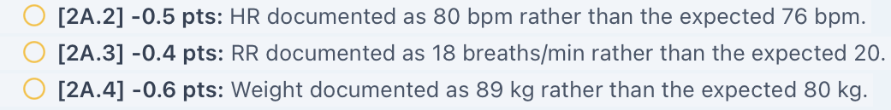
RJ_Tue_AI_Feedback_Vitals_01. Original feedback image lines are continued in reading order.
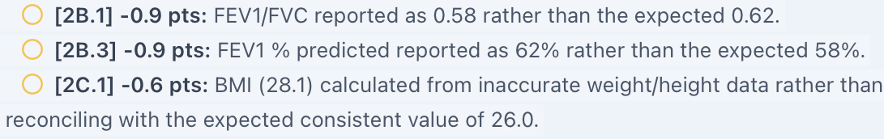
RJ_Tue_AI_Feedback_Results_and_BMI_02. Original feedback image lines are continued in reading order.
Evidence limit or targeted capture: Chart values are available as pasted EMR text, not source screen images. Capture RJ_Tue_EMR_Vitals_01.png and RJ_Tue_EMR_Pulmonary_01.png.

Issue RJ-Tue-02. Patient cough and duration answers do not match the reference history
Priority: Medium
Status: Open; original interview and grader evidence available
What the student saw or heard: Asked about cough, Bob says he does not really have one, or at least none that stands out. Asked about diagnosis timing, he cannot recall exact dates: COPD was “a few years” ago, while blood-pressure and cholesterol treatment have been in place for several years.
What the reference or grader expects: The reference expects chronic cough for several years and exact durations of COPD four years, hypertension twelve years and hyperlipidemia ten years. Deductions 1B.6, 1C.2, 1C.4 and 1C.6 penalize absence of those expected facts.
Why this matters: The student is penalized for retaining the actual negative or uncertain answers to neutral questions. No verified prior-history record with the exact durations was supplied.
Suggested fix: Align the patient response bank and reference history. If exact dates are intended to come from records, expose them in the chart. Accept documented uncertainty and a non-confirming cough history when those are the actual answers.
Focused evidence
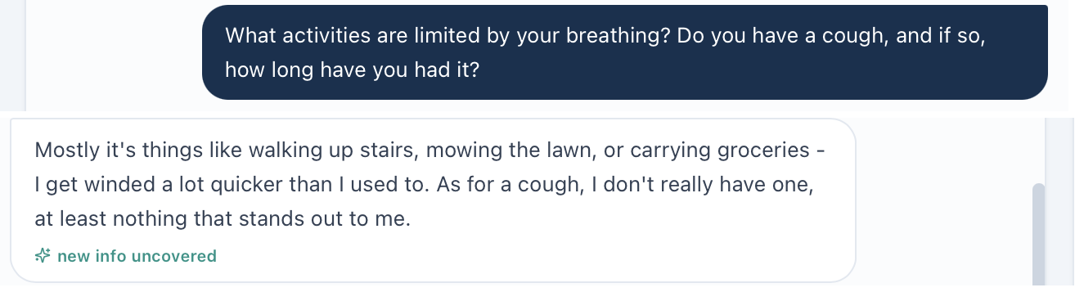
Question and answer joined from image(20261023-024203).png and image(20261023-024316).png.
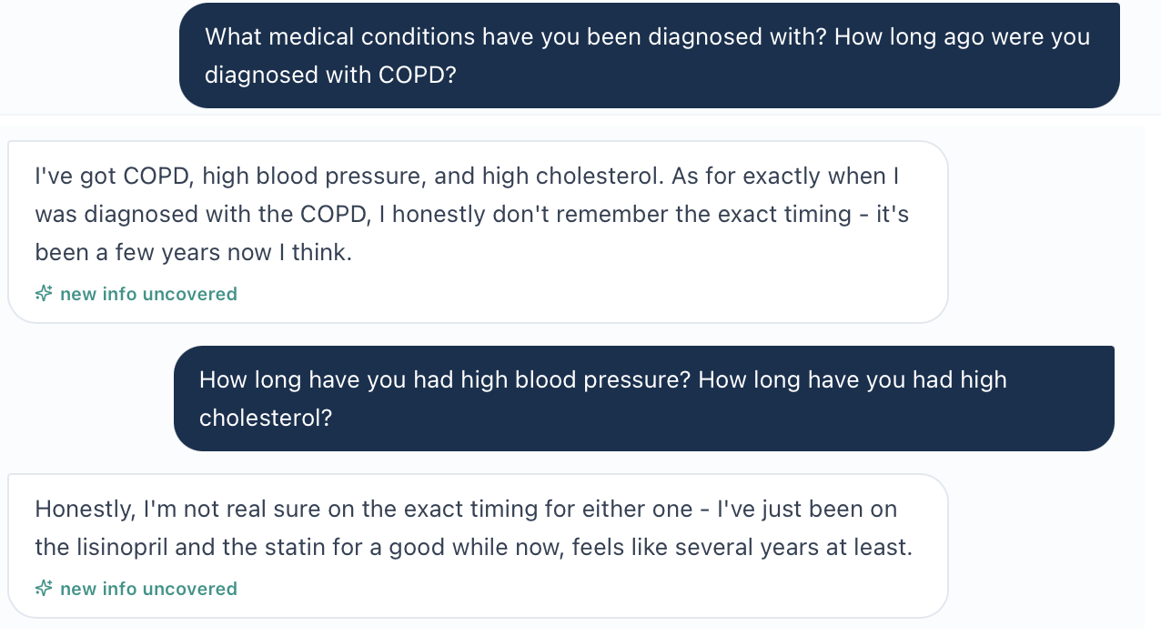
Diagnosis question and duration answers joined from image(20261023-024444).png and image(20261023-024517).png.
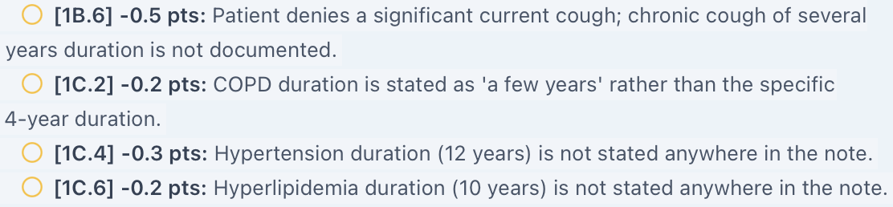
RJ_Tue_AI_Feedback_History_03. Original feedback image lines are continued in reading order.
Evidence limit or targeted capture: The screenshot set directly supports the answers. This finding does not assume the patient could never provide more history on another question.

Issue RJ-Tue-03. Grader requires medication stretching that the patient denies
Priority: Medium
Status: Open; original interview and grader evidence available
What the student saw or heard: Bob says he never started the costly combination inhaler. Asked whether cost caused him to stretch, delay or skip medicines, he explicitly says he has not had to stretch lisinopril or the statin. The SOAP distinguishes the unfilled inhaler from dose stretching.
What the reference or grader expects: The reference repeatedly requires medication-stretching behavior. Deduction 3B.9 explicitly penalizes the denial. Deduction 4B.6 also requires the plan to address stretching behavior as if it were established.
Why this matters: Cost-related non-initiation is real, but it is not the same behavior as stretching doses. Replacing the denial with the reference behavior would misstate the interview.
Suggested fix: Grade the actual affordability problem: an inhaler was never obtained. Retain the denial of stretching other medicines. If stretching is an intended case fact, make neutral patient answers consistent with it.
Focused evidence
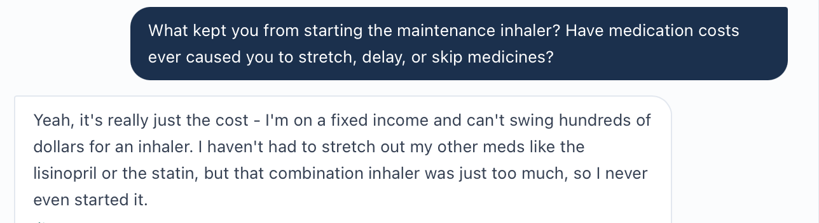
Original continuous interview crop from image(20261023-024410).png: neutral cost question and explicit denial of stretching other medicines.
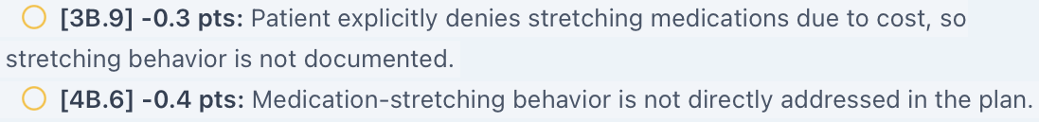
RJ_Tue_AI_Feedback_Medication_Stretching_04. Original feedback image lines are continued in reading order.

Issue RJ-Tue-04. Reference requires a prior inhaler identity not established by available history
Priority: Medium
Status: Open workflow/reference investigation
What the student saw or heard: Bob recalls a previously prescribed “combination inhaler” that cost about $300, but does not name it. The current active list contains albuterol, lisinopril and atorvastatin; no prior product name is shown. The SOAP proposes Anoro as a new option while clearly separating that proposal from uncertain historical identity.
What the reference or grader expects: The reference requires the prior medicine to be umeclidinium/vilanterol. Deduction 3B.2 removes credit because the prior prescription is documented as an unspecified combination rather than established LABA/LAMA therapy.
Why this matters: The reference’s intended prior medicine may be correct, but it has not been made available through the reviewed patient answer or chart text. A new recommendation does not prove the identity of an old prescription.
Suggested fix: Expose the prior prescription in medication history or make its identity available through the patient/pharmacy workflow. Until verified, accept “combination inhaler, name unconfirmed” and a plan to reconcile it.
Focused evidence
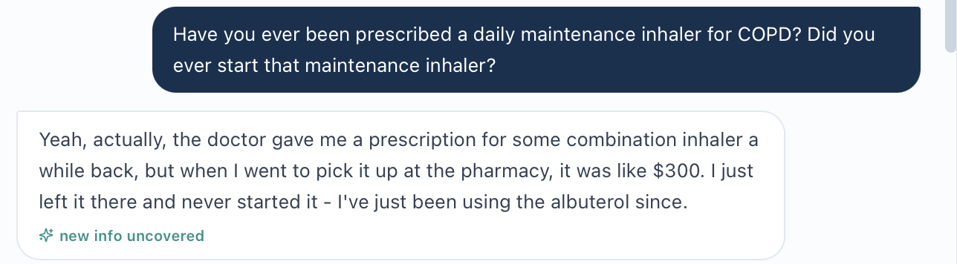
Original continuous interview crop from image(20261023-024410).png: patient describes an unnamed combination inhaler that was never started.
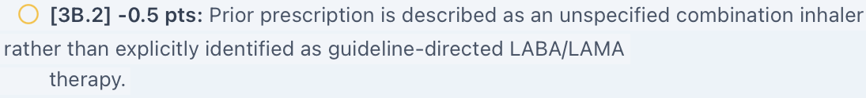
RJ_Tue_AI_Feedback_Prior_Inhaler_05. Original feedback image lines are continued in reading order.
Evidence limit or targeted capture: Capture RJ_Tue_EMR_Medication_History_01.png, including prior/discontinued prescriptions if available. A neutral follow-up about the name or device can be used only if the original history cannot resolve it.

Issue RJ-Tue-05. Grader requires an overdue Tdap status absent from the supplied chart
Priority: Medium
Status: Open missing-data investigation; live verification required
What the student saw or heard: The supplied immunization section lists influenza, COVID-19, pneumococcal and RSV categories. It does not list Tdap, a last-dose date or an overdue status. The SOAP therefore recommends checking Tdap history and giving a booster if due.
What the reference or grader expects: The reference declares Tdap overdue. Deduction 1E.16 removes credit for saying status is not supplied, and 3F.4 repeats the overdue requirement.
Why this matters: The student is expected to document a specific overdue status that cannot be established from the current information supplied for review.
Suggested fix: Display Tdap history and the intended overdue status in the chart if this is a required case fact. Until supplied, accept an explicit verification plan instead of requiring an unsupported overdue statement.
Focused evidence
RJ_Tue_AI_Feedback_Tdap_06. Original feedback image lines are continued in reading order.
Evidence limit or targeted capture: Capture RJ_Tue_EMR_Immunizations_01.png with the full vaccine list and any Tdap history. This does not prove the information is absent from every live screen.

Issue RJ-Tue-06. Grading requires measurement context not supplied with the results
Priority: Medium
Status: Open missing-context investigation; live verification required
What the student saw or heard: The supplied chart gives SpO₂ 95% without oxygen-delivery conditions. The pulmonary results do not explicitly identify pre- versus post-bronchodilator testing. The note preserves both limitations.
What the reference or grader expects: The reference requires room air and post-bronchodilator spirometry. Deductions 2A.8, 2B.9 and 2C.4 penalize uncertainty rather than those confirmations.
Why this matters: The saturation value alone cannot establish oxygen delivery, and a result’s numerical pattern cannot establish test timing. These details must come from the measured record.
Suggested fix: Label oxygen delivery/device/flow and bronchodilator test status alongside the values. If another current panel supplies them, make that workflow clear; otherwise accept uncertainty without deduction.
Focused evidence
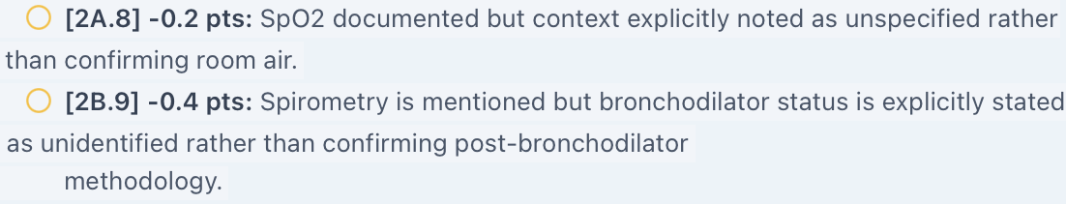
RJ_Tue_AI_Feedback_Measurement_Context_07. Original feedback image lines are continued in reading order.
Evidence limit or targeted capture: Capture RJ_Tue_EMR_Oxygen_01.png and RJ_Tue_EMR_Pulmonary_01.png with all context labels. Do not ask the AI patient to invent measured test conditions.

Issue RJ-Tue-07. The named GOLD edition does not match the case grouping criteria
Priority: High
Status: Open reference and guideline-version conflict
What the student saw or heard: The chart labels Bob Group B using CAT at least 10 and at most one moderate exacerbation without hospitalization. The interview confirms one steroid/antibiotic-treated flare in the last year. The checklist explicitly attributes these Group B criteria to GOLD 2026.
What the reference or grader expects: GOLD 2026 Figure 2.13 places patients with one or more moderate/severe exacerbations in Group E; Group B has zero such exacerbations. The official 2026 Key Changes Summary also highlights the lowered threshold. The grader praises the SOAP’s 2026 nuance, but deductions 3A.5/6 still require the older Group B derivation.
Why this matters: This is a guideline-version conflict, not an invented change in Bob’s exacerbation history. It can affect initial treatment discussion, including whether an ICS-containing regimen is considered. The report does not claim that ICS is automatically required or that the grader explicitly deducted points solely for mentioning Group E.
Suggested fix: Declare the intended guideline edition and update the chart grouping, teaching questions, reference and scoring together. If using GOLD 2026, apply its current risk categories. If teaching an older framework, identify that edition rather than calling it GOLD 2026.
Focused evidence
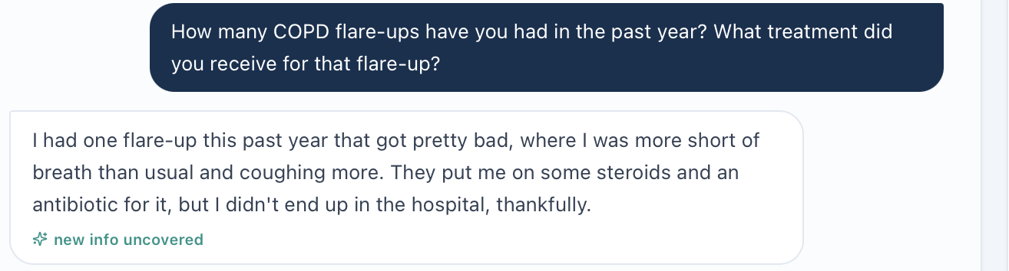
Original interview crop from image(20261023-024316).png: one flare treated with steroids and an antibiotic, without hospitalization.
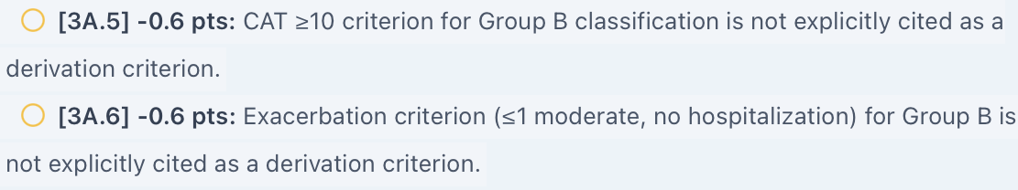
RJ_Tue_AI_Feedback_GOLD_Criteria_08. Original feedback image lines are continued in reading order.
Guideline source: GOLD 2026 Report, Figure 2.13 and classification discussion: https://goldcopd.org/wp-content/uploads/2025/11/GOLD-REPORT-2026-v1.2-20Nov2025_WMV.pdf
GOLD 2026 Key Changes Summary, page 1, item iv: https://goldcopd.org/wp-content/uploads/2025/11/KEY-CHANGES-GOLD-2026-10Nov2025.pdf
Evidence limit or targeted capture: Capture RJ_Tue_EMR_GOLD_Group_01.png with the current problem-list classification/advisory. Guideline sources are listed above.

Issue RJ-Tue-08. Feedback may have missed the monitoring and follow-up text
Priority: Medium
Status: Unable to verify until the exact submitted Plan fields are reviewed
What the student saw or heard: The SOAP draft in this conversation contains a labeled Monitoring plan covering CAT, dyspnea, activity, rescue use, exacerbations, adherence, technique, adverse effects, affordability, BP/labs and spirometry at least annually. It also contains follow-up at one to two weeks, four to six weeks and approximately three months.
What the reference or grader expects: The feedback says monitoring items and an explicit follow-up timeframe are absent. Examples include 4E.1–8/10 and 4G.1/3/4/5/7. The continuation screenshot directly shows several of these missing-text claims.
Why this matters: If the full draft was submitted, these deductions conflict with text that was present. If the section was omitted or truncated during entry, this is a submission/documentation problem rather than a scoring defect. The exact submitted note and payload have not been supplied.
Suggested fix: First compare the saved, submitted Plan/Monitoring/Follow-up fields with the graded text. If the section is present, investigate section mapping, truncation or scoring and regrade. If absent, restore it and submit again. Do not call the grader defective based on the draft alone.
Focused evidence
Chat draft excerpt, not verified submitted-note evidence: “Monitoring plan: Track CAT score, dyspnea, activity tolerance, albuterol frequency, exacerbations, maintenance adherence, technique, adverse effects and affordability.” The draft also says “with a comprehensive COPD review at approximately 3 months.” This text is not a recreated EMR screenshot.
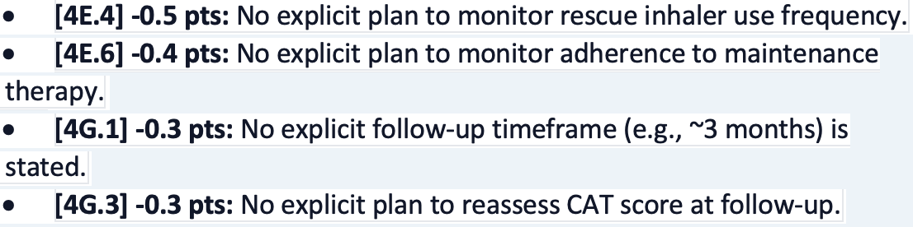
RJ_Tue_AI_Feedback_Monitoring_09. Original feedback image lines are continued in reading order.
Evidence limit or targeted capture: Capture RJ_Tue_EMR_Submitted_Plan_01.png and sequential _02.png if needed, showing the actual saved fields and encounter. Preserve the current feedback; no individual-deduction recapture is requested.

Issue RJ-Tue-09. Mosteller body surface area needs arithmetic verification
Priority: Medium
Status: Open chart investigation; original live-screen verification required
What the student saw or heard: The supplied Vitals text lists height 5 feet 10 inches (177.8 cm), weight 89 kg and BSA (Mosteller) 2.04 m².
What the reference or grader expects: The named calculation gives square root of (177.8 × 89 / 3600) = approximately 2.10 m². No BSA requirement or related grader deduction is alleged.
Why this matters: The displayed calculated result does not reproduce from the visible inputs. This observation is separate from the wrong weight and BMI targets in RJ-Tue-01.
Suggested fix: Check source inputs, units and the Mosteller calculation. Verify the live display before confirming the defect; if these inputs are correct, the displayed result should round to approximately 2.10 m².
Focused evidence
No original live-screen screenshot supplied. Evidence is the pasted Vitals text and reproducible calculation above.
Evidence limit or targeted capture: Capture RJ_Tue_EMR_BSA_01.png with height, weight, the Mosteller label and the BSA value together.

Additional Live EMR Screenshots Still Needed
Capture only the fields below, retaining Bob’s name and Tuesday initial-visit context. Existing interview and feedback screenshots will be reused; do not repeat individual interview answers or grader rows.
RJ_Tue_EMR_Vitals_01.png: Capture: HR, RR, weight, height, BMI and BP with labels and encounter context.
RJ_Tue_EMR_Pulmonary_01.png: Capture: FEV1, FVC, FEV1/FVC and all pre/post-bronchodilator labels; include units and percent predicted.
RJ_Tue_EMR_Oxygen_01.png: Capture: SpO₂ with all room-air, device and flow fields. Check any separate respiratory observations panel.
RJ_Tue_EMR_Immunizations_01.png: Capture: the complete immunization list, including any Tdap history or overdue flag.
RJ_Tue_EMR_Medication_History_01.png: Capture: active, prior and discontinued inhaler prescriptions with names and reconciliation status.
RJ_Tue_EMR_GOLD_Group_01.png: Capture: the Group B label and its displayed criteria/advisory, including any guideline edition shown.
RJ_Tue_EMR_Submitted_Plan_01.png and _02.png: Capture: actual saved Plan, Monitoring and Follow-up fields that were graded. Use sequential images if needed to preserve complete text.
RJ_Tue_EMR_BSA_01.png: Capture: height, weight and displayed Mosteller BSA together.
Retest Acceptance
After fixes, compare the exact corrected fields and regrade faithful chart/interview documentation. Pass means current measurements and patient answers receive credit, missing measured context is supplied or accepted as unknown, and the declared guideline edition matches the grouping rules. For RJ-Tue-08, first establish whether the monitoring section was actually submitted. A higher score alone does not prove the factual defects are fixed.

Robert “Bob” Jenkins Wednesday 3 Month Follow Up
Initial audit • Grading result 74.1% • Review date October 23, 2026
Purpose: Review unresolved differences between the Wednesday follow-up chart, Bob’s actual interview answers, the reference checklist and the grader. The main concern is that faithful chart and interview documentation receives deductions for different hidden targets. This is the first audit of this encounter, not a post-fix retest.

Quick Guide for Non-Clinical Readers
Term | Plain-language meaning
VACS / EMR | Virtual Ambulatory Care Simulation / electronic medical record.
AI patient / grader | The simulated patient / the system that scores the clinical note.
SOAP | Subjective, Objective, Assessment and Plan sections of a clinical note.
COPD / exacerbation | Chronic obstructive pulmonary disease / a breathing flare-up.
LABA / LAMA / ICS | Two types of long-acting airway-opening medicine / an inhaled steroid. Anoro contains a LABA and a LAMA.
Adherence / technique | How consistently medicine is taken / how the inhaler is used.
GOLD / CAT | COPD guideline organization / COPD Assessment Test symptom score.
FEV1 / FVC | Air breathed out in one second / total air breathed out during a forced breath.
Post-bronchodilator | A breathing test measured after an airway-opening medicine.
HR / RR / SpO₂ | Heart rate / respiratory rate / blood oxygen saturation.
BMI / Tdap / RSV | Body mass index / tetanus-diphtheria-pertussis vaccine / respiratory syncytial virus.

Final Review Summary
The grader returned 74.1% (“Solid”) and recognized the correct decision to address inhaler technique and missed doses before escalating treatment. Ten grouped findings remain open: one High, eight Medium and one Low priority. Image-supported patient conflicts are distinguished from chart investigations that still need targeted live evidence. No corrected score is calculated.
Issue and priority | Unresolved finding
RJ-Wed-01 • High | Current measurements differ from grading targets.
RJ-Wed-02 • Medium | Actual rescue use and trend conflict with expected daily use.
RJ-Wed-03 • Medium | Grader requires an initial daily-use claim not clearly established by the answer.
RJ-Wed-04 • Medium | Reference requires patient beliefs and an expectation judgment not established by the interview.
RJ-Wed-05 • Medium | Tdap overdue status required without a supplied last-dose record.
RJ-Wed-06 • Medium | Reconciliation completion required despite a pending chart status.
RJ-Wed-07 • Medium | Post-bronchodilator confirmation required without a supplied label.
RJ-Wed-08 • Medium | Reference requires both mild improvement and no improvement.
RJ-Wed-09 • Medium | GOLD grouping uses an interval history rather than a verified full-year history.
RJ-Wed-10 • Low | Possible failure to recognize equivalent technique-correction wording.
Evidence reviewed: Pasted Wednesday chart; seven original interview images 095323, 095447, 095509, 095533, 095553, 095612 and 095631; reference Pasted text(20261023-100243).txt; SOAP draft in this conversation; and four grader images 101025, 101047, 101122 and 101149. Original screenshots remain the source; focused crops appear under the relevant issue.
Limits: No targeted live EMR screenshots or export of the exact submitted note were supplied. The grader quotes several phrases from the draft, but this does not independently establish every submitted field. Crops join adjacent source images only where a question and answer cross a screenshot boundary; captions identify this.
Excluded: Routine omissions of optional counseling wording, explicit disease-progression discussion, congratulatory language, and explicit statements that unneeded tests are unnecessary are not counted as software defects. Static dates and age/DOB differences are excluded. Wednesday explicitly supplies room-air saturation and BSA 2.10 m², so Tuesday’s missing oxygen context and BSA concern are not carried forward.

Issue RJ-Wed-01. Current chart measurements differ from the grader targets
Priority: High
Status: Open factual conflict; live EMR confirmation pending
What the student saw or heard: The supplied chart and SOAP report BP 130/76 mmHg, HR 78/min, RR 18/min, weight 89 kg, height 70 inches, BMI 28.1 kg/m², SpO₂ 95% on room air, FEV1/FVC 0.58 and FEV1 63% predicted.
What the reference or grader expects: The reference instead expects BP 132/82, HR 76, RR 20, weight 80 kg, height 69 inches, BMI 26.0, SpO₂ 97%, ratio 0.62 and FEV1 58%. Deductions 2A.1–6, 2B.1–2/8–9, 2C.1 and 3A.16–17/19 repeat these differences. At 80 kg and 69 inches, BMI rounds to 26.1, adding a smaller internal reference-rounding concern.
Why this matters: Using the chart values is treated as incorrect. Multiple measurements appear to come from a different encounter dataset.
Suggested fix: Bind the chart, reference and grader to one Wednesday dataset. Accept the visible values and their units; calculate BMI from the same height and weight. Regrade affected criteria after alignment.
Focused evidence
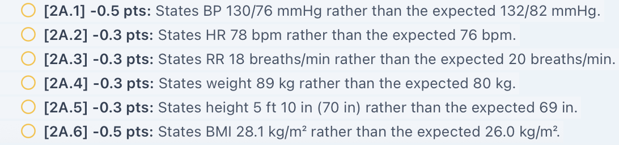
Original grader crop RJ_Wed_AI_Feedback_vitals.png. Long source lines continue in reading order without rewriting.
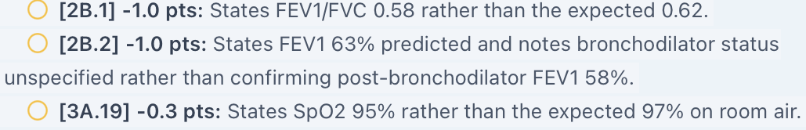
Original grader crop RJ_Wed_AI_Feedback_lung.png. Long source lines continue in reading order without rewriting.
Evidence limit or targeted capture: Capture RJ_Wed_EMR_Vitals_01.png and RJ_Wed_EMR_Pulmonary_01.png. Pasted chart text is evidence of the supplied dataset, not a substitute for a live source capture.

Issue RJ-Wed-02. Rescue inhaler frequency and trend differ from the actual answer
Priority: Medium
Status: Open; original interview and grader images support the conflict
What the student saw or heard: Asked how often he uses albuterol and how use has changed, Bob says he reaches for it “several times during the week” and that use “hasn’t really changed much.” The SOAP preserves several times weekly and little perceived change.
What the reference or grader expects: The reference and grader require approximately 1–2 times daily and a slight reduction from baseline. Examples are 1B.7–8, 2B.5–6, 2C.6 and 3A.5.
Why this matters: The feedback calls faithful transcription a material frequency discrepancy. A different intended baseline does not justify replacing the current answer.
Suggested fix: Align neutral patient answers with the intended case facts, or accept the observed weekly use and uncertain trend. Keep patient-reported frequency separate from measured objective findings.
Focused evidence
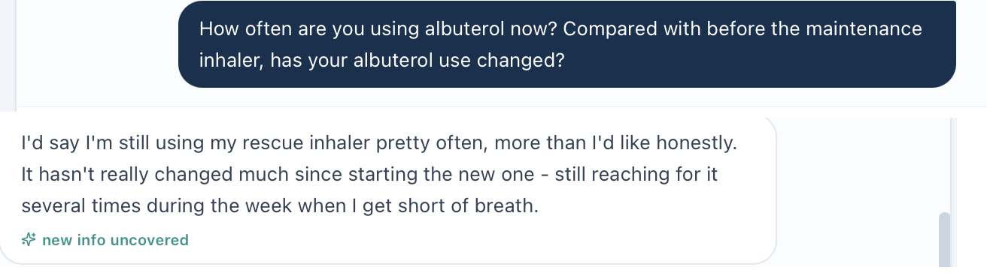
Question from image(20261023-095323).png joined to its answer in image(20261023-095447).png.
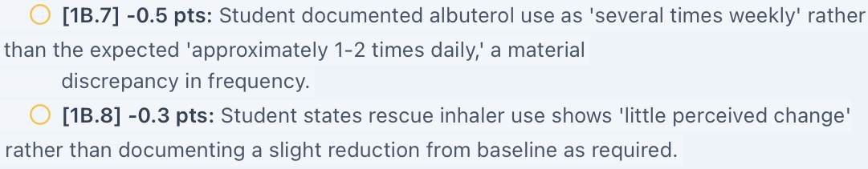
Original grader crop RJ_Wed_AI_Feedback_rescue.png. Long source lines continue in reading order without rewriting.

Issue RJ-Wed-03. Grader requires a daily adherence claim despite explicit missed doses
Priority: Medium
Status: Open; original interview and grader images available
What the student saw or heard: Bob first says he tries to take the new inhaler every day but forgets, then immediately clarifies actual use as 3–4 days weekly. A repeated neutral question confirms 3–4 days weekly. A later medication-list answer states the once-daily regimen.
What the reference or grader expects: Deduction 1B.15 requires documentation that he reports daily compliance before clarification. The reference likewise states patient reports daily use.
Why this matters: The record supports prescribed frequency and intended use, with inconsistent actual use. It does not clearly establish a separate unqualified claim of perfect daily compliance. A later regimen statement should not erase the explicit adherence history.
Suggested fix: Distinguish prescribed regimen, intended use and actual doses taken. Accept an accurate 3–4-days-weekly history without requiring an unsupported earlier claim. If an intentional initial overstatement is part of the case, make the patient answer explicit and consistent.
Focused evidence
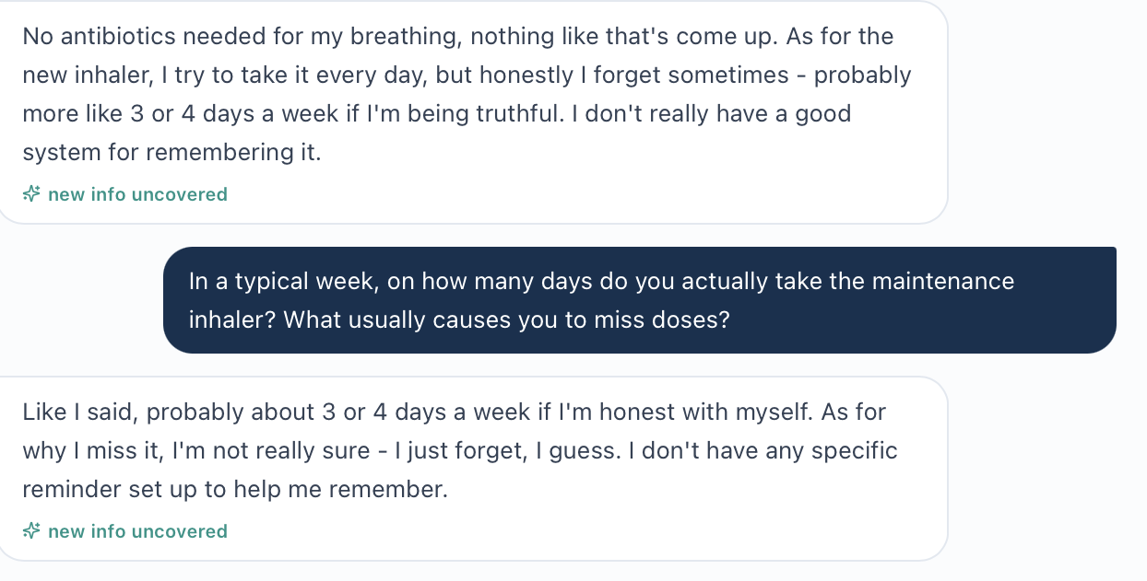
Original interview image(20261023-095509).png: initial answer and repeated adherence clarification.
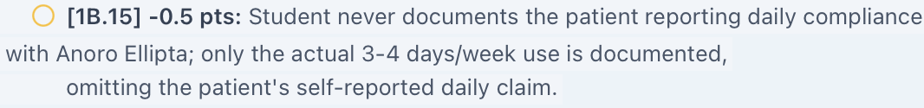
Original grader crop RJ_Wed_AI_Feedback_daily.png. Long source lines continue in reading order without rewriting.

Issue RJ-Wed-04. Reference requires unconfirmed beliefs and an unsupported expectation judgment
Priority: Medium
Status: Open reference alignment investigation
What the student saw or heard: Bob describes opening the cover until it clicks, blowing into the mouthpiece, then inhaling. He does not explicitly say he believes this forces medicine into his lungs or that his technique is correct. He hoped for more relief by three months and reports only a small improvement.
What the reference or grader expects: Items 1B.16/18 require those specific beliefs. Items 1G.2, 3B.6, 3C.3 and 4B.9 require the student to label his expectations unrealistic. The reference also offers failure to open the cover completely as a technique error, although the actual answer says he opens it until it clicks.
Why this matters: The technique error is established, but the patient’s explanation for it and a judgment that his expectations are unrealistic are not. Disappointment after three months is not enough by itself to prove an unrealistic timeline, particularly with poor delivery and missed doses.
Suggested fix: Grade the observable error and established forgetfulness. Make intended beliefs available through neutral answers or treat them as questions to clarify. Accept a plan to explore expectations rather than requiring an unverified judgment.
Focused evidence
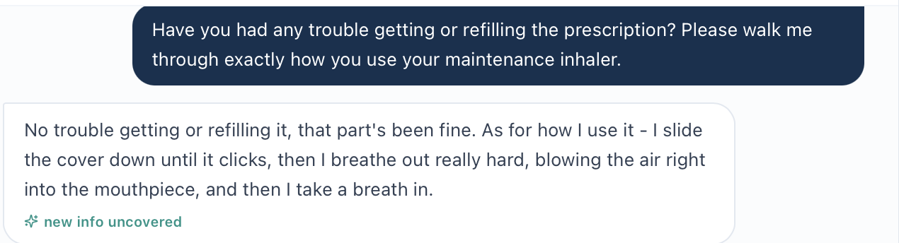
Original technique question and answer from image(20261023-095533).png.
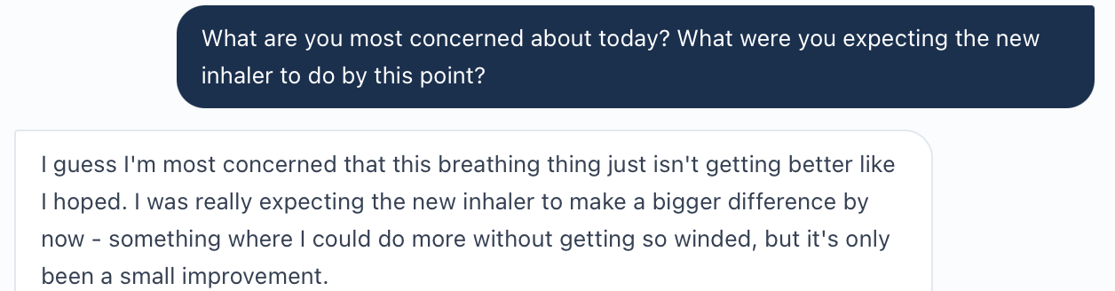
Original expectations question and answer from image(20261023-095631).png.

Issue RJ-Wed-04 continued
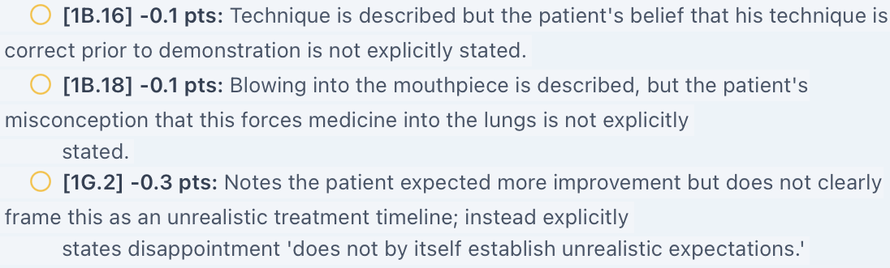
Original grader crop RJ_Wed_AI_Feedback_mental.png. Long source lines continue in reading order without rewriting.
Evidence limit or targeted capture: These are missing confirmations, not explicit patient denials. A brief neutral question about what he believes the breathing-out step does and what improvement/timeline he expected can resolve intended facts.

Issue RJ-Wed-05. Tdap overdue status is required without supporting dose history
Priority: Medium
Status: Open missing-data investigation; live chart verification pending
What the student saw or heard: The supplied chart lists influenza, COVID-19, pneumococcal and RSV vaccination categories, with no Tdap record or last-dose date. The SOAP states Tdap status is unknown and plans verification and administration if due.
What the reference or grader expects: The reference declares Tdap overdue; 1E.14 and 3E.4 deduct credit for not asserting that status. Feedback also reasons that the standard ten-year interval establishes overdue status.
Why this matters: A recommended interval alone cannot establish whether this patient is overdue without a last-dose history. Unknown status is not the same as a confirmed missed booster.
Suggested fix: Display the intended Tdap dose history or overdue flag in the student-facing chart. Until verified, accept unknown status with an actionable vaccination review plan.
Focused evidence
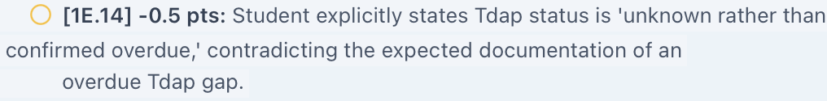
Original grader crop RJ_Wed_AI_Feedback_tdap.png. Long source lines continue in reading order without rewriting.
Evidence limit or targeted capture: Capture RJ_Wed_EMR_Immunizations_01.png with the full vaccine history and any Tdap details.

Issue RJ-Wed-06. Reference declares medication reconciliation complete while the chart says pending
Priority: Medium
Status: Open workflow/status investigation; live verification pending
What the student saw or heard: The supplied medication panel explicitly says “Med rec: Pending.” The interview confirms four prescription medicines but does not fully establish OTC products, supplements or adverse effects. The SOAP therefore retains pending status.
What the reference or grader expects: Deduction 1E.15 requires complete reconciliation of the four active medicines. Feedback assumes listing the four medicines and doses means reconciliation is complete.
Why this matters: A complete visible prescription list does not automatically establish that the reconciliation workflow has been completed or the list is comprehensive.
Suggested fix: Align the displayed workflow status and grading requirement. Define what completes reconciliation and score verified actions. Do not infer a completed chart workflow solely from a medication table.
Focused evidence
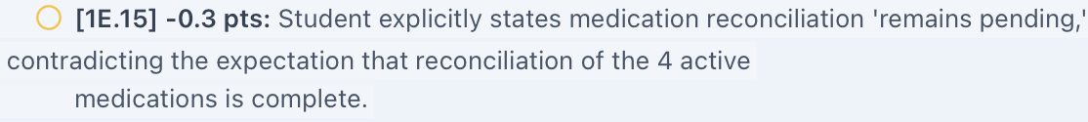
Original grader crop RJ_Wed_AI_Feedback_rec.png. Long source lines continue in reading order without rewriting.
Evidence limit or targeted capture: Capture RJ_Wed_EMR_Medication_Reconciliation_01.png showing status, active list and completion controls. Check whether the student actually completed the workflow before confirming a defect.

Issue RJ-Wed-07. Grader requires a test condition not supplied with spirometry
Priority: Medium
Status: Open missing-context investigation; live source label needed
What the student saw or heard: The supplied pulmonary results show ratio 0.58 and FEV1 63% predicted without an explicit pre- or post-bronchodilator label. The SOAP conditions GOLD spirometric grading on confirmation of post-bronchodilator testing.
What the reference or grader expects: The reference requires confirmation of post-bronchodilator testing; 2B.2 and 2B.10 penalize unspecified status. Its separate Grade 2 range says 50–69%; the GOLD range is 50% to less than 80%. Both the actual 63% and reference 58% fall within Grade 2, but the teaching range is incomplete.
Why this matters: Numbers alone do not establish when the test was measured. A hidden test-condition target and an incorrect severity range weaken the teaching record.
Suggested fix: Label test conditions beside results, correct the Grade 2 range, and accept qualified interpretation when the required condition is unavailable.
Focused evidence
Original grader crop RJ_Wed_AI_Feedback_context.png. Long source lines continue in reading order without rewriting.
Guideline source: GOLD 2026 Pocket Guide, spirometric grades: https://goldcopd.org/wp-content/uploads/2026/01/GOLD-Pocket-Guide-2026-v1.1-20Nov2025_WMV2.pdf
Evidence limit or targeted capture: Capture RJ_Wed_EMR_Pulmonary_01.png with complete test labels and any expanded report. Do not ask the AI patient to supply measured test conditions.

Issue RJ-Wed-08. Reference requires both mild improvement and no improvement
Priority: Medium
Status: Open; chart narrative and interview support mild improvement
What the student saw or heard: The chart says mild, suboptimal improvement. Bob repeatedly describes breathing as a little better, with a small improvement that falls short of his expectations. The SOAP consistently records mild improvement with persistent exertional limitation.
What the reference or grader expects: The checklist first requires mild improvement and slight reduction in dyspnea, but later repeatedly requires no improvement. Deductions 2B.3 and 2C.5 require no improvement despite the current answers.
Why this matters: The same truthful symptom description cannot satisfy opposing grading targets. Persistent substantial symptoms can coexist with mild improvement.
Suggested fix: Use one consistent response trajectory throughout the chart, interview, checklist and grader. Accept “mild/suboptimal improvement with persistent symptoms” for the supplied encounter.
Focused evidence
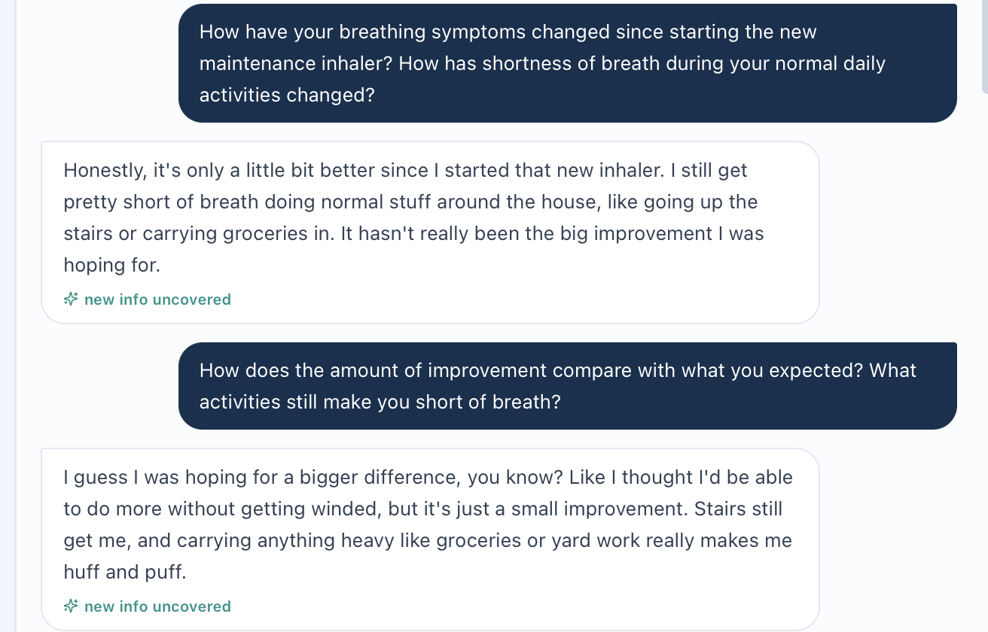
Original symptom questions and answers from image(20261023-095323).png.
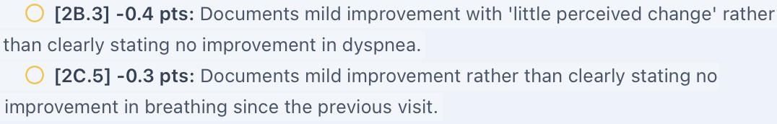
Original grader crop RJ_Wed_AI_Feedback_improve.png. Long source lines continue in reading order without rewriting.

Issue RJ-Wed-09. GOLD grouping requires the full risk window rather than the follow-up interval alone
Priority: Medium
Status: Open reference and time-window investigation
What the student saw or heard: Wednesday history establishes no events since the last visit, approximately three months. The prior Tuesday interview documented one steroid/antibiotic-treated flare during the preceding year. The SOAP defers a new A/B/E assignment until the full-year history is reconciled.
What the reference or grader expects: Items 2C.4 and 3A.2 require Group B from zero interval events. GOLD 2026 assesses exacerbations over the preceding year and places patients with at least one moderate or severe event in Group E. Three event-free months do not establish an event-free full year.
Why this matters: If the earlier flare remains within the current twelve-month window, a Group B label based on the shorter interval can misstate risk. The flare date is unknown, so this report does not assert that Wednesday must be Group E.
Suggested fix: Expose the event date and verify the complete prior-year history. Apply the stated guideline edition to that window. Accept an explicit reconciliation plan when dates are unavailable; do not equate interval stability with no annual exacerbations.
Focused evidence
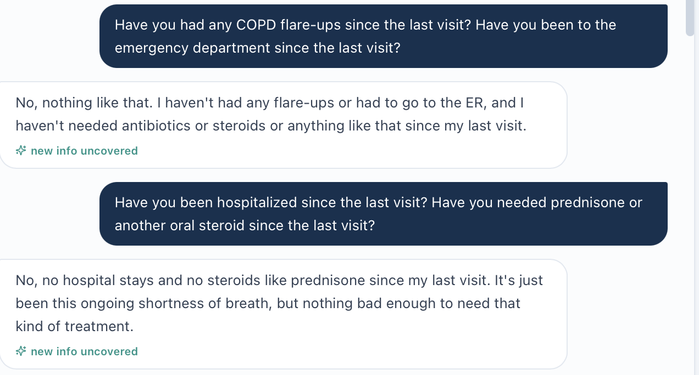
Wednesday interval event denials from image(20261023-095447).png.
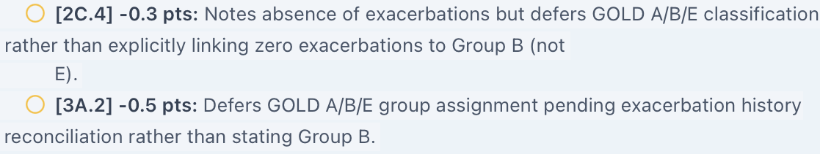
Original grader crop RJ_Wed_AI_Feedback_gold.png. Long source lines continue in reading order without rewriting.
Guideline source: GOLD 2026 Report, Figure 2.13 and classification discussion: https://goldcopd.org/wp-content/uploads/2026/01/GOLD-REPORT-2026-v1.3-8Dec2025_WMV2.pdf
Evidence limit or targeted capture: Capture RJ_Wed_EMR_Exacerbation_History_01.png with the event dates and current grouping/advisory. Tuesday history is longitudinal context only, not proof of the exact Wednesday risk window.

Issue RJ-Wed-10. Equivalent technique-correction wording may not receive credit
Priority: Low
Status: Unable to verify without the exact saved note
What the student saw or heard: The chat SOAP explicitly identifies exhaling into the loaded device as the error. Its Plan instructs the patient to exhale fully away from the inhaler and confirms technique by demonstration.
What the reference or grader expects: Deduction 3C.5 acknowledges the “exhale away” instruction but removes credit because the note does not literally say never blow into the mouthpiece.
Why this matters: The correction may convey the required meaning without the specific negative phrase. Explicit “do not blow into the mouthpiece” would strengthen counseling, but a literal phrase requirement may under-credit equivalent documentation.
Suggested fix: Compare the exact submitted text with the criterion. Accept equivalent wording when it clearly directs exhalation away from the device and identifies blowing into it as incorrect. Retain deduction only if the intended criterion requires a distinct counseling action not documented.
Focused evidence
Original grader crop RJ_Wed_AI_Feedback_semantic.png. Long source lines continue in reading order without rewriting.
Evidence limit or targeted capture: Capture RJ_Wed_EMR_Submitted_SOAP_01.png and sequential continuation images of the actual saved assessment and technique plan. Do not recreate a live screen from the chat draft.

Additional Live EMR Evidence Needed
Capture only the targeted fields below with Bob’s identity and Wednesday follow-up context visible. Reuse the saved complete interview and feedback; no individual interview or grader recaptures are needed.
RJ_Wed_EMR_Vitals_01.png: Capture: BP, HR, RR, SpO₂ with room-air label, height, weight and BMI.
RJ_Wed_EMR_Pulmonary_01.png: Capture: FEV1, percent predicted, FVC, ratio, units and all pre/post-bronchodilator labels; expand the report if available.
RJ_Wed_EMR_Immunizations_01.png: Capture: complete vaccine history, including any Tdap date or overdue flag.
RJ_Wed_EMR_Medication_Reconciliation_01.png: Capture: active medicines, reconciliation status and available completion controls.
RJ_Wed_EMR_Exacerbation_History_01.png: Capture: prior-year flare dates, treatment, hospitalization history and the displayed risk group/advisory.
RJ_Wed_EMR_Submitted_SOAP_01.png and sequential continuations: Capture: the actual saved note assessed by the grader, including the technique assessment and Plan. Retain all text in readable sequence.
Acceptance Checks After Correction
A passing check requires the grader to accept the current chart measurements and actual patient answers, resolve opposing improvement targets, use verified reconciliation and vaccine status, and apply test labels and the correct annual risk window. Review the exact submitted note before attributing wording deductions to a scoring failure. Regrade after source alignment; a higher score alone does not demonstrate that the underlying conflicts are fixed.

Robert “Bob” Jenkins Thursday 6 Month Follow Up
Initial audit • Grading result 88.6% • Review date October 23, 2026
Purpose: Document unresolved conflicts between Thursday’s COPD chart, actual AI-patient answers, the reference checklist and grading feedback. The case supports escalation from Anoro to triple therapy, but the assessment prompt, supplemental data and several grading targets do not consistently describe that encounter. This is an Initial audit of Thursday, not a post-fix retest.

Quick Guide for Non-Clinical Readers
Term | Plain-language meaning
VACS / EMR | Virtual Ambulatory Care Simulation / the electronic patient chart.
AI patient / grader | The simulated patient answering questions / the system scoring the note.
SOAP | Subjective, Objective, Assessment and Plan sections of a clinical note.
COPD / exacerbation | Chronic obstructive pulmonary disease / a breathing flare-up.
LABA / LAMA | Two types of long-acting airway-opening medicine. Anoro contains both.
ICS / triple therapy | Inhaled corticosteroid / an ICS plus a LABA and a LAMA.
Eosinophils | A type of white blood cell that can help predict benefit from an inhaled steroid.
FEV1 / FVC | Air breathed out in one second / total air breathed out during a forced breath.
Post-bronchodilator | A breathing test measured after an airway-opening medicine.
CAT / ACT | COPD Assessment Test / Asthma Control Test: questionnaires for different conditions.
SpO₂ / room air | Blood oxygen saturation / breathing without supplemental oxygen.
Tdap / RSV | Tetanus-diphtheria-pertussis vaccine / respiratory syncytial virus.

Final Review Summary
The grader returned 88.6% (“Strong”) and recognized the rationale for adding an ICS, Trelegy dosing, technique education and monitoring. Seven grouped findings remain open: four High and three Medium priority. The current chart narrative and interview describe persistent symptoms and recurrent flare-ups, while portions of the reference expect marked improvement. Live EMR captures are still needed to complete several findings. No corrected score is calculated.
Issue and priority | Unresolved finding
RJ-Thu-01 • High | Assessment asks about starting a treatment already prescribed.
RJ-Thu-02 • High | Supplemental spirometry, CAT and asthma entries conflict with the main chart.
RJ-Thu-03 • High | Grader expects oxygen and pulmonary values different from both supplied datasets.
RJ-Thu-04 • High | Grader expects improvement and infrequent rescue use despite the actual deterioration history.
RJ-Thu-05 • Medium | Expected tobacco history differs from the chart and direct answers.
RJ-Thu-06 • Medium | Overdue Tdap required without a supplied dose history.
RJ-Thu-07 • Medium | Optimized inhaler technique required without current demonstration or verification.
Evidence reviewed: Pasted Thursday chart; seven complete source interview images 234800, 235036, 235058, 235126, 235211, 235308 and 235426; the reference checklist pasted with the SOAP request; the SOAP draft in this conversation; and grader images image(20261024-001021).png and image(20261024-001103).png. Focused crops below retain original source text. Screenshot timestamps are source filenames, not visit dates.
Evidence limits: The chart was supplied as text, without targeted live EMR screenshots. The two grading images cover the score, strengths, opportunities and listed deductions through 4A.11. The second ends at the “Gold Standard Comparison” heading; any content below that heading was not supplied. No hidden comparison text is assumed. An exact saved-note export was not supplied, although feedback quotes multiple draft phrases.
Not counted as defects: Omitted explicit cutoffs, optional counseling phrases, a numerical rescue-use target, and missing exact words about independence or quality of life are not automatically software defects. The patient was asked about goals and quality of life and answered that he wanted fewer exacerbations, less breathlessness and no urgent care. These goals were preserved. Static dates and age/DOB calendar differences are excluded. No Tuesday or Wednesday finding is presumed to persist without Thursday evidence.

Issue RJ-Thu-01. Assessment asks whether to escalate to LABA LAMA despite current Anoro
Priority: High
Status: Open treatment-stage conflict; live source capture pending
What the student saw or heard: The active list and HPI identify umeclidinium/vilanterol (Anoro Ellipta) 62.5/25 mcg, one inhalation daily. The advisory identifies recurrent exacerbations despite this dual therapy and recommends considering ICS escalation. The assessment instead asks, “Should therapy be escalated to LABA/LAMA?”
What the reference or grader expects: The supplied Plan correctly offers triple therapy and the reference requires Trelegy. The grader praises the escalation to triple therapy. No deduction for choosing triple therapy is alleged.
Why this matters: The question describes an earlier treatment step than the current regimen. A learner may be directed to prescribe the treatment already being taken instead of assessing whether to add ICS.
Suggested fix: Update Thursday’s assessment to ask whether to add ICS to LABA/LAMA after reviewing adherence, technique, exacerbations and eosinophils. Keep the question, advisory, medication list and Plan options synchronized.
Focused evidence
No original live EMR screenshot was supplied for this issue. Evidence is the pasted Thursday chart and reference text described above.
Evidence limit or targeted capture: Capture RJ_Thu_EMR_Assessment_and_Plan_01.png and RJ_Thu_EMR_Medications_01.png. The current conflict is documented in pasted chart text; it is not yet supported by a live screen image.

Issue RJ-Thu-02. Supplemental pulmonary and asthma entries conflict with the main COPD chart
Priority: High
Status: Open internal chart investigation; live screen verification pending
What the student saw or heard: The main pulmonary panel reports FEV1 1.8 L (60% predicted), FVC 3.16 L and ratio 0.57. Supplemental data report post-bronchodilator FEV1 61% and ratio 0.56. The advisory/problem list gives CAT 17, but supplemental data give CAT 15 and ACT 17 labeled “Partly controlled asthma component.” The problem list documents COPD without an established asthma diagnosis.
What the reference or grader expects: One current dataset should identify the test, test conditions and symptom-score assessment. If these values represent different tests or time points, that distinction must be shown. An ACT entry does not by itself establish asthma. If ACT is intended, its interpretation also needs checking: 17 falls below the usual well-controlled threshold of 20.
Why this matters: The learner cannot select a reliable baseline or safely infer an asthma component. The supplemental pattern resembles a different clinical scenario, but its origin cannot be established from the supplied evidence.
Suggested fix: Confirm the correct Thursday spirometry and CAT score, label test conditions and distinguish historical results. Remove or correct the asthma entry unless supported by verified history; correct any ACT interpretation. Preserve the discrepancy until the source is resolved.
Focused evidence
No original live EMR screenshot was supplied for this issue. Evidence is the pasted Thursday chart and reference text described above.
Interpretation source: American Thoracic Society, Asthma Control Test scoring: an ACT score above 19 indicates well-controlled asthma. https://www.thoracic.org/members/assemblies/assemblies/srn/questionaires/act.php
Evidence limit or targeted capture: Capture RJ_Thu_EMR_Pulmonary_and_Scores_01.png and sequential _02.png if needed, showing both the main results and supplemental block, plus RJ_Thu_EMR_Problem_List_01.png. No recreated chart image is included.

Issue RJ-Thu-03. Grader requires oxygen and spirometry values absent from the supplied chart
Priority: High
Status: Open grading-data conflict; live chart evidence pending
What the student saw or heard: The supplied detailed Vitals show SpO₂ 94% on room air. Main spirometry gives ratio 0.57 and FEV1 60%; supplemental post-bronchodilator values are ratio 0.56 and FEV1 61%. The SOAP documents the disagreement rather than selecting a hidden value.
What the reference or grader expects: The reference and grader require SpO₂ 97%, post-bronchodilator ratio 0.62 and FEV1 58% predicted. Deductions 2A.7, 2B.1 and 2B.2 penalize the chart-based values. Feedback groups 0.56 and 0.57 as post-bronchodilator even though only the supplemental set explicitly supplies that condition.
Why this matters: Neither visible pulmonary dataset matches the grading target. Fixing the internal chart discrepancy alone will not resolve grading unless the expected dataset is aligned too.
Suggested fix: Use one verified Thursday dataset across the EMR, reference and grader. Accept faithful documentation of conflicting source values while the inconsistency remains. Regrade affected measurement criteria after correction.
Focused evidence
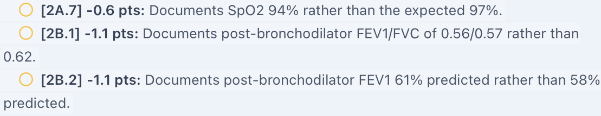
Original grader crop RJ_Thu_AI_Feedback_objective.png. Source lines continue in reading order without rewriting.
Evidence limit or targeted capture: Capture RJ_Thu_EMR_Vitals_01.png with oxygen conditions and RJ_Thu_EMR_Pulmonary_and_Scores_01.png. The grader crop proves the expected targets, not the live measured values.

Issue RJ-Thu-04. Expected improvement and rescue frequency contradict the actual clinical course
Priority: High
Status: Open; original interview and grading images directly support the conflict
What the student saw or heard: The chart chief concern is ongoing flare-ups and rescue inhaler need. Bob says breathing has not gotten much better, he uses albuterol almost every day and has had two more flare-ups in three months, one requiring urgent care. He reports concern about worsening lungs and avoiding further urgent care.
What the reference or grader expects: The reference requires significant improvement, a chief concern of improved breathing after correct technique and albuterol weekly or less. Deductions 1A.8, 1A.9 and 1B.18 enforce that different trajectory. Elsewhere the reference requires escalation to Trelegy, which fits the recurrent-exacerbation chart rather than its improvement narrative.
Why this matters: The student loses credit for documenting the patient’s actual symptom burden. The reference appears to combine improvement after technique correction with a later exacerbation-driven escalation scenario. This is a source-alignment inference, not proof of how the software was built.
Suggested fix: Choose the intended Thursday trajectory and align chart, patient, reference and grader. For this supplied case, accept persistent dyspnea, almost-daily rescue use and recurrent exacerbations. Keep a future treatment goal separate from the patient’s current rescue frequency.
Focused evidence
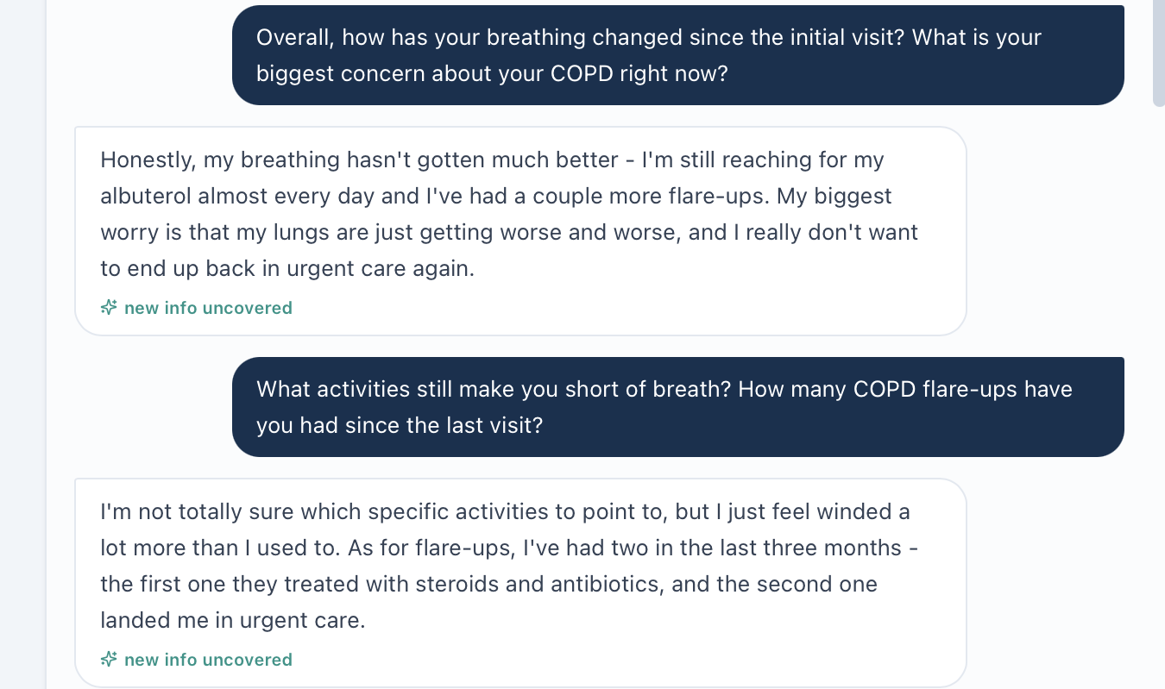
Original Thursday interview crop from image(20261023-234800).png: symptom trajectory, rescue use and interval flare history.
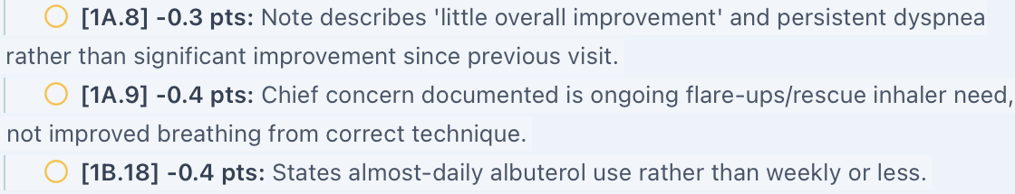
Original grader crop RJ_Thu_AI_Feedback_status.png. Source lines continue in reading order without rewriting.

Issue RJ-Thu-05. Smoking history targets differ from the chart and direct patient answers
Priority: Medium
Status: Open; original interview and grader images available
What the student saw or heard: The Thursday social history documents a 45 pack-year history and cessation five years ago. Asked about smoking and then asked again about lifetime exposure and quit timing, Bob consistently gives 45 pack-years and approximately five years.
What the reference or grader expects: The reference requires approximately 30 pack-years and cessation ten years ago. Deductions 1D.5, 1D.6 and 3D.2 apply those different targets.
Why this matters: The chart and current answers agree, but the learner is penalized for preserving them. These facts affect longitudinal risk history and should not be replaced by hidden reference values.
Suggested fix: Align the smoking exposure and cessation fields across the Thursday chart, patient response bank and grader. Accept 45 pack-years and five years for the supplied encounter unless verified records correct that history.
Focused evidence
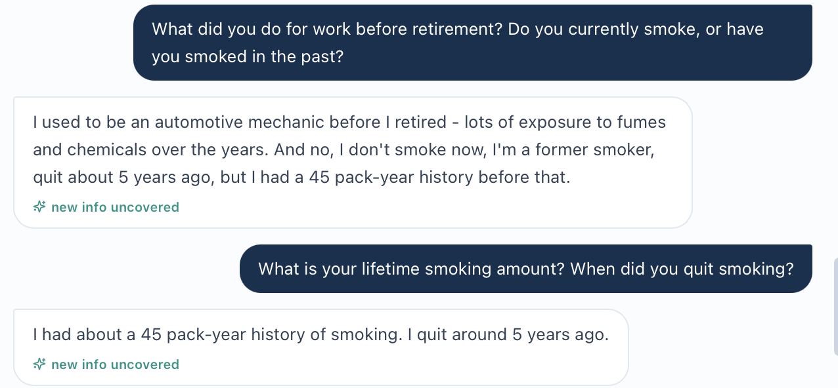
Original interview crop from image(20261023-235308).png: two questions yield consistent exposure and quit timing.
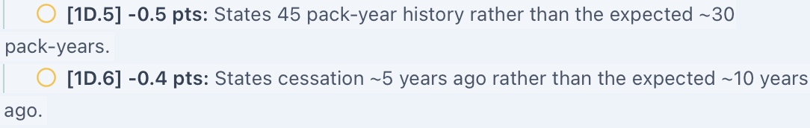
Original grader crop RJ_Thu_AI_Feedback_smoking.png. Source lines continue in reading order without rewriting.

Issue RJ-Thu-06. Tdap overdue status is required without a last-dose record
Priority: Medium
Status: Open missing-data investigation; live history confirmation pending
What the student saw or heard: The supplied immunization section lists influenza, COVID-19, pneumococcal and RSV categories but does not show Tdap, a last-dose date or an overdue flag. The SOAP states the history is unknown and plans verification and vaccination if indicated.
What the reference or grader expects: The reference declares Tdap overdue. Deductions 1E.18 and 3E.4 require that status. Narrative feedback cites the standard greater-than-ten-year interval, but the supplied chart does not establish that such an interval has elapsed for Bob.
Why this matters: A recommended booster interval is not proof that this patient is overdue. The chart must provide a last-dose history or an intended overdue status before a definitive statement can be required.
Suggested fix: Display the intended Tdap record and due status or accept an explicit history-verification and vaccination plan. Do not require the student to convert unknown history into a confirmed overdue dose.
Focused evidence
Original grader crop RJ_Thu_AI_Feedback_tdap.png. Source lines continue in reading order without rewriting.
Evidence limit or targeted capture: Capture RJ_Thu_EMR_Immunizations_01.png with the complete record and any Tdap dose date or due flag. This report does not prove the information is absent from every live panel.

Issue RJ-Thu-07. Resolved inhaler technique is required without current confirmation
Priority: Medium
Status: Open verification gap; not proof of persistent misuse
What the student saw or heard: Bob reports taking Anoro every morning, with his wife placing it beside his coffee mug. This confirms an improved adherence routine. The supplied Thursday interview does not include a current step-by-step technique answer or observed demonstration. The chart HPI confirms compliance but does not state that technique was checked.
What the reference or grader expects: The reference requires technique to be optimized and the previous problem resolved. Deductions 3A.13 and 3C.1 penalize the note for treating technique as unverified. The grader’s strengths nevertheless praise checking technique and adherence before escalation.
Why this matters: Regular dosing and correct device use are separate facts. The supplied evidence cannot establish current technique quality, but it also does not show that the earlier error persists.
Suggested fix: Provide a current technique observation in the chart or make it obtainable through a neutral demonstration question. Accept an explicit verification plan when no assessment is available. Once observed, document technique as correct or describe the actual remaining error.
Focused evidence
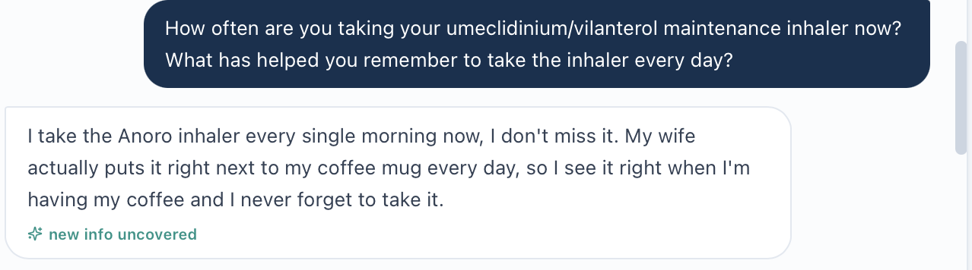
Original interview crop from image(20261023-235058).png: daily-use routine and spouse reminder, without technique demonstration.
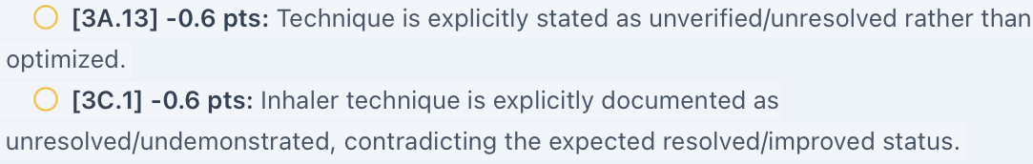
Original grader crop RJ_Thu_AI_Feedback_technique.png. Source lines continue in reading order without rewriting.
Evidence limit or targeted capture: Capture RJ_Thu_EMR_Technique_Observation_01.png if the chart documents an assessment. If none exists, ask one neutral question: “Please walk me through exactly how you use your Anoro inhaler now.” Preserve the entire short continuation once, rather than requesting individual answer screenshots.

Additional Live EMR Evidence Needed
Capture only the fields below with Bob’s identity and Thursday six-month follow-up context visible. Existing complete interview images and the supplied grading feedback will be reused. No individual interview or grader-row recaptures are requested.
RJ_Thu_EMR_Assessment_and_Plan_01.png: Capture: the LABA/LAMA assessment question and triple-therapy Plan options. Use a sequential second image only if needed.
RJ_Thu_EMR_Medications_01.png: Capture: current Anoro product, dose and daily regimen with the active medication list.
RJ_Thu_EMR_Pulmonary_and_Scores_01.png and _02.png: Capture: main spirometry, all pre/post-bronchodilator labels, supplemental spirometry, CAT and ACT entries, plus the advisory score if it is on a separate screen.
RJ_Thu_EMR_Problem_List_01.png: Capture: COPD diagnosis, symptom summary and any documented asthma diagnosis.
RJ_Thu_EMR_Vitals_01.png: Capture: SpO₂ 94% with the room-air label and encounter context.
RJ_Thu_EMR_Immunizations_01.png: Capture: complete vaccine history and any Tdap date, due status or overdue flag.
RJ_Thu_EMR_Technique_Observation_01.png: Capture: any current documented inhaler-technique assessment. If none exists, record that it is unavailable rather than recreating a confirmation.
Remaining Review Limits
The exact saved SOAP is not supplied. Do not attribute every wording deduction to a scoring defect based only on the chat draft. The reference’s independence goal, missing explicit quality-of-life phrase, numerical eosinophil cutoff, exact obstruction threshold, formal Grade 2 wording, vaccination rationale and rescue-use target can be addressed as documentation improvements where clinically supported. They are not added to the seven software/data findings.
Acceptance Checks After Correction
Pass requires one coherent Thursday treatment stage and dataset, acceptance of the actual smoking and symptom history, a visible or accepted-unknown Tdap status, and a current technique assessment or credit for an appropriate verification plan. Regrade after source alignment. A higher score alone does not establish that the factual conflicts are fixed.

Maria Thompson Tuesday Initial Visit
Initial audit • Grading result 87.2% • Review date October 21, 2026
Purpose: Document unresolved system, data, and grading conflicts observed during Maria Thompson’s Tuesday initial ambulatory care visit. Compare the live case, actual AI-patient answers, supplied grading checklist, and AI-grader feedback without importing hidden reference facts into the student record.

Quick Guide for Non-Clinical Readers
Term | Plain-language meaning
VACS | Virtual Ambulatory Care Simulation, the training system being reviewed.
EMR | Electronic medical record: the chart visible to the student.
AI patient / AI grader | The simulated patient who answers questions / the system that scores the SOAP note.
SOAP | Subjective, Objective, Assessment, Plan: the four parts of the student’s clinical note.
ACO / COPD | Asthma-COPD overlap / chronic obstructive pulmonary disease: breathing conditions in this case.
ICS | Inhaled corticosteroid: a lung medicine that reduces airway inflammation. Nasal fluticasone is not a lung ICS controller.
NKDA | No known drug allergies. This conflicts with the documented sulfonamide allergy.
SpO₂ / room air | Blood oxygen saturation / breathing without supplemental oxygen.
BSA / Mosteller | Body surface area / the calculation named by the Vitals screen.

Final Review Summary
Eight grouped findings require developer action or investigation: three High priority and five Medium priority. The grader returned 87.2% and praised the note’s clinical reasoning, but deducted points where actual patient uncertainty or adherence problems differed from expected history. Separately, the live-case text contains an allergy-banner conflict and treatment-stage prompts inconsistent with the initial medication list.
Patient / day | Scope and unresolved findings
Maria Thompson / Tuesday initial visit | 8 grouped findings: 3 High, 5 Medium. Grading completed successfully; no technical grading failure reported.
Image-supported findings | MT-Tue-02, 03, 06, 07, 08. Relevant uploaded screenshots appear under each issue.
Live-screen evidence incomplete | MT-Tue-01, 04, 09 rely wholly or partly on pasted EMR content. The absence of a source image is stated under each issue.
Evidence boundaries: The current supplied grading checklist and feedback are reference evidence. Earlier reports and the sample’s patient findings are not proof of this encounter. Interview screenshots are readable but do not preserve every exchange in the pasted transcript. The four grader screenshots cover the full feedback. No recreated chart image or SOAP screenshot is used as live-system proof.
Excluded from the issue count: Routine SOAP wording, section organization, explicit guideline citations and interpretation thresholds, and unconfirmed vitamin D strength. The “Missing →” labels beside populated results and the technique-demonstration expectation remain unverified observations and are not counted as confirmed defects. Static dates and age/DOB calendar differences are not reported as bugs.

Patient C – Maria Thompson – Tuesday Initial Visit

Issue MT-Tue-01. Allergy banner says no allergies despite a documented antibiotic allergy
Priority: High
Status: Still needs developer investigation; live-screen verification outstanding
Problem type: Internal EMR / safety
Problem: The medication safety banner disagrees with the patient header and allergy panel.
What the student saw or heard: The pasted Tuesday header and allergy panel identify sulfonamide antibiotics causing rash; the panel grades severity as moderate. The medication screen says “Allergy/interaction check active · NKDA — no conflicts.” The AI patient also reports a rash with sulfonamide antibiotics.
What the master rubric or AI grader expects: The current reference checklist does not establish an NKDA expectation. The grader acknowledges the documented banner discrepancy in its strengths; no allergy-related point loss is alleged.
Why this is a problem: A student may see a false no-allergy message while reviewing medicines, despite a recorded drug allergy.
Suggested fix: Make the medication safety banner and allergy checks use the same verified allergy status as the header and allergy panel. Verify reaction severity separately; do not remove the allergy to match the banner.
Focused screenshot evidence
No original live-screen image available for this issue.
Evidence limitation: Live-system screenshot of the medication banner and allergy record was not uploaded. The conflict is documented in the pasted current EMR; grader praise is corroborating feedback, not independent proof of the live banner.

Issue MT-Tue-02. Initial-visit questions and plan assume Trelegy and biologic treatment
Priority: High
Status: Still needs developer action
Problem type: Internal EMR / treatment-stage workflow
Problem: The displayed assessment and plan refer to treatment that is absent from the initial medication list.
What the student saw or heard: The current initial-visit medication list has tiotropium and rescue albuterol, with no lung ICS controller. The assessment asks “Should Trelegy be continued?” The plan offers “Start mepolizumab (Nucala) injection and continue Trelegy,” or switching Trelegy to Breztri. The first option is selected in the uploaded screen.
What the master rubric or AI grader expects: The supplied checklist includes ICS initiation and also inconsistent alternative treatment instructions. The actual grader praises initiating budesonide/formoterol while continuing tiotropium and albuterol. It does not establish that Maria is already taking Trelegy.
Why this is a problem: The structured workflow pushes the student toward a later treatment stage and does not offer the initial treatment action described in the current chart and SOAP.
Suggested fix: Align the Tuesday initial assessment and plan options with the verified initial medication list. Provide an appropriate ICS-containing initiation option; reserve continuing Trelegy and biologic escalation prompts for a case that actually supplies that treatment history.
Focused screenshot evidence
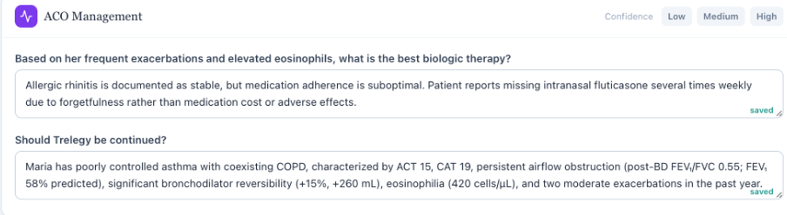
Assessment screen: prompts ask about a biologic and continuing Trelegy.
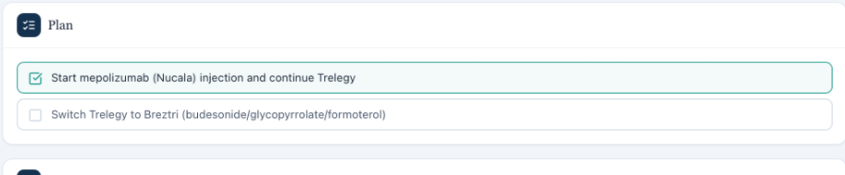
Plan screen: available respiratory options assume an existing Trelegy regimen; the biologic option is selected.
Evidence limitation: The uploaded assessment/plan images do not include the patient header or initial-visit label. Patient/day attribution is supplied by the current conversation and pasted chart. A live medication-list/context image remains outstanding.

Issue MT-Tue-03. AI patient gives two different current Spiriva frequencies
Priority: High
Status: Still needs developer action
Problem type: AI-patient internal contradiction / medication safety
Problem: Two neutral questions elicit incompatible descriptions of current medication frequency.
What the student saw or heard: When asked how her regimen changed after COPD diagnosis, Maria says she currently takes Spiriva “twice a day.” Asked to list current medicines, she says “2 puffs once a day.” The latter agrees with the pasted EMR prescription.
What the master rubric or AI grader expects: The checklist expects two tiotropium inhalations daily. Grader deduction 1B.19 refers to documented Spiriva dosing confusion; its point loss is accounted for under MT-Tue-08 rather than counted again here.
Why this is a problem: The auditor cannot determine whether this is intentional patient misuse or an inconsistent simulated answer; either interpretation changes medication reconciliation.
Suggested fix: Make current-use answers consistent across neutral questions. If twice-daily misuse is intentional, preserve that actual-use history consistently and make the rubric/grader recognize it as a problem to identify.
Focused screenshot evidence
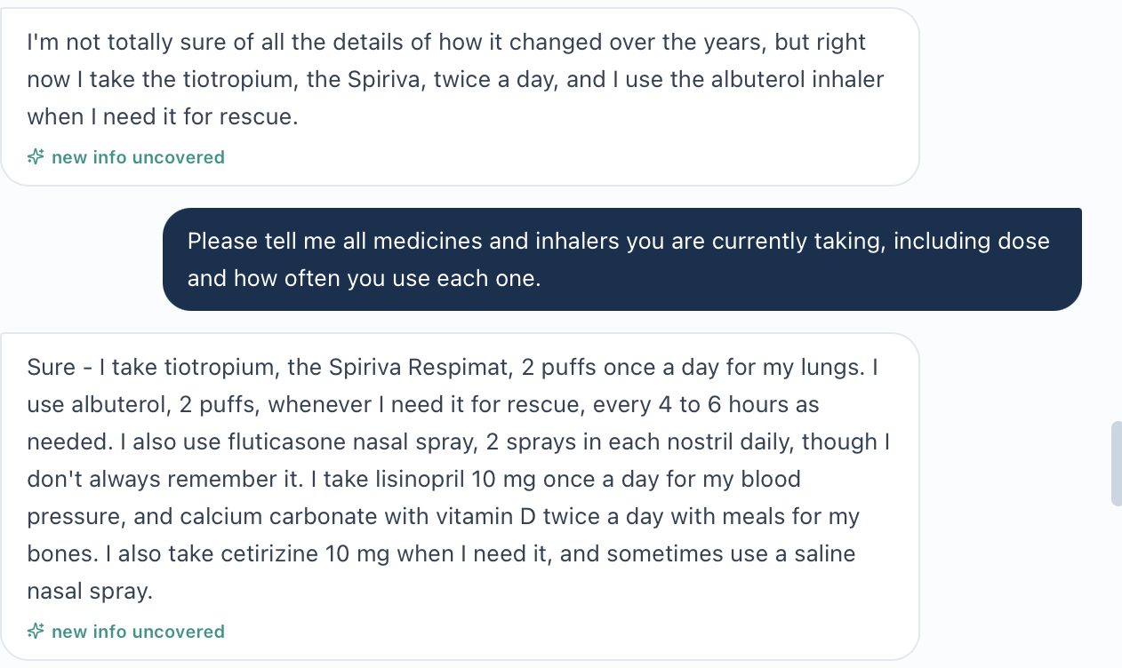
One continuous interview image contains both “twice a day” and “2 puffs once a day.”

Issue MT-Tue-04. Displayed body surface area does not match the stated calculation inputs
Priority: Medium
Status: Still needs developer investigation; live-screen verification outstanding
Problem type: Internal EMR / calculated data
Problem: The displayed Mosteller result does not match the recorded height and weight.
What the student saw or heard: The pasted Vitals screen lists weight 71 kg, height 5′4″, and “BSA (Mosteller) 2.04 m².”
What the master rubric or AI grader expects: No BSA grading requirement or deduction is claimed. Independent arithmetic using the displayed formula gives sqrt((162.56 cm × 71 kg) / 3600) = approximately 1.79 m².
Why this is a problem: The chart contains a calculated value that cannot be reproduced from its visible inputs.
Suggested fix: Check the Mosteller calculation and its height/weight inputs. Display approximately 1.79 m² for 71 kg and 162.56 cm, or correct the visible inputs if they are wrong.
Focused screenshot evidence
No original live-screen image available for this issue.
Evidence limitation: No live Vitals screenshot showing BSA was uploaded. This finding relies on the current pasted EMR values and the independently reproducible calculation; screenshot verification remains outstanding.

Issue MT-Tue-06. Grader requires symptom details that neutral patient questions do not provide
Priority: Medium
Status: Still needs developer action
Problem type: AI patient vs grader / rubric vs live case
Problem: The student loses points for preserving uncertain or non-confirming symptom answers instead of documenting the reference’s positive findings.
What the student saw or heard: The pasted interview records uncertain wheezing frequency, no recalled significant cough pattern, and no quantifiable albuterol frequency. Maria describes rhinitis as stable and says she has not noticed a seasonal pattern. The nasal-history screenshot directly preserves the stable/uncertain seasonal answers.
What the master rubric or AI grader expects: Checklist and grader expect intermittent wheezing, chronic cough, several-times-daily albuterol, positive nasal symptoms, and seasonal worsening. Relevant deductions: 1B.3–5, 1B.16–17, 1F.3–4, 3A.3, and 3B.4. Repeated deductions are grouped here.
Why this is a problem: Accurately recording the actual patient answers cannot satisfy grading expectations that require different subjective history.
Suggested fix: Synchronize the patient response bank, checklist, and grader for Tuesday. Accept faithful documentation of uncertainty when that is what neutral questions elicit; do not require students to insert the hidden positive history.
Focused screenshot evidence
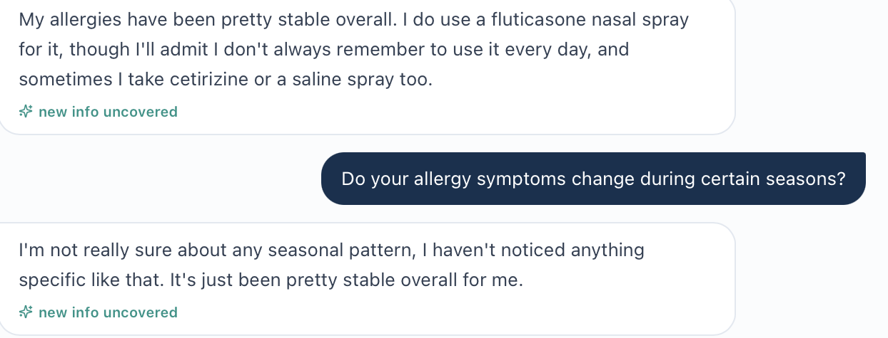
Patient reports stable rhinitis and no recognized seasonal pattern.
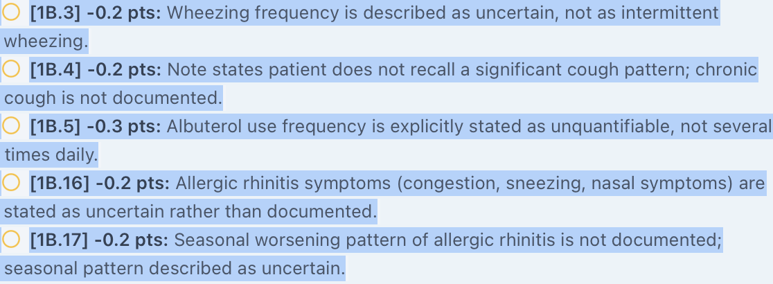
Grader deducts for uncertain wheezing, cough, rescue frequency, nasal symptoms, and seasonality.
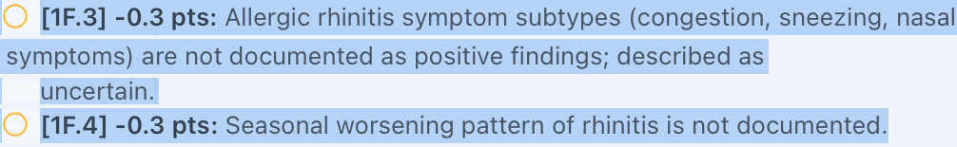
Additional rhinitis deductions repeat the same underlying expectation conflict.
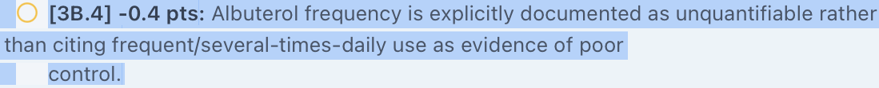
Assessment deduction 3B.4 again expects quantified frequent albuterol use.
Evidence limitation: The uploaded interview image set omits the wheeze, cough, and rescue-frequency exchanges. Their current answers are available in the pasted full transcript, not as uploaded image proof. No new individual-answer capture is assumed.

Issue MT-Tue-07. Grader expects prior steroid-inhaler use that the patient cannot recall
Priority: Medium
Status: Still needs developer action
Problem type: AI patient vs grader / rubric vs live case
Problem: The grader explicitly deducts for documenting valid patient uncertainty about prior lung ICS use.
What the student saw or heard: Asked whether she previously used an inhaled corticosteroid, Maria says: “I’m not sure, I don’t recall using one before.” She then names current tiotropium and rescue albuterol.
What the master rubric or AI grader expects: The reference expects prior ICS use and a regimen change after COPD diagnosis. Deduction 1B.18 removes 0.2 points because the patient cannot recall prior ICS use, calling it opposite to the expected positive history.
Why this is a problem: The student is required to replace the actual answer with a history the patient did not provide.
Suggested fix: Align the Tuesday patient’s prior-treatment answers with the intended reference, or accept documented uncertainty and remove the deduction when prior use cannot be established.
Focused screenshot evidence
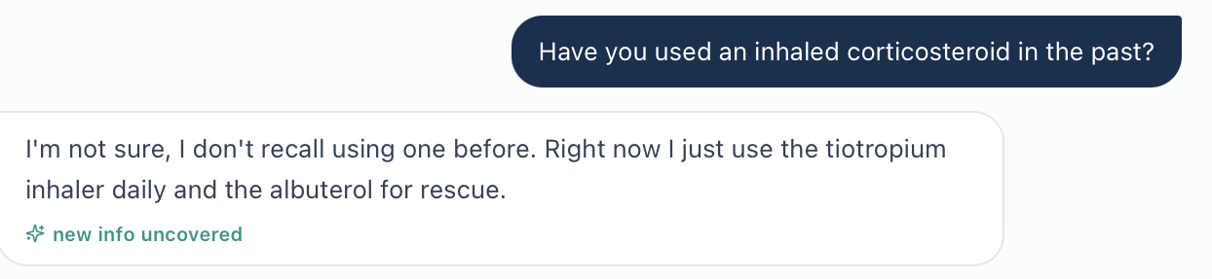
Neutral question and complete answer: patient cannot recall prior lung ICS use.
Deduction 1B.18 explicitly expects positive prior ICS history instead.

Issue MT-Tue-08. Grader expects good adherence despite reported missed medication
Priority: Medium
Status: Still needs developer action
Problem type: AI patient vs grader / rubric vs live case
Problem: The rubric’s broad good-adherence expectation conflicts with the current patient’s medication-specific account.
What the student saw or heard: Maria says she takes Spiriva and albuterol regularly but does not always remember daily fluticasone nasal spray. Her Spiriva frequency also varies across answers, documented separately in MT-Tue-03.
What the master rubric or AI grader expects: The checklist expects good adherence. Deduction 1B.19 removes 0.2 points because forgetting fluticasone and Spiriva dosing confusion are documented “rather than good adherence.”
Why this is a problem: The student is penalized for identifying a real adherence concern supplied by the simulated patient.
Suggested fix: Use medication-specific adherence expectations. Award accurate identification and management of the missed nasal spray and dosing uncertainty, or correct patient answers if uniformly good adherence is the intended case.
Focused screenshot evidence
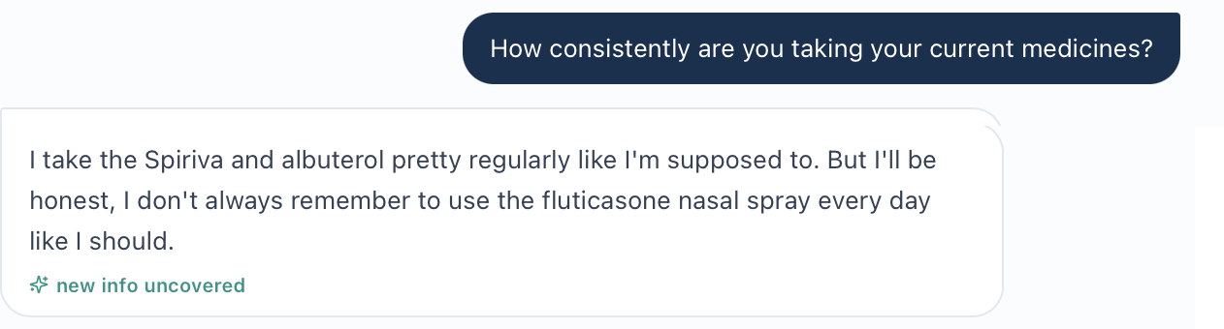
Patient distinguishes regular respiratory inhaler use from forgotten daily nasal spray.
Deduction 1B.19 penalizes reporting those adherence problems.

Issue MT-Tue-09. Grader requires room-air status that is not supplied in the pasted oxygen record
Priority: Medium
Status: Still needs developer investigation; live-screen verification outstanding
Problem type: EMR vs grader / missing objective context
Problem: The grader expects an oxygen-delivery detail absent from the current student-facing information supplied for review.
What the student saw or heard: The pasted Objective and Vitals sections display SpO₂ 95% without a room-air statement, oxygen device, or oxygen flow. The SOAP preserves that limitation rather than inventing oxygen context.
What the master rubric or AI grader expects: The checklist expects SpO₂ 95% on room air. Deduction 2A.7 removes 0.4 points because the note states oxygen delivery was not specified.
Why this is a problem: The student loses credit for refusing to infer a measured observation’s context from an unstated assumption.
Suggested fix: Display oxygen delivery or explicitly state room air beside the oxygen saturation, if that is the intended case. Until the workflow supplies it, accept documentation that oxygen context is not specified.
Focused screenshot evidence
Deduction 2A.7 requires room-air status and removes 0.4 points.
Evidence limitation: An actual live oxygen-context screenshot was not uploaded. The missing-context conclusion applies to the EMR content supplied for this review; it does not establish that no other live screen contains the detail.

Maria Thompson Wednesday 3-Month Follow-up
Initial audit • Grading result 71% • Review date October 22, 2026
Purpose: Record unresolved conflicts between the follow-up chart, simulated patient, reference rubric, and actual grader feedback. Each finding identifies what must be aligned and what evidence is still needed.

Quick Guide for Non-Clinical Readers
Term | Plain-language meaning
VACS / EMR | Training simulation / electronic medical record visible to the student.
SOAP | Subjective, Objective, Assessment, Plan: the four parts of a clinical note.
ACO / COPD | Asthma-COPD overlap / chronic obstructive pulmonary disease.
NKDA | No known drug allergies.
Trelegy / LAMA | Trelegy combines three lung medicines. One is umeclidinium, a long-acting muscarinic antagonist (LAMA). Tiotropium is another LAMA.
OCS / exacerbation | Oral corticosteroids such as prednisone / a breathing flare-up.
FEV1 / FEV1/FVC | Breathing-test measures of airflow and airway blockage.
Eosinophils | Blood cells used as a marker of a type of inflammation.
SpO₂ / room air | Blood oxygen level / breathing without extra oxygen.
BSA / Mosteller | Body surface area / the calculation named on the Vitals screen.

Final Review Summary
The grader completed successfully and returned 71%. Nine grouped findings remain open: two High-priority safety or medication conflicts and seven Medium-priority data or grading conflicts. The same root cause may appear in several deductions; those deductions are grouped rather than counted as separate software defects.
Issue | Unresolved finding
MT-Wed-01 • High | Recorded allergy conflicts with NKDA banner and grading requirement.
MT-Wed-03 • Medium | Displayed body surface area does not match height and weight.
MT-Wed-04 • Medium | Reference objective data do not match this follow-up chart.
MT-Wed-05 • Medium | Grader requires improved breathing despite worsening patient answers.
MT-Wed-06 • Medium | Grader requires a larger exacerbation and steroid history than supplied.
MT-Wed-07 • Medium | Grader requires controlled rhinitis despite persistent symptoms.
MT-Wed-08 • High | Grader requires separate tiotropium and additional medicines not confirmed.
MT-Wed-09 • Medium | Grader requires historical details the current patient cannot recall.
MT-Wed-10 • Medium | Grader requires room-air context absent from supplied chart text.
Evidence reviewed: Current follow-up EMR text; nine uploaded interview images (one overlaps another); supplied follow-up rubric; and six grader screenshots. Focused original-image excerpts sit directly below each issue. Long grader lines are split into ordered image strips for readability; their text is not rewritten.
Evidence limits: No targeted live EMR screenshots were supplied. Chart-only findings remain pending live-screen verification. Prior Tuesday facts are not substituted for current Wednesday patient answers. The 71% result is reported without estimating a corrected score.
Tracking and exclusions: MT-Wed-02 (follow-up header versus an initial-visit documentation label) remains a capture candidate only: the label may belong to historical documentation and is not counted. Routine note omissions, explicit guideline citations, problem order, and optional monitoring details are not treated as software defects. No technical grading failure is claimed.

Issue MT-Wed-01. Allergy record conflicts with NKDA banner and grading
Priority: High
Status: Open — developer action required
What the student saw or heard: The current header and allergy panel list sulfonamide antibiotics causing rash, with moderate severity in the panel. The medication banner says “NKDA — no conflicts.” The patient independently reports a severe rash; severity needs reconciliation, but the allergy itself is present.
What the reference or grader expects: The reference requires NKDA. Deduction 1E.28 removes 0.3 points because literal NKDA was absent, while explicitly admitting the patient has a documented sulfonamide allergy and NKDA should not be stated.
Why this is a problem: A student is penalized for retaining a documented allergy, while the medication safety banner contradicts the allergy record.
Suggested fix: Use one verified allergy record across the chart, banner, patient responses, and grading. Award accurate allergy documentation. Verify severity separately rather than deleting the allergy.
Focused screenshot evidence
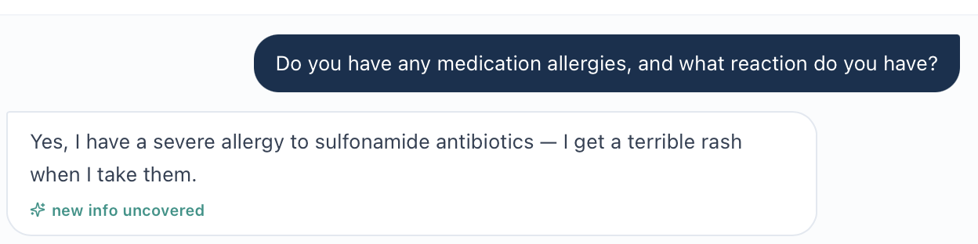
Interview source image(20261022-074849).png: focused continuous crop of the original exchange.
Grader evidence: MT_Wed_AI_Allergy; original screenshot lines continued in reading order.
Evidence limit / targeted capture: Capture MT_Wed_EMR_Allergy_01.png: medication safety banner and patient/day context; MT_Wed_EMR_Allergy_02.png: allergy panel including substance, reaction, severity. These original live screenshots are still needed.

Issue MT-Wed-03. Body surface area does not match the displayed inputs
Priority: Medium
Status: Open — live-screen verification required
What the student saw or heard: The supplied Vitals text displays height 5′4″, weight 71 kg, and BSA (Mosteller) 2.04 m².
What the reference or grader expects: Using the stated Mosteller calculation: square root of (162.56 cm × 71 kg / 3600) = approximately 1.79 m². No grader deduction is claimed for this value.
Why this is a problem: The displayed calculated result cannot be reproduced from the visible inputs.
Suggested fix: Check the calculation and the source height/weight. For these inputs, show approximately 1.79 m², or correct the visible inputs if they are wrong.
Focused screenshot evidence
No original live-screen screenshot supplied for this issue.
Evidence limit / targeted capture: Chart-text finding; live verification outstanding. Capture MT_Wed_EMR_Vitals_BSA_01.png with the Vitals heading, height, weight, BSA label/value, and patient/day context.

Issue MT-Wed-04. Reference objective values and missing-data rules are stale
Priority: Medium
Status: Open — developer action required
What the student saw or heard: The follow-up chart supplies FEV1 1.52 L (61%), ratio 0.56, eosinophils 520 cells/µL rising from 420, and temperature 98.6°F. ACT 17 and CAT 15 are populated even though the section labels them “Missing.”
What the reference or grader expects: The supplied rubric instead repeatedly expects FEV1 58%, ratio 0.55 and eosinophils 420. It also says temperature is not documented. Actual deduction 2C.23 removes 0.3 points because the student documented the available temperature rather than identifying a gap. The grader’s strengths correctly praise the current 61%, 0.56 and 520 values; no numeric-value deduction is alleged.
Why this is a problem: The reference includes prior-stage values and a missing-data requirement contradicted by this encounter. The temperature deduction directly penalizes use of visible data.
Suggested fix: Bind the reference to Wednesday’s dataset. Remove the temperature-gap deduction when temperature is supplied. Check “Missing” labels against populated values. Distinguish a supplied baseline comparison from any genuinely missing longer-term trend.
Focused screenshot evidence
Grader evidence: MT_Wed_AI_Temperature; original screenshot lines continued in reading order.
Evidence limit / targeted capture: Capture MT_Wed_EMR_Objective_01.png: current spirometry and eosinophils with trend; MT_Wed_EMR_Objective_02.png: temperature, ACT/CAT and “Missing” labels. Current live images remain outstanding. Reference source: Pasted text(20261022-082752).txt, Objective and Assessment sections.

Issue MT-Wed-05. Grader requires improvement that the patient does not report
Priority: Medium
Status: Open — developer action required
What the student saw or heard: On neutral questions, Maria says breathing is rougher, ordinary activities are harder, and rescue inhaler use is a few times weekly and slightly more than before. She reports reduced walking and gardening. These answers do not establish improvement.
What the reference or grader expects: Deductions 1A.8, 1B.1–5, 1D.4, and 1F.1–2 expect less baseline dyspnea, better activity tolerance and decreased rescue use. The feedback summary itself acknowledges that the expected improvement was not present in the supplied clinical narrative.
Why this is a problem: Faithfully documenting the patient’s direction of change loses credit. Students would have to reverse the patient’s account to satisfy the reference.
Suggested fix: Align the patient response bank and Wednesday rubric with the intended symptom trajectory. Accept worsening or uncertainty when those are the answers elicited by neutral questions.
Focused screenshot evidence
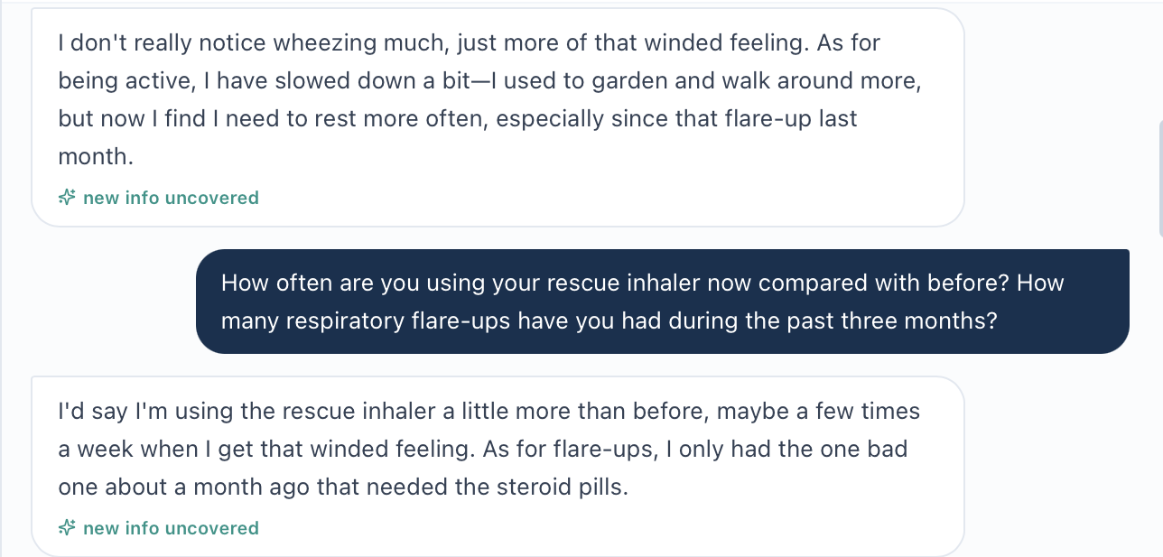
Interview source image(20261022-074617).png: focused continuous crop of the original exchange.
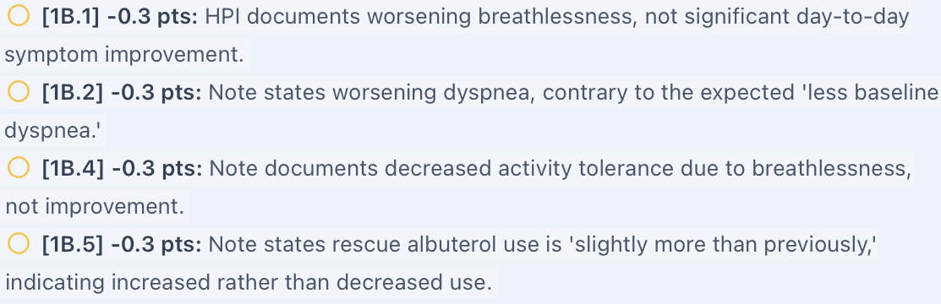
Grader evidence: MT_Wed_AI_Symptoms; original screenshot lines continued in reading order.

Issue MT-Wed-06. Exacerbation and steroid totals exceed the supplied history
Priority: Medium
Status: Open — developer action required
What the student saw or heard: The chart HPI and patient both describe one moderate exacerbation about four weeks ago. The patient recalls prednisone, does not recall antibiotics, and denies an emergency visit or hospitalization. A current annual total is not established.
What the reference or grader expects: The reference and deductions 1B.7, 2B.15–16, 2C.5/10, 3B.1/2/12/18 and 3D.13 require three events in three months, five in twelve months, and antibiotic treatment or high cumulative steroid exposure. Those additional events are not supplied by the current chart or interview.
Why this is a problem: The same unsupported history drives repeated deductions across note sections. Patient uncertainty about antibiotics is converted into an expected positive finding.
Suggested fix: Use one consistent exacerbation timeline across chart, interview and rubric. Supply dates, treatment and annual totals if those facts are intended. Accept explicit uncertainty until records establish them; do not infer five courses from one documented event.
Focused screenshot evidence
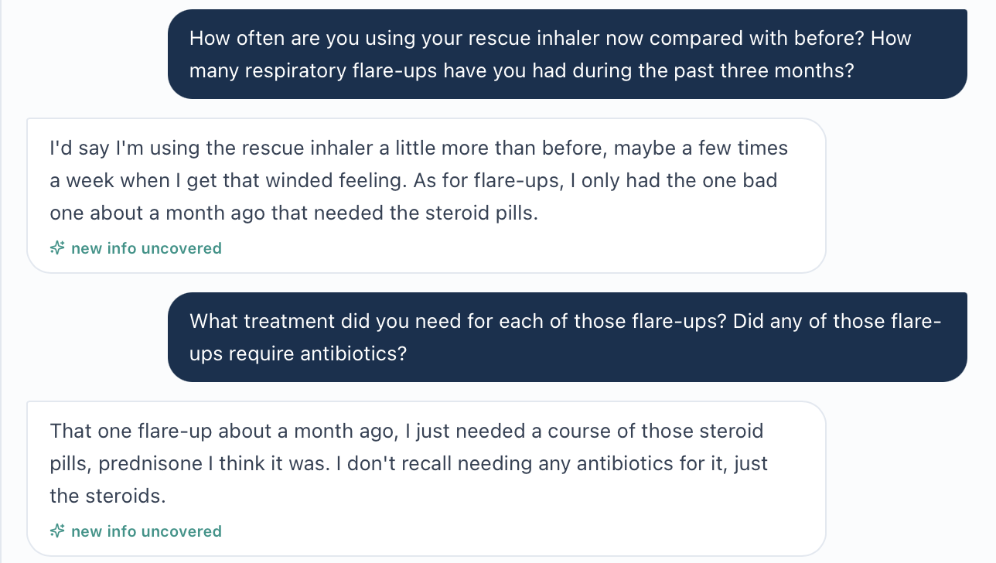
Interview source image(20261022-074617).png: focused continuous crop of the original exchange.
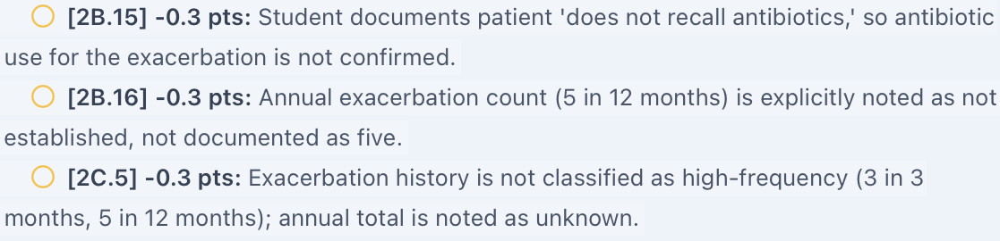
Grader evidence: MT_Wed_AI_Exacerbations; original screenshot lines continued in reading order.

Issue MT-Wed-07. Rhinitis grading contradicts the current symptom history
Priority: Medium
Status: Open — developer action required
What the student saw or heard: Maria says she is not using nasal fluticasone. She reports ongoing sneezing and congestion with seasonal symptoms, and uses cetirizine or saline. The SOAP records symptomatic rhinitis and a need to reassess treatment.
What the reference or grader expects: The rubric expects controlled or improved rhinitis and says it no longer contributes to breathing burden. Deductions 3E.2/4 and 4C.4/7 penalize the symptomatic assessment and absence of a “no change because controlled” plan. The general feedback simultaneously advises acknowledging rhinitis as uncontrolled.
Why this is a problem: The same feedback asks the student both to identify uncontrolled rhinitis and to document it as controlled. The patient does not support the controlled premise.
Suggested fix: Align the current patient answers, assessment target and treatment plan. Grade management against actual nasal symptoms and medication use. Remove deductions that require a controlled status contrary to the interview.
Focused screenshot evidence
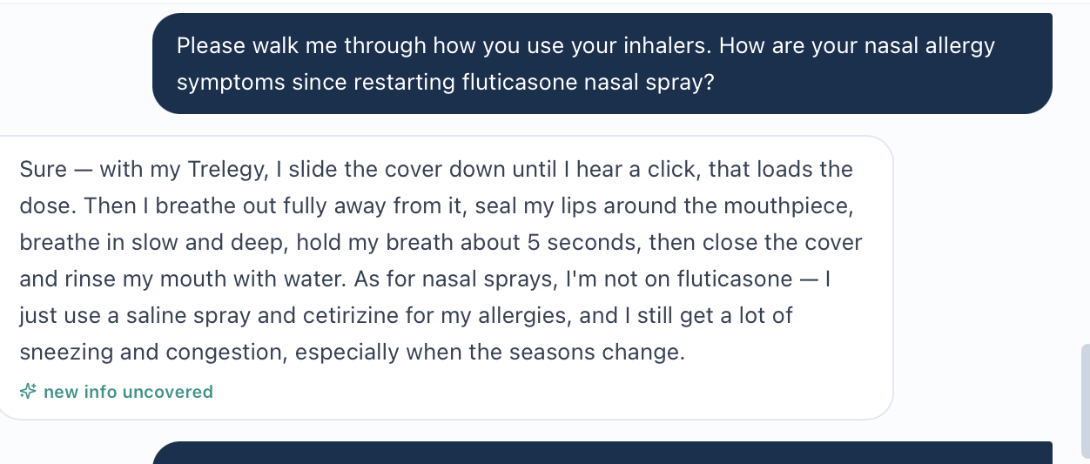
Interview source image(20261022-074743).png: focused continuous crop of the original exchange.
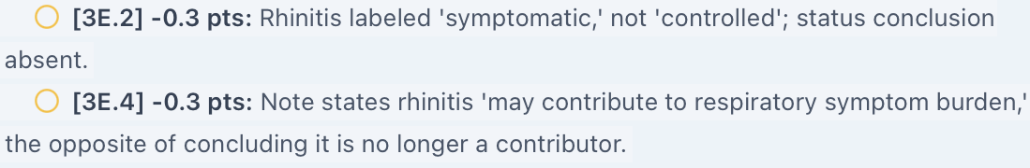
Grader evidence: MT_Wed_AI_Rhinitis; original screenshot lines continued in reading order.
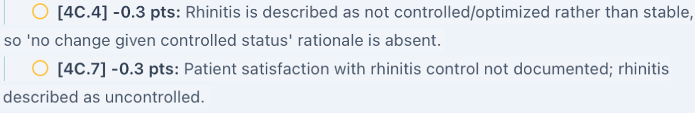
Grader evidence: MT_Wed_AI_Rhinitis_Plan; original screenshot lines continued in reading order.
Evidence limit / targeted capture: No extra nasal symptom capture is needed; the uploaded interview provides the relevant responses.

Issue MT-Wed-08. Medication grading expects separate tiotropium despite Trelegy
Priority: High
Status: Open — developer action required
What the student saw or heard: The current chart lists Trelegy 100/62.5/25 daily and rescue albuterol. The patient explicitly rejects current Symbicort and Spiriva use and lists Trelegy, albuterol, cetirizine and saline. She also says she is not using nasal fluticasone.
What the reference or grader expects: Deductions 1E.5, 4A.5 and 4A.28 require a separate tiotropium sig or continuation. Deduction 1E.27 penalizes four confirmed current medicines against an expected five to six. The grader itself acknowledges that tiotropium is not separately prescribed and Trelegy already contains the LAMA component.
Why this is a problem: The reference rewards an unsupported additional medicine and could encourage duplicate LAMA therapy. A target medication count cannot override a reconciled list.
Suggested fix: Grade the verified Wednesday regimen. Remove standalone tiotropium requirements unless it is actually prescribed and clinically intended. Reconcile omitted prior medicines with records; do not add drugs solely to reach a count.
Focused screenshot evidence
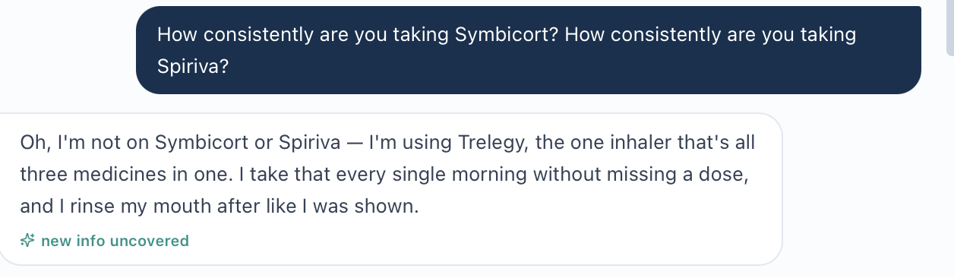
Interview source image(20261022-074707).png: focused continuous crop of the original exchange.
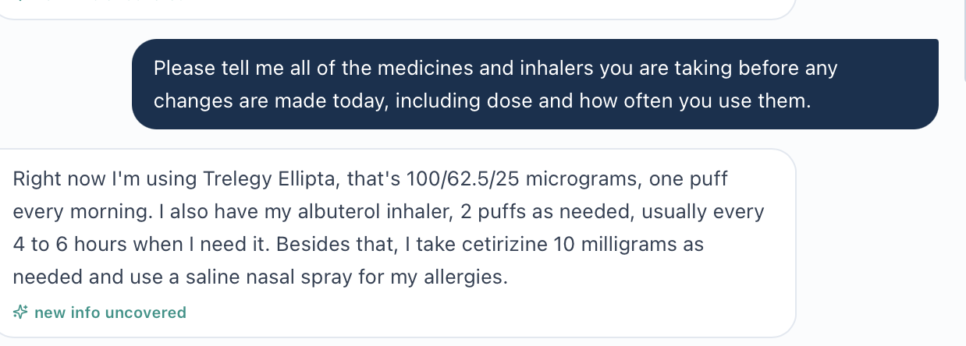
Interview source image(20261022-074817).png: focused continuous crop of the original exchange.
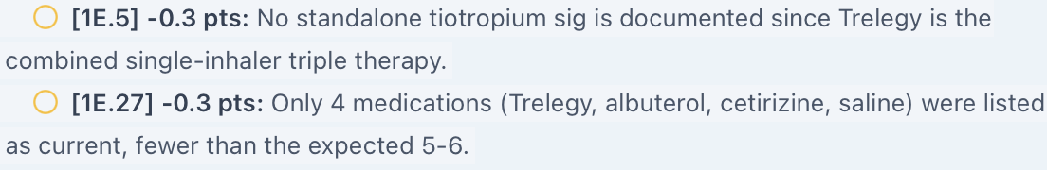
Grader evidence: MT_Wed_AI_Meds; original screenshot lines continued in reading order.
Grader evidence: MT_Wed_AI_LAMA; original screenshot lines continued in reading order.
Evidence limit / targeted capture: Capture MT_Wed_EMR_Medications_01.png: all active and discontinued medicines, doses, sigs and patient/day heading. Pending medication reconciliation must remain visible; prior Tuesday prescriptions are not proof of current use.

Issue MT-Wed-09. Current patient cannot provide the historical details required by grading
Priority: Medium
Status: Open — developer action required
What the student saw or heard: The Wednesday patient cannot recall diagnosis dates or prior surgery. She also denies hypertension and osteopenia when asked. These answers differ from earlier Tuesday history; the SOAP records the discrepancy for verification.
What the reference or grader expects: Deductions 1C.2/4/10 expect childhood-onset asthma, COPD diagnosed eight years ago and cholecystectomy. Earlier Tuesday material contains these facts, but the current pasted Wednesday chart does not supply them as historical records and the current patient does not confirm them.
Why this is a problem: The student cannot resolve the discrepancy by inventing recall or silently importing a different encounter’s history. This is a patient/reference continuity problem until records are available.
Suggested fix: Align the longitudinal patient history or expose the verified prior record in the current chart. Accept clear reconciliation language while history remains uncertain. Do not penalize faithful recording of the current answers.
Focused screenshot evidence
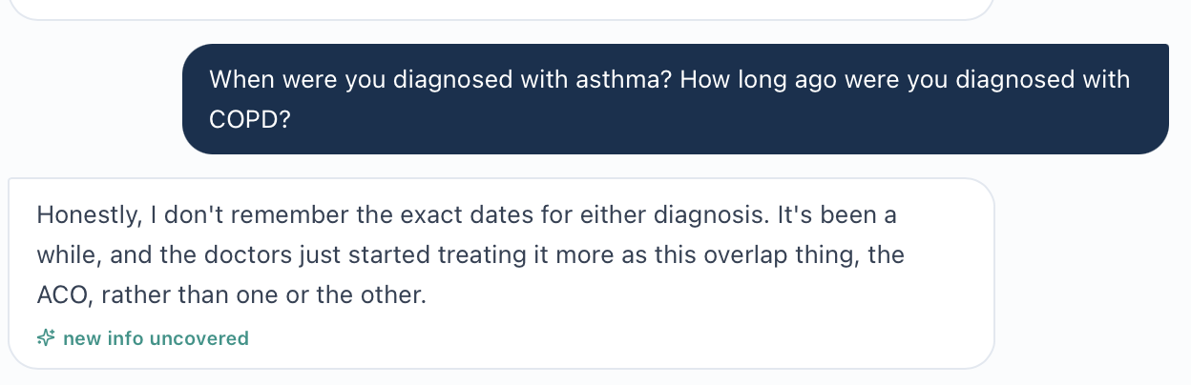
Interview source image(20261022-074849).png: focused continuous crop of the original exchange.
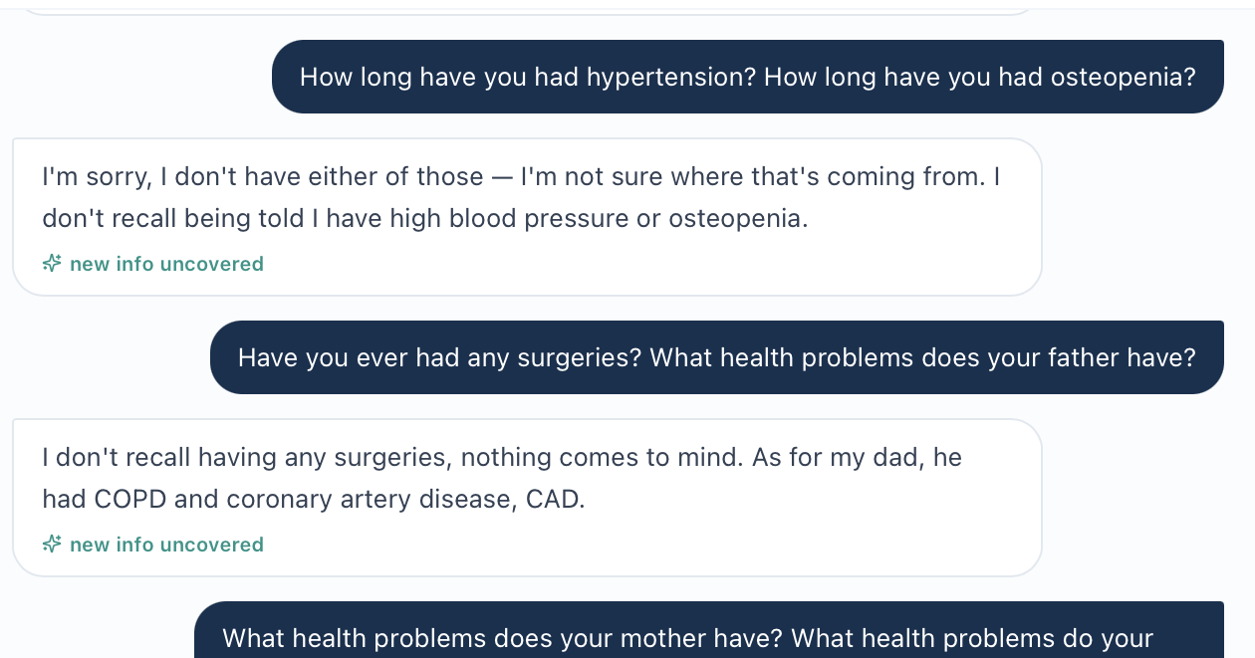
Interview source image(20261022-074927).png: focused continuous crop of the original exchange.
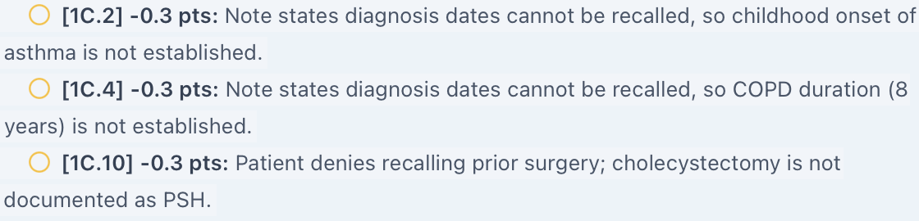
Grader evidence: MT_Wed_AI_History; original screenshot lines continued in reading order.
Evidence limit / targeted capture: Capture MT_Wed_EMR_History_01.png only if current Wednesday history or prior records are accessible. Verify source and encounter before resolving the discrepancy.

Issue MT-Wed-10. Room-air grading requires an oxygen detail absent from supplied chart text
Priority: Medium
Status: Open — live-screen verification required
What the student saw or heard: The supplied vitals record gives SpO₂ 95% without oxygen device, flow or a room-air statement. The SOAP identifies oxygen delivery as unspecified.
What the reference or grader expects: Deductions 2A.7 and 2A.9 each remove 0.1 points because room air was not confirmed. The reference requires room air.
Why this is a problem: A measurement condition is treated as documented even though it is absent from the supplied chart. This conclusion is limited to the information available for this audit.
Suggested fix: Display room air or oxygen device/flow beside the saturation. Until provided, accept “oxygen delivery unspecified” and do not require inference.
Focused screenshot evidence
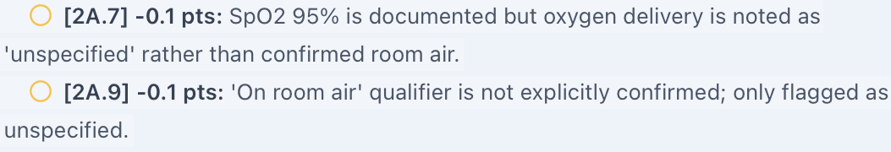
Grader evidence: MT_Wed_AI_Oxygen; original screenshot lines continued in reading order.
Evidence limit / targeted capture: Capture MT_Wed_EMR_Oxygen_01.png: the complete SpO₂ field and any oxygen-device or flow fields, with patient/day context. Check whether another live panel supplies the missing detail before confirming the defect.

Additional Live-EMR Screenshots Still Needed
Use the exact filenames and capture instructions below. Preserve the patient name, Wednesday follow-up context and relevant field labels. These are targeted chart captures; do not repeat the full interview or grader capture.
Allergy: MT_Wed_EMR_Allergy_01.png and _02.png: safety banner and allergy panel.
Vitals: MT_Wed_EMR_Vitals_BSA_01.png: height, weight and BSA; MT_Wed_EMR_Oxygen_01.png: SpO₂ plus oxygen context.
Objective: MT_Wed_EMR_Objective_01.png and _02.png: current lung tests, eosinophil trend, temperature, ACT/CAT and “Missing” labels.
Medication: MT_Wed_EMR_Medications_01.png: full active/discontinued list and reconciliation status.
History / visit label: MT_Wed_EMR_History_01.png if records exist. MT_Wed_EMR_Visit_Context_01.png: follow-up header and initial-visit documentation label together; MT-Wed-02 remains uncounted until its meaning is verified.
Retest acceptance
After fixes, verify only the affected fields and neutral patient questions, then regrade a note that faithfully preserves the verified facts. Pass means the chart, patient, reference and grader agree, with no points lost for retaining a real allergy, the actual symptom direction, the supplied exacerbation history or the confirmed medication list. Do not revise facts merely to satisfy the old rubric.

Maria Thompson Thursday 3-Month Follow-up
Initial audit • Grading result 64.6% • Review date October 22, 2026
Purpose: Document unresolved differences between the Thursday chart, reference checklist and actual grading feedback. The main concern is that the grader expects an improved patient already receiving Trelegy and mepolizumab, while the supplied Thursday chart shows ongoing symptoms on Symbicort plus Spiriva and a plan to consider biologic treatment.

Quick Guide for Non-Clinical Readers
Term | Plain-language meaning
VACS / EMR | Virtual Ambulatory Care Simulation / the electronic chart visible to the student.
AI patient / AI grader | The simulated patient / the system that evaluates the clinical note.
SOAP | Subjective, Objective, Assessment and Plan: the four sections of a clinical note.
ACO / COPD | Asthma-COPD overlap / chronic obstructive pulmonary disease.
ICS / LABA / LAMA | Three inhaled drug classes. Symbicort supplies ICS/LABA and Spiriva supplies LAMA. Trelegy combines all three classes in one inhaler.
Biologic / anti-IL-5 | A targeted treatment / a treatment directed at an inflammatory pathway involving eosinophils.
Eosinophils | Blood cells used to assess one type of inflammation.
FEV1 / FVC | Air breathed out in one second / total air breathed out during a forced breath.
ACT / CAT | Asthma Control Test / COPD Assessment Test: questionnaires used to track symptoms.
NKDA / SpO₂ | No known drug allergies / blood oxygen saturation.
BSA / Mosteller | Body surface area / the named method for calculating it from height and weight.
BP / HR / RR / BMI | Blood pressure / heart rate / breathing rate / body mass index.

Final Review Summary
The grader completed and returned 64.6% (“Developing”). Seven grouped findings remain open: five High priority and two Medium priority. Repeated deductions are grouped under their underlying factual conflict. No corrected score is calculated, and no technical grading failure is reported.
Issue / priority | Unresolved finding
MT-Thu-01 • High | Grader assumes Trelegy and an established mepolizumab regimen instead of the supplied treatment stage.
MT-Thu-02 • High | Grader requires different vital signs, pulmonary results and eosinophils.
MT-Thu-03 • High | Grader expects interval improvement not established by the current chart.
MT-Thu-04 • High | NKDA requirement contradicts the recorded sulfonamide-antibiotic allergy.
MT-Thu-05 • High | Grader requires controlled rhinitis despite the chart’s uncontrolled status and stopped nasal steroid.
MT-Thu-06 • Medium | Room-air grading requirement lacks support in the supplied oxygen record.
MT-Thu-07 • Medium | Displayed Mosteller BSA does not match the visible height and weight.
Evidence and Review Limits
Live chart: The user supplied detailed Thursday EMR text. It establishes what is available for comparison here, but original live-screen images are still needed for chart-only claims.
Patient interview: Eight Thursday interview image filenames were supplied earlier (170357 through 170814), but the files are absent from their supplied local paths. Their content could not be reviewed or cropped. This report does not assert what the Thursday AI patient said.
Reference checklist: The Thursday checklist pasted in the conversation is reviewed as reference evidence, including its own inconsistent values and treatment assumptions.
Actual grader: Four uploaded feedback images, 172956, 173022, 173049 and 173114, show the score, narrative and listed deductions. The Gold Standard Comparison panel is not expanded in the supplied image. Focused original-image lines appear beneath each issue; long lines are continued as image strips in source order.
Excluded: Routine omissions about symptom frequency, family history, onset dates, technique demonstration, motivation, alcohol/drug history, guideline wording, vaccination phrasing and follow-up preferences are not classified as software bugs without source evidence. Static age/date arithmetic is excluded. The historical “Initial Ambulatory Care Pharmacist Visit” label is not treated as a confirmed visit-stage defect.

Issue MT-Thu-01. Grader expects a different medication regimen and treatment stage
Priority: High
Status: Open; chart-to-grader conflict evidenced, live-screen confirmation pending
What the student saw: Thursday’s active list contains Symbicort 160/4.5 mcg, 2 puffs twice daily, plus Spiriva Respimat 2.5 mcg, 2 puffs daily. Neither Trelegy nor mepolizumab appears. The advisory says to consider biologic escalation; the available plan option is referral for anti-IL-5 evaluation and restarting nasal fluticasone.
What the reference and grader expect: The checklist requires Trelegy 100/62.5/25 mcg daily and mepolizumab 100 mg subcutaneously every four weeks. The grader treats these as already started and penalizes biologic referral. Examples: 1E.2/3, 1E.4b, 3A.12/13, 3C.7/8, 4A.2/5 and 5C.3.
Why this matters: This changes which medicines the student should document and whether the student should refer for escalation or continue an established biologic. The checklist also says biologic therapy is “not indicated” while expecting current mepolizumab; it must distinguish no new initiation from no ongoing indication.
Suggested fix: Bind the Thursday medication list, advisory, plan options, reference and grader to the same case version. If post-biologic follow-up is intended, supply the actual start history and active prescriptions. Otherwise grade the documented Symbicort/Spiriva regimen and referral stage.
Focused evidence
image(20261022-173022).png: deductions 1E.2 and 1E.3 require Trelegy. Original screenshot lines are continued in reading order.
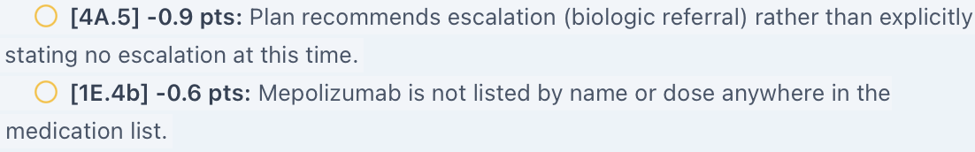
image(20261022-173114).png: deductions require no escalation and a mepolizumab listing. Original screenshot lines are continued in reading order.
Evidence limit: Current chart evidence is pasted text, not a live screenshot. MT_Thu_EMR_Treatment_01.png and MT_Thu_EMR_Treatment_02.png remain needed.

Issue MT-Thu-02. Grader substitutes different measured results for the supplied chart
Priority: High
Status: Open; chart-to-grader conflict evidenced, live-screen confirmation pending
What the student saw: The SOAP uses the values in the supplied Thursday chart. The grader calls several of those values approximate or imprecise because its expected values differ.
What the reference and grader expect: Examples: 2A.1 expects BP 128/80 instead of 124/72 (repeat 122/70); 2A.3 expects RR 18 instead of 16; 2A.6 expects BMI 26.5 instead of 26.9; 2B.1/2 expect ratio 0.60 and FEV1 66% instead of 0.57 and 58%; 2B.3 expects eosinophils 50 instead of 380 cells/µL. The checklist itself later accepts BMI 26.9 and SpO₂ 96%, despite earlier targets of 26.5 and 97%.
Why this matters: These are different case values, not rounding differences. Eosinophils 50 versus 380 also changes the apparent response to treatment. The current BMI of 26.9 is consistent with 71 kg and 64 inches.
Suggested fix: Use the current encounter’s measured values as the grading source. Remove stale numeric targets and make duplicate checklist items consistent. Do not penalize exact chart transcription.
Focused evidence
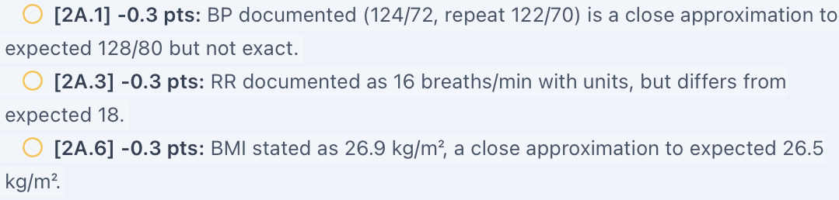
image(20261022-173022).png: actual deductions for chart-matched BP, RR and BMI. Original screenshot lines are continued in reading order.
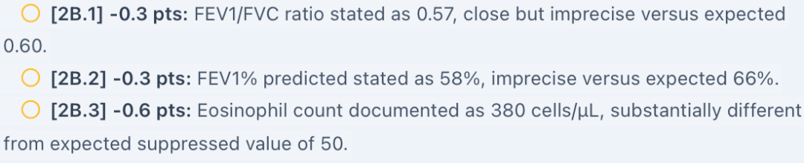
image(20261022-173049).png: actual deductions for chart-matched spirometry and eosinophils. Original screenshot lines are continued in reading order.
Evidence limit: Obtain MT_Thu_EMR_Vitals_01.png and MT_Thu_EMR_Results_01.png to verify the current live fields.

Issue MT-Thu-03. Grader requires an improved clinical trajectory not established by the chart
Priority: High
Status: Open; chart-to-grader conflict evidenced, live-screen confirmation pending
What the student saw: The current HPI says continued dyspnea and two exacerbations in the last twelve months, including one hospitalization, despite reported adherence. ACT is 14 and CAT is 18. The supplied chart does not establish improved wheeze, nighttime symptoms, exercise tolerance or reduced rescue use.
What the reference and grader expect: The checklist and feedback require significant improvement, reduced rescue use, a mild flare in three months and CAT improvement from 19 to 13. Actual deductions include 1A.7, 1B.1/6, 3A.2/4/5 and 3D.2/4. The rubric also explicitly retains the chart’s two annual exacerbations with hospitalization.
Why this matters: The grader rewards a different clinical course. Two annual exacerbations and one mild flare in a three-month window could coexist, so the time windows alone are not a contradiction. The confirmed conflict is ongoing symptoms/CAT 18 versus the expected improved state/CAT 13; the shorter-term history still needs interview verification.
Suggested fix: Synchronize the intended symptom trajectory and score history across chart, AI patient, checklist and grader. Establish the time window for each exacerbation count. Accept faithful chart documentation and do not assume a response to treatment that the current encounter does not establish.
Focused evidence
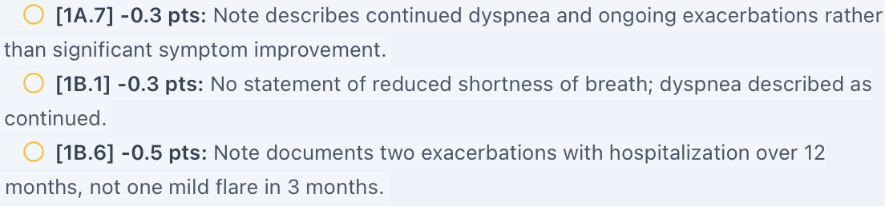
image(20261022-173022).png: deductions require improvement and a different flare description. Original screenshot lines are continued in reading order.
image(20261022-173049).png: deduction 3A.4 requires CAT 19 to 13 instead of the displayed CAT 18. Original screenshot lines are continued in reading order.
Evidence limit: No Thursday interview answers were accessible for verification. MT_Thu_EMR_Control_01.png should show the HPI, ACT and CAT; do not infer unseen patient answers.

Issue MT-Thu-04. NKDA grading contradicts the documented antibiotic allergy
Priority: High
Status: Open; chart-to-grader conflict evidenced, live-screen confirmation pending
What the student saw: The Thursday header and allergy panel record sulfonamide antibiotics causing rash. Severity is listed as moderate. The medication safety banner nevertheless says “NKDA — no conflicts.” The SOAP preserves the allergy and flags the banner discrepancy.
What the reference and grader expect: The checklist requires NKDA twice. Deductions 1E.9 and 1E.12 penalize the note for recording the allergy rather than affirming NKDA. The grader’s strengths also praise recognition of this same discrepancy.
Why this matters: The record, safety banner and grading target disagree about an important medication-safety fact. Accurate allergy documentation loses credit.
Suggested fix: Use the verified allergy record across the header, medication checks, allergy panel and grading. Retain the documented reaction unless verification establishes a correction. Award identification of the banner conflict.
Focused evidence
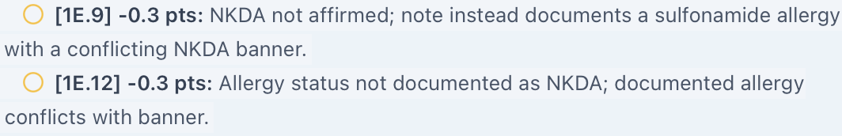
image(20261022-173022).png: two deductions require NKDA despite the documented sulfonamide allergy. Original screenshot lines are continued in reading order.
Evidence limit: Capture MT_Thu_EMR_Allergy_01.png and MT_Thu_EMR_Allergy_02.png. The current allergy-panel and banner evidence is supplied as text only.

Issue MT-Thu-05. Rhinitis grading requires control despite the chart’s uncontrolled status
Priority: High
Status: Open; chart-to-grader conflict evidenced, live-screen confirmation pending
What the student saw: The HPI and problem list identify uncontrolled allergic rhinitis after stopping intranasal fluticasone. Cetirizine is prescribed at 10 mg daily. The structured plan offers restarting fluticasone, which the SOAP recommends.
What the reference and grader expect: The checklist’s final item and deduction 1F.3b require rhinitis to be well managed on cetirizine as needed. The grader’s strengths simultaneously call the uncontrolled-rhinitis assessment and nasal-fluticasone restart an accurate interpretation of the available picture.
Why this matters: The grader both praises and penalizes the same chart-based status. A false controlled premise could discourage treatment of the documented uncontrolled condition. The patient’s own allergy-breathing correlation remains unverified and is not counted as a confirmed defect.
Suggested fix: Align rhinitis status and the cetirizine regimen across the HPI, problem list, medication list, checklist and grader. Grade the plan against the verified current symptoms and actual nasal medication use.
Focused evidence
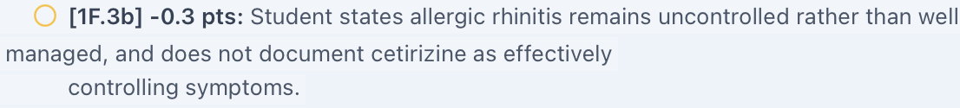
image(20261022-173114).png: deduction 1F.3b requires well-managed rhinitis on cetirizine. Original screenshot lines are continued in reading order.
Evidence limit: Capture MT_Thu_EMR_Rhinitis_01.png showing the uncontrolled status, stopped fluticasone and current cetirizine regimen. The supplied Thursday interview files could not be inspected.

Issue MT-Thu-06. Room-air grading requires an oxygen context absent from supplied data
Priority: Medium
Status: Open investigation; live-screen verification pending
What the student saw: The supplied Thursday vitals display SpO₂ 96% without a room-air statement, oxygen device or flow rate. The SOAP records oxygen delivery as unspecified.
What the reference and grader expect: The reference requires room air. Deduction 2A.7 removes 0.4 points because room-air status was not confirmed. The checklist separately gives SpO₂ 97% and 96%; the numeric inconsistency is grouped under MT-Thu-02.
Why this matters: The student cannot establish oxygen-delivery conditions from the supplied value alone. Whether another live panel provides that detail remains unverified.
Suggested fix: Display room air or the oxygen device and flow beside saturation, if known. Until the workflow supplies it, accept accurate documentation that delivery conditions are unspecified.
Focused evidence
image(20261022-173022).png: deduction 2A.7 requires room-air confirmation. Original screenshot lines are continued in reading order.
Evidence limit: Capture MT_Thu_EMR_Oxygen_01.png with the complete saturation and any device/flow fields. Confirm that the detail is not supplied elsewhere before closing verification.

Issue MT-Thu-07. Mosteller body surface area does not match the visible inputs
Priority: Medium
Status: Open investigation; live-screen verification pending
What the student saw: The supplied Thursday Vitals text lists weight 71 kg, height 5 feet 4 inches (162.56 cm), and BSA (Mosteller) 2.04 m².
What the reference and grader expect: Independent calculation using the named method gives square root of (162.56 × 71 / 3600) = approximately 1.79 m². No BSA-related rubric requirement or grader deduction is alleged.
Why this matters: The displayed calculation cannot be reproduced from the displayed height and weight. This is a chart-data investigation, independent of the grade.
Suggested fix: Check the calculation, units and source inputs. If 71 kg and 162.56 cm are correct, display approximately 1.79 m². Verify in the live chart before marking the defect confirmed.
Focused evidence
No original live-screen screenshot supplied. Evidence is the pasted Vitals record and reproducible arithmetic above.
Evidence limit: No original live screenshot is available. Capture MT_Thu_EMR_BSA_01.png showing the height, weight, BSA label and value together.

Additional Live EMR Screenshots Still Needed
Capture only the fields below, retaining Maria’s name and Thursday follow-up context where possible. These are original live EMR captures; the report’s text and grader excerpts do not replace them.
MT_Thu_EMR_Treatment_01.png: Capture: the full active/discontinued medication list, medication-reconciliation status and Thursday context. Show whether Trelegy or mepolizumab appears anywhere in current prescriptions.
MT_Thu_EMR_Treatment_02.png: Capture: the biologic advisory plus assessment question and structured Plan choices, including referral and nasal-fluticasone restart.
MT_Thu_EMR_Vitals_01.png: Capture: BP/repeat BP, HR, RR, temperature, weight, height, BMI and SpO₂ with their labels.
MT_Thu_EMR_Results_01.png: Capture: FEV1, FVC, FEV1/FVC and eosinophils, including units, result context and encounter identification.
MT_Thu_EMR_Control_01.png: Capture: current HPI with dyspnea/exacerbation history and ACT 14/CAT 18. Use a second sequential image if the fields do not fit readably together.
MT_Thu_EMR_Allergy_01.png / MT_Thu_EMR_Allergy_02.png: Capture: the NKDA medication banner in the first image and sulfonamide allergy record with reaction/severity in the second.
MT_Thu_EMR_Rhinitis_01.png: Capture: uncontrolled rhinitis, stopped intranasal fluticasone and prescribed cetirizine frequency. If separate screens are needed, continue _02.png.
MT_Thu_EMR_Oxygen_01.png: Capture: saturation and all oxygen delivery/device/flow fields. Check any separate respiratory observations panel.
MT_Thu_EMR_BSA_01.png: Capture: height, weight and the displayed Mosteller BSA together.
Interview and Grading Evidence
The four current feedback files were used for focused grader crops. No individual-answer or individual-deduction recapture is requested. The eight already-supplied Thursday interview images need to become accessible before any interview-dependent claim can be confirmed or cropped; earlier-day interview images were not substituted.
Retest Acceptance
For each corrected issue, verify the exact live field and regrade faithful documentation. Pass requires agreement between the current encounter and the grader, including active medicines, treatment stage, measured results, allergy status and rhinitis status. A higher score alone does not prove the factual conflict is fixed. Retest interview-dependent items only after the original answer evidence can be reviewed.

