WEEK 4 UAT / QA BUG REPORT
Heart Failure + Anticoagulation + Atrial Fibrillation Module
Developer / IT handoff — clinical data, patient-case mapping, grading, UI, and technical issues

Purpose of this report
This report translates the Week 4 clinical/student audit into developer-facing QA findings. The goal is to make each issue reproducible and understandable from an IT/web-development perspective without requiring the developer to interpret clinical shorthand. The report preserves the original Day → Patient organization and places the original screenshot evidence directly after the issue it supports.
Prepared from: Week 4 VACS Issues.docx. Screenshot evidence was extracted from the original audit and retained with the corresponding Week 4 finding.

Most important overall finding
The largest Week 4 problem is a mismatch between the information presented to the student (EMR + standardized-patient interview) and the information used by the grading/reference system. In several cases, the student accurately documented what the patient said, but the grading key expected different history, objective data, procedure history, monitoring behavior, or medication-related information. There are also independent technical/UI problems that can prevent grading or display the wrong encounter interval.

1. Executive Summary
- Patient/EMR information does not consistently match the grading/reference information.
- Objective values such as labs, vitals, weight, and other measured data are sometimes different from the values used by the grading key.
- Some rubric items require information the student cannot obtain from the available patient interview/EMR, including social history, home monitoring, and procedure details.
- The Wednesday Michael Thompson grading workflow cannot retrieve the granular rubric, preventing feedback/grade completion.
- Encounter interval labels are inconsistent with the intended Week 4 follow-up schedule.
- Robert Jenkins has a clinically important weight discrepancy because apixaban dose-reduction criteria depend on weight, making this more than a cosmetic EMR error.
- Robert Jenkins is graded against colonoscopy/periprocedural information despite the patient-facing interview denying or not establishing such a procedure.
- The patient-facing tobacco/social history can contradict other sections of the case.
- The Weekly Performance Summary can return an application error.

2. Priority Summary / Suggested Ticket List
ID | Area | Issue | Priority | Primary impact
W4-01 | Case mapping | Patient/EMR data do not match grading/reference data | CRITICAL | Incorrect clinical grading
W4-02 | Objective data | Labs/vitals/weight used by key differ from student-visible data | CRITICAL | Clinical reasoning and dosing affected
W4-03 | Grading | Granular rubric unavailable for Wednesday Michael | CRITICAL | Grading cannot complete
W4-04 | Anticoagulation | Robert weight discrepancy affects apixaban dose logic | CRITICAL | Medication-safety / dosing risk
W4-05 | Procedure history | Robert is graded on colonoscopy/periprocedural details not established by interview | CRITICAL | Student may be forced to invent history
W4-06 | Encounter metadata | 1-, 3-, and 6-month follow-up labels are inconsistent | HIGH | Wrong workflow/rubric context
W4-07 | Unavailable history | Rubric expects social/home-monitoring information not provided | HIGH | Students penalized for unavailable data
W4-08 | Medication/adherence | Angela's apixaban adherence/cost scenario must match grading logic | HIGH | Anticoagulation assessment affected
W4-09 | Clinical history | Tobacco/family-history values can conflict across case sections | HIGH | Incorrect clinical documentation
W4-10 | Weekly Summary | Application error when generating weekly performance summary | HIGH | Feature unavailable

3. Tuesday — Michael Thompson
W4-01 — Grading submission does not return a valid response [CRITICAL]
Current / observed The student reported that submitting the SOAP note failed to return a valid grading response.
Expected / grading reference Submitting a completed Week 4 encounter should return the rubric/grade response successfully.
Why this is a problem Inspect the grading request/response path, payload validation, error handling, and encounter-to-rubric mapping. Log the encounter ID and rubric key/version so failures can be traced. Add an end-to-end regression test for this patient.
Recommended fix: See screenshot evidence below.
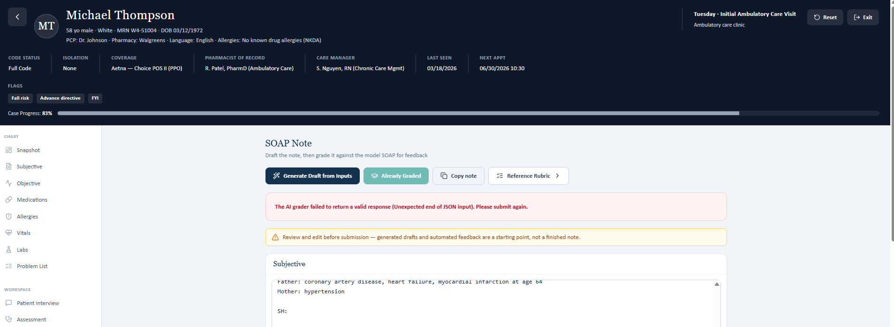
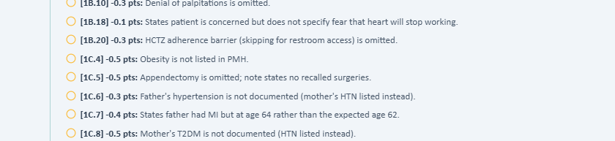

W4-02 — Rubric requires information that is not available from the patient [HIGH]
Current / observed The patient could not provide job, marital status, or living situation details. The audit notes that points were deducted for information that could not be provided.
Expected / grading reference If the learner cannot obtain a value from the EMR or standardized-patient interview, the rubric should accept 'unknown/not documented/not available' rather than requiring an unsupported value.
Why this is a problem Make the rubric availability-aware. Every required field should map to a student-visible EMR field or scripted patient response. If the field is intentionally unavailable, do not deduct points for documenting that it is unknown.
Recommended fix: See screenshot evidence below.
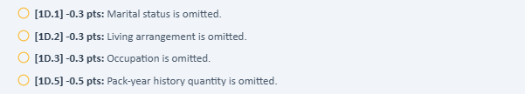

W4-03 — Labs and vitals in the grading key do not match the EMR [CRITICAL]
Current / observed The audit states that available labs/vitals were keyed differently from the values shown in the EMR, and additional 'not documented' values were not actually measured in the Labs tab.
Expected / grading reference The grader should evaluate the objective values that are actually displayed to the student in the encounter.
Why this is a problem Use one source-of-truth encounter object for labs/vitals and have both the EMR and grading engine read from it. Add a pre-publication validation that compares all rubric objective values against the student-visible EMR.
Recommended fix: See screenshot evidence below.
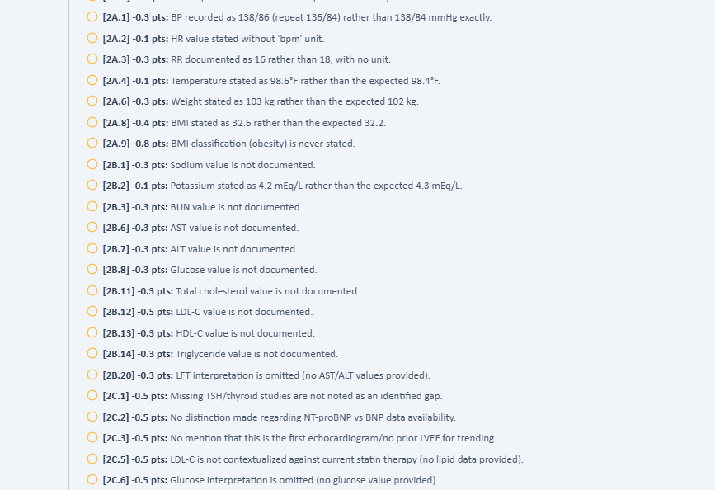

W4-04 — Tobacco history is internally inconsistent [HIGH]
Current / observed One section describes the patient as a former smoker, while the detailed social-history interview says the patient has never smoked or used tobacco.
Expected / grading reference All student-facing representations of the same patient should contain the same tobacco history unless the case explicitly explains a change or correction.
Why this is a problem Synchronize the HPI summary and detailed social-history fields. Store tobacco status as one structured value and render it consistently across the case.
Recommended fix: See screenshot evidence below.

4. Tuesday — Angela Brooks
W4-05 — Apixaban adherence and cost scenario must match the grading reference [HIGH]
Current / observed The patient reports that she stopped apixaban completely because it costs approximately $50/month and she is on a fixed income. She is taking her other heart medications consistently.
Expected / grading reference The grading reference should use the same adherence state and reason for nonadherence: intentional discontinuation due to cost.
Why this is a problem Synchronize the standardized-patient response, EMR medication history, and grading key. Ensure the grader distinguishes 'missed doses' from 'stopped completely due to cost' because these produce different clinical assessments.
Recommended fix: See screenshot evidence below.
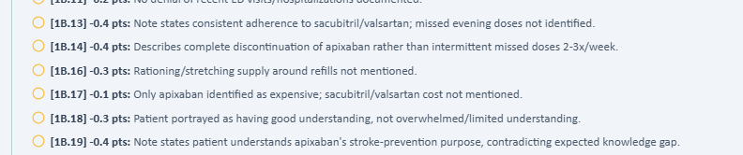
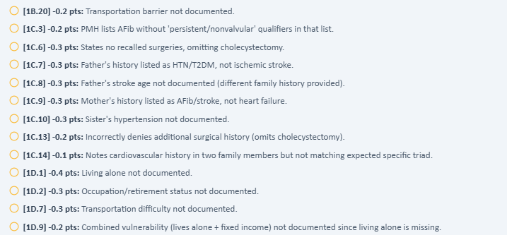
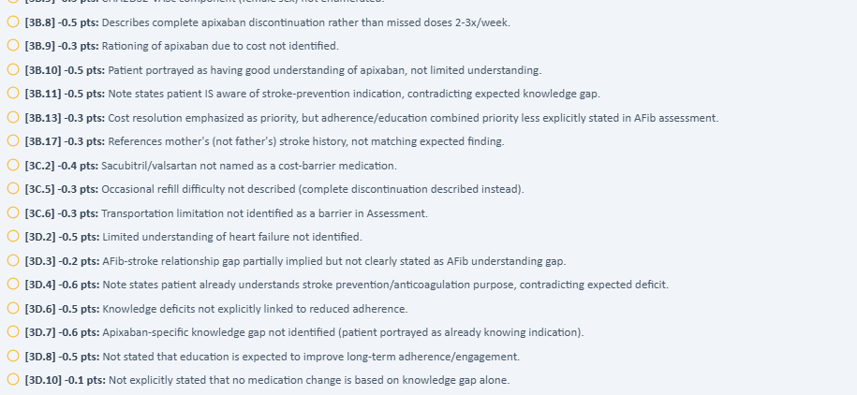
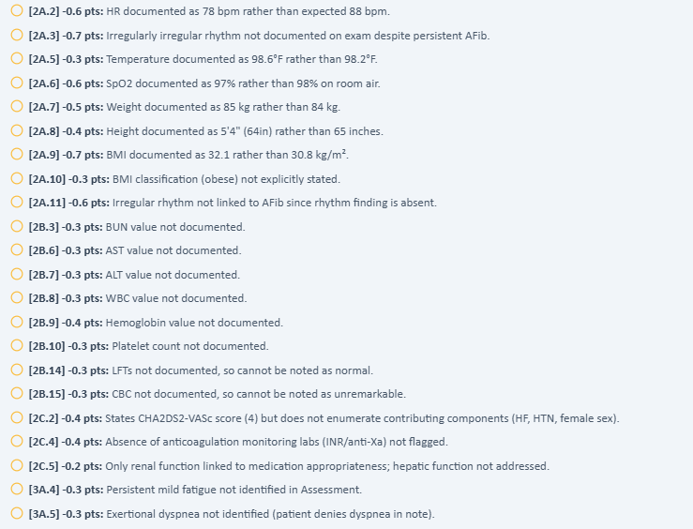

W4-06 — Social-history fields are required even though the patient cannot provide them [MEDIUM]
Current / observed The patient cannot provide living situation, employment/retirement, or transportation details. These details were not established in the available interview.
Expected / grading reference The rubric should not require unsupported social-history details.
Why this is a problem Either add scripted responses for these fields or make the grading logic accept 'unknown/not documented.' Do not penalize the learner for accurately documenting the patient's inability to provide the information.
Recommended fix: See screenshot evidence below.

W4-07 — Objective values used for grading do not match student-visible EMR [HIGH]
Current / observed The audit documents point deductions based on EMR-listed vitals and labs, while the grading key uses different values and/or requires additional measurements that are not available.
Expected / grading reference The grading engine should use the exact objective data presented in the student's encounter.
Why this is a problem Centralize the objective-data source and validate the rubric against the EMR before the case is released.
Recommended fix: See screenshot evidence below.
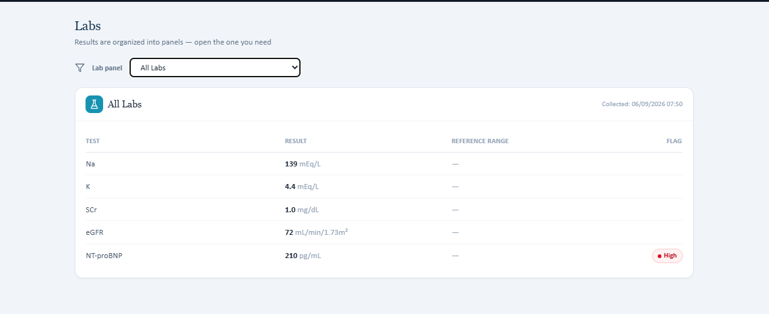
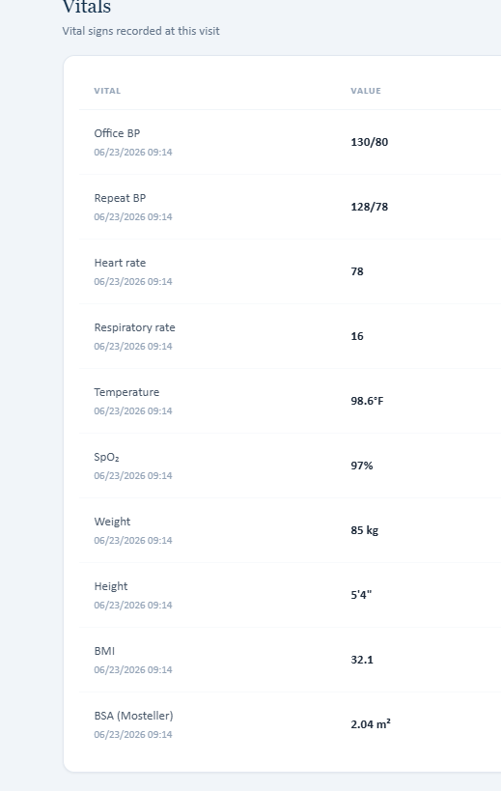

5. Tuesday — Robert Jenkins
W4-08 — Weight discrepancy can change apixaban dose-reduction logic [CRITICAL]
Current / observed The student-visible EMR documents weight 58 kg and BMI 20.0 kg/m², while the audit/reference indicates a substantially different expected weight. Weight is directly relevant to apixaban dose-reduction criteria.
Expected / grading reference The patient weight used for medication assessment and grading must be the same value shown in the student EMR.
Why this is a problem Correct the source data and synchronize weight across the EMR, grading key, and patient case. Add a validation test for anticoagulant dose criteria whenever weight is a grading input.
Recommended fix: See screenshot evidence below.
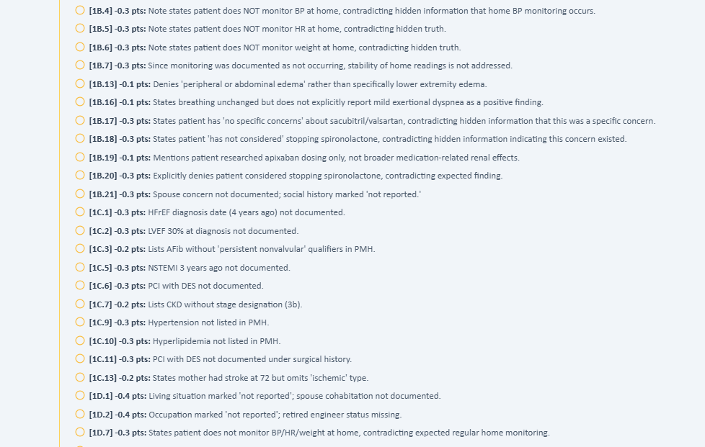
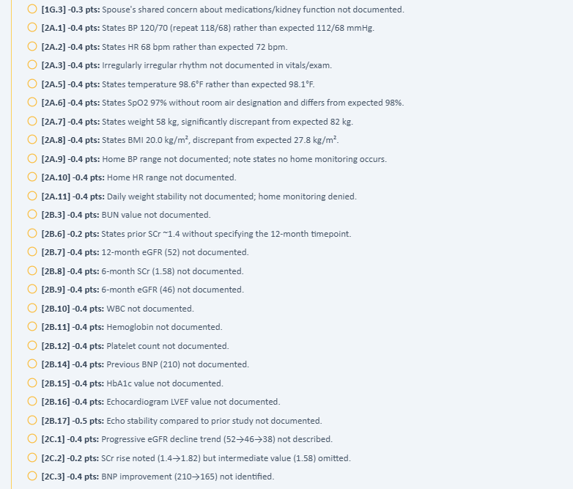
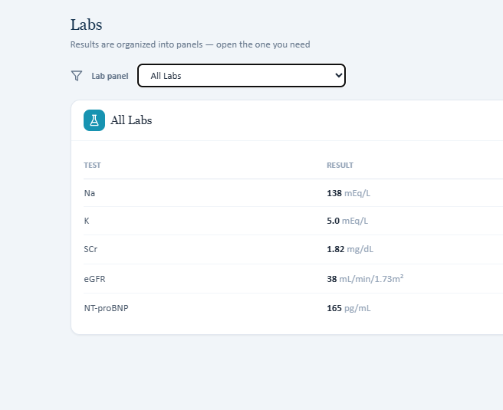
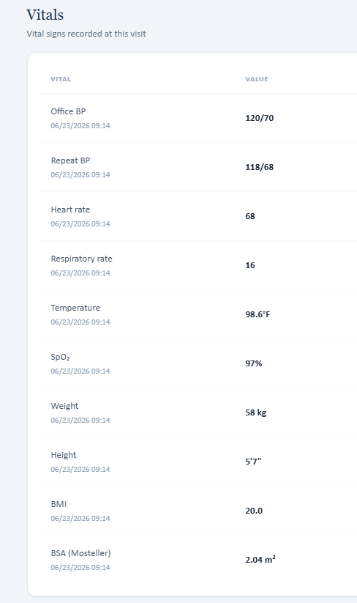

W4-09 — Home BP/HR/weight monitoring history conflicts with the expected case [HIGH]
Current / observed The patient states he does not regularly monitor BP, HR, or weight at home. The audit identifies a conflicting expected history of regular home monitoring.
Expected / grading reference The grading key should reflect the patient's actual reported monitoring behavior.
Why this is a problem Synchronize the standardized-patient script and grading key. If home monitoring is a required learning objective, explicitly include the expected monitoring history in the patient script.
Recommended fix: See screenshot evidence below.
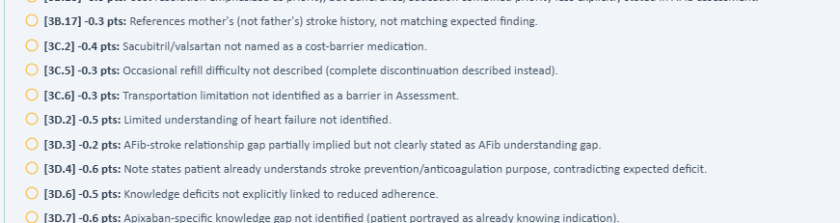

W4-10 — Rubric expects concerns that the patient did not express [HIGH]
Current / observed The patient did not report concerns about continuing sacubitril/valsartan and did not consider stopping spironolactone. The audit flags reference expectations that contradict this interview.
Expected / grading reference The grader should score the patient's actual medication concerns, not an unspoken concern from a hidden reference.
Why this is a problem Align the scripted patient response with the rubric, or remove the rubric dependency. If the educational objective is to assess medication-related kidney concerns, the SP script must actually surface that concern.
Recommended fix: See screenshot evidence below.



W4-11 — Unavailable spouse/living/work information should not be scored as missing clinical data [MEDIUM]
Current / observed The patient cannot provide details about spouse involvement, living situation, or previous occupation.
Expected / grading reference Only information available to the student should be required for grading.
Why this is a problem Make these fields optional or availability-aware. If caregiver involvement is clinically important, include a structured question and scripted answer in the encounter.
Recommended fix: See screenshot evidence below.




W4-12 — Objective data required by the key are not consistently available [HIGH]
Current / observed The audit notes that the grading key uses values not consistently present in the EMR and requires additional lab information that is not measured.
Expected / grading reference The rubric should reference only objective values that are present in the student-facing encounter.
Why this is a problem Add a source-of-truth validation for labs/vitals before publication and prevent grading criteria from referencing hidden/unmeasured values.
Recommended fix: See screenshot evidence below.


6. Wednesday — Michael Thompson
W4-13 — Granular rubric cannot be retrieved [CRITICAL]
Current / observed The grading screen reports: 'Granular rubric not found for key: Week 4 patient a wednesday.' The audit states this occurred on both submission attempts and prevented the student from receiving feedback/grade.
Expected / grading reference Every published encounter must resolve to a valid rubric key before submission.
Why this is a problem Validate rubric-key existence at page load and again before submission. Store explicit encounter ID, patient ID, week, visit interval, rubric ID, and rubric version. Add an automated test that submits this exact encounter.
Recommended fix: See screenshot evidence below.
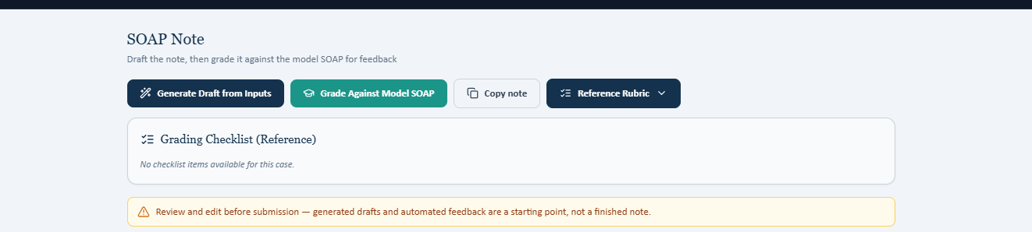
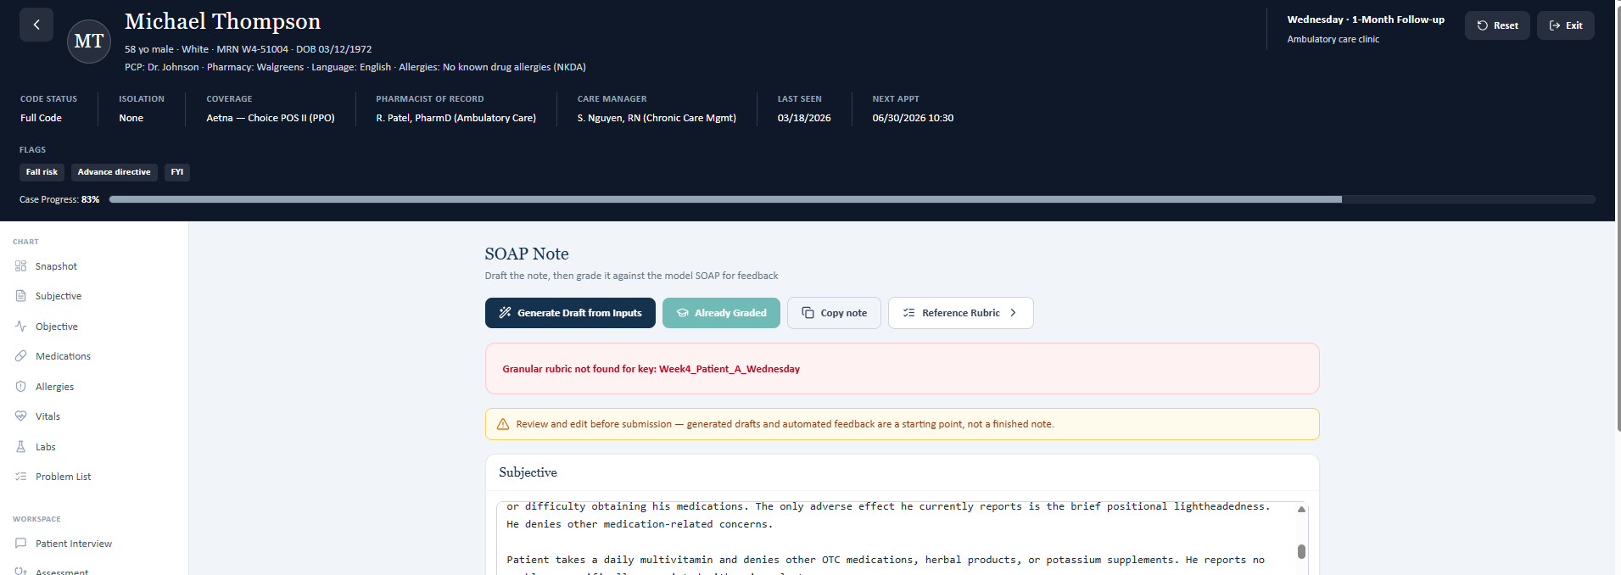

W4-14 — Wednesday encounter interval is labeled incorrectly [HIGH]
Current / observed Wednesday is intended to represent a 3-month follow-up, but Michael Thompson's screen is labeled as a 1-month follow-up.
Expected / grading reference The encounter header, EMR, grading context, and rubric should all show the same follow-up interval.
Why this is a problem Drive the interval from a single encounter configuration rather than manually entered display text. Add regression tests for every Week 4 patient/visit combination.
Recommended fix: See screenshot evidence below.
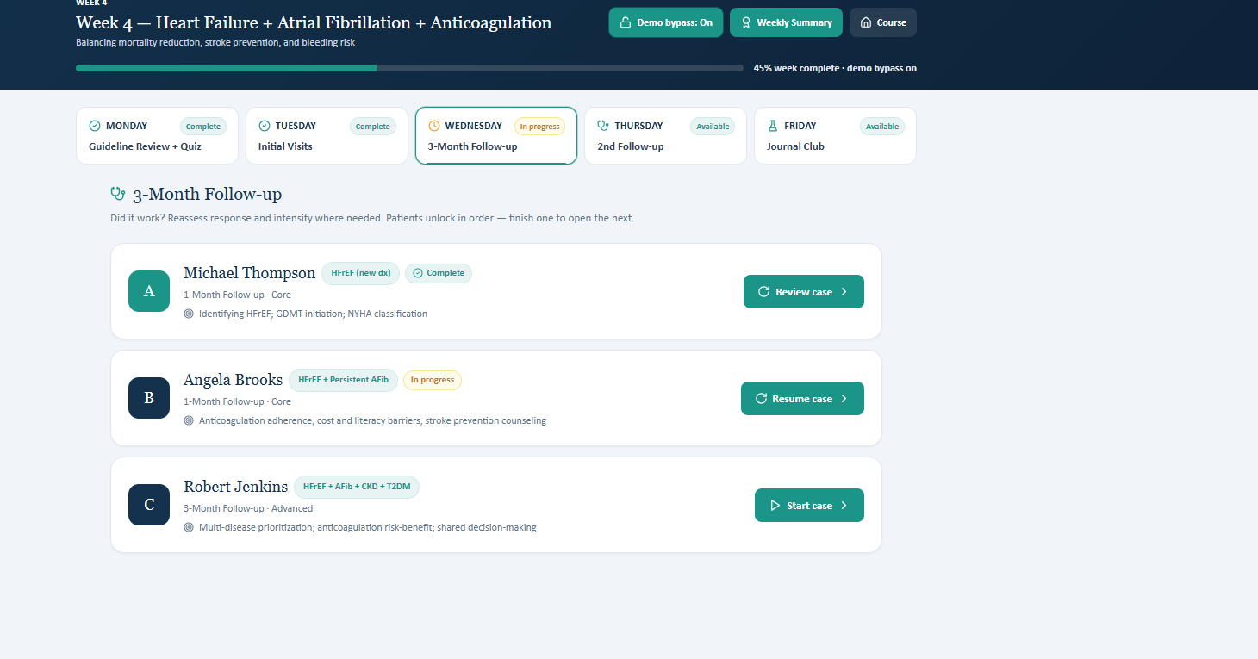
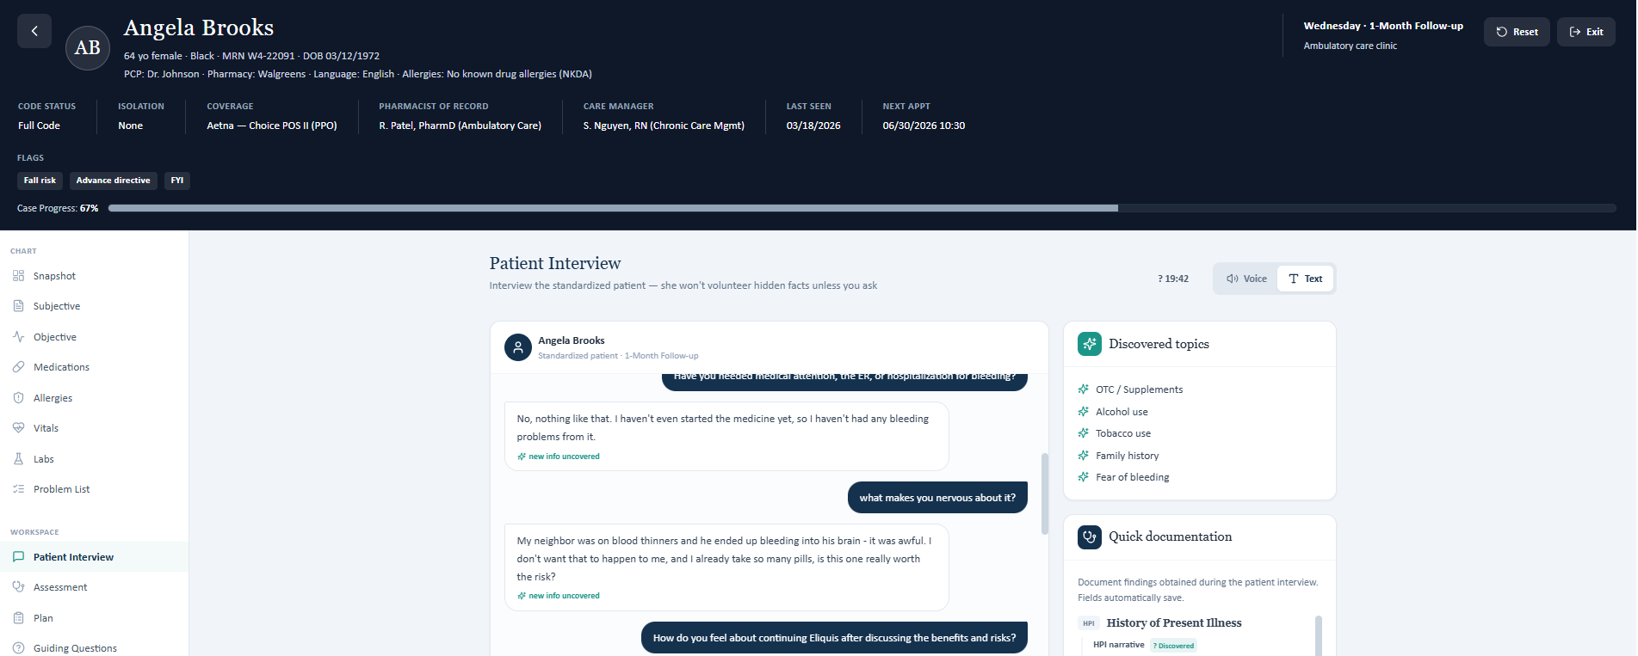

7. Wednesday — Angela Brooks
W4-15 — Labs and vitals are not consistently available or keyed [HIGH]
Current / observed The audit states that labs/vitals are keyed incorrectly and/or not available to the student, while grading deductions depend on those values.
Expected / grading reference The grader should use the exact labs/vitals displayed in the student EMR.
Why this is a problem Synchronize objective data and add automated key-vs-EMR validation before publication.
Recommended fix: See screenshot evidence below.
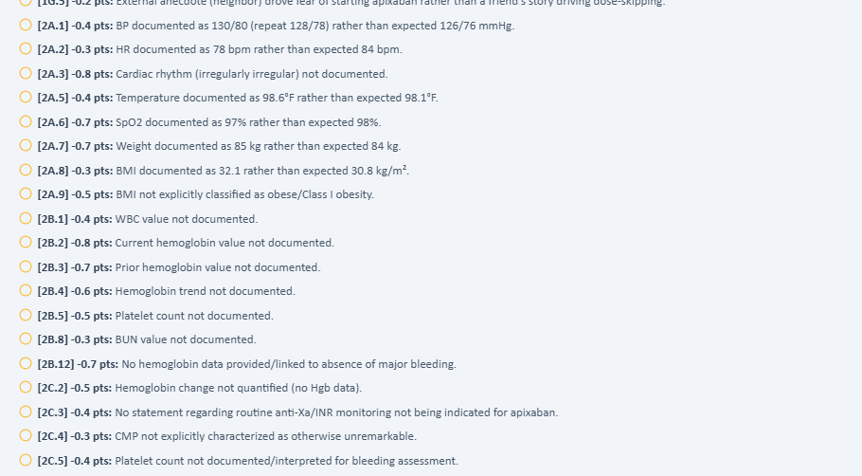
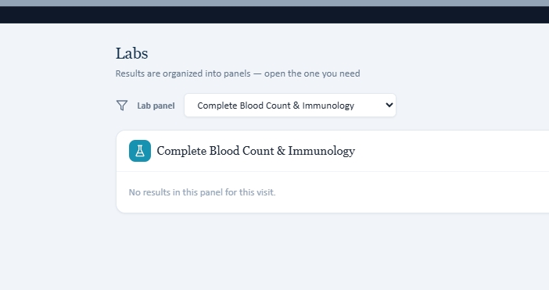
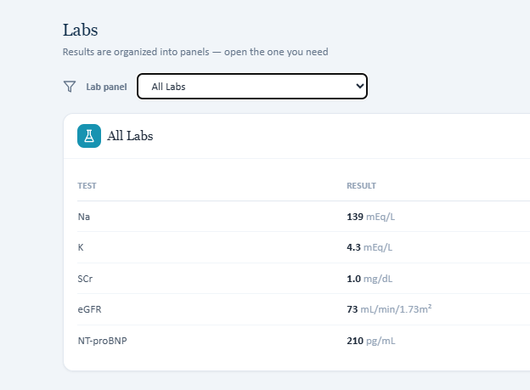
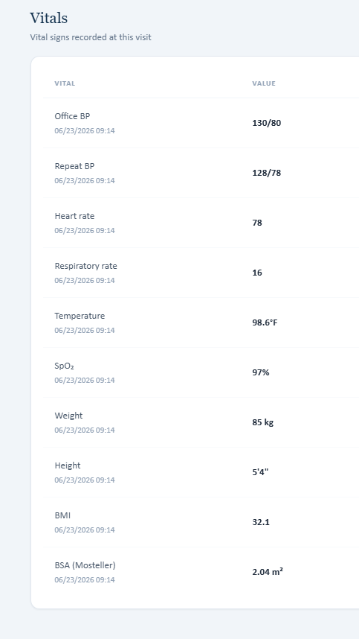
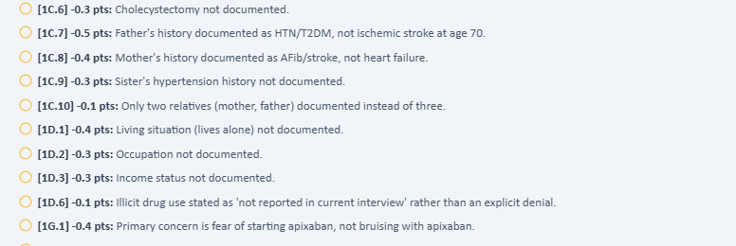

W4-16 — Bleeding/bruising grading should respect that apixaban was not started [HIGH]
Current / observed The patient repeatedly states that she has not started apixaban, therefore she reports no bleeding/bruising from the medication. The clinical concern is fear of starting anticoagulation, not an adverse event while taking it.
Expected / grading reference The grading logic should distinguish pre-treatment absence of bleeding from post-treatment bleeding assessment.
Why this is a problem Make adverse-effect questions conditional on medication exposure. Grade counseling about future bleeding precautions and shared decision-making when the patient has not started therapy.
Recommended fix: See screenshot evidence below.
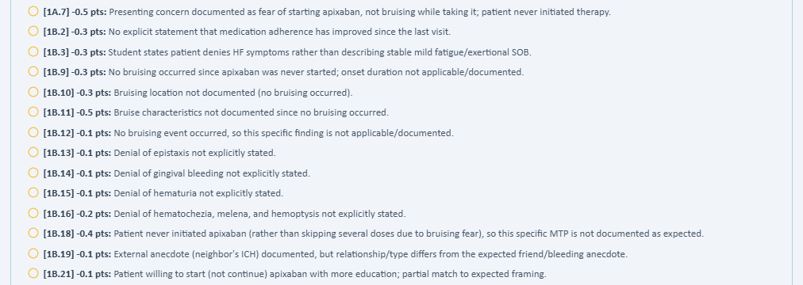
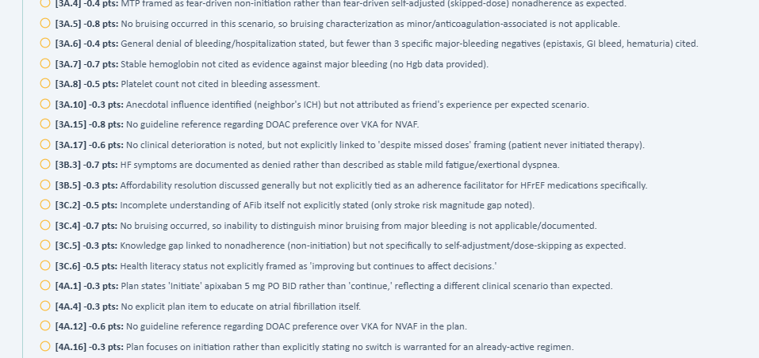

8. Wednesday — Robert Jenkins
W4-17 — Patient history fields are not consistently available to support all rubric requirements [MEDIUM]
Current / observed The patient does not provide detailed living situation/occupation information and does not consistently provide home monitoring data.
Expected / grading reference The rubric should only require history that is available through the EMR or patient interview.
Why this is a problem Use availability-aware grading and make nonclinical social-history fields optional unless they are explicitly part of the learning objective.
Recommended fix: See screenshot evidence below.

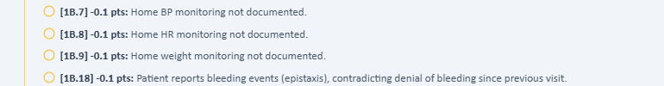
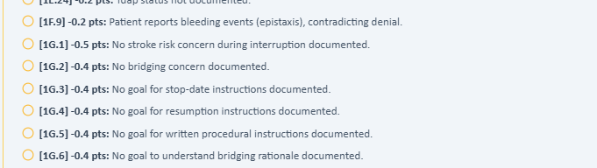

9. Thursday — Michael Thompson
W4-18 — Thursday encounter is labeled as 3-month instead of 6-month follow-up [HIGH]
Current / observed The Week 4 Thursday workflow is intended to be a 6-month follow-up, but the case is displayed/listed as a 3-month follow-up for Michael Thompson.
Expected / grading reference The encounter interval should be 6 months everywhere in the workflow.
Why this is a problem Use a single encounter-interval field for display, EMR, rubric selection, and grading. Add regression tests for all Thursday patients.
Recommended fix: See screenshot evidence below.
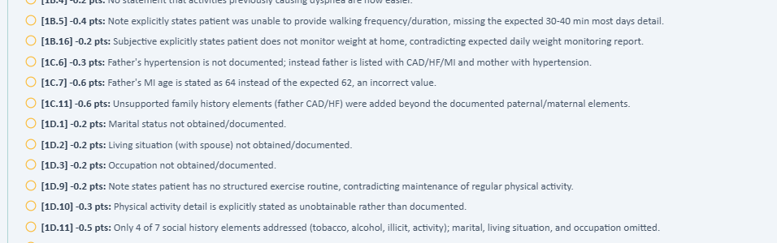
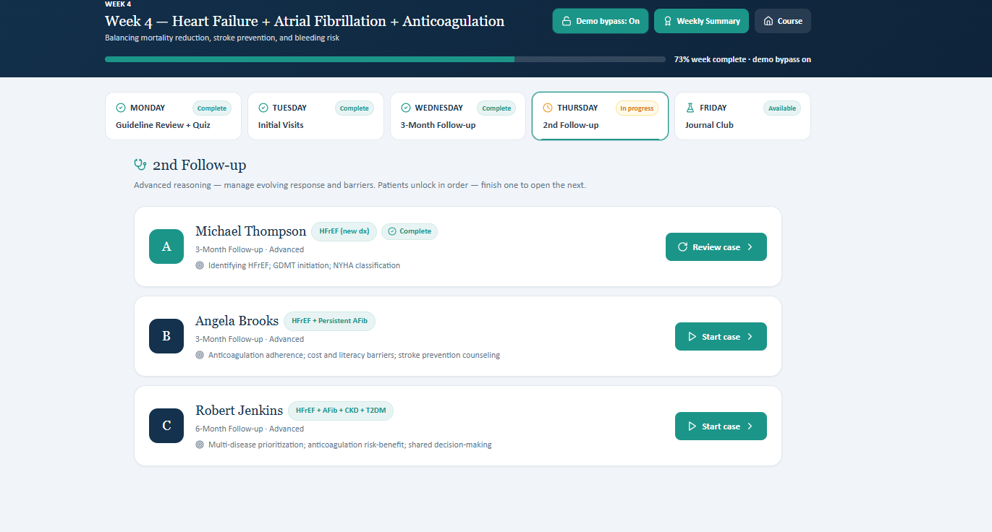

W4-19 — Home monitoring and exercise details are unavailable but may be expected by grading [MEDIUM]
Current / observed The patient does not have a defined exercise routine and does not monitor weight, BP, or HR at home.
Expected / grading reference The rubric should not require exact exercise frequency or home-monitoring values that the patient never provided.
Why this is a problem Either script these values into the standardized-patient encounter or accept 'not routinely monitored/no structured routine' as a valid response.
Recommended fix: See screenshot evidence below.



10. Thursday — Angela Brooks
W4-20 — Thursday encounter is labeled as 3-month instead of 6-month follow-up [HIGH]
Current / observed The Thursday workflow is intended to be a 6-month follow-up, but Angela Brooks is listed as a 3-month follow-up.
Expected / grading reference The patient-facing encounter and grading context should identify this as a 6-month follow-up.
Why this is a problem Drive the visit interval from the encounter configuration and use the same value for the UI and rubric selection.
Recommended fix: See screenshot evidence below.
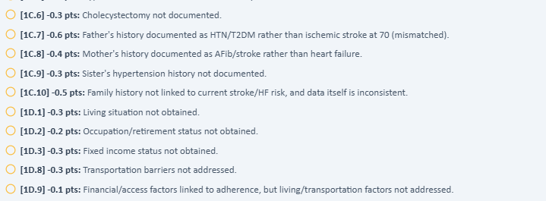

W4-21 — Vitals/family-history values do not consistently match the expected encounter [HIGH]
Current / observed The audit identifies differences between documented values (for example BP/HR and family-history details) and the expected encounter data.
Expected / grading reference The same patient should have one authoritative set of vitals and family history across EMR, SP script, and grading reference.
Why this is a problem Centralize structured clinical-history and objective data and validate all copies against the source before release.
Recommended fix: See screenshot evidence below.
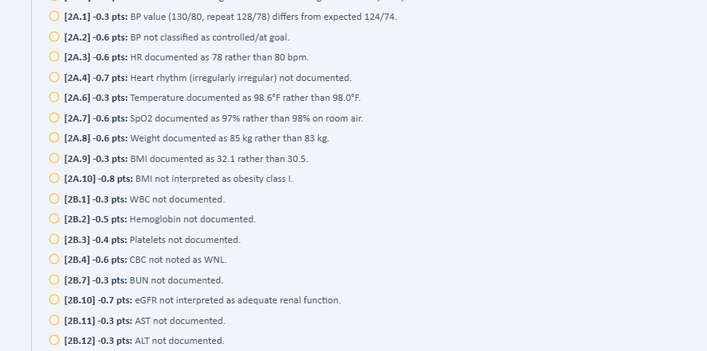
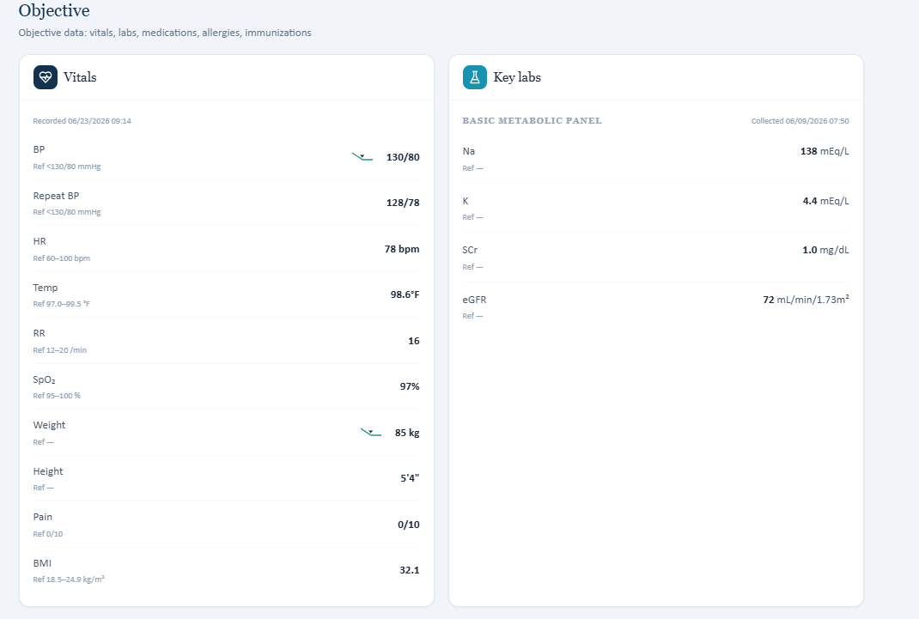

W4-22 — Surgery, living situation, occupation, and transportation fields are not established [MEDIUM]
Current / observed The patient states these details have not been discussed or are not available.
Expected / grading reference The grading system should not require unsupported social or surgical history.
Why this is a problem Either provide the information in the student-facing case or allow 'unknown/not documented' without deduction.
Recommended fix: See screenshot evidence below.


11. Thursday — Robert Jenkins
W4-23 — Colonoscopy/procedure history in the grading key conflicts with the patient-facing encounter [CRITICAL]
Current / observed The grading deductions require colonoscopy findings and periprocedural apixaban management, but the patient cannot recall a colonoscopy and the available interview does not establish the procedure details.
Expected / grading reference Procedure-specific grading should only activate when a verified procedure is part of the student-visible encounter.
Why this is a problem If the colonoscopy is intended to be part of the case, add the procedure record/results to the EMR and script. If it is not part of the case, remove procedure-specific grading criteria.
Recommended fix: See screenshot evidence below.
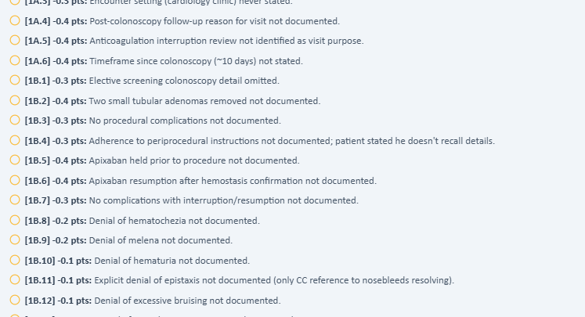
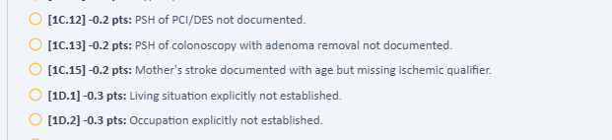

W4-24 — Periprocedural apixaban interruption/resumption details are unavailable [CRITICAL]
Current / observed The patient cannot recall what he did with apixaban around the alleged colonoscopy.
Expected / grading reference The learner should not be required to document exact interruption/resumption timing when the patient-facing encounter does not provide it.
Why this is a problem Make procedure-management grading conditional on a verified procedure and available medication-hold information. Otherwise accept 'not known/not documented.'
Recommended fix: See screenshot evidence below.


W4-25 — Objective labs/vitals do not match grading values and additional labs are not measured [HIGH]
Current / observed The audit states that the grading key uses different labs/vitals and expects additional laboratory values that are not measured in the student-visible encounter.
Expected / grading reference The grader must use the values available in the student's EMR.
Why this is a problem Centralize objective data and automatically compare the rubric against the EMR before case publication.
Recommended fix: See screenshot evidence below.
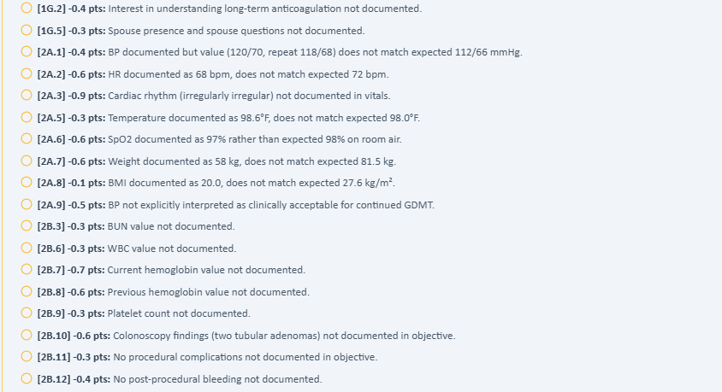
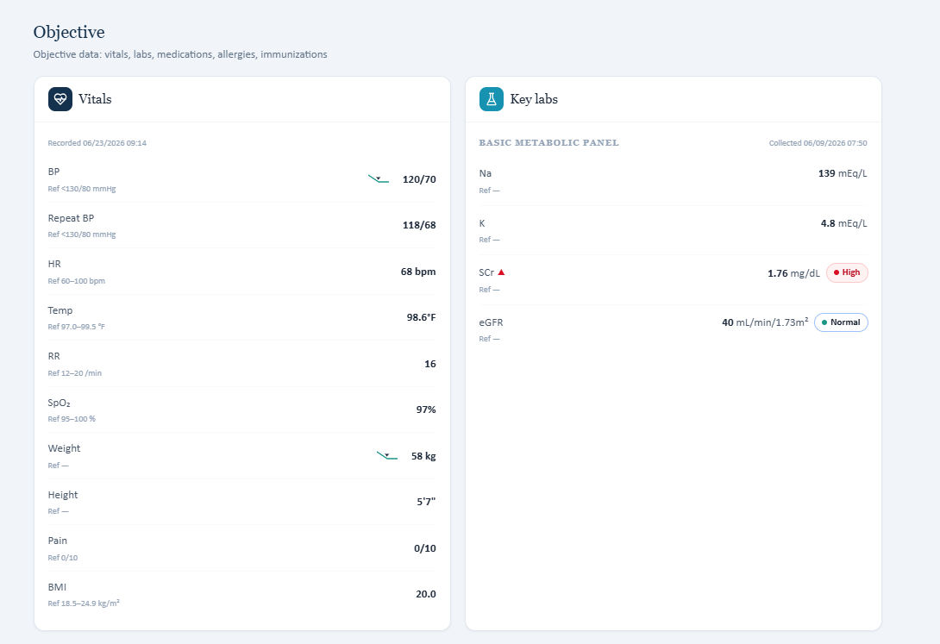

W4-26 — Social history and other background details are unavailable [MEDIUM]
Current / observed The patient cannot provide detailed living situation/occupation information.
Expected / grading reference The rubric should not penalize a student for documenting unavailable background information.
Why this is a problem Make nonessential social-history fields optional or provide scripted answers if they are part of the learning objective.
Recommended fix: See screenshot evidence below.


12. Independent Technical / UI Bugs
W4-27 — Weekly Performance Summary returns an application error [HIGH]
Current / observed Clicking 'Generate your weekly performance summary' results in an error message rather than the expected summary.
Expected / grading reference The control should generate and display the student's weekly performance summary.
Why this is a problem Inspect the Weekly Summary API response, authentication/session state, empty-state handling, and frontend rendering. Add an end-to-end test that completes Week 4 and then generates the summary.
Recommended fix: See screenshot evidence below.
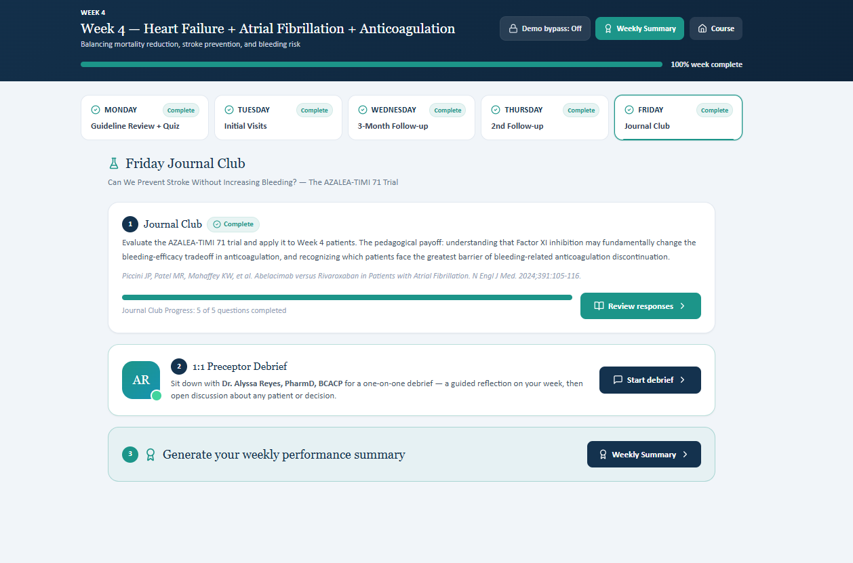
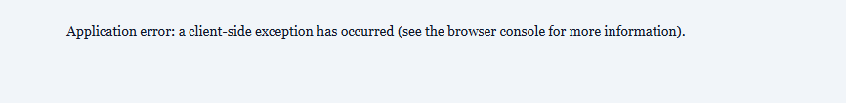

13. Cross-Cutting Grading Logic Concerns

Key distinction for the developer
The Week 4 audit contains two fundamentally different types of grading problems: (1) a true student omission, where the required information was available but not documented, and (2) a source-data mismatch, where the student documented the patient-facing information correctly but the grading reference expects a different or hidden value. These should not be scored the same way.
Information unavailable to the student: If the EMR and standardized-patient interview do not provide a value, the student should be able to document 'unknown,' 'not assessed,' or 'not available' without being penalized for not inventing the reference value.
Reference answers should be traceable: Every required grading element should map to a student-visible EMR field, a scripted standardized-patient response, or a clearly stated clinical-reasoning criterion.
Clinical accuracy should outrank hidden-reference matching: A SOAP note that accurately reflects the patient-facing data should not be marked wrong simply because a hidden reference contains conflicting clinical facts.
Version control: If multiple versions of a patient case exist, the EMR, patient script, grading rubric, and scoring engine should share an explicit case/version identifier.
Procedure-specific grading should be conditional: Questions about colonoscopy, surgery, dental procedures, medication holds, or bridging should only be activated when the procedure is actually part of the student-visible encounter.
Dose-critical fields require stronger validation: Fields such as weight and renal function can change anticoagulant dosing. These values should be treated as high-priority structured data and validated before grading.

14. Recommended Developer / QA Fix Plan
- Create one versioned source-of-truth encounter object for each patient visit, including medications, adherence, symptoms, procedures, vitals, labs, and follow-up interval.
- Have the EMR display and grading engine read from the same structured encounter data rather than separate manually entered values.
- Run an automated pre-publication comparison between student-visible EMR values and every objective value referenced by the rubric.
- Make rubric items availability-aware so 'unknown/not documented' is acceptable when the information is not obtainable.
- Make procedure-specific anticoagulation criteria conditional on a verified procedure record.
- Validate rubric availability before enabling SOAP submission.
- Use one encounter-interval field to drive the 1-, 3-, and 6-month labels and rubric selection.
- Add regression tests for all Week 4 patients, not just one patient, because the discrepancies appear across multiple cases.
- Test high-risk clinical fields separately: anticoagulant dose criteria, renal function, weight, bleeding history, and medication adherence.
- Fix the Weekly Performance Summary error and test the full workflow from encounter → SOAP submission → grade → rubric → weekly summary.

15. Suggested QA Acceptance Criteria
- A student cannot be penalized for documenting a fact exactly as stated by the standardized patient when the hidden grading reference contains a different fact.
- Every graded lab, vital, weight, renal value, medication, adherence state, and procedure is present in the student-visible encounter.
- The EMR display and grading key use identical objective values.
- Each Week 4 patient shows the correct visit interval in the header and grading context.
- Every published Week 4 encounter resolves to a valid granular rubric key.
- SOAP-note submission returns a valid grading response without a client/server parsing or missing-rubric error.
- Procedure-specific anticoagulation grading is disabled when the patient-facing encounter does not establish the procedure.
- The Weekly Performance Summary generates successfully after the Week 4 workflow is completed.
- A case-release check identifies conflicting medication, adherence, tobacco, family-history, procedure, or objective-data fields before students can access the case.
Ticket | Original screenshot(s) | Purpose
W4-01 | para2_img1.png; para7_img1.png | Tuesday Michael — grading submission failure
W4-02 | para17_img1.png | Tuesday Michael — unavailable history / grading deduction
W4-03 | para28_img1.png | Tuesday Michael — labs/vitals mismatch
W4-04 | para35_img1.png | Tuesday Michael — tobacco-history inconsistency
W4-05 | para43_img1.png; para57_img1.png; para72_img1.png; para81_img1.png; para82_img1.png | Tuesday Angela — apixaban adherence/cost
W4-06 | para72_img1.png | Tuesday Angela — unavailable social history
W4-07 | para86_img1.png; para87_img1.png | Tuesday Angela — objective-data grading issue
W4-08 | para104_img1.png; para116_img1.png; para117_img1.png; para118_img1.png | Tuesday Robert — weight/dose and objective-data evidence
W4-09 | para126_img1.png | Tuesday Robert — monitoring/clinical-data evidence
W4-10 | para104_img1.png; para116_img1.png | Tuesday Robert — medication-concern mismatch
W4-11 | para116_img1.png; para117_img1.png; para118_img1.png | Tuesday Robert — unavailable social history
W4-12 | para126_img1.png | Tuesday Robert — lab/vital grading issue
W4-13 | para145_img1.png; para148_img1.png | Wednesday Michael — missing granular rubric
W4-14 | para153_img1.png; para154_img1.png | Wednesday Michael — wrong follow-up interval
W4-15 | para169_img1.png; para169_img2.png; para169_img3.png; para170_img1.png; para178_img1.png | Wednesday Angela — objective data
W4-16 | para190_img1.png; para191_img1.png | Wednesday Angela — apixaban not started / bleeding logic
W4-17 | para212_img1.png; para216_img1.png; para222_img1.png | Wednesday Robert — unavailable history/monitoring
W4-18 | para251_img1.png; para260_img1.png; para261_img1.png | Thursday Michael — wrong interval
W4-19 | para251_img1.png; para260_img1.png | Thursday Michael — unavailable monitoring/exercise
W4-20 | para266_img1.png | Thursday Angela — wrong interval
W4-21 | para278_img1.png; para279_img1.png | Thursday Angela — objective/family-history mismatch
W4-22 | para279_img1.png | Thursday Angela — unavailable history
W4-23 | para283_img1.png; para295_img1.png | Thursday Robert — colonoscopy/procedure mismatch
W4-24 | para295_img1.png | Thursday Robert — unavailable periprocedural apixaban details
W4-25 | para306_img1.png; para307_img1.png | Thursday Robert — objective-data mismatch
W4-26 | para306_img1.png | Thursday Robert — unavailable background history
W4-27 | para309_img1.png; para309_img2.png | Technical — Weekly Performance Summary error

Final QA Note
This report intentionally does not 'correct' the clinical cases by inventing missing information. It identifies where the student-facing case, EMR, standardized-patient interview, and grading/reference system appear to disagree. The expected developer fix is to synchronize the source data and grading logic so the student is evaluated on the information actually available during the encounter.
All screenshots in this report were retained from the original Week 4 audit and placed immediately after the developer-facing issue they support, matching the evidence-first organization used in the Week 3 report.
16. Appendix A — Screenshot Evidence Index
Screenshots from the original Week 4 VACS Issues document are embedded directly after the developer-facing issue they support. The filenames below preserve the original source-paragraph traceability.
Tuesday — Michael Thompson
W4-01: para2_img1.png; para7_img1.png
W4-02: para17_img1.png
W4-03: para28_img1.png
W4-04: para35_img1.png
Tuesday — Angela Brooks
W4-05: para43_img1.png; para57_img1.png; para72_img1.png; para81_img1.png; para82_img1.png
W4-06: para72_img1.png
W4-07: para86_img1.png; para87_img1.png
Tuesday — Robert Jenkins
W4-08: para104_img1.png; para116_img1.png; para117_img1.png; para118_img1.png
W4-09: para126_img1.png
W4-10: para104_img1.png; para116_img1.png
W4-11: para116_img1.png; para117_img1.png; para118_img1.png
W4-12: para126_img1.png
Wednesday — Michael Thompson
W4-13: para145_img1.png; para148_img1.png
W4-14: para153_img1.png; para154_img1.png
Wednesday — Angela Brooks
W4-15: para169_img1.png; para169_img2.png; para169_img3.png; para170_img1.png; para178_img1.png
W4-16: para190_img1.png; para191_img1.png
Wednesday — Robert Jenkins
W4-17: para212_img1.png; para216_img1.png; para222_img1.png
Thursday — Michael Thompson
W4-18: para251_img1.png; para260_img1.png; para261_img1.png
W4-19: para251_img1.png; para260_img1.png
Thursday — Angela Brooks
W4-20: para266_img1.png
W4-21: para278_img1.png; para279_img1.png
W4-22: para279_img1.png
Thursday — Robert Jenkins
W4-23: para283_img1.png; para295_img1.png
W4-24: para295_img1.png
W4-25: para306_img1.png; para307_img1.png
W4-26: para306_img1.png
Technical / UI
W4-27: para309_img1.png; para309_img2.png

