Week 1 VACS Fix Verification
Remaining Issues After Retest
AI Patient, EMR, and Grader/Rubric Discrepancies Still Not Completely Corrected
Retest date: August 24, 2026
Cross-checked against the Week 1 VACS SOAP Note Grading Rubrics Master List
Scope: Only findings that remain not fixed or partially fixed are included. Items that passed retest are intentionally omitted from the detailed sections.

Executive Summary
22 visit-level findings remain open across James Wilson and Linda Martinez. Repeated defects are counted on each visit when they can independently affect SOAP-note grading. No confirmed remaining issue was identified for Maria Gonzalez after the retest.
Encounter | Remaining findings
Maria Gonzalez - Tuesday | 0
Maria Gonzalez - Wednesday | 0
Maria Gonzalez - Thursday | 0
James Wilson - Tuesday | 3
James Wilson - Wednesday | 3
James Wilson - Thursday | 3
Linda Martinez - Tuesday | 3
Linda Martinez - Wednesday | 8
Linda Martinez - Thursday | 2
Status interpretation: NOT FIXED = the current AI/EMR value conflicts with the rubric or required information remains unavailable. PARTIALLY FIXED = part of the original defect is corrected, but a scored detail remains wrong or unavailable.
Evidence handling: Per tester instruction, the same James Wilson surgery-age screenshot and home-BP screenshot are reused under each applicable James visit because the same response recurred. Master-rubric excerpts are included next to the retest evidence.

Highest-Priority Recurring Patterns
- Visit-state leakage / longitudinal mismatch: earlier or later home BP and glucose ranges are being returned on the wrong day.
- Persistent surgical-history age mismatch: James gives ages 20/55 instead of 19/51; Linda cannot provide the rubric-listed ages 49/52.
- Objective EMR/rubric mismatch: Linda Wednesday serum creatinine remains 1.26 mg/dL in the EMR versus 1.28 mg/dL in the rubric.
- Medication-state mismatch: Linda Thursday still reports prior semaglutide and atorvastatin doses instead of the current uptitrated/intensified doses.
- Hidden follow-up history: Linda Wednesday still cannot provide graded adherence, diet, exercise, and fatigue details.

James Wilson
Detailed unresolved findings only

Tuesday Initial Visit
# | Remaining issue | Status
1 | Home BP average/log remains unavailable | PARTIALLY FIXED
2 | Fasting home glucose range does not match Tuesday rubric | NOT FIXED
3 | Surgical procedures are disclosed, but the ages remain mismatched | PARTIALLY FIXED

1. Home BP average/log remains unavailable PARTIALLY FIXED
Current retest | AI patient now reports checking BP 1-2 times/week and readings in the high 140s/90s, but says he does not keep a written log and does not provide a numeric average.
Master rubric | Master rubric IDs 1B.13-1B.14 expect 1-2 checks/week and high 140s/90s; Objective ID 2A.7 separately requires a home BP log average of approximately 149/91 mmHg.
Why still open | Frequency and range are corrected, but the separately graded log-average value is still unavailable. A student cannot document ~149/91 without inventing data.

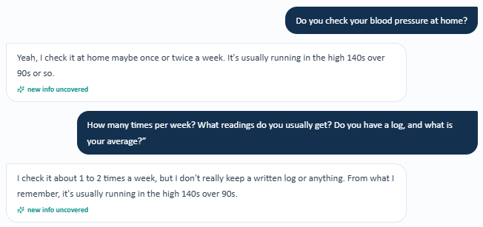
Retest evidence - James Wilson home BP response. This same response is reused for each James visit per tester instruction.
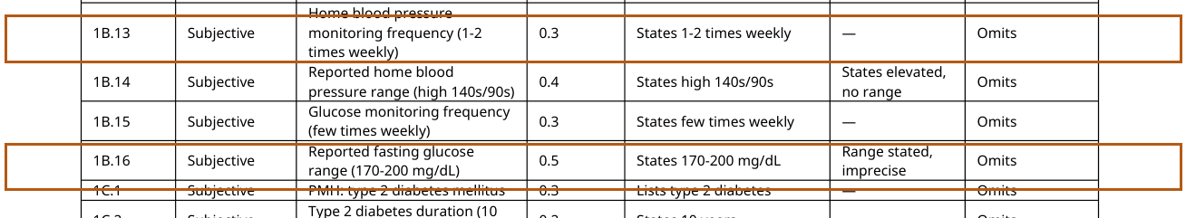
Master rubric - James Tuesday, IDs 1B.13-1B.16 (home BP frequency/range and fasting glucose criteria).
Master rubric - James Tuesday, Objective ID 2A.7: home BP log average ~149/91 mmHg.

2. Fasting home glucose range does not match Tuesday rubric NOT FIXED
Current retest | AI patient reports checking glucose a few times/week with fasting readings around 140-160 mg/dL.
Master rubric | Master rubric ID 1B.16 requires fasting glucose 170-200 mg/dL for the Tuesday initial visit.
Why still open | The monitoring behavior is now discoverable, but the numeric range appears to be from a later visit and would lose credit if documented as stated.


Master rubric - James Tuesday, ID 1B.16 requires fasting glucose 170-200 mg/dL.

3. Surgical procedures are disclosed, but the ages remain mismatched PARTIALLY FIXED
Current retest | AI patient reports appendectomy at age 20 and knee scope at age 55.
Master rubric | Master rubric IDs 1C.9-1C.10 specify appendectomy at age 19 and right knee arthroscopy at age 51.
Why still open | The prior surgery denials are fixed, but the ages remain inconsistent with the grading key. The same age mismatch is reproduced across James Tuesday, Wednesday, and Thursday.


Retest evidence - James reports appendectomy age 20 and knee scope age 55. Reused for all three James visits per tester instruction.
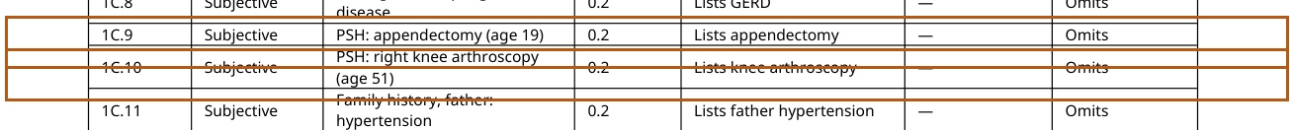
Master rubric - James Tuesday, IDs 1C.9-1C.10: appendectomy age 19; right knee arthroscopy age 51.

Wednesday 3-Month Follow-Up
# | Remaining issue | Status
1 | Home BP data remain on the wrong visit state and average is unavailable | NOT FIXED
2 | Prior occupation is still unavailable | NOT FIXED
3 | Surgical ages remain mismatched | PARTIALLY FIXED

1. Home BP data remain on the wrong visit state and average is unavailable NOT FIXED
Current retest | AI patient continues to return 1-2 checks/week with readings in the high 140s/90s and no numeric log average.
Master rubric | Master rubric ID 1B.10 requires mid-130s/80s for Wednesday; Objective ID 2A.7 requires a home BP log average of approximately 136/84 mmHg.
Why still open | The AI patient is still returning the initial-visit BP pattern instead of the Wednesday follow-up pattern, and the graded numeric average is missing.


Retest evidence - representative James home BP response reused for Wednesday per tester instruction.
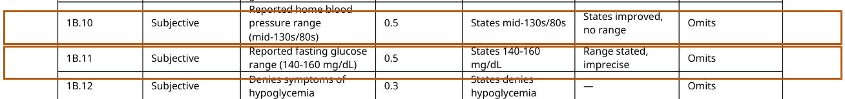
Master rubric - James Wednesday, IDs 1B.10-1B.11: BP mid-130s/80s; fasting glucose 140-160 mg/dL.
Master rubric - James Wednesday, Objective ID 2A.7: home BP log average ~136/84 mmHg.

2. Prior occupation is still unavailable NOT FIXED
Current retest | AI patient confirms he is retired but repeatedly says he cannot recall what kind of work he did before retirement.
Master rubric | Master rubric ID 1D.2 requires "recently retired truck driver."
Why still open | Retirement status is available, but the occupation itself remains hidden/unavailable after a direct question.

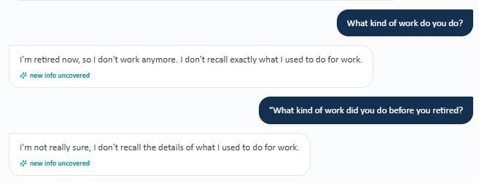
Retest evidence - James cannot recall his prior occupation.
Master rubric - James Wednesday, ID 1D.2: recently retired truck driver.

3. Surgical ages remain mismatched PARTIALLY FIXED
Current retest | AI patient reports appendectomy at age 20 and knee scope at age 55.
Master rubric | Master rubric IDs 1C.9-1C.10 specify appendectomy at age 19 and right knee arthroscopy at age 51.
Why still open | The procedures are now available, but exact ages still conflict with the rubric.


Retest evidence - same James surgery-age response reused for Wednesday per tester instruction.
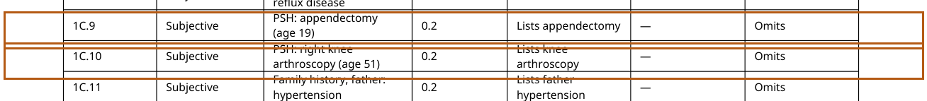
Master rubric - James Wednesday, IDs 1C.9-1C.10: appendectomy age 19; right knee arthroscopy age 51.

Thursday 6-Month Follow-Up
# | Remaining issue | Status
1 | Home BP remains inconsistent with the Thursday follow-up state | NOT FIXED
2 | Fasting glucose remains too high for the Thursday rubric state | NOT FIXED
3 | Surgical ages remain mismatched | PARTIALLY FIXED

1. Home BP remains inconsistent with the Thursday follow-up state NOT FIXED
Current retest | AI patient continues to return 1-2 checks/week with high 140s/90s and no numeric average.
Master rubric | Master rubric ID 1B.10 requires home BP in the 120s/70s; Objective ID 2A.7 requires a home BP average of approximately 126/78 mmHg.
Why still open | The returned BP history is still the initial-visit pattern rather than the improved Thursday pattern and lacks the separately graded average.


Retest evidence - representative James home BP response reused for Thursday per tester instruction.
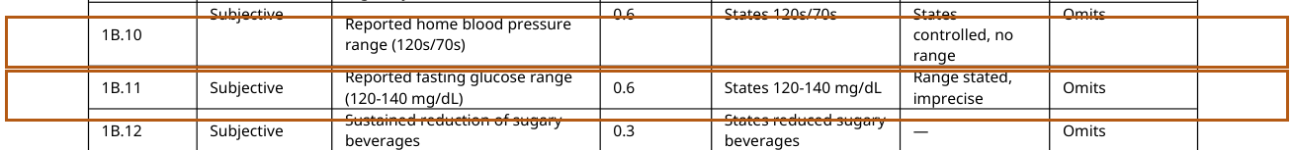
Master rubric - James Thursday, IDs 1B.10-1B.11: BP 120s/70s; fasting glucose 120-140 mg/dL.
Master rubric - James Thursday, Objective ID 2A.7: home BP average ~126/78 mmHg.

2. Fasting glucose remains too high for the Thursday rubric state NOT FIXED
Current retest | AI patient reports fasting glucose around 140-160 mg/dL.
Master rubric | Master rubric ID 1B.11 requires 120-140 mg/dL on Thursday.
Why still open | The AI patient is returning the prior follow-up glucose range instead of the Thursday range.

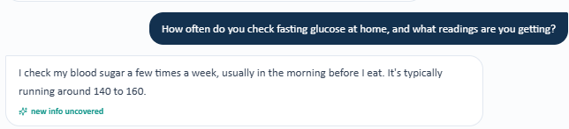
Retest evidence - James Thursday fasting glucose response is 140-160 mg/dL.

Master rubric - James Thursday, ID 1B.11 requires fasting glucose 120-140 mg/dL.

3. Surgical ages remain mismatched PARTIALLY FIXED
Current retest | AI patient reports appendectomy at age 20 and knee scope at age 55.
Master rubric | Master rubric IDs 1C.9-1C.10 specify appendectomy at age 19 and right knee arthroscopy at age 51.
Why still open | Procedures are disclosed, but the exact ages remain inconsistent with the grading key.


Retest evidence - same James surgery-age response reused for Thursday per tester instruction.
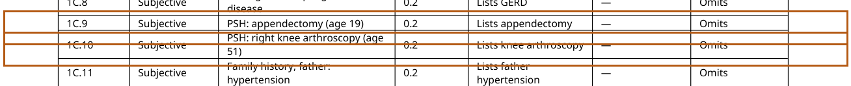
Master rubric - James Thursday, IDs 1C.9-1C.10: appendectomy age 19; right knee arthroscopy age 51.

Linda Martinez
Detailed unresolved findings only

Tuesday Initial Visit
# | Remaining issue | Status
1 | Home BP reflects the later follow-up state rather than Tuesday baseline | NOT FIXED
2 | Fasting glucose reflects a later follow-up range | NOT FIXED
3 | Surgery ages remain unavailable | PARTIALLY FIXED

1. Home BP reflects the later follow-up state rather than Tuesday baseline NOT FIXED
Current retest | AI patient says she checks BP "pretty regularly" and gives an average around 123/75 mmHg.
Master rubric | Master rubric IDs 1B.8-1B.9 require approximately twice-weekly monitoring with high 130s/low 80s; Objective ID 2A.7 requires an average around 138/82 mmHg.
Why still open | The response appears to pull the later Thursday BP value into Tuesday and does not reproduce the Tuesday frequency/range.


Retest evidence - Linda Tuesday returns BP average ~123/75.
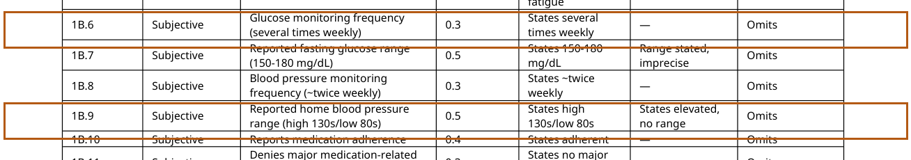
Master rubric - Linda Tuesday, IDs 1B.6-1B.9: glucose and BP baseline monitoring criteria.
Master rubric - Linda Tuesday, Objective ID 2A.7: home BP average ~138/82 mmHg.

2. Fasting glucose reflects a later follow-up range NOT FIXED
Current retest | AI patient reports fasting glucose around 120-140 mg/dL.
Master rubric | Master rubric ID 1B.7 requires fasting glucose 150-180 mg/dL on Tuesday.
Why still open | The value now becomes available, but it is the wrong visit-state range and would be scored as incorrect.


Retest evidence - Linda Tuesday reports fasting glucose 120-140 mg/dL.

Master rubric - Linda Tuesday, ID 1B.7 requires fasting glucose 150-180 mg/dL.

3. Surgery ages remain unavailable PARTIALLY FIXED
Current retest | AI patient now confirms gallbladder removal and total abdominal hysterectomy but says she cannot remember the ages.
Master rubric | Master rubric criteria 1C.12 and 1C.13 identify cholecystectomy at age 49 and total abdominal hysterectomy at age 52. Tester reports points are deducted when the ages are not provided.
Why still open | The procedures are fixed, but the age component still cannot be elicited and remains a scoring problem.


Retest evidence - representative Linda response: cannot recall ages of gallbladder removal or hysterectomy.
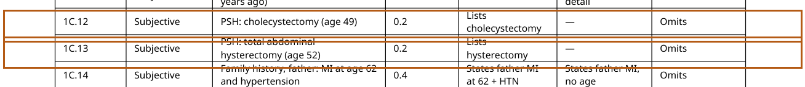
Master rubric - Linda Tuesday, criteria list cholecystectomy age 49 and total abdominal hysterectomy age 52.

Wednesday First Follow-Up
# | Remaining issue | Status
1 | Missed-dose history still contradicts the rubric | NOT FIXED
2 | Home BP remains mapped to the wrong follow-up state | NOT FIXED
3 | Fasting glucose remains mapped to the Thursday range | NOT FIXED
4 | Required dietary improvements remain unavailable | NOT FIXED
5 | Exercise frequency and duration remain unavailable | NOT FIXED
6 | Positional edema is fixed, but intermittent fatigue is still denied | PARTIALLY FIXED
7 | Surgery ages remain unavailable | PARTIALLY FIXED
8 | Serum creatinine remains unsynchronized between EMR and rubric | NOT FIXED

1. Missed-dose history still contradicts the rubric NOT FIXED
Current retest | AI patient says she has not missed any doses since the last visit.
Master rubric | Master rubric ID 1B.4 requires documentation of approximately 1-2 isolated missed doses.
Why still open | This is a direct zero-versus-positive adherence-history mismatch after a targeted question.


Retest evidence - Linda Wednesday says she has missed no doses.
Master rubric - Linda Wednesday, ID 1B.4: 1-2 isolated missed doses.

2. Home BP remains mapped to the wrong follow-up state NOT FIXED
Current retest | AI patient says she checks BP regularly and gives an average around 123/75 mmHg.
Master rubric | Master rubric IDs 1B.7-1B.8 require several-times-weekly monitoring with upper 120s/upper 70s; Objective ID 2A.6 requires an average around 129/78 mmHg.
Why still open | The 123/75 value matches the later Thursday state, not Wednesday, and the expected Wednesday range/frequency are not reproduced.


Retest evidence - Linda Wednesday returns BP average ~123/75.
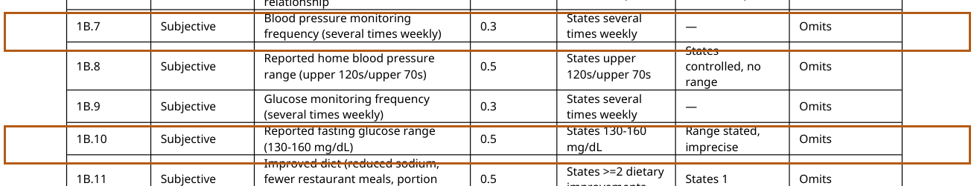
Master rubric - Linda Wednesday, IDs 1B.7-1B.10: BP and glucose monitoring criteria.
Master rubric - Linda Wednesday, Objective ID 2A.6: home BP average ~129/78 mmHg.

3. Fasting glucose remains mapped to the Thursday range NOT FIXED
Current retest | AI patient reports fasting glucose around 120-140 mg/dL.
Master rubric | Master rubric ID 1B.10 requires 130-160 mg/dL on Wednesday.
Why still open | The response supplies a numeric range, but it is the later Thursday value rather than the Wednesday value.


Retest evidence - Linda Wednesday reports fasting glucose 120-140 mg/dL.

Master rubric - Linda Wednesday, ID 1B.10 requires fasting glucose 130-160 mg/dL.

4. Required dietary improvements remain unavailable NOT FIXED
Current retest | When asked specifically about sodium, restaurant meals, and portion size, AI patient says she cannot provide specific changes.
Master rubric | Master rubric ID 1B.11 expects improved diet with reduced sodium, fewer restaurant meals, and portion control; full credit requires at least two improvements.
Why still open | The exact positive lifestyle findings used for scoring still cannot be elicited from the patient.

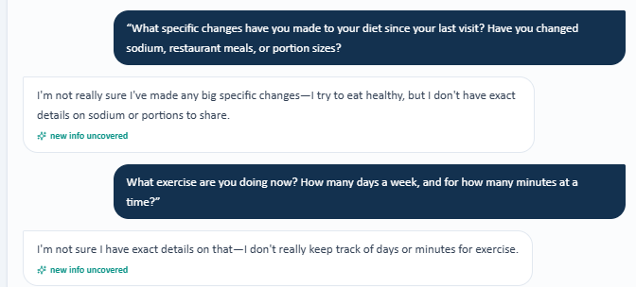
Retest evidence - Linda Wednesday cannot provide specific diet changes and cannot quantify exercise.
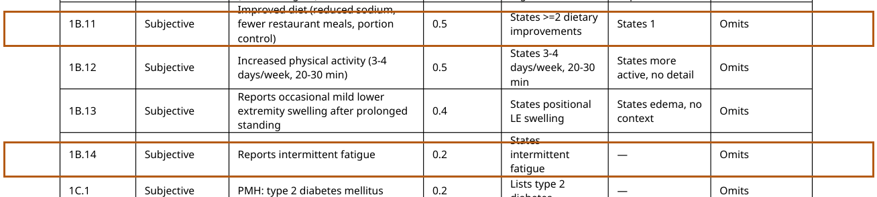
Master rubric - Linda Wednesday, IDs 1B.11-1B.14: diet, activity, positional edema, and intermittent fatigue.

5. Exercise frequency and duration remain unavailable NOT FIXED
Current retest | AI patient says she does not track exercise days or minutes and cannot provide exact details.
Master rubric | Master rubric ID 1B.12 requires activity approximately 3-4 days/week for 20-30 minutes.
Why still open | The patient still cannot provide the quantitative exercise history used by the grader.


Retest evidence - same Linda Wednesday screenshot shows exercise days/minutes are unavailable.

Master rubric - Linda Wednesday, ID 1B.12 requires 3-4 days/week for 20-30 minutes.

6. Positional edema is fixed, but intermittent fatigue is still denied PARTIALLY FIXED
Current retest | AI patient now confirms mild leg swelling after prolonged standing but says she has not noticed unusual fatigue.
Master rubric | Master rubric IDs 1B.13-1B.14 require both positional lower-extremity swelling and intermittent fatigue.
Why still open | One half of the symptom-state contradiction is corrected; the fatigue criterion remains opposite the grading key.

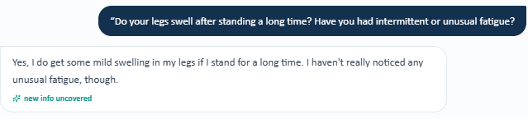
Retest evidence - Linda confirms positional swelling but denies unusual fatigue.

Master rubric - Linda Wednesday includes both positional edema and intermittent fatigue.

7. Surgery ages remain unavailable PARTIALLY FIXED
Current retest | AI patient confirms gallbladder removal and total abdominal hysterectomy but cannot recall either age.
Master rubric | Master rubric criteria 1C.12-1C.13 identify cholecystectomy at age 49 and total abdominal hysterectomy at age 52. Tester reports age omission loses points.
Why still open | The surgical procedures are now discoverable, but the scored age detail remains unavailable.


Retest evidence - representative Linda surgery-age response; same inability to recall ages was observed across visits.
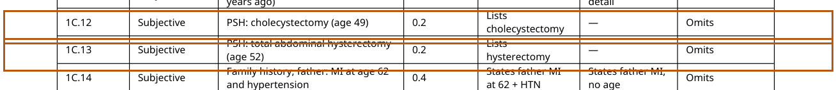
Master rubric - Linda Wednesday, surgery criteria include cholecystectomy age 49 and hysterectomy age 52.

8. Serum creatinine remains unsynchronized between EMR and rubric NOT FIXED
Current retest | Wednesday EMR still displays serum creatinine 1.26 mg/dL.
Master rubric | Master rubric Objective ID 2B.6 requires serum creatinine 1.28 mg/dL.
Why still open | This is a direct objective-data mismatch. A student copying the visible EMR would still lose credit for the grader's different value.

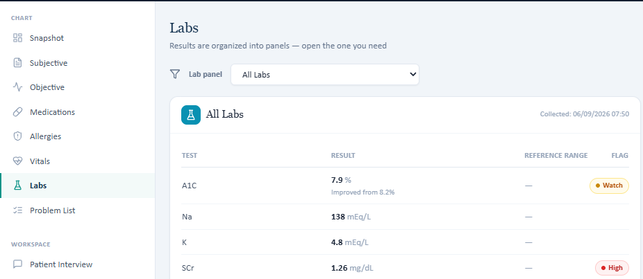
Retest evidence - Linda Wednesday EMR still shows serum creatinine 1.26 mg/dL.
Master rubric - Linda Wednesday, Objective ID 2B.6 requires serum creatinine 1.28 mg/dL.

Thursday Final Follow-Up
# | Remaining issue | Status
1 | Current semaglutide and atorvastatin doses remain at prior doses | NOT FIXED
2 | Surgery ages remain unavailable | PARTIALLY FIXED

1. Current semaglutide and atorvastatin doses remain at prior doses NOT FIXED
Current retest | AI patient reports semaglutide 0.5 mg weekly and atorvastatin 40 mg daily. The grader screenshot specifically deducts for these old/prior doses.
Master rubric | Master rubric ID 1E.8 requires semaglutide 1 mg weekly (uptitrated from 0.5 mg), and ID 1E.17 requires atorvastatin 80 mg daily (intensified from 40 mg).
Why still open | The current medication state remains unsynchronized. Documenting the AI patient's doses would still be graded as using old/prior doses.

Retest/grader evidence - deductions for semaglutide 0.5 mg instead of 1 mg and atorvastatin 40 mg instead of 80 mg.
Master rubric - Linda Thursday, ID 1E.8: semaglutide 1 mg, uptitrated from prior 0.5 mg.
Master rubric - Linda Thursday, ID 1E.17: atorvastatin 80 mg, intensified from prior 40 mg.

2. Surgery ages remain unavailable PARTIALLY FIXED
Current retest | AI patient confirms gallbladder removal and total abdominal hysterectomy but says she cannot remember the ages.
Master rubric | Master rubric criteria 1C.12-1C.13 identify cholecystectomy at age 49 and total abdominal hysterectomy at age 52. Tester reports points are deducted when ages are omitted.
Why still open | The procedures are fixed, but the age details remain unavailable at the final follow-up.


Retest evidence - representative Linda surgery-age response; she cannot recall the ages.
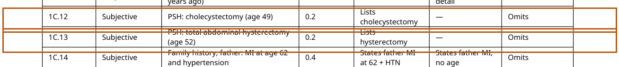
Master rubric - Linda Thursday, surgery criteria include cholecystectomy age 49 and hysterectomy age 52.

Recommended Developer Actions
Synchronize longitudinal AI-patient state by visit day: Ensure Tuesday, Wednesday, and Thursday home BP/glucose/adherence/lifestyle facts resolve to the specific day rather than reusing another visit's state.
Use a single source of truth for scored objective values: Linda Wednesday SCr should be 1.28 mg/dL everywhere if that is the rubric value, or the rubric should be updated to the visible EMR value.
Synchronize current medication state: Linda Thursday semaglutide should surface as 1 mg weekly and atorvastatin as 80 mg daily if those are the active graded doses.
Persist exact surgical history fields: Where ages are explicitly scored, return the same procedure age in the AI patient and visible history on every day.
Retest after deployment using only student-visible information: A SOAP note built solely from the AI interview and visible EMR should receive full credit for each corrected criterion without relying on hidden facts.
Source documents: Week 1 VACS Issue Report FINAL.docx; Week 1 VACS SOAP Note Grading Rubrics Master List.docx; fresh retest screenshots/interviews supplied August 24, 2026.

