WEEK 2

VACS AI Patient and Grading Issue Report
Final Clinical and Operational Audit
Initial audit cycle
  - David Chen • Michael Turner • Angela Rodriguez
  - Initial visits and three month and six month follow-ups
Prepared by
Imani Issa
PharmD Candidate, Class of 2027
University of North Texas Health Fort Worth College of Pharmacy and Health Professions
Purpose Provide developers and clinical faculty with a verified, actionable list of unresolved conflicts in the supplied VACS evidence. VACS means Virtual Ambulatory Care Simulation.

Executive summary
The review identified 19 grouped findings across nine encounters: 16 confirmed defects or source conflicts and 3 items needing clinical review. The highest-priority findings concern an incorrect allergy reassurance, conflicting objective data, an unsupported medication history, renal-dose grading and a contradictory safety warning.
Address the safety and data-consistency findings first. Then align patient answers with gradeable facts and clarify the clinical decision rules. No fix or successful retest was supplied; this is an Initial Audit, not a closure report.
Priority | Confirmed findings | Clinical review items | Total
High | 5 | 1 | 6
Medium | 7 | 2 | 9
Low | 4 | 0 | 4
Total | 16 | 3 | 19

Scope Three patients × three stated encounter stages. The review uses 139 unique screenshot images from 155 supplied PNG files, the user’s pasted case data and clarifications, and the supplied audit workflow guide.
Verification boundary This report verifies the supplied evidence snapshots. It does not claim a live application retest, a backend inspection, a corrected grade or a completed clinical treatment change. Evidence crops are original screenshot pixels, not recreated chart displays.

Quick guide and glossary
Term | Plain-language meaning
EMR | Electronic medical record: the chart information visible to the student.
AI patient and AI grader | The simulated patient answering questions, and the separate system evaluating the submitted note.
Rubric | The grading criteria. No separate master scoring rubric was supplied; feedback shows what the grader expected.
SOAP | Subjective, Objective, Assessment and Plan: the four parts of a clinical note.
NKDA | No known drug allergies. This label conflicts with a documented penicillin reaction in Angela’s chart.
CKD and chronicity | Chronic kidney disease; chronicity means evidence that a kidney abnormality has persisted over time.
eGFR and creatinine | Kidney filtration estimate and a blood marker used to assess kidney function. Lower eGFR can affect medicine dosing.
UACR and albuminuria | Urine albumin-to-creatinine ratio; albuminuria means excess albumin protein in urine.
A2 | Moderately increased urine albumin category; all Angela values discussed here remain within this category.
ASCVD and PREVENT | Atherosclerotic cardiovascular disease: artery-related heart attack/stroke risk. PREVENT is a cardiovascular risk-estimation method.
LDL and HDL | Two cholesterol measurements. LDL is a key target for cholesterol-lowering treatment.
Statin and ezetimibe | Medicines that lower LDL cholesterol. Ezetimibe is a nonstatin option that may be added when appropriate.
BP and systolic BP | Blood pressure; systolic BP is the upper number.
ACE inhibitor and ARB | Drug classes used for blood pressure and kidney protection. Losartan is an ARB.
AST and ALT | Blood tests often used to assess liver injury.
Metformin ER and twice daily | An extended-release diabetes medicine; twice daily means two doses per day, not one total daily dose.
BMI | Body mass index, calculated from weight in kilograms divided by height in meters squared.
Pack-year | A measure of cumulative cigarette exposure. One pack a day for ten years equals ten pack-years.
OTC and NSAID | Over-the-counter medicine; NSAIDs include ibuprofen and can affect kidney function and blood pressure.
Points and evidence codes | Point deductions are shown exactly in focused grader crops. E numbers identify report figures, not extra findings.

Finding register
ID | Finding | Priority | Disposition
V01 | Penicillin allergy conflicts with the medication safety banner | High | Developer action
V02 | Angela is graded against different objective values | High | Developer action
V03 | The grader requires an unsupported simvastatin history | High | Developer action
V04 | Metformin renal dose adjustment is penalized | High | Developer action
V05 | A father’s heart attack at 61 is misclassified as premature | Medium | Developer action
V06 | Initial urine albumin history is required without an accessible dated record | Medium | Developer action
V07 | Michael’s personal history and uncertain answers conflict with grading | Medium | Developer action
V08 | Michael is graded for lifestyle changes he does not report | Medium | Developer action
V09 | Michael’s home blood pressure record does not match the interview | Medium | Developer action
V10 | David’s denials and treatment commitment are replaced by expected concerns | Medium | Developer action
V11 | Angela’s symptoms and lifestyle answers conflict with grading | Medium | Developer action
V12 | A reasonable blood pressure plan appears under an unsafe warning | High | Developer action
V13 | Guideline citations are called optional and then scored as required | Low | Developer action
V14 | Lipid goals and acceptable escalation need clinical review | High | Clinical review
V15 | The blood pressure target is graded without its measurement context | Medium | Clinical review
V16 | A small urine albumin change is treated as definite clinical improvement | Medium | Clinical review
V17 | Populated objective fields are labeled missing | Low | Developer action
V18 | The LDL row displays a urine albumin trend | Low | Developer action
V19 | Angela’s displayed initial BMI does not match height and weight | Low | Developer action

Findings V01–V16 concern clinical data, patient answers or grading. Findings V17–V19 are separate interface or calculation issues. Multiple deductions with the same underlying problem are grouped together; counts are not additive by patient or day.

Evidence coverage and verification method
Patient | Stage | Interview images | Feedback images | EMR images
David Chen | Tuesday initial | 9 | 3 | 3
David Chen | Wednesday three month | 10 | 3 | 2
David Chen | Thursday six month | 9 | 2 | 1
Michael Turner | Tuesday initial | 7 | 3 | 5
Michael Turner | Wednesday three month | 9 | 3 | 2
Michael Turner | Thursday six month | 11 | 3 | 2
Angela Rodriguez | Tuesday initial | 9 | 3 | 6
Angela Rodriguez | Wednesday three month | 9 | 3 | 5
Angela Rodriguez | Thursday six month | 9 | 3 | 5
Total | 9 encounters | 82 | 26 | 31

Michael’s Wednesday home-BP source now uses the final filename MT_Wed_Patient_Interview_Home_BP_01.png. Its pixels match the earlier mislabeled copy exactly, so it is counted once as interview evidence.
All supplied screenshot sets were reviewed. Duplicate copies were identified by file hash. Text extraction helped locate content; selected evidence was checked visually and cropped from the original files. The audit preserves differences among chart data, patient answers and grader expectations.
The submitted SOAP notes and a standalone master scoring rubric were not supplied as separate source artifacts. Claims about what the grader deducted come from the feedback itself. This prevents independent recalculation of full grades or resolution of every note-specific wording dispute.
Evidence update David’s added Wednesday and Thursday renal screenshots confirm eGFR 40 and 41, creatinine 1.90 and 1.85 mg/dL, and potassium 5.1 and 4.9 mEq/L. His Wednesday lipid screenshot confirms LDL 82 mg/dL. These original images are now included under V04 and V14.
Additional live EMR screenshots still needed None for the previously requested renal and lipid evidence. Their capture gaps are resolved. The 19 findings remain open because additional evidence does not establish a developer fix or a successful grading retest.

V01 Penicillin allergy conflicts with the medication safety banner
Priority: High | Status: Still needs developer action
Problem type: Internal EMR and medication safety | Scope: Angela Rodriguez · Tuesday, Wednesday and Thursday
Verification: Confirmed
Problem: The medication screen reports no known drug allergies even though the allergy table records a penicillin reaction. The contradiction recurs at all three stages.
What the student sees or hears: The allergy table says penicillin caused a rash in childhood. The patient gives the same history. The medication safety banner says “NKDA — no conflicts.”
What the grader or reference expects: The allergy table and medication safety display should agree. No conflicting grader expectation is needed to establish this defect.
Why it matters: A false allergy reassurance can influence medication selection and teach students to overlook a documented reaction. The screenshots prove a display conflict; they do not prove that every underlying interaction check fails.
Please fix: Use the documented allergy in every relevant display. Remove NKDA when an allergy is recorded. Retest the banner and an allergy-relevant medication check at all three stages; do not mark the issue fixed from a cosmetic change alone.

Evidence
  E001 Tuesday medication safety banner reports NKDA and no conflicts.  Source: AR_Tue_EMR_Medication_List_01(1).png | 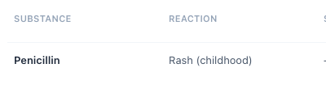  E002 Tuesday allergy table records penicillin rash in childhood.  Source: AR_Tue_EMR_Allergy_Conflict_01(1).png

  E003 Wednesday medication safety banner repeats NKDA.  Source: AR_Wed_EMR_01.png | 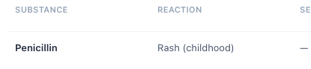  E004 Wednesday allergy table still records penicillin rash.  Source: AR_Wed_EMR_05.png

  E005 Thursday medication safety banner still reports NKDA.  Source: AR_Thu_EMR_04.png | 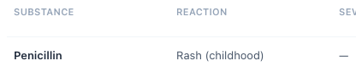  E006 Thursday allergy table still records penicillin rash.  Source: AR_Thu_EMR_05.png

V02 Angela is graded against different objective values
Priority: High | Status: Still needs developer action
Problem type: EMR versus grader | Scope: Angela Rodriguez · Tuesday values and all three ASCVD risk baselines
Verification: Confirmed
Problem: The Tuesday grader rejects multiple values that match the visible chart. Its alternative cardiovascular risk baseline then carries into Wednesday and Thursday.
What the student sees or hears: The visible Tuesday risk estimate is 14.5%. The subsequent displayed estimates are 14.5% and 13.2%. The table below separates chart values from the grader’s alternatives.
What the grader or reference expects: The grader expects Tuesday ASCVD risk of 17.4% and reuses that as the historical baseline in later visits. It also expects the alternative vital signs and laboratory results below.
Why it matters: Students lose credit for accurate transcription, and the competing values can change risk classification or treatment decisions. The intended case version cannot be determined from these conflicts alone.
Please fix: Choose and clinically validate the intended encounter data, then synchronize the EMR and grading criteria for each stage. Regrade exact chart-value submissions and verify the same baseline is used in every trend. Treat the BMI calculation separately under V19.
Field | Visible Tuesday EMR | Grader expectation
Blood pressure | 138/84; repeat 136/82 mmHg | 142/86; repeat 140/84 mmHg
Sodium; potassium | 139; 4.6 mEq/L | 138; 4.7 mEq/L
Creatinine; eGFR | 1.20 mg/dL; 53 mL/min/1.73 m² | 1.18 mg/dL; 54 mL/min/1.73 m²
AST; ALT | 22; 21 U/L | 20; 19 U/L
Total cholesterol; HDL; triglycerides | 234; 46; 200 mg/dL | 238; 41; 185 mg/dL
10-year ASCVD risk | 14.5% | 17.4%

Evidence
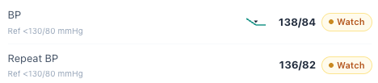  E007 Tuesday live office blood pressures are 138/84 and 136/82 mmHg.  Source: AR_Tue_EMR_Vitals_BMI_01(1).png | 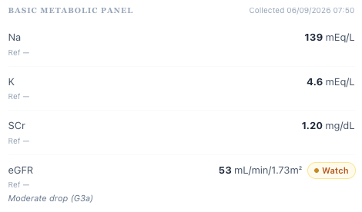  E008 Tuesday live sodium, potassium, creatinine and eGFR.  Source: AR_Tue_EMR_Lab_Values_01(1).png

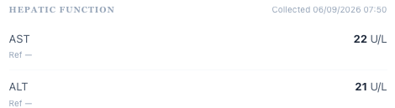  E009 Tuesday live liver enzyme values.  Source: AR_Tue_EMR_Lab_Values_01(1).png | 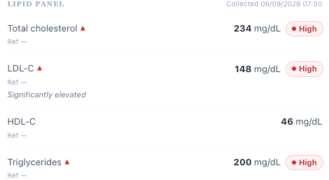  E010 Tuesday live lipid results.  Source: AR_Tue_EMR_Lab_Values_01(1).png

E011 Tuesday visible ASCVD risk is 14.5%.
Source: AR_Tue_EMR_ASCVD_Risk_01(1).png
E012 Tuesday grader substitutes 142/86 and 140/84.
Source: AR_Tue_AI_Feedback_02(1).png

E013 Tuesday grader substitutes a different set of renal laboratory values.
Source: AR_Tue_AI_Feedback_02(1).png
E014 Tuesday grader expects different liver enzymes and total cholesterol.
Source: AR_Tue_AI_Feedback_03(1).png
E015 Tuesday grader expects different HDL and triglycerides.
Source: AR_Tue_AI_Feedback_03(1).png
E016 Tuesday grader expects 17.4% instead of 14.5%.
Source: AR_Tue_AI_Feedback_03(1).png
E017 Wednesday grader carries forward the unsupported 17.4% baseline.
Source: AR_Wed_AI_Feedback_02.png
E018 Thursday grader again expects a 17.4% baseline.
Source: AR_Thu_AI_Feedback_02.png

V03 The grader requires an unsupported simvastatin history
Priority: High | Status: Still needs developer action
Problem type: EMR and AI patient versus grader | Scope: Angela Rodriguez · Tuesday and Wednesday
Verification: Confirmed
Problem: The grader expects current or prior simvastatin and its discontinuation, but that medicine is not established by the visible medication list or the medication interview.
What the student sees or hears: Tuesday lists losartan and amlodipine, with zero discontinued medicines. The patient reports that rosuvastatin was prescribed but never started. Wednesday documents rosuvastatin 20 mg daily; the current list still shows no discontinued medicine.
What the grader or reference expects: Tuesday deductions require simvastatin in medication history and a plan to stop it. Wednesday again requires an explicit simvastatin discontinuation statement.
Why it matters: This expectation pressures students to invent a medication exposure or a discontinuation action. A missing old prescription is possible, but it must be made available before it can be required.
Please fix: Either expose and reconcile the intended simvastatin history in the chart and patient script, or remove its grading requirements. Accept the actual medication reconciliation until the sources agree.

Evidence
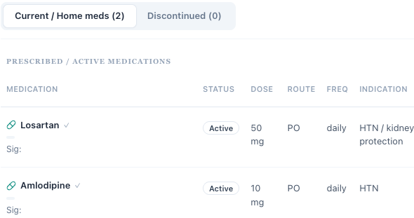
E019 Tuesday chart lists two current medicines and zero discontinued medicines; neither is simvastatin.
Source: AR_Tue_EMR_Medication_List_01(1).png
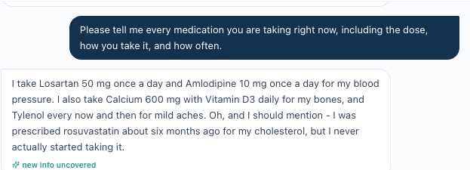
E020 Tuesday medication reconciliation identifies losartan, amlodipine, supplements and unstarted rosuvastatin.
Source: AR_Tue_INT_Patient_Interview_06(1).png
E021 Tuesday grader requires simvastatin in the medication history.
Source: AR_Tue_AI_Feedback_02(1).png
E022 Tuesday grader requires a discontinuation plan for the unestablished medicine.
Source: AR_Tue_AI_Feedback_03(1).png
E023 Wednesday grader repeats the simvastatin discontinuation expectation.
Source: AR_Wed_AI_Feedback_02.png

V04 Metformin renal dose adjustment is penalized
Priority: High | Status: Still needs developer action
Problem type: Clinical safety and grader reference | Scope: David Chen · Tuesday, Wednesday and Thursday
Verification: Confirmed with direct EMR evidence at all three stages
Problem: All three feedback sets deduct 0.8 points for reducing metformin ER from 1,000 mg twice daily to 1,000 mg total daily.
What the student sees or hears: The live renal panels show eGFR 42 on Tuesday, 40 on Wednesday and 41 on Thursday. The follow-up creatinine values are 1.90 and 1.85 mg/dL; potassium is 5.1 then 4.9 mEq/L. Patient medication interviews continue to report metformin ER 1,000 mg twice daily.
What the grader or reference expects: The grader explicitly requires continuation of 1,000 mg twice daily. ADA/KDIGO recommends reducing metformin to 1,000 mg daily when eGFR is 30–44 mL/min/1.73 m² [R1].
Why it matters: The fixed-dose expectation penalizes a recommended safety adjustment for reduced kidney clearance. Direct EMR and grader evidence now support the finding at all three stages.
Please fix: Replace the unconditional continuation criterion with renal-dose-aware scoring. Accept a justified 1,000 mg total daily plan with appropriate monitoring. Retest the grading at all three stages after the criterion is corrected.

Evidence
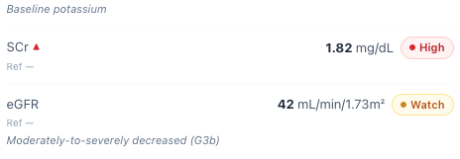
E024 Tuesday live creatinine 1.82 mg/dL and eGFR 42 mL/min/1.73 m².
Source: DC_Tue_EMR_Renal_Labs_01.png
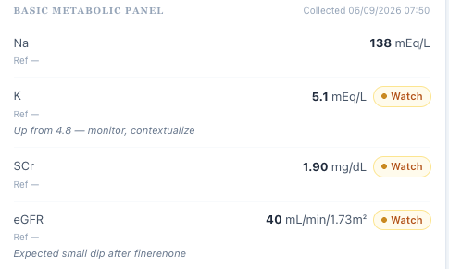  E025 Wednesday live potassium 5.1 mEq/L, creatinine 1.90 mg/dL and eGFR 40 mL/min/1.73 m².  Source: DC_Wed_EMR_Renal_Labs_01.png | 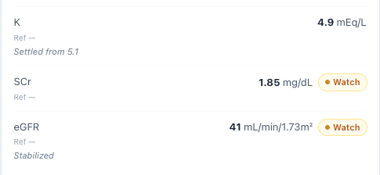  E026 Thursday live potassium 4.9 mEq/L, creatinine 1.85 mg/dL and eGFR 41 mL/min/1.73 m².  Source: DC_Thu_EMR_Renal_Labs_01.png

E027 Tuesday deducts 0.8 points for renal dose reduction.
Source: DC_Tue_AI_Feedback_03.png
E028 Wednesday deducts 0.8 points for 1,000 mg total daily instead of twice daily.
Source: DC_Wed_AI_Feedback_03.png
E029 Thursday repeats the same 0.8-point deduction.
Source: DC_Thu_AI_Feedback_02.png
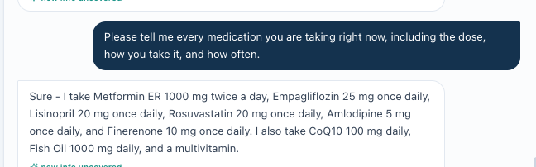
E030 Thursday patient reports metformin ER 1,000 mg twice daily along with the rest of the regimen.
Source: DC_Thu_INT_Patient_Interview_06.png

V05 A father’s heart attack at 61 is misclassified as premature
Priority: Medium | Status: Still needs developer action
Problem type: Clinical reference and EMR versus grader | Scope: Michael Turner · Tuesday, Wednesday and Thursday
Verification: Confirmed
Problem: The chart and grader treat the father’s heart attack at age 61 as meeting the formal premature-ASCVD family-history criterion.
What the student sees or hears: The father’s event age is consistently 61. The student’s distinction that this does not meet the male premature-event cutoff is penalized on each day.
What the grader or reference expects: The grader requires recognition of premature ASCVD. The conventional risk-enhancer definition uses an event before age 55 in a male first-degree relative and before 65 in a female relative [R5].
Why it matters: The family history remains relevant, but this incorrect label can distort risk reasoning and teaches the wrong criterion.
Please fix: Retain the actual family history and correct the premature-event label and grading logic. Do not change the father’s age merely to make it satisfy a risk-enhancer rule.

Evidence
E031 The family-history line calls a father’s heart attack at 61 premature ASCVD.
Source: MT_Tue_EMR_Social_Family_History_01(1).png
E032 Tuesday penalizes the correct male-age threshold interpretation.
Source: MT_Tue_AI_Feedback_02(2).png
E033 Wednesday repeats the premature-family-history deduction.
Source: MT_Wed_AI_Feedback_02.png
E034 Thursday repeats the same clinical classification conflict.
Source: MT_Thu_AI_Feedback_02(1).png

V06 Initial urine albumin history is required without an accessible dated record
Priority: Medium | Status: Still needs developer action
Problem type: Missing objective data and grading workflow | Scope: David Chen, Michael Turner and Angela Rodriguez · Tuesday
Verification: Confirmed availability gap in the supplied workflow
Problem: Initial grading requires historical urine albumin values or confirmed persistence beyond what the supplied chart evidence makes available.
What the student sees or hears: David’s chart shows UACR 520 mg/g. Michael’s shows 118 with an undated “prior 105.” Angela’s shows 165. The reviewer confirmed no additional dated UACR history was available.
What the grader or reference expects: David’s grader requires 505 as the prior value. Michael’s grader penalizes requesting a date to verify chronicity. Angela’s grader requires a prior result and trend without identifying an accessible record.
Why it matters: Students cannot create a historical result or its timing. CKD chronicity requires supporting evidence over at least three months, although an established diagnosis can also be supported by other clinical history [R2]. This finding does not erase the chart’s CKD diagnosis.
Please fix: Expose the required historical result and its time relationship, or award credit for documenting the missing data and a verification plan. Retest from the student view. Current-field screenshots cannot independently prove absence from every possible chart screen; the reviewer’s availability confirmation is part of the evidence.

Evidence
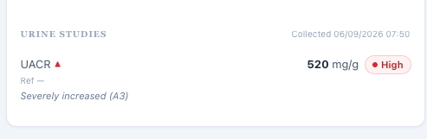  E035 David Tuesday shows current UACR 520 mg/g without the grader’s prior value.  Source: DC_Tue_EMR_UACR_History_01.png | 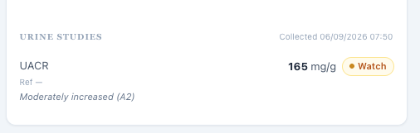  E036 Angela Tuesday shows current UACR 165 mg/g without a prior measurement.  Source: AR_Tue_EMR_UACR_History_01(1).png

E037 David grader requires a prior value of 505 mg/g and a comparison.
Source: DC_Tue_AI_Feedback_02.png
E038 Angela grader requires an unavailable historical value and trend.
Source: AR_Tue_AI_Feedback_03(1).png
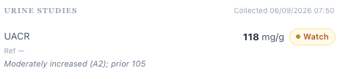
E039 Michael Tuesday shows current UACR 118 mg/g and prior 105, without a historical collection date.
Source: MT_Tue_EMR_Objective_Data_01(1).png
E040 Michael grader penalizes requesting the missing historical date.
Source: MT_Tue_AI_Feedback_02(2).png

V07 Michael’s personal history and uncertain answers conflict with grading
Priority: Medium | Status: Still needs developer action
Problem type: AI patient versus EMR and grader | Scope: Michael Turner · Tuesday, Wednesday and Thursday
Verification: Confirmed
Problem: The patient repeatedly supplies one personal history while the chart or grader expects another. Exact drug doses and condition durations are also required after the patient says he does not know them.
What the student sees or hears: The interview identifies a warehouse manager, about 10 pack-years, cessation about five years ago, and 1–2 drinks per month. Tuesday follow-up questions do not establish an exact ibuprofen dose or condition durations.
What the grader or reference expects: The chart says accountant, 20 pack-years and cessation six years ago. Follow-up graders use those values and weekly alcohol. Tuesday grading expects ibuprofen 400–600 mg and hypertension/hyperlipidemia durations of eight/five years.
Why it matters: These are substantive source conflicts, not transcription mistakes. Converting a tentative 200 mg tablet guess into a verified 400–600 mg dose would overstate the available medication history.
Please fix: Reconcile the patient script, chart and gradeable history. Preserve unknown or uncertain answers when directly elicited. If exact values are required, make them reliably obtainable without leading the patient.

Evidence
E041 Michael chart says accountant and 20 pack-years with smoking cessation six years ago.
Source: MT_Tue_EMR_Social_Family_History_01(1).png
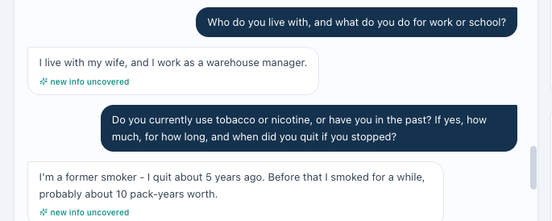
E042 Thursday patient reports warehouse manager, smoking cessation five years ago and about 10 pack-years.
Source: MT_Thu_INT_Patient_Interview_08(1).png

E043 Wednesday patient reports 1–2 drinks per month.
Source: MT_Wed_INT_Patient_Interview_07.png
E044 Wednesday grader expects six years, 20 pack-years and weekly drinking.
Source: MT_Wed_AI_Feedback_03.png
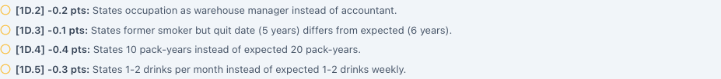
E045 Thursday repeats the conflicting history expectations.
Source: MT_Thu_AI_Feedback_02(1).png
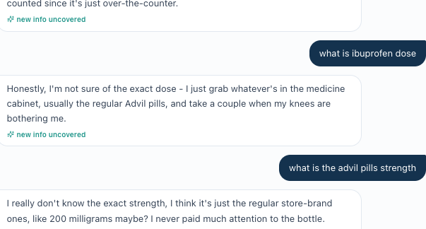
E046 Tuesday patient is unsure of ibuprofen dose and tablet strength even after follow-up.
Source: MT_Tue_INT_Patient_Interview_01(1).png
E047 Tuesday grader requires an unconfirmed 400–600 mg dose.
Source: MT_Tue_AI_Feedback_02(2).png
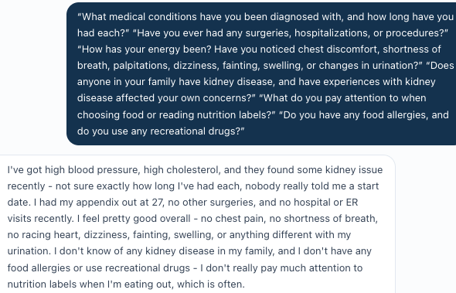
E048 Tuesday patient says condition durations are unknown in response to a direct question.
Source: MT_Tue_INT_Patient_Interview_07(2).png
E049 Tuesday grader requires exact durations of eight and five years.
Source: MT_Tue_AI_Feedback_02(2).png

V08 Michael is graded for lifestyle changes he does not report
Priority: Medium | Status: Still needs developer action
Problem type: AI patient versus grader | Scope: Michael Turner · Tuesday, Wednesday and Thursday
Verification: Confirmed
Problem: The grader requires a progressively improving walking and diet narrative even when the patient denies an established exercise routine or new dietary changes.
What the student sees or hears: Tuesday: sedentary and unable to sustain a routine. Wednesday: reduced ibuprofen but no other specific diet or exercise change. Thursday: trying to eat out less, but still no set exercise routine.
What the grader or reference expects: Tuesday grading expects walking one to two times weekly. Wednesday expects fewer restaurant meals, more home cooking and regular walking. Thursday expects walking four to five days weekly. Wednesday also penalizes avoiding an unsupported causal attribution for weight loss.
Why it matters: The student is pushed to document behaviors that were not reported and to attribute measured weight change to an unverified cause.
Please fix: Align the stage-specific patient answers and grading expectations. Reward accurate reports of limited behavior change and appropriate new goals. Do not require exercise or dietary causation solely because weight decreased.

Evidence

E050 Tuesday patient describes being sedentary and having no sustained exercise routine.
Source: MT_Tue_INT_Patient_Interview_02(2).png
E051 Tuesday grader expects walking one to two times weekly.
Source: MT_Tue_AI_Feedback_02(2).png

E052 Wednesday patient reports no specific diet or exercise changes.
Source: MT_Wed_INT_Patient_Interview_04.png
E053 Wednesday grader requires diet and walking changes that were denied.
Source: MT_Wed_AI_Feedback_02.png
E054 Wednesday grader requires attribution of weight loss to unconfirmed behavior change.
Source: MT_Wed_AI_Feedback_03.png
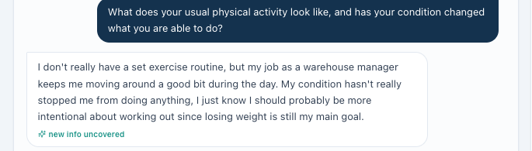
E055 Thursday patient still reports no set exercise routine.
Source: MT_Thu_INT_Patient_Interview_09(1).png
E056 Thursday grader expects walking four to five days weekly.
Source: MT_Thu_AI_Feedback_02(1).png

V09 Michael’s home blood pressure record does not match the interview
Priority: Medium | Status: Still needs developer action
Problem type: AI patient versus EMR and missing-data grading | Scope: Michael Turner · Tuesday, Wednesday and Thursday
Verification: Confirmed
Problem: Tuesday’s chart contains a home log that the patient does not report. Wednesday and Thursday grading requires home values after the patient explicitly denies monitoring.
What the student sees or hears: Tuesday’s EMR supplies a five-day average near 136/83; the patient cannot recall readings and says he does not write them down. Wednesday and Thursday he says he has no home readings. The reviewer confirmed that no current home average or range was available in those follow-up EMRs.
What the grader or reference expects: Follow-up deductions require an average, a range or comparison with office BP. Tuesday is different: the visible chart average was available and should not be described as hidden.
Why it matters: Accurate documentation of absent readings is penalized on follow-up. Tuesday’s disagreement needs reconciliation rather than deletion of an available chart value.
Please fix: Synchronize the Tuesday patient response with the actual log or provide an explanation. On follow-up, expose any intended log or accept “not monitoring/no readings” with a monitoring plan. The final Wednesday source is MT_Wed_Patient_Interview_Home_BP_01.png and remains interview evidence.

Evidence
E057 Tuesday chart supplies a five-day average of about 136/83 mmHg.
Source: MT_Tue_EMR_Objective_Data_02(1).png
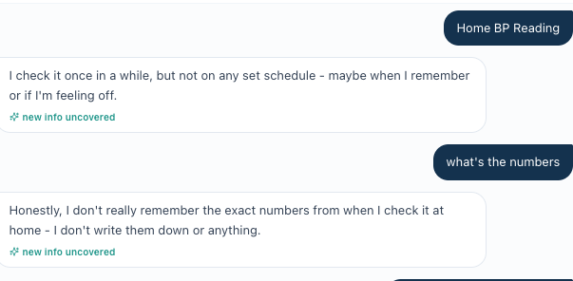
E058 Tuesday patient reports no written record and cannot recall numbers.
Source: MT_Tue_INT_Patient_Interview_04(2).png
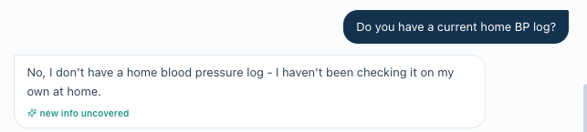
E059 Wednesday patient reports no home monitoring or log; the final filename correctly identifies interview evidence.
Source: MT_Wed_Patient_Interview_Home_BP_01.png
E060 Wednesday grader requires an average and office comparison after monitoring was denied.
Source: MT_Wed_AI_Feedback_03.png
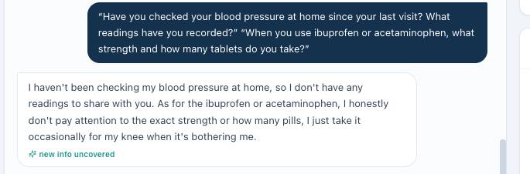
E061 Thursday patient again reports no home BP readings.
Source: MT_Thu_INT_Patient_Interview_11(1).png
E062 Thursday grader requires an average and range.
Source: MT_Thu_AI_Feedback_02(1).png

V10 David’s denials and treatment commitment are replaced by expected concerns
Priority: Medium | Status: Still needs developer action
Problem type: AI patient versus grader | Scope: David Chen · Tuesday and Thursday
Verification: Confirmed
Problem: The grader expects symptoms, barriers or uncertainty that conflict with the obtained answers.
What the student sees or hears: Tuesday David denies fatigue and cost/access barriers. Thursday he says the data convinced him to continue therapy. When asked about lifestyle changes, he describes walking but cannot specify dietary changes.
What the grader or reference expects: Tuesday deductions require mild fatigue and a cost concern. Thursday deductions require questioning continued treatment and reporting dietary improvement.
Why it matters: A student would have to reverse the patient’s answer to meet these criteria. Discussing possible future cost barriers is reasonable; documenting a denied barrier as currently present is not.
Please fix: Accept the actual denials, expressed treatment commitment and dietary uncertainty. If the intended stage requires a particular concern, revise the patient interaction and confirm it can be elicited neutrally before retaining that scoring requirement.

Evidence

E063 Tuesday patient denies fatigue and other listed symptoms.
Source: DC_Tue_INT_Patient_Interview_01.png
E064 Tuesday grader expects mild fatigue.
Source: DC_Tue_AI_Feedback_02.png

E065 Tuesday patient denies medication access and cost barriers.
Source: DC_Tue_INT_Patient_Interview_06.png
E066 Tuesday grader expects a cost concern despite the answer.
Source: DC_Tue_AI_Feedback_02.png
E067 The same cost mismatch also affects the assessment grade.
Source: DC_Tue_AI_Feedback_03.png
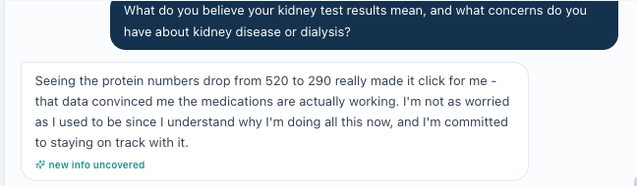
E068 Thursday patient says the evidence convinced him and he is committed to treatment.
Source: DC_Thu_INT_Patient_Interview_04.png
E069 Thursday grader expects him to question whether continued therapy is necessary.
Source: DC_Thu_AI_Feedback_02.png

E070 Thursday patient cannot specify dietary changes.
Source: DC_Thu_INT_Patient_Interview_04.png
E071 Thursday grader expects dietary improvement rather than uncertainty.
Source: DC_Thu_AI_Feedback_02.png

V11 Angela’s symptoms and lifestyle answers conflict with grading
Priority: Medium | Status: Still needs developer action
Problem type: AI patient versus grader | Scope: Angela Rodriguez · Tuesday, Wednesday and Thursday
Verification: Confirmed for the specific elicited items below
Problem: The grader substitutes expected symptoms, durations and behavior details for the patient’s actual responses.
What the student sees or hears: Tuesday she denies the listed symptoms and gives uncertain condition dates. Wednesday she reports walking but no major diet change. Thursday she reports more cooking and healthier choices without specific processed-food reduction, and says dialysis is not her current focus.
What the grader or reference expects: Tuesday criteria require fatigue, nighttime cramps, 15 years of hypertension and 12 years of hyperlipidemia. Later criteria require specific dietary improvements and explicit dialysis-avoidance motivation.
Why it matters: A broad report of healthier choices does not establish a specific change in packaged-food intake. A general concern about kidney health does not automatically establish the exact personal motivation required by the grader.
Please fix: Grade the elicited symptoms, timing, dietary details and priorities accurately. Accept uncertainty. Keep unasked subjects separate: no confirmed defect is assigned here for Thursday home BP or independence, and the supposed question about stopping lifelong therapy is not treated as a verified patient statement.

Evidence

E072 Tuesday patient denies the symptoms in the question, including fatigue and cramps.
Source: AR_Tue_INT_Patient_Interview_01(1).png
E073 Tuesday grader expects fatigue and nighttime cramps.
Source: AR_Tue_AI_Feedback_02(1).png
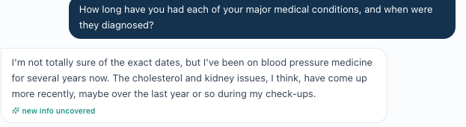
E074 Tuesday patient reports uncertain dates, several years of BP treatment, and newer cholesterol/kidney issues.
Source: AR_Tue_INT_Patient_Interview_04(1).png
E075 Tuesday grader expects 15 years of hypertension and 12 years of hyperlipidemia.
Source: AR_Tue_AI_Feedback_02(1).png

E076 Wednesday patient reports regular walking but no major dietary changes.
Source: AR_Wed_INT_Patient_Interview_03(1).png
E077 Wednesday grader expects reduced packaged-food intake.
Source: AR_Wed_AI_Feedback_02.png
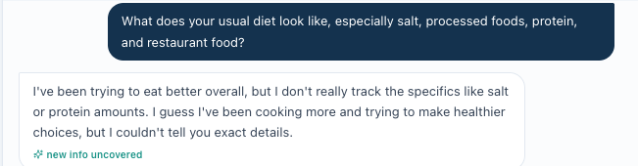
E078 Thursday patient reports healthier choices and more cooking but cannot give the requested dietary specifics.
Source: AR_Thu_INT_Patient_Interview_09.png
E079 Thursday grader requires a specific processed-food reduction not established by the answer.
Source: AR_Thu_AI_Feedback_02.png
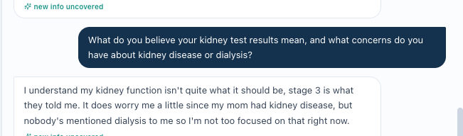
E080 Thursday patient says dialysis is not her current focus when directly asked.
Source: AR_Thu_INT_Patient_Interview_09.png
E081 Thursday grader instead requires explicit dialysis-avoidance motivation.
Source: AR_Thu_AI_Feedback_02.png

V12 A reasonable blood pressure plan appears under an unsafe warning
Priority: High | Status: Still needs developer action
Problem type: Safety-warning classification and clinical grading | Scope: Angela Rodriguez · Wednesday, with a related Tuesday dosing expectation
Verification: Confirmed warning contradiction; dosing criteria need clinical review
Problem: Wednesday places losartan titration under “UNSAFE RECOMMENDATIONS” while the same text explicitly calls it clinically reasonable and not unsafe.
What the student sees or hears: The patient reports home BP around 136/82 and no dizziness. The visible regimen is losartan 50 mg plus amlodipine 10 mg. The submitted recommendation is described by the grader as increasing losartan to 100 mg.
What the grader or reference expects: The grader insists on deferring intensification/continuing 50 mg. Tuesday also deducts for a proposed increase. The full submitted SOAP is not separately preserved here, so any claimed internal note inconsistency cannot be independently adjudicated.
Why it matters: A rubric-preferred choice is presented as a safety problem despite the grader’s own statement to the contrary. CKD guidance supports using a tolerated, approved dose of an ACE inhibitor or ARB with kidney-function and potassium monitoring after changes [R2]. That does not make escalation mandatory for every patient.
Please fix: Remove the unsafe classification unless a specific clinical hazard is identified. Let clinical faculty define acceptable continuation and titration pathways based on BP, tolerance, shared decisions and follow-up labs. Check assessment–plan consistency against the submitted text, not against a preferred answer alone.

Evidence

E082 The unsafe-recommendation heading contains text that expressly says the recommendation is not unsafe.
Source: AR_Wed_AI_Feedback_01.png
E083 Wednesday grader requires continuation at 50 mg instead of titration.
Source: AR_Wed_AI_Feedback_03.png
E084 Tuesday grader also insists on 50 mg rather than a supported titration plan.
Source: AR_Tue_AI_Feedback_03(1).png
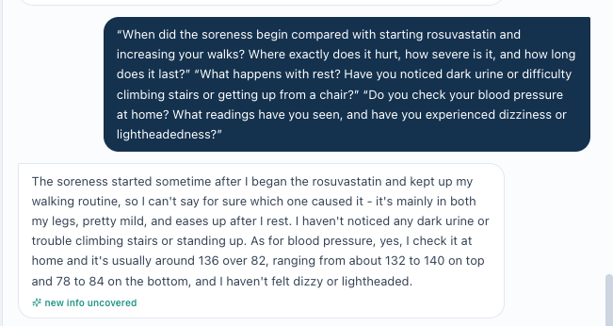
E085 Wednesday patient provides home BP about 136/82 and denies dizziness; the complete question and answer are preserved.
Source: AR_Wed_INT_Patient_Interview_09(2).png

V13 Guideline citations are called optional and then scored as required
Priority: Low | Status: Still needs developer action
Problem type: Internal grader feedback inconsistency | Scope: David Chen · Tuesday
Verification: Confirmed wording conflict
Problem: The narrative says adding guideline names is not required for credit, while the deduction list removes credit for missing a guideline name.
What the student sees or hears: The final narrative presents explicit ACC/AHA or KDIGO names as an optional enhancement.
What the grader or reference expects: A separate deduction removes 0.4 points because the KDIGO 2024 CKD guideline is not cited. Other citation-related deductions are also present.
Why it matters: The learner cannot tell which citation requirements are mandatory. This is a feedback-consistency finding, not a conclusion that all guideline-reference deductions are invalid.
Please fix: Make the narrative and scoring contract agree. State which citation elements earn points and which are optional, then retest feedback for a note with and without the required citation.

Evidence
E086 Narrative says additional guideline names are not required for credit.
Source: DC_Tue_AI_Feedback_01.png
E087 The same feedback deducts points for not citing the guideline name.
Source: DC_Tue_AI_Feedback_02.png

V14 Lipid goals and acceptable escalation need clinical review
Priority: High | Status: Still needs clinical and developer review
Problem type: Clinical reference and risk-method transparency | Scope: David Chen Wednesday; Michael Turner Wednesday; Angela Rodriguez Wednesday and maintenance decisions
Verification: Clinical review required
Problem: Several deductions favor describing LDL as controlled or rejecting further treatment discussion without a clearly documented risk method and target.
What the student sees or hears: David’s live Wednesday lipid panel confirms LDL 82 mg/dL with diabetes and CKD; the grader also quotes 82. Michael’s live LDL is 96 and displayed risk is 10.7%. Angela’s live Wednesday LDL is 89 with displayed risk 14.5%; Thursday LDL is 78. The calculator used for the displayed percentages is not identified.
What the grader or reference expects: David’s grader requires “controlled.” Michael’s requires no further intensification. Angela’s penalizes discussing ezetimibe. ADA 2026 supports an LDL goal below 70 for higher-risk adults aged 40–75 with diabetes [R3]. The 2026 lipid guideline uses PREVENT risk, with different goals across risk categories; its thresholds cannot simply be applied to an unidentified older score [R4].
Why it matters: A favorable LDL change does not by itself settle the treatment target. Conversely, these screenshots alone do not establish that every patient needs a nonstatin drug. The newly supplied lipid screenshot resolves David’s source gap; the treatment and grading criteria still need clinical review.
Please fix: Have clinical faculty specify the guideline, calculator, inputs, risk category, LDL goal and accepted treatment alternatives. Allow justified shared-decision plans, including conditional escalation, rather than forcing a universal no-change answer. Retest the revised criteria against the confirmed LDL values.

Evidence

E088 David Wednesday live LDL is 82 mg/dL, confirming the value evaluated by the grader.
Source: DC_Wed_EMR_Lipid_Panel_01.png
E089 David grader requires LDL 82 mg/dL to be described as controlled.
Source: DC_Wed_AI_Feedback_03.png
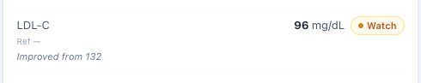  E090 Michael Wednesday live LDL is 96 mg/dL, improved from 132.  Source: MT_Wed_EMR_Lipid_Panel_01.png | 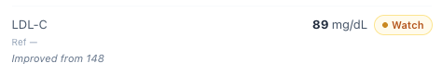  E091 Angela Wednesday live LDL is 89 mg/dL, improved from 148.  Source: AR_Wed_EMR_03.png

E092 Michael grader requires a no-intensification conclusion before the risk method is clarified.
Source: MT_Wed_AI_Feedback_01.png
E093 Angela grader penalizes discussion of an additional LDL-lowering medicine.
Source: AR_Wed_AI_Feedback_03.png

V15 The blood pressure target is graded without its measurement context
Priority: Medium | Status: Still needs clinical and developer review
Problem type: Clinical guideline interpretation | Scope: Michael Turner · Tuesday
Verification: Clinical review required
Problem: The grader deducts for a BP goal below 130/80 and expects systolic BP below 120, without documenting the measurement conditions needed to apply that target.
What the student sees or hears: The chart itself displays a reference below 130/80. The interview describes casual home measurement without a standardized technique.
What the grader or reference expects: KDIGO’s systolic goal below 120 applies to standardized office measurements when tolerated [R2]. The 2025 AHA/ACC guideline supports a systolic goal below 130 in CKD [R6]. These are not interchangeable readings or universally exclusive approaches.
Why it matters: A single rigid target can make a clinically supported plan appear wrong and omit the role of measurement technique and tolerance.
Please fix: Specify the measurement method and intended guideline framework. Accept a justified goal with standardized or home BP follow-up, and reserve deductions for an actually unsupported target or missing rationale.

Evidence
E094 Michael grader rejects the stated BP goal in favor of a KDIGO systolic target below 120.
Source: MT_Tue_AI_Feedback_03(2).png

V16 A small urine albumin change is treated as definite clinical improvement
Priority: Medium | Status: Still needs clinical and developer review
Problem type: Clinical interpretation and grading | Scope: Angela Rodriguez · Thursday
Verification: Clinical review required
Problem: The grader penalizes cautious language about whether the small UACR decline establishes meaningful improvement.
What the student sees or hears: The live trend is 165 to 160 to 155 mg/g: a numerical decline of about 6.1% from the first value, remaining in the A2 range.
What the grader or reference expects: The grader requires progressive or modest improvement. KDIGO notes substantial within-person ACR variability; even much larger reductions can reflect fluctuation [R2].
Why it matters: Describing the direction as a small numerical improvement is reasonable. Claiming that this alone proves a treatment effect or meaningful risk reduction is stronger than the available data support. The exact submitted wording should also be reviewed before changing a score.
Please fix: Accept language such as “small downward trend with persistent A2 albuminuria; clinical significance uncertain.” Distinguish arithmetic change from established treatment benefit and continue to require appropriate CKD interpretation and monitoring.

Evidence
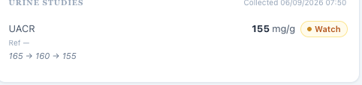
E095 Angela Thursday UACR is 155 mg/g with the visible 165 to 160 to 155 trend.
Source: AR_Thu_EMR_02.png
E096 Grader requires progressive improvement rather than a cautious interpretation of the small change.
Source: AR_Thu_AI_Feedback_02.png
E097 A second deduction expects a modest-improvement statement.
Source: AR_Thu_AI_Feedback_02.png
  - INTERFACE AND CALCULATION FINDINGS

V17 Populated objective fields are labeled missing
Priority: Low | Status: Still needs developer action
Problem type: Interface and data-state labeling | Scope: Michael Turner and Angela Rodriguez · all three stages
Verification: Confirmed
Problem: The additional-objective-data area prefixes populated values with “Missing.”
What the student sees or hears: The same line displays Missing and a numeric body-surface area or ASCVD score. Michael Tuesday also has a populated home BP average; Angela Tuesday includes a populated rosuvastatin fill-history statement.
What the grader or reference expects: No grader comparison is needed. A missing-data indicator should reflect actual data availability.
Why it matters: Students may overlook usable data or assume they must calculate or elicit a value that is already present. This report does not count these populated fields as inaccessible.
Please fix: Use a neutral label for supplemental data and a missing indicator only for absent values. Verify all affected stages and ensure changing the label does not remove the actual value.

Evidence
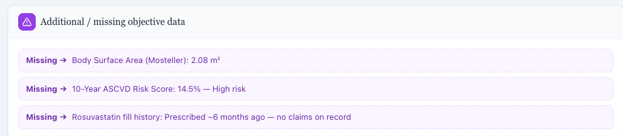
E098 Populated calculated values and fill history are marked Missing.
Source: AR_Tue_EMR_ASCVD_Risk_01(1).png
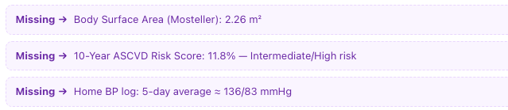
E099 Michael Tuesday labels a populated home BP log and calculated values Missing.
Source: MT_Tue_EMR_Objective_Data_02(1).png
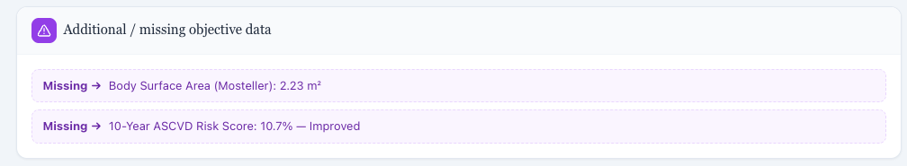
E100 The Missing label persists on Wednesday despite displayed values.
Source: MT_Wed_EMR_Additional_Objective_Data_01(1).png

E101 Angela Thursday repeats the Missing labels on populated values.
Source: AR_Thu_EMR_03.png

V18 The LDL row displays a urine albumin trend
Priority: Low | Status: Still needs developer action
Problem type: Interface annotation | Scope: Michael Turner · Thursday
Verification: Confirmed
Problem: The LDL cholesterol row includes the UACR trend 118 to 102 to 98.
What the student sees or hears: The current LDL value is correctly shown as 84 mg/dL, but the annotation beneath it names a urine albumin sequence. The supplied LDL sequence is 132 to 96 to 84 mg/dL.
What the grader or reference expects: The LDL annotation should describe LDL. The UACR trend belongs with the urine result.
Why it matters: The mixed annotation can confuse which measurement is improving and can contaminate copied clinical documentation.
Please fix: Move the UACR annotation to its matching result. If an LDL trend is displayed, use 132 to 96 to 84 with the correct units and encounter mapping.

Evidence
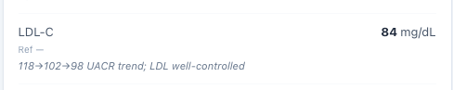
E102 The LDL row contains the UACR trend 118 to 102 to 98.
Source: MT_Thu_EMR_LDL_UACR_Annotation_01(1).png

V19 Angela’s displayed initial BMI does not match height and weight
Priority: Low | Status: Still needs developer action
Problem type: Internal EMR calculation | Scope: Angela Rodriguez · Tuesday
Verification: Confirmed
Problem: The chart displays BMI 35.9 with a weight and height that calculate to about 36.3.
What the student sees or hears: Weight is 96 kg and height is 5 feet 4 inches (1.6256 m). BMI = 96 ÷ 1.6256² = 36.33 kg/m², which rounds to 36.3.
What the grader or reference expects: The grader’s 36.3 is arithmetically consistent with the displayed height and weight. The live 35.9 is the inconsistent value.
Why it matters: A student who accurately copies the displayed BMI loses credit. This is a chart calculation problem, not evidence that the grader’s formula is wrong.
Please fix: Recalculate BMI from the same encounter’s height and weight, or correct the underlying measurement if it is wrong. Use consistent rounding and retest the displayed value and grade together.

Evidence
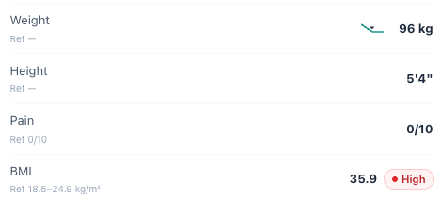
E103 Angela Tuesday shows 96 kg, 5 feet 4 inches and BMI 35.9 together.
Source: AR_Tue_EMR_Vitals_BMI_01(1).png
E104 Grader correctly calculates approximately 36.3; the displayed chart BMI needs correction.
Source: AR_Tue_AI_Feedback_03(1).png

Disposition of other observations
These checks explain why the audit does not treat every deduction or missing answer as a defect. They are not additional counted findings.
Observation | Audit disposition
Static age, DOB and calendar differences | Excluded by the supplied simulation audit rules. Stated visit stages were used; no age was recalculated.
Different suggested follow-up intervals | A recommendation for the next visit is not proof that the grader used the wrong current visit stage. These deductions are not labeled stage-synchronization defects.
Michael Tuesday risk score, vaccines and home BP | These are visible in supplied EMR screenshots. Omissions may be documentation misses; the report does not label them unavailable.
Michael Thursday risk comparison | 10.7% is Wednesday’s value; 11.8% is the visible initial baseline. Requiring a clearly labeled baseline comparison is not automatically a wrong-value defect.
Angela Thursday home BP | No current readings were elicited in the saved interview; the reviewer also reported no current EMR log. The 1.2 points across 2A.7, 2A.8 and 2C.4 remain an interview/documentation gap, not a confirmed grader-data conflict.
Angela Tuesday home BP and Thursday independence | Not adequately elicited. Absence from the supplied record does not prove that a direct question would fail to obtain the information.
Angela Thursday questions about stopping treatment | The expected personal question is not established in the saved interview. Keep it as a script-review question, not a proven symptom or a counted defect beyond V11’s direct answer conflicts.
Angela Tuesday historical rosuvastatin dose | The dose of the unstarted prescription was not confirmed by the interview. Do not backfill the later 20 mg dose into that historical prescription as a verified fact.
Angela Wednesday leg soreness | The patient describes mild soreness after walking and cannot establish its cause. Thursday it resolves. Do not label a confirmed statin injury or require a severe-toxicity conclusion from these facts.
Michael atorvastatin intensity wording | Atorvastatin 20 mg is moderate intensity; 40 mg is high intensity. The option says 20–40 mg “toward” a high-intensity dose, so it is ambiguous wording rather than a confirmed claim that 20 mg is high intensity.
David Tuesday referral source | A pharmacist-initiated follow-up concern does not rule out a PCP referral. The formal referral source is not sufficiently established to call the PCP expectation false.
Routine SOAP completeness | Medication routes, guideline references, supported numeric trends, symptom questions, vaccine plans and explicit assessment–plan links can be legitimate documentation opportunities. They were not turned into software defects.
Unknown OTC doses and uncertain history | Preserve uncertainty. A deduction is only reported as a mismatch when the expected fact conflicts with an actual answer or is unavailable in the verified workflow.
Duplicate screenshots and score totals | Sixteen byte-identical duplicate files were excluded from the analytical count, including the renamed Wednesday home-BP copy. Screenshot overlap was not counted twice. No total score was recomputed or predicted without the complete scoring contract.
Fix status and technical failures | No implemented fix or successful retest was supplied. No saved screenshot demonstrates a grading parser failure. All reported defects remain initial observations, not post-fix test results.

Clinical references
Official clinical sources were checked for the treatment-changing findings. References support interpretation; they do not replace the patient-specific chart or interview. Accessed 10 October 2026.
R1 ADA and KDIGO consensus report on diabetes management in CKD
2022 · Metformin consensus statement and renal dose guidance.
Open source

R2 KDIGO Clinical Practice Guideline for Evaluation and Management of CKD
2024 · Chronicity; recommendations 3.4.1 and practice points 3.6.1–3.6.2; albuminuria variability discussion, printed page S198.
Open source

R3 ADA Standards of Care Cardiovascular Disease and Risk Management
2026 · Recommendations 10.20–10.21 on higher-risk diabetes and LDL targets.
Open source

R4 ACC and AHA Multisociety Guideline on Management of Dyslipidemia
2026 · PREVENT-based risk categories and primary-prevention treatment goals.
Open source

R5 ACC Guidelines Made Simple on Blood Cholesterol
2018 guideline summary · Formal premature-ASCVD family-history age thresholds.
Open source

R6 AHA and ACC Multisociety High Blood Pressure Guideline
2025 · Section 5.3.8 on hypertension treatment in CKD.
Open source

Statin dose-intensity cross-check: ACC statin-intolerance tool (atorvastatin 10–20 mg moderate; 40–80 mg high).
Open ACC statin-intensity reference

Retest acceptance checklist
Use this report’s finding IDs when reporting fixes. Close a finding only after the affected student-facing source and the relevant grading behavior have been retested.
- V01–V04: correct the allergy display, reconcile the objective values and medication history, and test the renal-dose-aware metformin criterion.
- V05–V11: ask neutral questions that reproduce the relevant patient answers. Verify that documented denials, uncertainty and absent readings do not trigger deductions for hidden facts.
- V12–V16: obtain clinical sign-off on accepted alternatives, calculator and target definitions, and warning severity. Retest both acceptable alternatives and genuinely unsafe or unsupported plans.
- V17–V19: verify populated-field labels, the LDL/UACR annotation and the BMI calculation at the affected stages.
- Preserve the full retest interview and grader feedback before reset. Record Not Fixed, Partially Fixed, Unable to Verify or New as appropriate. A duplicate upload is not a successful retest.
Final audit status Nineteen findings remain open for developer action or clinical investigation. No confirmed fix is claimed in this Initial Audit.

