Week 2 EMR / SOAP Grading Issue Report
Organized by Patient and Day - Programmer Review
Scope: This report contains only the patient/day issues currently documented in the supplied Week 2 issue file. Other patients and days are being reviewed separately by another student.

Testing Conditions
- Issues were reproduced/rechecked after performing a hard refresh of the application.
- The same workflows were also checked in an incognito/private browsing tab to reduce the likelihood that cached browser data, cookies, or local session state were causing the discrepancy.
- Screenshots below are retained as evidence of what was visible to the student and what the grader returned.
- Severity is based on likely impact: High = medication/allergy/lab/vital or other clinically important source mismatch; Medium = hidden/inaccessible rubric data, interview-vs-grader mismatch, or cross-day inconsistency; Low = minor wording/display inconsistency with limited impact.

Executive Summary
The repeated pattern is that the grading engine sometimes appears to use a different source of truth than the information visible in the EMR or elicited from the standardized patient interview. The most concerning examples involve medications, allergies, vitals, and laboratory values. Additional recurring issues involve rubric-required data that are not visible or cannot be obtained from the patient on that day.
High severity | Medium severity | Low severity
5 | 13 | 0
Note: Counts reflect the distinct issue groups documented in this report; a single issue may contain multiple rubric deductions.

David Chen - Week 2 Tuesday Initial Visit
1. Tdap required by grader but not displayed in EMR [Medium severity] Point deduction: -0.3 pts
What the student sees | The immunization section shows influenza and COVID-19 as up to date, pneumococcal as none documented, and Shingrix as none documented. Tdap is not displayed.
What the grader does | The grader deducted points because Tdap/Td was not characterized as overdue.
Why this is a problem | The student is being graded on information that is not visible in the immunization section.
Recommended fix | Either display Tdap status in the EMR before grading or remove Tdap-specific scoring when the field is unavailable.

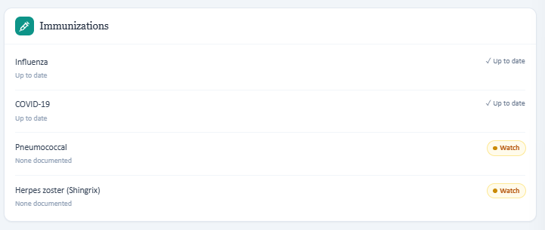
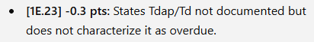

2. Allergy information is internally inconsistent [High severity] Point deduction: -0.4 pts
What the student sees | The patient header displays “Allergies: No known,” while the detailed allergy tab shows a sulfa (trimethoprim/sulfamethoxazole) allergy with hives.
What the grader does | The grader expects NKDA and penalizes documentation of the sulfa allergy.
Why this is a problem | This creates a patient-safety issue because two parts of the same chart disagree about a drug allergy.
Recommended fix | Use one synchronized allergy source across the header, detailed allergy tab, medication checking, and grading key. If a discrepancy exists, the grader should accept explicit reconciliation documentation.


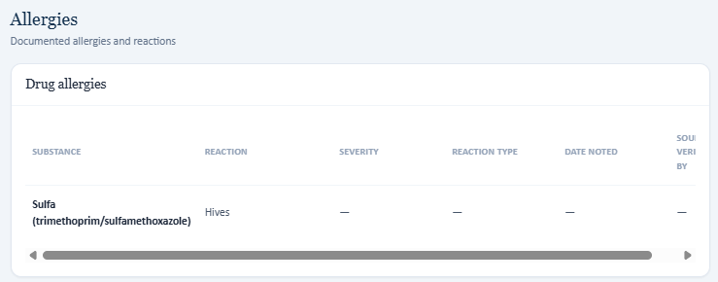
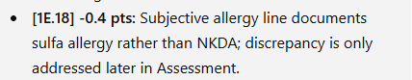

3. Patient age differs between EMR and grading key [Medium severity] Point deduction: -0.3 pts
What the student sees | The visible patient header shows David Chen as 60 years old.
What the grader does | The grader states the correct age is 62 and deducts points for documenting 60.
Why this is a problem | The student cannot satisfy both the visible EMR and the grading key.
Recommended fix | Synchronize age/demographic data between the visible patient header and the grading source of truth.


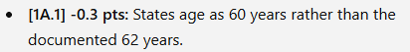

4. Medication list in EMR/interview conflicts with grader medication key [High severity] Point deduction: Multiple deductions totaling approximately -1.4 pts
What the student sees | The EMR medication tab and patient interview show lisinopril 40 mg daily, empagliflozin 10 mg daily, metformin 1000 mg twice daily, and atorvastatin 20 mg daily.
What the grader does | The grader expects a different regimen, including lower-dose lisinopril, higher-dose empagliflozin, rosuvastatin, amlodipine, and ER metformin.
Why this is a problem | Medication mismatch is clinically significant and creates repeated deductions despite the student copying the visible medication list accurately.
Recommended fix | Ensure the grader uses the medication list shown in the same encounter. Add automated regression checks that compare the rendered medication table with the rubric source before release.

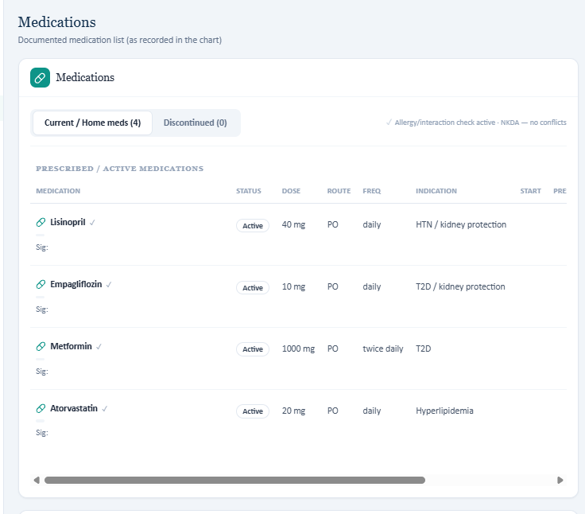
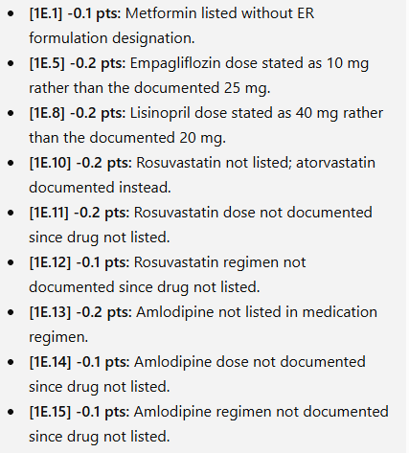

5. Family history from patient interview conflicts with grader [Medium severity] Point deduction: At least -0.5 pts
What the student sees | The patient states that his father had hypertension and an MI at age 54; mother has hypertension and T2DM; brother had bypass surgery at age 58.
What the grader does | The grader expects father MI at 58 and paternal T2DM, which were not disclosed in the interview.
Why this is a problem | A source-faithful SOAP note is penalized for documenting the standardized patient’s actual response.
Recommended fix | Define whether the grader should prioritize the live interview or a chart carry-forward field. If both differ, the rubric should accept documentation of the discrepancy.

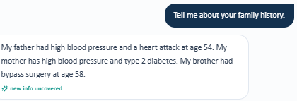
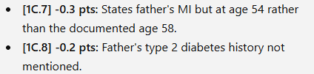

6. Vital signs / body measurements conflict with grader [High severity] Point deduction: Approximately -1.7 pts
What the student sees | The EMR displays HR 68 bpm, weight 88 kg, height 5'9", and BMI 28.6.
What the grader does | The grader expects HR 72 bpm, weight 102 kg, height 70 inches, and BMI 32.3 kg/m².
Why this is a problem | The grader penalizes exact transcription of the visible vitals and materially changes weight/BMI classification.
Recommended fix | Synchronize encounter vitals and derived BMI with the grading key. If BMI is calculated, derive it from the same height/weight shown to the student.

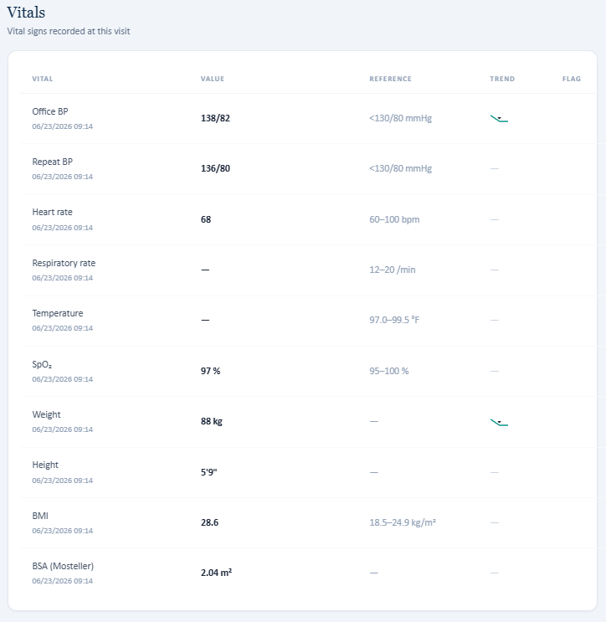
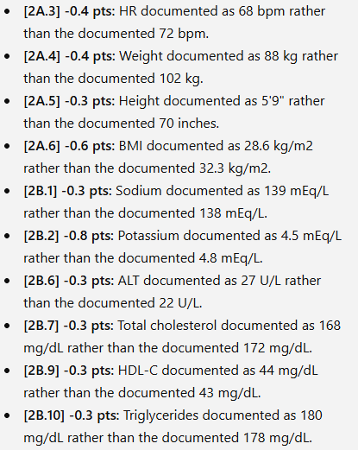

7. Laboratory values in EMR conflict with grader [High severity] Point deduction: Approximately -2.3 pts
What the student sees | The EMR lab panel shows Na 139, K 4.5, ALT 27, total cholesterol 168, HDL-C 44, triglycerides 180, along with the other visible results.
What the grader does | The grader expects different values, including Na 138, K 4.8, ALT 22, total cholesterol 172, HDL-C 43, and triglycerides 178.
Why this is a problem | This is a direct clinical-data mismatch and can alter assessment, monitoring, and treatment recommendations.
Recommended fix | Use a single encounter-specific lab dataset for both rendering and grading. Add automated source-consistency checks for every scored lab field.

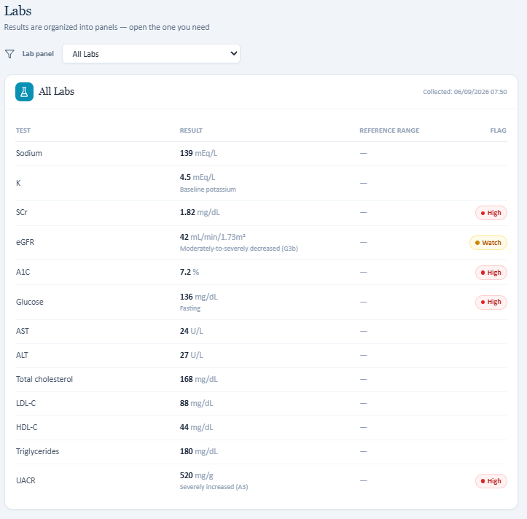


David Chen - Week 2 Wednesday 3-Month Follow-Up
1. Social-history facts cannot be obtained on this day but are graded as required [Medium severity] Point deduction: -0.5 pts total
What the student sees | When asked occupation and marital status, the standardized patient says these are not things he has talked about and does not provide the information.
What the grader does | The grader deducts points for missing occupation and marital status.
Why this is a problem | The student asks the correct questions but the patient response prevents completion of rubric-required fields. The information is available on other days, creating a cross-day inconsistency.
Recommended fix | Either allow relevant carry-forward social history to be visible, make the standardized patient answer consistently, or do not score fields the patient refuses/cannot answer in that encounter.

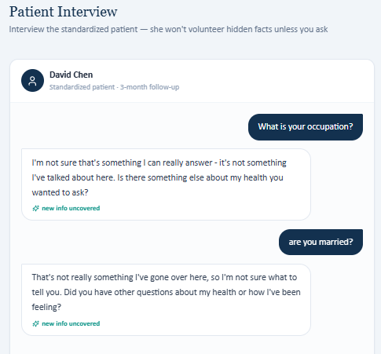
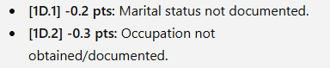

2. Height shown in EMR is graded as incorrect [High severity] Point deduction: -0.2 pts
What the student sees | The vitals section displays height as 5'9".
What the grader does | The grader says the correct height is 70 inches.
Why this is a problem | 5'9" equals 69 inches, so the displayed value and grader key are not equivalent.
Recommended fix | Synchronize the height value and its unit conversion between EMR and grader; avoid silently converting to a different height.

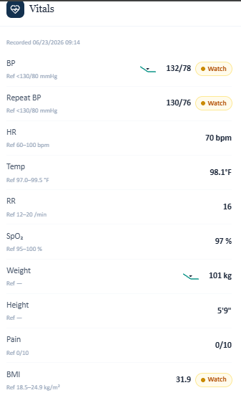
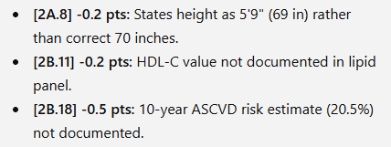

3. HDL-C is unavailable, but ASCVD risk is still required [Medium severity] Point deduction: -0.7 pts total
What the student sees | The visible lab panel does not include HDL-C for this follow-up.
What the grader does | The grader deducts for missing HDL-C and also for not documenting a 20.5% 10-year ASCVD risk estimate.
Why this is a problem | A standard ASCVD calculation cannot be reproduced from the visible inputs when HDL-C is absent.
Recommended fix | Display all inputs required for a scored risk calculation or provide the calculated risk in the EMR. Do not deduct for an unavailable derived value.

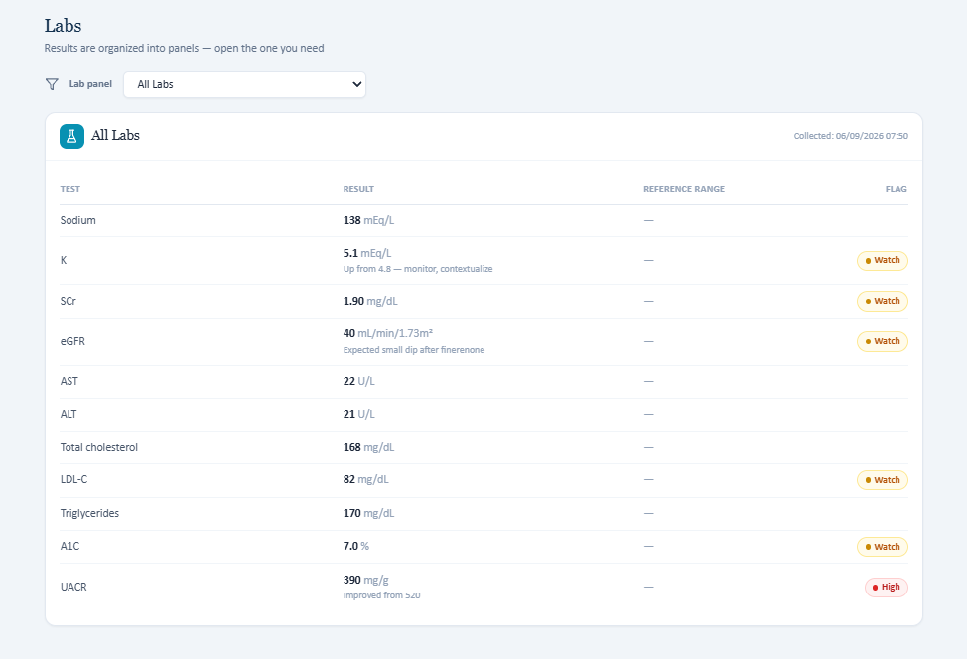


4. Tdap is graded although not displayed in immunizations [Medium severity] Point deduction: -0.6 pts
What the student sees | The immunization section does not display a Tdap status.
What the grader does | The grader deducts because Tdap was not addressed.
Why this is a problem | This repeats the Tuesday hidden-immunization problem.
Recommended fix | Display Tdap status before grading or remove the Tdap-specific criterion for encounters where it is absent.

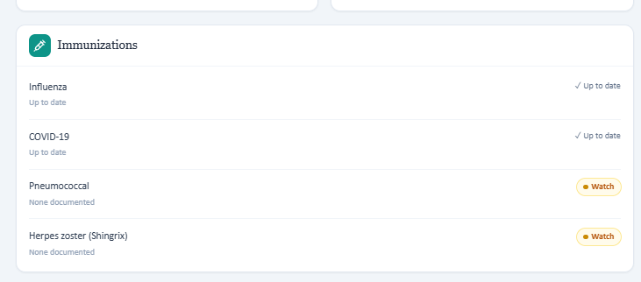
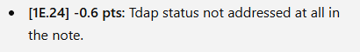

David Chen - Week 2 Thursday 6-Month Follow-Up
1. HDL-C / ASCVD risk are hidden from the student [Medium severity] Point deduction: At least -0.7 pts
What the student sees | The visible Thursday lab panel omits HDL-C. The report notes that the value/risk becomes apparent only after grading.
What the grader does | The grader expects HDL-C 46 mg/dL and a 10-year ASCVD risk estimate of 18.7%.
Why this is a problem | The student is penalized for a calculation that cannot be independently reproduced from the visible lab data.
Recommended fix | Expose HDL-C and/or the calculated risk before SOAP submission, or remove those scoring criteria when the required data are hidden.

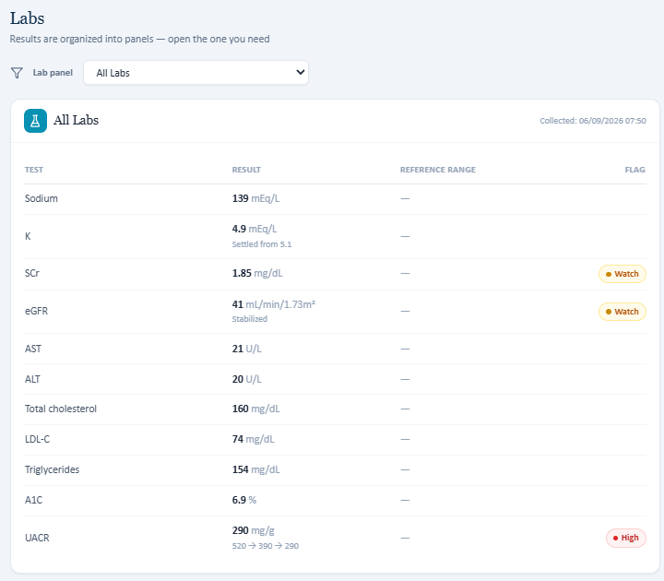
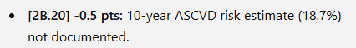
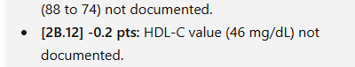

2. Exercise history required by grader contradicts patient response [Medium severity] Point deduction: -0.5 pts
What the student sees | When asked about physical activity, the patient says he does not have a specific routine to report and later does not remember saying he walks four days per week.
What the grader does | The grader deducts for not documenting approximately four days per week of walking.
Why this is a problem | The grading key conflicts with the standardized patient response and encourages fabrication of a history the patient denied/failed to confirm.
Recommended fix | Make the patient response and rubric agree. If carry-forward exercise data are intended, surface them explicitly and allow reconciliation.

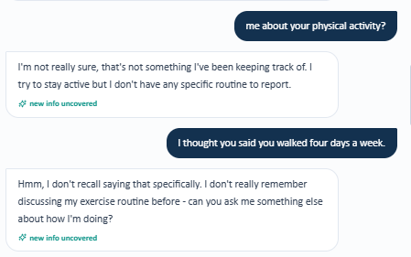
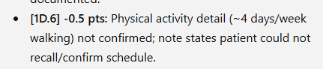

3. Family history conflicts with grader [Medium severity] Point deduction: At least -1.1 pts
What the student sees | The patient reports father MI at 54, mother HTN/T2DM, and brother bypass surgery at 58.
What the grader does | The grader expects father MI at 58, paternal T2DM, and maternal CKD.
Why this is a problem | The standardized patient’s answer is scored as incorrect even when documented accurately.
Recommended fix | Define one source of truth for family history or explicitly accept chart-versus-interview reconciliation.

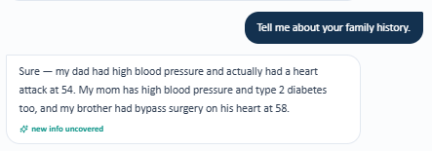
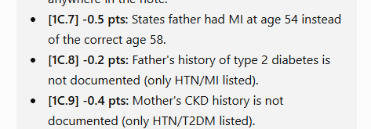

4. Patient age differs between visible header and grader [Medium severity] Point deduction: -0.4 pts
What the student sees | The visible header shows age 60.
What the grader does | The grader expects age 62.
Why this is a problem | This repeats the Tuesday age mismatch and suggests stale or unsynchronized demographic data.
Recommended fix | Synchronize demographic data across patient header, encounter data, and rubric.


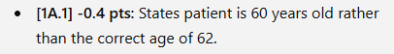

Angela Rodriguez - Week 2 Thursday 6-Month Follow-Up
1. Marital status expected by grader but not disclosed by patient [Medium severity] Point deduction: -0.2 pts
What the student sees | The patient is asked whether she is married and whether she has ever been married. She declines/does not provide the information.
What the grader does | The grader expects “widowed” and deducts for not documenting it.
Why this is a problem | The student cannot ethically infer or invent a marital status that the standardized patient did not disclose.
Recommended fix | Make the standardized patient provide the required history, surface the information elsewhere in the EMR, or stop grading it as required for that encounter.

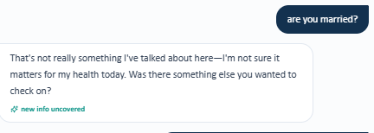
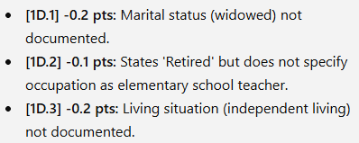

2. Living situation expected by grader but patient does not provide it [Medium severity] Point deduction: -0.2 pts
What the student sees | The patient is asked whether she lives alone/with someone and does not provide a clear living arrangement.
What the grader does | The grader expects independent living and deducts for its absence.
Why this is a problem | A rubric-required social-history detail is inaccessible despite direct questioning.
Recommended fix | Align the standardized-patient response with the rubric or remove the scored requirement when the patient will not answer.

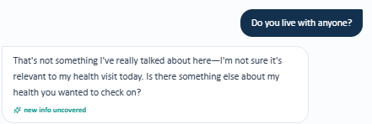


3. Prior occupation is required by grader but unavailable in interview [Medium severity] Point deduction: -0.1 pts
What the student sees | The patient says she is retired. When asked what she did before retirement, she says she is not sure that information has come up and does not answer.
What the grader does | The grader expects “elementary school teacher.”
Why this is a problem | The student is penalized for not documenting information that cannot be obtained from the standardized patient.
Recommended fix | Have the standardized patient disclose the occupation when asked, expose it in the chart, or do not score the hidden occupation.

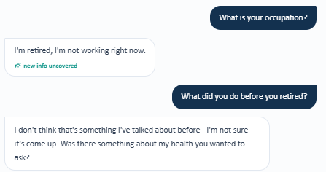

Recurring / System-Wide Issue Summary
The following patterns recur across multiple encounters. These are grouped by bug type so the development team can evaluate whether the underlying problem is a shared data-source, grading-key, or standardized-patient synchronization issue.
A. EMR Data vs. Grader Source-of-Truth Mismatch [High]
- David Chen Tuesday: medication regimen differs between visible EMR/interview and grader.
- David Chen Tuesday: HR, weight, height, and BMI differ between visible vitals and grader.
- David Chen Tuesday: multiple lab values differ between visible lab panel and grader.
- David Chen Wednesday: displayed height 5'9" is graded against 70 inches.
Recommended system-level fix: Use one encounter-specific structured dataset to populate both the UI and the grading rubric. Add automated pre-release checks that compare every scored medication, vital, lab, and demographic field.
B. Patient Interview vs. Grader Mismatch [Medium]
- David Chen Tuesday: family history given by patient differs from grader.
- David Chen Thursday: family history given by patient differs from grader.
- David Chen Thursday: patient cannot confirm a 4-day/week walking routine, but grader requires it.
- Angela Rodriguez Thursday: patient does not disclose marital status, living situation, or prior occupation, but grader requires specific answers.
Recommended system-level fix: Make standardized-patient responses and grading keys derive from the same encounter script/data source. When the patient declines or cannot answer, the grader should not require an undisclosed fact.
C. Hidden / Inaccessible Rubric Data [Medium]
- David Chen Tuesday: Tdap not shown but grader expects overdue status.
- David Chen Wednesday: Tdap not shown but grader expects it to be addressed.
- David Chen Wednesday: HDL-C missing while ASCVD risk is required.
- David Chen Thursday: HDL-C/ASCVD risk are not visible before grading.
- Angela Rodriguez Thursday: marital status, independent living, and elementary-school-teacher occupation are graded despite being unavailable in the interview.
Recommended system-level fix: If a datum is scored, display it or make it obtainable before submission. Otherwise remove the criterion or allow “not available/not obtained” without penalty.
D. Internal EMR Inconsistency [High]
- David Chen Tuesday: header says no known allergies while detailed allergy tab lists sulfa/TMP-SMX with hives.
Recommended system-level fix: Synchronize duplicated clinical fields across the UI. Allergy conflicts should be treated as high priority because they can affect medication safety.
E. Cross-Day / Carry-Forward Inconsistency [Medium]
- David Chen social-history details can be elicited on some days but are unavailable on Wednesday while still being graded.
- Repeated age/family-history discrepancies suggest encounter state or grading data may be stale or sourced from a different patient version.
Recommended system-level fix: Define which data should persist across visits and ensure carry-forward data are consistently available to both the user and grader. Consider versioned encounter snapshots rather than mixing current and prior state.

Reproduction Note
The discrepancies documented above were checked after a hard refresh and were also tested in an incognito/private browsing tab. The issues persisted, which makes a simple browser-cache or local-session explanation less likely and supports review of the application data flow, standardized-patient state, and grading-key synchronization.

