WEEK 2

VACS AI Patient & Grading Issue Report
Final Clinical and Operational Audit
Prepared by
Hawo Sadik
PharmD Candidate, Class of 2027
D'Youville University School of Pharmacy
Purpose: This Week 2 audit independently reviews the original student-facing VACS EMR, AI-patient interview, AI-grader feedback, and interface/operational evidence for nine Hyperlipidemia + CKD encounters. Routine SOAP-writing omissions are excluded unless they reveal a system mismatch. Encounter-specific project analyses were used only as investigation leads; every confirmed finding below was checked against original Week 2 evidence. No prior Week 2 consolidated audit report was used as proof. The Week 3 sample controlled report design and issue-development style only, not Week 2 facts. No independently verified Week 2 master-rubric document was present in the supplied source package, so this report does not invent rubric criterion numbers or present unverified rubric claims as fact. Supplemental source-consistency review also uses the official Patient A/B/C Master Profile documents to compare foundational patient facts with live EMR content and with criterion-level expectations explicitly exposed in original AI-grader feedback screenshots. Those feedback-exposed criterion identifiers are quoted only when visible in the original feedback and are not treated as an independently supplied master-rubric document.

Quick Guide for Non-Clinical Readers
Term | Plain-language meaning
AI patient | The simulated standardized patient the student interviews.
EMR | Electronic medical record/chart shown to the student.
AI grader | The automated scoring system that evaluates the submitted SOAP note.
CKD | Chronic kidney disease.
eGFR | Estimated glomerular filtration rate; a measure used to describe kidney filtration.
UACR | Urine albumin-to-creatinine ratio; a measure of albumin/protein leakage in urine.
LDL-C | Low-density lipoprotein cholesterol.
ASCVD risk | Estimated risk of atherosclerotic cardiovascular disease over a defined time period.
BSA | Body surface area; a calculated measure of body size.
Mosteller BSA | A formula using height and weight: square root of (height in cm × weight in kg / 3600).
BMI | Body mass index.
NKDA | No known drug allergies.
Statin | A cholesterol-lowering medication class, including rosuvastatin and atorvastatin.
Finerenone | A medication used in some patients with diabetic CKD and albuminuria.

Final Review Summary
This revised reconstruction contains 68 grouped visit-specific system/data/interface/workflow findings across all 9 Week 2 visits, plus one separate cross-case grader-performance finding. Repeated defects are retained under each affected visit when they can independently change what a learner sees or how that visit is graded. No overall AI-grader percentage scores are reported.
Encounter | Exact live visit-stage wording | Grouped confirmed findings | Primary defect pattern / verification status
AR – Angela Rodriguez – Tuesday | Tuesday · initial collaborative practice management | 8 | Allergy conflict; medication/grader dataset conflict; hidden grader data
AR – Angela Rodriguez – Wednesday | Wednesday · 3-month follow-up | 8 | Follow-up stage, allergy, stale Problem List, advisory/patient mismatch
AR – Angela Rodriguez – Thursday | Thursday · six-month follow-up | 8 | Follow-up metadata, allergy, stale Problem List, hidden grader data, technical failure
MT – Michael Turner – Tuesday | Tuesday · initial collaborative practice management | 6 | Pronoun/interface issue, populated “Missing” home BP, hidden grader data
MT – Michael Turner – Wednesday | Wednesday · 3-month follow-up | 7 | Pronoun/interface issue, follow-up metadata, stale Problem List, patient/grader history mismatch
MT – Michael Turner – Thursday | Thursday · six-month follow-up | 7 | Pronoun/interface issue, follow-up metadata, stale Problem List, patient/grader biography mismatch
DC – David Chen – Tuesday | Tuesday · initial collaborative practice management | 8 | Pronoun/interface issue, AI-patient stage conflict, objective leakage, populated “Missing” home BP
DC – David Chen – Wednesday | Wednesday · 3-month follow-up | 8 | Pronoun/interface issue, follow-up metadata, stale Problem List, hidden/shared-decision grader data
DC – David Chen – Thursday | Thursday · 2nd 3-month follow-up | 8 | Pronoun/interface issue, three-way visit-stage conflict, stale Problem List, patient/grader mismatch

Repeated Week 2 Issues Across Visits
Issue | Patient(s) | Visits affected | Frequency
BSA Mosteller calculation error | AR, MT, DC | 9 of 9 visits | 9
BSA omitted from Objective/Snapshot but shown in dedicated Vitals | AR, MT, DC | 9 of 9 visits | 9
Exact numeric ASCVD risk required by grader but not displayed live | AR, MT, DC | 9 of 9 visits | 9
Encounter-stage synchronization contradiction | AR, MT, DC | 7 of 9 visits | 7
Stale Problem List descriptors vs current encounter data | AR, MT, DC | 7 of 9 visits | 7
NKDA conflicts with documented penicillin rash | AR | 3 of 3 AR visits | 3
Home BP value displayed while labeled “Missing” | MT, DC | MT Tue + all 3 DC visits | 4
Wrong Patient Interview pronoun | MT, DC | MT Tue/Wed/Thu + DC Tue/Wed/Thu | 6

Cross-Case Operational Finding — AI-Grader Response-Time Variability
What was observed: During live Week 2 testing, time from grader submission to usable feedback varied substantially by patient: MT approximately 6–8 minutes on average, AR approximately 5 minutes, and DC approximately 3 minutes.
Why this matters: A several-minute difference between comparable grading workflows makes the system less predictable and less efficient. Long, inconsistent waits slow both learner and audit workflows, make it harder to distinguish normal processing from a stalled grader, and increase the chance of unnecessary resubmission. The concern is consistency and efficiency across cases; it does not imply that every case must complete in exactly the same number of seconds.
Suggested fix: Benchmark the grading pipeline by patient/case, identify why some encounters take substantially longer, and establish a reasonably consistent performance target. Provide a clear processing state so users can distinguish “still processing” from “failed,” and regression-test all nine Week 2 encounters after optimization.
Evidence note: These values are auditor-observed estimates and are not supported by timestamp screenshots. No screenshot is used or fabricated for this timing finding. This cross-case performance observation is kept separate from the AR Thursday JSON/feedback failure.
Counting note: This is a cross-case operational performance finding and is not added to each visit’s grouped issue count.
Main pattern: The dominant Week 2 failure is source synchronization. The live chart, standardized patient, grader, and interface repeatedly operate from different stages, histories, calculated values, or demographic templates. Three especially systematic patterns are now directly supported: every dedicated Vitals screen displays BSA 2.04 m² despite different heights/weights; every grader requires an exact ASCVD risk percentage absent from the student-facing workflow; and the wrong female pronoun appears in all 6 of 6 MT/DC Patient Interview interfaces. Grader response time also varied materially by case, creating an additional cross-case efficiency concern.

Audit Method and Source Boundaries
Live EMR: Controls what objective information and interface state the learner could actually see.
AI patient: Controls what subjective information the standardized patient actually provided after neutral questioning.
AI grader: Controls what the scoring system actually expected, deducted, or contradicted.
Verified master rubric/reference: No independently supplied Week 2 master-rubric document was included in the controlling source set. Where the supplemental Master Profile vs VACS AI Rubric review cites criterion identifiers, those identifiers are taken directly from original AI-grader feedback screenshots and are used only to describe what the grader explicitly expected. They are not presented as an independently verified master-rubric file.
Official master patient profiles: Patient A / Michael Turner, Patient B / Angela Rodriguez, and Patient C / David Chen master-profile documents control foundational identity and baseline-history facts only for the supplemental source-consistency review. They are not used to overwrite legitimate Wednesday/Thursday follow-up changes that the baseline profile does not define.
Interface/operational evidence: Used separately for stage labels, pronouns, missing-data states, display problems, grader failure, and observed latency.
Evidence rule: Original Week 2 screenshots control. Contact sheets used for internal review are not included as report evidence. Screenshots from recreated SOAP/EMR Word files and any earlier Week 2 audit reports are not used as proof. Each report image below is a focused crop derived from an original Week 2 screenshot.
Evidence update: New visit-specific original screenshots directly confirm the incorrect “she” Patient Interview instruction on all six MT/DC visits. Three original AR Thursday screenshots directly confirm two “Unexpected end of JSON input” grading failures and a subsequent “Already Graded” state without usable feedback. The only remaining evidence limitation for these newly revised operational findings is grader timing: MT approximately 6–8 minutes, AR approximately 5 minutes, and DC approximately 3 minutes are auditor-observed estimates because timestamp screenshots were not collected.

Patient AR – Angela Rodriguez – Tuesday – Tuesday · initial collaborative practice management
8 confirmed system/data/interface/workflow issues are included for this visit. Items are grouped by underlying root cause so one defect is not counted multiple times merely because it produced several grader deductions.
# | Issue | Problem type
1 | Allergy safety data contradicts itself: NKDA banner/medication check versus penicillin rash in the Allergy tab and patient history | Critical — Internal EMR contradiction / patient safety
2 | Rosuvastatin treatment state conflicts across active medication list, Problem List, and AI patient | Critical — Internal EMR / AI-patient contradiction
3 | Problem List contains stale baseline values despite newer current objective data | High — Data synchronization
4 | AI grader objective and lipid reference uses a different dataset from the live AR Tuesday EMR | Critical — EMR and grader disagree
5 | AI grader requires a 10-year ASCVD risk of 17.4% that is not displayed in the live workflow | High — Hidden/unavailable grader data
6 | AI grader expects subjective history that the standardized patient denies, cannot recall, or does not supply | High — AI patient and grader disagree
7 | BSA labeled as Mosteller is mathematically incorrect (2.04 m² displayed; 2.05 m² calculated) | Medium — Clinical calculation logic
8 | BSA appears in dedicated Vitals but is omitted from the Objective/Snapshot vitals shown to the learner | Medium — Interface/display problem

Issue 1. Allergy safety data contradicts itself: NKDA banner/medication check versus penicillin rash in the Allergy tab and patient history
What the student saw or heard: The newly supplied authentic AR Tuesday header correctly identifies the encounter as “Tuesday · initial collaborative practice management” but simultaneously reports “Allergies: No known drug allergies (NKDA).” The medication safety area also identifies NKDA/no conflicts, while the dedicated Allergy tab lists penicillin with a childhood rash. The AI patient reports a childhood penicillin rash when asked.
Why this is a problem: Angela Rodriguez’s official master profile documents a penicillin allergy with a childhood rash, and the dedicated Allergy tab agrees with that foundational record. The prominent header/medication-safety layers instead report NKDA. A learner can therefore receive mutually exclusive allergy states from the same case, which can change prescribing and counseling decisions and undermines confidence in the safety logic.
Suggested fix: Use one allergy record as the source for the header, medication-safety check, dedicated Allergy tab, AI patient, and grader. Remove NKDA whenever an active penicillin allergy is present.
Focused screenshot evidence
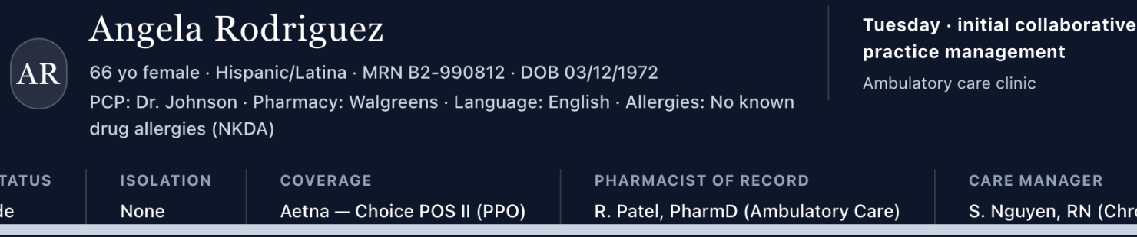
Updated authentic AR Tuesday header confirms the correct Tuesday initial visit stage while still displaying NKDA.
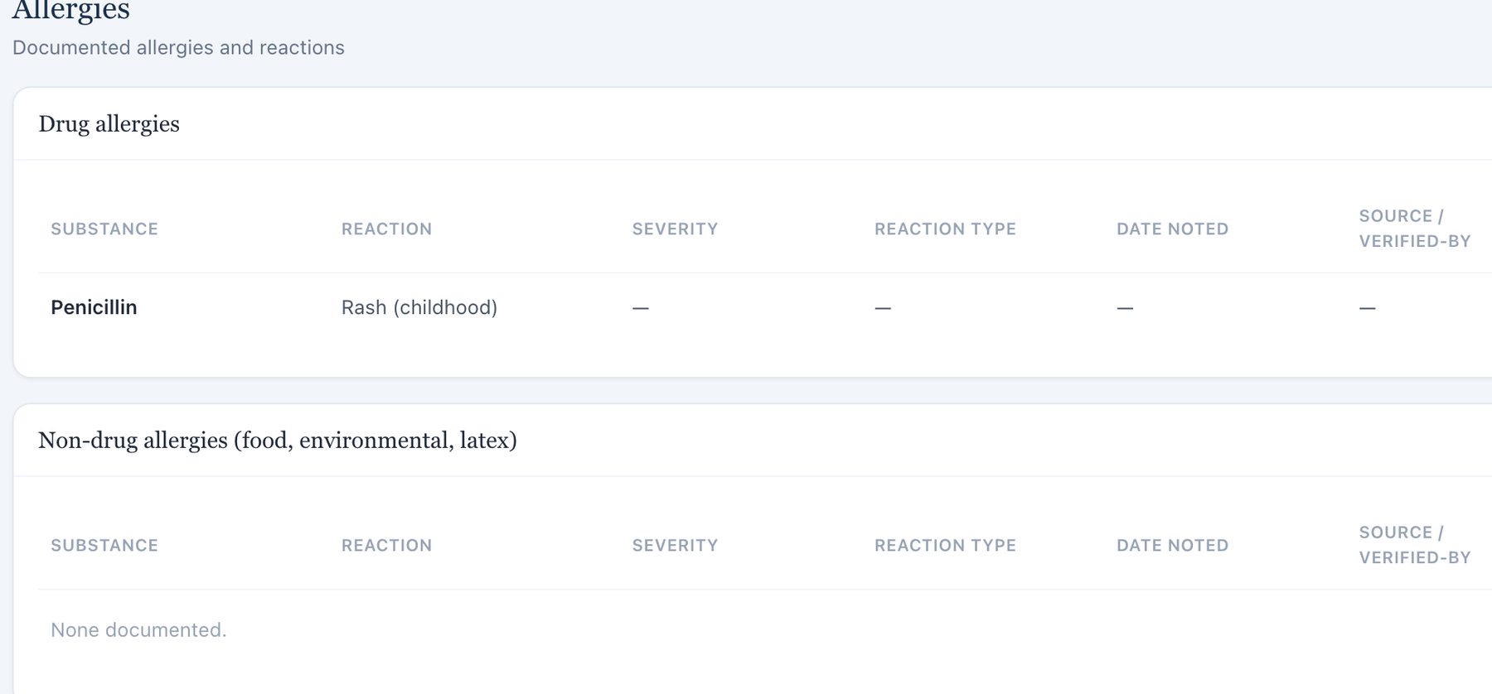
Dedicated Allergy tab lists penicillin — rash (childhood).
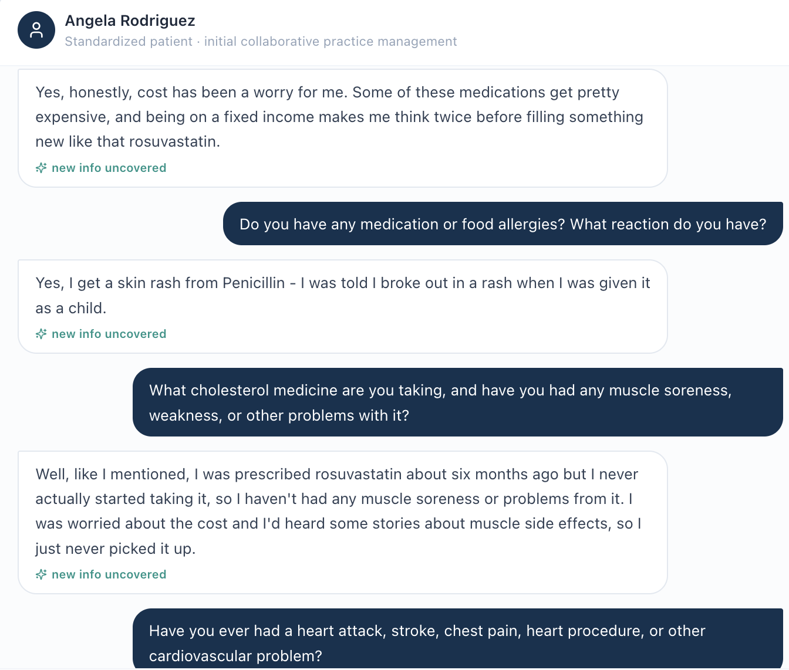
AI patient reports a childhood rash from penicillin.

Issue 2. Rosuvastatin treatment state conflicts across active medication list, Problem List, and AI patient
What the student saw or heard: The live medication list marks rosuvastatin 20 mg daily as active. The Problem List still describes LDL-C 148 mg/dL as “untreated.” During the interview, the patient says rosuvastatin had been prescribed previously but she never actually started it because of cost and muscle-side-effect concerns.
What the AI grader expected: The grader further expects a simvastatin history, creating a fourth incompatible medication storyline.
Why this is a problem: Medication exposure determines how the LDL result should be interpreted and what treatment decision is appropriate. A patient who has never started therapy is clinically different from a patient actively taking high-intensity rosuvastatin. The learner should not have to choose between an active-medication table, a problem label saying untreated, the standardized patient’s direct report, and a grader expecting another statin entirely.
Suggested fix: Choose the intended AR Tuesday medication history and synchronize the active medication list, Problem List treatment status, AI-patient response bank, and grader reference to that single history.
Focused screenshot evidence
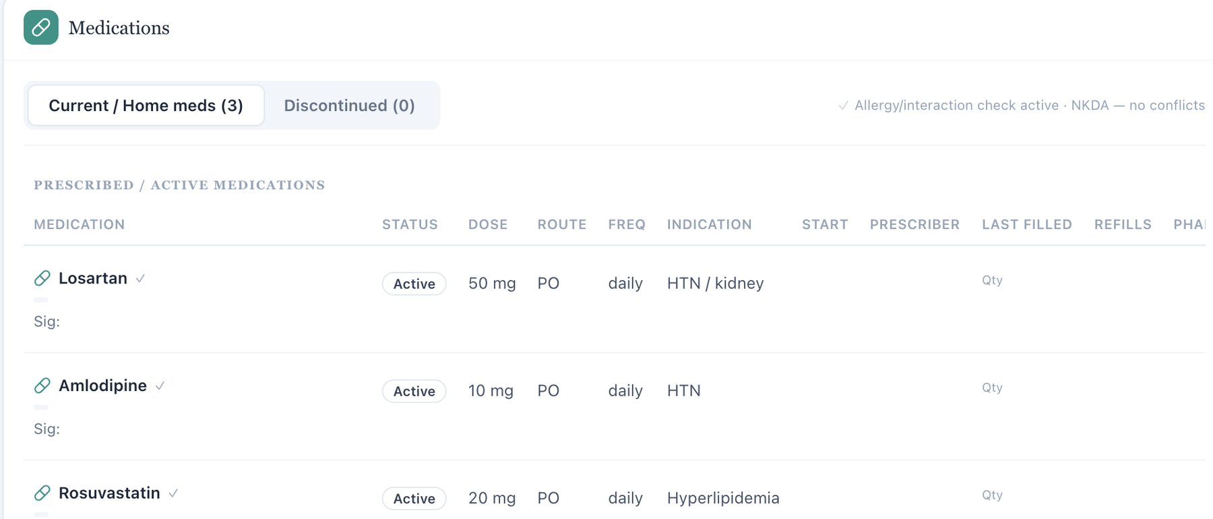
Live medication list marks rosuvastatin 20 mg daily as active.
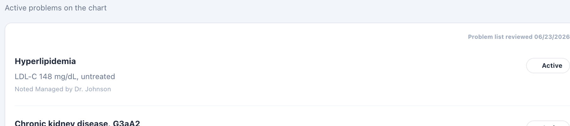
Problem List describes LDL-C 148 mg/dL as untreated.
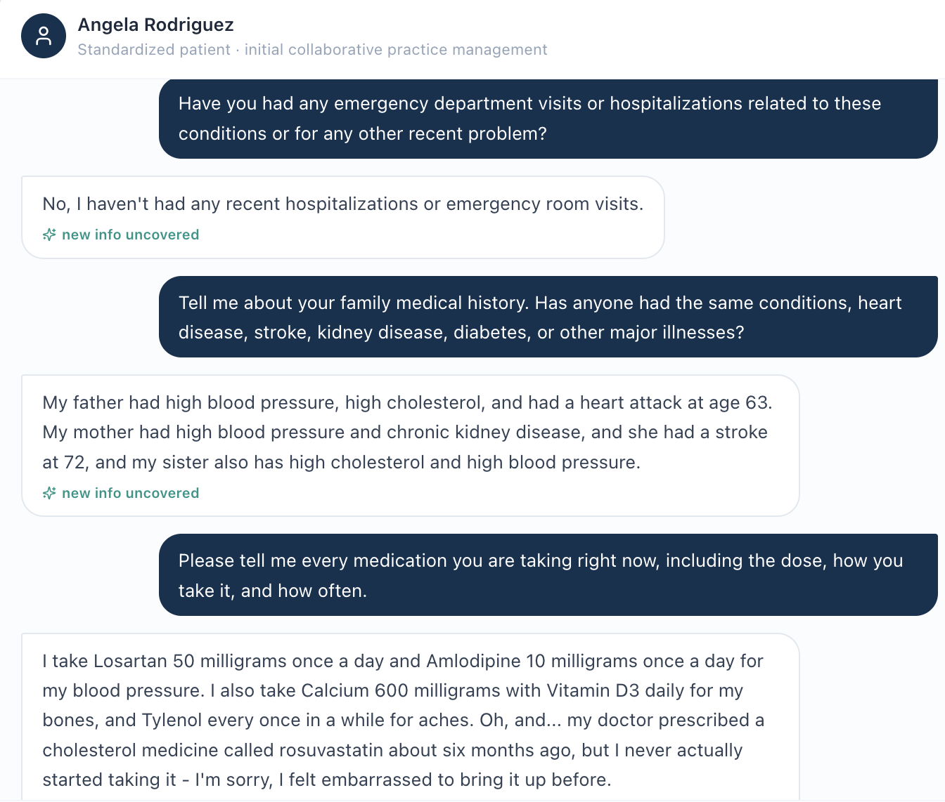
AI-patient medication history states the prescribed rosuvastatin was not actually started.

Issue 3. Problem List contains stale baseline values despite newer current objective data
What the student saw or heard: The current Tuesday objective data show LDL-C 78 mg/dL, eGFR 54 mL/min/1.73 m², UACR 155 mg/g, and BMI 35.2. The Problem List still says LDL-C 148 mg/dL “untreated,” eGFR 53/UACR 165, blood pressure in the mid-130s/80s, and BMI 35.9.
Why this is a problem: Historical values can be useful, but here they are presented as active problem-state descriptors without a clear historical label. The strongest contradiction is LDL 148 “untreated” while the current medication table and current LDL data describe a different treatment state. Stale problem summaries can mislead a learner about whether therapy is working and which values should be used for assessment.
Suggested fix: Synchronize active Problem List descriptors to the current encounter dataset, or explicitly label baseline/historical values with dates so they are not mistaken for the current state.
Focused screenshot evidence
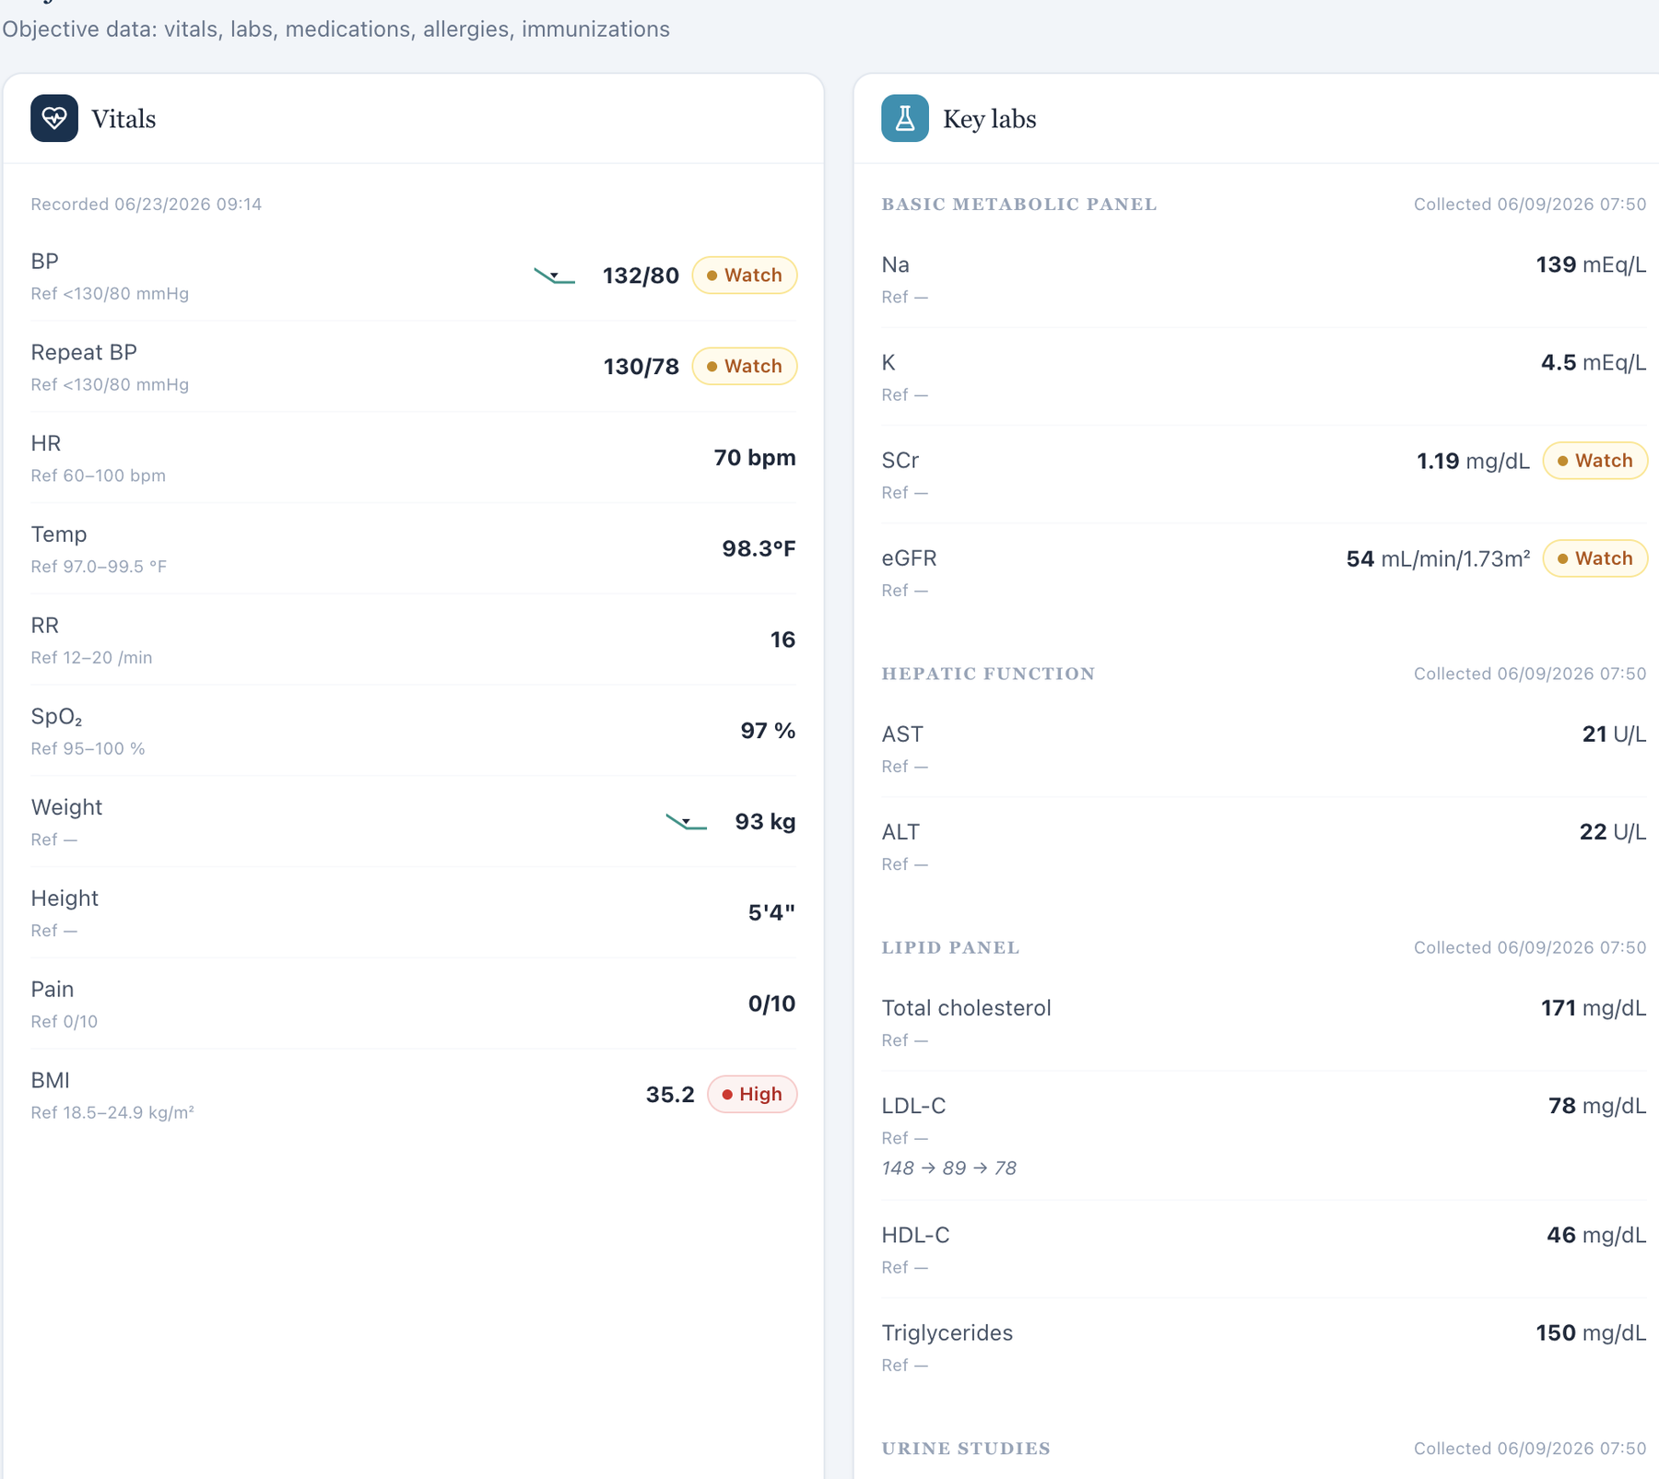
Current Objective displays newer vitals and laboratory values.
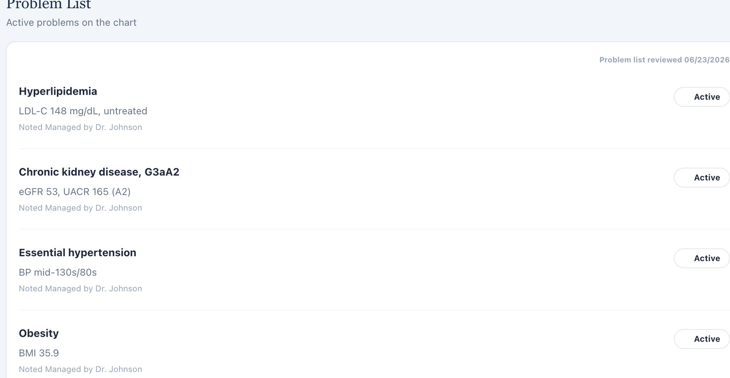
Problem List retains older LDL-C, kidney, BP, and BMI descriptors.

Issue 4. AI grader objective and lipid reference uses a different dataset from the live AR Tuesday EMR
What the student saw or heard: Live objective values include BP 132/80 (repeat 130/78), HR 70, weight 93 kg, BMI 35.2, potassium 4.5, LDL-C 78, total cholesterol 171, HDL-C 46, triglycerides 150, and UACR 155.
What the AI grader expected: The grader deductions expect materially different values, including BP 142/86 (repeat 140/84), HR 74, weight 96 kg, BMI 36.3, potassium 4.7, total cholesterol 238, HDL-C 41, triglycerides 185, and UACR 165. It also expects a simvastatin-based lipid storyline.
Why this is a problem: The student is penalized for copying the live chart accurately. The disagreement spans vitals, chemistry, lipids, albuminuria, and treatment context, which is too broad to be a single transcription error. It strongly indicates that the grader is evaluating a different AR Tuesday dataset. This undermines educational validity because correct student-facing information is scored as wrong.
Suggested fix: Bind the AR Tuesday grader to the exact same encounter dataset shown in the live EMR and regression-test every objective criterion after synchronization.
Focused screenshot evidence
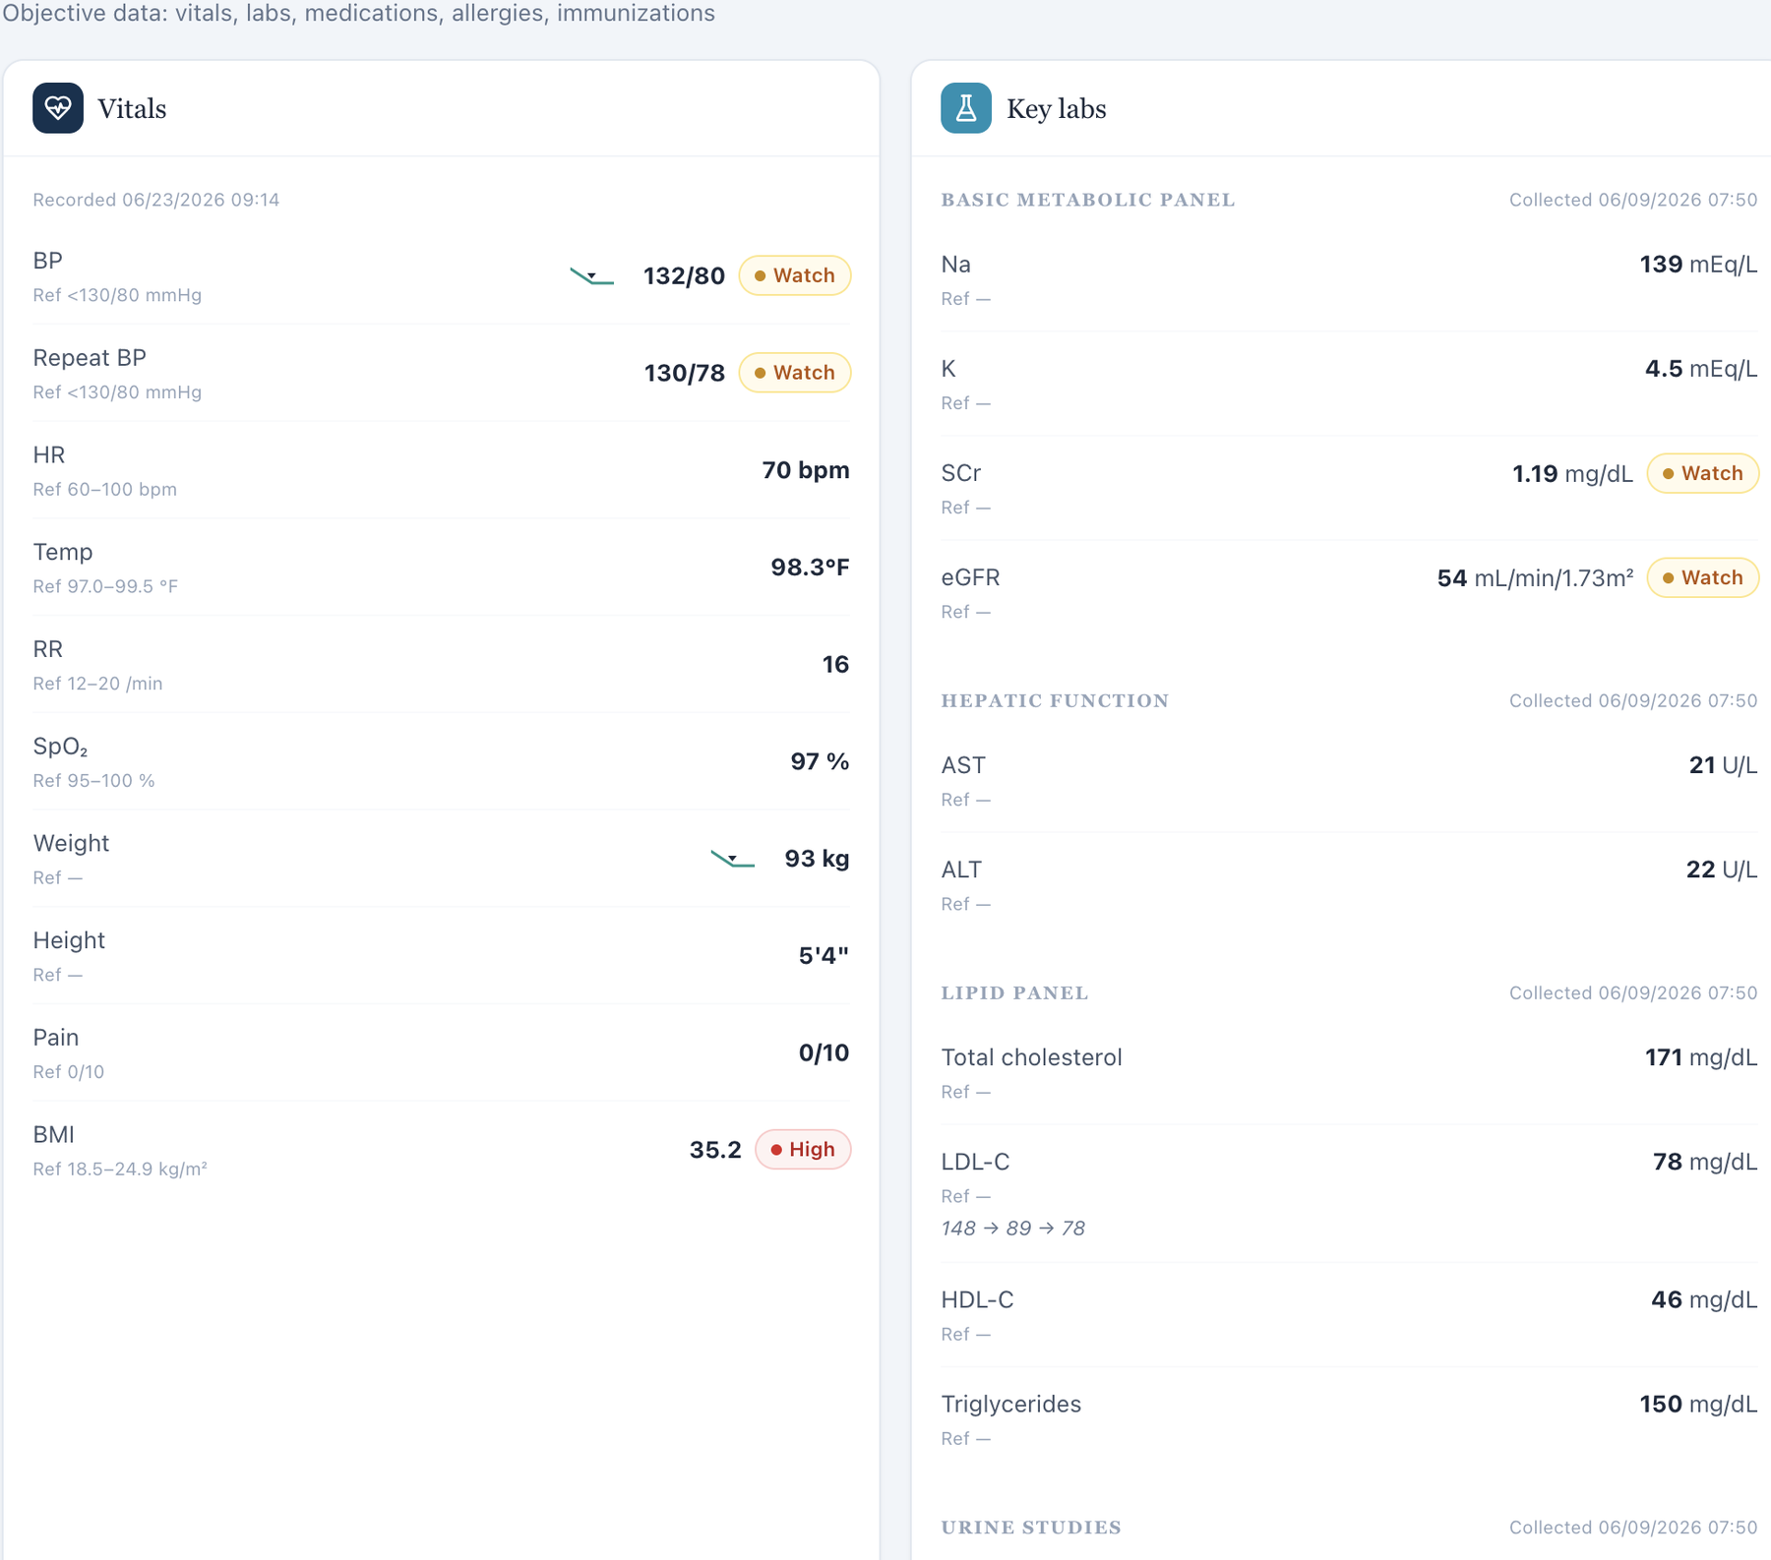
Live AR Tuesday Objective values used by the learner.
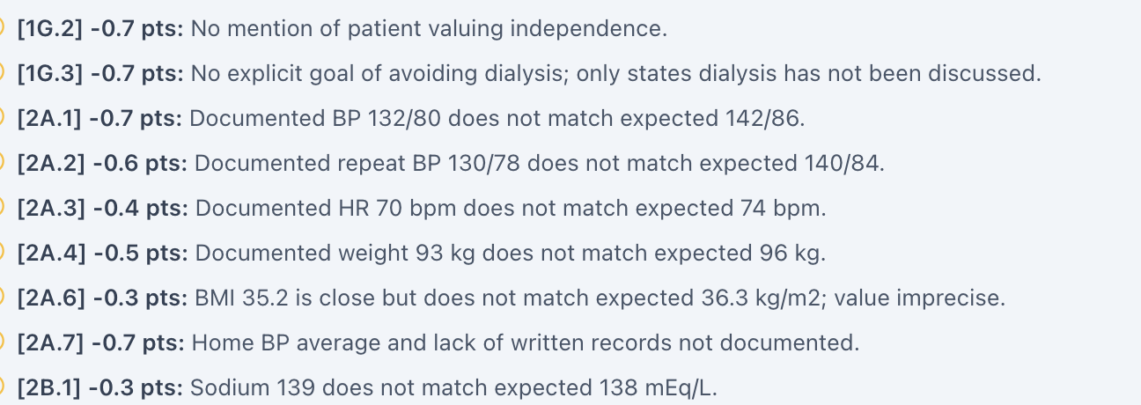
Focused grader deductions expect different BP, HR, weight, and BMI values.
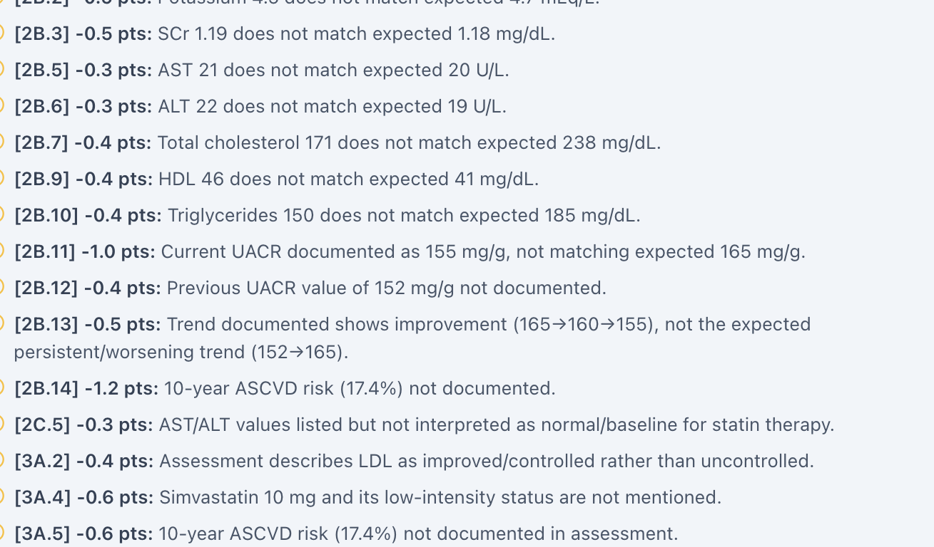
Focused grader deductions continue with different laboratory, lipid, and UACR values.

Issue 5. AI grader requires a 10-year ASCVD risk of 17.4% that is not displayed in the live workflow
What the student saw or heard: The captured student-facing EMR shows vitals, medications, kidney function, lipids, and albuminuria, but no calculated 10-year ASCVD risk percentage or calculator result is displayed.
What the AI grader expected: The grader explicitly deducts for failure to document a 10-year ASCVD risk estimate of 17.4% and related risk classification.
Why this is a problem: A precise calculated percentage cannot be safely invented. If VACS intends the numeric score to be graded, the variables and calculation method must either be exposed or the calculated result must be displayed. Requiring a hidden number rewards guessing rather than documentation of available evidence. This pattern recurs across all nine Week 2 visits with a different hidden percentage for each stage.
Suggested fix: Display the encounter-specific ASCVD risk result and calculation inputs in the learner workflow, or remove the exact numeric percentage from grader requirements.
Focused screenshot evidence
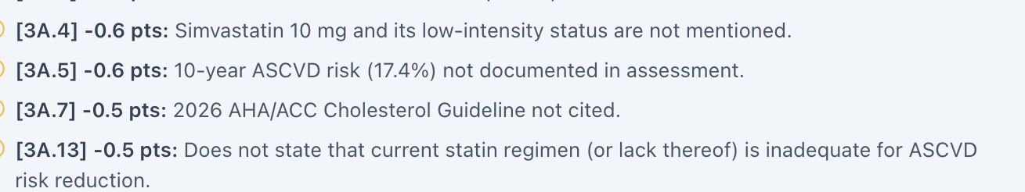
Grader deduction requires the specific 10-year ASCVD risk estimate of 17.4%.
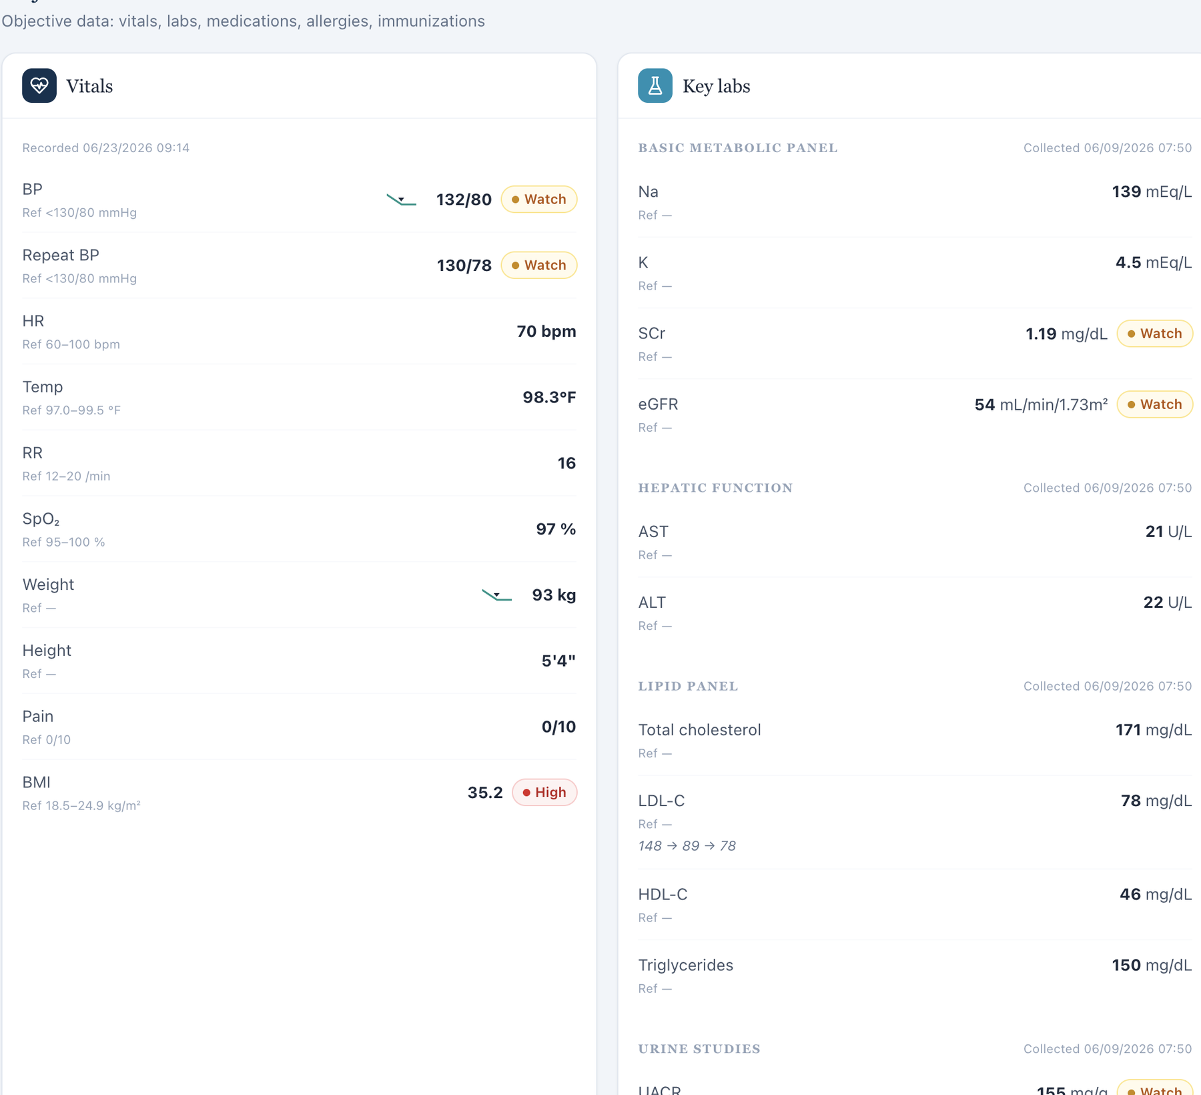
Captured live Objective contains no ASCVD calculator or risk-percentage field.

Issue 6. AI grader expects subjective history that the standardized patient denies, cannot recall, or does not supply
What the student saw or heard: Neutral questioning produced denials or uncertainty for several facts. The patient denies leg cramps and cannot provide the exact duration of her hypertension/hyperlipidemia. Her medication history centers on rosuvastatin non-initiation and cost/side-effect concerns.
What the AI grader expected: The grader expects occasional nighttime leg cramping, exact disease durations, a simvastatin history, medication-stretching behavior, and several specific motivations/behavioral details that are not returned by the AI patient in the preserved interview.
Why this is a problem: The student must document what the standardized patient actually says. When the grader expects a conflicting hidden narrative, accurate interviewing cannot earn full credit and the learner is pressured to fabricate facts. This is a standardized-patient/reference synchronization defect, not an ordinary SOAP omission.
Suggested fix: Synchronize the AR Tuesday AI-patient response bank with the grader’s intended subjective history, or revise the grader to accept the live patient’s actual answers after neutral questioning.
Focused screenshot evidence
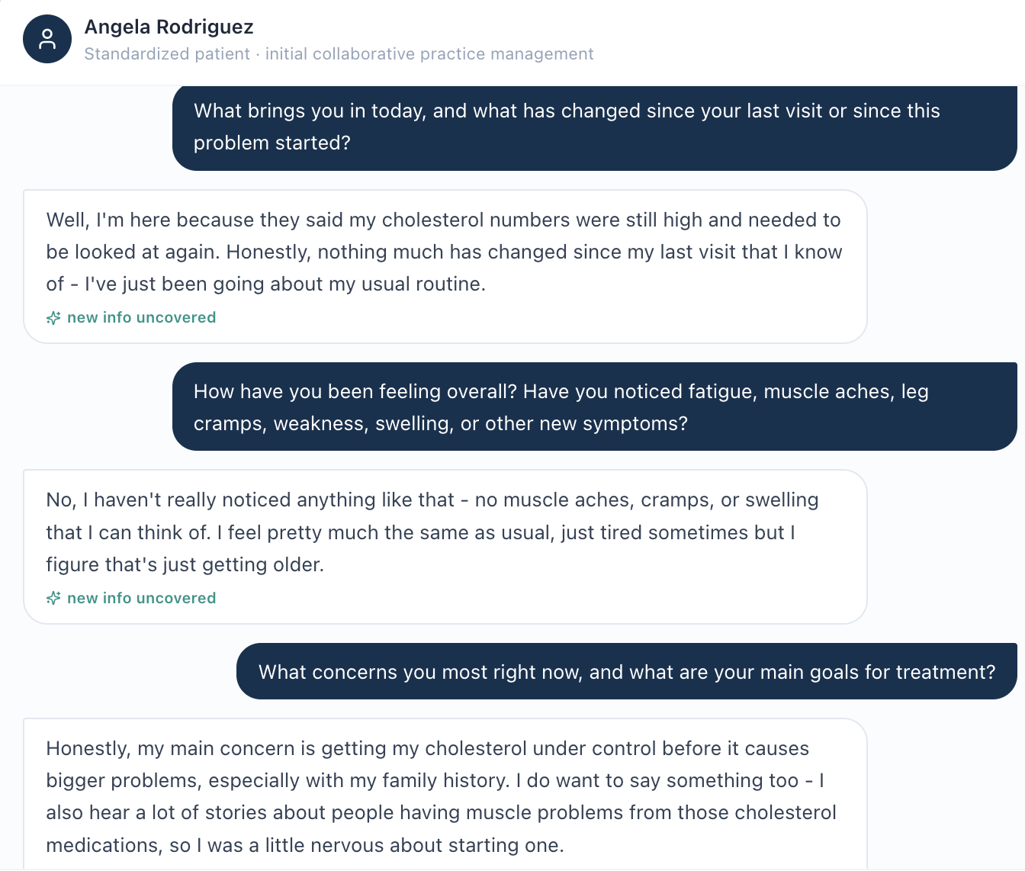
AI patient denies the symptom pattern the grader expects.
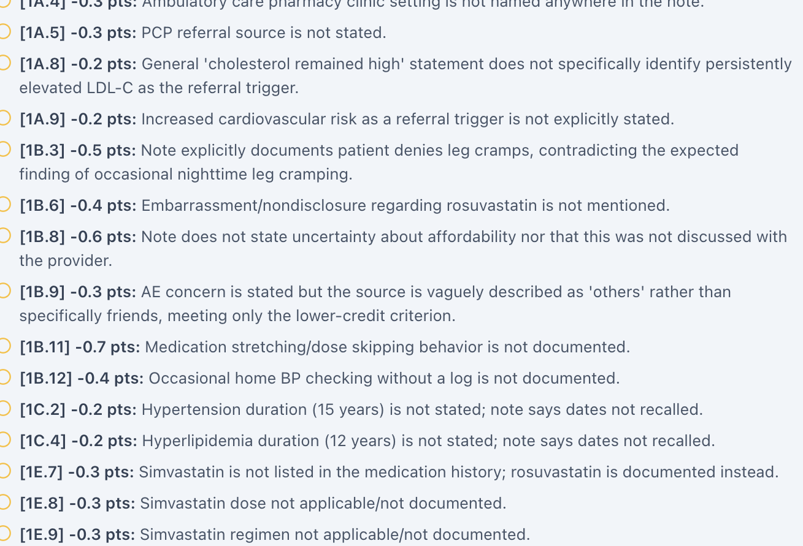
Grader deductions require leg cramps, exact histories, and other subjective facts not supplied by the patient.

Issue 7. BSA labeled as Mosteller is mathematically incorrect (2.04 m² displayed; 2.05 m² calculated)
What the student saw or heard: The dedicated Vitals tab displays weight 93 kg, height 64 in, and “BSA (Mosteller) 2.04 m².”
Why this is a problem: The Mosteller equation is BSA = √(height in cm × weight in kg / 3600). Using the values displayed in this encounter gives 2.049 m², which rounds to 2.05 m², not 2.04 m². Because the same 2.04 m² value appears across patients with substantially different body sizes, this looks like a shared calculation or hard-coded-value defect rather than normal rounding. BSA can be used in medication dosing and clinical interpretation; a field explicitly labeled with a formula should be mathematically reproducible from the height and weight shown next to it.
Suggested fix: Recalculate BSA from the active encounter height and weight using the documented Mosteller formula, round consistently, and regression-test all nine Week 2 encounters.
Focused screenshot evidence
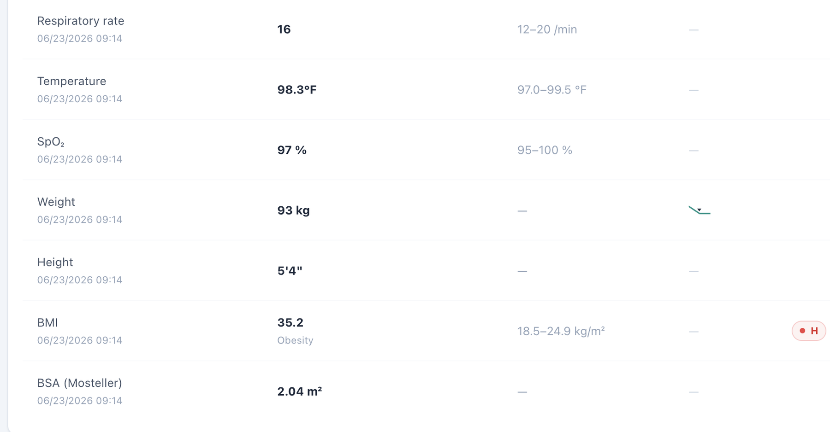
Dedicated Vitals shows weight 93 kg, height 64 in, and the repeated BSA value 2.04 m².

Issue 8. BSA appears in dedicated Vitals but is omitted from the Objective/Snapshot vitals shown to the learner
What the student saw or heard: The student-facing Objective/Snapshot vitals card displays the encounter vitals through BMI but does not show BSA. Opening the dedicated Vitals tab adds a BSA field for the same encounter.
Why this is a problem: The same clinical data element is not propagated consistently across VACS views. A learner working from the Objective/Snapshot may reasonably believe BSA is unavailable, while a learner who opens the dedicated Vitals page sees an additional calculated field. The inconsistency becomes more important because the displayed BSA is also mathematically wrong in this encounter. Display rules should not make required or clinically relevant data depend on which tab the student happens to open.
Suggested fix: Use one vitals data model for Snapshot/Objective and dedicated Vitals. Either display BSA consistently in both locations or intentionally omit it from both; do not grade a value that is hidden from the primary Objective view.
Focused screenshot evidence
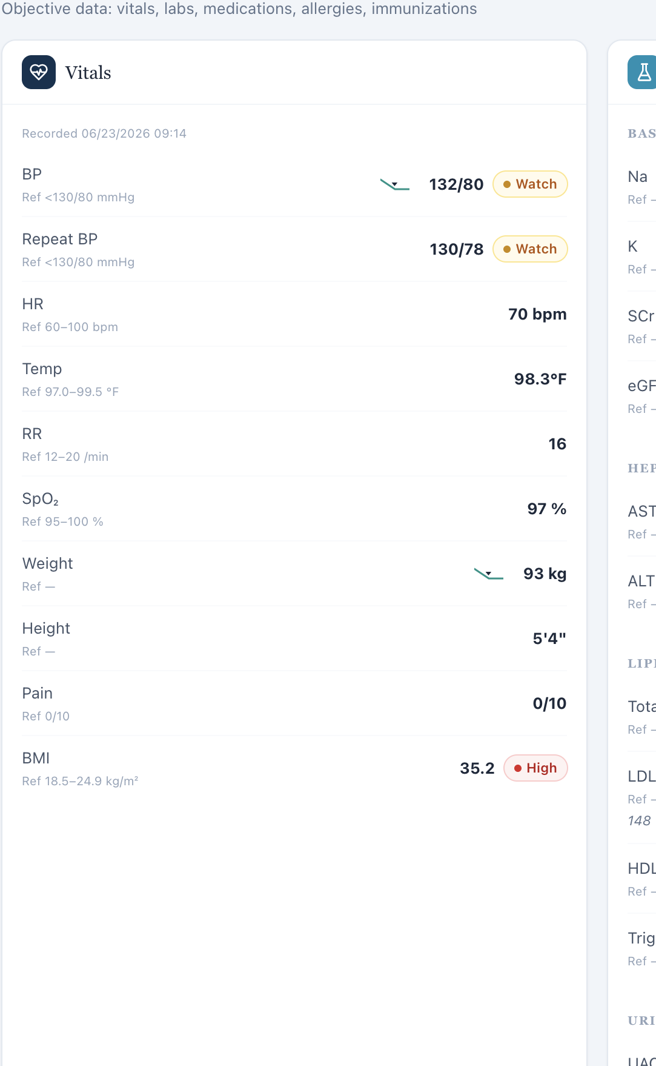
Objective/Snapshot vitals ends at BMI; no BSA field is displayed in the primary objective view.
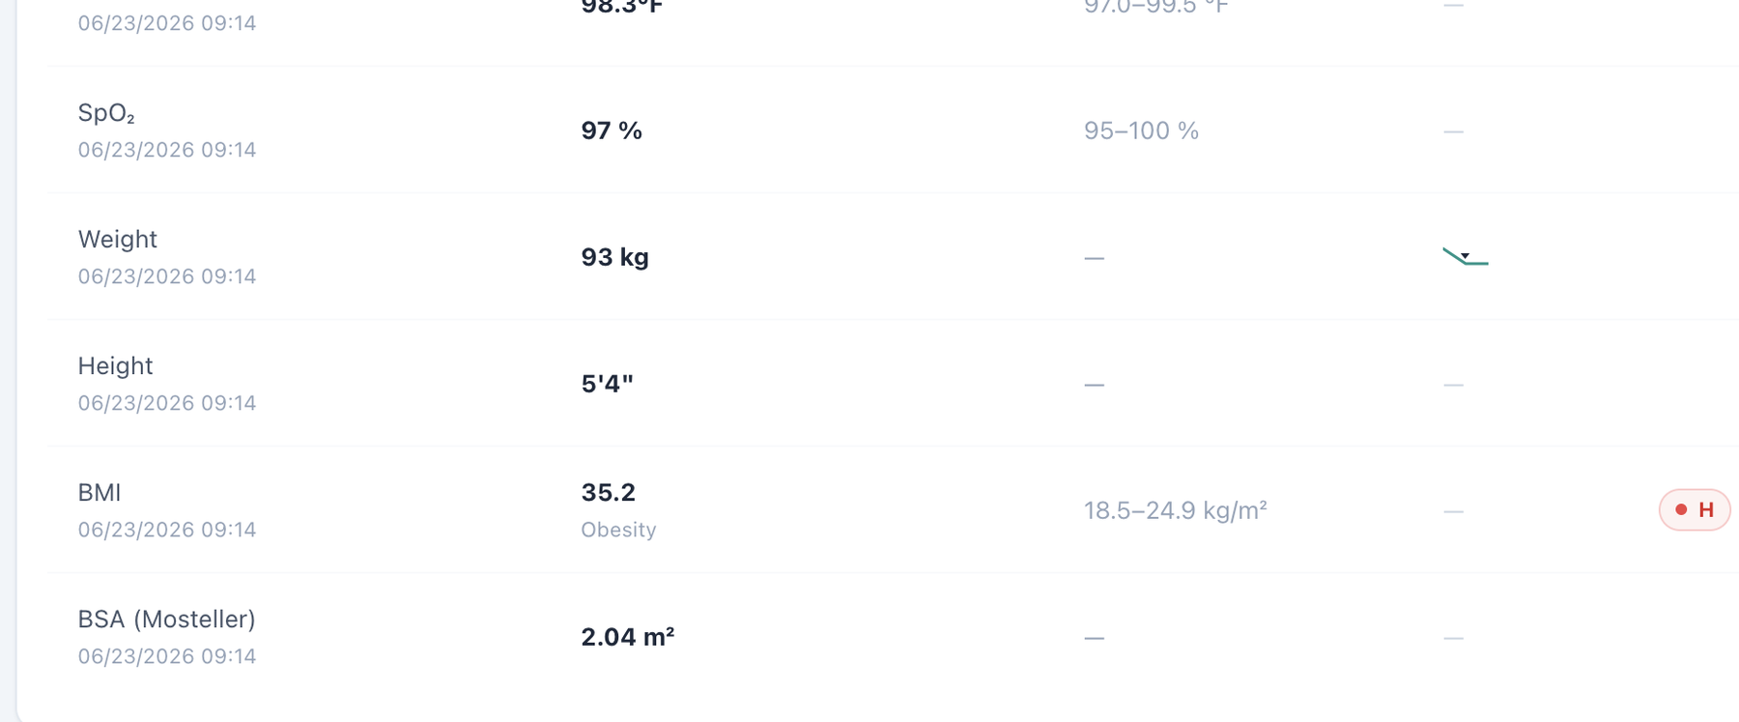
Dedicated Vitals for the same encounter includes a BSA field beneath BMI.

Patient AR – Angela Rodriguez – Wednesday – Wednesday · 3-month follow-up
8 confirmed system/data/interface/workflow issues are included for this visit. Items are grouped by underlying root cause so one defect is not counted multiple times merely because it produced several grader deductions.
# | Issue | Problem type
1 | Wednesday 3-month follow-up header conflicts with “Initial Ambulatory Care Pharmacist Visit” inside the same chart | High — Encounter synchronization
2 | Allergy safety data remains contradictory at the 3-month follow-up | Critical — Internal EMR contradiction / patient safety
3 | Problem List remains on baseline values after treatment response is visible in current labs | High — Data synchronization
4 | Best Practice Advisory says the statin is well tolerated while the AI patient reports new muscle soreness | High — EMR/AI-patient clinical-logic conflict
5 | AI grader requires a 10-year ASCVD risk of 14.5% that is not available in the live Wednesday workflow | High — Hidden/unavailable grader data
6 | Grader expects specific follow-up lifestyle and motivation facts that the AI patient does not report | High — AI patient and grader disagree
7 | BSA labeled as Mosteller is mathematically incorrect (2.04 m² displayed; 2.07 m² calculated) | Medium — Clinical calculation logic
8 | BSA appears in dedicated Vitals but is omitted from the Objective/Snapshot vitals shown to the learner | Medium — Interface/display problem

Issue 1. Wednesday 3-month follow-up header conflicts with “Initial Ambulatory Care Pharmacist Visit” inside the same chart
What the student saw or heard: The live encounter header and AI-patient panel identify Wednesday as a 3-month follow-up. The charted Subjective section still labels the documented encounter as an “Initial Ambulatory Care Pharmacist Visit.”
Why this is a problem: The case contains two visit-stage values at once. Stage controls what should already have happened, which medication changes are expected, which trends should exist, and which history is baseline versus follow-up. A learner should not need to infer which label is authoritative.
Suggested fix: Change the chart metadata to the same 3-month follow-up stage used by the live header and AI patient; ensure this stage is also the one used by the grader.
Focused screenshot evidence
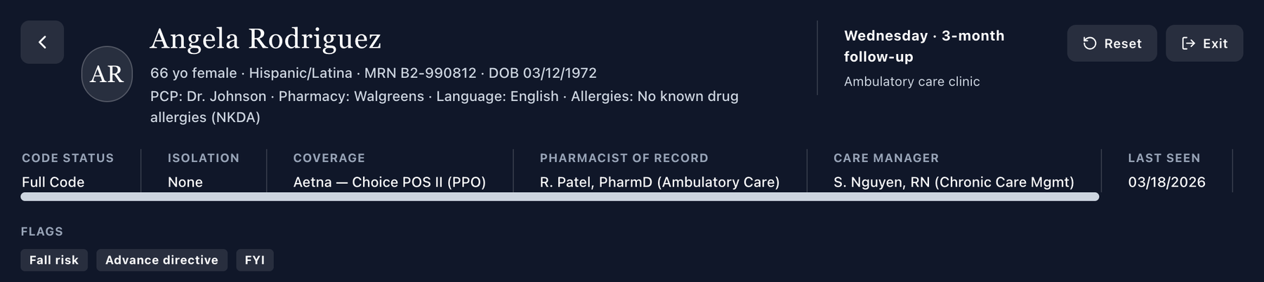
Live header identifies Wednesday · 3-month follow-up.

Charted Subjective metadata still says Initial Ambulatory Care Pharmacist Visit.

Issue 2. Allergy safety data remains contradictory at the 3-month follow-up
What the student saw or heard: The header/medication safety state reports NKDA/no conflicts while the dedicated Allergy tab lists penicillin — rash (childhood).
Why this is a problem: This is the same patient-safety contradiction seen on Tuesday and it persists independently into the Wednesday visit. A learner can act on an incorrect NKDA status even though the chart also contains a specific allergy record.
Suggested fix: Make all Wednesday allergy displays consume the same active allergy record and suppress NKDA when penicillin rash is documented.
Focused screenshot evidence
Live header presents NKDA.
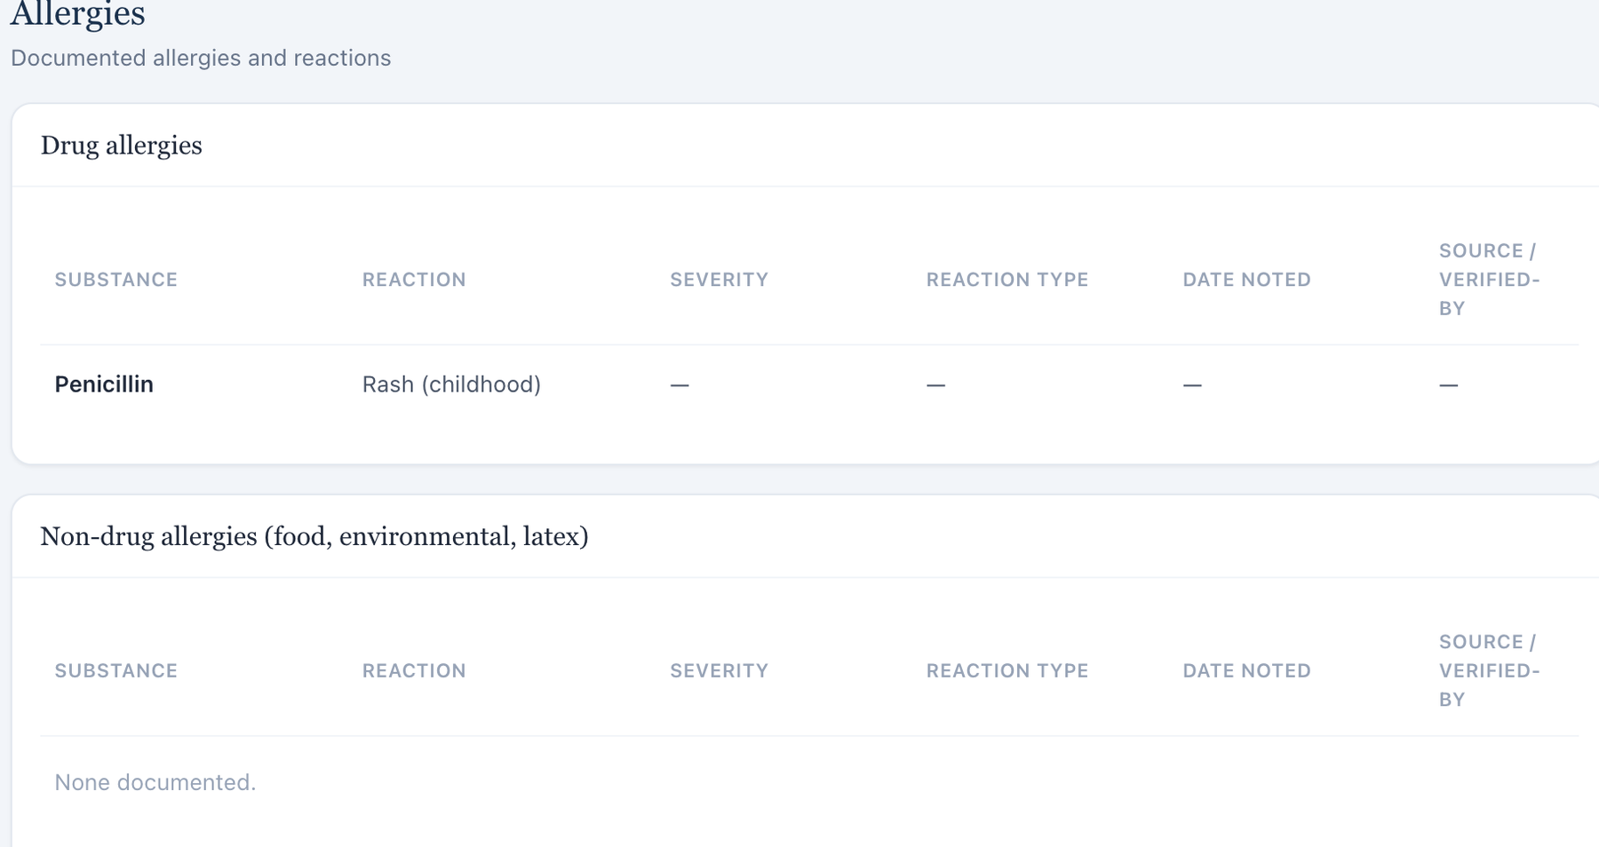
Dedicated Allergy tab lists penicillin with childhood rash.

Issue 3. Problem List remains on baseline values after treatment response is visible in current labs
What the student saw or heard: Current Wednesday data show LDL-C about 89 mg/dL, eGFR 53, UACR 160, BP 136/82, and BMI 35.9. The Problem List still carries the earlier “LDL-C 148 mg/dL, untreated” language and older kidney/BP descriptors.
Why this is a problem: The follow-up is specifically about treatment response. Leaving “untreated” and baseline values as the active problem description can reverse the clinical meaning of the current labs and can interfere with both student assessment and grader comparisons.
Suggested fix: Update the Problem List to the Wednesday current treatment state or clearly label 148 mg/dL and other baseline figures as historical values with dates.
Focused screenshot evidence
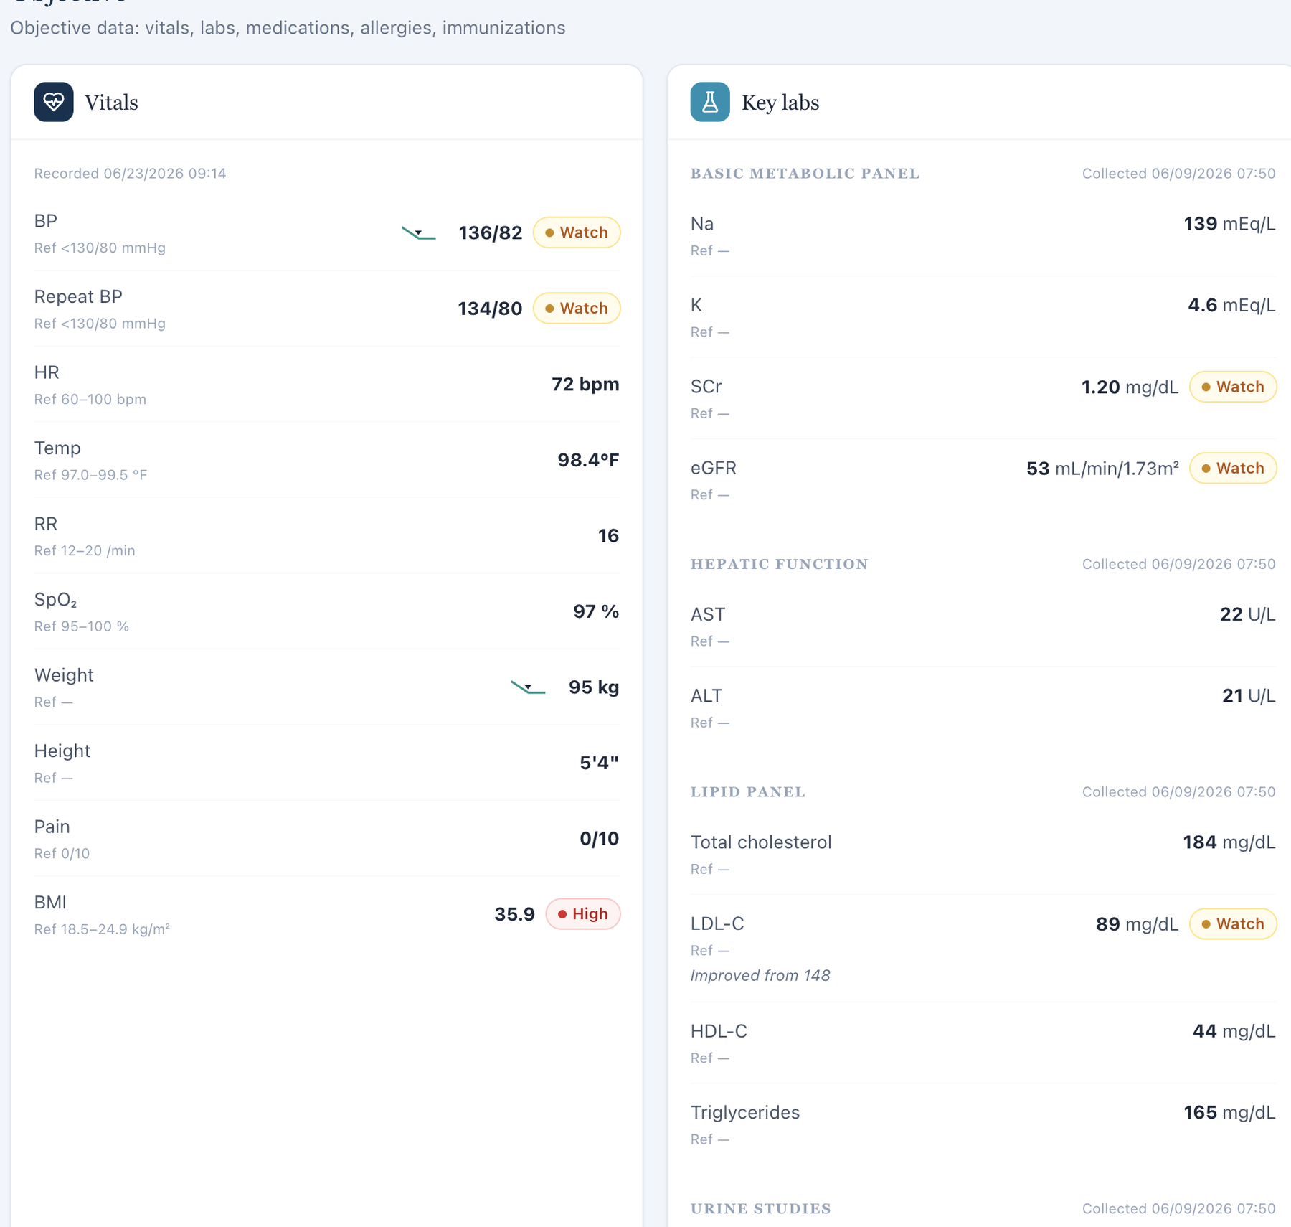
Current Wednesday Objective shows the follow-up dataset.
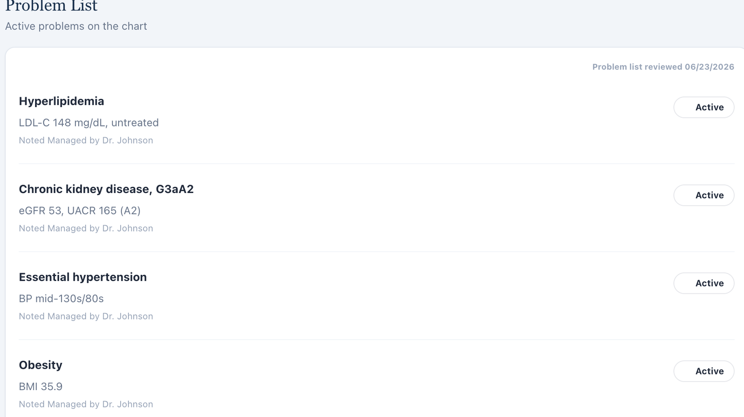
Problem List still describes baseline/untreated values.

Issue 4. Best Practice Advisory says the statin is well tolerated while the AI patient reports new muscle soreness
What the student saw or heard: The live advisory characterizes the statin response as well tolerated. In the interview, the patient reports occasional mild soreness in both legs, especially after walking, and specifically asks whether it could be related to rosuvastatin.
Why this is a problem: The patient’s symptom report does not prove statin toxicity, but it does make the unqualified “well tolerated” advisory incomplete. The learner should be prompted to assess the symptom rather than being told there is no tolerability concern. Conflicting clinical cues can alter the adverse-effect assessment and counseling.
Suggested fix: Build the tolerability advisory from the same current symptom/adverse-effect state returned by the AI patient, or use neutral wording that prompts assessment instead of declaring the medication well tolerated.
Focused screenshot evidence
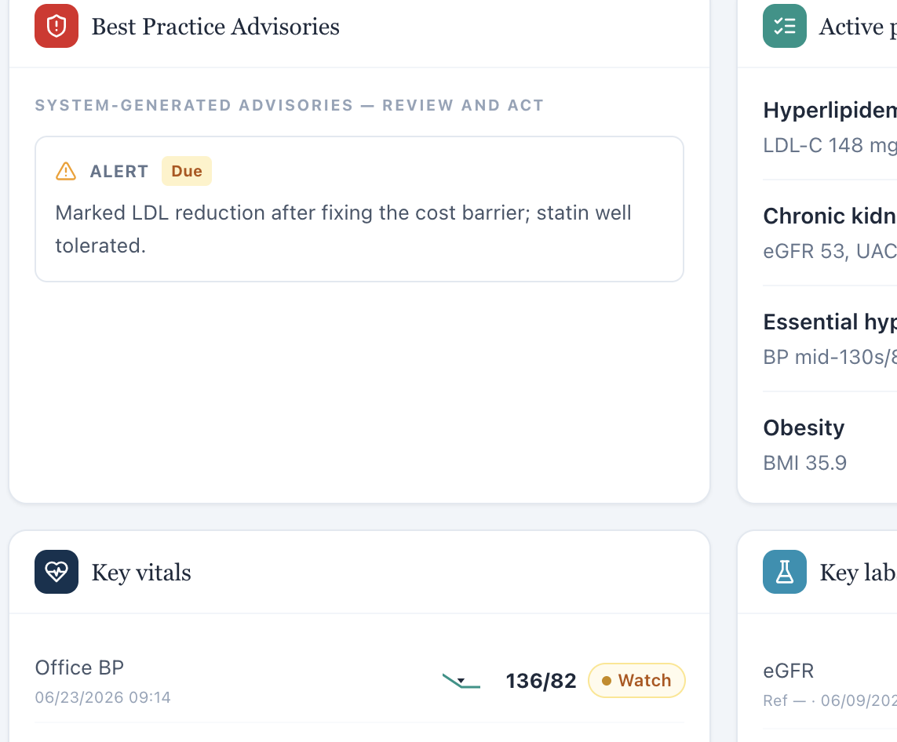
Live advisory describes statin therapy as well tolerated.
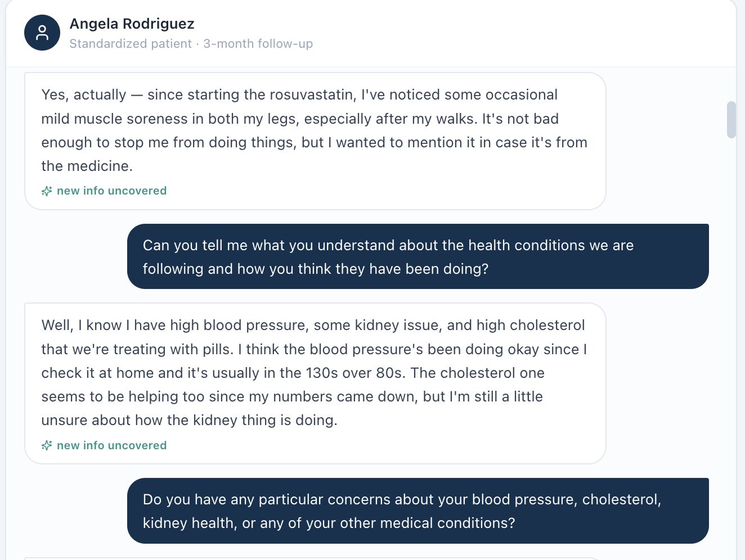
AI patient reports occasional bilateral leg muscle soreness after starting rosuvastatin.

Issue 5. AI grader requires a 10-year ASCVD risk of 14.5% that is not available in the live Wednesday workflow
What the student saw or heard: No calculated ASCVD risk percentage is displayed in the captured live Wednesday EMR.
What the AI grader expected: The grader expects a current 10-year ASCVD risk of 14.5% and an improvement comparison from 17.4% to 14.5%.
Why this is a problem: Neither exact risk value is exposed to the learner. Requiring a hidden current score and hidden prior score creates a grading criterion that cannot be satisfied without an external calculation or unsupported inference.
Suggested fix: Expose the current and relevant prior ASCVD risk values in the learner-facing encounter or remove exact numeric risk deductions.
Focused screenshot evidence
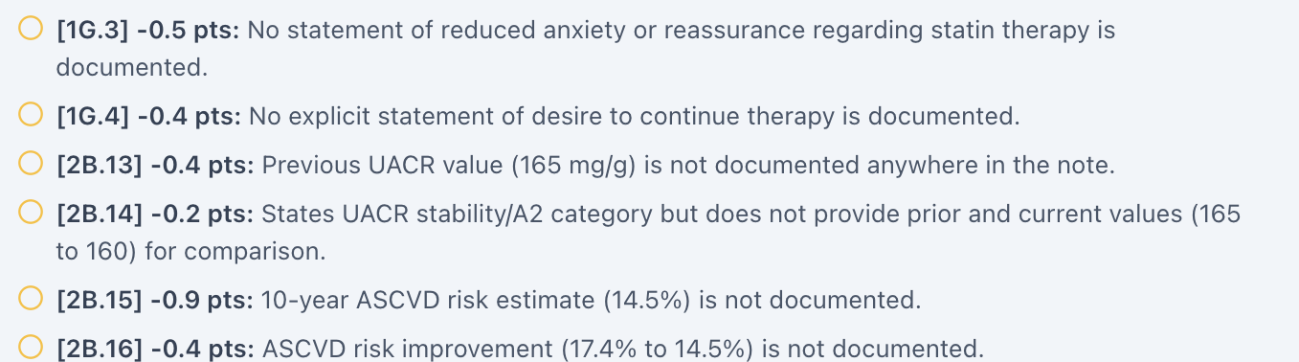
Grader requires the hidden 14.5% ASCVD risk and 17.4% to 14.5% trend.
Live Objective does not display an ASCVD risk calculator/result.

Issue 6. Grader expects specific follow-up lifestyle and motivation facts that the AI patient does not report
What the student saw or heard: During neutral questioning the patient does not provide the grader’s detailed diet/exercise trajectory and is not consistently able to supply the specific behavior-change narrative expected for the follow-up.
What the AI grader expected: The grader deductions call for specific increased walking, reduced packaged food, dialysis-avoidance/independence motivations, reduced anxiety, and other longitudinal facts.
Why this is a problem: A longitudinal standardized patient must return the intended follow-up history when asked neutrally. Otherwise, a well-conducted interview produces a history that cannot match the grader. The learner should not transform vague or absent patient statements into specific behavioral claims.
Suggested fix: Synchronize the Wednesday AI-patient follow-up responses with the intended grader history, or grade only the facts the patient actually returns.
Focused screenshot evidence
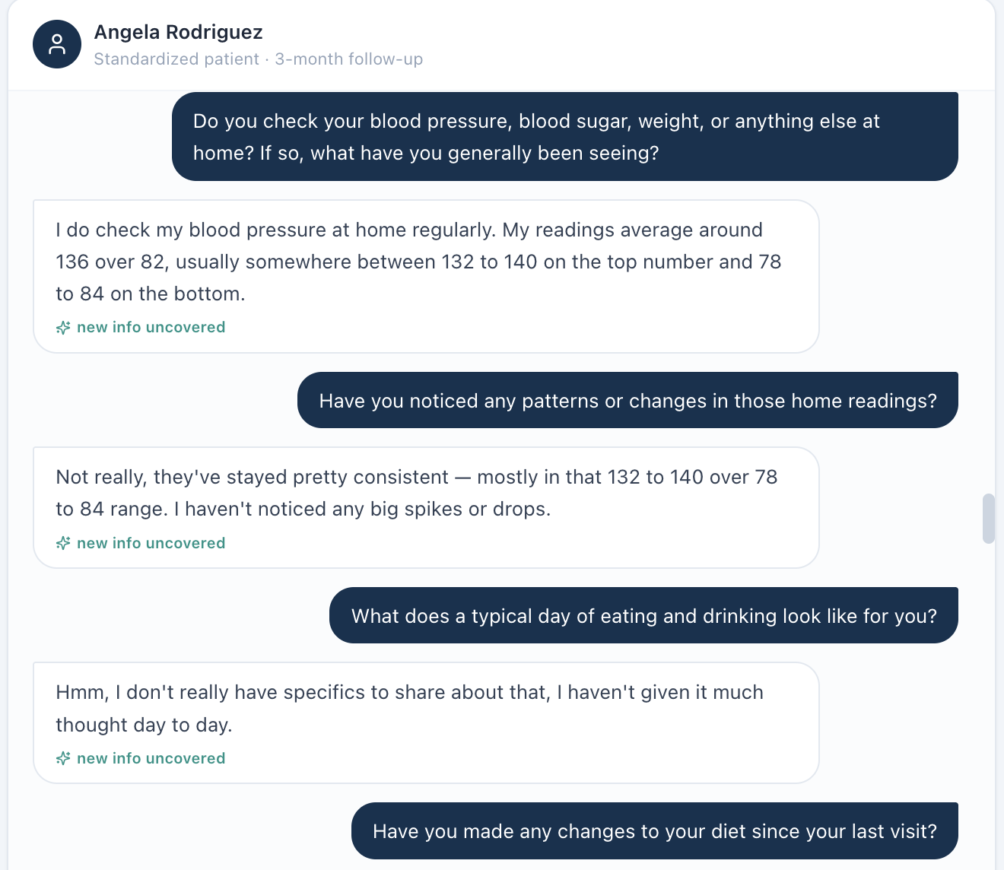
AI patient does not provide the specific lifestyle-change detail expected by grading.
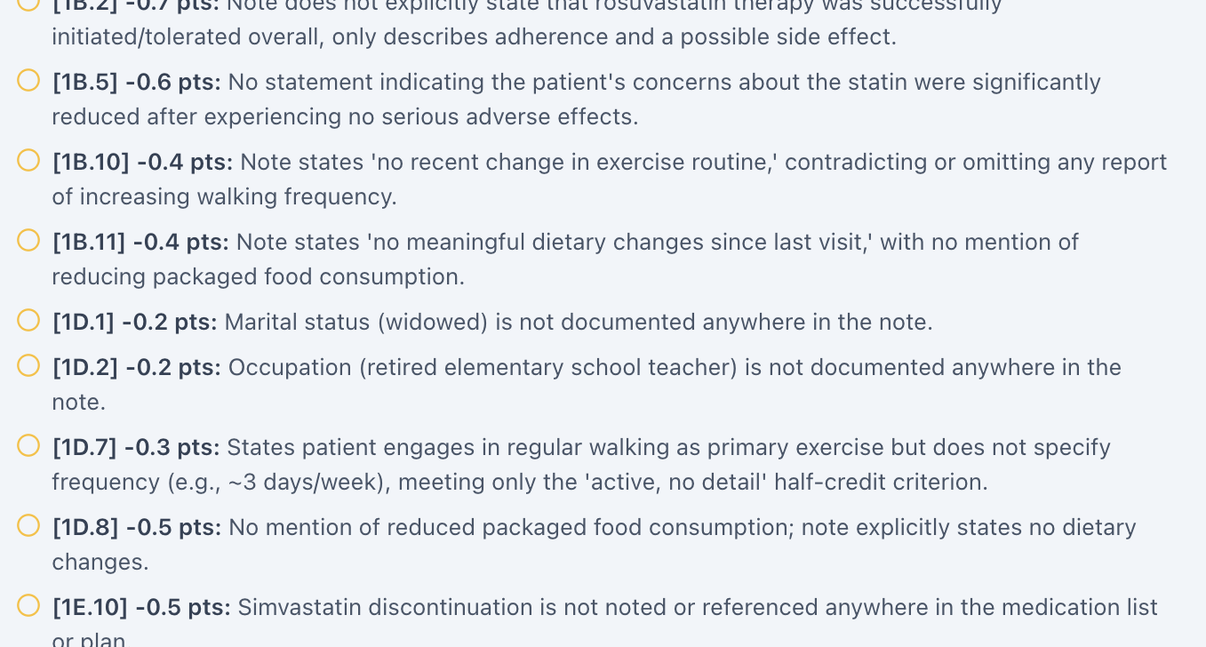
Grader deductions require specific lifestyle and motivational details.

Issue 7. BSA labeled as Mosteller is mathematically incorrect (2.04 m² displayed; 2.07 m² calculated)
What the student saw or heard: The dedicated Vitals tab displays weight 95 kg, height 64 in, and “BSA (Mosteller) 2.04 m².”
Why this is a problem: The Mosteller equation is BSA = √(height in cm × weight in kg / 3600). Using the values displayed in this encounter gives 2.071 m², which rounds to 2.07 m², not 2.04 m². Because the same 2.04 m² value appears across patients with substantially different body sizes, this looks like a shared calculation or hard-coded-value defect rather than normal rounding. BSA can be used in medication dosing and clinical interpretation; a field explicitly labeled with a formula should be mathematically reproducible from the height and weight shown next to it.
Suggested fix: Recalculate BSA from the active encounter height and weight using the documented Mosteller formula, round consistently, and regression-test all nine Week 2 encounters.
Focused screenshot evidence
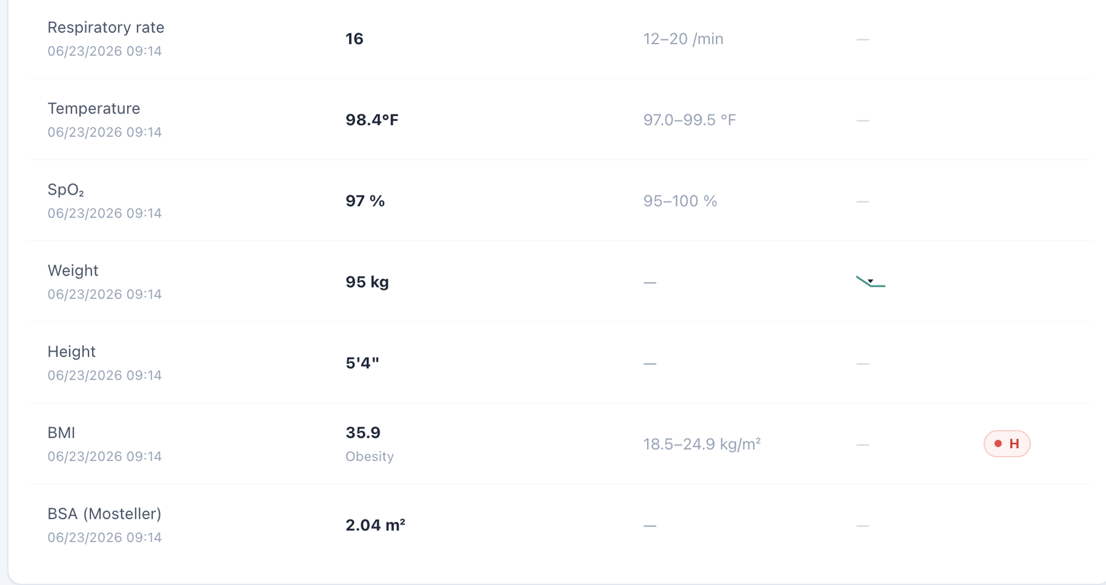
Dedicated Vitals shows weight 95 kg, height 64 in, and the repeated BSA value 2.04 m².

Issue 8. BSA appears in dedicated Vitals but is omitted from the Objective/Snapshot vitals shown to the learner
What the student saw or heard: The student-facing Objective/Snapshot vitals card displays the encounter vitals through BMI but does not show BSA. Opening the dedicated Vitals tab adds a BSA field for the same encounter.
Why this is a problem: The same clinical data element is not propagated consistently across VACS views. A learner working from the Objective/Snapshot may reasonably believe BSA is unavailable, while a learner who opens the dedicated Vitals page sees an additional calculated field. The inconsistency becomes more important because the displayed BSA is also mathematically wrong in this encounter. Display rules should not make required or clinically relevant data depend on which tab the student happens to open.
Suggested fix: Use one vitals data model for Snapshot/Objective and dedicated Vitals. Either display BSA consistently in both locations or intentionally omit it from both; do not grade a value that is hidden from the primary Objective view.
Focused screenshot evidence
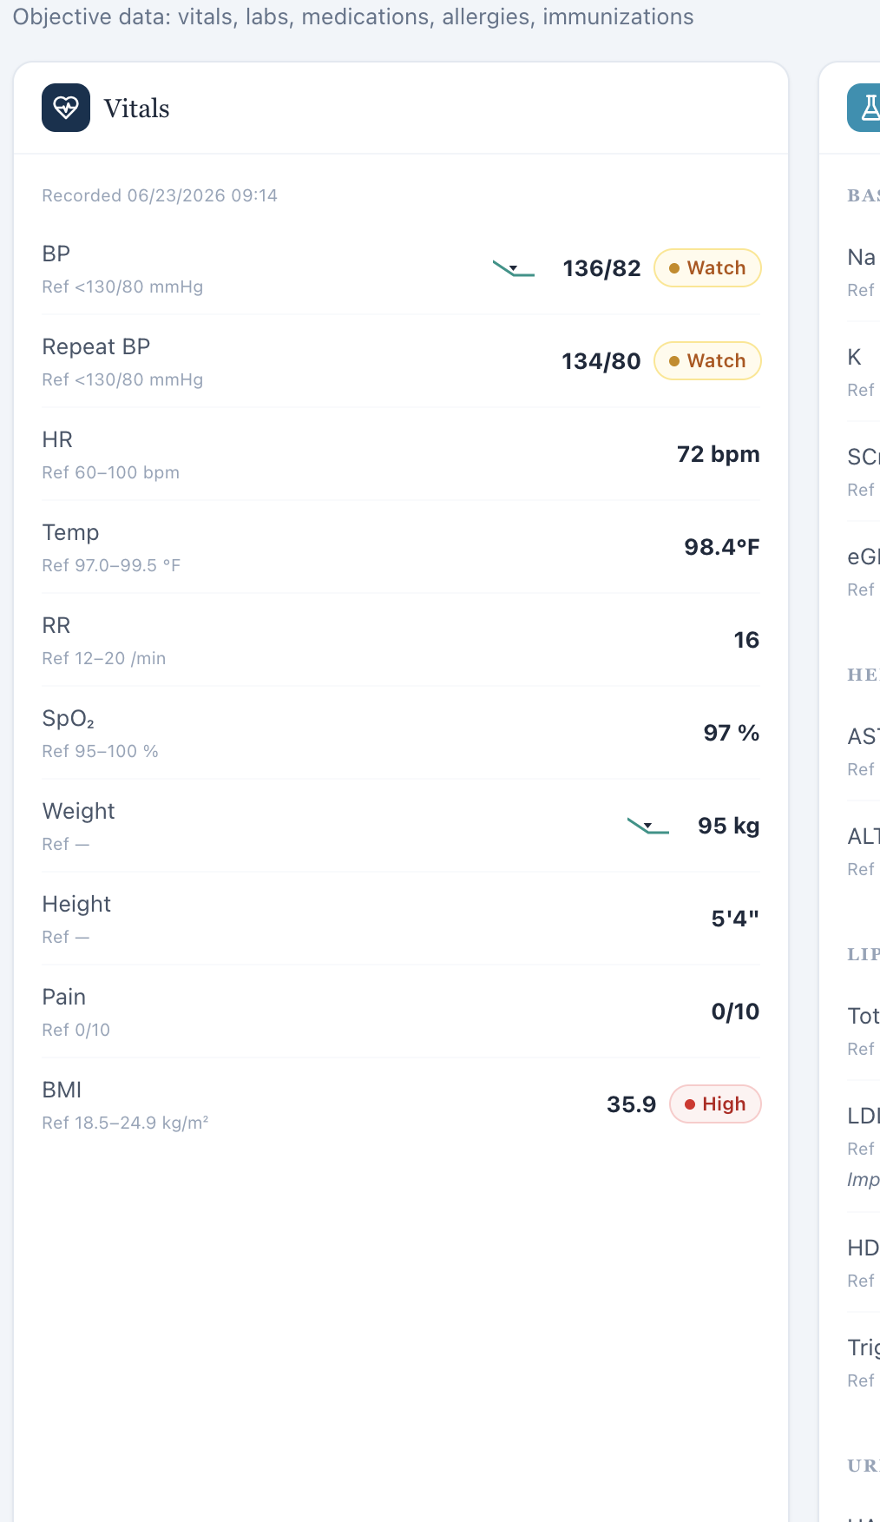
Objective/Snapshot vitals ends at BMI; no BSA field is displayed in the primary objective view.
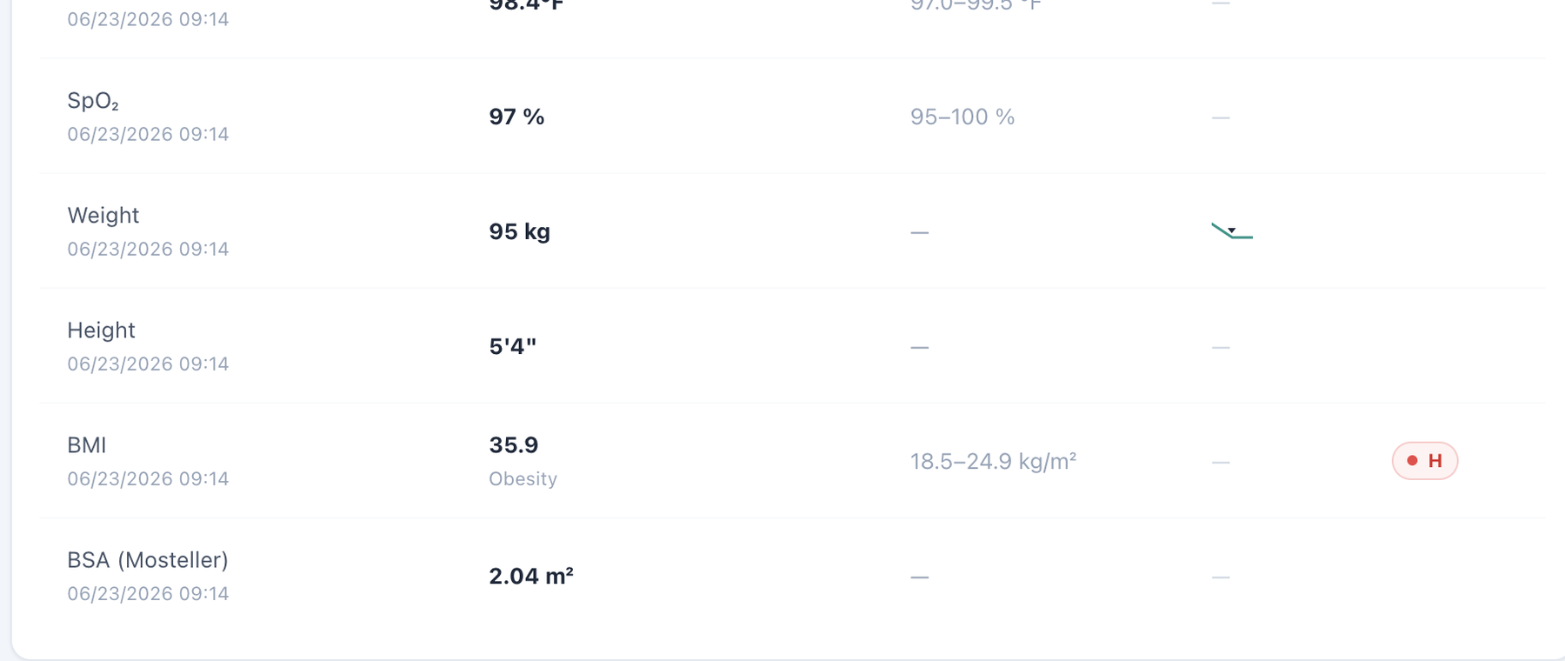
Dedicated Vitals for the same encounter includes a BSA field beneath BMI.

Patient AR – Angela Rodriguez – Thursday – Thursday · six-month follow-up
8 confirmed system/data/interface/workflow issues are included for this visit. Items are grouped by underlying root cause so one defect is not counted multiple times merely because it produced several grader deductions.
# | Issue | Problem type
1 | Thursday six-month follow-up still contains “Initial Ambulatory Care Pharmacist Visit” chart metadata | High — Encounter synchronization
2 | Allergy safety contradiction persists through the six-month AR visit | Critical — Internal EMR contradiction / patient safety
3 | Problem List remains stale at six months despite improved current LDL-C and kidney markers | High — Data synchronization
4 | AI grader requires a 10-year ASCVD risk of 13.2% and prior risk trend that the live workflow does not show | High — Hidden/unavailable grader data
5 | Grader requires a continuing-therapy misconception even though the AI patient reports confidence and no unresolved concern | High — AI patient and grader disagree
6 | AR Thursday AI grader repeatedly fails and can enter an “Already Graded” state without usable feedback | Critical/High — Technical grading failure / workflow reliability
7 | BSA labeled as Mosteller is mathematically incorrect (2.04 m² displayed; 2.05 m² calculated) | Medium — Clinical calculation logic
8 | BSA appears in dedicated Vitals but is omitted from the Objective/Snapshot vitals shown to the learner | Medium — Interface/display problem

Issue 1. Thursday six-month follow-up still contains “Initial Ambulatory Care Pharmacist Visit” chart metadata
What the student saw or heard: The live header and AI patient identify a six-month follow-up, but the charted Subjective section still labels the visit as an Initial Ambulatory Care Pharmacist Visit.
Why this is a problem: The inconsistency leaves longitudinal encounter metadata unsynchronized at the final Week 2 AR stage. It can change what prior treatment history and trends the learner expects to see and can also cause the grader to use the wrong stage.
Suggested fix: Update the chart visit metadata to six-month follow-up and make the same stage value authoritative for the AI patient and grader.
Focused screenshot evidence
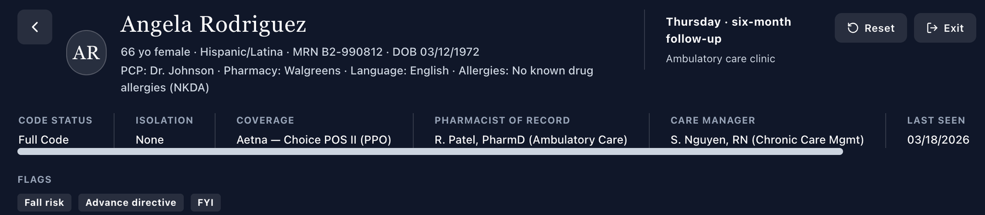
Live header identifies Thursday · six-month follow-up.

Chart metadata still identifies an Initial Ambulatory Care Pharmacist Visit.

Issue 2. Allergy safety contradiction persists through the six-month AR visit
What the student saw or heard: NKDA/no-conflict status remains visible in the header/medication workflow while the Allergy tab contains penicillin — rash (childhood).
Why this is a problem: The same allergy defect recurs independently on all three AR visits. A six-month follow-up does not resolve the underlying safety risk if the authoritative banner still says NKDA.
Suggested fix: Unify the allergy source across all AR days and regression-test that the penicillin allergy is shown consistently in every medication-safety surface.
Focused screenshot evidence
Header still presents NKDA.
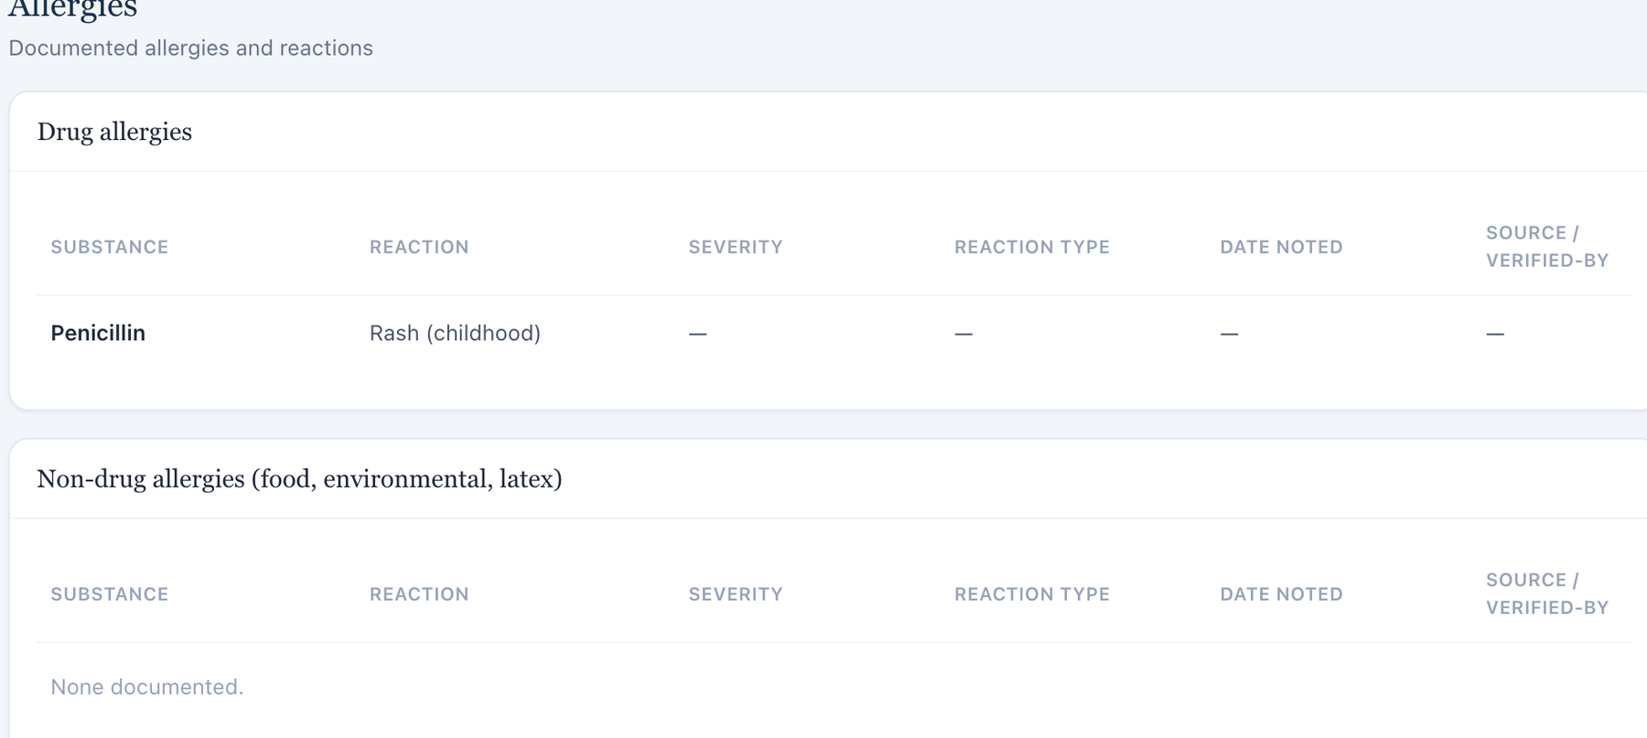
Dedicated Allergy tab shows penicillin rash.

Issue 3. Problem List remains stale at six months despite improved current LDL-C and kidney markers
What the student saw or heard: The current six-month dataset includes LDL-C 78 mg/dL, eGFR 54, UACR 155, BP 132/80, and BMI 35.2. The Problem List continues to display baseline language such as LDL-C 148 mg/dL “untreated” with older kidney/BP/BMI values.
Why this is a problem: A six-month follow-up is specifically intended to demonstrate longitudinal response. Presenting old values as the active problem state obscures that trajectory and creates conflict with the current Objective and medication data.
Suggested fix: Update six-month Problem List descriptors to current values or explicitly label all baseline numbers as historical with dates.
Focused screenshot evidence
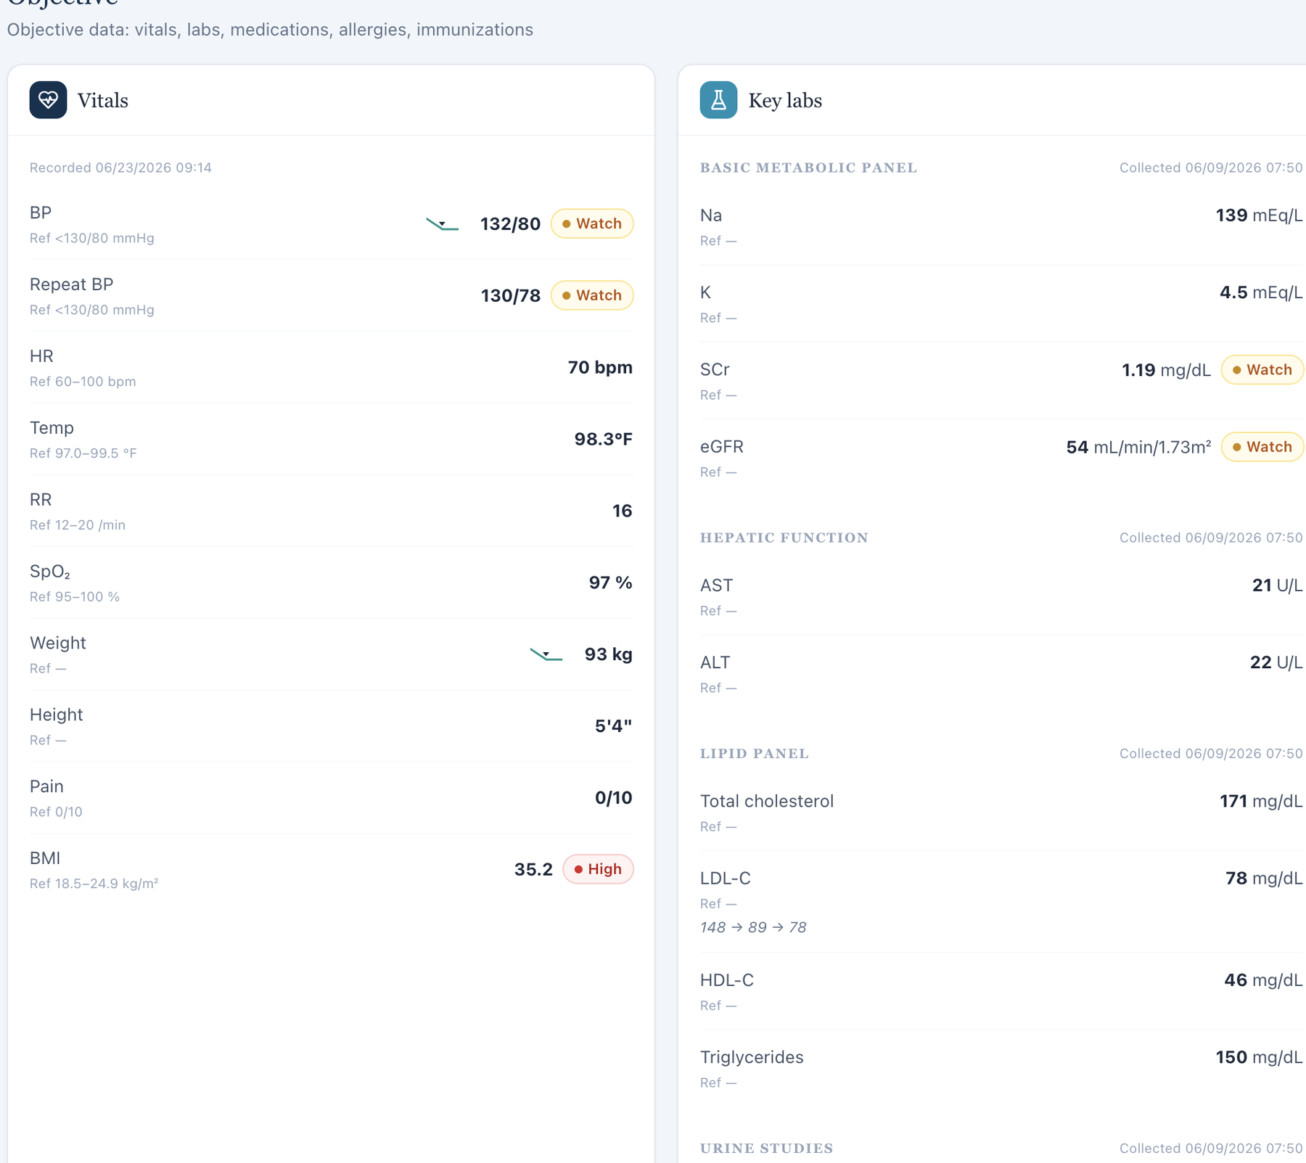
Current six-month Objective shows the active dataset.
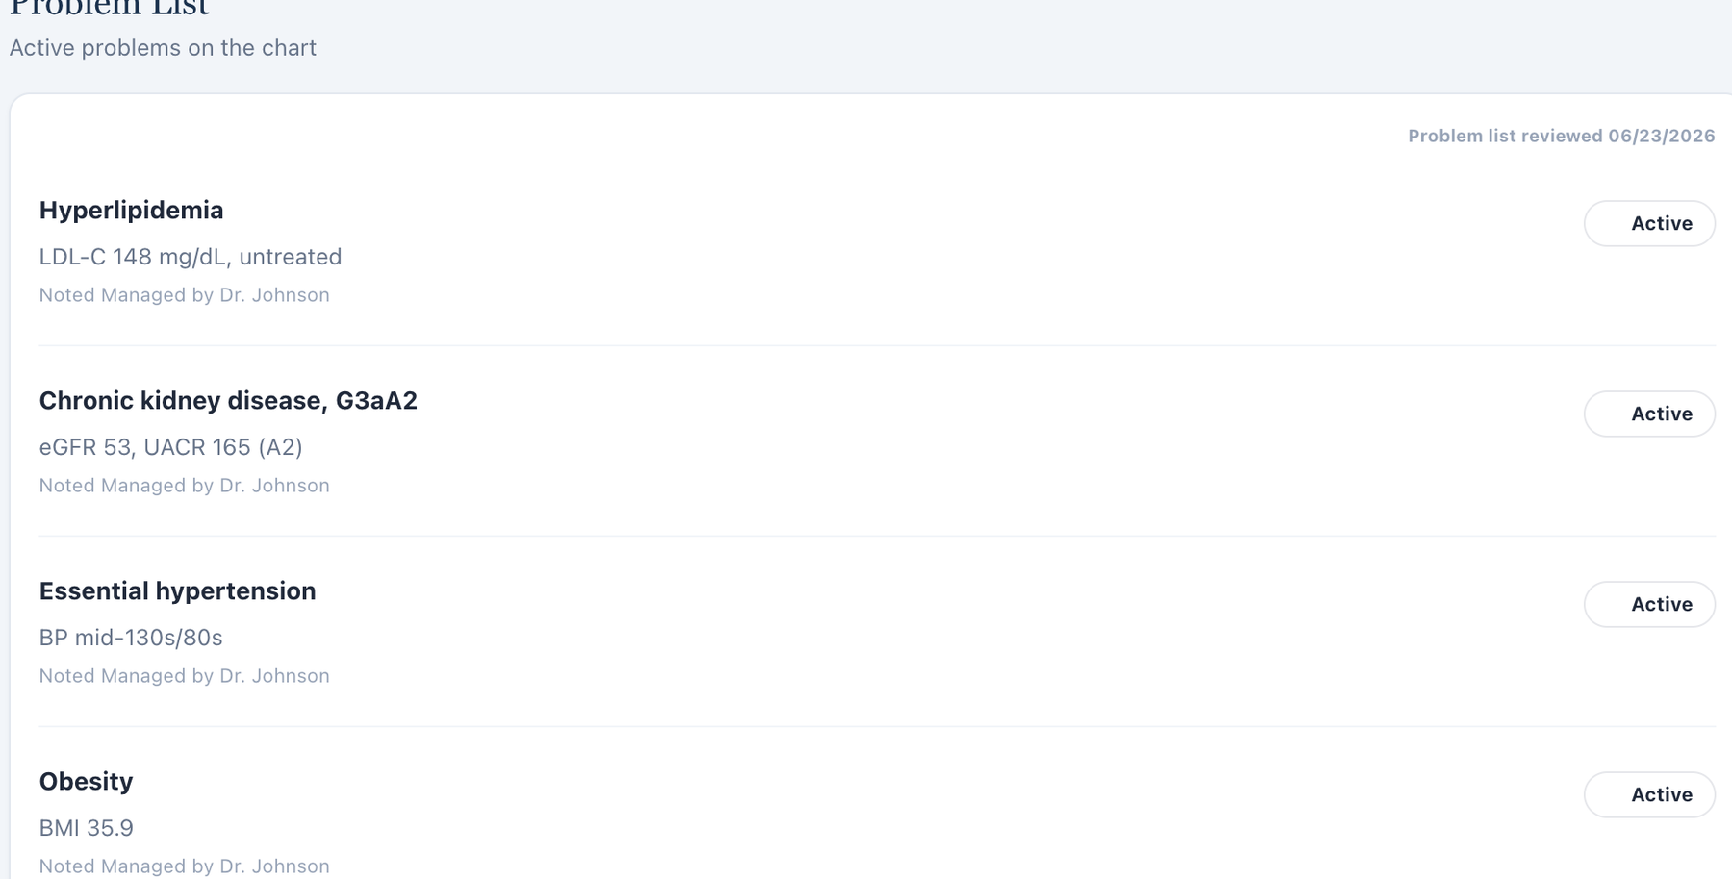
Problem List retains baseline/untreated descriptors.

Issue 4. AI grader requires a 10-year ASCVD risk of 13.2% and prior risk trend that the live workflow does not show
What the student saw or heard: The six-month EMR exposes current vitals, lipid values, kidney function, and medication data but no numeric ASCVD risk score.
What the AI grader expected: The grader requires a current 13.2% 10-year ASCVD risk and a longitudinal improvement from the hidden earlier risk value.
Why this is a problem: The learner cannot independently verify or quote the exact percentage from VACS. The same hidden-risk pattern is present in every patient/day, indicating a systematic disconnect between what the grader requires and what the learner can see.
Suggested fix: Display the calculated risk and any prior risk value needed for trend grading, or remove those numeric deductions.
Focused screenshot evidence
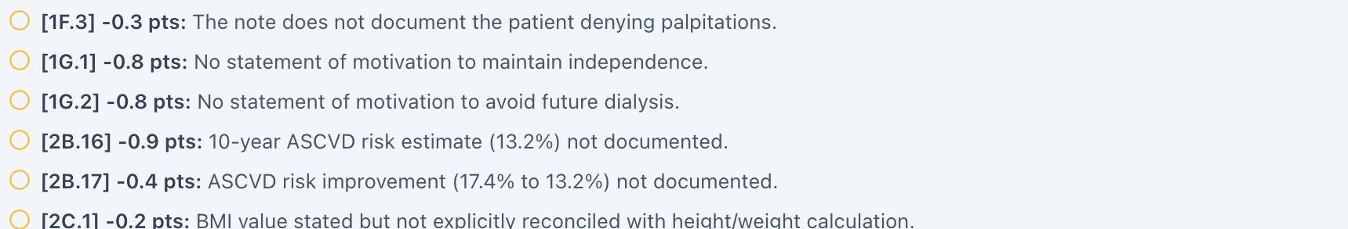
Grader requires the specific 13.2% ASCVD risk value.
Live six-month Objective has no ASCVD risk field.

Issue 5. Grader requires a continuing-therapy misconception even though the AI patient reports confidence and no unresolved concern
What the student saw or heard: At the end of the six-month interview, the patient says she understands her medications and conditions well, feels more confident, trusts rosuvastatin is helping, and has no other concerns.
What the AI grader expected: The grader feedback expects a specific knowledge deficit/misconception about the need to continue therapy and deducts when that concern is not documented.
Why this is a problem: A patient-specific misconception cannot be invented merely because it appears in a hidden grading reference. The standardized patient explicitly answers the opposite when asked broadly and neutrally. Penalizing the student for not documenting a concern the patient denies creates an impossible grading condition.
Suggested fix: Either make the AI patient reliably express the intended continuing-therapy misconception after neutral questioning or remove that misconception from the grader for this encounter.
Focused screenshot evidence

AI patient says she understands the regimen, feels confident, and has no other concerns.
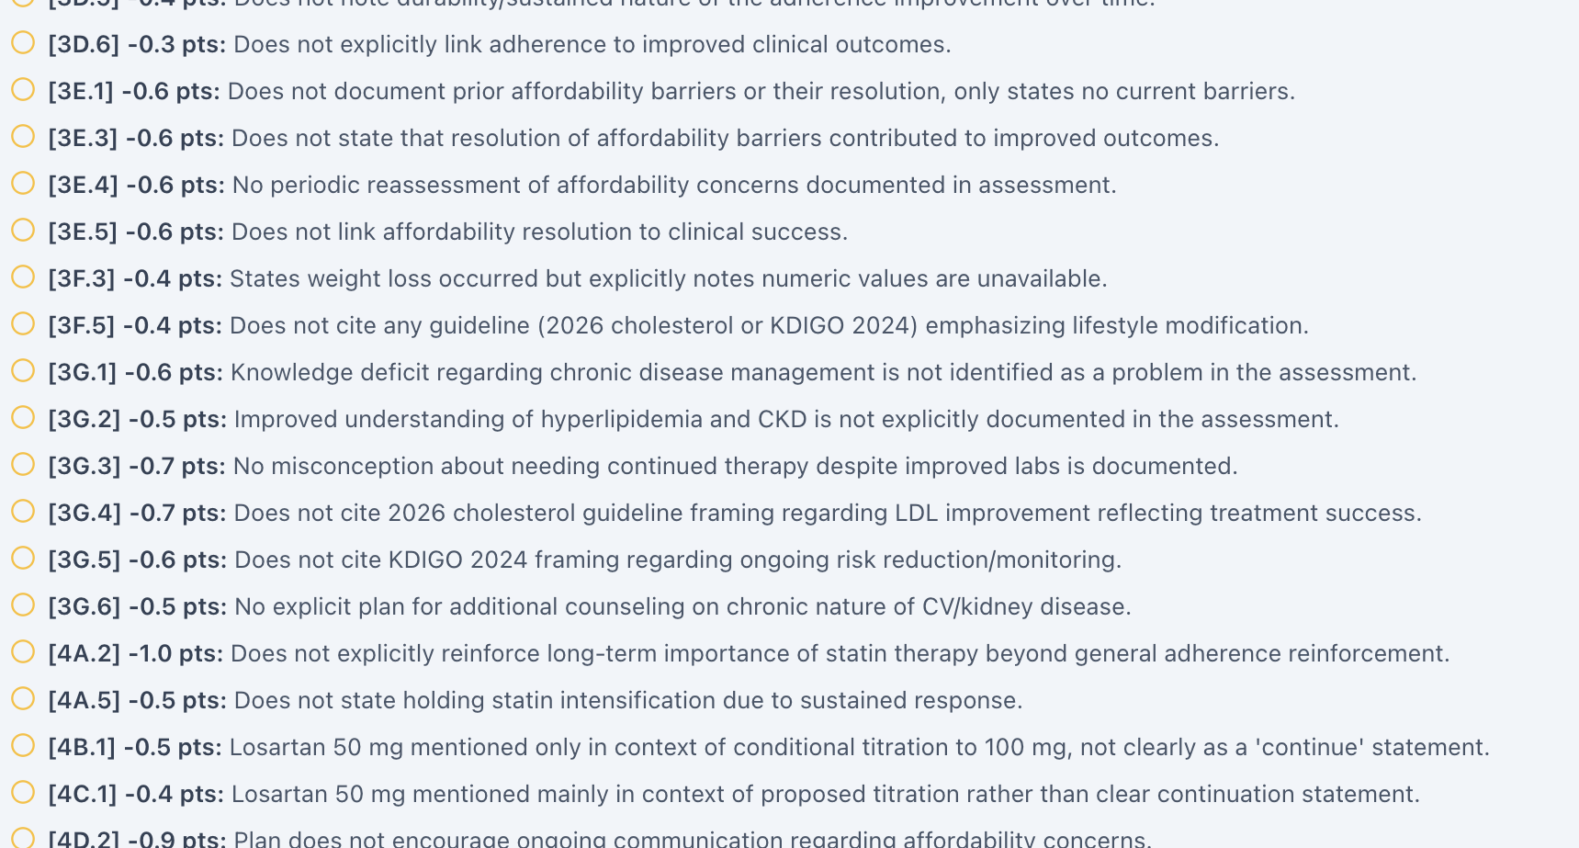
Grader requires a specific knowledge-deficit/continuation concern not supplied by the patient.

Issue 6. AR Thursday AI grader repeatedly fails and can enter an “Already Graded” state without usable feedback
What the student saw or heard: Three original AR Thursday failure-state screenshots now document the grading sequence. The first attempt returned “The AI grader failed to return a valid response (Unexpected end of JSON input). Please submit again.” while the interface simultaneously displayed “Already Graded”; the auditor observed this after approximately 5 minutes. A second attempt reproduced the same JSON failure and “Already Graded” state after approximately 3 minutes. A third captured state showed “Already Graded” without usable grader feedback visible.
Why this is a problem: This is a technical/workflow reliability defect, not a clinical SOAP error. Grading cannot be reliably verified when the system requests resubmission while also treating the note as already graded. The user may be locked out of a clean retry, feedback may be inaccessible, and repeated attempts consume substantial time. A later successful result does not erase or disprove these earlier failure states.
Suggested fix: Inspect and correct the grader response/parsing and state-handling workflow. An incomplete JSON response should leave the attempt clearly failed rather than completed; “Already Graded” should appear only after a complete grading response is successfully stored and retrievable; and a failed attempt should permit a clean retry without resetting or locking the encounter.
Timing evidence note: The approximately 5-minute and 3-minute values are auditor-observed estimates and are not supported by timestamp screenshots. The screenshots directly prove the failure messages and interface states, not the exact elapsed time.
Focused screenshot evidence
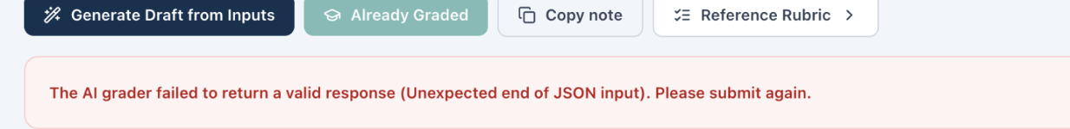
AR Thursday failure attempt 1: the grader reports “Unexpected end of JSON input” while the interface also shows “Already Graded.”
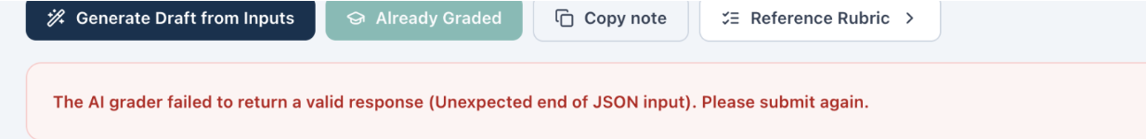
AR Thursday failure attempt 2: the same JSON-response failure is reproduced, again with “Already Graded” visible.
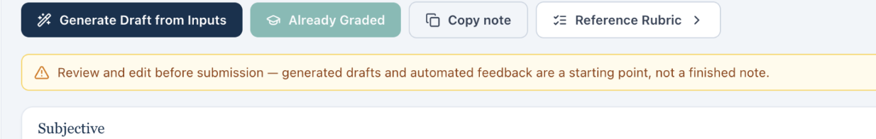
AR Thursday failure state 3: the interface says “Already Graded,” but no usable grader feedback is visible.

Issue 7. BSA labeled as Mosteller is mathematically incorrect (2.04 m² displayed; 2.05 m² calculated)
What the student saw or heard: The dedicated Vitals tab displays weight 93 kg, height 64 in, and “BSA (Mosteller) 2.04 m².”
Why this is a problem: The Mosteller equation is BSA = √(height in cm × weight in kg / 3600). Using the values displayed in this encounter gives 2.049 m², which rounds to 2.05 m², not 2.04 m². Because the same 2.04 m² value appears across patients with substantially different body sizes, this looks like a shared calculation or hard-coded-value defect rather than normal rounding. BSA can be used in medication dosing and clinical interpretation; a field explicitly labeled with a formula should be mathematically reproducible from the height and weight shown next to it.
Suggested fix: Recalculate BSA from the active encounter height and weight using the documented Mosteller formula, round consistently, and regression-test all nine Week 2 encounters.
Focused screenshot evidence
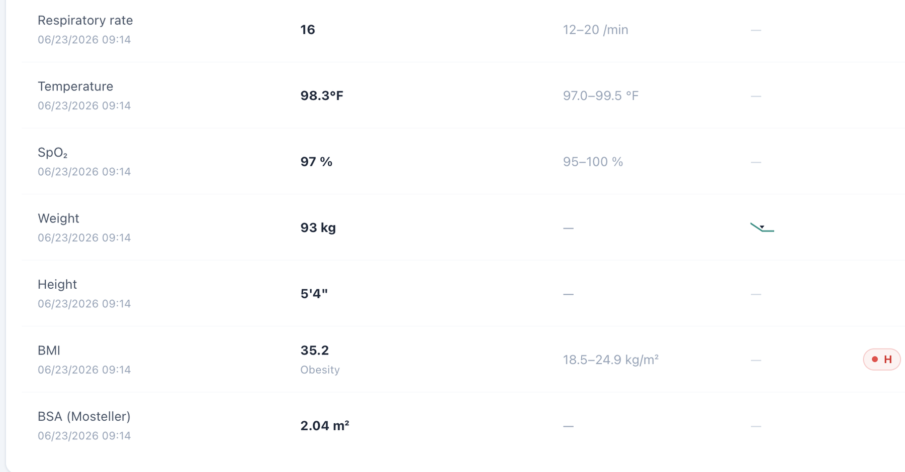
Dedicated Vitals shows weight 93 kg, height 64 in, and the repeated BSA value 2.04 m².

Issue 8. BSA appears in dedicated Vitals but is omitted from the Objective/Snapshot vitals shown to the learner
What the student saw or heard: The student-facing Objective/Snapshot vitals card displays the encounter vitals through BMI but does not show BSA. Opening the dedicated Vitals tab adds a BSA field for the same encounter.
Why this is a problem: The same clinical data element is not propagated consistently across VACS views. A learner working from the Objective/Snapshot may reasonably believe BSA is unavailable, while a learner who opens the dedicated Vitals page sees an additional calculated field. The inconsistency becomes more important because the displayed BSA is also mathematically wrong in this encounter. Display rules should not make required or clinically relevant data depend on which tab the student happens to open.
Suggested fix: Use one vitals data model for Snapshot/Objective and dedicated Vitals. Either display BSA consistently in both locations or intentionally omit it from both; do not grade a value that is hidden from the primary Objective view.
Focused screenshot evidence
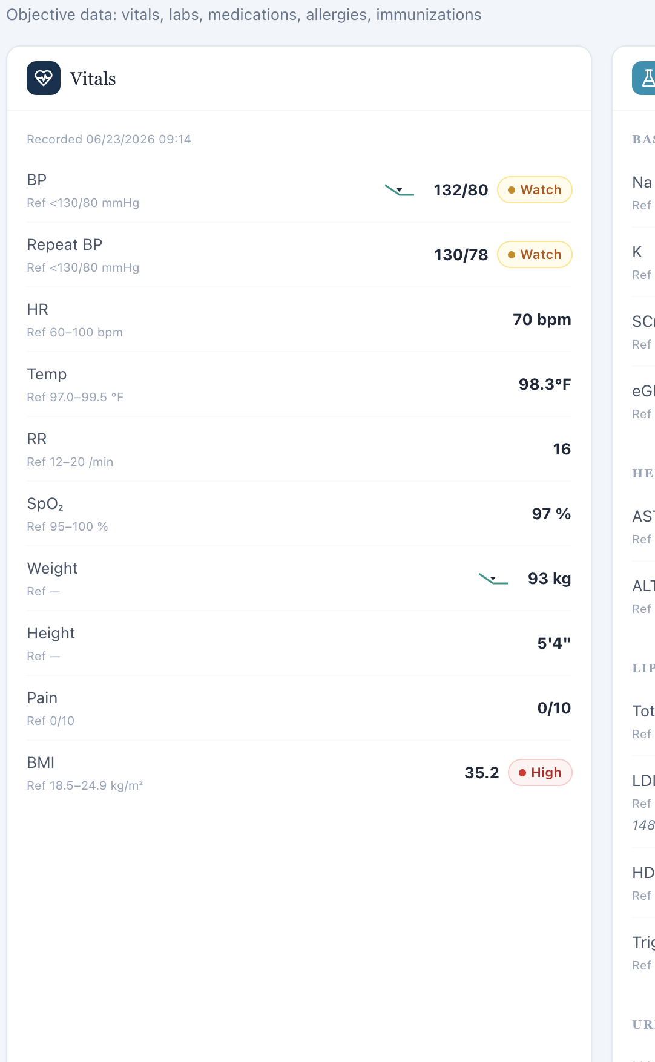
Objective/Snapshot vitals ends at BMI; no BSA field is displayed in the primary objective view.
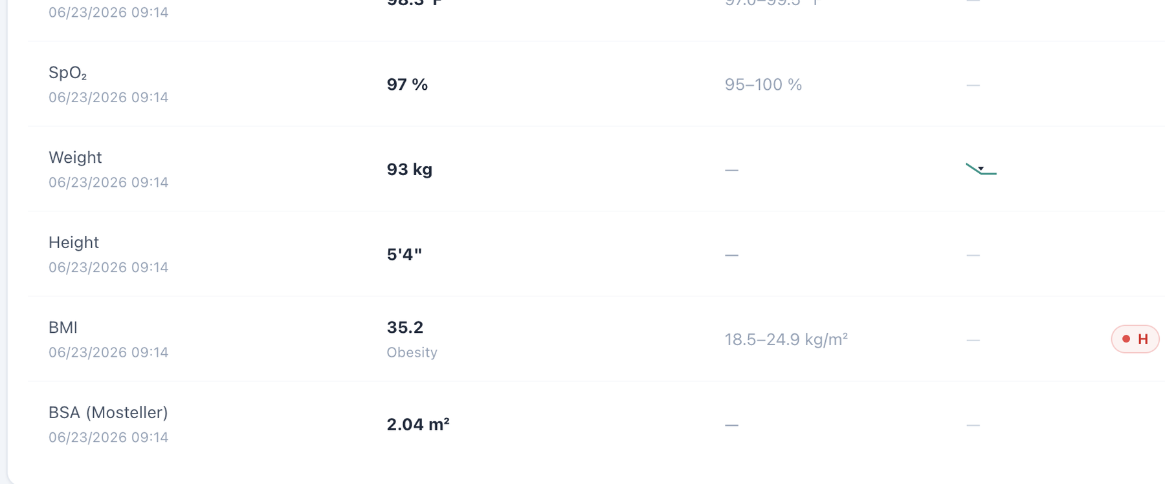
Dedicated Vitals for the same encounter includes a BSA field beneath BMI.

Patient MT – Michael Turner – Tuesday – Tuesday · initial collaborative practice management
6 confirmed system/data/interface/workflow issues are included for this visit. Items are grouped by underlying root cause so one defect is not counted multiple times merely because it produced several grader deductions.
# | Issue | Problem type
1 | Patient Interview uses the wrong pronoun for a male patient | Medium — Interface/display problem
2 | Home BP average is shown as a numeric result while simultaneously labeled “Missing” | Medium — Interface/display logic
3 | AI grader requires a 10-year ASCVD risk of 11.8% that is not displayed in the MT Tuesday EMR | High — Hidden/unavailable grader data
4 | Grader expects fatigue, alcohol, exercise, and history details that conflict with the AI patient’s answers | High — AI patient and grader disagree
5 | BSA labeled as Mosteller is mathematically incorrect (2.04 m² displayed; 2.26 m² calculated) | Medium — Clinical calculation logic
6 | BSA appears in dedicated Vitals but is omitted from the Objective/Snapshot vitals shown to the learner | Medium — Interface/display problem

Issue 1. Patient Interview uses the wrong pronoun for a male patient
What the student saw or heard: Michael Turner is a male patient. The Tuesday Patient Interview instruction states: “Interview the standardized patient — she won’t volunteer hidden facts unless you ask.”
Why this is a problem: The interface displays a demographic pronoun that does not match the active patient. The same wording is now directly confirmed across all three MT visits and all three DC visits, showing a repeated interface/template defect rather than an isolated typo. The mismatch can confuse the learner about patient identity and reduces confidence that patient-specific interface content is synchronized to the active record.
Suggested fix: Bind the Patient Interview instruction to the patient demographic record, or use gender-neutral wording such as “Interview the standardized patient — the patient won’t volunteer hidden facts unless you ask.” Regression-test the instruction on every MT and DC visit.
Focused screenshot evidence

MT Tuesday: visit-specific Patient Interview evidence shows the incorrect “she won’t volunteer…” instruction.

Issue 2. Home BP average is shown as a numeric result while simultaneously labeled “Missing”
What the student saw or heard: The Objective/Additional section displays a numeric 5-day home BP average (approximately 136/83 mmHg) but prefixes the row with “Missing.”
Why this is a problem: The field cannot be both missing and displayed. The label makes the learner uncertain whether the value is valid, whether it should be used, or whether another hidden value is expected. This same “Missing but populated” pattern recurs in DC home-BP rows.
Suggested fix: If a home BP result is available, render it as a normal objective/result field and remove the “Missing” label. Use “Missing” only when no value is supplied.
Focused screenshot evidence
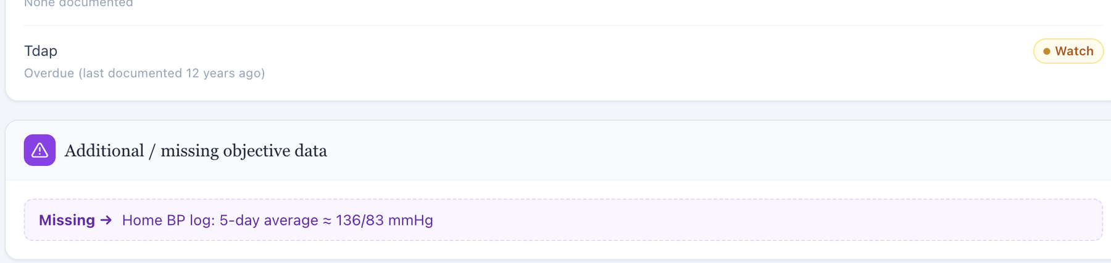
Objective shows a populated home BP average inside a row labeled “Missing.”

Issue 3. AI grader requires a 10-year ASCVD risk of 11.8% that is not displayed in the MT Tuesday EMR
What the student saw or heard: The live MT Tuesday workflow shows vitals, lipids, kidney values, medications, and albuminuria but no calculated ASCVD risk percentage.
What the AI grader expected: The grader explicitly deducts for the absent 10-year ASCVD risk estimate of 11.8%.
Why this is a problem: A specific risk percentage is hidden from the learner. Requiring it without exposing the result or calculation workflow encourages unsupported calculation assumptions and is inconsistent with the source-only documentation rule.
Suggested fix: Expose 11.8% (with inputs/method) in the learner-facing case or remove the exact numeric risk criterion.
Focused screenshot evidence
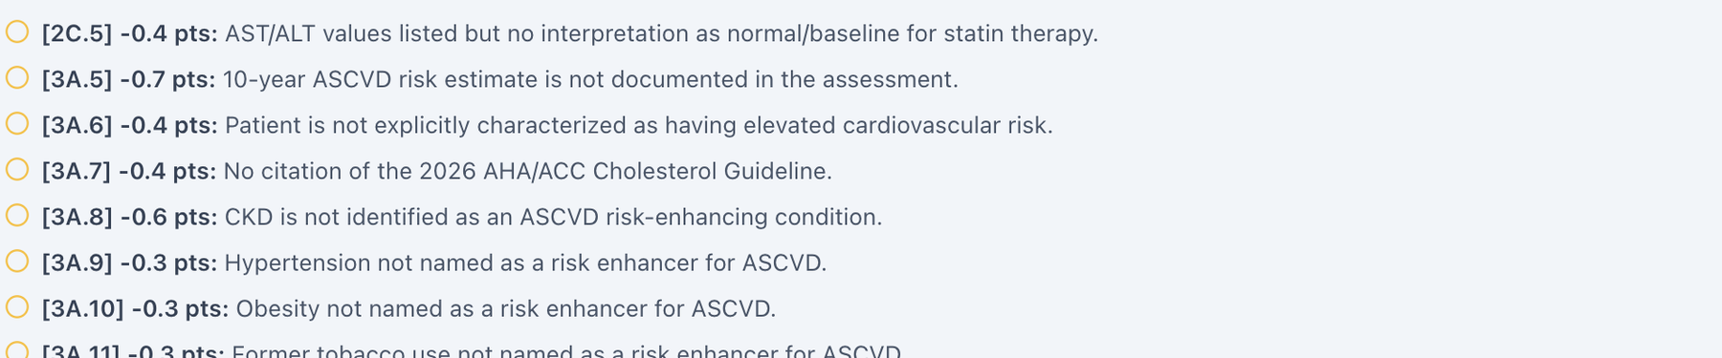
Grader requires the hidden 11.8% 10-year ASCVD risk.
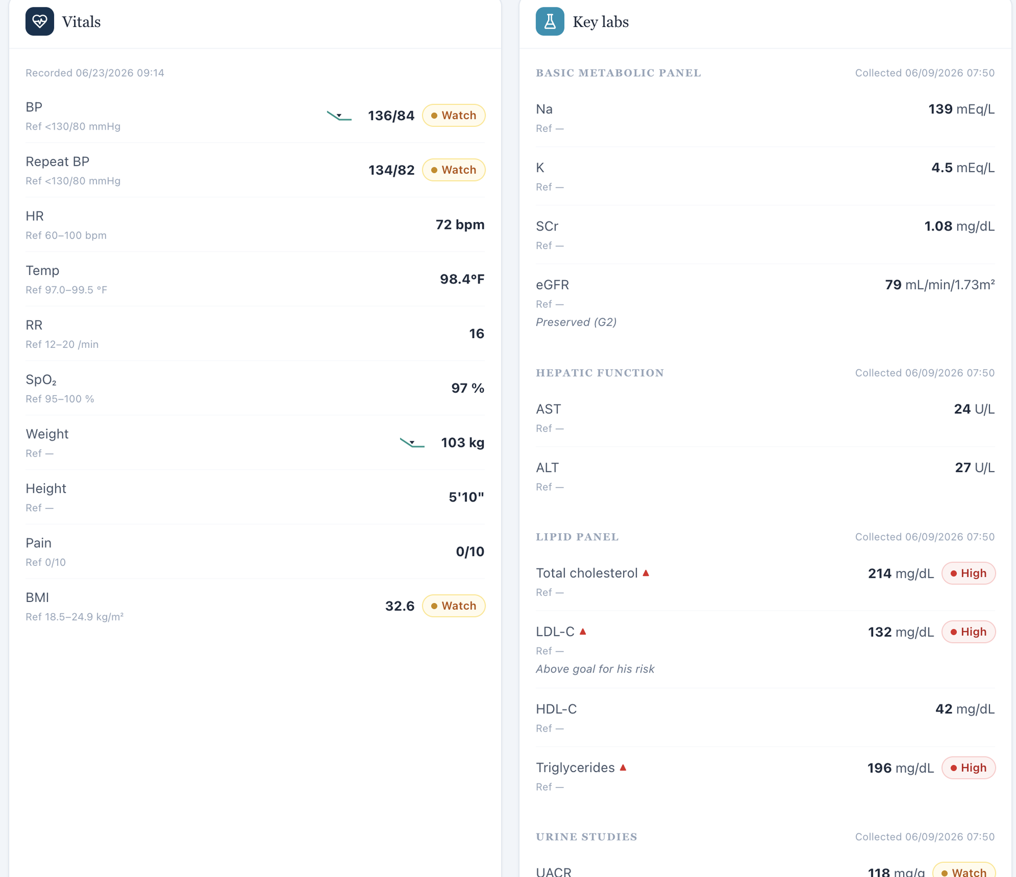
Live Objective contains no ASCVD risk field.

Issue 4. Grader expects fatigue, alcohol, exercise, and history details that conflict with the AI patient’s answers
What the student saw or heard: The AI patient denies fatigue and muscle symptoms, reports alcohol only about 1–2 drinks per month, and describes being active at work without a regular structured exercise program. He cannot supply every exact disease-duration detail.
What the AI grader expected: The grader expects mild fatigue, alcohol weekly rather than monthly, a specific structured-exercise frequency, and exact historical details.
Why this is a problem: These are subjective facts that should come from the patient, not from a hidden answer key. The student should not change a denial to mild fatigue or turn monthly alcohol use into weekly use simply to satisfy grading. This is a mismatch between the standardized patient and grading reference.
Suggested fix: Align the MT Tuesday AI-patient history with the intended grader history or grade the patient’s actual answers as correct.
Focused screenshot evidence
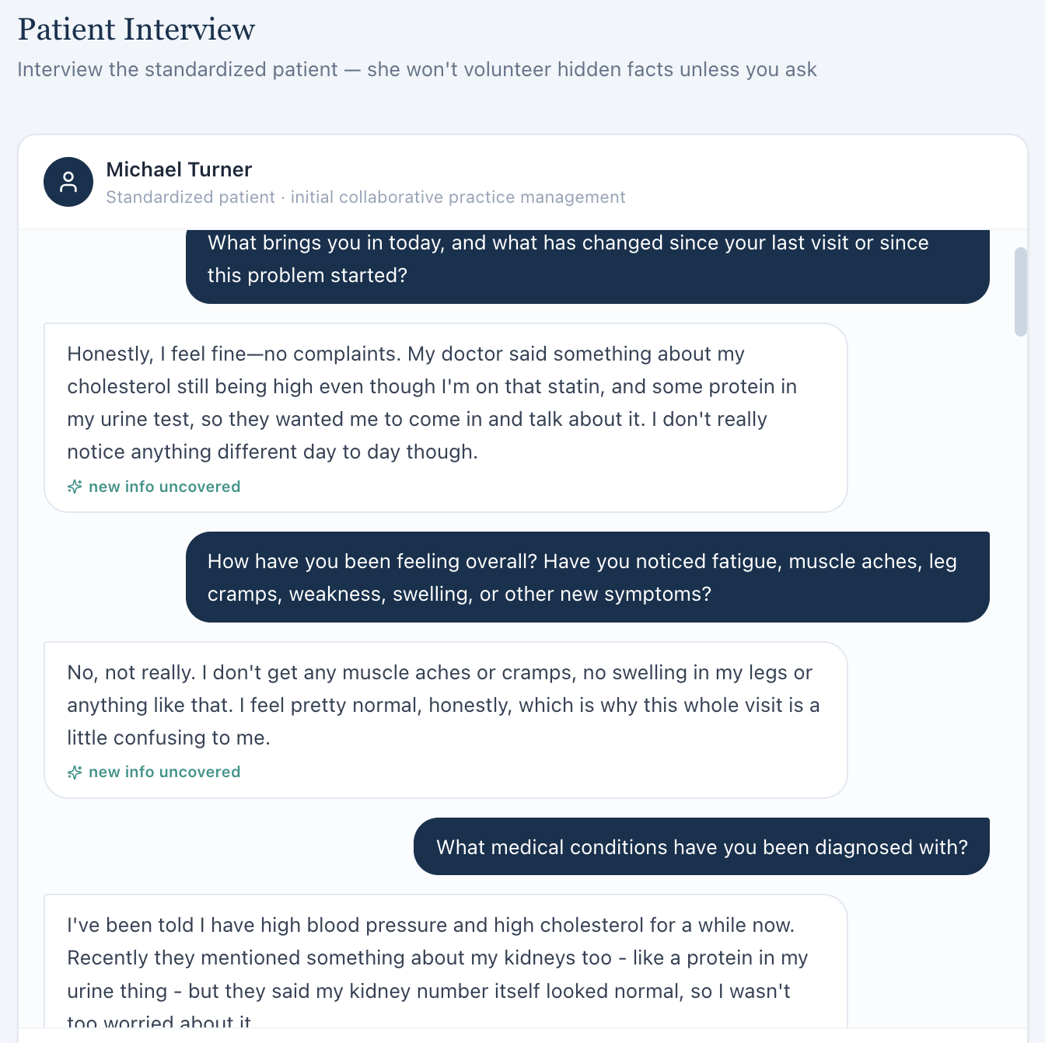
AI patient denies fatigue and other symptoms during neutral questioning.
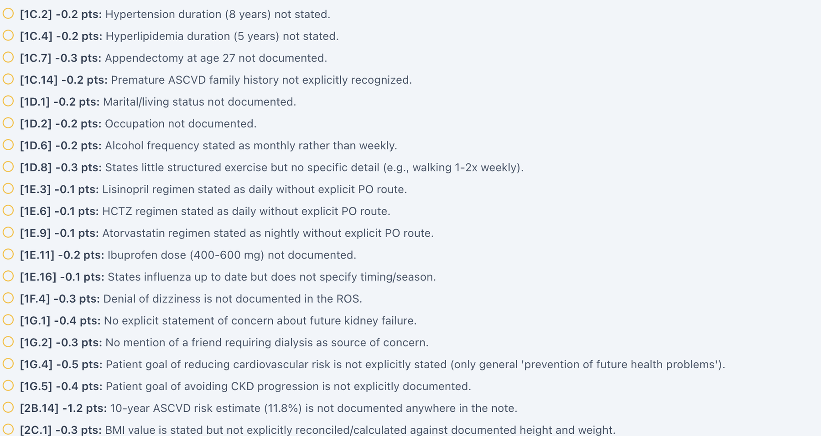
Grader deductions expect different fatigue, alcohol, exercise, and history details.

Issue 5. BSA labeled as Mosteller is mathematically incorrect (2.04 m² displayed; 2.26 m² calculated)
What the student saw or heard: The dedicated Vitals tab displays weight 103 kg, height 70 in, and “BSA (Mosteller) 2.04 m².”
Why this is a problem: The Mosteller equation is BSA = √(height in cm × weight in kg / 3600). Using the values displayed in this encounter gives 2.255 m², which rounds to 2.26 m², not 2.04 m². Because the same 2.04 m² value appears across patients with substantially different body sizes, this looks like a shared calculation or hard-coded-value defect rather than normal rounding. BSA can be used in medication dosing and clinical interpretation; a field explicitly labeled with a formula should be mathematically reproducible from the height and weight shown next to it.
Suggested fix: Recalculate BSA from the active encounter height and weight using the documented Mosteller formula, round consistently, and regression-test all nine Week 2 encounters.
Focused screenshot evidence
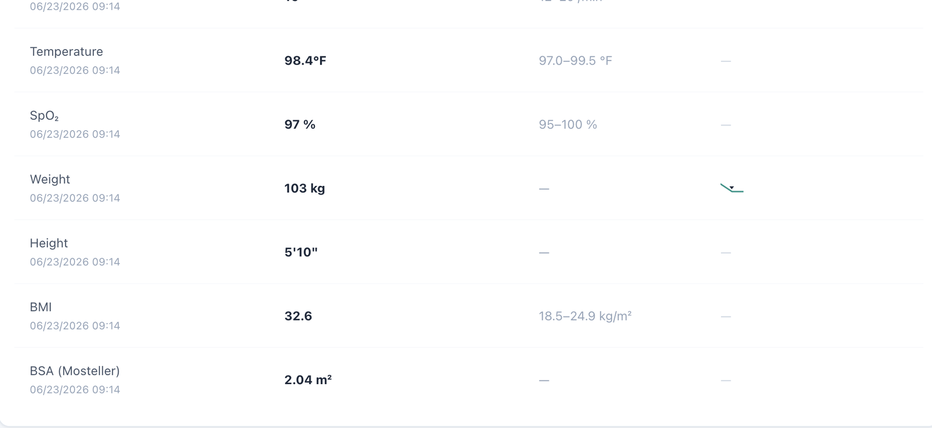
Dedicated Vitals shows weight 103 kg, height 70 in, and the repeated BSA value 2.04 m².

Issue 6. BSA appears in dedicated Vitals but is omitted from the Objective/Snapshot vitals shown to the learner
What the student saw or heard: The student-facing Objective/Snapshot vitals card displays the encounter vitals through BMI but does not show BSA. Opening the dedicated Vitals tab adds a BSA field for the same encounter.
Why this is a problem: The same clinical data element is not propagated consistently across VACS views. A learner working from the Objective/Snapshot may reasonably believe BSA is unavailable, while a learner who opens the dedicated Vitals page sees an additional calculated field. The inconsistency becomes more important because the displayed BSA is also mathematically wrong in this encounter. Display rules should not make required or clinically relevant data depend on which tab the student happens to open.
Suggested fix: Use one vitals data model for Snapshot/Objective and dedicated Vitals. Either display BSA consistently in both locations or intentionally omit it from both; do not grade a value that is hidden from the primary Objective view.
Focused screenshot evidence
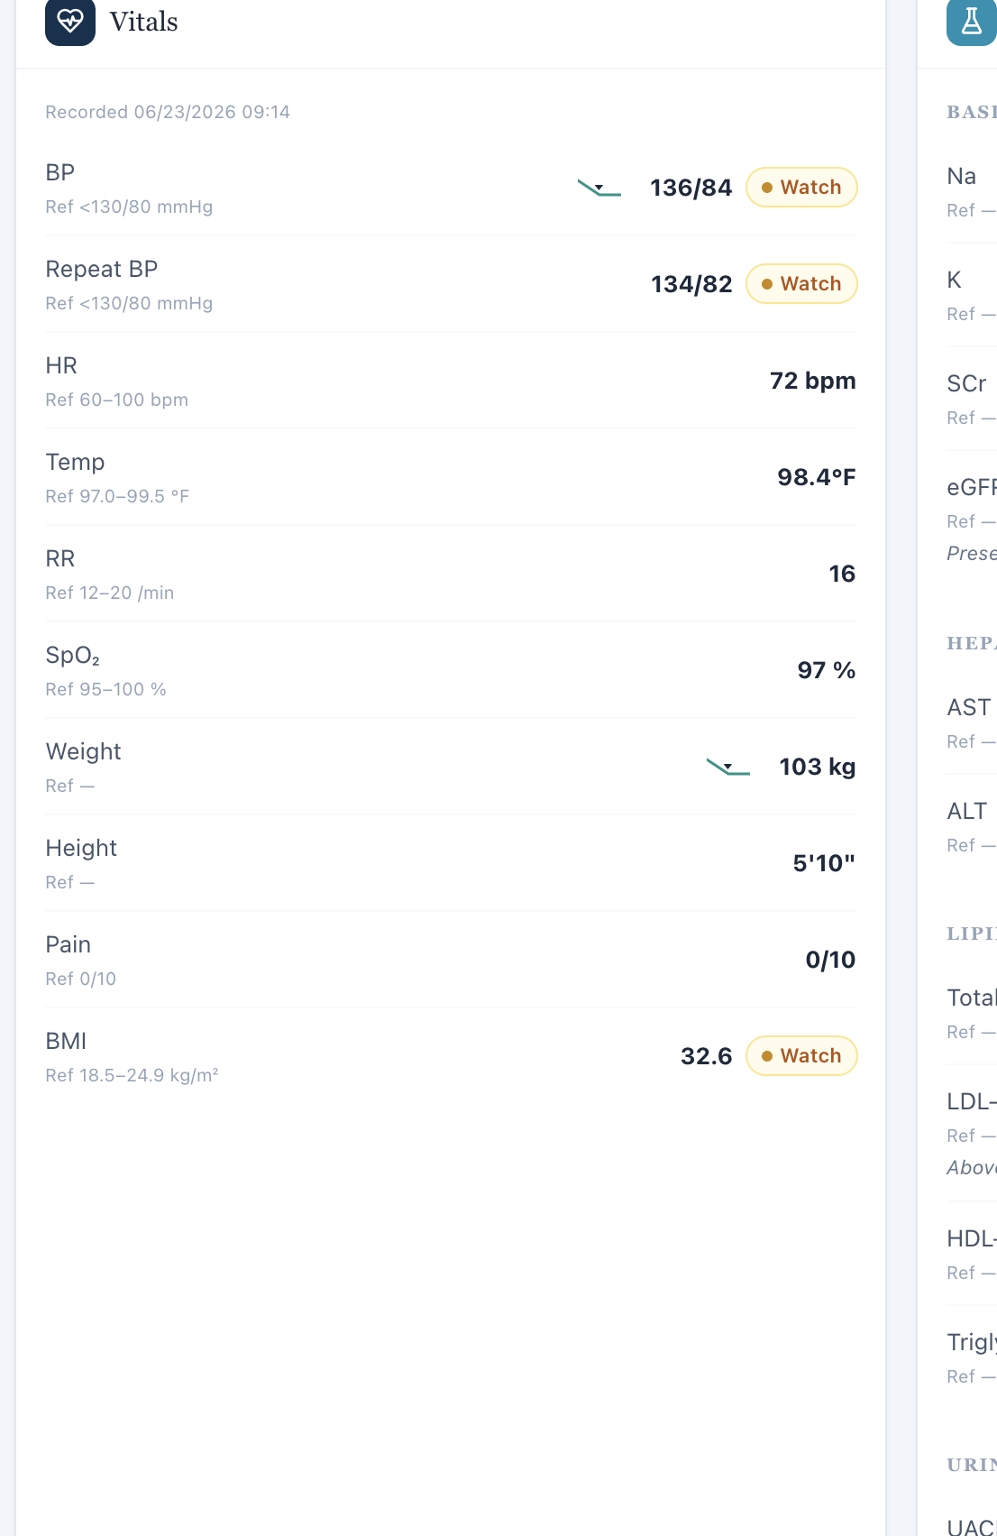
Objective/Snapshot vitals ends at BMI; no BSA field is displayed in the primary objective view.
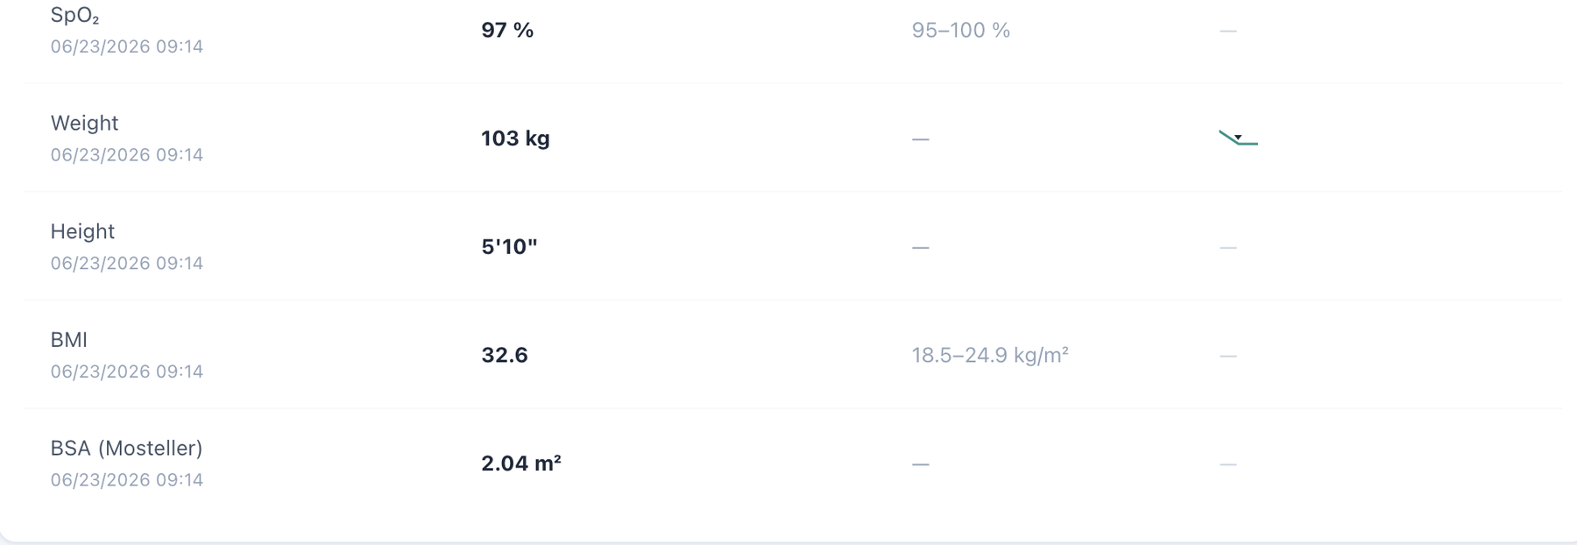
Dedicated Vitals for the same encounter includes a BSA field beneath BMI.

Patient MT – Michael Turner – Wednesday – Wednesday · 3-month follow-up
7 confirmed system/data/interface/workflow issues are included for this visit. Items are grouped by underlying root cause so one defect is not counted multiple times merely because it produced several grader deductions.
# | Issue | Problem type
1 | Patient Interview uses the wrong pronoun for a male patient | Medium — Interface/display problem
2 | Wednesday 3-month follow-up conflicts with “Initial Ambulatory Care Pharmacist Visit” in chart metadata | High — Encounter synchronization
3 | Problem List is stale relative to the Wednesday treatment-response dataset | High — Data synchronization
4 | AI grader requires a 10-year ASCVD risk of 10.7% and prior risk trend not shown in the live workflow | High — Hidden/unavailable grader data
5 | Grader family-history, smoking, alcohol, and lifestyle expectations do not match the AI patient’s follow-up history | High — AI patient and grader disagree
6 | BSA labeled as Mosteller is mathematically incorrect (2.04 m² displayed; 2.23 m² calculated) | Medium — Clinical calculation logic
7 | BSA appears in dedicated Vitals but is omitted from the Objective/Snapshot vitals shown to the learner | Medium — Interface/display problem

Issue 1. Patient Interview uses the wrong pronoun for a male patient
What the student saw or heard: Michael Turner is a male patient. The MT Wednesday Patient Interview instruction states: “Interview the standardized patient — she won’t volunteer hidden facts unless you ask.”
Why this is a problem: The interface displays a demographic pronoun that does not match the active patient. Because the same wording recurs across both male patients and all three visits for each patient, this is a repeated interface/template defect rather than an isolated typo. The mismatch can confuse the learner about patient identity, reduces confidence that patient-specific interface content is synchronized to the active record, and creates an unprofessional user experience.
Suggested fix: Bind the Patient Interview instruction to the patient demographic record, or use gender-neutral wording such as “Interview the standardized patient — the patient won’t volunteer hidden facts unless you ask.” Regression-test the instruction on every MT and DC visit.
Focused screenshot evidence

Michael Turner — MT Wednesday: visit-specific Patient Interview evidence shows the incorrect “she won’t volunteer…” instruction.

Issue 2. Wednesday 3-month follow-up conflicts with “Initial Ambulatory Care Pharmacist Visit” in chart metadata
What the student saw or heard: The live header/AI patient identify a 3-month follow-up, while the charted Subjective metadata still uses the initial-visit label.
Why this is a problem: The chart and encounter shell disagree about whether this is a baseline or follow-up visit. That changes the expected medication history and interpretation of improving LDL, UACR, BP, NSAID use, and weight.
Suggested fix: Synchronize the chart metadata to Wednesday 3-month follow-up and use that same stage in every VACS layer.
Focused screenshot evidence
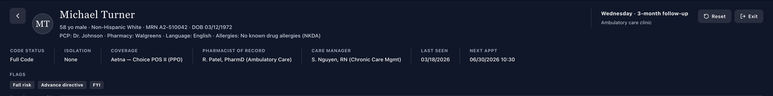
Live header identifies Wednesday · 3-month follow-up.

Chart metadata retains the initial-visit label.

Issue 3. Problem List is stale relative to the Wednesday treatment-response dataset
What the student saw or heard: Current follow-up data include LDL-C 96 mg/dL, eGFR 78, UACR 102, BP 132/80, weight 101 kg, and BMI 31.9. The active Problem List retains baseline values including LDL-C 132, eGFR 79/UACR 118, BP in the mid-130s, and BMI 32.6.
Why this is a problem: The problem summary appears to be a baseline snapshot carried forward without clear historical labeling. In a longitudinal teaching case, this can cause the learner to compare current data to the wrong “current” state and can contaminate grading of trends.
Suggested fix: Update the Problem List to current Wednesday values or explicitly mark retained values as baseline/prior data with dates.
Focused screenshot evidence
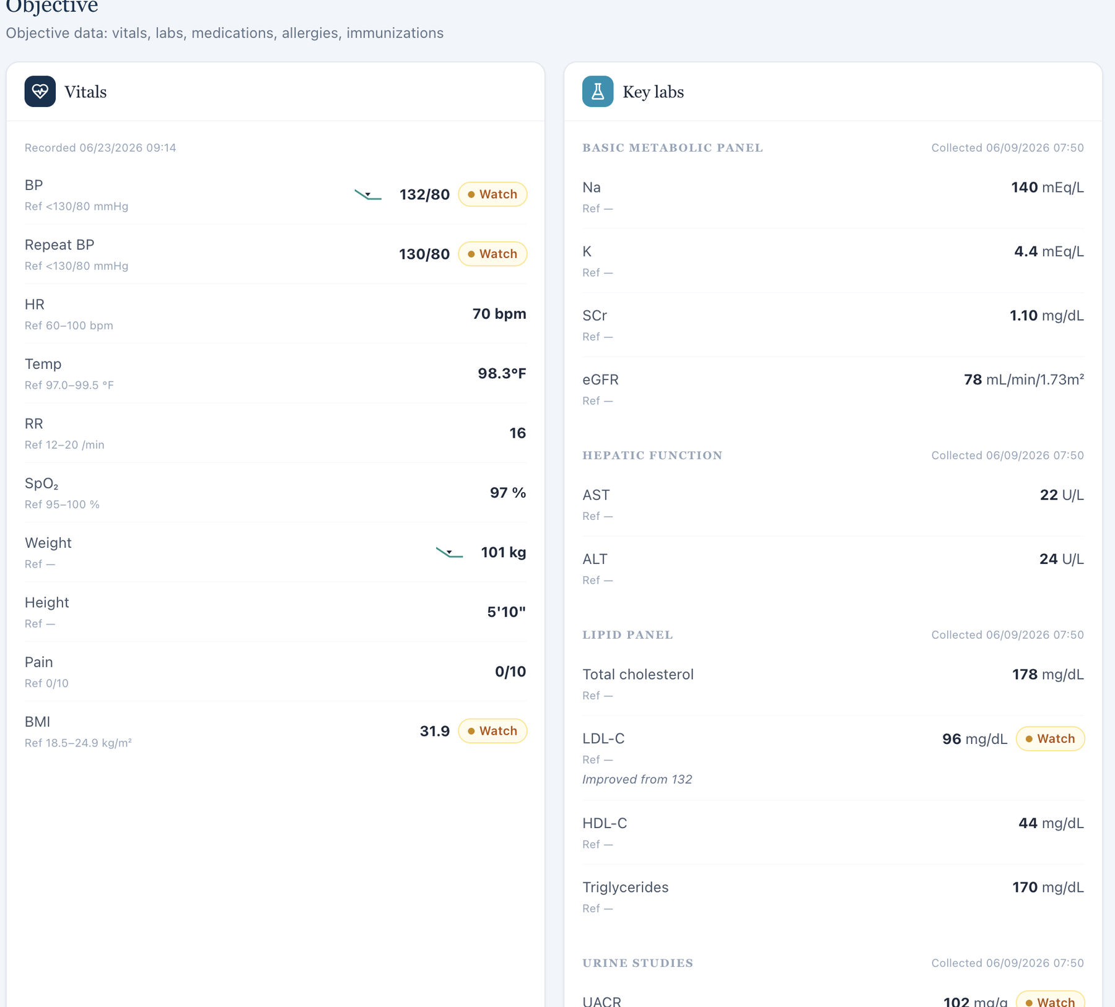
Current Wednesday Objective shows updated values.
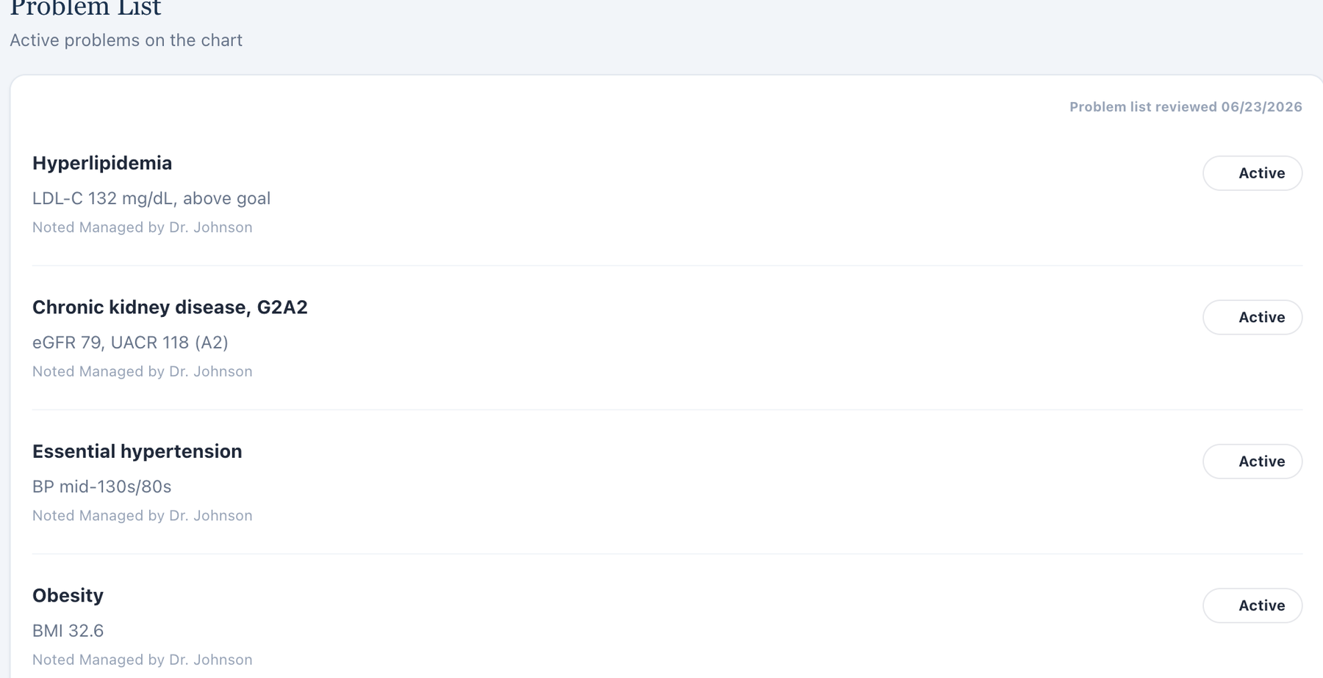
Problem List retains Tuesday baseline descriptors.

Issue 4. AI grader requires a 10-year ASCVD risk of 10.7% and prior risk trend not shown in the live workflow
What the student saw or heard: No ASCVD calculator/result is visible in the captured Wednesday EMR.
What the AI grader expected: The grader requires 10.7% current 10-year ASCVD risk and improvement from the prior 11.8% value.
Why this is a problem: Both the current and prior numeric percentages are hidden from the student-facing workflow, yet the grader treats them as documentation requirements.
Suggested fix: Display the risk calculation/trend in VACS or remove the exact numeric risk deductions.
Focused screenshot evidence
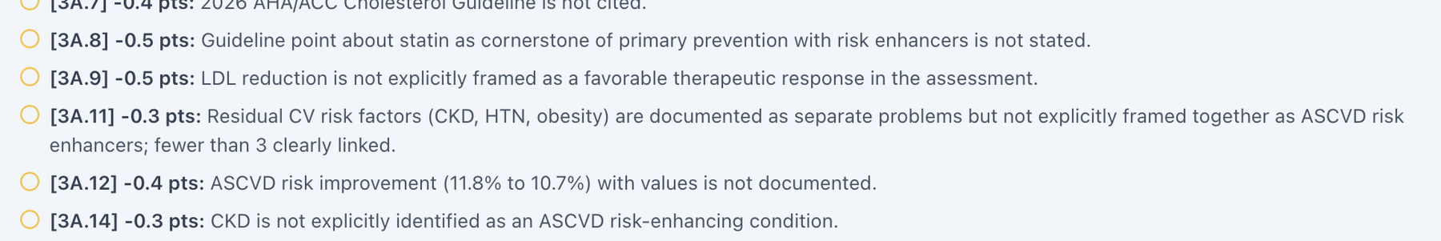
Grader requires the 11.8% to 10.7% ASCVD risk trend.
Live Objective has no ASCVD risk field.

Issue 5. Grader family-history, smoking, alcohol, and lifestyle expectations do not match the AI patient’s follow-up history
What the student saw or heard: The AI patient reports father dying of stroke at 68, former smoking of roughly 10 pack-years with cessation about 5 years ago, alcohol 1–2 drinks per month, and no consistent structured exercise/diet-change trajectory.
What the AI grader expected: The grader expects different family-history details, about 20 pack-years and 6 years since quitting, weekly alcohol, and specific reduced restaurant meals/home cooking/walking behavior.
Why this is a problem: These are patient-reported historical and behavioral facts. The standardized patient and grader are using different longitudinal histories, so accurate documentation of the live interview is penalized.
Suggested fix: Make the MT Wednesday AI patient and grader use the same family, tobacco, alcohol, diet, and exercise history.
Focused screenshot evidence
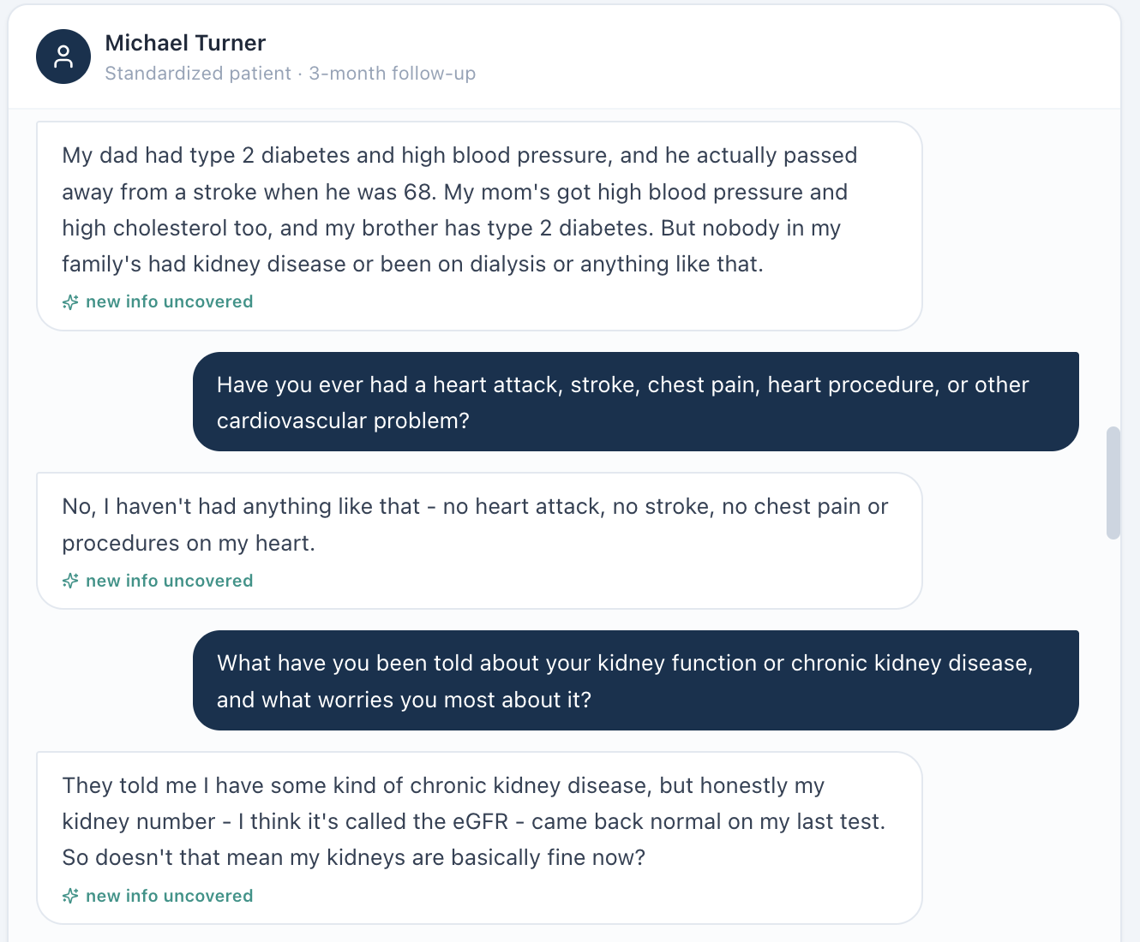
AI-patient family history differs from grader expectations.
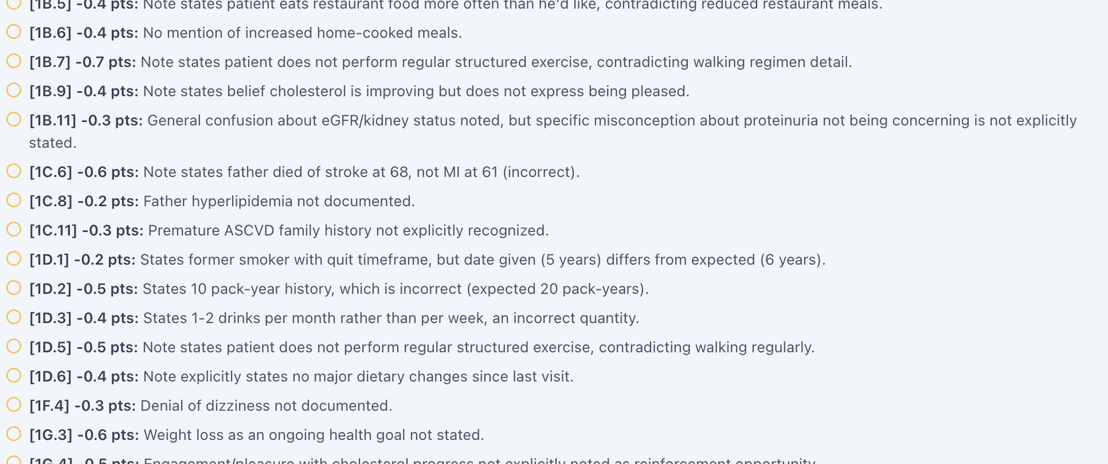
Focused grader deductions require a different family/social/lifestyle history.

Issue 6. BSA labeled as Mosteller is mathematically incorrect (2.04 m² displayed; 2.23 m² calculated)
What the student saw or heard: The dedicated Vitals tab displays weight 101 kg, height 70 in, and “BSA (Mosteller) 2.04 m².”
Why this is a problem: The Mosteller equation is BSA = √(height in cm × weight in kg / 3600). Using the values displayed in this encounter gives 2.233 m², which rounds to 2.23 m², not 2.04 m². Because the same 2.04 m² value appears across patients with substantially different body sizes, this looks like a shared calculation or hard-coded-value defect rather than normal rounding. BSA can be used in medication dosing and clinical interpretation; a field explicitly labeled with a formula should be mathematically reproducible from the height and weight shown next to it.
Suggested fix: Recalculate BSA from the active encounter height and weight using the documented Mosteller formula, round consistently, and regression-test all nine Week 2 encounters.
Focused screenshot evidence
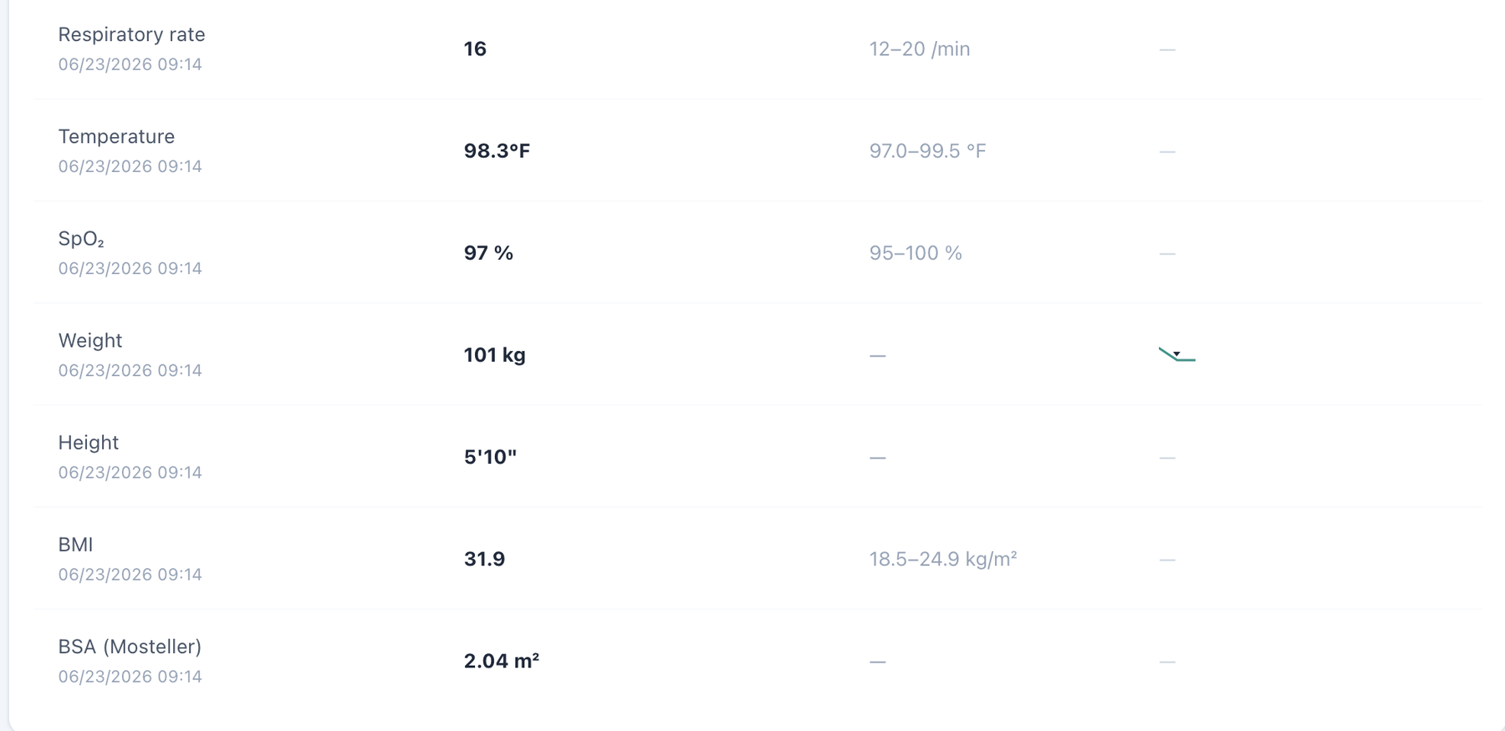
Dedicated Vitals shows weight 101 kg, height 70 in, and the repeated BSA value 2.04 m².

Issue 7. BSA appears in dedicated Vitals but is omitted from the Objective/Snapshot vitals shown to the learner
What the student saw or heard: The student-facing Objective/Snapshot vitals card displays the encounter vitals through BMI but does not show BSA. Opening the dedicated Vitals tab adds a BSA field for the same encounter.
Why this is a problem: The same clinical data element is not propagated consistently across VACS views. A learner working from the Objective/Snapshot may reasonably believe BSA is unavailable, while a learner who opens the dedicated Vitals page sees an additional calculated field. The inconsistency becomes more important because the displayed BSA is also mathematically wrong in this encounter. Display rules should not make required or clinically relevant data depend on which tab the student happens to open.
Suggested fix: Use one vitals data model for Snapshot/Objective and dedicated Vitals. Either display BSA consistently in both locations or intentionally omit it from both; do not grade a value that is hidden from the primary Objective view.
Focused screenshot evidence
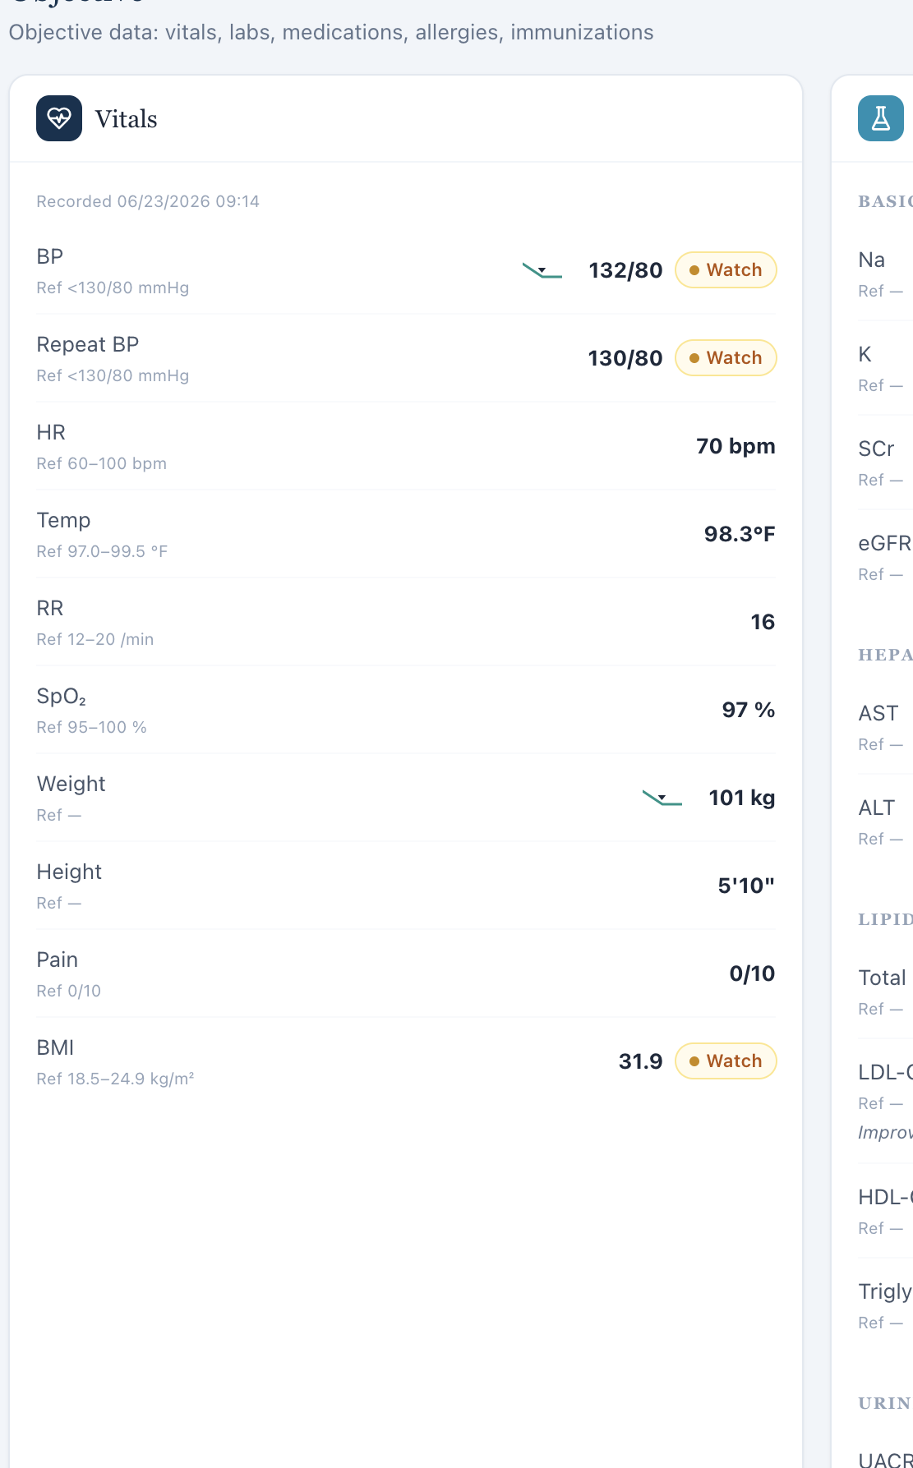
Objective/Snapshot vitals ends at BMI; no BSA field is displayed in the primary objective view.
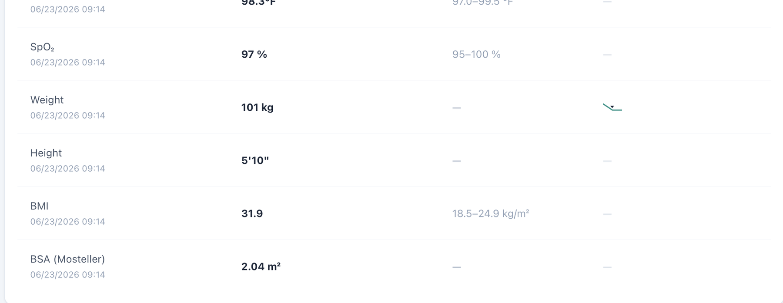
Dedicated Vitals for the same encounter includes a BSA field beneath BMI.

Patient MT – Michael Turner – Thursday – Thursday · six-month follow-up
7 confirmed system/data/interface/workflow issues are included for this visit. Items are grouped by underlying root cause so one defect is not counted multiple times merely because it produced several grader deductions.
# | Issue | Problem type
1 | Patient Interview uses the wrong pronoun for a male patient | Medium — Interface/display problem
2 | Thursday six-month follow-up conflicts with the chart’s initial-visit metadata | High — Encounter synchronization
3 | Problem List remains on baseline values at the six-month MT visit | High — Data synchronization
4 | AI grader requires a 10-year ASCVD risk of 9.8% and 11.8% to 9.8% trend not shown live | High — Hidden/unavailable grader data
5 | Grader uses a different family/social/lifestyle history than the six-month AI patient | High — AI patient and grader disagree
6 | BSA labeled as Mosteller is mathematically incorrect (2.04 m² displayed; 2.21 m² calculated) | Medium — Clinical calculation logic
7 | BSA appears in dedicated Vitals but is omitted from the Objective/Snapshot vitals shown to the learner | Medium — Interface/display problem

Issue 1. Patient Interview uses the wrong pronoun for a male patient
What the student saw or heard: Michael Turner is a male patient. The MT Thursday Patient Interview instruction states: “Interview the standardized patient — she won’t volunteer hidden facts unless you ask.”
Why this is a problem: The interface displays a demographic pronoun that does not match the active patient. Because the same wording recurs across both male patients and all three visits for each patient, this is a repeated interface/template defect rather than an isolated typo. The mismatch can confuse the learner about patient identity, reduces confidence that patient-specific interface content is synchronized to the active record, and creates an unprofessional user experience.
Suggested fix: Bind the Patient Interview instruction to the patient demographic record, or use gender-neutral wording such as “Interview the standardized patient — the patient won’t volunteer hidden facts unless you ask.” Regression-test the instruction on every MT and DC visit.
Focused screenshot evidence
Michael Turner — MT Thursday: visit-specific Patient Interview evidence shows the incorrect “she won’t volunteer…” instruction.

Issue 2. Thursday six-month follow-up conflicts with the chart’s initial-visit metadata
What the student saw or heard: The live header and AI patient identify a six-month follow-up, while the charted Subjective section retains “Initial Ambulatory Care Pharmacist Visit.”
Why this is a problem: The final MT encounter mixes baseline and follow-up metadata. This can cause wrong historical comparisons and can explain why some grader expectations appear to come from another case stage.
Suggested fix: Set the chart metadata to Thursday six-month follow-up and propagate that stage to all encounter layers.
Focused screenshot evidence
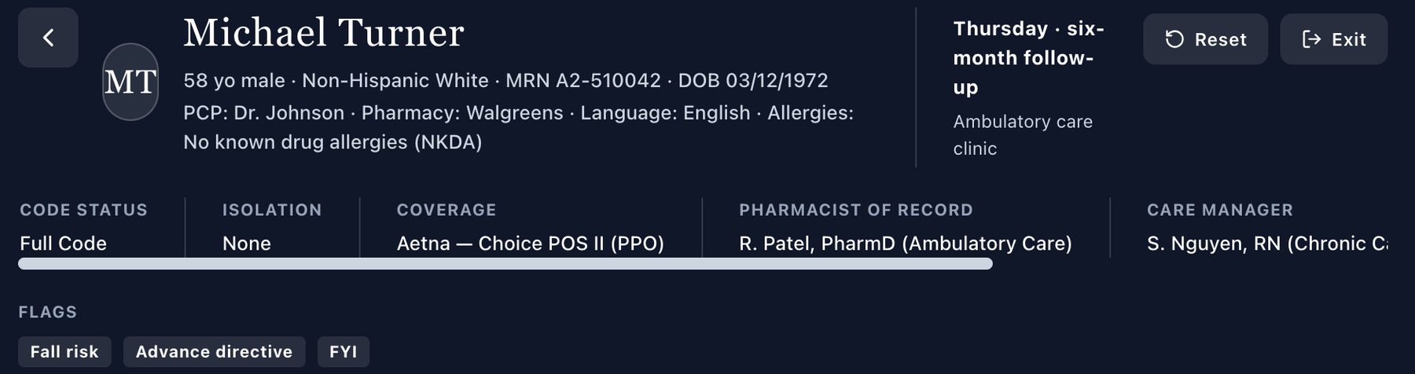
Live header identifies Thursday · six-month follow-up.
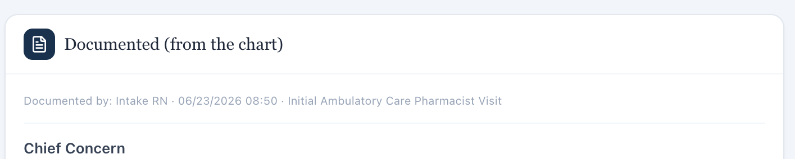
Chart metadata still uses the initial-visit label.

Issue 3. Problem List remains on baseline values at the six-month MT visit
What the student saw or heard: Current Thursday values are LDL-C 84, eGFR 77, UACR 98, BP 130/78, weight 99 kg, and BMI 31.3. The Problem List continues to show baseline LDL 132, eGFR 79/UACR 118, BP in the mid-130s, and BMI 32.6.
Why this is a problem: The stale summary obscures the improvement trajectory and can be mistaken for the active condition state.
Suggested fix: Update or date-label the Problem List so historical baseline values are not presented as current six-month values.
Focused screenshot evidence
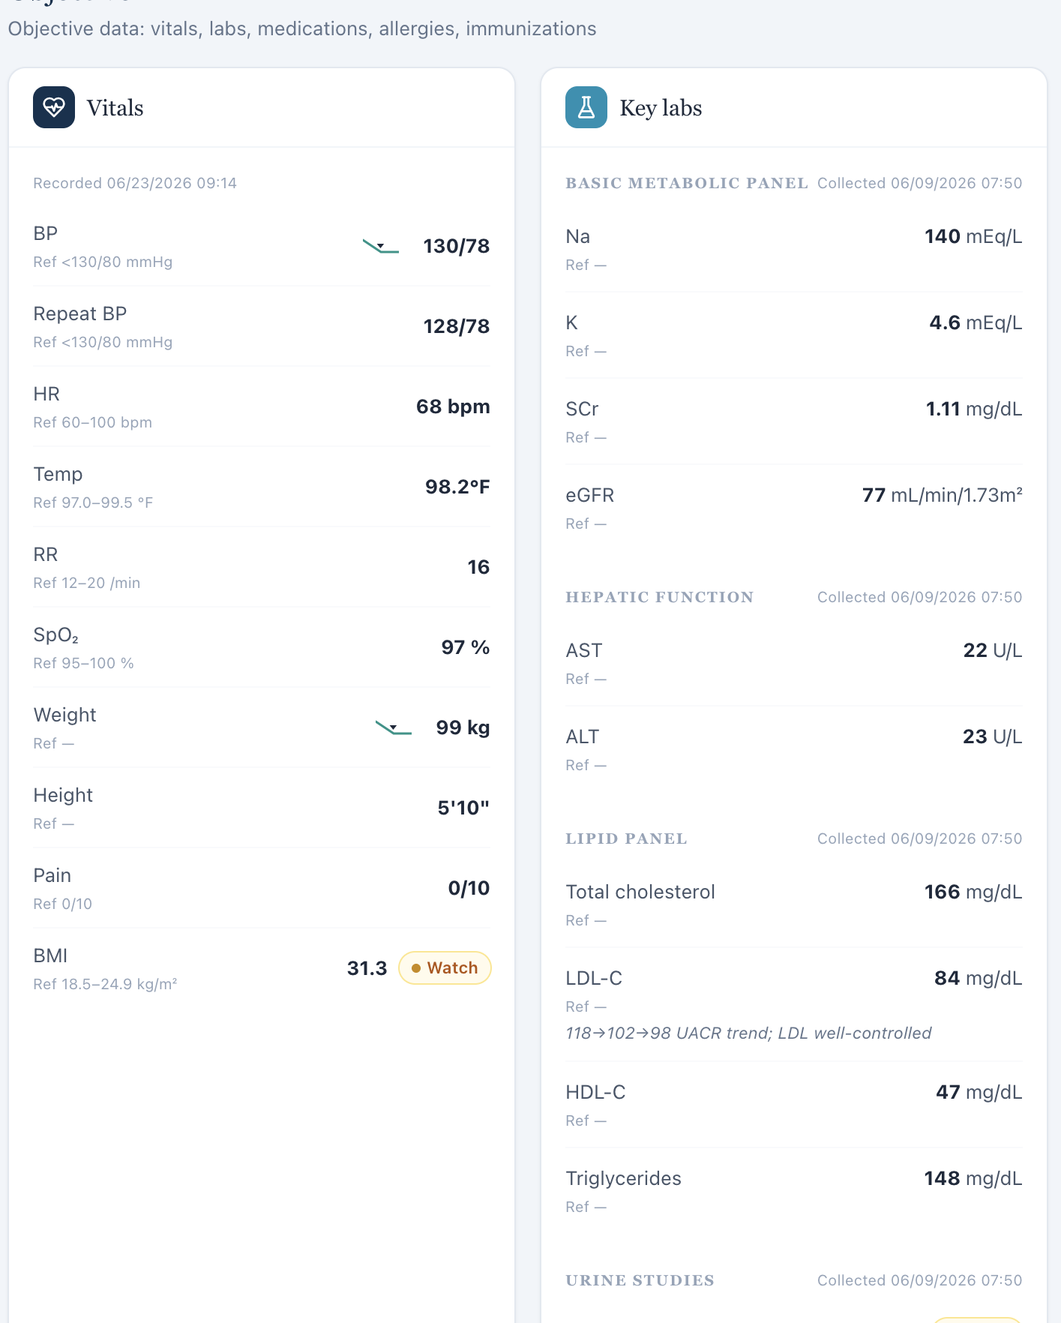
Current Thursday Objective shows the six-month values.
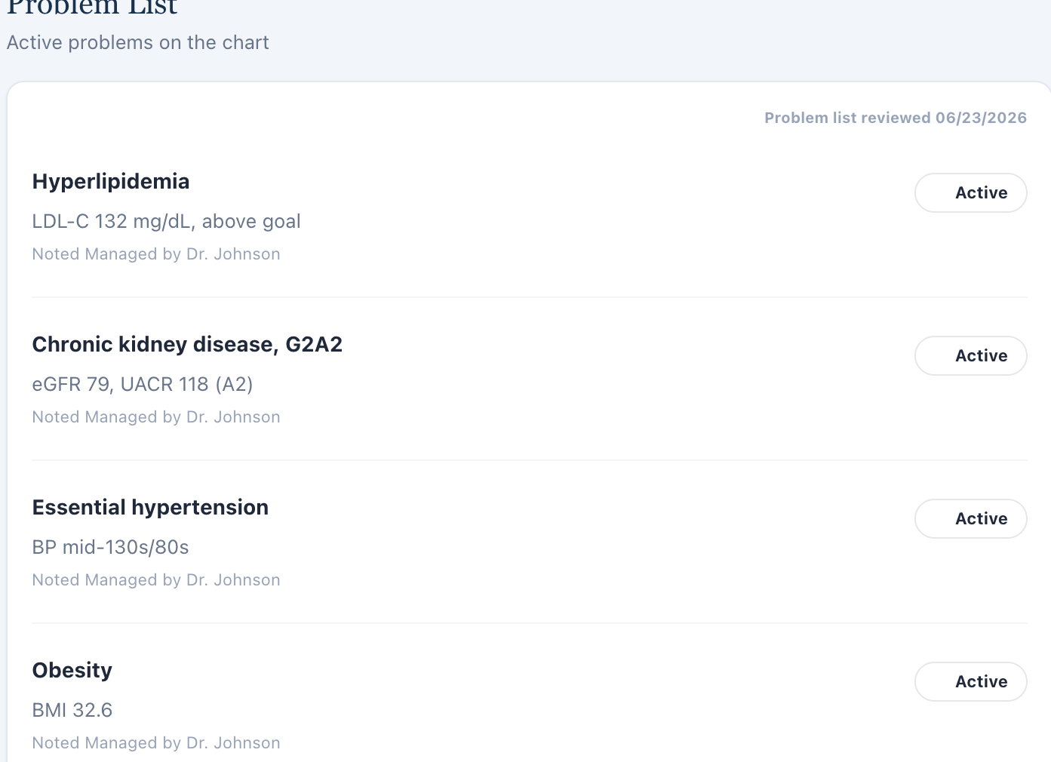
Problem List retains baseline values.

Issue 4. AI grader requires a 10-year ASCVD risk of 9.8% and 11.8% to 9.8% trend not shown live
What the student saw or heard: The six-month EMR does not display a numeric ASCVD risk score.
What the AI grader expected: The grader requires a current 9.8% 10-year risk and a longitudinal comparison from 11.8% to 9.8%.
Why this is a problem: Exact hidden calculations are being graded despite not being present in the learner-facing dataset.
Suggested fix: Expose the current/prior risk values in the case or remove these numeric deductions.
Focused screenshot evidence
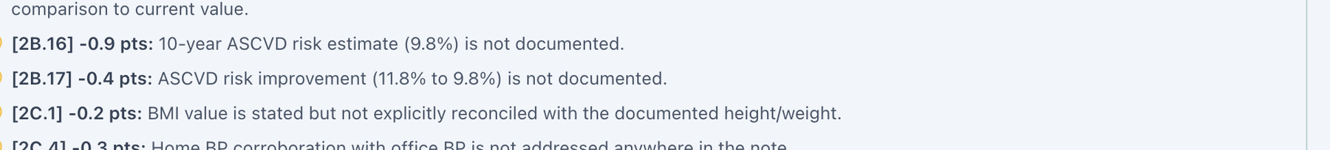
Grader requires the hidden 9.8% risk and prior-to-current trend.
Live Objective does not show an ASCVD risk result.

Issue 5. Grader uses a different family/social/lifestyle history than the six-month AI patient
What the student saw or heard: The AI patient reports father dying of stroke at 68, warehouse-manager occupation, about 10 pack-years with cessation 5 years ago, alcohol 1–2 drinks per month, and does not supply the grader’s exact structured-exercise detail.
What the AI grader expected: The grader expects a father’s myocardial infarction at 61, occupation “accountant,” about 20 pack-years and 6 years since quitting, weekly alcohol, and exercise 4–5 days/week for 30–40 minutes.
Why this is a problem: This is not a documentation-style difference; the underlying patient facts differ. A learner cannot document the hidden grader history without contradicting the standardized patient.
Suggested fix: Synchronize MT Thursday patient biography, family history, tobacco/alcohol history, and exercise responses to the grader’s intended case—or revise the grader to the live patient.
Focused screenshot evidence
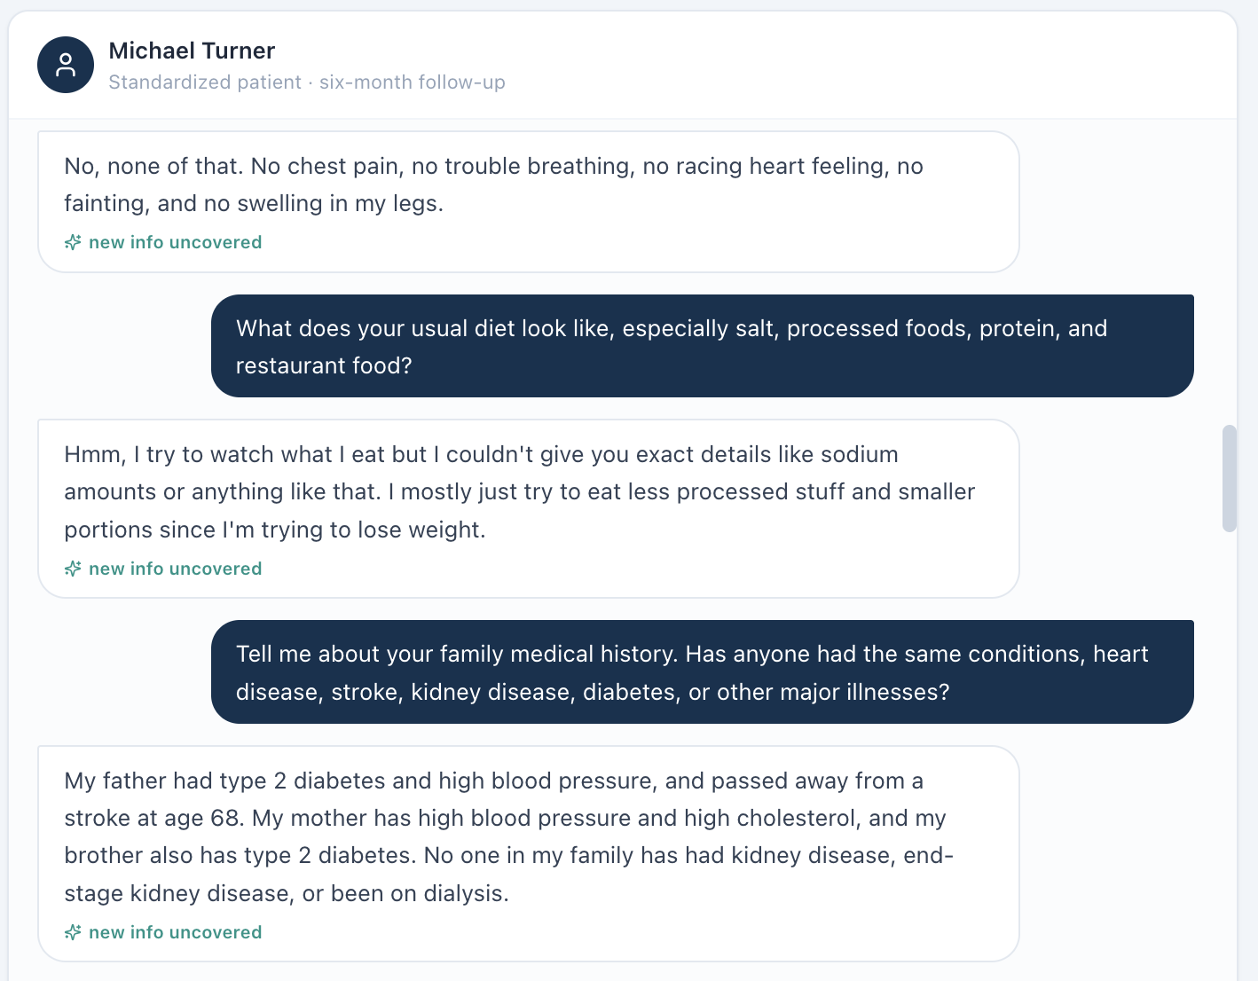
AI-patient family/social history is different from grader expectations.
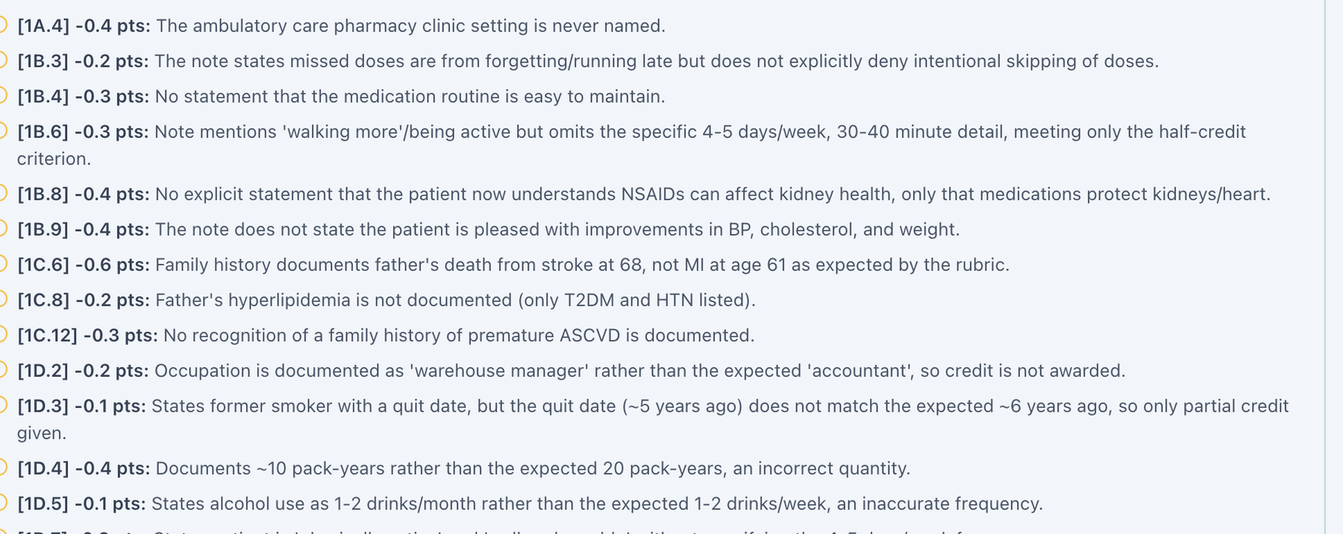
Focused grader deductions require different family, occupation, tobacco, alcohol, and exercise details.

Issue 6. BSA labeled as Mosteller is mathematically incorrect (2.04 m² displayed; 2.21 m² calculated)
What the student saw or heard: The dedicated Vitals tab displays weight 99 kg, height 70 in, and “BSA (Mosteller) 2.04 m².”
Why this is a problem: The Mosteller equation is BSA = √(height in cm × weight in kg / 3600). Using the values displayed in this encounter gives 2.211 m², which rounds to 2.21 m², not 2.04 m². Because the same 2.04 m² value appears across patients with substantially different body sizes, this looks like a shared calculation or hard-coded-value defect rather than normal rounding. BSA can be used in medication dosing and clinical interpretation; a field explicitly labeled with a formula should be mathematically reproducible from the height and weight shown next to it.
Suggested fix: Recalculate BSA from the active encounter height and weight using the documented Mosteller formula, round consistently, and regression-test all nine Week 2 encounters.
Focused screenshot evidence
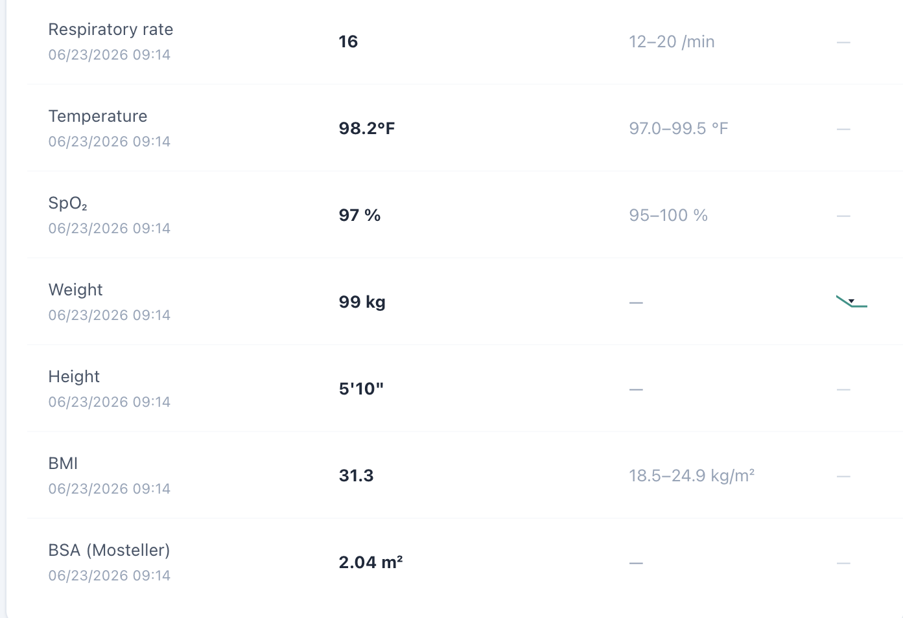
Dedicated Vitals shows weight 99 kg, height 70 in, and the repeated BSA value 2.04 m².

Issue 7. BSA appears in dedicated Vitals but is omitted from the Objective/Snapshot vitals shown to the learner
What the student saw or heard: The student-facing Objective/Snapshot vitals card displays the encounter vitals through BMI but does not show BSA. Opening the dedicated Vitals tab adds a BSA field for the same encounter.
Why this is a problem: The same clinical data element is not propagated consistently across VACS views. A learner working from the Objective/Snapshot may reasonably believe BSA is unavailable, while a learner who opens the dedicated Vitals page sees an additional calculated field. The inconsistency becomes more important because the displayed BSA is also mathematically wrong in this encounter. Display rules should not make required or clinically relevant data depend on which tab the student happens to open.
Suggested fix: Use one vitals data model for Snapshot/Objective and dedicated Vitals. Either display BSA consistently in both locations or intentionally omit it from both; do not grade a value that is hidden from the primary Objective view.
Focused screenshot evidence
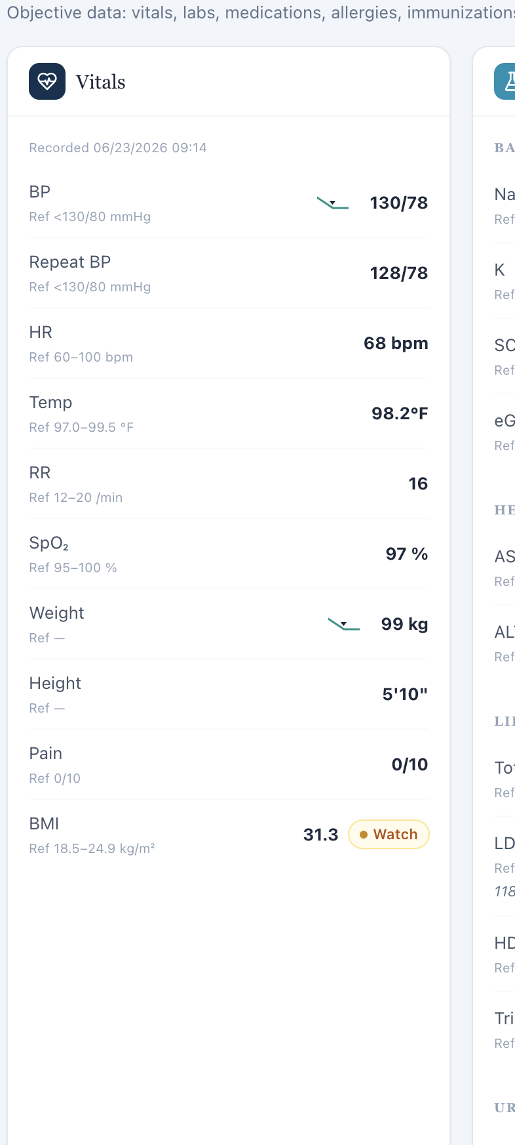
Objective/Snapshot vitals ends at BMI; no BSA field is displayed in the primary objective view.
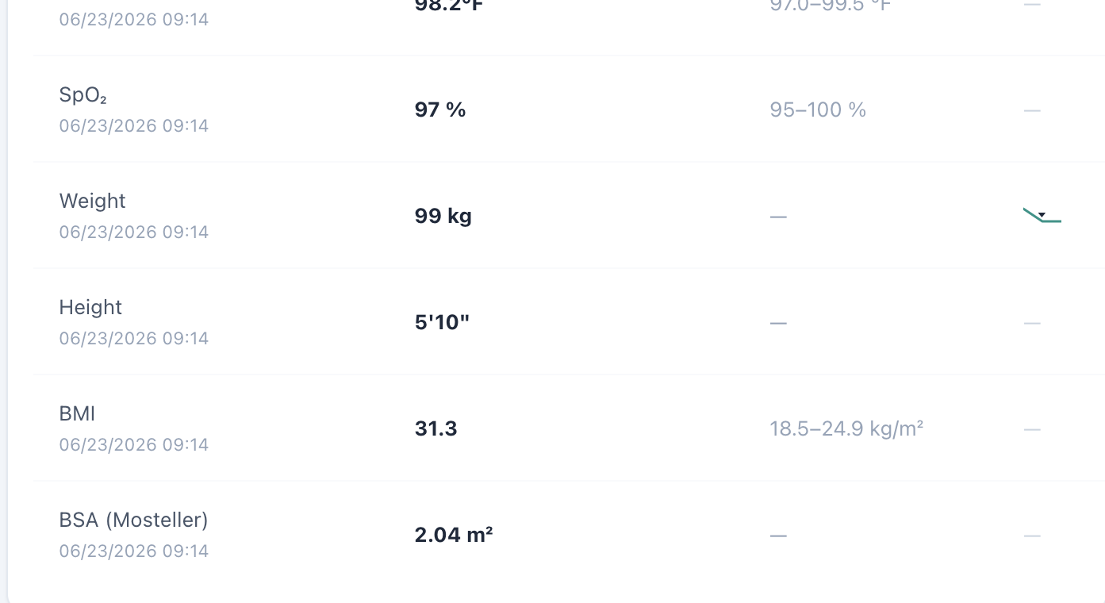
Dedicated Vitals for the same encounter includes a BSA field beneath BMI.

Patient DC – David Chen – Tuesday – Tuesday · initial collaborative practice management
8 confirmed system/data/interface/workflow issues are included for this visit. Items are grouped by underlying root cause so one defect is not counted multiple times merely because it produced several grader deductions.
# | Issue | Problem type
1 | Patient Interview uses the wrong pronoun for a male patient | Medium — Interface/display problem
2 | Formal Tuesday encounter is labeled initial, but the AI patient describes the visit as a regular follow-up | High — Encounter synchronization / AI-patient conflict
3 | Subjective finerenone recommendation/decline history is exposed in the Objective “missing data” panel | High — Data-source separation / interface problem
4 | Home BP average is populated while labeled “Missing” in the DC Tuesday Objective panel | Medium — Interface/display logic
5 | AI grader requires a 10-year ASCVD risk of 22% that is not displayed in the DC Tuesday workflow | High — Hidden/unavailable grader data
6 | Grader expects mild fatigue and nocturia even though the AI patient denies those symptoms | High — AI patient and grader disagree
7 | BSA labeled as Mosteller is mathematically incorrect (2.04 m² displayed; 2.24 m² calculated) | Medium — Clinical calculation logic
8 | BSA appears in dedicated Vitals but is omitted from the Objective/Snapshot vitals shown to the learner | Medium — Interface/display problem

Issue 1. Patient Interview uses the wrong pronoun for a male patient
What the student saw or heard: David Chen is a male patient. The DC Tuesday Patient Interview instruction states: “Interview the standardized patient — she won’t volunteer hidden facts unless you ask.”
Why this is a problem: The interface displays a demographic pronoun that does not match the active patient. Because the same wording recurs across both male patients and all three visits for each patient, this is a repeated interface/template defect rather than an isolated typo. The mismatch can confuse the learner about patient identity, reduces confidence that patient-specific interface content is synchronized to the active record, and creates an unprofessional user experience.
Suggested fix: Bind the Patient Interview instruction to the patient demographic record, or use gender-neutral wording such as “Interview the standardized patient — the patient won’t volunteer hidden facts unless you ask.” Regression-test the instruction on every MT and DC visit.
Focused screenshot evidence

David Chen — DC Tuesday: visit-specific Patient Interview evidence shows the incorrect “she won’t volunteer…” instruction.

Issue 2. Formal Tuesday encounter is labeled initial, but the AI patient describes the visit as a regular follow-up
What the student saw or heard: The live header and AI-patient label identify Tuesday as initial collaborative-practice management. In the patient’s first response, however, he says he is there for his “regular follow-up” for diabetes, blood pressure, and kidney issues.
Why this is a problem: The standardized patient’s own description conflicts with the case stage. That can alter how the learner asks about prior treatment decisions, trends, and referral context. Even though the top-level label says initial, the patient narrative tells the learner the opposite.
Suggested fix: Make the DC Tuesday AI-patient opening narrative match the intended initial encounter, or change the encounter stage everywhere if this is actually a follow-up.
Focused screenshot evidence
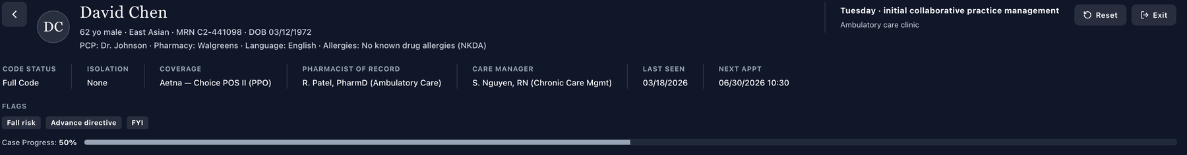
Live header identifies Tuesday · initial collaborative practice management.
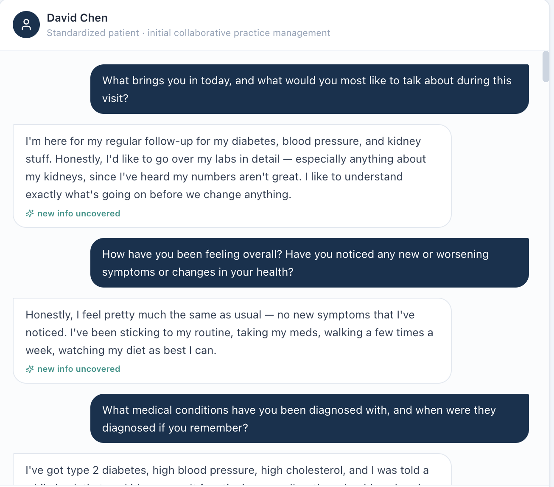
AI patient opens by calling the encounter a regular follow-up.

Issue 3. Subjective finerenone recommendation/decline history is exposed in the Objective “missing data” panel
What the student saw or heard: The Objective/Additional section reveals that another provider previously recommended finerenone and that the patient declined it, even though this is a historical shared-decision fact that the learner can elicit from the patient.
Why this is a problem: The VACS workflow is designed to separate student-facing objective chart data from subjective information obtained through interviewing. Exposing a prior patient decision inside Objective leaks an interview answer and can bias the learner’s questioning. It also makes the phrase “missing objective data” inaccurate because a patient decision is not an objective measurement.
Suggested fix: Move prior recommendation/decline history to an appropriate chart-history or subjective source, or require the learner to elicit it from the AI patient. Do not label it objective data.
Focused screenshot evidence
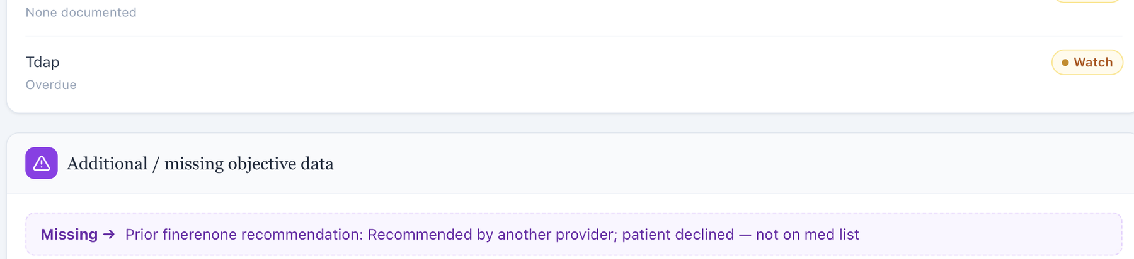
Objective “Additional / missing” panel exposes prior finerenone recommendation and patient decline.

Issue 4. Home BP average is populated while labeled “Missing” in the DC Tuesday Objective panel
What the student saw or heard: The Additional/missing section displays a numeric 7-day home BP average (about 138/80 mmHg) in a row labeled “Missing.”
Why this is a problem: The learner is shown a valid-looking number and told it is missing at the same time. That undermines confidence in the field and recurs in all three DC visits.
Suggested fix: Render available home BP logs as normal results and reserve the “Missing” label for absent data.
Focused screenshot evidence
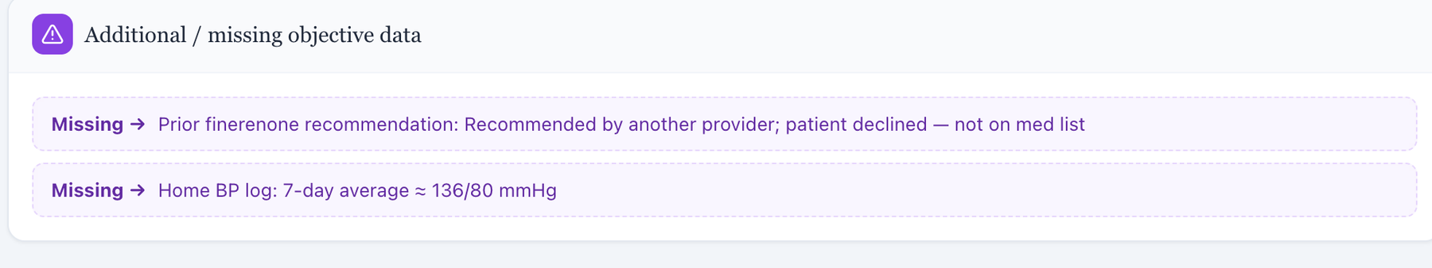
A numeric home BP average is displayed inside a “Missing” row.

Issue 5. AI grader requires a 10-year ASCVD risk of 22% that is not displayed in the DC Tuesday workflow
What the student saw or heard: The live initial DC EMR shows diabetes, lipid, BP, CKD, and albuminuria data but no calculated ASCVD risk percentage.
What the AI grader expected: The grader deducts for failure to document a 10-year ASCVD risk of 22%.
Why this is a problem: The exact score is hidden from the learner. It cannot be treated as a student omission when the workflow does not supply it.
Suggested fix: Display the 22% risk result/calculation or remove the exact percentage from grading.
Focused screenshot evidence
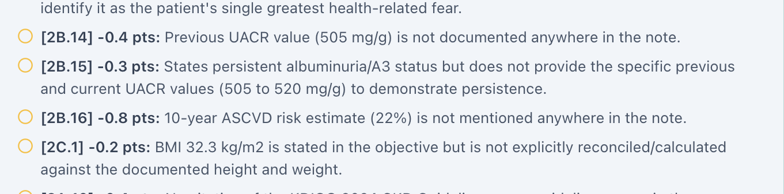
Grader deduction requires 10-year ASCVD risk 22%.
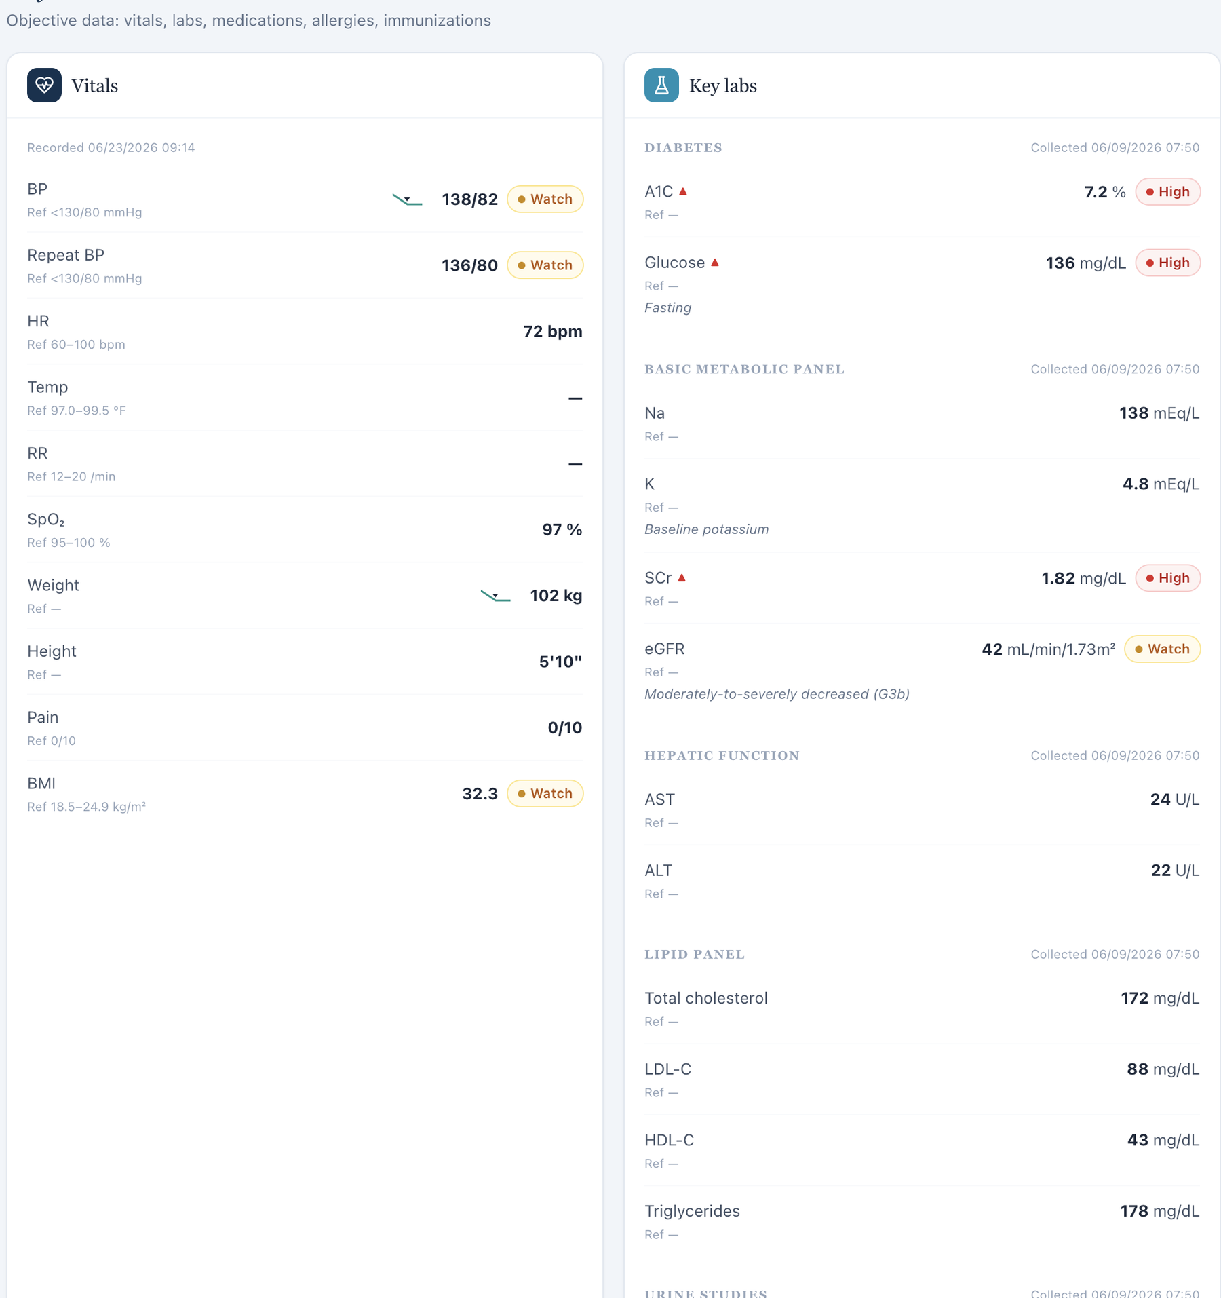
Live Objective contains no ASCVD risk field.

Issue 6. Grader expects mild fatigue and nocturia even though the AI patient denies those symptoms
What the student saw or heard: The standardized patient denies fatigue and does not report the expected nocturia/urinary symptom pattern when asked.
What the AI grader expected: The grader explicitly deducts because the note denies unusual fatigue rather than reporting mild fatigue and because occasional nocturia is not documented.
Why this is a problem: These are symptoms that must come from the patient. A student should not convert a denial into a positive symptom to satisfy a hidden reference. This is a direct standardized-patient/grader contradiction.
Suggested fix: Align the DC Tuesday patient symptom responses with the intended case, or revise the grader to accept the live denials.
Focused screenshot evidence
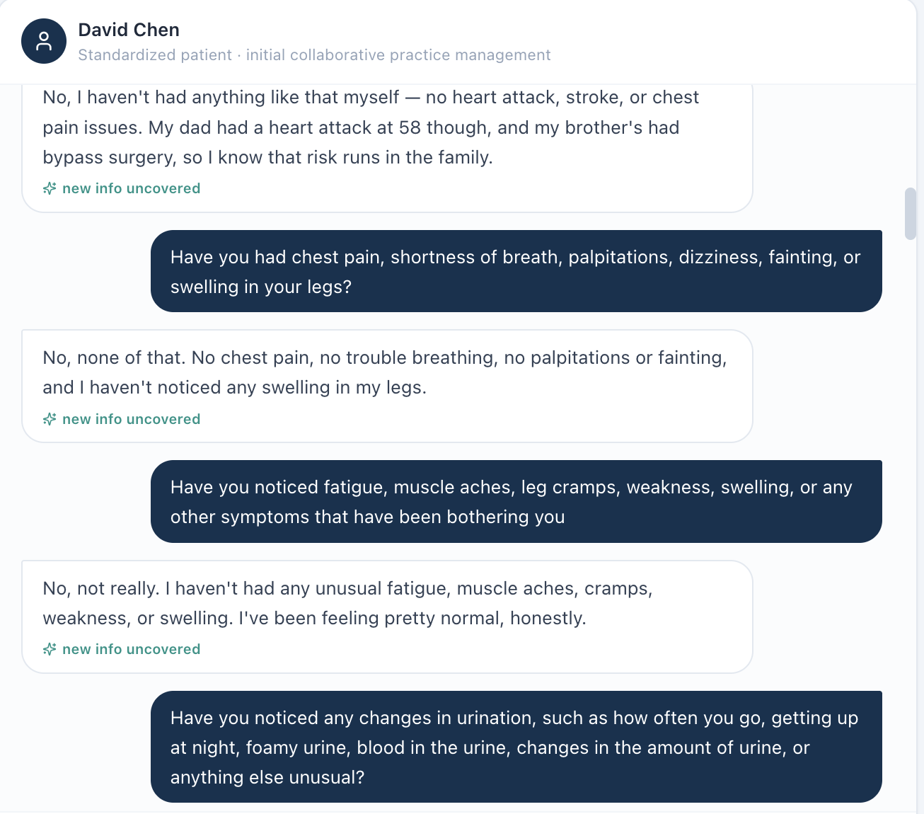
AI patient denies the symptom pattern expected by the grader.
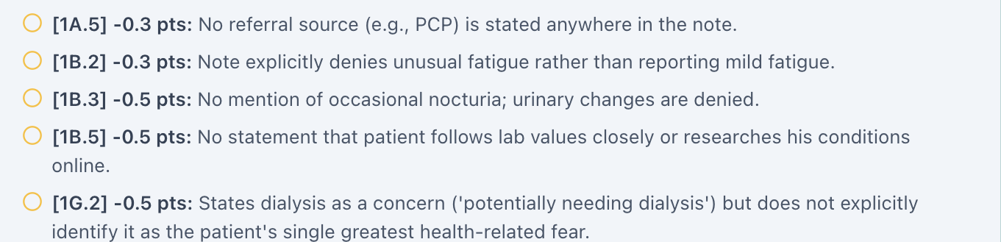
Grader requires mild fatigue and occasional nocturia despite the live patient denials.

Issue 7. BSA labeled as Mosteller is mathematically incorrect (2.04 m² displayed; 2.24 m² calculated)
What the student saw or heard: The dedicated Vitals tab displays weight 102 kg, height 70 in, and “BSA (Mosteller) 2.04 m².”
Why this is a problem: The Mosteller equation is BSA = √(height in cm × weight in kg / 3600). Using the values displayed in this encounter gives 2.244 m², which rounds to 2.24 m², not 2.04 m². Because the same 2.04 m² value appears across patients with substantially different body sizes, this looks like a shared calculation or hard-coded-value defect rather than normal rounding. BSA can be used in medication dosing and clinical interpretation; a field explicitly labeled with a formula should be mathematically reproducible from the height and weight shown next to it.
Suggested fix: Recalculate BSA from the active encounter height and weight using the documented Mosteller formula, round consistently, and regression-test all nine Week 2 encounters.
Focused screenshot evidence
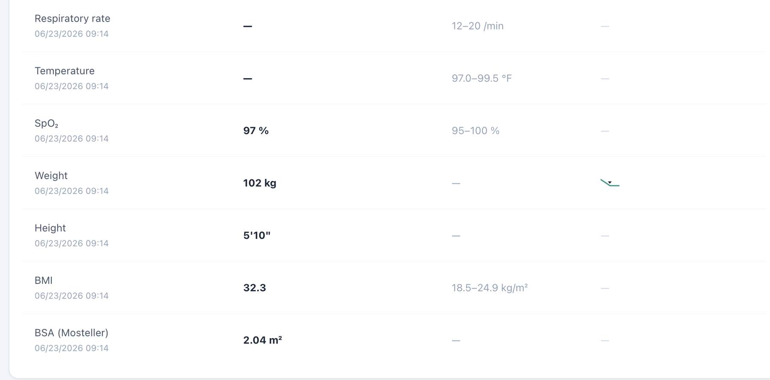
Dedicated Vitals shows weight 102 kg, height 70 in, and the repeated BSA value 2.04 m².

Issue 8. BSA appears in dedicated Vitals but is omitted from the Objective/Snapshot vitals shown to the learner
What the student saw or heard: The student-facing Objective/Snapshot vitals card displays the encounter vitals through BMI but does not show BSA. Opening the dedicated Vitals tab adds a BSA field for the same encounter.
Why this is a problem: The same clinical data element is not propagated consistently across VACS views. A learner working from the Objective/Snapshot may reasonably believe BSA is unavailable, while a learner who opens the dedicated Vitals page sees an additional calculated field. The inconsistency becomes more important because the displayed BSA is also mathematically wrong in this encounter. Display rules should not make required or clinically relevant data depend on which tab the student happens to open.
Suggested fix: Use one vitals data model for Snapshot/Objective and dedicated Vitals. Either display BSA consistently in both locations or intentionally omit it from both; do not grade a value that is hidden from the primary Objective view.
Focused screenshot evidence
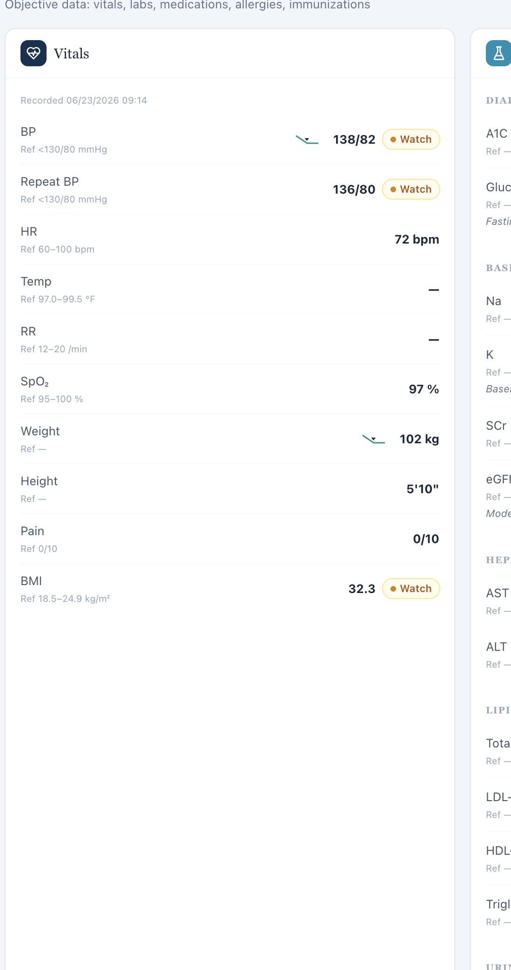
Objective/Snapshot vitals ends at BMI; no BSA field is displayed in the primary objective view.
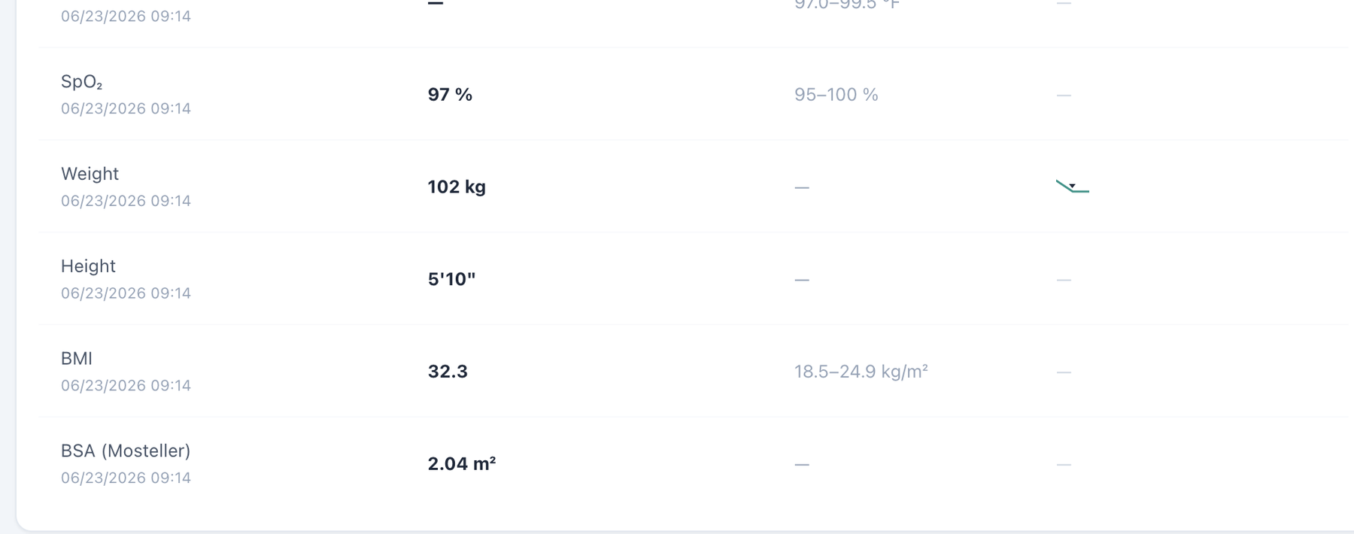
Dedicated Vitals for the same encounter includes a BSA field beneath BMI.

Patient DC – David Chen – Wednesday – Wednesday · 3-month follow-up
8 confirmed system/data/interface/workflow issues are included for this visit. Items are grouped by underlying root cause so one defect is not counted multiple times merely because it produced several grader deductions.
# | Issue | Problem type
1 | Patient Interview uses the wrong pronoun for a male patient | Medium — Interface/display problem
2 | Wednesday 3-month follow-up conflicts with “Initial Ambulatory Care Pharmacist Visit” chart metadata | High — Encounter synchronization
3 | Problem List is stale relative to Wednesday current kidney, diabetes, lipid, and BP values | High — Data synchronization
4 | Home BP log is displayed as a populated result while marked “Missing” | Medium — Interface/display logic
5 | AI grader requires a 10-year ASCVD risk of 20.5% that is not shown in the live Wednesday EMR | High — Hidden/unavailable grader data
6 | Grader requires specific diet, goals, prior shared decision-making, and patient questions not reliably returned by the AI patient | High — AI patient and grader disagree
7 | BSA labeled as Mosteller is mathematically incorrect (2.04 m² displayed; 2.23 m² calculated) | Medium — Clinical calculation logic
8 | BSA appears in dedicated Vitals but is omitted from the Objective/Snapshot vitals shown to the learner | Medium — Interface/display problem

Issue 1. Patient Interview uses the wrong pronoun for a male patient
What the student saw or heard: David Chen is a male patient. The DC Wednesday Patient Interview instruction states: “Interview the standardized patient — she won’t volunteer hidden facts unless you ask.”
Why this is a problem: The interface displays a demographic pronoun that does not match the active patient. Because the same wording recurs across both male patients and all three visits for each patient, this is a repeated interface/template defect rather than an isolated typo. The mismatch can confuse the learner about patient identity, reduces confidence that patient-specific interface content is synchronized to the active record, and creates an unprofessional user experience.
Suggested fix: Bind the Patient Interview instruction to the patient demographic record, or use gender-neutral wording such as “Interview the standardized patient — the patient won’t volunteer hidden facts unless you ask.” Regression-test the instruction on every MT and DC visit.
Focused screenshot evidence

David Chen — DC Wednesday: visit-specific Patient Interview evidence shows the incorrect “she won’t volunteer…” instruction.

Issue 2. Wednesday 3-month follow-up conflicts with “Initial Ambulatory Care Pharmacist Visit” chart metadata
What the student saw or heard: The live header identifies Wednesday as a 3-month follow-up, but the charted Subjective metadata retains the initial-visit label.
Why this is a problem: The mismatch blurs which values are baseline and which changes should be attributed to finerenone and other ongoing therapy.
Suggested fix: Synchronize the chart metadata and all case layers to the Wednesday 3-month follow-up stage.
Focused screenshot evidence
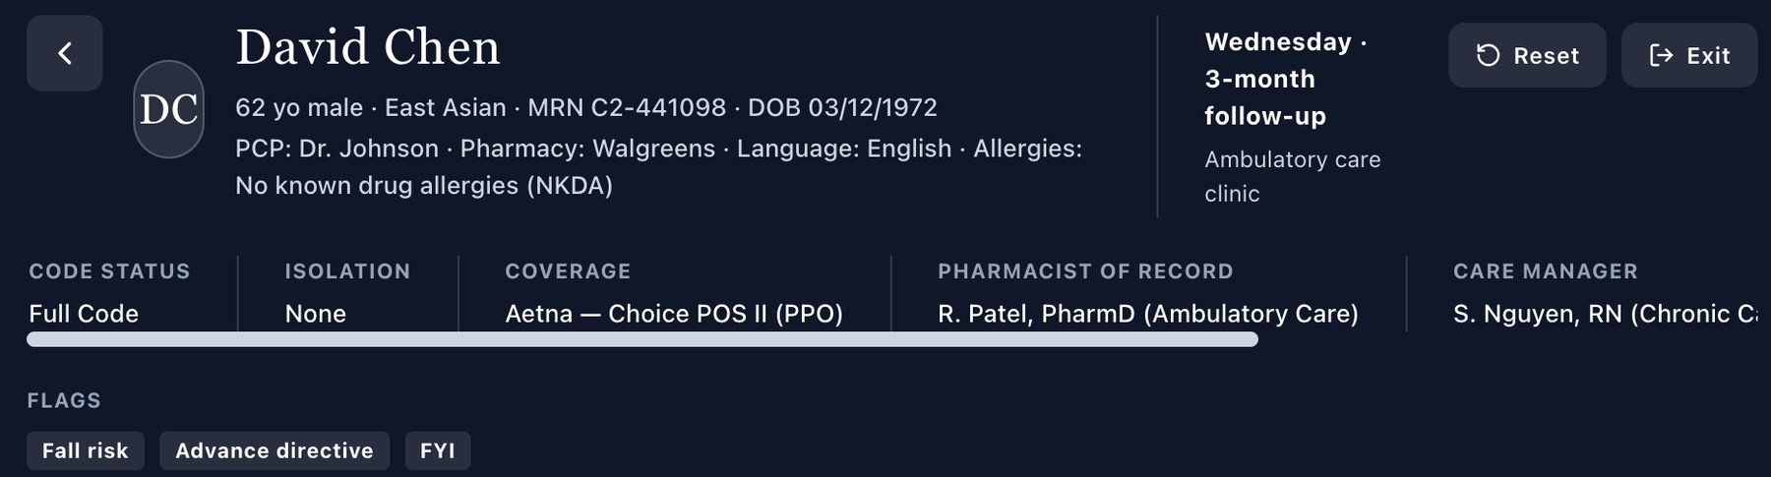
Live header identifies Wednesday · 3-month follow-up.

Charted Subjective metadata still identifies an Initial Ambulatory Care Pharmacist Visit.

Issue 3. Problem List is stale relative to Wednesday current kidney, diabetes, lipid, and BP values
What the student saw or heard: Current Wednesday values include LDL-C 82, eGFR 40, UACR 390, A1C 7.0%, and BP 132/78. The Problem List still reflects the Tuesday baseline: LDL-C 88, eGFR 42/UACR 520, A1C 7.2%, and BP in the mid-130s.
Why this is a problem: The follow-up is intended to show changes in albuminuria, potassium/renal function, diabetes, lipids, and BP. A stale active problem summary can misstate whether the treatment is improving or worsening these conditions.
Suggested fix: Update the Problem List from the active Wednesday dataset or label baseline values as dated historical references.
Focused screenshot evidence
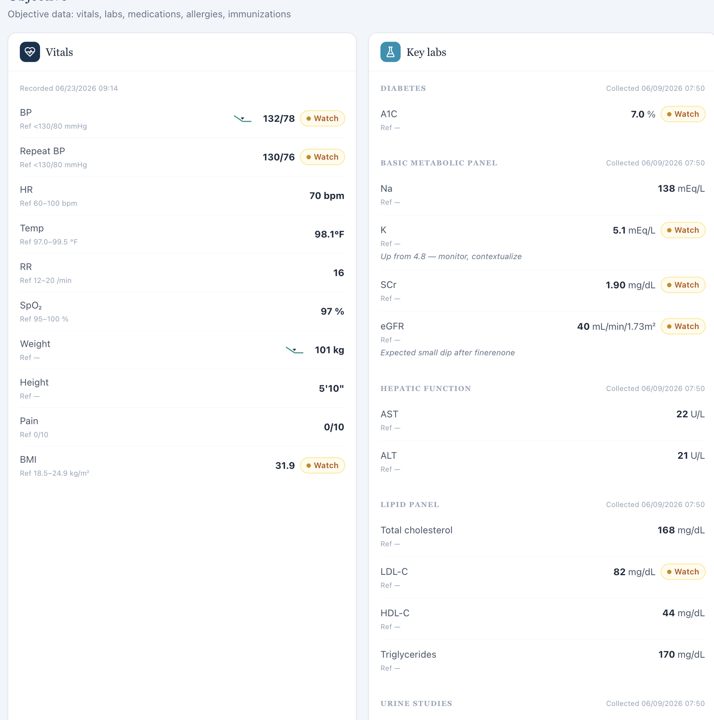
Current Wednesday Objective shows updated kidney, diabetes, lipid, and BP data.
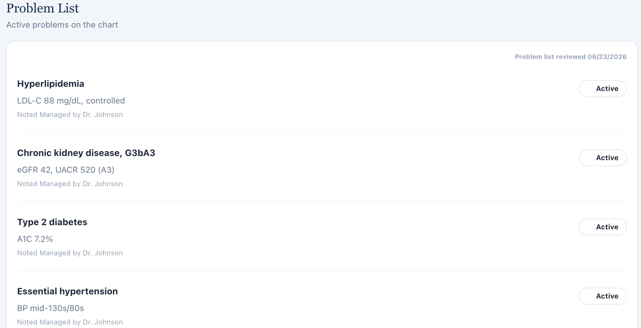
Problem List retains Tuesday baseline values.

Issue 4. Home BP log is displayed as a populated result while marked “Missing”
What the student saw or heard: The Wednesday Additional/missing panel shows a 7-day home BP average around 131/77 mmHg with a range, but the row is still labeled “Missing.”
Why this is a problem: The field conveys two mutually exclusive states and can make the learner question whether the home values are valid or merely a placeholder.
Suggested fix: Remove the “Missing” label whenever the home BP log is populated and show the result in a normal home-monitoring field.
Focused screenshot evidence
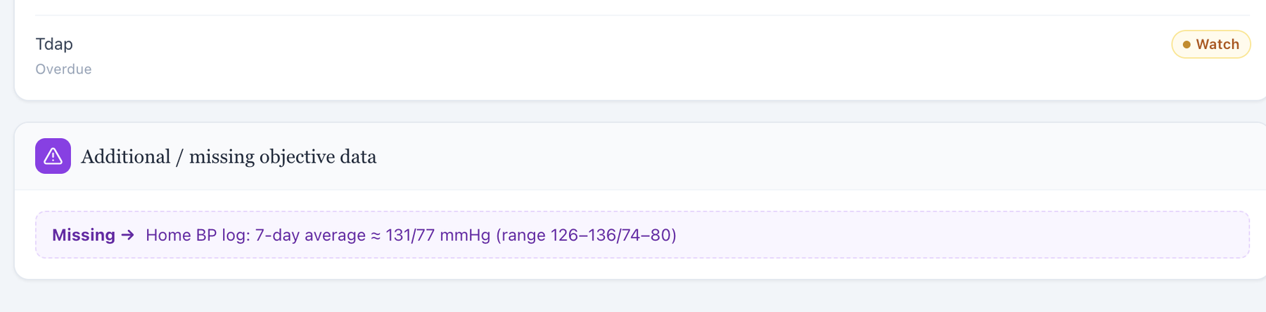
Wednesday Objective displays the home BP average/range inside a “Missing” row.

Issue 5. AI grader requires a 10-year ASCVD risk of 20.5% that is not shown in the live Wednesday EMR
What the student saw or heard: No numeric ASCVD risk result is displayed in the live Wednesday case.
What the AI grader expected: The grader specifically expects a 20.5% 10-year ASCVD risk.
Why this is a problem: A learner cannot document an exact risk percentage that VACS does not supply or calculate visibly.
Suggested fix: Expose the 20.5% risk calculation/result or remove the exact numeric criterion.
Focused screenshot evidence
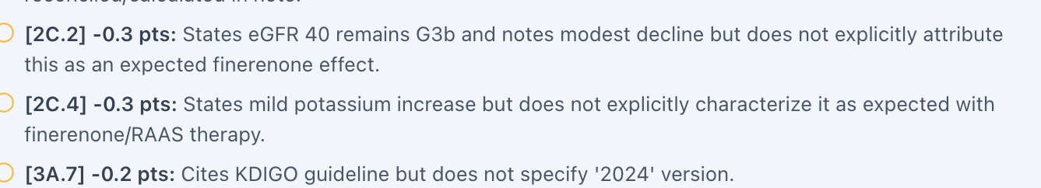
Grader deduction requires the hidden 20.5% 10-year ASCVD risk.
Live Objective has no ASCVD risk field.

Issue 6. Grader requires specific diet, goals, prior shared decision-making, and patient questions not reliably returned by the AI patient
What the student saw or heard: The preserved interview does not reliably produce the grader’s exact dietary-change narrative, dialysis-avoidance wording, prior shared-decision details at finerenone initiation, or the requested nuanced questions about eGFR/UACR changes.
What the AI grader expected: The grader deducts for those specific patient-reported or historical details even though they are not consistently available from the live standardized patient.
Why this is a problem: The learner cannot be expected to document patient questions, goals, or historical shared decisions that the patient does not provide. Requiring them turns hidden reference facts into fabricated subjective history.
Suggested fix: Synchronize the Wednesday standardized patient to return the intended facts after neutral questioning, or remove unsupported subjective facts from grading.
Focused screenshot evidence
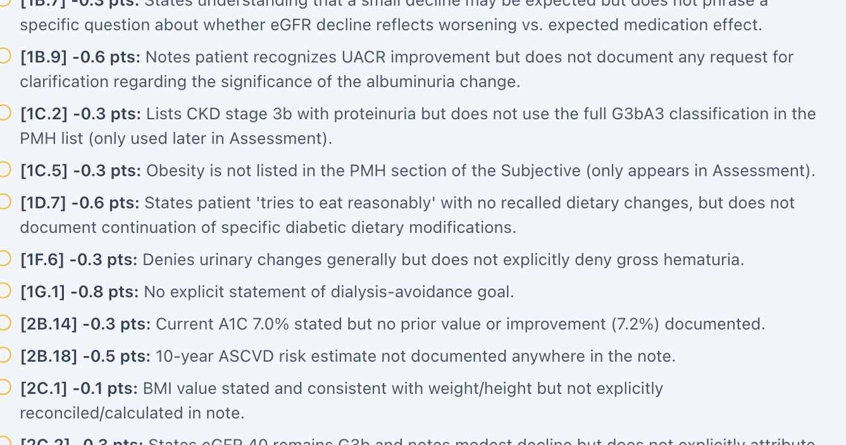
Focused grader deductions require specific patient questions, diet, goals, and prior-history details.
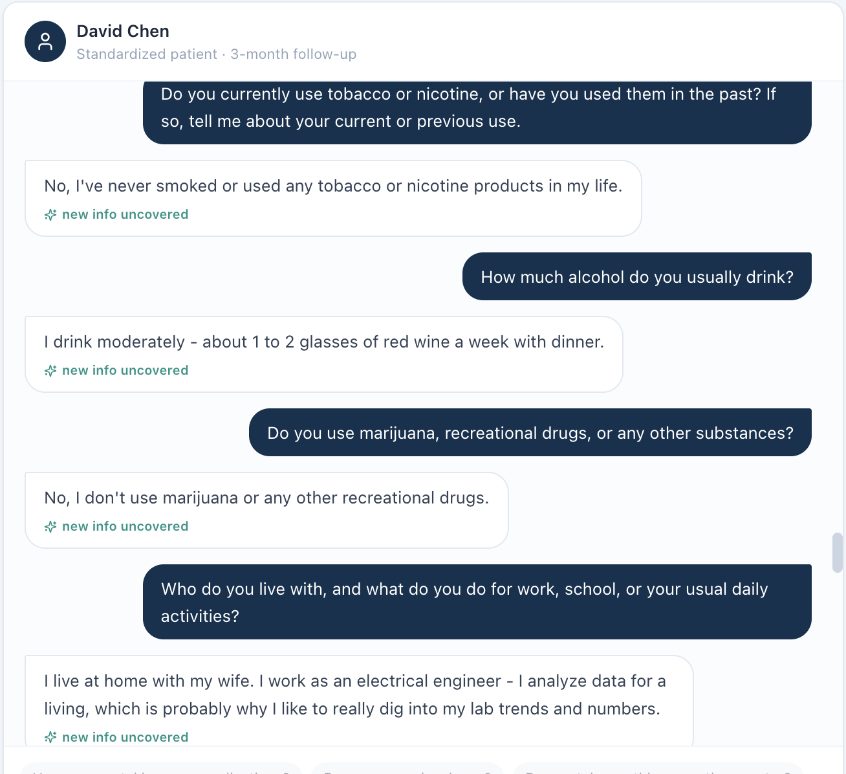
Preserved AI-patient interview provides the live subjective response rather than the hidden grader narrative.

Issue 7. BSA labeled as Mosteller is mathematically incorrect (2.04 m² displayed; 2.23 m² calculated)
What the student saw or heard: The dedicated Vitals tab displays weight 101 kg, height 70 in, and “BSA (Mosteller) 2.04 m².”
Why this is a problem: The Mosteller equation is BSA = √(height in cm × weight in kg / 3600). Using the values displayed in this encounter gives 2.233 m², which rounds to 2.23 m², not 2.04 m². Because the same 2.04 m² value appears across patients with substantially different body sizes, this looks like a shared calculation or hard-coded-value defect rather than normal rounding. BSA can be used in medication dosing and clinical interpretation; a field explicitly labeled with a formula should be mathematically reproducible from the height and weight shown next to it.
Suggested fix: Recalculate BSA from the active encounter height and weight using the documented Mosteller formula, round consistently, and regression-test all nine Week 2 encounters.
Focused screenshot evidence
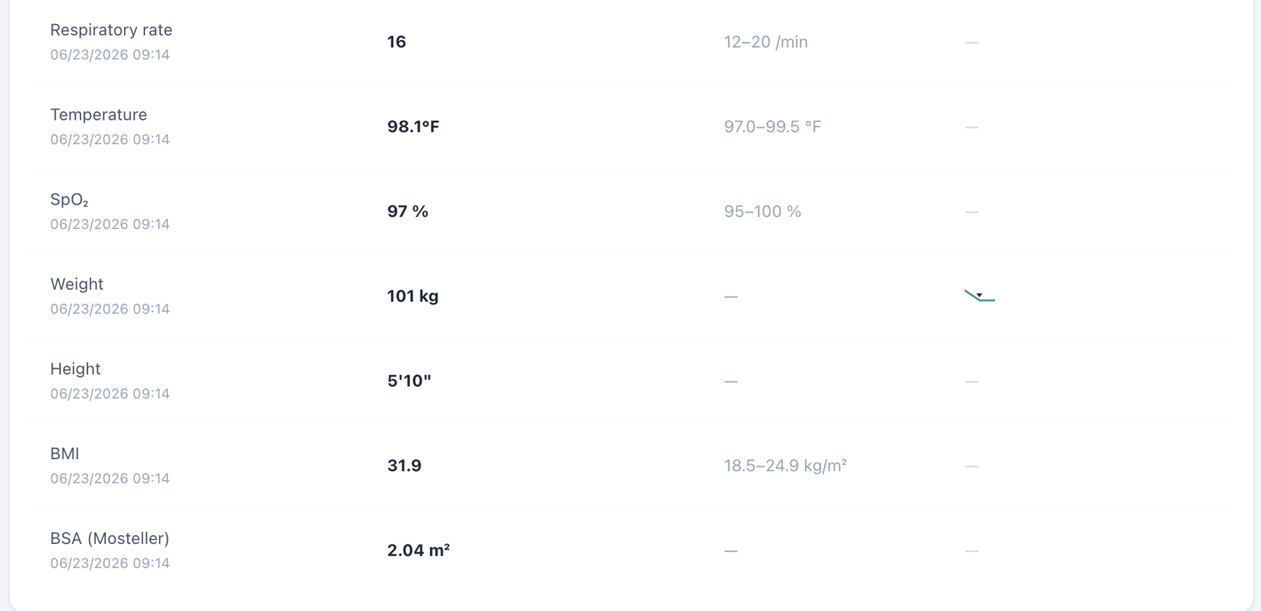
Dedicated Vitals shows weight 101 kg, height 70 in, and the repeated BSA value 2.04 m².

Issue 8. BSA appears in dedicated Vitals but is omitted from the Objective/Snapshot vitals shown to the learner
What the student saw or heard: The student-facing Objective/Snapshot vitals card displays the encounter vitals through BMI but does not show BSA. Opening the dedicated Vitals tab adds a BSA field for the same encounter.
Why this is a problem: The same clinical data element is not propagated consistently across VACS views. A learner working from the Objective/Snapshot may reasonably believe BSA is unavailable, while a learner who opens the dedicated Vitals page sees an additional calculated field. The inconsistency becomes more important because the displayed BSA is also mathematically wrong in this encounter. Display rules should not make required or clinically relevant data depend on which tab the student happens to open.
Suggested fix: Use one vitals data model for Snapshot/Objective and dedicated Vitals. Either display BSA consistently in both locations or intentionally omit it from both; do not grade a value that is hidden from the primary Objective view.
Focused screenshot evidence
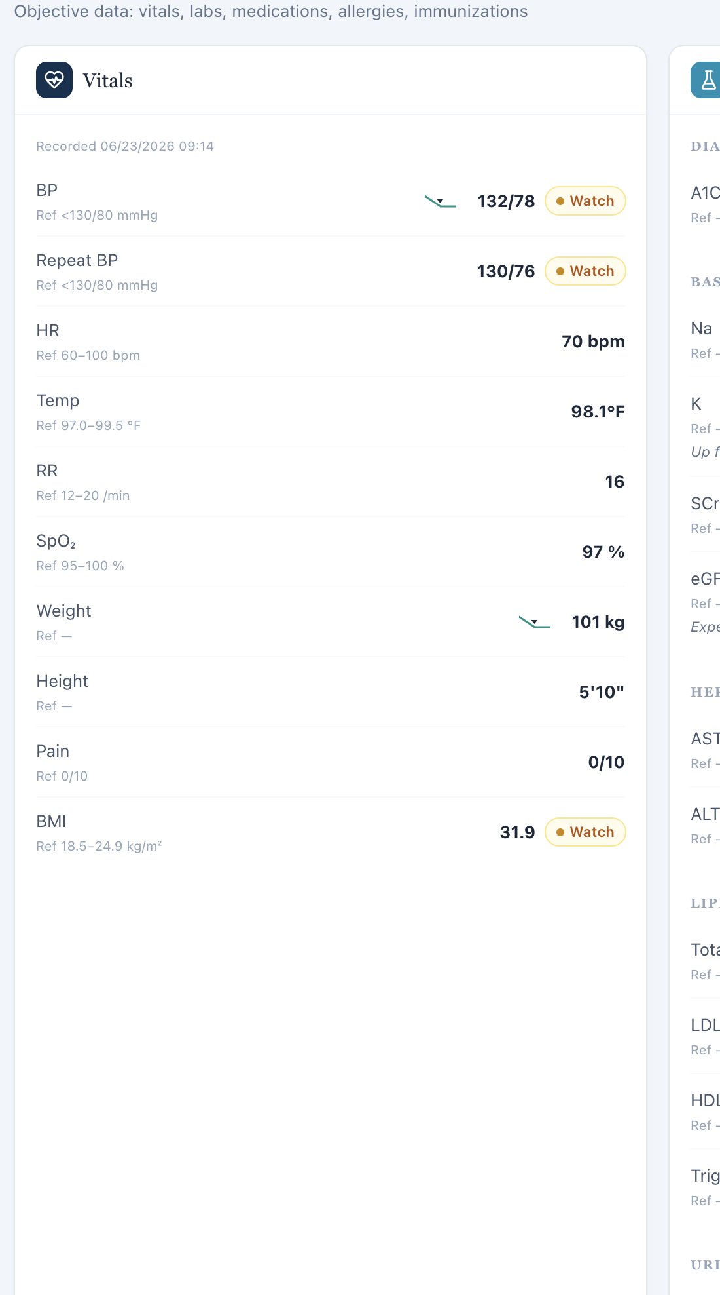
Objective/Snapshot vitals ends at BMI; no BSA field is displayed in the primary objective view.
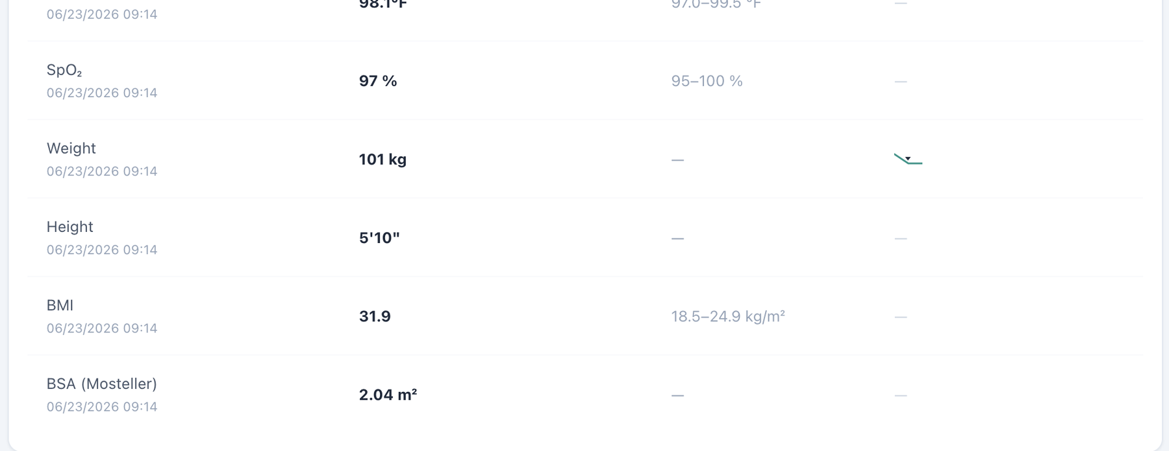
Dedicated Vitals for the same encounter includes a BSA field beneath BMI.

Patient DC – David Chen – Thursday – Thursday · 2nd 3-month follow-up
8 confirmed system/data/interface/workflow issues are included for this visit. Items are grouped by underlying root cause so one defect is not counted multiple times merely because it produced several grader deductions.
# | Issue | Problem type
1 | Patient Interview uses the wrong pronoun for a male patient | Medium — Interface/display problem
2 | Thursday visit stage is split three ways: “2nd 3-month follow-up,” “Initial Visit,” and grader-required six-month follow-up | Critical/High — Encounter synchronization
3 | Problem List remains on the Tuesday baseline at the final DC visit | High — Data synchronization
4 | Home BP average/range is visible while the row is labeled “Missing” | Medium — Interface/display logic
5 | AI grader requires a 10-year ASCVD risk of 18.7% and prior risk trend not shown in the live case | High — Hidden/unavailable grader data
6 | Grader requires a continuing-therapy concern and diet history that the AI patient explicitly does not provide | High — AI patient and grader disagree
7 | BSA labeled as Mosteller is mathematically incorrect (2.04 m² displayed; 2.21 m² calculated) | Medium — Clinical calculation logic
8 | BSA appears in dedicated Vitals but is omitted from the Objective/Snapshot vitals shown to the learner | Medium — Interface/display problem

Issue 1. Patient Interview uses the wrong pronoun for a male patient
What the student saw or heard: David Chen is a male patient. The DC Thursday Patient Interview instruction states: “Interview the standardized patient — she won’t volunteer hidden facts unless you ask.”
Why this is a problem: The interface displays a demographic pronoun that does not match the active patient. Because the same wording recurs across both male patients and all three visits for each patient, this is a repeated interface/template defect rather than an isolated typo. The mismatch can confuse the learner about patient identity, reduces confidence that patient-specific interface content is synchronized to the active record, and creates an unprofessional user experience.
Suggested fix: Bind the Patient Interview instruction to the patient demographic record, or use gender-neutral wording such as “Interview the standardized patient — the patient won’t volunteer hidden facts unless you ask.” Regression-test the instruction on every MT and DC visit.
Focused screenshot evidence

David Chen — DC Thursday: visit-specific Patient Interview evidence shows the incorrect “she won’t volunteer…” instruction.

Issue 2. Thursday visit stage is split three ways: “2nd 3-month follow-up,” “Initial Visit,” and grader-required six-month follow-up
What the student saw or heard: The live header and AI patient label the encounter “Thursday · 2nd 3-month follow-up.” The chart metadata still says Initial Ambulatory Care Pharmacist Visit.
What the AI grader expected: The grader explicitly says the visit should be documented as a “6-month follow-up.”
Why this is a problem: Three incompatible stage labels exist for one encounter. This is a direct synchronization failure and can change the expected longitudinal treatment and trend data. “2nd 3-month follow-up” is also unnecessarily confusing phrasing when the intended longitudinal stage is six months.
Suggested fix: Use one authoritative stage across all layers. The corrected live wording should be “Thursday · 6-month follow-up,” with matching chart metadata, AI-patient label, and grader.
Focused screenshot evidence
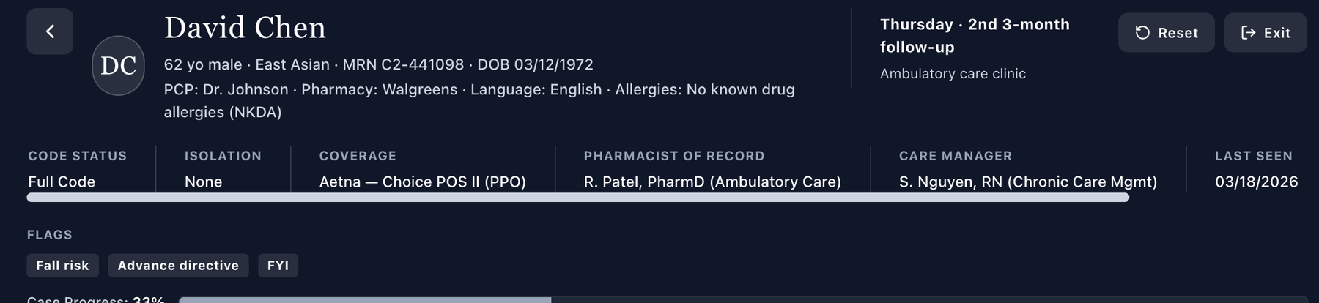
Live header says “Thursday · 2nd 3-month follow-up.”

Chart metadata retains the initial-visit label.
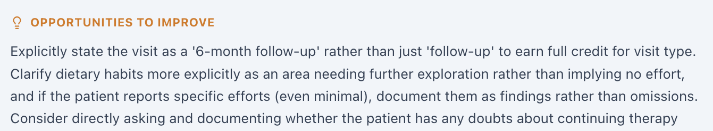
Grader feedback explicitly requires the visit to be stated as a 6-month follow-up.

Issue 3. Problem List remains on the Tuesday baseline at the final DC visit
What the student saw or heard: Current Thursday values include LDL-C 74, eGFR 41, UACR 290, A1C 6.9%, BP 128/76, and weight 99 kg. The Problem List continues to display baseline LDL 88, eGFR 42/UACR 520, A1C 7.2%, and BP in the mid-130s.
Why this is a problem: The active problem summary does not reflect the longitudinal improvement that the current labs show and that the patient discusses. This can mislead both the learner and automated grading about the treatment response.
Suggested fix: Update the active Problem List to Thursday values or mark the older values explicitly as baseline/historical.
Focused screenshot evidence
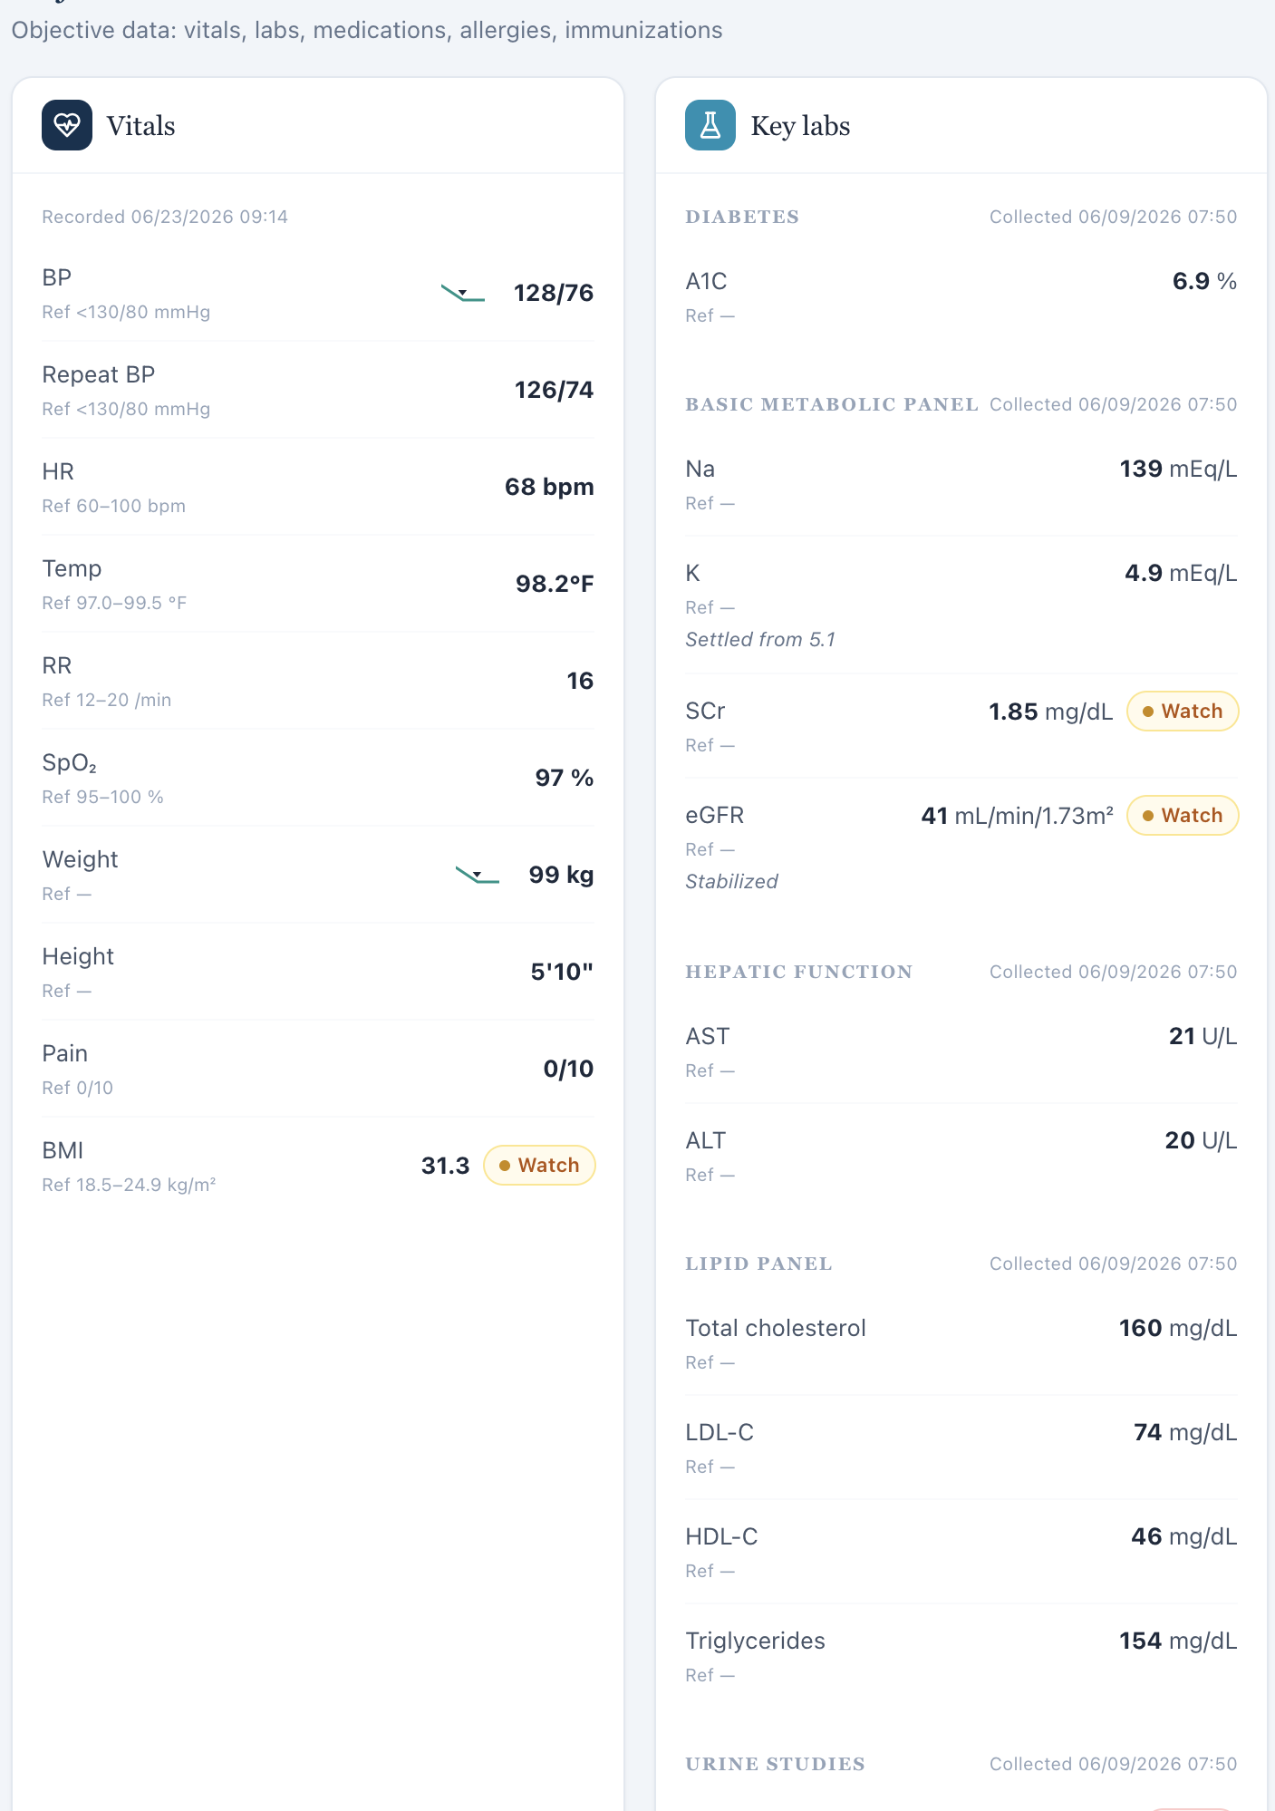
Current Thursday Objective shows improved/current values.
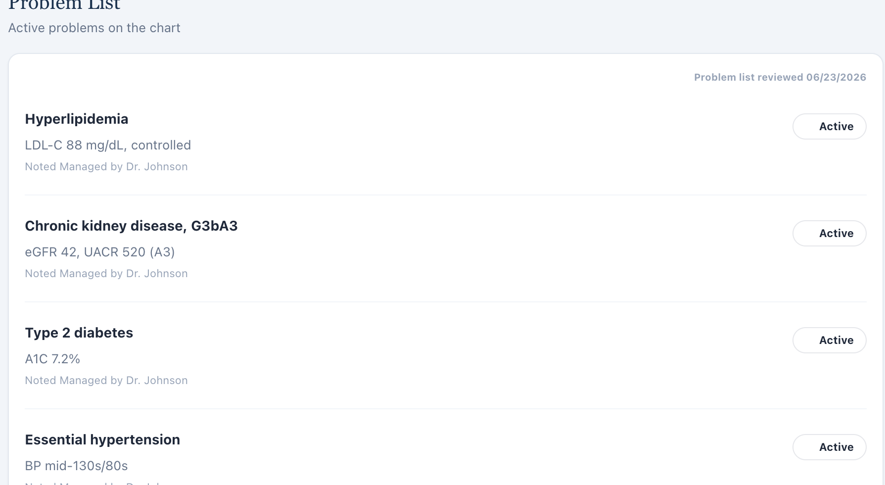
Problem List still displays the baseline dataset.

Issue 4. Home BP average/range is visible while the row is labeled “Missing”
What the student saw or heard: The Thursday Additional/missing panel displays a 7-day home BP average around 127/75 mmHg with a range, yet labels the row “Missing.”
Why this is a problem: The contradictory field state repeats the same interface defect seen earlier and can lead students to ignore valid home-monitoring data.
Suggested fix: Treat the populated home BP log as available data and remove the missing-state styling/label.
Focused screenshot evidence
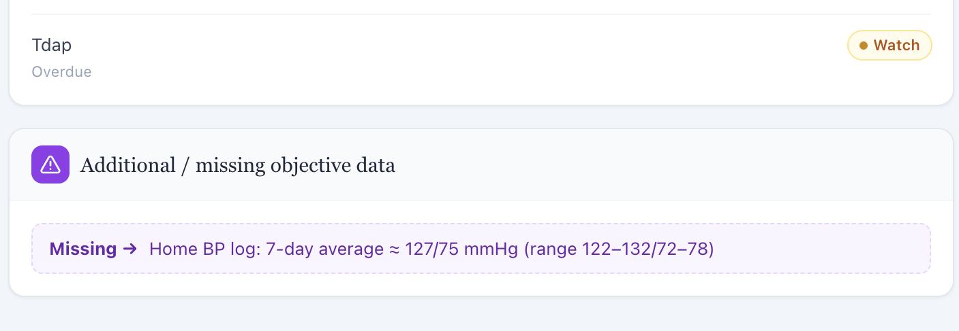
Thursday Objective shows a populated home BP average/range in a “Missing” row.

Issue 5. AI grader requires a 10-year ASCVD risk of 18.7% and prior risk trend not shown in the live case
What the student saw or heard: No numeric ASCVD risk result is displayed in the learner-facing Thursday EMR.
What the AI grader expected: The grader requires an 18.7% 10-year ASCVD risk and improvement from 22% to 18.7%.
Why this is a problem: The student is graded on a current and prior calculated percentage that are not visible in the workflow.
Suggested fix: Display both values and calculation context if they are required, or remove the exact numeric deductions.
Focused screenshot evidence
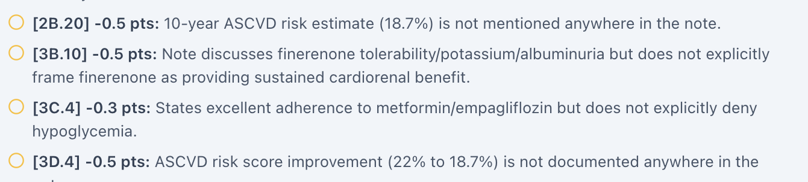
Grader requires the hidden 18.7% ASCVD risk and 22% to 18.7% trend.
Live Objective contains no ASCVD risk result.

Issue 6. Grader requires a continuing-therapy concern and diet history that the AI patient explicitly does not provide
What the student saw or heard: When asked about concerns, the AI patient says he is clear on the plan, the UACR improvement convinced him, and he feels good about staying on therapy. When asked about other lifestyle changes, he says he has not tracked specific cooking/eating-out changes.
What the AI grader expected: The grader deducts for not documenting a patient question or misconception about whether continued therapy is necessary and for not reporting the expected continued dietary-improvement efforts.
Why this is a problem: The standardized patient directly contradicts the hidden grader narrative. A learner cannot ethically document a doubt the patient denies or convert “not tracked” into specific diet improvements.
Suggested fix: Align the DC Thursday AI-patient response bank with the intended continuation/diet storyline, or grade the actual patient responses as correct.
Focused screenshot evidence
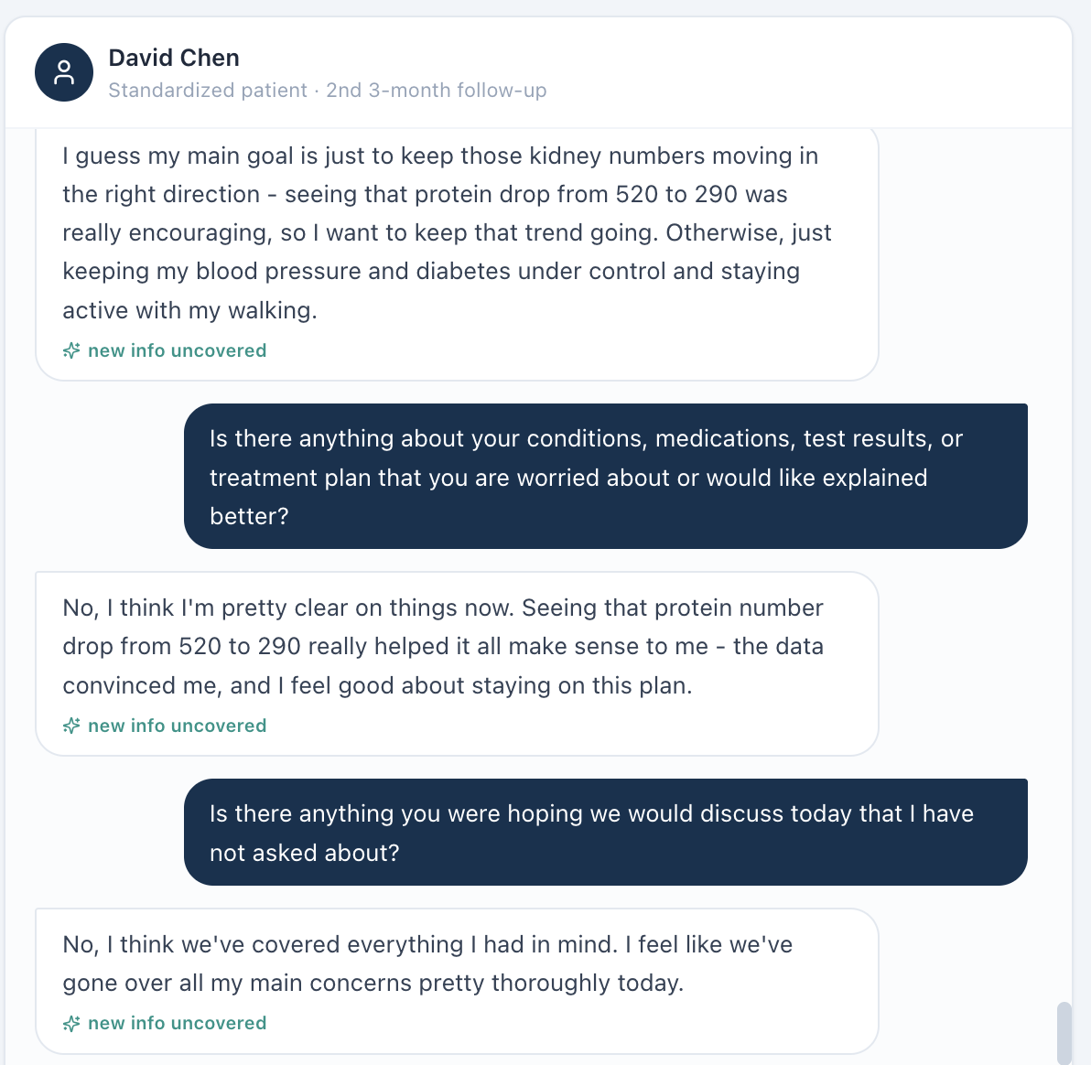
AI patient says the data convinced him and he feels good about staying on the plan.
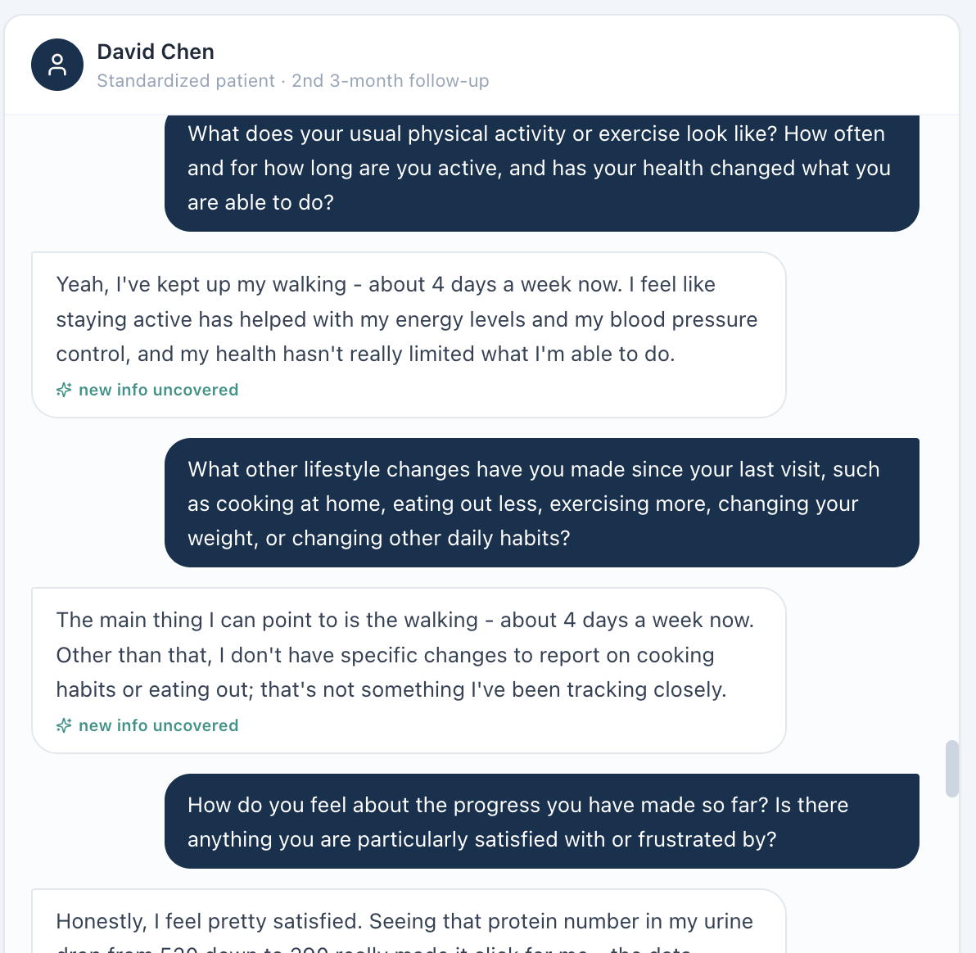
AI patient says he has not tracked specific cooking or eating-out changes.
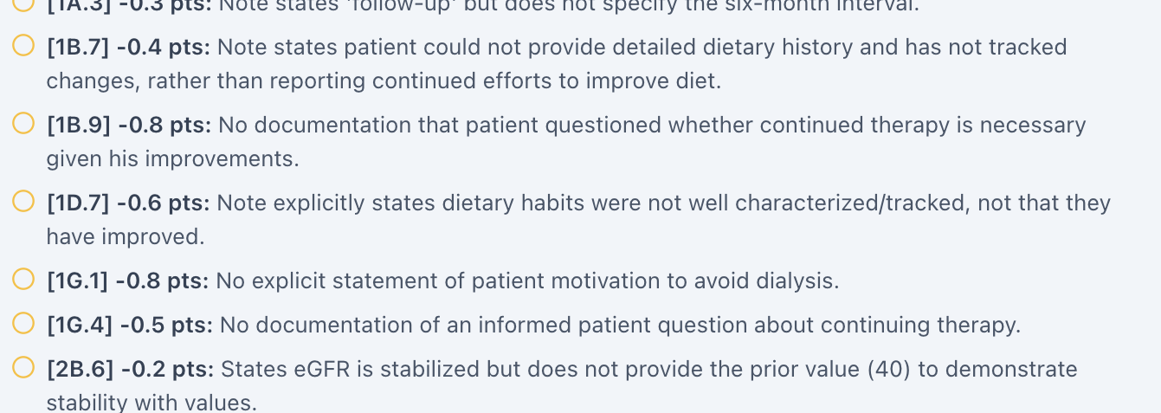
Grader deductions require a continued-therapy question and specific diet efforts.

Issue 7. BSA labeled as Mosteller is mathematically incorrect (2.04 m² displayed; 2.21 m² calculated)
What the student saw or heard: The dedicated Vitals tab displays weight 99 kg, height 70 in, and “BSA (Mosteller) 2.04 m².”
Why this is a problem: The Mosteller equation is BSA = √(height in cm × weight in kg / 3600). Using the values displayed in this encounter gives 2.211 m², which rounds to 2.21 m², not 2.04 m². Because the same 2.04 m² value appears across patients with substantially different body sizes, this looks like a shared calculation or hard-coded-value defect rather than normal rounding. BSA can be used in medication dosing and clinical interpretation; a field explicitly labeled with a formula should be mathematically reproducible from the height and weight shown next to it.
Suggested fix: Recalculate BSA from the active encounter height and weight using the documented Mosteller formula, round consistently, and regression-test all nine Week 2 encounters.
Focused screenshot evidence
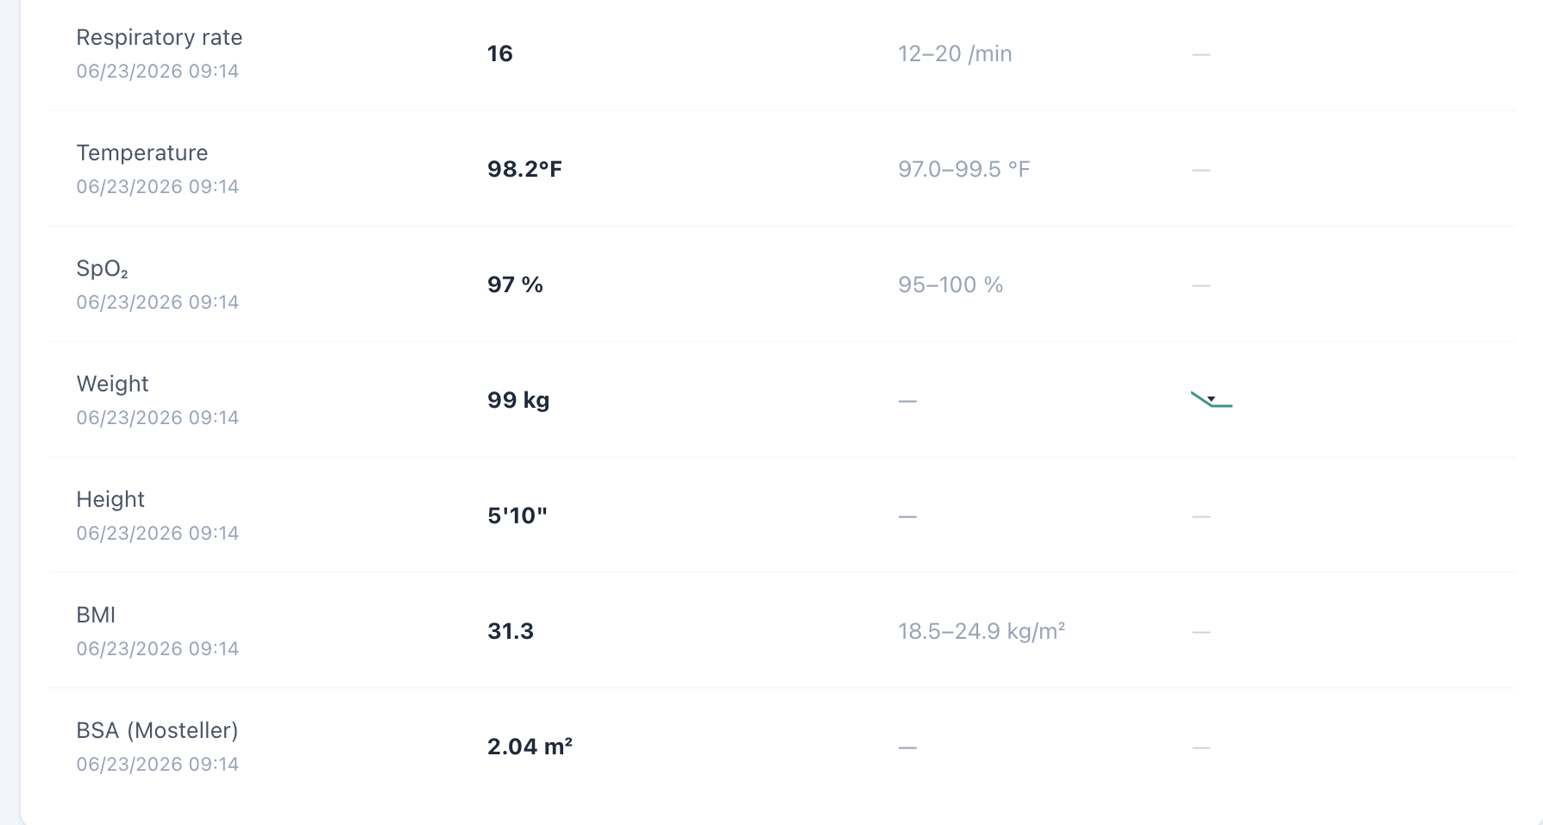
Dedicated Vitals shows weight 99 kg, height 70 in, and the repeated BSA value 2.04 m².

Issue 8. BSA appears in dedicated Vitals but is omitted from the Objective/Snapshot vitals shown to the learner
What the student saw or heard: The student-facing Objective/Snapshot vitals card displays the encounter vitals through BMI but does not show BSA. Opening the dedicated Vitals tab adds a BSA field for the same encounter.
Why this is a problem: The same clinical data element is not propagated consistently across VACS views. A learner working from the Objective/Snapshot may reasonably believe BSA is unavailable, while a learner who opens the dedicated Vitals page sees an additional calculated field. The inconsistency becomes more important because the displayed BSA is also mathematically wrong in this encounter. Display rules should not make required or clinically relevant data depend on which tab the student happens to open.
Suggested fix: Use one vitals data model for Snapshot/Objective and dedicated Vitals. Either display BSA consistently in both locations or intentionally omit it from both; do not grade a value that is hidden from the primary Objective view.
Focused screenshot evidence
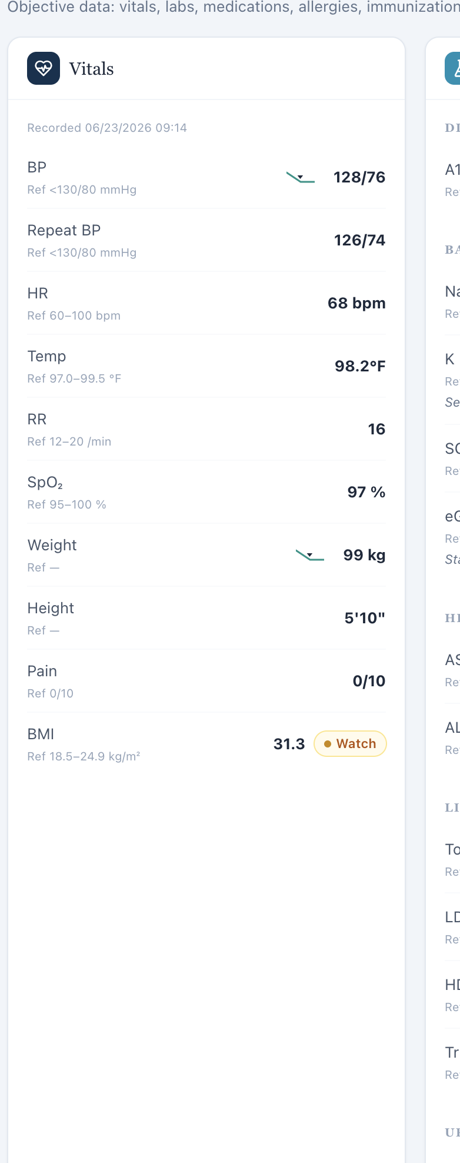
Objective/Snapshot vitals ends at BMI; no BSA field is displayed in the primary objective view.
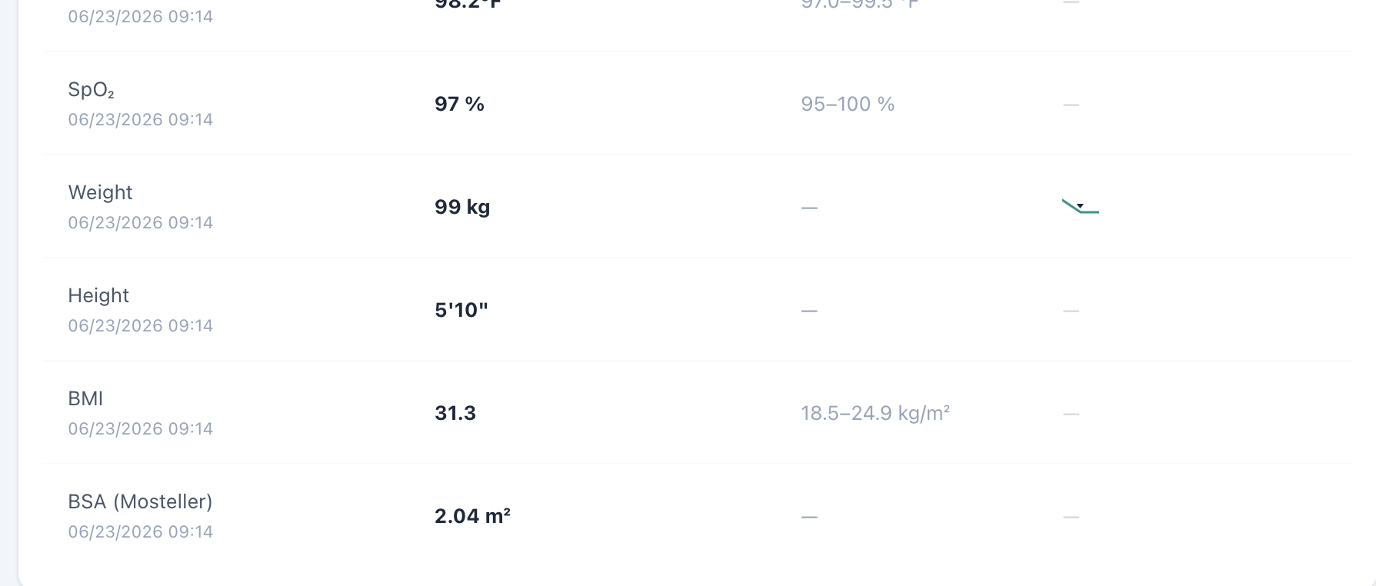
Dedicated Vitals for the same encounter includes a BSA field beneath BMI.

Master Profile vs VACS AI Rubric Consistency Review
This supplemental source-consistency review compares the official Week 2 master patient profiles with patient facts and criterion-level expectations explicitly exposed in the original VACS AI-grader feedback. Its purpose is to determine whether the grading reference appears to contain facts that conflict with, or extend beyond, the intended foundational patient profile. Because no standalone Week 2 master-rubric file was supplied, “VACS AI rubric” in this section means only the expectations directly evidenced by the preserved AI-grader feedback screenshots. These supplemental findings are not added to the 68 visit-specific defect count.
Patient mapping: Patient A = MT = Michael Turner; Patient B = AR = Angela Rodriguez; Patient C = DC = David Chen.

Patient A / MT / Michael Turner — Master Profile vs VACS AI Rubric
Source-level interpretation: A particularly useful finding appears in the MT Thursday feedback. The grader rejects a father’s stroke at age 68 and instead expects an MI at age 61; rejects “warehouse manager” and expects “accountant”; rejects approximately 10 pack-years and expects 20; rejects a 5-year cessation interval and expects approximately 6; and rejects monthly alcohol use in favor of weekly use. Those grader expectations match Michael Turner’s official master profile. Therefore, the previously documented MT Thursday inconsistency is best localized to the standardized-patient biography/history versus the grader reference for those facts, not to cross-patient contamination within the underlying grader reference.
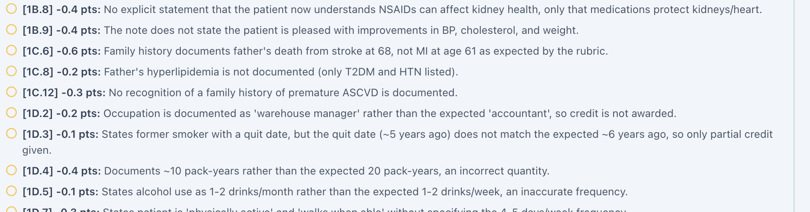
MT Thursday grader feedback expects MI at age 61, accountant occupation, approximately 6 years since smoking cessation, 20 pack-years, and weekly alcohol use — all consistent with Michael Turner’s master profile.

MT-MR-U1 — Tuesday rubric expects additional symptom/history facts not established in the master profile
Status: Possible discrepancy requiring clarification
Problem type: Master Profile vs VACS AI Rubric
Master profile: Michael Turner’s profile defines his chronic diseases, personality, medication history, hidden NSAID use, social and family history, goals, and fears. It does not establish mild fatigue, chronic/intermittent knee pain, or a specific usual home-BP range.
VACS AI rubric evidenced by feedback: Tuesday feedback expects mild fatigue (1B.2), chronic/intermittent knee pain (1B.4), and a usual home BP range in the 130s/80s (1B.6).
Why this requires clarification: These facts are not contradicted by the official master profile, but they are also not defined there. They appear to be supplemental encounter facts embedded in the grading reference.
Potential downstream effect: If these are intended hidden interview facts, the AI-patient response bank should be built from the same controlled source. Otherwise the grader can require information that is not anchored in the official patient profile.
Recommended correction: Confirm whether these are intentional Tuesday-specific facts. If so, add them to a controlled visit-specific case addendum and synchronize the AI patient, live encounter, and grader. If not, remove them as mandatory grading facts.
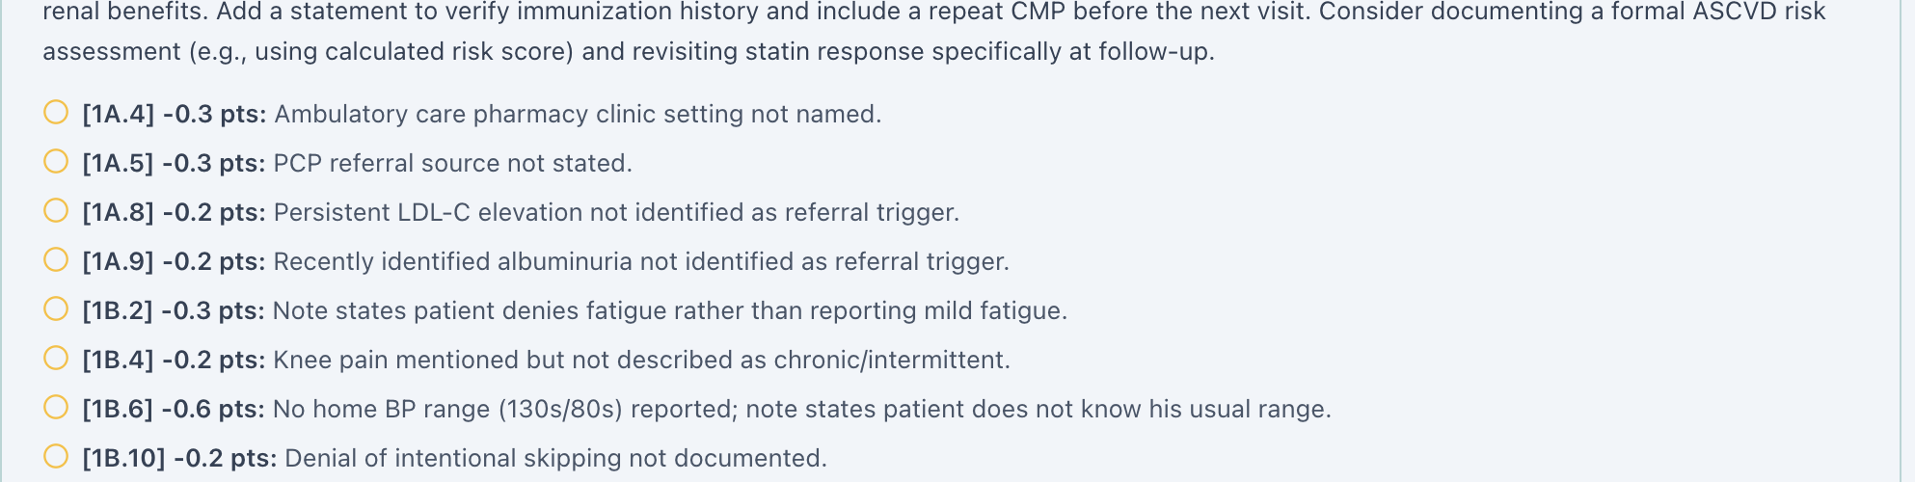
MT Tuesday grader deductions explicitly expect mild fatigue (1B.2), chronic/intermittent knee pain (1B.4), and a usual home BP range in the 130s/80s (1B.6).

MT-MR-U2 — Rubric adds a specific atorvastatin administration time not present in the profile
Status: Possible discrepancy requiring clarification
Problem type: Master Profile vs VACS AI Rubric
Master profile: Atorvastatin 10 mg — 1 tablet by mouth once daily.
VACS AI rubric evidenced by feedback: Tuesday grader feedback expects atorvastatin to be documented as nightly. (Rubric reference: 1E.9.)
Why this requires clarification: “Once daily” and “nightly” are not necessarily clinically contradictory, but the grader imposes a more specific administration time than the official master profile defines.
Recommended correction: Either make “once daily” sufficient for grading or explicitly add nighttime administration to the authoritative profile/visit-specific addendum if that timing is intended.
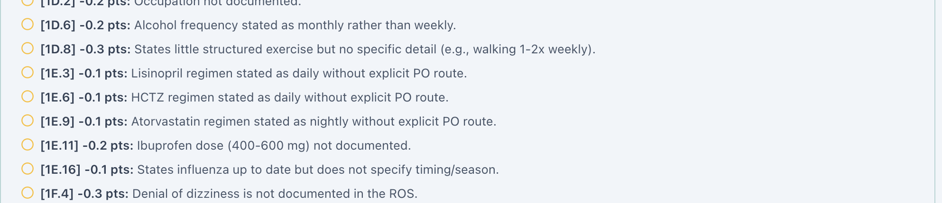
MT Tuesday grader feedback states that atorvastatin was documented as daily rather than the expected nightly regimen (1E.9).

Patient B / AR / Angela Rodriguez — Master Profile vs VACS AI Rubric

AR-MR-U1 — Rubric appears to add a medication-stretching/dose-skipping history
Status: Possible discrepancy requiring clarification
Problem type: Master Profile vs VACS AI Rubric
Master profile: The explicitly identified hidden medication issue is that rosuvastatin 20 mg was prescribed but never started, with cost/access concerns intentionally hidden. The master profile does not describe stretching existing medication supplies or dose skipping.
VACS AI rubric evidenced by feedback: Tuesday feedback deducts because “medication stretching/dose skipping behavior is not documented.” (Rubric reference: 1B.11.)
Why this requires clarification: This is a distinct hidden adherence behavior. The official profile already contains a detailed non-initiation/affordability storyline, but dose stretching is not part of that stated history.
Potential downstream effect: The standardized patient and grader may be operating from two different affordability/adherence stories: never starting rosuvastatin versus stretching or skipping medication doses.
Recommended correction: Confirm whether dose stretching is genuinely part of Angela’s intended Tuesday history. If yes, add it explicitly to the authoritative profile or visit addendum. If not, remove that expectation from the grader.

AR-MR-U2 — Rubric expects occasional nighttime leg cramps not defined in the profile
Status: Possible discrepancy requiring clarification
Master profile: Angela is worried about medication adverse effects, but the profile does not state that she currently experiences nighttime leg cramps.
VACS AI rubric evidenced by feedback: Tuesday feedback states that documenting a denial of leg cramps contradicts the expected finding of occasional nighttime leg cramping. (Rubric reference: 1B.3.)
Potential downstream effect: This affects statin-tolerability questioning and can change the subjective assessment of muscle symptoms.
Recommended correction: Confirm whether nighttime leg cramps belong to Angela’s intended Tuesday profile. If so, document them in the authoritative case source rather than leaving them only in the grader reference.

AR-MR-U3 — Rubric expects a specific home-BP behavior absent from the profile
Status: Possible discrepancy requiring clarification
Master profile: The official Angela Rodriguez profile does not establish a specific home-BP checking pattern or a lack of written BP logs.
VACS AI rubric evidenced by feedback: Tuesday feedback expects occasional home-BP checking without a log. (Rubric reference: 1B.12.)
Recommended correction: Confirm whether this is an intended Tuesday-specific behavior. If it is, place it in a controlled visit-specific source shared by the AI patient and grader.
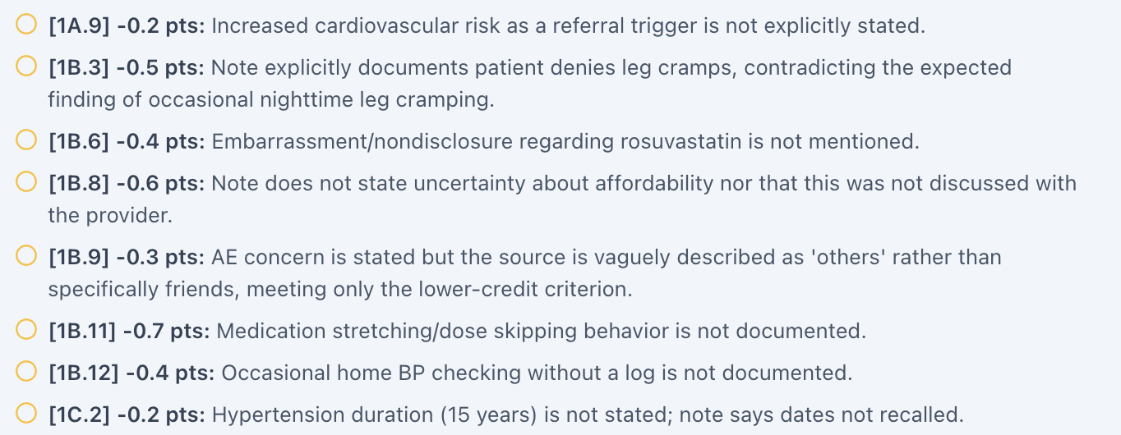
AR Tuesday grader feedback expects occasional nighttime leg cramping (1B.3), medication stretching/dose skipping (1B.11), and occasional home-BP checking without a log (1B.12).

Patient C / DC / David Chen — Master Profile vs VACS AI Rubric

DC-MR-U1 — Tuesday rubric expects additional symptoms not established in the master profile
Status: Possible discrepancy requiring clarification
Problem type: Master Profile vs VACS AI Rubric
Master profile: David Chen’s official baseline profile does not specify fatigue or nocturia.
VACS AI rubric evidenced by feedback: Tuesday feedback expects mild fatigue (1B.2) and occasional nocturia (1B.3).
Why this requires clarification: These may be intentional encounter-specific symptoms, but they cannot be verified from the official master profile.
Recommended correction: Add them to a patient/day case addendum if intended, or remove them as mandatory grader facts if they are not part of the intended Tuesday story.

DC-MR-U2 — Rubric introduces a prior UACR value that the master profile does not establish
Status: Unable to determine from master profile alone
Master profile: Current UACR is 520 mg/g. No prior UACR value is provided in the official baseline profile.
VACS AI rubric evidenced by feedback: Tuesday feedback expects a previous UACR of 505 mg/g and a 505-to-520 mg/g trend. (Rubric references: 2B.14 and 2B.15.)
Why this matters: The current 520 mg/g value matches the official profile, but the 505 mg/g historical baseline exists only in the grader reference among the supplied master-profile sources.
Recommended correction: If 505 mg/g is an intended prior value, add it to an authoritative longitudinal patient record so the live EMR, AI patient, and grader can all reference the same trend.
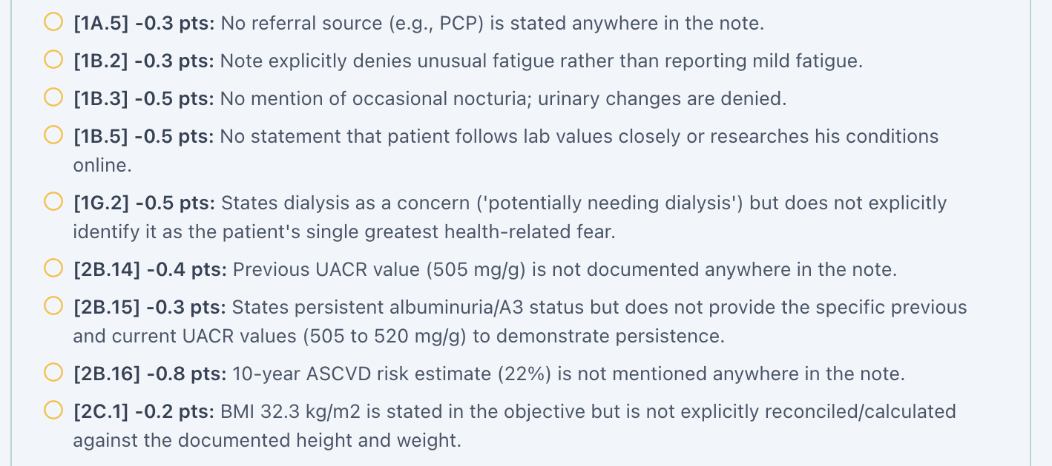
DC Tuesday grader feedback expects mild fatigue (1B.2), occasional nocturia (1B.3), a prior UACR of 505 mg/g with a 505-to-520 mg/g trend (2B.14–2B.15), and a 22% 10-year ASCVD risk (2B.16).

DC-MR-U3 — ASCVD percentages are rubric-defined but not present in the master profile
Status: Unable to determine from master profile alone; not a confirmed contradiction
Master profile: The profile describes David as having high cardiovascular risk but does not provide a numeric 10-year ASCVD percentage for Tuesday, Wednesday, or Thursday.
VACS AI rubric evidenced by feedback: The grader uses specific longitudinal 10-year ASCVD-risk values: approximately 22% on Tuesday (2B.16), 20.5% on Wednesday (feedback narrative and 3D.4), and 18.7% on Thursday (2B.10/3D.4, including a 22% to 18.7% trend).
Why this requires clarification: These values may be legitimate derived encounter data, but the official master profile alone cannot validate them. They should therefore be treated as a separate longitudinal reference dataset rather than as master-profile facts.
Recommended correction: If VACS intends these exact percentages to be graded, store the calculation inputs and/or resulting values in an authoritative encounter-level source available to all case components.
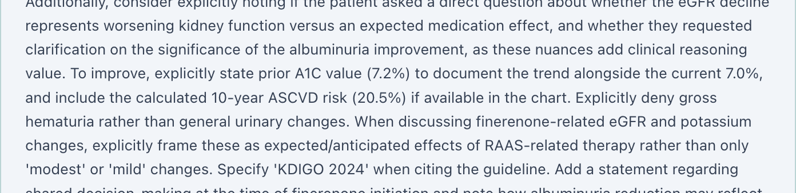
DC Wednesday grader narrative explicitly references a calculated 10-year ASCVD risk of 20.5%.
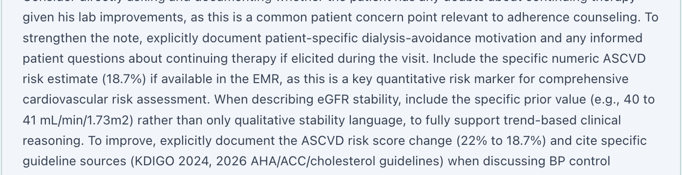
DC Thursday grader narrative explicitly references a 10-year ASCVD risk of 18.7% and a 22% to 18.7% improvement trend.

Cross-Patient Interpretation of the Master Profile / Grader Review
The feedback-based comparison does not show wholesale cross-patient contamination of the grader reference. In fact, the clearest patient-specific baseline facts in MT Thursday align with Michael Turner’s official master profile, and the major AR/DC grader expectations also preserve their respective patient identities. The more consistent source-level concern is that the grader contains supplemental hidden symptoms, behaviors, historical values, and calculated longitudinal metrics that are not fully represented in the baseline master-profile documents. These should be placed in a controlled visit-specific reference so the AI patient, live EMR, and grader are built from the same authoritative case facts.

Master Profile vs Live VACS EMR Consistency Review — Additional AR Clarification
The newly supplied authentic AR Tuesday header resolves the previous AR Tuesday header-evidence gap. It confirms the correct Tuesday initial encounter stage, directly confirms the NKDA header problem, and provides the live coverage label used for the source-level comparison below.

AR-EMR2 — Insurance/coverage entries differ and require clarification
Status: Possible inconsistency requiring clarification
Priority: Medium — Demographic/access-context clarity
Problem type: Master Profile vs Live VACS EMR
Master profile: Angela Rodriguez’s official profile lists Medicare Part D.
Live VACS EMR: The authentic Tuesday header displays “Coverage: Aetna — Choice POS II (PPO),” and the same Aetna coverage label is visible in the Wednesday and Thursday headers.
Why this requires clarification: The two source records use different coverage descriptions, and medication affordability is intentionally important to Angela’s case. However, Medicare Part D may describe prescription-drug coverage while Aetna Choice POS II may represent medical coverage. The available evidence therefore does not prove that the entries are mutually exclusive.
Potential downstream effect: Ambiguous coverage labeling can alter the context of medication-access counseling, affordability expectations, and case realism.
Recommended correction: Confirm Angela’s intended medical and prescription coverage and label each coverage type explicitly in the master profile and live EMR. If both are intended, distinguish “medical coverage” from “prescription coverage” so the case does not appear internally inconsistent.
Authentic AR Tuesday header: correct Tuesday initial stage, NKDA displayed in the header, and Aetna — Choice POS II (PPO) shown as coverage.

Week 2 Cross-Encounter Synthesis
Encounter-stage synchronization: Seven of nine visits contain a supported stage contradiction. The false AR Tuesday stage finding has been removed because it came from a wrong/misfiled image rather than the actual Tuesday EMR. Supported contradictions remain on AR Wednesday/Thursday, MT Wednesday/Thursday, and all three DC visits. DC Tuesday’s AI patient calls an initial encounter a regular follow-up, and DC Thursday remains the clearest three-way split: live header/AI patient “2nd 3-month follow-up,” chart “Initial,” and grader “6-month follow-up.”
Stale Problem List data: Seven visits (all AR visits, MT Wednesday/Thursday, and DC Wednesday/Thursday) carry older problem-state values alongside newer objective data. The problem is not that historical values exist; it is that they are displayed as active problem descriptors without a clear historical label. This can reverse the apparent treatment-response story.
BSA calculation: All nine dedicated Vitals screens display 2.04 m². Independent Mosteller calculations from the displayed height and weight range from 2.05 to 2.26 m² across these cases. A single repeated value despite materially different body sizes is evidence of a shared calculation/hard-coded-value defect.
BSA propagation: All nine Objective/Snapshot vitals panels omit BSA even though the dedicated Vitals tab contains a BSA row. The same data element is therefore available or unavailable depending on navigation path.
Pronoun interface defect: Visit-specific screenshots now directly confirm the same incorrect “she won’t volunteer hidden facts unless you ask” instruction in all six male MT/DC encounters: MT Tuesday, Wednesday, Thursday and DC Tuesday, Wednesday, Thursday. The 6-of-6 recurrence indicates a shared Patient Interview template/interface defect rather than an isolated visit typo.
Allergy safety: All three AR visits show an NKDA/no-conflict state while the dedicated Allergy tab contains penicillin rash. This is a repeated internal EMR safety contradiction, not a student documentation problem.
Hidden grader data: Every visit has a grader requirement for an exact numeric 10-year ASCVD risk percentage that is not displayed in the student-facing EMR. Required values progress by patient/day (AR 17.4%, 14.5%, 13.2%; MT 11.8%, 10.7%, 9.8%; DC 22%, 20.5%, 18.7%). Students should not be required to invent or guess these values.
AI-patient/grader history mismatch: Across all three patients, grader feedback frequently requires symptoms, biography, lifestyle details, motivations, or patient questions that the standardized patient denies or does not supply. The clearest examples include AR Thursday’s required continued-therapy misconception despite the patient reporting confidence; MT Thursday’s different father/occupation/smoking/alcohol history; DC Tuesday fatigue/nocturia; and DC Thursday therapy/diet requirements contradicted by the patient.
Objective/display logic: A home BP value is visibly populated while marked “Missing” in MT Tuesday and all three DC visits. DC Tuesday additionally exposes a prior finerenone recommendation/decline—a subjective/shared-decision fact—inside the Objective “missing data” panel.
Master-profile source localization: The supplemental profile review shows that the MT Thursday grader expectations for family history, occupation, smoking exposure, smoking-cessation interval, and alcohol use match Michael Turner’s official master profile. This localizes those MT conflicts to the standardized-patient biography/history rather than to cross-patient contamination of the grader reference. Across MT, AR, and DC, several additional symptoms, hidden behaviors, prior laboratory values, and calculated ASCVD percentages appear in grader feedback but are not defined in the baseline master profiles; these should be maintained in controlled visit-specific addenda if they are intended case facts. Angela’s Medicare Part D versus Aetna Choice POS II labels should be clarified as medical versus prescription coverage rather than treated as a confirmed contradiction without additional source evidence.
Technical grading reliability: AR Thursday now has direct screenshot evidence of two reproducible “Unexpected end of JSON input” grader failures and an “Already Graded” state without usable visible feedback. This is a system/workflow failure distinct from clinical scoring content. The auditor-observed approximately 5-minute and 3-minute waits for the two failures are not timestamp-supported.
Grader latency: Auditor-observed Week 2 processing time averaged approximately 6–8 minutes for MT, approximately 5 minutes for AR, and approximately 3 minutes for DC. These values are estimates and are not supported by timestamp screenshots. The several-minute cross-case variation slows workflow and makes it harder to distinguish slow processing from a stalled grader; latency should be benchmarked and made more consistent and efficient. This finding remains separate from the AR Thursday JSON/failed-feedback states.

Developer Action Priorities
1. Create one authoritative encounter-stage value per patient/day and use it for the live header, chart metadata, AI patient, and grader. Correct DC Thursday to “Thursday · 6-month follow-up.”
2. Synchronize active Problem List values with the current encounter dataset, or clearly label baseline/historical values with dates instead of presenting them as current.
3. Correct BSA calculation logic using the active encounter height and weight, then regression-test all nine Week 2 patients/days.
4. Standardize BSA propagation across Objective/Snapshot and dedicated Vitals. Do not require a value that is hidden from the primary objective view.
5. Use a single allergy source for banner, medication safety, Allergy tab, AI patient, and grader; remove NKDA when a penicillin allergy is active.
6. Bind grader objective/reference expectations to the exact live student-facing dataset. AR Tuesday should be regression-tested first because its grader expects a broadly different vitals/lipid/kidney dataset.
7. Display exact ASCVD risk values and calculation inputs if they are graded, or remove exact numeric ASCVD requirements from all nine graders.
8. Synchronize standardized-patient subjective response banks with grader expectations so neutral questioning returns the intended symptoms, social history, goals, and treatment concerns.
9. Correct the Patient Interview pronoun logic across all six MT/DC visits. Prefer a gender-neutral instruction or bind pronouns to the active patient demographic record, then regression-test every MT and DC encounter.
10. Correct “Missing” logic so populated home BP logs are displayed as available data. Keep subjective/shared-decision facts out of the Objective “missing data” panel.
11. Repair grader response/parsing and state handling so “Unexpected end of JSON input” leaves the attempt clearly failed, does not incorrectly commit the note to an “Already Graded” state, permits a clean retry, and preserves/retrieves valid feedback after successful grading.
12. Benchmark and reduce the observed grader response-time variation (MT approximately 6–8 minutes, AR approximately 5 minutes, DC approximately 3 minutes). Establish a reasonably consistent performance target across cases; these timing values are auditor-observed estimates without timestamp screenshots.
13. Provide clearer grader processing and failure-state messaging so users can distinguish “still processing” from “failed” and do not resubmit merely because a slow case appears stalled.
14. Create a controlled visit-specific source/addendum for supplemental grader-required facts that are not defined in the baseline master profiles, including encounter-specific symptoms, hidden adherence behaviors, prior laboratory values, and calculated ASCVD-risk values.
15. Clarify Angela Rodriguez’s insurance fields by distinguishing medical coverage from prescription coverage. Confirm whether Aetna Choice POS II and Medicare Part D are both intended and label each explicitly if so.
16. After fixes, regression-test all nine Week 2 encounters end-to-end using the same source-separation and evidence rules used in this audit, including the official master-profile mapping and visit-specific addenda.

Items Reviewed but Not Counted as Developer Defects
• Routine SOAP omissions such as not naming a guideline, not writing the word “stable,” not adding every numeric treatment goal, or not expanding every counseling point. These are student documentation opportunities unless they expose a system mismatch.
• Static simulation age/date arithmetic. The audit uses the displayed simulated age and does not report calendar-age or follow-up-date arithmetic as a defect.
• Clinical management findings intentionally embedded in the case (for example NSAID exposure, nonadherence, obesity, or medication hesitancy) unless the VACS layers contradict each other about the fact.
• DC Tuesday respiratory rate/temperature and other rubric-specific targets that could not be independently tied to a verified Week 2 master-rubric criterion in the supplied source set. They are not asserted here merely because a prior analysis mentioned them.

Source and Evidence Notes
Original live EMR evidence: The original Week 2 browser screenshots from the nine encounter folders were used to verify stage labels, medications, allergies, current objective values, Problem List values, BSA behavior, “Missing” fields, and interface wording.
Original AI-patient evidence: Complete preserved interview screenshot sets were reviewed for the subjective facts actually returned by each standardized patient. Focused report crops show only the relevant question/answer or stage/context.
Original AI-grader feedback: Complete grader screenshot sets were reviewed. Focused crops show the exact deduction or expectation relevant to the issue and intentionally exclude overall percentage grades.
Master rubric / grader-reference limitation: No independently supplied Week 2 master-rubric document was included among the controlling source files. Criterion identifiers used in the supplemental Master Profile vs VACS AI Rubric review are quoted only when directly visible in original AI-grader feedback screenshots; they describe feedback-exposed expectations rather than a separately verified rubric document.
Official master patient profiles: Patient A / Michael Turner, Patient B / Angela Rodriguez, and Patient C / David Chen master-profile documents were used only for the supplemental source-consistency reviews. They establish foundational patient facts and baseline histories; legitimate later follow-up changes were not labeled discrepancies merely because they differ from baseline.
Week 3 sample: Used only as the visual/structural model for headings, tables, issue flow, screenshot placement, captions, page density, and developer-facing explanation. No Week 3 patient facts, clinical findings, names, or rubric criteria were imported into Week 2.
Prior project analyses: Used only as a checklist of items to re-investigate. Original evidence controls whenever a prior analysis and the screenshots could differ. No prior Week 2 consolidated audit report was used as evidence.
Evidence presentation: The final report uses focused crops derived from original screenshot files. Internal contact sheets were used only for review and are not included as final proof. Screenshots of recreated EMR/SOAP Word documents are excluded.
Technical failure evidence: Three newly supplied original AR Thursday screenshots directly document two “Unexpected end of JSON input” failures and an “Already Graded” state without usable visible feedback. These screenshots are placed beneath the technical-grading issue; the later successful grader result is not used to negate the earlier failures.
Latency limitation: MT approximately 6–8 minutes, AR approximately 5 minutes, and DC approximately 3 minutes are auditor-observed averages. No timestamp screenshots were supplied, so these are estimates rather than instrumented timing measurements. No screenshot has been fabricated for this finding.
Pronoun evidence: Six newly supplied visit-specific Patient Interview screenshots directly confirm the wrong “she” instruction on MT Tuesday, MT Wednesday, MT Thursday, DC Tuesday, DC Wednesday, and DC Thursday. The report therefore counts the defect in all 6 of 6 MT/DC encounters.
End of Week 2 Initial Audit

