WEEK 3

VACS AI Patient & Grading Issue Report
Programmer-Facing Nine-Consultation Clinical and Operational Audit
Sarah Thompson • Robert “Bob” Jenkins • Maria Thompson
Prepared by Jeffrey Nunnally
PharmD Candidate, Class of 2027
D’Youville University School of Pharmacy

Purpose and audience
This report is written primarily for the VACS programmer/site builder. It explains confirmed Week 3 system, data, longitudinal-state, decision-support, and grading defects in plain language, while preserving enough clinical detail to show why each defect matters. The analysis compares four layers for every encounter: the electronic EMR shown to the student, the standardized AI-patient interview, the master SOAP grading rubric, and the AI grader.
Routine SOAP-writing suggestions are separated from system defects. When the student-facing data and hidden grading reference disagree, this audit preserves what the student could actually see or elicit rather than inventing missing clinical facts.

Quick Guide for Non-Clinical Readers
Term | Plain-language meaning
AI patient | The simulated patient the student interviews through text.
EMR | Electronic medical record: the chart shown to the student.
Master rubric | The visit-specific scoring reference that defines expected facts and documentation.
AI grader | The automated scoring feedback returned after SOAP submission.
ACT | Asthma Control Test; a questionnaire score used to judge asthma symptom control.
CAT | COPD Assessment Test; a questionnaire score used to quantify COPD symptom burden.
PFT / spirometry | Breathing tests that measure airflow and lung function.
FEV1 | Amount of air exhaled during the first second of a forced breath.
FEV1/FVC | Ratio used to identify airflow obstruction.
ICS | Inhaled corticosteroid; anti-inflammatory inhaler medication.
LABA | Long-acting bronchodilator used for maintenance treatment.
LAMA | Another class of long-acting bronchodilator used for maintenance treatment.
SMART / MART | Asthma strategy using an ICS/formoterol inhaler for both maintenance and symptom relief.
Albuterol / SABA | Short-acting rescue inhaler used for quick relief.
ACO | Asthma-COPD overlap; features of both diseases.
Eosinophils | Blood-cell count that can influence steroid or biologic treatment decisions.
OCS | Oral corticosteroid, such as prednisone.
NKDA | No known drug allergies.
GINA / GOLD | Major guideline frameworks used for asthma and COPD management.
Biologic | Advanced injectable therapy targeting a specific inflammatory pathway, used in selected severe asthma/ACO cases.

Why these clinical values matter to the software
Clinical item | Why the programmer should care
ACT / CAT | These scores classify symptom control. Loading the wrong score can change whether the system recommends continuing therapy or escalating treatment.
FEV1 / FEV1:FVC | These lung-function values influence obstruction and severity. Different values can produce different disease classifications and treatment logic.
Eosinophils | This biomarker can change whether adding an inhaled steroid or an advanced biologic appears appropriate.
Exacerbation / flare | The number and severity of recent flares affect future-risk assessment and controller escalation.
ICS / LABA / LAMA | These are medication classes. The classes already being used determine what the next treatment step should be.
Inhaler technique | A medication can fail if the device is used incorrectly. Therapy should not be labeled “optimized” when the AI patient demonstrates device errors.
Allergy status | A patient-safety constraint. “NKDA” and a documented drug allergy cannot both be true in a safe medication-checking workflow.
Visit stage | Initial, 3-month, and 6-month encounters represent different points in treatment. Wrong stage metadata can load the wrong regimen, prompts, or grader reference.

How to read each issue
What the student saw or heard: The actual student-facing chart or AI-patient information.
What the master rubric says: The intended visit-specific facts and scoring criteria.
What the AI grader expected: The reference state actually used by the scoring output.
Why this is a problem: Clinical/educational consequence of the mismatch.
Suggested fix: Functional correction recommended from the audit.
Likely technical failure mode: A developer-oriented hypothesis; explicitly an inference, not proof of backend implementation.
Regression test / acceptance criterion: A concrete test that should pass before the issue is considered fixed.

Executive Summary
Bottom line. Across nine consultations, this review confirms 49 grouped system/data defects: 21 Critical, 23 High, and 5 Medium. The dominant failure mode is synchronization: different VACS components repeatedly describe different patient states, treatment stages, objective values, histories, or medication regimens.
Observed grader scores ranged from 27.4% to 75.4% (mean 50.2%). Because many deductions were triggered by mismatched or unavailable data, these scores cannot be interpreted as a pure measure of student documentation quality.
Patient | Grader scores (%) | Issues | Critical | High | Medium
Sarah Thompson | 75.4 / 56.4 / 51.3 | 15 | 6 | 8 | 1
Robert “Bob” Jenkins | 64.7 / 61.8 / 31.2 | 15 | 4 | 8 | 3
Maria Thompson | 55.1 / 28.4 / 27.4 | 19 | 11 | 7 | 1
TOTAL | Range 27.4–75.4; mean 50.2 | 49 | 21 | 23 | 5

Severity definitions
Severity | Meaning
Critical | Can materially change treatment or safety, or causes accurate documentation to be graded as clinically wrong/unsafe.
High | Material source mismatch that changes case interpretation, scoring, or longitudinal reasoning.
Medium | Discoverability, metadata, or reference mismatch that is important for validity but less likely to reverse a treatment decision.

Evidence hierarchy and provenance
The audit gives highest weight to what the student could actually access: live VACS/browser screens and standardized AI-patient answers. The user also supplied Word EMRs that are direct copies of the electronic VACS record; these are treated as faithful source text for encounter reconstruction. Original browser/interview/grader captures are preferred for displayed figure evidence whenever available. The master rubric is used to identify intended scoring facts, while the AI grader output shows which reference facts were actually applied.

Patient A - Sarah Thompson - Asthma
15 confirmed grouped system/data issues across three sequential visits. Each issue below includes the source conflict, plain-language clinical significance, a likely technical failure mode, an acceptance test, and focused evidence.
Encounter | AI-grader score | Issues | Dominant pattern
Tuesday - Initial Visit | 75.4% | 5 | Current symptom frequencies conflict with the grader’s expected history; Recent prednisone use is documented but the grader requires its denial
Wednesday - 3-Month Follow-Up | 56.4% | 5 | Follow-up vital signs and body-size data conflict with the grader; Wednesday spirometry sources and grader reference are mutually incompatible
Thursday - 6-Month Follow-Up | 51.3% | 5 | The grader requires zero symptoms and zero PRN use despite Sarah’s reported symptoms; Hiking, elementary-school employment, and related exposure history remain unsupported

Patient A - Tuesday - Initial Visit
5 confirmed grouped system/data issues are included for this visit. AI-grader result: 75.4%. Issues are grouped by underlying defect rather than by every individual point deduction.
# | Issue | Problem type
1 | Current symptom frequencies conflict with the grader’s expected history | High — AI patient and grader disagree
2 | Recent prednisone use is documented but the grader requires its denial | Critical — EMR/AI patient and grader disagree
3 | Grader vital-sign reference does not match the live chart | High — live EMR and grader disagree
4 | Demographic and background details expected by grading were not supplied consistently | Medium — AI patient and hidden expected history disagree
5 | Controller-treatment history is internally inconsistent | Critical — chart, AI patient, and grader describe different treatment stages

Issue 1. Current symptom frequencies conflict with the grader’s expected history
Problem type: High — AI patient and grader disagree | Severity: High | Status: New on Day 1
What the student saw or heard: Sarah reported albuterol use 1–2 times/day on 5–6 days/week and nighttime awakening 2–3 nights/week; the SOAP documented those answers.
What the grader expected: The AI grader expected albuterol only 4–5 times/week and nighttime symptoms approximately once/week. The master rubric instead specifies 1–2 uses/day on most days and 2–3 nighttime awakenings/week, matching the patient response and SOAP.
Why this is a problem: The deduction contradicts both the standardized-patient answer and master-rubric criteria 1B.6 and 1B.8. This is a confirmed grader-reference defect, not a student documentation error.
Suggested fix: Replace the Day 1 grader values with the master-rubric values and regression-test criteria 1B.6 and 1B.8 using neutral interview wording.
Plain-language clinical meaning | Daytime symptoms, nighttime symptoms, activity limitation, and rescue-inhaler use are the practical measures of breathing control. Different frequencies can change whether the case is interpreted as controlled, improving, or in need of escalation.
Likely technical failure mode | Likely symptom-state or time-window mismatch between the standardized patient, longitudinal HPI, rubric, and grader reference.
Regression test / acceptance criterion | Seed one symptom-control state for the visit, then ask neutral questions for daytime symptoms, nighttime symptoms, activity, and rescue use. The returned answers and grader expectations must match the same state and time window.

Focused screenshot evidence
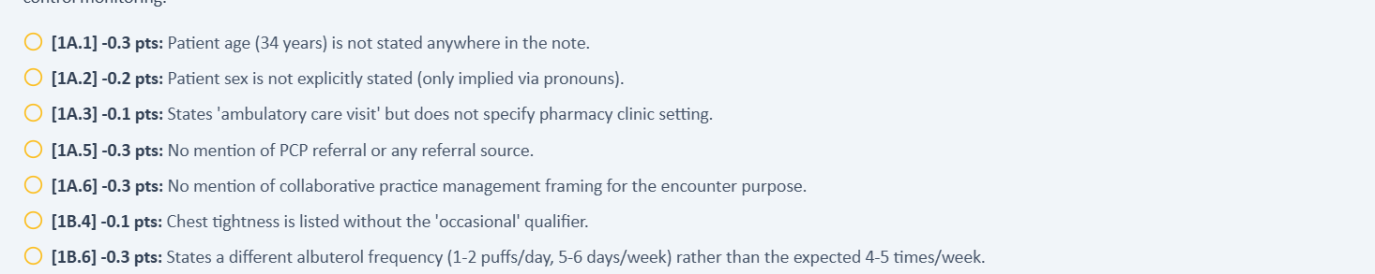
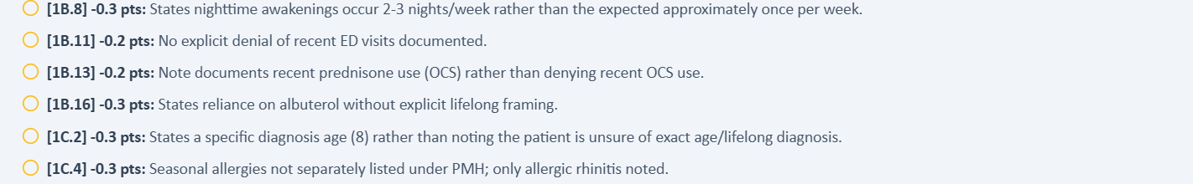
The Day 1 grader deducts because the student documented Sarah’s higher patient-reported frequencies.

Issue 2. Recent prednisone use is documented but the grader requires its denial
Problem type: Critical — EMR/AI patient and grader disagree | Severity: Critical | Status: New on Day 1; persists later
What the student saw or heard: The live HPI and standardized patient document a viral-triggered urgent-care exacerbation 6 weeks earlier treated with prednisone for 5 days.
What the grader expected: Both the AI grader and master-rubric criteria 1B.13/1F.3 require denial of recent OCS use.
Why this is a problem: Here the grader follows the master rubric, but the master rubric conflicts with the live chart and patient. The authoritative case data must be reconciled before scoring.
Suggested fix: Decide whether Day 1 is intended to include the prednisone course; then synchronize the EMR, patient, and master-rubric criteria. Until reconciled, suppress OCS-history scoring.
Plain-language clinical meaning | Exacerbations are clinically important breathing flares. Their number, severity, steroid use, and hospitalization history strongly influence future-risk assessment and whether controller therapy should be intensified.
Likely technical failure mode | Likely longitudinal-history desynchronization: the AI patient, HPI, rubric, and grader are pulling exacerbation events from different time windows or case versions.
Regression test / acceptance criterion | Store exacerbations as dated events in one longitudinal record. For each visit, derive the 3-month and 12-month counts from those same events and verify identical counts in HPI, AI patient, rubric, and grader.

Focused screenshot evidence
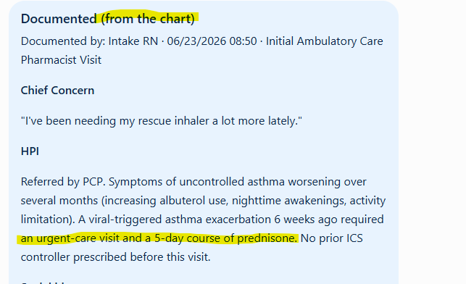
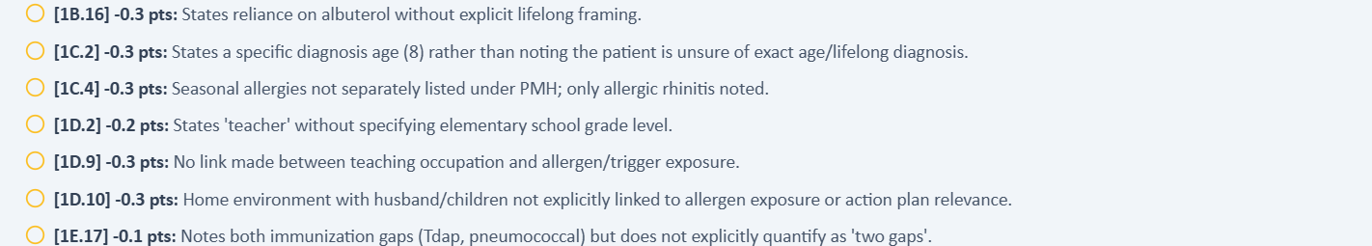
The live Day 1 HPI and grader feedback directly contradict each other about prednisone exposure.

Issue 3. Grader vital-sign reference does not match the live chart
Problem type: High — live EMR and grader disagree | Severity: High | Status: New on Day 1; recurs Day 2
What the student saw or heard: Live values are HR 82 bpm, temperature 98.2°F, SpO2 98%, weight 76 kg, height 5 ft 5 in, and BMI 27.9 kg/m².
What the grader expected: The AI grader calls HR 88 bpm and temperature 98.6°F correct. The master rubric specifies HR 82 bpm and 98.2°F, exactly matching the live chart; it also requires “room air,” which the live chart does not display.
Why this is a problem: The HR and temperature deductions directly contradict master-rubric criteria 2A.2 and 2A.4. The room-air element in criterion 2A.5 is unobservable in the live interface.
Suggested fix: Bind the grader to rubric values HR 82 and 98.2°F. Either expose oxygen-delivery status in the EMR or accept SpO2 98% without the qualifier.
Plain-language clinical meaning | Vital signs and objective measurements identify the patient’s current physiologic state and are used to interpret severity and derived values such as BMI or oxygenation. Penalizing exact transcription of the visible chart is a data-integrity failure.
Likely technical failure mode | Likely grader reference points to another patient/day snapshot or an older visit-state version, while the live EMR and rubric use a different objective dataset.
Regression test / acceptance criterion | Bind every scored objective criterion to the same visit-state ID used to render the live chart. Programmatically compare the values before grading; if any mismatch exists, mark the visit non-scorable rather than deducting points.

Focused screenshot evidence
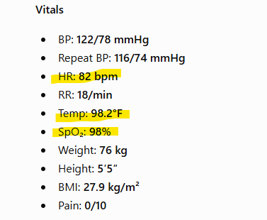
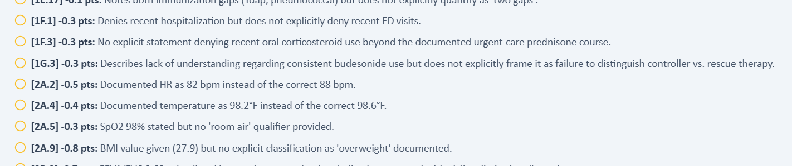
Live Day 1 values compared with the grader’s incompatible HR, temperature, and room-air expectations.

Issue 4. Demographic and background details expected by grading were not supplied consistently
Problem type: Medium — AI patient and hidden expected history disagree | Severity: Medium | Status: New on Day 1; persists later
What the student saw or heard: Sarah gave a specific asthma diagnosis age of 8 and identified herself only as a teacher; the encounter supported allergic rhinitis but not every additional qualifier demanded later.
What the grader expected: The master rubric and grader expect age 8, “elementary school teacher,” hiking details, and separately labeled seasonal allergies; the patient supplied age 8 but only “teacher” and did not consistently supply the other qualifiers.
Why this is a problem: The age-8 deduction is a confirmed grader error because the master rubric agrees with the patient. The occupation, hiking, and seasonal-allergy deductions reveal patient-versus-rubric availability gaps.
Suggested fix: Correct the age criterion in the grader and make all rubric-required history discoverable through neutral questions before assigning points.
Plain-language clinical meaning | Background history establishes patient identity and risk factors. Exact occupation, smoking exposure, family history, and diagnosis duration may be graded; if the AI patient cannot provide the expected fact, the learner should not be forced to invent it.
Likely technical failure mode | Likely fixed-history fields are duplicated across the standardized-patient persona and rubric or are not persisted consistently across visits.
Regression test / acceptance criterion | Ask neutral questions for each scored history item in a clean session. The AI patient must return the rubric-aligned fact or the criterion must be non-scoring. Repeat across follow-ups to verify longitudinal persistence.

Focused screenshot evidence
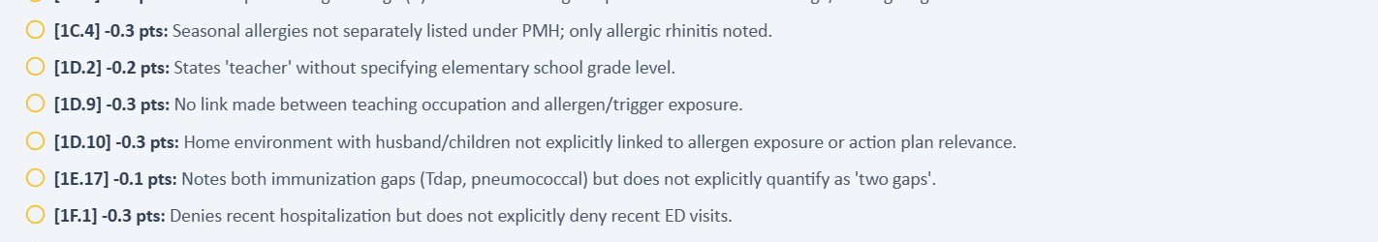
The grader rejects the specific age supplied by Sarah and adds occupation/allergy qualifiers not established in the encounter.

Issue 5. Controller-treatment history is internally inconsistent
Problem type: Critical — chart, AI patient, and grader describe different treatment stages | Severity: Critical | Status: New on Day 1; affects Day 2
What the student saw or heard: The live chart says no prior ICS controller was prescribed, while Sarah reported intermittent budesonide use; the active-medication view showed albuterol, cetirizine, and fluticasone without a controller.
What the grader expected: The grader alternately treats the case as never having received controller therapy while recognizing the documented budesonide discrepancy.
Why this is a problem: This changes the core assessment from untreated asthma to adherence or reconciliation failure and makes several mutually exclusive rubric statements impossible to satisfy.
Suggested fix: Select one intended initial-visit treatment history and synchronize the HPI, medication list, AI patient, and grader.
Plain-language clinical meaning | The current medication regimen defines the treatment stage. If one screen says the patient is already on a therapy while another asks the student to start, continue, or escalate a different therapy, the “correct” next clinical step becomes impossible to determine.
Likely technical failure mode | Likely multiple case branches or stale medication-state objects are active simultaneously. Medication list, prompts, AI patient, and grader are not using a single versioned regimen.
Regression test / acceptance criterion | Assign one medication list to the visit-state ID and make all prompts and grader criteria derive from it. Reload the visit and verify the AI patient names the same regimen. Any prompt referring to a non-current drug should fail pre-release validation.

Focused screenshot evidence
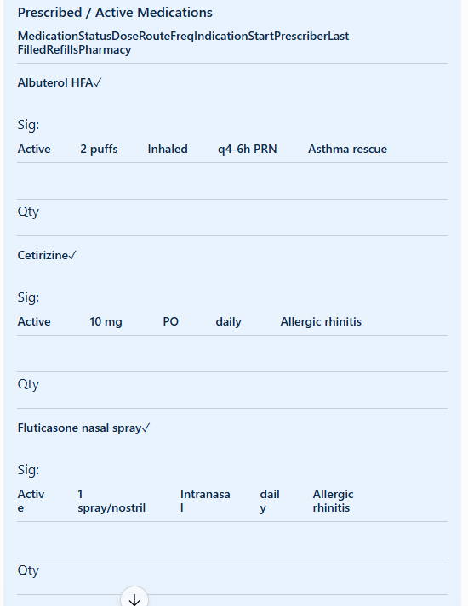
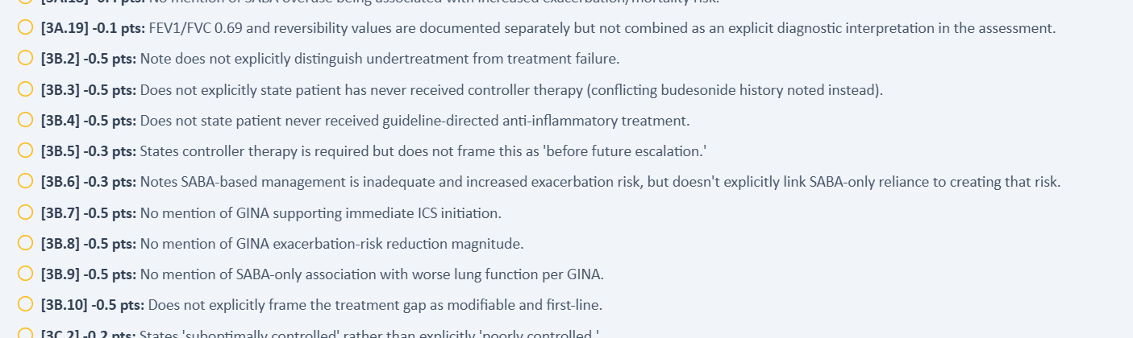
Live medication/HPI evidence and grader deductions show incompatible controller histories.

Patient A - Wednesday - 3-Month Follow-Up
5 confirmed grouped system/data issues are included for this visit. AI-grader result: 56.4%. Issues are grouped by underlying defect rather than by every individual point deduction.
# | Issue | Problem type
1 | Follow-up vital signs and body-size data conflict with the grader | High — live EMR and grader disagree
2 | Wednesday spirometry sources and grader reference are mutually incompatible | Critical — internal EMR inconsistency plus grader mismatch
3 | Follow-up symptom and functional history expected by grading was not reported by Sarah | High — AI patient and grader disagree
4 | Medication-history scoring contradicts the patient’s reported medication reconciliation | High — AI patient/EMR and grader disagree
5 | Treatment-escalation logic contradicts the grader’s own clinical summary | Critical — internal grader contradiction

Issue 1. Follow-up vital signs and body-size data conflict with the grader
Problem type: High — live EMR and grader disagree | Severity: High | Status: Not fixed from Day 1
What the student saw or heard: The live Wednesday chart shows HR 76 bpm, weight 75 kg, height 5 ft 5 in, and BMI 27.5 kg/m²; the master rubric specifies HR 78 bpm but agrees on weight and BMI.
What the grader expected: The AI grader expects HR 88 bpm, weight 65 kg, and BMI 23.9 kg/m².
Why this is a problem: This is a three-way HR conflict (live 76, rubric 78, grader 88) plus a confirmed grader error for weight/BMI, where the rubric agrees with the live chart.
Suggested fix: Reconcile HR 76 versus 78, then bind the grader to the final Day 2 dataset. Replace grader-only weight 65 kg/BMI 23.9 with rubric/live values 75 kg/27.5.
Plain-language clinical meaning | Vital signs and objective measurements identify the patient’s current physiologic state and are used to interpret severity and derived values such as BMI or oxygenation. Penalizing exact transcription of the visible chart is a data-integrity failure.
Likely technical failure mode | Likely grader reference points to another patient/day snapshot or an older visit-state version, while the live EMR and rubric use a different objective dataset.
Regression test / acceptance criterion | Bind every scored objective criterion to the same visit-state ID used to render the live chart. Programmatically compare the values before grading; if any mismatch exists, mark the visit non-scorable rather than deducting points.

Focused screenshot evidence
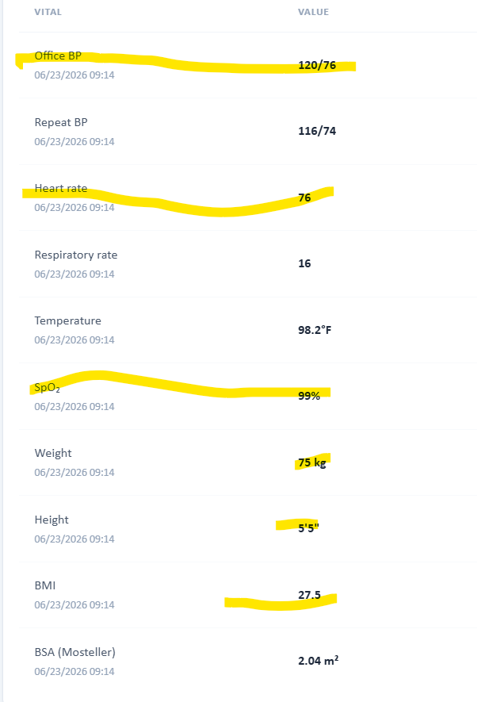
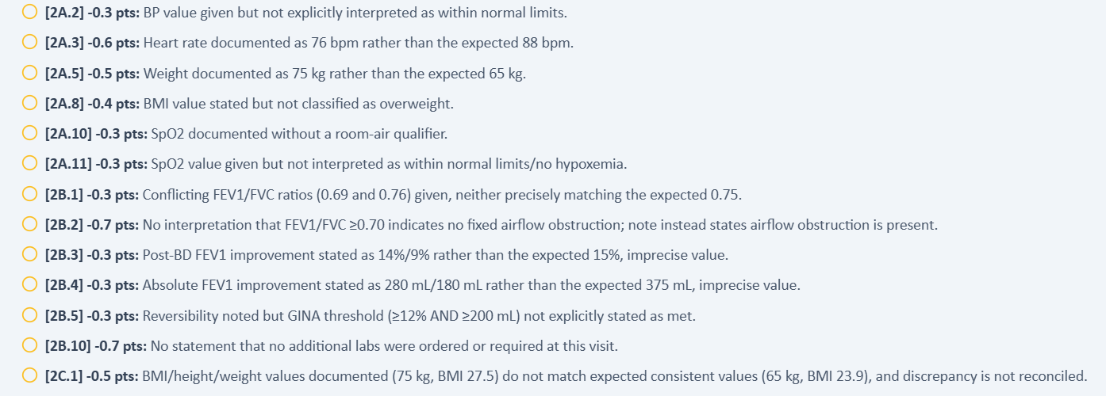
The live Wednesday vitals and the grader’s incompatible expected HR and weight.

Issue 2. Wednesday spirometry sources and grader reference are mutually incompatible
Problem type: Critical — internal EMR inconsistency plus grader mismatch | Severity: Critical | Status: New/expanded on Day 2
What the student saw or heard: The pulmonary-studies panel displays FEV1/FVC 0.69 and +14%/+280 mL, while “Additional/missing objective data” displays FEV1/FVC 0.76 and +9%/+180 mL.
What the grader expected: The master rubric identifies 0.76 and +9%/+180 mL as authoritative; the AI grader expects 0.75 and +15%/+375 mL, while a stale live panel still shows 0.69 and +14%/+280 mL.
Why this is a problem: The rubric resolves the intended Day 2 values, confirming that the AI grader is wrong and the pulmonary-studies panel is stale. Students nevertheless see both live value sets.
Suggested fix: Retain only rubric values 0.76/+9%/+180 mL in the Day 2 interface and grader; remove or relabel the stale Day 1 pulmonary panel.
Plain-language clinical meaning | Spirometry measures airflow and helps classify obstruction and disease severity. Different FEV1 or FEV1/FVC values can change the diagnosis, severity label, and treatment pathway.
Likely technical failure mode | Likely multiple objective-data sources or stale reference records. Primary labs, “missing data” boxes, rubric values, and grader reference values appear to be populated independently.
Regression test / acceptance criterion | Seed one spirometry panel for the visit and verify the same FEV1, FEV1/FVC, reversibility, units, and interpretation appear everywhere. A SOAP that transcribes the visible panel exactly must receive full factual credit.

Focused screenshot evidence
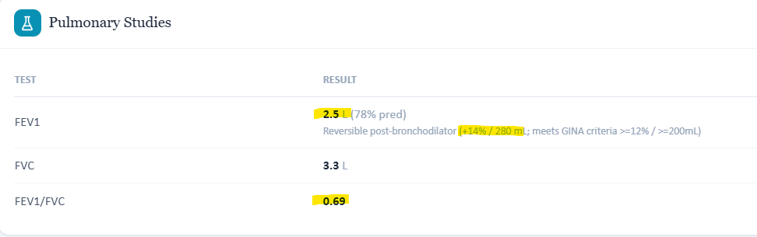
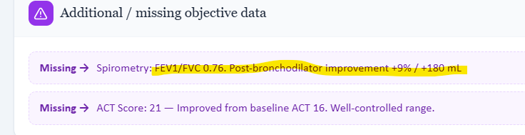
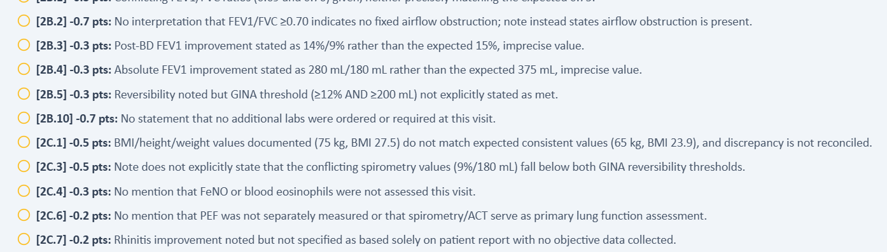
Two incompatible live spirometry panels compared with a third, grader-only value set.

Issue 3. Follow-up symptom and functional history expected by grading was not reported by Sarah
Problem type: High — AI patient and grader disagree | Severity: High | Status: Not fixed; expands from Day 1
What the student saw or heard: Sarah denied recent nighttime awakenings and did not establish hiking or outdoor-activity resumption as part of her history.
What the grader expected: The master rubric and grader expect nighttime symptoms 1–2 times/month, resumed hiking/outdoor activity, and improved exercise markers.
Why this is a problem: This is primarily a standardized-patient-versus-rubric mismatch: the grader is consistent with the rubric, but the required facts were not supplied by Sarah.
Suggested fix: Add rubric-aligned answers to the patient response bank for nighttime symptoms and functional recovery, or make those criteria non-scoring when not discoverable.
Plain-language clinical meaning | Daytime symptoms, nighttime symptoms, activity limitation, and rescue-inhaler use are the practical measures of breathing control. Different frequencies can change whether the case is interpreted as controlled, improving, or in need of escalation.
Likely technical failure mode | Likely symptom-state or time-window mismatch between the standardized patient, longitudinal HPI, rubric, and grader reference.
Regression test / acceptance criterion | Seed one symptom-control state for the visit, then ask neutral questions for daytime symptoms, nighttime symptoms, activity, and rescue use. The returned answers and grader expectations must match the same state and time window.

Focused screenshot evidence
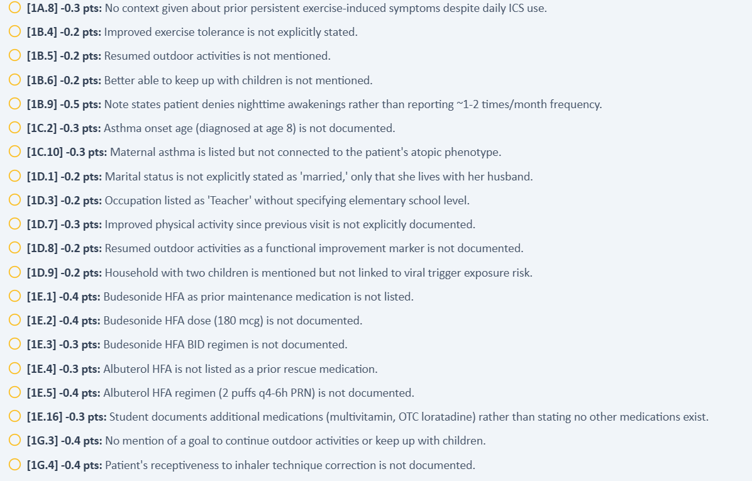
Day 2 feedback demands nighttime and outdoor-activity facts that conflict with or were absent from Sarah’s answers.

Issue 4. Medication-history scoring contradicts the patient’s reported medication reconciliation
Problem type: High — AI patient/EMR and grader disagree | Severity: High | Status: Partially fixed but still inconsistent
What the student saw or heard: Sarah reported current SMART therapy, cetirizine/fluticasone, a multivitamin, and OTC loratadine; the prior-regimen details were not consistently exposed in the follow-up chart.
What the grader expected: The grader requires detailed prior budesonide/albuterol regimens while also deducting because the student documented the additional multivitamin and OTC loratadine instead of stating no other medicines existed.
Why this is a problem: Master-rubric criterion 1E.16 explicitly expects no additional medicines, but Sarah reported a multivitamin and OTC loratadine. This is a patient-versus-rubric conflict rather than a grader-only error.
Suggested fix: Reconcile the patient response bank with criterion 1E.16 and treat accurately elicited OTC products as valid medication-reconciliation data.
Plain-language clinical meaning | The current medication regimen defines the treatment stage. If one screen says the patient is already on a therapy while another asks the student to start, continue, or escalate a different therapy, the “correct” next clinical step becomes impossible to determine.
Likely technical failure mode | Likely multiple case branches or stale medication-state objects are active simultaneously. Medication list, prompts, AI patient, and grader are not using a single versioned regimen.
Regression test / acceptance criterion | Assign one medication list to the visit-state ID and make all prompts and grader criteria derive from it. Reload the visit and verify the AI patient names the same regimen. Any prompt referring to a non-current drug should fail pre-release validation.

Focused screenshot evidence
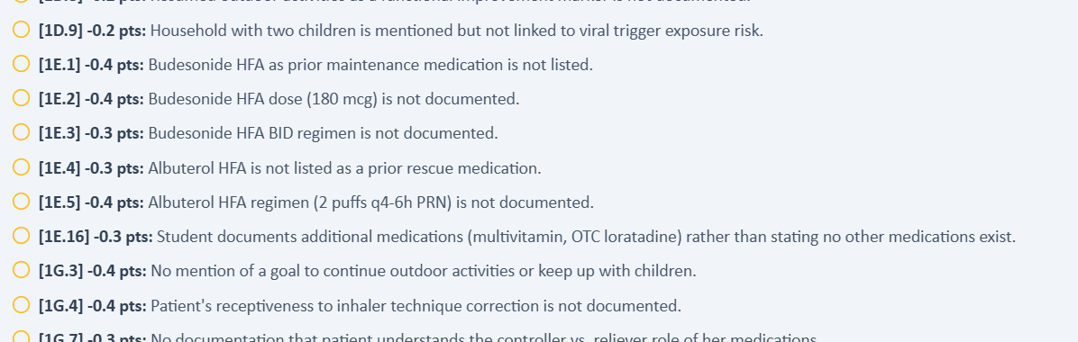
The Day 2 grader rejects patient-reported additional medicines while requiring prior medication details not consistently displayed.

Issue 5. Treatment-escalation logic contradicts the grader’s own clinical summary
Problem type: Critical — internal grader contradiction | Severity: Critical | Status: New on Day 2
What the student saw or heard: ACT was 21, symptoms were improved, the patient denied recent exacerbations/OCS use, and the note appropriately continued SMART without escalation.
What the grader expected: The grader’s strengths praise continuation without unnecessary escalation, while its deductions demand escalation. Master-rubric criteria 4A.4 and 4A.5 explicitly require no escalation because ACT 21 is well controlled.
Why this is a problem: This is a confirmed grader defect: both the narrative and master rubric support the student’s decision, while the scoring logic applies the opposite treatment branch.
Suggested fix: Correct the Day 2 scoring branch to award continuation/no escalation and remove criteria 4A.1/4A.4/4A.5 deductions that demand step-up therapy.
Plain-language clinical meaning | The current medication regimen defines the treatment stage. If one screen says the patient is already on a therapy while another asks the student to start, continue, or escalate a different therapy, the “correct” next clinical step becomes impossible to determine.
Likely technical failure mode | Likely multiple case branches or stale medication-state objects are active simultaneously. Medication list, prompts, AI patient, and grader are not using a single versioned regimen.
Regression test / acceptance criterion | Assign one medication list to the visit-state ID and make all prompts and grader criteria derive from it. Reload the visit and verify the AI patient names the same regimen. Any prompt referring to a non-current drug should fail pre-release validation.

Focused screenshot evidence
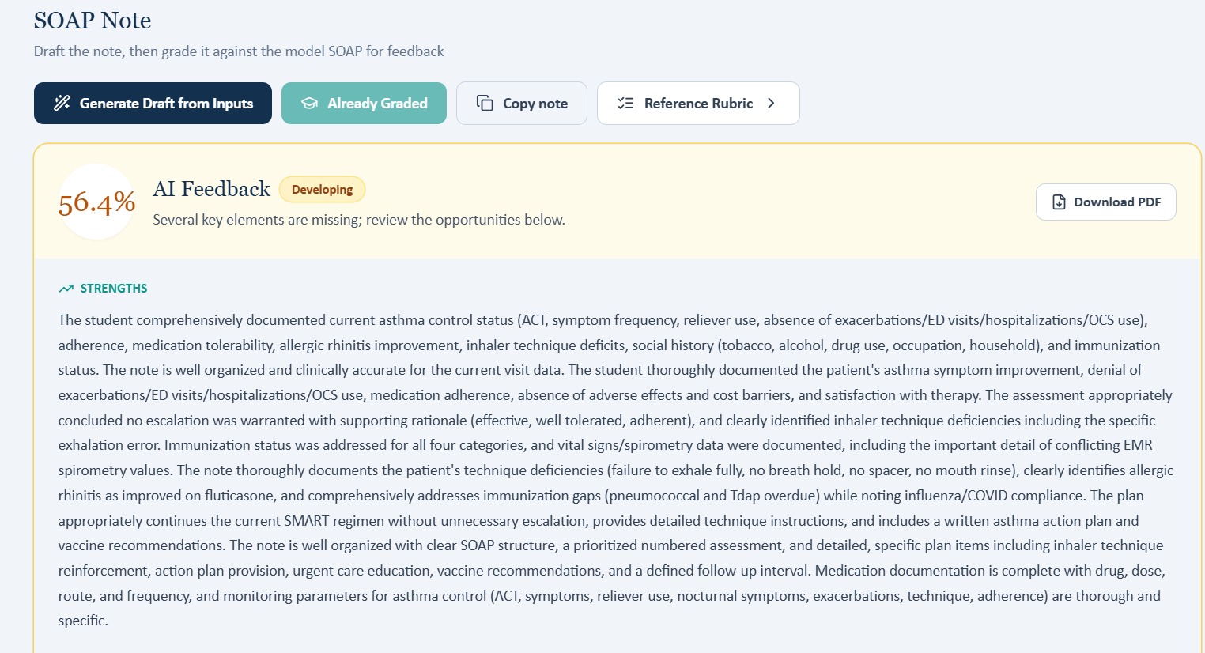
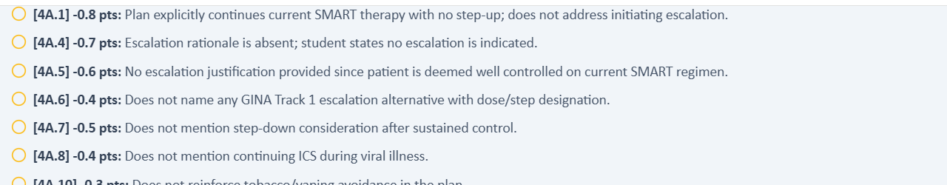
The grader’s strengths endorse no escalation, while its plan criteria deduct for the same decision.

Patient A - Thursday - 6-Month Follow-Up
5 confirmed grouped system/data issues are included for this visit. AI-grader result: 51.3%. Issues are grouped by underlying defect rather than by every individual point deduction.
# | Issue | Problem type
1 | The grader requires zero symptoms and zero PRN use despite Sarah’s reported symptoms | Critical — AI patient and grader disagree
2 | Hiking, elementary-school employment, and related exposure history remain unsupported | High — grader expects facts the AI patient did not provide
3 | Allergic-rhinitis medication regimen belongs to a different case version | Critical — current EMR/AI patient and grader disagree
4 | Day 3 objective expectations do not match the displayed clinical data | High — EMR and grader disagree or required qualifier is unavailable
5 | Grader requires unsupported OCS denial, technique confirmation, and full self-management understanding | High — documented facts and grader-required assertions disagree

Issue 1. The grader requires zero symptoms and zero PRN use despite Sarah’s reported symptoms
Problem type: Critical — AI patient and grader disagree | Severity: Critical | Status: Not fixed; worsened by Day 3
What the student saw or heard: Sarah repeatedly reported one extra Symbicort puff 1–2 times/week and nighttime cough/wheeze about once/month.
What the grader expected: The AI grader expects zero breakthrough symptoms, no PRN use, and no nighttime symptoms. Master-rubric criteria 1B.2-1B.4 instead specify 1-2 daytime/PRN episodes per week and one nighttime episode in the past month.
Why this is a problem: The deductions explicitly acknowledge the patient-reported values and then penalize them, even though those values match the master rubric. This is a confirmed grader-reference defect.
Suggested fix: Bind Day 3 symptom scoring to rubric criteria 1B.2-1B.4 and remove every zero-symptom/no-PRN deduction.
Plain-language clinical meaning | Daytime symptoms, nighttime symptoms, activity limitation, and rescue-inhaler use are the practical measures of breathing control. Different frequencies can change whether the case is interpreted as controlled, improving, or in need of escalation.
Likely technical failure mode | Likely symptom-state or time-window mismatch between the standardized patient, longitudinal HPI, rubric, and grader reference.
Regression test / acceptance criterion | Seed one symptom-control state for the visit, then ask neutral questions for daytime symptoms, nighttime symptoms, activity, and rescue use. The returned answers and grader expectations must match the same state and time window.

Focused screenshot evidence
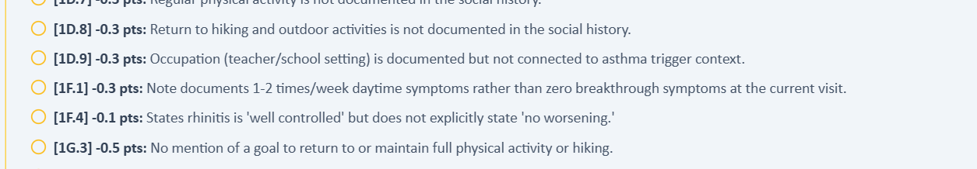
The grader states the documented patient-reported symptom frequency but grades against a different zero-symptom dataset.

Issue 2. Hiking, elementary-school employment, and related exposure history remain unsupported
Problem type: High — grader expects facts the AI patient did not provide | Severity: High | Status: Not fixed from Days 1–2
What the student saw or heard: Sarah said she had not previously mentioned hiking, identified herself only as a teacher, and did not report a specific school-grade setting or occupational viral exposure.
What the grader expected: The master rubric and grader require return to hiking/outdoor activities, “elementary school teacher,” and related context.
Why this is a problem: The grader is rubric-consistent here, but the standardized patient did not supply the required specificity and explicitly disclaimed prior hiking history.
Suggested fix: Make rubric-required occupation and hiking facts discoverable in the response bank, or reduce scoring to the broader facts the patient actually provides.
Plain-language clinical meaning | Background history establishes patient identity and risk factors. Exact occupation, smoking exposure, family history, and diagnosis duration may be graded; if the AI patient cannot provide the expected fact, the learner should not be forced to invent it.
Likely technical failure mode | Likely fixed-history fields are duplicated across the standardized-patient persona and rubric or are not persisted consistently across visits.
Regression test / acceptance criterion | Ask neutral questions for each scored history item in a clean session. The AI patient must return the rubric-aligned fact or the criterion must be non-scoring. Repeat across follow-ups to verify longitudinal persistence.

Focused screenshot evidence
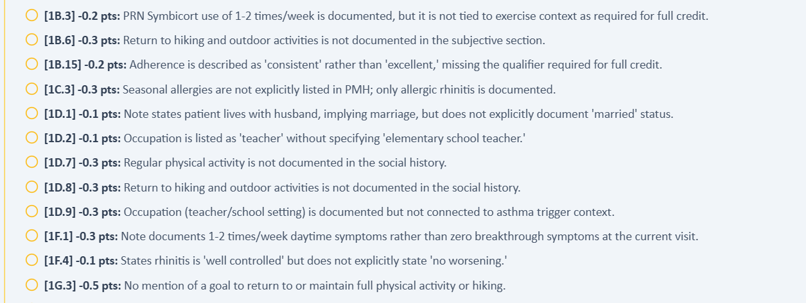
Day 3 grading again requires unsupported hiking and elementary-school details.

Issue 3. Allergic-rhinitis medication regimen belongs to a different case version
Problem type: Critical — current EMR/AI patient and grader disagree | Severity: Critical | Status: New/expanded on Day 3
What the student saw or heard: The current regimen is cetirizine 10 mg daily plus fluticasone nasal spray daily, and Sarah reports good rhinitis control.
What the grader expected: The AI grader expects loratadine 10 mg PRN and no intranasal corticosteroid. The master rubric instead requires cetirizine 10 mg daily plus daily fluticasone, matching the EMR and patient.
Why this is a problem: This is a confirmed grader-reference defect: Day 3 master-rubric criteria 1E.6-1E.10 and 4C.1-4C.2 support the documented regimen.
Suggested fix: Replace the grader’s loratadine/no-INCS branch with the rubric-aligned cetirizine-plus-fluticasone regimen and remove inapplicable add-INCS deductions.
Plain-language clinical meaning | Allergic rhinitis is upper-airway inflammation that can contribute to breathing symptoms. The exact allergy regimen also helps identify which longitudinal case branch is active.
Likely technical failure mode | Likely medication/history branch mismatch between the AI patient, EMR medication list, and grader reference.
Regression test / acceptance criterion | Verify the same rhinitis symptoms and medication regimen across live medication list, AI patient, rubric, and grader. Correct documentation of the visible regimen must not trigger deductions for another allergy medication.

Focused screenshot evidence
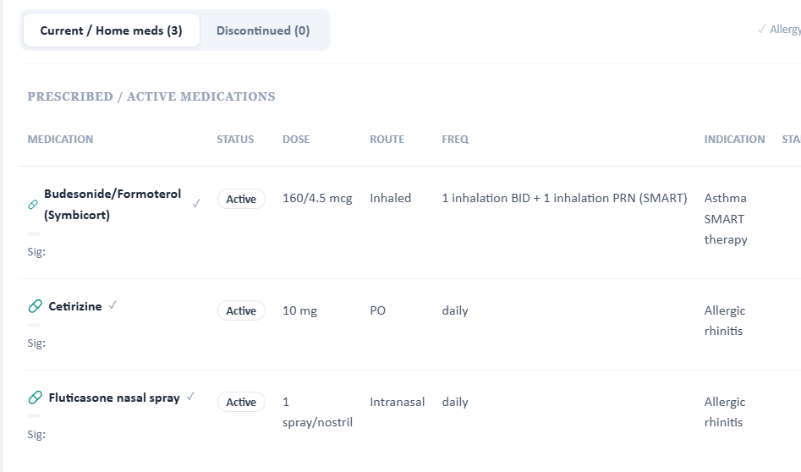
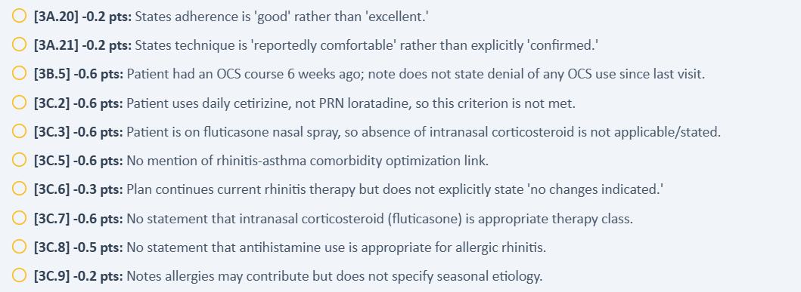
The grader openly acknowledges current cetirizine/fluticasone while scoring against loratadine/no nasal steroid.

Issue 4. Day 3 objective expectations do not match the displayed clinical data
Problem type: High — EMR and grader disagree or required qualifier is unavailable | Severity: High | Status: Not fixed; objective mismatch persists
What the student saw or heard: The encounter documents FEV1/FVC 0.77, height 5 ft 5 in, and SpO2 99% without an oxygen-delivery qualifier.
What the grader expected: The AI grader expects FEV1/FVC 0.80, converts 5 ft 5 in incorrectly to 65.5 inches, and requires “room air.” The master rubric specifies FEV1/FVC 0.77 and height 65 inches, matching the chart, but also requires the unavailable room-air qualifier.
Why this is a problem: The PFT and height deductions directly contradict master-rubric criteria 2B.1 and 2A.5. The room-air criterion remains a rubric/interface availability defect.
Suggested fix: Use rubric/live values 65 inches and 0.77. Either display oxygen-delivery status in the live EMR or accept SpO2 99% without “room air.”
Plain-language clinical meaning | Vital signs and objective measurements identify the patient’s current physiologic state and are used to interpret severity and derived values such as BMI or oxygenation. Penalizing exact transcription of the visible chart is a data-integrity failure.
Likely technical failure mode | Likely grader reference points to another patient/day snapshot or an older visit-state version, while the live EMR and rubric use a different objective dataset.
Regression test / acceptance criterion | Bind every scored objective criterion to the same visit-state ID used to render the live chart. Programmatically compare the values before grading; if any mismatch exists, mark the visit non-scorable rather than deducting points.

Focused screenshot evidence
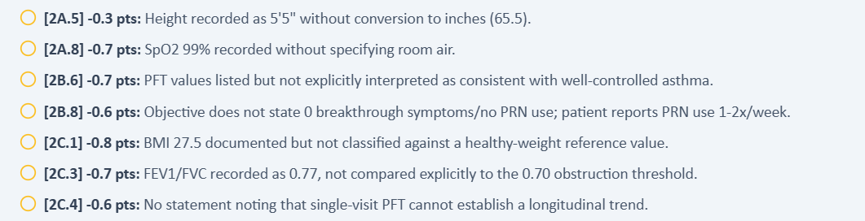
Day 3 deductions expose the incompatible PFT value, incorrect height conversion, and unavailable room-air requirement.

Issue 5. Grader requires unsupported OCS denial, technique confirmation, and full self-management understanding
Problem type: High — documented facts and grader-required assertions disagree | Severity: High | Status: Not fixed from earlier visits
What the student saw or heard: Sarah had a prednisone course 6 weeks earlier, reported being comfortable with previously taught technique without direct observation, and said she lacked a detailed written action plan.
What the grader expected: The AI grader expects denial of OCS use, “confirmed/improved” technique, and full-plan understanding. The master rubric explicitly includes the 5-day prednisone course, while the latter assertions remain unsupported without observation or a detailed action plan.
Why this is a problem: The OCS denial is a confirmed grader error against master-rubric criteria 1B.8-1B.12 and 3B.1-3B.4; the technique/action-plan language would overstate the available evidence.
Suggested fix: Remove the OCS-denial deduction, reserve “confirmed” for directly observed technique, and score the incomplete action plan as a care gap rather than presumed mastery.
Plain-language clinical meaning | Inhaler technique determines whether the patient is actually receiving the medication. A regimen should not be considered “optimized” if the simulated patient demonstrates device errors; that can change whether treatment should be intensified.
Likely technical failure mode | Likely response-bank/rubric desynchronization. The patient persona has one device-technique state while the rubric/grader assumes another, or the technique state is not keyed to the specific inhaler device.
Regression test / acceptance criterion | For the exact inhaler in the medication list, ask a neutral “walk me through it” question. The AI patient must demonstrate the intended steps/errors, and the grader must evaluate those same steps. Repeat after the next longitudinal transition to confirm persistence.

Focused screenshot evidence
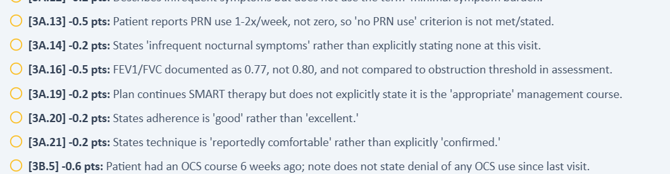
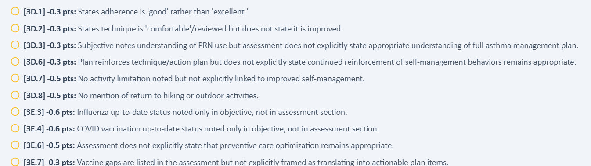
Day 3 criteria demand stronger or opposite assertions than Sarah’s actual history supports.

Patient B - Robert “Bob” Jenkins - COPD
15 confirmed grouped system/data issues across three sequential visits. Each issue below includes the source conflict, plain-language clinical significance, a likely technical failure mode, an acceptance test, and focused evidence.
Encounter | AI-grader score | Issues | Dominant pattern
Tuesday - Initial Visit | 64.7% | 5 | AI grader objective reference does not match the live Tuesday EMR or master rubric; AI-patient symptom history conflicts with the master-rubric Tuesday history
Wednesday - 3-Month Follow-Up | 61.8% | 5 | Wednesday grader uses the wrong maintenance medication and objective dataset; AI-patient Anoro technique directly contradicts the master rubric’s “appropriate technique” state
Thursday - 6-Month Follow-Up | 31.2% | 5 | Thursday grader uses a different patient/medication/objective dataset than both the live EMR and master rubric; Grader treatment/safety logic reverses the live and rubric eosinophi

Patient B - Tuesday - Initial Visit
5 confirmed grouped system/data issues are included for this visit. AI-grader result: 64.7%. Issues are grouped by underlying defect rather than by every individual point deduction.
# | Issue | Problem type
1 | AI grader objective reference does not match the live Tuesday EMR or master rubric | Critical — EMR/rubric and grader disagree
2 | AI-patient symptom history conflicts with the master-rubric Tuesday history | High — AI patient and rubric disagree
3 | Diagnosis-duration facts required by the rubric are not obtainable from the Tuesday AI patient | High — Required patient facts are unavailable
4 | AI-patient maintenance/rescue understanding and cost behavior conflict with the rubric | High — AI patient and rubric disagree
5 | CAT 18 and “Tdap overdue” are graded as required despite not being available in the live workflow | Medium — Required information is unavailable

Issue 1. AI grader objective reference does not match the live Tuesday EMR or master rubric
Problem type: Critical — EMR/rubric and grader disagree | Severity: Critical
What the student saw or heard: The live chart shows HR 80 bpm, RR 18/min, weight 89 kg, BMI 28.1 kg/m², SpO₂ 95%, FEV1/FVC 0.58, and FEV1 62% predicted. These are the values used in the SOAP note.
What the master rubric says: The Tuesday master rubric uses the same core values: HR 80, RR 18, weight 89 kg, BMI 28.1, SpO₂ 95%, post-bronchodilator FEV1/FVC 0.58, and FEV1 62% predicted. (Rubric references: 2A.2-2A.7, 2B.1-2B.6)
What the AI grader expected: The 64.7% grader deducts for HR 80 instead of 76, RR 18 instead of 20, weight 89 instead of 80, FEV1/FVC 0.58 instead of 0.62, and FEV1 62% instead of 58%.
Why this is a problem: The student is marked wrong for accurately copying values that are simultaneously present in the live EMR and official master rubric. This is a direct grading-reference synchronization failure.
Suggested fix: Replace the Tuesday grader’s objective reference dataset with the values in the live EMR/master rubric and regression-test all linked BMI, spirometry, and GOLD-severity deductions.
Plain-language clinical meaning | Vital signs and objective measurements identify the patient’s current physiologic state and are used to interpret severity and derived values such as BMI or oxygenation. Penalizing exact transcription of the visible chart is a data-integrity failure.
Likely technical failure mode | Likely grader reference points to another patient/day snapshot or an older visit-state version, while the live EMR and rubric use a different objective dataset.
Regression test / acceptance criterion | Bind every scored objective criterion to the same visit-state ID used to render the live chart. Programmatically compare the values before grading; if any mismatch exists, mark the visit non-scorable rather than deducting points.

Focused screenshot evidence
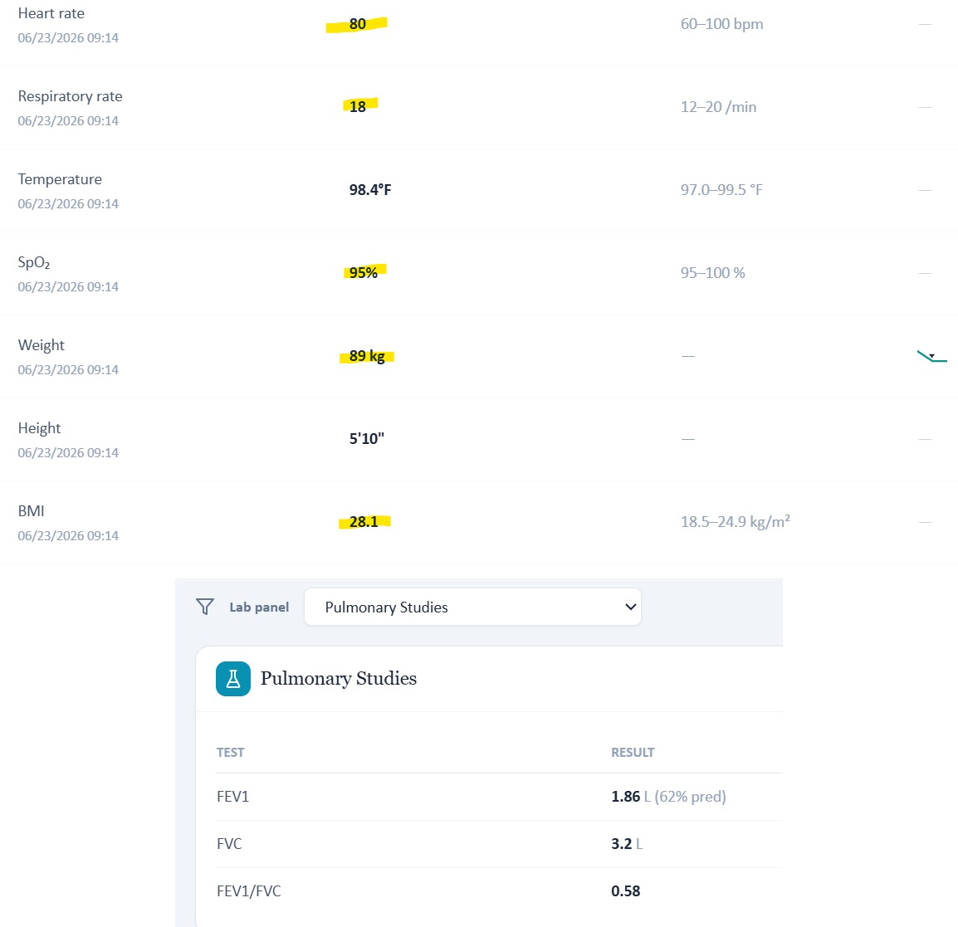
Live Tuesday browser captures show the vital signs and spirometry used in the submitted SOAP note.
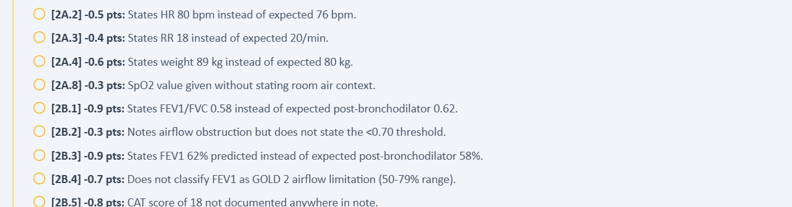
Focused AI-grader excerpt: the grader expects a different objective dataset.

Issue 2. AI-patient symptom history conflicts with the master-rubric Tuesday history
Problem type: High — AI patient and rubric disagree | Severity: High
What the student saw or heard: Neutral interview questions produced a gradual worsening over the past several months, activity limits including walking, mowing, stairs and garage tasks, and essentially no significant cough.
What the master rubric says: The master rubric expects worsening dyspnea over the past year, carrying groceries and home projects as specific limitations, and a chronic cough present for several years. (Rubric references: 1B.2, 1B.4-1B.6)
What the AI grader expected: The grader deducts because “several months” is not “past year,” groceries/home projects were not documented, and the patient’s denial of significant cough conflicts with the expected chronic cough.
Why this is a problem: Accurate documentation of the standardized patient’s answers cannot earn full credit. The conflict is not a wording problem in the SOAP note; the generated patient history is different from the rubric history.
Suggested fix: Synchronize the Tuesday standardized-patient response bank with the master-rubric symptom history, or revise those rubric criteria to accept the actual AI-patient responses.
Plain-language clinical meaning | Daytime symptoms, nighttime symptoms, activity limitation, and rescue-inhaler use are the practical measures of breathing control. Different frequencies can change whether the case is interpreted as controlled, improving, or in need of escalation.
Likely technical failure mode | Likely symptom-state or time-window mismatch between the standardized patient, longitudinal HPI, rubric, and grader reference.
Regression test / acceptance criterion | Seed one symptom-control state for the visit, then ask neutral questions for daytime symptoms, nighttime symptoms, activity, and rescue use. The returned answers and grader expectations must match the same state and time window.

Focused screenshot evidence
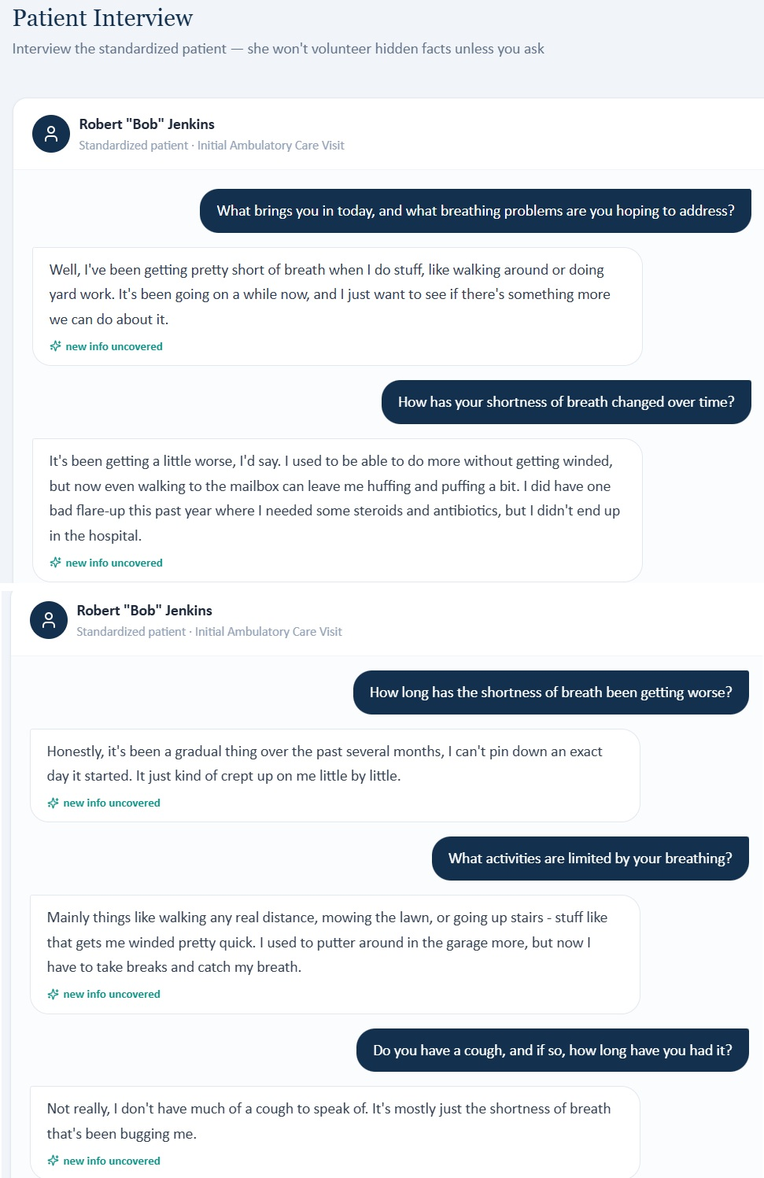
AI-patient interview evidence: worsening is described over several months and cough is largely denied.
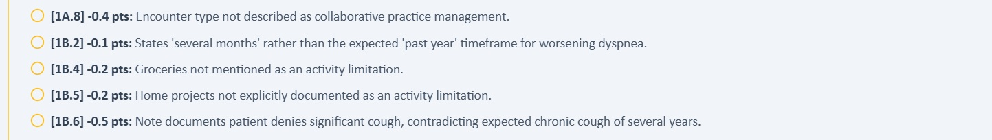
Focused grader deductions for the conflicting Tuesday symptom history.

Issue 3. Diagnosis-duration facts required by the rubric are not obtainable from the Tuesday AI patient
Problem type: High — Required patient facts are unavailable | Severity: High
What the student saw or heard: When asked directly how long he had COPD, hypertension, and hyperlipidemia, Bob repeatedly said he could not remember the exact durations.
What the master rubric says: The master rubric requires COPD duration 4 years, hypertension 12 years, and hyperlipidemia 10 years for full credit. (Rubric references: 1C.2, 1C.4, 1C.6)
What the AI grader expected: The grader deducts for all three missing durations even though the student explicitly asked the patient and the AI patient did not provide them.
Why this is a problem: This creates an impossible-information problem: the student must either invent exact durations or lose points despite appropriate interviewing.
Suggested fix: Make the AI patient provide the intended 4/12/10-year durations when directly asked, or remove exact-duration scoring when the standardized patient responds that he does not know.
Plain-language clinical meaning | Background history establishes patient identity and risk factors. Exact occupation, smoking exposure, family history, and diagnosis duration may be graded; if the AI patient cannot provide the expected fact, the learner should not be forced to invent it.
Likely technical failure mode | Likely fixed-history fields are duplicated across the standardized-patient persona and rubric or are not persisted consistently across visits.
Regression test / acceptance criterion | Ask neutral questions for each scored history item in a clean session. The AI patient must return the rubric-aligned fact or the criterion must be non-scoring. Repeat across follow-ups to verify longitudinal persistence.

Focused screenshot evidence
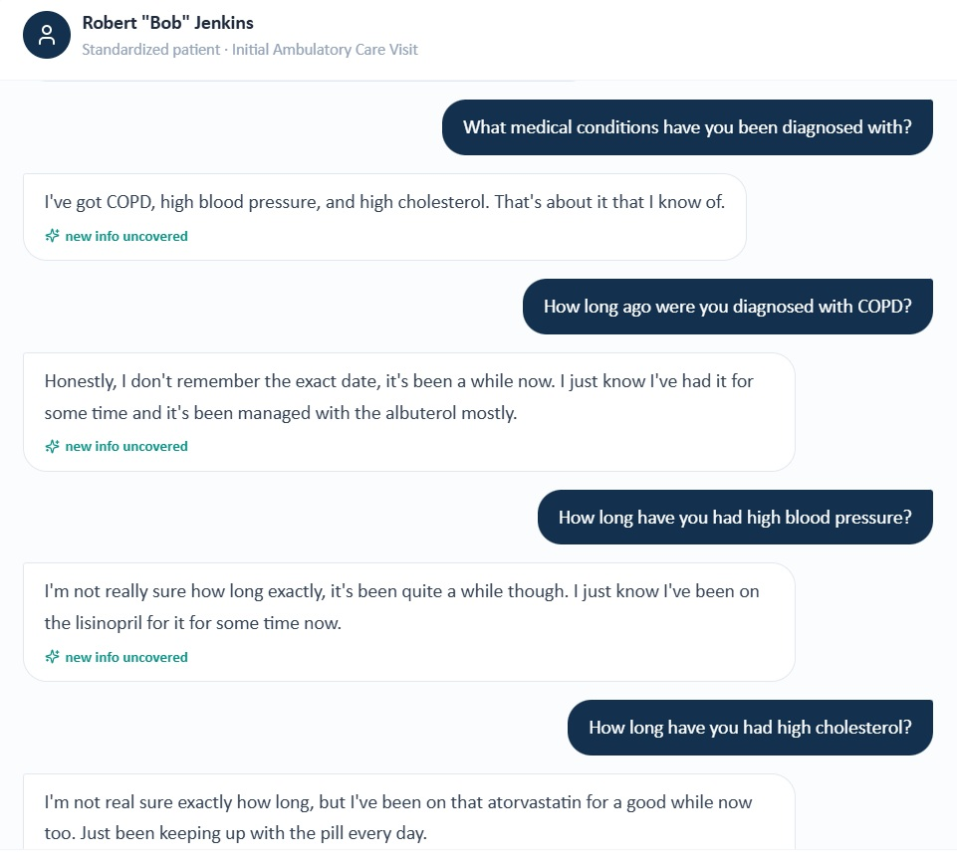
AI patient cannot supply the exact COPD, hypertension, or hyperlipidemia durations.
Focused grader excerpt: exact 4-, 12-, and 10-year durations are nevertheless required.

Issue 4. AI-patient maintenance/rescue understanding and cost behavior conflict with the rubric
Problem type: High — AI patient and rubric disagree | Severity: High
What the student saw or heard: Bob correctly explains that albuterol is a rescue inhaler and the maintenance inhaler is intended for daily prevention. He also says the expensive maintenance inhaler was never filled; he does not report stretching his current lisinopril or atorvastatin.
What the master rubric says: The rubric expects a limited maintenance-therapy understanding or belief that albuterol alone is sufficient, plus medication-stretching behavior due to cost. (Rubric references: 1B.15, 1D.10, 1E.17, 1G.4-1G.5)
What the AI grader expected: The grader penalizes the note for documenting that the patient understands rescue versus maintenance therapy and for not documenting medication stretching.
Why this is a problem: The rubric asks the student to document beliefs and behaviors that the AI patient specifically does not report. This encourages fabrication of a knowledge deficit and cost behavior.
Suggested fix: Align the patient response bank and rubric on whether the barrier is primarily cost, knowledge, medication stretching, or some combination. Full credit should follow the actual elicited response.
Plain-language clinical meaning | Medication understanding and cost barriers determine adherence counseling. The student can only document the behavior and concerns the standardized patient actually reports.
Likely technical failure mode | Likely standardized-patient behavioral state differs from the rubric’s intended counseling scenario.
Regression test / acceptance criterion | Use neutral adherence/cost questions and confirm the AI patient returns the intended scenario. Grade only facts actually available from the patient response bank.

Focused screenshot evidence
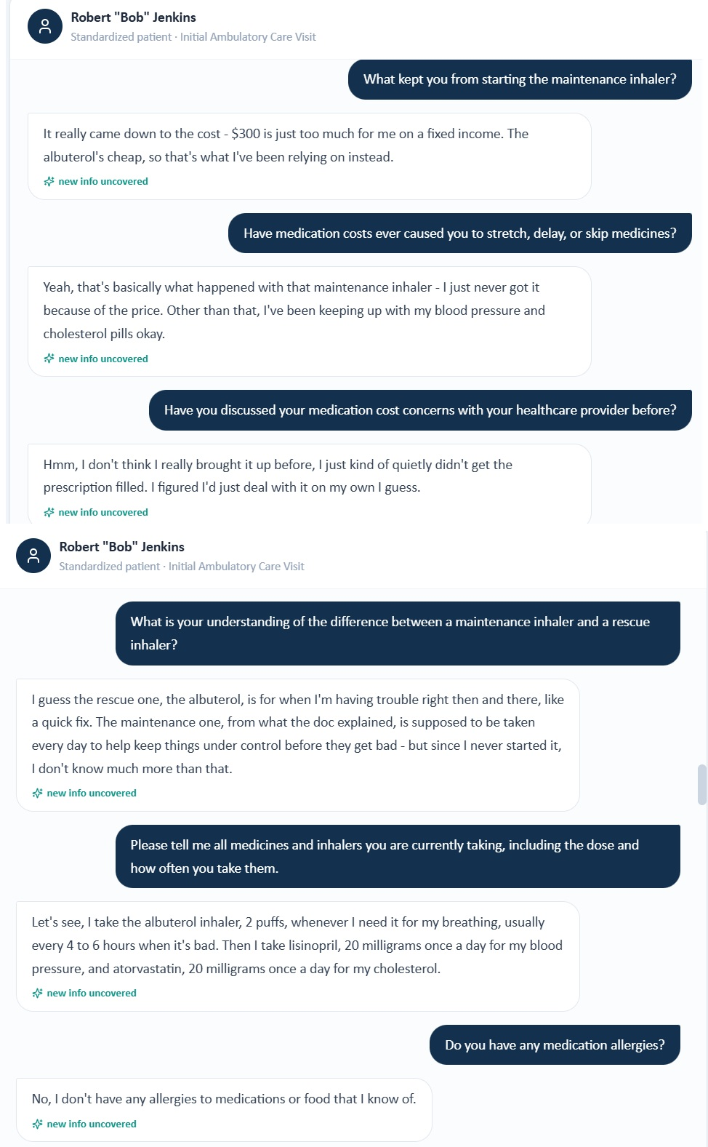
Interview evidence: the barrier is the $300 unfilled inhaler, while Bob can explain rescue versus maintenance roles.
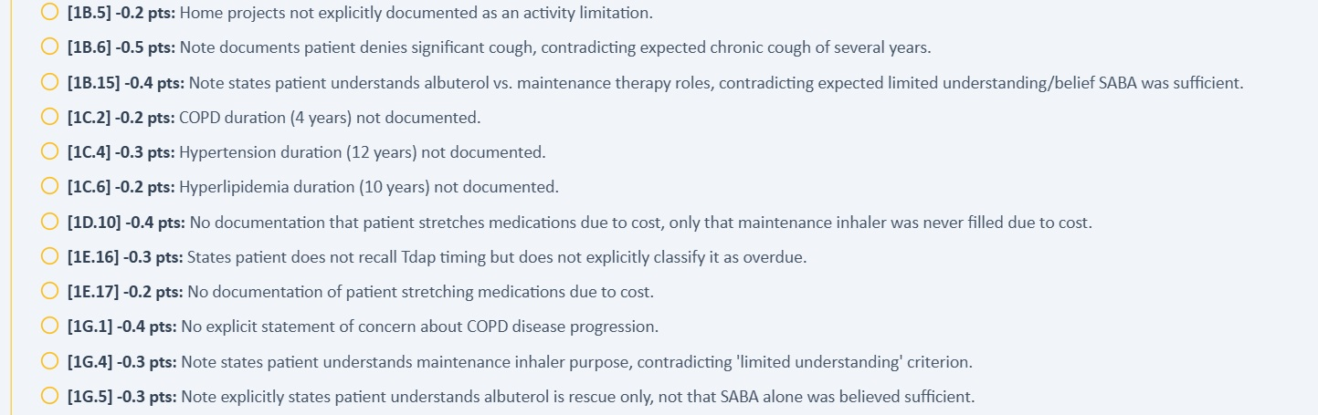
Focused grader excerpt: the scoring model expects limited understanding and medication-stretching behavior.

Issue 5. CAT 18 and “Tdap overdue” are graded as required despite not being available in the live workflow
Problem type: Medium — Required information is unavailable | Severity: Medium
What the student saw or heard: The live Tuesday Objective displays spirometry, eosinophils, and immunizations but no numeric CAT result. Pneumococcal and RSV are marked “not documented”; Tdap is not displayed. When asked, the AI patient says he does not remember his last tetanus-containing vaccine.
What the master rubric says: The master rubric requires CAT score 18 with interpretation and labels Tdap as overdue. (Rubric references: 1E.16, 2B.5-2B.6)
What the AI grader expected: The grader deducts for missing CAT 18 and for documenting Tdap as unknown rather than overdue.
Why this is a problem: The student cannot safely infer a CAT score or overdue Tdap status that is neither displayed nor supplied by the standardized patient.
Suggested fix: Display CAT 18 and Tdap status in the live encounter if they are intended to be graded, or accept “not documented/unknown” when that is all the workflow provides.
Plain-language clinical meaning | Vaccination status is preventive-care information. It may not change the immediate inhaler choice, but it is graded and affects respiratory-risk counseling, so the student must be able to see or elicit the exact status being scored.
Likely technical failure mode | Likely incomplete UI exposure or preventive-care data stored separately from the rubric reference.
Regression test / acceptance criterion | For every vaccine criterion, expose a status in the live chart or AI patient. If the status is unknown/not documented, the grader must accept that exact state. Prevent “received” and “not documented” from coexisting for the same vaccine/date.

Focused screenshot evidence
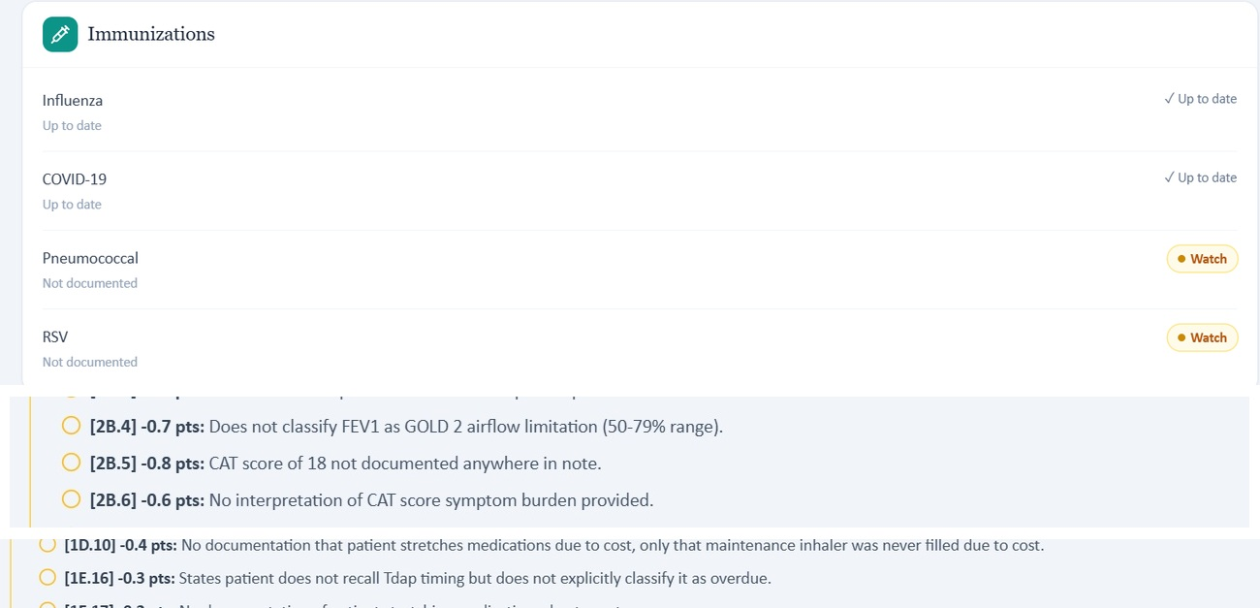
Live immunization evidence plus focused grader deductions for CAT 18 and Tdap status.

Patient B - Wednesday - 3-Month Follow-Up
5 confirmed grouped system/data issues are included for this visit. AI-grader result: 61.8%. Issues are grouped by underlying defect rather than by every individual point deduction.
# | Issue | Problem type
1 | Wednesday grader uses the wrong maintenance medication and objective dataset | Critical — EMR/rubric and grader disagree
2 | AI-patient Anoro technique directly contradicts the master rubric’s “appropriate technique” state | High — AI patient and rubric disagree
3 | Rescue-use trend in the AI patient does not match the master-rubric Wednesday trajectory | High — AI patient and rubric disagree
4 | CAT 16 and baseline CAT 18 are required by the rubric but not displayed in the live Wednesday EMR | High — Required objective data are unavailable
5 | Wednesday encounter banner says 3-month follow-up while chart documentation still says initial visit | Medium — Internal EMR inconsistency

Issue 1. Wednesday grader uses the wrong maintenance medication and objective dataset
Problem type: Critical — EMR/rubric and grader disagree | Severity: Critical
What the student saw or heard: The live Wednesday chart lists umeclidinium/vilanterol (Anoro Ellipta) 62.5/25 mcg daily. It shows BP 130/76, HR 78, RR 18, SpO₂ 95%, weight 89 kg, BMI 28.1, FEV1/FVC 0.58, and FEV1 63% predicted.
What the master rubric says: The Wednesday master rubric also identifies Anoro Ellipta as the maintenance LABA/LAMA and uses BP 130/76, HR 78, RR 18, weight 89 kg, BMI 28.1, SpO₂ 95%, FEV1/FVC 0.58, and FEV1 63% predicted. (Rubric references: 1E.1-1E.2, 2A.1-2A.8, 2B.1-2B.2)
What the AI grader expected: The grader repeatedly expects Spiriva HandiHaler/tiotropium and a different objective set: BP 132/82, HR 76, RR 20, weight 80 kg, BMI 26.0, SpO₂ 97%, FEV1/FVC 0.62, and FEV1 58%.
Why this is a problem: This is a clear reference-binding failure. Correct medication reconciliation and objective transcription are scored as wrong because the grader is using another case/version.
Suggested fix: Bind the Wednesday grader to the same Anoro and objective dataset as the master rubric/live EMR, then re-test all medication, device, GOLD-grade, and vital-sign criteria.
Plain-language clinical meaning | The current medication regimen defines the treatment stage. If one screen says the patient is already on a therapy while another asks the student to start, continue, or escalate a different therapy, the “correct” next clinical step becomes impossible to determine.
Likely technical failure mode | Likely multiple case branches or stale medication-state objects are active simultaneously. Medication list, prompts, AI patient, and grader are not using a single versioned regimen.
Regression test / acceptance criterion | Assign one medication list to the visit-state ID and make all prompts and grader criteria derive from it. Reload the visit and verify the AI patient names the same regimen. Any prompt referring to a non-current drug should fail pre-release validation.

Focused screenshot evidence
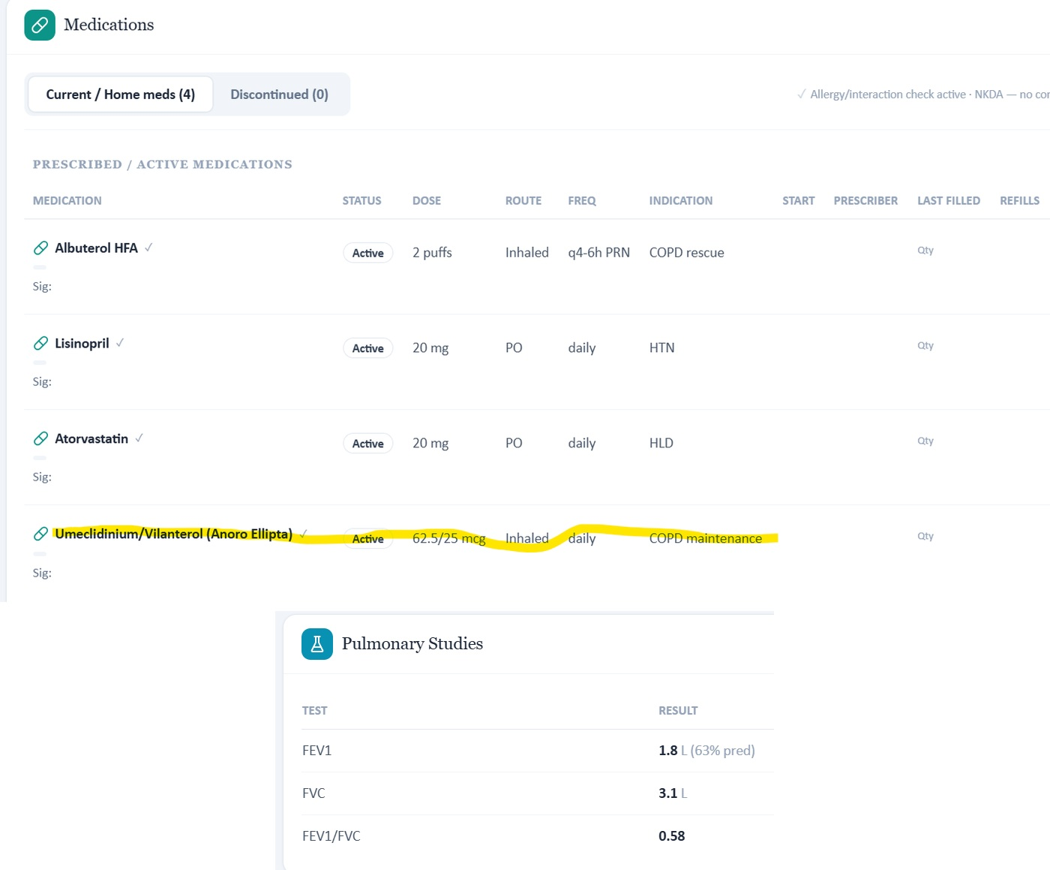
Live Wednesday browser captures: Anoro Ellipta and spirometry 0.58 / 63% predicted.
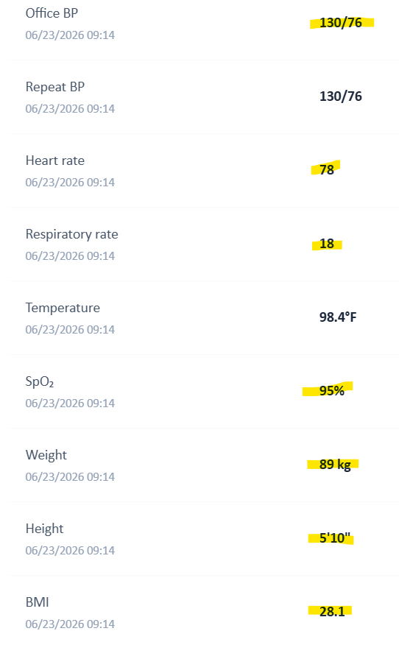
Live Wednesday vital signs: 130/76, HR 78, RR 18, SpO₂ 95%, weight 89 kg, BMI 28.1.
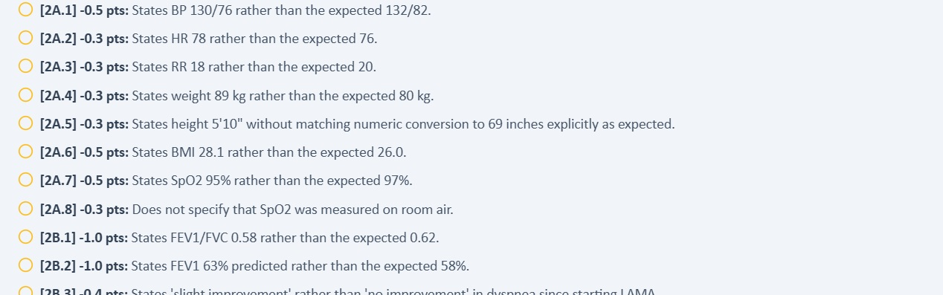
Focused grader excerpt: alternate Wednesday vital and spirometry values are expected.
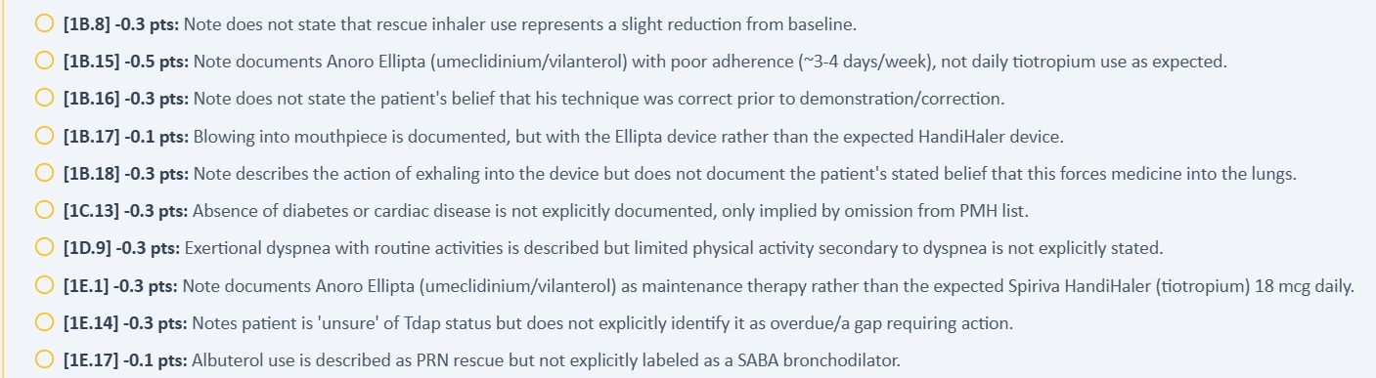
Focused grader excerpt: Spiriva/tiotropium is expected instead of the live/rubric Anoro regimen.

Issue 2. AI-patient Anoro technique directly contradicts the master rubric’s “appropriate technique” state
Problem type: High — AI patient and rubric disagree | Severity: High
What the student saw or heard: Bob demonstrates multiple Ellipta errors: he exhales directly into the mouthpiece, uses an ordinary/unspecified inhalation rather than a deliberate deep inhalation, and says he did not know he should hold his breath afterward.
What the master rubric says: The master rubric states that inhaler technique should be assessed as appropriate with no errors and specifically says technique is not the adherence barrier. (Rubric references: 1B.21, 3A.20, 3B.10)
What the AI grader expected: The grader expects HandiHaler-specific technique/beliefs and deducts when the note documents Ellipta errors and does not call technique appropriate.
Why this is a problem: The live AI patient makes technique a clinically relevant problem, while the rubric requires the opposite conclusion. This changes the causal interpretation of persistent symptoms and the appropriate intervention.
Suggested fix: Choose one intended Wednesday technique state. If technique is meant to be correct, update the AI patient responses; if the live errors are intended, revise the rubric and grader to score correction of those Ellipta errors.
Plain-language clinical meaning | Inhaler technique determines whether the patient is actually receiving the medication. A regimen should not be considered “optimized” if the simulated patient demonstrates device errors; that can change whether treatment should be intensified.
Likely technical failure mode | Likely response-bank/rubric desynchronization. The patient persona has one device-technique state while the rubric/grader assumes another, or the technique state is not keyed to the specific inhaler device.
Regression test / acceptance criterion | For the exact inhaler in the medication list, ask a neutral “walk me through it” question. The AI patient must demonstrate the intended steps/errors, and the grader must evaluate those same steps. Repeat after the next longitudinal transition to confirm persistence.

Focused screenshot evidence
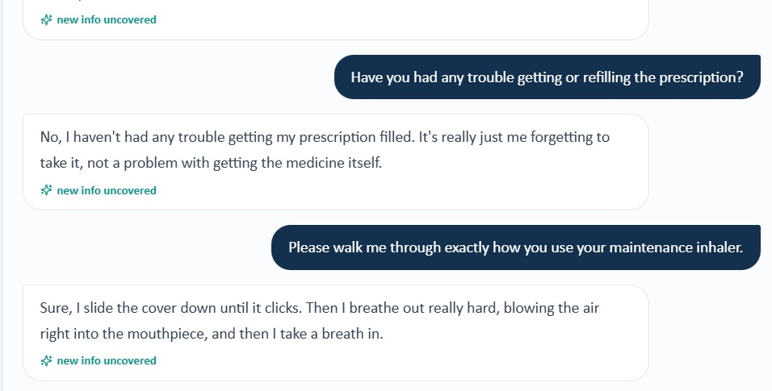
AI patient explicitly describes exhaling into the Anoro Ellipta mouthpiece.
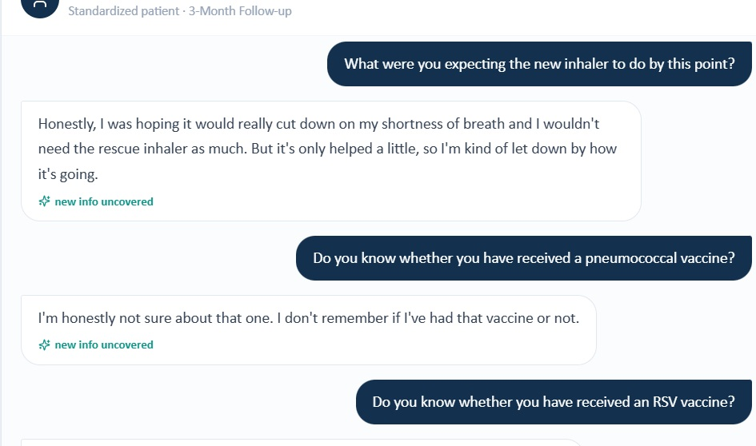
Follow-up interview: Bob reports no deliberate breath-hold and an ordinary inhalation technique.
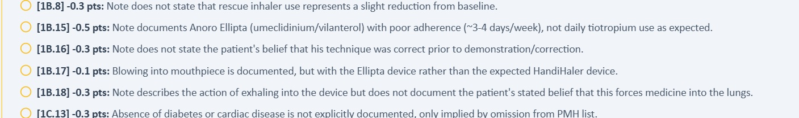
Focused grader excerpt: scoring expects a different device/technique state.

Issue 3. Rescue-use trend in the AI patient does not match the master-rubric Wednesday trajectory
Problem type: High — AI patient and rubric disagree | Severity: High
What the student saw or heard: Bob reports albuterol several times per day on some days and says he cannot tell that rescue use has decreased much since starting the maintenance inhaler.
What the master rubric says: The master rubric expects approximately 1–2 albuterol uses daily and explicitly requires a slight reduction from baseline as evidence of modest benefit. (Rubric references: 1B.7-1B.8, 2B.6, 2C.6, 3A.5)
What the AI grader expected: The grader deducts because the note reflects “several times/day on some days” rather than 1–2 times daily and does not claim a slight reduction.
Why this is a problem: The student cannot document an improvement trend the standardized patient denies or cannot identify. The mismatch also affects assessment of treatment response.
Suggested fix: Synchronize the Wednesday AI-patient rescue-use responses with the intended 1–2-times-daily/slight-reduction trajectory, or revise the rubric to accept the actual reported pattern.
Plain-language clinical meaning | Daytime symptoms, nighttime symptoms, activity limitation, and rescue-inhaler use are the practical measures of breathing control. Different frequencies can change whether the case is interpreted as controlled, improving, or in need of escalation.
Likely technical failure mode | Likely symptom-state or time-window mismatch between the standardized patient, longitudinal HPI, rubric, and grader reference.
Regression test / acceptance criterion | Seed one symptom-control state for the visit, then ask neutral questions for daytime symptoms, nighttime symptoms, activity, and rescue use. The returned answers and grader expectations must match the same state and time window.

Focused screenshot evidence
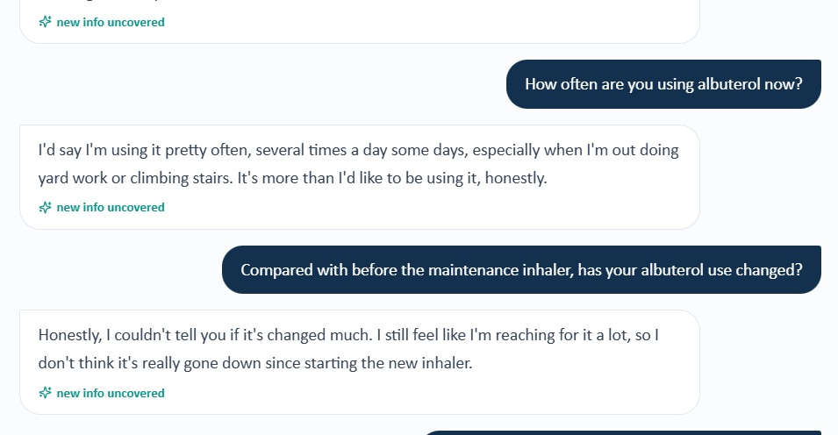
AI patient reports frequent rescue use and says it has not clearly decreased.
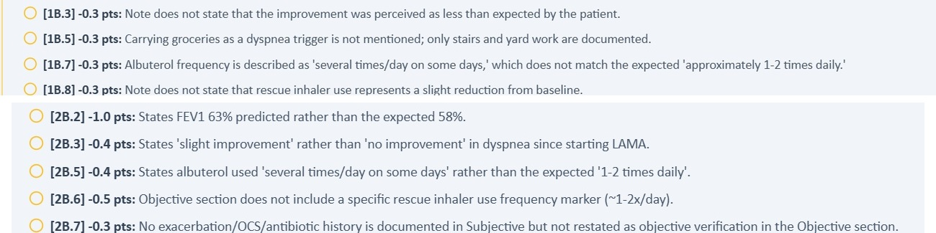
Focused grader deductions require 1–2 uses/day and a slight reduction from baseline.

Issue 4. CAT 16 and baseline CAT 18 are required by the rubric but not displayed in the live Wednesday EMR
Problem type: High — Required objective data are unavailable | Severity: High
What the student saw or heard: The live Wednesday Objective exposes spirometry and eosinophils but does not display a current CAT score or a baseline CAT comparison.
What the master rubric says: The master rubric requires current CAT 16, baseline CAT 18, and interpretation of a 2-point improvement. (Rubric references: 2B.3-2B.5, 2C.5)
What the AI grader expected: The grader’s narrative instructs the student to incorporate CAT 16 and its interpretation even though the live Objective does not provide that value.
Why this is a problem: This again forces a choice between inventing objective data and losing points for omitting it.
Suggested fix: Display CAT 16 and the baseline CAT 18 in the live Wednesday workflow if these are intended scoring inputs, or remove CAT-specific deductions when the values are unavailable.
Plain-language clinical meaning | This mismatch changes the clinical state the learner is expected to document or reason from. Even when it does not create immediate safety risk, it weakens the validity of the score because the learner and grader are not working from the same case.
Likely technical failure mode | Likely cross-component state/version mismatch. At least two VACS components appear to load different representations of the same patient/day.
Regression test / acceptance criterion | Assign a unique patient+visit state/version ID and log it in every component. Before grading, compare the critical fields used by the rubric with those rendered to the student; block scoring on any mismatch.

Focused screenshot evidence
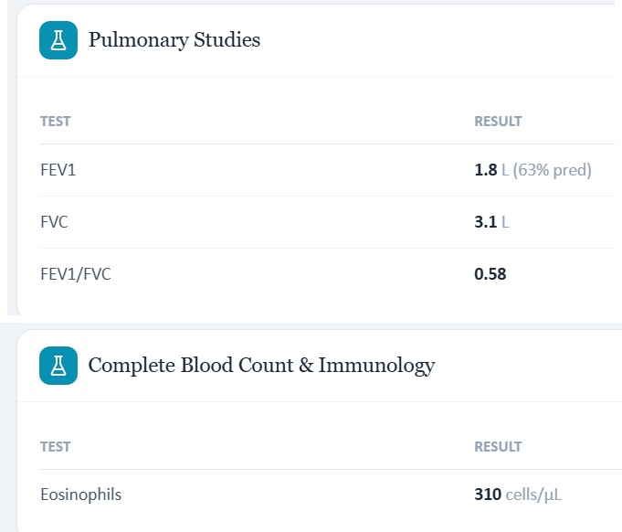
Live Wednesday pulmonary/CBC browser captures show the available objective data; no CAT score is displayed.
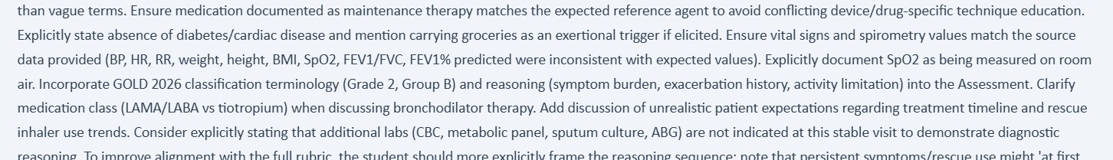
Grader narrative instructs use of CAT 16 despite its absence from the live Objective data.

Issue 5. Wednesday encounter banner says 3-month follow-up while chart documentation still says initial visit
Problem type: Medium — Internal EMR inconsistency | Severity: Medium
What the student saw or heard: The encounter header identifies “Wednesday · 3-Month Follow-up,” but the chart’s documentation line says “Initial Ambulatory Care Pharmacist Visit.”
What the master rubric says: The master rubric clearly defines this encounter as a 3-month follow-up after LABA/LAMA initiation. (Rubric references: 1A.3-1A.6)
What the AI grader expected: The grader also expects follow-up context, making the stale “Initial” chart label an internal EMR inconsistency rather than a grading-reference difference.
Why this is a problem: Conflicting encounter-stage labels can mislead the student about what longitudinal history and treatment response should be assessed and documented.
Suggested fix: Update the chart-documentation metadata so the encounter stage consistently reads 3-month follow-up across the header, chart text, and grading context.
Plain-language clinical meaning | The visit stage tells the learner and the software whether this is a baseline encounter or a follow-up after treatment changes. Stale “initial visit” metadata can make the wrong longitudinal state appear active.
Likely technical failure mode | Likely encounter metadata is copied forward or generated from a different field than the banner, without a cross-field validation rule.
Regression test / acceptance criterion | Generate all visible visit labels from one encounter-stage enum. Before rendering or grading, assert that banner, chart attribution, rubric visit label, and grader reference all carry the same stage.

Focused screenshot evidence
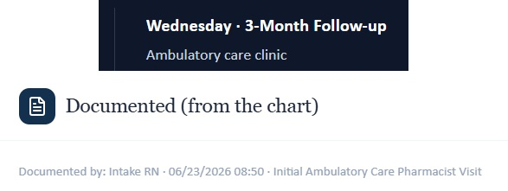
Live Wednesday evidence: the banner says 3-month follow-up while the chart documentation line says initial visit.

Patient B - Thursday - 6-Month Follow-Up
5 confirmed grouped system/data issues are included for this visit. AI-grader result: 31.2%. Issues are grouped by underlying defect rather than by every individual point deduction.
# | Issue | Problem type
1 | Thursday grader uses a different patient/medication/objective dataset than both the live EMR and master rubric | Critical — EMR/rubric and grader disagree
2 | Grader treatment/safety logic reverses the live and rubric eosinophil-guided triple-therapy decision | Critical — Grader safety logic conflicts with EMR/rubric
3 | AI-patient Anoro technique is uncertain, while the master rubric requires technique to be optimized | High — AI patient and rubric disagree
4 | Thursday grader’s symptom/rescue trajectory conflicts with both the live patient and master rubric | High — Grader references another trajectory/timepoint
5 | Thursday encounter banner says 6-month follow-up while chart attribution remains “Initial Ambulatory Care Pharmacist Visit” | Medium - Encounter-stage metadata inconsistency

Issue 1. Thursday grader uses a different patient/medication/objective dataset than both the live EMR and master rubric
Problem type: Critical — EMR/rubric and grader disagree | Severity: Critical
What the student saw or heard: The live Thursday chart shows Anoro Ellipta 62.5/25 mcg daily, weight 89 kg, SpO₂ 94%, FEV1/FVC 0.57, FEV1 60% predicted, eosinophils 310 cells/µL, CAT 17, and a 45-pack-year history with cessation 5 years ago.
What the master rubric says: The Thursday master rubric independently uses the same Anoro regimen, 89 kg, SpO₂ 94%, FEV1/FVC 0.57, FEV1 60% predicted, eosinophils 310, CAT 17, and 45 pack-years/quit 5 years. (Rubric references: 1D.5-1D.6, 1E.1-1E.3, 2A.1-2A.7, 2B.1-2B.5)
What the AI grader expected: The 31.2% grader expects Spiriva/tiotropium, weight 80 kg, SpO₂ 97%, FEV1/FVC 0.62, FEV1 58%, eosinophils 150 cells/µL, 30 pack-years, and cessation 10 years ago.
Why this is a problem: This is not a small transcription discrepancy; it is a materially different COPD case. Accurate medication, laboratory, spirometry, anthropometric, and smoking-history documentation is systematically penalized.
Suggested fix: Replace the Thursday grader reference with the official Thursday master-rubric/live-EMR dataset and regression-test every criterion that depends on those values.
Plain-language clinical meaning | The current medication regimen defines the treatment stage. If one screen says the patient is already on a therapy while another asks the student to start, continue, or escalate a different therapy, the “correct” next clinical step becomes impossible to determine.
Likely technical failure mode | Likely multiple case branches or stale medication-state objects are active simultaneously. Medication list, prompts, AI patient, and grader are not using a single versioned regimen.
Regression test / acceptance criterion | Assign one medication list to the visit-state ID and make all prompts and grader criteria derive from it. Reload the visit and verify the AI patient names the same regimen. Any prompt referring to a non-current drug should fail pre-release validation.

Focused screenshot evidence
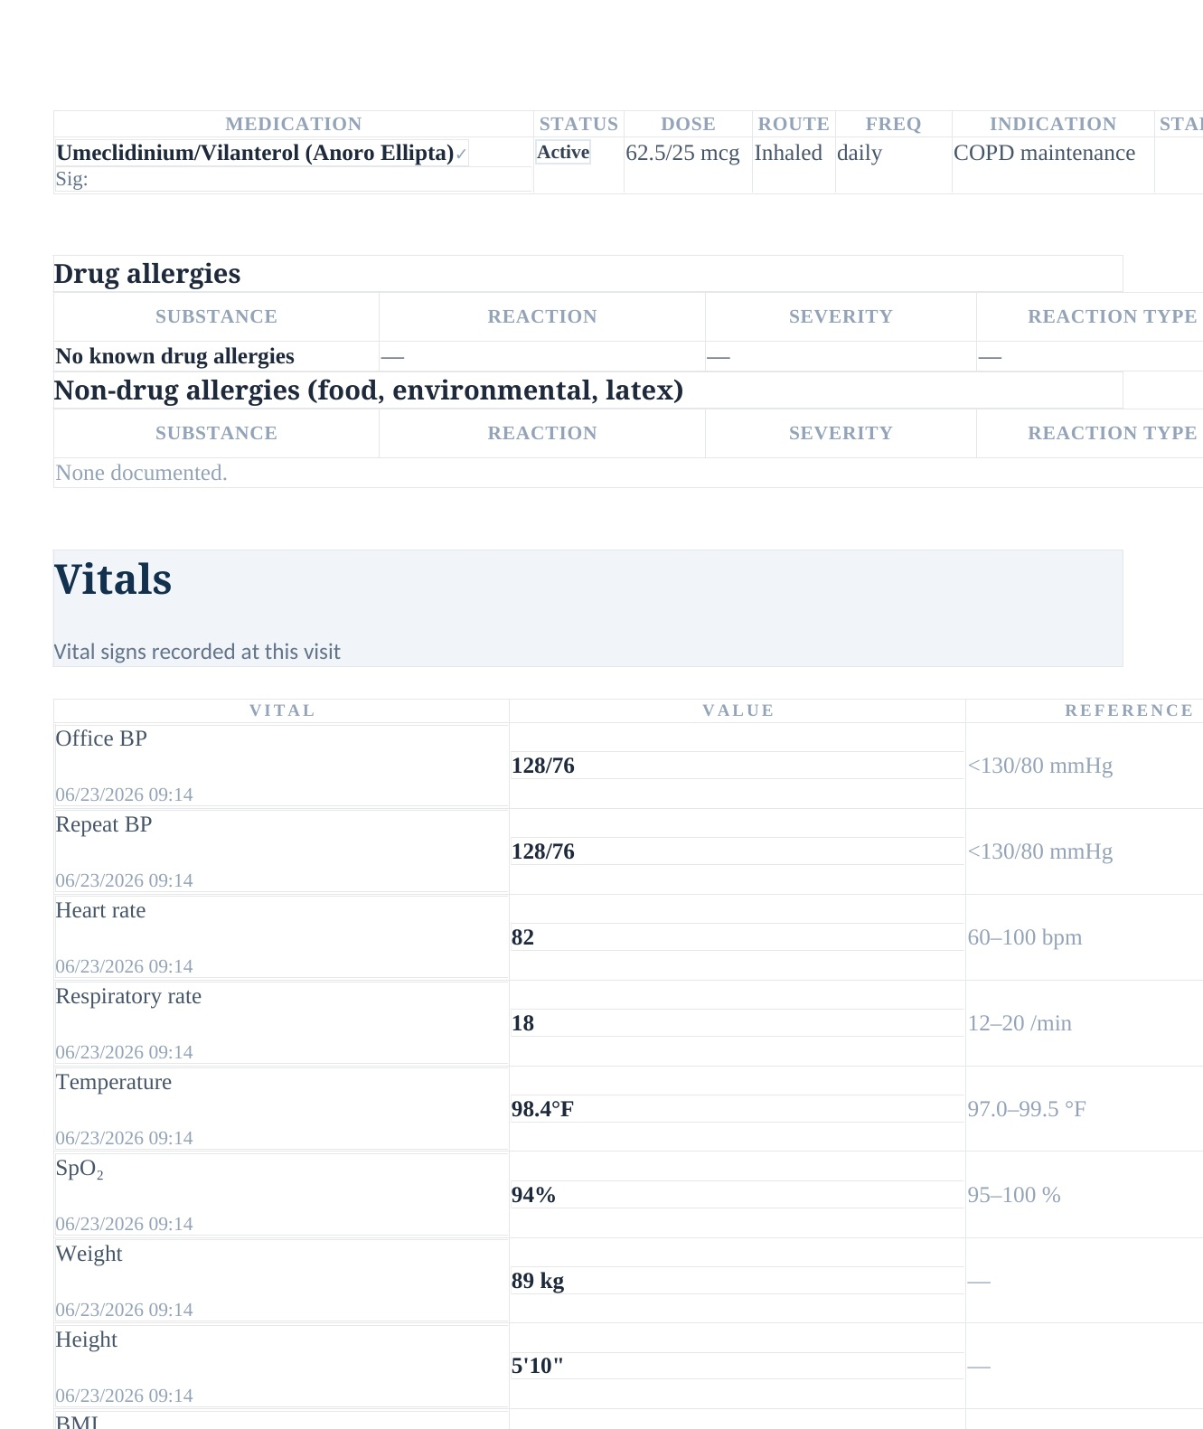
Thursday EMR rendering: Anoro Ellipta is active and the live vital/anthropometric values include 89 kg and SpO₂ 94%.
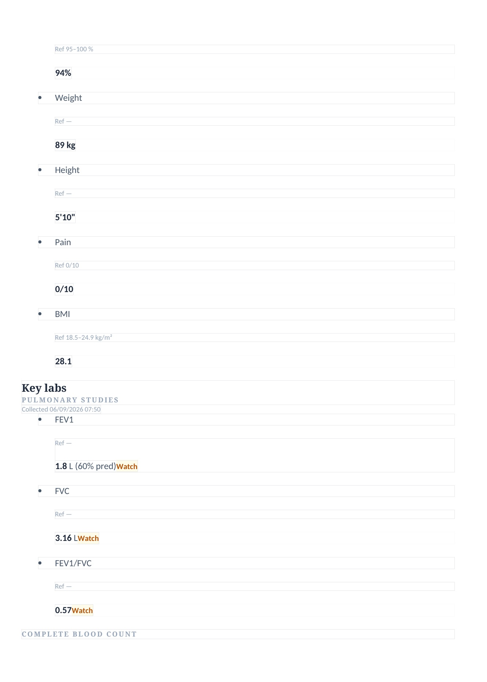
Thursday EMR rendering: FEV1 60% predicted and FEV1/FVC 0.57.
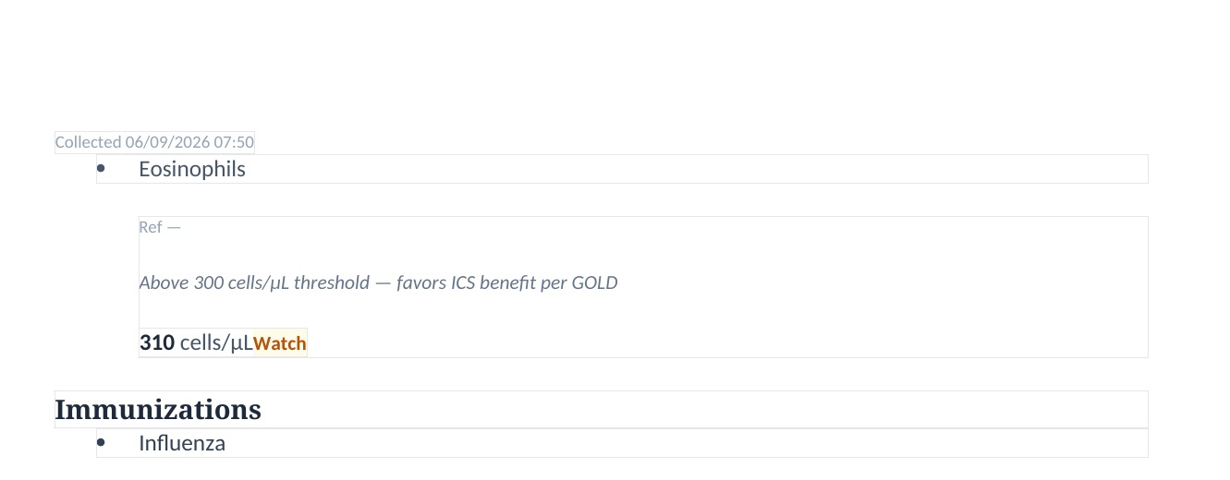
Thursday EMR rendering: eosinophils 310 cells/µL with an explicit >300/ICS-benefit advisory.
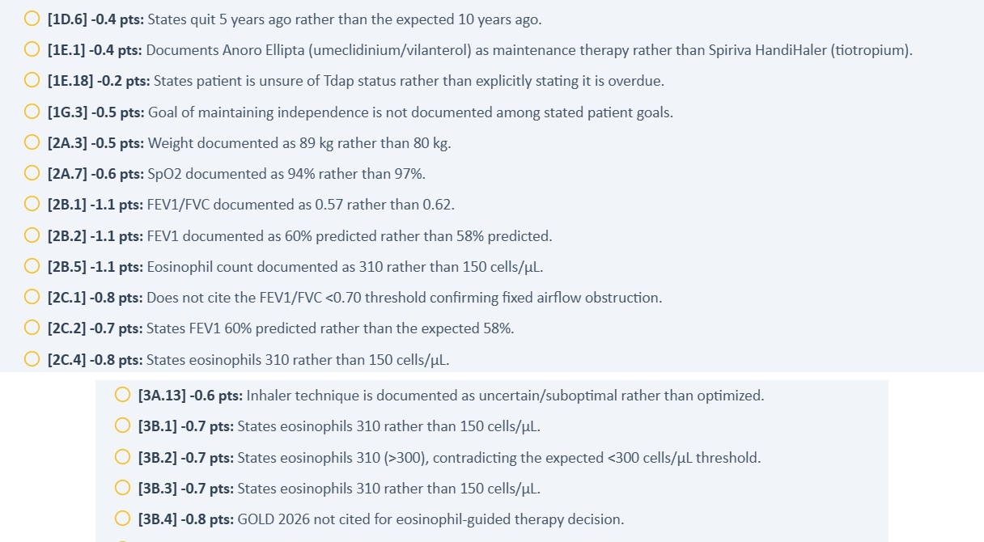
Focused grader excerpts: the scoring model expects a different medication, objective, and eosinophil dataset.

Issue 2. Grader treatment/safety logic reverses the live and rubric eosinophil-guided triple-therapy decision
Problem type: Critical — Grader safety logic conflicts with EMR/rubric | Severity: Critical
What the student saw or heard: The live EMR explicitly states that eosinophils are above the 300 cells/µL threshold and favor ICS benefit. Its guiding questions ask why escalation to triple therapy is appropriate, and the counseling script says an inhaled steroid is being added because flare-ups continue.
What the master rubric says: The master rubric states that 310 cells/µL exceeds the GOLD 2026 threshold for maximal ICS benefit, defines the patient as a frequent exacerbator on LABA/LAMA, and directs discontinuation of Anoro with initiation of Trelegy Ellipta 100/62.5/25 mcg once daily. (Rubric references: 2C.4-2C.5, 3A.11, 3B.1-3B.10, 4A.1-4A.4)
What the AI grader expected: The grader instead treats 310 as wrong because it expects eosinophils 150/<300 and deducts because the plan uses Trelegy rather than Spiriva/tiotropium.
Why this is a problem: This is a safety-critical reversal: the grader discourages the exact escalation strategy that the live advisory and official rubric are designed to teach.
Suggested fix: Bind the safety/treatment logic to the verified Thursday eosinophil and exacerbation data. Re-test the complete LABA/LAMA-to-ICS/LABA/LAMA escalation pathway, including the >300 cells/µL rule.
Plain-language clinical meaning | Eosinophils are a blood marker used in these cases to decide whether anti-inflammatory inhaler therapy or an advanced biologic treatment is likely to help. A different value or treatment stage can reverse the expected treatment decision.
Likely technical failure mode | Likely visit-state/reference binding failure: the live chart, decision-support rule, rubric, and grader are not resolving the same biomarker value and treatment-stage object.
Regression test / acceptance criterion | Load the affected visit and assert one eosinophil value, one current regimen, and one escalation target across EMR, advisory, rubric, AI patient, and grader. Submit a SOAP that follows the live decision support and confirm the grader rewards the same decision.

Focused screenshot evidence
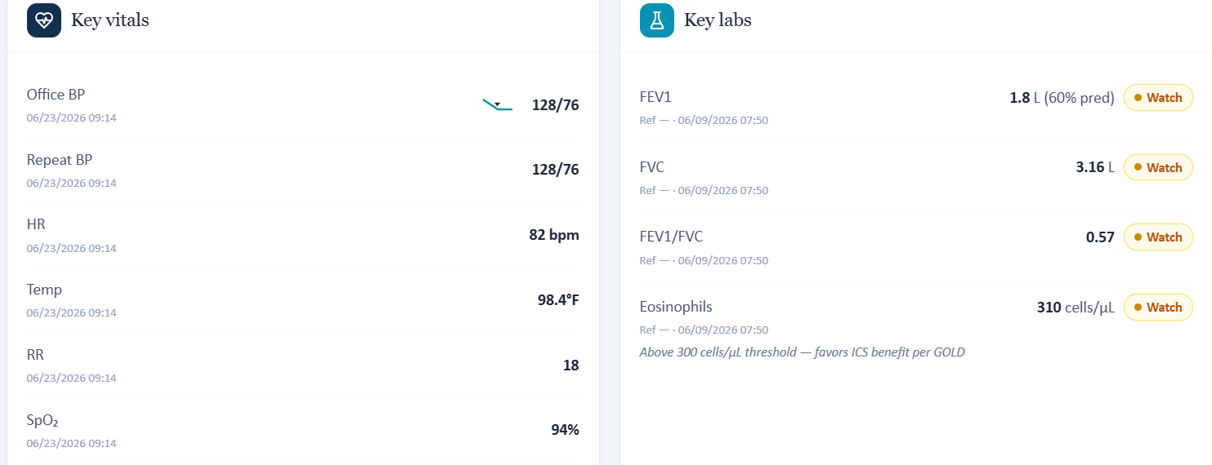
Original live VACS capture: eosinophils are 310 cells/µL and the chart explicitly states that values above 300 favor inhaled-corticosteroid benefit.
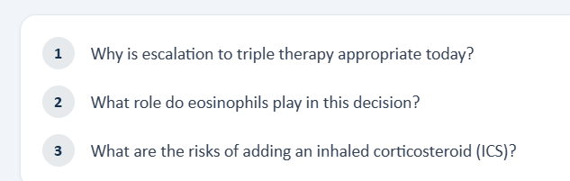
Original live VACS guiding questions explicitly teach escalation to triple therapy and ask the learner to use eosinophils in that decision.

Issue 3. AI-patient Anoro technique is uncertain, while the master rubric requires technique to be optimized
Problem type: High — AI patient and rubric disagree | Severity: High
What the student saw or heard: When asked to demonstrate Anoro Ellipta use, Bob gives an incomplete description and cannot confidently state how long he holds his breath; he estimates only a few seconds. The live interview therefore supports continued technique assessment/reinforcement.
What the master rubric says: The master rubric requires inhaler technique to be “optimized” and specifically says it should not remain a barrier before declaring true treatment failure. (Rubric references: 3A.13)
What the AI grader expected: The grader deducts because the SOAP accurately calls technique uncertain/suboptimal rather than optimized/resolved.
Why this is a problem: The standardized patient and rubric require mutually exclusive conclusions. Because technique status affects whether recurrent exacerbations represent treatment failure, the mismatch is clinically important.
Suggested fix: If Thursday is intended to represent true treatment failure after successful implementation, update the AI patient so he demonstrates correct Ellipta technique. Otherwise revise the rubric/grader to allow technique to remain a modifiable contributor.
Plain-language clinical meaning | Inhaler technique determines whether the patient is actually receiving the medication. A regimen should not be considered “optimized” if the simulated patient demonstrates device errors; that can change whether treatment should be intensified.
Likely technical failure mode | Likely response-bank/rubric desynchronization. The patient persona has one device-technique state while the rubric/grader assumes another, or the technique state is not keyed to the specific inhaler device.
Regression test / acceptance criterion | For the exact inhaler in the medication list, ask a neutral “walk me through it” question. The AI patient must demonstrate the intended steps/errors, and the grader must evaluate those same steps. Repeat after the next longitudinal transition to confirm persistence.

Focused screenshot evidence
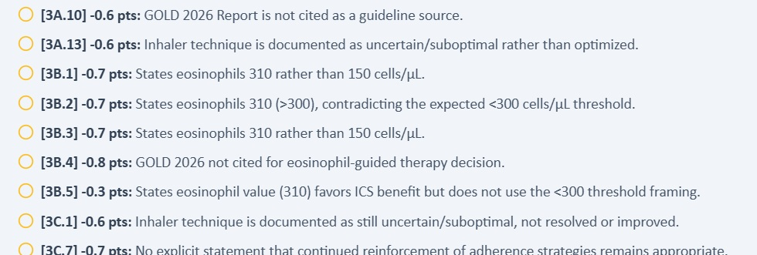
Focused grader excerpt: the scoring model requires “optimized” technique and penalizes the live interview’s uncertainty.

Issue 4. Thursday grader’s symptom/rescue trajectory conflicts with both the live patient and master rubric
Problem type: High — Grader references another trajectory/timepoint | Severity: High
What the student saw or heard: The live interview describes breathing as still “pretty rough,” albuterol almost every day, persistent activity limitation, and concern that COPD is worsening. The chart simultaneously documents two exacerbations in the past 3 months and three in the past year.
What the master rubric says: The master rubric expects recurrent flare-ups with continued dyspnea and approximately once-daily albuterol, with only mild/partial improvement rather than a low-symptom state. (Rubric references: 1A.8-1A.9, 1B.6-1B.18, 1G.5)
What the AI grader expected: The grader deducts because the note does not show “significant improvement,” expects albuterol weekly or less, and also uses a different smoking and maintenance-medication history.
Why this is a problem: The grader appears to be referencing a different longitudinal timepoint. Its improvement/rescue expectations are incompatible not only with the live patient but also with the official Thursday rubric’s frequent-exacerbator scenario.
Suggested fix: Replace the grader’s symptom and rescue-use reference state with the Thursday master-rubric trajectory and verify that longitudinal case-state selection is keyed to the correct visit.
Plain-language clinical meaning | Daytime symptoms, nighttime symptoms, activity limitation, and rescue-inhaler use are the practical measures of breathing control. Different frequencies can change whether the case is interpreted as controlled, improving, or in need of escalation.
Likely technical failure mode | Likely symptom-state or time-window mismatch between the standardized patient, longitudinal HPI, rubric, and grader reference.
Regression test / acceptance criterion | Seed one symptom-control state for the visit, then ask neutral questions for daytime symptoms, nighttime symptoms, activity, and rescue use. The returned answers and grader expectations must match the same state and time window.

Focused screenshot evidence
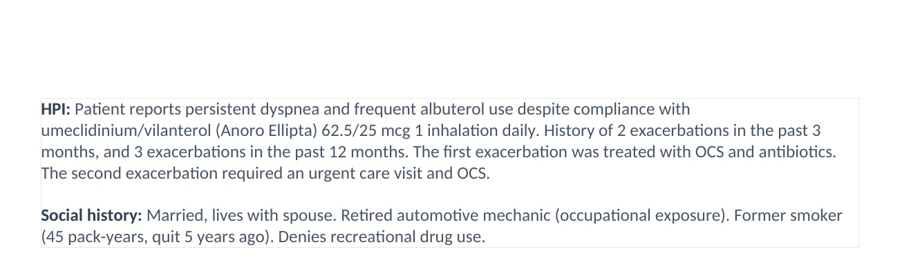
Thursday EMR rendering: persistent dyspnea and frequent albuterol use despite Anoro, with 2 exacerbations in 3 months / 3 in 12 months.
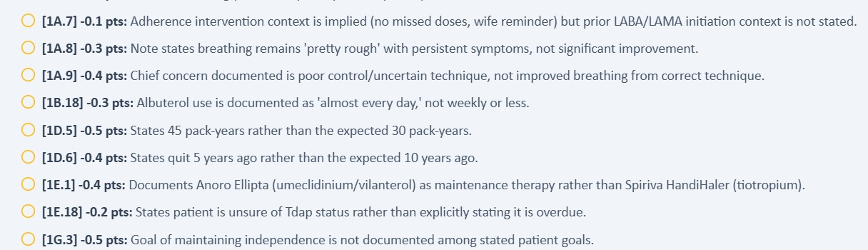
Focused grader excerpt: the scoring model expects significant improvement, weekly-or-less albuterol, and a different smoking/maintenance history.

Issue 5. Thursday encounter banner says 6-month follow-up while chart attribution remains “Initial Ambulatory Care Pharmacist Visit”
Problem type: Medium - Encounter-stage metadata inconsistency | Severity: Medium
What the student saw or heard: The encounter banner says “Thursday · 6-Month Follow-up,” while the chart documentation line still says “Initial Ambulatory Care Pharmacist Visit.” The live guiding questions correctly ask why escalation to triple therapy is appropriate; therefore, the confirmed defect is the stale encounter attribution, not the previously suspected LABA/LAMA escalation wording.
What the master rubric says: The master rubric defines this as a 6-month follow-up after LABA/LAMA treatment and evaluates escalation to triple therapy. The banner is consistent with that stage; the “Initial Ambulatory Care Pharmacist Visit” attribution is not.
What the AI grader expected: The grader uses a different treatment-stage reference elsewhere in the same visit, but this specific live-EMR defect is the stale initial-visit label.
Why this is a problem: Encounter-stage metadata is used by students and developers to understand where the patient is in a longitudinal sequence. Leaving “Initial” attached to a 6-month follow-up makes it harder to debug downstream medication, symptom, and grading state and risks binding later logic to the wrong encounter stage.
Suggested fix: Generate the chart attribution from the same visit-state object that drives the encounter banner. For Thursday, both locations should identify the 6-month follow-up. Add a validation check that blocks rendering when banner stage and chart-attribution stage differ.
Plain-language clinical meaning | The visit stage tells the learner and the software whether this is a baseline encounter or a follow-up after treatment changes. Stale “initial visit” metadata can make the wrong longitudinal state appear active.
Likely technical failure mode | Likely encounter metadata is copied forward or generated from a different field than the banner, without a cross-field validation rule.
Regression test / acceptance criterion | Generate all visible visit labels from one encounter-stage enum. Before rendering or grading, assert that banner, chart attribution, rubric visit label, and grader reference all carry the same stage.

Focused screenshot evidence

Original live VACS capture: Thursday banner identifies a 6-month follow-up.
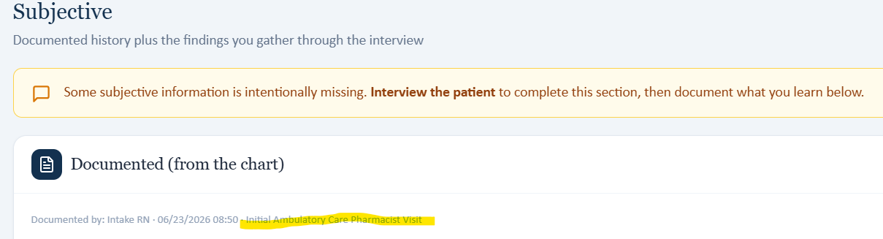
Original live VACS capture: the same encounter is still attributed to “Initial Ambulatory Care Pharmacist Visit.”

Patient C - Maria Thompson - ACO
19 confirmed grouped system/data issues across three sequential visits. Each issue below includes the source conflict, plain-language clinical significance, a likely technical failure mode, an acceptance test, and focused evidence.
Encounter | AI-grader score | Issues | Dominant pattern
Tuesday - Initial Visit | 55.1% | 6 | Live Tuesday treatment stage is internally inconsistent: Spiriva/albuterol medication list vs Trelegy/Symbicort prompts; ACT/CAT scores and exact bronchodilator-response values req
Wednesday - 3-Month Follow-Up | 28.4% | 6 | Wednesday is split across incompatible live, rubric, and grader case datasets; Live encounter is labeled 3-month follow-up while the chart attribution still says Initial Ambulatory
Thursday - 3-Month Follow-Up | 27.4% | 7 | Thursday treatment and visit stage are not synchronized across live EMR, master rubric, and grader; Thursday objective pulmonary/control data differ across live EMR, master rubric,

Patient C - Tuesday - Initial Visit
6 confirmed grouped system/data issues are included for this visit. AI-grader result: 55.1%. Issues are grouped by underlying defect rather than by every individual point deduction.
# | Issue | Problem type
1 | Live Tuesday treatment stage is internally inconsistent: Spiriva/albuterol medication list vs Trelegy/Symbicort prompts | Critical - Internal EMR treatment-stage conflict
2 | ACT/CAT scores and exact bronchodilator-response values required by grading are not displayed in the live Objective data | High - Required objective information unavailable
3 | Tuesday AI grader uses objective reference values that conflict with both the live EMR and master rubric | Critical - Grader dataset mismatch
4 | Occupation, smoking timeline, symptom details, and technique expectations are not synchronized across AI patient/rubric/grader | High - AI patient/rubric/grader history mismatch
5 | Rubric/grader expect medications and preventive-care facts the live Tuesday case does not provide | High - Medication/immunization dataset mismatch
6 | Medication interaction checker reports NKDA despite a documented sulfonamide-antibiotic rash allergy | Critical - Internal EMR allergy-safety conflict

Issue 1. Live Tuesday treatment stage is internally inconsistent: Spiriva/albuterol medication list vs Trelegy/Symbicort prompts
Problem type: Critical - Internal EMR treatment-stage conflict | Severity: Critical
What the student saw or heard: The live medication list shows tiotropium (Spiriva) plus albuterol. In the same encounter, the Assessment asks whether Trelegy should be continued, and the Guiding Questions ask what to monitor after Symbicort initiation.
What the master rubric says: The Tuesday master rubric is built around tiotropium/Spiriva plus rescue albuterol, with other chronic medications and an ICS-containing therapy decision; it does not support simultaneous Trelegy continuation and post-Symbicort-monitoring prompts. Relevant rubric areas: 1E.1-1E.13, 3A.11-3A.13.
What the AI grader expected: The grader rewards an ICS/LABA initiation framework and penalizes missing Symbicort-related details, while the live EMR simultaneously exposes a Trelegy-continuation prompt.
Why this is a problem: The student is being asked to reason from mutually incompatible treatment stages inside one live visit. Medication identity determines whether the clinical task is initiation, continuation, or escalation.
Suggested fix: Choose one Tuesday medication/treatment stage and synchronize the live medication list, Assessment prompts, Guiding Questions, master rubric, and grader to that same stage.
Plain-language clinical meaning | The current medication regimen defines the treatment stage. If one screen says the patient is already on a therapy while another asks the student to start, continue, or escalate a different therapy, the “correct” next clinical step becomes impossible to determine.
Likely technical failure mode | Likely multiple case branches or stale medication-state objects are active simultaneously. Medication list, prompts, AI patient, and grader are not using a single versioned regimen.
Regression test / acceptance criterion | Assign one medication list to the visit-state ID and make all prompts and grader criteria derive from it. Reload the visit and verify the AI patient names the same regimen. Any prompt referring to a non-current drug should fail pre-release validation.

Focused screenshot evidence
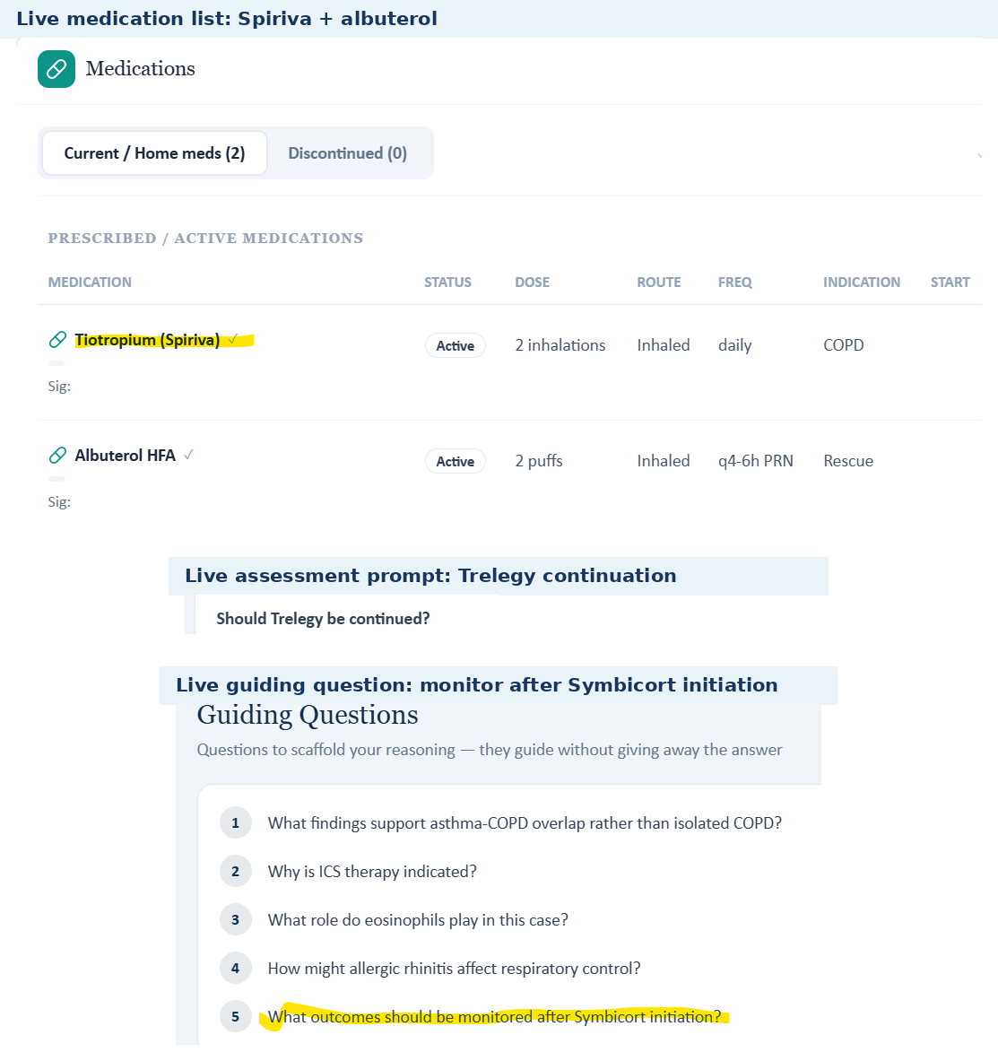
Tuesday live medication and assessment screens show Spiriva/albuterol, a Trelegy-continuation question, and a Symbicort-initiation monitoring question in the same encounter.

Issue 2. ACT/CAT scores and exact bronchodilator-response values required by grading are not displayed in the live Objective data
Problem type: High - Required objective information unavailable | Severity: High
What the student saw or heard: The live PFT panel displays FEV1 1.45 L (58% predicted), FVC 2.63 L, pre-BD FEV1/FVC 0.54, post-BD FEV1/FVC 0.55, and eosinophils 420 cells/uL. It does not display an ACT score, CAT score, or the exact +15% / +260 mL bronchodilator response.
What the master rubric says: The Tuesday master rubric requires +15% and +260 mL bronchodilator improvement plus ACT 15 and CAT 19, including interpretation. Relevant rubric areas: 2B.4-2B.10, 2C.2-2C.6.
What the AI grader expected: The grader deducts specifically because +15%, +260 mL, ACT 15, and CAT 19 are absent from the SOAP.
Why this is a problem: These are objective results. When the student is not shown them, documenting them would require invention rather than chart transcription or patient interview.
Suggested fix: Display all rubric-required PFT calculations and ACT/CAT scores in the live Objective workflow, or suppress deductions for values that the live encounter does not expose.
Plain-language clinical meaning | Spirometry measures airflow and helps classify obstruction and disease severity. Different FEV1 or FEV1/FVC values can change the diagnosis, severity label, and treatment pathway.
Likely technical failure mode | Likely multiple objective-data sources or stale reference records. Primary labs, “missing data” boxes, rubric values, and grader reference values appear to be populated independently.
Regression test / acceptance criterion | Seed one spirometry panel for the visit and verify the same FEV1, FEV1/FVC, reversibility, units, and interpretation appear everywhere. A SOAP that transcribes the visible panel exactly must receive full factual credit.

Focused screenshot evidence
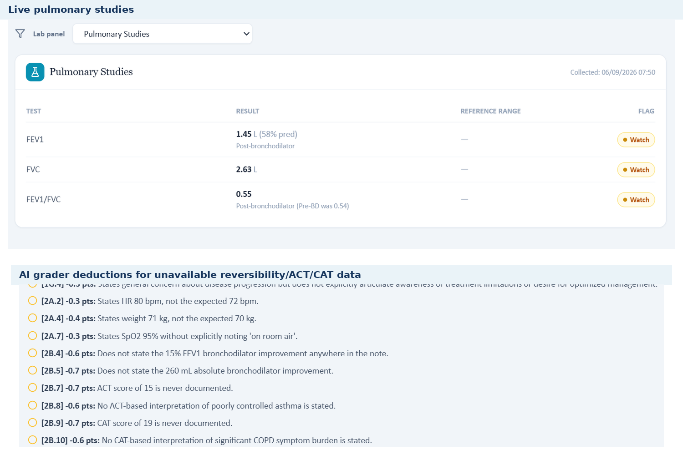
The live PFT panel lacks the exact reversibility and control-score data that the grader later requires.

Issue 3. Tuesday AI grader uses objective reference values that conflict with both the live EMR and master rubric
Problem type: Critical - Grader dataset mismatch | Severity: Critical
What the student saw or heard: The live Tuesday chart shows HR 80 bpm and weight 71 kg, which were transcribed into the submitted SOAP.
What the master rubric says: The Tuesday master rubric also specifies HR 80 bpm and weight 71 kg (2A.2 and 2A.4), matching the live chart.
What the AI grader expected: The grader instead states that HR 80 should have been 72 bpm and weight 71 kg should have been 70 kg. It therefore penalizes accurate live-chart transcription despite the master rubric agreeing with the student.
Why this is a problem: This is a direct grading-reference error: the live source and master reference agree, but the grader is using a different objective dataset.
Suggested fix: Replace the grader's Tuesday objective reference with the master-rubric/live-EMR values, then regression-test every objective criterion for Maria Tuesday.
Plain-language clinical meaning | Vital signs and objective measurements identify the patient’s current physiologic state and are used to interpret severity and derived values such as BMI or oxygenation. Penalizing exact transcription of the visible chart is a data-integrity failure.
Likely technical failure mode | Likely grader reference points to another patient/day snapshot or an older visit-state version, while the live EMR and rubric use a different objective dataset.
Regression test / acceptance criterion | Bind every scored objective criterion to the same visit-state ID used to render the live chart. Programmatically compare the values before grading; if any mismatch exists, mark the visit non-scorable rather than deducting points.

Focused screenshot evidence
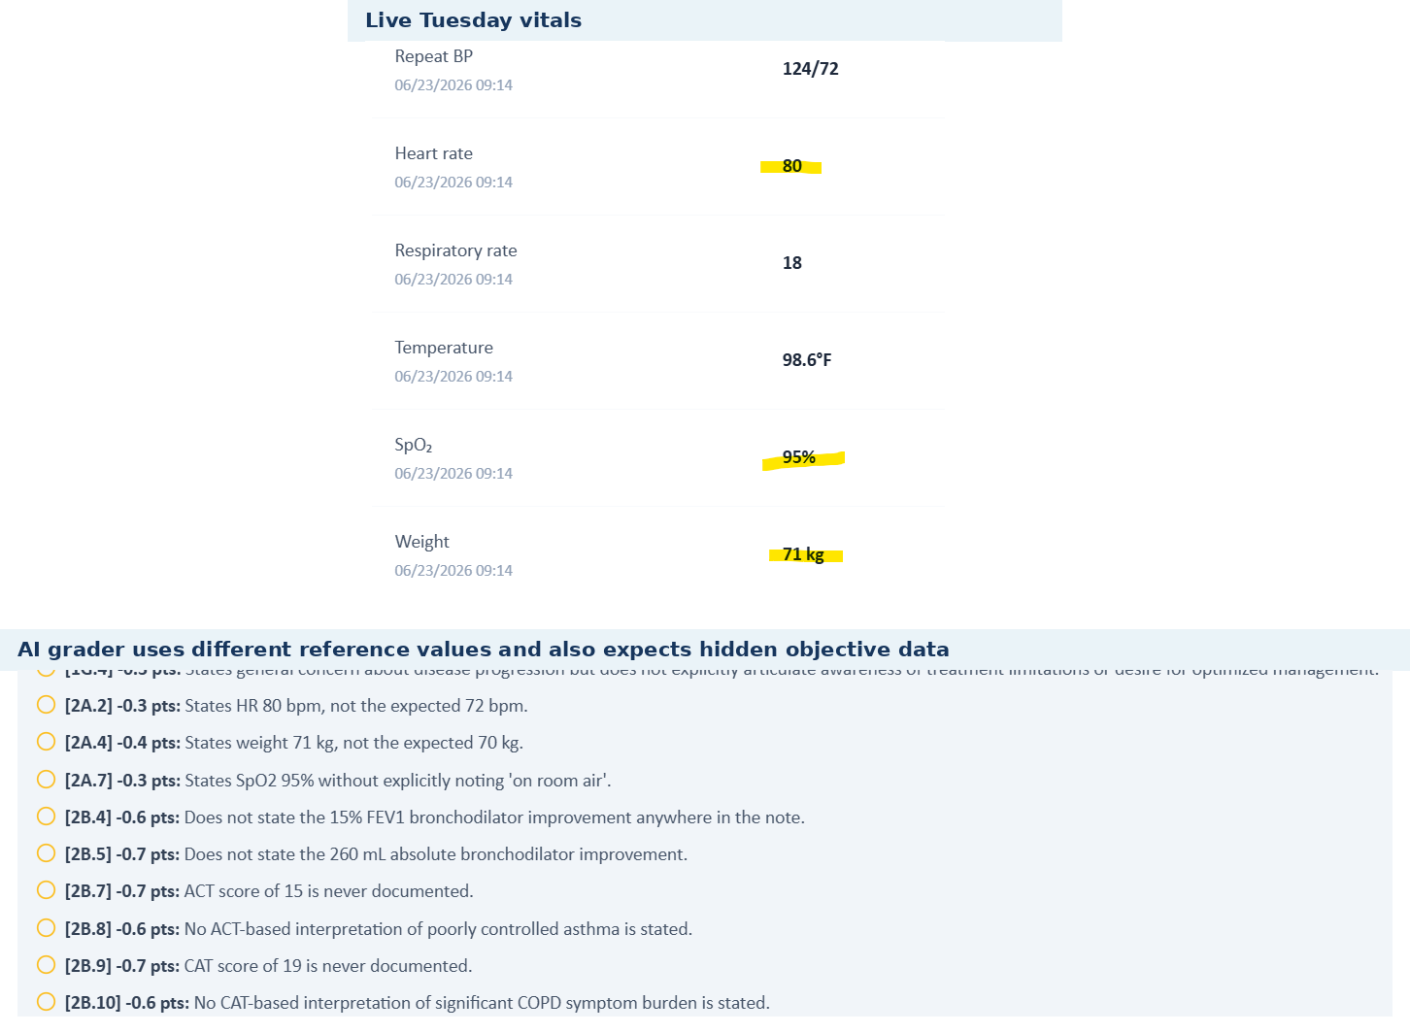
Live Tuesday vitals compared with the grader deductions that use different expected values.

Issue 4. Occupation, smoking timeline, symptom details, and technique expectations are not synchronized across AI patient/rubric/grader
Problem type: High - AI patient/rubric/grader history mismatch | Severity: High
What the student saw or heard: The live chart/AI patient describe a retired teacher, former smoker with 30 pack-years who quit 10 years ago, no distinct chronic cough, unquantified rescue use, and incomplete certainty about inhaler technique.
What the master rubric says: The master rubric expects a retired elementary-school principal, smoking cessation 12 years ago, chronic cough, several-times-daily albuterol, and appropriate inhaler technique. Relevant rubric areas include 1B.3-1B.5, 1B.20, 1D.3-1D.6.
What the AI grader expected: The grader penalizes the note for documenting the AI patient's actual answers, including retired teacher, 10-year cessation, absent chronic cough, unquantified albuterol, and uncertain technique. One grader line additionally expects a never-smoker status, which conflicts with both the live case and master rubric.
Why this is a problem: Neutral interview answers cannot simultaneously satisfy these competing histories. Some items are clinically material because they affect COPD risk characterization and treatment optimization.
Suggested fix: Synchronize the standardized-patient response bank with the master Tuesday history, and align the grader to the same smoking/occupation/technique dataset.
Plain-language clinical meaning | Inhaler technique determines whether the patient is actually receiving the medication. A regimen should not be considered “optimized” if the simulated patient demonstrates device errors; that can change whether treatment should be intensified.
Likely technical failure mode | Likely response-bank/rubric desynchronization. The patient persona has one device-technique state while the rubric/grader assumes another, or the technique state is not keyed to the specific inhaler device.
Regression test / acceptance criterion | For the exact inhaler in the medication list, ask a neutral “walk me through it” question. The AI patient must demonstrate the intended steps/errors, and the grader must evaluate those same steps. Repeat after the next longitudinal transition to confirm persistence.

Focused screenshot evidence
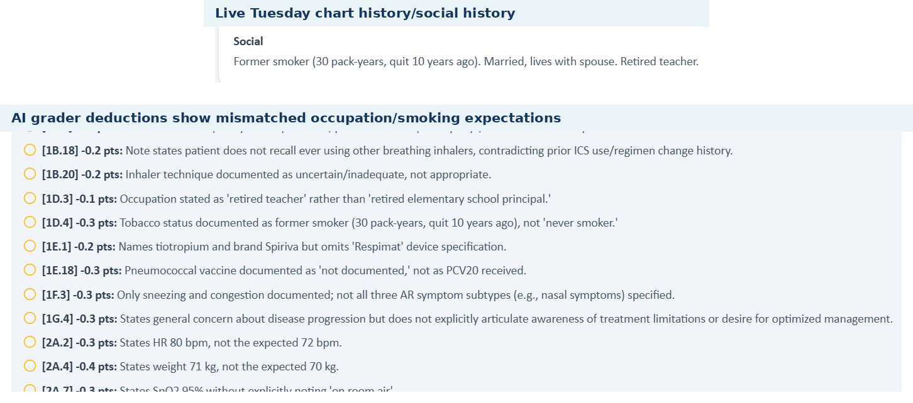
Live Tuesday history and grader deductions demonstrate conflicting occupation, smoking, symptom, and technique expectations.

Issue 5. Rubric/grader expect medications and preventive-care facts the live Tuesday case does not provide
Problem type: High - Medication/immunization dataset mismatch | Severity: High
What the student saw or heard: The live medication list contains Spiriva and albuterol. During interview, Maria also reports cetirizine and saline spray and denies other regular medicines/supplements. Pneumococcal vaccination is listed as not documented.
What the master rubric says: The Tuesday master rubric expects fluticasone nasal spray, lisinopril 20 mg daily, calcium carbonate/vitamin D twice daily, and PCV20 received, in addition to the respiratory medications. Relevant rubric areas: 1E.7-1E.13 and 1E.18.
What the AI grader expected: The grader deducts for the missing PCV20 and additional expected medication/history details.
Why this is a problem: A medication or vaccination fact cannot be documented reliably when both the live list and standardized patient fail to provide it. This also creates a medication-reconciliation problem across sources.
Suggested fix: Populate all intended chronic medications and vaccine statuses in the live case and standardized-patient history, or revise the rubric/grader to match the encounter actually shown.
Plain-language clinical meaning | Vaccination status is preventive-care information. It may not change the immediate inhaler choice, but it is graded and affects respiratory-risk counseling, so the student must be able to see or elicit the exact status being scored.
Likely technical failure mode | Likely incomplete UI exposure or preventive-care data stored separately from the rubric reference.
Regression test / acceptance criterion | For every vaccine criterion, expose a status in the live chart or AI patient. If the status is unknown/not documented, the grader must accept that exact state. Prevent “received” and “not documented” from coexisting for the same vaccine/date.

Focused screenshot evidence
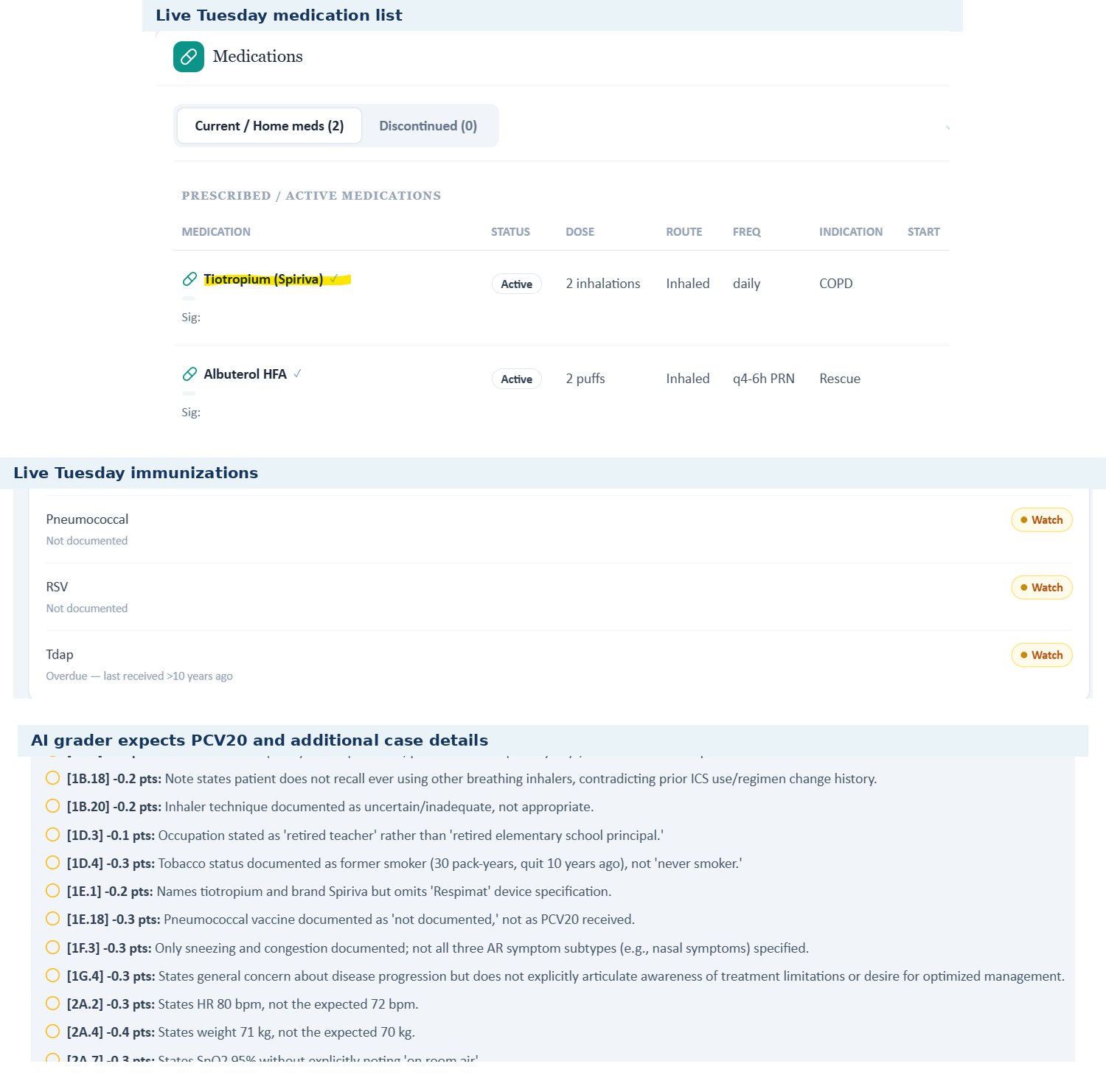
Tuesday live medication and immunization screens do not contain several items required by the reference case.

Issue 6. Medication interaction checker reports NKDA despite a documented sulfonamide-antibiotic rash allergy
Problem type: Critical - Internal EMR allergy-safety conflict | Severity: Critical
What the student saw or heard: The dedicated live allergy screen lists sulfonamide antibiotics with rash. Elsewhere in the same live visit, the medication/interaction banner states “NKDA - no conflicts.”
What the master rubric says: The master Tuesday rubric requires sulfonamide-antibiotic allergy with rash (1E.14-1E.15), so the dedicated allergy record is consistent with the intended case.
What the AI grader expected: The grader did not resolve the internal safety contradiction; it evaluates medication documentation while the interaction checker itself is operating under an NKDA banner.
Why this is a problem: Allergy data are safety-critical. A drug-interaction/allergy checker should not report NKDA when the same chart contains a drug allergy.
Suggested fix: Use a single allergy source of truth across header, allergy table, and medication interaction checker; add automated validation that prevents an NKDA status when a drug allergy exists.
Plain-language clinical meaning | Drug-allergy data are a safety constraint, not just background history. If one component says “no known drug allergies” while another records a sulfonamide rash, medication checking and grading can make unsafe assumptions.
Likely technical failure mode | Likely duplicated allergy state: the header/allergy table, interaction checker, and grader appear to read different fields or cached versions rather than one canonical allergy record.
Regression test / acceptance criterion | Create one allergy in the visit state, reload every screen, and verify the header, dedicated allergy page, medication interaction checker, AI patient, and grader all return the same allergy. The build should fail validation if any layer still reports NKDA.

Focused screenshot evidence
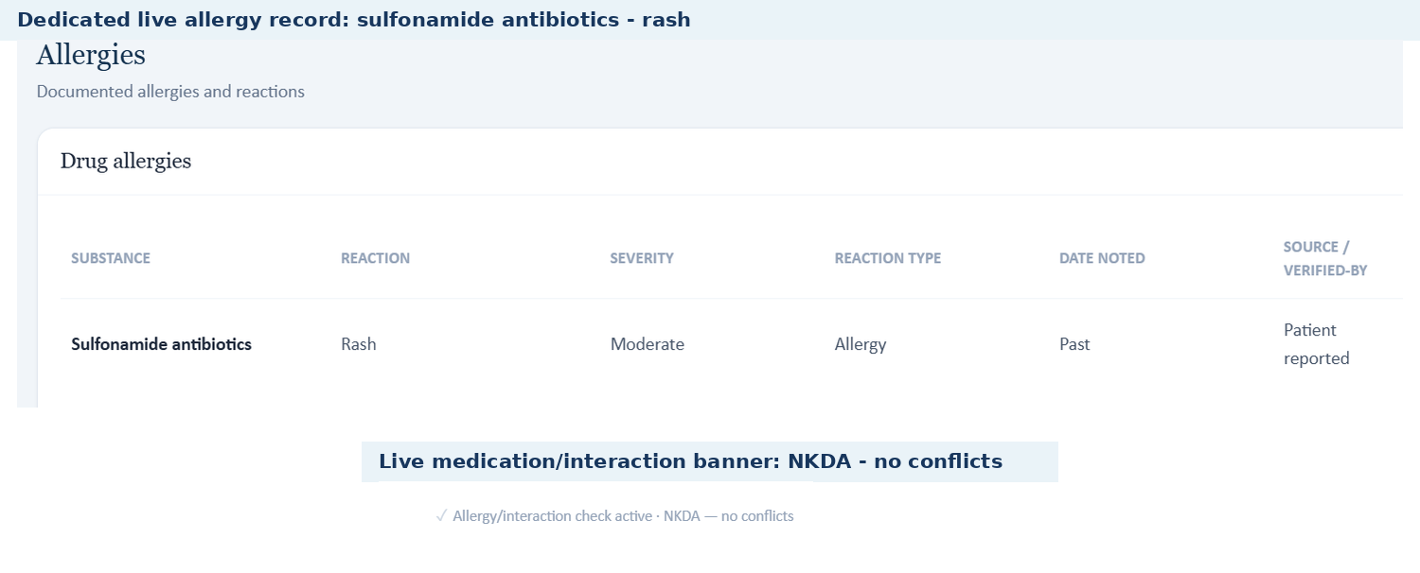
Two live Tuesday screens show the same chart containing a sulfonamide rash allergy and an NKDA interaction-check banner.

Patient C - Wednesday - 3-Month Follow-Up
6 confirmed grouped system/data issues are included for this visit. AI-grader result: 28.4%. Issues are grouped by underlying defect rather than by every individual point deduction.
# | Issue | Problem type
1 | Wednesday is split across incompatible live, rubric, and grader case datasets | Critical - Three-way case-stage mismatch
2 | Live encounter is labeled 3-month follow-up while the chart attribution still says Initial Ambulatory Care Pharmacist Visit | Medium - Internal visit-stage labeling conflict
3 | Live Wednesday eosinophil value is internally inconsistent: CBC 520 vs guiding-question 420 cells/uL | High - Internal EMR lab inconsistency
4 | Chart says Trelegy technique is excellent while the AI patient repeatedly demonstrates incorrect MDI-style technique | Critical - EMR vs AI-patient technique conflict
5 | Biologic-candidacy logic assumes optimized therapy and persistent exacerbations that the live interview does not establish | Critical - Incorrect live clinical-logic assumption
6 | Wednesday allergy information is internally contradictory: sulfonamide rash vs NKDA | Critical - Internal EMR allergy-safety conflict

Issue 1. Wednesday is split across incompatible live, rubric, and grader case datasets
Problem type: Critical - Three-way case-stage mismatch | Severity: Critical
What the student saw or heard: The live encounter is a 3-month follow-up with worsening symptoms on Trelegy, one prednisone-treated flare, and no Symbicort/Spiriva/fluticasone nasal-spray regimen.
What the master rubric says: The Wednesday master rubric itself labels the visit as a 3-month follow-up (1A.4) but expects a different storyline: significant improvement vs six months ago, Symbicort + Spiriva + fluticasone, three exacerbations in the prior three months, all treated with systemic corticosteroids, one also with antibiotics, and mepolizumab initiated at this visit (1B.1-1B.16, 1E.1-1E.28).
What the AI grader expected: The grader then introduces a third version: it explicitly says the note should have been a “6-month follow-up,” and penalizes the live Trelegy/worsening/one-exacerbation scenario for not matching its expected Symbicort/Spiriva/fluticasone case.
Why this is a problem: The student cannot write one SOAP note that is faithful to all three sources. Even the visit interval is inconsistent between master rubric and grader.
Suggested fix: Rebuild Maria Wednesday from one canonical dataset and verify that live EMR, standardized-patient answers, master rubric, and grader all use the same visit interval, regimen, symptom trajectory, and exacerbation history.
Plain-language clinical meaning | This issue indicates that the learner is being shown more than one version of the same patient/day. When case versions diverge, even correct clinical reasoning can be graded against a different state.
Likely technical failure mode | Likely multiple case-version objects are being loaded concurrently or different VACS components are resolving different version identifiers.
Regression test / acceptance criterion | Log the patient+visit version ID in every component and assert equality before rendering/grading. A mismatch must block scoring and identify the disagreeing component/field in the developer log.

Focused screenshot evidence
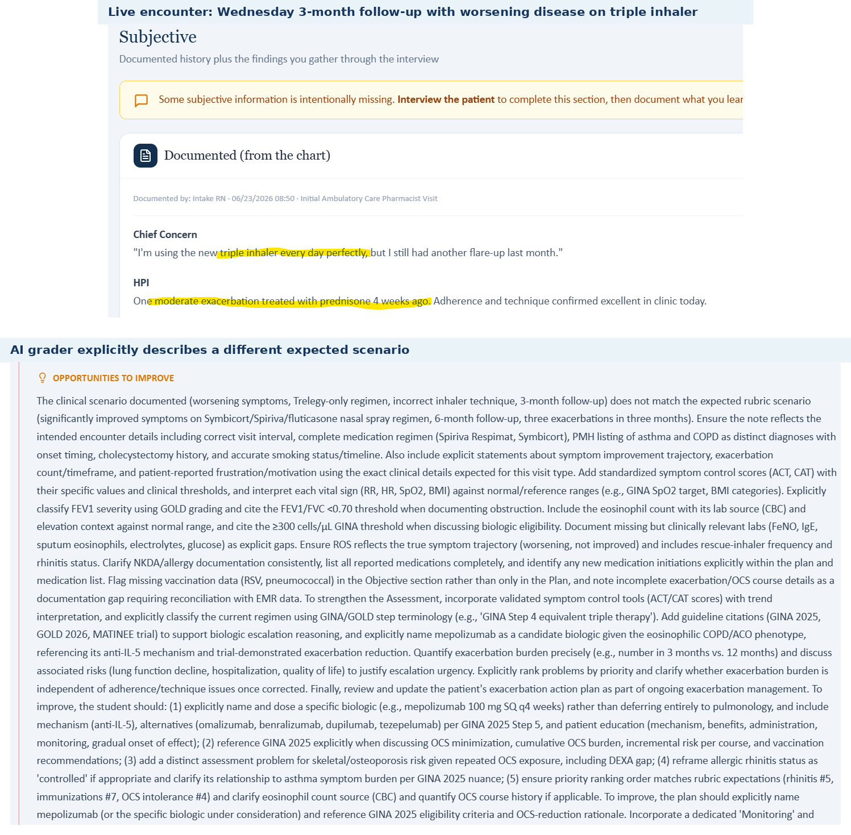
The live Wednesday case and the grader's own narrative explicitly describe different expected scenarios.

Issue 2. Live encounter is labeled 3-month follow-up while the chart attribution still says Initial Ambulatory Care Pharmacist Visit
Problem type: Medium - Internal visit-stage labeling conflict | Severity: Medium
What the student saw or heard: The top encounter banner states “Wednesday - 3-Month Follow-up.” The documented-history attribution on the same screen says “Initial Ambulatory Care Pharmacist Visit.”
What the master rubric says: The master Wednesday rubric expects a 3-month follow-up (1A.4) and an ambulatory care pharmacy clinic setting (1A.5).
What the AI grader expected: The grader incorrectly expects a 6-month follow-up, adding another conflicting visit-stage label.
Why this is a problem: Visit-stage labels drive which prior therapy and trend data should exist. Contradictory labels make it unclear whether the chart is an initial, 3-month, or 6-month encounter.
Suggested fix: Generate visit labels from a single encounter-stage field and validate chart attribution, banner, rubric, and grader against that value.
Plain-language clinical meaning | The visit stage tells the learner and the software whether this is a baseline encounter or a follow-up after treatment changes. Stale “initial visit” metadata can make the wrong longitudinal state appear active.
Likely technical failure mode | Likely encounter metadata is copied forward or generated from a different field than the banner, without a cross-field validation rule.
Regression test / acceptance criterion | Generate all visible visit labels from one encounter-stage enum. Before rendering or grading, assert that banner, chart attribution, rubric visit label, and grader reference all carry the same stage.

Focused screenshot evidence
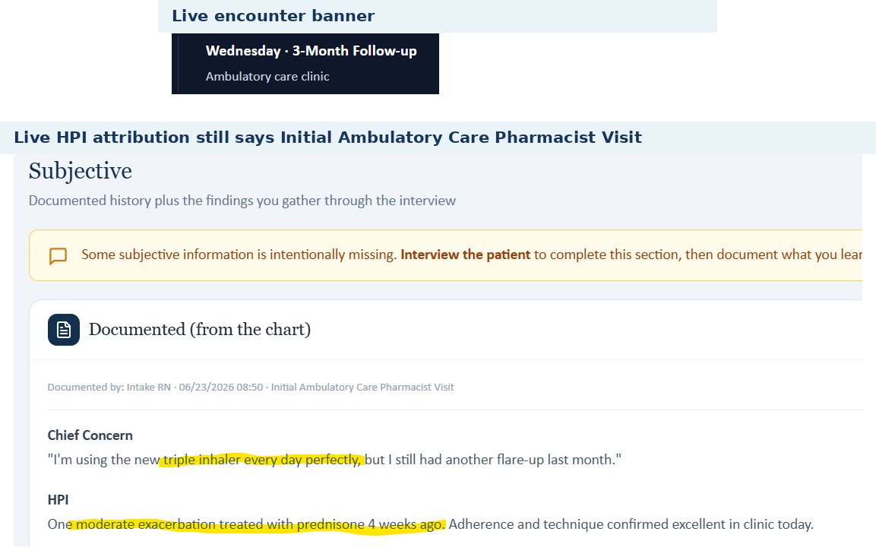
Two live Wednesday areas label the same encounter as both a 3-month follow-up and an initial pharmacist visit.

Issue 3. Live Wednesday eosinophil value is internally inconsistent: CBC 520 vs guiding-question 420 cells/uL
Problem type: High - Internal EMR lab inconsistency | Severity: High
What the student saw or heard: The live CBC/Immunology panel reports absolute eosinophils 520 cells/uL, rising from baseline 420.
What the master rubric says: The master Wednesday rubric uses an eosinophilic phenotype as part of advanced-therapy reasoning, but its case expectations are not synchronized with the live lab trajectory.
What the AI grader expected: The live Guiding Question asks about “persistent eosinophilia (420 cells/uL) despite triple therapy,” while the grader evaluates the SOAP using the 520 value in some places and a different hidden scenario in others.
Why this is a problem: Two different current eosinophil values appear in the same encounter. This can directly change phenotype interpretation and biologic reasoning.
Suggested fix: Bind assessment prompts to the current lab result rather than a stale baseline/template value, and add consistency checks between laboratory panels and generated guiding questions.
Plain-language clinical meaning | Eosinophils are a blood marker used in these cases to decide whether anti-inflammatory inhaler therapy or an advanced biologic treatment is likely to help. A different value or treatment stage can reverse the expected treatment decision.
Likely technical failure mode | Likely visit-state/reference binding failure: the live chart, decision-support rule, rubric, and grader are not resolving the same biomarker value and treatment-stage object.
Regression test / acceptance criterion | Load the affected visit and assert one eosinophil value, one current regimen, and one escalation target across EMR, advisory, rubric, AI patient, and grader. Submit a SOAP that follows the live decision support and confirm the grader rewards the same decision.

Focused screenshot evidence
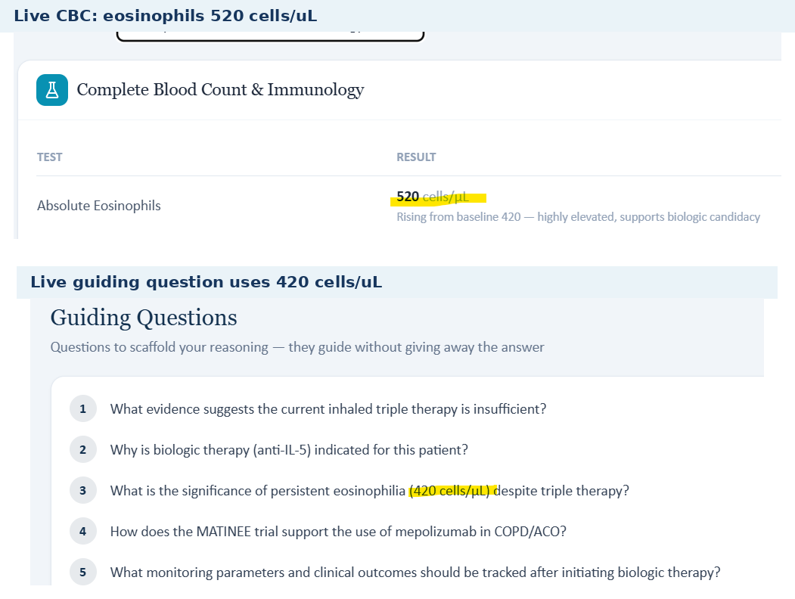
The live Wednesday CBC shows 520 cells/uL while the live guiding question uses 420 cells/uL.

Issue 4. Chart says Trelegy technique is excellent while the AI patient repeatedly demonstrates incorrect MDI-style technique
Problem type: Critical - EMR vs AI-patient technique conflict | Severity: Critical
What the student saw or heard: The live HPI states adherence and technique were “confirmed excellent in clinic today.” In the interview, Maria twice describes Trelegy by shaking it and “pressing down” while inhaling, which the grader itself labels incorrect MDI-style technique for a DPI device.
What the master rubric says: The master Wednesday rubric expects appropriate inhaler technique (1B.15, 1E.22).
What the AI grader expected: The grader deducts because the SOAP accurately documented the incorrect technique returned by the standardized patient.
Why this is a problem: Technique is a prerequisite to declaring inhaled treatment optimized. The EMR, AI patient, and rubric cannot simultaneously support “excellent technique” and incorrect device use.
Suggested fix: Make the standardized-patient device demonstration match the intended case, or remove the “excellent technique” chart statement and biologic-optimization assumptions until correct technique is demonstrated.
Plain-language clinical meaning | Inhaler technique determines whether the patient is actually receiving the medication. A regimen should not be considered “optimized” if the simulated patient demonstrates device errors; that can change whether treatment should be intensified.
Likely technical failure mode | Likely response-bank/rubric desynchronization. The patient persona has one device-technique state while the rubric/grader assumes another, or the technique state is not keyed to the specific inhaler device.
Regression test / acceptance criterion | For the exact inhaler in the medication list, ask a neutral “walk me through it” question. The AI patient must demonstrate the intended steps/errors, and the grader must evaluate those same steps. Repeat after the next longitudinal transition to confirm persistence.

Focused screenshot evidence
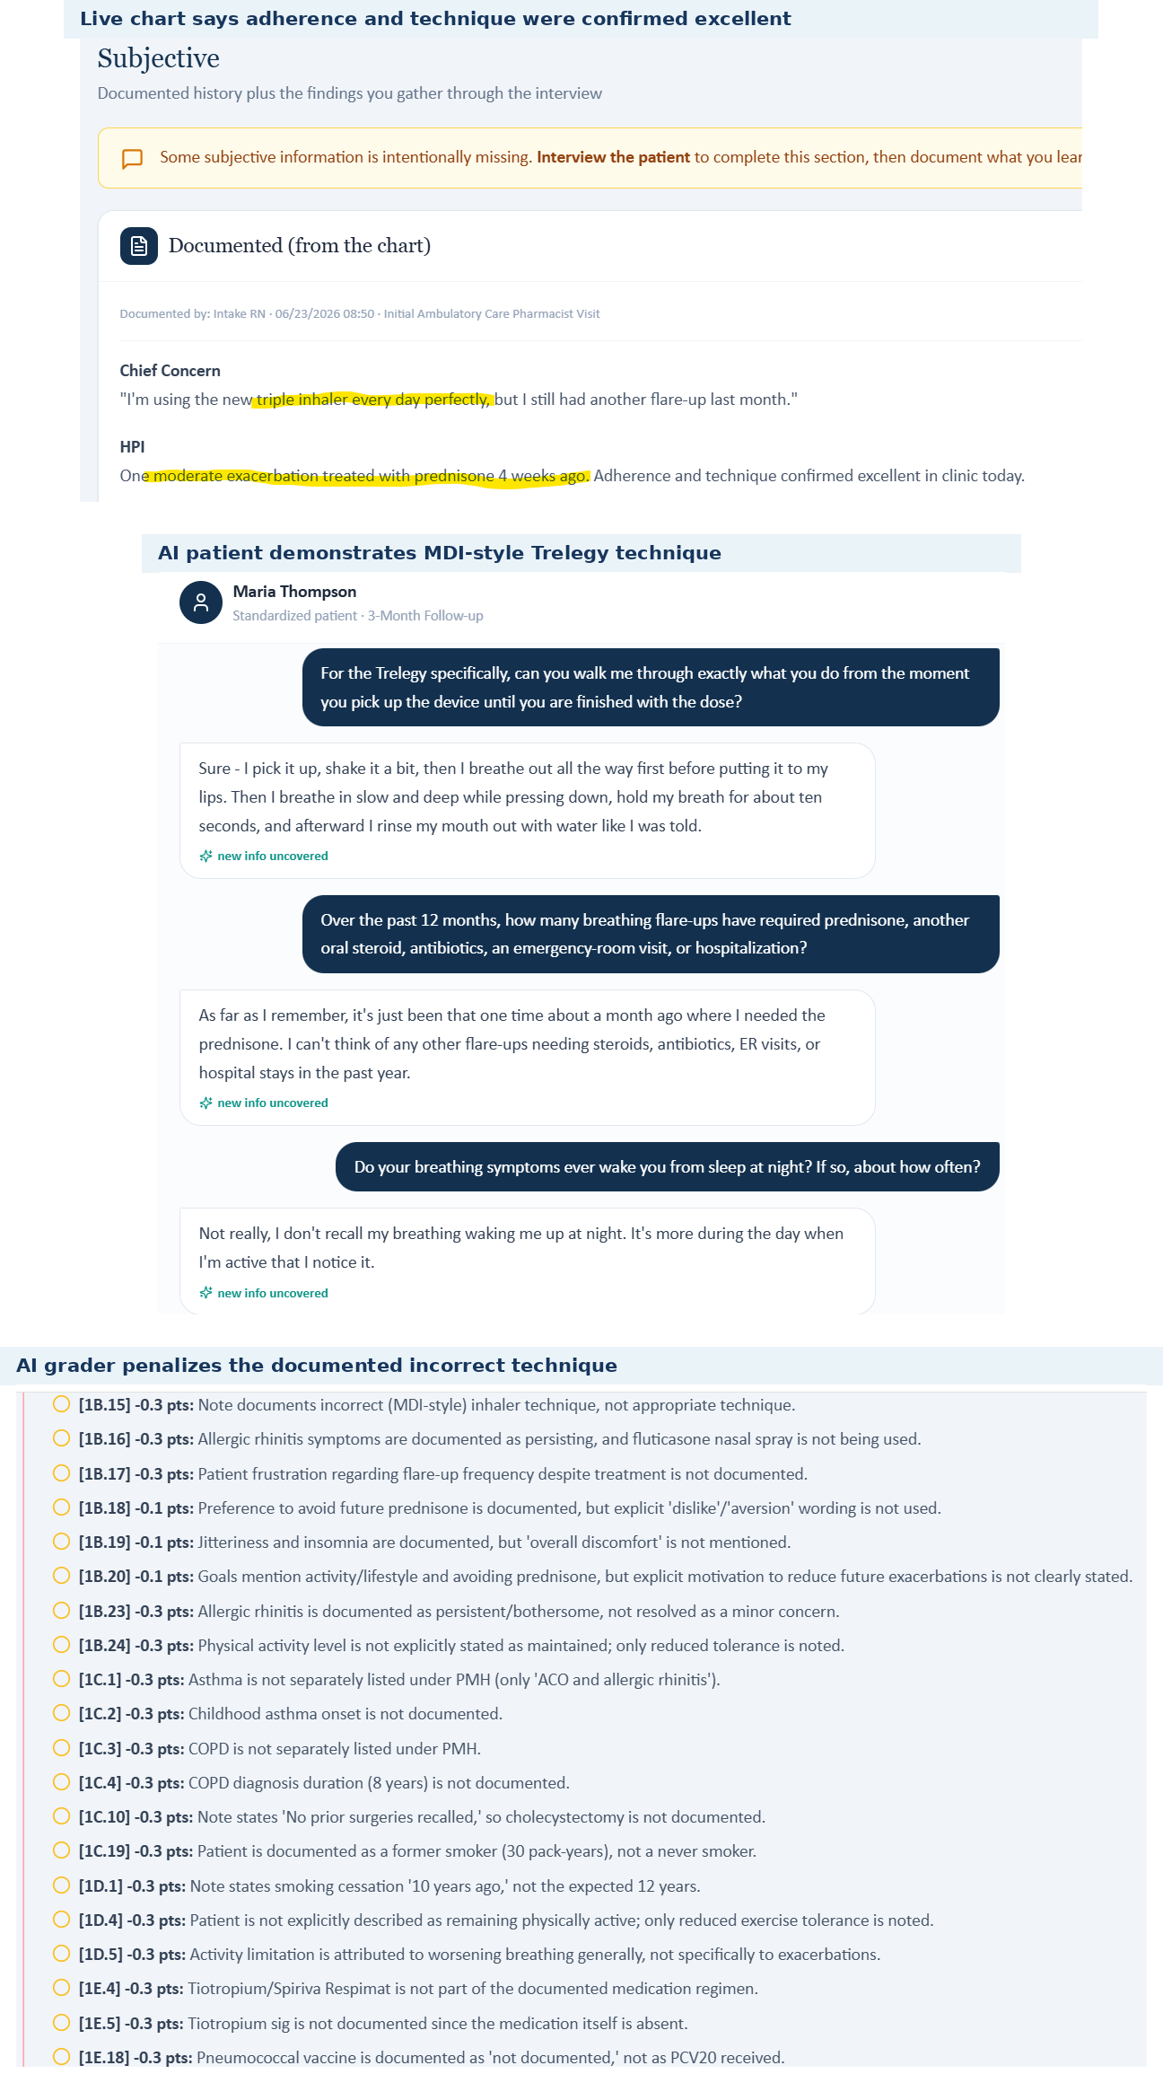
Live chart and AI-patient interview directly contradict each other on Trelegy technique; the grader confirms the interview technique is incorrect.

Issue 5. Biologic-candidacy logic assumes optimized therapy and persistent exacerbations that the live interview does not establish
Problem type: Critical - Incorrect live clinical-logic assumption | Severity: Critical
What the student saw or heard: The live Assessment asks for the next step “with optimized inhalers, proven adherence, and persistent eosinophilic exacerbations.” Yet the interview establishes incorrect Trelegy technique and only one prednisone-treated exacerbation in the previous 12 months, with no antibiotics, ED visit, or hospitalization.
What the master rubric says: The master Wednesday rubric expects a different exacerbation burden and a biologic initiation decision, including mepolizumab as a new medication (1B.6-1B.10, 1E.26).
What the AI grader expected: The grader penalizes the submitted note for not treating the therapy as optimized and for not initiating mepolizumab, even though the live patient evidence undermines those assumptions.
Why this is a problem: The assessment prompt effectively supplies a conclusion that conflicts with the data the student just elicited. That can drive premature escalation and obscures the purpose of the interview.
Suggested fix: Generate biologic-candidacy prompts only after validating current exacerbation count, adherence, and device technique. If those criteria are not met, the prompt should direct reconciliation/optimization before escalation.
Plain-language clinical meaning | Eosinophils are a blood marker used in these cases to decide whether anti-inflammatory inhaler therapy or an advanced biologic treatment is likely to help. A different value or treatment stage can reverse the expected treatment decision.
Likely technical failure mode | Likely visit-state/reference binding failure: the live chart, decision-support rule, rubric, and grader are not resolving the same biomarker value and treatment-stage object.
Regression test / acceptance criterion | Load the affected visit and assert one eosinophil value, one current regimen, and one escalation target across EMR, advisory, rubric, AI patient, and grader. Submit a SOAP that follows the live decision support and confirm the grader rewards the same decision.

Focused screenshot evidence
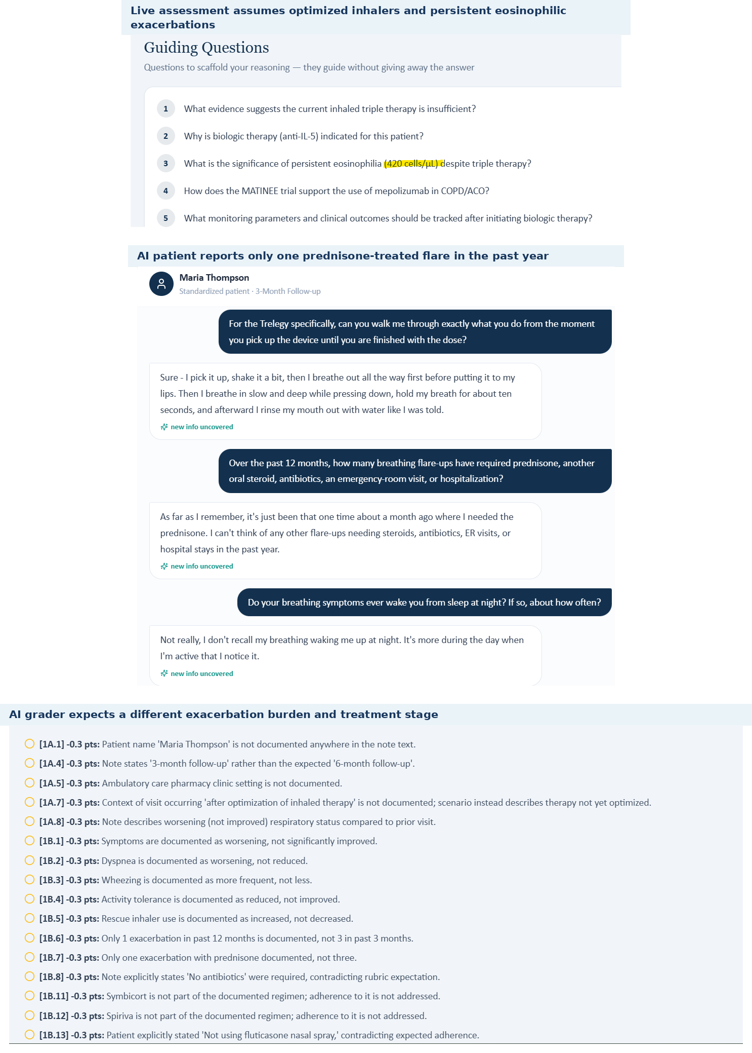
Live assessment assumptions are contradicted by the same encounter's AI-patient exacerbation and technique answers.

Issue 6. Wednesday allergy information is internally contradictory: sulfonamide rash vs NKDA
Problem type: Critical - Internal EMR allergy-safety conflict | Severity: Critical
What the student saw or heard: Maria's header and interview report sulfonamide-antibiotic allergy with rash. The dedicated live drug-allergy section says “No known drug allergies,” and the medication/interaction area also reports NKDA.
What the master rubric says: The master Wednesday rubric states the sulfonamide allergy is the only documented allergy and specifically says NKDA does not apply (1E.14-1E.15, 1E.28).
What the AI grader expected: The grader includes deductions related to allergy inconsistency while simultaneously using the broader mismatched case dataset.
Why this is a problem: This is a direct medication-safety synchronization problem within the live chart.
Suggested fix: Unify allergy data across patient header, dedicated allergy table, and interaction checker; block grading/medication review when these sources disagree.
Plain-language clinical meaning | Drug-allergy data are a safety constraint, not just background history. If one component says “no known drug allergies” while another records a sulfonamide rash, medication checking and grading can make unsafe assumptions.
Likely technical failure mode | Likely duplicated allergy state: the header/allergy table, interaction checker, and grader appear to read different fields or cached versions rather than one canonical allergy record.
Regression test / acceptance criterion | Create one allergy in the visit state, reload every screen, and verify the header, dedicated allergy page, medication interaction checker, AI patient, and grader all return the same allergy. The build should fail validation if any layer still reports NKDA.

Focused screenshot evidence
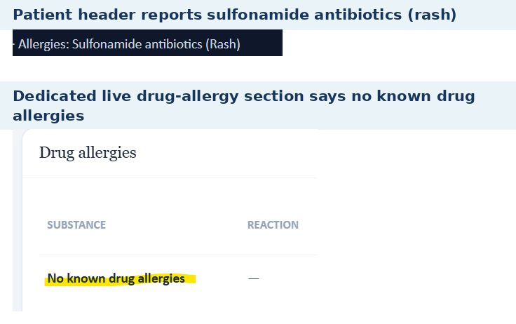
The Wednesday patient header and allergy table display mutually exclusive allergy states.

Patient C - Thursday - 3-Month Follow-Up
7 confirmed grouped system/data issues are included for this visit. AI-grader result: 27.4%. Issues are grouped by underlying defect rather than by every individual point deduction.
# | Issue | Problem type
1 | Thursday treatment and visit stage are not synchronized across live EMR, master rubric, and grader | Critical - Three-way treatment-stage mismatch
2 | Thursday objective pulmonary/control data differ across live EMR, master rubric, and grader | Critical - Three-way objective-data mismatch
3 | Exacerbation trajectory differs materially across live AI patient, master rubric, and grader | Critical - Three-way clinical-trajectory mismatch
4 | AI patient demonstrates uncertain/incomplete inhaler technique while the reference case expects appropriate technique | High - AI-patient/rubric technique mismatch
5 | Osteopenia is active, but calcium/vitamin D “continuation” is required despite being absent from the live medication history | High - Medication-reconciliation/rubric mismatch
6 | Thursday allergy checker again reports NKDA despite a documented sulfonamide rash allergy | Critical - Internal EMR allergy-safety conflict
7 | Preventive-care, occupation, and smoking background remain unsynchronized | High - Background/immunization dataset mismatch

Issue 1. Thursday treatment and visit stage are not synchronized across live EMR, master rubric, and grader
Problem type: Critical - Three-way treatment-stage mismatch | Severity: Critical
What the student saw or heard: The live encounter banner says Thursday - 3-Month Follow-Up. The chart describes persistent dyspnea, two exacerbations in 12 months with one hospitalization, Symbicort + Spiriva, and uncontrolled rhinitis. The attribution line again says “Initial Ambulatory Care Pharmacist Visit.”
What the master rubric says: The master Thursday rubric expects a 6-month follow-up with significant improvement on Symbicort + Spiriva, no pulmonary escalation, and no new pulmonary medication. Relevant areas: 1A.4-1A.7, 3A.2-3A.13, 4A.1-4A.8.
What the AI grader expected: The grader describes yet another stage: a patient improved after mepolizumab/Trelegy, with suppressed eosinophils and no escalation needed.
Why this is a problem: The same Thursday submission is being compared against incompatible encounter stages and regimens. This explains many large deductions unrelated to the SOAP's fidelity to the live case.
Suggested fix: Create one canonical Thursday stage and propagate it to banner, HPI attribution, medications, AI patient, rubric, and grader. Regression-test the expected medication and escalation decision.
Plain-language clinical meaning | The visit stage tells the learner and the software whether this is a baseline encounter or a follow-up after treatment changes. Stale “initial visit” metadata can make the wrong longitudinal state appear active.
Likely technical failure mode | Likely encounter metadata is copied forward or generated from a different field than the banner, without a cross-field validation rule.
Regression test / acceptance criterion | Generate all visible visit labels from one encounter-stage enum. Before rendering or grading, assert that banner, chart attribution, rubric visit label, and grader reference all carry the same stage.

Focused screenshot evidence
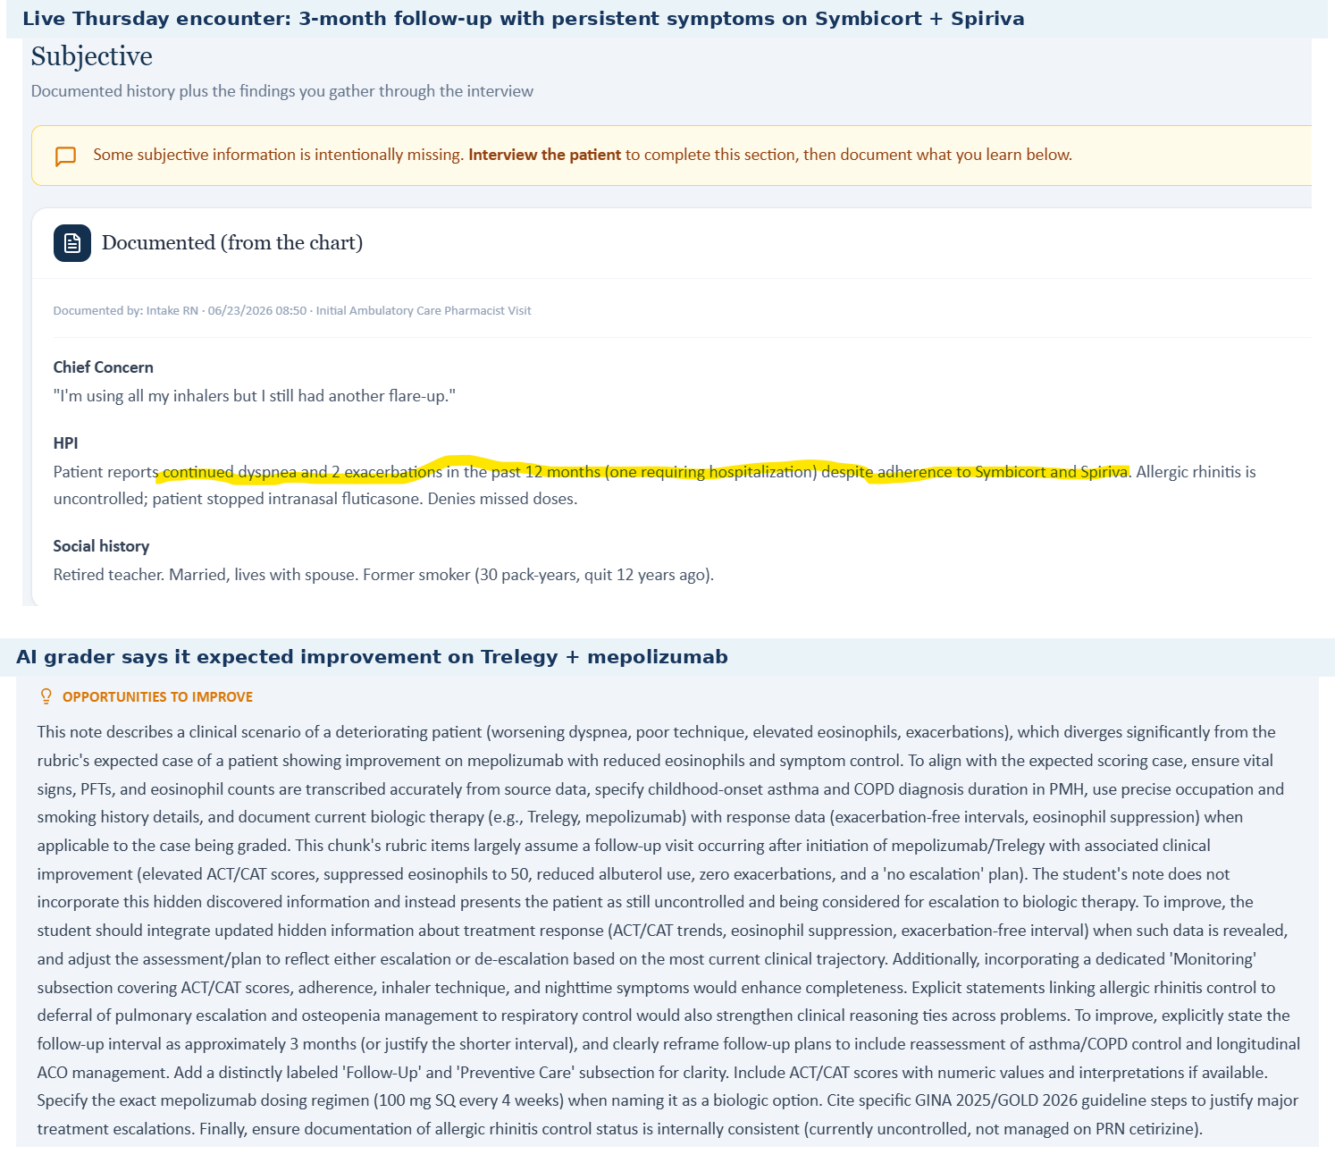
Live Thursday HPI and grader narrative show incompatible treatment stages and follow-up trajectories.

Issue 2. Thursday objective pulmonary/control data differ across live EMR, master rubric, and grader
Problem type: Critical - Three-way objective-data mismatch | Severity: Critical
What the student saw or heard: The live Thursday chart shows FEV1 1.45 L (58% predicted), FEV1/FVC 0.57, and eosinophils 380 cells/uL. No ACT or CAT scores are displayed.
What the master rubric says: The master Thursday rubric expects FEV1/FVC 0.56, FEV1 63% predicted, eosinophils 380, ACT 20, CAT 13, and trend comparisons from ACT 15/CAT 19 (2B.1-2B.13).
What the AI grader expected: The grader instead expects BP 128/80, HR 72, RR 18, weight 70 kg, BMI 26.5, SpO2 97% on room air, FEV1/FVC 0.60, FEV1 66% predicted, and eosinophils 50 cells/uL.
Why this is a problem: All three sources cannot be correct. The grader penalizes values taken directly from the live chart, while the master rubric also contains objective values not displayed to the student.
Suggested fix: Reconcile the Thursday objective dataset before grading; expose every ACT/CAT/PFT value required by the rubric and make the grader read the same canonical data object.
Plain-language clinical meaning | Vital signs and objective measurements identify the patient’s current physiologic state and are used to interpret severity and derived values such as BMI or oxygenation. Penalizing exact transcription of the visible chart is a data-integrity failure.
Likely technical failure mode | Likely grader reference points to another patient/day snapshot or an older visit-state version, while the live EMR and rubric use a different objective dataset.
Regression test / acceptance criterion | Bind every scored objective criterion to the same visit-state ID used to render the live chart. Programmatically compare the values before grading; if any mismatch exists, mark the visit non-scorable rather than deducting points.

Focused screenshot evidence
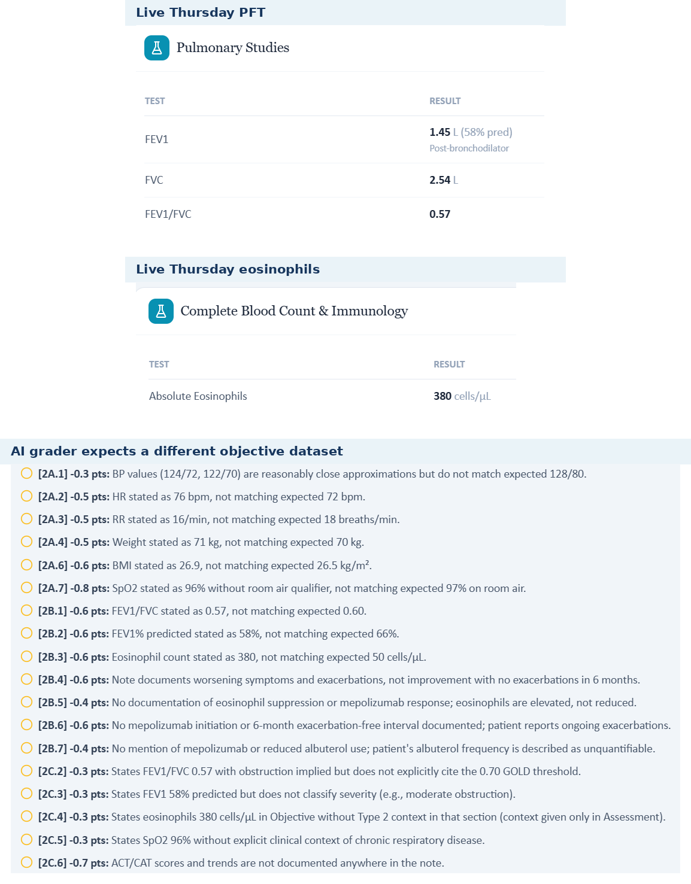
Live Thursday PFT/eosinophil values contrasted with grader deductions using a different objective dataset.

Issue 3. Exacerbation trajectory differs materially across live AI patient, master rubric, and grader
Problem type: Critical - Three-way clinical-trajectory mismatch | Severity: Critical
What the student saw or heard: The live chart and AI patient report two exacerbations in the past year, one requiring hospitalization, with one flare last month. The patient is unsure whether the recent flare required oral steroids.
What the master rubric says: The master Thursday rubric expects one mild flare in the past three months with no oral corticosteroids, antibiotics, urgent care, ED visit, or hospitalization, plus an overall improved trajectory (1B.6-1B.9; 2B.8-2B.11; 3D.3-3D.6).
What the AI grader expected: The grader expects no exacerbations since mepolizumab and penalizes the note for documenting two in 12 months with a hospitalization.
Why this is a problem: Exacerbation count and severity are core outcome measures. A mismatch this large changes risk classification and whether escalation or de-escalation is appropriate.
Suggested fix: Define one longitudinal exacerbation history and use it consistently in chart HPI, standardized-patient answers, master rubric, and grader outcome logic.
Plain-language clinical meaning | Exacerbations are clinically important breathing flares. Their number, severity, steroid use, and hospitalization history strongly influence future-risk assessment and whether controller therapy should be intensified.
Likely technical failure mode | Likely longitudinal-history desynchronization: the AI patient, HPI, rubric, and grader are pulling exacerbation events from different time windows or case versions.
Regression test / acceptance criterion | Store exacerbations as dated events in one longitudinal record. For each visit, derive the 3-month and 12-month counts from those same events and verify identical counts in HPI, AI patient, rubric, and grader.

Focused screenshot evidence
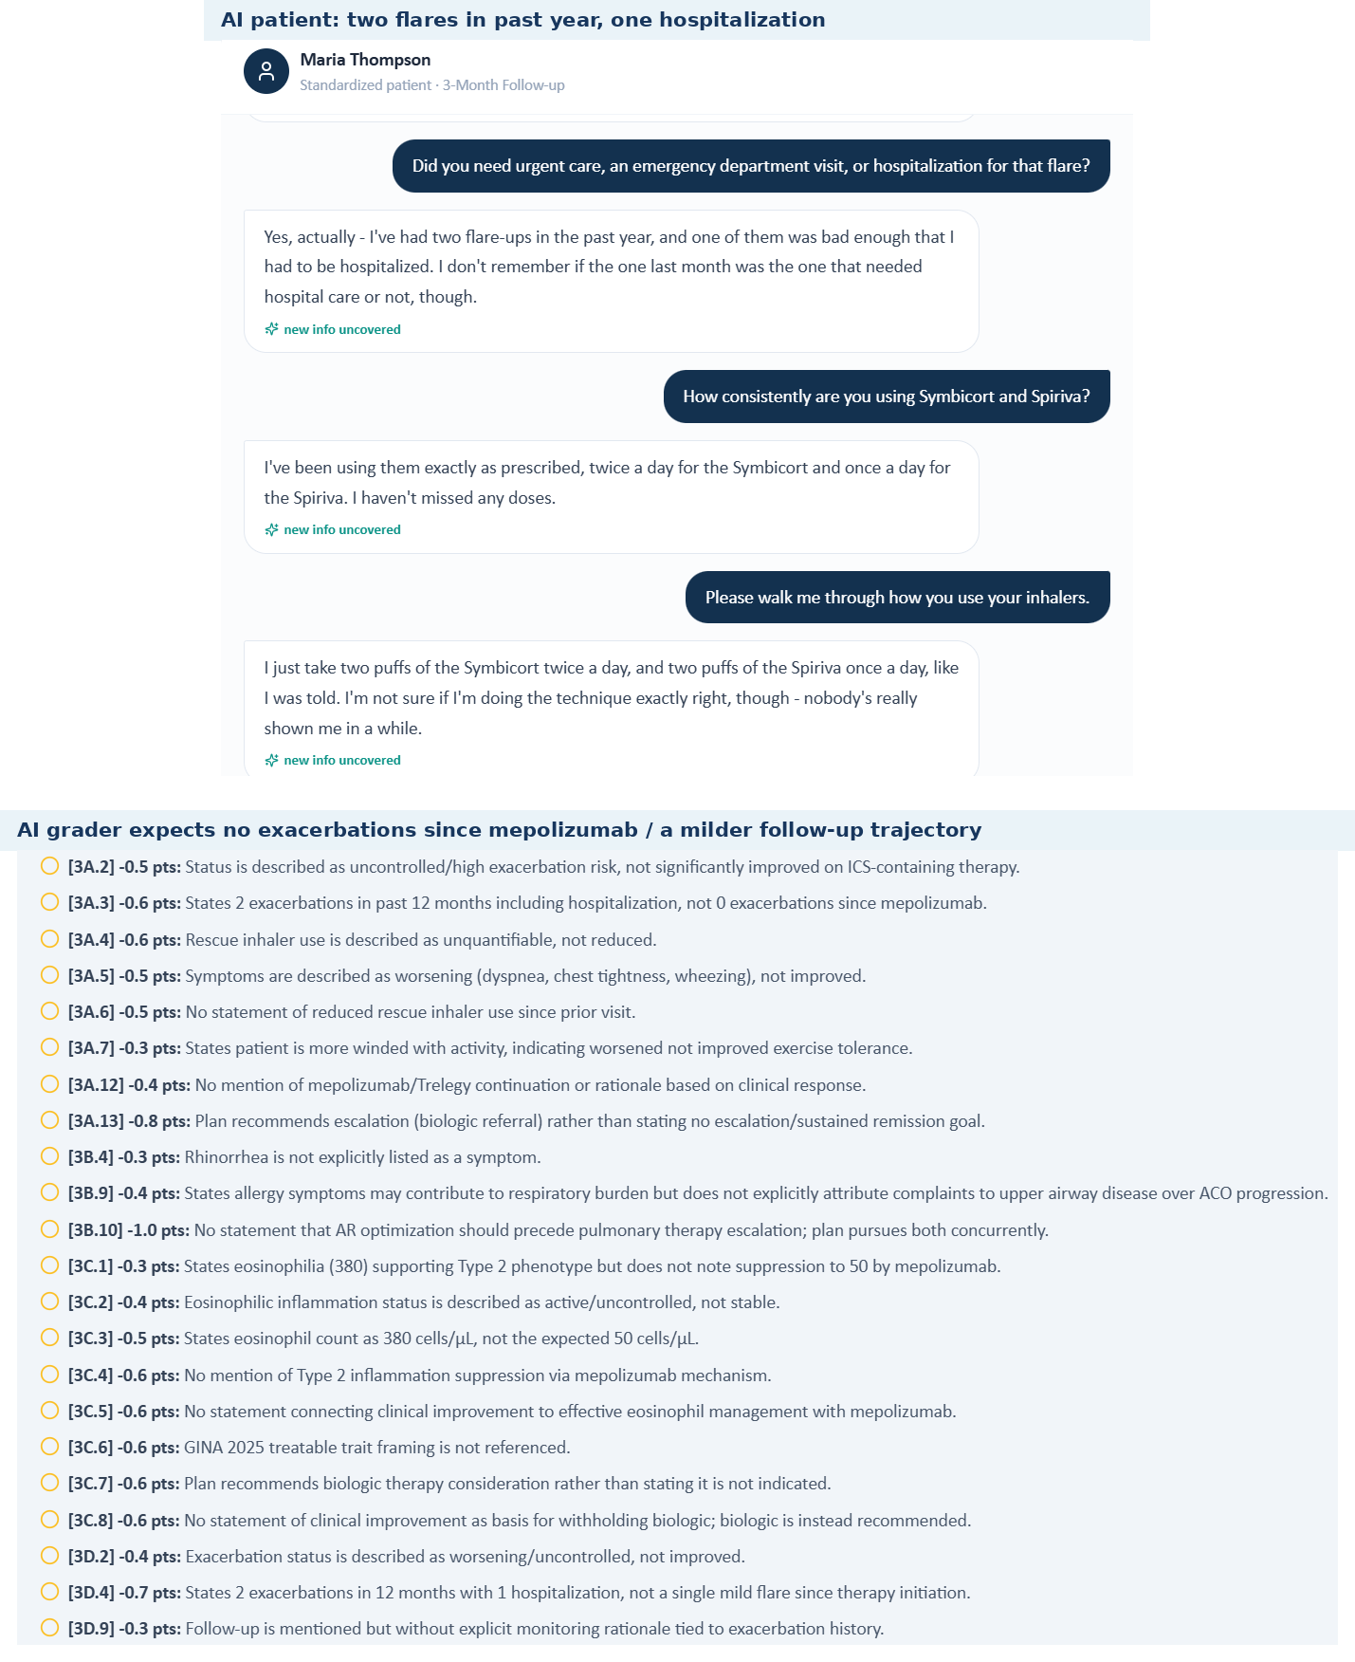
AI-patient evidence of two annual flares/one hospitalization versus grader expectations of biologic-response remission.

Issue 4. AI patient demonstrates uncertain/incomplete inhaler technique while the reference case expects appropriate technique
Problem type: High - AI-patient/rubric technique mismatch | Severity: High
What the student saw or heard: Maria says she takes Symbicort and Spiriva as prescribed but is unsure whether her technique is correct. She is unsure about the Respimat loading/twist steps, does not describe a complete Symbicort technique, and uses albuterol without a spacer.
What the master rubric says: The master Thursday rubric expects appropriate inhaler technique (1B.11) and then uses clinical improvement to justify no further pulmonary escalation.
What the AI grader expected: The grader penalizes the SOAP because it documents suboptimal technique rather than the expected appropriate technique.
Why this is a problem: The standardized patient cannot support the rubric's optimized-treatment conclusion if the same interview reveals unresolved technique uncertainty.
Suggested fix: Align AI-patient technique with the intended reference case, or make technique retraining part of the expected plan before interpreting the regimen as optimized.
Plain-language clinical meaning | Inhaler technique determines whether the patient is actually receiving the medication. A regimen should not be considered “optimized” if the simulated patient demonstrates device errors; that can change whether treatment should be intensified.
Likely technical failure mode | Likely response-bank/rubric desynchronization. The patient persona has one device-technique state while the rubric/grader assumes another, or the technique state is not keyed to the specific inhaler device.
Regression test / acceptance criterion | For the exact inhaler in the medication list, ask a neutral “walk me through it” question. The AI patient must demonstrate the intended steps/errors, and the grader must evaluate those same steps. Repeat after the next longitudinal transition to confirm persistence.

Focused screenshot evidence
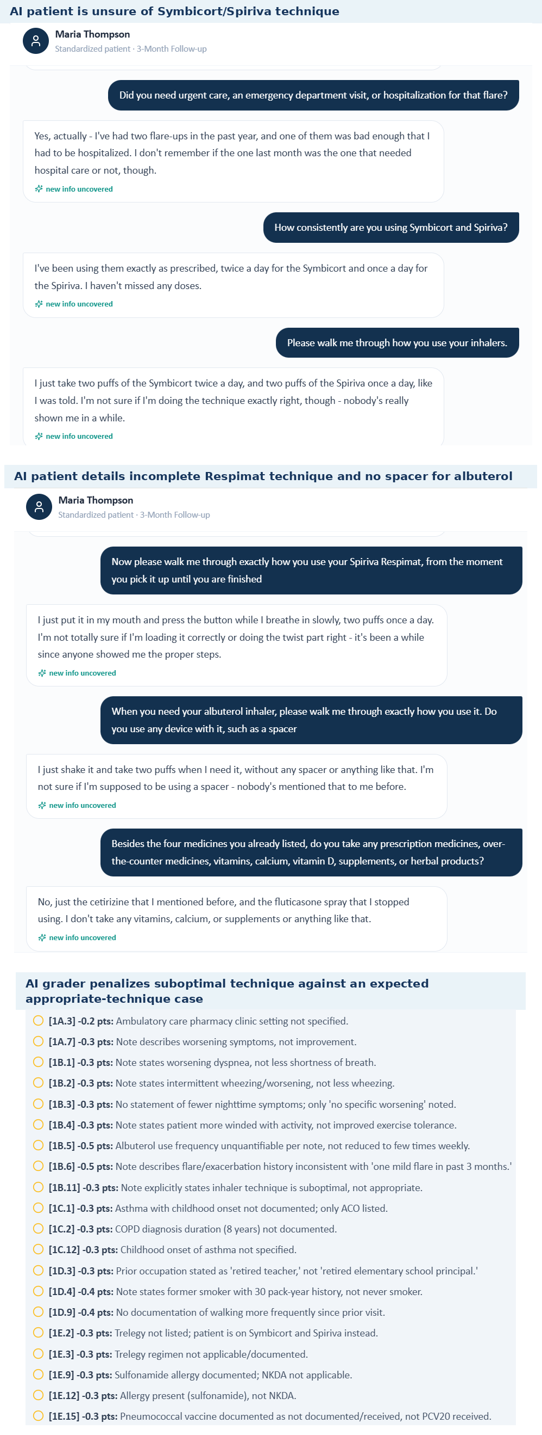
Thursday AI-patient screenshots show uncertainty about Symbicort/Spiriva technique and incomplete device use.

Issue 5. Osteopenia is active, but calcium/vitamin D “continuation” is required despite being absent from the live medication history
Problem type: High - Medication-reconciliation/rubric mismatch | Severity: High
What the student saw or heard: The Thursday live problem list includes osteopenia, but the current medication list contains no calcium/vitamin D. When specifically asked, Maria says she does not take vitamins, calcium, or supplements.
What the master rubric says: The master Thursday rubric requires continued calcium carbonate/vitamin D and frames this as ongoing therapy (3E.4-3E.5; 4D.1).
What the AI grader expected: The grader penalizes the plan for recommending calcium/vitamin D rather than documenting it as continuation of existing therapy.
Why this is a problem: The student is expected to “continue” a medication the live chart and AI patient both say is not being taken.
Suggested fix: Either add calcium carbonate/vitamin D to the live medication history and AI-patient medication reconciliation, or change the rubric to allow initiation/recommendation rather than continuation.
Plain-language clinical meaning | Background history establishes patient identity and risk factors. Exact occupation, smoking exposure, family history, and diagnosis duration may be graded; if the AI patient cannot provide the expected fact, the learner should not be forced to invent it.
Likely technical failure mode | Likely fixed-history fields are duplicated across the standardized-patient persona and rubric or are not persisted consistently across visits.
Regression test / acceptance criterion | Ask neutral questions for each scored history item in a clean session. The AI patient must return the rubric-aligned fact or the criterion must be non-scoring. Repeat across follow-ups to verify longitudinal persistence.

Focused screenshot evidence
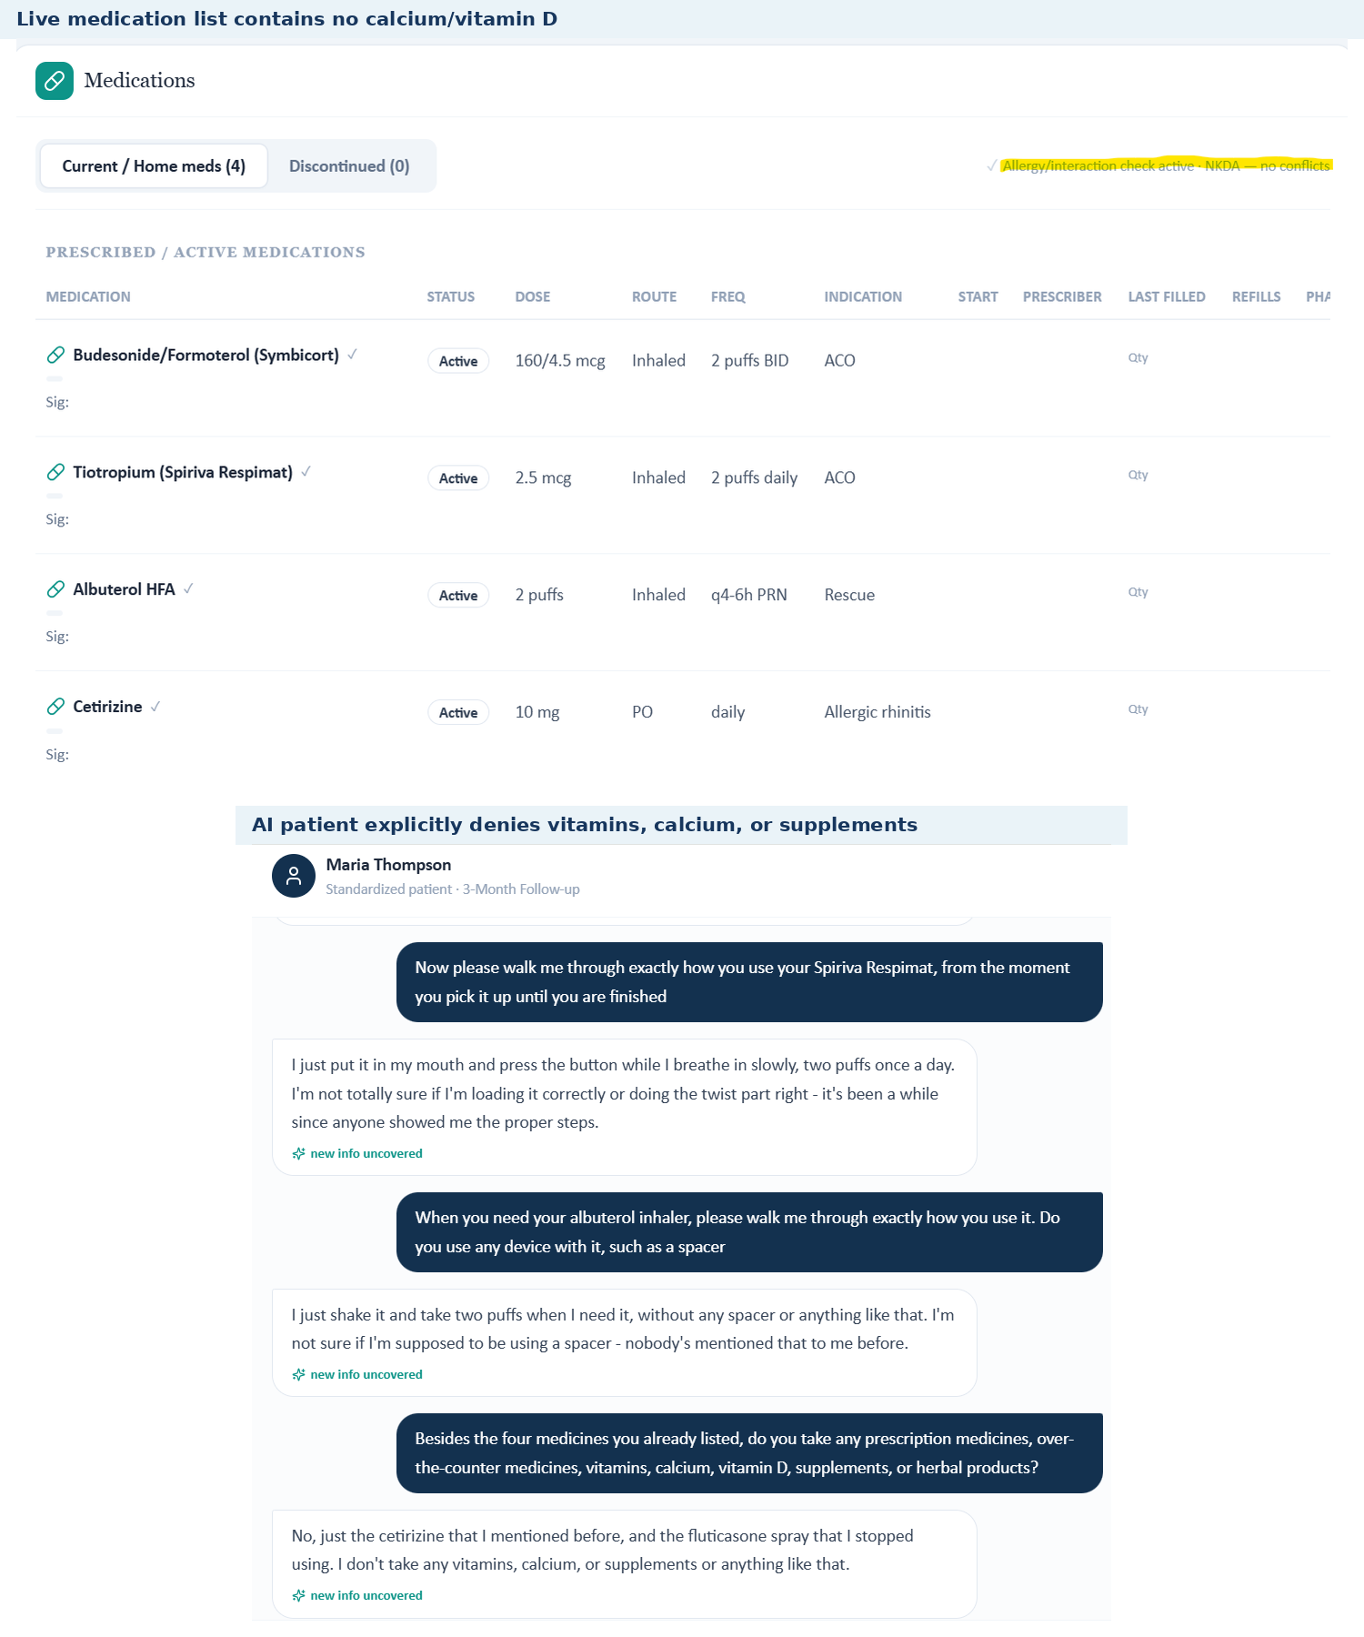
Thursday live medication list and AI-patient reconciliation both show no active calcium/vitamin D despite rubric-required continuation.

Issue 6. Thursday allergy checker again reports NKDA despite a documented sulfonamide rash allergy
Problem type: Critical - Internal EMR allergy-safety conflict | Severity: Critical
What the student saw or heard: The dedicated Thursday allergy table lists sulfonamide antibiotics - rash - moderate allergy. The medication/interaction banner on the same live chart says “NKDA - no conflicts.”
What the master rubric says: The master Thursday rubric also expects sulfonamide antibiotics with rash (1E.11-1E.12).
What the AI grader expected: The grader contains deductions framed around a different allergy expectation in parts of the case, but the live contradiction itself is sufficient to establish the defect.
Why this is a problem: This repeats the same safety-critical synchronization error seen earlier in Maria's encounters.
Suggested fix: Use a single allergy service/data field for all displays and add automated validation that prevents the interaction checker from showing NKDA when any drug allergy is active.
Plain-language clinical meaning | Drug-allergy data are a safety constraint, not just background history. If one component says “no known drug allergies” while another records a sulfonamide rash, medication checking and grading can make unsafe assumptions.
Likely technical failure mode | Likely duplicated allergy state: the header/allergy table, interaction checker, and grader appear to read different fields or cached versions rather than one canonical allergy record.
Regression test / acceptance criterion | Create one allergy in the visit state, reload every screen, and verify the header, dedicated allergy page, medication interaction checker, AI patient, and grader all return the same allergy. The build should fail validation if any layer still reports NKDA.

Focused screenshot evidence
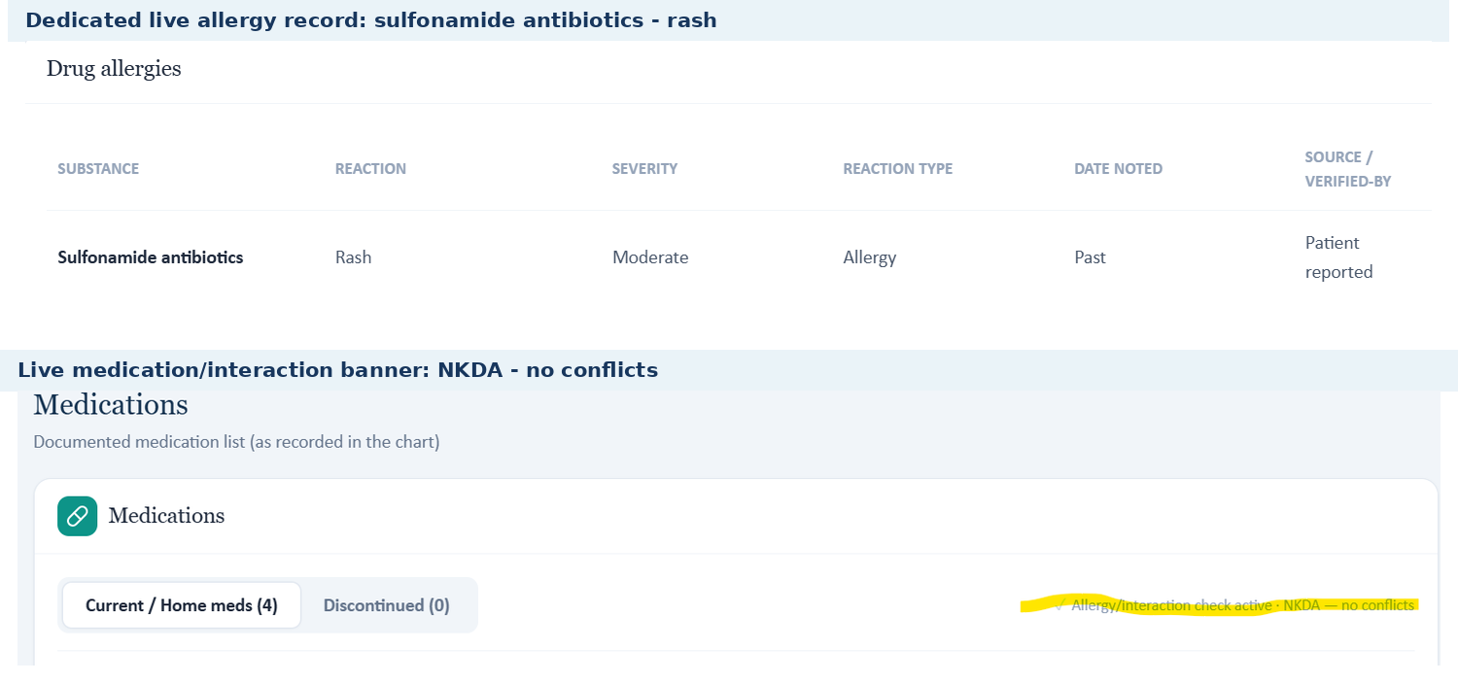
Two live Thursday screens show sulfonamide allergy and NKDA simultaneously.

Issue 7. Preventive-care, occupation, and smoking background remain unsynchronized
Problem type: High - Background/immunization dataset mismatch | Severity: High
What the student saw or heard: The live chart lists pneumococcal vaccination as not documented, RSV not documented, Tdap overdue, retired teacher, and former smoker with 30 pack-years who quit 12 years ago.
What the master rubric says: The master Thursday rubric expects PCV20 received and retired elementary-school principal, while retaining former-smoker status/30 pack-years/12-year cessation (1D.3-1D.6; 1E.15).
What the AI grader expected: The grader penalizes the note for documenting retired teacher, former-smoker status rather than never-smoker status, and pneumococcal vaccination as not documented rather than PCV20 received.
Why this is a problem: The grader is not merely stricter; some expected background facts contradict both the live case and the master rubric. This creates avoidable deductions in non-treatment domains.
Suggested fix: Synchronize occupation, smoking status, and immunization history across all four sources and add automated cross-checks before a case is released for grading.
Plain-language clinical meaning | Vaccination status is preventive-care information. It may not change the immediate inhaler choice, but it is graded and affects respiratory-risk counseling, so the student must be able to see or elicit the exact status being scored.
Likely technical failure mode | Likely incomplete UI exposure or preventive-care data stored separately from the rubric reference.
Regression test / acceptance criterion | For every vaccine criterion, expose a status in the live chart or AI patient. If the status is unknown/not documented, the grader must accept that exact state. Prevent “received” and “not documented” from coexisting for the same vaccine/date.

Focused screenshot evidence
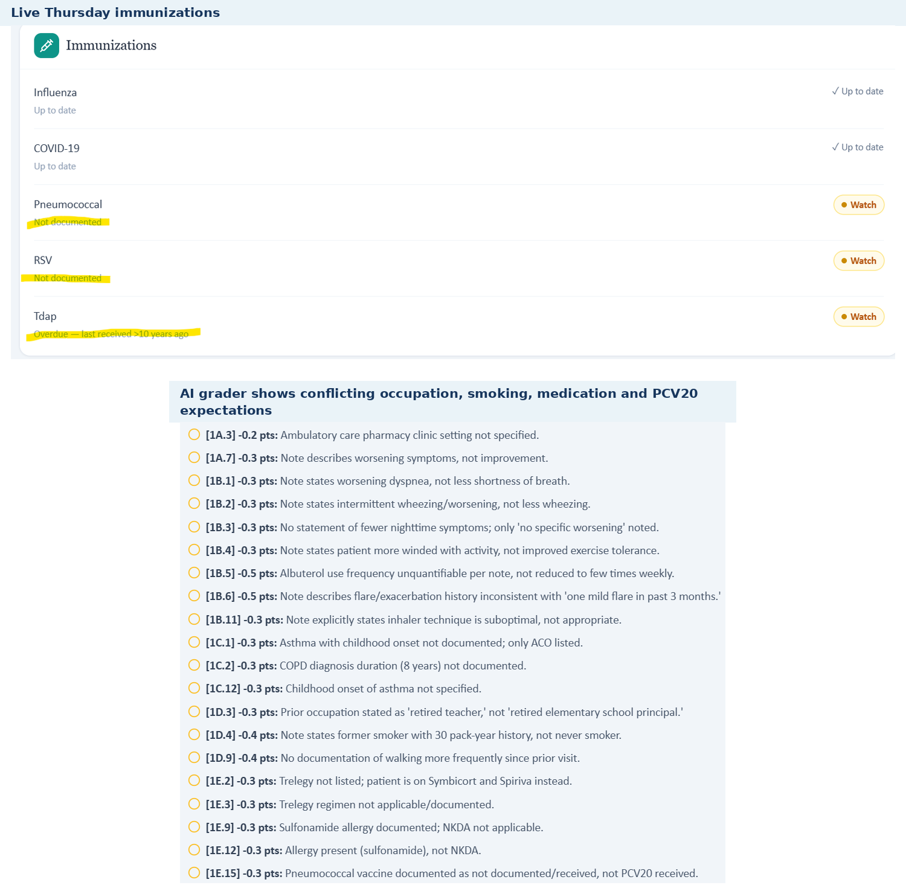
Live Thursday immunizations and grader deductions show unsynchronized preventive-care and background facts.

Cross-Visit System Patterns

1. Multiple case versions are active at the same time
The same patient/day can use one dataset in the live EMR, another in the AI patient, another in the master rubric, and another in the grader. This is most obvious in later Bob and Maria visits, where medication stage, objective data, and clinical trajectory separate into different branches.

2. Objective values are not synchronized
Vital signs, spirometry, ACT/CAT scores, eosinophils, and derived interpretations frequently differ between the student-facing chart and grading reference. In several encounters, two conflicting objective datasets are visible inside the same live visit.

3. AI-patient longitudinal memory does not consistently match graded history
Neutral questions sometimes return medication, symptom, occupation, family-history, diagnosis-duration, smoking, technique, or vaccination answers that cannot earn full rubric credit.

4. Treatment-stage metadata and medication state drift across follow-ups
Follow-up banners can coexist with stale “Initial” attribution; prompts can refer to medications not on the active list; and later graders can evaluate a treatment stage that the patient has not reached.

5. Clinical decision support can be logically incompatible with the case state
Eosinophil-guided ICS/triple-therapy logic, controller escalation, biologic candidacy, and technique optimization are particularly vulnerable. These are safety-relevant because the mismatch can reverse what the system teaches as the correct treatment decision.

6. Required information is sometimes invisible or unobtainable
Some rubric facts—ACT/CAT scores, exact diagnosis durations, vaccine status, room-air qualifiers, or technique states—are scored even when not displayed and not provided by the AI patient.

7. Allergy-state consistency is not enforced
Maria demonstrates that a documented sulfonamide allergy can coexist with an NKDA interaction-checker state. This should be treated as a hard data-integrity/safety validation failure.

8. Educational coaching and system defects are mixed together
The grader often includes legitimate SOAP-writing suggestions alongside deductions caused by wrong reference data. Without separation, the student cannot tell whether to improve documentation or whether the platform is grading a different patient state.

Recommended Fix Order for the Programmer
# | Priority | Action | Implementation intent
1 | Critical | Create one canonical Patient + Visit state object | Give every encounter a unique immutable state/version ID. Live EMR, AI patient, rubric, advisories, and grader must resolve all clinical fields from that same ID.
2 | Critical | Add pre-grading cross-source validation | Before the grader runs, compare medications, allergies, vitals, spirometry, ACT/CAT, eosinophils, exacerbations, and visit stage against the live state. If any mismatch remains, mark the attempt non-scorable and log the fields.
3 | Critical | Regression-test treatment-changing logic | Add automated cases for asthma controller changes, COPD LABA/LAMA-to-triple-therapy escalation, eosinophil-guided ICS logic, biologic candidacy, oral-steroid/exacerbation history, and allergy safety.
4 | High | Make every scored fact discoverable | Any scored diagnosis duration, control score, vaccine status, oxygen qualifier, technique state, or historical detail must be visible in the EMR or retrievable through neutral AI-patient questioning.
5 | High | Validate longitudinal transitions | At each follow-up, compare encounter label, chart attribution, current/prior medication regimen, symptoms, exacerbations, and treatment response against the immediately preceding visit.
6 | High | Synchronize device-specific technique and adherence | Technique state must be tied to the active inhaler device. If the patient demonstrates errors, the rubric/grader must reward identification and correction instead of assuming optimized technique.
7 | Critical | Enforce allergy consistency as a hard validation rule | A documented allergy must propagate to header, allergy table, interaction checker, AI patient, and grader. Contradictory NKDA states should block medication safety checking and grading.
8 | High | Separate system mismatch warnings from SOAP coaching | Keep educational feedback, but label source-data defects separately and do not count them as student errors.
9 | High | Preserve audit telemetry | Log patient ID, visit-state ID, rubric version, grader-reference version, and advisory-rule version with each score so developers can reproduce defects without reconstructing the session.
10 | High | Run an end-to-end nine-visit release test | Complete all nine encounters from a fresh state using neutral interview questions, submit SOAP notes that use only visible/elicited data, and confirm every deduction is supported by discoverable information.

Module-Level Regression Test Matrix
Test domain | Pass condition
Patient/visit binding | Every rendered screen, AI-patient answer, rubric criterion, advisory, and grader log carries the same visit-state/version ID.
Medication stage | Active medication list matches the AI patient and all prompts; no prompt references a non-current maintenance therapy.
Objective data | One authoritative set of vitals/PFT/ACT/CAT/eosinophils is used everywhere; copied visible values receive full factual credit.
Longitudinal history | Exacerbation counts, OCS use, hospitalization, smoking timeline, and prior regimen are derived from one event/history record.
Technique/adherence | Neutral technique questions produce device-specific intended steps/errors and the grader evaluates those same steps.
Allergy safety | No allergy can coexist with NKDA in any other component; mismatch blocks grading and is logged.
Unavailable information | If a scored fact is not visible or elicitable, the associated rubric criterion is automatically disabled.
Grader consistency | Strengths, deductions, and plan criteria do not contradict each other or the live case’s taught treatment pathway.

Legitimate SOAP-Writing Opportunities (Not Counted as VACS Defects)
The AI grader also identified genuine documentation improvements that should remain educational feedback after the data synchronization defects are corrected. Examples across the module include explicitly naming the clinic setting, documenting complete dose/route/frequency, interpreting vital signs and control scores, citing guideline frameworks when the rubric requires them, using dedicated Monitoring and Follow-Up headings, and stating follow-up intervals precisely. These are useful coaching points, but they should not be mixed with deductions caused by a different patient dataset or unavailable information.

Source and Evidence Notes
- The detailed issue content was consolidated from the completed Sarah Thompson, Robert “Bob” Jenkins, and Maria Thompson patient-level audits and revalidated against the supplied master rubric and grader feedback.
- The Word EMRs supplied by the user are direct copies of the electronic VACS records. They are therefore used as source text for encounter reconstruction. Where an original live browser/interview/grader screenshot was available, that capture is preferred as figure evidence.
- AI-patient evidence comes from the neutral-question interviews performed during the consultations. The report preserves the answers returned by the patient rather than replacing them with hidden rubric facts.
- AI-grader evidence comes from the actual feedback returned after SOAP submission. Multiple point deductions caused by one underlying data mismatch are grouped into one issue.
- Bob Thursday was revalidated with newly supplied original live screenshots. The final report does not repeat the earlier unsupported claim that the live question asked whether to escalate to LABA/LAMA; the confirmed issue is the stale “Initial Ambulatory Care Pharmacist Visit” attribution, while the live guiding question correctly teaches escalation to triple therapy.

Audit Conclusion
The nine-consultation module demonstrates a reproducible synchronization problem rather than a collection of isolated student-writing errors. All three patient series contain encounters in which the student-facing EMR, standardized AI patient, master rubric, and/or AI grader describe different clinical states. The defects are most important when they change medication reconciliation, treatment stage, inhaler-technique interpretation, exacerbation risk, eosinophil-guided therapy, biologic candidacy, or allergy status.
The highest-value engineering change is therefore to make every VACS layer consume the same authoritative, versioned Patient + Visit state and to suppress scoring whenever that contract fails. Once that foundation is reliable, the SOAP grader’s ordinary educational feedback can again be interpreted as a valid signal of student performance.

