VACS Week 1 SOAP grading report
Virtual Ambulatory Care Simulator / November 9, 2026
VACS awarded 100% in six of nine encounters. Three itemized deductions show that a perfect score was not automatic. All nine results carried the rating “Strong.”

Scores by patient and day
Patient | Tuesday | Wednesday | Thursday | Evidence pages
MG | 100% | 100% | 100% | 2–4
JW | 100% | 99.7% | 100% | 5–7
LM | 99.5% | 99.1% | 100% | 8–10

Why the grader deducted points
Encounter | Rubric item | Points | Reason given
LM Tuesday | 3A.13 | −0.5 | The assessment listed kidney disease first without naming combined kidney and cardiovascular risk reduction as the highest-impact opportunity.
JW Wednesday | 3F.4 | −0.3 | The assessment did not link the 2.5 kg loss to both increased activity and dietary changes.
LM Wednesday | 4F.3 | −0.9 | The patient education plan omitted an explicit statement that kidney and cardiovascular risk persisted despite improvement.

Medication discrepancies at full credit
On Tuesday, JW’s feedback flagged empagliflozin as active in the medication list even though cost had prevented him from starting it. MG’s feedback flagged a mismatch between the reported ibuprofen dose range and the listed dose. Both encounters received 100%.

What the screenshots show
The 18 captures pair a grade with feedback for each encounter.

MG on Tuesday
The grader praised the medication reconciliation, then flagged a dose discrepancy. The history gave an ibuprofen range of 400–600 mg, while the Objective medication list gave a single lower dose. It also suggested clarifying whether the knee symptom was pain, stiffness, or both.
Grading result 100% MG_AI Feedback_Tue_01.png
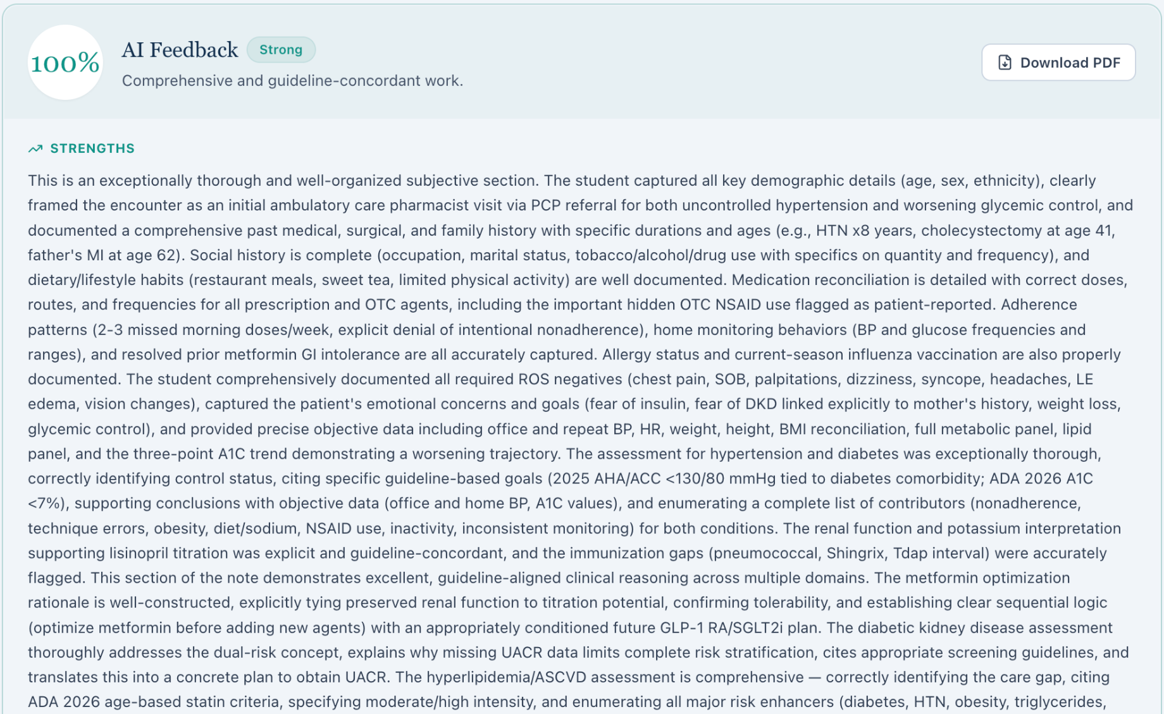
Opportunities to improve MG_AI Feedback_Tue_02.png
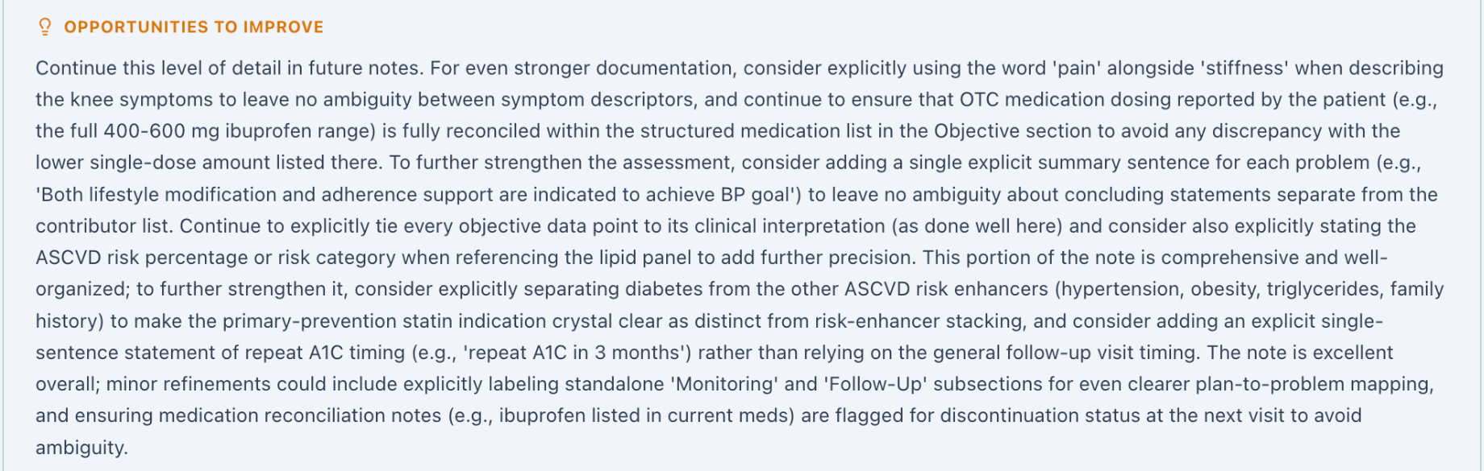

MG on Wednesday
The grader credited the note for tracking A1C from 8.2% to 7.5% and LDL cholesterol from 112 to 78 mg/dL. It suggested recording medication tolerability within the hypertension assessment and the patient’s interest in weight treatment within the lifestyle plan.
Grading result 100% MG_AI Feedback_Wed_01.png
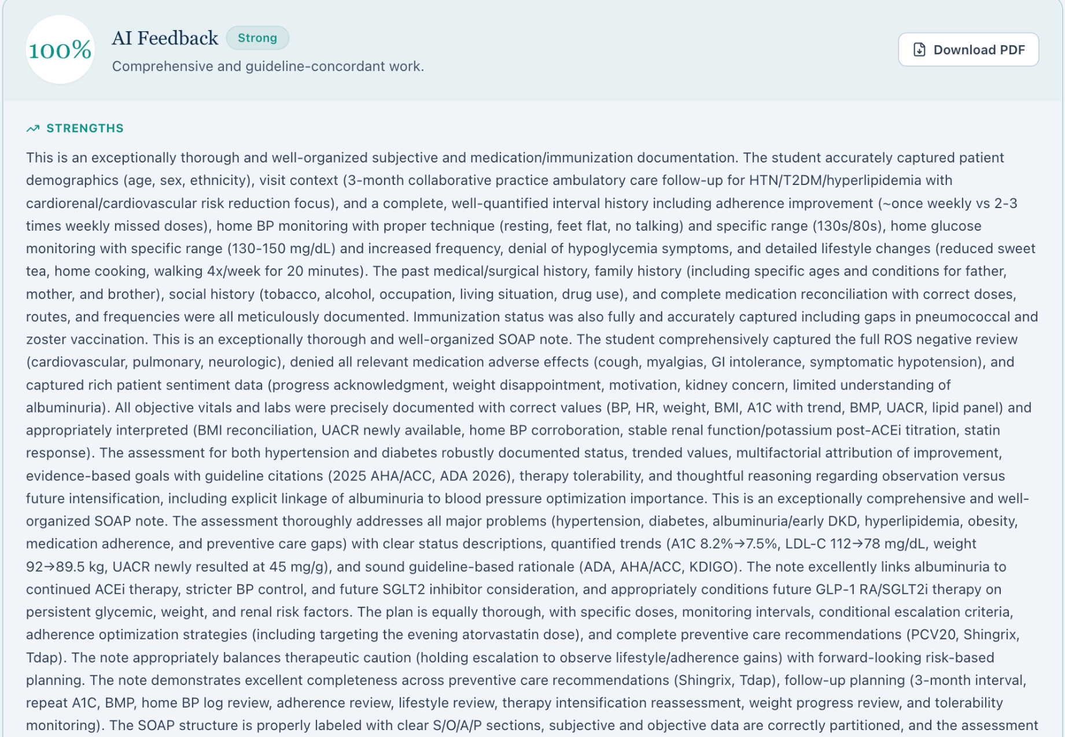
Opportunities to improve MG_AI Feedback_Wed_02.png
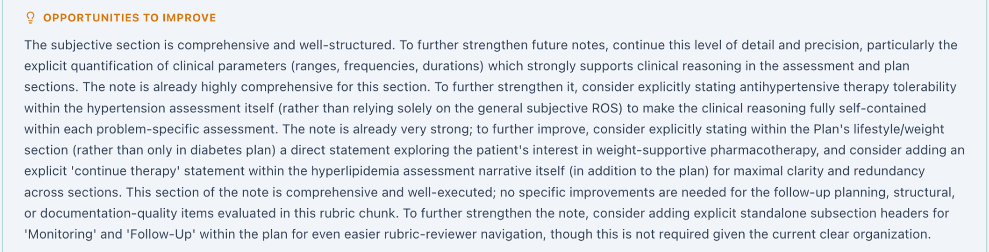

MG on Thursday
The grader credited the note for recording interest in a GLP-1 receptor agonist. It suggested explaining how the patient’s comfort with injections informed the choice of therapy, documenting home blood pressure monitoring in Subjective, and labeling initial and repeat office readings consistently.
Grading result 100% MG_AI Feedback_Thu_02.png
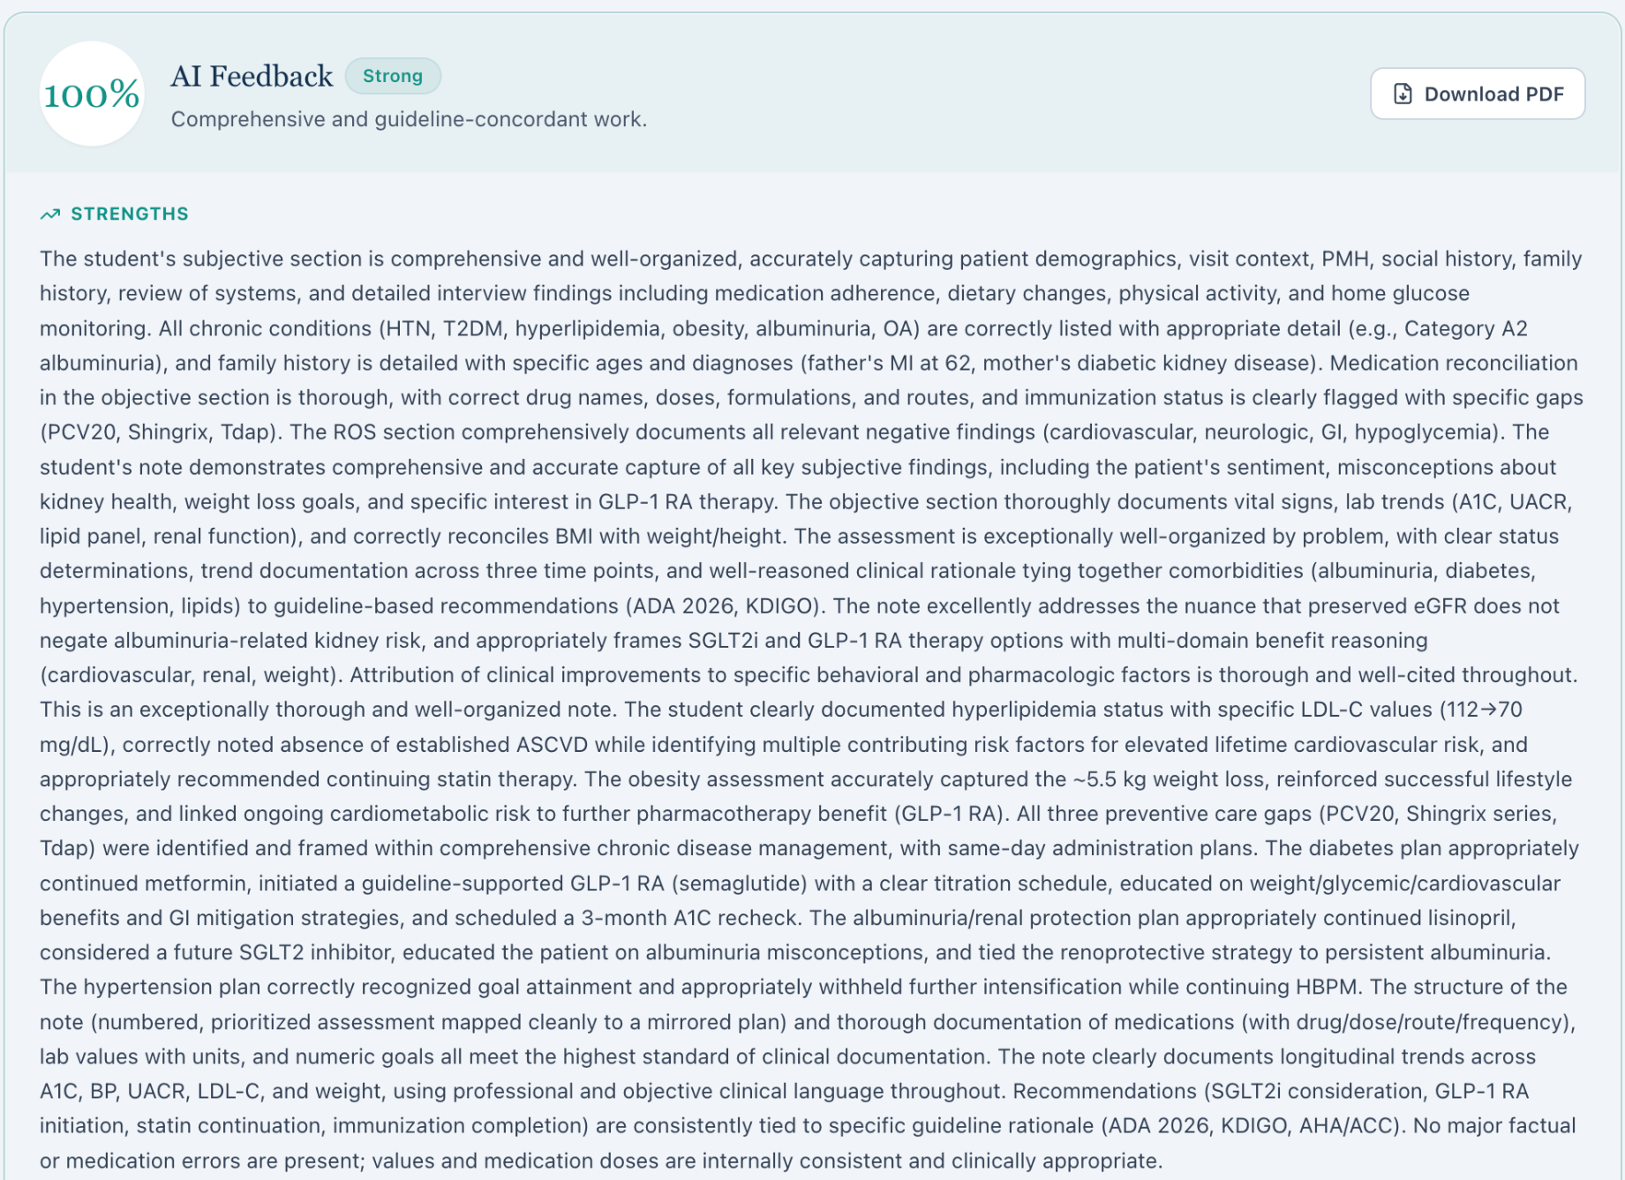
Opportunities to improve MG_AI Feedback_Thu_01.png
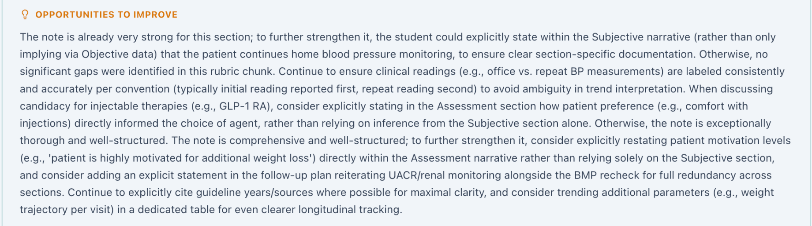

JW on Tuesday
The strengths panel described the active medication list as fully reconciled. The improvement panel said the patient had never started empagliflozin because of cost, even though the Objective list showed 10 mg daily as active. The grader flagged the conflict and awarded full credit.
Grading result 100% JW_AI Feedback_Tue_01.png
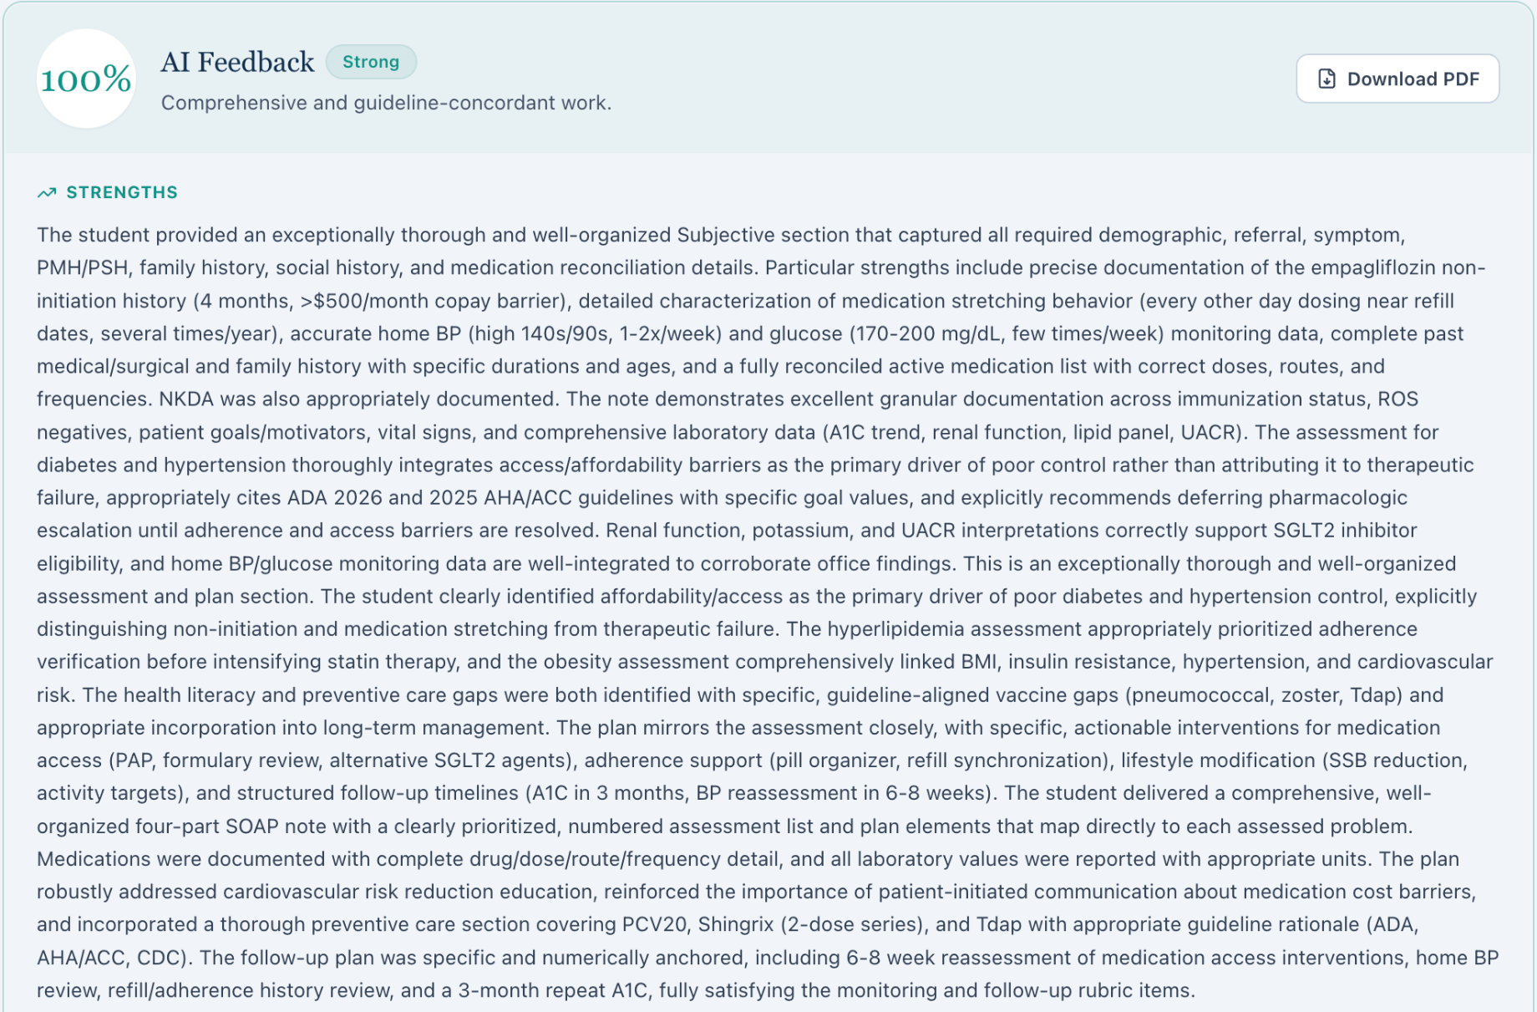
Opportunities to improve JW_AI Feedback_Tue_02.png
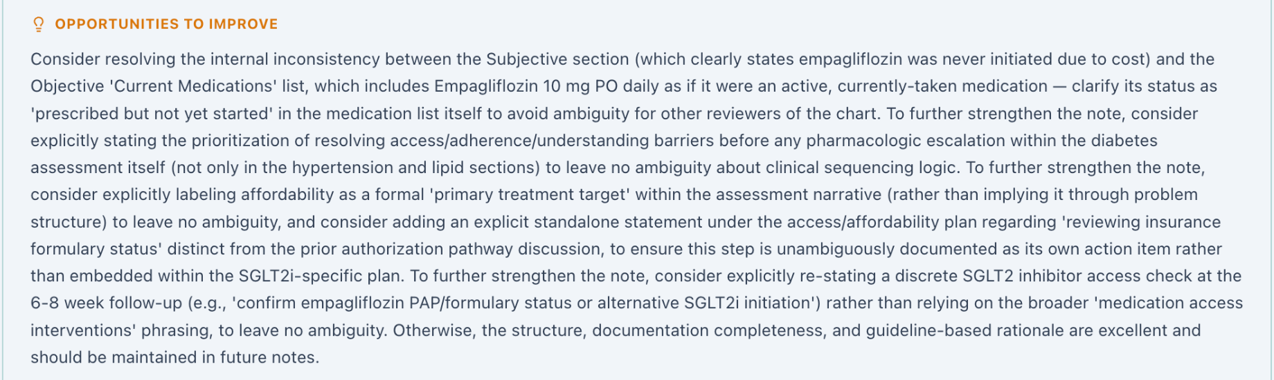

JW on Wednesday
The grader deducted 0.3 points because the obesity assessment did not explicitly link the 2.5 kg weight loss to both increased walking and dietary changes. The feedback acknowledged that those behaviors appeared elsewhere in the note.
Grading result 99.7% JW_AI Feedback_Wed_01.png
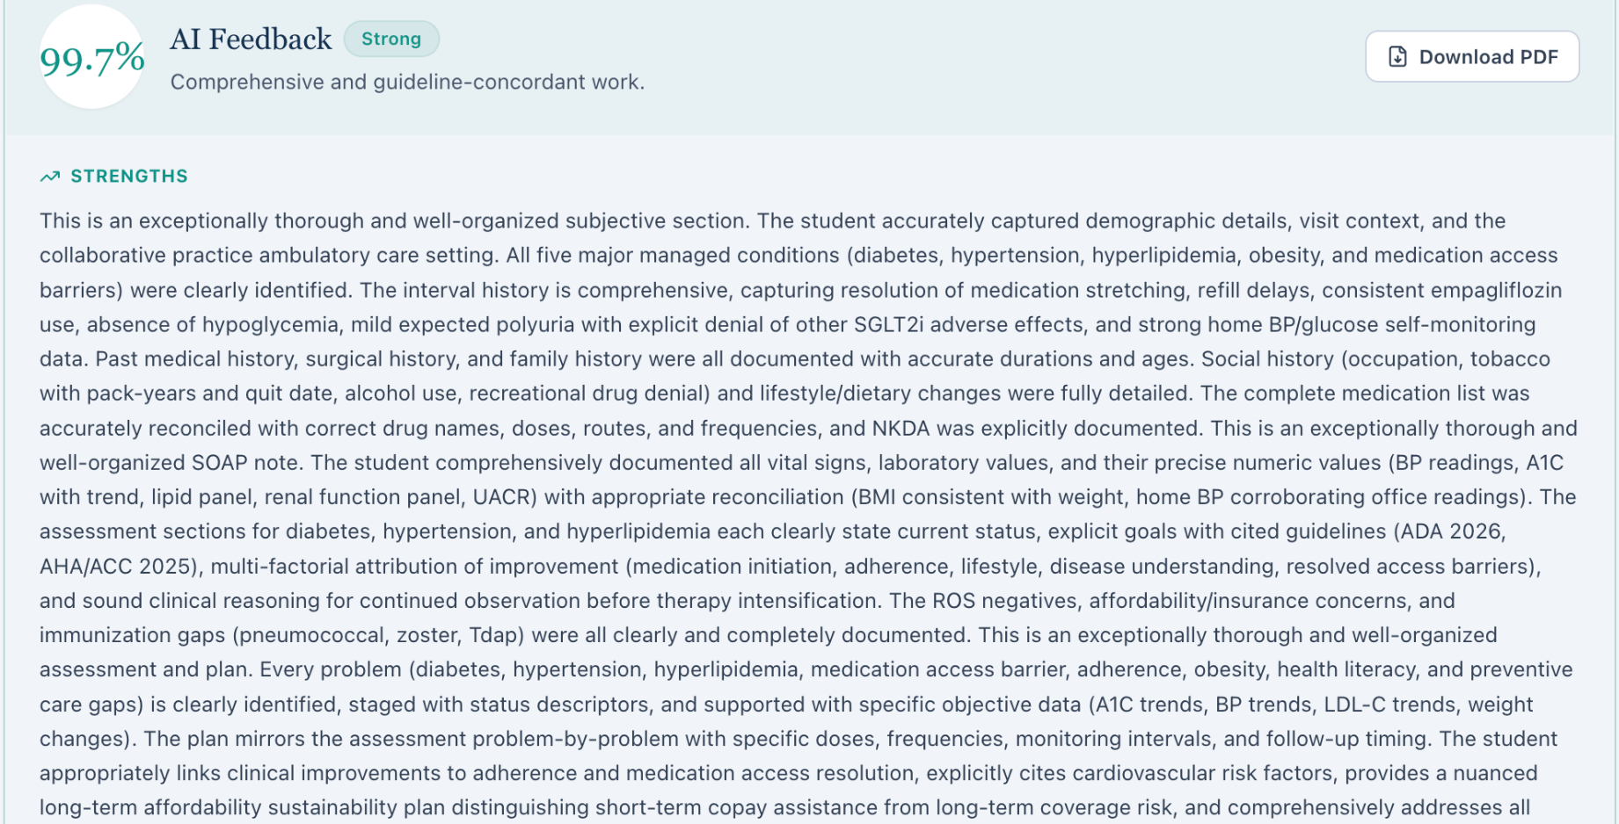
Rubric item 3F.4 −0.3 points JW_AI Feedback_Wed_02.png
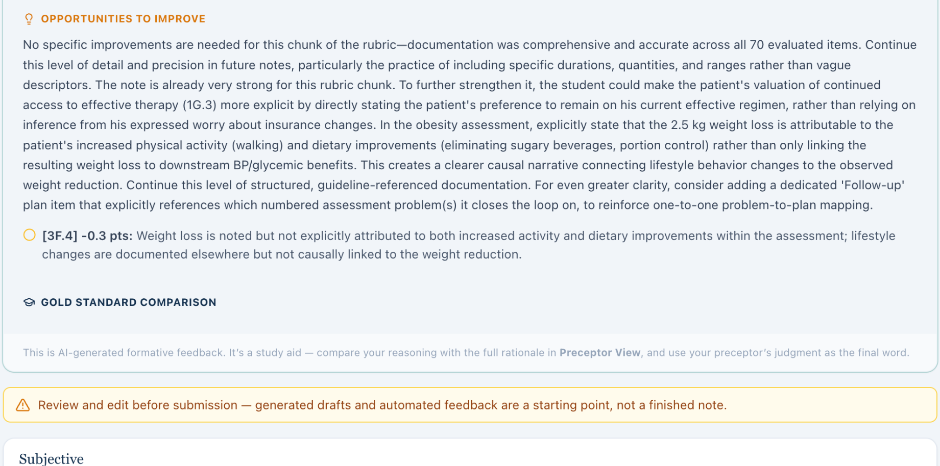

JW on Thursday
The grader credited the plan to reassess medication affordability and suggested naming backup assistance options in the Plan. At the bottom of the second screenshot, part of the first Subjective line identifies James Wilson and a six-month follow-up.
Grading result 100% JW_AI Feedback_Thu_01.png
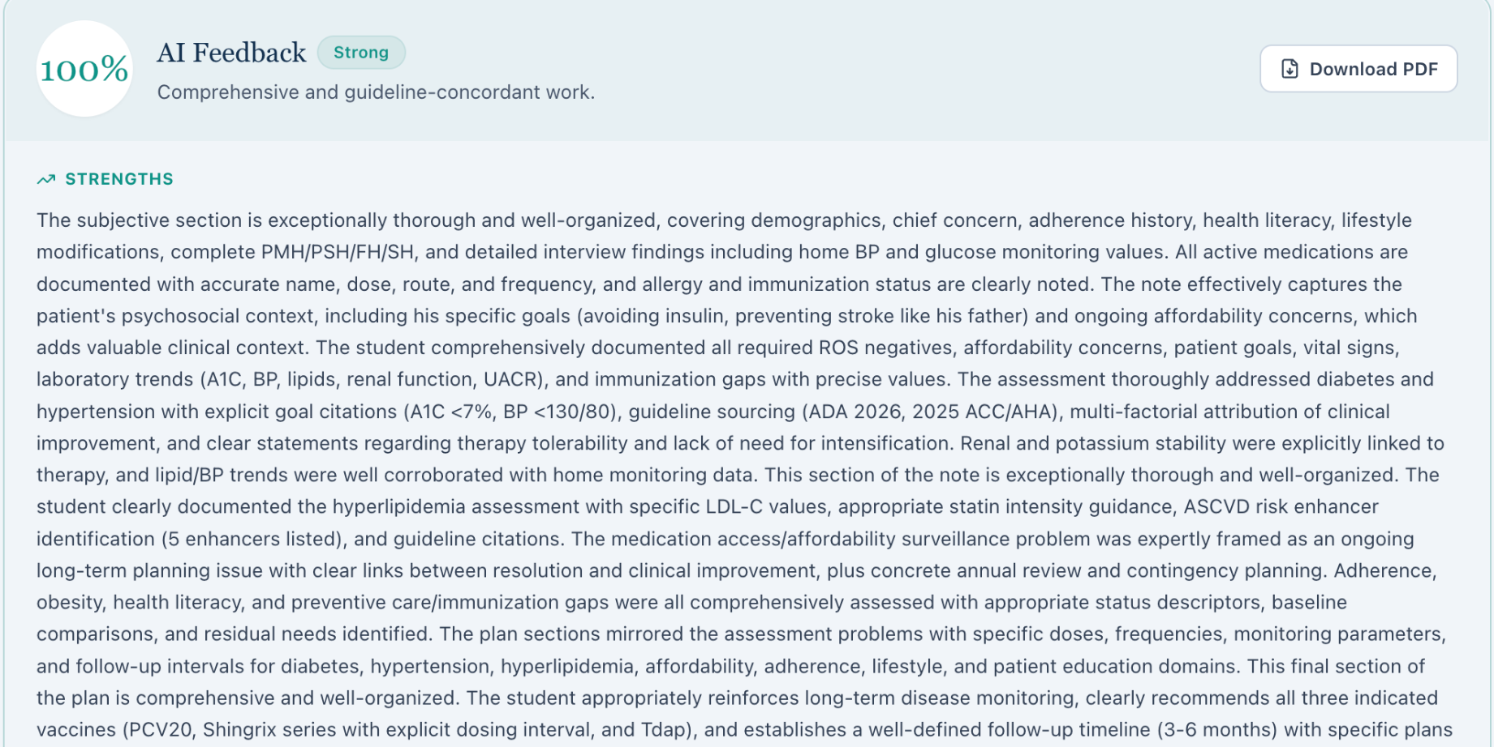
Opportunities to improve JW_AI Feedback_Thu_02.png
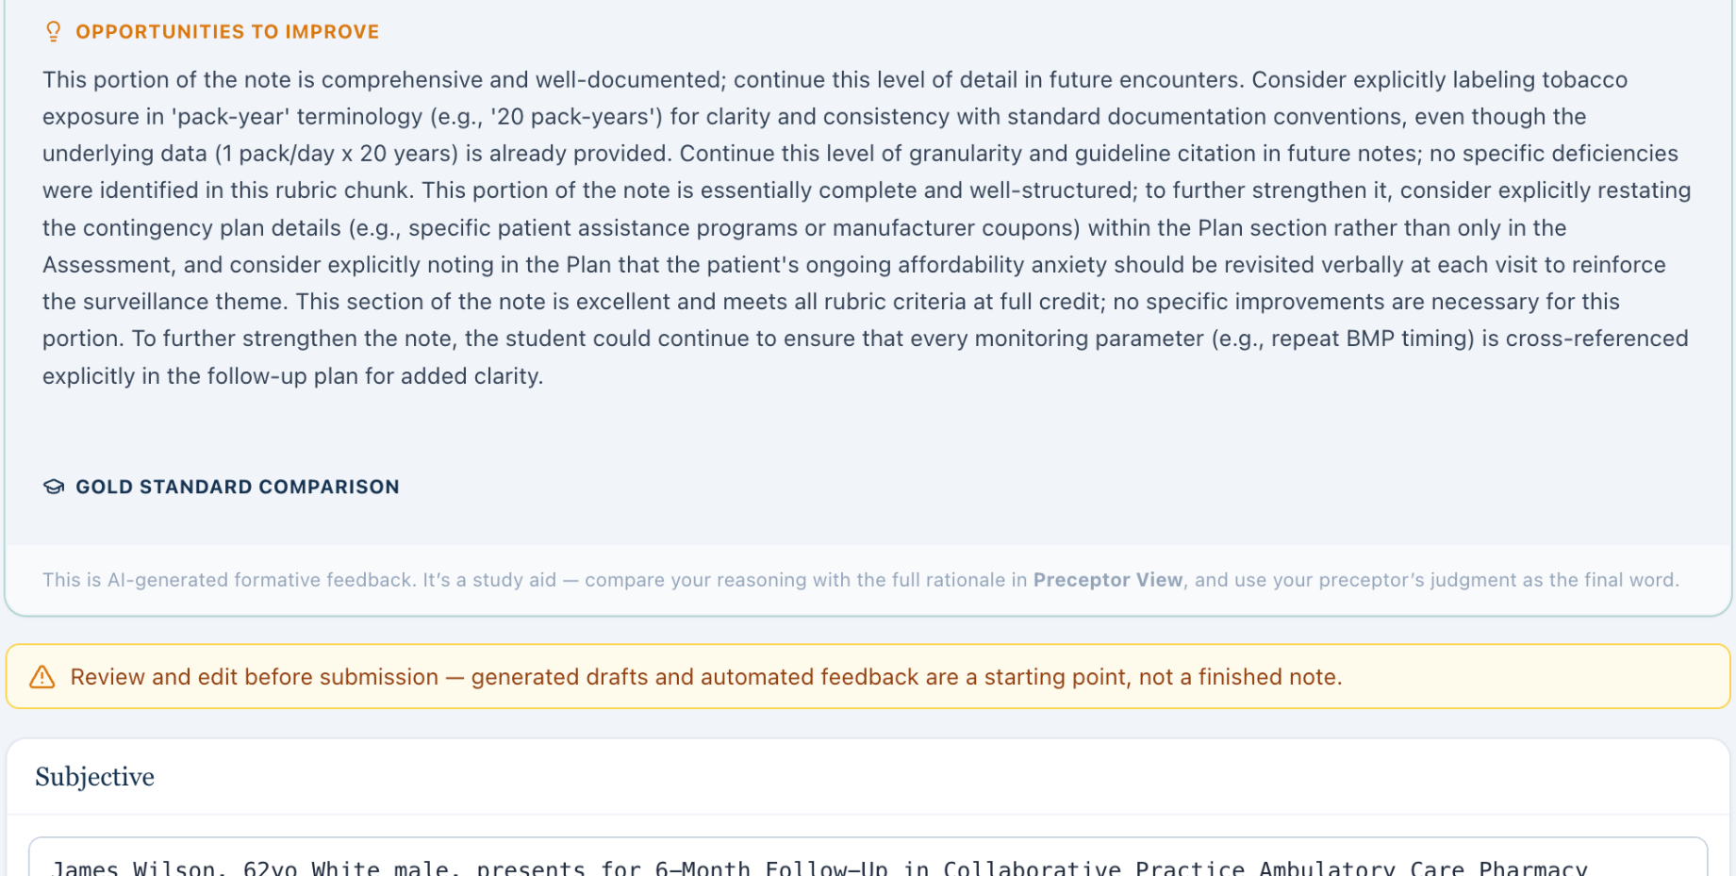

LM on Tuesday
The grader recognized that chronic kidney disease appeared first in the assessment. It deducted 0.5 points because the assessment did not explicitly name reducing kidney and cardiovascular risk together as the highest-impact treatment opportunity.
Grading result 99.5% LM_AI Feedback_Tue_01.png
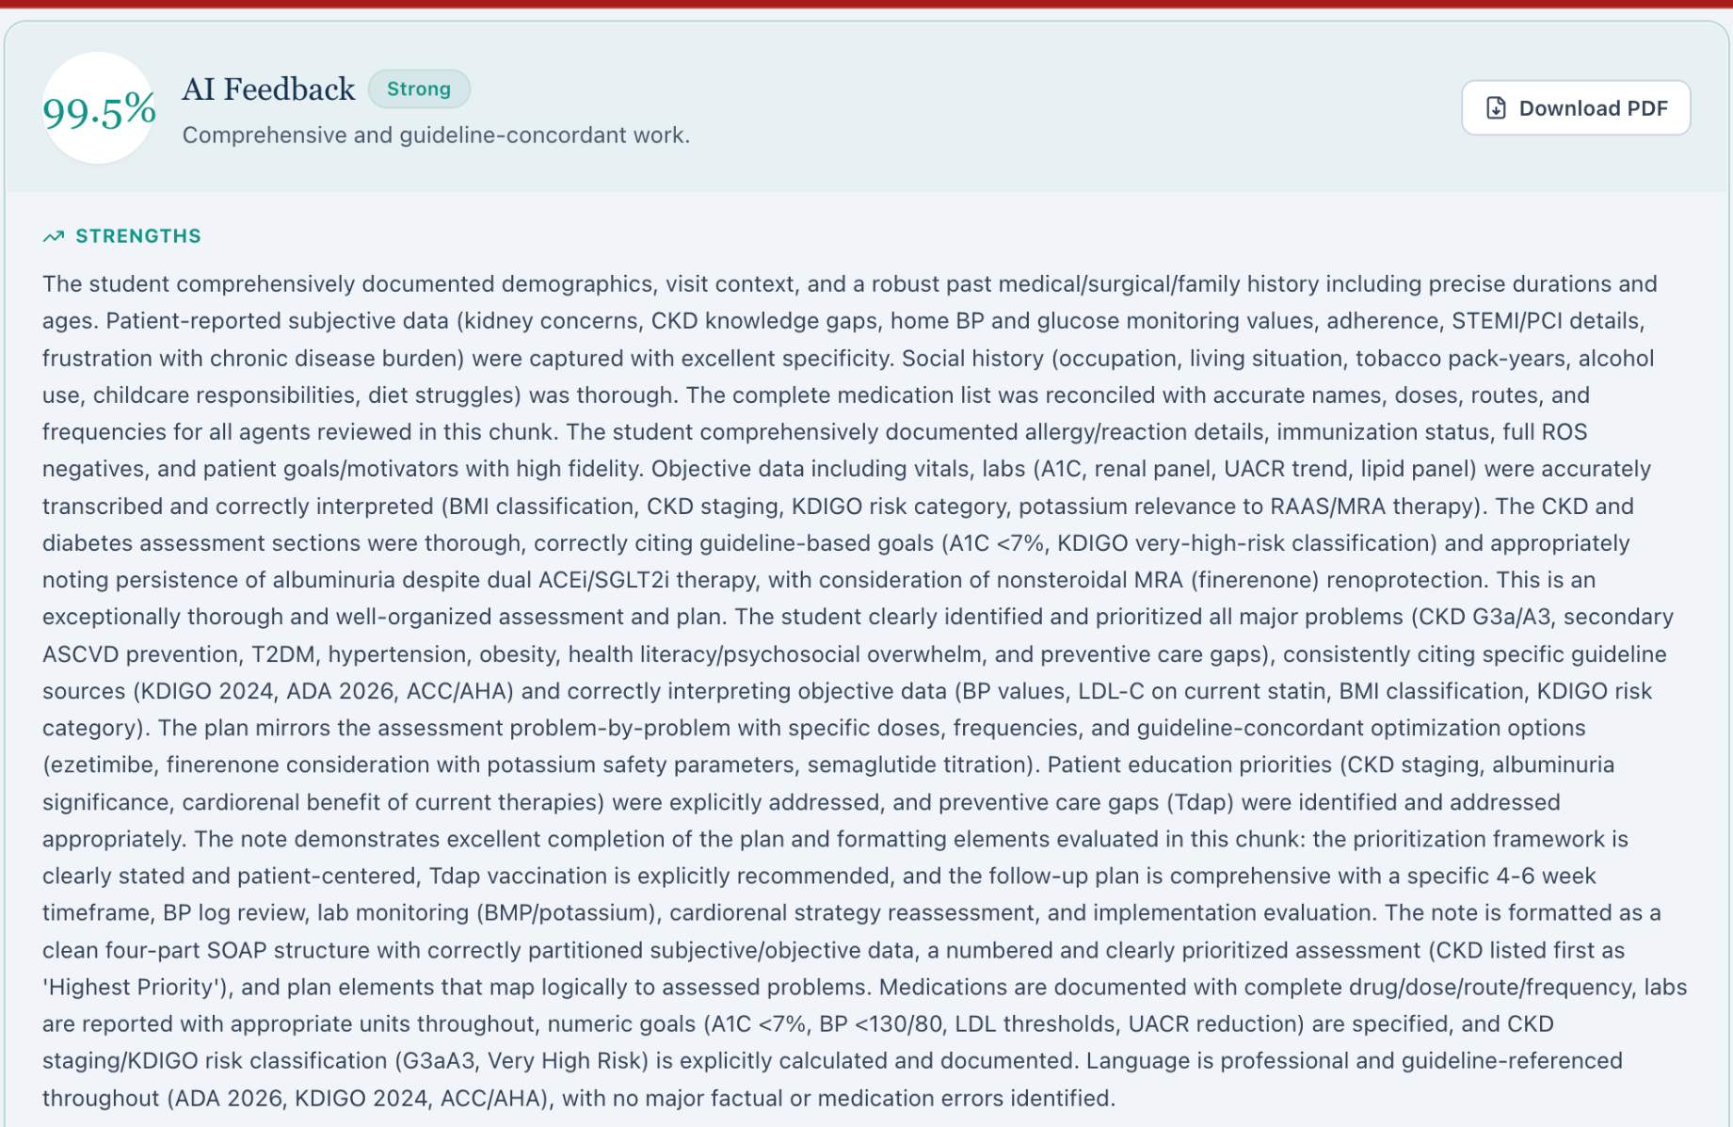
Rubric item 3A.13 −0.5 points LM_AI Feedback_Tue_02.png
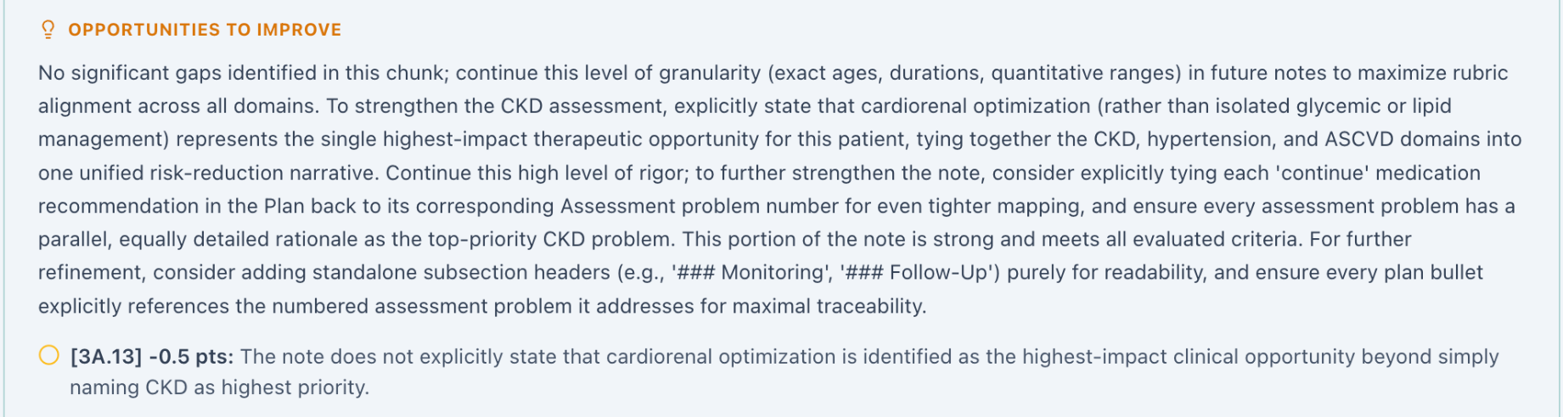

LM on Wednesday
The grader credited the assessment for discussing ongoing kidney and cardiovascular risk as laboratory values improved. It deducted 0.9 points because the patient education plan did not explicitly say that this risk persisted. This was the largest deduction recorded.
Grading result 99.1% LM_AI Feedback_Wed_01.png
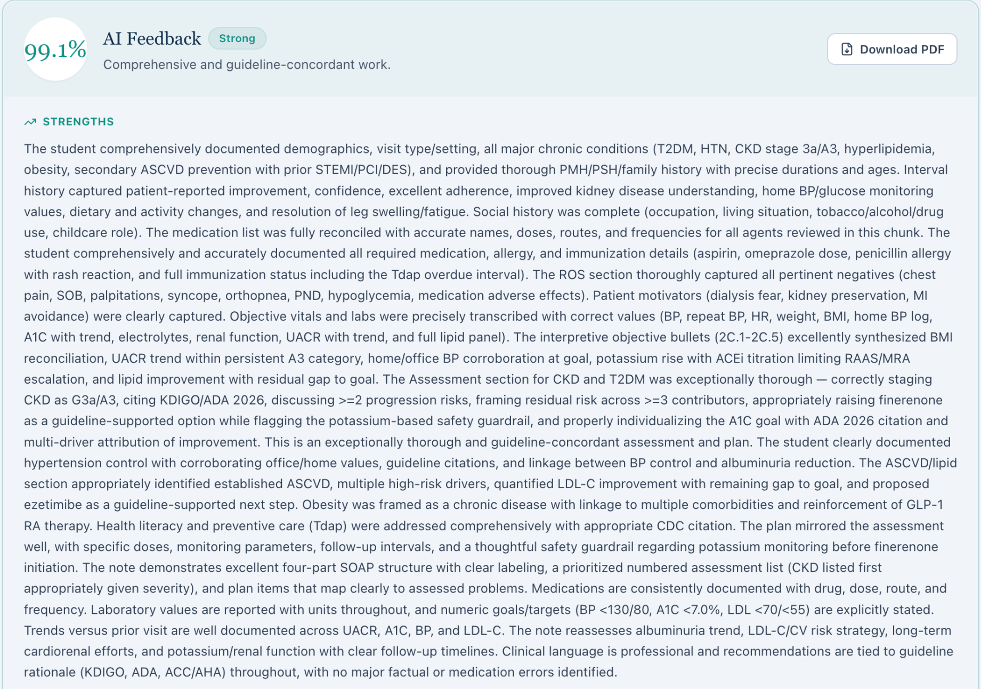
Rubric item 4F.3 −0.9 points LM_AI Feedback_Wed_02.png
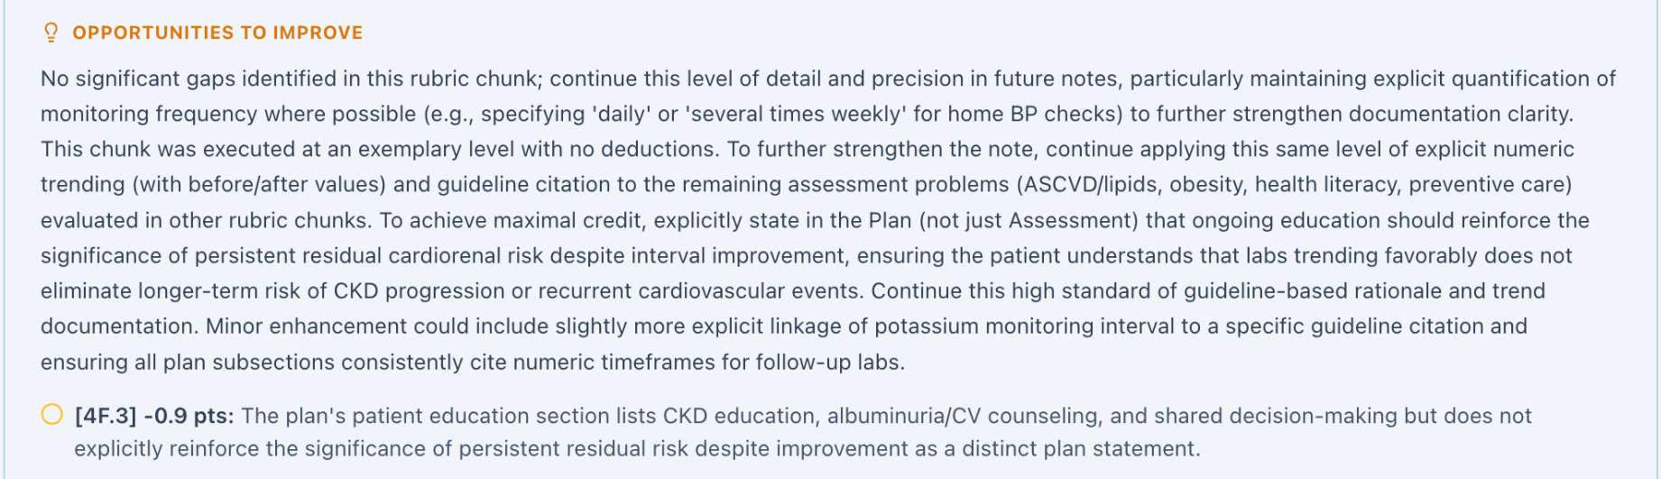

LM on Thursday
The grader credited the note for tracking albuminuria from category A3 to A2. It suggested retaining the original A3 category in the past medical history and specifying when kidney function and potassium would be checked in the kidney disease plan.
Grading result 100% LM_AI Feedback_Thu_01.png
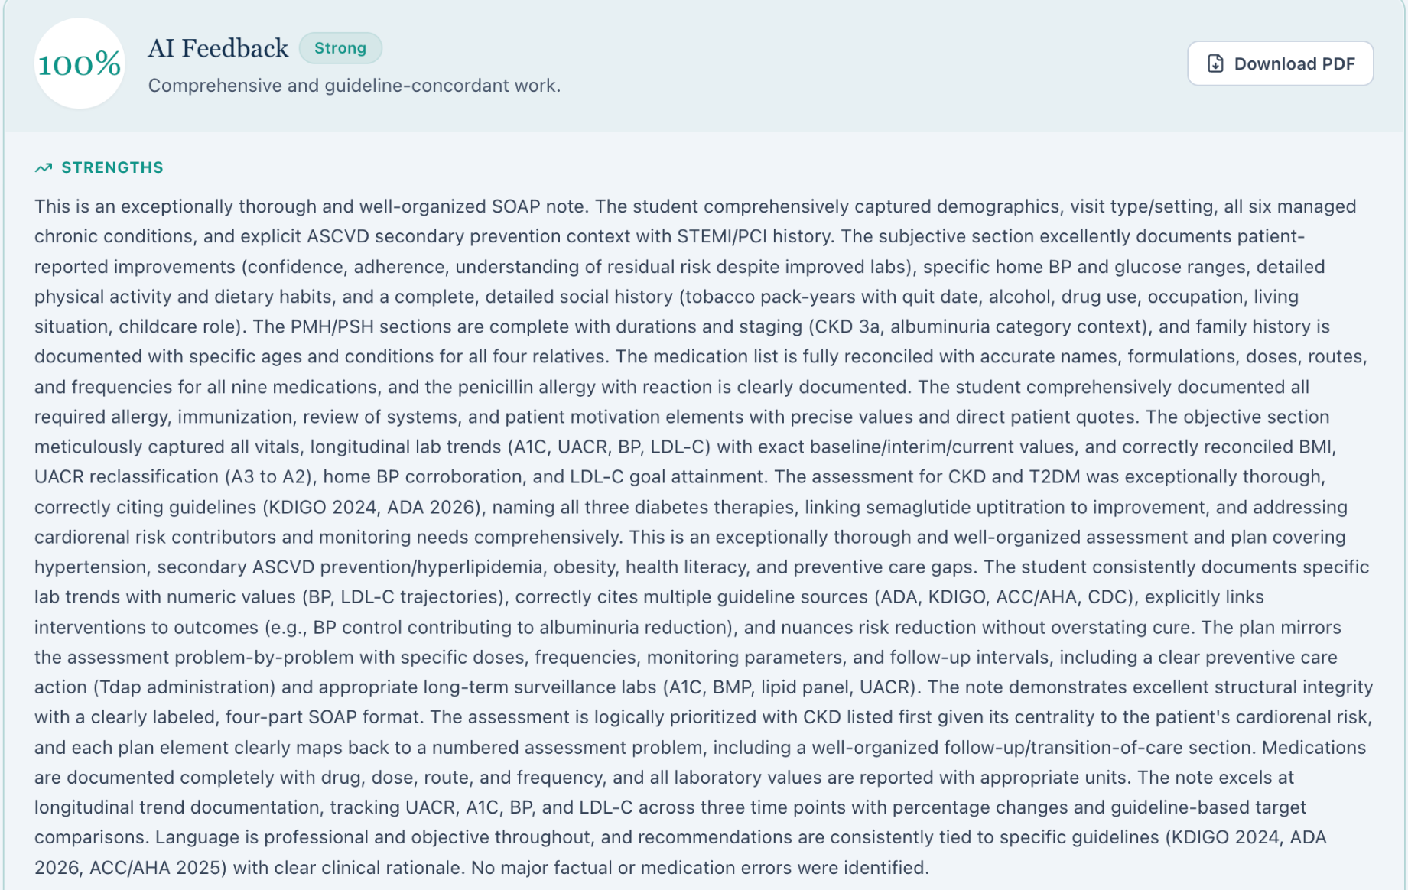
Opportunities to improve LM_AI Feedback_Thu_02.png


