Testing Overview
Testing environment: Google Chrome.
Scope: Week 2 — Hyperlipidemia & CKD; patients tested: Michael Turner and Angela Rodriguez.
Workflow tested: Patient Interview → Discovered Topics → Quick Documentation → SOAP Note Generation → Grading.
Session length: 20 minutes.
Reproducibility: Recurring issues were reproduced on the days tested; recurring issues are identified in the report.
Purpose: This report documents observed application behavior and expected behavior. It is intended for direct review by the web developer, with the rotation preceptor copied for visibility.
Week 2 Application Issues — Developer QA / UAT Problem List
Topic: Hyperlipidemia & CKD
Purpose: Translate pharmacy-student testing observations into reproducible software issues, expected behavior, and acceptance criteria. Patient/day labels are retained so issues can be traced to the original testing scenario.

Issue Summary
ID | Day / Patient | Issue | Priority | Screenshot
BUG-01 | Monday  Quiz / Cardiorenal Integration guideline | Guideline link returns 404 | High | Page 1
BUG-02 | Tuesday; also Wednesday & Thursday  Michael Turner | HPI and Current Medications not recognized as discovered | Critical | Pages 1 & 6
BUG-03 | Tuesday  Michael Turner | Unasked topics marked as discovered | High | Page 2
BUG-04 | Tuesday  Angela Rodriguez | Unrelated topics triggered by initial question | High | Page 3
BUG-05 | Wednesday  Angela Rodriguez | Multiple unrelated topics triggered by one statement | High | Page 5
BUG-06 | Thursday  Michael Turner | Grading penalizes unavailable marital/living-status information | High | Page 2
BUG-07 | Tuesday/Thursday  Michael Turner; Angela Rodriguez | Generated SOAP wording conflicts with grading rubric | High | Pages 2–3
BUG-08 | Wednesday  Angela Rodriguez | Height/weight/BMI values are internally inconsistent | High | Page 4
BUG-09 | Wednesday  Angela Rodriguez | Grading requires home BP data the patient does not have | High | Page 4
BUG-10 | Tuesday  Michael Turner | Session expiration message does not match configured duration | Medium | Page 2
BUG-11 | All days / both patients  General workflow | Reset does not reset timer while remaining in the day | High | Page 6
BUG-12 | Wednesday  Angela Rodriguez | Grading submission throws JSON error and no grade appears | Critical | Page 6

Issue classification: Application Bug = software behavior/error; Grading Logic = scoring/evaluation behavior; Content/Configuration = resource, case-data, or session-setting discrepancy.

Detailed Bug Reports
BUG-01 — Guideline link returns 404
Testing context | Monday | Quiz / Cardiorenal Integration guideline
Actual behavior | Selecting the Cardiorenal Integration guideline opens a 404 “page could not be found” error instead of the guideline.
Expected behavior | The correct guideline/document should open successfully.
Priority / evidence | High | Page 1
Developer acceptance criteria | Verify the guideline URL/resource mapping and confirm the link resolves to the intended document.
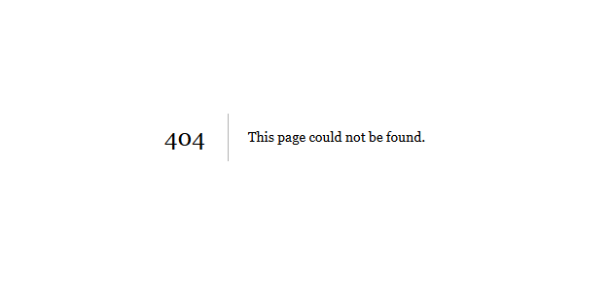
Original source screenshot 1 — image11.png
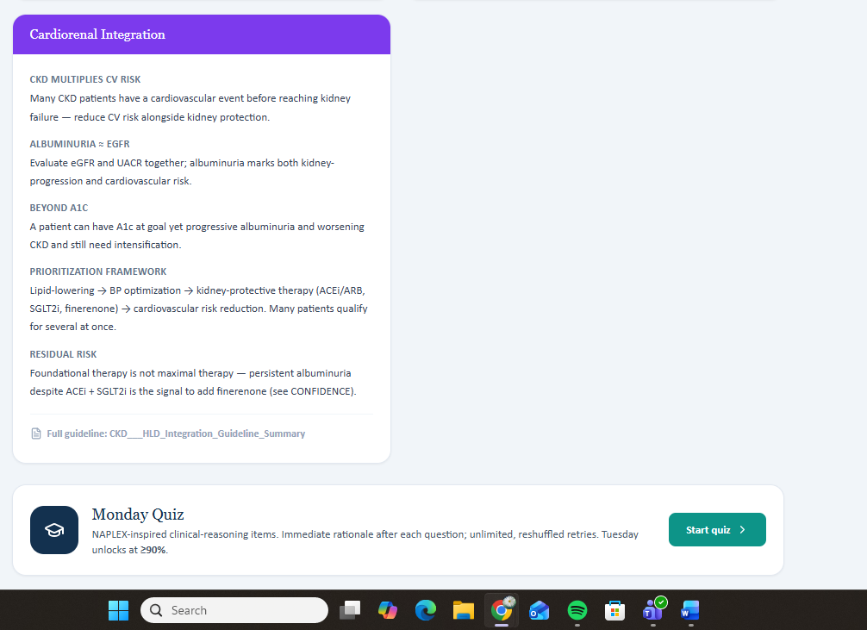
Original source screenshot 2 — image4.png
BUG-02 — HPI and Current Medications not recognized as discovered
Testing context | Tuesday; also Wednesday & Thursday | Michael Turner
Actual behavior | The student asks questions that produce HPI and Current Medications information, and the information appears in Quick Documentation, but those categories do not appear under Discovered Topics.
Expected behavior | HPI and Current Medications should be marked discovered when relevant information is actually obtained from the interview.
Priority / evidence | Critical | Pages 1 & 6
Developer acceptance criteria | Review topic-detection rules for these two categories. Test across all three days and both patient scenarios.
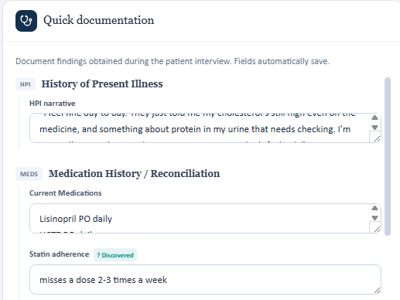
Original source screenshot 1 — image1.png
BUG-03 — Unasked topics marked as discovered
Testing context | Tuesday | Michael Turner
Actual behavior | Family History and Hospitalization / ED Visits appear as discovered even though the student had not asked about those topics.
Expected behavior | A topic should become discovered only after the conversation contains relevant information about that topic.
Priority / evidence | High | Page 2
Developer acceptance criteria | Prevent topic state from being populated solely from case relevance or anticipated questions.
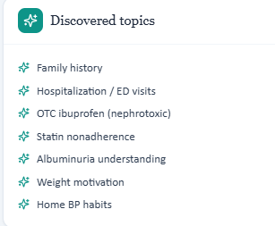
Original source screenshot 1 — image6.png
BUG-04 — Unrelated topics triggered by initial question
Testing context | Tuesday | Angela Rodriguez
Actual behavior | After an initial general question, Hospitalization / ED Visits, Cost barrier, and Home BP habits appear as discovered even though they are not related to the question/response.
Expected behavior | Only topics supported by the actual conversation content should be marked discovered.
Priority / evidence | High | Page 3
Developer acceptance criteria | Improve semantic relevance matching between patient response and topic classification.
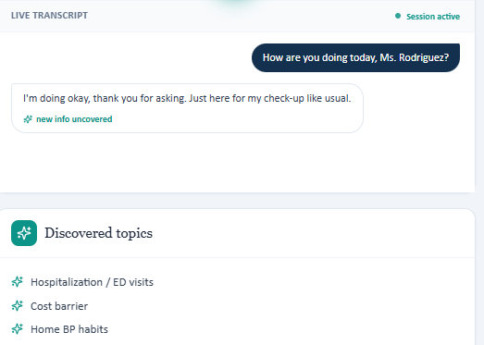
Original source screenshot 1 — image7.png
BUG-05 — Multiple unrelated topics triggered by one statement
Testing context | Wednesday | Angela Rodriguez
Actual behavior | After one patient-interview statement, four unrelated topics appear as discovered: Family History, Hospitalization / ED Visits, Confidence in statin, and Lifestyle goals.
Expected behavior | Topics should be discovered only when supported by the current conversation.
Priority / evidence | High | Page 5
Developer acceptance criteria | Review false-positive topic detection; compare detected topics against transcript content.
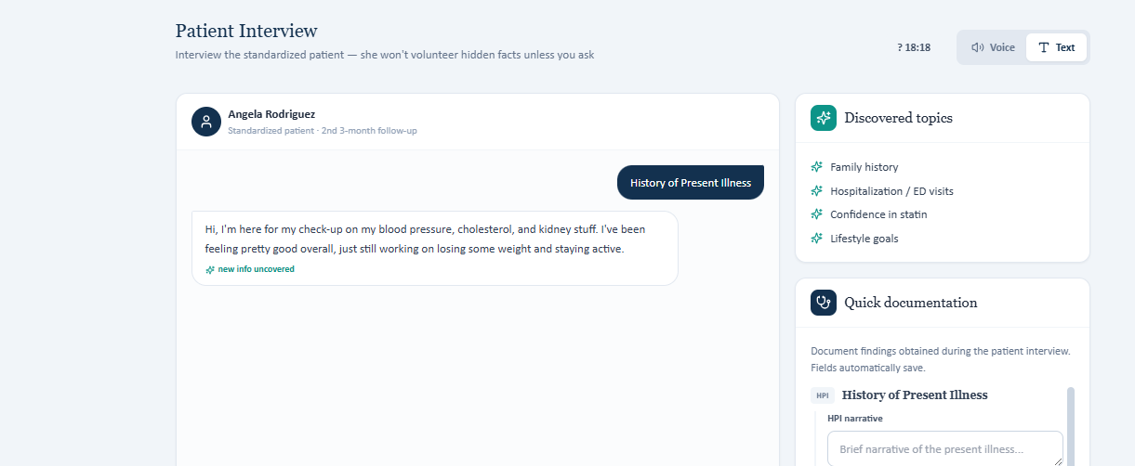
Original source screenshot 1 — image3.png
BUG-06 — Grading penalizes unavailable marital/living-status information
Testing context | Thursday | Michael Turner
Actual behavior | The student asked about marital status, but the patient did not provide the information. The grading system still deducts points for the missing information.
Expected behavior | If the student appropriately asks and the patient does not provide/know the information, the student should not be penalized as though the question was omitted.
Priority / evidence | High | Page 2
Developer acceptance criteria | Differentiate 'not asked' from 'asked but unavailable/not provided' in grading logic.
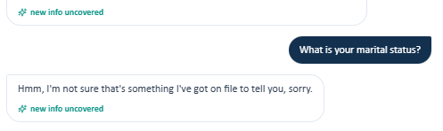
Original source screenshot 1 — image8.png
BUG-07 — Generated SOAP wording conflicts with grading rubric
Testing context | Tuesday/Thursday | Michael Turner; Angela Rodriguez
Actual behavior | The Generate Draft from Inputs function produces wording that is later penalized by grading. Examples include '2nd 3-month follow-up' and an 'initial ambulatory pharmacy visit' without explicit collaborative-practice wording.
Expected behavior | Generated drafts should use terminology consistent with the grading rubric, or the rubric should accept the application's generated wording.
Priority / evidence | High | Pages 2–3
Developer acceptance criteria | Align draft-generation templates with grading criteria; avoid penalizing unedited system-generated language.
BUG-08 — Height/weight/BMI values are internally inconsistent
Testing context | Wednesday | Angela Rodriguez
Actual behavior | Chart shows height 5'2", while weight is 95 kg and BMI is 35.9. Grading feedback indicates 5'4" would reconcile 95 kg with BMI 35.9.
Expected behavior | Height, weight, and BMI should be mathematically consistent. If BMI is calculated automatically, it should derive from stored height and weight.
Priority / evidence | High | Page 4
Developer acceptance criteria | Check source data and BMI calculation/display logic; determine whether height or BMI is the incorrect stored value.
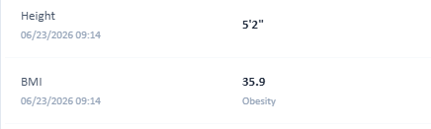
Original source screenshot 1 — image2.png
BUG-09 — Grading requires home BP data the patient does not have
Testing context | Wednesday | Angela Rodriguez
Actual behavior | Patient does not routinely monitor BP at home, so home BP average, range, and corroboration cannot be supplied. The rubric still deducts points for these items.
Expected behavior | When home monitoring is not performed, an appropriate statement that home BP cannot currently be assessed should satisfy the criterion.
Priority / evidence | High | Page 4
Developer acceptance criteria | Make grading conditional on patient-specific availability/applicability of home BP data.
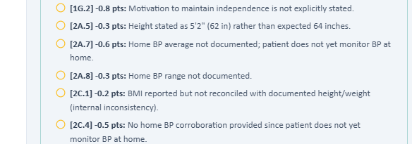
Original source screenshot 1 — image5.png
BUG-10 — Session expiration message does not match configured duration
Testing context | Tuesday | Michael Turner
Actual behavior | Session was configured for 20 minutes, but the application displayed '30-minute session expired.'
Expected behavior | Expiration messaging should reflect the actual configured session duration.
Priority / evidence | Medium | Page 2
Developer acceptance criteria | Check session-duration configuration and timer/message binding.

Original source screenshot 1 — image10.png
BUG-11 — Reset does not reset timer while remaining in the day
Testing context | All days / both patients | General workflow
Actual behavior | After Reset, the timer continues from its previous state unless the student exits the day and re-enters it.
Expected behavior | Reset should fully reset the day's state, including the timer, without requiring an exit/re-entry.
Priority / evidence | High | Page 6
Developer acceptance criteria | Ensure timer state is included in the reset operation and is reinitialized immediately.
BUG-12 — Grading submission throws JSON error and no grade appears
Testing context | Wednesday | Angela Rodriguez
Actual behavior | Submitting the SOAP note for grading produced a JSON parsing error: 'Expected ',' or '}' after property value in JSON at position 10539 (line 76 column 927).' No grade appeared, and the student had to reset the day.
Expected behavior | Submission should complete successfully and return a grade/feedback. Malformed JSON should be caught and handled before the student sees a raw parsing error.
Priority / evidence | Critical | Page 6
Developer acceptance criteria | Validate generated payload before submission and identify the field/content causing invalid JSON.
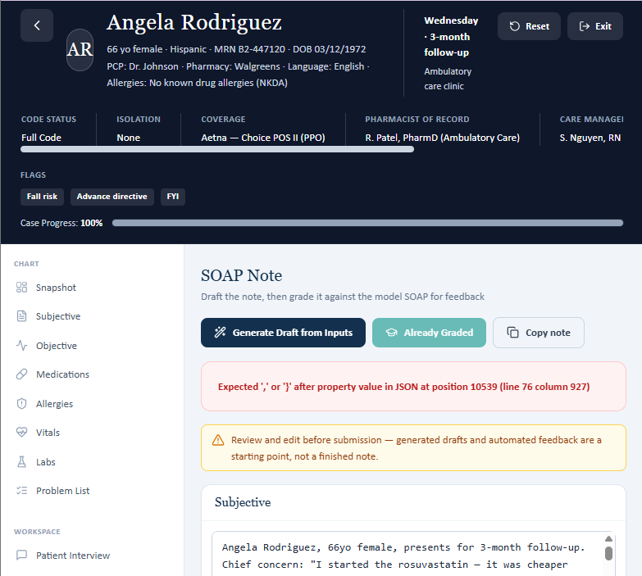
Original source screenshot 1 — image9.png

Cross-Cutting Issues
QA-01 — Discovered Topics: false positives and false negatives
Observed pattern: Across both patients and multiple days, topic detection has two failure modes: (1) unrelated/unasked topics are marked discovered, and (2) HPI and Current Medications can fail to register even when relevant information is obtained.
Recommended behavior: Review the topic-classification pipeline for both precision and recall. A topic should be marked discovered only when the transcript contains sufficient evidence for that topic.
QA-02 — Grading should account for patient-dependent information
Observed pattern: The grading logic appears to require information even when the student asked and the patient did not provide it, or when the patient does not monitor/possess the requested data.
Recommended behavior: Differentiate at minimum: not asked; asked but unavailable/not provided; not applicable; provided and documented; provided but documented incorrectly.
QA-03 — Generated content and grading criteria are not aligned
Observed pattern: The application can generate SOAP-note wording that the grading rubric later penalizes.
Recommended behavior: Align generation templates and grading criteria so students are not penalized for unedited system-generated language.
QA-04 — Reset should reset complete session state
Observed pattern: Resetting a day does not immediately reset the timer unless the student exits and re-enters.
Recommended behavior: Reset should reinitialize all day/session state, including timer and relevant progress/state variables, without navigation workarounds.

Recommended Fix Order
- Critical: Resolve the grading-submission JSON error and the Discovered Topics detection failures.
- High: Fix grading logic for unavailable patient information; align generated SOAP-note language with grading criteria; fix the Reset/timer state; resolve height/weight/BMI inconsistency.
- Medium: Correct session-duration messaging.

Source: Week 2: Hyperlipidemia & CKD testing notes and screenshots provided by the pharmacy student.
Screenshot provenance: Screenshots embedded in this report were extracted directly from the original “VACS Week 2 Issues” document and placed with the corresponding issue.

Comprehensive Issue Report and Recommended Fixes
Based on the student-facing case, simulated patient interview, AI grading feedback, and Objective-tab screenshot
Patient Angela Rodriguez – Thursday 6-month follow-up

1. Purpose and Scope
Purpose. This report documents inconsistencies uncovered while testing an AI-based SOAP note grader. The central concern is that the grader sometimes appears to compare the student's note to hidden/reference facts without first confirming whether those facts were available to the student or whether the simulated patient explicitly contradicted them.
Scope. This report focuses on reproducible grading and case-content issues. The synthetic patient's age discrepancy is intentionally excluded, because the age field is not maintained like a live patient record and was specifically requested to be ignored.

2. Executive Summary
Primary systemic defect: The AI grader does not consistently distinguish between student-accessible evidence and hidden/reference data. As a result, it can penalize clinically accurate, source-grounded documentation and can implicitly reward unsupported or fabricated facts.
- Direct patient answers are sometimes treated as wrong when they conflict with hidden reference data.
- Exact historical values are scored even when they were not visible in the chart or obtainable from the patient.
- The grader does not reliably distinguish unknown/not documented from negative, overdue, or never received.
- The grader sometimes expects continuation of an activity the patient explicitly says she is not doing.
- The grader can be too literal about wording/location even when equivalent information is documented elsewhere.
- Student errors and case-content/reference conflicts are mixed together in the same score instead of being separated.
- The rendered UI and backend/extracted case content may not always match, as demonstrated by the Immunizations section.

3. Recommended Core Grading Principle
Before deducting points, the grader should determine whether the expected information was actually available to the student. For encounter documentation, direct simulated-patient responses and visible student-facing chart data should take precedence over hidden/reference facts. If the hidden reference conflicts with the patient or rendered UI, the grader should flag a case-content discrepancy and apply no student deduction.

4. Priority Issue Matrix
Priority | Issue | Observed Evidence | Grader Behavior | Recommended Fix
P0 | Home BP contradiction | Patient explicitly reports no home BP monitoring and no monitor. | Requires home BP average/range and 'continue monitoring'. | Patient response controls; mark home BP average/range N/A and accept 'initiate monitoring'.
P0 | Paternal MI contradiction | Patient explicitly says she does not recall father having a heart attack. | Requires father MI at age 63. | No deduction; flag reference-vs-patient conflict.
P0 | Hidden objective/history values | UACR 160, ASCVD 17.4→13.2, weight 96 kg, prior leg soreness not visible initially. | Exact values/history required. | Only score accessible facts or expose them to student.
P0 | Immunization UI mismatch | Rendered Immunizations card is blank. | Requires specific vaccine statuses and gaps. | Blank UI = unknown/unavailable; do not infer up-to-date/overdue.
P1 | Mother CKD hidden | Patient reports mother HTN + stroke, not CKD. | Requires maternal CKD. | Expose CKD in encounter or remove criterion.
P1 | Height/BMI mismatch | Visible chart: 5'2", 93 kg, BMI 35.2. | Expects inferred 5'4". | Reward discrepancy identification, not silent overwrite.
P1 | Follow-up interval conflict | Visible case says 3-month follow-up. | Requires 6-month follow-up. | Synchronize visible case and grading reference.
P1 | Social-history hidden facts | Marital status/occupation not provided by patient. | Requires widowed/occupation. | Accept declined/not provided unless made discoverable.

5. Detailed Issues

1. Home blood pressure data directly conflicts with the simulated patient
Severity: P0 - Critical
Observed student-facing evidence
The patient was directly asked whether she has home blood pressure readings. She stated that she does not check blood pressure at home, does not have a machine, and only gets it checked in the office. The structured interview fields also document that she does not check at home and has no monitor.
AI grader behavior / expectation
The grader deducted points for missing a home BP average, missing a home BP range, failing to corroborate office BP with home readings, and recommending initiation rather than continuation of home BP monitoring.
Why this is a problem
The expected answer is incompatible with the actual encounter. A student who invents home readings or writes that monitoring should be 'continued' would be documenting information the patient denied. This can train students toward inaccurate clinical documentation.
Recommended fix
Implement a source-conflict rule. When the patient explicitly denies home monitoring, the home average/range criteria should become not applicable. 'No home readings available' and 'initiate/offer home BP monitoring' should receive full credit. If hidden reference data contains home readings, generate a separate case-QA alert and do not deduct from the student.
Suggested regression test
Input: patient says 'I do not check BP at home.' Hidden reference contains home BP values. Expected grader result: no deduction for absent home BP values; case-conflict alert; 'initiate home BP monitoring' accepted.

2. Father's myocardial infarction directly conflicts with the patient's answer
Severity: P0 - Critical
Observed student-facing evidence
The patient repeatedly reports father with hypertension, hyperlipidemia, and stage 4 CKD. When specifically asked whether her father ever had a heart attack, she says she does not recall him ever having one.
AI grader behavior / expectation
The grader expects 'father had MI at age 63' and deducts points when the SOAP note documents the patient's actual answer.
Why this is a problem
This is a direct contradiction between hidden reference data and the live simulated encounter. The current grading behavior rewards unsupported documentation over accurate patient-reported history.
Recommended fix
Direct patient testimony should control encounter documentation. If hidden reference data conflicts, apply no student deduction and flag the case for author review. The grader should never require a hidden event that the patient explicitly denies or does not recall.
Suggested regression test
Input: patient denies/does not recall paternal MI; note documents that response. Expected: full documentation credit and reference-conflict alert.

3. Mother's CKD is required even though the patient never reports it
Severity: P1 - High
Observed student-facing evidence
The patient reports mother with hypertension and stroke at age 72. Maternal CKD is not stated in the visible interview information.
AI grader behavior / expectation
The grader deducts points for failure to document mother's CKD.
Why this is a problem
A diagnosis should not be inferred or invented from unrelated family-history data. If the hidden key contains maternal CKD, the student needs a way to access it.
Recommended fix
Either add maternal CKD to a visible chart field or simulated-patient response, or remove it from scoring. The grader should check accessibility before deducting.
Suggested regression test
Input: maternal CKD only in hidden key, not visible encounter. Expected: criterion excluded from scoring.

4. Intermediate UACR 160 mg/g is hidden
Severity: P0 - Critical
Observed student-facing evidence
Visible data originally showed UACR 165 mg/g previously and 155 mg/g currently.
AI grader behavior / expectation
The grader requires the three-point trend 165 → 160 → 155 mg/g and deducts for not including 160 mg/g.
Why this is a problem
The 160 mg/g value was not available to the student in the original encounter. This is a hidden-value grading error.
Recommended fix
If a three-point trend is required, display the intermediate value in the student-facing record. Otherwise accept the complete visible trend.
Suggested regression test
Input: hidden historical value absent from UI. Expected: no deduction for omission.

5. Exact ASCVD risk trend is hidden
Severity: P0 - Critical
Observed student-facing evidence
The original student-facing case did not display exact 10-year ASCVD risk values.
AI grader behavior / expectation
The grader requires 17.4% → 13.2% and deducts for missing exact values.
Why this is a problem
Students should not be required to reproduce precise hidden calculations unless all required inputs and/or the prior calculated value are visible and internally consistent.
Recommended fix
Display the risk calculation in the chart or make exact values optional. Accept a supported qualitative risk discussion when exact values are unavailable.
Suggested regression test
Input: risk values only in hidden reference. Expected: no exact-number deduction.

6. Previous weight of 96 kg is hidden
Severity: P1 - High
Observed student-facing evidence
The visible encounter contains current weight 93 kg and patient-reported weight loss. The original case did not show prior weight 96 kg.
AI grader behavior / expectation
The grader expects the exact trend 96 → 93 kg.
Why this is a problem
The student is penalized for omitting a value that was not visible.
Recommended fix
Expose previous weight if exact longitudinal trend is graded, or accept current weight plus documented patient-reported loss.
Suggested regression test
Input: prior weight absent from chart. Expected: no deduction for missing exact prior value.

7. Prior mild leg soreness and resolution are hidden
Severity: P1 - High
Observed student-facing evidence
The original interview documents no current rosuvastatin-associated muscle aches. Prior mild leg soreness was not part of the initial visible history.
AI grader behavior / expectation
The grader expects both the historical soreness and its resolution.
Why this is a problem
The student cannot document a historical adverse effect that is neither visible nor elicitable.
Recommended fix
Make the history visible in a previous note or simulated-patient response if it is required for grading. Otherwise do not score it.
Suggested regression test
Input: prior symptom only in hidden key. Expected: criterion not scored.

8. Prior medication fears are inferred rather than explicitly supported
Severity: P2 - Moderate
Observed student-facing evidence
The patient says rosuvastatin is going well and that she feels more confident now. The original visible interview does not explicitly state a prior medication fear.
AI grader behavior / expectation
The grader expects prior medication fears to be documented as a former adherence barrier.
Why this is a problem
The grader is turning an implication into a required historical fact. 'More confident now' does not necessarily prove a prior fear without supporting context.
Recommended fix
Only require prior fear if it is explicitly documented or elicitable. Otherwise grade the supported current confidence/adherence information.
Suggested regression test
Input: current confidence present; prior fear absent. Expected: no deduction for not labeling a prior fear.

9. Immunization section is blank in the rendered Objective tab
Severity: P0 - Critical
Observed student-facing evidence
The rendered Objective tab shows an 'Immunizations' card at the bottom of the page, but the card contains no entries. There is no text stating 'none documented,' no vaccine names, no dates, and no status indicators.
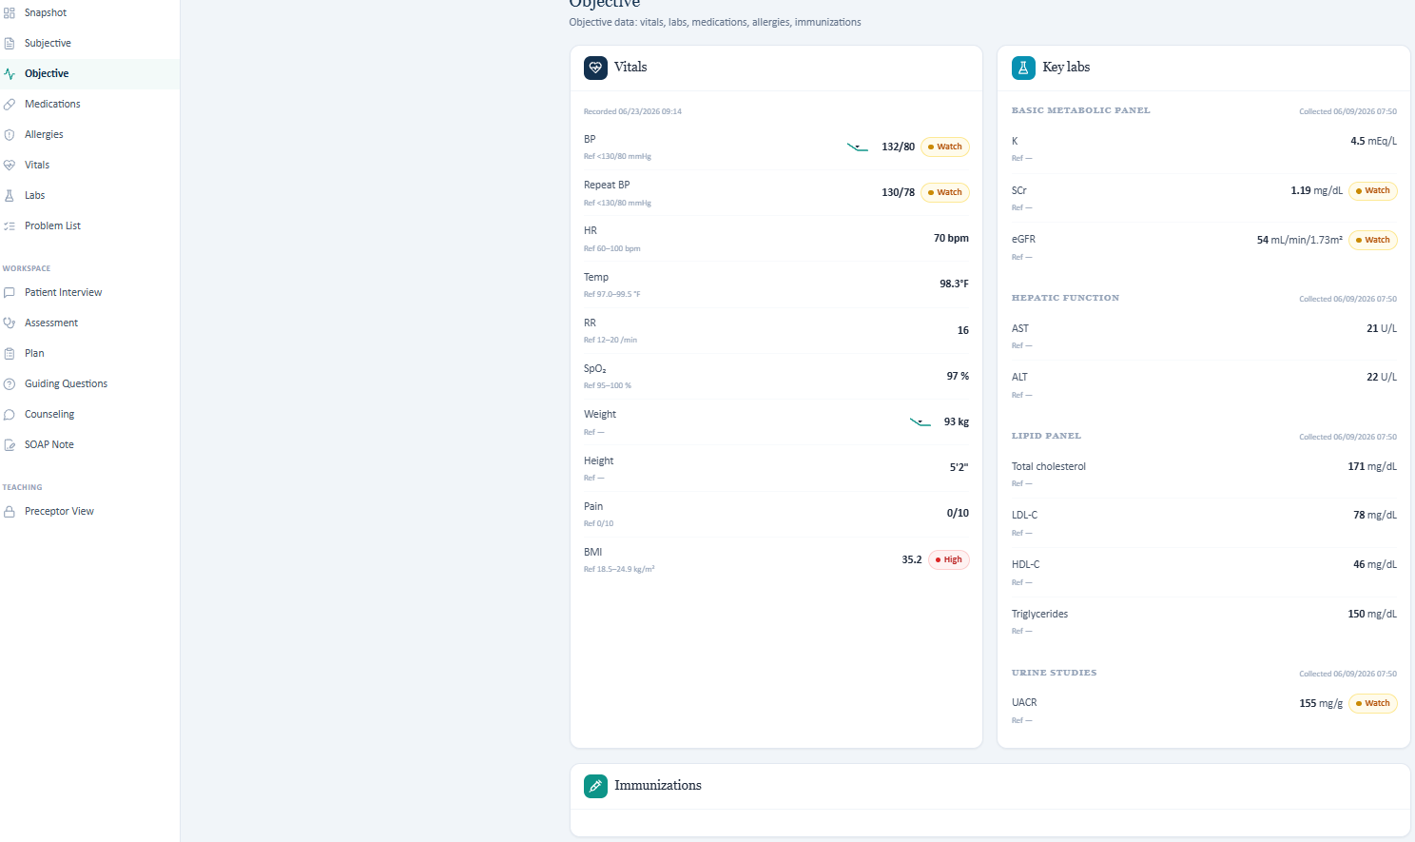
Figure 1. Full Objective-tab screenshot. The Immunizations card is visible at the bottom and contains no displayed information.
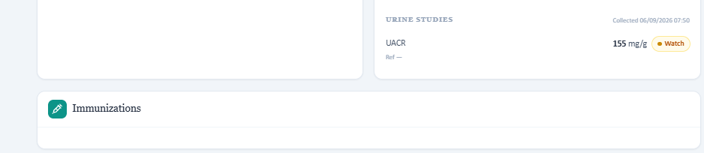
Figure 2. Cropped view of the Immunizations card showing that the student-facing section is blank.
Backend/extraction discrepancy
A prior text representation of the case included wording equivalent to 'Immunizations - none documented,' while the rendered UI available to the student is blank. This suggests a mismatch between backend/extracted data and the actual student-facing interface.
AI grader behavior / expectation
The grader expects specific conclusions such as influenza and COVID-19 being up to date, Tdap being overdue, and pneumococcal/zoster gaps being identified.
Why this is a problem
A blank section does not establish any definitive vaccination state. The student cannot safely infer 'up to date,' 'overdue,' 'never received,' or 'none documented' from a blank card. The clinically defensible entry is that immunization history/status is unavailable in the visible record and requires verification.
Recommended fix
1. Grade against the rendered student-facing data, not hidden backend text. 2. When the Immunizations card is blank, accept 'immunization history unavailable/unknown; verify records.' 3. If specific vaccine statuses are required, display them in the UI or make them elicitable from the patient. 4. Add an automated UI-versus-backend parity check so required grading facts cannot exist only outside the student-facing interface.
Suggested regression test
Input: Immunizations card renders blank while hidden reference contains vaccine statuses. Expected: no deductions for unknown vaccine status; case-data/UI mismatch alert.

10. Influenza, COVID-19, and Tdap are graded with unsupported certainty
Severity: P0 - Critical
Observed student-facing evidence
The patient states she is honestly not sure whether she is up to date and would need her records checked. The rendered Immunizations card is blank.
AI grader behavior / expectation
The grader expects influenza and COVID-19 to be documented as up to date and Tdap as overdue.
Why this is a problem
Neither the patient nor the visible UI supports those definitive statuses. 'Unknown' is clinically different from 'up to date' or 'overdue.'
Recommended fix
Use explicit status states such as up to date / overdue / declined / unknown. Patient uncertainty plus blank UI should map to 'unknown; verify records.'
Suggested regression test
Input: patient says 'not sure' and UI is blank. Expected: unknown/reconciliation documentation receives full credit.

11. Height/BMI mismatch is penalized despite appropriate reconciliation
Severity: P1 - High
Observed student-facing evidence
The visible chart shows height 5'2", weight 93 kg, and BMI 35.2 kg/m². Those values are internally inconsistent.
AI grader behavior / expectation
The grader expects the note to use approximately 64 inches/5'4" because that height better matches the listed BMI.
Why this is a problem
Silently replacing a charted measurement with an inferred value is poor documentation practice. The correct response is to identify the discrepancy and verify the source measurement.
Recommended fix
Award full credit for preserving the documented values and flagging the mismatch for remeasurement/reconciliation. Do not require an inferred replacement value unless a corrected measurement is explicitly provided.
Suggested regression test
Input: charted height/BMI mathematically inconsistent. Expected: discrepancy flag accepted; no penalty for not overwriting source height.

12. Follow-up interval conflicts with the student-facing case
Severity: P1 - High
Observed student-facing evidence
The case is labeled as a second 3-month follow-up and includes a near-term next appointment date.
AI grader behavior / expectation
The grader expects an explicit 6-month follow-up.
Why this is a problem
The visible case and grading reference are not synchronized.
Recommended fix
Use one authoritative interval across the visible chart, reference answer, rubric, and grader prompt. If they conflict, generate a case-QA alert and avoid deduction.
Suggested regression test
Input: visible chart says 3 months, hidden key says 6 months. Expected: case inconsistency alert.

13. Marital status is expected as 'widowed' although the patient does not provide it
Severity: P1 - High
Observed student-facing evidence
When asked whether she is married, the patient does not provide a marital status and indicates that this has not been discussed.
AI grader behavior / expectation
The grader expects 'widowed.'
Why this is a problem
The student should not infer a hidden marital status after the patient declines or does not provide it.
Recommended fix
Either make 'widowed' visible/elicitable or accept 'not disclosed/declined/not provided.'
Suggested regression test
Input: patient does not disclose marital status. Expected: no penalty for accurate non-disclosure documentation.

14. Occupation is required but not provided by the patient
Severity: P1 - High
Observed student-facing evidence
When asked about work, the patient does not provide an occupation and says she does not recall discussing her job.
AI grader behavior / expectation
The grader expects occupation documentation.
Why this is a problem
This is unavailable information once the student has asked and the patient has not answered.
Recommended fix
Accept 'occupation not provided' or modify the simulated patient so the required occupation can be obtained.
Suggested regression test
Input: student asks occupation, patient gives no occupation. Expected: no hidden-value deduction.

15. Living situation may be graded too literally
Severity: P2 - Moderate
Observed student-facing evidence
The patient says, "I live at home and get around fine day to day."
AI grader behavior / expectation
The grader expects 'living independently.'
Why this is a problem
The two statements are semantically close. An AI grader should recognize equivalent meaning rather than require exact phrasing.
Recommended fix
Use semantic equivalence. Accept documentation such as 'lives at home and functions independently day to day' when supported by the patient response.
Suggested regression test
Input: patient describes independent day-to-day function without saying the exact word 'independent.' Expected: full credit.

16. Recreational drug use should reflect conversation state
Severity: P2 - Moderate
Observed student-facing evidence
The updated interview now explicitly states that the patient does not use recreational drugs.
AI grader behavior / expectation
Earlier grading deducted points when this had not yet been asked/available.
Why this is a problem
The grader should know whether a question was asked before deciding whether a missing negative is an omission versus unavailable information.
Recommended fix
Track interview state. Once asked and denied, award full credit. Before it is asked, distinguish 'not elicited' from an incorrect answer.
Suggested regression test
Input: question later asked and denied. Expected: updated note receives full credit.

17. ROS negatives should reflect whether they were actually elicited
Severity: P2 - Moderate
Observed student-facing evidence
The updated interview explicitly denies shortness of breath, heart racing/palpitations, fainting/syncope, and leg swelling/edema.
AI grader behavior / expectation
Earlier grading treated these as missing because they had not yet appeared in the available interview transcript.
Why this is a problem
If the educational goal is to reward asking the questions, the grader should score the questioning behavior, not assume hidden negatives were available from the start.
Recommended fix
Use conversation-state awareness: not asked, asked-positive, asked-negative, or patient unable/declines. Score accordingly.
Suggested regression test
Input: direct ROS denial appears later. Expected: no ongoing deduction.

18. Knowledge-gap grading attributes an unstated medication-discontinuation belief
Severity: P2 - Moderate
Observed student-facing evidence
The patient says, "I feel good about my medicines now. What else should I be doing?" and separately expresses concern about protecting her kidneys.
AI grader behavior / expectation
The grader expects the patient to be documented as questioning whether long-term therapy is still needed now that laboratory values have improved.
Why this is a problem
That specific misconception is not actually stated. The grader is transforming a broad management question into a more specific belief.
Recommended fix
Reward appropriate counseling about long-term therapy, but do not require the student's subjective documentation to attribute an unstated belief to the patient.
Suggested regression test
Input: patient asks general management question, not 'can I stop my meds?' Expected: no penalty for accurately preserving meaning.

19. Kidney-progression concern is documented but grader is overly placement-sensitive
Severity: P2 - Moderate
Observed student-facing evidence
The patient explicitly states that she is worried about her kidneys because her father developed advanced CKD and wants to prevent worsening.
AI grader behavior / expectation
The grader criticized the chief concern for not tying the generic opening question directly to CKD prevention.
Why this is a problem
The clinically relevant concern exists elsewhere in the Subjective section. Requiring the concept in one exact field can create false deductions despite complete documentation.
Recommended fix
Unless the rubric intentionally tests field placement, search the entire appropriate section for semantically equivalent documentation.
Suggested regression test
Input: CKD concern appears in HPI/patient concerns rather than CC. Expected: credit if the rubric is about content, not location.

20. Sodium was scored before it was available
Severity: P1 - High
Observed student-facing evidence
The original student-facing material did not show sodium. A sodium value of 139 mEq/L was supplied later during testing.
AI grader behavior / expectation
The grader deducted for failure to report sodium.
Why this is a problem
Required objective values must be visible or otherwise obtainable at the time the student completes the note.
Recommended fix
Expose sodium in the BMP if it is mandatory. Otherwise treat it as unavailable and do not deduct.
Suggested regression test
Input: sodium absent from visible case. Expected: no deduction.

21. Student errors and case-content defects are combined into a single score
Severity: P0 - Critical
Observed student-facing evidence
Several deductions arose from hidden or contradictory case data rather than omissions the student could correct.
AI grader behavior / expectation
The grader presents these deductions in the same list as true documentation weaknesses.
Why this is a problem
This makes the score difficult to interpret and obscures whether a low score reflects student performance or simulation/reference defects.
Recommended fix
Produce separate sections: (A) Student Performance Findings, which affect score, and (B) Case/Reference QA Alerts, which do not affect score.
Suggested regression test
Input: one real omission plus one hidden-key conflict. Expected: only real omission lowers score; hidden conflict appears under QA alerts.

22. Grader may reward unsupported hidden-reference facts
Severity: P0 - Critical
Observed student-facing evidence
When the hidden key contains information that the patient contradicts or never provides, a student could potentially gain points by inserting the hidden fact anyway.
AI grader behavior / expectation
Current feedback implies that such hidden-reference matching is rewarded.
Why this is a problem
This creates the wrong educational incentive: matching a hidden key instead of accurately documenting the encounter.
Recommended fix
Add a no-fabrication rule: do not award credit solely for a hidden-reference fact unless it is supported by the accessible encounter. If unsupported, either ignore it or flag it.
Suggested regression test
Input: note inserts father MI despite patient denial. Expected: no extra credit; possibly flag as unsupported documentation.

6. Recommended AI-Grader Architecture Changes
Evidence Availability Gate: Before scoring a rubric item, classify it as: visible in chart; stated by patient; discoverable if asked; explicitly denied; unknown; patient declined; unavailable; hidden-reference-only; or contradictory.
Source-Priority Hierarchy: For encounter documentation, use this order: direct simulated-patient response → visible current chart → visible historical chart → calculations based on visible inputs → hidden reference. Hidden reference should not override a direct encounter response.
Contradiction Detection: When two sources conflict, stop normal scoring for that criterion. Generate a case-QA alert and avoid a student deduction until the content team resolves the conflict.
Unknown-State Logic: Treat 'unknown', 'not documented', 'patient unsure', and 'blank UI' as distinct from negative findings or overdue status.
Conversation-State Awareness: The grader should know whether the student asked a question, what the patient answered, and whether the answer was positive, negative, unknown, or declined.
Semantic Equivalence: Use meaning-based matching instead of exact wording for living situation, ROS, goals, medication adherence, and patient concerns.
No-Fabrication Safeguard: Do not reward a student for including hidden-reference facts that are unsupported or contradicted by the encounter.
UI/Backend Data Parity: Any fact intended to be graded should be available through the rendered student experience. Automated tests should compare backend/reference values with what is actually displayed.
Separate Scoring vs QA: Only student-controllable errors should affect the score. Case/reference/UI conflicts should appear in a separate non-scoring QA section.

7. Suggested Grader Prompt / Policy Text
Grade the student's SOAP note using information actually available through the student-facing chart and simulated patient encounter. Before deducting points for a missing fact, determine whether the student could reasonably have obtained that fact. Direct responses from the simulated patient and visible student-facing chart data take precedence over hidden/reference data for purposes of encounter documentation. Do not penalize accurate documentation of an explicit denial, unknown history, patient refusal, blank field, or unavailable data. Do not reward unsupported hidden-reference facts that contradict the encounter. When the reference answer conflicts with the patient response or rendered UI, classify the issue as a case-content discrepancy, apply no student deduction, and flag it for review.

8. Recommended Regression Test Suite
Test | Scenario | Expected Result
Home BP conflict | Patient says no home BP monitoring; hidden reference has home readings. | No deduction for missing home average/range; 'initiate monitoring' accepted; case-conflict alert.
Paternal MI conflict | Patient denies/does not recall MI; hidden reference says MI at 63. | Patient response accepted; no deduction; case-conflict alert.
Blank immunization UI | Rendered card blank; hidden key has vaccine statuses. | Unknown/reconcile accepted; no definitive vaccine-status deduction; UI/reference alert.
Hidden lab trend | Intermediate UACR exists only in key. | Criterion excluded from scoring unless visible.
Hidden risk score | Exact ASCVD values exist only in key. | No exact-number deduction.
Height/BMI mismatch | Visible EHR values are mathematically inconsistent. | Discrepancy identification gets full credit; no required inferred overwrite.
Patient declines marital status | Hidden key says widowed. | Accurate 'not disclosed' accepted.
Occupation not provided | Student asks but patient gives no occupation. | No hidden occupation deduction.
ROS later elicited | Initial note says not elicited; later patient explicitly denies. | Updated note receives full credit; conversation state respected.
Unsupported hidden fact inserted | Student writes paternal MI despite patient denial. | Do not reward hidden-key matching; flag unsupported documentation.

9. Final Development Recommendation
Highest-impact engineering change: Add an evidence-availability and contradiction-resolution layer before rubric scoring. That one change would address the most serious problems uncovered: home-BP contradictions, paternal-MI contradictions, hidden-data deductions, immunization uncertainty, social-history nonresponses, and UI/reference mismatches.
Expected outcome: The grader would remain rigorous while becoming safer and more educationally valid: students would be rewarded for accurate clinical documentation, true omissions would still be identified, and defects in the simulated case itself would be surfaced to developers rather than incorrectly lowering the student's grade.

Appendix A. Key Evidence Captured During Testing
Home BP: Patient explicitly reports no home BP monitoring and no home monitor.
Family history - father: Patient reports HTN/HLD/stage 4 CKD and specifically does not recall a heart attack.
Family history - mother: Patient reports HTN and stroke at 72; no maternal CKD supplied.
Marital status: Patient does not provide it.
Occupation: Patient does not provide it.
Living situation: Patient reports living at home and getting around fine day to day.
Recreational drugs: Patient explicitly denies recreational drug use.
ROS: Patient explicitly denies shortness of breath, palpitations/heart racing, syncope/fainting, and leg edema.
Sodium: Later supplied as 139 mEq/L.
Immunizations: Rendered Objective-tab card is blank; patient says she is unsure whether she is up to date.

10. Additional Patient Interview / Quick Documentation UI Issues
Source of additional findings. The following issues were reproduced in the Angela Rodriguez (Patient B) Thursday patient-interview workflow and were documented in the supplied issue list. They concern incorrect or missing synchronization between the live transcript's 'new info uncovered' indicator, the Quick Documentation fields, and the Discovered Topics panel.

23. New information is uncovered in the transcript but the corresponding Quick Documentation field does not become Discovered
Severity: P1 - High
Observed behavior
When the student asks, “What are your current medications?”, the patient provides a complete medication list and the live transcript displays “new info uncovered.” The Quick Documentation area shows Medication Adherence as Discovered, but the newly provided medication information is not consistently reflected as a newly discovered/updated state in the expected Quick Documentation workflow.
Expected behavior
When the transcript identifies a response as new information, the associated structured documentation field(s) should be updated or marked Discovered in a consistent, deterministic way. The discovery indicator should correspond to the topic actually uncovered by the patient's answer.
Why this matters
The live transcript and structured documentation can become out of sync. Students may see that the system recognized new information but receive no clear indication of where it belongs, which can cause missed documentation, duplicate questioning, and inconsistent grading if the grader relies on discovery-state metadata.
Recommended fix
Create a single topic-mapping event for each patient response. The same backend event should drive: (1) the 'new info uncovered' transcript badge, (2) the correct Quick Documentation field's Discovered state, and (3) the Discovered Topics panel. Add logging that records the response, resolved topic ID, and all UI components updated from that event. If multiple topics are genuinely uncovered, return an explicit list rather than allowing independent classifiers to label different topics.
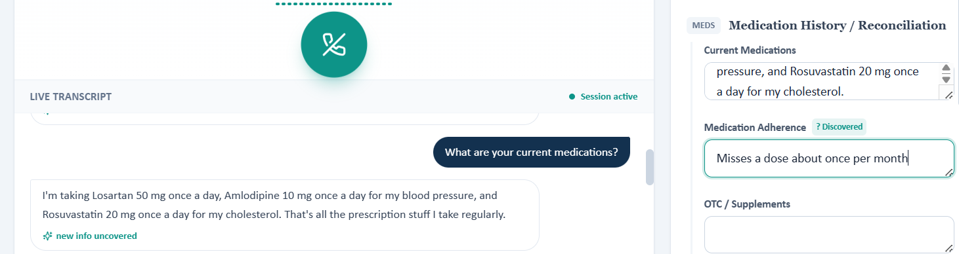
Figure 3. Medication question: transcript shows 'new info uncovered' while discovery state in Quick Documentation is not clearly synchronized to the medication information.
Suggested regression test
Run the same interview question, verify the transcript's 'new info uncovered' state, then assert that only the correct Quick Documentation field/topic is marked Discovered and that unrelated fields remain unchanged.

24. Diagnosis-duration question is incorrectly mapped to Family History
Severity: P0 - Critical
Observed behavior
The student asks how long ago the patient was diagnosed with high blood pressure, kidney disease, and high cholesterol. The patient replies that she does not remember the exact dates but has been dealing with all three for a while. The live transcript labels the response 'new info uncovered,' while the right-side interface marks Family History as Discovered. The Discovered Topics panel also includes Family history, even though the question and answer concern the patient's own diagnosis history/disease duration rather than family history.
Expected behavior
This response should map to an HPI / Past Medical History / disease-history topic such as duration of hypertension, CKD, and hyperlipidemia. Family History should not be marked Discovered unless the response actually contains information about relatives.
Why this matters
This is a semantic topic-classification error. It can populate the wrong SOAP section, cause the student to believe family history has been completed when it has not, and potentially affect AI grading if discovery metadata is used to determine whether required history was elicited.
Recommended fix
Revise the topic classifier and ontology so that phrases about 'how long have you had/been diagnosed with [condition]' resolve to HPI/PMH/disease duration, not Family History. Family History should require an explicit relative/family relationship signal (e.g., mother, father, sibling, family, hereditary history). Add negative examples to classifier tests: 'How long have YOU had hypertension?' must never map to Family History.
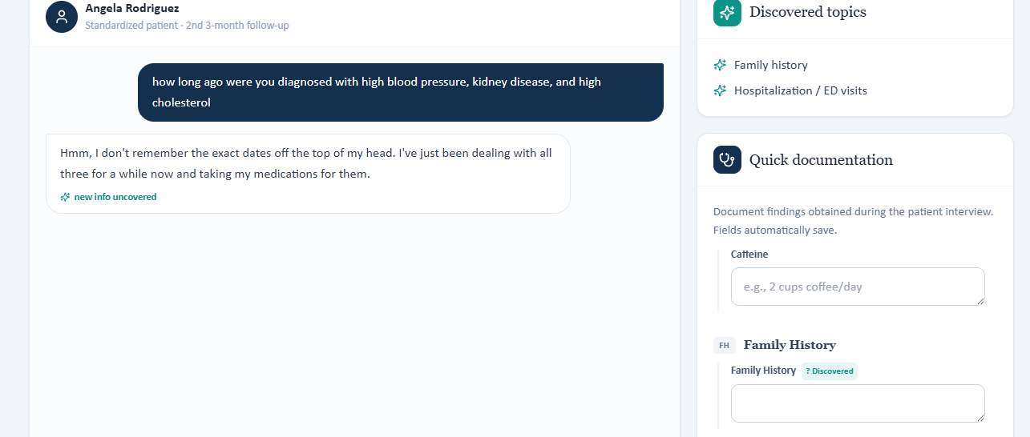
Figure 4. Diagnosis-duration question is labeled 'new info uncovered,' but Family History is incorrectly marked Discovered in Quick Documentation.
Suggested regression test
Run the same interview question, verify the transcript's 'new info uncovered' state, then assert that only the correct Quick Documentation field/topic is marked Discovered and that unrelated fields remain unchanged.

25. Medication-adherence follow-up is incorrectly mapped to Disease Understanding and Weight/Goals
Severity: P0 - Critical
Observed behavior
The student asks, “Do you know what medication you normally forget to take?” The patient responds that she does not keep track of which medication it is and that missing a dose is infrequent. The transcript correctly shows 'new info uncovered.' However, the Quick Documentation panel shows Discovered badges next to Weight / Goals and Disease Understanding rather than the medication-adherence topic that the response actually addresses.
Expected behavior
The response should map to Medication Adherence (and possibly medication reconciliation if the system uses a secondary topic). Weight / Goals and Disease Understanding should remain unchanged because the response contains no new weight goal or disease-understanding information.
Why this matters
This is a strong false-positive classification example. Incorrect discovery badges can mislead the learner about which required interview domains are complete, leave the correct adherence field incomplete, and contaminate downstream scoring or analytics that assume a 'Discovered' badge means the topic was truly elicited.
Recommended fix
Constrain topic classification using both the user's question and the patient's response. For this exchange, intent should be classified as medication adherence before the response is analyzed. Use the question intent as a strong prior and permit topic switching only when the answer clearly introduces a different domain. Add explicit regression cases ensuring adherence questions cannot mark Weight / Goals or Disease Understanding without relevant content.
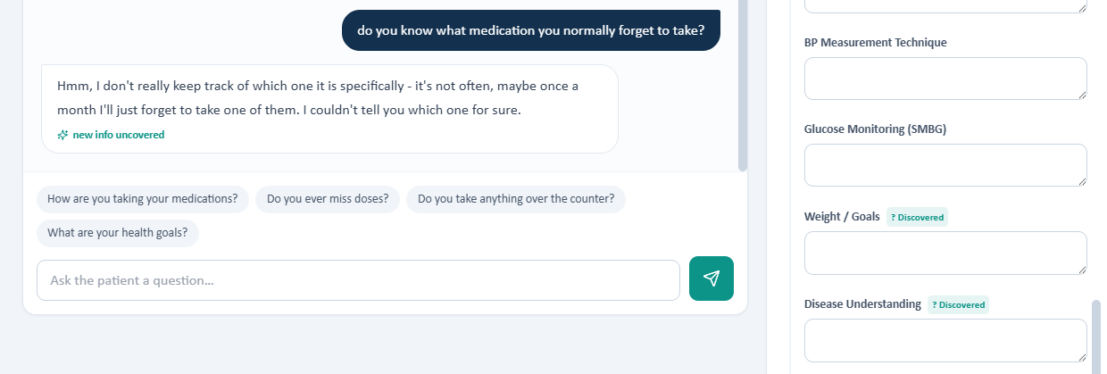
Figure 5. Medication-adherence follow-up is marked 'new info uncovered,' while unrelated Weight / Goals and Disease Understanding fields are shown as Discovered.
Suggested regression test
Run the same interview question, verify the transcript's 'new info uncovered' state, then assert that only the correct Quick Documentation field/topic is marked Discovered and that unrelated fields remain unchanged.

11. Cross-Cutting Root Cause Suggested by the Interview UI Bugs
Likely failure mode: The 'new info uncovered' badge, Quick Documentation discovery badges, and Discovered Topics list may be generated by separate classification paths or by a shared classifier with insufficiently constrained topic mapping. The screenshots show both missing synchronization and incorrect cross-topic assignment.
- Use one canonical topic ID per uncovered fact and propagate that same ID to transcript, Quick Documentation, Discovered Topics, and grader state.
- Condition classification on both the student's question intent and the patient's answer, not the answer alone.
- Require strong evidence before marking unrelated domains as Discovered.
- Allow multiple-topic outputs only when each topic is independently supported by the response.
- Record an auditable event log: question, answer, classifier topic(s), confidence, affected UI field(s), and grader-visible state.
- Add end-to-end UI tests that assert the same topic appears consistently across transcript, Quick Documentation, Discovered Topics, and any grading payload.

12. Additional Regression Tests for Discovery-State Synchronization
Student Question | Patient Answer Domain | Expected Discovered Topic | Negative Assertion
Current medications | Medication list response | Medication History/Reconciliation | Must not mark unrelated topics.
How long diagnosed? | Patient's own HTN/CKD/HLD duration | HPI/PMH/Disease History | Must not mark Family History.
Which medication do you forget? | Adherence detail | Medication Adherence | Must not mark Weight/Goals or Disease Understanding.

David Chen Tuesday Initial Visit
Major AI Grader Discrepancies
Purpose: identify the most important grading discrepancies where the AI feedback conflicts with, is not supported by, or appears to overlook information in the original EMR/patient interview or the submitted revised SOAP note. This list is intentionally limited to major issues rather than every minor deduction.

Highest-Priority Discrepancies
- Fatigue: grader expects mild fatigue, but the patient explicitly denied fatigue in the interview.
- Pneumococcal vaccine: grader expects 'none documented'/a vaccine gap, while the EMR explicitly lists pneumococcal vaccination as up to date.
- Family history: grader requires father MI at 58 plus paternal T2DM and maternal CKD, but the patient interview gave father MI at 54, mother HTN/T2DM, and brother CABG at 58.
- Unsupported subjective details: nocturia, dialysis as greatest fear, online research/lab-tracking behavior, full-time work/activity level, dietary lapses, and broad urinary complaints were not established in the supplied interview.
- ASCVD risk: grader expects a 22% 10-year risk even though that value was not documented in the supplied EMR and was intentionally not added.
- Follow-up: grader expects ~3 months, while the EMR explicitly lists the next appointment as 06/30/2026, about one week after the visit.
- NKDA: grader states NKDA was not documented, but the revised SOAP note explicitly included 'No known drug allergies (NKDA)' in the identifying-data section.
- Quick documentation discovery-state bug: asking about current medications produces “new info uncovered” in the transcript, but the Current Medications field does not show “Discovered” in the Quick documentation panel.

Detailed Major Discrepancies
Issue | AI Grader Feedback | What the Source/Note Shows | Why This Is Major | Recommended Fix
1. Fatigue | [1B.2] Grader says the patient should have mild fatigue and deducts for documenting a denial. | The patient interview explicitly states: no fatigue, dizziness, chest pain, or shortness of breath; he reports feeling normal overall. | Direct contradiction between the grader key and the patient interview. The SOAP note was source-faithful. | The grader should accept 'denies fatigue' for this case or the source case should be corrected if mild fatigue is intended.
2. Pneumococcal vaccination | [1E.21], [3H.2], [4G.1] Grader expects pneumococcal vaccine to be 'none documented'/a gap. | The EMR immunization section explicitly lists Pneumococcal: Up to date. | Direct factual conflict. This creates multiple deductions from a single source mismatch. | Grade according to the displayed EMR status ('up to date'), or revise the EMR if a pneumococcal gap is intended.
3. Family history conflict | [1C.7-1C.9] Grader expects father MI at 58, father T2DM, and mother CKD. | The patient interview states father HTN + MI at 54; mother HTN + T2DM; brother CABG at 58. The chart summary separately lists father MI at 58 + T2DM and mother T2DM + CKD. | The source itself contains conflicting family-history versions. The user specifically requested that the SOAP note use the patient-interview version. | The grader should not penalize a note that follows the patient interview. Ideally, the case should reconcile the chart-versus-interview discrepancy.
4. Nocturia | [1B.3] Grader deducts for not documenting occasional nocturia. | Occasional nocturia was not established in the supplied patient interview/EMR content used for the SOAP note. | Hidden-key detail not supported by the visible source. Adding it would require inventing patient information. | Remove this deduction unless nocturia is added to the source encounter.
5. Dialysis as greatest fear | [1G.2] Grader deducts 0.9 points for omitting dialysis as the patient's greatest fear. | The patient expressed concern about worsening kidney numbers, rising urine protein, family history, finerenone-related hyperkalemia, cost, and pill burden. Dialysis was not stated as his greatest fear. | Large deduction for a psychosocial detail that is not supported by the visible interview. | Remove this deduction unless the patient interview explicitly includes dialysis fear.
6. Online research / lab-tracking behavior | [1B.5], [1G.3] Grader expects close lab tracking and researching conditions online. | The source supports that the patient is highly analytical, watches kidney-related results, and wants to understand the rationale for recommendations. It does not explicitly establish online research behavior. | The grader converts a reasonable inference into a required factual statement and deducts twice for it. | Accept source-supported wording such as 'highly engaged/analytical and follows kidney results,' but do not require undocumented online research.
7. 22% 10-year ASCVD risk | [2B.16], [3D.2] Grader requires a 22% 10-year ASCVD risk. | The supplied EMR does not display a 22% risk estimate. The revised note intentionally did not add an undocumented calculated value. | A precise risk percentage is being graded as required despite not being present in the source. The case also contains an age/DOB inconsistency, which can affect risk calculation. | Either provide the 22% risk in the source/rubric-visible data or do not deduct for omitting it.
8. Follow-up interval | [4H.1] Grader expects approximately a 3-month follow-up and deducts for the 06/30/2026 date. | The EMR explicitly lists the next appointment as 06/30/2026 at 10:30, approximately one week after the 06/23/2026 visit. | Direct conflict between the expected grading interval and the charted appointment date. | Treat 06/30/2026 as an interim/next scheduled follow-up and, if desired, separately require a longer-term 3-month follow-up rather than marking the charted date wrong.
9. NKDA documentation | [1E.18] Grader says NKDA is not documented anywhere in the revised note. | The revised SOAP note explicitly includes 'Allergies: No known drug allergies (NKDA)' in the identifying-data table. | This appears to be a grader extraction/recognition failure rather than a content omission. | The grader should recognize NKDA when documented in a table or header, not only in a separate allergy paragraph.
10. Other unsupported subjective expectations | [1B.4], [1D.7], [1F.7], [3B.4] Grader expects full-time/active work status, dietary lapses, broad urinary denials, and explicit denial of hypoglycemia. | The source documents occupation as electrical engineer, attempts a diabetic diet, gross hematuria denial, and medication adherence/tolerability. It does not clearly document the additional required details. | These deductions reward adding information that was not actually elicited or documented. | Grade only details supported by the source, or add the missing interview questions/answers to the case.
11. Quick documentation discovery-state bug | After the patient is asked about current medications, the live transcript indicates "new info uncovered," but the Current Medications field in the Quick documentation panel does not change to show "Discovered." | The screenshot shows the medication question and answer in the transcript with "new info uncovered." In the Quick documentation panel, Medication Adherence and Diet/Nutrition display a green "Discovered" tag, while Current Medications remains unmarked. | This is a visible UI/state-sync inconsistency. The system recognizes that new medication information was uncovered but does not propagate that discovery state to the corresponding quick-documentation field, which can mislead the learner into thinking the topic was not completed. | When a medication answer triggers "new info uncovered," automatically mark Current Medications as "Discovered" in Quick documentation, using the same state behavior as Medication Adherence and other discovered fields.

Recommended Reporting Summary
The most significant problem is that the AI grader appears to use hidden or conflicting answer-key details that are not consistently represented in the visible EMR/patient interview. Several deductions are therefore not documentation-quality issues; they are source-to-grader mismatches. The clearest examples are fatigue, pneumococcal vaccination status, family-history age/details, dialysis fear, nocturia, the 22% ASCVD risk, and the expected 3-month follow-up interval.
For future grading reliability, the scoring key should be aligned with the exact patient interview and objective tabs shown to the student. If a detail is required for points, it should be explicitly present in the source encounter rather than inferred from a hidden key.

Screenshot Evidence - Quick Documentation Discovery-State Bug
Observed behavior: The patient answers the Current Medications question and the transcript shows “new info uncovered,” but the corresponding Current Medications field remains without a “Discovered” badge. Nearby fields such as Medication Adherence and Diet/Nutrition do show the green “Discovered” state.

Figure 1. David Chen Tuesday Initial Visit - Current Medications discovery-state mismatch in Quick documentation.
Impact: This can create confusion for the learner because the interview system confirms that relevant information was uncovered while the documentation workflow simultaneously appears incomplete. It may also contribute to unnecessary repeated questioning or inaccurate assumptions about which interview topics still need to be addressed.

David Chen Wednesday 3-Month Follow-Up
Major AI Grader Discrepancies
Purpose: document the most important cases where the AI grader appears to require hidden or conflicting information that is not supported by the Wednesday EMR/patient interview, or where the visible source itself contains competing versions. This is intended for inclusion in a combined programmer/bug-report document.

Highest-Priority Issues
- Family history conflict: Wednesday patient interview says father MI at 54, mother HTN/T2DM, brother CABG at 58; grader expects father MI at 58 + father T2DM + mother CKD.
- Social history conflict: Wednesday interview does not establish occupation or marital status and says the patient is not much of an exerciser; grader expects occupation, married status, and walking 3-4 days/week.
- Immunization mismatch: the Wednesday EMR immunization section is blank, yet the grader expects specific influenza/COVID status and pneumococcal, zoster, and Tdap gaps.
- Hidden subjective requirements: grader expects the patient to report doing well overall, greater comfort with finerenone, noticing albuminuria improvement, asking about that improvement, no hospitalizations/ED visits, and motivation to avoid dialysis/preserve kidney function; these are not documented in the Wednesday interview.
- ASCVD risk mismatch: grader requires a 20.5% 10-year ASCVD risk despite no such value being displayed in the Wednesday EMR.
- ROS mismatch: grader requires explicit denials of chest pain and gross hematuria, although these questions/answers are not documented in the Wednesday interview.

Detailed Major Discrepancies
Issue | AI Grader Expectation | What Wednesday Source Shows | Why This Is a Major Discrepancy | Recommended Programmer Fix
1. Family history - chart/key vs. Wednesday interview | Grader deductions [1C.7]-[1C.9] require father MI at 58, father T2DM, and mother CKD. | Wednesday patient interview states: father had HTN and MI at age 54; mother has HTN and T2DM; brother had bypass surgery at age 58. | This is not simply a SOAP-note omission. The grader is scoring a different family-history version than the one provided by the patient during this day's interview. | Reconcile the source data. If the grader should use interview answers for that day, accept age 54 and the interview family history. If the chart history is intended to override the interview, make that explicit in the case.
2. Occupation and marital status | Grader deductions [1D.1] and [1D.2] expect marital status and occupation to be documented. | When asked occupation, the Wednesday patient says he does not recall having that information to share for this visit. When asked if married, he does not provide a marital-status answer. | The grader appears to expect carryover/hidden information that the standardized patient does not provide during the Wednesday encounter. | Either expose the carryover social history in the Wednesday EMR or do not penalize the note for documenting these items as not established.
3. Exercise/activity history | Grader deductions [1D.6] and [4F.1] expect walking 3-4 days/week and continuation of a walking program. | Wednesday interview response: 'I'm not much of an exerciser... I mostly just go about my day-to-day stuff.' | Direct conflict. The SOAP note accurately reflected the Wednesday interview, while the grader expects a different exercise history. | Align the grader with the Wednesday response, or change the standardized-patient response if 3-4 days/week walking is intended.
4. Diet history | Grader deduction [1D.7] expects continued diabetic dietary modification. | Wednesday interview: patient says he tries to watch what he eats, has no specific details written down, and nothing has really changed lately. | The grader requires more specific diet behavior than the source supplies. | Accept the documented vague diet history, or add an explicit 'continues diabetic diet' statement to the source encounter.
5. Immunization status and vaccine gaps | Grader deductions [1E.20]-[1E.24], [3H.1]-[3H.4], and [4G.1]-[4G.3] expect influenza/COVID status and pneumococcal, zoster, and Tdap gaps. | The Wednesday Objective section shows an 'Immunizations' heading but no actual vaccine entries/statuses beneath it. | The grader is scoring vaccine facts that are not visible in the Wednesday EMR. This can lead students to either invent data or lose points for source-faithful documentation. | Populate the Wednesday immunization section with the intended statuses/gaps, or remove those deductions.
6. 'Doing well overall' and improved comfort with finerenone | Grader deductions [1B.1] and [1B.4] expect an explicit statement that the patient is doing well overall and feels more comfortable/understands finerenone benefits now. | The Wednesday patient says he feels normal and has no major symptoms, but repeatedly says he remains nervous about potassium 5.1 and the eGFR dip. | The hidden-key interpretation overstates reassurance/comfort compared with the actual interview. | Accept 'clinically feels normal but remains nervous' as the source-supported description, unless an explicit improved-comfort statement is added to the interview.
7. Patient noticing albuminuria improvement / asking about it | Grader deductions [1B.8] and [1B.9] require the patient to notice improved urine protein and ask for clarification. | The Wednesday interview focuses on potassium and eGFR. The UACR improvement from 520 to 390 is visible in objective labs, but the patient does not state that he noticed it or ask about it. | Objective laboratory improvement is being converted into a required subjective patient statement that is absent from the interview. | Do not require this subjective statement unless the standardized patient explicitly says it.
8. Hospitalizations and ED visits since last visit | Grader deductions [1B.11] and [1B.12] expect explicit negatives for hospitalization and ED visits. | The Wednesday patient interview does not include questions or answers about interval hospitalizations or emergency-department visits. | These are hidden interview requirements not available to the student from the documented encounter. | Add these questions/answers to the interview if they are rubric items, or remove the deductions.
9. Dialysis / long-term kidney-function motivation | Grader deductions [1G.1] and [1G.2] expect motivation to avoid dialysis and preserve long-term kidney function. | The Wednesday patient's stated concern is potassium 5.1 and the small kidney-number/eGFR decrease. He does not mention dialysis or explicitly state a long-term kidney-preservation motivation. | These are substantial subjective/psychosocial points based on content not present in the source. | Only score these if they are explicitly elicited in the Wednesday standardized-patient encounter.
10. Chest pain and gross hematuria ROS | Grader deductions [1F.1] and [1F.6] require explicit denials of chest pain and gross hematuria. | Wednesday ROS questions document shortness of breath, palpitations, fatigue, dizziness, muscle symptoms, urinary-habit changes, swelling/foamy urine, and syncope. Chest pain and gross hematuria are not explicitly asked or answered. | The grader requires negative ROS statements that cannot be truthfully documented from this day's interview. | Add explicit chest-pain and hematuria questions to the encounter, or do not deduct for their absence.
11. 10-year ASCVD risk of 20.5% | Grader deductions [2B.18] and [3D.4] require a 20.5% 10-year ASCVD risk estimate. | The Wednesday EMR does not display a calculated ASCVD risk percentage. | A precise calculated risk is treated as a required chart fact even though it is not visible in the source. This is especially problematic for a copy/paste SOAP exercise that is supposed to use the provided EMR. | Display the 20.5% risk in the EMR/rubric-facing data or stop scoring it as a required source-derived fact.
12. HDL-C value | Grader deduction [2B.11] says HDL-C should be documented. | The Wednesday lipid panel shown in the EMR includes total cholesterol 168 mg/dL, LDL-C 82 mg/dL, and triglycerides 170 mg/dL; an HDL-C result is not shown in the supplied Wednesday lab data. | The grader appears to require a laboratory value absent from the visible source. | Add HDL-C to the Wednesday lab panel if it is required, or remove the deduction.

Important Note: Items That Are More Likely True SOAP-Note Omissions
Not every deduction is a grader bug. Several feedback items could reasonably be improved from the Wednesday source itself, including explicitly comparing eGFR 42 -> 40, A1C 7.2% -> 7.0%, naming a CMP for follow-up labs, explicitly tying eGFR 40 to G3b, adding guideline citations if the rubric requires them, and strengthening the benefit-risk conclusion for continuing finerenone. Those items are different from the source-vs-grader discrepancies listed above.

Programmer-Facing Summary
The major pattern is that the grader appears to use hidden carryover data or an answer key that does not match the Wednesday standardized-patient responses. The most consequential conflicts involve family history, social history/exercise, immunizations, subjective finerenone understanding, dialysis motivation, ROS negatives, and the 20.5% ASCVD risk. These mismatches can penalize source-faithful documentation and may encourage users to add facts that were never provided.

David Chen Thursday 2nd 3-Month Follow-Up
Major AI Grader Discrepancies
Purpose: identify the most important grader-versus-source mismatches for the Thursday encounter so this section can be appended to the combined programmer report. This list emphasizes discrepancies that could cause a source-faithful SOAP note to lose points or encourage documentation of facts that were not provided.

Highest-Priority Discrepancies
Visit interval hallucination: the grader says the note called this a 6-month follow-up, but the submitted note identified it as a Thursday '2nd 3-month follow-up,' matching the EMR.
Social-history conflict: the Thursday interview does not establish marital status, occupation, or a walking routine; the grader expects married/occupation and walking about 4 days/week.
Family-history conflict: the Thursday interview says father MI at 54, mother HTN/T2DM, brother CABG at 58; the grader expects father MI at 58 + father T2DM + mother CKD.
Immunization mismatch: the Thursday EMR's immunization section is blank, but the grader expects influenza/COVID up to date and specific pneumococcal, zoster, and Tdap gaps.
Hidden subjective requirements: the grader expects hospital/ED negatives, dialysis-avoidance motivation, kidney-preservation motivation, and a patient question about whether therapy is still needed despite improvement; these are not present in the Thursday interview.
Hidden objective/risk values: the grader requires HDL-C 46 mg/dL and a 10-year ASCVD risk of 18.7%, neither of which is shown in the Thursday EMR.

Detailed Major Discrepancies
Issue | AI Grader Expectation | What Thursday Source Shows | Why Major | Recommended Programmer Fix
1. Visit interval | [1A.3] Grader says the note states a 6-month follow-up and then contradicts itself with second 3-month follow-up. | The Thursday EMR explicitly labels the encounter 'Thursday · 2nd 3-month follow-up.' The submitted SOAP note also used 'Thursday, 2nd 3-month follow-up' and did not intentionally document a 6-month visit. | This appears to be a grader extraction/hallucination error rather than a documentation error. | Update the grader to recognize the explicit visit label in the note and source; do not penalize for a 6-month interval that was not documented.
2. Exercise / walking history | [1B.6], [1D.6], [4F.1] Grader expects walking about 4 days/week and continuation of a walking program. | Thursday patient response: 'I don't really have a set routine that I can tell you about — nothing specific comes to mind.' | Direct conflict between the standardized-patient response and grader key. A source-faithful note should not invent a 4-days/week walking routine. | Either change the patient response to state the intended walking frequency or remove these deductions.
3. Diet improvement | [1B.7], [1D.7] Grader expects continued dietary improvement efforts. | Thursday interview says the patient tries to eat okay but does not have his diet mapped out and has not tracked specifics. | The grader requires a more specific improvement claim than the interview supports. | Accept the source-supported diet wording or explicitly add continued dietary improvement to the standardized-patient response.
4. Family history | [1C.7]-[1C.9] Grader expects father MI at 58, father T2DM, and mother CKD. | Thursday interview: father HTN and MI at 54; mother HTN and T2DM; brother CABG at 58. | The grader is using a different family-history version than the Thursday interview. This is a recurring cross-day source inconsistency. | Reconcile the chart and interview histories, or specify which source should control grading.
5. Marital status and occupation | [1D.1], [1D.2] Grader expects both to be documented. | When asked directly, the Thursday standardized patient says he does not have information about marital status or job available in this visit. | The grader expects hidden/carryover social history that the patient explicitly does not provide on this day. | Expose carryover data in the Thursday chart if required, or do not penalize the note for documenting these items as not established.
6. Recreational drug use | [1D.5] Grader expects recreational drug-use status. | The Thursday interview shown in the EMR does not include a recreational-drug question/answer. | A negative drug-use statement cannot be truthfully documented from this day alone. | Add the question/answer to Thursday if required, or remove the deduction.
7. Hospitalizations and ED visits | [1B.10], [1B.11] Grader expects explicit negatives since the prior visit. | No interval hospitalization or ED-visit question/answer appears in the Thursday interview. | These are hidden required subjective facts rather than omissions from available source data. | Add these interval-history questions to the standardized encounter if they are rubric-scored.
8. Patient question about whether therapy is still needed | [1B.9], [1G.4], [3F.3], [3F.6] Grader expects the patient to question whether continued treatment is necessary despite improved labs. | Thursday source says the opposite: 'This makes sense now,' 'I'm committed to staying on everything,' and 'I feel pretty good about where things stand with my treatment plan.' | Direct contradiction. The grader expects a misconception that the patient interview specifically resolves. | Align the grader with the Thursday patient's documented improved understanding, or modify the interview to include the intended question.
9. Dialysis avoidance / kidney-preservation motivation | [1G.1], [1G.2] Grader expects motivation to avoid dialysis and preserve long-term kidney function. | The Thursday interview documents confidence in the regimen, lower albuminuria, manageable cost, and commitment to therapy, but does not mention dialysis or explicitly state this motivation. | These are significant psychosocial deductions based on details absent from the source. | Only score these items if the standardized patient explicitly says them.
10. Immunization statuses and gaps | [1E.20]-[1E.24], [3H.1]-[3H.4], [4G.1]-[4G.3] expect influenza/COVID up to date plus pneumococcal, zoster, and Tdap gaps. | The Thursday EMR contains an 'Immunizations' heading but no populated vaccine statuses. | The grader is requiring vaccine facts that are not visible in the source and then penalizing source-faithful documentation for not inventing them. | Populate the Thursday immunization section with the intended statuses/gaps or remove these deductions.
11. Gross hematuria and muscle cramps | [1F.6], [1F.9] Grader expects explicit denial of gross hematuria and muscle cramps. | Thursday interview includes no urinary changes, no swelling, no chest pain/dizziness, and no muscle weakness/soreness/unusual fatigue. It does not explicitly state gross hematuria or cramps. | The grader requires more specific ROS wording than the actual interview provides. | Add explicit questions/answers for gross hematuria and cramps if they are required rubric items.
12. HDL-C 46 mg/dL | [2B.12] Grader requires HDL-C 46 mg/dL. | Thursday lipid panel in the EMR shows total cholesterol 160, LDL-C 74, and triglycerides 154 mg/dL; HDL-C is not displayed. | The grader requires a lab value not present in the visible Thursday data. | Add HDL-C to the Thursday lab panel if required, or remove the deduction.
13. 10-year ASCVD risk 18.7% | [2B.20], [3D.4] Grader requires 18.7% and improvement from 22% to 18.7%. | No calculated ASCVD risk percentage appears in the Thursday EMR. | A precise risk estimate is being treated as a source fact despite not being shown. This creates hidden-key grading. | Display the risk estimate in the EMR/rubric-visible data or do not deduct for omission.
14. Height must be 70 inches | [2A.8] Grader deducts because height was documented as 5'9" rather than 70 inches. | The EMR itself documents height as 5'9". The SOAP note copied the source exactly. | The grader appears to require a converted value rather than source-faithful transcription; also, 5'9" equals 69 inches, not 70 inches. | Correct the rubric conversion requirement or accept the EMR value as documented.

Items That Are More Likely True SOAP-Note Improvement Opportunities
Several feedback items are not source/grader bugs and could reasonably be improved in a future SOAP note: explicitly document surgical history if available; cite KDIGO 2024 and 2026 AHA/ACC guidance if the rubric requires named guidelines; explicitly call potassium 4.9 mEq/L acceptable; state that continued lipid-lowering therapy remains warranted; provide numeric treatment goals if required by the rubric; note the weight trend from 102 kg to 99 kg only if prior values are intended to be carried forward; and specify a follow-up interval if the rubric requires one. These should be distinguished from the hidden-data conflicts above.

Programmer-Facing Summary
The dominant issue is recurring mismatch between the standardized-patient responses shown for the current day and the grader's hidden answer key. On Thursday, the most consequential conflicts involve the visit interval, exercise history, family history, social history, immunizations, the supposed question about stopping therapy, dialysis motivation, HDL-C, ASCVD risk, and the height conversion. These mismatches can penalize accurate documentation and may encourage students to enter facts that were never provided or that directly contradict the interview.

Journal Club (Friday) Testing Summary
The Journal Club module was tested and no functional issues, discrepancies, or grading concerns were identified during use. The content displayed appropriately, the workflow functioned as expected, and there were no apparent problems with navigation, responses, documentation, or grading behavior.
Based on testing completed during this rotation, no bugs or corrective actions are recommended for the Journal Club portion of the system at this time.

