WEEK 3
VACS Retest Report
Remaining Issues Only
Plain-language version for technical review
Purpose
This report lists only problems that still need to be fixed after retesting. Items that were verified as fixed are intentionally not repeated.
Main rule: A student should not lose points for accurately documenting what the live chart or AI patient says.
Audience: technical/developer review. Medical terms are explained in simple English.

Quick Guide
The four parts of VACS should tell the same story for the same patient and day:
- EMR = the chart the student sees.
- AI patient = the simulated patient the student interviews.
- Rubric = the reference facts used for scoring.
- AI grader = the system that scores the SOAP note.
If these four parts use different data, the student can be penalized for being correct.

Priority Levels
Priority | Meaning
CRITICAL | Stops grading or can lead to the wrong clinical decision.
HIGH | Can create a wrong score or wrong patient story.
MEDIUM | Creates confusing or contradictory information but is lower risk.

Retest Coverage
- Sarah Thompson: Tuesday, Wednesday, and Thursday were retested and the grader returned feedback.
- Robert “Bob” Jenkins: Tuesday, Wednesday, and Thursday were submitted, but the grader failed with the same JSON error each time.
- Maria Thompson: the retest grader also produced the same JSON error on the current submission, so the remaining Maria grader issues cannot be verified yet.

At a Glance — 10 Grouped Problems Still Open
# | Patient / Day | Priority | Still needs fixing
1 | Sarah Tue | HIGH | Grader uses the wrong Tuesday patient story.
2 | Sarah Tue | CRITICAL | Grader uses the wrong Tuesday vitals and breathing-test values.
3 | Sarah Wed | CRITICAL | Grader is on the wrong treatment stage.
4 | Sarah Wed | CRITICAL | Grader uses the wrong objective/PFT data and creates an unsafe warning.
5 | Sarah Wed | MEDIUM | AI patient reports extra medicines that the grader says should not exist.
6 | Sarah Thu | CRITICAL | Grader uses the wrong Thursday objective values.
7 | Sarah Thu | HIGH | Grader expects the wrong allergy/rhinitis medicine regimen.
8 | Sarah Thu | CRITICAL | Grader uses the wrong symptom and exacerbation history.
9 | Sarah Thu | MEDIUM | Chart says ACT/PFT data are “Missing” even though they are present.
10 | Shared | CRITICAL | AI grader returns “Unexpected end of JSON input” and cannot grade Robert; same error also appears during Maria retest.

Sarah Thompson — Tuesday Initial Visit
Retest AI score: 65.6%. Only unresolved system/data problems are listed below.
ST-TUE-R1 — Grader uses the wrong Tuesday patient story
HIGH | Still needs developer action
Problem: The AI patient and the grader are still using different versions of Sarah’s Tuesday history.
What the student sees: Sarah reports intermittent budesonide/controller use, an urgent-care flare about 6 weeks ago, and a 5-day prednisone course. She also reports albuterol on most days and nighttime symptoms 2–3 nights/week.
What the grader expects: The grader expects no controller, no recent oral steroid, different symptom frequencies, and uncertainty about the exact asthma diagnosis age.
Why this matters: A student can lose points for documenting the AI patient accurately. This also changes whether the case is “no controller treatment” versus “poor use of an existing controller.”
Please fix: Choose one Tuesday storyline and make the EMR, AI patient, rubric, and grader all use that same storyline. Do not require the student to guess which version is correct.
Live EMR / AI patient  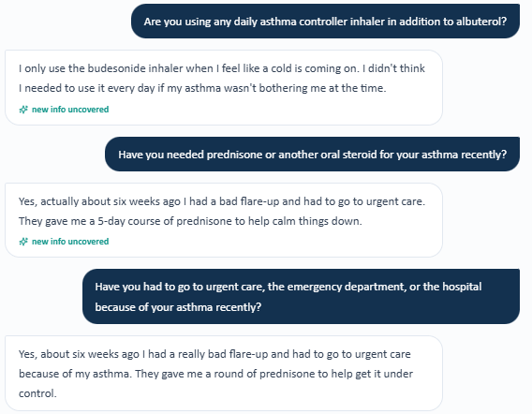  AI patient: budesonide use + recent prednisone/urgent care.  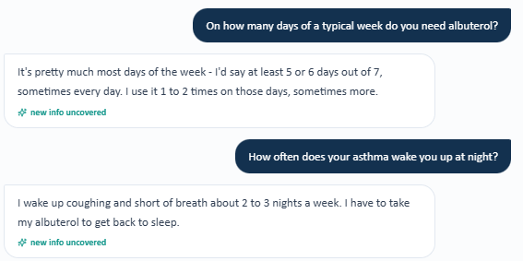  AI patient: albuterol most days + night symptoms 2–3 nights/week. | AI grader  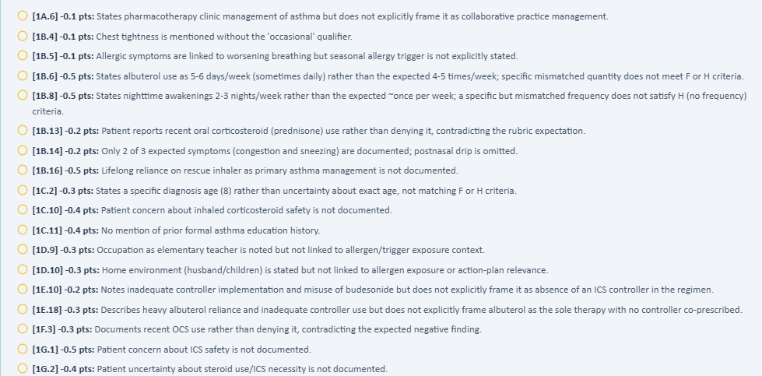  Grader deductions expect a different history.

ST-TUE-R2 — Grader uses the wrong Tuesday objective values
CRITICAL | Still needs developer action
Problem: The live chart values and the grader reference values do not match.
What the student sees: Live chart: BP 122/78, HR 82, SpO₂ 98%, weight 76 kg, BMI 27.9, FEV1/FVC 0.69, bronchodilator change +14% / +280 mL.
What the grader expects: Grader expects BP 118/76, HR 88, SpO₂ 97%, weight 65 kg, BMI 23.9, FEV1/FVC 0.75, and +15% / +375 mL.
Why this matters: The grader can mark correct chart data as wrong and can also change the clinical interpretation of the breathing test.
Please fix: Make the Tuesday grader load the same objective data shown in Sarah’s live Tuesday chart. Regression-test every listed value together, not one field at a time.
Live EMR / AI patient  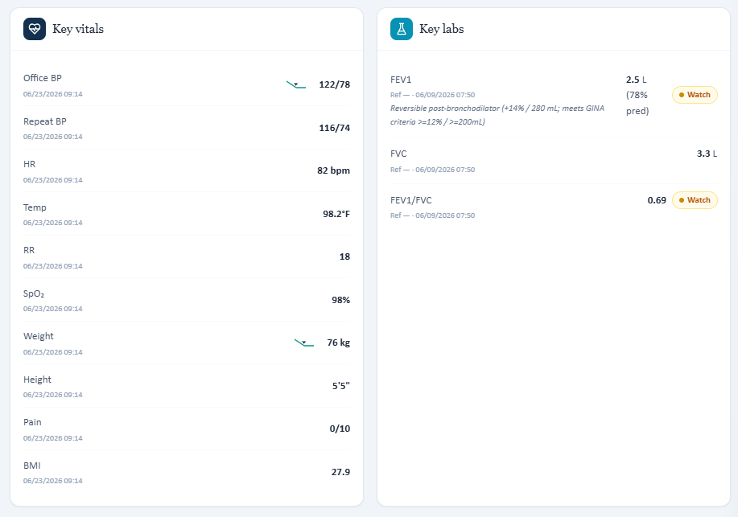  Live Tuesday vitals and pulmonary values used by the student. | AI grader  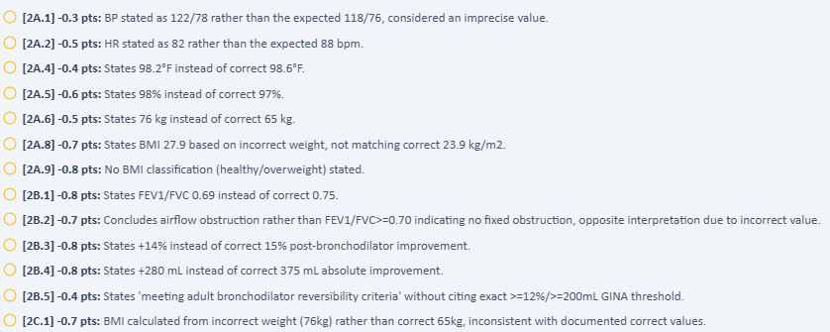  Grader expects a different objective dataset.

Sarah Thompson — Wednesday 3-Month Follow-Up
Retest AI score: 60.8%.
ST-WED-R1 — Grader is on the wrong treatment stage
CRITICAL | Still needs developer action
Problem: The live Wednesday case is already a SMART-therapy follow-up, but the grader still scores it like SMART has not started yet.
What the student sees: The EMR and AI patient show Symbicort (budesonide/formoterol) 160/4.5 mcg, 1 inhalation twice daily plus 1 inhalation as needed. There is no separate rescue inhaler.
What the grader expects: The grader expects separate budesonide HFA plus albuterol and deducts because the SOAP continues SMART instead of starting/escalating SMART at this visit.
Why this matters: This can push the student toward the wrong treatment decision because the grader is using the wrong point in the patient timeline.
Please fix: Bind the Wednesday grader to the Wednesday follow-up treatment stage. The medication list, advisory, AI patient, rubric, and grader must all show the same stage.
Live EMR / AI patient  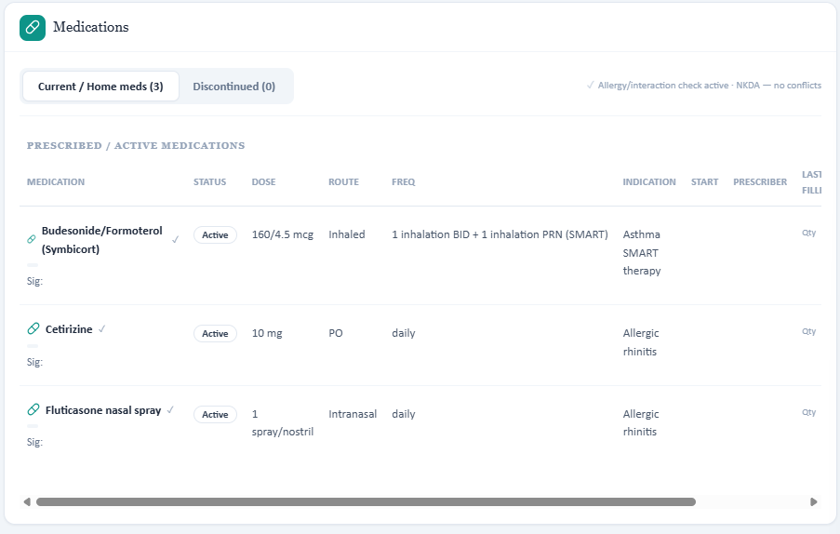  Live EMR: Symbicort SMART regimen.  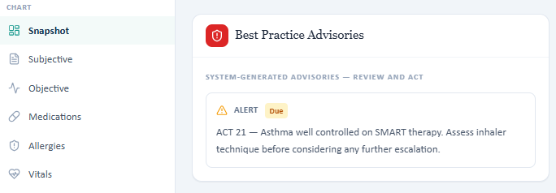  Live advisory: ACT 21, well controlled on SMART. | AI grader  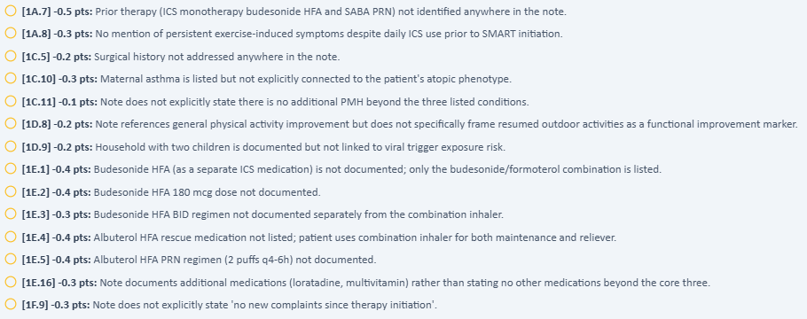  Grader still expects pre-SMART budesonide + albuterol treatment.

ST-WED-R2 — Wrong objective/PFT dataset creates an “unsafe” warning
CRITICAL | Still needs developer action
Problem: The grader still uses different vital signs and breathing-test values than the live Wednesday chart.
What the student sees: Live chart: BP 120/76, HR 76, RR 16, weight 75 kg, BMI 27.5, FEV1/FVC 0.69, and bronchodilator change +14% / +280 mL.
What the grader expects: The grader expects BP 118/76, HR 88, RR 18, weight 65 kg, BMI 23.9, FEV1/FVC 0.75, and +15% / +375 mL. It then labels the student’s interpretation of the live PFT as potentially unsafe.
Why this matters: A safety warning should not be triggered because the student used the values shown in the live chart. This can confuse students and reviewers and can drive the wrong step-up/step-down decision.
Please fix: Make the Wednesday grader use the exact live Wednesday objective dataset. After the fix, submit a SOAP using the live PFT values and confirm that no false unsafe warning appears.
Live EMR / AI patient  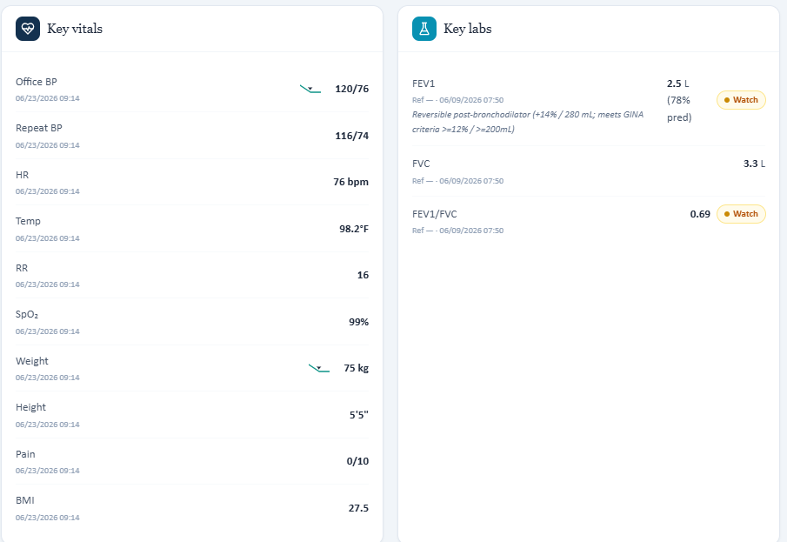  Live Wednesday vitals and PFT values. | AI grader  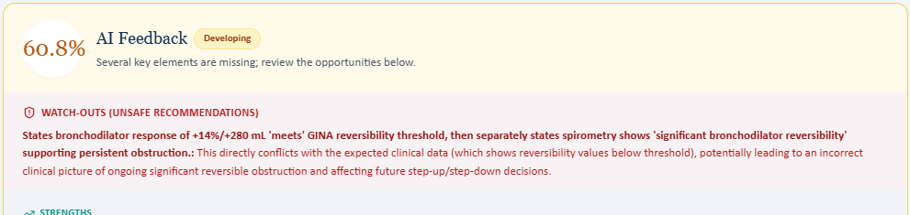  False unsafe warning caused by a different hidden PFT dataset.  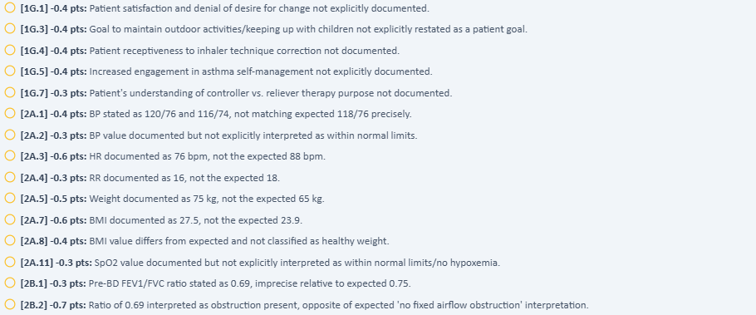  Grader deductions use different objective values.

ST-WED-R3 — AI patient reports extra medicines that the grader says should not exist
MEDIUM | Still needs developer action
Problem: The medication interview and the grader do not agree on the complete medication list.
What the student sees: The AI patient reports Symbicort, cetirizine, fluticasone nasal spray, intermittent loratadine, and a daily multivitamin.
What the grader expects: The grader deducts for loratadine and multivitamin because it expects no additional medicines beyond the core regimen.
Why this matters: A student should include medicines the patient reports during medication reconciliation. The current behavior makes accurate documentation look wrong.
Please fix: Either remove the extra medicines from the AI patient or add them to the intended reference. Then make the grader accept the same list.
Live EMR / AI patient  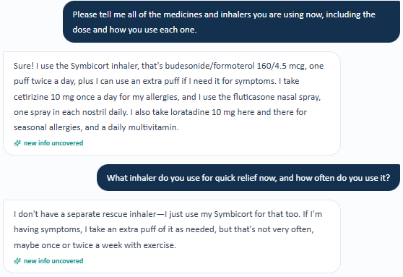  AI patient spontaneously reports loratadine and multivitamin. | AI grader    Grader deduction says the extra medicines should not be present.

Sarah Thompson — Thursday 6-Month Follow-Up
Retest AI score: 49.9%.
ST-THU-R1 — Grader uses the wrong Thursday objective values
CRITICAL | Still needs developer action
Problem: The live Thursday vitals/PFT values still do not match the grader reference.
What the student sees: Live chart: BP 120/76 (repeat 116/74), HR 76, RR 16, weight 75 kg, BMI 27.5, FEV1 85% predicted, FEV1/FVC 0.77.
What the grader expects: The grader expects BP 118/76, HR 88, RR 18, weight 65 kg, BMI 23.9, and FEV1/FVC 0.80.
Why this matters: The student is penalized for copying the live chart correctly. This also changes how lung function is interpreted.
Please fix: Make the Thursday grader use the Thursday live objective dataset and re-test all values together.
Live EMR / AI patient  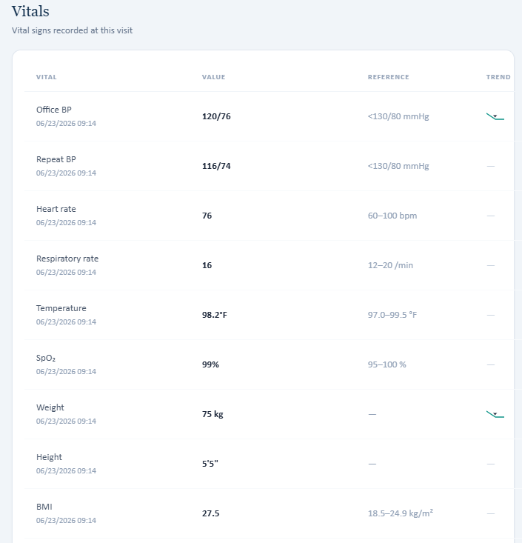  Live Thursday vitals.  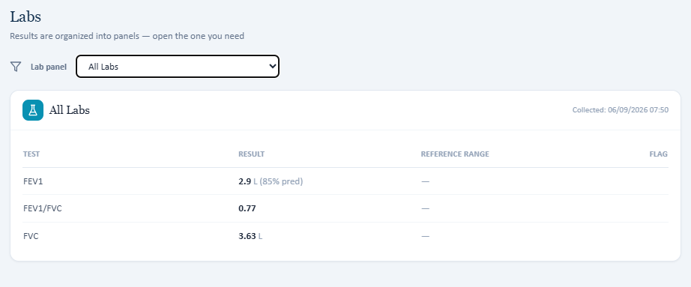  Live Thursday pulmonary results. | AI grader  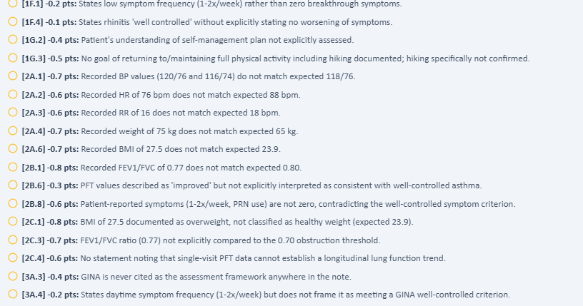  Grader expects different objective values.

ST-THU-R2 — Grader expects the wrong allergy/rhinitis medicine regimen
HIGH | Still needs developer action
Problem: The live chart, AI patient, and grader do not agree on Sarah’s allergy medicines.
What the student sees: Live EMR and AI patient show cetirizine 10 mg daily plus fluticasone nasal spray daily. The patient says her nasal allergy symptoms are controlled.
What the grader expects: The grader expects loratadine as-needed and no intranasal steroid. It deducts for cetirizine and fluticasone.
Why this matters: Medication reconciliation cannot be graded fairly when the reference medication list is different from the live chart.
Please fix: Choose the intended Thursday rhinitis regimen and synchronize the EMR, AI patient, rubric, and grader. The current live case supports cetirizine + fluticasone.
Live EMR / AI patient  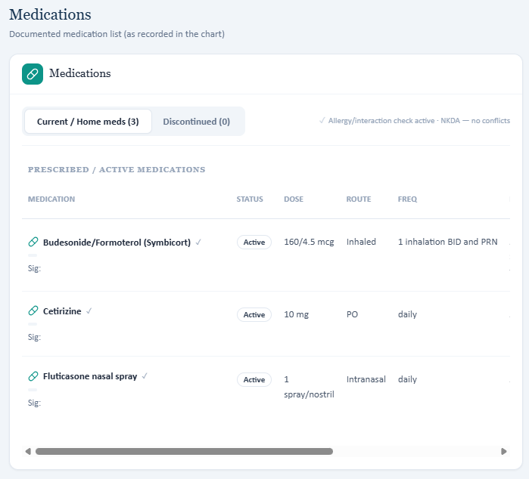  Live EMR medication list: cetirizine + fluticasone.  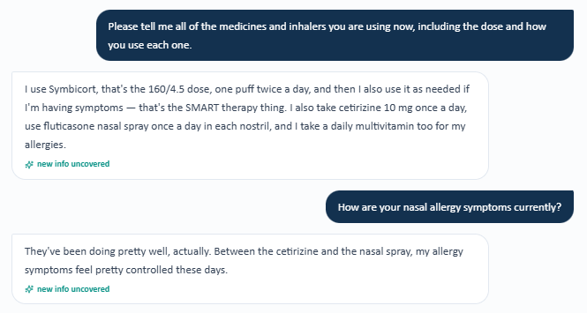  AI patient confirms the same regimen and controlled nasal symptoms. | AI grader  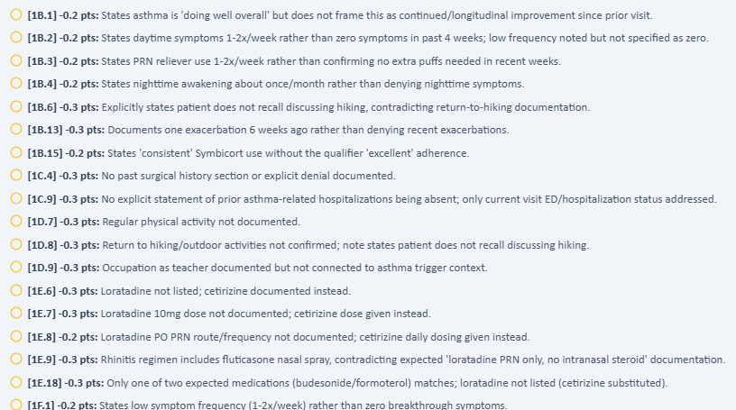  Grader deductions expect loratadine and no nasal steroid.

ST-THU-R3 — Grader uses the wrong symptom and exacerbation history
CRITICAL | Still needs developer action
Problem: The AI patient reports low-frequency symptoms plus one recent steroid-treated flare, but the grader expects no symptoms and no recent flare.
What the student sees: AI patient: daytime symptoms/extra Symbicort about 1–2 times/week, nighttime symptoms about once/month, no activity limitation, and one viral flare 6 weeks ago treated at urgent care with prednisone for 5 days.
What the grader expects: The grader expects zero daytime symptoms, zero extra reliever puffs, no nighttime symptoms, and no recent exacerbation. It also creates a warning that the “well controlled” label is unsafe.
Why this matters: The live advisory correctly separates current good symptom control from future risk. The grader should not punish that clinically appropriate distinction.
Please fix: Synchronize Thursday symptom frequency and exacerbation history. Then re-test the “well controlled now, but future risk remains” logic so it does not generate a false safety warning.
Live EMR / AI patient  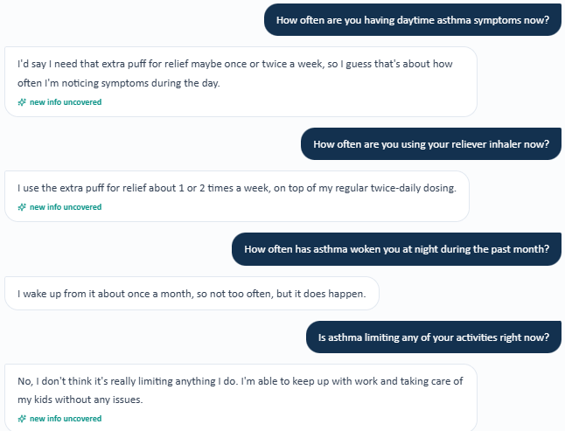  AI patient: low-frequency current symptoms and no activity limitation.  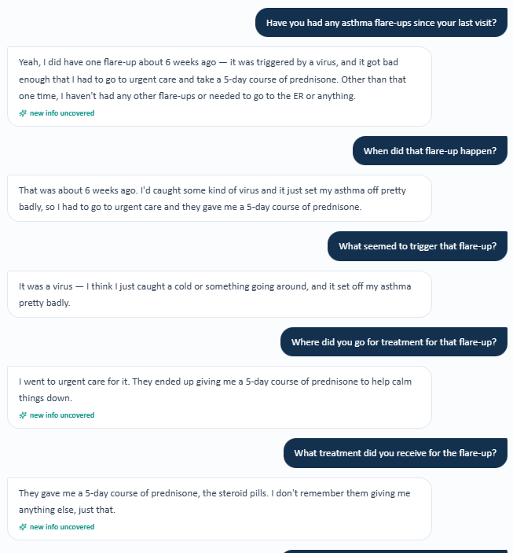  AI patient: viral flare 6 weeks ago, urgent care, 5-day prednisone course. | AI grader  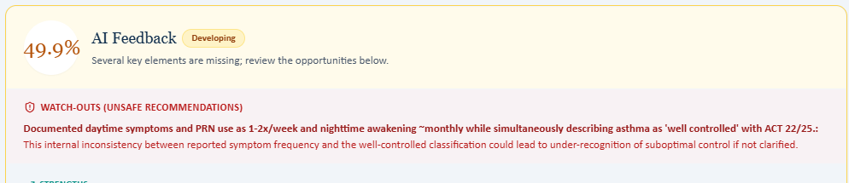  False unsafe warning based on the grader’s different symptom reference.    Grader deductions expect zero symptoms and no recent exacerbation.

ST-THU-R4 — “Missing” box says objective data are missing even though they are present
MEDIUM | Still needs developer action
Problem: The same chart both displays Sarah’s pulmonary/ACT results and labels those results as “Missing.”
What the student sees: The Labs area shows FEV1 2.9 L (85% predicted), FEV1/FVC 0.77, and FVC 3.63 L. The chart also shows ACT 22 elsewhere.
What the grader expects: The “Additional / missing objective data” box still says the spirometry and ACT 22 are missing.
Why this matters: This is internally contradictory. It can make students search for data that are already present or think they need to invent/request duplicate data.
Please fix: Before showing a “Missing” message, check whether the value already exists anywhere in the current encounter. Do not show both “present” and “missing” for the same result.
Chart says “Missing”  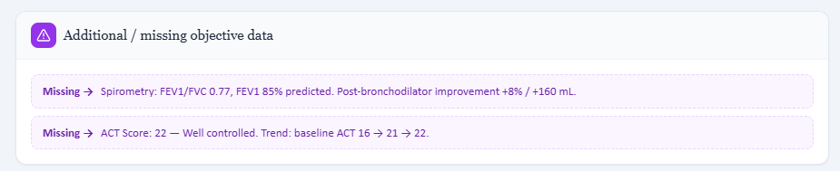  Chart flags spirometry and ACT 22 as “Missing.”    The same chart already contains the pulmonary values. | Same chart shows the data    Same encounter: objective data are present, so the missing flag is incorrect.

Shared Grading Failure — Robert Jenkins and Maria Thompson
SHARED-R1 — AI grader returns incomplete JSON and cannot grade the SOAP note
CRITICAL | Still needs developer action
Problem: The grading workflow fails before it can return a score or feedback.
What the student sees: Robert Jenkins Tuesday, Wednesday, and Thursday each show the same error. The same error also appeared again during the current Maria retest submission.
What the grader expects: No valid grader response is produced. The app displays: “The AI grader failed to return a valid response (Unexpected end of JSON input). Please submit again.”
Why this matters: This blocks the core grading workflow. It also prevents verification of the remaining Robert and Maria grader fixes.
Please fix: Please inspect the raw AI grader response before JSON parsing. Check for truncated/incomplete output, serialization problems, null/empty responses, and output-length limits. Add validation and a safe retry path before parsing. Log the failing response so the exact cause can be reproduced.
Note: Do not treat this as a SOAP-note writing error. The grader did not finish returning a valid structured result.
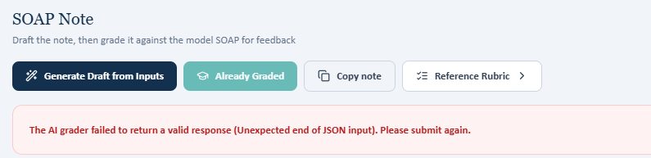
Representative screenshot. The same screen was seen on Robert Tuesday/Wednesday/Thursday and again during Maria retest.

What Cannot Be Verified Yet
- Robert Jenkins: all previously reported grader-related fixes remain unverified because all three days are blocked by the JSON error.
- Maria Thompson: current grader-related retest findings cannot be classified as fixed or not fixed until the grader returns a valid result.
- The report does not mark these hidden grader issues as fixed just because the front-end chart appears different.

Recommended Fix Order
1 | Fix the shared JSON grading failure  Highest priority. The system cannot be reliably retested while the grader response is incomplete.

2 | Make the grader load the correct patient + day reference  Sarah’s Tuesday, Wednesday, and Thursday results show repeated wrong-case or wrong-stage data in the grader.

3 | Fix the “missing objective data” rule  Do not mark ACT or PFT values as missing when those values are already displayed in the same encounter.

4 | Regression-test the full data set for each day  For each patient/day, compare medications, symptoms, exacerbations, vitals, PFT values, control scores, allergies, and treatment stage in one test.

5 | Confirm the student never has to invent data  If the EMR or AI patient gives a value, the grader should accept that same value. If data are truly unavailable, the grader should not require a fabricated number.

Simple Regression-Test Checklist
- Open the exact patient and exact day.
- Confirm the EMR medication list matches the intended visit stage.
- Ask neutral patient questions and confirm the AI patient gives the same case history.
- Copy the live vitals and pulmonary values into the SOAP note exactly.
- Submit the SOAP note once.
- Confirm the grader expects the same values and does not generate a false safety warning.
- If the grader fails, save the raw model response and parser error before retrying.

Evidence Note
Screenshots in this report come from the live VACS EMR, AI-patient interview, AI-grader feedback, and the shared grading-error screen. Duplicate fixed items and routine SOAP-writing deductions are intentionally excluded.

