WEEK 3

VACS AI Patient & Grading Issue Report
Final Clinical and Operational Audit
Prepared by
Justin Armstrong
PharmD Candidate, Class of 2027
University of Maryland Eastern Shore
School of Pharmacy
Purpose: This report lists confirmed Week 3 system/data problems found by comparing the live VACS EMR shown to the student, the AI-patient interview, the master SOAP grading rubric, and the AI grader. Routine SOAP-writing suggestions are excluded unless they reveal a system mismatch. Repeated problems are listed under each visit because they can affect grading independently on different days. Screenshots rendered from EMR/SOAP-note Word documents are intentionally excluded. Evidence images come only from live VACS/browser captures, AI-patient interviews, AI-grader feedback, or master-rubric excerpts. Interview and grader screenshots are tightly cropped to the exact question/answer or deduction relevant to each issue so the evidence remains readable.

Quick Guide for Non-Clinical Readers
Term | Plain-language meaning
AI patient | The simulated patient the student interviews.
EMR | The electronic patient chart shown to the student.
Grader / rubric | The AI scoring system and the clinical facts it expects.
ACT | Asthma Control Test; a questionnaire score used to measure asthma control.
CAT | COPD Assessment Test; a questionnaire score used to measure COPD symptom burden.
PFT / spirometry | Breathing tests used to measure airflow and lung function.
FEV1 | The amount of air exhaled during the first second of a forced breath.
FEV1/FVC | A lung-function ratio used to identify airflow obstruction.
ICS | Inhaled corticosteroid; an anti-inflammatory inhaler medication.
LABA | Long-acting bronchodilator used for maintenance treatment.
LAMA | Another class of long-acting bronchodilator used for maintenance treatment.
SMART / MART | Asthma strategy using an ICS/formoterol inhaler for maintenance and symptom relief.
Albuterol / SABA | A short-acting rescue inhaler for quick symptom relief.
ACO | Asthma-COPD overlap; features of both asthma and COPD.
Eosinophils | A blood-cell count that can help guide some asthma/COPD treatment decisions.
OCS | Oral corticosteroid, such as prednisone.
NKDA | No known drug allergies.
GINA / GOLD | Major guideline sources for asthma and COPD management.

Final Review Summary
This final review contains 44 grouped findings across all 9 Week 3 visits. Only confirmed conflicts, missing-information problems, incorrect clinical logic, or grading-workflow failures are included. Repeated issues are kept under each visit when they can affect grading independently.
Encounter | Grouped issues
Patient A – Sarah Thompson – Tuesday Initial Visit | 5
Patient A – Sarah Thompson – Wednesday 3-Month Follow-Up | 5
Patient A – Sarah Thompson – Thursday 6-Month Follow-Up | 5
Patient B – Robert “Bob” Jenkins – Tuesday Initial Visit | 5
Patient B – Robert “Bob” Jenkins – Wednesday 3-Month Follow-Up | 5
Patient B – Robert “Bob” Jenkins – Thursday 6-Month Follow-Up | 5
Patient C – Maria Thompson – Tuesday Initial Visit | 5
Patient C – Maria Thompson – Wednesday 3-Month Follow-Up | 3
Patient C – Maria Thompson – Thursday 3-Month Follow-Up | 6
Main pattern: Most high-impact Week 3 defects are synchronization problems. The live EMR, AI patient, master rubric, and AI grader are not consistently using the same patient/day dataset or treatment stage.

Patient A – Sarah Thompson – Tuesday Initial Visit
5 confirmed system/data issues are included for this visit. Items are grouped so one underlying problem is not counted multiple times just because it caused several grader deductions. Grading result: 68.9%.
# | Issue | Problem type
1 | ACT score is required by the rubric/grader but the live EMR says it was not administered | High — EMR and grader disagree
2 | Current controller medication and recent prednisone history conflict with the intended initial-treatment case | High — EMR/AI patient and rubric disagree
3 | AI grader objective reference does not match either the live EMR or the master rubric | Critical — EMR/rubric and grader disagree
4 | AI patient symptom history does not match the master-rubric Tuesday history | High — AI patient and rubric disagree
5 | Preventive-care information required by the rubric is not available in the live Objective section | Medium — Required information is unavailable

Issue 1. ACT score is required by the rubric/grader but the live EMR says it was not administered
What the student saw or heard: The Objective section states “ACT Score: Not yet administered.” The student has no valid numeric ACT result to document.
What the master rubric says: Master rubric requires ACT 16 and interpretation as poorly controlled asthma. (Rubric references: 2B.7-2B.9, 3A.7)
What the AI grader expected: The final 68.9% feedback deducts for missing ACT 16 and the lack of ACT-based control interpretation.
Why this is a problem: The student is penalized for refusing to invent a score that the live encounter explicitly says was not administered.
Suggested fix: Either administer/display ACT in the encounter before grading, or make “not yet administered” an accepted response and remove numeric ACT deductions when the workflow does not supply a score.
Focused screenshot evidence
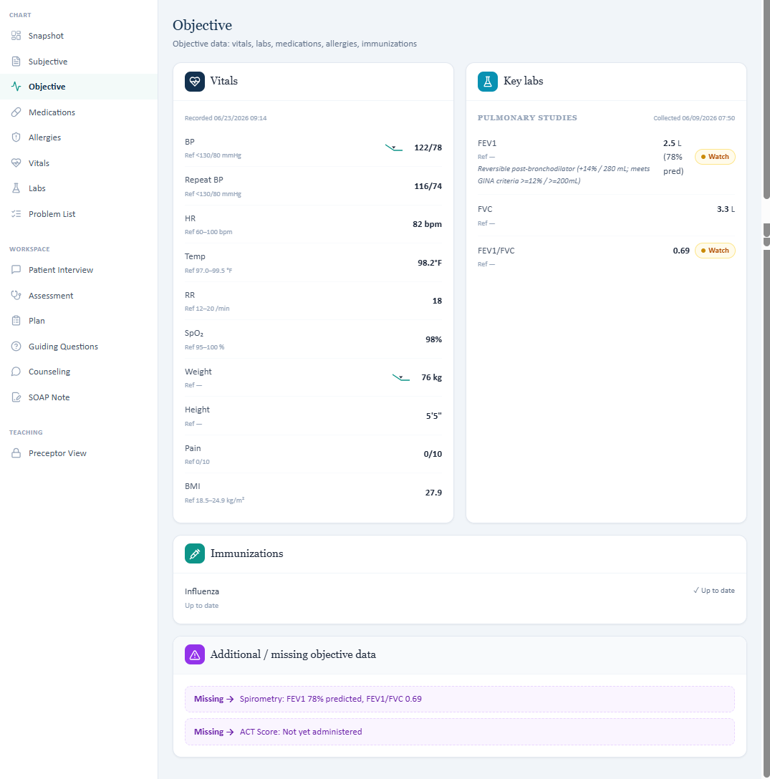
Live Objective shows the ACT was not administered and displays only the available objective information.

Issue 2. Current controller medication and recent prednisone history conflict with the intended initial-treatment case
What the student saw or heard: The live medication list contains budesonide HFA 180 mcg BID, and the chart/interview says a viral exacerbation 6 weeks ago required urgent care and a 5-day prednisone course.
What the master rubric says: The master rubric expects no ICS-containing controller in the current regimen, albuterol as sole asthma therapy, and denial of recent oral corticosteroid use. (Rubric references: 1B.13, 1E.10, 1E.18, 1F.3, 3B.1-3B.5)
What the AI grader expected: The grader deducts points because budesonide and recent prednisone were documented, matching the live case but not its expected reference.
Why this is a problem: These differences change whether the case represents undertreatment with no controller versus poor use of an existing controller, and they change exacerbation-risk assessment.
Suggested fix: Choose the intended Tuesday storyline and synchronize the medication list, chart HPI, AI patient responses, master rubric, and grader to that same storyline.
Focused screenshot evidence
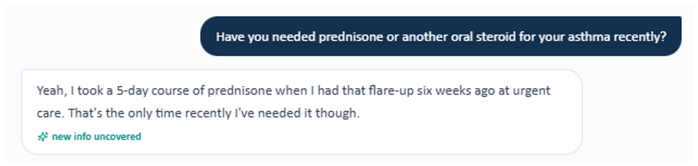
Evidence – AI patient confirms a 5-day prednisone course after the urgent-care asthma flare.
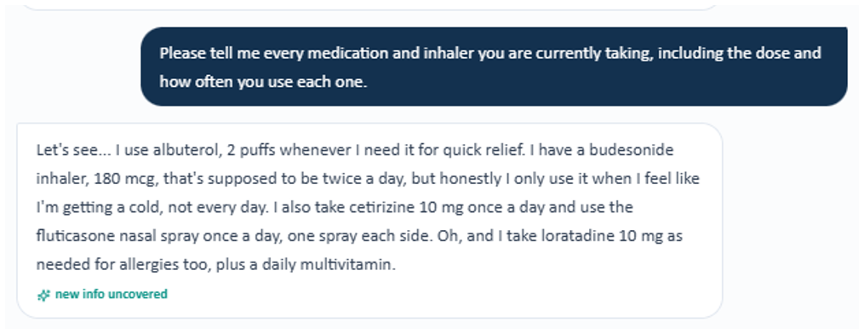
Evidence – AI patient reports an existing budesonide controller plus albuterol, rather than the rubric’s no-controller initial-treatment history.

Issue 3. AI grader objective reference does not match either the live EMR or the master rubric
What the student saw or heard: Live EMR: BP 122/78, HR 82, RR 18, temp 98.2°F, SpO₂ 98%, weight 76 kg, height 65 in, BMI 27.9; PFT FEV1/FVC 0.69 with +14% / +280 mL reversibility.
What the master rubric says: The master rubric uses these same Tuesday values: BP 122/78, HR 82, RR 18, temp 98.2°F, SpO₂ 98% on room air, 76 kg, 65 in, BMI 27.9, FEV1/FVC 0.69, +14% / +280 mL. (Rubric references: 2A.1-2A.9, 2B.1-2B.4)
What the AI grader expected: The 68.9% grader instead expects BP 118/76, HR 88, temp 98.6°F, SpO₂ 97%, weight 65 kg, BMI 23.9, FEV1/FVC 0.75, +15% and +375 mL.
Why this is a problem: The student is marked wrong for accurately transcribing the live chart, and the grader even reaches a different airflow-obstruction interpretation from the master rubric.
Suggested fix: Replace the Tuesday grader’s objective reference values with the master-rubric/live-EMR values and re-test every objective criterion.
Focused screenshot evidence

Live Tuesday vitals and PFT values used in the submitted SOAP note.
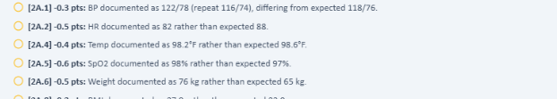
Evidence – Focused AI-grader feedback excerpt 1: only the deduction(s) and description relevant to this issue are shown.
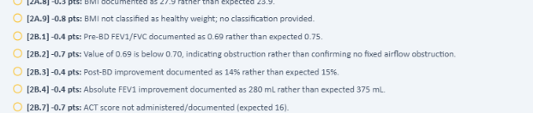
Evidence – Focused AI-grader feedback excerpt 2: only the deduction(s) and description relevant to this issue are shown.

Issue 4. AI patient symptom history does not match the master-rubric Tuesday history
What the student saw or heard: The interview reports roughly a 6-week worsening period, albuterol about 4-5 times/week, nighttime coughing about once/week, no clear hiking avoidance, and daily fluticasone use.
What the master rubric says: The master rubric expects worsening over several months, albuterol 1-2 times daily on most days, nighttime awakenings 2-3 nights/week, hiking/outdoor avoidance, and intermittent fluticasone despite daily prescription. (Rubric references: 1B.1, 1B.6-1B.9, 1B.15, 1D.7-1D.8)
What the AI grader expected: The grader penalizes the SOAP for documenting the AI patient’s actual answers rather than the expected history.
Why this is a problem: Neutral interview questions produce answers that cannot earn full credit, even when documented exactly.
Suggested fix: Update the standardized-patient response bank so neutral questions reliably return the intended rubric history, or revise the rubric to match the live AI patient.
Focused screenshot evidence
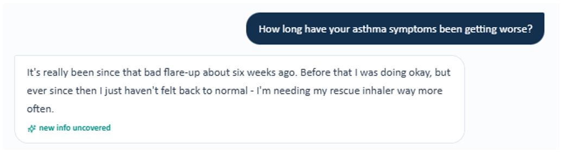
Evidence – AI patient says the worsening began after the flare about six weeks earlier, not over several months.
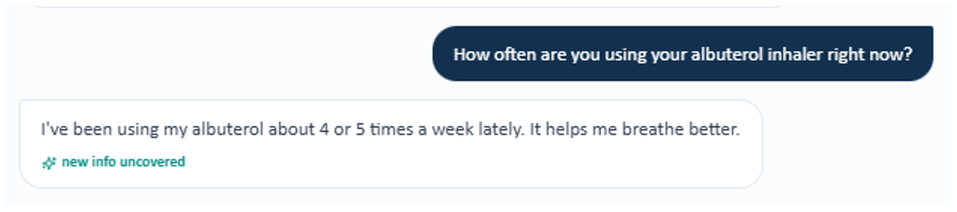
Evidence – AI patient reports albuterol about 4–5 times per week, not 1–2 times daily on most days.
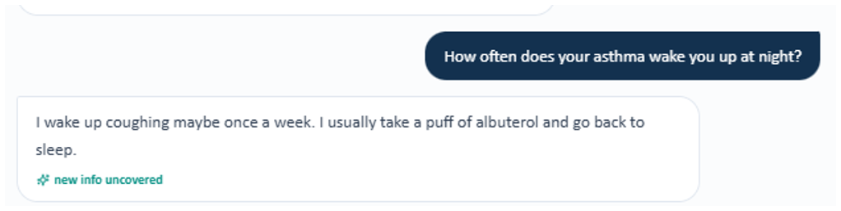
Evidence – AI patient reports nighttime coughing about once per week, not 2–3 nights per week.
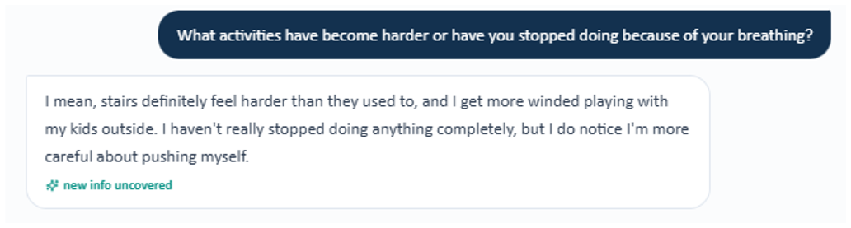
Evidence – AI patient describes more difficulty with stairs and playing with her children but says she has not completely stopped activities.
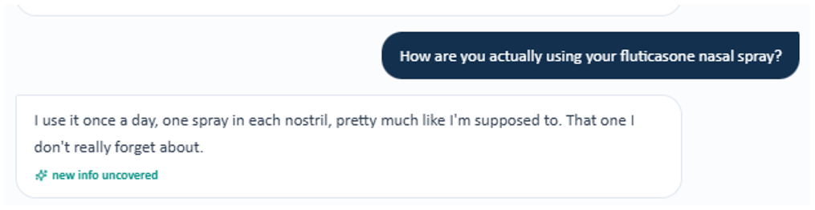
Evidence – AI patient reports using fluticasone nasal spray daily as prescribed, not intermittently.

Issue 5. Preventive-care information required by the rubric is not available in the live Objective section
What the student saw or heard: Objective displays influenza as up to date; COVID, pneumococcal, and Tdap statuses are not displayed.
What the master rubric says: Master rubric expects influenza and COVID current, pneumococcal vaccination not documented, and Tdap overdue/gap handling. (Rubric references: 1E.12-1E.15, 3E.2-3E.6)
What the AI grader expected: The grader deducts for COVID uncertainty and failure to identify the exact expected vaccine gaps.
Why this is a problem: Students are expected to document specific vaccine statuses that the chart does not provide.
Suggested fix: Display all rubric-required vaccine categories and status values in the live immunization section, or remove deductions for unavailable categories.
Focused screenshot evidence

Live Objective/Immunizations area shows influenza but does not expose the full vaccine set required by grading.

Patient A – Sarah Thompson – Wednesday 3-Month Follow-Up
5 confirmed system/data issues are included for this visit. Items are grouped so one underlying problem is not counted multiple times just because it caused several grader deductions. Grading result: 70%.
# | Issue | Problem type
1 | Wednesday treatment stage is not synchronized: budesonide-only EMR vs SMART regimen in the master rubric | Critical — EMR and rubric case stage disagree
2 | Objective section contains mutually incompatible asthma and COPD-style data | Critical — Internal EMR inconsistency
3 | AI grader vitals do not match the master rubric/live Wednesday chart | High — EMR/rubric and grader disagree
4 | Control-status advisory conflicts with the documented ACT 21 trajectory | High — Incorrect EMR clinical logic
5 | AI patient adherence/technique/rhinitis responses do not match the master-rubric follow-up findings | High — AI patient and rubric disagree

Issue 1. Wednesday treatment stage is not synchronized: budesonide-only EMR vs SMART regimen in the master rubric
What the student saw or heard: The live medication list and AI patient show budesonide HFA 180 mcg BID plus separate albuterol rescue. The patient explicitly says she is not on a budesonide/formoterol combination.
What the master rubric says: Master rubric expects budesonide/formoterol 160/4.5 mcg used as SMART: maintenance plus 1 inhalation PRN for relief. (Rubric references: 1E.1-1E.5, 1B.8, 4A.1-4A.6)
What the AI grader expected: The grader warns that albuterol may be an inaccurate reliever reconciliation and evaluates the case against budesonide/formoterol SMART expectations.
Why this is a problem: The medication identity changes the entire assessment, step-therapy decision, inhaler technique, and reliever counseling.
Suggested fix: Make the Wednesday EMR medication list and AI patient reflect the intended SMART regimen, or rewrite the Wednesday rubric/grader for budesonide plus albuterol.
Focused screenshot evidence
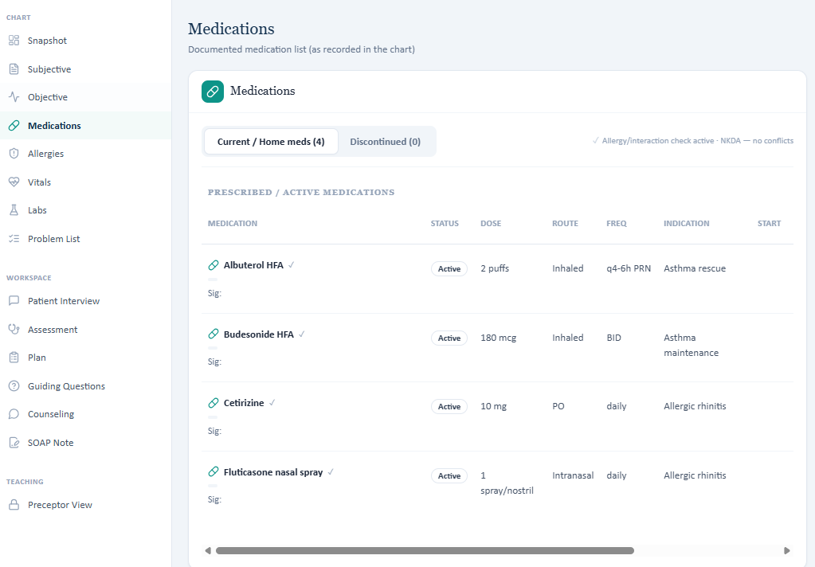
Live Wednesday medication list shows budesonide rather than the rubric-expected budesonide/formoterol SMART regimen.
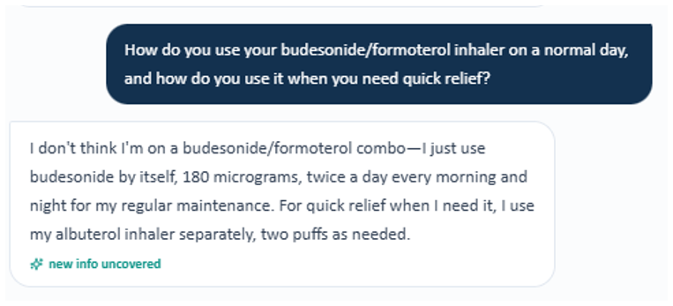
Evidence – AI patient explicitly says she is not using a budesonide/formoterol combination; she reports budesonide alone for maintenance and albuterol separately for relief.

Issue 2. Objective section contains mutually incompatible asthma and COPD-style data
What the student saw or heard: Primary pulmonary studies show FEV1 78% predicted and FEV1/FVC 0.69 with +14%/+280 mL reversibility. HPI states ACT 21. The “Additional / missing objective data” box instead says FEV1/FVC 0.58, FEV1 63% predicted, and CAT 16.
What the master rubric says: Master rubric expects asthma follow-up data: FEV1/FVC 0.76, +9%/+180 mL, ACT 21 with improvement from ACT 16. It does not use CAT 16 as the key asthma-control score. (Rubric references: 2B.1-2B.9, 2C.2)
What the AI grader expected: The grader identifies multiple spirometry/value mismatches and medication-stage inconsistencies.
Why this is a problem: The student cannot know which objective dataset is authoritative; CAT 16 appears to be COPD-oriented data inserted into an asthma encounter.
Suggested fix: Remove the incorrect .58/63/CAT16 “missing” entries, display the intended Wednesday PFT values and ACT score in one authoritative location, and ensure all tabs use the same source.
Focused screenshot evidence
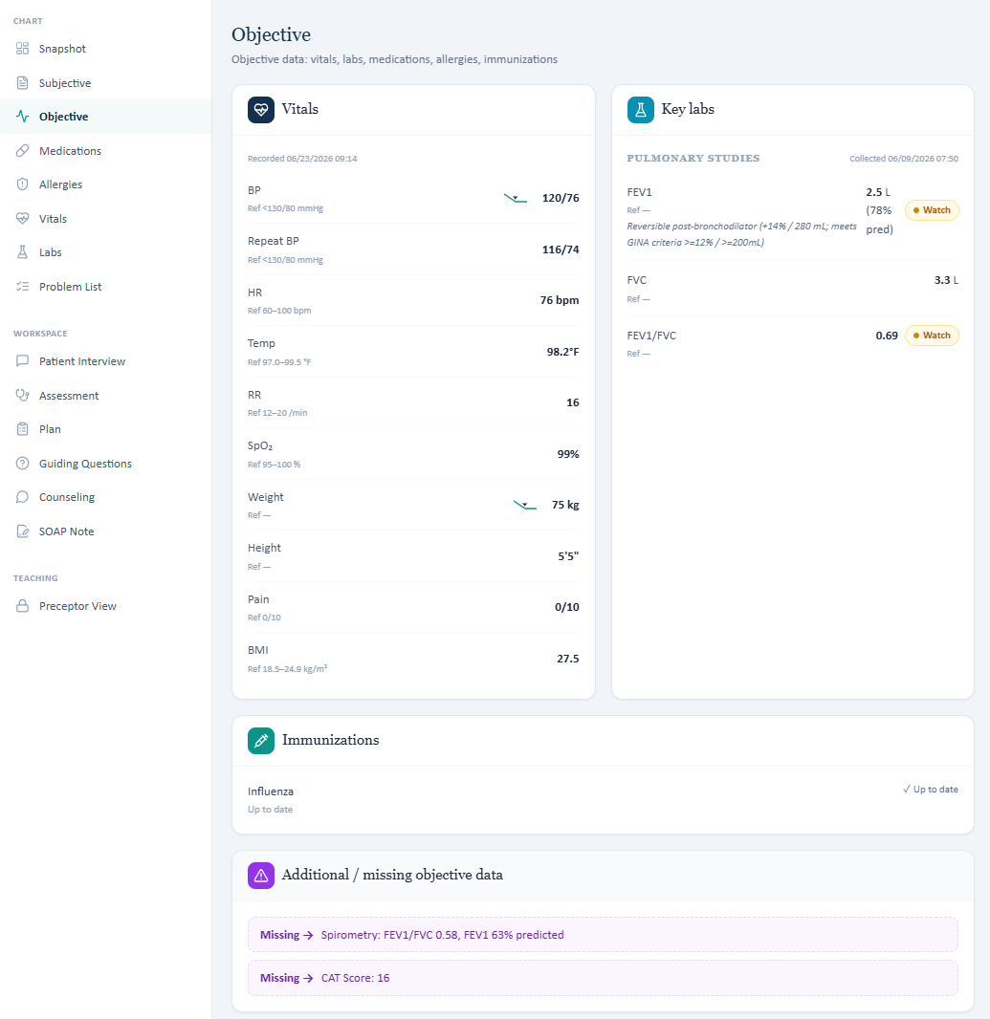
Evidence – The Additional / missing objective-data box introduces a second pulmonary dataset and CAT 16 into an asthma follow-up.

Issue 3. AI grader vitals do not match the master rubric/live Wednesday chart
What the student saw or heard: Live EMR: BP 120/76, HR 76, RR 16, SpO₂ 99%, weight 75 kg, height 65 in, BMI 27.5.
What the master rubric says: Master rubric uses BP 120/76, RR 16, weight 75 kg, height 65 in, BMI 27.5, SpO₂ 99%; HR is 78 bpm. (Rubric references: 2A.1-2A.12)
What the AI grader expected: The final grader expects a substantially different set including HR 88, RR 18, weight 65 kg, and BMI 23.9.
Why this is a problem: Most values in the live chart are penalized even though they align with the master rubric.
Suggested fix: Point the Wednesday grader to the same objective dataset used by the master rubric and live EMR; reconcile the small HR 76 vs 78 discrepancy separately.
Focused screenshot evidence
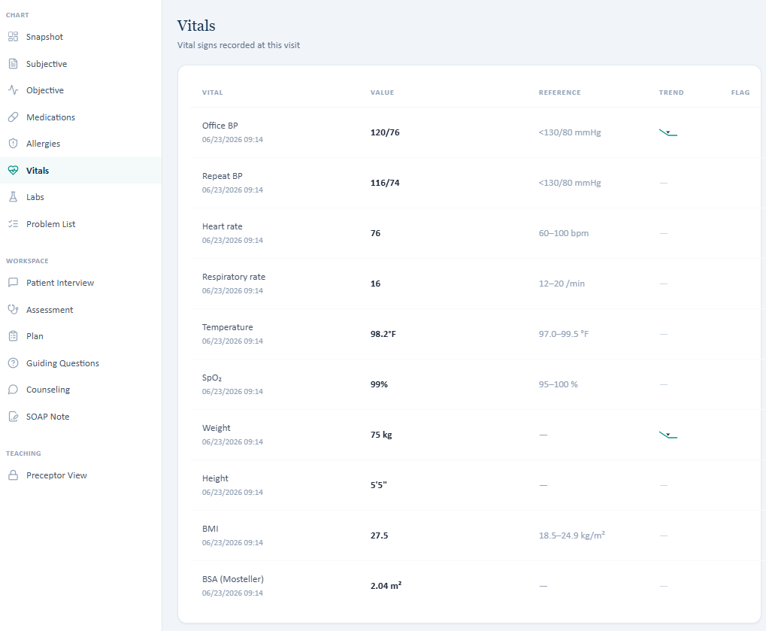
Live Wednesday vital signs that were transcribed into the SOAP note.
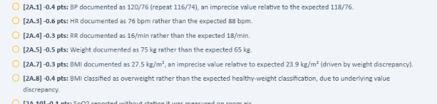
Evidence – Focused AI-grader feedback excerpt 1: only the deduction(s) and description relevant to this issue are shown.
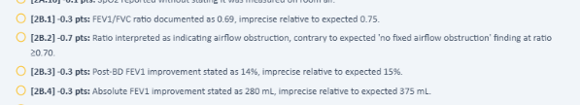
Evidence – Focused AI-grader feedback excerpt 2: only the deduction(s) and description relevant to this issue are shown.

Issue 4. Control-status advisory conflicts with the documented ACT 21 trajectory
What the student saw or heard: The HPI states ACT 21 and improved daily ICS adherence, while the Best Practice Advisory says “Asthma partly controlled” and directs the student to consider adding a LABA.
What the master rubric says: Master rubric interprets ACT 21 as well-controlled asthma and expects a SMART follow-up with improved control. (Rubric references: 2B.6-2B.9, 3A control-status criteria)
What the AI grader expected: The grader treats the encounter as if SMART is already the correct regimen and criticizes deferring escalation based on medication reconciliation concerns.
Why this is a problem: The alert, HPI, medication list, and intended control interpretation point in different directions.
Suggested fix: Rebuild the advisory from the intended Wednesday medication/control dataset and verify that ACT status, current therapy, and escalation advice are logically consistent.
Focused screenshot evidence
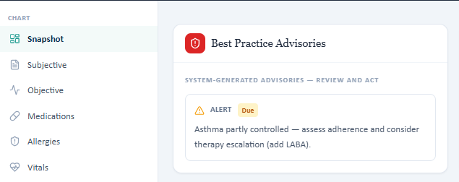
Live advisory labels asthma partly controlled while the same encounter documents an ACT-based improvement trajectory.

Issue 5. AI patient adherence/technique/rhinitis responses do not match the master-rubric follow-up findings
What the student saw or heard: Patient reports budesonide adherence, allergy symptoms “about the same,” and does not provide the two rubric-specific inhaler errors.
What the master rubric says: Master rubric expects significant rhinitis improvement on daily fluticasone and two observed inhaler errors: failure to fully exhale before inhalation and failure to hold breath afterward. (Rubric references: 1B.16-1B.18)
What the AI grader expected: The feedback deducts for rhinitis status and technique findings that were not provided by the AI patient.
Why this is a problem: Accurate transcription of the standardized patient cannot satisfy the intended rubric.
Suggested fix: Align Wednesday AI-patient responses with the intended technique and rhinitis findings, without requiring leading questions.
Focused screenshot evidence
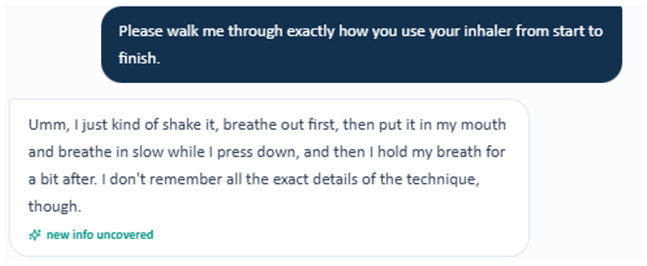
Evidence – AI patient’s technique description includes exhaling before inhalation and holding her breath afterward; the rubric expects those exact steps to be missed.
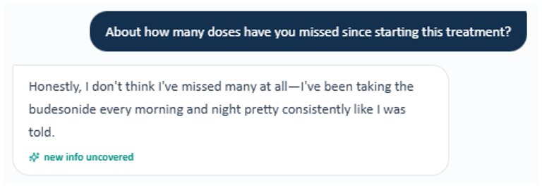
Evidence – AI patient reports very few or no missed budesonide doses, rather than the more specific adherence finding expected by the rubric.
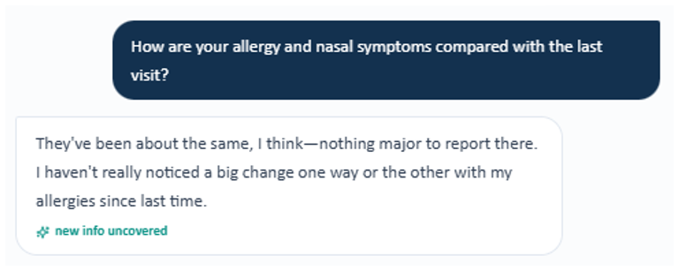
Evidence – AI patient says her allergy/nasal symptoms are about the same rather than significantly improved.
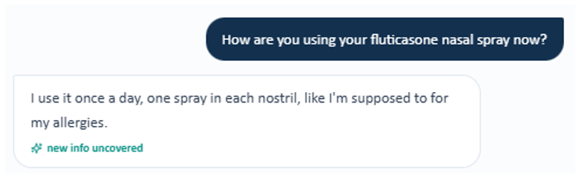
Evidence – AI patient reports daily fluticasone nasal-spray use, which conflicts with grader deductions that assume a different rhinitis scenario.

Patient A – Sarah Thompson – Thursday 6-Month Follow-Up
5 confirmed system/data issues are included for this visit. Items are grouped so one underlying problem is not counted multiple times just because it caused several grader deductions. Grading result: 56%.
# | Issue | Problem type
1 | COPD-specific LAMA/LABA advisory is displayed in Sarah’s asthma SMART encounter | Critical — Incorrect EMR advisory
2 | Live problem list says “well controlled” while the same encounter documents a recent prednisone-treated exacerbation | High — Internal EMR inconsistency
3 | Thursday AI grader objective values are from a different dataset than the live EMR/master rubric | Critical — EMR/rubric and grader disagree
4 | AI grader expects the wrong allergic-rhinitis medication regimen | High — EMR and grader disagree
5 | ACT 22 required by the master rubric is not displayed in the live Thursday Objective data | Medium — Required information is unavailable

Issue 1. COPD-specific LAMA/LABA advisory is displayed in Sarah’s asthma SMART encounter
What the student saw or heard: Best Practice Advisory: “Recurrent exacerbations despite dual bronchodilator therapy (LAMA/LABA). Consider ICS escalation based on eosinophil count.” Active problem beside it is asthma, “Well controlled on SMART.”
What the master rubric says: Sarah Thursday is an asthma SMART follow-up. The master rubric evaluates budesonide/formoterol SMART, ACT control, and asthma exacerbation risk—not COPD LAMA/LABA escalation. (Rubric references: Sarah Thursday asthma criteria; no LAMA/LABA COPD pathway)
What the AI grader expected: The grader evaluates asthma control and never treats a COPD LAMA/LABA advisory as appropriate for this patient.
Why this is a problem: This is a clear cross-case clinical advisory contamination and could direct a student toward the wrong disease pathway.
Suggested fix: Remove the COPD LAMA/LABA/eosinophil advisory from Sarah Thursday and map the asthma-specific advisory to this encounter.
Focused screenshot evidence
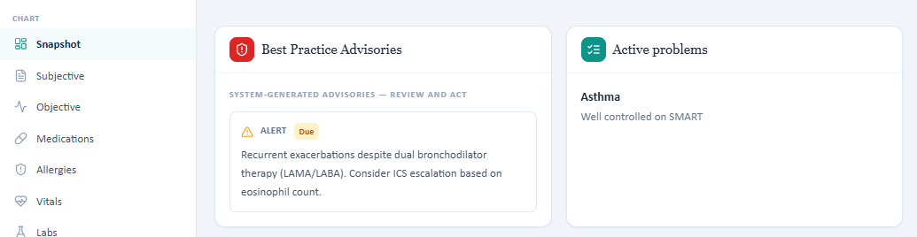
Evidence – COPD LAMA/LABA/eosinophil advisory appears in Sarah’s asthma SMART encounter.

Issue 2. Live problem list says “well controlled” while the same encounter documents a recent prednisone-treated exacerbation
What the student saw or heard: Problem list: “Well controlled on SMART.” HPI: viral-triggered exacerbation 6 weeks ago, urgent-care visit, 5-day prednisone course.
What the master rubric says: Master rubric also includes that single exacerbation and treats it as a future-risk datapoint while expecting otherwise improved symptom control. (Rubric references: 1B.8-1B.14, 2C.2)
What the AI grader expected: The grader’s watch-out criticizes an unqualified “well controlled/no escalation” conclusion because of the recent OCS-requiring exacerbation.
Why this is a problem: The chart’s own control label is too absolute for the risk history presented and creates contradictory cues.
Suggested fix: Use a control label that distinguishes current symptom control from future exacerbation risk, or add explanatory context to the problem list.
Focused screenshot evidence
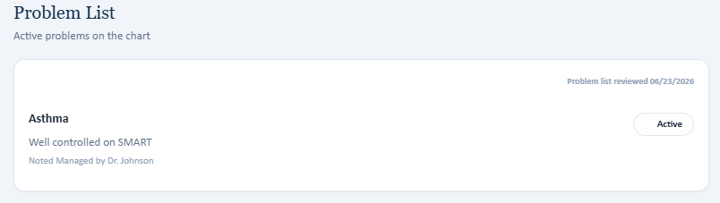
Evidence – Problem list labels asthma “Well controlled on SMART.”
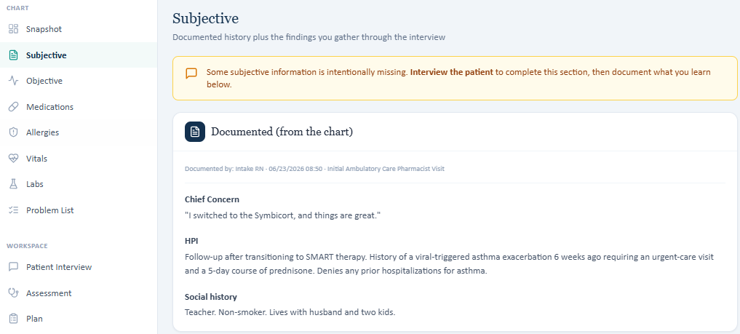
Evidence – Same encounter documents an urgent-care exacerbation and 5-day prednisone course 6 weeks earlier.
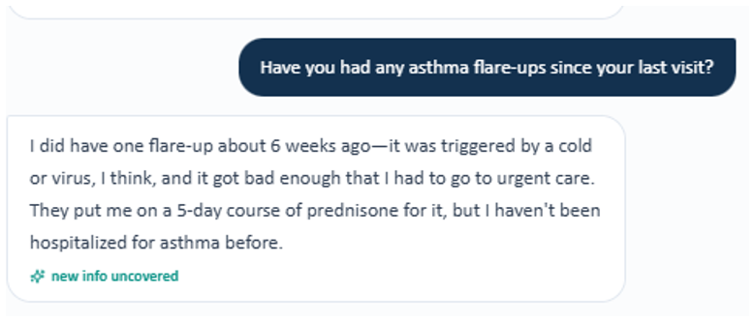
Evidence – AI patient independently confirms one viral-triggered flare about six weeks earlier that required urgent care and a 5-day prednisone course.

Issue 3. Thursday AI grader objective values are from a different dataset than the live EMR/master rubric
What the student saw or heard: Live: FEV1/FVC 0.77, FEV1 85% predicted; additional data adds +8%/+160 mL. Vitals include HR 76, RR 16, 75 kg, BMI 27.5, SpO₂ 99%.
What the master rubric says: Master rubric expects FEV1/FVC 0.77, +8%/+160 mL, HR 76, RR 16, 75 kg, BMI 27.5, SpO₂ 99%, and ACT 22. BP differs slightly (master 118/74 vs live 120/76). (Rubric references: 2A.1-2A.8, 2B.1-2B.9)
What the AI grader expected: The 56% grader instead expects FEV1/FVC 0.80, HR 88, RR 18, weight 65 kg, BMI 23.9, and other values not used by the master rubric.
Why this is a problem: The grader marks correct live/master values as factual errors.
Suggested fix: Replace the grader’s Thursday objective reference dataset with the master-rubric values and reconcile only true residual differences such as BP.
Focused screenshot evidence
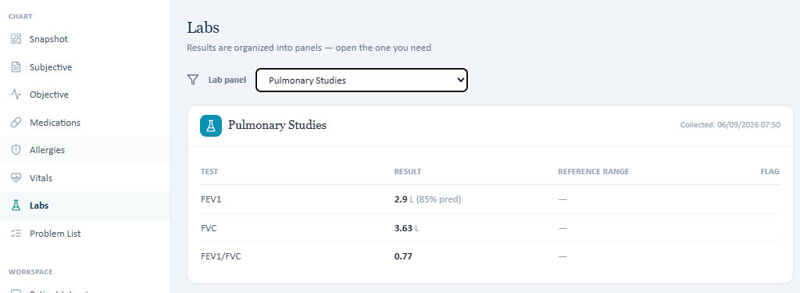
Live Thursday spirometry used in the SOAP note.
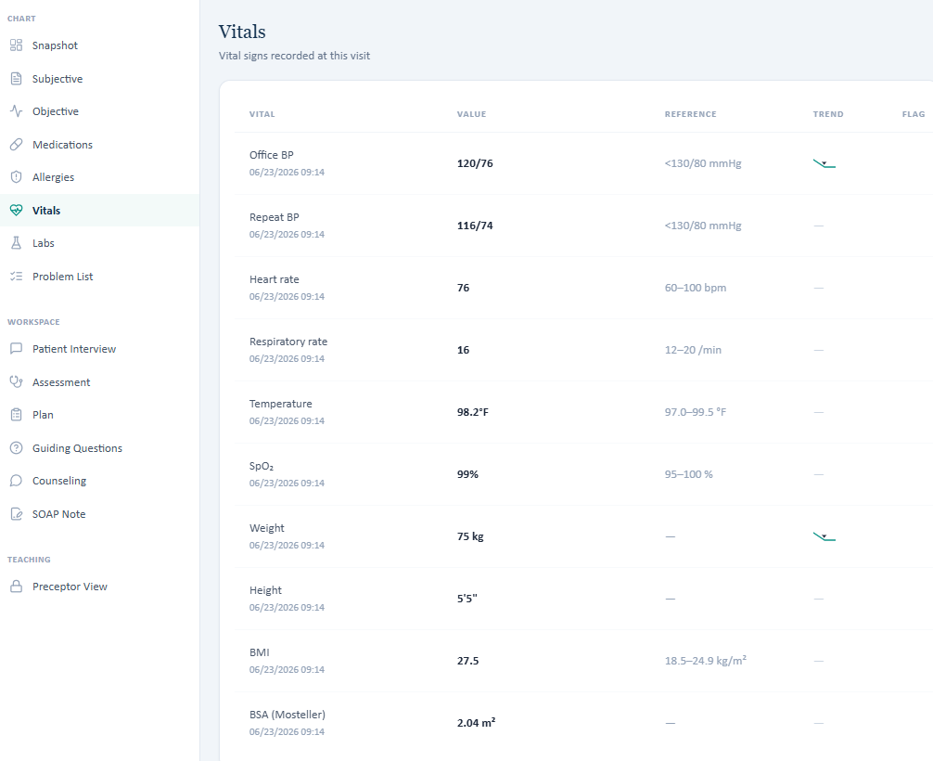
Live Thursday vital signs used in the SOAP note.

Issue 4. AI grader expects the wrong allergic-rhinitis medication regimen
What the student saw or heard: Live medications: Symbicort 160/4.5 as SMART, cetirizine 10 mg daily, and fluticasone nasal spray daily.
What the master rubric says: Master rubric expects the same three active medications: budesonide/formoterol, cetirizine, and fluticasone nasal spray. (Rubric references: 1E.1-1E.10, 1E.18)
What the AI grader expected: The grader deducts because it expects loratadine PRN and “no intranasal steroid.”
Why this is a problem: The student loses medication-reconciliation points for accurately documenting the EMR and master-rubric regimen.
Suggested fix: Correct the grader’s Thursday medication reference to cetirizine + fluticasone, matching the master rubric and live EMR.
Focused screenshot evidence
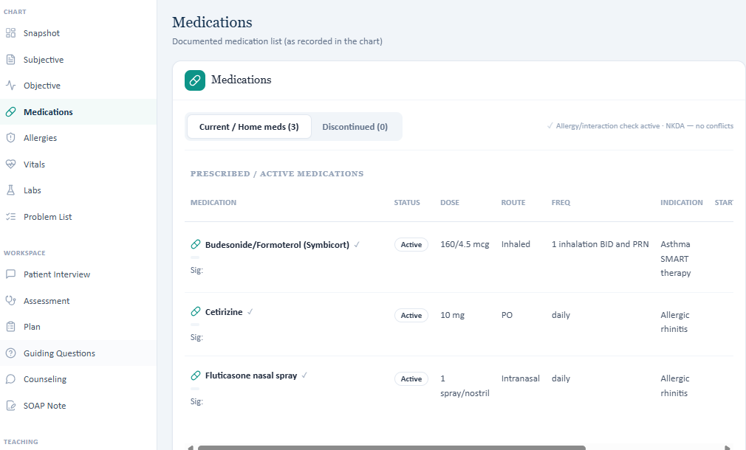
Live medication list documents Symbicort, cetirizine, and fluticasone nasal spray.
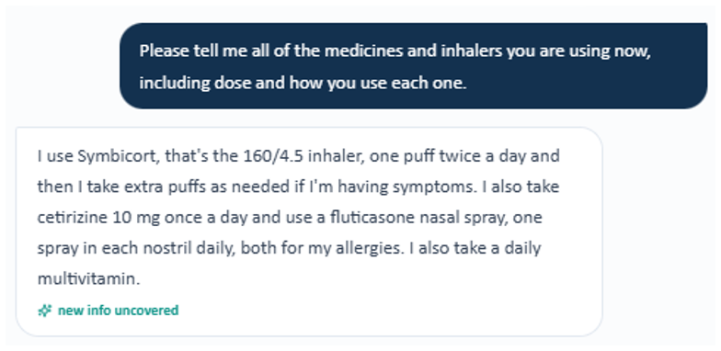
Evidence – AI patient reports Symbicort, cetirizine, and daily fluticasone nasal spray, consistent with the live medication list and inconsistent with the grader’s loratadine/no-intranasal-steroid reference.

Issue 5. ACT 22 required by the master rubric is not displayed in the live Thursday Objective data
What the student saw or heard: The live Thursday Objective “Additional / missing” section lists spirometry only; no ACT score is visible.
What the master rubric says: Master rubric requires ACT 22, interpretation as well-controlled, and trend from baseline ACT 16 to 22. (Rubric references: 2B.7-2B.9)
What the AI grader expected: The grader focuses on other mismatches, but the live workflow still does not expose the rubric-required ACT result.
Why this is a problem: A student cannot independently document or trend a score not displayed or administered in the workflow.
Suggested fix: Display ACT 22 in the Objective/questionnaire workflow if it is intended to be graded.
Focused screenshot evidence

Evidence – Captured Thursday Objective/PFT evidence; the rubric-required ACT 22 is not shown in the captured live objective data.
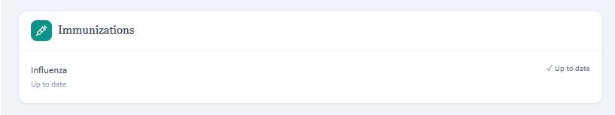
Live Objective immunization display contains influenza only.

Patient B – Robert “Bob” Jenkins – Tuesday Initial Visit
5 confirmed system/data issues are included for this visit. Items are grouped so one underlying problem is not counted multiple times just because it caused several grader deductions. Grading result: 65%.
# | Issue | Problem type
1 | Live problem list/advisory classifies COPD as GOLD Group E while the master rubric expects Group B | Critical — EMR and rubric disagree
2 | Tuesday vital signs/anthropometrics in the live EMR do not match the master rubric | High — EMR and rubric disagree
3 | Spirometry values disagree across live EMR, master rubric, and AI grader | Critical — EMR, rubric, and grader disagree
4 | Exacerbation history in the live EMR/AI patient does not match the master-rubric initial COPD case | High — EMR/AI patient and rubric disagree
5 | CAT and immunization data are incomplete/inconsistent in the live Objective workflow | Medium — Required information unavailable / mislabeled

Issue 1. Live problem list/advisory classifies COPD as GOLD Group E while the master rubric expects Group B
What the student saw or heard: Problem list shows “COPD — GOLD Group E.” The advisory also states mMRC 3.
What the master rubric says: Master rubric derives GOLD Group B from CAT ≥10 and no more than one moderate exacerbation without hospitalization; it specifically expects mMRC to be missing. (Rubric references: 2C.2, 2C.5, 3A.3-3A.6)
What the AI grader expected: The grader deducts for Group E and for documenting mMRC 3 instead of treating mMRC as unavailable.
Why this is a problem: The live chart directs the student to a different GOLD treatment pathway than the intended rubric.
Suggested fix: If Group B is intended, change the live problem list/advisory to Group B and remove the mMRC 3 value unless it is intentionally part of the case.
Focused screenshot evidence
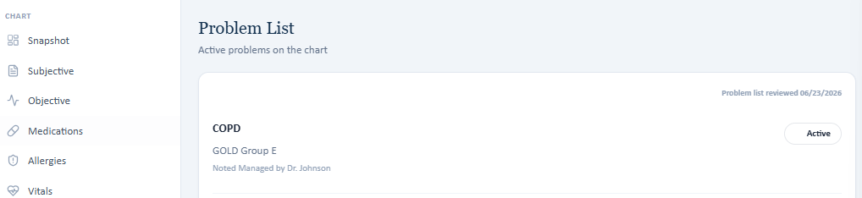
Live problem list classifies COPD as GOLD Group E.
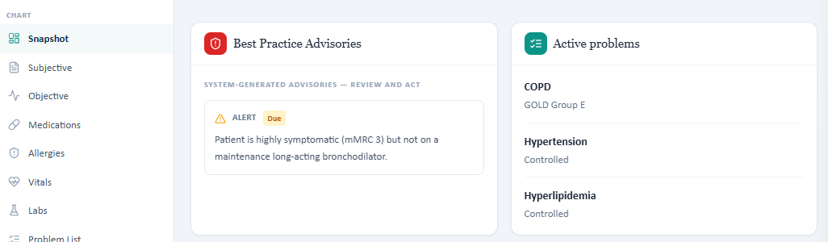
Live advisory supplies mMRC 3 even though the master rubric treats it as unavailable.

Issue 2. Tuesday vital signs/anthropometrics in the live EMR do not match the master rubric
What the student saw or heard: Live: BP 132/82, HR 76, RR 20, SpO₂ 97%, weight 80 kg, height 69 in, BMI 26.0.
What the master rubric says: Master: BP 132/78, HR 80, RR 18, SpO₂ 95% room air, weight 89 kg, height 70 in, BMI 28.1. (Rubric references: 2A.1-2A.8)
What the AI grader expected: The grader largely follows the master-rubric values and deducts for the live values.
Why this is a problem: The student is penalized for copying the chart exactly.
Suggested fix: Replace the Tuesday live vitals with the intended master dataset or revise the rubric/grader if the live dataset is intended.
Focused screenshot evidence
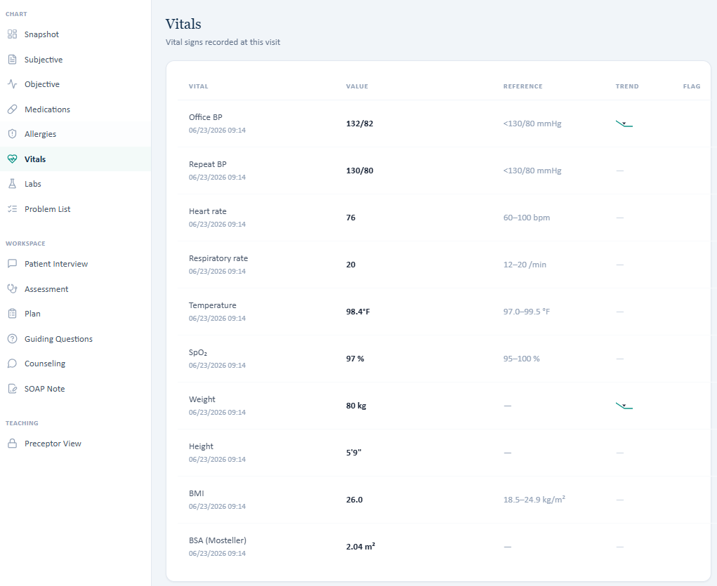
Live Tuesday vital signs and anthropometrics.

Issue 3. Spirometry values disagree across live EMR, master rubric, and AI grader
What the student saw or heard: Live primary spirometry: FEV1/FVC 0.57 and FEV1 60% predicted.
What the master rubric says: Master rubric: FEV1/FVC 0.58 and FEV1 62% predicted. (Rubric references: 2B.1-2B.4, 3A.8-3A.9)
What the AI grader expected: The grader expects FEV1/FVC 0.62 and FEV1 58% predicted, effectively using yet another pair of numbers.
Why this is a problem: No single source of truth exists for lung-function interpretation and GOLD grade.
Suggested fix: Select one verified spirometry dataset and propagate it identically to the live lab panel, master rubric, and grader reference.
Focused screenshot evidence
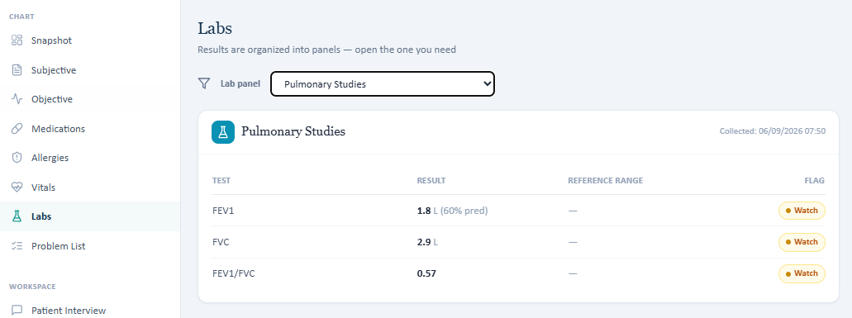
Live Tuesday spirometry values.
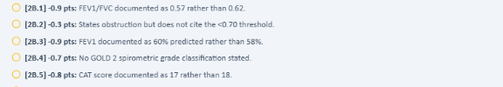
Evidence – Focused AI-grader feedback excerpt 1: only the deduction(s) and description relevant to this issue are shown.

Issue 4. Exacerbation history in the live EMR/AI patient does not match the master-rubric initial COPD case
What the student saw or heard: Live HPI states 2 moderate COPD exacerbations in the past 3 months. The interview cannot confirm exact OCS/antibiotic/hospital details.
What the master rubric says: Master rubric expects one exacerbation in the past year, treated with oral corticosteroids and antibiotics, without hospitalization. (Rubric references: 1B.9-1B.12, 2B.7-2B.8)
What the AI grader expected: The grader penalizes two-in-three-months documentation and missing OCS/antibiotic/no-hospitalization details.
Why this is a problem: Exacerbation count changes GOLD grouping and initial maintenance treatment selection.
Suggested fix: Synchronize Tuesday chart and AI-patient exacerbation history to the intended one-exacerbation Group B storyline, or revise the master/grader if two recent exacerbations are intended.
Focused screenshot evidence
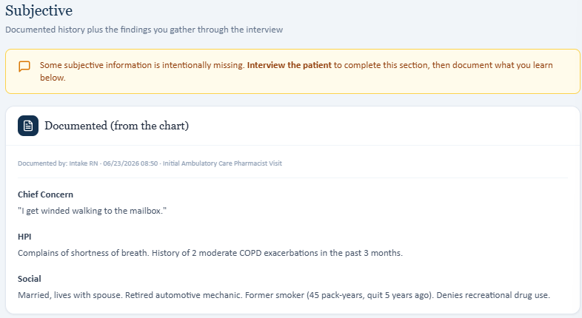
Live HPI documents two moderate exacerbations in the past 3 months.
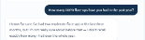
Evidence – Focused AI-patient interview evidence 1: only the question and answer relevant to this issue are shown.

Evidence – Focused AI-patient interview evidence 2: only the question and answer relevant to this issue are shown.

Evidence – Focused AI-patient interview evidence 3: only the question and answer relevant to this issue are shown.

Issue 5. CAT and immunization data are incomplete/inconsistent in the live Objective workflow
What the student saw or heard: The additional-data box lists CAT 17 and repeats spirometry as “Missing” even though spirometry is already displayed. Immunizations show influenza only.
What the master rubric says: Master expects CAT 18; influenza and COVID current, pneumococcal and RSV not documented, and other preventive-care details. (Rubric references: 2B.5-2B.6, 1E.12-1E.15)
What the AI grader expected: The grader deducts CAT 17 vs 18 and vaccine-status gaps.
Why this is a problem: The “missing” label is misleading, and required preventive data are unavailable.
Suggested fix: Correct CAT to the intended value, stop labeling already displayed spirometry as missing, and display all graded vaccine categories.
Focused screenshot evidence
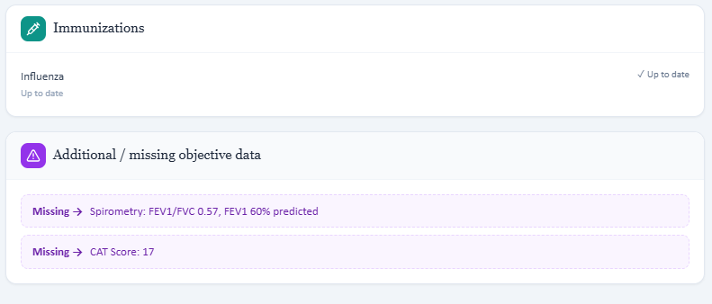
Live Objective shows CAT 17, influenza-only immunizations, and spirometry simultaneously labeled missing.

Patient B – Robert “Bob” Jenkins – Wednesday 3-Month Follow-Up
5 confirmed system/data issues are included for this visit. Items are grouped so one underlying problem is not counted multiple times just because it caused several grader deductions. Grading result: 63.4%.
# | Issue | Problem type
1 | Advisory and problem list call Anoro treatment “LAMA therapy” even though Anoro is LAMA/LABA | Critical — Incorrect EMR medication logic
2 | AI grader uses the wrong medication and objective dataset; live EMR and master rubric agree | Critical — EMR/rubric and grader disagree
3 | AI patient adherence and inhaler-technique findings conflict with the master rubric | High — AI patient and rubric disagree
4 | “Additional / missing” box labels already displayed spirometry as missing | Medium — EMR interface logic
5 | Family-history and preventive-care responses are not synchronized with the master rubric | Medium — AI patient and EMR disagree

Issue 1. Advisory and problem list call Anoro treatment “LAMA therapy” even though Anoro is LAMA/LABA
What the student saw or heard: Advisory: “COPD symptoms persistent despite LAMA therapy.” Problem list: “Symptomatic despite LAMA.” Active medication is umeclidinium/vilanterol (Anoro Ellipta), a LAMA/LABA combination.
What the master rubric says: Master rubric explicitly identifies umeclidinium/vilanterol as a LABA/LAMA combination product. (Rubric references: 1E.16 and Wednesday maintenance-therapy criteria)
What the AI grader expected: The grader also becomes confused about medication identity and expects a different maintenance inhaler.
Why this is a problem: Incorrect drug-class labeling can produce the wrong escalation algorithm.
Suggested fix: Change Wednesday advisory/problem wording to “despite LAMA/LABA therapy” (or the intended dual-bronchodilator wording).
Focused screenshot evidence
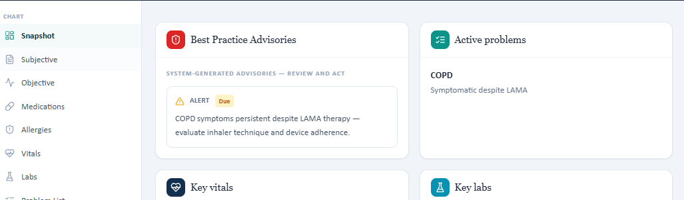
Live advisory/problem list calls the regimen LAMA therapy even though Anoro is a LAMA/LABA combination.

Issue 2. AI grader uses the wrong medication and objective dataset; live EMR and master rubric agree
What the student saw or heard: Live: Anoro Ellipta 62.5/25 daily; BP 130/76, HR 78, RR 18, SpO₂ 95%, 89 kg, 70 in, BMI 28.1; FEV1/FVC 0.58, FEV1 63%, CAT 16.
What the master rubric says: Master rubric uses the same Anoro regimen and the same objective values, including CAT 16. (Rubric references: 1E.1-1E.2, 2A.1-2A.8, 2B.1-2B.5)
What the AI grader expected: The 63.4% grader expects Spiriva/tiotropium and a different set of vitals and spirometry values (including FEV1/FVC 0.62 and FEV1 58%).
Why this is a problem: This is strong evidence that the Wednesday grader is attached to a different Robert Jenkins reference dataset.
Suggested fix: Point the Wednesday grader to the same model/reference data used by the master rubric and live EMR.
Focused screenshot evidence
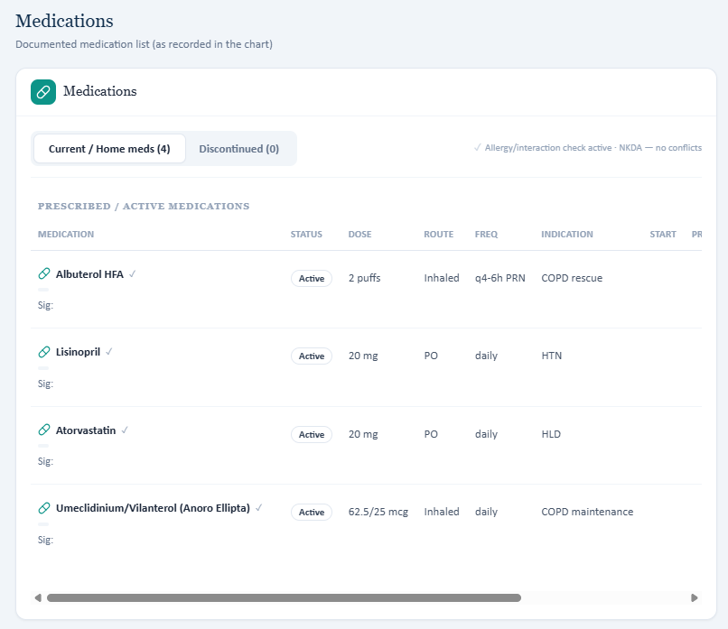
Live medication list contains Anoro Ellipta.
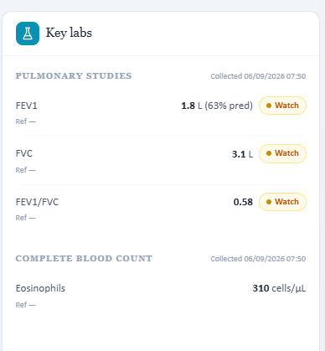
Live PFT values used for Wednesday assessment.

Issue 3. AI patient adherence and inhaler-technique findings conflict with the master rubric
What the student saw or heard: Patient says he takes Anoro essentially 7 days/week with rare misses and describes exhaling forcefully into the Ellipta mouthpiece.
What the master rubric says: Master rubric expects initial “most days” self-report that resolves to only 3-4 days/week due to forgetfulness, and it expects inhaler technique to be appropriate with no errors. (Rubric references: 1B.14-1B.21, 1B.25)
What the AI grader expected: The grader penalizes the note because the AI patient’s daily adherence and Ellipta-specific technique error do not match the expected adherence/technique narrative.
Why this is a problem: The student cannot obtain the intended adherence diagnosis from neutral questioning.
Suggested fix: Update the AI patient to return the intended 3-4 days/week/forgetfulness history and the intended technique findings, or revise the rubric to the live response.
Focused screenshot evidence

Evidence – Focused AI-patient interview evidence 1: only the question and answer relevant to this issue are shown.

Evidence – Focused AI-patient interview evidence 2: only the question and answer relevant to this issue are shown.
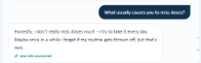
Evidence – Focused AI-patient interview evidence 3: only the question and answer relevant to this issue are shown.
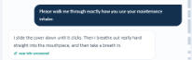
Evidence – Focused AI-patient interview evidence 4: only the question and answer relevant to this issue are shown.

Issue 4. “Additional / missing” box labels already displayed spirometry as missing
What the student saw or heard: FEV1/FVC 0.58 and FEV1 63% are displayed in pulmonary studies and repeated in the “Missing” box. CAT 16 is also placed there.
What the master rubric says: Master treats these as valid objective results for the visit. (Rubric references: 2B.1-2B.5)
What the AI grader expected: The grader uses different values, which makes the duplicate “missing” display even more confusing.
Why this is a problem: Students may believe a result is unavailable when it is visible directly above.
Suggested fix: Only label truly unavailable values as missing; move CAT into a normal questionnaire/result field if it is a valid result.
Focused screenshot evidence
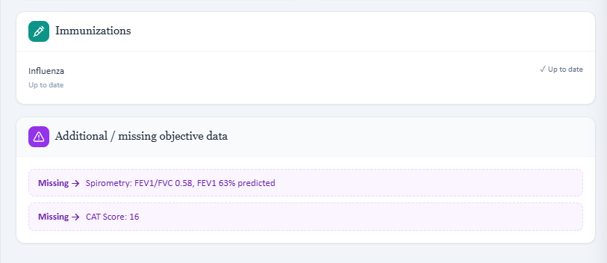
Evidence – The live Objective repeats displayed spirometry in the purple “Missing” section.

Issue 5. Family-history and preventive-care responses are not synchronized with the master rubric
What the student saw or heard: Interview identifies father with CAD and brother with COPD; live immunizations display influenza only.
What the master rubric says: Master expects father with COPD and CAD, brother with COPD, influenza and COVID current, and explicit pneumococcal/RSV gaps. (Rubric references: 1C.8-1C.11, 1E.10-1E.13)
What the AI grader expected: The grader deducts for missing paternal COPD and incomplete vaccine statuses.
Why this is a problem: Accurate interview documentation loses points because the standardized patient omits expected history.
Suggested fix: Align family-history responses and expose the full preventive-care record in the live chart.
Focused screenshot evidence
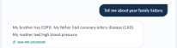
Evidence – Focused AI-patient interview evidence 1: only the question and answer relevant to this issue are shown.
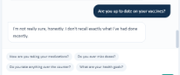
Evidence – Focused AI-patient interview evidence 2: only the question and answer relevant to this issue are shown.

Patient B – Robert “Bob” Jenkins – Thursday 6-Month Follow-Up
5 confirmed system/data issues are included for this visit. Items are grouped so one underlying problem is not counted multiple times just because it caused several grader deductions. Grading result: 33.7%.
# | Issue | Problem type
1 | AI grader uses a different Thursday COPD dataset than both the live EMR and master rubric | Critical — EMR/rubric and grader disagree
2 | Grader safety warning conflicts with the live advisory and master eosinophil/exacerbation criteria | Critical — EMR/rubric and grader safety logic disagree
3 | Primary spirometry conflicts with the “missing” spirometry box | High — Internal EMR inconsistency
4 | Live exacerbation/adherence trajectory matches the master rubric but not the grader | High — EMR/AI patient and grader disagree
5 | Smoking/family-history data in the grader do not match the master/live Thursday case | Medium — EMR/rubric and grader disagree

Issue 1. AI grader uses a different Thursday COPD dataset than both the live EMR and master rubric
What the student saw or heard: Live: Anoro Ellipta daily, eosinophils 310, CAT 17, 2 exacerbations in 3 months / 3 in 12 months, BP 128/76, HR 82, SpO₂ 94%, 89 kg.
What the master rubric says: Master rubric uses Anoro, eosinophils 310, CAT 17, the same exacerbation counts, and the same Thursday vital signs. (Rubric references: 1E.1-1E.6, 2A.1-2A.8, 2B.1-2B.6)
What the AI grader expected: The 33.7% grader expects Spiriva, eosinophils 150, a different PFT set, weight 80 kg, SpO₂ 97%, a different smoking history, and an improvement trajectory.
Why this is a problem: The grader labels evidence-based escalation reasoning potentially unsafe because it is checking against the wrong patient state.
Suggested fix: Replace the Thursday grader reference with the master-rubric/live-EMR Thursday dataset and re-test the safety rule.
Focused screenshot evidence
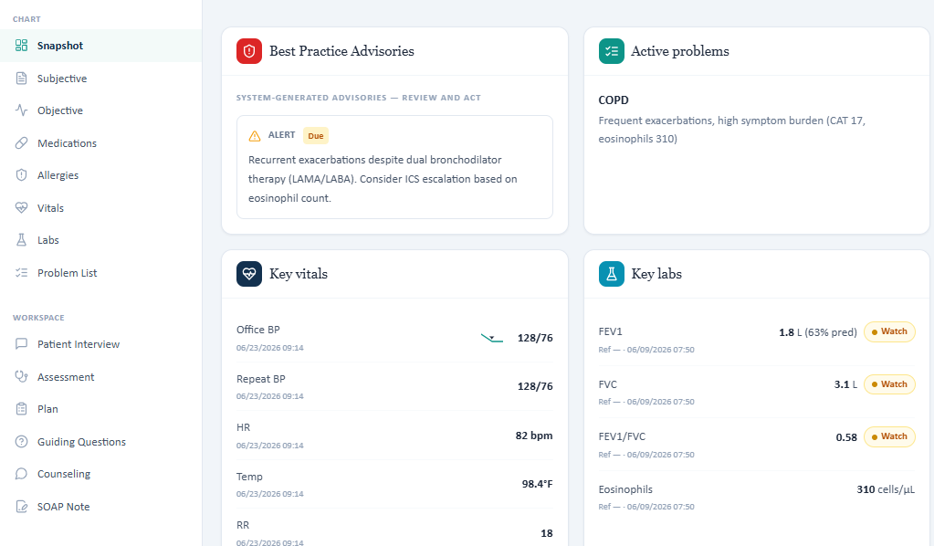
Live Thursday PFT/eosinophils: FEV1/FVC 0.58, FEV1 63% predicted, eosinophils 310.
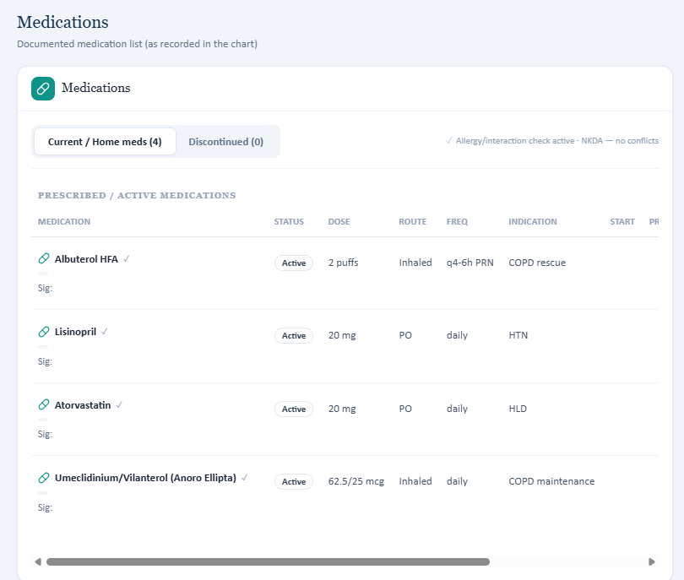
Live Thursday maintenance medication is Anoro Ellipta.

Issue 2. Grader safety warning conflicts with the live advisory and master eosinophil/exacerbation criteria
What the student saw or heard: Live advisory: recurrent exacerbations despite LAMA/LABA; consider ICS escalation based on eosinophil count. Eosinophils are 310 cells/µL.
What the master rubric says: Master rubric explicitly states eosinophils 310 exceed the 300 cells/µL threshold for maximal ICS benefit and identifies a frequent-exacerbator pattern on LABA/LAMA. (Rubric references: 2C.4-2C.5)
What the AI grader expected: The grader flags ICS-containing triple therapy as potentially unsafe because it expects eosinophils 150 and a different medication/history dataset.
Why this is a problem: A safety warning is being generated from incorrect reference data and may teach the opposite of the intended case logic.
Suggested fix: Bind safety checks to the same verified eosinophil and exacerbation data as the master rubric; regression-test the ICS escalation decision.
Focused screenshot evidence
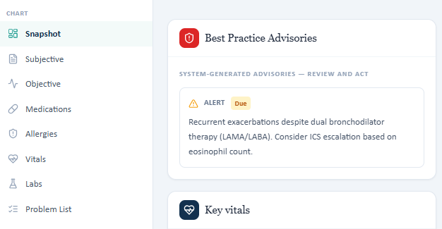
Live advisory tells the student to consider ICS escalation based on recurrent exacerbations/eosinophils.
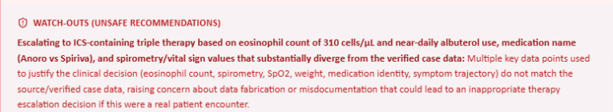
Evidence – Focused AI-grader feedback excerpt 1: only the deduction(s) and description relevant to this issue are shown.

Issue 3. Primary spirometry conflicts with the “missing” spirometry box
What the student saw or heard: Primary pulmonary panel: FEV1/FVC 0.58 and FEV1 63% predicted. “Additional / missing” box: FEV1/FVC 0.57 and FEV1 60% predicted.
What the master rubric says: Master rubric expects 0.57 and 60% predicted, which matches the “missing” box rather than the primary lab panel. (Rubric references: 2B.1-2B.2, 2C.1-2C.2)
What the AI grader expected: The grader expects a third set (0.62 ratio / 58% predicted).
Why this is a problem: There are three competing spirometry datasets for one encounter.
Suggested fix: Select one authoritative post-bronchodilator dataset and use it in the primary lab panel, missing-data logic, master rubric, and grader.
Focused screenshot evidence
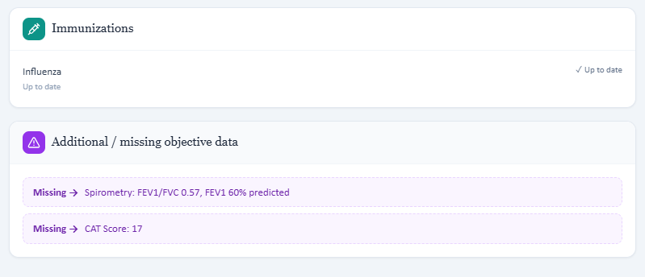
Evidence – Purple “Missing” box lists 0.57/60%, conflicting with the primary 0.58/63% panel.

Issue 4. Live exacerbation/adherence trajectory matches the master rubric but not the grader
What the student saw or heard: Live HPI/interview: 2 exacerbations since last visit, OCS/antibiotics for the first, urgent care + OCS for the second, excellent daily Anoro adherence, frequent rescue use.
What the master rubric says: Master expects the same two recent exacerbations, daily adherence, and approximately daily albuterol use. (Rubric references: 1B.6-1B.18)
What the AI grader expected: The grader expects significant improvement, weekly-or-less albuterol use, corrected technique, and a different maintenance drug.
Why this is a problem: The grader penalizes the intended high-risk follow-up storyline and may be referencing another timepoint.
Suggested fix: Update Thursday grader history to the master-rubric exacerbation/adherence trajectory.
Focused screenshot evidence
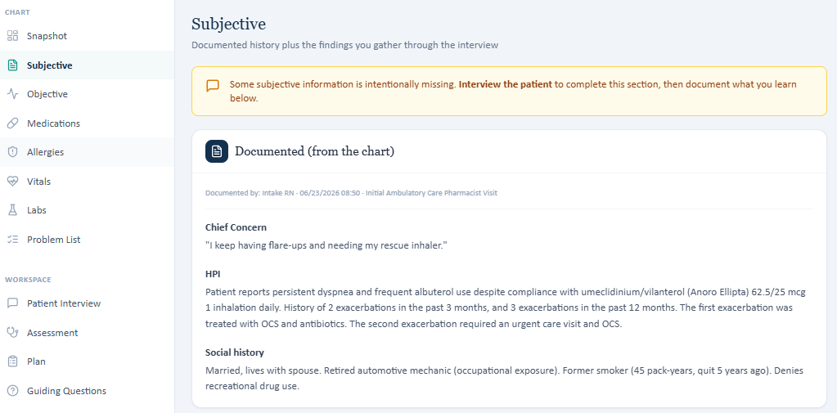
Live chart documents 2 exacerbations in 3 months and 3 in 12 months.

Evidence – Focused AI-patient interview evidence 1: only the question and answer relevant to this issue are shown.

Evidence – Focused AI-patient interview evidence 2: only the question and answer relevant to this issue are shown.
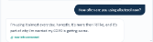
Evidence – Focused AI-patient interview evidence 3: only the question and answer relevant to this issue are shown.

Issue 5. Smoking/family-history data in the grader do not match the master/live Thursday case
What the student saw or heard: Live chart: former smoker, 45 pack-years, quit 5 years ago; father CAD, brother COPD.
What the master rubric says: Master also expects 45 pack-years/quit 5 years and includes father COPD + CAD and brother COPD. (Rubric references: 1C.8-1C.11, 1D.4-1D.6)
What the AI grader expected: The grader expects 30 pack-years/quit 10 years and treats father COPD as expected while the live AI patient does not consistently provide it.
Why this is a problem: Background history is being scored against a different case version.
Suggested fix: Synchronize the grader and AI patient family/smoking histories to the master Thursday data.
Focused screenshot evidence

Evidence – Focused AI-patient interview evidence 1: only the question and answer relevant to this issue are shown.

Evidence – Focused AI-patient interview evidence 2: only the question and answer relevant to this issue are shown.

Patient C – Maria Thompson – Tuesday Initial Visit
5 confirmed system/data issues are included for this visit. Items are grouped so one underlying problem is not counted multiple times just because it caused several grader deductions. Grading result: 58.8%.
# | Issue | Problem type
1 | Live Tuesday demographics/history differ substantially from the master-rubric Maria case | Critical — EMR/AI patient and rubric disagree
2 | Tuesday live vital signs differ from the master rubric/grader | High — EMR and rubric disagree
3 | Pulmonary values are internally inconsistent and the master rubric expects yet another specific reversibility value | Critical — Internal EMR inconsistency
4 | ACT 15 and CAT 19 required by the master rubric are absent from the live Tuesday workflow | High — Required information is unavailable
5 | Spiriva device technique returned by the AI patient is inconsistent with the intended Respimat device | High — AI patient and medication device disagree

Issue 1. Live Tuesday demographics/history differ substantially from the master-rubric Maria case
What the student saw or heard: Live chart/interview: never smoker, NKDA, father CAD, mother allergic rhinitis, sister asthma, and one exacerbation reported as requiring hospitalization.
What the master rubric says: Master rubric expects former smoker with 30 pack-years, sulfonamide-antibiotic allergy with rash, father COPD + CAD, mother asthma + allergic rhinitis, and no hospitalization for the two OCS-treated exacerbations. (Rubric references: 1B.13, 1C.7-1C.10, 1D.4-1D.5, 1E.14-1E.15)
What the AI grader expected: The 58.8% grader largely follows the master history and penalizes the live hospitalization/family-history/smoking/allergy differences.
Why this is a problem: This is not a documentation wording issue; the live standardized patient is a materially different Maria Thompson history.
Suggested fix: Choose the intended Maria Tuesday history and synchronize banner/allergies/social/family/exacerbation data across the EMR, AI patient, rubric, and grader.
Focused screenshot evidence
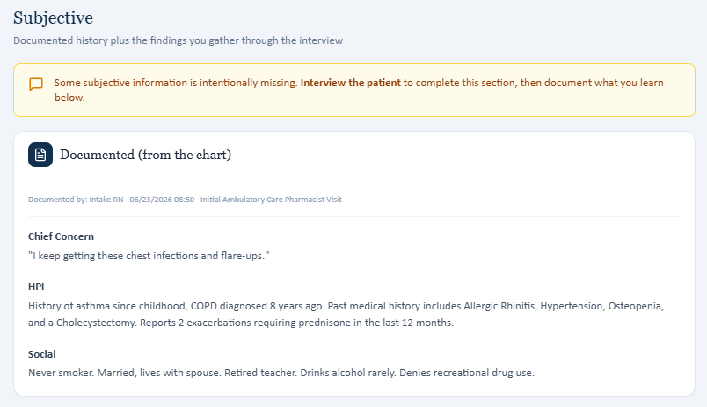
Live Tuesday chart HPI/social history used by the student.
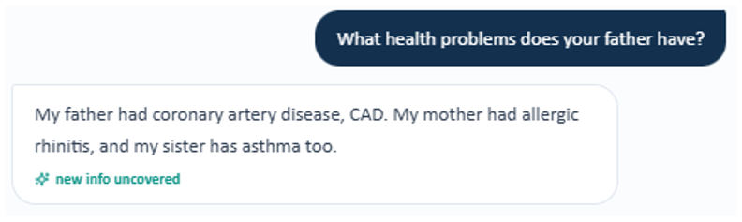
Evidence – AI patient reports father with CAD, mother with allergic rhinitis, and sister with asthma—different from the master-rubric family history.
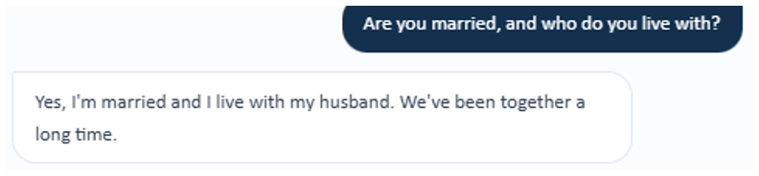
Evidence – AI patient confirms she is married and lives with her husband.

Issue 2. Tuesday live vital signs differ from the master rubric/grader
What the student saw or heard: Live: BP 128/80 (repeat 126/78), HR 72, RR 18, SpO₂ 97%, 70 kg, 64 in, BMI 26.5.
What the master rubric says: Master: BP 126/74, HR 80, RR 18, SpO₂ 95% room air, 71 kg, 64 in, BMI 26.9. (Rubric references: 2A.1-2A.7)
What the AI grader expected: The grader deducts toward the master values, including BP 126/74, BMI 26.9, and SpO₂ 95%.
Why this is a problem: Students are penalized for using the live Objective tab.
Suggested fix: Update the live Tuesday vitals to the intended master dataset or revise the rubric/grader if the live values are correct.
Focused screenshot evidence
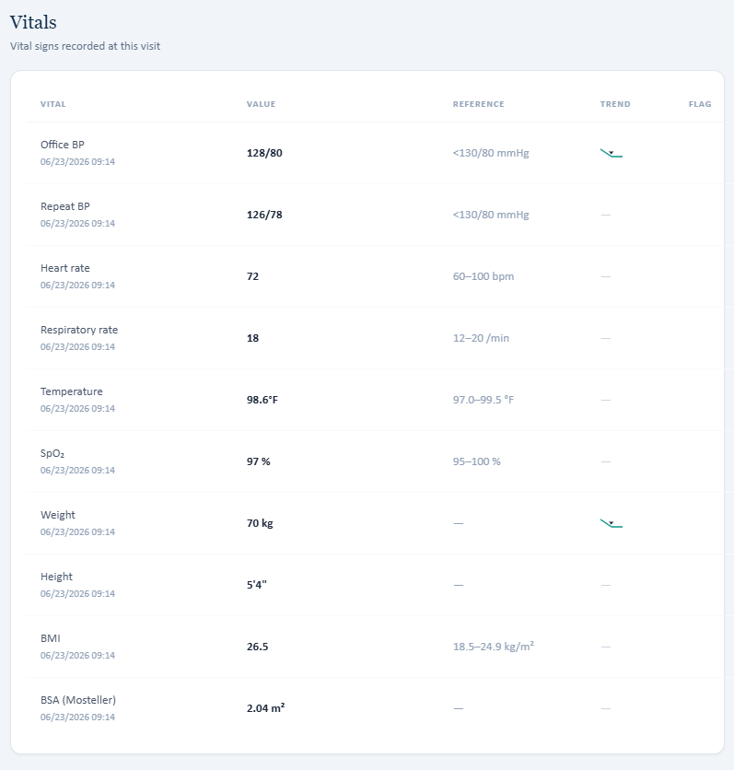
Live Tuesday vital signs and anthropometrics.

Issue 3. Pulmonary values are internally inconsistent and the master rubric expects yet another specific reversibility value
What the student saw or heard: Primary panel: pre-BD FEV1/FVC 0.54, post-BD 0.55, FEV1 58% predicted, eosinophils 420. “Missing” box instead states FEV1/FVC 0.60, FEV1 65%, +15%/+250 mL.
What the master rubric says: Master expects pre-BD 0.54, post-BD 0.55, FEV1 58%, +15%/+260 mL, eosinophils 420. (Rubric references: 2B.1-2B.6)
What the AI grader expected: The grader criticizes the conflicting/unreconciled PFT data and expects the master reversibility values.
Why this is a problem: The live chart contains both correct-looking master values and conflicting alternate values, making reliable interpretation impossible.
Suggested fix: Remove the incorrect .60/65% alternate dataset, display the intended +15%/+260 mL bronchodilator response with the primary PFTs, and stop marking available PFTs as missing.
Focused screenshot evidence
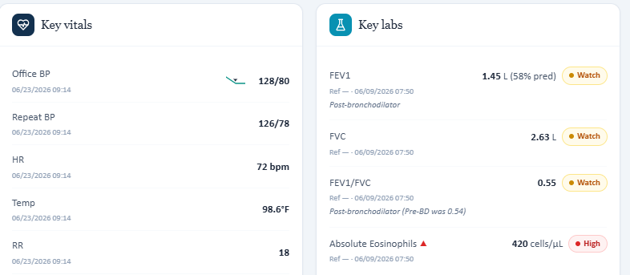
Evidence – Primary live pulmonary panel.
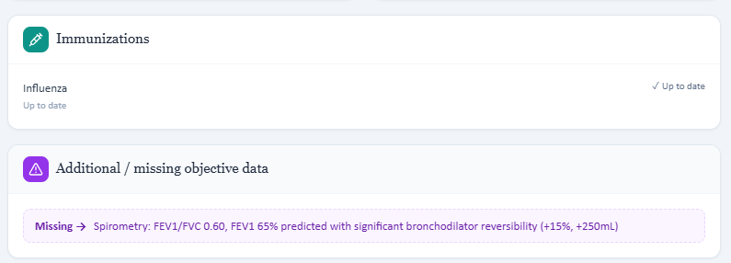
Evidence – Additional/missing section presents a conflicting spirometry/reversibility set.

Issue 4. ACT 15 and CAT 19 required by the master rubric are absent from the live Tuesday workflow
What the student saw or heard: No ACT or CAT value is displayed in the Tuesday live Objective data.
What the master rubric says: Master requires ACT 15 (poorly controlled asthma) and CAT 19 (significant COPD symptom burden). (Rubric references: 2B.7-2B.10, 2C.4-2C.5)
What the AI grader expected: The grader deducts both ACT and CAT values/interpretations.
Why this is a problem: Students cannot document validated control scores that VACS does not provide.
Suggested fix: Add ACT 15 and CAT 19 to the Tuesday objective/questionnaire workflow or remove those grading criteria when scores are unavailable.
Focused screenshot evidence

Live Objective does not display the master-rubric ACT/CAT baseline scores and shows influenza as the only immunization.

Issue 5. Spiriva device technique returned by the AI patient is inconsistent with the intended Respimat device
What the student saw or heard: The patient describes placing a capsule in the device and piercing it before inhalation.
What the master rubric says: Master specifically lists tiotropium (Spiriva Respimat). Respimat does not use a capsule-piercing technique. (Rubric references: 1E.1 and inhaler-technique criteria)
What the AI grader expected: The grader deducts because the described capsule/piercing technique is inconsistent with Spiriva Respimat.
Why this is a problem: The AI patient teaches/tests the wrong device and can cause incorrect counseling.
Suggested fix: Update the AI patient’s tiotropium technique script to the Respimat device steps, or change the medication/device in the case if HandiHaler is intended.
Focused screenshot evidence
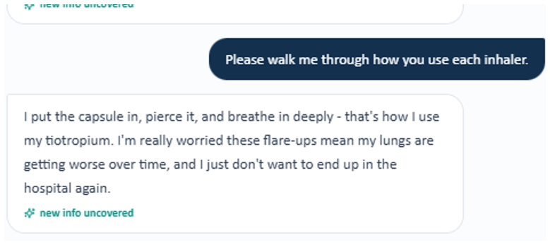
Evidence – AI patient describes inserting and piercing a capsule for tiotropium, which is HandiHaler-style technique rather than Respimat technique.

Patient C – Maria Thompson – Wednesday 3-Month Follow-Up
3 confirmed system/data issues are included for this visit. Items are grouped so one underlying problem is not counted multiple times just because it caused several grader deductions. Grading result: Grader error — no score.
# | Issue | Problem type
1 | AI SOAP grader fails with “Unexpected end of JSON input” after three attempts | Critical — Technical grading failure
2 | Master-rubric visit label says “6-month follow-up” although the intended/live Wednesday visit is 3-month | Low — Master rubric typo
3 | Wednesday Objective data contains conflicting pulmonary values and incomplete control-score data | High — Internal EMR inconsistency

Issue 1. AI SOAP grader fails with “Unexpected end of JSON input” after three attempts
What the student saw or heard: Submitting the Maria Wednesday SOAP repeatedly returns: “The AI grader failed to return a valid response (Unexpected end of JSON input). Please submit again.” The same error occurred on three attempts.
What the master rubric says: A grading rubric exists for the encounter, so the workflow should return a score and structured feedback. (Rubric references: Operational issue; prevents all rubric criteria from being evaluated)
What the AI grader expected: No valid grading response is produced; the workflow is blocked.
Why this is a problem: The student cannot complete grading or compare the live encounter against the grader for this visit.
Suggested fix: Log the raw model response and parser error, ensure complete JSON is returned before parsing, add retry/validation handling, and regression-test this exact Maria Wednesday SOAP payload.
Focused screenshot evidence
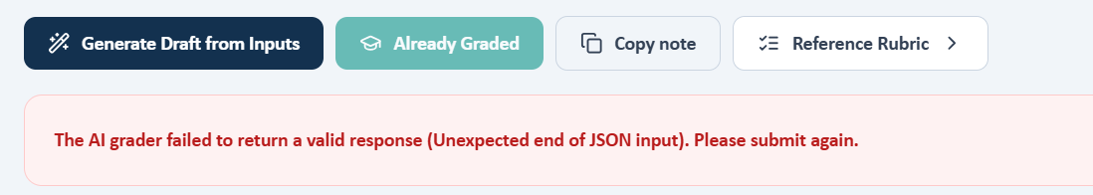
Evidence – Reproducible grading failure: “Unexpected end of JSON input.”

Issue 2. Master-rubric visit label says “6-month follow-up” although the intended/live Wednesday visit is 3-month
What the student saw or heard: The live Wednesday banner shows “Wednesday · 3-Month Follow-up.”
What the master rubric says: Master rubric criterion 1A.4 labels Wednesday as “6-month follow-up.” Based on the current workflow/testing, this appears to be a label typo rather than the intended visit interval. (Rubric references: 1A.4)
What the AI grader expected: The user-confirmed grading workflow accepts the 3-month visit wording when grading functions; the current blocker is the JSON error, not the visit label.
Why this is a problem: The typo can confuse reviewers and future case maintenance even if it is not currently driving the score.
Suggested fix: Change the Maria Wednesday master-rubric heading/criterion from 6-month to 3-month without changing other content solely on the basis of the label.
Focused screenshot evidence
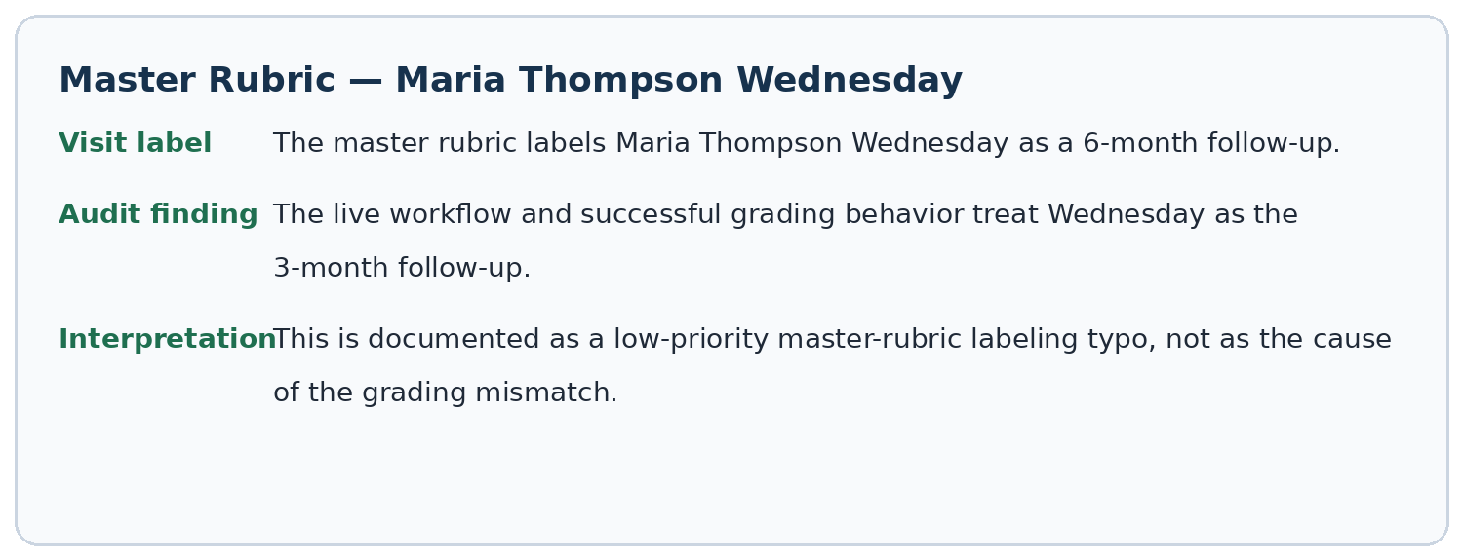
Evidence – Master-rubric excerpt documenting the Wednesday label typo and audit interpretation.

Issue 3. Wednesday Objective data contains conflicting pulmonary values and incomplete control-score data
What the student saw or heard: Primary: FEV1/FVC 0.55, FEV1 58%, eosinophils 420. “Missing” box: FEV1/FVC 0.57, FEV1 60%, CAT 17. No ACT is visible.
What the master rubric says: The master Wednesday rubric uses a different advanced-case dataset, including FEV1/FVC 0.56, FEV1 61%, eosinophils 520, ACT 17, CAT 15, and multiple recent exacerbations. (Rubric references: 2B/2C objective criteria)
What the AI grader expected: Because the grader currently crashes, these discrepancies cannot be validated against its active reference.
Why this is a problem: Even after the JSON error is fixed, the encounter may still grade inconsistently unless its objective source is synchronized.
Suggested fix: Verify the intended Maria Wednesday clinical dataset, then make pulmonary values, ACT/CAT, treatment stage, master rubric, and grader reference identical.
Focused screenshot evidence
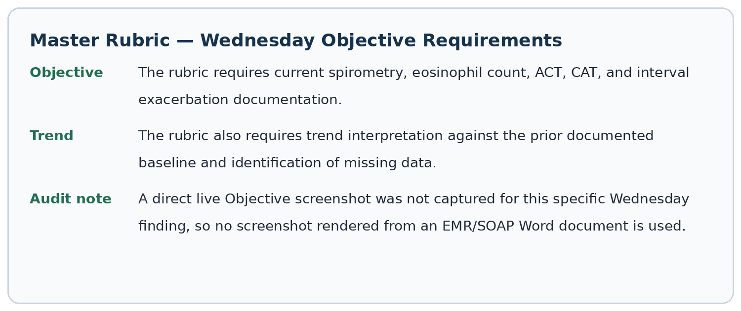
Evidence – Master-rubric objective requirements and explicit note that no screenshot rendered from an EMR/SOAP Word document is used for this finding.

Patient C – Maria Thompson – Thursday 3-Month Follow-Up
6 confirmed system/data issues are included for this visit. Items are grouped so one underlying problem is not counted multiple times just because it caused several grader deductions. Grading result: 29.4%.
# | Issue | Problem type
1 | AI grader is evaluating Maria Thursday against a different treatment stage than the live EMR | Critical — Live case and grader use different case stages
2 | Thursday vital signs differ across live EMR, master rubric, and grader | High — EMR, rubric, and grader disagree
3 | Thursday pulmonary/control data differ across all three sources | Critical — EMR, rubric, and grader disagree
4 | Medication-allergy safety discrepancy: EMR says NKDA; AI patient and master rubric say sulfonamide rash | Critical — EMR and AI patient allergy mismatch
5 | Clinical trajectory and biologic recommendation are contradictory across EMR, master rubric, and grader | Critical — EMR, rubric, and grader disagree
6 | Smoking/family/immunization background is not synchronized | High — EMR/AI patient, rubric, and grader disagree

Issue 1. AI grader is evaluating Maria Thursday against a different treatment stage than the live EMR
What the student saw or heard: Live Thursday: Symbicort + Spiriva, eosinophils 380, ACT 14, CAT 18, persistent/worsening symptoms, and a recent hospitalization; advisory says consider biologic escalation.
What the master rubric says: Master Thursday also uses Symbicort + Spiriva and eosinophils 380, but expects improved ACT 20/CAT 13 and only one mild flare without OCS/hospitalization. It does not expect an already established mepolizumab/Trelegy response. (Rubric references: 1E medication criteria, 2B.1-2B.13, 3A/3C response criteria)
What the AI grader expected: The 29.4% grader expects a well-controlled patient already on Trelegy + mepolizumab, eosinophils around 50, no exacerbations in 6 months, improved ACT/CAT, and no escalation.
Why this is a problem: The grader is clearly using a different longitudinal stage/case version than the live Thursday encounter and the master Thursday rubric.
Suggested fix: Identify which Maria reference object the Thursday grader is loading and bind it to the Thursday master-rubric dataset; regression-test medication, biologic status, eosinophils, ACT/CAT, and exacerbation trajectory together.
Focused screenshot evidence
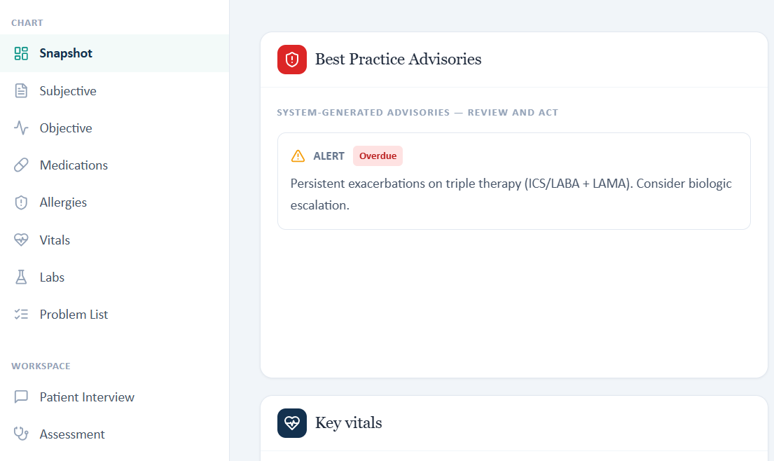
Live Thursday advisory says persistent exacerbations on ICS/LABA + LAMA and to consider biologic escalation.
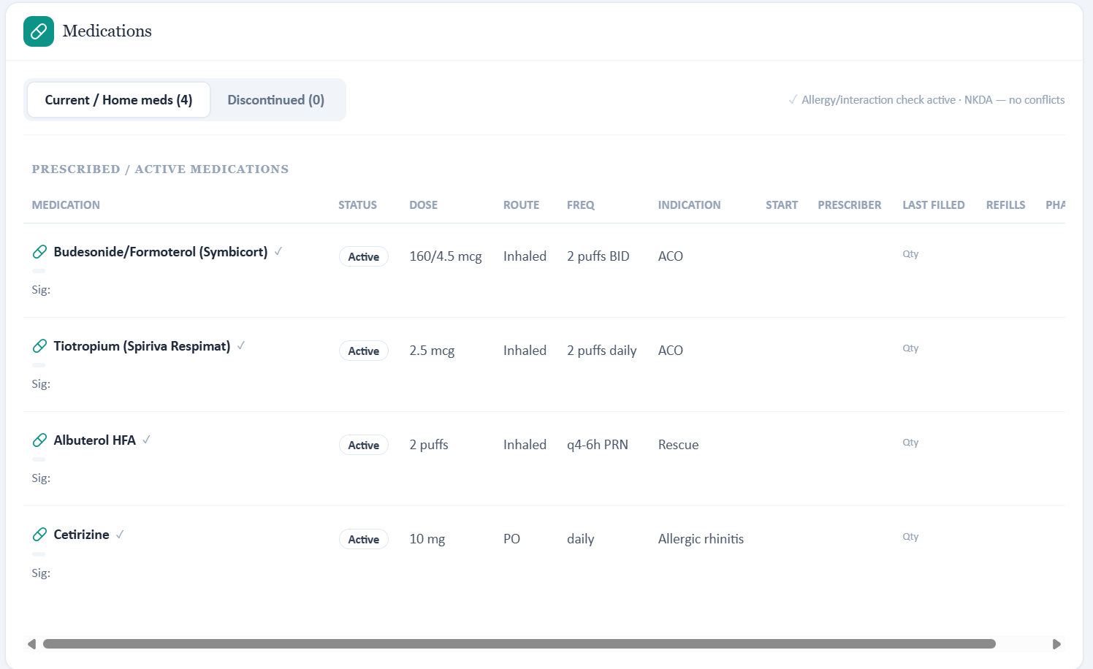
Live medication list is Symbicort + Spiriva, not Trelegy + mepolizumab.
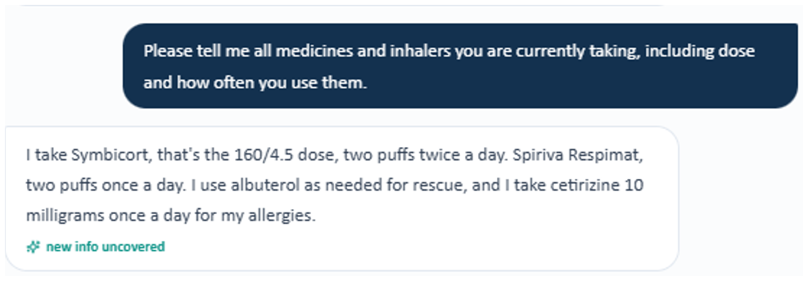
Evidence – AI patient reports Symbicort plus Spiriva and albuterol; Trelegy and mepolizumab are not part of the reported regimen.
Evidence – Focused AI-grader feedback excerpt 1: only the deduction(s) and description relevant to this issue are shown.
Evidence – Focused AI-grader feedback excerpt 2: only the deduction(s) and description relevant to this issue are shown.

Issue 2. Thursday vital signs differ across live EMR, master rubric, and grader
What the student saw or heard: Live: BP 130/80, HR 76, RR 18, SpO₂ 94%, weight 70 kg, height 64 in, BMI 26.5.
What the master rubric says: Master: BP 124/72, HR 76, RR 16, SpO₂ 96% room air, weight 71 kg, height 64 in, BMI 26.9. (Rubric references: 2A.1-2A.7)
What the AI grader expected: Grader expects yet another set including BP 128/80, HR 72, and SpO₂ 97%.
Why this is a problem: There is no authoritative set of Thursday vitals for the student or grader.
Suggested fix: Choose the verified Thursday objective dataset and propagate it to the live chart, master rubric, and grader.
Focused screenshot evidence
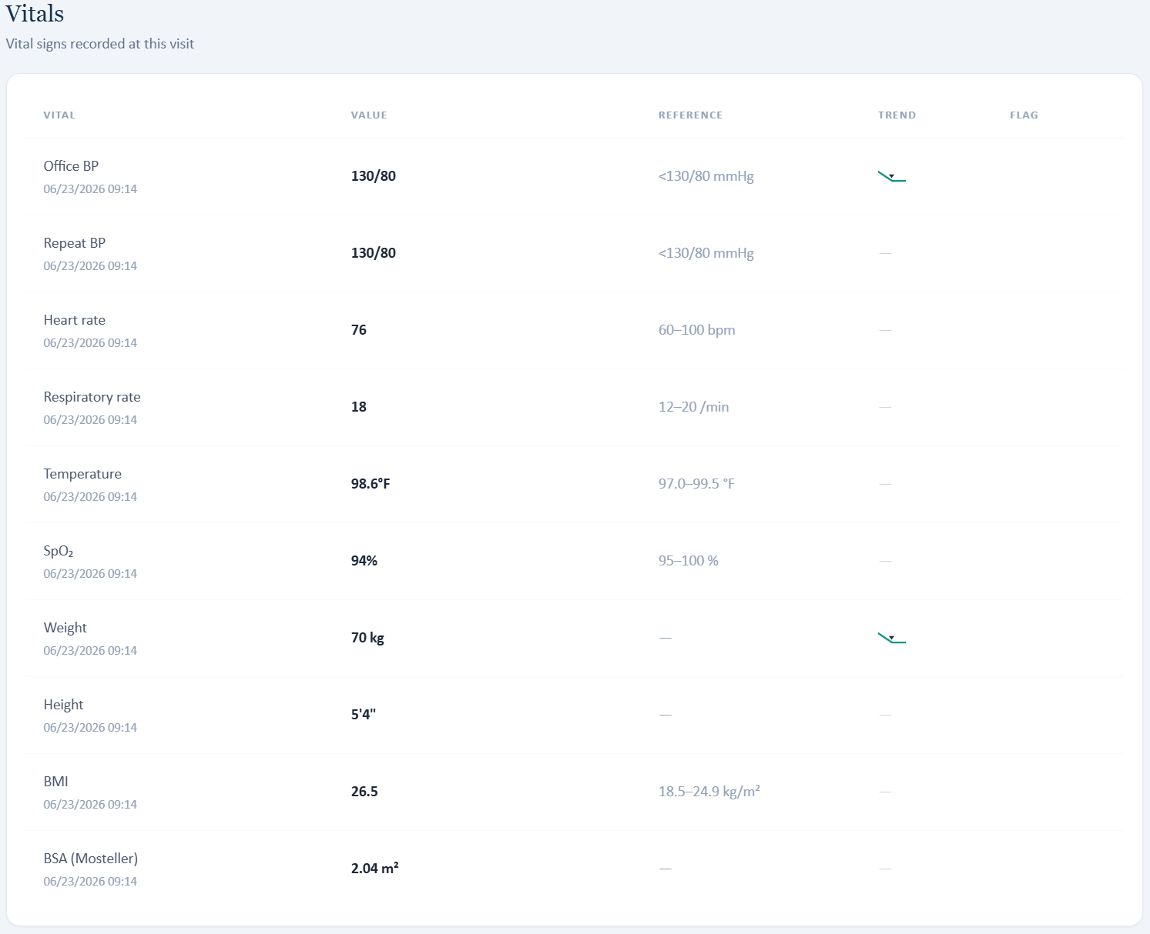
Live Thursday vital signs and anthropometrics.

Issue 3. Thursday pulmonary/control data differ across all three sources
What the student saw or heard: Live: FEV1/FVC 0.57, FEV1 58%, eosinophils 380, ACT 14, CAT 18.
What the master rubric says: Master: FEV1/FVC 0.56, FEV1 63%, eosinophils 380, ACT 20, CAT 13 with improvement from prior ACT 15/CAT 19. (Rubric references: 2B.1-2B.13, 2C.2-2C.6)
What the AI grader expected: Grader expects FEV1/FVC 0.60, FEV1 66%, eosinophils 50 (suppressed), and an improved biologic-response picture.
Why this is a problem: Treatment-response conclusions—especially biologic decisions—change completely depending on which source is used.
Suggested fix: Create a single verified Thursday response dataset and update all five linked values together: spirometry, eosinophils, ACT, CAT, and exacerbation history.
Focused screenshot evidence
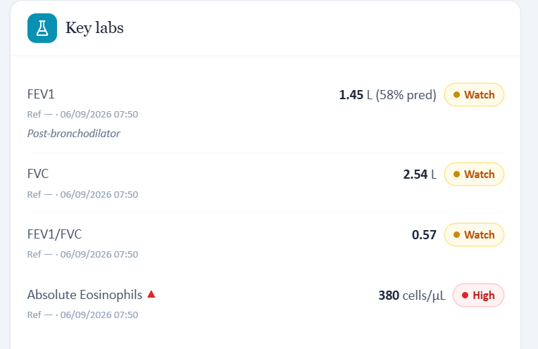
Live Thursday PFT/eosinophils.
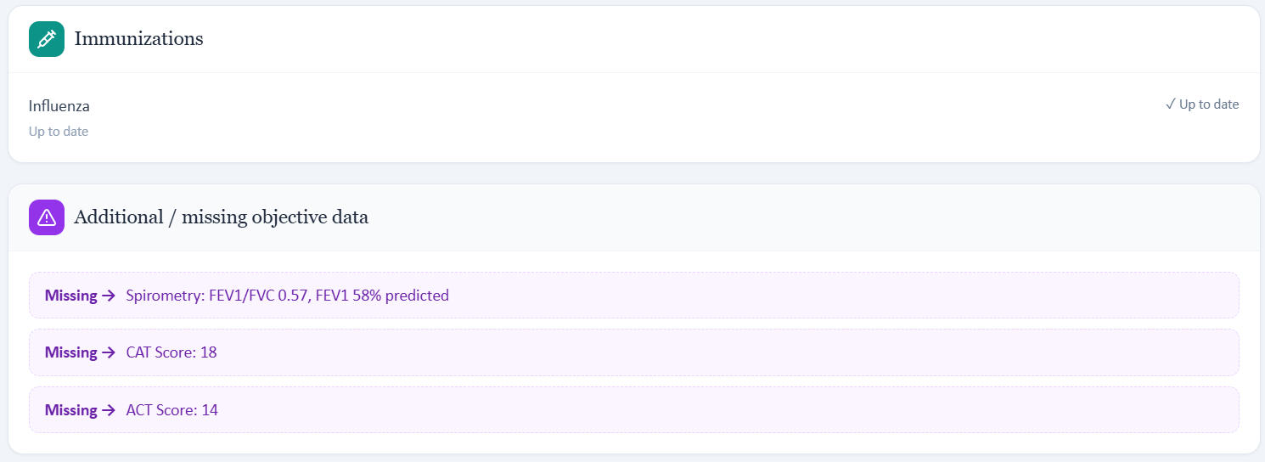
Live Objective supplies ACT 14 and CAT 18 while calling them “missing.”

Issue 4. Medication-allergy safety discrepancy: EMR says NKDA; AI patient and master rubric say sulfonamide rash
What the student saw or heard: Live Allergy tab/header says no known drug allergies. During interview Maria reports a severe sulfonamide-antibiotic allergy causing rash.
What the master rubric says: Master Thursday rubric explicitly expects sulfonamide antibiotics with rash. (Rubric references: 1E.11-1E.12)
What the AI grader expected: The grader penalizes the note for documenting the patient-reported allergy because it expects a different dataset/NKDA state in this run.
Why this is a problem: Regardless of grading, this is a medication-safety inconsistency inside the simulation and could teach unsafe reconciliation behavior.
Suggested fix: Update the live allergy record to sulfonamide antibiotics — rash if that is the intended case, and make the grader accept the reconciled allergy.
Focused screenshot evidence
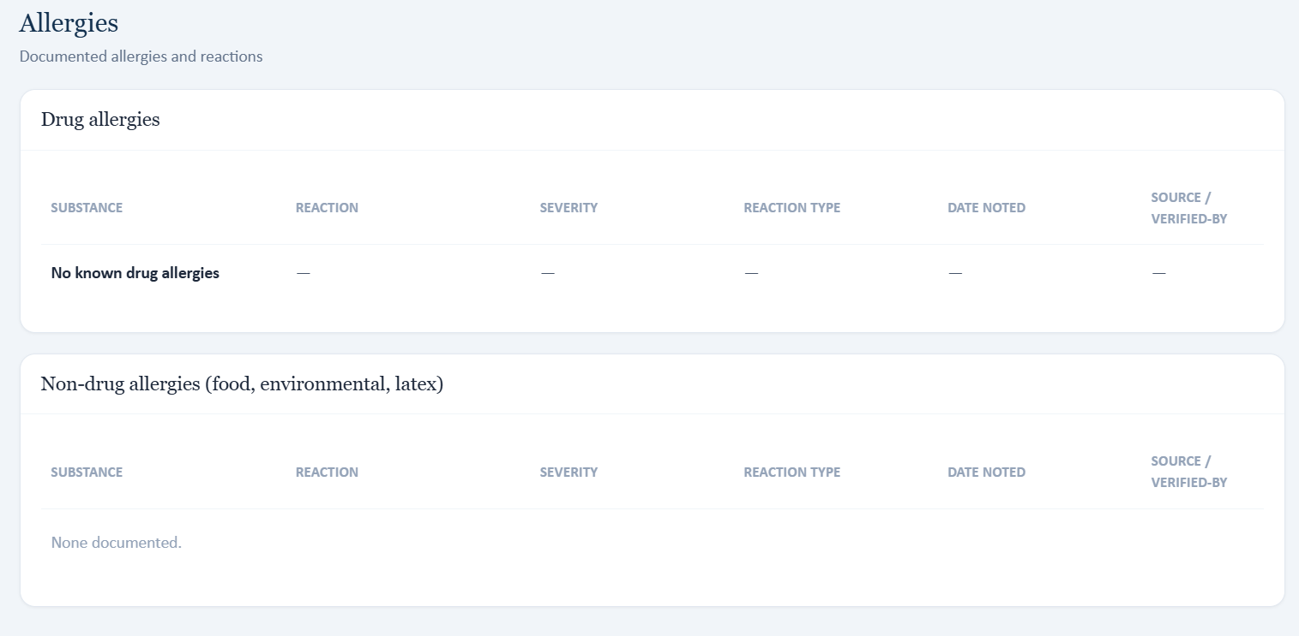
Live Allergy tab documents no known drug allergies.
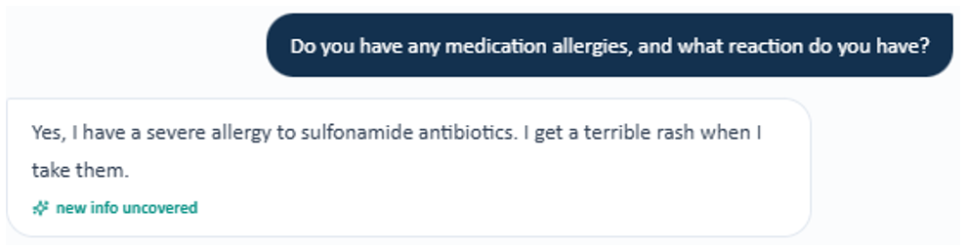
Evidence – AI patient reports a severe sulfonamide-antibiotic allergy with rash while the live Allergy tab states no known drug allergies.

Issue 5. Clinical trajectory and biologic recommendation are contradictory across EMR, master rubric, and grader
What the student saw or heard: Live advisory says persistent exacerbations on ICS/LABA + LAMA and to consider biologic escalation; patient reports worsening symptoms and hospitalization.
What the master rubric says: Master Thursday expects improvement on Symbicort + Spiriva, one mild flare with no OCS/antibiotics/hospitalization, and states biologic therapy is not indicated at this time. (Rubric references: 2B.8-2B.13, 3C.5-3C.9, 4A.8)
What the AI grader expected: The grader expects the patient already to be on mepolizumab/Trelegy with suppressed eosinophils and no escalation needed.
Why this is a problem: The same encounter simultaneously supports “consider biologic,” “do not use biologic,” and “already on biologic.”
Suggested fix: Define the intended Thursday treatment stage, then align the advisory, problem list, patient responses, master rubric, and grader to that single stage.
Focused screenshot evidence

Live advisory recommends considering biologic escalation.
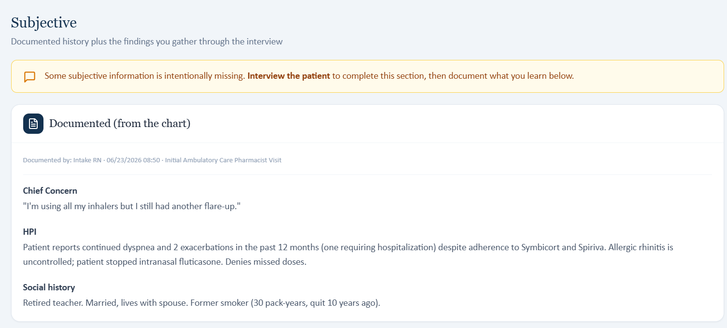
Live HPI documents continued dyspnea, two exacerbations, and one hospitalization.
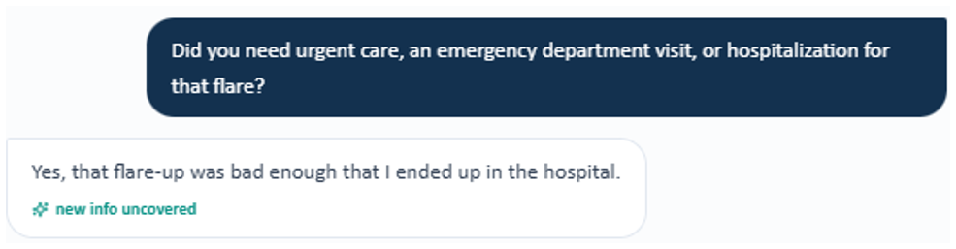
Evidence – AI patient confirms that the recent flare was severe enough to require hospitalization.
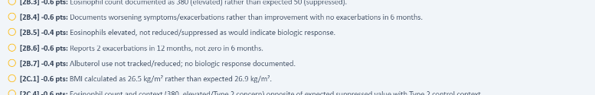
Evidence – Focused AI-grader feedback excerpt 1: only the deduction(s) and description relevant to this issue are shown.
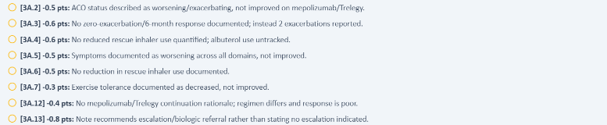
Evidence – Focused AI-grader feedback excerpt 2: only the deduction(s) and description relevant to this issue are shown.
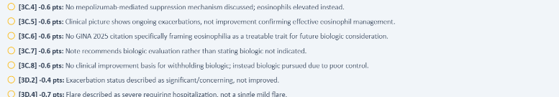
Evidence – Focused AI-grader feedback excerpt 3: only the deduction(s) and description relevant to this issue are shown.
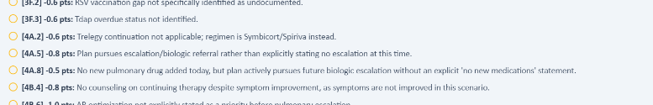
Evidence – Focused AI-grader feedback excerpt 4: only the deduction(s) and description relevant to this issue are shown.

Issue 6. Smoking/family/immunization background is not synchronized
What the student saw or heard: Live chart says former smoker 30 pack-years, quit 10 years ago; interview family history is father CAD, mother allergic rhinitis, sister asthma; Objective shows influenza only.
What the master rubric says: Master Thursday expects former smoker 30 pack-years, quit 12 years ago; father COPD + CAD, mother asthma + allergic rhinitis; influenza/COVID current, RSV not documented, Tdap overdue and other vaccine statuses. (Rubric references: 1C.7-1C.10, 1D.4-1D.6, 1E.13-1E.18)
What the AI grader expected: The grader expects never-smoker status and also deducts for missing COVID/PCV20/RSV/Tdap details.
Why this is a problem: Basic history and preventive-care facts vary by source, creating unavoidable deductions.
Suggested fix: Synchronize smoking, family history, and the complete five-category immunization record across the case.
Focused screenshot evidence
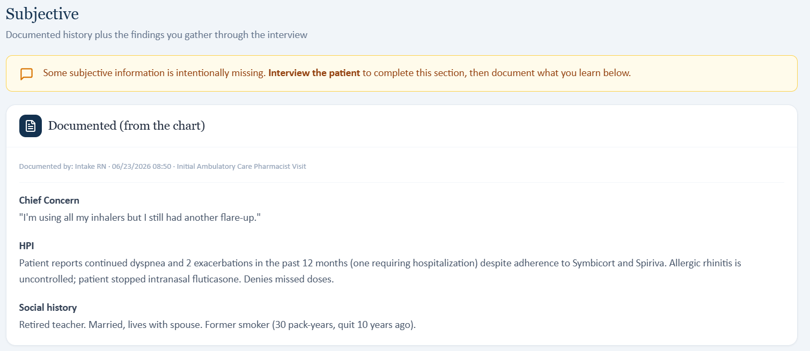
Live social history documents former smoking, 30 pack-years, quit 10 years ago.

Live Objective immunization section shows influenza only.
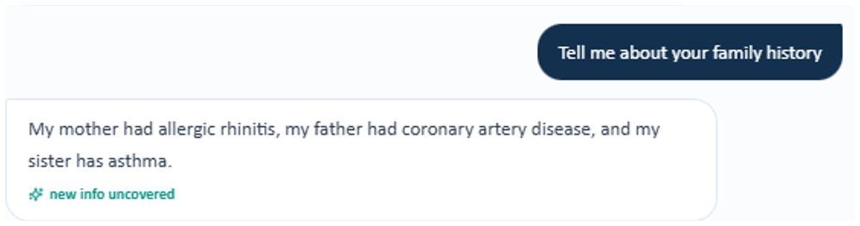
Evidence – AI patient reports mother with allergic rhinitis, father with CAD, and sister with asthma.
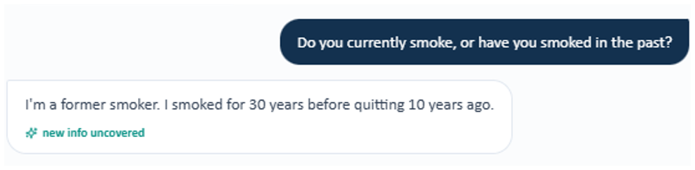
Evidence – AI patient reports a 30-year smoking history and quitting 10 years ago, while the grader expects never-smoker status.
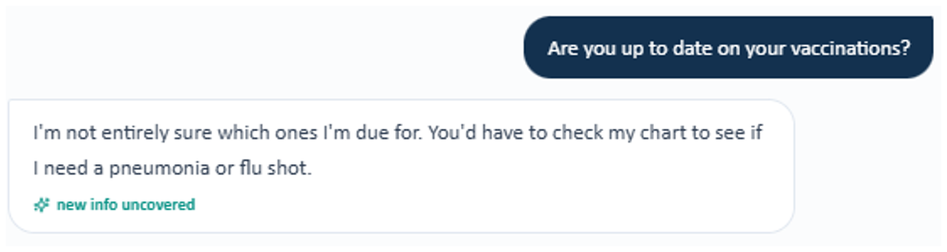
Evidence – AI patient cannot identify which vaccines are due and says the chart would need to be checked.

Cross-Visit Patterns
1. Multiple case versions are active at the same time. The same patient/day can use one dataset in the live EMR, another in the AI patient, another in the master rubric, and another in the AI grader. This is most obvious in Robert Thursday and Maria Thursday.
2. Objective values are not synchronized. Vital signs, spirometry, ACT/CAT scores, eosinophils, and exacerbation counts frequently differ between the student-facing chart and the values used for grading.
3. AI-patient memory does not always match graded history. Neutral interview questions sometimes return medication, symptom, family-history, surgical-history, smoking, or vaccination answers that cannot earn full rubric credit.
4. “Additional / missing objective data” can contradict the primary Objective section. Several visits display pulmonary values normally and then repeat different values in a purple box labeled “Missing.” This creates two simultaneous versions of the same objective data.
5. Best Practice Advisories and problem-list logic can be mapped to the wrong regimen or condition. Examples include COPD LAMA/LABA/eosinophil logic appearing in an asthma SMART encounter and Anoro being treated as LAMA-only therapy.
6. The grader has both reference-data and technical failures. Some visits grade against values or treatment stages not present in the live case. Maria Wednesday additionally fails to produce a valid JSON grading response after repeated attempts.

Recommended Fix Order
1. Establish one canonical dataset for every Patient + Day encounter. Bind the live EMR, AI-patient memory, master rubric, Best Practice Advisories, and AI grader to the same version identifier.
2. Synchronize all treatment-changing objective data. Verify vitals, spirometry, ACT/CAT, eosinophils, exacerbation counts, medication lists, and allergy data first because these can change clinical decisions.
3. Correct AI-patient longitudinal memory. Ensure follow-up patients reliably return prior and current history that remains graded, without requiring students to guess or fabricate hidden information.
4. Correct Best Practice Advisory and problem-list rules. Trigger advisories from the actual medication classes, diagnosis, symptom status, and current treatment stage shown in the encounter.
5. Repair and revalidate the AI grader. Replace incorrect reference datasets, fix the Maria Wednesday JSON parsing failure, and add schema validation/retry handling for malformed model output.
6. Regression-test all 9 Week 3 encounters end-to-end. For each visit, complete the interview, write a SOAP note using only visible/elicited information, submit it for grading, and confirm that every deduction is supported by information the student could actually obtain.

Source and Evidence Notes
• The master comparison source is the VACS SOAP Note Grading Rubrics Master List used for Week 3 audit testing.
• AI-patient evidence comes from the fresh neutral-question interviews performed during this audit. Where higher-resolution split screenshots were available, the report uses a tight crop of only the exact question-and-answer exchange relevant to that issue. Maria Wednesday is not re-captured because the grading workflow failed with the JSON error; that visit is documented with the technical-error evidence and available live/rubric evidence.
• AI-grader evidence comes from the actual grading feedback returned after SOAP submission. When relevant deductions are separated in the feedback list, multiple focused crops are shown rather than one long screenshot.
• EMR evidence comes from live VACS/browser captures. Screenshots rendered from EMR/SOAP-note Word documents are not included in this report.
• Robert Jenkins interview evidence uses the original captured interview images because no replacement split screenshots were supplied; those crops are kept small to avoid unnecessary enlargement of the source pixels.
• Maria Wednesday is treated as the intended 3-month follow-up. The master-rubric “6-month” wording is documented only as a low-priority label typo because the grading workflow accepts the 3-month wording when grading functions.

