

**Department of Computer Science**

**HITEC University, Taxila**

**BS Computer Science Program**

**(Batch 2022)**

**CS-206 Computer Organization & Assembly language 4(3+1)**

**Lab Folder**

**SPRING 2024**

**Instructor: Fatima Rauf**

**Submitted By:**

**Abdul Ahad (22-CS-071)**

**Lab Report # 1**

**Task 1:** Write the following code in emulator and examine the contents of registers by single stepping

MOV AL, 57

MOV DH,69

MOV DL, 72

MOV BX, DX

MOV BH, AL

MOV AH, 20

ADD AX, DX

**Output:**

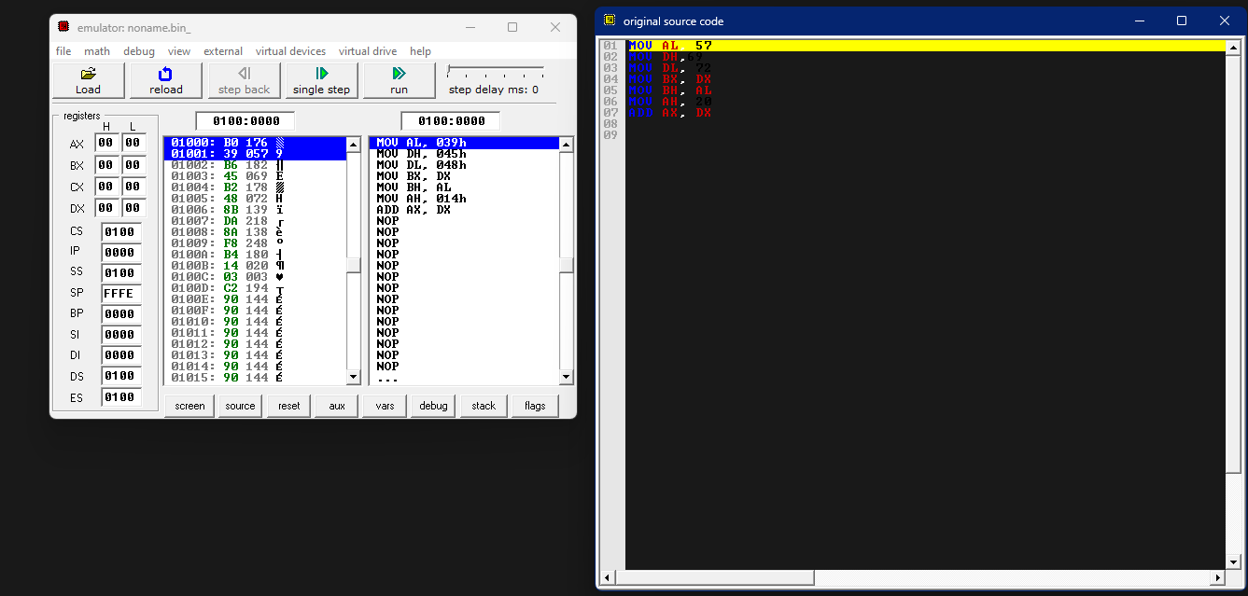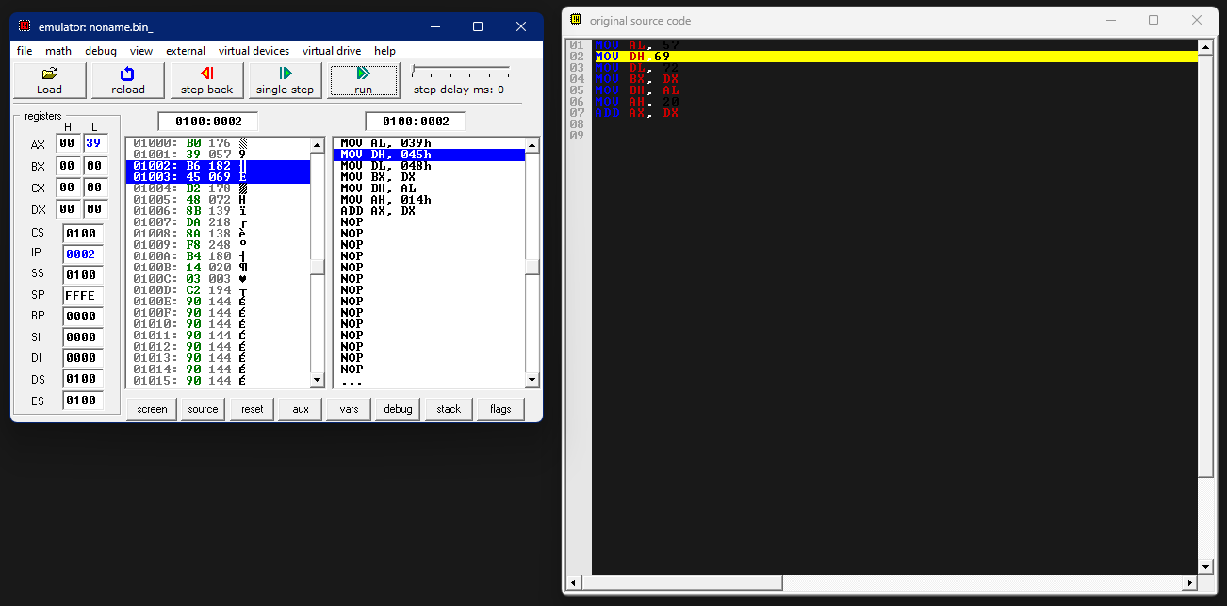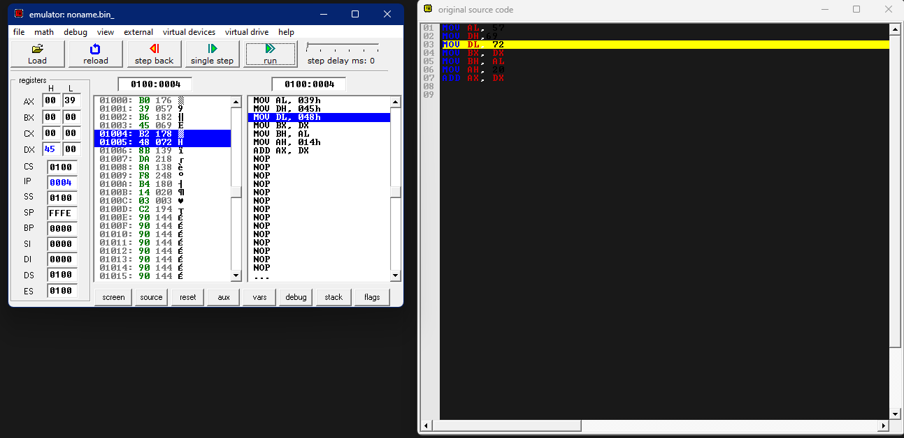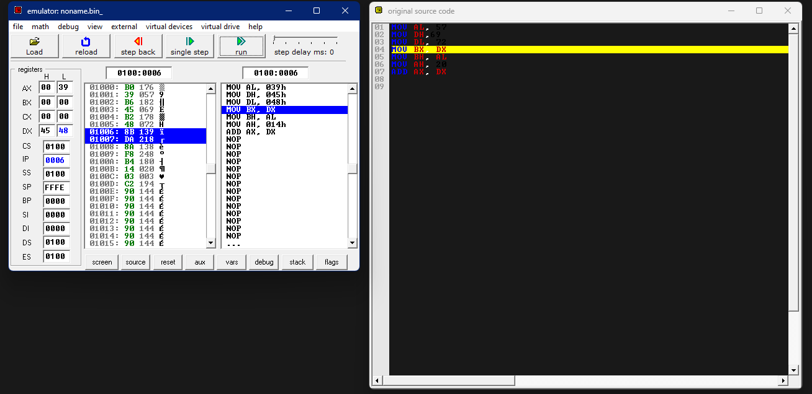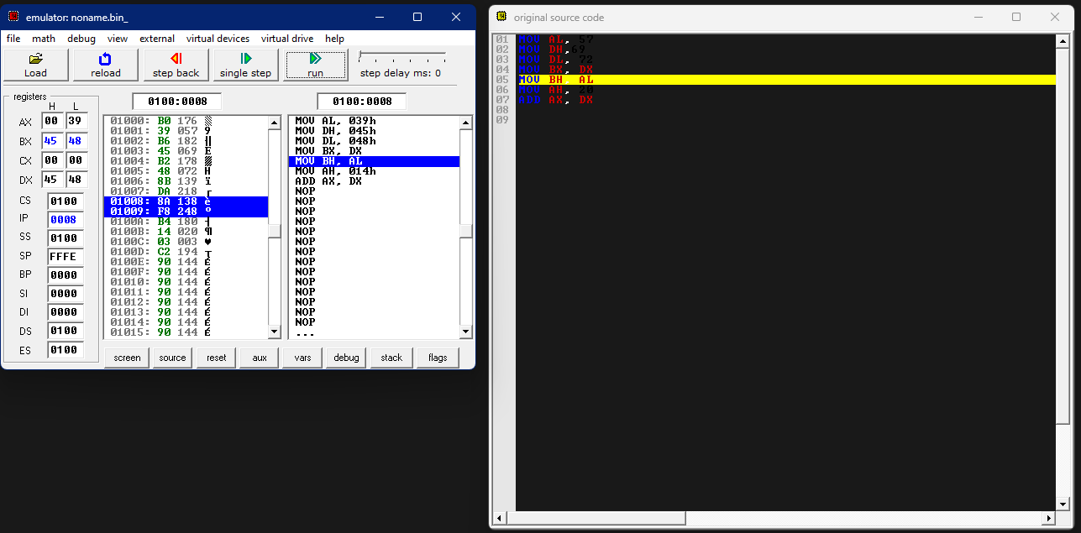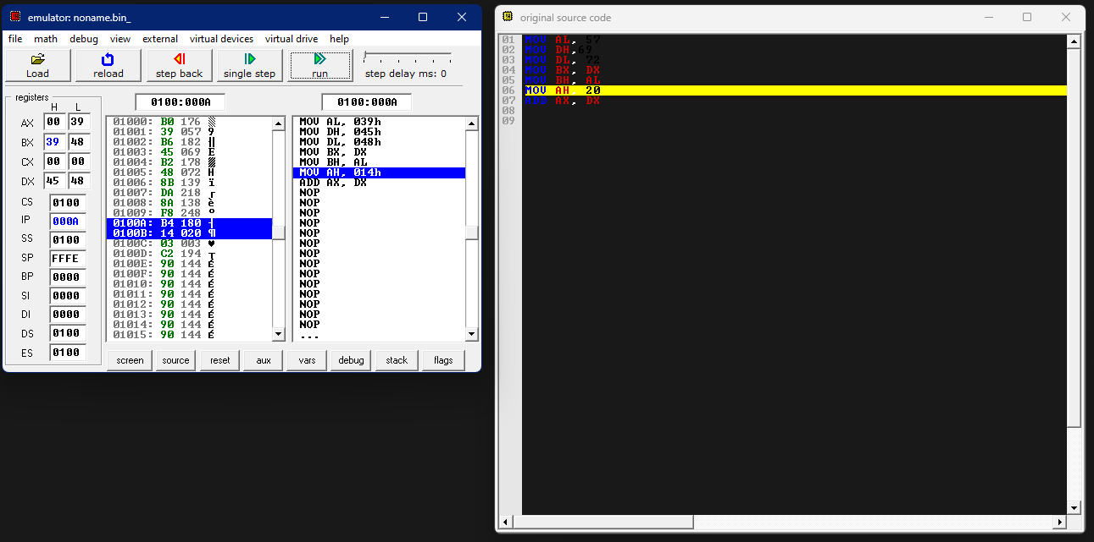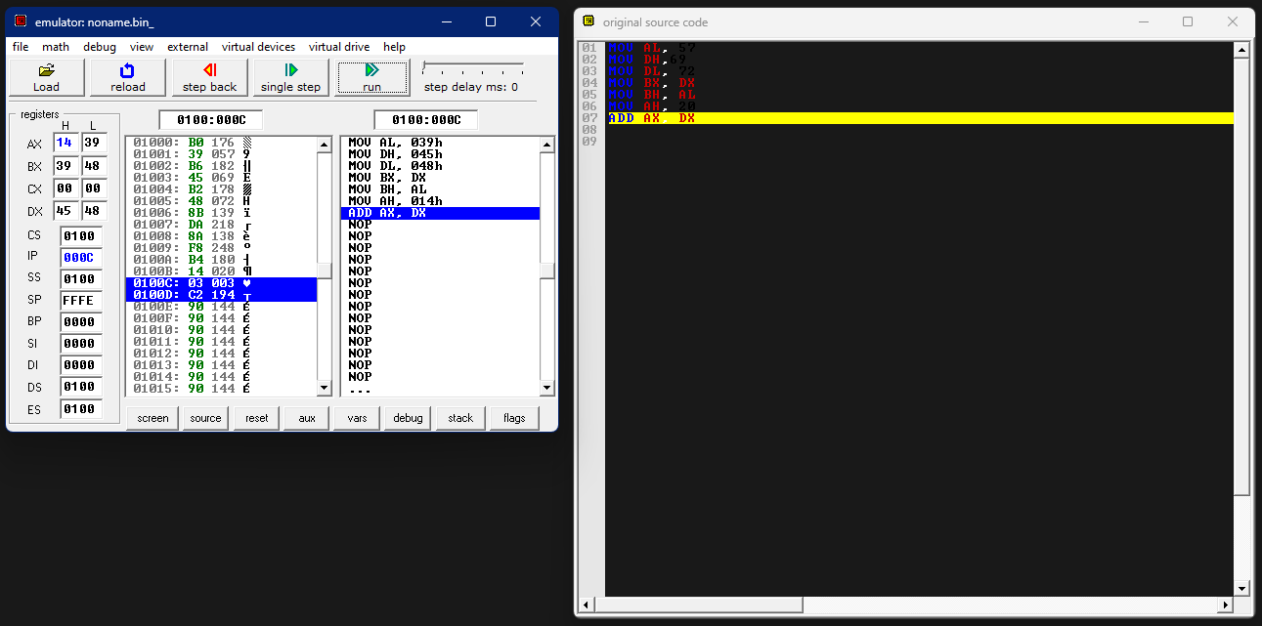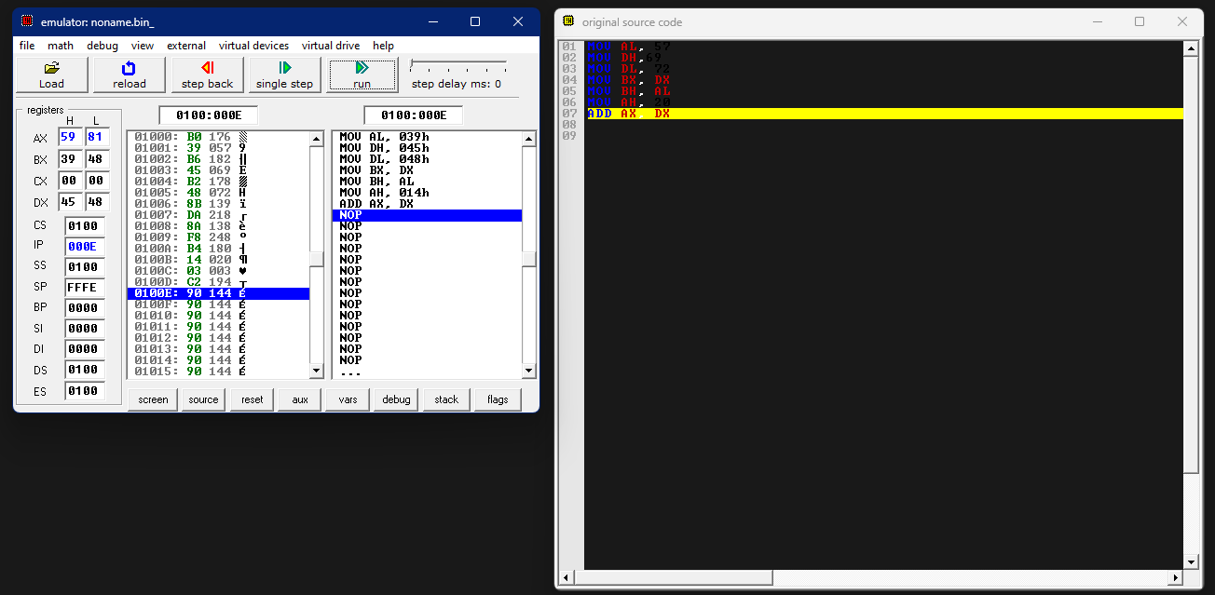

**Task 2:** Write an assembly language code that take a character as input and display same character on screen. (Only screen shots)

**Code:**

*.model small*

*.stack 100h*

*.code*

*main proc*

*MOV ah, 1*

*int 21h*

*MOV bl, al*

*MOV ah , 2*

*MOV dl , bl*

*int 21h*

*mov ah , 4ch*

*end main*

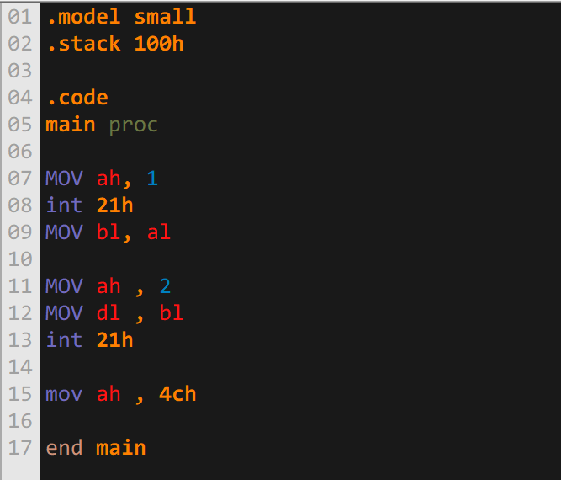

**Output:**

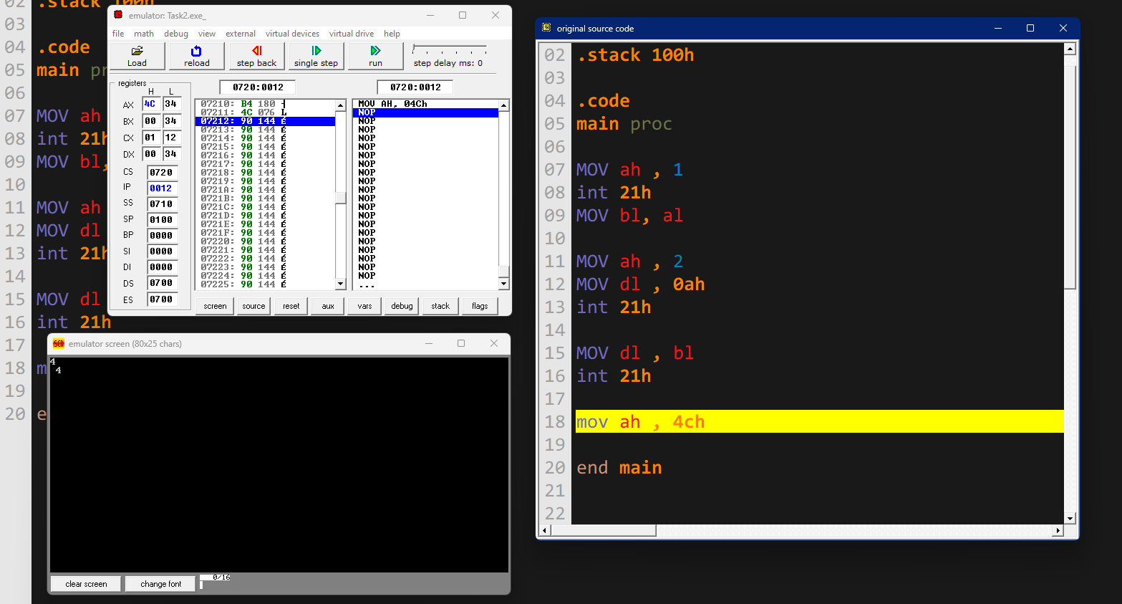

**Task 3:** Write difference between input and output function used in assembly language.

**Answer:** The Difference Between Input and Output Function in assembly language is:

|  |  |
| --- | --- |
| **Input Function** | **Output Function** |
| * The **“AH”** must have the value **1** for the input function to initiate * The input value is stored in the **“AL”** register. | * The **“AH”** must have the value **2** for the input function to initiate * The Output value is Taken from the **“DL”** register. |

**Task 4:**

MOV AL, ‘9’

ADD AL, ‘5’

Have a close look at results?

**Output:**

