

**Department of Computer Science**

**HITEC University, Taxila**

**BS Computer Science Program**

**(Batch 2022)**

**CS-206 Computer Organization & Assembly language 4(3+1)**

**Lab Folder**

**SPRING 2024**

**Instructor: Fatima Rauf**

**Submitted By:**

**Abdul Ahad (22-CS-071)**

**Lab Report # 10**

**Task 1:** Write Assembly program which writes a String to a file. Define String in program.

**Code:**

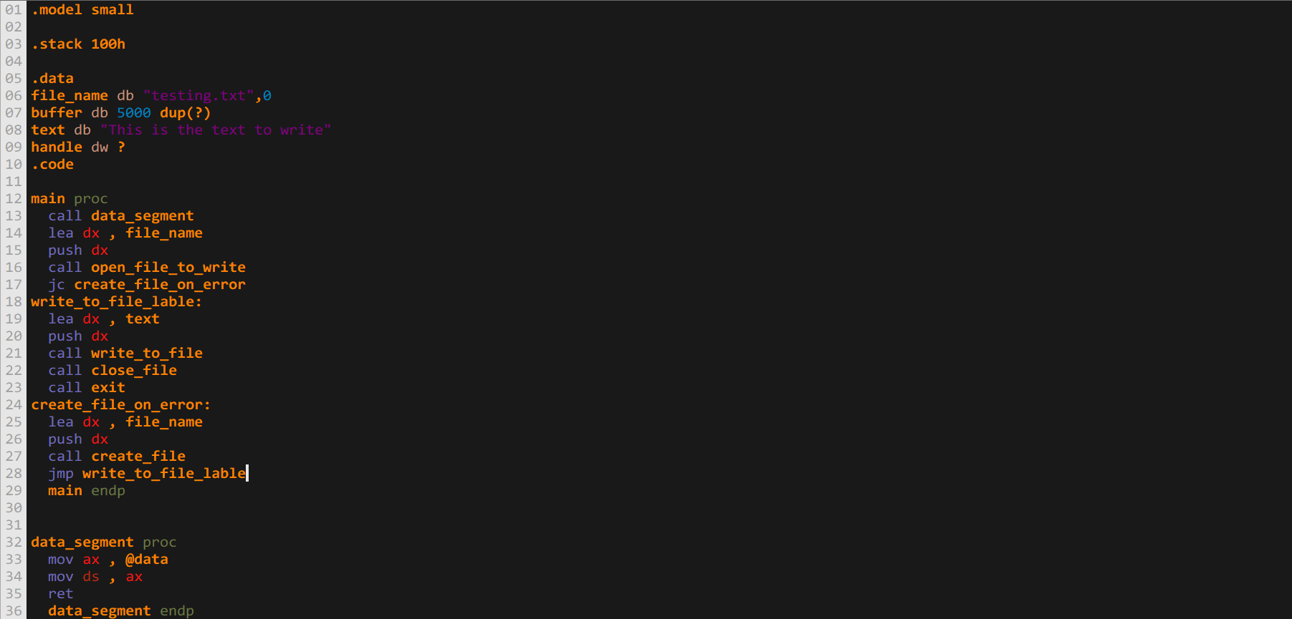

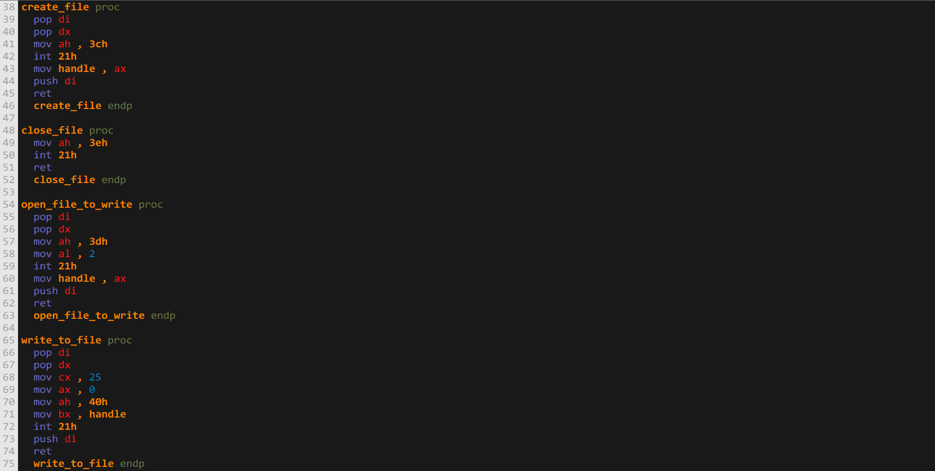

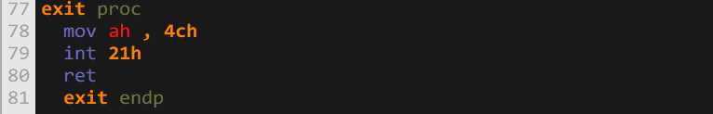

**Output:**

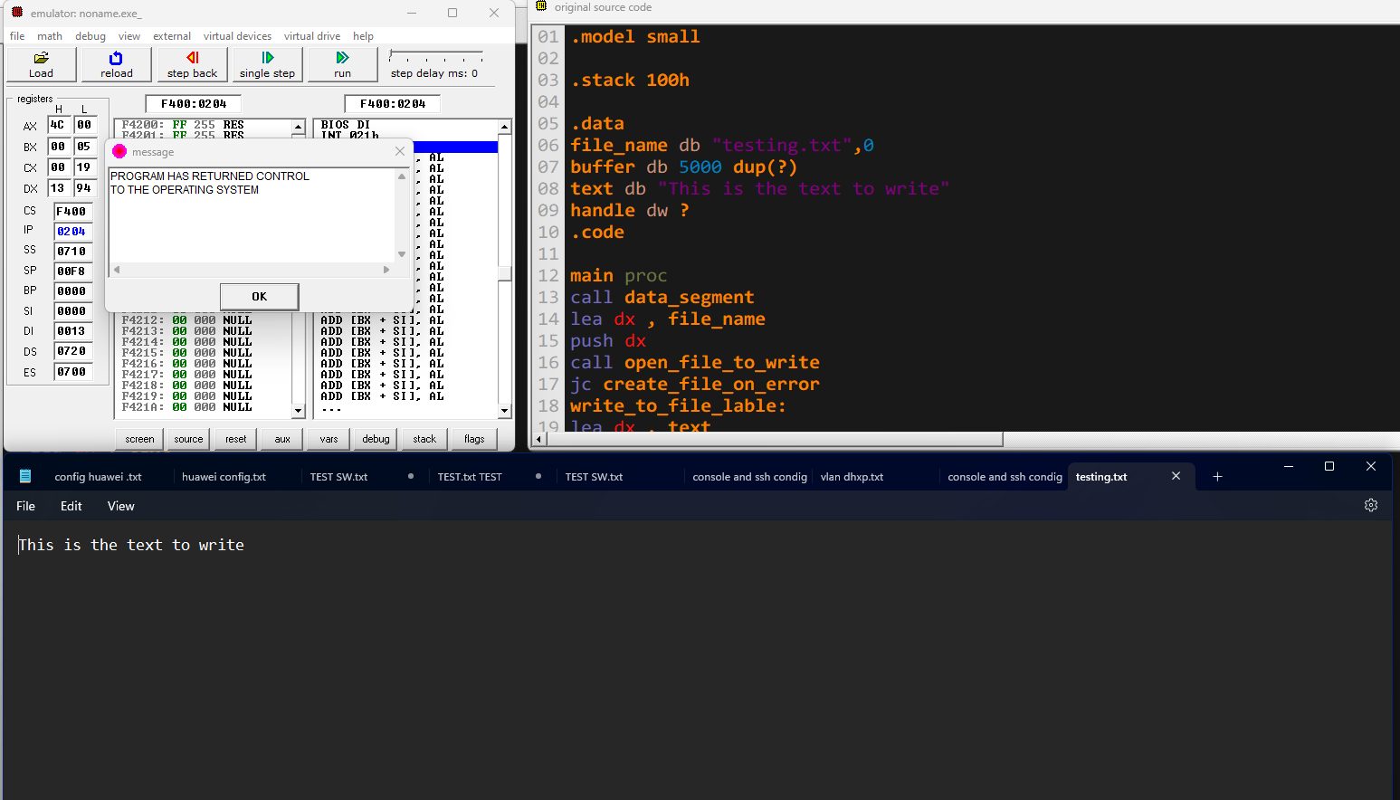

**Task 2:** Write assembly program, which opens a file and print its contents on CONSOLE and closes the file.

**Code:**

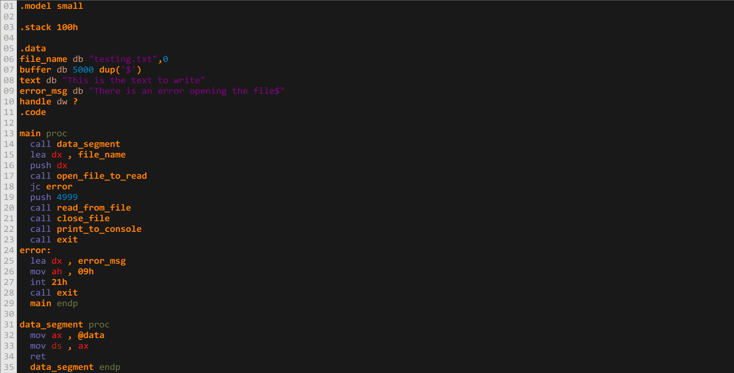

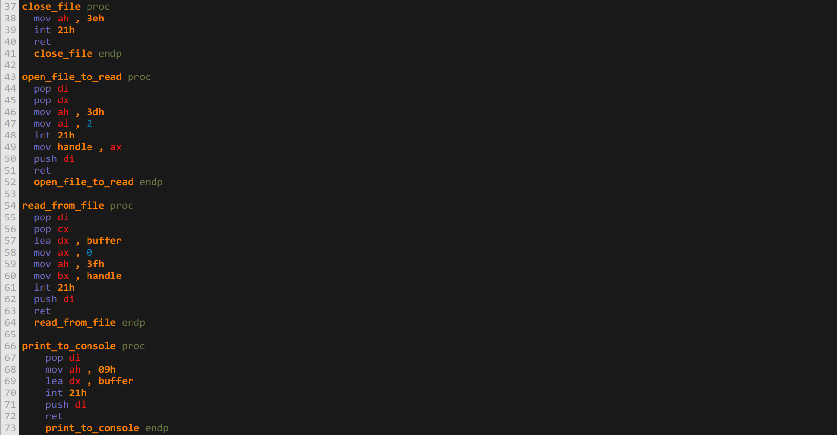 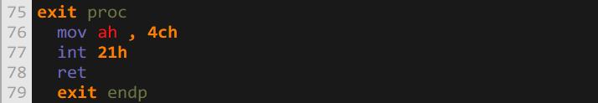

**Output:**

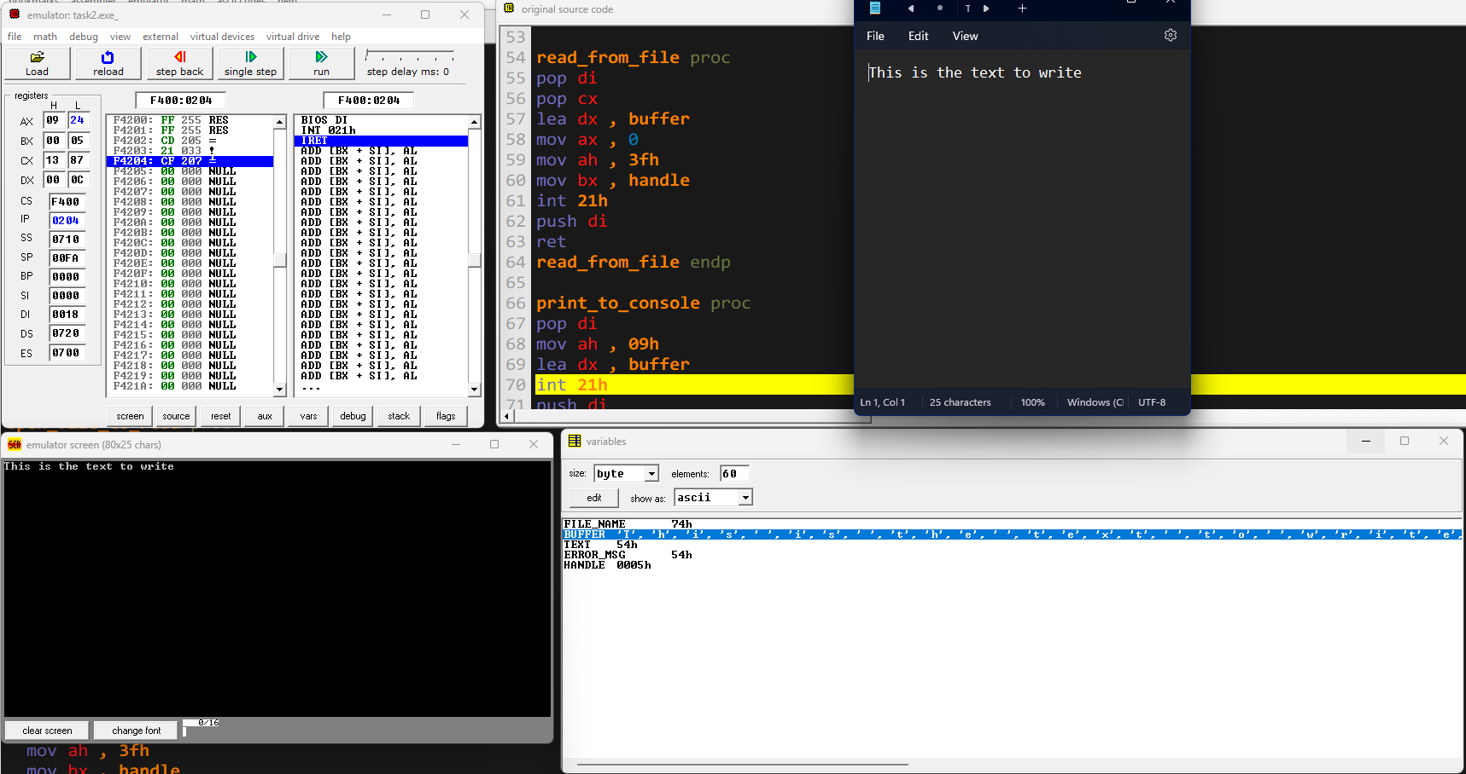

**Conclusion:** These assembly programs offer practical demonstrations of file handling in assembly language. The first reads from a file, prints its contents, and closes it, while the second writes a predefined string to a file. They cover opening, reading from, writing to, and closing files, showcasing essential file operations and error handling mechanisms. These examples serve as a solid foundation for understanding how assembly interacts with file systems.