

**Department of Computer Science**

**HITEC University, Taxila**

**BS Computer Science Program**

**(Batch 2022)**

**CS-206 Computer Organization & Assembly language 4(3+1)**

**Lab Folder**

**SPRING 2024**

**Instructor: Fatima Rauf**

**Submitted By:**

**Abdul Ahad (22-CS-071)**

**Lab Report # 13**

**Task 1:** Perform addition, subtraction, multiplication, and division operations on single-precision floating-point numbers.

**Code:**

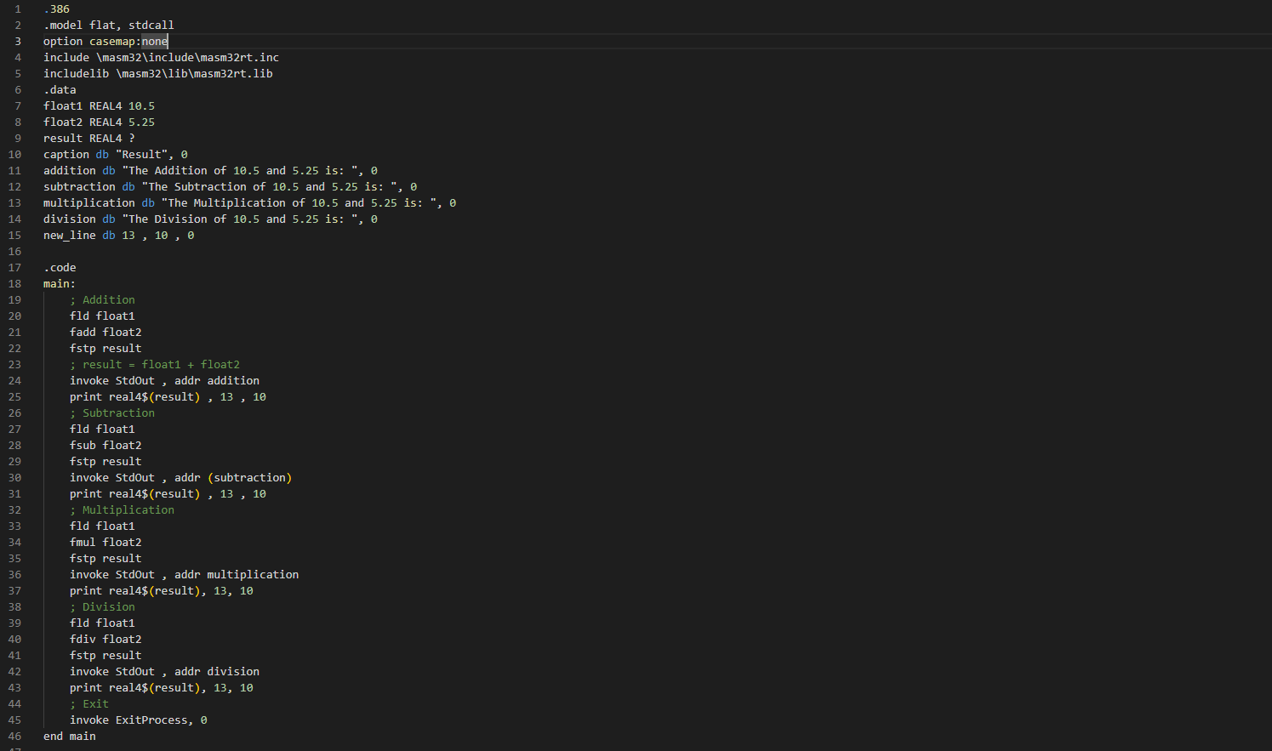

**Output:**

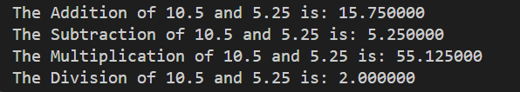

**Task 2:** Convert integer numbers to floating-point format and vice versa.

**Code:**

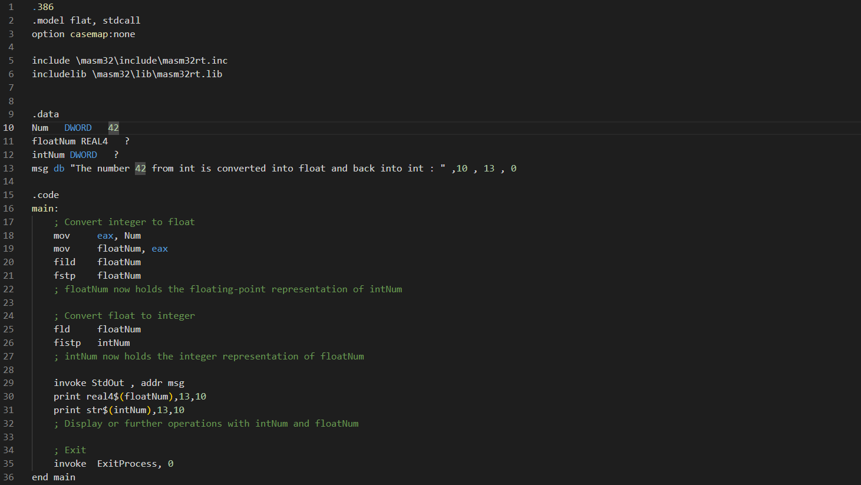

**Output:**



**Task 3:** Write an assembly language code that perform square root of floating-point numbers in assembly language.

**Code:**

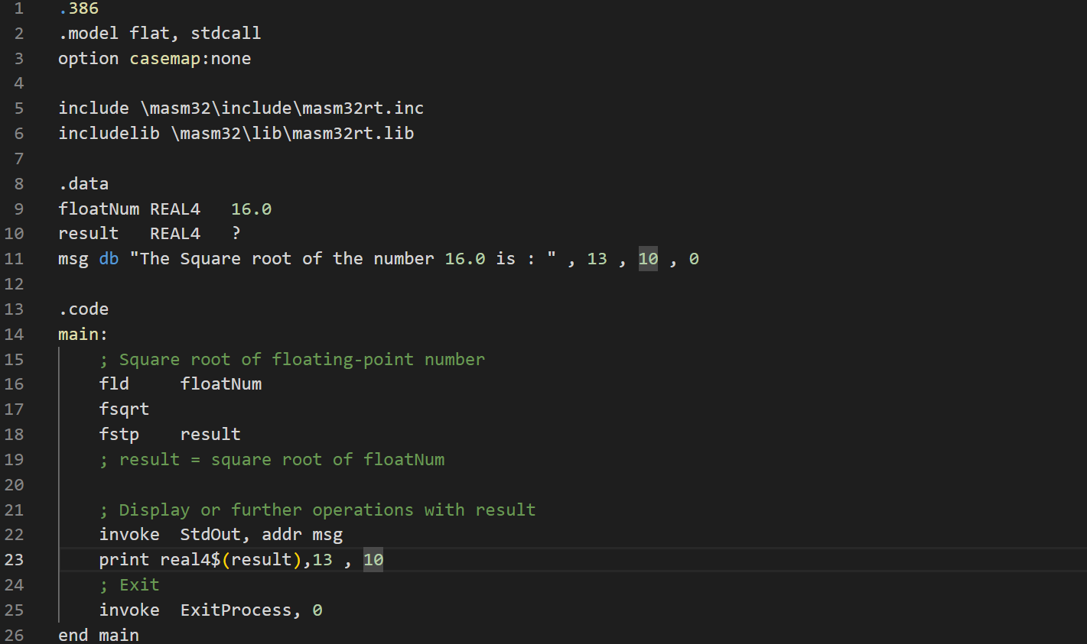

**Output:**



**Conclusion:**

In this exercise, we have explored the use of MASM32 assembly language to perform various operations on single-precision floating-point numbers. We covered three main tasks:

1. **Arithmetic Operations**:
   * Addition, subtraction, multiplication, and division of floating-point numbers.
   * The results of these operations were displayed on the console using the StdOut function and the print macro.
2. **Integer-Floating Point Conversion**:
   * Conversion of an integer to a floating-point number and vice versa.
   * The converted values were also displayed on the console.
3. **Square Root Calculation**:
   * Calculation of the square root of a floating-point number.
   * The result of this calculation was displayed on the console.

These tasks demonstrated the capabilities of MASM32 in handling floating-point arithmetic and conversions, providing a fundamental understanding of how assembly language can manipulate and display floating-point data. The use of MASM32's macros and functions, such as StdOut and print, facilitated the display of results, making it easier to verify the correctness of operations.

By completing these tasks, we have gained insight into the precision and control offered by assembly language programming, especially in scenarios requiring low-level manipulation of data.