

**Department of Computer Science**

**HITEC University, Taxila**

**BS Computer Science Program**

**(Batch 2022)**

**CS-206 Computer Organization & Assembly language 4(3+1)**

**Lab Folder**

**SPRING 2024**

**Instructor: Fatima Rauf**

**Submitted By:**

**Abdul Ahad (22-CS-071)**

**Lab Report # 14**

**Task 1:** Write an assembly code in y86 for subtracting two numbers.

**Code:**

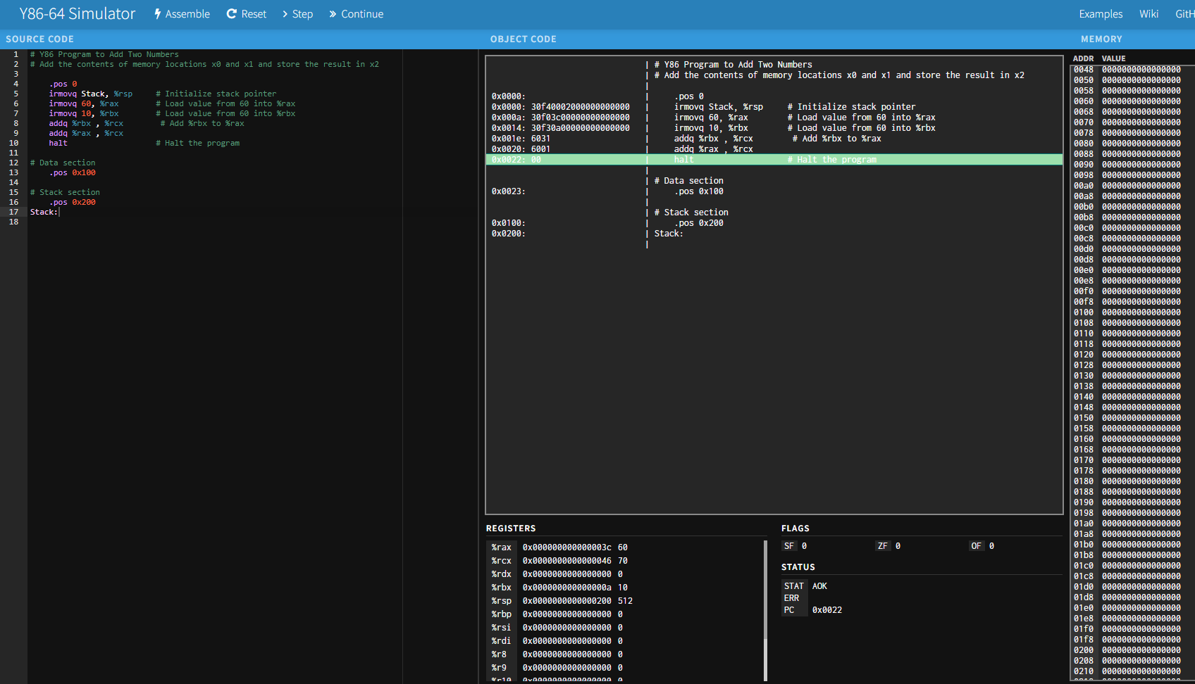

**Output:**

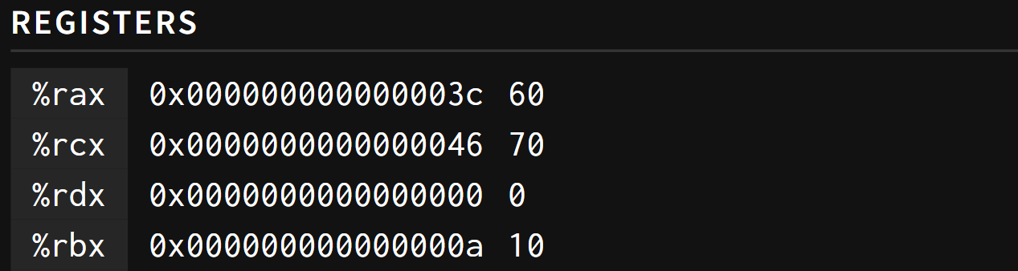

**Task 2:** Write an assembly code in y86 for adding two numbers.

**Code:**

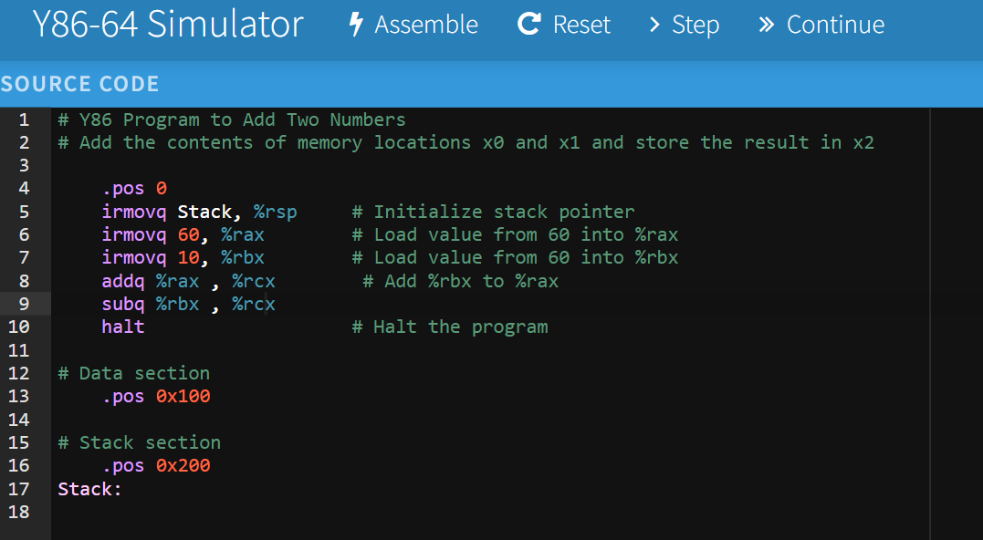

**Output:**

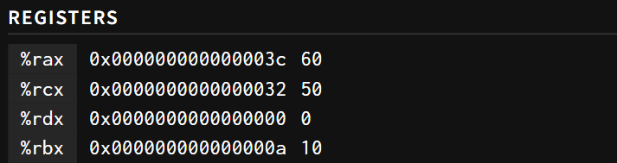

**Conclusion:**

In these Y86 assembly programs, we performed basic arithmetic operations—addition and subtraction—on two integers using simple instructions. Each program demonstrates the following key concepts:

1. **Initialization**:
   * Both programs initialize the stack pointer to ensure proper stack management using irmovq Stack, %rsp.
2. **Loading Immediate Values**:
   * The programs use irmovq to load immediate values (60 and 10) into registers %rax and %rbx.
3. **Arithmetic Operations**:
   * **Task 1**: Adds the values in %rax and %rbx, stores the result in %rcx, and then adds %rax to %rcx again.
   * **Task 2**: Adds the values in %rax and %rbx, stores the result in %rcx, and then subtracts %rbx from %rcx.
4. **Program Termination**:
   * Both programs use the halt instruction to stop the execution.

These simple tasks illustrate how Y86 assembly language can be used to manipulate and process data at a low level, providing a fundamental understanding of how basic arithmetic operations are performed in assembly. The clarity and simplicity of these programs make them an excellent starting point for learning Y86 assembly language and understanding the inner workings of CPU operations.