

**Department of Computer Science**

**HITEC University, Taxila**

**BS Computer Science Program**

**(Batch 2022)**

**CS-206 Computer Organization & Assembly language 4(3+1)**

**Lab Folder**

**SPRING 2024**

**Instructor: Fatima Rauf**

**Submitted By:**

**Abdul Ahad (22-CS-071)**

**Lab Report # 2**

**Task 1:** Perform the following arithmetic expression:

Result = -5 + (8 - 2)

**Hint: Use neg, sub and add commands.**

**Code:**

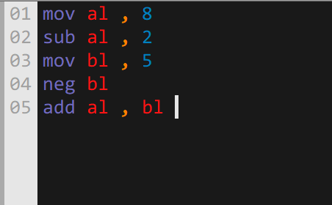

**Output:**

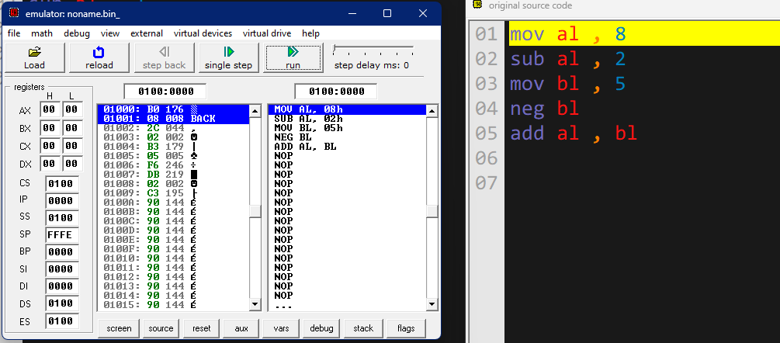

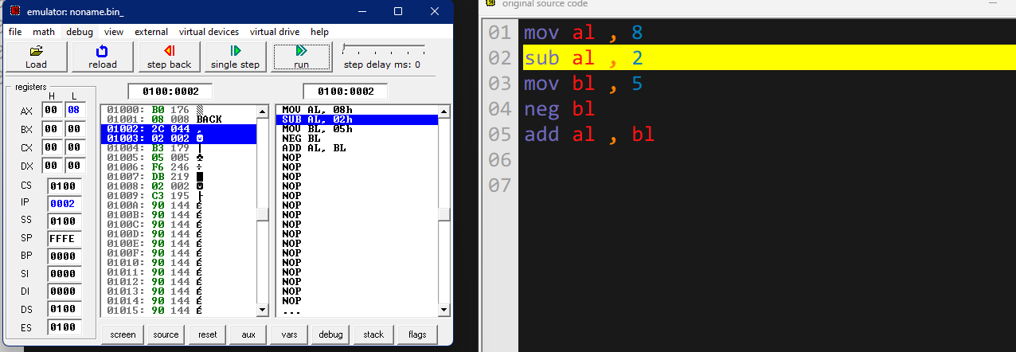

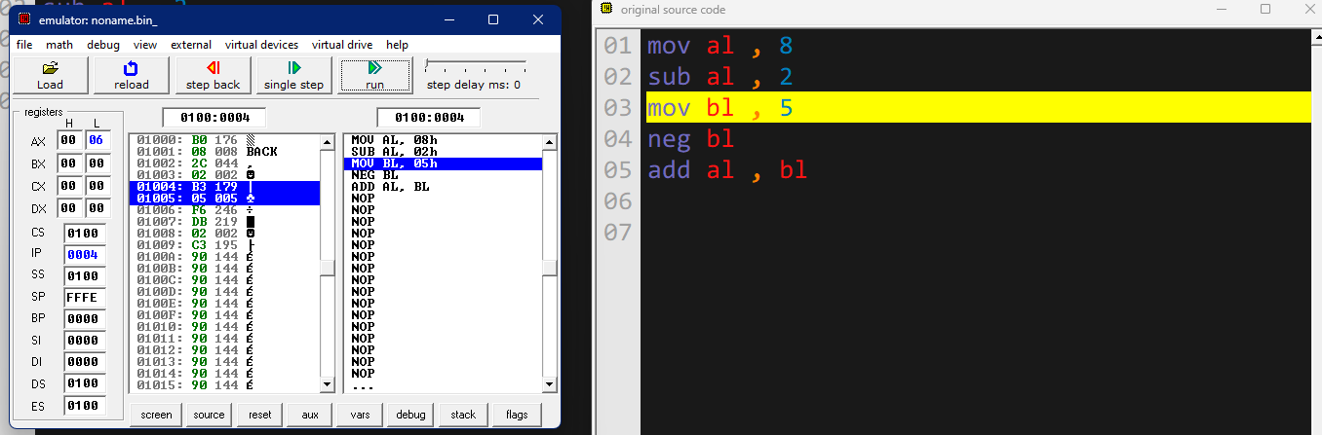

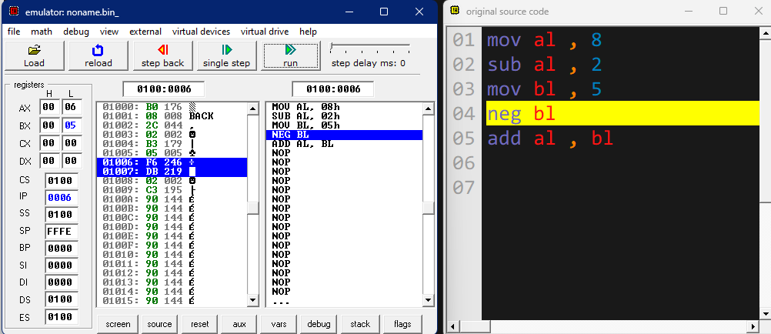

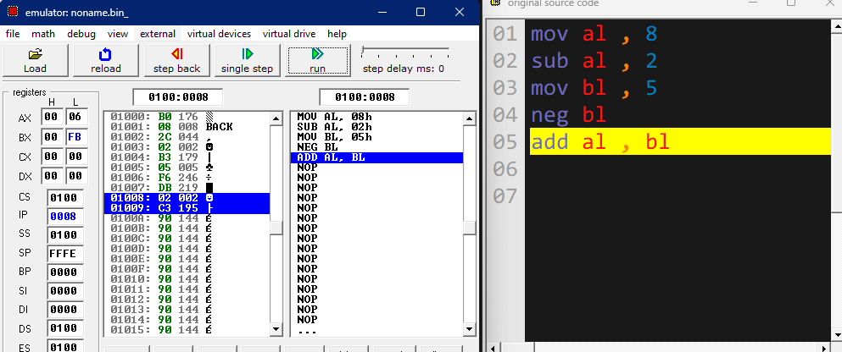

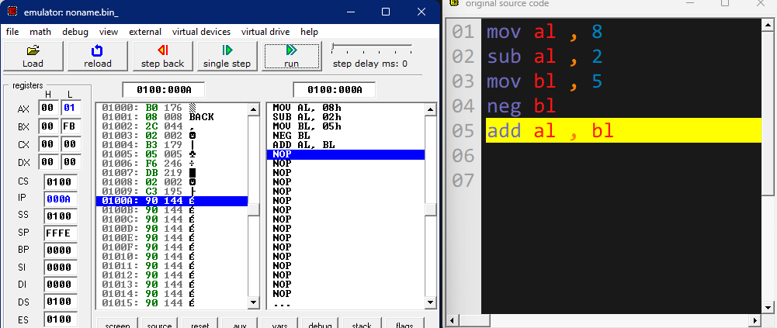

**Task 2:** Take two numbers of 16 bits and add them also subtract them.

**Code:**

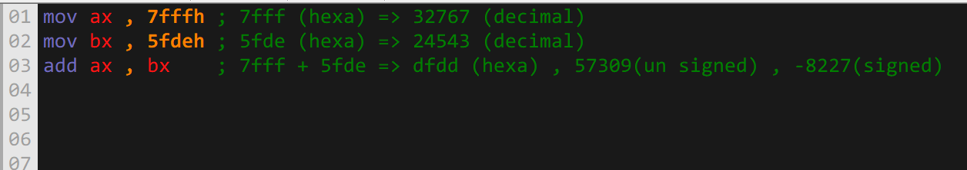

**Output:**

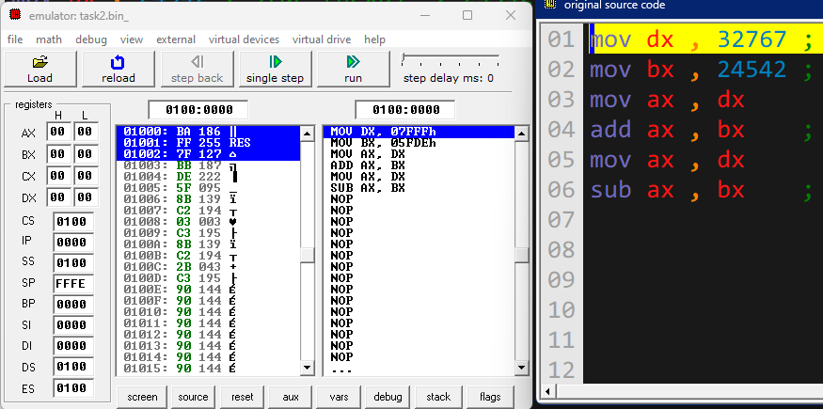

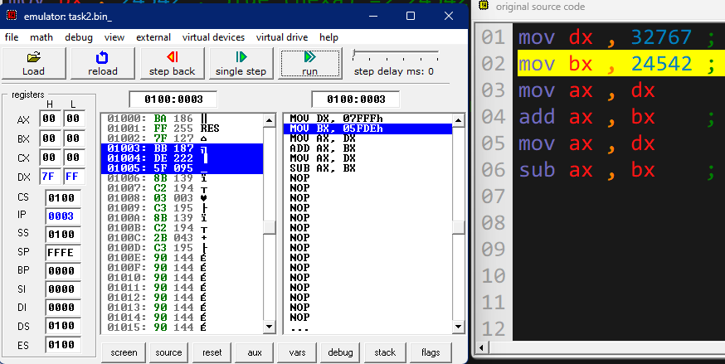

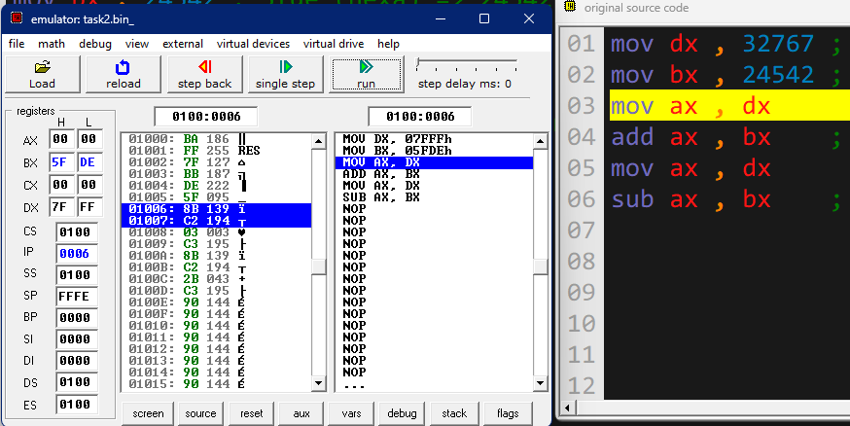

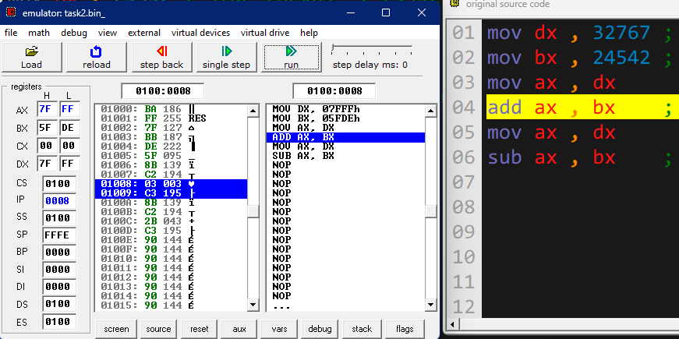

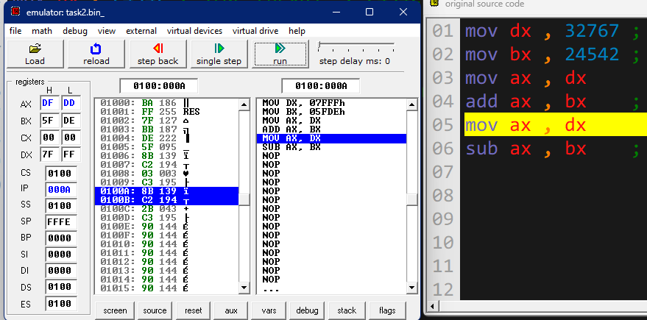

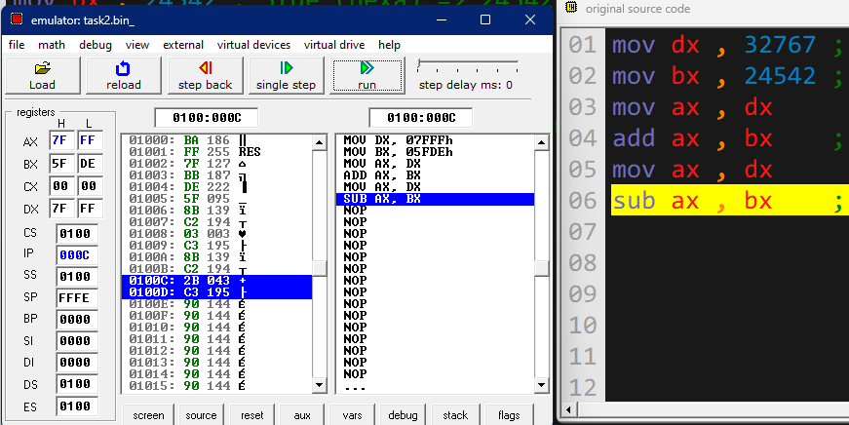

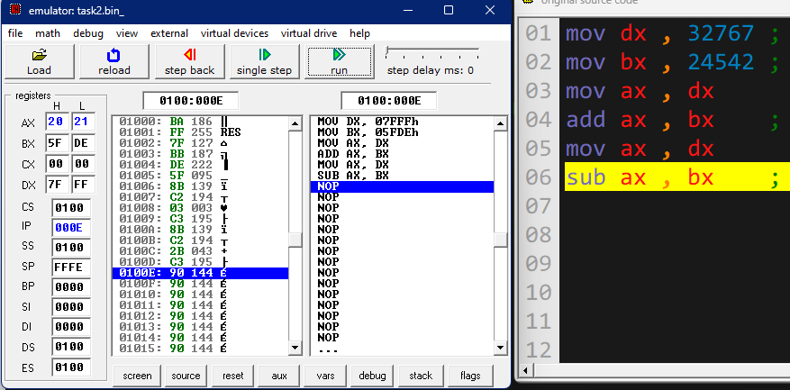

**Task 3:** To input a character at run time, convert its case (from lower to upper) and display it.

**Code:**

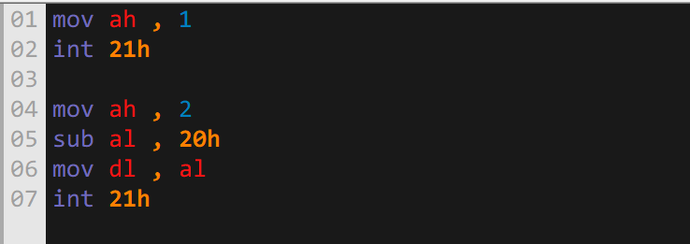

**Output:**

