

**Department of Computer Science**

**HITEC University, Taxila**

**BS Computer Science Program**

**(Batch 2022)**

**CS-206 Computer Organization & Assembly language 4(3+1)**

**Lab Folder**

**SPRING 2024**

**Instructor: Fatima Rauf**

**Submitted By:**

**Abdul Ahad (22-CS-071)**

**Lab Report # 3**

**Task 1:** Take two numbers from user and subtract them.

**Code:**

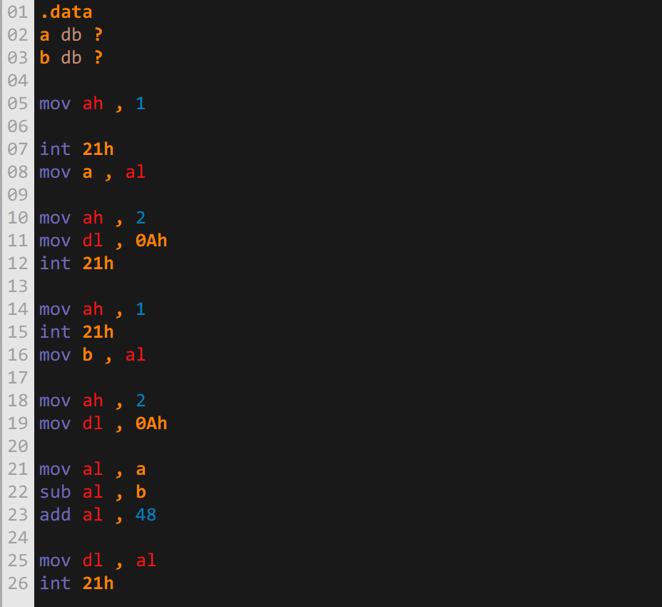

**Output:**

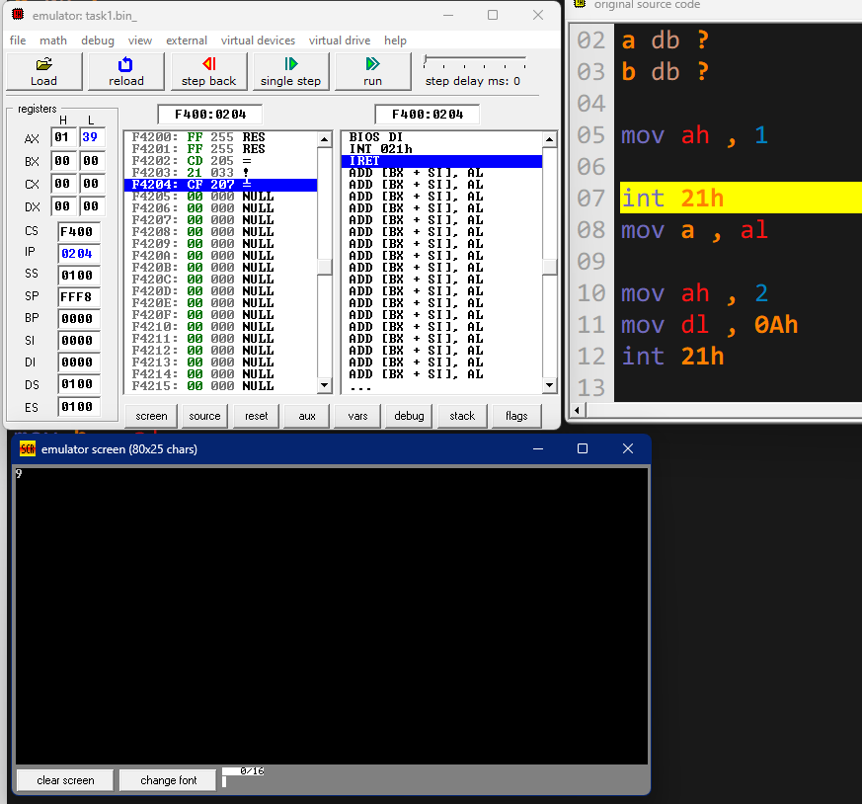

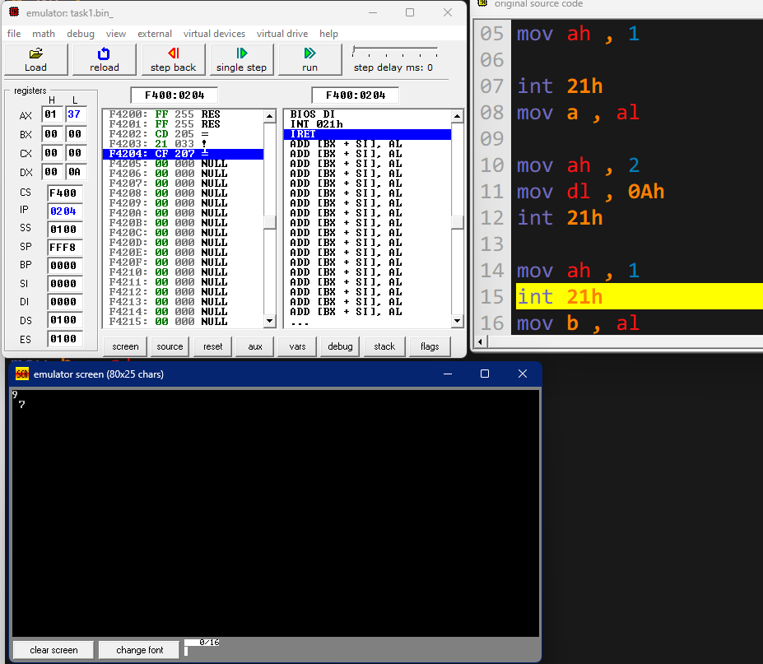

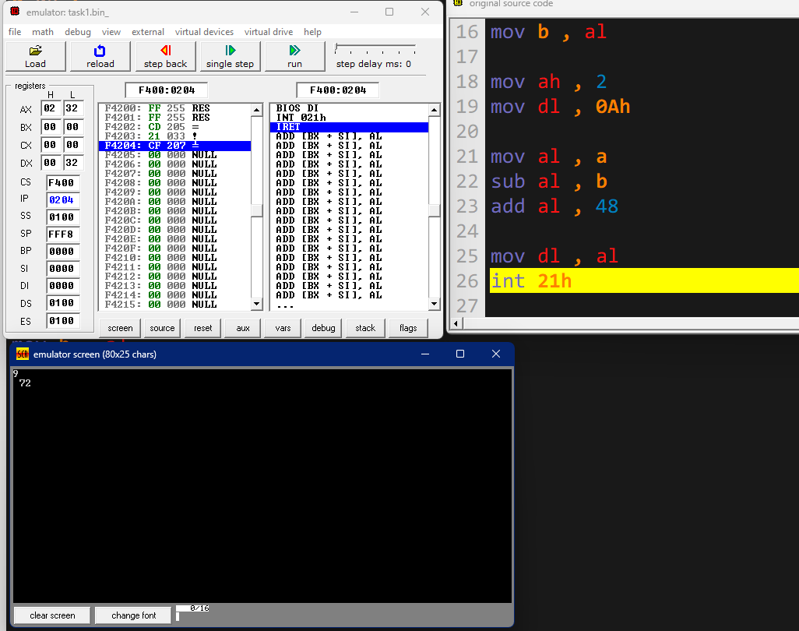

**Task 2:** Take two numbers and perform multiplication and also division on these and show output.

**Code:**

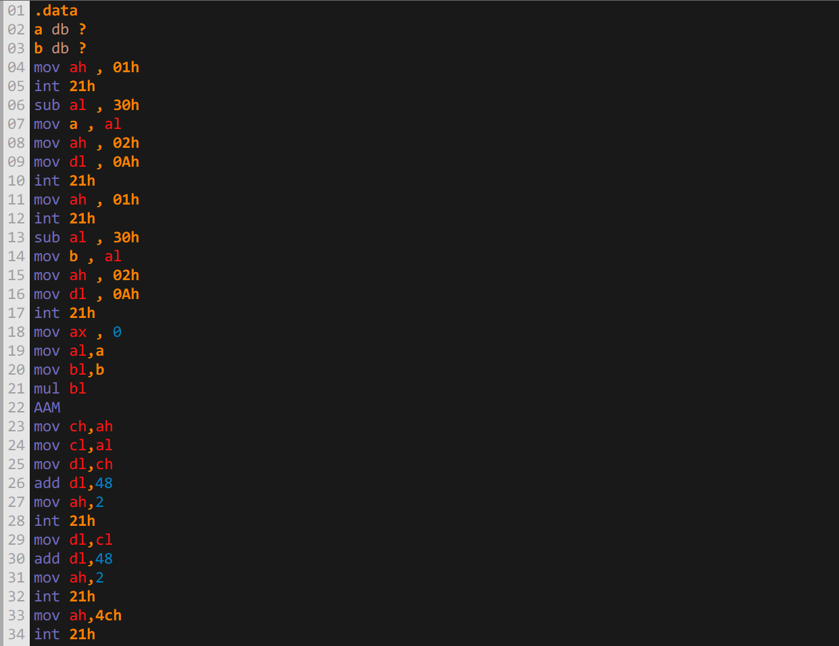

**Output:**

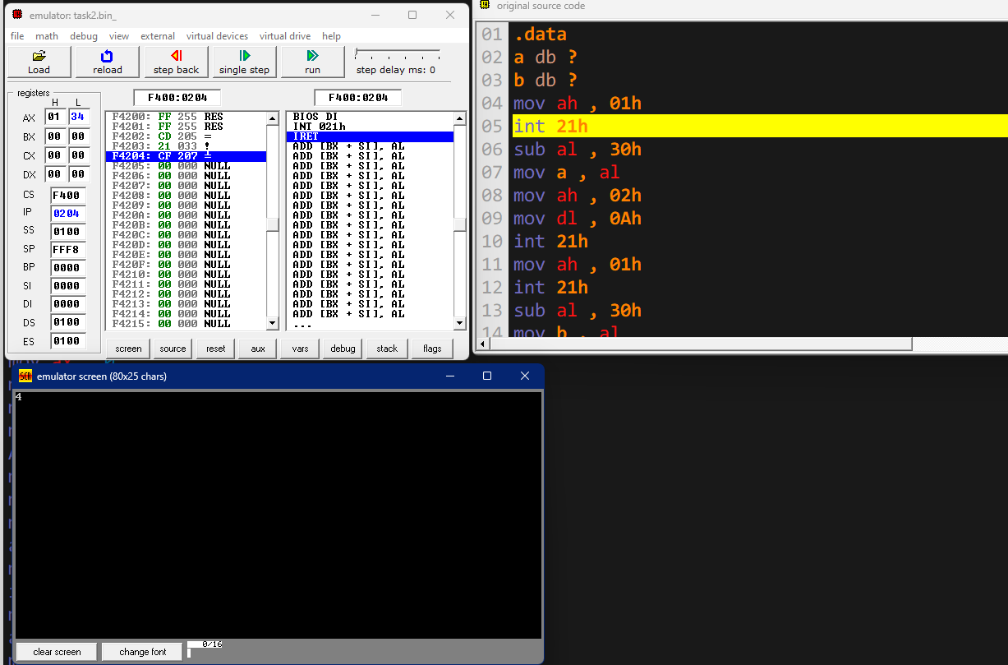

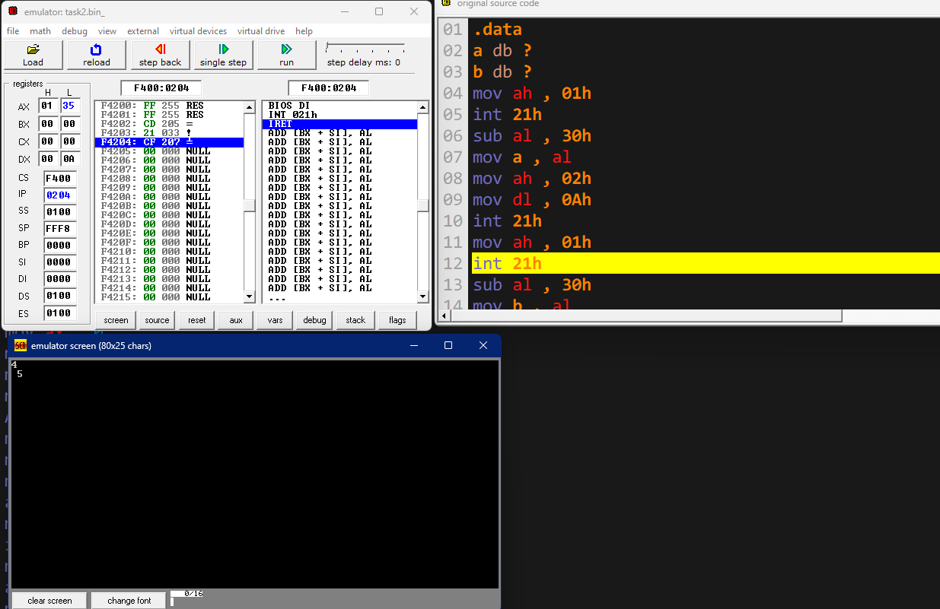

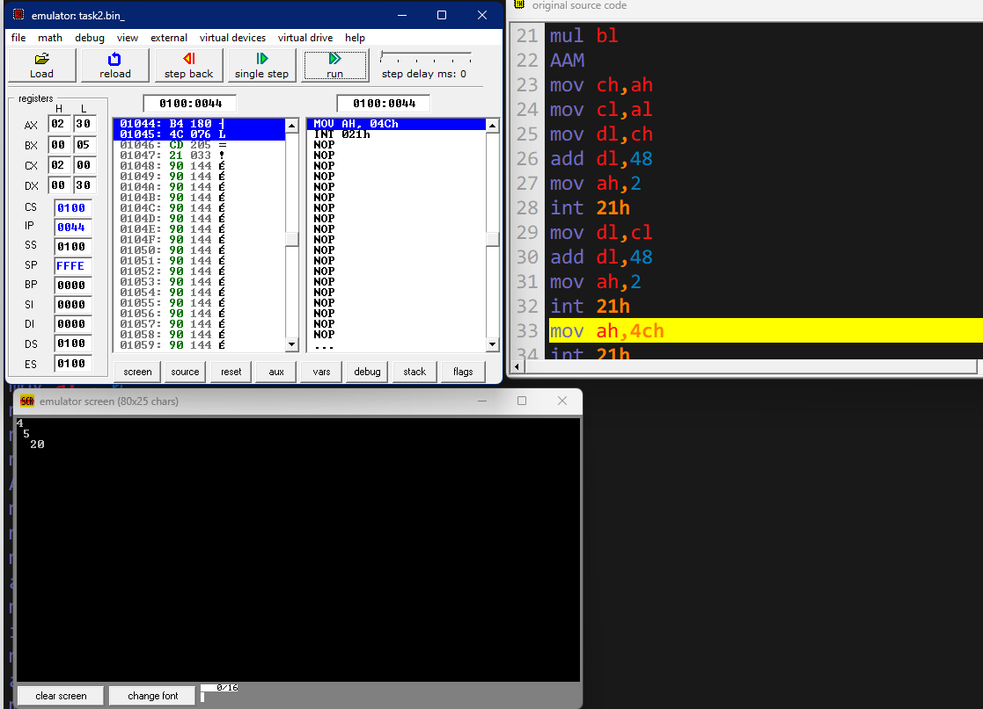

**Task 3:** Take three numbers from user and add them.

**Code:**

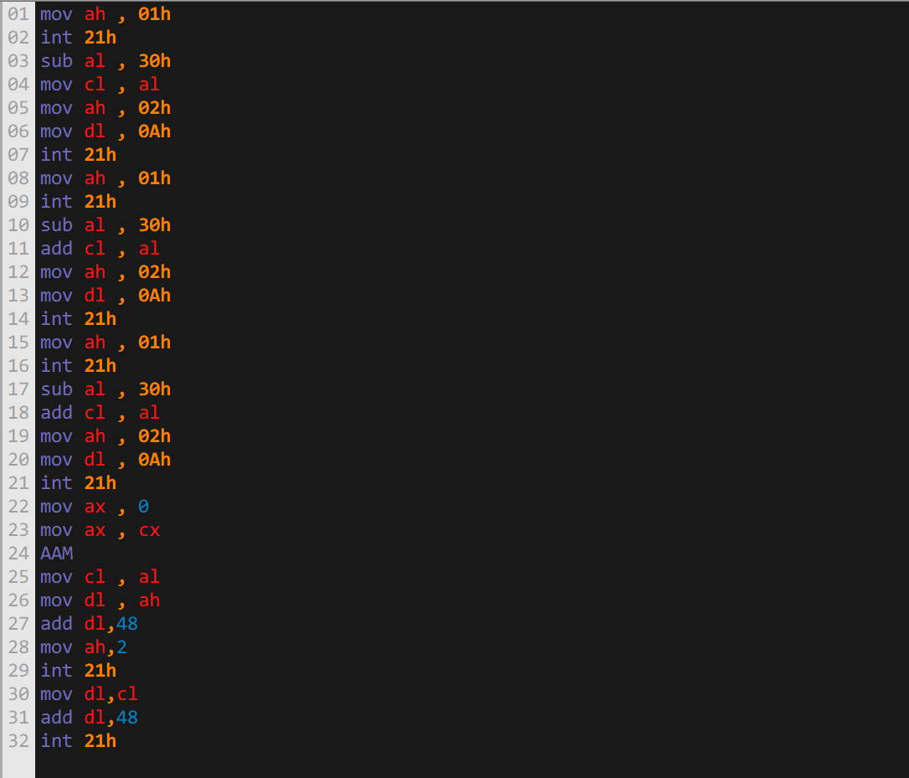

**Output:**

