

**Department of Computer Science**

**HITEC University, Taxila**

**BS Computer Science Program**

**(Batch 2022)**

**CS-206 Computer Organization & Assembly language 4(3+1)**

**Lab Folder**

**SPRING 2024**

**Instructor: Fatima Rauf**

**Submitted By:**

**Abdul Ahad (22-CS-071)**

**Lab Report # 5**

**Task 1:** Take 2 numbers from user as input and perform their AND, OR and XOR Operation

**Explanation:** For this task I utilized the variables to store values as only using the registers can cause data loss or really difficult to handle.

I also utilized the AAM functionality of the emu8086 to separate the ascii values and print them separately.

I utilized the AND, OR, XOR operation to complete the task

**Code:**

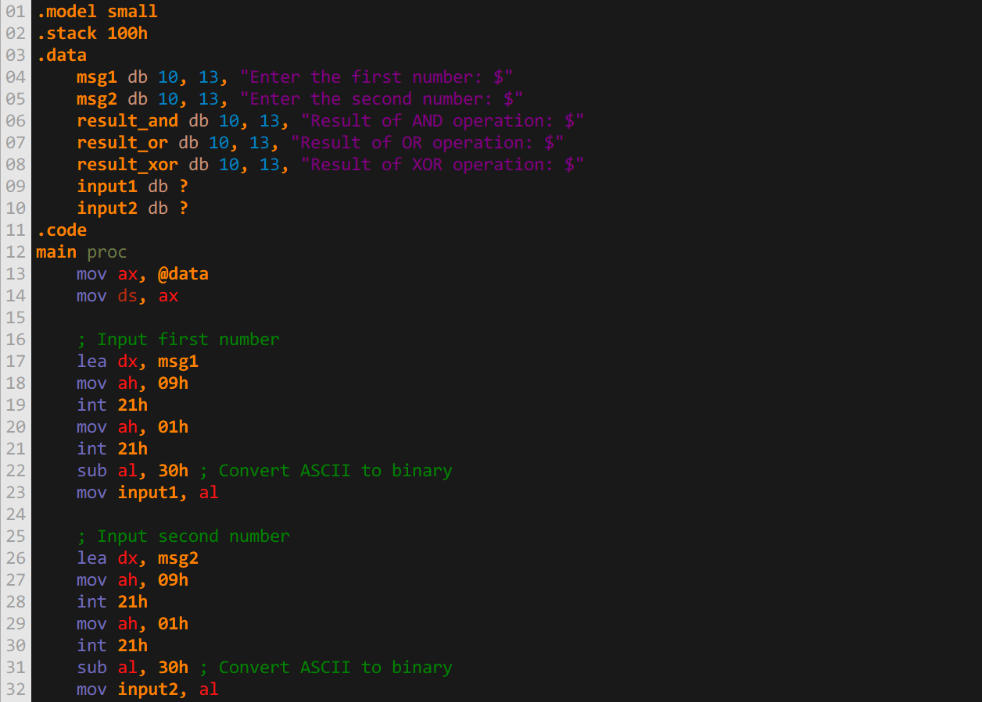

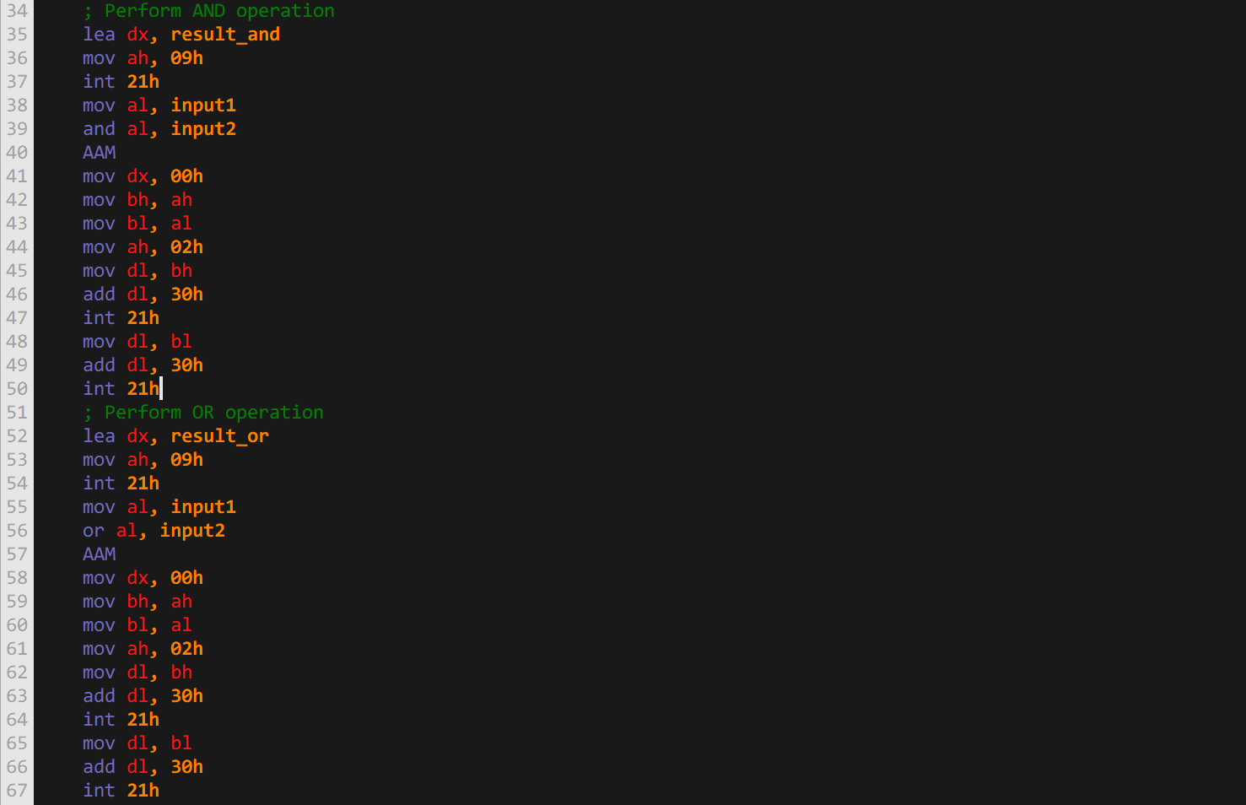

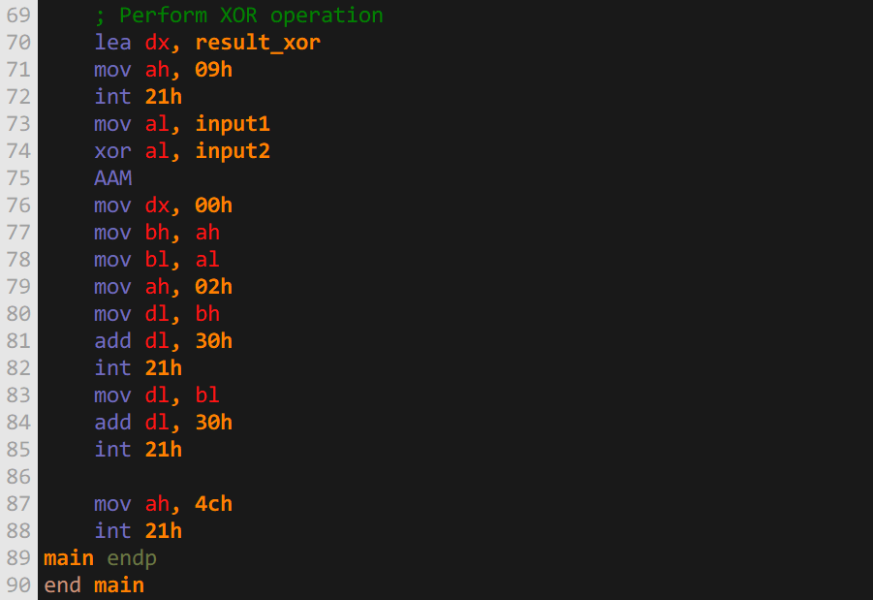

**Output:**

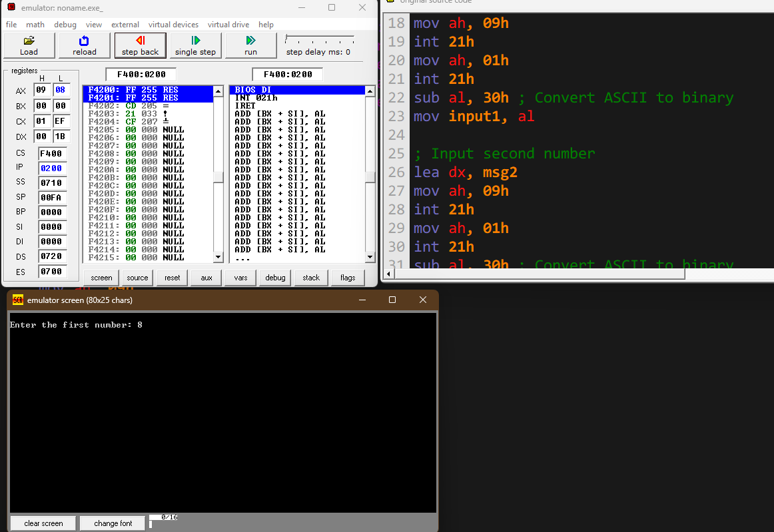

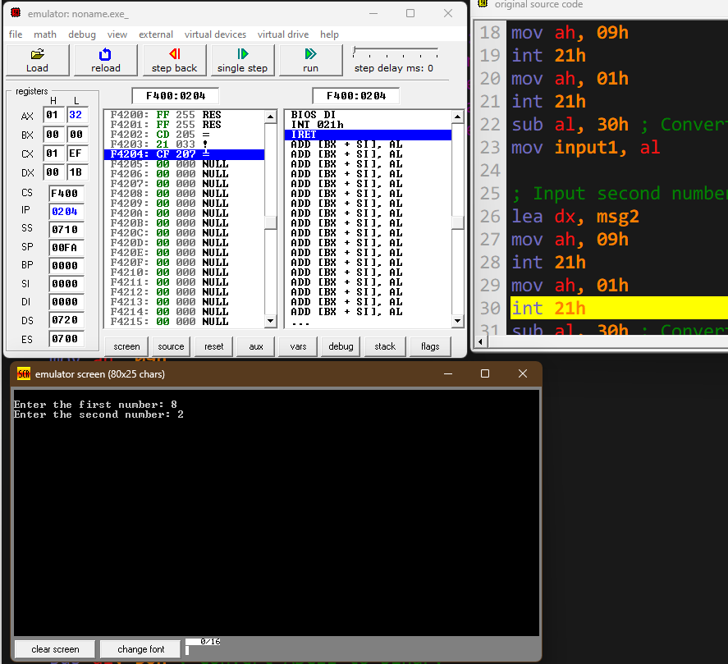

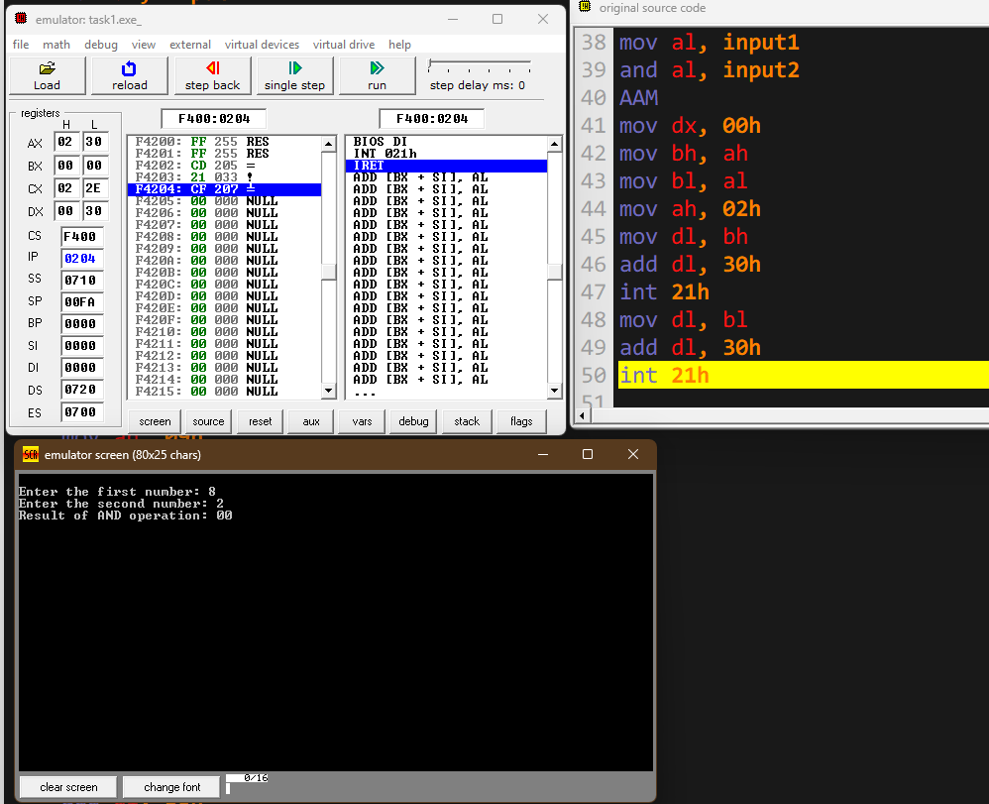

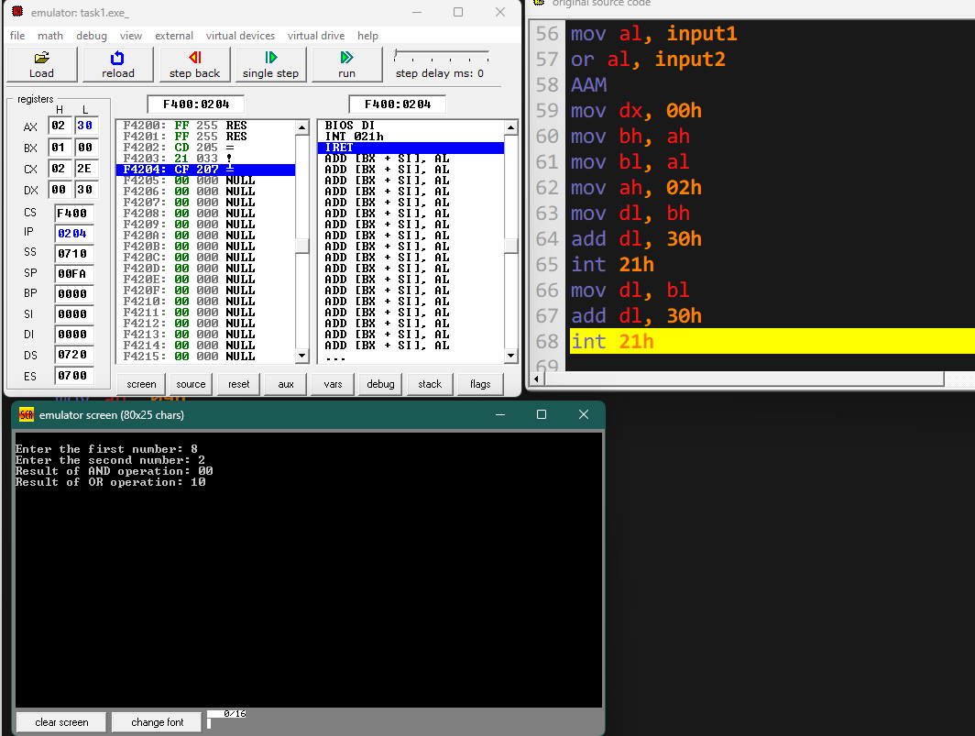

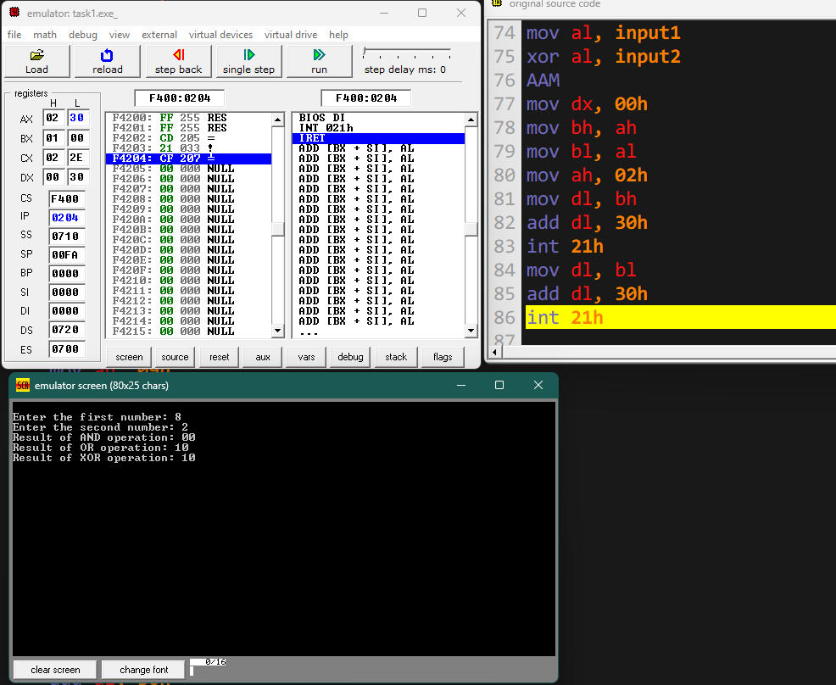

**Task 2:** Take decimal number as input and convert it into its ASCII value by using appropriate logical operator.

**Explanation:** The AND,OR and XOR operations can be utilized to perform the task as the hold special functionality if utilized correctly.

**Code:**

**Output:**

The task was **not possible** to **perform** using the **AND OR** and **XOR** bitwise operations **ONLY**

**Task 3:** Write a program that tells given number is odd or even by using suitable logical operator.

**Explanation:** By utilizing the and operation. We can determine weather the input number was even or odd:  
**use** the **AND operation** between **input** and the value **0000 0001b**

and then compare the out put to 1 if equal then odd else even

**Code:**

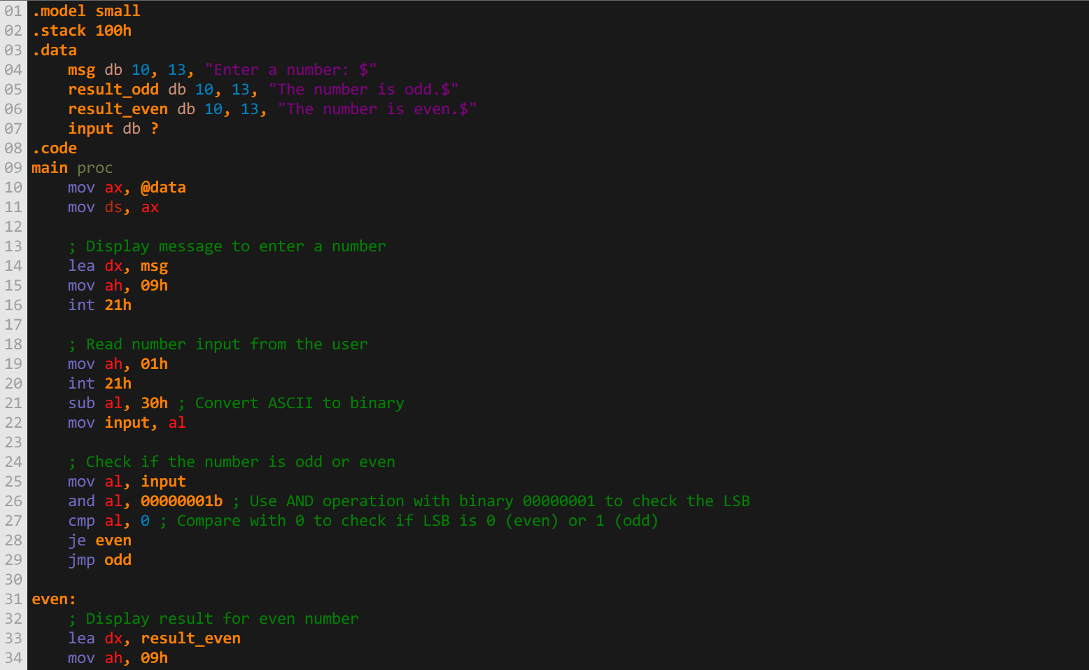

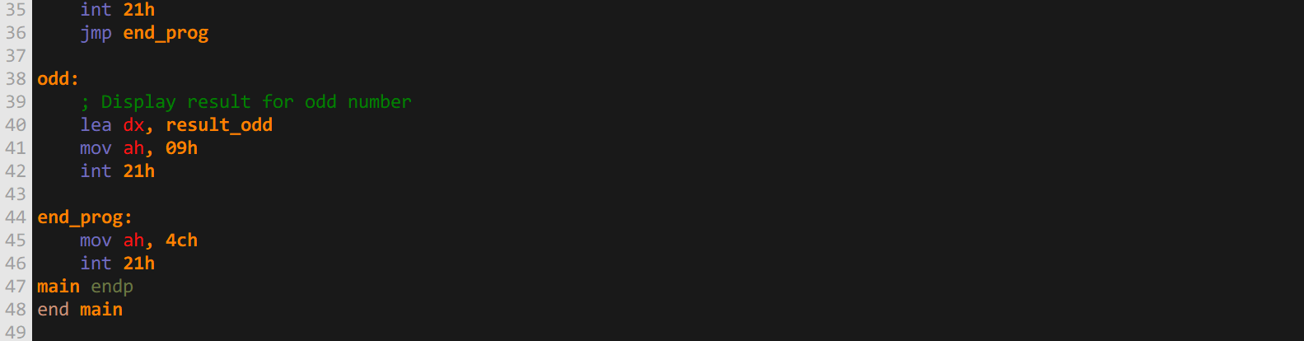

**Output:**

